-

A TREATMENT IMPROVEMENT PROTOCOL
Trau a-In or ed Be aviora Hea t
- -
are 1• n erv1• ces

on

www.sam .gov• 1-877-SAMHSA-7 (1-877-726-4727)

A TREATMENT IMPROVEMENT PROTOCOL
Trauma-Info med Ca e in Beha ioral H alt S vices

Tl 7
U.S. DEPARTMENT OF HEALTH AND HUMAN SERVICES
Substance Abuse and Mental Health Services Administration Center for Substance Abuse Treatment
1 Choke Cherry Road Rockville, MD 20857

Trauma-Informed Care in Behavioral Health Services

Acknowledgments
This publication was produced under contract numbers 270-99-7072, 270-04-7049, and 270- 09-0307 by the Knowledge Application Program (KAP), a Joint Venture ofThe CDM Group, Inc., and JBS International, Inc., for the Substance Abuse and Mental Health Services Administration (SAMHSA), U.S. Department of Health and Human Services (HHS). Andrea Kopstein, Ph.D., M.P.H., Karl D. White, Ed.D., and Christina Currier served as the Contracting Officer's Representatives.

Disclaimer
The views, opinions, and content expressed herein are the views of the consensus panel members and do not necessarily reflect the official position of SAMHSA or HHS. No official support of or endorsement by SAMHSA or HHS for these opinions or for the instruments or resources described are intended or should be inferred. The guidelines presented should not be considered substitutes for individualized client care and treatment decisions.

Public Domain Notice
All materials appearing in this volume except those taken directly from copyrighted sources are in the public domain and may be reproduced or copied without permission from SAMHSA or the authors. Citation of the source is appreciated. However, this publication may not be reproduced or distributed for a fee without the specific, written authorization of the Office of Communications, SAMHSA, HHS.

Electronic Access and Copies of Publication
This publication may be ordered or downloaded from SAMHSA's Publications Ordering Web page at http://store.samhsa.gov. Or, please call SAMHSA at 1-877-SAMHSA-7 (1-877-726- 4727) (English and Espanol).

Recommended Citation
Substance Abuse and Mental Health Services Administration. Trauma-Informed Care in Behavioral Health Services. Treatment Improvement Protocol (TIP) Series 57. HHS Publication No. (SMA) 13-4801. Rockville, MD: Substance Abuse and Mental Health Services Administration, 2014.

Originating Office
Qyality Improvement and Workforce Development Branch, Division of Services Improvement, Center for Substance Abuse Treatment, Substance Abuse and Mental Health Services Administration, 1 Choke Cherry Road, Rockville, MD 20857.

HHS Publication No. (SMA) 14-4816 First Printed 2014

II

Please share your thoughts about this publication by completing a brief online survey at:

https://www.surveymonkey.com/r/KAPPFS

The survey takes about 7 minutes to complete and is anonymous.
Your feedback will help SAMHSA develop future products.

Contents

Consensus Panel. vii
KAP Expert Panel and Federal Government Participants ix
What Is aTIP? xi
Foreword xiii
HowThisTIP Is Organized xv
Terminology xvi
PART 1: A PRACTICAL GUIDE FOR THE PROVISION OF BEHAVIORAL HEALTH SERVICES 1
Chapter 1-Trauma-Informed Care: A Sociocultural Perspective 3
Scope of the TIP 4
Intended Audience 4
Before You Begin 4
Structure of the TIP 6
What Is Trauma? 7
Trauma Matters in Behavioral Health Services 7
Trauma-Informed Intervention and Treatment Principles 11
As You Proceed 32
Chapter 2-TraumaAwareness 33
Types ofTrauma 33
Characteristics of Trauma 46
Individual and Sociocultural Features 52
Chapter 3-Understandingthe Impact ofTrauma 59
Sequence of Trauma Reactions 60
Common Experiences and Responses to Trauma 61
Subthreshold Trauma-Related Symptoms 75
Specific Trauma-Related Psychological Disorders 77
Other Trauma- Related and Co-Occurring Disorders 85

Ill

Trauma-Informed Care in Behavioral Health Services
Chapter 4-Screening and Assessment 91
Screening and Assessment 92
Barriers and Challenges to Trauma-Informed Screening and Assessment 99
Cross-Cultural Screening and Assessment 103
Choosing Instruments 104
Trauma-Informed Screening and Assessment 106
Concluding Note 110
Chapter 5-Clinical Issues Across Services 111
Trauma-Informed Prevention and Treatment Objectives 111
Treatment Issues 127
Making Referrals to Trauma-Specific Services 135
Chapter 6-Trauma-Specific Services 137
Introduction 137
Trauma-Specific Treatment Models 139
Integrated Models for Trauma 147
Emerging Interventions 153
Concluding Note 155
PART 2: AN IMPLEMENTATION GUIDE FOR BEHAVIORAL HEALTH PROGRAM ADMINISTRATORS 157
Chapter 1-Trauma-lnformed Organizations 159
Strategy #1: Show Organizational and Administrative Commitment to TIC 161
Strategy #2: Use Trauma-Informed Principles in Strategic Planning 162
Strategy #3: Review and Update Vision, Mission, and Value Statements 162
Strategy #4: Assign a Key Staff Member To Facilitate Change 163
Strategy #5: Create a Trauma-Informed Oversight Committee 163
Strategy #6: Conduct an Organizational Self-Assessment ofTrauma-lnformed Services 164
Strategy #7: Develop an Implementation Plan 164
Strategy #8: Develop Policies and Procedures To Ensure Trauma-Informed Practices and
To Prevent Retraumatization 166
Strategy #9: Develop a Disaster Plan 166
Strategy #10: Incorporate Universal Routine Screenings 167
Strategy #11: Apply Culturally Responsive Principles 167
Strategy #12: Use Science-Based Knowledge 169
Strategy #13: Create a Peer-Support Environment 169
Strategy#14: Obtain Ongoing Feedback and Evaluations 170
Strategy #15: Change the Environment To Increase Safety 171
Strategy #16: Develop Trauma-Informed Collaborations 171
Chapter 2-Building aTrauma-Informed Workforce 173
Introduction 173
Workforce Recruitment, Hiring, and Retention 174
IV

Contents
Training in TIC 177
Trauma-Informed Counselor Competencies 181
Counselor Responsibilities and Ethics 182
Clinical Supervision and Consultation 191
Secondary Traumatization 193
Counselor Self-Care 205
APPENDICES 215
Appendix A-Bibliography 215
Appendix B-Trauma Resource List 247
Appendix C-HistoricalAccount ofTrauma 267
Appendix D-Screening and Assessment Instruments 271
Appendix £-Consumer Materials 285
Appendix F-Organizational Assessment for Trauma- Informed Care 287
Appendix G-Resource Panel 289
Appendix H-Field Reviewers 293
Appendix I-Cultural Competence and Diversity Network Participants 299
AppendixJ-Acknowledgments 300
EXHIBITS
Exhibit 1.1-1: TIC Framework in Behavioral Health Services-Sociocultural Perspective 6
Exhibit 1.1-2: A Social-Ecological Model for Understanding Trauma and Its Effects 15
Exhibit 1.1-3: Understanding the Levels Within the Social-Ecological Model of
Trauma and Its Effects 16
Exhibit 1.1-4: Cross-Cutting Factors of Culture 26
Exhibit 1.2-1: Trauma Examples 35
Exhibit 1.3-1: Immediate and Delayed Reactions to Trauma 62
Exhibit 1.3-2: Cognitive Triad of Traumatic Stress 67
Exhibit 1.3-3: DSM-5 Diagnostic Criteria for ASD 78
Exhibit 1.3-4: DSM-5 Diagnostic Criteria for PTSD 82
Exhibit 1.3-5: ICD-10 Diagnostic Criteria for PTSD 85
Exhibit 1.3-6: Important Treatment Facts About PTSD and Substance Use Disorders 89
Exhibit 1.4-1: Grounding Techniques 98
Exhibit 1.4-2: Key Areas ofTrauma Screening and Assessment 105
Exhibit 1.4-3: SLE Screening 107
Exhibit 1.4-4: STaT: Intimate Partner Violence Screening Tool 108
Exhibit 1.4-5: PC-PTSD Screen 108
Exhibit 1.4-6: The SPAN 108
Exhibit 1.4-7: The PTSD Checklist 109
Exhibit 1.4-8: Resilience Scales 110
Exhibit 1.5-1: OBSERVATIONS: A Coping Strategy 119
V

Trauma-Informed Care in Behavioral Health Services
Exhibit 2.1-1: TIC Planning Guidelines 165
Exhibit 2.2-1: Clinical Practice Issues Relevant to Counselor Training in Trauma-
Informed Treatment Settings 179
Exhibit 2.2-2: Guidelines for Training in Mental Health Interventions forTrauma-
Exposed Populations 180
Exhibit 2.2-3: Trauma-Informed Counselor Competencies Checklist 183
Exhibit 2.2-4: Sample Statement of the Client's Right to Confidentiality From a
Client Bill of Rights 185
Exhibit 2.2-5: Green Cross Academy ofTraumatology Ethical Guidelines for the
Treatment of Clients Who Have Been Traumatized 186
Exhibit 2.2-6: Boundaries in Therapeutic Relationships 189
Exhibit 2.2-7: Counselor Strategies To Prevent Secondary Traumatization 198
Exhibit 2.2-8: Secondary Traumatization Signs 199
Exhibit 2.2-9: ProQOL Scale 201
Exhibit 2.2-10: Your Scores on the ProQOL: Professional Qyality of Life Screening 202
Exhibit 2.2-11: What Is My Score and What Does It Mean? 203
Exhibit 2.2-12: Clinical Supervisor Guidelines for Addressing SecondaryTraumatization 205
Exhibit 2.2-13: Comprehensive Self-Care Plan Worksheet 208
Exhibit 2.2-14: Comprehensive Self-Care Plan Worksheet Instructions 209
Exhibit 2.2-15: The Ethics of Self-Care 210

VI

Consensus Panel

Note: Each panelist's information reflects his or her affiliation at the time of the Consensus Panel meeting and may not reflect that person's most current affiliation.

Chair

Lisa M. Najavits, Ph.D.
Research Psychologist
Veterans Affairs Boston Healthcare System Professor of Psychiatry
Boston University School of Medicine Boston, MA

Co-Chair
Linda B. Cottier, Ph.D., M.P.H. Professor of Epidemiology in Psychiatry Department of Psychiatry
Washington University-St. Louis St. Louis, MO

Workgroup Leaders

Stephanie S. Covington, Ph.D., LCSW, MFCC
Co- Director
Center for Gender and Justice Institute for Relational Development La Jolla, CA

Margaret Cramer, Ph.D.
Clinical Psychologist/Clinical Instructor Harvard Medical School
Boston,MA

Anne M. Herron, M.S.
Director
Treatment Programming
New York State Office of Alcoholism and Substance Abuse Services
Albany,NY

Denise Hien, Ph.D.
Research Scholar
Social Intervention Group School of Social Work Columbia University NewYork,NY

Dee S. Owens, M.P.A.
Director
Alcohol-Drug Information Indiana University Bloomington, IN

Panelists

Charlotte Chapman, M.S., LPC, CAC
Training Director
Division of Addiction Psychiatry
Mid-Atlantic Addiction Technology Transfer Center
Virginia Commonwealth University Richmond, VA

VII

Trauma-Informed Care in Behavioral Health Services

Scott F. Coffey, Ph.D.
Associate Professor
Department of Psychiatry and Human Behavior
University of Mississippi Medical Center Jackson,MS

ReneeM. Cunningham-Williams,M.S.W., M.P.E., Ph.D.
Research Assistant/Professor of Social Work Department of Psychiatry
Washington University St. Louis, MO

Chad D. Emrick, Ph.D.
Administrative Director
Substance Abuse Treatment Program Denver VA Medical Center (116Al) Denver,CO

Charles R. Figley, Ph.D.
Professor
Director of the Traumatology Institute Florida State University
Tallahassee, FL

Larry M. Gentilello, M.D., FACS
Professor and Chairman
Division of Burn, Trauma, and Critical Care University ofTexas Southwestern Medical
School Dallas,TX

Robert Grant, Ph.D. Trauma Consultant Oakland,CA

Anthony (Tony) Taiwai Ng, M.D.
Disaster Psychiatrist Washington, DC

Pallavi Nishith, Ph.D. Associate Research Professor Center for Trauma Department of Psychology
University of Missouri-St. Louis St. Louis, MO

Joseph B. Stone, Ph.D., CACIII, ICADC Program Manager and Clinical Supervisor Confederated Tribes of Grand Ronde
Behavioral Health Program Grand Ronde, OR

Michael Villanueva, Ph.D.
Research Professor
Center on Alcoholism, Substance Abuse, and Addiction
Albuquerque, NM

viii

KAP Expert Panel and Federal Government Participants

Barry S. Brown, Ph.D.
Adjunct Professor
University of North Carolina-Wilmington Carolina Beach, NC

Jacqueline Butler, M.S.W., LISW, LPCC, CCDC III, CJS
Professor of Clinical Psychiatry College of Medicine
University of Cincinnati Cincinnati, OH

DeionCash
Executive Director
Community Treatment and Correction Center, Inc.
Canton,OH

Debra A. Claymore, M.Ed.Adm. Owner/Chief Executive Officer WC Consulting, LLC
Loveland, CO

Carlo C. DiClemente, Ph.D.
Chair
Department of Psychology
University of Maryland-Baltimore County Baltimore, MD

Catherine E. Dube, Ed.D. Independent Consultant Brown University Providence, RI

Jerry P. Flanzer, D.S.W., LCSW, CAC
Chief, Services
Division of Clinical and Services Research National Institute on Drug Abuse Bethesda, MD

Michael Galer, D.B.A. Independent Consultant Westminster, MA

Renata}. Henry, M.Ed.
Director
Division of Alcoholism, Drug Abuse and Mental Health
Delaware Department of Health and Social Services
New Castle, DE

Joel Hochberg, M.A.
President
Asher & Partners Los Angeles, CA

IX

Trauma-Informed Care in Behavioral Health Services

Jack Hollis, Ph.D.
Associate Director, Center for Health Research
Kaiser Permanente Portland, OR

Mary BethJohnson, M.S.W.
Director
Addiction Technology Transfer Center University of Missouri-Kansas City Kansas City, MO

Eduardo Lopez Executive Producer EVS Communications Washington, DC

Holly A. Massett, Ph.D.
Academy for Educational Development Washington, DC

Diane Miller
Chief
Scientific Communications Branch National Institute on Alcohol Abuse and
Alcoholism Bethesda, MD

Harry B. Montoya, M.A. President/Chief Executive Officer Hands Across Cultures
Espanola, NM

Richard K. Ries, M.D.
Director/Professor
Outpatient Mental Health Services Dual Disorder Programs
Seattle, WA

Gloria M. Rodriguez, D.S.W.
Research Scientist
Division of Addiction Services
New Jersey Department of Health and Senior Services
Trenton,NJ

Everett Rogers, Ph.D.
Center for Communications Programs Johns Hopkins University
Baltimore, MD

Jean R. Slutsky, P.A., M.S.P.H.
Senior Health Policy Analyst
Agency for Healthcare Research & Qyality Rockville, MD

Nedra Klein Weinreich, M.S.
President
Weinreich Communications Canoga Park, CA

Clarissa Wittenberg
Director
Office of Communications and Public Liaison
National Institute of Mental Health Bethesda, MD

Consulting Members of the KAP Expert Panel
Paul Purnell, M.A Social Solutions, LLC Potomac,MD

Scott Ratzan, M.D., M.P.A., M.A. Academy for Educational Development Washington, DC

Thomas W. Valente, Ph.D.
Director
Master of Public Health Program Department of Preventive Medicine School of Medicine
University of Southern California Los Angeles, CA

Patricia A. Wright, Ed.D. Independent Consultant Baltimore, MD

X

What Is a TIP?

Treatment Improvement Protocols (TIPs) are developed by the Substance Abuse and Mental Health Services Administration (SAMHSA) within the U.S. Department of Health and Human Services (HHS). Each TIP involves the development of topic-specific best practice guidelines for the prevention and treatment of substance use and mental disorders. TIPs draw on the experience and knowledge of clinical, research, and administrative experts of various forms of treatment and prevention. TIPs are distributed to facilities and individuals across the country. Published TIPs can be accessed via the Internet at http://store.samhsa.gov.
Although each consensus-based TIP strives to include an evidence base for the practices it rec­ ommends, SAMHSA recognizes that behavioral health is continually evolving, and research fre­ quently lags behind the innovations pioneered in the field. A major goal of each TIP is to convey "front-line" information quickly but responsibly. If research supports a particular approach, cita­ tions are provided.

XI

Foreword

The Substance Abuse and Mental Health Services Administration (SAMHSA) is the agency within the U.S. Department of Health and Human Services that leads public health efforts to advance the behavioral health of the nation. SAMHSA's mission is to reduce the impact of sub­ stance abuse and mental illness on America's communities.
The Treatment Improvement Protocol (TIP) series fulfills SAMHSA's mission to improve pre­ vention and treatment of substance use and mental disorders by providing best practices guidance to clinicians, program administrators, and payers. TIPs are the result of careful consideration of all relevant clinical and health services research findings, demonstration experience, and imple­ mentation requirements. A panel of non-Federal clinical researchers, clinicians, program admin­ istrators, and patient advocates debates and discusses their particular area of expertise until they reach a consensus on best practices. This panel's work is then reviewed and critiqued by field reviewers.
The talent, dedication, and hard work that TIP panelists and reviewers bring to this highly par­ ticipatory process have helped bridge the gap between the promise of research and the needs of practicing clinicians and administrators to serve, in the most scientifically sound and effective ways, people in need of behavioral health services. We are grateful to all who have joined with us to contribute to advances in the behavioral health field.

Pamela S. Hyde,J.D.
Administrator
Substance Abuse and Mental Health Services Administration

H. Westley Clark, M.D.,J.D., M.P.H., CAS, FASAM
Director
Center for Substance Abuse Treatment
Substance Abuse and Mental Health Services Administration

Frances M. Harding
Director
Center for Substance Abuse Prevention
Substance Abuse and Mental Health Services Administration

Paolo del Vecchio, M.S.W.
Director
Center for Mental Health Services
Substance Abuse and Mental Health Services Administration

XIII

6 Trauma-Specific Services
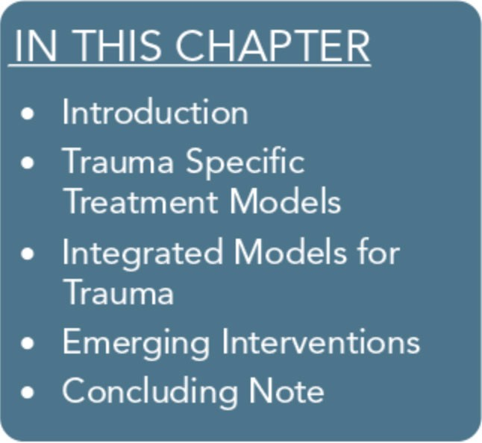
This chapter covers various treatment approaches designed specifi­ cally to treat trauma-related symptoms, trauma-related disorders, and specific disorders of traumatic stress. The models presented do not comprise an exhaustive list, but rather, serve as examples.
These models require training and supervised experience to be conducted safely and effectively. The chapter begins with a section on trauma-specific treatment models, providing a brief overview of interventions that can be delivered immediately after a trauma, as well as trauma-specific interventions for use beyond the immediate crisis. The second segment focuses on integrated care that targets trauma-specific treatment for mental, substance use, and co­ occurring disorders. Even though entry-level, trauma-informed behavioral health service providers are unlikely to be in a position to use these interventions, having some knowledge of them is nev­ ertheless important. Currently, more research is needed to tease out the most important ingredients of early interventions and their role in the prevention of more pervasive traumatic stress symp­ toms. More science-based evidence is available for trauma-specific treatments that occur and extend well beyond the immediate reac­ tions to trauma. The last part of the chapter provides a brief review of selected emerging interventions that have not been covered elsewhere in this Treatment Improvement Protocol (TIP).

Introduction
Trauma-specific therapies vary in their approaches and objectives. Some are present focused, some are past focused, and some are combinations (Najavits, 2007a). Present-focused approaches pri­ marily address current coping skills, psychoeducation, and manag­ ing symptoms for better functioning. Past-focused approaches primarily focus on telling the trauma story to understand the im­ pact of the trauma on how the person functions today, experienc­ ing emotions that were too overwhelming to experience in the past, and helping clients more effectively cope in the present with their

137

Trauma-Informed Care in Behavioral Health Services
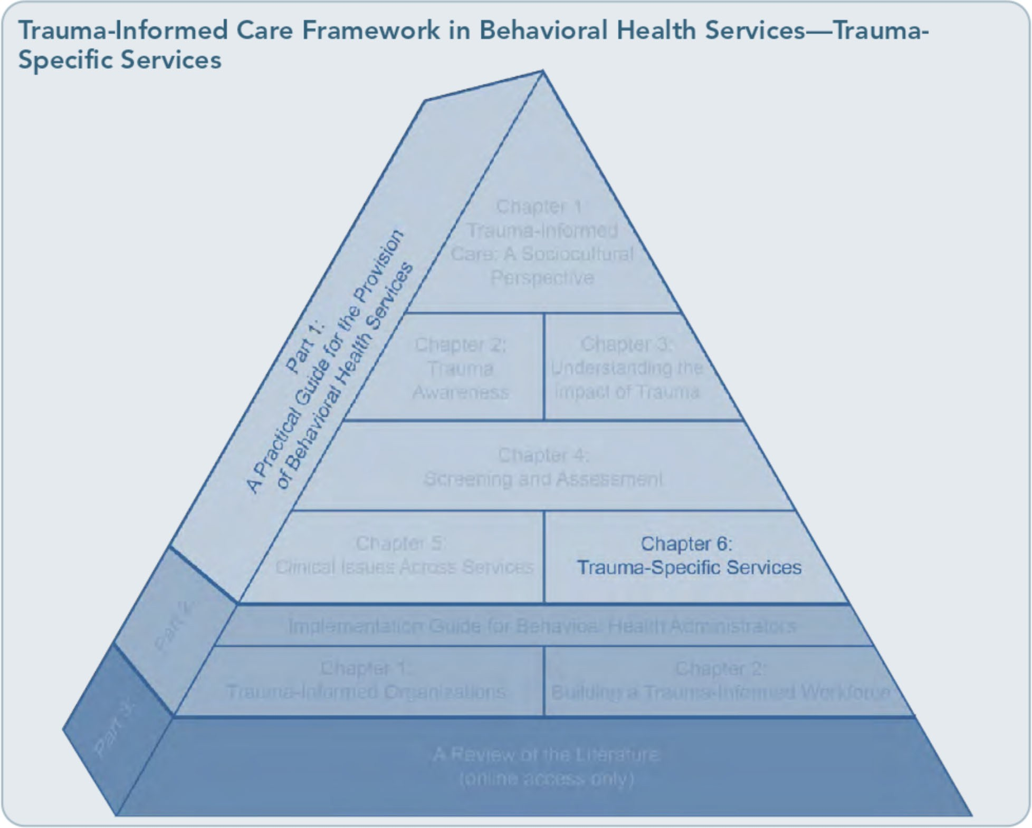

traumatic experiences. Clients participating in present-focused approaches may reveal some of their stories; past-focused approaches em­ phasize how understanding the past influences current behavior, emotion, and thinking, thereby helping clients cope more effectively with traumatic experiences in the present.
The distinction between these approaches lies in the primary emphasis of the approach. De­ pending on the nature of the trauma and the specific needs of the client, one approach may be more suitable than the other. For instance, in short-term treatment for clients in early recovery from mental illness and/or substance abuse, present-focused, cognitive-behavioral, or psychoeducational approaches are generally more appropriate. For clients who are stable in their recovery and have histories of develop-
mental trauma where much of the trauma has been repressed, a past-focused orientation may be helpful. Some clients may benefit from both types, either concurrently or sequentially.
This chapter discusses a number of treatment models, general approaches, and techniques. A treatment model is a set of practices designed to alleviate symptoms, promote psychological well-being, or restore mental health. Treat­ ment techniques are specific procedures that can be used as part of a variety of models.
Some models and techniques described in this chapter can be used with groups, some with individuals, and some with both. This chapter is selective rather than comprehensive; addi­ tional models are described in the literature.
See, for example, the PILOTS database on the Web site of the National Center for PTSD

138

Part 1, Chapter 6-T rauma-Specific Services

(NCPTSD; http://www.ptsd.va.gov) for treatment literature related to trauma and posttraumatic stress disorder (PTSD). For an overview of models for use with both adult and child populations, refer to Models far De­ veloping Trauma-Informed Behavioral Health Systems and Trauma-Specific Services (Center for Mental Health Services, 2008).
Some treatments discussed in this chapter are described as evidence based. Because research on integrated treatment models is so new, many have only been examined in a few studies. Giv­ en these circumstances and the fact that an outcome study provides only limited evidence of efficacy, the term "evidence based" should be interpreted cautiously. Additional scientific study is needed to determine whether some treatments discussed herein are, in fact, evi­ dence based. A good resource for evaluating evidence-based, trauma-specific treatment models is Effective Treatments far PTSD (Foa, Keane, Friedman, & Cohen, 2009). Although evidence-based interventions should be a pri­ mary consideration in selecting appropriate treatment models for people with symptoms of trauma that co-occur with mental and sub­ stance use disorders (see Allen, 2001, for an indepth discussion of trauma and serious men­ tal illness), other factors must also be weighed, including the specific treatment needs of the client; his or her history of trauma, psychosocial and cultural background, and experiences in prior trauma treatment; the overall treatment plan for the client; and the competencies of the program's clinical staf£ Although behavioral health counselors can prepare to help their cli­ ents address some of the issues discussed in Chapter 5,specialized training is necessary to provide treatment for co-occurring substance use and mental disorders related to trauma.
The Substance Abuse and Mental Health Ser­ vices Administration (SAMHSA) has created the National Registry of Evidence-Based Pro-

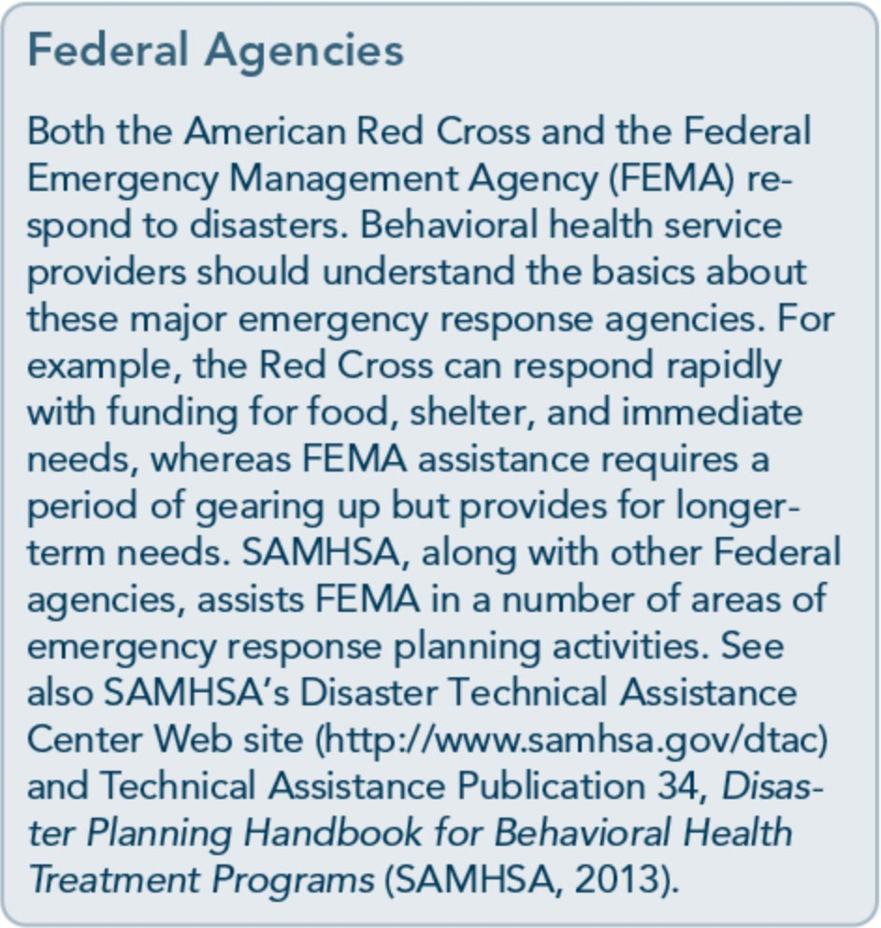
grams and Practices (NREPP) as a resource for reviewing and identifying effective treatment programs. Programs can be nominated for con­ sideration as co-occurring disorders programs or substance abuse prevention or treatment programs, and their quality of evidence, readi­ ness for dissemination, and training considera­ tions are then reviewed. For more detailed information, including details about several evidence-based co-occurring trauma treatment programs, visit the NREPP Web site (http://www.nrepp.samhsa.gov). Program mod­ els for specialized groups, such as adolescents, can also be found on the NREPP Web site. For specific research-oriented information on trauma-specific treatments, refer to Part 3 of this TIP, which provides a literature review and links to select abstracts (available online).

Trauma-Specific Treatment Models

Immediate Interventions
Intervention in the first 48 hours
The acute intervention period comprises the first 48 hours after a traumatic event. In a

139

Trauma-Informed Care in Behavioral Health Services

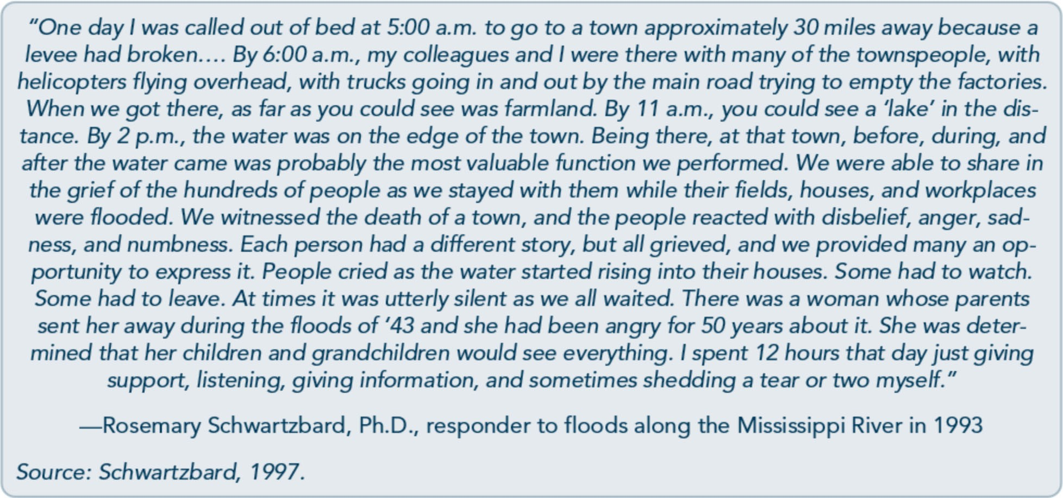

disaster, rescue operations usually begin with local agencies prior to other organizations ar­ riving on the scene. Law enforcement is likely to take a primary role on site. Whether it is a disaster, group trauma, or individual trauma (including a trauma that affects an entire fami­ ly, such as a house fire), a hierarchy of needs should be established: survival, safety, security, food, shelter, health (physical and mental), ori­ entation of survivors to immediate local ser­ vices, and communication with family, friends, and community (National Institute of Mental Health, 2002). In this crucial time, appropriate interventions include educating survivors about resources; educating other providers, such as faith-based organizations and social service groups, to screen for increased psychological effects including use of substances; and use of a trauma response team that assists clients with their immediate needs. No formal interventions should be attempted at this time, but a profes­ sionally trained, empathic listener can offer solace and support (Litz & Gray, 2002).

Basic needs
Basic necessities, such as shelter, food, and water, are key to survival and a sense of safety. It is important to focus on meeting these basic needs and on providing a supportive environ-
ment. Clients' access to prescribed medications may be interrupted after a trauma, particularly a disaster, so providers should identify clients' medication needs for preexisting physical and mental disorders, including methadone or other pharmacological treatment for substance use. For example, after September 11, 2001, substance abuse treatment program adminis­ trators in New York had to seek alternative methadone administration options (Frank, Dewart, Schmeidler, & Demirjian, 2006).

Psychological first aid
The psychological first aid provided in the first 48 hours after a disaster is designed to ensure safety, provide an emotionally support­ ive environment and activities, identify those with high-risk reactions, and facilitate com­ munication, including strong, reassuring lead­ ership immediately after the event. The primary helping response of psychological first aid is to provide a calm, caring, and supportive environment to set the scene for psychological recovery. It is also essential that all those first
responding to a trauma-rescue workers, med­ ical professionals, behavioral health workers (including substance abuse counselors),jour­ nalists, and volunteers-be familiar with rele­ vant aspects of traumatic stress. Approaching

140

Part 1, Chapter 6-T rauma-Specific Services

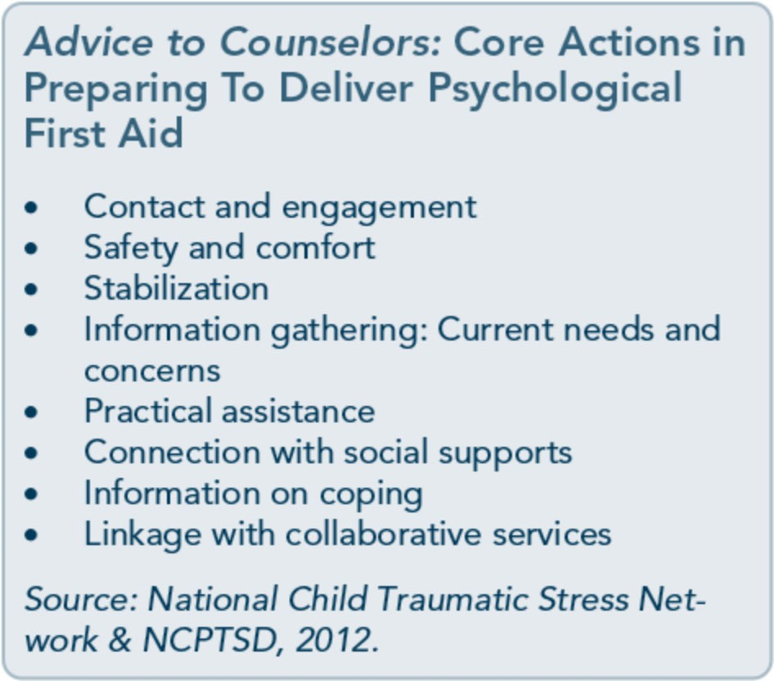
survivors with genuine respect, concern, and knowledge increases the likelihood that the caregiver can (NCPTSD, 2002):
- Answer questions about what survivors may be experiencing.
- Normalize their distress by affirming that what they are experiencing is normal.
- Help them learn to use effective coping strategies.
- Help them be aware of possible symptoms that may require additional assistance.
- Provide a positive experience that will in­ crease their chances of seeking help if they need it in the future.
Clinical experience suggests that care be taken to respect a survivor's individual method of coping; some may want information, for ex­ ample, whereas others do not. Similarly, some may want to talk about the event, but others won't. An excellent guide to providing psycho­ logical first aid is available online from the Terrorism and Disaster Branch of the National Child Traumatic Stress Network (http://www.nctsn.org/content/psychological­ first-aid).
Critical incident stress debriefing Initially developed for work with first re­ sponders and emergency personnel, critical incident stress debriefing (CISD; Mitchell &

Everly, 2001) is now widely used and encom­ passes various group protocols used in a varie­ ty of settings. This facilitator-led group intervention is for use soon after a traumatic event with exposed people. The goal is to pro­ vide psychological closure by encouraging par­ ticipants to talk about their experiences and then giving a didactic presentation on com­ mon stress reactions and management.
The widespread use of CISD has occurred despite the publication of conflicting results regarding its efficacy. Claims that single­ session psychological debriefing can prevent development of chronic negative psychological sequelae are not empirically supported (van Emmerik, Kamphuis, Hulsbosch, & Emmelkamp, 2002). Some controlled studies suggest that it may impede natural recovery from trauma (McNally, Bryant, & Ehlers, 2003). Other research suggests emphasizing screening to determine the need for early in­ terventions. Mitchell and Everly (2001) point out that many of the studies showing negative
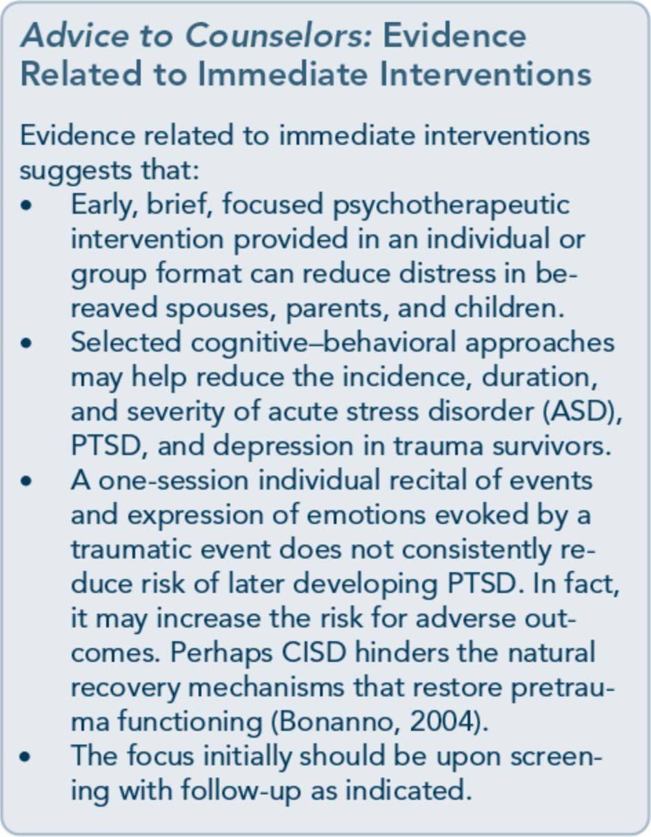

141

Trauma-Informed Care in Behavioral Health Services

142

results were not conducted with first respond­ ers; that is, CISD may be appropriate for some, but not all, groups. A recent study of 952 U.S. peacekeepers and CISD by the U.S. Army Research Unit-Europe (Adler et al., 2008) found mixed results.

Interventions Beyond the Initial Response to Trauma
In the interest of increasing your overall famil­ iarity with relevant approaches, the following sections review several traumatic stress treat­ ment approaches that counselors will most likely encounter when collaborating with cli­ nicians or agencies that specialize in trauma­ specific services and treating traumatic stress.

Cognitive-behavioral therapies
Most PTSD models involve cognitive­ behavioral therapy (CBT) that integrates cog­ nitive and behavioral theories by incorporating two ideas: first, that cognitions (or thoughts) mediate between situational demands and one's attempts to respond to them effectively, and second, that behavioral change influences acceptance of altered cognitions about oneself or a situation and establishment of newly learned cognitive-behavioral interaction pat­ terns. In practice, CBT uses a wide range of coping strategies.
There are many different varieties of CBT. CBT originated in the 1970s (Beck, Rush,

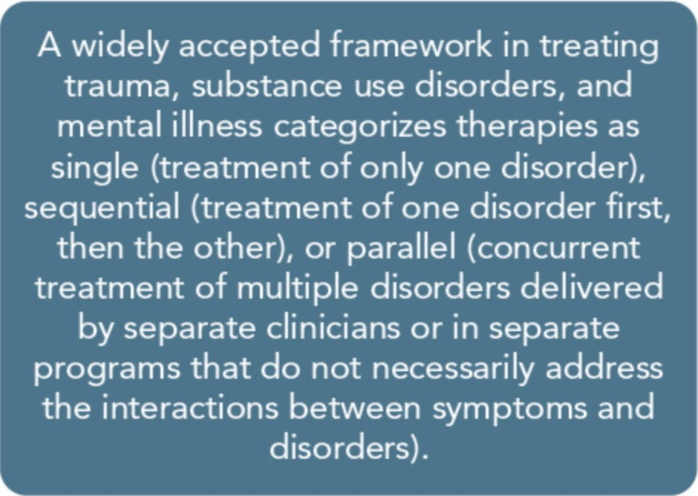
Shaw & Emery, 1979; Ellis & Harper, 1975) and has expanded since then to address vari­ ous populations, including people who use substances, people who experience anxiety, people with PTSD or personality disorders, children and adolescents, individuals involved in the criminal justice system, and many oth­ ers. CBT has also been expanded to include various techniques, coping skills, and ap­ proaches, such as dialectical behavior therapy (DBT; Linehan, 1993), Seeking Safety (Najavits, 2002a), and mindfulness (Segal, Williams, & Teasdale, 2002). Traditional CBT emphasizes symptom reduction or resolution, but recent CBT approaches have also empha­ sized the therapeutic relationship, a particular­ ly important dynamic in trauma treatment (Jackson, Nissenson, & Cloitre, 2009).
CBT has been applied to the treatment of trauma and has also been widely and effective­ ly used in the treatment of substance use. A review of efficacy research on CBT for PTSD is provided by Rothbaum, Meadows, Resick, and Foy (2000). Najavits and colleagues (2009) and O'Donnell and Cook (2006) offer an overview of CBT therapies for treating PTSD and substance abuse. In addition, a free online training resource incorporating CBT for traumatized children within the communi­ ty, Trauma-Focused CBT, is available from the Medical University of South Carolina (http://tfcbt.musc.edu/).
Cognitive processing therapy Cognitive processing therapy (CPT) is a manualized 12-session treatment approach that can be administered in a group or indi­ vidual setting (Resick & Schnicke, 1992, 1993). CPT was developed for rape survivors and combines elements of existing treatments for PTSD, specifically exposure therapy (see the "Exposure Therapy" section later in this chapter) and cognitive therapy. The exposure therapy component of treatment consists of

Part 1, Chapter 6-T rauma-Specific Services

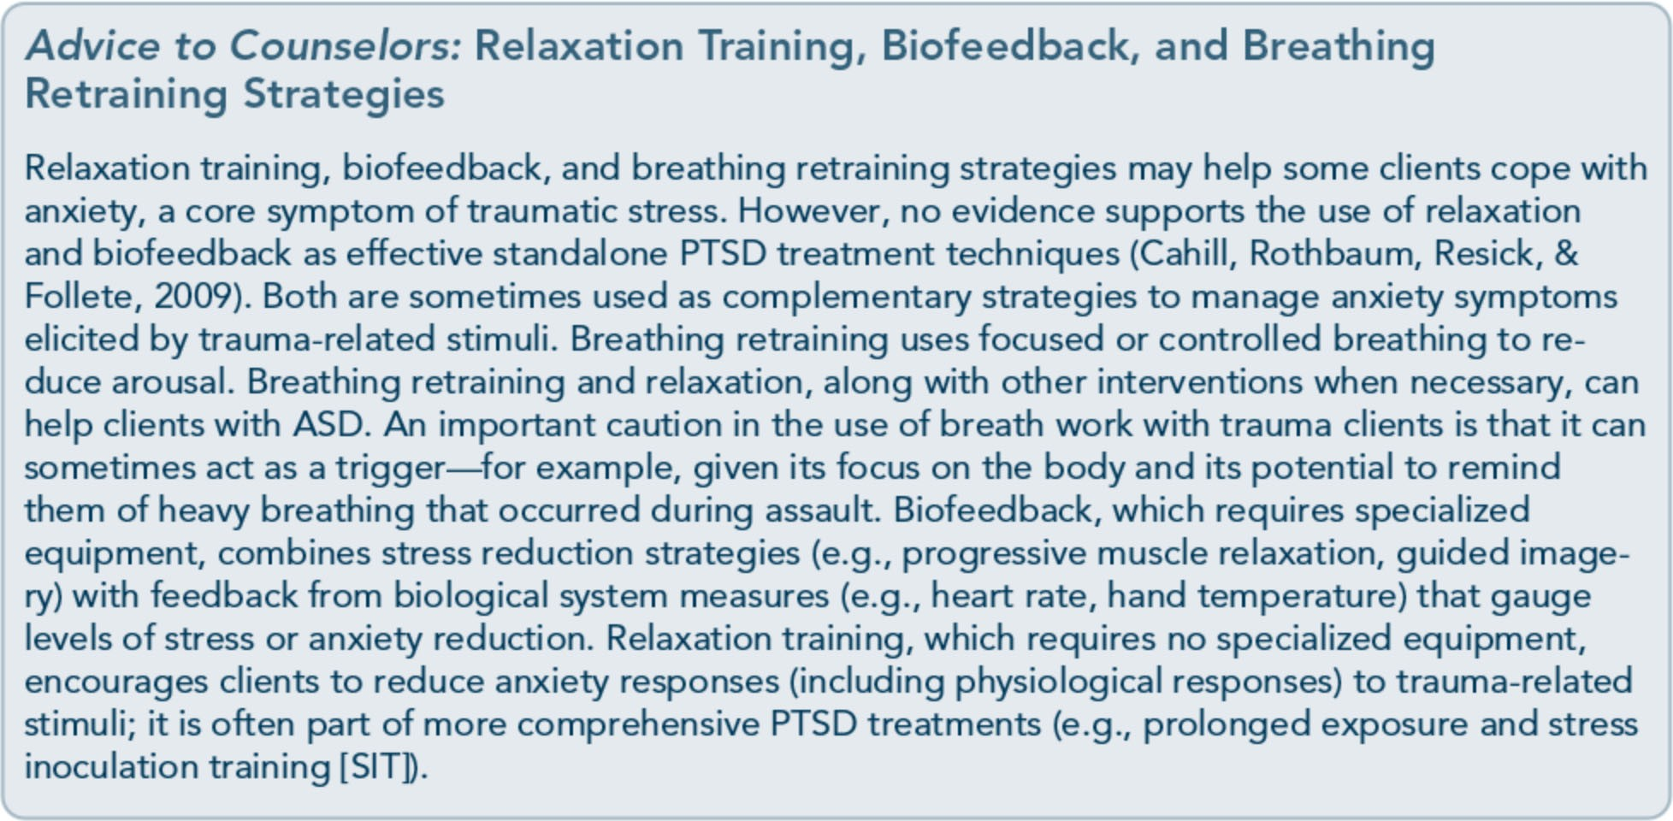

clients writing a detailed account of their trauma, including thoughts, sensations, and emotions that were experienced during the event. The client then reads the narrative aloud during a session and at home. The cog­ nitive therapy aspect of CPT uses six key PTSD themes identified by McCann and Pearlman (1990): safety, trust, power, control, esteem, and intimacy. The client is guided to identify cognitive distortions in these areas, such as maladaptive beliefs.
Results from randomized, placebo-controlled trials for the treatment of PTSD related to interpersonal violence (Resick, 2001; Resick, Nishith, Weaver, Astin, & Feuer, 2002) sup­ port the use of CPT. CPT and prolonged exposure therapy models are equally and high­ ly positive in treating PTSD and depression in rape survivors; CPT is superior in reducing guilt (Nishith, Resick, & Griffin, 2002; Resick et al., 2002; Resick, Nishith, & Griffin, 2003). CPT has shown positive out­ comes with refugees when administered in the refugees' native language (Schulz, Marovic­ Johnson, & Huber, 2006) and with veterans (Monson et al., 2006). However, CPT has not been studied with high-complexity popula-
tions such as individuals with substance de­ pendence, homelessness, current domestic violence, serious and persistent mental illness, or suicidality. CPT requires a 3-day training plus consultation (Karlin et al., 2010). Resick and Schicke (1996) published a CPT treat­ ment manual, Cognitive Processing Therapy for Rape Victims: A Treatment Manual.

Exposure therapy
Exposure therapy for PTSD asks clients to directly describe and explore trauma-related memories, objects, emotions, or places. In­ tense emotions are evoked (e.g., sadness, anxi­ ety) but eventually decrease, desensitizing clients through repeated encounters with traumatic material. Careful monitoring of the pace and appropriateness of exposure-based interventions is necessary to prevent retrauma­ tization (clients can become conditioned to fear the trauma-related material even more).
Clients must have ample time to process their memories and integrate cognition and affect, so some sessions can last for 1.5 hours or more. For simple cases, exposure can work in as few as 9 sessions; more complex cases may require 20 or more sessions (Foa, Hembree, & Rothbaum, 2007). Various techniques can

143

Trauma-Informed Care in Behavioral Health Services

144

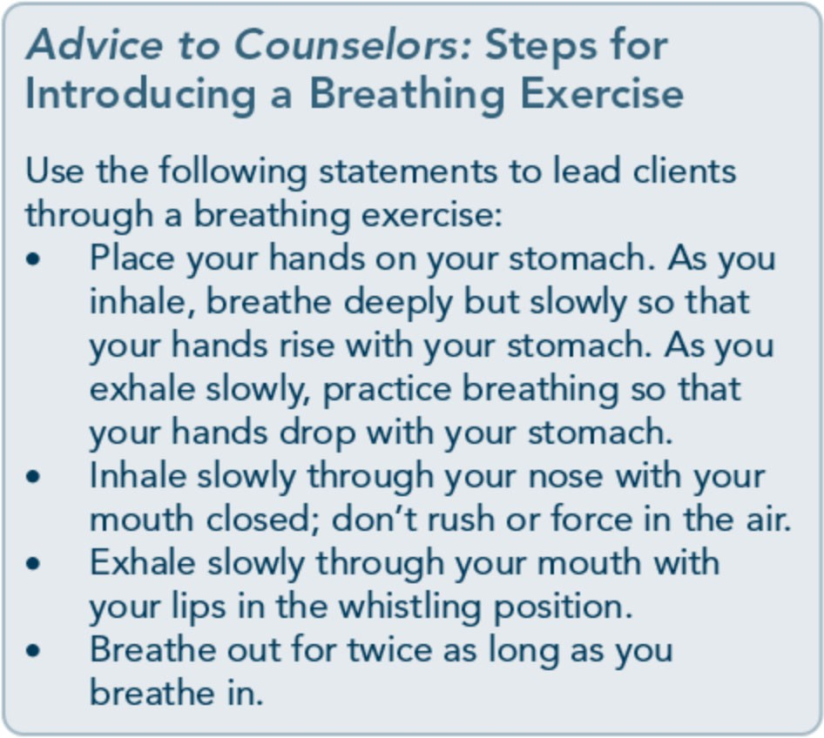
expose the client to traumatic material. Two of the more common methods are exposure through imagery and in vivo ("real life") exposure.
The effectiveness of exposure therapy has been firmly established (Rothbaum et al., 2000); however, adverse reactions to exposure therapy have also been noted. Some individu­ als who have experienced trauma exhibit an exacerbation of symptoms during or following exposure treatments. Even so, the exacerba­ tion may depend on counselor variables during administration. Practitioners of exposure ther­ apy need comprehensive training to master its techniques (Karlin et al., 2010); a counselor unskilled in the methods of this treatment model can not only fail to help his or her cli­ ents, but also cause symptoms to worsen.
Exposure therapy is recommended as a first­ line treatment option when the prominent trauma symptoms are intrusive thoughts, flashbacks, or trauma-related fears, panic, and avoidance. However, counselors should exer­ cise caution when using exposure with clients who have not maintained stability in manag­ ing mental illness symptoms or abstinence from substance use disorders. Studies and rou­ tine use of exposure have consistently excluded high-complexity clients such as those with

substance dependence, homelessness, current domestic violence, serious and persistent men­ tal illness, or suicidality. The only trial of ex­ posure therapy with a substance dependence sample found that it did not outperform standard substance abuse treatment on most variables (Mills et al., 2012).
Prolonged exposure therapy for PTSD is listed in SAMHSA's NREPP. For reviews of exposure therapy, also see Najavits (2007a) and Institute of Medicine (2008). In addition to prolonged exposure therapy, other therapies incorporate exposure and desensitization tech­ niques, including eye movement desensitiza­ tion and reprocessing (EMDR; Shapiro, 2001), cognitive processing, and systematic desensitization therapies (Wolpe, 1958).

Eye movement desensitization and reprocessing
EMDR (Shapiro, 2001) is one of the most widely used therapies for trauma and PTSD. The treatment protocols ofEMDR have evolved into sophisticated paradigms requiring training and, preferably, clinical supervision.
EMDR draws on a variety of theoretical
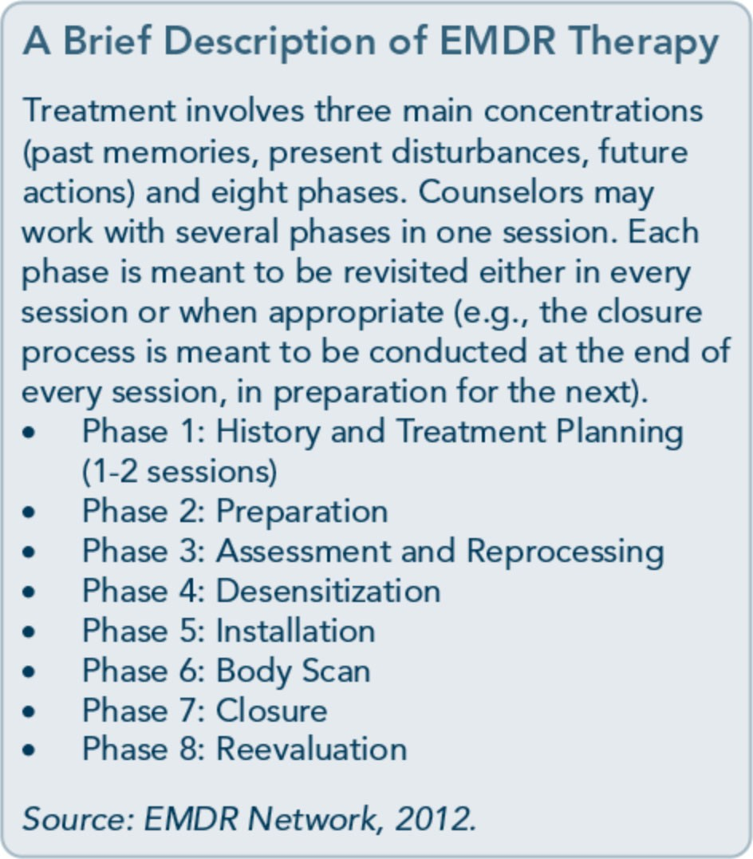

Part 1, Chapter 6-T rauma-Specific Services

frameworks, including psychoneurology, CBT, information processing, and nonverbal repre­ sentation of traumatic memories. The goal of this therapy is to process the experiences that are causing problems and distress. It is an ef­ fective treatment for PTSD (Seidler & Wagner, 2006) and is accepted as an evidence­ based practice by the U.S. Department of Veterans Affairs (VA), the Royal College of Psychiatrists, and the International Society for Traumatic Stress Studies (Najavits, 2007a); numerous reviews support its effectiveness (e.g., Mills et al., 2012). EMDR values the development of"resource installation'' (calming procedures) and engages in exposure work to desensitize clients to traumatic material, using external tracking techniques across the visual field to assist in processing distressing materi­ al. Training in EMDR, available through the EMDR Institute, is required before counselors use this treatment. It is listed in SAMHSA's NREPP (EMDR Network, 2012). Thus far, there is no study examining the use of EMDR with clients in substance abuse treatment. See Part 3 of this TIP, available online, to review empirical work on EMDR.

Narrative therapy
Narrative therapy is an emerging approach to understanding human growth and change; it is founded on the premise that individuals are the experts on their own lives and can access their existing intrapsychic and interpersonal resources to reduce the impact of problems in their lives. Developed for the treatment of PTSD resulting from political or community violence, narrative therapy is based on CBT principles, particularly exposure therapy (Neuner, Schauer, Elbert, & Roth, 2002; Neuner, Schauer, Klaschik, Karunakara, & Elbert, 2004). This approach views psycho­ therapy not as a scientific practice, but as a natural extension of healing practices that
have been present throughout human history. For a trauma survivor, the narrative, as it is

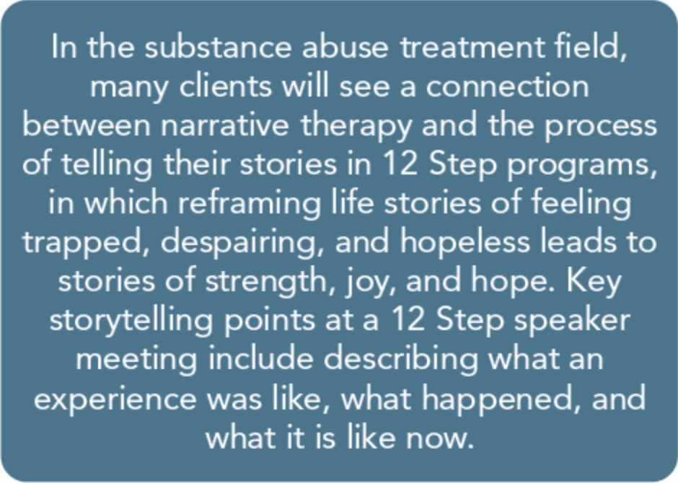
told and retold, expresses the traumatic expe­ rience, puts the trauma in the context of the survivor's life, and defines the options he or she has for change. Narrative structure helps clients connect events in their lives, reveals strings of events, explores alternative expres­ sions of trauma, evokes explanations for cli­ ents' behaviors, and identifies their knowledge and skills. The use of stories in therapy, with the client as the storyteller, generally helps lessen suffering (McLeod, 1997; White, 2004).

Skills training in affective and interpersonal regulation
Skills training in affective and interpersonal regulation (STAIR) is a two-phase cognitive­ behavioral model that adapts therapies devel­ oped by others into a new package (Cloitre, Koenen, Cohen, & Han, 2002). Phase 1 con­ sists of eight weekly sessions of skills training in affect and interpersonal regulation derived from general CBT and DBT (Linehan, 1993) and adapted to address trauma involving childhood abuse. Session topics are labeling and identifying feelings, emotion manage­ ment, distress tolerance, acceptance of feel­ ings, identifying trauma-based interpersonal schemas, identifying conflict between trauma­ generated feelings and current interpersonal goals, role-plays on issues of power and con­ trol, and role-plays on developing flexibility in interpersonal situations. Phase 2 features eight

145

Trauma-Informed Care in Behavioral Health Services

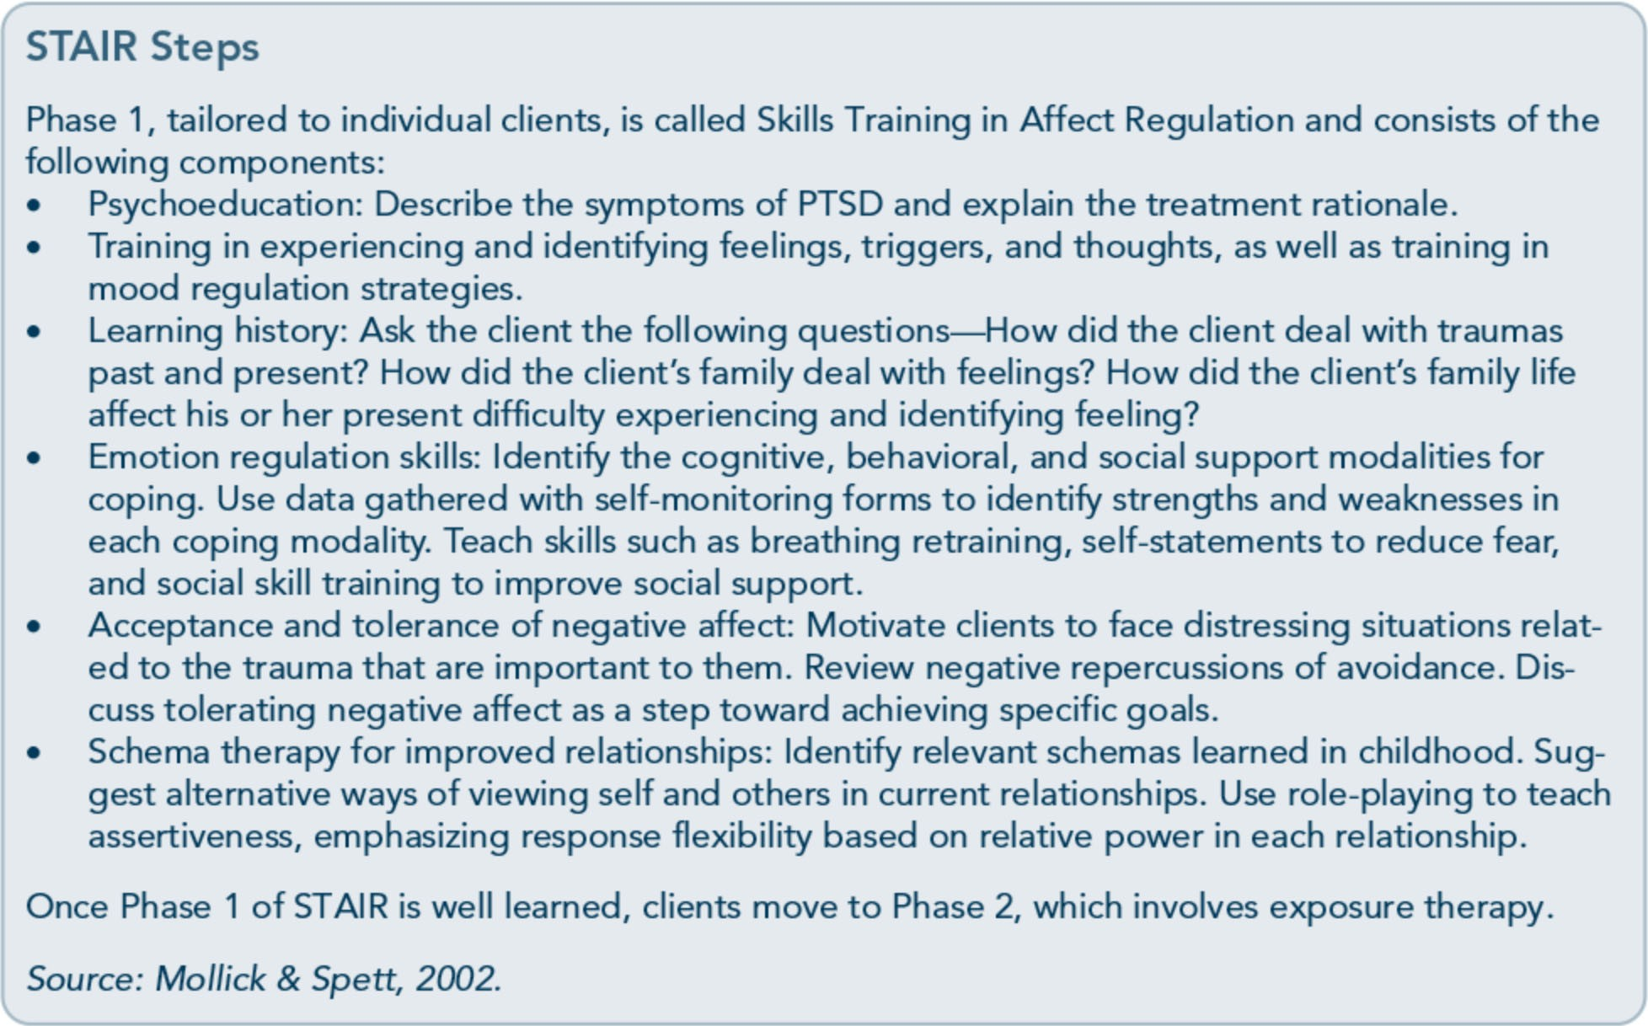

146
sessions of modified prolonged exposure using a narrative approach.
Cloitre and colleagues (2002) assigned women with PTSD related to childhood abuse ran­ domly to STAIR or a minimal attention wait­ list, excluding clients with current substance dependence as well as other complexities.
ST AIR participants showed significantly greater gains in affect regulation, interpersonal skills, and PTSD symptoms than the control participants. These gains were maintained through follow-up at 3 and 9 months. How­ ever, it is not clear from this study whether DBT and exposure were both needed. Phase 1 therapeutic alliance and negative mood regula­ tion skills predicted Phase 2 exposure success in reducing PTSD, suggesting the importance of establishing a strong therapeutic relation­ ship and emotion regulation skills before con­ ducting exposure work with people who have chronic PTSD.
Stress inoculation training
SIT was originally developed to manage anxiety (Meichenbaum, 1994; Meichenbaum &Deffenbacher, 1988). Kilpatrick, Veronen, and Resick (1982) modified SIT to treat rape survivors based on the idea that the anxiety and fear that rape survivors experience during their trauma generalizes to other objectively safe situations. SIT treatment components include education, skills training (muscle relaxation training, breathing retraining, role-playing, guided self-talk, assertiveness training, and thought stopping [i.e., actively and forcefully ending negative thoughts by thinking
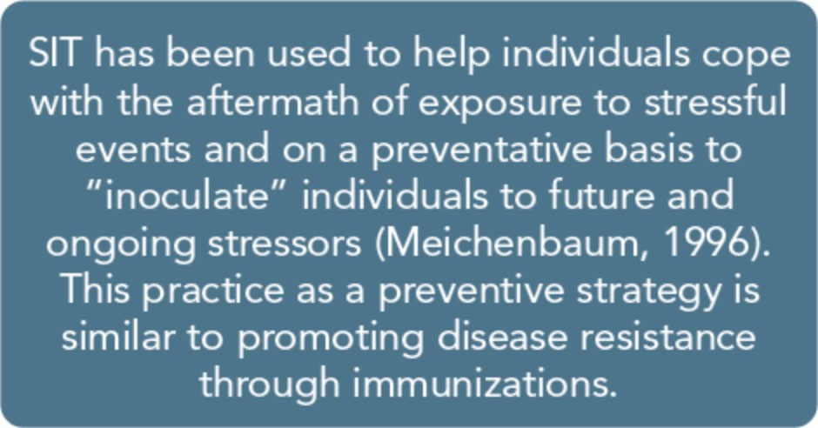

Part 1, Chapter 6-T rauma-Specific Services

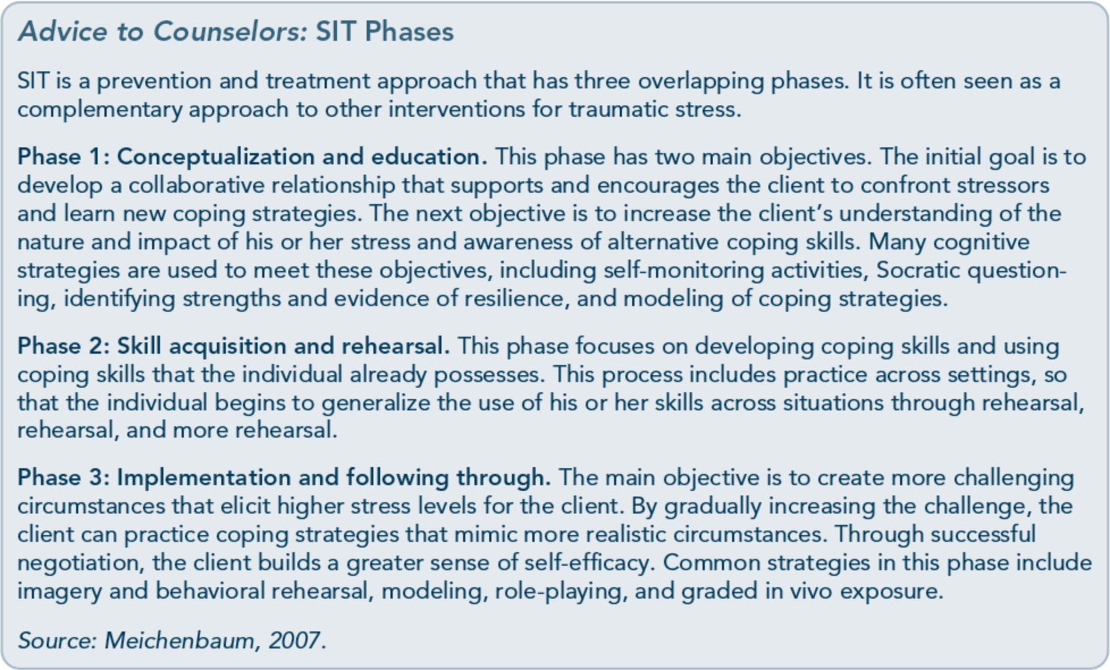

"STOP" and then redirecting thoughts in a more positive direction]), and skills applica­ tion. The goal is to help clients learn to man­ age their anxiety and to decrease avoidant behavior by using effective coping strategies. Randomized controlled clinical trials have indicated that SIT reduces the severity of PTSD compared with waitlist controls and shows comparable efficacy to exposure therapy. At follow-up (up to 12 months after treat­ ment), gains were maintained (Foa et al., 1999; Foa, Rothbaum, Riggs, &Murdock, 1991).

Other therapies
Numerous interventions introduced in the past 20 years focus on traumatic stress. For some interventions, the evidence is limited, and for other others, it is evolving. One exam­ ple is the traumatic incident reduction (TIR) approach. This brief memory-oriented inter­ vention is designed for children, adolescents, and adults who have experienced traumatic stress (Valentine & Smith, 2001). Listed in
SAMHSA's NREPP, the intervention is de­ signed to process specific traumatic incidents or problematic themes related to the trauma, including specific feelings, emotions, sensa­ tions, attitudes, or pain. It involves having cli­ ents talk through the traumatic incident repeatedly with the anticipation that changes in affect will occur throughout the repetitions. TIR is a client-centered approach.

Integrated Models for Trauma
This section covers models specifically de­ signed to treat trauma-related symptoms along with either mental or substance use disorders at the same time. Integrated treatments help clients work on several presenting problems simultaneously throughout the treatment, a promising and recommended strategy (Dass­ Brailsford &Myrick, 2010; Najavits, 20026; Nixon & Nearmy, 2011). Thus far, research is limited, but what is available suggests that integrated treatment models effectively reduce

147

Trauma-Informed Care in Behavioral Health Services

substance abuse, PTSD symptoms, and other mental disorder symptoms. TIP 42, Substance Abuse Treatment far Persons With Co-Occurring Disorders (Center for Substance Abuse Treat­ ment, 2005c), offers a detailed description of integrated treatment. In contrast with inte­ grated models, other model types include sin­ gle (treatment of only one disorder), sequential (treatment of one disorder first, then the other), or parallel (concurrent treat­ ment of multiple disorders delivered by sepa­ rate clinicians or in separate programs that do not necessarily address the interactions be­ tween symptoms and disorders).
Similar to single models, integrated treatment models are designed for use in a variety of settings (e.g., outpatient, day treatment, and/or residential substance abuse and mental health clinics/programs). Most models listed are manual-based treatments that address trauma-related symptoms, mental disorders, and substance use disorders at the same time. Additional approaches and further details on the selected approaches can be found at NREPP (http://www.nrepp.samhsa.gov).

Addiction and Trauma Recovery Integration Model
The Addiction and Trauma Recovery Inte­ grated Model (ATRIUM; Miller & Guidry, 2001) integrates CBT and relational treatment through an emphasis on mental, physical, and spiritual health. This 12-week model for indi­ viduals and groups blends psychoeducational, process, and expressive activities, as well as information on the body's responses to addic­ tion and traumatic stress and the impact of trauma and addiction on the mind and spirit. It helps clients explore anxiety, sexuality, self­ harm, depression, anger, physical complaints and ailments, sleep difficulties, relationship challenges, and spiritual disconnection. It was

designed primarily for women and focuses on developmental (childhood) trauma and inter­ personal violence, but it recognizes that other types of traumatic events occur.
The ATRIUM model consists of three phases of treatment. The first stage, or "outer circle," consists of the counselor collecting data from the client about his or her trauma history, of­ fering psychoeducation on the nature of trau­ ma, and helping the client assess personal strengths. ATRIUM actively discourages the evocation of memories of abuse or other trau­ ma events in this phase. The second stage, or "middle circle," allows clients and counselors to address trauma symptoms more directly and specifically encourages clients to reach out to and engage with support resources in the community. The middle circle also emphasiz­ es learning new information about trauma and developing additional coping skills. The third stage of the program, the "inner circle," focus­ es on challenging old beliefs that arose as a result of the trauma. For instance, the concept of "nonprotecting bystander" is used to repre­ sent the lack of support that the traumatized person experienced at the time of the trauma. This representation is replaced with the "pro­ tective presence" of supportive others today.
ATRIUM was used in one of the nine study sites of SAMHSA's Women, Co-Occurring Disorders and Violence Study. Across all sites, trauma-specific models achieved more favora­ ble outcomes than control sites that did not use trauma-specific models (Morrissey et al., 2005). There has not yet been a study of ATRIUM per se, however. A manual describ­ ing the theory behind this model in greater depth, as well as how to implement it, is pub­ lished under the title Addictions and Trauma Recovery: Healing the Body, Mind, and Spirit (Miller & Guidry, 2001).

148

Part 1, Chapter 6-T rauma-Specific Services

Beyond Trauma: A Healing Journey for Women
Beyond Trauma (Covington, 2003) is a curric­ ulum for women's services based on theory, research, and clinical experience. It was devel­ oped for use in residential, outpatient, and correctional settings; domestic violence pro­ grams; and mental health clinics. It uses behavioral techniques and expressive arts and is based on relational therapy. Although the materials are designed for trauma treatment, the connection between trauma and substance abuse in women's lives is a theme throughout. Beyond Trauma has a psychoeducational com­ ponent that defines trauma by way of its pro­ cess as well as its impact on the inner self (thoughts, feelings, beliefs, values) and the outer self (behavior and relationships, includ­ ing parenting). Coping skills are emphasized; specific exercises develop emotional wellness.

Concurrent Treatment of PTSD and Cocaine Dependence Concurrent Treatment of PTSD and Cocaine Dependence (CTPCD) is a 16-session, twice­ weekly individual outpatient psychotherapy model designed to treat women and men with co-occurring PTSD and cocaine dependence (Coffey, Schumacher, Brimo, & Brady, 2005). CTPCD combines imagery and in vivo expo­ sure therapy (in which the client becomes de­ sensitized to anxiety-producing stimuli through repeated exposure to them) for the treatment of PTSD with elements of CBT for substance dependence. To balance the dual needs of abstinence skill building and prompt trauma treatment, the first five sessions focus on coping skills for cocaine dependence. Ses­ sion six transitions into exposure therapy, which begins in earnest in session seven and is combined with CBT for the treatment of sub­ stance abuse.

CTPCD helps reduce substance use and PTSD symptoms. The use of any illicit drug, as measured by urine screens, was quite low during the 16-week treatment trial and didn't escalate during the second half of treatment­ when most exposure sessions occurred. PTSD symptoms dropped significantly over the course of treatment, as did self-reported de­ pressive symptoms; however, the dropout rate was high (Coffey, Dansky, & Brady, 2003).
CTPCD was reformulated into Concurrent Prolonged Exposure (COPE; Mills et al., 2012), which was compared with treatment as usual in a high-complexity clinical sample of individuals who had PTSD and substance dependence. Both treatment conditions result­ ed in improvements in PTSD with no differ­ ence at 3 months (though COPE showed significantly greater improvement at 9 months); moreover, the two conditions did not differ in impact on substance use outcomes, depression, or anxiety.

Integrated CBT
Integrated CBT is a 14-session individual therapy model designed for PTSD and sub­ stance use. It incorporates elements such as psychoeducation, cognitive restructuring, and breathing retraining (McGovern, Lamber­ Harris, Alterman, Xie, & Meier, 2011). A ran­ domized controlled trial showed that both integrated CBT and individual addiction treatment achieved improvements in substance use and other measures of psychiatric symp­ tom severity with no difference between the treatments.

Seeking Safety
Seeking Safety is an empirically validated, present-focused treatment model that helps clients attain safety from trauma and substance abuse (Najavits, 2002a). The Seeking Safety manual (Najavits, 20026) offers clinician guide­ lines and client handouts and is available in

149

Trauma-Informed Care in Behavioral Health Services

several languages. Training videos and other implementation materials are available online (http://www.seekingsafety.org). Seeking Safety is flexible; it can be used for groups and indi­ viduals, with women and men, in all settings and levels of care, by all clinicians, for all types of trauma and substance abuse.
Seeking Safety covers 25 topics that address cognitive, behavioral, interpersonal, and case management domains. The topics can be conducted in any order, using as few or as many as are possible within a client's course of treatment. Each topic represents a coping skill relevant to both trauma and substance abuse, such as compassion, taking good care of your­ self, healing from anger, coping with triggers, and asking for help. This treatment model builds hope through an emphasis on ideals and simple, emotionally evocative language and quotations. It attends to clinician process­ es and offers concrete strategies that are thought to be essential for clients dealing with concurrent substance use disorders and histo­ ries of trauma.
More than 20 published studies (which include pilot studies, randomized controlled trials, and multisite trials representing various investiga­ tors and populations) provide the evidence base for this treatment model. For more infor­ mation, see SAMHSA'.s NREPP Web site (http://www.nrepp.samhsa.gov) as well as the "Outcomes" section of the Seeking Safety Web site (http://www.seekingsafety.org/3-03- 06/studies.html). Study samples included peo­ ple with chronic, severe trauma symptoms and substance dependence who were diverse in ethnicity and were treated in a range of set­ tings (e.g., criminal justice, VA centers, adoles­ cent treatment, homelessness services, public sector). Seeking Safety has shown positive outcomes on trauma symptoms, substance abuse, and other domains (e.g., suicidality,
HIV risk, social functioning, problem-solving,

sense of meaning); consistently outperformed treatment as usual; and achieved high satisfac­ tion ratings from both clients and clinicians. It has been translated into seven languages, and a version for blind and/or dyslexic individuals is available.
The five key elements of Seeking Safety are:
- Safety as the overarching goal (helping clients attain safety in their relationships, thinking, behavior, and emotions).
- Integrated treatment (working on trauma and substance abuse at the same time).
- A focus on ideals to counteract the loss of ideals in both trauma and substance abuse.
- Four content areas: cognitive, behavioral, interpersonal, and case management.
- Attention to clinician processes (address­
ing countertransference, self-care, and other issues).

Substance Dependence PTSD Therapy
Substance Dependence PTSD Therapy (Triffleman, 2000) was designed to help cli­ ents of both sexes cope with a broad range of traumas. It combines existing treatments for PTSD and substance abuse into a structured, 40-session (5-month, twice-weekly) individual therapy that occurs in two phases. Phase I is "Trauma-Informed, Addictions-Focused Treatment" and focuses on coping skills and cognitive interventions as well as creating a safe environment. Phase I draws on CBT models, anger management, relaxation training, HIV risk reduction, and motivational en­ hancement techniques. Phase II, "Trauma­ Focused, Addictions-Informed Treatment," begins with psychoeducation about PTSD fol­ lowed by ''Anti-Avoidance I," in which a modi­ fied version of stress inoculation training is taught in two to four sessions. Following this is ''Anti-Avoidance II,"lasting 6 to 10 sessions, in which in vivo exposure is used.

150

Part 1, Chapter 6-T rauma-Specific Services

Trauma Affect Regulation: Guide for Education and Therapy
Trauma Affect Regulation: Guide for Educa­ tion and Therapy (TARGET; Ford & Russo, 2006; Frisman, Ford, Lin, Mallon, & Chang, 2008) uses emotion and information pro-

cessing in a present-focused, strengths-based approach to education and skills training for trauma survivors with severe mental, substance use, and co-occurring disorders across diverse populations.TARGET helps trauma survivors understand how trauma changes the brain's

TARGET: The Seven-Step FREEDOM Approach
Focus: Being focused helps a person pay attention and think about what's happening right now instead of just reacting based on alarm signals tied to past trauma. This step teaches participants to use the SOS skill (Slow down, Orient, Self-check) to pay attention to body signals and the immediate environment and to use a simple scale to measure stress and control levels.
Recognize triggers: Recognizing trauma triggers enables a person to anticipate and reset alarm signals as he or she learns to distinguish between a real threat and a reminder. This step helps par­ ticipants identify personal triggers, take control, and short-circuit their alarm reactions.
Emotion self-check: The goal of this skill is to identify two types of emotions. The first are "alarm" or reactive emotions such as terror, rage, shame, hopelessness, and guilt. Because these emotions are the most noticeable after trauma, they are the alarm system's way of keeping a person primed and ready to fend off further danger. The second type of emotion, "main" emotions, include posi­ tive feelings (e.g., happiness, love, comfort, compassion) and feelings that represent positive striv­ ings (e.g., hope, interest, confidence). By balancing both kinds of emotions, a person can reflect and draw on his or her own values and hopes even when the alarm is activated.
Evaluate thoughts: When the brain is in alarm mode, thinking tends to be rigid, global, and cata­ strophic. Evaluating thoughts, as with identifying emotions, is about achieving a healthier balance of positive as well as negative thinking. Through a two-part process, participants learn to evaluate the situation and their options with a focus on how they choose to act-moving from reactive thoughts to "main" thoughts. This is a fundamental change from the PTSD pattern, which causes problems by taking a person straight from alarm signals to automatic survival reactions.
Define goals: Reactive goals tend to be limited to just making it through the immediate situation or away from the source of danger. These reactive goals are necessary in true emergencies but don't reflect a person's "main" goals of doing worthwhile things and ultimately achieving a good and meaningful life. This step teaches one how to create "main" goals that reflect his or her deeper hopes and values.
Options: The only options that are available when the brain's alarm is turned on and won't turn off are automatic "flight/fight" or "freeze/submit" reactive behaviors that are necessary in emergencies but often unhelpful in ordinary living. This step helps identify positive intentions often hidden by the more extreme reactive options generated by the alarm system. This opens the possibility for a greater range of options that take into consideration one's own needs and goals as well as those of others.
Make a contribution: When the brain's alarm is turned on and reacting to ordinary stressors as if they were emergencies, it is very difficult for a person to come away from experiences with a feeling that they have made a positive difference. This can lead to feelings of alienation, worthlessness, or spiritual distress. The ultimate goal of TARGET is to empower adults and young people to think clearly enough to feel in control of their alarm reactions and, as a result, to be able to recognize the contribution they are making not only to their own lives, but to others' lives as well.
Source: Advanced Trauma Solutions, 2012.

151

Trauma-Informed Care in Behavioral Health Services

normal stress response into an extreme survival-based alarm response that can lead to PTSD, and it teaches them a seven-step ap­ proach to making the PTSD alarm response less distressing and more adaptive (summa­ rized by the acronym FREEDOM: Focus, Recognize triggers, Emotion self-check, Eval­ uate thoughts, Define goals, Options, and Make a contribution).
TARGET can be presented in individual therapy or gender-specific psychoeducational groups, and it has been adapted for individuals who are deaf; it has also been translated into Spanish and Dutch. TARGET is a resilience­ building and recovery program not limited to individual or group psychotherapy; it is also designed to provide an educational curriculum and milieu intervention that affects all areas of practice in school, therapeutic, or correctional programs. TARGET is listed in SAMHSA's NREPP (http://www.nrepp.samhsa.gov).

Trauma Recovery and Empowerment Model
The trauma recovery and empowerment mod­ el (TREM) of therapy (Fallot & Harris, 2002; Harris & Community Connections Trauma Work Group, 1998) is a manualized group intervention designed for female trauma survi-

vors with severe mental disorders. TREM addresses the complexity oflong-term adapta­ tion to trauma and attends to a range of diffi­ culties common among survivors of sexual and physical abuse. TREM focuses mainly on de­ veloping specific recovery skills and current functioning and uses techniques that are effec­ tive in trauma recovery services. The model's content and structure, which cover 33 topics, are informed by the role of gender in women's experience of and coping with trauma.
TREM can be adapted for shorter-term resi­ dential settings and outpatient substance abuse treatment settings, among others. Adaptations of the model for men and adolescents are available. The model was used in SAMHSA's Women, Co-Occurring Disorders and Vio­ lence Study for three of the nine study sites and in SAMHSA's Homeless Families pro­ gram, and it is listed in SAMHSA's NREPP. This model has been used with clients in sub­ stance abuse treatment; research by Toussaint,
VanDeMark, Bornemann, and Graeber (2007) shows that women in a residential sub­ stance abuse treatment program showed sig­ nificantly better trauma treatment outcomes using TREM than they did in treatment as usual, but no difference in substance use.

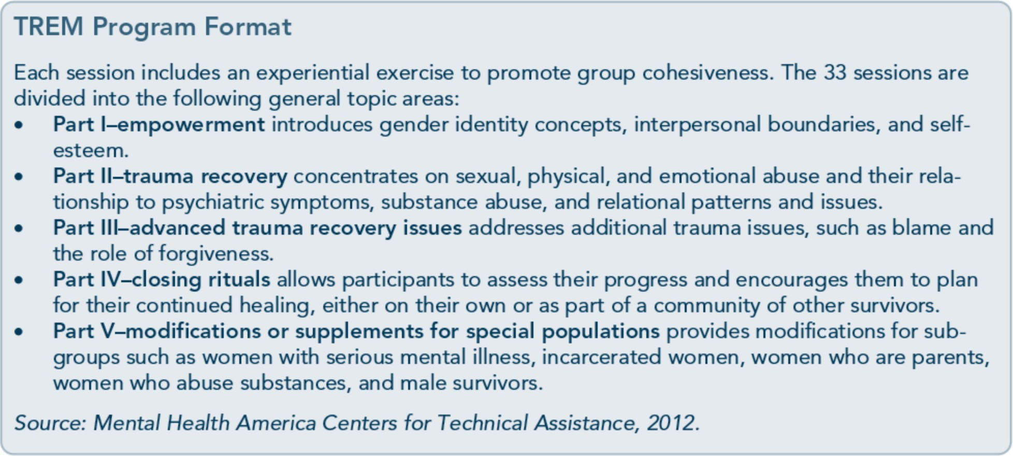

152

Part 1, Chapter 6-T rauma-Specific Services

Triad Women's Project
The Triad Project was developed as a part of SAMHSA's Women, Co-Occurring Disorders and Violence Study. It is a comprehensive, trauma-informed, consumer-responsive inte­ grated model designed for female trauma sur­ vivors with co-occurring substance use and mental disorders who live in semirural areas. Triad integrates motivational enhancement for substance use disorders, DBT, and intensive case management techniques for co-occurring mental disorders. This program is a 16-week group intervention for women that uses inte­ grated case management services, a
curriculum-based treatment group, and a peer support group (Clark & Fearday, 2003).

Emerging Interventions
New interventions are emerging to address traumatic stress symptoms and disorders. The following sections summarize a few interven­ tions not highlighted in prior chapters; this is not an exhaustive list. In addition to specific interventions, technology is beginning to shape the delivery of care and to increase ac­ cessibility to tools that complement trauma­ specific treatments. Numerous applications are available and evolving. For more information on the role of technology in the delivery of care, see the planned TIP, Using Technology­ Based Therapeutic Tools in Behavioral Health Services (SAMHSA, planned g).

Couple and Family Therapy
Trauma and traumatic stress affects significant relationships, including the survivor's family. Although minimal research has targeted the effectiveness of family therapy with trauma survivors, it is important to consider the needs of the individual in the context of their rela­ tionships. Family and couples therapy may be key to recovery. Family members may experi­ ence secondary traumatization silently, lack

understanding of traumatic stress symptoms or treatment, and/or have their own histories of trauma that influence their willingness to sup­ port the client in the family or to talk about anything related to trauma and its effects.
Family members can engage in similar pat­ terns of avoidance and have their own triggers related to the trauma being addressed at the time. A range of couple and family therapies have addressed traumatic stress and PTSD, but few studies exist that support or refute their value. Current couple or family therapies that have some science-based evidence include behavioral family therapy, behavioral marital therapy, cognitive-behavioral couples treat­ ment, and lifestyle management courses (Riggs, Monson, Glynn, & Canterino, 2009).

Mindfulness Interventions Mindfulness is a process of learning to be pre­ sent in the moment and observing internal experience (e.g., thoughts, bodily sensations) and external experience (e.g., interactions with others) in a nonjudgmental way. Mindfulness challenges limiting beliefs that arise from trauma, quells anxiety about future events, and simply helps one stay grounded in the present.
It plays a significant role in helping individuals
who have been traumatized observe their ex­ periences, increase awareness, and tolerate uncomfortable emotions and cognitions.
To date, mindfulness-based interventions ap­ pear to be valuable as an adjunct to trauma­ specific interventions and in decreasing arous­ al (Baer, 2003). It may also help individuals tolerate discomfort during exposure-oriented and trauma processing interventions. Overall, mindfulness practices can help clients in man­ aging traumatic stress, coping, and resilience. In a study of firefighters, mindfulness was associated with fewer PTSD symptoms, de­ pressive symptoms, physical symptoms, and alcohol problems when controlling for other variables (Smith et al., 2011).

153

Trauma-Informed Care in Behavioral Health Services

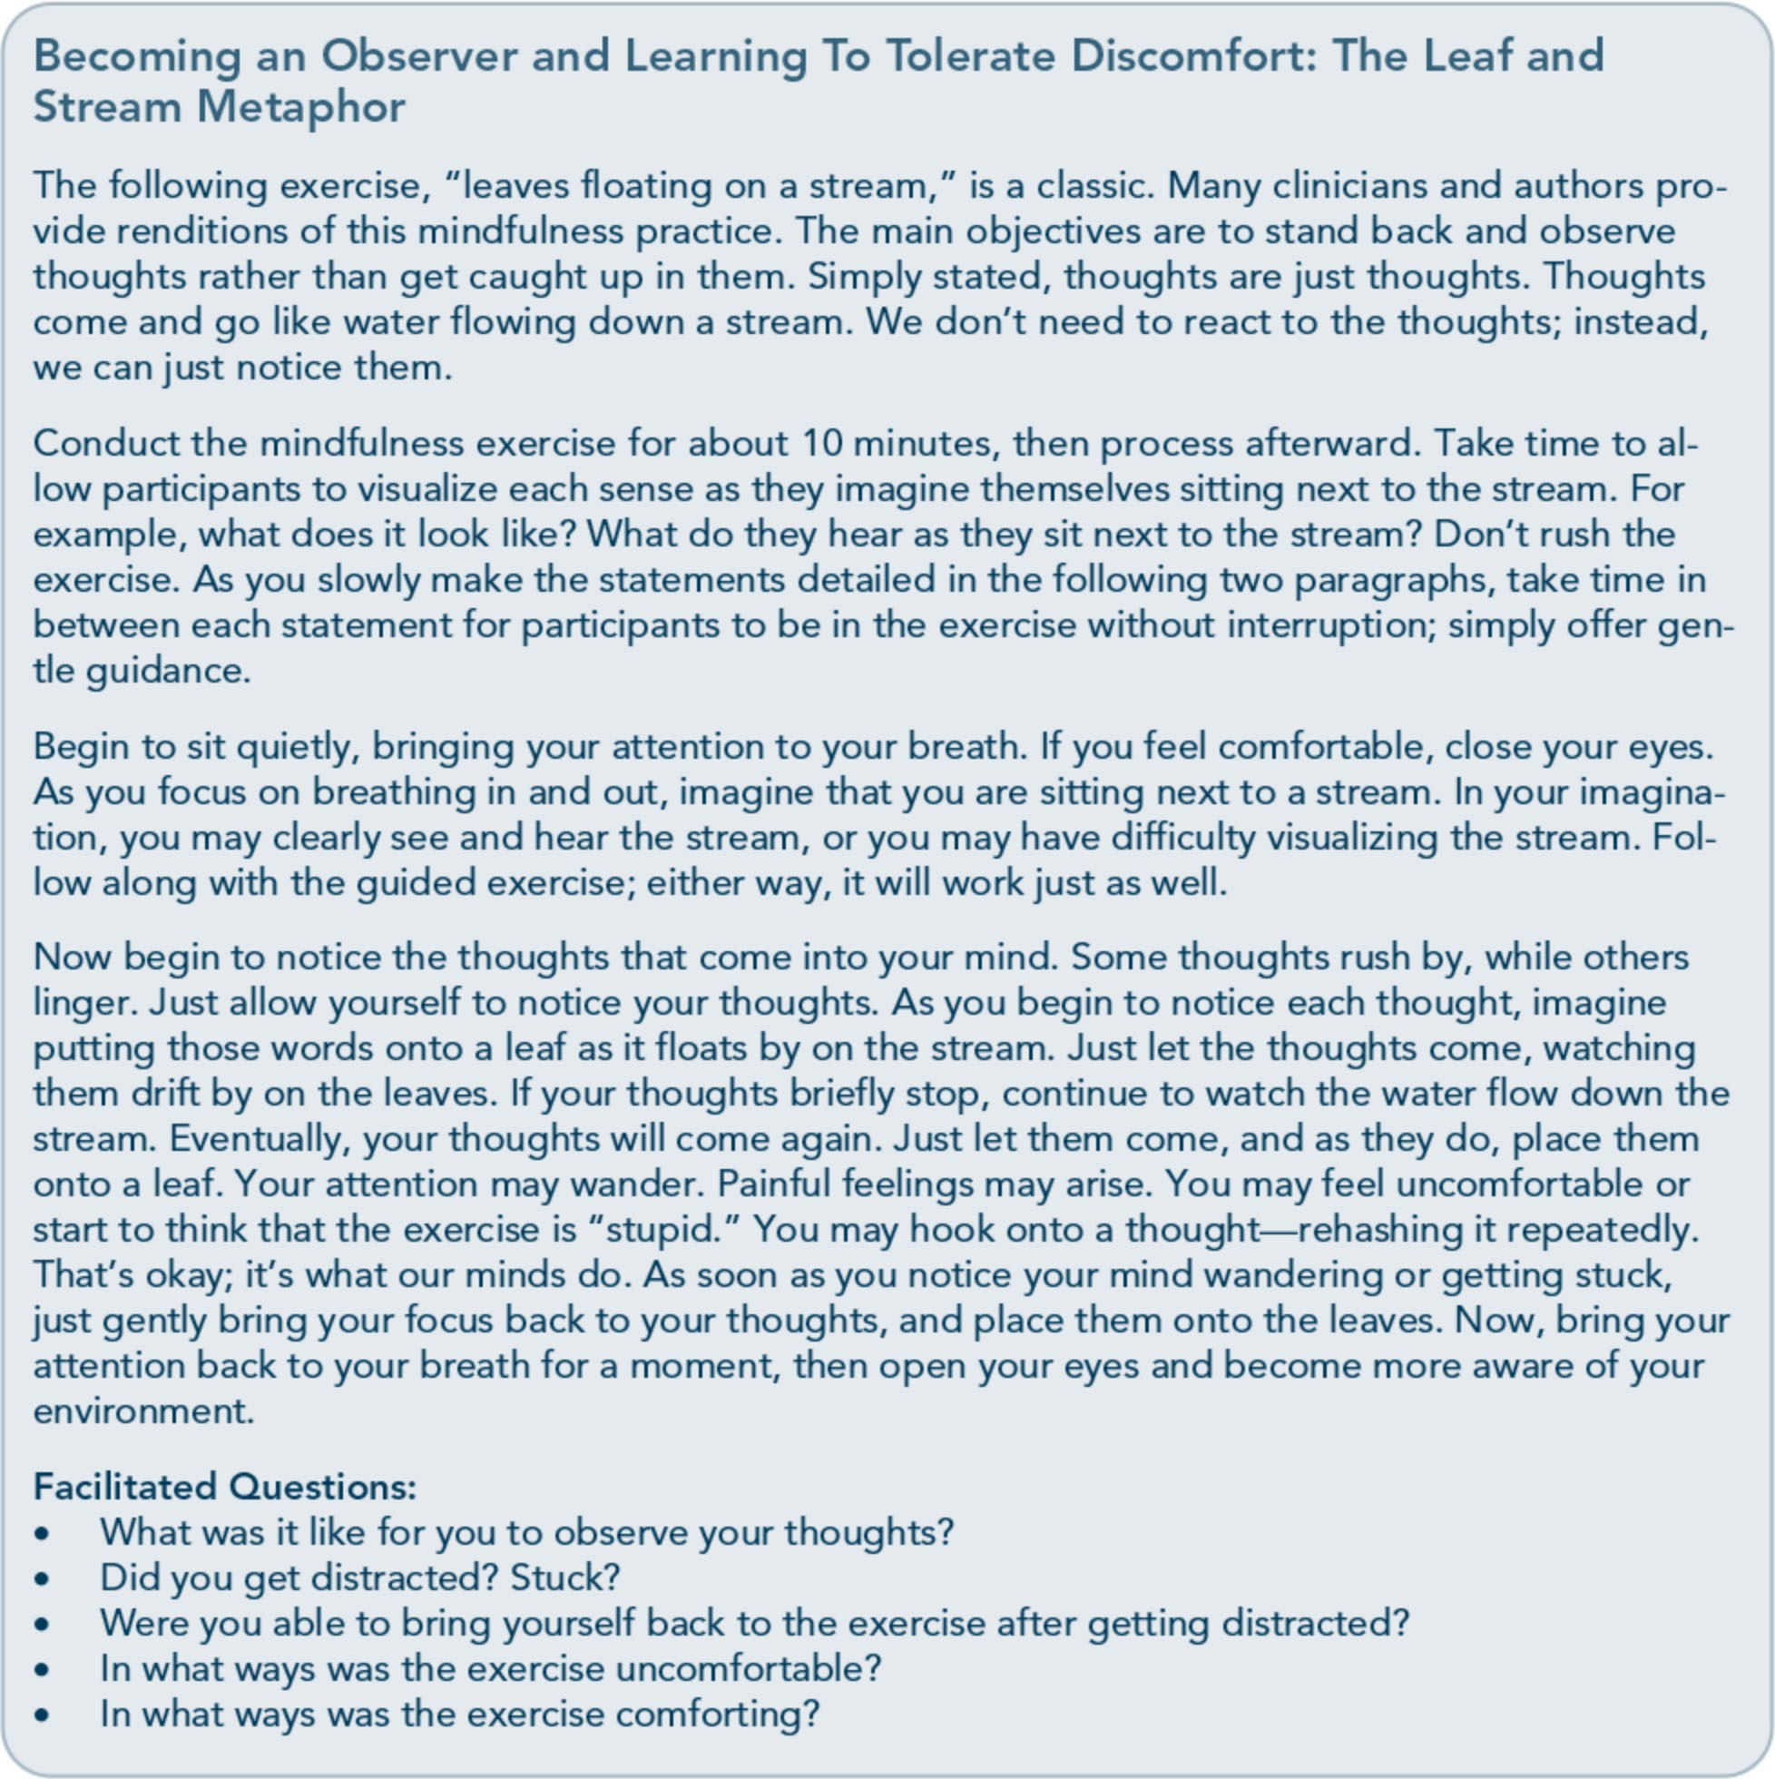

For clients and practitioners who want to de­ velop a greater capacity for mindfulness, see Kabat-Zinn's books Wherever You Go, There You Are: Mincifulness Meditation In Everyday Life (1994) and Full Catastrophe Living: Using the Wisdom ofYour Body and Mind to Face Stress, Pain, and Illness (1990). For clinical applications of mindfulness, see Mincifulness­ Based Cognitive Therapy far Depression: A New Approach to Preventing Relapse (Segal et al., 2002) and Relapse Prevention: Maintenance
Strategies in the Treatment of Addictive Behav­ iors (Marlatt & Donovan, 2005).

Pharmacological Therapy Pharmacotherapy for people with mental, sub­ stance use, and traumatic stress disorders needs to be carefully managed by physicians who are well versed in the treatment of each condition. Medications can help manage and control symptoms; however, they are only a part of a comprehensive treatment plan. There

154

Part 1, Chapter 6-T rauma-Specific Services

are no specific "antitrauma" drugs; rather, cer­ tain drugs target specific trauma symptoms. Clients receiving pharmacotherapy need care­ ful assessment. Some clients with preexisting mental disorders may need further adjustment in medications due to the physiological effects of traumatic stress. In addition, sudden with­ drawal from a pattern of self-administered substances can not only lead to dangerous lev­ els of physical distress, but also exacerbate the emergence of more severe PTSD symptoms. Distress after trauma often lessens over time, which can sometimes make the use of medica­ tions unnecessary for some individuals. Some trauma survivors do not develop long-term psychological problems from their experiences that require medication; others may simply refuse the initiation of pharmacotherapy or the use of additional medications.

Concluding Note
Behavioral health counselors can best serve clients who have experienced trauma by providing integrated treatment that combines

therapeutic models to target presenting symp­ toms and disorders. Doing so acknowledges that the disorders interact with each other.
Some models have integrated curricula; others that address trauma alone can be combined with behavioral health techniques with which the counselor is already familiar.
In part, the choice of a treatment model or general approach will depend on the level of evidence for the model, the counselor's train­ ing, identified problems, the potential for pre­ vention, and the client's goals and readiness
for treatment. Are improved relationships with family members a goal? Will the client be satisfied if sleep problems decrease, or is the goal resolution of broader issues? Are there substance use or substance-related disorders? Is the goal abstinence? Collaborating with clients to decide on goals, eliciting what they would like from treatment, and determining what they expect to happen can provide some clues as to what treatment models or tech­ niques might be successful in keeping clients engaged in recovery.

155

Appendix A-Bibliography

Abrahams, I. A., Ali, 0., Davidson, L., Evans, A. C., King,]. K., Poplawski, P., et al. (2010).
Philadelphia behavioral health services traniformation: Practice guidelines for recovery and resilience oriented treatment. Philadelphia: Department of Behavioral Health and Intellectual Disability Services.
Adams, R. E., Figley, C.R., & Boscarino,]. A. (2008). The Compassion Fatigue Scale: Its use with social workers following urban disaster. Research on Social Work Practice, 18, 238-250.
Adler, A. B., Litz, B. T., Castro, C. A., Suvak, M., Thomas,]. L., Burrell, L., et al. (2008). A group randomized trial of critical incident stress debriefing provided to U.S. peacekeepers.journalof Traumatic Stress, 21, 253-263.
Administration on Children, Youth, and Families. (2002). Sexual abuse among homeless adolescents: Prevalence, correlates, and sequelae. Washington, DC: Administration on Children, Youth, and Families.
Advanced Trauma Solutions, Inc. (2012). Trauma affect regulation: Guide for education & therapy.
Farmington, CT: Advanced Trauma Solutions, Inc.
Allen,]. G. (2001). Traumatic relationships and serious mental disorders. New York: John Wiley &
Sons Ltd.
American Psychiatric Association. (1980). Diagnostic and statistical manual of mental disorders. (3rd ed.). Washington, DC: American Psychiatric Association.
American Psychiatric Association. (2000a). Diagnostic and statistical manual of mental disorders.
(4th ed., text rev.). Washington, DC: American Psychiatric Association.
American Psychiatric Association. (20006). Position statement on therapies focused on memories of
childhood physical and sexual abuse. Washington, DC: American Psychiatric Association.
American Psychiatric Association. (2012a). G 03 posttraumatic stress disorder. Washington, DC:
American Psychiatric Association.
American Psychiatric Association. (20126). Proposed draft revisions to DSM disorders and criteria.
Washington, DC: American Psychiatric Association.
American Psychiatric Association. (2013a). Diagnostic and statistical manual of mental disorders.
(5th ed.). Arlington, VA: American Psychiatric Association.

215

Trauma-Informed Care in Behavioral Health Services

American Psychiatric Association. (2013b). Highlights of changes from DSM-IV-TR to DSM-5.
Arlington, VA: American Psychiatric Association.
American Psychological Association & The Ad Hoc Committee on Legal and Ethical Issues in the Treatment oflnterpersonal Violence. (2003). Potential problems far psychologists working with the area of interpersonal violence. Washington, DC: American Psychiatric Association.
Anda, R. F., Felitti, V.J., Bremner,]. D., Walker,]. D., Whitfield, C., Perry, B. D., et al. (2006). The enduring effects of abuse and related adverse experiences in childhood. A convergence of evidence from neurobiology and epidemiology. European Archives of Psychiatry and Clinical Neuroscience, 256 (3), 174-86.
Anda, R. F., Felitti, V.J., Brown, D., Chapman, D., Dong, M., Dube, S. R., et al. (2006). Insights into intimate partner violence from the adverse childhood experiences (ACE) study. In The physician's guide to intimate partner violence and abuse (pp. 77-88). Volcano, CA: Volcano Press.
Andreasen, N. C. (2010). Posttraumatic stress disorder: A history and a critique.Annals of the New YorkAcademy of Sciences, 1208, 67-71.
Antony, M. M., Orsillo, S. M., & Roemer, L. (2001). Practitioner's guide to empirically based measures of anxiety. New York: Plenum Press.
Arkowitz, H., Miller, W.R., Westra, H. A., & Rollnick, S. (2008). Motivational interviewing in the treatment of psychological problems: Conclusions and future directions. In Motivational interviewing in the treatment of psychological problems (pp. 324-342). New York: Guilford Press.
Auerbach, S. (2003). Sleep disorders related to alcohol and other drug use. In A.W. Graham, T. K. Schultz, M. F. Mayo-Smith, R. K. Ries, & B. B. Wilford (Eds.), Principles of addiction medicine. (3rd ed.). (pp. 1179-1193). Chevy Chase, MD: American Society of Addiction Medicine.
Baer, R. A. (2003). Mindfulness training as a clinical intervention: A conceptual and empirical review. Clinical Psychology: Science and Practice, 10, 125-143.
Baker, K. G. & Gippenreiter,J. B. (1998). Stalin's purge and its impact on Russian families: A pilot study. In Y. Danieli (Ed.), International handbook of multigenerational legacies of trauma (pp.
403-434). New York: Plenum Press.
Bartone, P. T., Roland, R.R., Picano,J.J., & Williams, T. (2008). Psychological hardiness predicts success in US Army Special Forces candidates. International journal of Selection and Assessment, 16, 78-81.
Batten, S. V. & Hayes, S. C. (2005). Acceptance and commitment therapy in the treatment of comorbid substance abuse and post-traumatic stress disorder: A case study. Clinical Case Studies, 4, 246-262.
Beck, A. T. (1993). Beck anxiety inventory. San Antonio, TX: The Psychological Corporation. Beck, A. T., Rush, A.]., Shaw, B. F., & Emery, G. (1979). Cognitive therapy of depression. New York:
Guilford Press.
Beck, A. T., Steer, R. A., & Brown, G. K. (1996). Beck depression inventory -II manual. San Antonio, TX: The Psychological Corporation.

216

Appendix A-Bibliography

Beck, A. T., Wright, F. D., Newman, C. F., & Liese, B. F. (1993). Cognitive therapy of substance abuse. New York: Guilford Press.
Bell, C. C. (2011). Trauma, culture, and resiliency. In S. M. Southwick, B. T. Litz, D. Charney, &
M.J. Friedman (Eds.), Resilience and mental health: Challenges across the lifespan (pp. 176-187). New York: Cambridge University Press.
Benedek, D. M. & Ursano, R.J. (2009). Posttraumatic stress disorder: From phenomenology to clinical practice. FOCUS: The journal of Lifelong Learning in Psychiatry, 7, 160-175.
Bernard,]. M. & Goodyear, R. K. (2009). Fundamentals of clinical supervision. (4th ed.). Upper Saddle River, NJ: Merrill/Pearson.
Bernstein, D. P. (2000). Childhood trauma and drug addiction: Assessment, diagnosis, and
treatment.Alcoholism Treatment Quarterly, 18, 19-30.
Bernstein, E. M. & Putnam, F. W. (1986). Development, reliability, and validity of a dissociation
scale.journal of Nervous and Mental Disease, 174, 727-735.
Bills, L.J. (2003). Using trauma theory and S.A.G.E. in outpatient psychiatric practice. Psychiatric Quarterly, 74, 191-203.
Blackburn, C. (1995). Family and relapse. Counselor. Alexandria, VA: National Association of Alcoholism and Drug Abuse Counselors.
Blake, D., Weathers, F., Nagy, L., Koloupek, D., Klauminzer, G., Charney, D., et al. (1990). Clinician Administered PTSD Scale (CAPS). Boston: National Center for Post-Traumatic Stress Disorder.
Bleich, A., Gelkopf, M., & Solomon, Z. (2003). Exposure to terrorism, stress-related mental health symptoms, and coping behaviors among a nationally representative sample in Israel. journal of the American Medical Association, 290, 612-620.
Bloom, S. L. (1997). Creating sanctuary: Toward the evolution of sane societies. New York: Routledge. Bloom, S. L., Bennington-Davis, M., Farragher, B., McCorkle, D., Nice-Martini, K., & Wellbank,
K. (2003). Multiple opportunities for creating sanctuary. Psychiatric Quarterly, 74, 173-190.
Bloom, S. L., Foderaro,]. F., & Ryan, R. (2006). S.E.L.F: A trauma-informed psychoeducational group Curriculum. Retrieved on November 18, 2013, from: http://sanctuaryweb.com/PDFs_new/COMPLETE%20INTRODUCTO RY%20MATERI AL.pdf
Bober, T. & Regehr, C. (2006). Strategies for reducing secondary or vicarious trauma: Do they work? Brie/Treatment and Crisis Intervention, 6, 1-9.
Bonanno, G. A. (2004). Loss, trauma, and human resilience: Have we underestimated the human capacity to thrive after extremely aversive events? American Psychologist, 29, 20-28.
Bonanno, G. A. & Mancini, A. D. (2011). Toward a lifespan approach to resilience and potential trauma. In S. M. Southwick, B. T. Litz, D. Charney, &M.J. Friedman (Eds.), Resilience and mental health: Challenges across the lifespan (pp. 120-134). New York: Cambridge University Press.

217

Trauma-Informed Care in Behavioral Health Services

Bowman, C. G. &Mertz, E. (1996). A dangerous direction: Legal intervention in sexual abuse survivor therapy. Harvard Law Review, 109, 551-639.
Brady, K. T., Killeen, T., Saladin, M. E., Dansky, B., & Becker, S. (1994). Comorbid substance abuse and posttraumatic stress disorder: Characteristics of women in treatment. American journal on Addictions, 3, 160-164.
Breslau, N. (2002). Gender differences in trauma and posttraumatic stress disorder.journal of
Gender Specific Medicine, 5, 34-40.
Brewin, C.R. (2007). Remembering and forgetting. In M.J. Friedman, T. M. Keane, & P.A. Resick (Eds.), Handbook of PTSD: Science and practice (pp. 116-134). New York: Guilford Press.
Brewin, C.R., Andrews, B., & Valentine,]. D. (2000). Meta-analysis of risk factors for posttraumatic stress disorder in trauma-exposed adults.journal of Consulting and Clinical
Psychology, 68, 748-766.
Bride, B. E. (2007). Prevalence of secondary traumatic stress among social workers. Social Work, 52,
63-70.
Briere,]. (1995). Trauma symptom inventory professional manual. Odessa, FL: Psychological Assessment Resources.
Briere, J. (1996a). Therapy far adults molested as children: Beyond survival (2nd ed.). New York: Springer Pub.
Briere,]. (19966). Trauma symptom checklist far children professional manual. Odessa, FL: Psychological Assessment Resources.
Briere,]. (1997). Psychological assessment of adult posttraumatic states. (1st ed.). Washington, DC: American Psychological Association.
Briere, J. & Scott, C. (2006a). Central issues in trauma treatment. In Principles of trauma therapy: A guide to symptoms, evaluation, and treatment (pp. 67-85). Thousand Oaks, CA: Sage Publications.
Briere,]. & Scott, C. (20066). Principles of trauma therapy: A guide to symptoms, evaluation, and treatment. Thousand Oaks, CA: Sage Publications.
Briere,]., & Scott, C. (2012). Principles of trauma therapy: A guide to symptoms, evaluation, and treatment. (2nd ed.). Thousand Oaks, CA: Sage Publications.
Bronfenbrenner,U. (1979). The ecology of human development: Experiments by nature and design.
Cambridge, MA: Harvard University Press.
Bronfenbrenner,U. & Ceci, S.J. (1994). Nature-nurture reconceptualized in developmental perspective: A bioecological model. Psychological Review, 101, 568-586.
Brown, L. S. (2008). Feminist therapy. InJ. L. Lebow (Ed.), Twenty-first century psychotherapies: Contemporary approaches to theory and practice (pp. 277-306). Hoboken, NJ: John Wiley & Sons, Inc.

218

Appendix A-Bibliography

Brown, P. J., Read,]. P., & Kahler, C. W. (2003). Comorbid posttraumatic stress disorder and substance use disorders: Treatment outcomes and the role of coping. In P. Ouimette & P. J. Brown (Eds.), Trauma and substance abuse: Causes, consequences, and treatment of comorbid disorders (pp. 171-188). Washington, DC: American Psychological Association.
Bryant, R. A. & Harvey, A. G. (2000). Acute stress disorder: A handbook of theory, assessment, and treatment. (1st ed.). Washington, DC: American Psychological Association.
Bryant, R. A. & Harvey, A.G. (2003). Gender differences in the relationship between acute stress disorder and posttraumatic stress disorder following motor vehicle accidents.Australian and New Zealand journal of Psychiatry, 37, 226-229.
Burke, P.A., Carruth, B., & Prichard, D. (2006). Counselor self-care in work with traumatized addicted people. In B. Carruth (Ed.), Psychological trauma and addiction treatment (pp. 283- 302). New York: Haworth Press.
Cahill, S. P., Rothbaum, B. 0., Resick, P.A., & Follette, V. M. (2009). Cognitive-behavioral therapy for adults. In E. B. Foa, T. M. Keane, M.J. Friedman, &J. A. Cohen (Eds.), Effective treatments far PTSD: Practice guidelines from the International Society far Traumatic Stress Studies. (2nd ed.). (pp. 139-222). New York: Guilford Press.
Caldwell, B. A. & Redeker, N. (2005). Sleep and trauma: An overview. Issues in Mental Health Nursing, 26, 721-738.
Campbell-Sills, L. & Stein, M. B. (2007). Psychometric analysis and refinement of the Connor­ Davidson Resilience Scale (CD-RISC): Validation of a 10-item measure of resilience.journal of Traumatic Stress, 20, 1019-1028.
Capezza, N. M. & Najavits, L. M. (2012). Rates of trauma-informed counseling at substance abuse treatment facilities: Reports from over 10,000 programs. Psychiatric Services, 63, 390- 394.
Cardena, E., Koopman, C., Classen, C., Waelde, L. C., & Spiegel, D. (2000). Psychometric properties of the Stanford Acute Stress Reaction Qyestionnaire (SASRQ2: a valid and reliable measure of acute stress.journal ofTraumatic Stress, 13, 719-734.
Carlson, E. B. & Putnam, F. W. (1993). An update on the Dissociative Experiences Scale.
Dissociation, 6, 16-27.
Carroll,]. F. X. & McGinley,J.J. (2001). A screening form for identifying mental health problems in alcohol/other drug dependent persons. Alcoholism Treatment Quarterly, 19, 33-47.
Catalano, S. (2012). Intimate partner violence in the US. Washington, DC: Bureau ofJustice Statistics.
Catalano, S. M. (2004). Criminal victimization, 2003: National crime victimization survey.
Washington, DC: Bureau of Justice Statistics.
Centers for Disease Control and Prevention. (2009). The social-ecological model· A framework far prevention. Retrieved on November 20, 2013, from: http://www.cdc.gov/violenceprevention/overview/social-ecologicalmodel.html

219

Trauma-Informed Care in Behavioral Health Services

Centers for Disease Control and Prevention. (2012). Publications by health outcome: Adverse childhood experiences (ACE) study. Atlanta, GA: Centers for Disease Control and Prevention.
Centers for Disease Control and Prevention. (2013,January 18). Adverse Childhood Experiences (ACE) Study. Retrieved on August 14, 2013, from http://www.cdc.gov/ace/about.htm
Center for Mental Health Services. (1996). Responding to the needs of people with serious and persistent mental illness in times of major disaster (Rep. No. SMA 96-3077). Rockville, MD: Substance Abuse and Mental Health Services Administration.
Center for Mental Health Services, Division of Prevention, Traumatic Stress and Special Programs, Emergency Mental Health and Traumatic Stress Services Branch. (2003). Fact sheet (Rep. No. KEN 95-0011). Rockville, MD: Substance Abuse and Mental Health Services Administration.
Center for Mental Health Services, Substance Abuse and Mental Health Services Administration. (2005). Roadmap to seclusion and restraint free mental health services. Rockville, MD: Substance Abuse and Mental Health Services Administration.
Center for Substance Abuse Treatment. (1993a). Improving treatment far drug-exposed infants. Treatment Improvement Protocol (TIP) Series 5. HHS Publication No. (SMA) 95-3057. Rockville, MD: Substance Abuse and Mental Health Services Administration.
Center for Substance Abuse Treatment. (19936). Pregnant, substance-using women. Treatment Improvement Protocol (TIP) Series 2. HHS Publication No. (SMA) 93-1998. Rockville, MD: Substance Abuse and Mental Health Services Administration.
Center for Substance Abuse Treatment. (1993c). Screening/or infectious diseases among substance abusers. Treatment Improvement Protocol (TIP) Series 6. HHS Publication No. (SMA) 95- 3060. Rockville, MD: Substance Abuse and Mental Health Services Administration.
Center for Substance Abuse Treatment. (1994). Simple screening instruments far outreach far alcohol and other drug abuse and infectious diseases. Treatment Improvement Protocol (TIP) Series 11. HHS Publication No. (SMA) 94-2094. Rockville, MD: Substance Abuse and Mental Health Services Administration.
Center for Substance Abuse Treatment. (1995a). Alcohol and other drug screening of hospitalized trauma patients. Treatment Improvement Protocol (TIP) Series 16. HHS Publication No. (SMA) 95-3041. Rockville, MD: Substance Abuse and Mental Health Services Administration.
Center for Substance Abuse Treatment. (19956). Combining alcohol and other drug treatment with diversion far juveniles in the justice system. Treatment Improvement Protocol (TIP) Series 21. HHS Publication No. (SMA) 95-3051. Rockville, MD: Substance Abuse and Mental Health Services Administration.
Center for Substance Abuse Treatment. (1995c). Developing state outcomes monitoring systems far alcohol and other drug abuse treatment. Treatment Improvement Protocol (TIP) Series 14. HHS Publication No. (SMA) 95-3031. Rockville, MD: Substance Abuse and Mental Health Services Administration.

220

Appendix A-Bibliography

Center for Substance Abuse Treatment. (1995d). The role and current status of patient placement criteria in the treatment of substance use disorders. Treatment Improvement Protocol (TIP) Series
13. HHS Publication No. (SMA) 95-3021. Rockville, MD: Substance Abuse and Mental Health Services Administration.
Center for Substance Abuse Treatment. (1995e). The tuberculosis epidemic: Legal and ethical issues far alcohol and other drug abuse treatment providers. Treatment Improvement Protocol (TIP) Series 18. HHS Publication No. (SMA) 95-3047. Rockville, MD: Substance Abuse and Mental Health Services Administration.
Center for Substance Abuse Treatment. (1996). Treatment drug courts: Integrating substance abuse treatment with legal case processing. Treatment Improvement Protocol (TIP) Series 23. HHS Publication No. (SMA) 96-3113. Rockville, MD: Substance Abuse and Mental Health Services Administration.
Center for Substance Abuse Treatment. (1997a). A guide to substance abuse services far primary care clinicians. Treatment Improvement Protocol (TIP) Series 24. HHS Publication No. (SMA) 97-3139. Rockville, MD: Substance Abuse and Mental Health Services Administration.
Center for Substance Abuse Treatment. (1997b). Substance abuse treatment and domestic violence. Treatment Improvement Protocol (TIP) Series 25. HHS Publication No. (SMA) 97-3163. Rockville, MD: Substance Abuse and Mental Health Services Administration.
Center for Substance Abuse Treatment. (1998a). Comprehensive case management far substance abuse treatment. Treatment Improvement Protocol (TIP) Series 27. HHS Publication No. (SMA) 98-3222. Rockville, MD: Substance Abuse and Mental Health Services Administration.
Center for Substance Abuse Treatment. (1998b). Continuity of offender treatment far substance use disorders from institution to community. Treatment Improvement Protocol (TIP) Series 30.
HHS Publication No. (SMA) 98-3245. Rockville, MD: Substance Abuse and Mental Health Services Administration.
Center for Substance Abuse Treatment. (1998c). Naltrexone and alcoholism treatment. Treatment Improvement Protocol (TIP) Series 28. HHS Publication No. (SMA) 98-3206. Rockville, MD: Substance Abuse and Mental Health Services Administration.
Center for Substance Abuse Treatment. (1998d). Substance abuse among older adults. Treatment Improvement Protocol (TIP) Series 26. HHS Publication No. (SMA) 98-3179. Rockville, MD: Substance Abuse and Mental Health Services Administration.
Center for Substance Abuse Treatment. (1998e). Substance use disorder treatment far people with physical and cognitive disabilities. Treatment Improvement Protocol (TIP) Series 29. HHS Publication No. (SMA) 98-3249. Rockville, MD: Substance Abuse and Mental Health Services Administration.
Center for Substance Abuse Treatment. (1999a). Brief interventions and brief therapies far substance abuse. Treatment Improvement Protocol (TIP) Series 34. HHS Publication No. (SMA) 99- 3353. Rockville, MD: Substance Abuse and Mental Health Services Administration.

221

Trauma-Informed Care in Behavioral Health Services

Center for Substance Abuse Treatment. (1999b). Enhancing motivation far change in substance abuse treatment. Treatment Improvement Protocol (TIP) Series 35. HHS Publication No. (SMA) 99-3354. Rockville, MD: Substance Abuse and Mental Health Services Administration.
Center for Substance Abuse Treatment. (1999c). Screening and assessing adolescents far substance use disorders. Treatment Improvement Protocol (TIP) Series 31. HHS Publication No. (SMA) 99-3282. Rockville, MD: Substance Abuse and Mental Health Services Administration.
Center for Substance Abuse Treatment. (1999d). Treatment of adolescents with substance use disorders. Treatment Improvement Protocol (TIP) Series 32. HHS Publication No. (SMA) 99- 3283. Rockville, MD: Substance Abuse and Mental Health Services Administration.
Center for Substance Abuse Treatment. (1999e). Treatment far stimulant use disorders. Treatment Improvement Protocol (TIP) Series 33. HHS Publication No. (SMA) 99-3296. Rockville, MD: Substance Abuse and Mental Health Services Administration.
Center for Substance Abuse Treatment. (2000a). Integrating substance abuse treatment and vocational services. Treatment Improvement Protocol (TIP) Series 38. HHS Publication No. (SMA) 00-3470. Rockville, MD: Substance Abuse and Mental Health Services Administration.
Center for Substance Abuse Treatment. (2000b). Substance abuse treatment far persons with child abuse and neglect issues. Treatment Improvement Protocol (TIP) Series 36. HHS Publication No. (SMA) 00-3357. Rockville, MD: Substance Abuse and Mental Health Services Administration.
Center for Substance Abuse Treatment. (2000c). Substance abuse treatment far persons with HIV/AIDS. Treatment Improvement Protocol (TIP) Series 37. HHS Publication No. (SMA) 00-3459. Rockville, MD: Substance Abuse and Mental Health Services Administration.
Center for Substance Abuse Treatment. (2004a). Clinical guidelines far the use of buprenorphine in the treatment of opioid addiction. Treatment Improvement Protocol (TIP) Series 40. HHS Publication No. (SMA) 04-3939. Rockville, MD: Substance Abuse and Mental Health Services Administration.
Center for Substance Abuse Treatment. (2004b). Substance abuse treatment and family therapy. Treatment Improvement Protocol (TIP) Series 39. HHS Publication No. (SMA) 04-3957. Rockville, MD: Substance Abuse and Mental Health Services Administration.
Center for Substance Abuse Treatment. (2005a). Medication-assisted treatment far opioid addiction.
Treatment Improvement Protocol (TIP) Series 43. HHS Publication No. SMA 05-4048. Rockville, MD: Substance Abuse and Mental Health Services Administration.
Center for Substance Abuse Treatment. (2005b). Substance abuse treatment far adults in the criminal justice system. Treatment Improvement Protocol (TIP) Series 44. HHS Publication No. (SMA) 05-4056. Rockville, MD: Substance Abuse and Mental Health Services Administration.
Center for Substance Abuse Treatment. (2005c). Substance abuse treatment far persons with co­ occurring disorders. Treatment Improvement Protocol (TIP) Series 42. HHS Publication No. SMA 05-3992. Rockville, MD: Substance Abuse and Mental Health Services Administration.

222

Appendix A-Bibliography

Center for Substance Abuse Treatment. (2005d). Substance abuse treatment: Group therapy.
Treatment Improvement Protocol (TIP) Series 41. HHS Publication No. SMA 05-4056. Rockville, MD: Substance Abuse and Mental Health Services Administration.
Center for Substance Abuse Treatment. (2006a). Detoxification and substance abuse treatment. Treatment Improvement Protocol (TIP) Series 45. HHS Publication No. SMA 06-4131. Rockville, MD: Substance Abuse and Mental Health Services Administration.
Center for Substance Abuse Treatment. (2006b). Substance abuse:Administrative issues in intensive outpatient treatment. Treatment Improvement Protocol (TIP) Series 46. HHS Publication No. SMA 06-4151. Rockville, MD: Substance Abuse and Mental Health Services Administration.
Center for Substance Abuse Treatment. (2006c). Substance abuse: Clinical issues in intensive outpatient treatment. Treatment Improvement Protocol (TIP) Series 47. HHS Publication No. SMA 06-4182. Rockville, MD: Substance Abuse and Mental Health Services Administration.
Center for Substance Abuse Treatment. (2008). Managing depressive symptoms in substance abuse clients during early recovery. Treatment Improvement Protocol (TIP) Series 48. HHS Publication No. SMA 08-4353. Rockville, MD: Substance Abuse and Mental Health Services Administration.
Center for Substance Abuse Treatment. (2009a).Addressing suicidal thoughts and behaviors in substance abuse treatment. Treatment Improvement Protocol (TIP) Series 50. HHS Publication No. SMA 09-4381. Rockville, MD: Substance Abuse and Mental Health Services Administration.
Center for Substance Abuse Treatment. (2009b). Clinical supervision and the professional development of the substance abuse counselor. Treatment Improvement Protocol (TIP) Series 52. HHS Publication No. SMA 09-4435. Rockville, MD: Substance Abuse and Mental Health Services Administration.
Center for Substance Abuse Treatment. (2009c). Incorporating alcohol pharmacotherapies into medical practice. Treatment Improvement Protocol (TIP) Series 49. HHS Publication No. SMA 09-4380. Rockville, MD: Substance Abuse and Mental Health Services Administration.
Center for Substance Abuse Treatment. (2009d). Substance abuse treatment:Addressing the specific needs of women. Treatment Improvement Protocol (TIP) Series 51. HHS Publication No.
SMA 09-4426. Rockville, MD: Substance Abuse and Mental Health Services Administration.
Center for Substance Abuse Treatment. (2009e). What are peer recovery support services? HHS Publication No. SMA 09-4454. Rockville, MD: Substance Abuse and Mental Health Services Administration, U.S. Department of Health and Human Services.
Chambless, D. L. & Hollon, S. D. (1998). Defining empirically supported therapies.journal of
Consulting and Clinical Psychology, 66, 7-18.
Chilcoat, H. D. & Breslau, N. (1998). Posttraumatic stress disorder and drug disorders: Testing causal pathways.Archives of General Psychiatry, 55, 913-917.
Christensen, R. C., Hodgkins, C. C., Garces, L. K., Estlund, K. L., Miller, M. D., & Touchton, R. (2005). Homeless, mentally ill and addicted: The need for abuse and trauma services.journal of Health Care far the Poor and Underserved, 16, 615-621.

223

Trauma-Informed Care in Behavioral Health Services

Claes, L. & Vandereycken, W. (2007). Is there a link between traumatic experiences and self­ injurious behaviours in eating-disordered patients? Eating Disorders, 15, 305-315.
Claes, L., Vandereycken, W., & Vertommen, H. (2005). Self-care versus self-harm: Piercing, tattooing, and self-injuring in eating disorders. European Eating Disorders Review, 13, 11-18.
Clark, C. & Fearday, F. E. (2003). Triad women's project: Group facilitator's manual. Tampa, FL: Louis de la Parte Florida Mental Health Institute, University of South Florida.
Cloitre, M., Koenen, K. C., Cohen, L. R., & Han, H. (2002). Skills training in affective and interpersonal regulation followed by exposure: A phase-based treatment for PTSD related to childhood abuse.journal of Consulting and Clinical Psychology, 70, 1067-1074.
Coffey, S. F., Dansky, B. S., & Brady, K. T. (2003). Exposure-based, trauma focused therapy for comorbid posttraumatic stress disorder-substance use disorder. In P. Ouimette & P.J. Brown (Eds.), Trauma and substance abuse: Causes, consequences, and treatment of comorbid disorders. (pp.
127-146). Washington, DC: American Psychological Association.
Coffey, S. F., Schumacher,]. A., Brady, K. T., &Dansky, B. S. (2003). Reductions in trauma symptomalogy during acute and protracted alcohol and cocaine abstinence. Symposium conducted at the Annual Meeting of the International Society for Traumatic Stress Studies, Chicago, IL.
Coffey, S. F., Schumacher,]. A., Brimo, M. L., & Brady, K. T. (2005). Exposure therapy for substance abusers with PTSD: Translating research to practice. Behavior Modification, 29, 10- 38.
Connor, K. M. & Davidson,]. R. T. (2003). Development of a new resilience scale: The Connor­ Davidson Resilience Scale (CD-RISC). Depression and Anxiety, 18, 76-82.
Connors, G.J., Donovan, D. M., & DiClemente, C. C. (2001). Substance abuse treatment and the stages of change selecting and planning interventions. New York: Guilford Press.
Cottler, L.B., Nishith, P., & Compton, W. M. (2001). Gender differences in risk factors for trauma exposure and post-traumatic stress disorder among inner-city drug abusers in and out of treatment. Comprehensive Psychiatry, 42, 111-117.
Courtois, C. A. & Ford,]. D. (Eds.). (2009). Treating complex traumatic stress disorders:An evidence­ based guide. New York: Guilford Press.
Covington, S.S. (2003). Beyond trauma:A healingjourneyfar women: Facilitator's guide. Center City, MN: Hazelden.
Covington, S.S. (2008). Helping women recover: A program far treating addiction. (Revised loose leaf ed.). San Francisco:Jossey-Bass.
Cross, T. L., Bazron, B.J., Dennis, K. W., &Isaacs, M. R. (1989). Towards a culturally competent system of care: A monograph on effective services far minority children who are severely emotionally disturbed (Vol. 1). Washington, DC: Georgetown University Child Development Center.
Danieli, Y., Brom, D., & Sills,]. (2005). Sharing knowledge and shared care.journal ofAggression, Maltreatment &Trauma, 10, 775-790.

224

Appendix A-Bibliography

Daniels, A., Grant, E., Filson, B., Powell, I., Fricks, L., & Goodale, L. (2010). Pillars of peer support: Traniforming mental health systems of care through peer support services. Retrieved on November 21, 2013, from: http://www.pillarsofpeersupport.org/final%20%20PillarsofPeerSupportService%20Report.pdf
Daniels, A. S., Tunner, T. P., Ashenden, P., Bergeson, S., Fricks, L., & Powell, I. (2012). Pillars of peer support -III- Whole health peer support services. Retrieved on November 21, 2013, from: http://www.pillarsofpeersupport.org/P.O.PS2011.pdf
Dass-Brailsford, P. &Myrick, A. C. (2010). Psychological trauma and substance abuse: The need for an integrated approach. Trauma, Violence, & Abuse, 11, 202-213.
Daoust,]. P., Renaud, M., Bruyere, B., Lemieux, V., Fleury, G., & Najavits, L. M. (2012). Posttraumatic stress disorder and substance use disorder: Evaluation of the effectiveness of a specialized clinic far French-Canadians based in a teaching hospital Retrieved on November 21, 2013, from: http://www.seekingsafety.org/3-03-06/studies.html
Davidson,]. R., Book, S. W., Colket,J. T., Tupler, L.A., Roth, S., David, D., et al. (1997).
Assessment of a new self-rating scale for post-traumatic stress disorder. Psychological Medicine, 27, 153-160.
De Bellis, M. D. (2002). Developmental traumatology: A contributory mechanism for alcohol and substance use disorders. Psychoneuroendocrinology, 27, 155-170.
de Fabrique, N., Van Hasselt, V. B., Vecchi, G. M., & Romano, S.J. (2007). Common variables associated with the development of Stockholm syndrome: Some case examples. Victims & Offenders, 2, 91-98.
de Girolamo, G. (1993). lnternational perspectives on the treatment and prevention of posttraumatic stress disorder. In J.P. Wilson & Raphael Beverley (Eds.), International handbook of traumatic stress syndrome (pp. 935-946). New York: Plenum Press.
dePanfilis, D. (2006). Child neglect: A guide far prevention, assessment, and intervention. Washington, DC: U.S. Department of Health and Human Services, Administration for Children and Families, Administration on Children, Youth and Families Children's Bureau, Office on Child Abuse and Neglect.
DeWolfe, D.J. (2000). Training manual· For mental health and human service workers in major disasters (Rep. No. ADM 90-538). Rockville, MD: Substance Abuse and Mental Health Services Administration.
Dillon,]. R. (2001). lnternalized homophobia, attributions of blame, and psychological distress among lesbian, gay, and bisexual trauma victims. Dissertation Abstracts International· Section B: The Sciences & Engineering, 62, 2054.
Dom, G., De, W. B., Hulstijn, W., & Sabbe, B. (2007). Traumatic experiences and posttraumatic stress disorders: differences between treatment-seeking early- and late-onset alcoholic patients. Comprehensive Psychiatry, 48, 178-185.
Driessen, M., Schulte, S., Luedecke, C., Schaefer, I., Sutmann, F., Ohlmeier, M., et al. (2008).
Trauma and PTSD in patients with alcohol, drug, or dual dependence: A multi-center study.
Alcoholism: Clinical & Experimental Research, 32, 481-488.

225

Trauma-Informed Care in Behavioral Health Services

Dube, S. R., Anda, R. F., Felitti, V.J., Edwards, V.J., & Croft,]. B. (2002). Adverse childhood experiences and personal alcohol abuse as an adult. Addictive Behaviors, 27, 713-725.
Duckworth, M. P. & Follette, V. M. (2011). Retraumatization: Assessment, treatment, and prevention. New York: Brunner-Routledge.
Ehlers, A. & Clark, D. (2003). Early psychological interventions for adult survivors of trauma: A review. Biological Psychiatry, 53, 817-826.
El-Gabalawy, R. (2012).Association between traumatic experiences and physical health conditions in a nationally representative sample. Retrieved on November 21, 2013, from: http://www.adaa.org/sites/default/files/El-Gabalawy0Ai20331.pdf
Ellis, A. & Harper, R. A. (1975). A new guide to rational living. Oxford, England: Prentice-Hall.
Elliott, D. E., Bjelajac, P., Fallot, R. D., Markoff, L. S., & Reed, B. G. (2005). Trauma-informed or trauma-denied: Principles and implementation of trauma-informed services for women.
journal of Community Psychology, 33, 461-477.
EMDR Network. (2012).A brief description of EMDR therapy. Retrieved on November 21, 2013, Retrieved on November 21from: http://www.emdrnetwork.org/description.html
Falck, R. S., Wang,]., Siegal, H. A., & Carlson, R. G. (2004). The prevalence of psychiatric disorder among a community sample of crack cocaine users: An exploratory study with practical implications.journal of Nervous and Mental Disease, 192, 503-507.
Falender, C. A. & Shafranske, E. P. (2004). Clinical supervision: A competency-based approach. (1st ed.). Washington, DC: American Psychological Association.
Fallot, R. D. & Harris, M. (2001). A trauma-informed approach to screening and assessment. In
M. Harris & R. D. Fallot (Eds.), Using trauma theory to design service systems (pp. 23-31). San Francisco: Jossey-Bass.
Fallot, R. D. & Harris, M. (2002). The trauma recovery and empowerment model (TREM): Conceptual and practical issues in a group intervention for women. Community Mental Health journal, 38, 475-485.
Fallot, R. D. & Harris, M. (2009). Creating cultures of trauma-informed care (CCTIC): A se!f­ assessment and planning protocol. Washington, DC: Community Connections.
Falsetti, S. A., Resnick, H. S., Resnick, P.A., & Kilpatrick, D. (1993). The Modified PTSD Symptom Scale: A brief self-report measure of posttraumatic stress disorder. Behavior Therapist, 16, 161-162.
Farley, M., Golding,]. M., Young, G., Mulligan, M., &Minkoff,]. R. (2004). Trauma history and relapse probability among patients seeking substance abuse treatment.journal of Substance Abuse Treatment, 27, 161-167.
Feder, A., Charney, D., & Collins, K. (2011). Neurobiology of resilience. In S. M. Southwick, B. T. Litz, D. Charney, &M.J. Friedman (Eds.), Resilience and mental health: Challenges across the lifespan (pp. 1-29). New York: Cambridge University Press.

226

Appendix A-Bibliography

Feldner, M. T., Monson, C. M., & Friedman, M.J. (2007). A critical analysis of approaches to targeted PTSD prevention: Current status and theoretically derived future directions. Behavior Modification, 31, 80-116.
Felitti, V.J., Anda, R. F., Nordenberg, D., Williamson, D. F., Spitz, A. M., Edwards, V., et al. (1998). Relationship of childhood abuse and household dysfunction to many of the leading causes of death in adults: The Adverse Childhood Experiences (ACE) study.American journal of Preventive Medicine, 14, 245-258.
Figley, C.R. (1995). Compassion fatigue: Toward a new understanding of the costs of caring. In B.
H. Stamm (Ed.), Secondary traumatic stress: Se!f-care issues far clinicians, researchers, and educators
(pp. 3-28). Lutherville, MD: Sidran Press.
Figley, C.R. (2002). Origins of traumatology and prospects for the future, part i.journal of Trauma Practice, 1, 17-32.
First, M. B., Spitzer, R. L., Gibbon, M., & Williams,]. B. W. (2011a). Structured clinical interview far DSM-IV-TR axis I disorders, research version, non-patient edition. New York: Biometrics Research, New York State Psychiatric Institute.
First, M. B., Spitzer, R. L., Gibbon, M., & Williams,]. B. W. (20116). Structured clinical interview far DSM-IV-TR axis I disorders, research version, patient edition. New York: Biometrics Research, New York State Psychiatric Institute.
Foa, E. B., Dancu, C. V., Hembree, E. A.,Jaycox, L. H., Meadows, E. A., & Street, G. P. (1999). A comparison of exposure therapy, stress inoculation training, and their combination for reducing posttraumatic stress disorder in female assault victims.journal of Consulting and Clinical Psychology, 67, 194-200.
Foa, E. B., Hembree, E. A., & Rothbaum, B. 0. (2007). Prolonged exposure therapy far PTSD: Emotional processing of traumatic experiences: Therapist guide. New York: Oxford University Press.
Foa, E. B., Keane, T. M., Friedman, M.J., & Cohen,]. A. (2009). Introduction. In E. B. Foa, T. M. Keane, M. J. Friedman, & J. A. Cohen (Eds.), Effective treatments far PTSD: Practice guidelines from the International Society far Traumatic Stress Studies. (2nd ed.). (pp.1-20). New York: Guilford Press.
Foa, E. B., Rothbaum, B. 0., Riggs, D.S., &Murdock, T. B. (1991). Treatment of posttraumatic stress disorder in rape victims: A comparison between cognitive-behavioral procedures and counseling.journal of Consulting & Clinical Psychology, 59, 715-723.
Foa, E. B., Stein, D.J., &McFarlane,A. C. (2006). Symptomatology and psychopathology of mental health problems after disaster.journal of Clinical Psychiatry, 67 Supplement 2, 15-25.
Ford,]. D. & Fournier, D. (2007). Psychological trauma and post-traumatic stress disorder among women in community mental health aftercare following psychiatric intensive care.journal of Psychiatric Intensive Care, 3, 27-34.
Ford,]. D. & Russo, E. (2006). Trauma-focused, present-centered, emotional self-regulation approach to integrated treatment for posttraumatic stress and addiction: Trauma adaptive recovery group education and therapy (TARGET).Americanjournal of Psychotherapy, 60, 335-355.

227

Trauma-Informed Care in Behavioral Health Services

Foy, D. W., Ruzek,J. I., Glynn, S. M., Riney, S.J., & Gusman, F. D. (2002). Trauma focus group therapy for combat-related PTSD: An update.journal of Clinical Psychology, 58, 907-918.
Frank, B., Dewart, T., Schmeidler,]., &Demirjian,A. (2006). The impact of9/11 on New York City's substance abuse treatment programs: A study of program administrators.journalof Addictive Diseases, 25, 5-14.
Frankl, V. E. (1992). Man's search far meaning: An introduction to logotherapy. (4th ed.). Boston: Beacon Press.
Friborg, 0., Hjemdal, 0., Rosenvinge,J. H., &Martinussen, M. (2003). A new rating scale for adult resilience: What are the central protective resources behind healthy adjustment?
International journal of Methods in Psychiatric Research, 12, 65-76.
Friedman, M.J. (2006). Posttraumatic stress disorder among military returnees from Afghanistan and Iraq.American]ournal of Psychiatry, 163, 586-593.
Frisman, L., Ford,]., Lin, H.J., Mallon, S., & Chang, R. (2008). Outcomes of trauma treatment using the TARGET model.Journal of Groups in Addiction and Recovery, 3, 285-303.
Frueh, B. C., Knapp, R. G., Cusack, K.J., Grubaugh, A. L., Sauvageot,J. A., Cousins, V. C., et al. (2005). Patients' reports of traumatic or harmful experiences within the psychiatric setting.
Psychiatric Services, 56, 1123-1133.
Galea, S., Ahern,]., Resnick, Kilpatrick, D., Bucuvalas, M., Gold,]., et al. (2002). Psychological sequelae of the September 11 terrorist attacks in New York City. New England journal of Medicine, 346, 982-987.
Gentilello, L. M., Ebel, B. E., Wickizer, T. M., Salkever, D. S., & Rivara, F. P. (2005). Alcohol interventions for trauma patients treated in emergency departments and hospitals: A cost benefit analysis.Annals of Surgery, 241, 541-550.
Gentilello, L. M., Villaveces, A., Ries, R.R., Nason, K. S., Daranciang, E., Donovan, D. M., et al. (1999). Detection of acute alcohol intoxication and chronic alcohol dependence by trauma
center staff Journal of Trauma, 47, 1131-1135.
Gill, D. A. & Picou,}. S. (1997). The day the water died: Cultural impacts of the Exxon Valdez oil spill. InJ. S. Picou (Ed.), The Exxon Valdez disaster: Readings on a modern social problem (pp.167-187). Dubuque, IA: Indo American Books.
Gone,J. P. (2009). A community-based treatment for Native American historical trauma: Prospects for evidence-based practice.journal of Consulting and Clinical Psychology, 77, 751-762.
Goodell,]. (2003). Who's a hero now? Retrieved on November 21, 2013 from: http://www.nytimes.com/2003/07/27/magazine/who-s-a-hero-now.html
Grant, B. F., Stinson, F. S., Dawson, D. A., Chou, S. P., Dufour, M. C., Compton, W., et al. (2004).
Prevalence and co-occurrence of substance use disorders and independent mood and anxiety disorders: Results from the National Epidemiologic Survey on Alcohol and Related Conditions.Archives of General Psychiatry, 61, 807-816.
Green, B. L. (1996). Trauma History Qyestionnaire. In B. H. Stamm (Ed.), Measurement of stress, trauma, and adaptation (pp. 366-369). Lutherville, MD: Sidran Press.

228

Appendix A-Bibliography

Green Cross Academy ofTraumatology. (2007). Standards of traumatology practice revised. Retrieved on November 18, 2013, from: http://www.greencross.org/index.php?option=com_content&view=article&id=183&Itemid=123
Green Cross Academy ofTraumatology. (2010). Standards ofse!f care. Retrieved on November 21, 2013,from: http://www.greencross.org/index.php?option=com_content&view=article&id=184&Itemid=124
Green,]. G., McLaughlin, K. A., Berglund, P.A., Gruber, M.J., Sampson, N. A., Zaslavsky, A. M., et al. (2010). Childhood adversities and adult psychiatric disorders in the National Comorbidity Survey Replication I: Associations with first onset of DSM-IV disorders.
Archives of General Psychiatry, 6 7, 113-123.
Greene, L. R., Meisler, A. W., Pilkey, D., Alexander, G., Cardella, L.A., Sirois, B. C., et al. (2004). Psychological work with groups in the Veterans Administration. In]. L.DeLucia-Waack, D.
A. Gerrity, C.R. Kalodner, & M. T. Riva (Eds.), Handbook of group counseling and psychotherapy
(pp. 322-337). Thousand Oaks, CA: Sage Publications.
Grossman, D. (1995). On killing: The psychological cost of learning to kill in war and society. (1st ed.).
Boston: Little Brown.
Guarino, K., Soares, P., Konnath, K., Clervil, R., and Bassuk, E. (2009). Trauma-informed organizational toolkit. Rockville, MD: Center for Mental Health Services, Substance Abuse and Mental Health Services Administration, and the Daniels Fund, the National Child Traumatic Stress Network, and the W. K. Kellogg Foundation.
Gutheil, T. G. & Brodsky, A. (2008). Preventing boundary violations in clinical practice. New York: Guilford Press.
Habukawa, M., Maeda, M., & Uchimura, N. (2010). Sleep disturbances in posttraumatic stress disorder. In L. Sher & A. Vilens (Eds.), Neurobiology of post-traumatic stress disorder (pp. 119- 135). Hauppage, NY: Nova Science Publishers, Inc.
Hamblen,]. (2001). PTSD in children and adolescents, a National Center far PTSD fact sheet.
Washington, DC: National Center for PTSD.
Harned, M. S., Najavits, L. M., & Weiss, R. D. (2006). Self-harm and suicidal behavior in women with comorbid PTSD and substance dependence.American journal of Addiction, 15, 392-395.
Harris, M. & Fallot, R. D. (2001a). Envisioning a trauma-informed service system: A vital paradigm shift. In M. Harris & R. D. Fallot (Eds.), Using trauma theory to design service systems (pp. 3-22). San Francisco:Jossey-Bass.
Harris, M. & Fallot, R. D. (20016). Trauma-informed inpatient services. In M. Harris & R. D. Fallot (Eds.), Using trauma theory to design service systems (pp. 33-46). San Francisco: Jossey­ Bass.
Harris, M. & Fallot, R. D. (2001c). Using trauma theory to design service systems: New directions far mental health services. San Francisco: Jossey-Bass.
Harris, M. & The Community Connections Trauma Work Group. (1998). Trauma recovery and empowerment: A clinician's guide far working with women in groups. New York: Simon & Schuster.

229

Trauma-Informed Care in Behavioral Health Services

Hayes, S. C. (2004). Acceptance and commitment therapy and the new behavior therapies: Mindfulness, acceptance, and relationship. In S. C. Hayes, V. M. Follette, & M. M. Linehan (Eds.), Mincifulness and acceptance: Expanding the cognitive-behavioral tradition (pp. 1-29). New York: Guilford Press.
Heim, C., Mletzko, T., Purselle, D., Musselman, D. L., & Nemeroff, C. B. (2008). The dexamethasone/corticotropin-releasing factor test in men with major depression: Role of childhood trauma. Biological Psychiatry, 63, 398-405.
Heim, C., Newport, D.J., Mletzko, T., Miller, A.H., & Nemeroff, C. B. (2008). The link between childhood trauma and depression: Insights from HPA axis studies in humans.
Psychoneuroendocrinology, 33, 693-710.
Herman,]. L. (1992). Trauma and recovery. New York: Basic Books. Herman,]. L. (1997). Trauma and recovery. (Rev. ed.). New York: Basic Books.
Hoge,M.A.,Morris,J. A., Daniels,A. S., Stuart, G. W., Huey, L. Y., &Adams, N. (2007).An action plan far behavioral health workforce development: A framework far discussion. Rockville, MD: Substance Abuse and Mental Health Services Administration.
Hooper, L. M., Stockton, P., Krupnick,J. L., & Green, B. L. (2011). Development, use, and psycho­ metric properties of the Trauma History Qyestionnaire.journalof Loss and Trauma, 16, 258-283.
Hopper, E. K., Bassuk, E. L., & Olivet,]. (2010). Shelter from the storm: Trauma-informed care in homelessness services settings. The Open Health Services and Policy journal, 3, 80-100.
Horowitz, M., Wilner, N., &Alvarez, W. (1979). Impact of Event Scale: A measure of subjective stress. Psychosomatic Medicine, 41, 209-218.
Huckshorn, K. (2009). Traniforming cultures ofcare toward recovery oriented services: Guidelines toward creating a trauma informed system ofcare: Trauma informed care (TIC) planning guidelines far use in developing an organizationalaction plan. Austin, TX:Texas Network of Youth Services.
Hui, C.H. &Triandis, H. C. (1986). Individualism-collectivism: A study of cross-cultural
researchers.journal of Cross-Cultural Psychology, 17, 225-248.
Huriwai, T. (2002). Re-enculturation: Culturally congruent interventions for Maori with alcohol­ and drug-use-associated problems in New Zealand. Substance Use and Misuse, 37, 1259-1268.
Hutton, D. (2000). Patterns of psychosocial coping and adaptation among riverbank erosion­ induced displacees in Bangladesh: Implications for development programming. Prehospital and Disaster Medicine, 15, S99.
Institute of Medicine. (2008). Treatment of posttraumatic stress disorder: An assessment of the evidence. Washington, DC: The National Academies Press.
Institute of Medicine & National Research Council. (2007). PTSD compensation and military service. Washington, DC: The National Academies.

230

Appendix A-Bibliography

Institute of Medicine, Committee on Prevention of Mental Disorders and Substance Abuse Among Children, O'Connell, M. E., Boat, T. F., Warner, K. E., National Research Council (U.S.), et al. (2009). Preventing mental, emotional, and behavioral disorders among young people: Progress and possibilities.Washington, DC: National Academies Press.
Jackson, C., Nissenson, K., & Cloitre, M. (2009). Cognitive-behavioral therapy. In C. A. Courtois (Ed.), Treating complex traumatic stress disorders: An evidence-based guide (pp. 243-263). New York: Guilford Press.
Jainchill, N., Hawke,]., & Yagelka,J. (2000). Gender, psychopathology, and patterns of homelessness among clients in shelter-based TCs. American journal of Drug and Alcohol Abuse, 26, 553-567.
Janoff-Bulman, R. (1992). Shattered assumptions: Towards a new psychology of trauma. New York: Free Press.
Jennings, A. (2004). Models far developing trauma-informed behavioral health systems and trauma­ specific services. Retrieved on November 21, 2013, from: http://www.theannainstitute.org/MDT.pdf
Jennings, A. (2007a). Blueprint far action: Building trauma-informed mental health service systems: State accomplishments, activities and resources. Retrieved on November 21, 2013, from: http://www.theannainstitute.org/2007%202008%20Blueprint%20BfA>20Criteria%202%2015
%2008.pdf
Jennings, A. (20076). Criteria far building a trauma-informed mental health service system. Adapted from "Developing Trauma-Informed Behavioral Health Systems."
Retrieved on November 21, 2013, from: http://www.theannainstitute.org/CBTIMHSS.pdf
Jennings, A. (2009). Models far developing trauma-informed behavioral health systems and trauma­ specific services: 2008 update. Retrieved on November 21, 2013, from: http://www.theannainstitute.org/Models%20for%20Developing%20Traums-Report%201-09- 09%20_FINAL_.pdf
Kabat-Zinn,]. (1994). Wherever you go, there you are: Mincifulness meditation in everyday life. (1st ed.). New York: Hyperion.
Kabat-Zinn,]., University of Massachusetts Medical Center/Worcester, & Stress, R. C. (1990). Full catastrophe living: Using the wisdom of your body and mind to face stress, pain, and illness. New York: Delacorte Press.
Karlin, B. E., Ruzek,J. I., Chard, K. M., Eftekhari, A., Monson, C. M., Hembree, E. A., et al. (2010). Dissemination of evidence-based psychological treatments for posttraumatic stress disorder in the Veterans Health Administration.journalofTraumatic Stress, 23, 663-673.
Karon, B. P. & Widener, A.J. (1997). Repressed memories and World War II: Lest we forget!
Professional Psychology: Research and Practice, 28, 338-340.
Keane, T. M., Brief, D.J., Pratt, E. M., &Miller, M. W. (2007). Assessment of PTSD and its comorbidities in adults. In M.J. Friedman, T. M. Keane, & P.A. Resick (Eds.), Handbook of PTSD: Science and practice (pp. 279-305). New York: Guilford Press.

231

Trauma-Informed Care in Behavioral Health Services

Keane, T. M., Fairbank,]. A., Caddell,]. M., Zimering, R. T., Taylor, K. L., &Mora, C. A. (1989). Clinical evaluation of a measure to assess combat exposure. Psychological Assessment, 1, 53-55.
Keane, T. M. & Piwowarczyk, L.A. (2006). Trauma, terror, and fear: Mental health professionals respond to the impact of9/11-an overview. In L.A. Schein, H. I. Spitz, G. M. Burlingame, &
P.R. Muskin (Eds.), Psychological effects of catastrophic disasters: Group approaches to treatment
(pp. 3-16). New York: Haworth Press.
Kelly, D. C., Howe-Barksdale, S., & Gitelson, D. (2011). Treating young veterans: Promoting resilience through practice and advocacy. New York: Springer Publishing.
Kessler, R. C., Chiu, W. T., Demler, 0., Merikangas, K. R., & Walters, E. E. (2005). Prevalence, severity, and comorbidity of 12-month DSM-IV disorders in the National Comorbidity Survey replication.Archives of General Psychiatry, 62, 617-627.
Kessler, R. C., Sonnega, A., Bromet, E., Hughes, M., & Nelson, C. B. (1995). Posttraumatic stress disorder in the National Comorbidity Survey.Archives of General Psychiatry, 52, 1048-1060.
Kessler, R. C., Sonnega, A., Bromet, E., Hughes, M., Nelson, C. B., & Breslau, N. N. (1999).
Epidemiological risk factors for trauma and PTSD. In R. Yehuda (Ed.), Risk factors far PTSD.
(pp. 23-59). Washington, DC: American Psychiatric Press.
Khantzian, E.J. (1985). The self-medication hypothesis of addictive disorders: focus on heroin and cocaine dependence. American journal of Psychiatry, 142, 1259-1264.
Kilpatrick, D. G., Veronen, L.J., & Resick, P.A. (1982). Psychological sequelae to rape: Assessment and treatment strategies. In D. M. Doleys, R. L. Meredith, & A. R. Ciminero (Eds.), Behavioral medicine: assessment and treatment strategies (pp. 473-497). New York: Plenum.
Kimerling, R., Ouimette, P., & Weitlauf,J. C. (2007). Gender issues in PTSD. In M.J. Friedman,
T. M. Keane, & P.A. Resick (Eds.), Handbook of PTSD: Science and practice (pp. 207-228). New York: Guilford Press.
Kirmayer, L.J. (1996). Confusion of the senses: Implications of ethnocultural variations in somatoform and dissociative disorders for PTSD. In A.J. Marsella &M.J. Friedman (Eds.), Ethnocultural aspects of posttraumatic stress disorder: Issues, research, and clinical applications (pp. 131-163). Washington, DC: American Psychological Association.
Klinic Community Health Centre. (2008). Trauma-informed· The trauma toolkit. Winnipeg, Manitoba: Klinic Community Health Centre.
Koenen, K. C., Stellman, S. D., Sommer,]. F.,Jr., & Stellman,]. M. (2008). Persisting posttraumatic stress disorder symptoms and their relationship to functioning in Vietnam veterans: A 14-year follow-up.journal ofTraumatic Stress, 21, 49-57.
Koenen, K. C., Stellman,]. M., Stellman, S. D., & Sommer,]. F.,Jr. (2003). Risk factors for course of posttraumatic stress disorder among Vietnam veterans: A 14-year follow-up of American Legionnaires.journal of Consulting & Clinical Psychology, 71, 980-986.
Kozaric-Kovacic, D., Ljubin, T., & Grappe, M. (2000). Comorbidity of posttraumatic stress disorder and alcohol dependence in displaced persons. Croatian Medical journal, 41, 173-178.

232

Appendix A-Bibliography

Kramer, T. L. & Green, B. L. (1997). Post-traumatic stress disorder: A historical context and evolution. In D. F. Halpern (Ed.), States of mind: American and post-Soviet perspectives on contemporary issues in psychology (pp. 215-237). New York: Oxford University Press.
Kress, V. E. & Hoffman, R. M. (2008). Non-suicidal self-injury and motivational interviewing: Enhancing readiness for change.journal of Mental Health Counseling, 30, 311-329.
Kubany, E. S., Haynes, S. N., Leisen, M. B., Owens,]. A., Kaplan, A. S., Watson, S. B., et al. (2000). Development and preliminary validation of a brief broad-spectrum measure of trauma exposure: The Traumatic Life Events Qyestionnaire. Psychological Assessment, 12, 210-224.
Kuhn,J. H. & Nakashima,]. (2011). Community homelessness assessment, local education and networking croup (CHA.LENG) far veterans: The seventeenth annual progress report. Retrieved on November 21, 2013, from: http://www.va.gov/HOMELESS/docs/chaleng/CHALENG_Report_Seventeenth_Annual.pdf
Lasiuk, G. C. & Hegadoren, K. M. (2006). Posttraumatic stress disorder part I: Historical development of the concept. Perspectives in Psychiatric Care, 42, 13-20.
Lavretsky, H., Siddarth, P., & Irwin, M. R. (2010). Improving depression and enhancing resilience in family dementia caregivers: A pilot randomized placebo-controlled trial of escitalopram.
The American journal of Geriatric Psychiatry, 18, 154-162.
Lester, K. M., Milby,]. B., Schumacher,]. E., Vuchinich, R., Person, S., & Clay, O.J. (2007).
Impact of behavioral contingency management intervention on coping behaviors and PTSD symptom reduction in cocaine-addicted homeless.journal ofTraumatic Stress, 20, 565-575.
Linehan, M. M. (1993). Dialectical behavior therapy for treatment of borderline personality disorder: Implications for the treatment of substance abuse. In L. S. Onken,]. D. Blaine, &J.J. Boren (Eds.), Behavioral treatments far drug abuse and dependence (pp. 201-216). Rockville, MD: National Institute on Drug Abuse.
Litz, B. T. & Gray, M.J. (2002). Early intervention for mass violence: What is the evidence? What should be done? Cognitive and Behavioral Practice, 9, 266-272.
Litz, B. T., Miller, M., Ruef, A., & McTeague, L. (2002). Exposure to trauma in adults. In M. Antony & D. Barlow (Eds.), Handbook of assessment and treatment planningfar psychological disorders. New York: Guilford Press.
Liu, D., Diorio,]., Day,J. C., Francis, D. D., & Meaney, M.J. (2000). Maternal care, hippocampal synaptogenesis and cognitive development in rats. Nature Neuroscience, 3, 799-806.
Mahalik,J. R. (2001). Cognitive therapy for men. In G. R. Brooks & G. E. Good (Eds.), The new handbook of psychotherapy and counseling with men: A comprehensive guide to settings, problems, and treatment approaches (pp. 544-564). San Francisco: Jossey-Bass.
Malta, L. S., Levitt,]. T., Martin, A., Davis, L., & Cloitre, M. (2009). Correlates of functional impairment in treatment-seeking survivors of mass terrorism. Behavior Therapy, 40, 39-49.
Marlatt, G. A. & Donovan, D. M. (Eds.) (2005). Relapse prevention: Maintenance strategies in the treatment of addictive behaviors. (2nd ed.). New York: Guilford Press.

233

Trauma-Informed Care in Behavioral Health Services

Martino, S., Canning-Ball, M., Carroll, K. M., & Rounsaville, B.J. (2011). A criterion-based stepwise approach for training counselors in motivational interviewing.journalof Substance Abuse Treatment, 40, 357-365.
Maschi, T. & Brown, D. (2010). Professional self-care and prevention of secondary trauma. In Helping bereaved children: A handbook far practitioners. (3rd ed.). (pp. 345-373). New York: Guilford Press.
McCaig, L. F. & Burt, C. W. (2005). National Hospital Ambulatory Medical Care Survey: 2003 emergency department summary. Hyattsville, MD: National Center for Health Statistics.
Mc Cann, L. & Pearlman, L. A. (1990). Vicarious traumatization: A framework for understanding the psychological effects of working with victims.journal of Traumatic Stress, 3, 1.
McGarrigle, T. & Walsh, C. A. (2011). Mindfulness, self-care, and wellness in social work: Effects of contemplative training.journal of Religion & Spirituality in Social Work: Social Thought, 30, 212-233.
McGovern, M. P., Lambert-Harris, C., Alterman, A. I., Xie, H., &Meier, A. (2011). A randomized controlled trial comparing integrated cognitive behavioral therapy versus individual addiction counseling for co-occurring substance use and posttraumatic stress disorders.journal of Dual Diagnosis, 7, 207-227.
McLeod,]. (1997). Narrative and psychotherapy. London: Sage Publications.
McNally, R.J. (2003). Remembering trauma. Cambridge, MA: Belknap Press of Harvard University Press.
McNally, R.J. (2005). Debunking myths about trauma and memory. The Canadian journal of
Psychiatry/La Revue Canadienne de Psychiatrie, 50, 817-822.
McNally, R.J., Bryant, R. A., & Ehlers, A. (2003). Does early psychological intervention promote recovery from posttraumatic stress? Psychological Science in the Public Interest, 4, 45-79.
McNamara, C., Schumacher,]. E., Milby,]. B., Wallace, D., & Usdan, S. (2001). Prevalence of nonpsychotic mental disorders does not affect treatment outcome in a homeless cocaine­ dependent sample. American journal of Drug and Alcohol Abuse, 2 7, 91-106.
Mead, S. (2008). Intentional peer support: An alternative approach. Plainfield, NH: Shery Mead Consulting.
Meaney, M.J., Brake, W., & Gratton, A. (2002). Environmental regulation of the development of mesolimbic dopamine systems: A neurobiological mechanism for vulnerability to drug abuse? Psychoneuroendocrinology, 27, 127-138.
Meichenbaum, D. (1994).A clinical handbook/practical therapist manual far assessing and treating adults with post-traumatic stress disorder (PTSD). Waterloo, Ontario: Institute Press.
Meichenbaum, D. (1996). Stress inoculation training for coping with stressors. The Clinical Psychologist, 49, 4-7.
Meichenbaum, D. (2007). Stress inoculation training: A preventative and treatment approach. In
Principles and practice of stress management. (3rd ed.). (pp. 497-516). New York: Guilford Press.

234

Appendix A-Bibliography

Meichenbaum, D. H. & Deffenbacher,J. L. (1988). Stress inoculation training. Counseling Psychologist, 16, 69-90.
Melnick, S. M. & Bassuk, E. L. (2000). Identifying and responding to violence among poor and homeless women. Nashville, TN: National Healthcare for the Homeless Council.
Meltzer-Brody, S., Churchill, E., & Davidson,}. R. T. (1999). Derivation of the SPAN, a brief diagnostic screening test for post-traumatic stress disorder. Psychiatry Research, 88, 63-70.
Mental Health America Centers for Technical Assistance. (2012). Trauma recovery and empowerment model (TREM). Alexandria, VA: Mental Health America Centers for Technical Assistance.
Miller, D. & Guidry, L. (2001). Addictions and trauma recovery: Healing the body, mind, and spirit. New York: W.W. Norton and Co.
Miller, K. E., Weine, S. M., Ramie, A., Brkic, N., Bjedic, Z. D., Smajkic, A., et al. (2002). The relative contribution of war experiences and exile-related stressors to levels of psychological distress among Bosnian refugees.journal ofTraumatic Stress, 15, 377-387.
Miller, N. A. & Najavits, L. M. (2012). Creating trauma-informed correctional care: A balance of goals and environment. European journal of Psychotraumatology, 3, 17246.
Miller, W.R. & Rollnick, S. (2002). Motivational interviewing: Preparing people far change. (2nd ed.). New York: Guilford Press.
Mills, K. L., Teesson, M., Back, S. E., Brady, K.T., Baker, A. L., Hopwood, S., et al. (2012). Integrated exposure-based therapy for co-occurring posttraumatic stress disorder and substance dependence: A randomized controlled trial.JAMA., 308, 690-699.
Mills, K. L., Teesson, M., Ross,]., & Peters, L. (2006). Trauma, PTSD, and substance use disorders: Findings from the Australian National Survey of Mental Health and Well-Being. American]ournal of Psychiatry, 163, 652-658.
Mitchell,]. T. & Everly, G. S.Jr. (2001). Critical Incident Stress Debriefing:An operations manual far CISD, defusing and other group crisis intervention services. (3rd ed.). Ellicott City, MD: Chevron Publishing Corporation.
Mollick, L. & Spett, M. (2002). Cloitre: Why exposure fails with most PTSD patients. Retrieved on November 21, 2013, from: http://www.nj-act.org/cloitre.html
Monson, C. M., Schnurr, P. P., Resick, P.A., Friedman, M.J., Young-Xu, Y., & Stevens, S. P. (2006). Cognitive processing therapy for veterans with military-related posttraumatic stress disorder.journal of Consulting and Clinical Psychology, 74, 898-907.
Moore, B. A. & Kennedy, C.H. (2011). Wheels down: Acijusting to life after deployment. (1st ed.).
Washington, DC: American Psychological Association.
Morrissey,]. P.,Jackson, E.W., Ellis, A. R., Amaro, H., Brown, V. B., & Najavits, L. M. (2005). Twelve-month outcomes of trauma-informed interventions for women with co-occurring disorders. Psychiatric Services, 56, 1213-1222.
Moul, D. E., Hall, M., Pilkonis, P.A., & Buysse, D.J. (2004). Self-report measures of insomnia in adults: Rationales, choices, and needs. Sleep Medicine Review, 8, 177-198.

235

Trauma-Informed Care in Behavioral Health Services

Mueser, K. T., Salyers, M. P., Rosenberg, S. D., Goodman, L.A., Essock, S. M., Osher, F. C., et al. (2004). Interpersonal trauma and posttraumatic stress disorder in patients with severe mental illness: Demographic, clinical, and health correlates. Schizophrenia Bulletin, 30, 45-57.
Myers, D. G. & Wee, D. F. (2002). Strategies for managing disaster mental health worker stress. In C.
R. Figley (Ed.), Treating compassion fatigue (pp. 181-211). New York: Brunner-Routledge.
Najavits, L. M. (2002a). Seeking safety: A treatment manual far PTSD and substance abuse. New York: Guilford Press.
Najavits, L. M. (20026). Seeking safety: Psychotherapy far PTSD and substance abuse. Retrieved on November 21, 2013, from: http://www.seekingsafety.org/
Najavits, L. M. (2004). Assessment of trauma, PTSD, and substance use disorder: A practical guide. In]. P. Wilson & T. Keane (Eds.),Assessingpsychological trauma and PTSD (pp. 466- 491). New York: Guilford Press.
Najavits, L. M. (2007a). Psychosocial treatments for posttraumatic stress disorder. In P. E. Nathan & E. M. Gorman (Eds.),A guide to treatments that work. (3d ed.). (pp. 513-530). New York: Oxford Press.
Najavits, L. M. (20076). Seeking safety: An evidence-based model for substance abuse and trauma/PTSD. In Therapist's guide to evidence-based relapse prevention (pp. 141-167). San Diego, CA: Elsevier Academic Press.
Najavits, L. M., Griffin, M. L., Luborsky, L., Frank, A., Weiss, R. D., Liese, B. S., et al. (1995).
Therapists' emotional reactions to substance abusers: A new questionnaire and initial findings.
Psychotherapy: Theory, Research, Practice, Training, 32, 669-677.
Najavits, L. M., Harned, M. S., Gallop, R.J., Butler, S. F., Barber,]. P., Thase, M. E., et al. (2007). Six-month treatment outcomes of cocaine-dependent patients with and without PTSD in a multisite national trial.journal of Studies on Alcohol and Drugs, 68, 353-361.
Najavits, L. M., Norman, S. B., Kivlahan, D., & Kosten, T. R. (2010). Improving PTSD/substance abuse treatment in the VA: A survey of providers. The American journal on Addictions, 19, 257-263
Najavits, L. M., Ryngala, D., Back, S. E., Bolton, E., Mueser, K.T., & Brady, K. T. (2009).
Treatment of PTSD and comorbid disorders. In E. B. Foa, T. M. Keane, M.J. Friedman, &J.
A. Cohen (Eds.), Effective treatments far PTSD: Practice guidelines from the International Society far Traumatic Stress Studies. (2nd ed.). (pp. 508-535). New York: Guilford Press.
Najavits, L. M., Sonn,J., Walsh, M., & Weiss, R. D. (2004). Domestic violence in women with PTSD and substance abuse.Addictive Behaviors, 29, 707-715.
Najavits, L. M., Weiss, R. D., Reif, S., Gastfriend, D.R., Siqueland, L., Barber,]. P., et al. (1998). The Addiction Severity Index as a screen for trauma and posttraumatic stress disorder.journal of Studies on Alcohol, 59, 56-62.
Najavits, L. M., Weiss, R. D., & Shaw, S. R. (1997). The link between substance abuse and post­ traumatic stress disorder in women: A research review.American journal on Addictions, 6, 273-283.

236

Appendix A-Bibliography

National Association of State Mental Health Program Directors. (2005). Trauma Informed Care (TIC) planning guidelines far use in developing an organizationalaction plan: Traniforming cultures ofcare toward recovery oriented services: Guidelines toward creating a trauma informed system ofcare.
Alexandria, VA: National Association of State Mental Health Program Directors.
National Center for Post-Traumatic Stress Disorder. (2002). Working with trauma survivors: A National Center far PTSD fact sheet. Washington, DC: National Center for PTSD.
National Child Traumatic Stress Network (2013). Types of traumatic stress. Retrieved on December 16, 2013, from: http://www.nctsn.org/trauma-types
National Child Traumatic Stress Network, Child Sexual Abuse Task Force and Research & Practice Core. (2004). How to implement trauma-focused cognitive behavioral therapy (TF-CBT). Los Angeles: National Child Traumatic Stress Network.
National Child Traumatic Stress Network & National Center for PTSD. (2012). Psychological first aid. Retrieved on November 21, 2013, from: http://www.nctsn.org/print/795
National Coalition for the Homeless. (2002). Why are people homeless?Washington,DC: National Coalition for the Homeless.
National Institute of Mental Health. (2002). Mental health and mass violence: Evidence-based early psychological intervention far victims/survivors of mass violence, a workshop to reach consensus on best practices. Washington, DC: U. S. Government Printing Office.
Neuner, F., Schauer, M., Klaschik, C., Karunakara, U., & Elbert, T. (2004). A comparison of narrative exposure therapy, supportive counseling, and psychoeducation for treating posttraumatic stress disorder in an African refugee settlement.journal of Consulting and Clinical Psychology, 72, 579-587.
Neuner, F., Schauer, M., Roth, W.T., & Elbert, T. (2002). A narrative exposure treatment as interven­ tion in a refugee camp: A case report. Behavioural and Cognitive Psychotherapy, 30, 205-210.
New Logic Organizational Learning. (2011). Creating a culture of care: A toolkit far creating a trauma-informed environment. Retrieved on November 21, 2013, from: http://www.dshs.state.tx.us/cultureofcare/toolkit.doc
New South Wales Institute of Psychiatry and Centre for Mental Health. (2000). Disaster mental health response handbook: An educational resource far mental health professionals involved in disaster manage­ ment. Sydney,Australia: New South Wales Institute of Psychiatry and Center for Mental Health.
Newell,]. M. & MacNeil, G. A. (2010). Professional burnout, vicarious trauma, secondary
traumatic stress, and compassion fatigue: A review of theoretical terms, risk factors, and preventive methods for clinicians and researchers. Best Practices in Mental Health: An International]ournal, 6, 57-68.
Nishith, P., Mechanic, M. B., & Resick, P.A. (2000). Prior interpersonal trauma: The contribution to current PTSD symptoms in female rape victims.journal ofAbnormal Psychology, 109,20-25.
Nishith, P., Resick, P.A., & Griffin, M. G. (2002). Pattern of change in prolonged exposure and cognitive-processing therapy for female rape victims with posttraumatic stress disorder.journal
of Consulting and Clinical Psychology, 70, 880-886.

237

Trauma-Informed Care in Behavioral Health Services

Nixon, R. D. V. & Nearmy, D. M. (2011). Treatment of comorbid posttraumatic stress disorder and major depressive disorder: A pilot study.journal ofTraumatic Stress, 24, 451-455.
Noll,]. G., Horowitz, L.A., Bonanno, G. A., Trickett, P. K., & Putnam, F. W. (2003).
Revictimization and self-harm in females who experienced childhood sexual abuse: Results from a prospective study.journal of Interpersonal Violence, 18, 1452-1471.
North, C. S., Eyrich, K. M., Pollio, D. E., & Spitznagel, E. L. (2004). Are rates of psychiatric disorders in the homeless population changing? American journal of Public Health, 94,103-108.
O'Donnell, C. & Cook,J. M. (2006). Cognitive-behavioral therapies for psychological trauma and comorbid substance use disorders. In B. Carruth (Ed.), Psychological trauma and addiction treatment. New York: Haworth Press.
Office of Applied Studies. (2002). Results from the 2001 National Household Survey on Drug Abuse: Voll., Summary of national findings HHS Publication No. SMA 02-3758. Rockville,MD: Substance Abuse and Mental Health Services Administration.
Ohio Legal Rights Service. (2007). Trauma informed treatment in behavioral health settings.
Columbus, OH: Ohio Legal Rights Service.
Olff, M., Langeland, W., Draijer, N., & Gersons, B. P.R. (2007). Gender differences in posttraumatic stress disorder. Psychological Bulletin, 133, 183-204.
Ompad, D. C., Ikeda, R. M., Shah, N., Fuller, C. M., Bailey, S., Morse, E., et al. (2005). Childhood sexual abuse and age at initiation of injection drug use.American journal of Public Health, 95, 703-709.
Osterman,]. E. & de Jong,]. T. V. M. (2007). Cultural issues and trauma. In M.J. Friedman, T. M. Keane, & P.A. Resick (Eds.), Handbook of PTSD: Science and practice (pp. 425-446). Guilford Press: New York.
Ouimette, P., Ahrens, C., Moos, R.H., & Finney,]. W. (1998). During treatment changes in substance abuse patients with posttraumatic stress disorder: The influence of specific interventions and program environments.journal of Substance Abuse Treatment, 15, 555-564.
Ouimette, P. & Brown, P. J. (2003). Trauma and substance abuse: Causes, consequences, and treatment of comorbid disorders. Washington, DC: American Psychological Association.
Paranjape, A. & Liebschutz,J. (2003). STaT: A three-question screen for intimate partner
violence.journal of Women's Health (Larchment), 12, 233-239.
Paulson, D.S. & Krippner, S. (2007). Haunted by combat: Understanding PTSD in war veterans including women, reservists, and those coming back from Iraq. Westport, CT: Praeger Security International.
Pearlman, L.A. & Saakvitne, K. W. (1995). Trauma and the therapist: Countertraniference and vicarious traumatization in psychotherapy with incest survivors. New York: W.W. Norton and Co.
Pennebaker,]. W., Kiecolt-Glaser,J. K., & Glaser, R. (1988). Disclosure of traumas and immune function: Health implications for psychotherapy.journal of Consulting and Clinical Psychology, 56, 239-245.

238

Appendix A-Bibliography

Pietrzak, R.H., Goldstein, R. B., Southwick, S. M., & Grant, B. F. (2011). Personality disorders associated with full and partial posttraumatic stress disorder in the U.S. population: Results from Wave 2 of the National Epidemiologic Survey on Alcohol and Related Conditions. journal of Psychiatric Research, 45, 678-686.
Pope, K. S. & Brown, L. S. (1996). Recovered memories of abuse: Assessment, therapy, forensics.
Washington, D.C: American Psychological Association.
Prescott, L., Soares, P., Konnath, K., & Bassuk, E. (2008). A long journey home: A guide far creating trauma-informed services far mothers and children experiencing homelessness. Retrieved on November 21, 2013, from: http://www.familyhomelessness.org/media/89.pdf
Prins, A., Ouimette, P., Kimerling, R., Cameron, R. P., Hugelshofer, D.S., Shaw-Hegwer,]., et al. (2004). The Primary Care PTSD Screen (PC-PTSD): Development and operating characteristics. Primary Care Psychiatry, 9, 9-14.
Read,]. P., Bollinger, A. R., & Sharkansky, E. (2003). Assessment of comorbid substance use disorder and posttraumatic stress disorder. In P. Ouimette & P.J. Brown (Eds.), Trauma and substance abuse: Causes, consequences, and treatment of comorbid disorders (pp. 111-125).
Washington, DC: American Psychological Association.
Reivich, K.J., Seligman, M.E., & McBride, S. (2011). Master resilience training in the U.S. Army.
American Psychologist, 66, 25-34.
Resick, P.A. (2001). Cognitive therapy for posttraumatic stress disorder.journal of Cognitive Psychotherapy:An International Quarterly, 15, 321-329.
Resick, P.A., Nishith, P., & Griffin, M. G. (2003). How well does cognitive-behavioral therapy treat symptoms of complex PTSD? An examination of child sexual abuse survivors within a clinical trial. CNS Spectrums, 8, 340-355.
Resick, P.A., Nishith, P., Weaver, T. L., Astin, M. C., & Feuer, C. A. (2002). A comparison of cognitive-processing therapy with prolonged exposure and a waiting condition for the treatment of chronic posttraumatic stress disorder in female rape victims.journal of Consulting & Clinical Psychology, 70, 867-879.
Resick, P.A. & Schnicke, M. K. (1992). Cognitive processing therapy for sexual assault victims.
journal of Consulting and Clinical Psychology, 60, 748-756.
Resick, P.A. & Schnicke, M. K. (1993). Cognitive processing therapy far rape victims: A treatment manual. Newbury Park, CA: Sage Publications.
Resick, P.A. & Schnicke, M. K. (1996). Cognitive processing therapy far rape victims: A treatment manual Newbury Park, CA: Sage Publications, Inc.
Resnick, H. S., Acierno, R., Kilpatrick, D. G., Holmes, M. (2005). Description of an early intervention to prevent substance abuse and psychopathology in recent rape victims. Behavior Modification, 29, 156-188.
Reynolds, M., Mezey, G., Chapman, M., Wheeler, M., Drummond, C., & Baldacchino, A. (2005).
Co-morbid post-traumatic stress disorder in a substance misusing clinical population. Drug and Alcohol Dependence, 77, 251-258.

239

Trauma-Informed Care in Behavioral Health Services

Riggs, D.S., Monson, C. M., Glynn, S. M., & Canterino,J. (2009). Couple and family therapy for adults. In E. B. Foa, T. M. Keane, M.J. Friedman, &J. A. Cohen (Eds.),Effective treatments far PTSD: Practice guidelines from the International Society far Traumatic Stress Studies. (2nd ed.). (pp. 458-478). New York: Guilford Press.
Rothbaum, B. 0., Meadows, E. A., Resick, P., & Foy, D. W. (2000). Cognitive-behavioral therapy.
In E. B. Foa & T. M. Keane (Eds.), Effective treatments far PTSD: Practice guidelines from the International Society far Traumatic Stress Studies (pp. 60-83). New York: Guilford Press.
Roy-Byrne, P. P., Russo,]., Michelson, E., Zatzick, D., Pitman, R. K., & Berliner, L. (2004). Risk factors and outcome in ambulatory assault victims presenting to the acute emergency department setting: implications for secondary prevention studies in PTSD. Depression and Anxiety, 19, 77-84.
Saakvitne, K. W., Pearlman, L.A., & Traumatic Stress Institute/Center for Adult & Adolescent Psychotherapy. (1996). Traniforming the pain:Aworkbook on vicarious traumatization. (1st ed.). New York: W.W. Norton and Co.
Salasin, S. (2011). Sine qua non for public health. National Council Magazine, 18.
Salyers, M. P., Evans, L.J., Bond, G. R., &Meyer, P. S. (2004). Barriers to assessment and treatment of posttraumatic stress disorder and other trauma-related problems in people with severe mental illness: Clinician perspectives. Community Mental Health journal, 40, 17-31.
San Diego Trauma Informed Guide Team. (2012).Are you asking the right questions? A client centered approach. Retrieved on November 21, 2013, from: http://www.elcajoncollaborative.org/uploads/1/4/1/5/1415935/sd_tigt_brochure2_f.pdf
Santa Mina, E. E. & Gallop, R. M. (1998). Childhood sexual and physical abuse and adult self­ harm and suicidal behaviour: A literature review. Canadian journal of Psychiatry, 43, 793-800.
Saxon, A.]., Davis, T. M., Sloan, K. L., McKnight, K. M.,Jeammet, P., & Kivlahan, D.R. (2001).
Trauma, symptoms of posttraumatic stress disorder, and associated problems among incarcerated veterans. Psychiatric Services, 52, 959-964.
Schein, L.A., Spitz, H. I., Burlingame, G. M., & Muskin, P.R. (2006). Psychological effects of catastrophic disasters: Group approaches to treatment. New York: Haworth Press.
Schulz, P. M., Marovic-Johnson, D., & Huber, L. C. (2006). Cognitive-behavioral treatment of rape- and war-related posttraumatic stress disorder with a female, Bosnian refugee. Clinical Case Studies, 5, 191-208.
Schwartzbard, R. (1997). On the scene report of the Missouri floods. Retrieved on November 21, 2013, from: http://www.aaets.org/arts/art23.htm
Segal, Z. V., Williams,]. M. G., & Teasdale,]. D. (2002). Mincifulness-based cognitive therapy far depression: A new approach to preventing relapse. New York: Guilford Press.
Seidler, G. H. & Wagner, F. E. (2006). Comparing the efficacy ofEMDR and trauma-focused cognitive-behavioral therapy in the treatment of PTSD: A meta-analytic study. Psychological Medicine, 36, 1515-1522.

240

Appendix A-Bibliography

Shapiro, F. (2001). Eye movement desensitization and reprocessing (EMDR): Basic principles, protocols, and procedures. (2nd ed.). New York: Guilford Press.
Sholomskas, D. E. & Carroll, K. M. (2006). One small step for manuals: Computer-assisted training in twelve-step facilitation.journal of Studies on Alcohol, 67, 939-945.
Shoptaw, S., Stein,}. A., & Rawson, R. A. (2000). Burnout in substance abuse counselors: Impact of environment, attitudes, and clients with HIV.journal of Substance Abuse Treatment, 19, 117-126.
Silver, R. C.,Poulin,M., Holman, E.A.,Mclntosh,D. N., Gil-Rivas, V., &Pizarro,]. (2004).
Exploring the myths of coping with a national trauma: A longitudinal study of responses to the September 11th terrorist attacks.Journal ofAggression, Maltreatment & Trauma, 9, 129-141.
Slattery, S. M. & Goodman, L.A. (2009). Secondary traumatic stress among domestic violence advocates: Workplace risk and protective factors. Violence Against Women, 15, 1358-1379.
Smith, B. W., Ortiz,]. A., Steffen, L. E., Tooley, E. M., Wiggins, K.T., Yeater, E. A., et al. (2011).
Mindfulness is associated with fewer PTSD symptoms, depressive symptoms, physical symptoms, and alcohol problems in urban firefighters.journal of Consulting and Clinical
Psychology, 79, 613-617.
Smith, D. W., Christiansen, E. H., Vincent, R. D., & Hann, N. E. (1999). Population effects of the bombing of Oklahoma City.journal of the Oklahoma State Medical Association, 92, 193-198.
Smyth,]. M., Hockemeyer,J. R., & Tulloch, H. (2008). Expressive writing and post-traumatic stress disorder: Effects on trauma symptoms, mood states, and cortisol reactivity. British
journal of Health Psychology, 13, 85-93.
Spitzer, C., Vogel, M., Barnow, S., Freyberger, H.J., & Grabe, H.J. (2007). Psychopathology and alexithymia in severe mental illness: the impact of trauma and posttraumatic stress symptoms.
European Archives of Psychiatry and Neurological Sciences, 257, 191-196.
Sprang, G., Clark,J.J., & Whitt-Woosley, A. (2007). Compassion fatigue, compassion satisfaction, and burnout: Factors impacting a professional's quality oflife.journal of Loss and Trauma, 12, 259-280.
Stamm, B. H. (1997). Work related secondary traumatic stress. PTSD Research Quarterly, 8, 1-3.
Stamm, B. H. (2012). Professional Quality of Life: Compassion satiifa,ction and fatigue version 5
(ProQOL). Retrieved on November 21, 2013, from: http://proqol.org/uploads/ProQOL_5_English.pd[
Stamm, B. H. & Figley, C.R. (1996). Compassion satiifaction and fatigue test. Pocatello, ID: Idaho State University.
Stamm, B. H. & Friedman, M. (2000). Cultural diversity in the appraisal and expression of trauma. In A. Y. Shalev, R. Yehuda, &A. C. McFarlane (Eds.),International handbook of human response to trauma (pp. 69-85). New York: Kluwer Academic/Plenum Publishers.
Starr, A.J., Smith, W.R., Frawley, W. H., Borer, D.S., Morgan, S.J., Reinert, C. M., et al. (2004). Symptoms of posttraumatic stress disorder after orthopaedic trauma.journal of Bone andjoint Surgery, 86-A, 1115-1121.

241

Trauma-Informed Care in Behavioral Health Services

Steel, Z., Chey, T., Silove, D., Marnane, C., Bryant, R. A., & Van, 0. M. (2009). Association of torture and other potentially traumatic events with mental health outcomes among populations exposed to mass conflict and displacement: A systematic review and meta­ analysis.]AMA, 302, 537-549.
Stewart, S. H. & Conrod, P.J. (2003). Psychosocial models of functional associations between posttraumatic stress disorder and substance use disorder. In P. Ouimette & P.J. Brown (Eds.), Trauma and substance abuse: Causes, consequences, and treatment of comorbid disorders (pp. 29-55). Washington, DC: American Psychological Association.
Stewart, S. H., Ouimette, P. C., & Brown, P.J. (2002). Gender and the comorbidity of PTSD with substance use disorders. In R. Kimerling, P. C. Ouimette, &J. Wolfe (Eds.), Gender and PTSD (pp. 233-270). New York: Guilford Press.
Stokols, D. (1996). Translating social ecological theory into guidelines for community health
promotion.American journal of Health Promotion, 10, 282-298.
Substance Abuse and Mental Health Services Administration. (2007). The Women, Co-Occurring Disorders and Violence Study and Children's Subset Study: Program summary. Rockville, MD: Substance Abuse and Mental Health Services Administration.
Substance Abuse and Mental Health Services Administration. (2011a). Addressing viral hepatitis in people with substance use disorders. Treatment Improvement Protocol (TIP) Series 53. HHS Publication No. SMA 11-4656). Rockville, MD: Substance Abuse and Mental Health Services Administration.
Substance Abuse and Mental Health Services Administration. (20116). Managing chronic pain in adults with or in recovery from substance use disorders. Treatment Improvement Protocol (TIP) Series 54. HHS Publication No. SMA 11-4661. Rockville, MD: Substance Abuse and Mental Health Services Administration.
Substance Abuse and Mental Health Services Administration. (2012). SAMHSA's working definition of trauma and principles and guidance far a trauma-informed approach [Draft]. Rockville, MD: Substance Abuse and Mental Health Services Administration.
Substance Abuse and Mental Health Services Administration. (2013a).Addressing the specific behavioral health needs of men.Treatment Improvement Protocol (TIP) Series 56. HHS Publication No. SMA 13-4736. Rockville, MD: Substance Abuse and Mental Health Services Administration.
Substance Abuse and Mental Health Services Administration. (20136). Behavioral health services far people who are homeless. Treatment Improvement Protocol (TIP) Series 55-R. HHS Publication No. SMA 13-4734. Rockville, MD: Substance Abuse and Mental Health Services Administration.
Substance Abuse and Mental Health Services Administration. (planned a). Behavioral health services: Building health, wellness, and quality of life far sustained recovery. Treatment Improvement Protocol (TIP) Series. Rockville, MD: Substance Abuse and Mental Health Services Administration.

242

Appendix A-Bibliography

Substance Abuse and Mental Health Services Administration. (planned b). Behavioral health services far American Indians and Alaska Natives. Treatment Improvement Protocol (TIP) Series. Rockville, MD: Substance Abuse and Mental Health Services Administration.
Substance Abuse and Mental Health Services Administration. (planned c). Improving cultural competence. Treatment Improvement Protocol (TIP) Series. Rockville, MD: Substance Abuse and Mental Health Services Administration.
Substance Abuse and Mental Health Services Administration. (planned d). Managing anxiety symptoms in behavioral health services. Treatment Improvement Protocol (TIP) Series.
Rockville, MD: Substance Abuse and Mental Health Services Administration.
Substance Abuse and Mental Health Services Administration. (planned e). Relapse prevention and recovery promotion in behavioral health services. Treatment Improvement Protocol (TIP) Series. Rockville, MD: Substance Abuse and Mental Health Services Administration.
Substance Abuse and Mental Health Services Administration. (planned f). Reintegration-related behavioral health issues in veterans and military families. Treatment Improvement Protocol (TIP) Series. Rockville, MD: Substance Abuse and Mental Health Services Administration.
Substance Abuse and Mental Health Services Administration. (planned g). Using technology-based therapeutic tools in behavioral health services. Treatment Improvement Protocol (TIP) Series.
Rockville, MD: Substance Abuse and Mental Health Services Administration.
Substance Abuse and Mental Health Services Administration & Office of Applied Studies. (2008). Impact of hurricanes Katrina and Rita on substance use and mental health. (Rep. No. January 31). Rockville, MD: Substance Abuse and Mental Health Services Administration & Office of Applied Studies.
Suvak, M., Maguen, S., Litz, B. T., Silver, R. C., & Holman, E. A. (2008). lndirect exposure to the September 11 terrorist attacks: Does symptom structure resemble PTSD? journal of Traumatic Stress, 21, 30-39.
Tanielian, T. &Jaycox, L. H. (2008). Invisible wounds of war: Psychological and cognitive injuries, their consequences, and services to assist recovery. Washington, DC: RAND Centre for Military Health Policy Research.
Teicher, M. H. (2002). Scars that won't heal: The neurobiology of child abuse. Scientific American,
286, 68-75.
Tolin, D. F. & Foa, E. B. (2006). Sex differences in trauma and posttraumatic stress disorder: A quantitative review of 25 years of research. Psychological Bulletin, 132, 959-992.
Toussaint, D. W., VanDeMark, N. R., Bornemann, A., & Graeber, C.J. (2007). Modifications to the trauma recovery and empowerment model (TREM) for substance-abusing women with histories of violence: Outcomes and lessons learned at a Colorado substance abuse treatment
center.journal of Community Psychology, 35, 879-894.
Tri-County Mental Health Services. (2008). You and Tri-county: Consumer rights and concerns.
Retrieved on November 21, 2013, from: http://tcmhs.org/pdfs/31288-Rightsbooklet.pdf

243

Trauma-Informed Care in Behavioral Health Services

Triffleman, E. (2000). Gender differences in a controlled pilot study of psychosocial treatment in substance dependent patients with post-traumatic stress disorder: Design considerations and outcomes. Alcoholism Treatment Quarterly, 18, 113-126.
Trippany, R. L., Kress, V. E.W., & Wilcoxon, S. A. (2004). Preventing vicarious trauma: What counselors should know when working with trauma survivors.journal of Counseling & Development, 82, 31-37.
Turnbull, G.J. (1998). A review of post-traumatic stress disorder; part I: Historical development and classification. Injury, 29, 87-91.
U.S. Committee for Refugees and Immigrants. (2006). World Refugee Survey 2006: Risks and rights.
Arlington, VA: U.S. Committee for Refugees and Immigrants.
U.S. Department of Health and Human Services, Health Resources and Services Administration. (2006). Model trauma system: Planning and evaluation. Rockville, MD: U.S. Department of Health and Human Services, Health Resources and Services Administration.
U.S. Department of Health and Human Services. (2003). Developing cultural competence in disaster mental health programs: Guiding principles and recommendations. (Rep. No. HHS Pub. No. SMA 03-3828). Rockville, MD: Center for Mental Health Services, Substance Abuse and Mental Health Services Administration.
U.S. Department of Housing and Urban Development & Office of Community Planning and Development. (2007). The annual homeless assessment report to Congress. Retrieved November 21, 2013, from: http://www.huduser.org/Publications/pdf/ahar.pdf
U.S. Department of Veterans Affairs & U.S. Department of Defense. (2010). "01/DoD clinical practice guideline far management of post-traumatic stress. Washington, DC: Department of Veterans Affairs, Department of Defense.
U.S. Fire Administration. (2007). I-JSW bridge collapse and response: Technical report series USFA­ TR-166 August. Emmittsburg, MD: U.S. Fire Administration.
University of South Florida, College of Behavioral and Community Sciences. (2012). Creating trauma-informed care environments:An organizational self-assessment. Retrieved on November 21, 2013, from: http://www.cfbhn.org/assets/TIC/youthresidentialself assess Fillable FORM%20%282%29.pdf
Vaishnavi, S., Connor, K., & Davidson,]. R. T. (2007). An abbreviated version of the Connor­ Davidson Resilience Scale (CD-RISC), the CD-RISC2: Psychometric properties and applications in psychopharmacological trials. Psychiatry Research, 152, 293-297.
Valent, P. (2002). Diagnosis and treatment of helper stresses, traumas, and illnesses. In C.R. Figley (Ed.), Treating compassion fatigue (pp. 17-38). New York: Brunner-Routledge.
Valentine, P. V. & Smith, T. E. (2001). Evaluating traumatic incident reduction therapy with female inmates: A randomized controlled clinical trial. Research on Social Work Practice, 11, 40-52.

244

Appendix A-Bibliography

van der Kolk, B. A., McFarlane, A. C., & Van der Hart, 0. (1996). A general approach to treatment of posttraumatic stress disorder. In B. A. van der Kolk, A. C. McFarlane, & L. Weisaeth (Eds.), Traumatic stress: The effects of overwhelming experience on mind, body, and society (pp. 417-440). New York: Guilford Press.
van der Kolk, B. A., McFarlane, A. C., & Weisaeth, L. (1996). Traumatic stress: the effects of overwhelming experience on mind, body, and society. New York: Guilford Press.
van der Kolk, B., Roth, S., Pelcovitz, D., &Mandel, F. (1993). Complex PTSD: Results of the PTSD field trials far DSM-IV. Washington, DC: American Psychiatric Association.
Van Emmerik, A. A. P., Kamphuis,J. H., Hulsbosch, A. M., & Emmelkamp, P. M. G. (2002).
Single session debriefing after psychological trauma: A meta-analysis. Lancet, 360, 766-771.
Varra, A. A. & Follette, V. M. (2005). ACT with posttraumatic stress disorder. In S. C. Hayes (Ed.),A practical guide to acceptance and commitment therapy (pp. 133-152). New York: Springer Science & Business Media.
Vlahov, D., Galea, S., Ahern,]., Resnick, H., & Kilpatrick, D. (2004). Sustained increased consumption of cigarettes, alcohol, and marijuana among Manhattan residents after September 11, 2001.Americanjournal of Public Health, 94, 253-254.
Vo, N.M. (2006). The Vietnamese boat people, 1954and 1975-1992.Jefferson, NC: McFarland &Co.
Vogt, D., Bruce, T. A., Street, A. E., & Stafford,]. (2007). Attitudes toward women and tolerance for sexual harassment among reservists. Violence Against Women, 13, 879-900.
Von Rueden, K. T., Hinderer, K. A., McQyillan, K. A., Murray, M., Logan, T., Kramer, B., et al. (2010). Secondary traumatic stress in trauma nurses: Prevalence and exposure, coping, and personal/environmental characteristics.journal ofTrauma Nursing, 17, 191-200.
Wagnild, G. M. & Young, H. M. (1993). Development and psychometric evaluation of the Resilience Scale.journal of Nursing Measurement, 1, 165-178.
Waldrop, A. E., Back, S. E., Verduin, M. L., & Brady, K.T. (2007). Triggers for cocaine and alcohol use in the presence and absence of posttraumatic stress disorder.Addictive Behaviors, 32, 634-639.
Walser, R. D. (2004). Disaster response: Professional and personal journeys at the Pentagon. The Behavior Therapist, 25, 27-30
Way, I., VanDeusen, K. M., Martin, G., Applegate, B., &Jandle, D. (2004). Vicarious trauma: A comparison of clinicians who treat survivors of sexual abuse and sexual offenders.journalof Interpersonal Violence, 19, 49-71.
Weathers, F. W., Litz, B. T., Herman, D.S., Huska,]. A., & Keane, T. M. (1993). The PTSD checklist: Reliability, validity, and diagnostic utility. Paper presented at the Annual Meeting of the International Society for Traumatic Stress Studies, San Antonio, TX.
Weine, S., Danieli, Y., Silove, D., Ommeren, M. V., Fairbank,]. A., & Saul,]. (2002). Guidelines for international training in mental health and psychosocial interventions for trauma exposed populations in clinical and community settings. Psychiatry, 65, 156-164.

245

Trauma-Informed Care in Behavioral Health Services

Weiss, D. &Marmar, C. (1997). The Impact of Event Scale-revised. In]. Wilson & T. Keane
(Eds.),Assessingpsychological trauma and PTSD. (pp. 399-411). New York: Guildford Press.
Weiss, L., Fabri, A., McCoy, K., Coffin, P., Netherland,]., & Finkelstein, R. (2002). A vulnerable population in a time of crisis: Drug users and the attacks on the World Trade Center.journal
of Urban Health: Bulletin of the New York Academy of Medicine, 79, 392-403.
Wessely, S., Bryant, R. A., Greenberg, N., Earnshaw, M., Sharpley,]., & Hughes,]. H. (2008).
Does psychoeducation help prevent posttraumatic psychological distress? Psychiatry: Interpersonal and Biological Processes, 71, 287-302.
Westermeyer,J. (2004). Cross-cultural aspects of substance abuse. In M. Galanter & H. D. Kleber (Eds.), The American Psychiatric Publishing textbook of substance abuse treatment. (3rd ed.). (pp. 89-98). Washington, DC: American Psychiatric Publishing.
Whitbeck, L.B., Chen, X., Hoyt, D.R., &Adams, G. W. (2004). Discrimination, historical loss and enculturation: culturally specific risk and resiliency factors for alcohol abuse among American Indians.journal of Studies on Alcohol, 65, 409-418.
White, M. (2004). Narrative therapy. Retrieved on November 21, 2013, from: http://www.massey.ac.nz/~alock/virtual/white.htm
Wilson,]. P. & Tang, C. S. (2007). Cross-cultural assessment of psychological trauma and PTSD. New York: Springer Publishing.
Wolfe,]. & Kimerling, R. (1997). Gender issues in the assessment of posttraumatic stress disorder. InJ. P. Wilson & T. M. Keane (Eds.),Assessingpsychological trauma and PTSD (pp. 192-238). New York: Guilford Press.
Wolpe,]. (1958). Psychotherapy by reciprocal inhibition. Stanford, CA: Stanford University Press.
Wolpe,]. &Abrams,]. (1991). Post-traumatic stress disorder overcome by eye-movement desensitization: A case report.journalof Behavior Therapy and Experimental Psychiatry, 22, 39-43.
Wong, P. T. P. & Wong, L. C.J. (2006). Handbook of multicultural perspectives on stress and coping.
Dallas, TX: Spring Publications.
World Health Organization. (1992). International statistical classification of diseases and related health problems. (10th revision ed.). Geneva, Switzerland: World Health Organization.
Young, M.A. (2001). The community crisis response team training manual Washington, DC: U.S. Department of Justice, Office of Justice Programs.
Zatzick, D. F.,Jurkovich, G.J., Gentilello, L.,Wisner, D., & Rivara, F. P. (2002). Posttraumatic stress, problem drinking, and functional outcomes after injury.Archives of Surgery, 137, 200-205.
Zatzick, D., Roy-Byrne, P., Russo,]., Rivara, F., Droesch, R., Wagner, A., et al. (2004). A randomized effectiveness trial of stepped collaborative care for acutely injured trauma survivors. Archives of General Psychiatry, 61, 498-506.
Zinzow, H. M., Resnick, H. S., Amstadter, A. B., McCauley,]. L., Ruggiero, K.J., & Kilpatrick, D. G. (2010). Drug- or alcohol-facilitated, incapacitated, and forcible rape in relationship to mental health among a national sample of women.journal of Interpersonal Violence, 25, 2217-2236.

246

