EVIDENCE-BASED RESOURCE GUIDE SERIES

Treating Concurrent Substance Use
Among Adults

Treating Concurrent Substance Use Among Adults
Acknowledgments
This report was prepared for the Substance Abuse and Mental Health Services Administration (SAMHSA) under contract number HHSS283201700001/ 75S20319F42002 with SAMHSA, U.S. Department of Health and Human Services (HHS). Donelle Johnson served as contracting officer representative.
Disclaimer
The views, opinions, and content of this publication are those of the authors and do not necessarily reflect the views, opinions, or policies of SAMHSA. Nothing in this document constitutes a direct or indirect endorsement by SAMHSA of any non-federal entity’s products, services, or policies, and any reference to non-federal entity’s products, services, or policies should not be construed as such.
Public Domain Notice
All material appearing in this publication is in the public domain and may be reproduced or copied without permission from SAMHSA. Citation of the source is appreciated. However, this publication may not be reproduced or distributed for a fee without the specific, written authorization of the Office of Communications, SAMHSA.
Electronic Access
This publication may be downloaded from http://store.samhsa.gov.
Recommended Citation
Substance Abuse and Mental Health Services Administration (SAMHSA): Treating Concurrent Substance Use Among Adults. SAMHSA Publication No. PEP21-06-02-002. Rockville, MD: National Mental Health and Substance Use Policy Laboratory. Substance Abuse and Mental Health Services Administration, 2021.
Originating Office
National Mental Health and Substance Use Policy Laboratory, Substance Abuse and Mental Health Services Administration, 5600 Fishers Lane, Rockville, MD 20857, Publication No. PEP21-06-02-002. Released 2021.
Nondiscrimination Notice
SAMHSA complies with applicable federal civil rights laws and does not discriminate on the basis of race, color, national origin, age, disability, or sex.
SAMHSA cumple con las leyes federales de derechos civiles aplicables y no discrimina por motivos de
raza, color, nacionalidad, ni edad, discapacidad o sexo.
Publication No. PEP21-06-02-002 Released 2021

Abstract
Despite the increased prevalence of individuals using multiple substances at the same time, limited research exists on evidence-based treatment practices that have demonstrated improved outcomes for individuals who use more than one substance. Therefore, there is a need to identify and assess the effectiveness of treatment practices so that clinicians and organizations have the necessary resources and evidence-based practices to assist this population.
The guide presents three evidence-based practices that engage and improve outcomes for individuals with concurrent substance use and concurrent substance use disorders:
- FDA-approved pharmacotherapy together with counseling to treat two substance combinations: 1. alcohol and cocaine dependence and 2. cocaine and opioid dependence
- Contingency management together with FDA-approved pharmacotherapy and counseling to treat two substance combinations: 1. cocaine and opioid use and dependence and 2. cocaine dependence and alcohol and opioid use
- Twelve-step facilitation therapy together with FDA-approved pharmacotherapy and counseling to treat two substance combinations: 1. cocaine and opioid dependence and 2. opioid and other substance dependence
The guide provides considerations and strategies for clinicians and organizations implementing evidence-based practices. These approaches will assist clinicians, behavioral health organizations, primary care providers, insurers, and policy makers in understanding, selecting, and implementing evidence-based interventions that support adults with concurrent substance use and/or concurrent substance use disorders.

Evidence-Based Resource Guide Series Overview

The Substance Abuse and Mental Health Services Administration (SAMHSA), and specifically its National Mental Health and Substance Use Policy Laboratory (Policy Lab), is pleased to fulfill the charge of the
21st Century Cures Act to disseminate information on evidence-based practices and service delivery models to prevent substance misuse and help individuals with substance use disorders (SUD), serious mental illnesses
(SMI), and serious emotional disturbances (SED) get the treatment and support what they need.
Treatment and recovery for SUD, SMI, and SED can vary based on several factors, including geography, socioeconomics, culture, gender, race, ethnicity, and age. This can complicate evaluating the effectiveness of services, treatments, and supports. Despite these variations, however, there is substantial evidence to inform the types of resources that can help reduce substance use, lessen symptoms of mental illness, and improve quality of life.
The Evidence-Based Resource Guide Series is a comprehensive set of modules with resources to improve health outcomes for people at risk for, experiencing, or recovering from SMI, SED, and/or SUD. It is designed for clinicians, administrators, community leaders, and others considering an intervention for their organization, community, client, loved one, or themselves.
A priority topic for SAMHSA is encouraging treatment practices and other services that improve outcomes
for adults with concurrent substance use (CSU) or
concurrent SUD – individuals who use more than one substance or have a diagnosed disorder with more than one substance at the same time. Other terms may be used to describe CSU and concurrent SUD—these include
co-occurring substance use, polysubstance use, and dual diagnosis.
This guide reviews the literature and science, examines evidence-based practices, determines key components of these treatment practices, identifies challenges and strategies for implementation, and discusses evaluation of evidence-based practices.
Expert panels of federal, state, and non-governmental participants provided input for each guide in this series. The panels included scientists, researchers, service providers, community administrators, federal and
state policy makers, and people with lived experience. Members provided input based on their knowledge of healthcare systems, implementation strategies, evidence- based practices, provision of services, and policies that foster change.
Research shows that implementing evidence-based practices requires a comprehensive, multi-pronged approach. This guide is one piece of an overall approach to implement and sustain change. Readers are encouraged to visit the SAMHSA website for additional tools and technical assistance opportunities.

FOREWORD

Content of the Guide
This guide contains a foreword (FW) and five chapters. The chapters stand alone and do not need to be read in order. Each chapter is designed to be brief and accessible to healthcare clinicians, healthcare system administrators, community members, policy makers, and others working to meet the needs of individuals at risk for, experiencing, or recovering
from concurrent substance use (CSU) or concurrent substance use disorders (SUD).
The goals of this guide are to review the literature on the effectiveness of treatment practices and other services for CSU and concurrent SUD, distill the research into recommendations for practice, and provide examples of how practitioners use these protocols in their organizations.
FW | Evidence-Based Resource Guide Series Overview  Introduction to the series.
1 | Issue Brief  Overview of current approaches and challenges to addressing CSU and concurrent SUD in communities.
2 | What Research Tells Us  Current evidence on effectiveness of the following practices included in the guide to address CSU and concurrent SUD: FDA-approved pharmacotherapy together with counseling; contingency management together with FDA-approved pharmacotherapy and counseling; and twelve-step facilitation therapy together with FDA-approved pharmacotherapy and counseling.
3 | Guidance for Selecting and Implementing Evidence-Based Practices  Considerations and practical information for clinicians and organizations to consider when selecting and implementing practices to address CSU and concurrent SUD.
4 | Examples of Treatment Programs  Descriptions of programs that use practices from Chapter 2 to address CSU and concurrent SUD.
5 | Resources for Evaluation and Quality Improvement  Guidance and resources for implementing best practices, monitoring outcomes, and improving quality.

FOCUS OF THE GUIDE
Limited research exists on evidence- based treatment practices that have demonstrated improved outcomes for individuals who use more than one substance. This guide presents an overview of current approaches and challenges to identifying and treating CSU and concurrent SUD in adults aged 18 and older. It documents three evidence-based practices that engage and improve outcomes for individuals with CSU and concurrent
SUD: FDA-approved pharmacotherapy together with counseling, contingency management together with FDA- approved pharmacotherapy and counseling, and twelve-step facilitation therapy together with FDA-approved pharmacotherapy and counseling.
The guide provides considerations and strategies for clinicians and organizations implementing evidence- based practices. It describes how three organizations deliver services to address CSU and concurrent SUD in adults aged 18 and older.
These approaches will assist clinicians, behavioral health organizations, primary care providers, insurers,
and policy makers in understanding, selecting, and implementing evidence- based interventions that support adults with CSU and/or concurrent SUD.

The framework below provides an overview of this guide. The review of treatment practices in Chapter 2 of the guide
includes specific outcomes, practitioner types, and delivery settings for each of the practices.

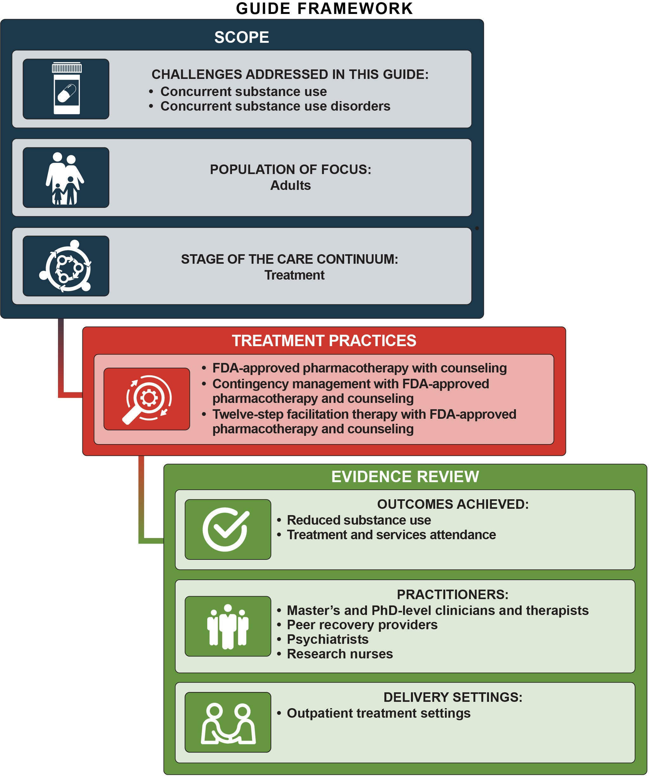

CHAPTER
1

Issue Brief

Many individuals use more than one substance. However, most research that examines substance use and establishes evidence-based practices for treatment addresses the use and treatment of a single substance.¹ Furthermore, the Diagnostic and Statistical Manual
of Mental Disorders (DSM-5)—which defines and classifies disorders to improve diagnosis, treatment, and research—includes a definition for substance use
disorders (SUD), but does not include a definition for or address concurrent substance use (CSU) or concurrent SUD, which complicates diagnosis and treatment.
Based on the DSM-5, SUD are a cluster of cognitive, behavioral, and physiological symptoms indicating that the individual continues using the substance despite significant substance-related problems.
Terminology
Clinicians and organizations may use other terms to describe CSU and concurrent SUD— these include co-occurring substance use, polysubstance use, and dual diagnosis.
This guide provides information on the prevalence and treatment of CSU (the use of more than one substance) and concurrent SUD (the use of more than one substance to the extent that the use of at least one substance causes significant impairment).

Individuals use more than one substance for a variety of reasons, including but not exclusive to:²⁻⁴
- Modify or enhance the effects of a single
substance
- Compensate for the effects of one substance by
taking another
- Prevent withdrawal symptoms
- Escape reality due to trauma, life circumstances, or other health problems
- Unavailability of their primary drug of choice
Once starting to use multiple substances, it may be difficult to stop.⁵
CSU and concurrent SUD lead to poor medical, mental health (including psychotic disorders), and substance use outcomes, for example, increased suicidal risk, medical problems, and overdoses.⁶⁻⁷
Treatment plans for multiple substances must address:²
  - The individual’s simultaneous intoxication and withdrawal from two or more substances
  - Varying timeframes for experiencing withdrawal symptoms for each substance
  - Withdrawal from one or more substances
  - Potential interactions between substances and Food and Drug Administration (FDA)-approved medications to treat the substance use and/or co- occurring mental disorder
Due to the complexity of treating individuals with CSU and concurrent SUD, individuals may require treatment and support services from different settings (e.g., residential, outpatient, or therapeutic communities) and different providers across settings.
Despite the prevalence of individuals using multiple substances at the same time, limited research exists on evidence-based treatment practices that have demonstrated improved treatment outcomes for
individuals who regularly use more than one substance.⁸ This guide assesses available treatment practices and other services for individuals with CSU or concurrent SUD, thereby filling a need to identify evidence-based treatment approaches and clinical resources for this population.
This chapter presents an overview of CSU and concurrent SUD, details risk and protective factors that influence CSU and concurrent SUD, and documents screening and assessment options to identify and address CSU and concurrent SUD in individuals.

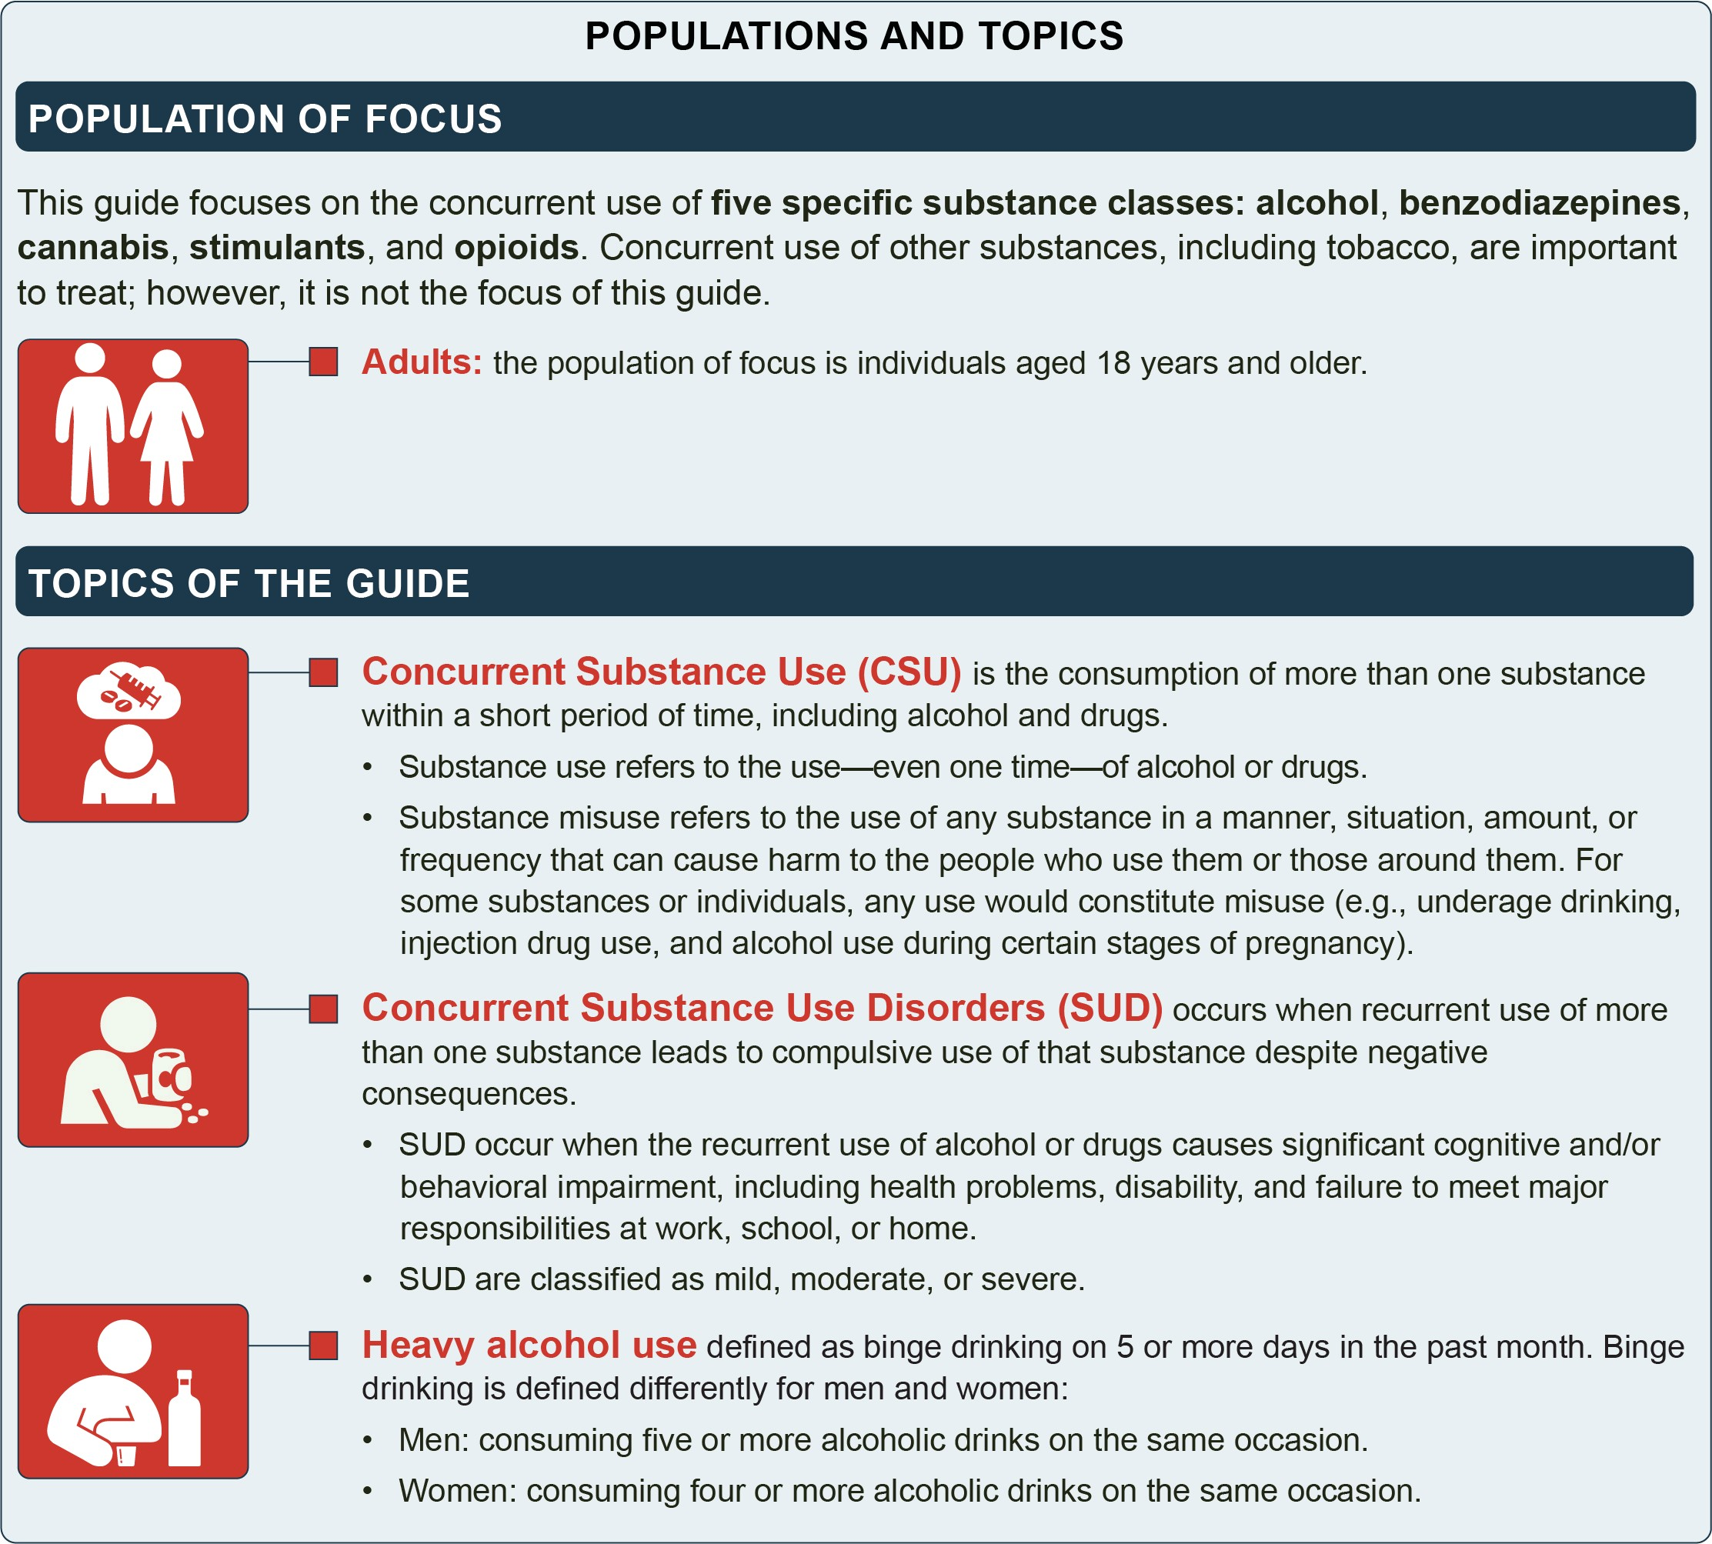

Prevalence and Patterns

Use of One Substance
Illicit drug use has increased steadily over the last 5 years among those 12 and older.⁹ Primary substances used or misused in 2019 included marijuana, prescription pain relievers, and hallucinogens.⁹
Heavy alcohol use remained high in 2019, with 8.4 percent of young adults aged 18 to 25 and 6.0 percent of all adults aged 18 or older reporting heavy alcohol use in the past month.⁹

The prevalence rates of heavy alcohol use differ by race and ethnicity. Prevalence was highest among Whites (7.4 percent), followed by Native Americans/Alaskan Natives (5.9 percent), Hispanics (4.9 percent), Native Hawaiians/ Other Pacific Islanders (4.6 percent), Blacks (4.0 percent), and Asians (2.6 percent). ¹⁰ When looking at age, the age group with the highest prevalence of heavy alcohol use is young adults aged 18 to 25 at 8.4 percent.⁹ Heavy alcohol use is also more prevalent among those who identify as lesbian, gay, and bisexual compared to those who do not (9.8 vs. 6.2 percent). ¹⁰

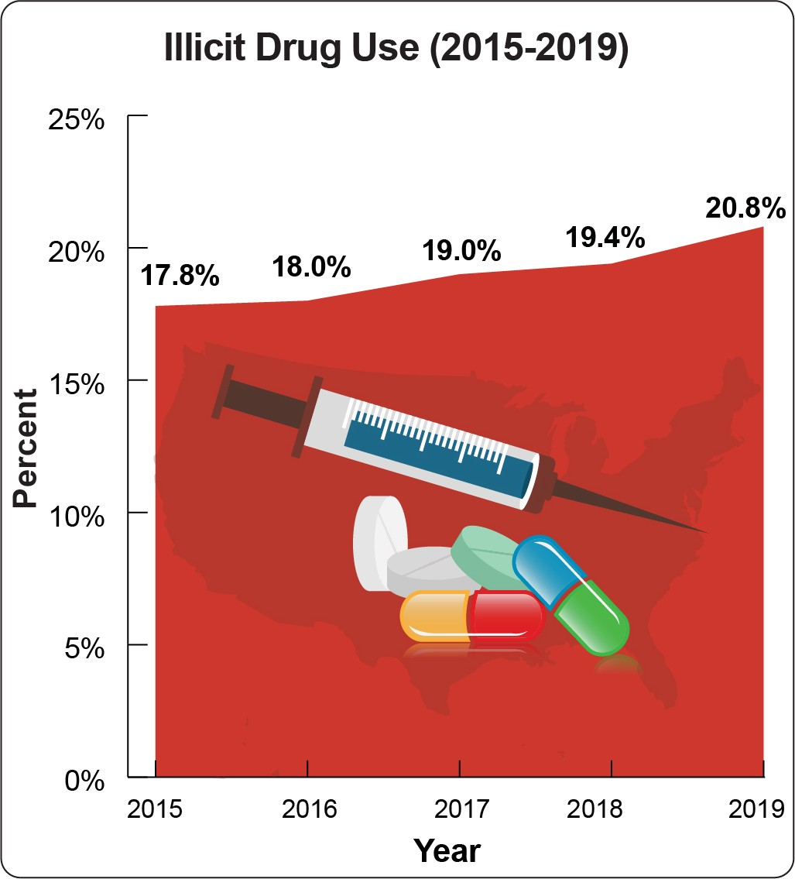
Source: Substance Abuse and Mental Health Services Administration. (2020). Key substance use and mental health indicators in the United States: Results from the 2019 National Survey on Drug Use and Health. https://www.samhsa.gov/data/ sites/default/files/reports/rpt29393/2019NSDUHFFRPDFWHTML/ 2019NSDUHFFR090120.htm
In 2019, 19.3 million people aged 18 or older reported having an SUD in the past year, including 7.4 million people with an illicit drug use disorder and 2.2 million people with both illicit drug and alcohol use disorders.⁹
The prevalence rates of SUD also differ by race and ethnicity. Prevalence was highest among Native Americans/Alaskan Natives (10.2 percent), followed by Native Hawaiians/Other Pacific Islanders (8.3 percent), Whites (8.1 percent), Blacks (7.6 percent), Hispanics (7.0 percent), and Asians (4.6 percent). ¹⁰ The age group with the highest prevalence of SUD is young adults aged 18 to 25 at 14.1 percent.⁹ SUD is more prevalent among those who identify as LGB compared to those who do not (18.3 percent vs. 7.1 percent).¹⁰ Men are also at greater risk:
62.7 percent of those with SUD in 2019 were male.⁹

Use of More Than One Substance
People who use one substance often use another. For example, of the people who used methamphetamines (a form of stimulants) in the past year, 68.1 percent also used marijuana, 43.7 percent used opioids, 32.2 percent used cocaine, and 13.4 percent reported heavy past month alcohol use.¹¹ Researchers have also found that individuals using marijuana were more likely to develop

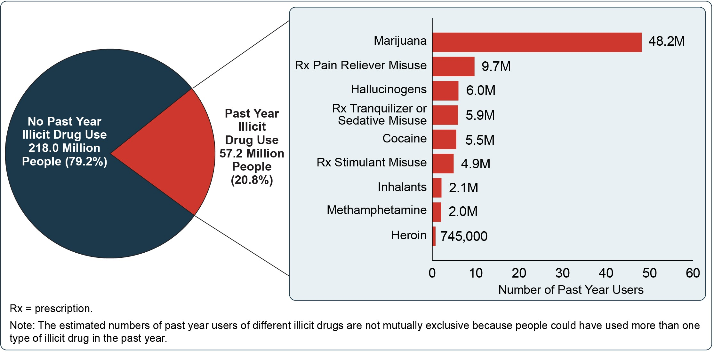
Source: Substance Abuse and Mental Health Services Administration. (2020). Key substance use and mental health indicators in the United States: Results from the 2019 National Survey on Drug Use and Health. https://www.samhsa.gov/data/sites/default/files/reports/ rpt29393/2019NSDUHFFRPDFWHTML/2019NSDUHFFR090120.htm

Among individuals with… | Percentage of individuals who also have…
 | Alcohol use disorder | Marijuana use disorder | Cocaine use disorder | Prescription opioid use disorder | Heroin use disorder
Alcohol use disorder | - | 9.5 | 3.3 | 3.9 | 0.9
Marijuana use disorder | 38.7 | - | 4.8 | 7.9 | 1.3
Cocaine use disorder | 59.8 | 21.3 | - | 16.4 | 13.4
Prescription opioid use disorder | 35.2 | 17.6 | 8.2 | - | 11.2
Heroin use disorder | 24.5 | 12.3 | 20.9 | 34.9 | -
Source: National Institute on Drug Abuse. (2020, April). Common comorbidities with substance use disorders research report: What are some approaches to diagnosis? National Institutes of Health. https://www.drugabuse.gov/publications/research-reports/common- comorbidities-substance-use-disorders/what-are-some-approaches-to-diagnosis

nonmedical prescription opioid use and opioid use disorder (OUD).¹²⁻¹³ Those using marijuana daily were also more likely to use cocaine, hallucinogens, inhalants, and tobacco.¹⁴
The prevalence rates of those who use more than one substance in the past month also differ by race and ethnicity. Prevalence was highest among Blacks (11.1 percent), followed closely by Whites (11.0 percent), Native Americans/Alaskan Natives (10.3 percent), Native Hawaiians/Other Pacific Islanders (9.3 percent), Hispanics (8.7 percent), and Asians (4.7 percent).¹⁰ The age group with the highest prevalence of those who use more than one substance is young adults aged 18 to 25 at
20.4 percent.¹⁰ CSU is more prevalent among those who identify as LGB compared to those who do not (29.5 percent vs. 9.8 percent).¹⁰
Of particular concern are pregnant women, with
prevalence estimates of 64.7 percent, 9.8 percent, and
4.5 percent for past 12-month drinking, current drinking, and binge drinking, respectively. Among those who were pregnant and reported drinking in the past 12 months,
41.7 percent also reported using at least one other substance in the past 12 months, principally marijuana (21.9 percent) and opioids (7.0 percent).¹⁵
In addition to CSU, many individuals develop concurrent SUD. For example, among people with a cocaine use disorder, nearly 60 percent have an alcohol use disorder and over 21 percent have a marijuana use disorder.¹⁶ Also, 90 percent of those with an OUD used more than two other substances within the same year, and over 25 percent had at least two other SUD.³

Protective and Risk Factors
Genetic and environmental protective and risk factors influence whether a person uses or misuses specific substances and develops an SUD. These same protective and risk factors also contribute to whether a person will use or misuse multiple substances and develop concurrent SUD.¹⁷
Protective factors that serve as barriers to an individual developing an SUD begin early in life: a stable living environment free from exposure to substances, trauma, and abuse, and healthy relationships with family and friends.¹⁸⁻¹⁹ Later in life, people with a consistent source of income, a feeling of purpose and belonging in one’s community, and a strong social support network are less likely to develop concurrent SUD.²⁰
Research has shown that those with concurrent SUD exhibit more severe risk factors when compared to their SUD counterparts.¹⁸ Those with more SUD were more likely to be younger, male, and single; have severe medical and psychiatric comorbidities, be socioeconomic disadvantaged, unemployed, and unemployment, and exposed to SUD through family or a peer group.^{19,21}

Impact of the Problem
SUD is associated with detrimental effects that include:⁵
- Adverse physical and mental health effects
- Negative outcomes for children who have a parent with SUD
- Criminalized behavior
- Costs associated with enforcement and incarceration
- Environmental damage
- Premature death

While studies on the impact of CSU and concurrent SUD are limited, available research demonstrates that, when compared to people with a single SUD, CSU and concurrent SUD are associated with higher rates of:
- Lifetime suicide attempts, arrests, and incarceration¹⁸
- Financial and legal problems¹⁸
- Increased likelihood of overdose²²⁻²³
- More severe medical and psychiatric comorbidities (e.g., the prevalence of a mental disorder is higher among those who are dependent on multiple psychoactive substances, such as heroin, alcohol, or cocaine, than those who use one substance)¹⁹
The effects of CSU and concurrent SUD are dependent on the combination of substances involved. For example, people who use alcohol and marijuana together are more than twice as likely to drive while impaired than those who did not use both together²⁴ and alcohol is involved in approximately 15 to 20 percent of opioid overdose deaths.²⁵

Screening and Assessment
Traditionally, SUD assessment, diagnosis, and treatment have focused on individual substances.^{18,21} However, among those diagnosed with an SUD, many may
use or be dependent on more than one substance.^{21,26}
For example, among people diagnosed with OUD,
a large proportion also use stimulants, alcohol, and/

Potential adverse acute and medical effects of combining substances include:
- Brain damage
- Coma
- Heart problems
- Respiratory failure
- Psychiatric illnesses, such as psychosis
- Liver damage and failure
- Seizures
- Stomach bleeding
- Heatstroke
- Suppressed breathing

or tobacco. Stimulant use may include use of cocaine and amphetamines. An additional substance carries increased risk to the client and necessitates appropriate intervention.
Healthcare providers, legal system personnel, and those working with adults should screen and, as appropriate, refer people for further assessment. Screening and comprehensive assessments are essential for identifying individuals at risk for or struggling with concurrent SUD. Moreover, it is important to assess
for all substances to achieve a more comprehensive understanding of the individual.

Combining Substances… | Potential Adverse Effects of the Combination
Stimulants (e.g., cocaine and MDMA/ ecstasy) | - Serotonin syndrome  - Psychosis  - Anxiety or panic attacks  - Cardiovascular problems, including heart attacks, potentially fatal ones
Depressants (e.g., benzodiazepines and alcohol) | - Accidents or injury due to sedation  - Fatal overdose  - Nonfatal overdose, which can result in permanent brain damage
Stimulants and Depressants (e.g., amphetamines and alcohol) | - Cardiovascular problems and heart failure  - Respiratory infections and bronchitis  - Dehydration, overheating, and kidney failure
Source: Positive Choices. (2019). Polydrug Use: Factsheet. https://positivechoices.org.au/teachers/polydrug-use-factsheet

Universal screening should be a standard part of any primary care practice. Additionally, clinicians who serve people entering substance use or mental health treatment should be equipped to screen and assess for use of multiple substances.
When first working with a potential client, primary care, mental health, and substance use clinicians can screen using a validated instrument, and then conduct a more thorough assessment to determine the severity and type of CSU or concurrent SUD. Objective assessment of biomarkers through specimen collection can provide collateral information to the self-reported screenings.
SAMHSA’s TAP 32: Clinical Drug Testing in Primary Care provides useful information on clinical testing.
Listed below are screening and assessment tools; tools for screening and assessing alcohol use can be combined with tools for screening and assessing other substance use. Costs differ by screening and assessment tool.
Screening Tools

Adults aged 18 and older
- Tobacco, Alcohol, Prescription Medication, and
Other Substance Use Tool (TAPS)²⁷
- Alcohol, Smoking, and Substance Involvement Screening Test (ASSIST)²⁸
- Drug Abuse Screening Test (DAST-10) Questionnaire (10-item)²⁹
- Drug Abuse Screening Test (DAST-20) Questionnaire (20-item)³⁰
- CAGE-AID Substance Abuse Screening Tool³¹
- Two-Item Conjoint Screening Test (TICS)³²
- Alcohol Use Disorders Identification Test
(AUDIT)³³
- AUDIT Alcohol Consumption Questions (AUDIT-C)³⁴
- Rapid Alcohol Problems Screen (RAPS4)³⁵
- Single-Question Alcohol Screening Test³⁶
- TWEAK (Tolerance, Worry About Drinking, Amnesia, Cut Down on Drinking)³⁷
Young Adults aged 18-25
- CRAFFT³⁸
- UNCOPE³⁹
Comprehensive Assessments

Adults
- Addiction Severity Index (ASI)⁴⁰
- Drug Use Screening Inventory - Revised (DUSI-R)⁴¹
- Global Appraisal of Individual Needs (GAIN)⁴²
- Adult Substance Use Survey - Revised (ASUS-R)⁴³
- Comprehensive Addictions and Psychological Evaluation (CAAPE-5)⁴⁴
- Composite International Diagnostic Interview Version (CIDI core)⁴⁵
- Structured Clinical Interview for DSM-5 (SCID- 5)46
- Substance Use Disorders Diagnostic Schedule (SUDDS-IV)⁴⁷
Young Adults
- Comprehensive Adolescent Severity Inventory (CASI)⁴⁸

Treatment
The majority of people aged 12 and older who are admitted to publicly funded SUD treatment use more than one substance.⁴⁹ For example, nearly all people entering treatment for OUD had used at least one non-opioid substance in the past month (more than 90 percent).⁵⁰
Adults with CSU or concurrent SUD involving alcohol, marijuana, opioids, and/or stimulants receive care in
a variety of settings, and often require withdrawal management, psychological and FDA-approved pharmacological treatment, and monitoring as part of their care plan.⁵¹ Treatment planning to address CSU and concurrent SUD can be challenging, as best practice treatment options to address one substance may limit clients’ eligibility to receive or enroll in treatment
for the other. For example, use of FDA-approved pharmacotherapy for OUD may influence an individual’s participation in a residential alcohol treatment program.⁵²

Individuals who have been identified with concurrent SUD have been shown to have complex related medical, psychiatric, and social needs. As a result of those complex needs, clients with concurrent SUD are prescribed significantly more antidepressants,
antipsychotics, and opioids than the general population.¹⁸ The prescribed medications, if used with alcohol and other substances, may put the client at risk for adverse drug interactions.

An effective treatment relationship is built on confidentiality. 42 CFR Part 2 regulates sharing of information. An update to the regulation intends to facilitate better coordination of care while maintaining its confidentiality protections against unauthorized disclosure and use.

A focus on individual substances or sequential treatment of each substance will not adequately meet all of a client’s needs, resulting in higher rates of unsuccessful treatment and relapse.¹⁸ Further, clinicians with specialized training in evidence-based treatment to address one substance may not have the capacity or skills to address the other. For example, an individual with concurrent opioid, stimulant, and marijuana use
or use disorders may receive psychological treatment (such as cognitive behavioral therapy) from a mental health clinician as part of stimulant and marijuana withdrawal treatment (as both are considered evidence- based practices to treat these SUD⁵³⁻⁵⁴), but would need to receive medications for their OUD from a clinician authorized to provide them.
When many systems of care are fragmented, there are inherent difficulties and complexities in identifying and treating individuals with concurrent SUD in a holistic manner. Effective treatment requires customized and coordinated care, which can often be challenging to access and have limited availability.
Considering the breadth and complexity associated with concurrent SUD, well-coordinated treatment encompassing social, behavioral health, and medical services in a single setting is advantageous. Co-location could lead to greater service utilization and positive outcomes²³ by employing case managers to provide
clients with a range of needed psychosocial services (e.g., transportation, employment assistance, legal assistance, childcare, food, and housing assistance). Once trust and rapport are established and their most pressing underlying needs are met, clients may be more likely to seek in- house medical and behavioral health care.
Realizing the importance of a client’s surrounding environment and access to and availability of substances, clinicians should be mindful to inquire about an individual’s living circumstances and social support network. They can then coordinate with the individual or the case manager (as appropriate) and integrate solutions and goals into treatment if CSU or concurrent SUD risks are apparent.
The remainder of this guide documents the research on evidence-based treatments that address more than one substance at the same time, and provides strategies and real-life examples of organizations providing treatment practices and other services to individuals with CSU and concurrent SUD.

Reference List

¹ Crummy, E. A., O’Neal, T. J., Baskin, B. M., & Ferguson, S. M. (2020). One is not enough:
Understanding and modeling polysubstance use. Frontiers in Neuroscience, 14, 569. https://dx.doi. org/10.3389%2Ffnins.2020.00569
² Kleber, H. D., Weiss, R. D., Anton, R. F., George,
T. P., Greenfield, S. F., Kosten, T. R., O’Brien, C.
P., Rounsaville, B. J., Strain, E. C., Ziedonis, D. M., Hennessy, G., & Connery, H. S. (2006). Practice guideline for the treatment of patients with substance use disorders: Second edition. American Psychiatric Association. https://psychiatryonline.org/pb/assets/ raw/sitewide/practice_guidelines/guidelines/ substanceuse.pdf
³ Compton, W. M., Valentino, R. J., & DuPont, R. L. (2021). Polysubstance use in the US opioid crisis. Molecular Psychiatry, 26(1), 41-50. https://doi. org/10.1038/s41380-020-00949-3
⁴ National Institute on Drug Abuse. (2020, May). The Science of Drug Use: A Resource for the Justice Sector. National Institutes of Health. https://www. drugabuse.gov/drug-topics/criminal-justice/science- drug-use-resource-justice-sector
⁵ U.S. Department of Health and Human Services (HHS), Office of the Surgeon General. (2016). Facing Addiction in America: The Surgeon General’s Report on Alcohol, Drugs and Health. Washington, DC: HHS, November 2016. https:// addiction.surgeongeneral.gov/sites/default/files/ surgeon-generals-report.pdf
⁶ Timko, C., Han, X., Woodhead, E., Shelley, A., & Cucciare, M. A. (2018). Polysubstance use by stimulant users: Health outcomes over three years. Journal of Studies on Alcohol and Drugs,
79(5), 799-807. https://dx.doi.org/10.15288%2Fjs ad.2018.79.799
⁷ Connolly, B. (2020, October 8). Opioid overdose crisis compounded by polysubstance use. The Pew Charitable Trusts. https://www.pewtrusts.org/en/ research-and-analysis/fact-sheets/2020/10/opioid- overdose-crisis-compounded-by-polysubstance-use
⁸ Manhapra A, Rosenheck R. Commentary on Lin et al. (2021). Saving lives during the opioid crisis- widening the focus from opioid use disorder to polysubstance use disorder and to multimorbidity.
Addiction, 116(1):105-106. https://doi.org/10.1111/ add.15229
⁹ Substance Abuse and Mental Health Services Ad- ministration. (2020). Key substance use and mental health indicators in the United States: Results from the 2019 National Survey on Drug Use and Health. https://www.samhsa.gov/data/sites/default/files/ reports/pt29393/2019NSDUHFFRPDFWHTM- L/2019NSDUHFFR090120.htm
¹⁰ Center for Behavioral Health Statistics and Quality. (2021). Results from the 2019 National Survey on Drug Use and Health: [Special Data Analyses].
¹¹ McCance-Katz, E. F. (2020). The National Survey on Drug Use and Health: 2019 [PowerPoint slides]. Substance Abuse and Mental Health Services Administration. https://www.samhsa.gov/data/sites/ default/files/reports/rpt29392/Assistant-Secretary- nsduh2019_presentation/Assistant-Secretary- nsduh2019_presentation.pdf
¹² Azagba, S., Shan, L., Manzione, L., Qeadan, F., & Wolfson, M. (2019). Trends in opioid misuse among marijuana users and non-users in the U.S. from 2007-2017. International Journal of Environmental Research and Public Health, 16(22), 4585. https:// doi.org/10.3390/ijerph16224585
¹³ Olfson, M., Wall, M. M., Liu, S. M., & Blanco, C. (2018). Cannabis use and risk of prescription opioid use disorder in the United States. American Journal of Psychiatry, 175(1), 47-53. https://doi.org/10.1176/ appi.ajp.2017.17040413
¹⁴ Tzilos, G. K., Reddy, M. K., Caviness, C. M., Anderson, B. J., & Stein, M. D. (2014). Getting higher: Co-occurring drug use among marijuana- using emerging adults. Journal of Addictive Diseases, 33(3), 202-209. https://psycnet.apa.org/doi
/10.1080/10550887.2014.950024
¹⁵ England, L. J., Bennett, C., Denny, C. H., Honein,
M. A., Gilboa, S. M., Kim, S. Y., Guy Jr., G. P., Tran,
E. L., Rose, C. E., Bohm, M. K., & Boyle, C. A. (2020). Alcohol use and co-use of other substances among pregnant females aged 12–44 years — United States, 2015–2018. Morbidity and Mortality Weekly Report, 69(31), 1009-1014. https://www.cdc.gov/ mmwr/volumes/69/wr/mm6931a1.htm

¹⁶ National Institute on Drug Abuse. (2020, April). Common comorbidities with substance use disorders research report: What are some approaches to diagnosis? National Institutes of Health. https:// www.drugabuse.gov/publications/research-reports/ common-comorbidities-substance-use-disorders/ what-are-some-approaches-to-diagnosis
¹⁷ Kendler, K. S., Jacobson, K. C., Prescott, C. A., & Neale, M. C. (2003). Specificity of genetic and environmental risk factors for use and abuse/ dependence of cannabis, cocaine, hallucinogens, sedatives, stimulants, and opiates in male twins.
American Journal of Psychiatry, 160(4), 687-695. https://doi.org/10.1176/appi.ajp.160.4.687
¹⁸ Bhalla, I. P., Stefanovics, E. A., & Rosenheck, R.
A. (2017). Clinical epidemiology of single versus multiple substance use disorders: Polysubstance use disorder. Medical Care, 55(9 Suppl 2), S24-S32. https://doi.org/10.1097/mlr.0000000000000731
¹⁹ Shaffer, H. J., LaPlante, D. A., LaBrie, R. A., Kidman, R. C., Donato, A. N., & Stanton, M. V. (2004). Toward a syndrome model of addiction: Multiple expressions, common etiology. Harvard Review of Psychiatry, 12(6), 367-374. https:// psycnet.apa.org/doi/10.1080/10673220490905705
²⁰ Sloboda, Z., Glantz, M. D., & Tarter, R. E. (2012). Revisiting the concepts of risk and protective factors for understanding the etiology and development
of substance use and substance use disorders: Implications for prevention. Substance Use & Misuse, 47(8-9), 944-962. https://doi.org/10.3109/10
826084.2012.663280
²¹ McCabe, S. E., & West, B. T. (2017). The 3-year course of multiple substance use disorders in the United States: A national longitudinal study. Journal of Clinical Psychiatry, 78(5), e537-e544. https://doi. org/10.4088/jcp.16m10657
²² Coffin, P. O., Galea, S., Ahern, J., Leon, A. C., Vlahov, D., & Tardiff, K. (2003). Opiates, cocaine and alcohol combinations in accidental drug overdose deaths in New York City, 1990-98. Addiction, 98(6), 739-747. https://doi.org/10.1046/ j.1360-0443.2003.00376.x
²³ Dillon, P., Copeland, J., & Jansen, K. (2003). Patterns of use and harms associated with non-medical ketamine use. Drug and Alcohol
Dependence, 69(1), 23-28. https://doi.org/10.1016/ s0376-8716(02)00243-0
²⁴ Subbaraman, M. S., & Kerr, W. C. (2015). Simultaneous versus concurrent use of alcohol and cannabis in the National Alcohol Survey. Alcoholism, Clinical and Experimental Research, 39(5), 872-879. https://doi.org/10.1111/acer.12698
²⁵ Tori, M. E., Larochelle, M. R., & Naimi, T.
S. (2020). Alcohol or benzodiazepine co- involvement with opioid overdose deaths in the United States, 1999-2017. JAMA
Network Open, 3(4), e202361. https://dx.doi. org/10.1001%2Fjamanetworkopen.2020.2361
²⁶ John, W. S., Zhu, H., Mannelli, P., Schwartz,
R. P., Subramaniam, G. A., & Wu, L. T. (2018). Prevalence, patterns, and correlates of multiple substance use disorders among adult primary care patients. Drug and Alcohol Dependence, 187, 79-87. https://doi.org/10.1016/j.drugalcdep.2018.01.035
²⁷ National Institutes of Health. (n.d.). TAPS: Tobacco, alcohol, prescription medication, and other substance use tool. https://www.drugabuse.gov/taps/#/
²⁸ Humeniuk, R., Henry-Edwards, S., Ali, R., Poznyak, V., & Monteiro, M. G. (2010). The alcohol,
smoking and substance involvement screening test (ASSIST): Manual for use in primary care. World Health Organization. https://apps.who.int/iris/ handle/10665/44320
²⁹ National Institute on Drug Abuse. (n.d.). Drug Abuse Screening Test (DAST-10). https:// cde.drugabuse.gov/sites/nida_cde/files/ DrugAbuseScreeningTest_2014Mar24.pdf
³⁰ Department of Public Health Sciences, University of Toronto. (n.d.). Drug Use Questionnaire (DAST
- 20). Health Resources & Services Administration. https://www.hrsa.gov/behavioral-health/drug-use- questionnaire-dast-20
³¹ Pedagogy Online Learning Systems (n.d.). CAGE- AID Substance Abuse Screening Tool. Health Resources & Services Administration. https://www. hrsa.gov/behavioral-health/cage-aid-substance- abuse-screening-tool
³² Veterans Integrated Service Network. (n.d.). Two- item Conjoint Screen (TICS). https://www.mirecc. va.gov/visn22/TICS.pdf
³³ Barbor, T., Higgins-Biddle, J. C., Saunders, J. B., & Monteiro, M. G. (2001). AUDIT: The alcohol use disorders identification test: Guidelines for use in primary health care. World Health Organization. https://www.who.int/publications/i/item/audit-the- alcohol-use-disorders-identification-test-guidelines- for-use-in-primary-health-care
³⁴ Bush, K., Kivlahan, D. R., McDonell, M. B., Fihn,
S. D., & Bradley, K. A. (1998). The AUDIT alcohol consumption questions (AUDIT-C): An effective brief screening test for problem drinking. Archives of Internal Medicine, 158(16), 1789-1795. https://doi. org/10.1001/archinte.158.16.1789

³⁵ National Institute on Alcohol Abuse and Alcoholism. (n.d.). Rapid Alcohol Problems Screen (RAPS4). Assessing Alcohol Problems: A Guide for Clinicians and Researchers (pp. 535-537). https://pubs. niaaa.nih.gov/publications/assessingalcohol/ InstrumentPDFs/54_RAPS4.pdf
³⁶ Smith, P. C., Schmidt, S. M., Allensworth-Davies, D., & Saitz, R. (2009). Primary care validation of a single-question alcohol screening test. Journal of General Internal Medicine, 24(7), 783-788.
³⁷ National Institute on Alcohol Abuse and Alcoholism. (n.d.). TWEAK. Assessing Alcohol Problems: A Guide for Clinicians and Researchers (pp. 649- 651). https://pubs.niaaa.nih.gov/publications/ assessingalcohol/instrumentpdfs/74_tweak.pdf
³⁸ CRAFFT. (n.d.). About the CRAFFT. Boston Children’s Hospital. https://crafft.org/about-the-crafft/
³⁹ Hoffman, N. (n.d.). UNCOPE. Evince Clinical Assessments. https://ncsacw. samhsa.gov/files/TrainingPackage/MOD2/ ExampleScreenQuestionsUNCOPE.pdf
⁴⁰ National Institute on Alcohol Abuse and Alcoholism. (n.d.). Addiction Severity Index (ASI). Assessing Alcohol Problems: A Guide for Clinicians and Researchers (pp. 245-247). https:// pubs.niaaa.nih.gov/publications/AssessingAlcohol/ InstrumentPDFs/04_ASI.pdf
⁴¹ National Institute on Alcohol Abuse and Alcoholism. (n.d.). Drug Use Screening Inventory (revised) (DUSI-R). Assessing Alcohol Problems: A Guide for Clinicians and Researchers (pp. 393-395). https:// pubs.niaaa.nih.gov/publications/AssessingAlcohol/ InstrumentPDFs/32_DUSI-R.pdf
⁴² National Institute on Alcohol Abuse and Alcoholism. (n.d.). Global Appraisal of Individual Needs (GAIN). Assessing Alcohol Problems: A Guide for Clinicians and Researchers (pp. 417-420). https:// pubs.niaaa.nih.gov/publications/AssessingAlcohol/ InstrumentPDFs/37_GAIN.pdf
⁴³ Center for Addictions Research and Evaluation. (2019). ASUS - R | Adult Substance Use Survey - Revised. http://aodassess.com/assessment_tools/asus/
⁴⁴ Hoffman, N. (2013). CAAPE-5: Comprehensive Addictions and Psychological Evaluation. Evince Clinical Assessments. https://evincediagnostics.com/ assessment/caape-5
⁴⁵ National Institute on Alcohol Abuse and Alcoholism. (n.d.). Composite International Diagnostic Interview (CIDI core) Version 2.1. Assessing Alcohol Problems: A Guide for Clinicians and Researchers (pp. 343- 345). https://pubs.niaaa.nih.gov/publications/ assessingalcohol/InstrumentPDFs/20_CIDI.pdf
⁴⁶ American Psychiatric Association. (n.d.). The Structured Clinical Interview for DSM-5®. https:// www.appi.org/products/structured-clinical- interview-for-dsm-5-scid-5
⁴⁷ National Institute on Alcohol Abuse and Alcoholism. (n.d.). Substance Use Disorders Diagnostic Schedule (SUDDS-IV). Assessing Alcohol Problems: A
Guide for Clinicians and Researchers (pp. 598- 601). https://pubs.niaaa.nih.gov/publications/ AssessingAlcohol/InstrumentPDFs/68_SUDDS-IV. pdf
⁴⁸ National Institute on Alcohol Abuse and Alcoholism. Comprehensive Adolescent Severity Inventory (CASI). (n.d.). Assessing Alcohol Problems: A Guide for Clinicians and Researchers (pp. 346- 348). https://pubs.niaaa.nih.gov/publications/ AssessingAlcohol/InstrumentPDFs/21_CASI.pdf
⁴⁹ Substance Abuse and Mental Health Services Administration. (2017). National Admissions to Substance Abuse Treatment Services: 2015
Treatment Episode Data Set (TEDS) 2005-2015. https://www.samhsa.gov/data/sites/default/ files/2015_Treatment_Episode_Data_Set_ National/2015_Treatment_Episode_Data_Set_ National.pdf
⁵⁰ Cicero, T. J., Ellis, M. S., & Kasper, Z. A. (2020). Polysubstance use: A broader understanding of substance use during the opioid crisis. American Journal of Public Health, 110(2), 244-250. https:// dx.doi.org/10.2105%2FAJPH.2019.305412
⁵¹ Connor, J. P., Gullo, M. J., White, A., & Kelly, A. B. (2014). Polysubstance use: Diagnostic challenges, patterns of use and health. Current Opinion in Psychiatry, 27(4), 269-275. https://doi.org/10.1097/ yco.0000000000000069
⁵² Nolan, S., Klimas, J., & Wood, E. (2016). Alcohol use in opioid agonist treatment. Addiction Science & Clinical Practice, 11(1), 17. https://dx.doi.org/10.11 86%2Fs13722-016-0065-6
⁵³ Copeland, J., & Swift, W. (2009) Cannabis use disorder: Epidemiology and management.
International Review of Psychiatry, 21(2), 96-103. https://doi.org/10.1080/09540260902782745
⁵⁴ Substance Abuse and Mental Health Services Administration. (2020). Treatment of Stimulant Use Disorders. https://store.samhsa.gov/sites/default/ files/SAMHSA_Digital_Download/PEP20-06-01- 001_508.pdf

Concurrent substance use (CSU) and concurrent substance use disorders (SUD) affect an individual’s physical and mental health. They can also create a larger public health problem that can have negative impacts on families and communities. Research on practices to address CSU and concurrent SUD is limited, making identification of the most effective treatment methods challenging. Through a literature review and consensus from technical experts (see Appendix 2), the Substance Abuse and Mental Health Services Administration (SAMHSA) identified three approaches used to address CSU and concurrent SUD in adults:
- FDA-approved pharmacotherapy together with counseling
- Contingency management together with FDA- approved pharmacotherapy and counseling
- Twelve-step facilitation (TSF) therapy together with FDA-approved pharmacotherapy and counseling

Treatment Practice Selection
To be considered for inclusion in this guide, eligible treatment practices had to meet the following criteria:
  - Be clearly defined and replicable
  - Address substance use reduction as a primary outcome
  - Be currently in use
  - Have evidence of effectiveness
  - Have accessible resources for effective
implementation

Evidence Review and Rating
A comprehensive review of published research for each selected treatment practice was conducted to determine its strength as an evidence-based practice. Each study examined the impact of the treatment practice on use of a combination of substances in two or more relevant substance classes—marijuana, alcohol, opioids, stimulants, and benzodiazepines.

2CHAPTER
What Research Tells Us
Screening for substance use through standardized tools helps clinicians identify adults who may be at risk for CSU and concurrent SUD and implement appropriate treatment plans. A comprehensive assessment and history of a client’s mental function, substance use behavior, trauma, health history, and home life typically
follow a positive screen. This assessment should be completed using a structured or semi-structured approach; the results can assist clinicians in determining appropriate next steps and tailoring specific treatments to meet the client’s needs. Chapter 1 describes screening and assessment tools.

Eligible research studies had to:
  - Employ a randomized or quasi-experimental design, or
  - Be a single sample pre-post design or an epidemiological study with a strong
counterfactual feature (i.e., a study that analyzes what would have happened in the absence of the intervention).
Descriptive and implementation studies and meta- analyses were not included in the review, but were documented to provide context and identify
implementation supports for the treatment practices.
Reviewers then rated each study as low support, moderate support, or high support of causal evidence. In this process, reviewers assessed each eligible study for evidence of improvements in substance use behavior as the primary outcomes of interest. They also reviewed the studies for related health and social outcomes, such as those related to mental health and criminal justice.

Causal Impact: Evidence demonstrating that an intervention causes or is responsible for the outcomes measured in the study’s sample population.

Reviewers checked each study to ensure rigorous methodology, asking questions such as:
  - Are experimental and comparison groups demographically equivalent, with the only difference being that participants in the experimental group received the intervention and those in the comparison group received treatment as usual or no or minimal intervention?
  - Was baseline equivalence established between the treatment and comparison groups on outcome measures?
  - Were missing data addressed appropriately?
  - Were outcome measures reliable, valid, and collected consistently from all participants?
Only randomized controlled trials, quasi-experimental designs, and epidemiological studies with a strong comparison group were eligible to receive a high or moderate rating.

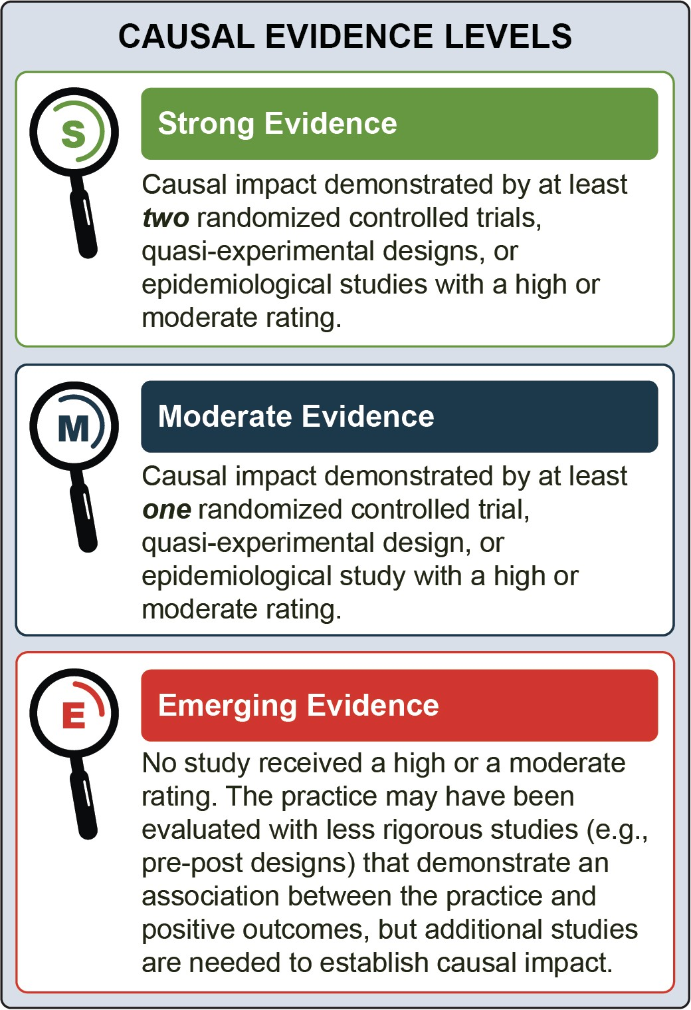

After all studies for a treatment practice were assessed and rated, the treatment practice was placed into one of three categories based on its causal evidence level: strong evidence, moderate evidence, or emerging evidence. See Appendix 2 for more information about the evidence review process.

Research Opportunity
This evidence review identified research studies for three
treatment practices and four substance combinations. Although the body of research is growing, clinicians continue to face the challenge of limited evidence, particularly from well-designed randomized controlled trials (RCTs), when selecting programs to address CSU and concurrent SUD in adults. There are multiple treatment practices for SUD for one substance, but they have not been studied for CSU and for additional substance combinations. The field would benefit from more research on treatment practices for different
combinations of substances and for diverse populations (inclusive of race, ethnicity, age, and sex).

Identification of Effective Treatment Practices for CSU
and Concurrent SUD

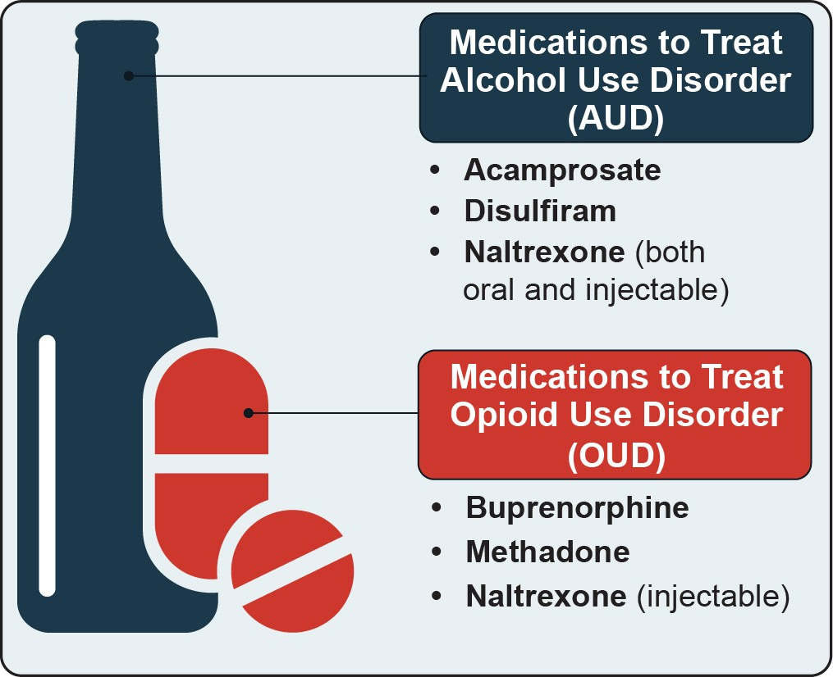
A Note on Terminology
The Diagnostic and Statistical Manual of Mental Disorders (DSM) provides standard criteria for the classification of mental health issues and substance use. Each version of the DSM includes different language to describe substance use:
- DSM-IV uses the terms “abuse” and “dependence”
- DSM-5 uses the term “use disorder”
This guide presents the terminology that was used in the relevant studies.

FDA-Approved Pharmacotherapy Together with Counseling

Overview
Pharmacotherapy refers to the use of medications approved by the Food and Drug Administration (FDA) to help reduce substance use. Pharmacotherapy is delivered alongside behavioral therapy to treat individuals with alcohol or opioid use disorders and address concurrent substance use. The FDA has approved several medications that may be prescribed to treat individuals with alcohol use disorder (AUD) or opioid use disorder (OUD).^{1,2}
A physician or other qualified licensed healthcare clinician will determine the appropriate medication, dose, and duration of pharmacotherapy for individuals with AUD or OUD and concurrent use of other substances. These determinations will be specific to

each individual, and include factors such as diagnosis, psychiatric and substance use histories, client preferences, and treatment availability. Pharmacotherapy may be utilized in combination with other treatment.³

Typical Settings
All pharmacotherapy for AUD and naltrexone for
OUD can be administered in a wide range of healthcare settings and levels of care, including substance use treatment programs or general medical settings, such
as primary care offices.² However, different regulations apply to buprenorphine and methadone for treating OUD. Only federally certified, accredited opioid treatment programs (OTPs) can administer methadone. A variety of waivered practitioner types in different settings, including primary care outpatient clinics and OTPs, can prescribe buprenorphine.

Substance | FDA-  Approved Medication | Administration | Setting |  |  | Prescriber
 |  |  | General Medical | Substance Use Treatment | Federally Certified, Accredited Opioid Treatment Programs
Alcohol | Acamprosate | Two delayed-release tablets by mouth three times per day | ✓ | ✓ | ✓ | Any qualified  practitioner
 | Disulfiram | Tablet by mouth once daily | ✓ | ✓ | ✓ | Any qualified  practitioner
 | Naltrexone | Tablet by mouth once daily, or injection every 4 weeks or once per month | ✓ | ✓ | ✓ | Any qualified  practitioner
Opioids | Buprenorphine | Tablet sublingually or buccally once daily or injection monthly | ✓ | ✓ | ✓ | Qualified practitioners who have received a federal waiver to prescribe
 | Methadone | Liquid concentrate, tablet, or oral solution by mouth once daily |  |  | ✓ | Qualified  practitioners in OTPs
 | Naltrexone | Injection every 4 weeks or once per month | ✓ | ✓ | ✓ | Any qualified  practitioner

Demographic Groups
All individuals may receive pharmacotherapy; however, additional considerations apply to pregnant and postpartum women. For treating OUD during pregnancy, methadone or buprenorphine is recommended.² Acamprosate, disulfiram, and naltrexone for AUD have not yet been studied for pregnant and breastfeeding women.¹

Clinician Types
Physicians or other qualified healthcare professionals can prescribe and monitor medications for AUD and naltrexone for OUD. Qualifying healthcare professionals must obtain a federal waiver to prescribe buprenorphine for OUD. In April 2021, new Practice Guidelines
were issued that make it easier for clinicians treating 30 or fewer people to prescribe buprenorphine; more information can be found in SAMHSA’s FAQ on this topic. Only federally certified and accredited OTPs can dispense methadone for OUD.

Scope of Evidence Review
The studies included in this review examined the impact of pharmacotherapy combined with counseling for concurrent SUD. Three studies evaluated pharmacotherapy for AUD in sample populations with concurrent cocaine dependence,⁴⁻⁶ and two evaluated pharmacotherapy for OUD in sample populations with concurrent cocaine dependence.⁷⁻⁸

FDA-Approved Pharmacotherapy Together With Counseling for Alcohol and Cocaine Dependence

Three studies examined the impact of FDA-approved pharmacotherapy for AUD combined with counseling for alcohol use and cocaine dependence.⁴⁻⁶ Participants received naltrexone, disulfiram, or both. The counseling approach and frequency varied slightly by study. Participants in two studies received cognitive

behavioral therapy (CBT), weekly for 12 weeks in one study⁵ and twice weekly for 11 weeks in the other.⁶ Those in the third study received twice weekly
individual therapy (using either a relapse prevention or counseling approach) during the first eight weeks, then weekly sessions for the last four weeks.⁴

Study Settings
All three studies were conducted in outpatient settings.⁴⁻⁶

Study Demographic Groups
The reviewed studies included individuals dependent on both alcohol and cocaine, as assessed by DSM-IV criteria.⁴⁻⁶
Participants across the three studies were predominantly male and predominately Black.⁴⁻⁶ At baseline, participants reported using cocaine an average of 14 to 17 days in the past month and using alcohol an average of 17 to 21 days.
Generally, individuals were excluded if they: had dependence on other substances (other than nicotine), had a co-occurring mental disorder, were pregnant
or breastfeeding, or had significant physical health conditions. One study excluded individuals with cannabis dependence;⁶ the other two did not.⁴⁻⁵

Study Clinician Types
Studies followed the required protocol for dispensing pharmacotherapy. Master’s- or doctoral-level therapists who were trained in delivering the particular intervention (CBT,⁵⁻⁶ relapse prevention, or counseling) provided the counseling.^{4,} ⁹

Intensity and Duration of Study Treatment
All three studies examined the impact of naltrexone given daily at 50 mg⁴ or 100 mg.⁵⁻⁶ One study also examined disulfiram (250 mg/day) and the combination of naltrexone (100 mg/day) and disulfiram (250 mg/ day).⁶ Participants in all studies received at least weekly behavioral therapy. One study examined pharmacotherapy added to counseling for 11 weeks,⁶ while the other two used a 12-week period.⁴⁻⁵
Outcomes Associated with Pharmacotherapy and Counseling for Alcohol And Cocaine Dependence
Two studies demonstrated that for adults with concurrent alcohol and cocaine dependence, a combined treatment of pharmacotherapy and counseling was associated with statistically significant reductions in:
- Use of both cocaine and alcohol6
- Heavy drinking (defined in both studies as four or more drinks per occasion for women and five or more drinks per occasion for men)5
The study with participants receiving individual relapse prevention or counseling did not demonstrate significant outcomes related to either cocaine or alcohol use.4
Outcomes were assessed at the end of the intervention period (11 or 12 weeks depending on the study).

FDA-Approved Pharmacotherapy Together With Counseling for Cocaine and Opioid Dependence
Two studies examined the impact of FDA-approved pharmacotherapy for OUD combined with counseling for dependence of cocaine and opioids.⁷⁻⁸ Though these two studies provide evidence for pharmacotherapy in this
population, neither was methodologically rigorous enough to receive a high or moderate study rating, leading to an emerging evidence rating for the treatment practice.
Participants received buprenorphine or methadone. All participants also received regular, individual counseling. In one study, participants received weekly standardized counseling based on interpersonal psychotherapy.⁸ In the other study, participants received counseling with the community reinforcement approach, twice weekly during the first 12 weeks and weekly during the last
- weeks of the study.⁷ The community reinforcement approach employs counseling and skills training to help clients set long-term goals and participate in rewarding, drug-free activities.⁷

Study Settings
The studies included in this review were conducted in outpatient settings.⁷⁻⁸

Study Demographic Groups
The reviewed studies included individuals dependent on both cocaine and opioids, one assessed by DSM-IIIR criteria⁸ and the other by DSM-IV criteria.⁷
In both studies, two-thirds of the participants were male.⁷⁻⁸ In one study, participants were predominantly Black;⁸ in the other study, half the participants were White and one-third were Black.⁷
In one study, at baseline, participants reported using opioids an average of 29 days out of the prior 30 days and using cocaine an average of 11 days.⁷ Past month substance use was not reported in the other study.⁸
Generally, individuals were excluded if they had dependence on other substances (except nicotine), a co- occurring mental disorder, a significant physical health condition, or were pregnant or breastfeeding.

Study Clinician Types
In one study, nursing staff administered buprenorphine,⁸
while the other study did not report this information. Manual-trained master’s-level clinicians provided standardized counseling based on interpersonal psychotherapy.⁸ Doctoral-level psychologists, a psychiatrist, and an addiction counselor with more than five years of experience provided counseling using the community reinforcement approach, in which they were all trained.⁷

Intensity and Duration of Study Treatment
One study examined the impact of pharmacotherapy and counseling for 13 weeks,⁸ while the other used a 24-week treatment period.⁷ One study assessed buprenorphine only;⁸ the other study assessed
both buprenorphine and methadone (administered separately).⁷ Participants in both studies received individual behavioral therapy at least weekly.

Outcomes Associated with Pharmacotherapy and Counseling for Cocaine and Opioid Dependence
Two studies demonstrated that for adults with concurrent cocaine and opioid dependence, pharmacotherapy
treatment combined with counseling was associated with statistically significant reductions in:
- Substance use (cocaine, opioids, both substances)
Outcomes were assessed at the end of the intervention period (13 or 24 weeks depending on the study).7-8

Contingency Management Together With Pharmacotherapy and Counseling

Overview
Contingency management (CM) is a behavioral intervention grounded in operant conditioning theory, which asserts that individual behaviors can be shaped by external reinforcement schedules.¹⁰ Operant conditioning explains how people learn new behaviors and CM reinforces positive behaviors with prizes, privileges, or monetary incentives (e.g., gift cards, cash).¹¹

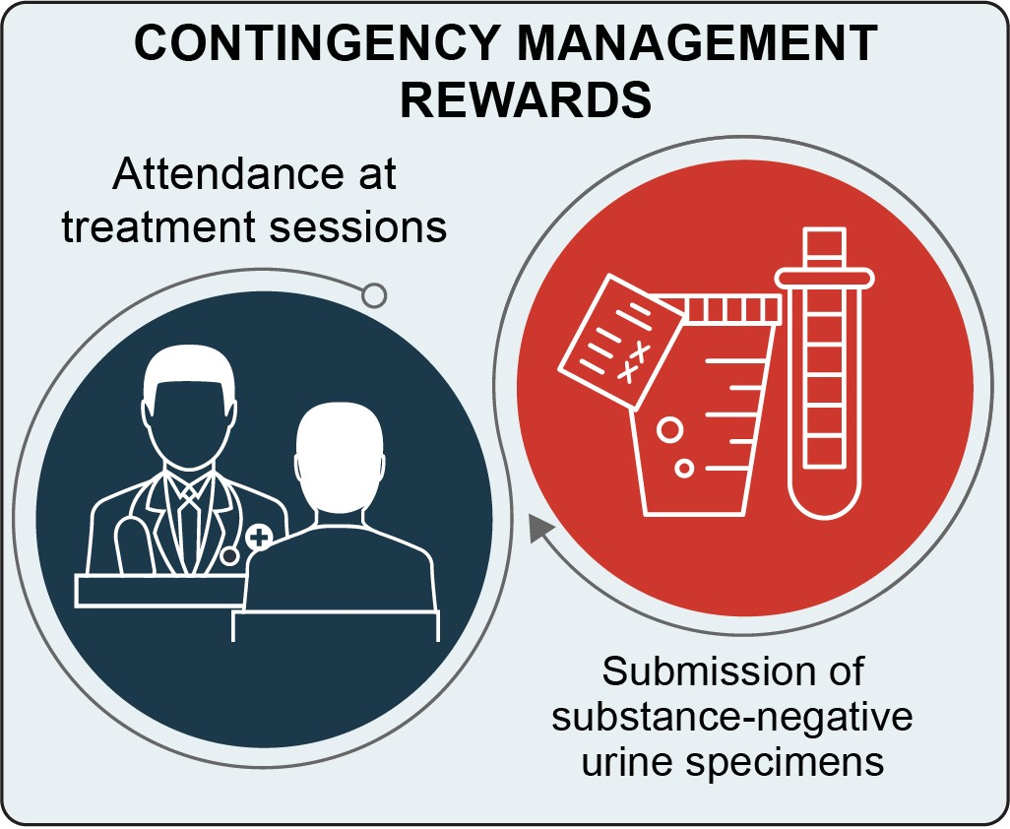

Reinforcement is typically provided in the form of either contingent prize draws¹² or contingent vouchers.¹³ The allowed number of prize drawings and the voucher values increase as the positive behaviors do. For individuals with CSU or concurrent SUD, reinforcements related to substance test results can either be:
  - Dually/wholly contingent (i.e., requiring urine specimens that are negative from multiple or all substances),¹⁴ or
  - “Split” contingent (i.e., rewarded independently for evidence of abstinence from each substance).¹⁵
Vouchers may be monetary or non-monetary (i.e., exchangeable for goods and services).
CM can also act as a “buy-in” for other behavioral interventions associated with longer-term benefits. For example, when combined with counseling, it may increase treatment attendance and pharmacotherapy adherence, which, in turn, can have long-term therapeutic benefits.¹⁶⁻¹⁸

Typical Settings
CM is implemented in a variety of healthcare settings, including both residential and outpatient care.¹⁹⁻²² It can be provided in conjunction with other treatment services, such as pharmacotherapy and individual or
group counseling. CM approaches have been adapted to include mobile and web-based applications to enhance access to substance use treatment for hard-to-reach populations.

Demographic Groups
CM has been used with adults,^{19,} ²³⁻²⁴ and to a lesser extent with youth.²⁵⁻²⁸

Clinician Types
A variety of professionals, such as primary care physicians, behavioral health professionals, and criminal justice personnel, can implement CM. Training or coursework in behavioral analysis is available to support implementation of this intervention.²⁹⁻³¹

Scope of Evidence Review
This review included 14 studies: 13 that assessed CM for the treatment of concurrent cocaine and opioid use and/ or dependence, and 1 that assessed CM for the treatment of concurrent cocaine, alcohol, and opioid use and/or dependence. In all studies, pharmacotherapy, in the form of methadone or buprenorphine, along with individual and/or group counseling, were provided.

Contingency Management Together With Pharmacotherapy and Counseling for Cocaine and Opioid Use and/or Dependence
Thirteen studies were reviewed for the treatment of concurrent cocaine and opioid use and/or dependence.^{7,} ^{15,} ³²⁻⁴² All studies provided participants with CM,
along with pharmacotherapy and individual and/
or group counseling.^{7,} ^{15,} ³²⁻⁴² Twelve studies provided pharmacotherapy in the form of methadone,^{15,} ³²⁻⁴² and the thirteenth provided pharmacotherapy in the form of buprenorphine.⁷

Study Settings
All 13 studies were conducted in outpatient behavioral health clinics.^{7,} ^{15,} ³²⁻⁴²

Study Demographic Groups
Studies included demographically diverse adults, aged 18 or older, who met criteria for concurrent opioid and cocaine use (based on self-report and/or urine screen) or disorder/dependence (as determined via clinical assessment, most often using a DSM-structured clinical interview).^{7,} ^{15,} ³²⁻⁴²
In studies that reported baseline substance use in past 30 days, self-reported cocaine use ranged from an average of 11⁷ to 21⁴¹ days and self-reported opioid use ranged from 1³⁴ to 29¹⁵ days. Two studies documented concurrent alcohol use (average self-reported use ranging 5 to 6 days in the past 30 days), but did not report subsequent alcohol use during the intervention or follow-up period.^{15,} ⁴¹
Eligibility criteria varied by study, with the most common exclusion criteria being severe and/or untreated mental disorder, gambling disorder, and inability to speak English.

Study Clinician Types
In one study, bachelor’s- to master’s-level substance use treatment counselors delivered CM.⁴⁰ In the remaining 12 studies, research staff with unspecified clinical training implemented CM. In all 13 studies, clinical staff (e.g., pharmacists, counselors, and nurses) provided pharmacotherapy and counseling.^{7,15,} ³²⁻⁴²

Intensity and Duration of Study Treatment
The studies utilized a mix of prize draw and voucher approaches; four used prize draws,^{33,} ^{36-37,} ³⁹ seven used vouchers,^{7,} ^{15,} ^{32,} ^{38,} ⁴⁰⁻⁴² and two used a combination of prize draws and vouchers.³⁴⁻³⁵
Requirements for the voucher and prize draw schedules were consistent across studies; participants earned a prize draw or voucher for every substance-negative urine specimen submitted.^{7,} ^{15,} ³²⁻⁴² In some studies, CM interventions required evidence of abstinence from both cocaine and opioids to receive reinforcers,^{7,} ^{34,} ³⁸ while others reinforced abstinence from cocaine alone^{15,} ^{32-33,} ^{35,} ³⁹⁻⁴² or independently reinforced abstinence from each substance.15, 32, 36-37, 39
Studies reported participants could earn a maximum of
$788 to $1,155 in voucher reinforcements or $117 to
$900 in prizes.^{7,} ^{15,} ³²⁻⁴²
Outcomes Associated with CM, Pharmacotherapy, and Counseling for Cocaine and Opioid Use and/or Dependence
Studies demonstrated that for adults with concurrent cocaine and opioid use and/or dependence, a combined treatment of CM, pharmacotherapy, and counseling was associated with statistically significant:
- Reductions in substance use (cocaine,32,34,40-41 or both cocaine and opioids7,15)
- Reductions in substance severity scores (as assessed using the Addiction Severity Index)35-36
- Increases in duration of abstinence from substance use (cocaine,32-33, 35-37,40 opioids,7,38 or both7,33,36,39)
- Increases in treatment attendance40
One study did not demonstrate significant outcomes in duration of abstinence from cocaine or in treatment retention.41
The time between the intervention period and follow-up ranged from discharge to two months.

Contingency Management Together With Pharmacotherapy and Counseling for Cocaine Dependence and Alcohol and Opioid Use

One reviewed study assessed CM for the treatment of concurrent cocaine dependence and alcohol and opioid use.³⁴ In addition to varying levels of CM, all participants received daily methadone (daily dose unspecified) and
at least monthly individual counseling and weekly group counseling (focusing on relapse prevention, coping, life skills training, and HIV/AIDS education).³⁴

Study Settings
The study included in this review was conducted at three outpatient methadone clinics.³⁴

Study Demographic Groups
Participants were adults, aged 18 or older, who met the DSM-IV criteria for cocaine dependence.³⁴ Participants were required to speak English, be in the clinic’s care for at least three months, and receive a stable dose of methadone for at least one month.
Participants were required to have submitted at least one cocaine-positive urine specimen as part of their usual treatment in the prior three months.
At baseline, participants reported, on average, 3 days of alcohol use, 2 days of heroin use, and 13 days of cocaine use in the past 30 days.
Individuals were excluded if they had “significant uncontrolled psychiatric illness” (e.g., active psychosis or suicide risk), scored less than 23 on the Mini Mental State Exam,⁴³ could not pass an informed consent quiz, or were in recovery from pathological gambling.
Participants were demographically diverse with respect to sex, race, and ethnicity. The average age was
approximately 40 years, and average annual income was approximately $15,000.

Study Clinician Types
This study did not specify which staff implemented the CM procedures.³⁴ Unspecified clinical staff administered pharmacotherapy. Substance use counselors with education levels ranging from high school to master’s degrees provided counseling and support activities.

Intensity and Duration of Study Treatment
For this study, the CM intervention provided escalating reinforcements if clients were abstinent from both cocaine and alcohol. Individuals were randomly assigned to one of four reinforcement approaches.
The CM intervention was delivered over a period of 12 weeks following an initial 2-week intake and evaluation. Urine and breath samples were collected two to three times per week during the intervention period, and individuals were eligible to earn a voucher or prize draw following each negative test. All three CM conditions yielded significant reductions in cocaine use relative to usual care.
Outcomes Associated with CM, Pharmacotherapy, and Counseling for Cocaine Dependence and Alcohol, and Opioid Use
The study demonstrated that for adults with concurrent cocaine, alcohol, and opioid use, a combined treatment of CM, pharmacotherapy, and counseling was associated with statistically significant:
- Increases in duration of sustained abstinence from cocaine and alcohol
- Reductions in cocaine and alcohol use Outcomes were assessed at the end of the intervention period and again at three-months
follow-up.34

Twelve-Step Facilitation (TSF) Therapy With Pharmacotherapy and Counseling
Goals of Twelve-Step Facilitation Therapy44-45
Acceptance
- Acceptance that one suffers from the chronic and progressive illness of substance use disorder.
- Acceptance that one has lost the ability to control one’s substance use.
- Acceptance that since there is no effective “cure” for SUD, the only viable alternative is cessation of substance use.
Surrender
- Acknowledgment that there is hope for recovery (defined as sustained cessation of substance use), but only through accepting the reality of loss of control and having
faith that some higher power can help the individual whose own willpower has been defeated by SUD.
- Acknowledgment that the fellowship of Alcoholics Anonymous (AA), Narcotics Anonymous (NA), and Cocaine Anonymous (CA) has helped millions of people with SUD to sustain their recovery and that one’s best chance for success is to follow the path of AA/ NA/CA.

Overview
Twelve-step facilitation (TSF) therapy is a manualized approach intended for individual, outpatient treatment. It assumes that SUD is a chronic, progressive disease.⁴⁴
TSF therapy is consistent with the 12 Steps of Alcoholics Anonymous (AA), and encourages participation in
12-step recovery programs; however, 12-step programs alone do not constitute TSF therapy.⁴⁴⁻⁴⁵
The two primary goals of this treatment are acceptance
and surrender, which relate to the first three steps in 12-step programs. TSF therapy goals inform specific treatment objectives in the cognitive, emotional, behavioral, social, and spiritual domains.
TSF therapy was manualized as part of Project MATCH (Matching Alcoholism Treatment to Client Heterogeneity) to treat individuals with AUD and has since been adapted to treat those with substance use disorders.⁴⁴⁻⁴⁵ Project MATCH was a five-year study that began in 1989 and assessed the benefit of matching treatment to individual client needs and characteristics,
rather than selecting treatment based on diagnosis alone.
TSF therapy includes 12 structured sessions discussing 11 topics. There are five core topics, considered central to treatment, and six elective topics, which are selected based on an individual’s specific needs. Often, a topic will be covered during several sessions. Each session has a specific agenda and suggested recovery tasks for clients to complete between sessions. Throughout, clients are encouraged to keep a journal and participate in 12-step programs, such as AA, Narcotics Anonymous (NA), or Cocaine Anonymous (CA). Though
described as a standalone treatment, TSF therapy may be combined with other approaches or treatments, depending on comorbid problems and SUD severity, such as pharmacotherapy, family therapy, or vocational counseling.⁴⁴

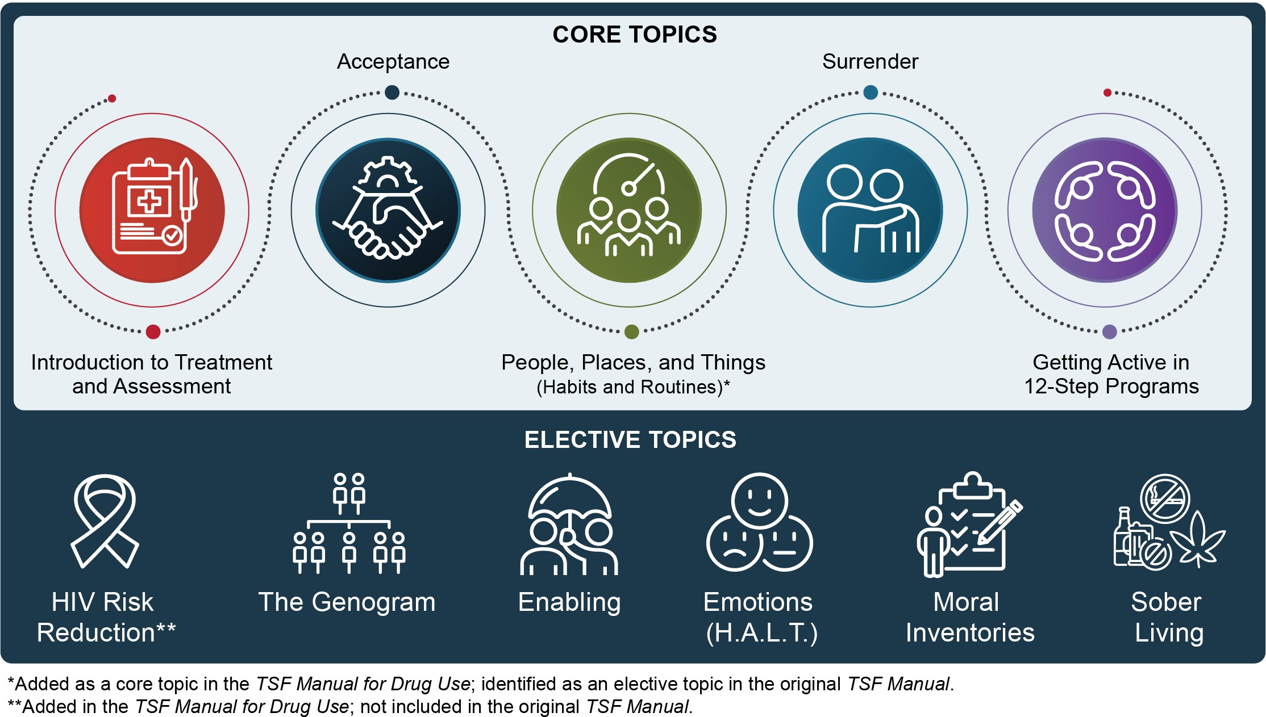

Typical Settings
TSF therapy is intended for outpatient settings. The intervention was developed as part of a multi-site clinical trial (Project MATCH),⁴⁶ which included both public and private treatment facilities, as well as hospital and university outpatient facilities.

Demographic Groups
The TSF therapy manual does not specify any special
consideration for different demographic groups.

Clinician Types
It is recommended that clinicians implementing TSF therapy be master’s-level therapists or certified substance use treatment counselors (e.g., Certified Alcohol/Drug Abuse Counselor), have at least three years of experience working with a population using substances, and be familiar with the 12-step approach.⁴⁴ If the clinician is not in recovery themselves, it is recommended that they attend at least ten 12-step group meetings (AA, NA, or CA) and ten Al-Anon or Families Anonymous meetings and familiarize themselves with the reading material recommended to clients.⁴⁵

Scope of Evidence Review
This review included two studies of TSF therapy, each focusing on a different set of substances: one study examined TSF therapy for cocaine and opioid use,⁴⁷ and the other examined intensive TSF therapy for opioids and other substance use.⁴⁸ In both studies, TSF therapy was delivered along with methadone maintenance therapy and counseling.⁴⁷⁻⁴⁸

TSF Therapy Together With Pharmacotherapy and Counseling for Cocaine and Opioid Dependence
One study provided evidence on the impact of TSF therapy, pharmacotherapy (in the form of methadone), and group counseling for adults using or dependent on cocaine and opioids.⁴⁷

Study Settings
The reviewed study was conducted in an outpatient substance use treatment center.⁴⁷

Study Demographic Groups
Individuals in the reviewed study were receiving methadone maintenance therapy and met DSM-IV criteria for cocaine dependence. The study sample was majority male (59 percent) and non-Hispanic White (64 percent). At baseline, participants reported using cocaine an average of 15 days, alcohol an average of 5 days, and opioids an average of 2 days out of the past 28 days.
Individuals were excluded from participation in the study if they were currently using barbiturates, had a principal substance use other than cocaine, ever had a psychotic
or bipolar disorder diagnosis (DSM-IV criteria), or had current thoughts of harming themselves or others.

Study Clinician Types
In the reviewed study, master’s-level counselors who were experienced in TSF therapy and had previously served as a TSF therapy trainer/supervisor delivered TSF therapy.

Intensity and Duration of Study Treatment
Individuals in the reviewed study received TSF therapy in weekly individual sessions over 12 weeks. They also received daily methadone and weekly group counseling, with other services available as needed.

Outcomes Associated with TSF Therapy, Pharmacotherapy, and Counseling for Cocaine and Opioid Dependence
One study demonstrated that for adults with concurrent cocaine and opioid dependence, a combined treatment
of TSF therapy, methadone maintenance, and group counseling was associated with statistically significant:
- Reductions in frequency of cocaine use during treatment (opioid use was not assessed)
- Increases in self-help meeting attendance during treatment and at follow-up
Outcomes were assessed during the course of the 12-week intervention and at follow-up interviews conducted every three months for one year.47

Intensive TSF Therapy Together With Pharmacotherapy and Counseling for Opioid and Other Substance Dependence

One study provided evidence for the impact of intensive TSF therapy, pharmacotherapy (in the form of methadone), and counseling for adults dependent on opioids and other substances.⁴⁸ This study was not methodologically rigorous enough to receive a high or moderate study rating, leading to an emerging evidence rating of the treatment practice.

Study Settings
The reviewed study was conducted in an outpatient community-based clinical facility, separate from the methadone clinics where participants received pharmacological treatment.⁴⁸

Study Demographic Groups
The reviewed study included individuals with OUD and either abuse or dependence of at least one other substance, based on DSM-IV criteria. Participants met dependence criteria for alcohol (35 percent), cocaine (46 percent), sedatives (10 percent), or another substance (35 percent), in addition to OUD. The study sample was 49 percent male and 13 percent ethnic minorities. At baseline, 81 percent of participants reported using opioids, and 87 percent reported using any substance in the past 30 days.
Individuals were excluded from participation if they currently had been diagnosed with schizophrenia, schizoaffective disorder, psychosis not otherwise specified, or bipolar affective disorder (DSM-IV criteria), or if there was a possibility of incarceration during treatment due to imminent criminal justice proceedings.

Study Clinician Types
In the reviewed study, therapists who had at least five years of experience treating substance use and had themselves recovered through the 12-step model
delivered TSF therapy. These therapists were trained in TSF therapy through a clinical workshop and supervised clinical work.

Intensity and Duration of Study Treatment
Participants in the reviewed study received a more intensive version of TSF therapy than described in the original protocol. Instead of 12 sessions over 12 to 24 weeks, the intensive TSF therapy consisted of 48 sessions over 16 weeks. All participants received
methadone maintenance, weekly individual counseling sessions with their therapist, weekly sessions with a sponsor (i.e., someone who was a member of a 12-step organization such as AA, NA, or CA), and weekly group counseling sessions.
Outcomes Associated with Intensive TSF Therapy, Pharmacotherapy, and Counseling for Opioids and Other Substance(s) Dependence
One study demonstrated that for adults with concurrent opioid and other substance use, a combined treatment of TSF therapy, methadone maintenance, and counseling was associated with statistically significant:48
- Reductions in any substance use Outcomes were assessed at the end of the
intervention period and at a six-month follow-up.

Summary of Evidence Review
The guide’s evidence review provides support for three practices treating use of different combinations of four substances. All studies were conducted in outpatient settings, with diverse adults. Clinicians providing the services, and the intensity and duration of treatment varied across the studies.

 | Pharmacotherapy With Counseling |  | Contingency Management With Pharmacotherapy and Counseling |  | Twelve-Step Facilitation Therapy With Pharmacotherapy and Counseling
Substance Combination | Alcohol and Cocaine | Cocaine and Opioids | Cocaine and Opioids | Cocaine, Alcohol, and Opioids | Cocaine and Opioids | Opioids and Other Substances
Causal Evidence Level | Moderate Evidence | Emerging Evidence | Strong Evidence | Moderate Evidence | Moderate Evidence | Emerging Evidence
Studied Outcomes | Cocaine and alcohol use | Cocaine and opioid use | Cocaine and opioids use and severity, treatment attendance | Cocaine and alcohol use | Cocaine use, self- help meeting attendance | Substance use
Description | Medications approved by the FDA to treat the specific use and/or disorders together with counseling |  | A behavioral intervention using external reinforcement  schedules to reward individuals for exhibiting positive behaviors |  | Individual therapy that aids with long-term abstinence by encouraging acceptance and  surrender, and facilitating active engagement in recovery groups
Studied Settings | Outpatient |  | Outpatient |  | Outpatient
Studied Demographic Groups | Predominately Black and predominantly male | Predominately Black and predominantly male | Diverse adults | Diverse adults | Majority non- Hispanic White and majority male | Majority White
Studied Clinician Types | Master’s- or doctoral-level therapists trained in  the particular counseling approach | Psychiatrists, master’s- or doctoral-level therapists, and experienced substance  use treatment counselors trained in  the particular counseling approach | Unspecified research staff, with pharmacotherapy and counseling provided by clinical staff |  | Master’s-level counselors experienced in TSF | Therapists who recovered through the  12-step model and are experienced in treating substance use
Studied Intensity and Duration of Treatment | 11 to 12 weeks | 13 to 24 weeks | 8 to 25 weeks | 12 weeks | 12 sessions  over 12 weeks | 48 sessions  over 16 weeks

Reference List

¹ Substance Abuse and Mental Health Services Administration. (2009). Incorporating alcohol pharmacotherapies into medical practice. Treatment Improvement Protocol (TIP) Series, No. 49. https:// www.ncbi.nlm.nih.gov/books/NBK64041/
² Substance Abuse and Mental Health Services Administration. (2020). Medications for opioid use disorder. Treatment Improvement Protocol (TIP) Series, No. 63. https://store.samhsa.gov/product/ TIP-63-Medications-for-Opioid-Use-Disorder-Full- Document/PEP20-02-01-006
³ National Academies of Sciences, Engineering, and Medicine (2019). Medications for Opioid Use
Disorder Save Lives. Washington, DC: The National Academies Press. https://doi.org/10.17226/25310
⁴ Schmitz, J. M., Stotts, A. L., Sayre, S. L., DeLaune,
K. A., & Grabowski, J. (2004). Treatment of cocaine-alcohol dependence with naltrexone and relapse prevention therapy. American Journal
of Addictions, 13(4), 333-341. https://doi. org/10.1080/10550490490480982
⁵ Schmitz, J. M., Lindsay, J. A., Green, C. E., Herin,
D. V., Stotts, A. L., & Moeller, F. G. (2009).
High-dose naltrexone therapy for cocaine-alcohol dependence. American Journal of Addictions, 18(5), 356-362. https://dx.doi.org/10.3109% 2F10550490903077929
⁶ Pettinati, H. M., Kampman, K. M., Lynch, K. G.,
Xie, H., Dackis, C., Rabinowitz, A. R., & O’Brien,
C. P. (2008). A double blind, placebo-controlled trial that combines disulfiram and naltrexone for treating co-occurring cocaine and alcohol dependence. Addictive Behaviors, 33(5), 651-667. https://dx.doi. org/10.1016%2Fj.addbeh.2007.11.011
⁷ Schottenfeld, R. S., Chawarski, M. C., Pakes, J. R., Pantalon, M. V., Carroll, K. M., & Kosten, T.
R. (2005). Methadone versus buprenorphine with contingency management or performance feedback for cocaine and opioid dependence. American Journal of Psychiatry, 162(2), 340-349. https://doi. org/10.1176/appi.ajp.162.2.340
⁸ Montoya, I. D., Gorelick, D. A., Preston, K. L., Schroeder, J. R., Umbricht, A., Cheskin, L. J., Lange, W. R., Contoreggi, C., Johnson, R.
E., & Fudala, P. J. (2004). Randomized trial of buprenorphine for treatment of concurrent opiate and cocaine dependence. Clinical Pharmacology & Therapeutics, 75(1), 34-48. https://doi.org/10.1016/j. clpt.2003.09.004
⁹ Schmitz, J. M., Stotts, A. L., Rhoades, H. M., & Grabowski, J. (2001). Naltrexone and relapse
prevention treatment for cocaine-dependent patients. Addictive Behaviors, 26(2), 167-180. https://doi. org/10.1016/s0306-4603(00)00098-8
¹⁰ Staddon, J. E., & Cerutti, D. T. (2003). Operant conditioning. Annual Review of Psychology, 54, 115-144. https://doi.org/10.1146/annurev. psych.54.101601.145124
¹¹ Petry, N. M. (2011). Contingency management: What it is and why psychiatrists should want to use it. The Psychiatrist, 35(5), 161-163. https://dx.doi. org/10.1192%2Fpb.bp.110.031831
¹² Petry, N. M. (2006). Contingency management treatments. British Journal of Psychiatry, 189, 97-
98. https://doi.org/10.1192/bjp.bp.106.022293
¹³ Lussier, J. P., Heil, S. H., Mongeon, J. A., Badger,
G. J., & Higgins, S. T. (2006). A meta‐analysis of voucher‐based reinforcement therapy for substance use disorders. Addiction, 101(2), 192-203. https:// doi.org/10.1111/j.1360-0443.2006.01311.x
¹⁴ Ainscough, T. S., McNeill, A., Strang, J., Calder, R., & Brose, L. S. (2017). Contingency management interventions for non-prescribed drug use during treatment for opiate addiction: A systematic review and meta-analysis. Drug and Alcohol Dependence, 178, 318-339. https://dx.doi.org/10.1016%2Fj. drugalcdep.2017.05.028
¹⁵ Epstein, D. H., Schmittner, J., Umbricht, A., Schroeder, J. R., Moolchan, E. T., & Preston, K.
L. (2009). Promoting abstinence from cocaine and heroin with a methadone dose increase and a
novel contingency. Drug and Alcohol Dependence, 101(1-2), 92-100. https://dx.doi.org/10.1016%2Fj. drugalcdep.2008.11.006

¹⁶ Petry, N. M., Weinstock, J., & Alessi, S. M. (2011). A randomized trial of contingency management delivered in the context of group counseling. Journal of Consulting and Clinical Psychology, 79(5), 686- 696. https://dx.doi.org/10.1037%2Fa0024813
¹⁷ Carroll, K. M., Ball, S. A., Nich, C., O’Connor, P. G., Eagan, D. A., Frankforter, T. L., Triffleman, E. G., Shi, J., & Rounsaville, B. J. (2001). Targeting behavioral therapies to enhance naltrexone treatment of opioid dependence: Efficacy of contingency management and significant other involvement. Archives of General Psychiatry, 58(8), 755-761. https://doi.org/10.1001/archpsyc.58.8.755
¹⁸ Carroll, K. M., Sinha, R., Nich, C., Babuscio, T., & Rounsaville, B. J. (2002). Contingency management to enhance naltrexone treatment of
opioid dependence: A randomized clinical trial of reinforcement magnitude. Experimental and Clinical Psychopharmacology, 10(1), 54-63. https://doi. org/10.1037/1064-1297.10.1.54
¹⁹ Higgins, S. T., Silverman, K., & Heil, S. H. (Eds.). (2008). Contingency management in substance abuse treatment. The Guilford Press.
²⁰ Griffith, J. D., Rowan-Szal, G. A., Roark, R. R., & Simpson, D. D. (2000). Contingency management in outpatient methadone treatment: A meta-analysis. Drug and Alcohol Dependence, 58(1-2), 55-66. https://doi.org/10.1016/s0376-8716(99)00068-x
²¹ Petry, N. M. (2000). A comprehensive guide to the application of contingency management procedures in clinical settings. Drug and Alcohol Dependence, 58(1-2), 9-25. https://doi.org/10.1016/s0376-
8716(99)00071-x
²² Rash, C. J., & Petry, N. M. (2015). Contingency management treatments are equally efficacious for both sexes in intensive outpatient settings. Experimental and Clinical Psychopharmacology,
23(5), 369-376. https://doi.org/10.1037/pha0000035
²³ Prendergast, M., Podus, D., Finney, J., Greenwell, L., & Roll, J. (2006). Contingency management for treatment of substance use disorders: A meta‐
analysis. Addiction, 101(11), 1546-1560. https://doi. org/10.1111/j.1360-0443.2006.01581.x
²⁴ Benishek, L. A., Dugosh, K. L., Kirby, K. C., Matejkowski, J., Clements, N. T., Seymour, B. L., & Festinger, D. S. (2014). Prize-based contingency management for the treatment of substance abusers: a meta-analysis. Addiction, 109(9), 1426-1436. https://doi.org/10.1111/add.12589
²⁵ Henggeler, S. W., Chapman, J. E., Rowland, M. D., Halliday-Boykins, C. A., Randall, J., Shackelford, J., & Schoenwald, S. K. (2008). Statewide adoption and initial implementation of contingency management for substance-abusing adolescents. Journal of Consulting and Clinical Psychology, 76(4), 556-567. https://dx.doi.org/10.1037%2F0022-006X.76.4.556
²⁶ Letourneau, E. J., McCart, M. R., Sheidow, A.
J., & Mauro, P. M. (2017). First evaluation of a contingency management intervention addressing adolescent substance use and sexual risk behaviors: Risk reduction therapy for adolescents. Journal of Substance Abuse Treatment, 72, 56-65. https://doi. org/10.1016/j.jsat.2016.08.019
²⁷ Stanger, C., & Budney, A. J. (2019). Contingency management: using incentives to improve outcomes for adolescent substance use disorders. Pediatric Clinics of North America, 66(6), 1183-1192. https:// doi.org/10.1016/j.pcl.2019.08.007
²⁸ Stanger, C., Lansing, A. H., & Budney, A. J. (2016). Advances in research on contingency management for adolescent substance use. Child and Adolescent Psychiatric Clinics, 25(4), 645-659. https://doi. org/10.1016/j.chc.2016.05.002
²⁹ Hartzler, B., Lash, S. J., & Roll, J. M. (2012). Contingency management in substance abuse treatment: A structured review of the evidence for its transportability. Drug and Alcohol Dependence, 122(1-2), 1-10. https://doi.org/10.1016/j. drugalcdep.2011.11.011
³⁰ Marlowe, D. B., Festinger, D. S., Dugosh, K.
L., Arabia, P. L., & Kirby, K. C. (2008). An effectiveness trial of contingency management in a felony preadjudication drug court. Journal of
Applied Behavior Analysis, 41(4), 565-577. https:// dx.doi.org/10.1901%2Fjaba.2008.41-565
³¹ Prendergast, M. L., Hall, E. A., Roll, J., & Warda,
U. (2008). Use of vouchers to reinforce abstinence and positive behaviors among clients in a drug court treatment program. Journal of Substance Abuse Treatment, 35(2), 125-136. https://doi.org/10.1016/j. jsat.2007.09.001
³² Epstein, D. H., Hawkins, W. E., Covi, L., Umbricht, A., & Preston, K. L. (2003). Cognitive-behavioral therapy plus contingency management for cocaine use: Findings during treatment and across 12-month follow-up. Psychology of Addictive Behaviors, 17(1), 73-82. https://doi.org/10.1037/0893-164x.17.1.73

³³ Ghitza, U. E., Epstein, D. H., Schmittner, J., Vahabzadeh, M., Lin, J. L., & Preston, K. L. (2007). Randomized trial of prize-based reinforcement density for simultaneous abstinence from cocaine and heroin. Journal of Consulting and Clinical Psychology, 75(5), 765-774. https://dx.doi. org/10.1037%2F0022-006X.75.5.765
³⁴ Petry, N. M., Alessi, S. M., Barry, D., & Carroll, K.
M. (2015). Standard magnitude prize reinforcers can be as efficacious as larger magnitude reinforcers in cocaine-dependent methadone patients. Journal of Consulting and Clinical Psychology, 83(3), 464-472. https://dx.doi.org/10.1037%2Fa0037888
³⁵ Petry, N. M., Alessi, S. M., Hanson, T., & Sierra, S. (2007). Randomized trial of contingent prizes versus vouchers in cocaine-using methadone patients. Journal of Consulting and Clinical Psychology, 75(6), 983-991. https://doi.org/10.1037/0022-
006X.75.6.983
³⁶ Petry, N. M., & Martin, B. (2002). Low-cost contingency management for treating cocaine- and opioid-abusing methadone patients. Journal of Consulting and Clinical Psychology, 70(2), 398-405. https://doi.org/10.1037//0022-006x.70.2.398
³⁷ Petry, N. M., Martin, B., & Simcic, F., Jr. (2005). Prize reinforcement contingency management for cocaine dependence: Integration with group therapy in a methadone clinic. Journal of Consulting and Clinical Psychology, 73(2), 354-359. https://doi. org/10.1037/0022-006x.73.2.354
³⁸ Poling, J., Oliveto, A., Petry, N., Sofuoglu, M.,
Gonsai, K., Gonzalez, G., Martell, B. & Kosten,
T. R. (2006). Six-month trial of bupropion with contingency management for cocaine dependence in a methadone-maintained population. Archives of General Psychiatry, 63(2), 219-228. https://doi. org/10.1001/archpsyc.63.2.219
³⁹ Preston, K. L., Ghitza, U. E., Schmittner, J. P., Schroeder, J. R., & Epstein, D. H. (2008).
Randomized trial comparing two treatment strategies using prize-based reinforcement of abstinence
in cocaine and opiate users. Journal of Applied Behavior Analysis, 41(4), 551-563. https://dx.doi. org/10.1901%2Fjaba.2008.41-551
⁴⁰ Rowan-Szal, G. A., Bartholomew, N. G., Chatham,
L. R., & Simpson, D. D. (2005). A combined cognitive and behavioral intervention for cocaine- using methadone clients. Journal of Psychoactive Drugs, 37(1), 75-84. https://doi.org/10.1080/027910
72.2005.10399750
⁴¹ Umbricht, A., DeFulio, A., Winstanley, E. L., Tompkins, D. A., Peirce, J., Mintzer, M. Z., Strain,
E. C., & Bigelow, G. E. (2014). Topiramate for cocaine dependence during methadone maintenance treatment: A randomized controlled trial. Drug
and Alcohol Dependence, 140, 92-100. https://doi. org/10.1016/j.drugalcdep.2014.03.033
⁴² Winstanley, E. L., Bigelow, G. E., Silverman, K., Johnson, R. E., & Strain, E. C. (2011). A randomized controlled trial of fluoxetine in the treatment of cocaine dependence among methadone-maintained patients. Journal of Substance Abuse Treatment, 40(3), 255-264. https://dx.doi.org/10.1016%2Fj. jsat.2010.11.010
⁴³ Folstein, M. F., Folstein, S. E., & McHugh, P. R. (1975). “Mini-mental state”: A practical method for grading the cognitive state of patients for
the clinician. Journal of Psychiatric Research, 12(3), 189-198. https://doi.org/10.1016/0022-
3956(75)90026-6
⁴⁴ Baker, S. M. (1998). Twelve step facilitation therapy for drug abuse and dependence. Yale University Psychotherapy Development Center. https:// medicine.yale.edu/psychiatry/research/programs/ clinical_people/pdc/TSF_176456_284_46619_ v1.pdf
⁴⁵ Nowinski, J., Baker, S., & Carroll, K. M. (1992). Twelve step facilitation therapy manual: A clinical research guide for therapists treating individuals with alcohol abuse and dependence. NIAAA Project MATCH Monograph Series, Volume 1. U.S. Department of Health & Human Services.
⁴⁶ Mattson, M. E., Allen, J. P., Miller, W. R., Hester,
R. K., Connors, G. J., Rychtarik, R. G., Randall,
C. L., Anton, R. F., Kadden, R. M., Cooney, N. L., DiClemente, C. C., Carbonari, J., Zweben, A.,
Longabaugh, R., Stout, R., Walker, R. D., Donovan, D., Babor, T. F., DelBoca, F. K. (1993). Project MATCH: Rationale and methods for a multisite clinical trial matching patients to alcoholism treatment. Alcoholism: Clinical and Experimental Research, 17(6), 1130-1145.
⁴⁷ Carroll, K. M., Nich, C., Shi, J. M., Eagan, D., & Ball, S. A. (2012). Efficacy of disulfiram and twelve step facilitation in cocaine-dependent individuals maintained on methadone: A randomized placebo- controlled trial. Drug and Alcohol Dependence, 126(1-2), 224-231. https://dx.doi.org/10.1016%2Fj. drugalcdep.2012.05.019

⁴⁸ Hayes, S. C., Wilson, K. G., Gifford, E. V., Bissett, R., Piasecki, M., Batten, S. V., Byrd, M., & Gregg, J. (2004). A preliminary trial of twelve-step facilitation and acceptance and commitment therapy with polysubstance-abusing methadone-maintained opiate addicts. Behavior Therapy, 35(4), 667-688. https:// doi.org/10.1016/S0005-7894(04)80014-5

3CHAPTER

Guidance for Selecting and Implementing Evidence-Based Practices

This chapter provides information for clinicians, program administrators, and other stakeholders interested in implementing
a practice to treat or address concurrent substance use (CSU) or concurrent substance use disorders (SUD) in adults. It documents clinical issues and other considerations that organizations and clinicians may encounter when engaging and providing services to clients with CSU or concurrent SUD, as well as strategies to address those concerns.

Strategies to Manage Clinical Issues
Clinicians may encounter several challenges when working with clients with CSU or concurrent SUD. The table below summarizes the most common clinical issues they may encounter and strategies to manage them.

Clinical Issue and Explanation |  | Management Strategy
Hesitancy to engage in treatment | Individuals with CSU or concurrent SUD may have mixed feelings or ambivalence towards treatment. | - “Meet individuals where they are” by identifying, connecting, and providing services that reflect their individual goals and keeping them engaged for potential treatment in the future.  - Incorporate motivational interviewing techniques.
Overdose risk | Individuals who intentionally or unknowingly mix substances have an increased risk for overdose. | - Assess client awareness of dangers of mixing substances and educate about risks.  - Monitor clients closely for overdose symptoms. Combinations of particular concern are:  - Opioids, especially fentanyl and/or heroin, with methamphetamine, benzodiazepines or cocaine  - Alcohol with benzodiazepines or opioids  - Assess biomarkers for the presence of psychoactive substances (i.e., saliva, urine, breath, etc.). The Substance Abuse and Mental Health Services’ (SAMHSA’s) Technical Assistance Publication 32: Clinical Drug Testing in Primary Care offers guidance to clinicians on implementing assessments.  - Maintain communication with treatment providers, public health officials, and clients about the purity, strengths, and potential contaminations of substances that are available in the area.  - Train program staff, clients, and family members on naloxone use and make naloxone available to clients, their families, and the community.  - Use federal funds to purchase fentanyl test strips (for federal grantees), which clients can use to determine whether drugs have been mixed or cut with fentanyl.
Intoxication | Substance use, including CSU and concurrent SUD, can increase euphoria, excitability, compulsive behavior (including sexual behavior), locomotor activity, and agitation. | - Assess client’s immediate safety, including overdose risk and ability to navigate home or to a safe space or assist in obtaining a taxi or other safe way home if their ability is impaired. This can also be an opportunity to hold clients accountable to consistent  boundaries; let the individual know that it is nice to see them in the clinic, however, coming intoxicated is not appropriate.
Withdrawal | As an individual stops substance use, they may experience symptoms like severe fatigue, insomnia, cognitive impairment, feelings of depression, anxiety, loss of energy, confusion, the inability to feel pleasure, and paranoia.1 Opioid withdrawal can also be fatal. | - Assess withdrawal through tools, including: the Clinical Institute Withdrawal Assessment for Alcohol-Revised (CIWA-Ar), the Clinical Institute Withdrawal Assessment for Benzodiazepines (CIWA-B), and the Clinical Institute Withdrawal Assessment for Opiates/ Opioids.  - Manage symptoms through medically monitored withdrawal programs.  - Assess if there are medications available that may allow for withdrawal symptom relief.  - Promote rest, mild/moderate exercise, and a healthy diet, as these can help to manage withdrawal symptoms.
 | Withdrawal may result in hypersexuality and impaired sexual functioning, leading to psychological distress.2 | - Provide risk reduction education about the possibility  of changes in sexual function during early recovery. Offer suggestions, ideas, and help to address sexual dysfunction if the client is acutely stressed about this.

Clinical Issue and Explanation |  | Management Strategy
Co-occurring medical and mental condi- tions | One of the challenges that practitioners face is deciphering between independent psychiatric disorders, psychiatric  disorders because of CSU or concurrent SUD, and psychiatric or physical health symptoms that arise from intoxication and withdrawal. | - Consider integrated treatment options regardless of the underlying cause(s) for the co-occurring diagnosis or other conditions. Integrated treatment provides primary and behavioral health care in the same setting.  - Coordinate services among clinicians, as lack of adequate treatment for either disorder may interfere with an individual’s overall recovery.  - Monitor and account for symptoms, chronic illnesses, and side effects related to medical and mental conditions.
Severity of disorder and level of care | Clients may receive treatment services at various levels within the continuum of care, depending on the severity of their disorder.  Assessing the required level of care for each client based on the severity of their disorder is critical. | - Evaluate the clients’ needs and ensure they receive services at the appropriate level.  - Promote services that support individuals at each stage of recovery. Step up to more intensive treatment or step down to less intensive treatment, as needed. Recovery is not linear.  Clinicians should be prepared for cycles of struggle and be willing to adjust intensity of services accordingly.

In addition to the issues and strategies noted above, several considerations and strategies can be implemented at the individual and organizational levels to promote implementation of CSU and concurrent SUD treatment.

Implementation Considerations and Strategies for Clinicians
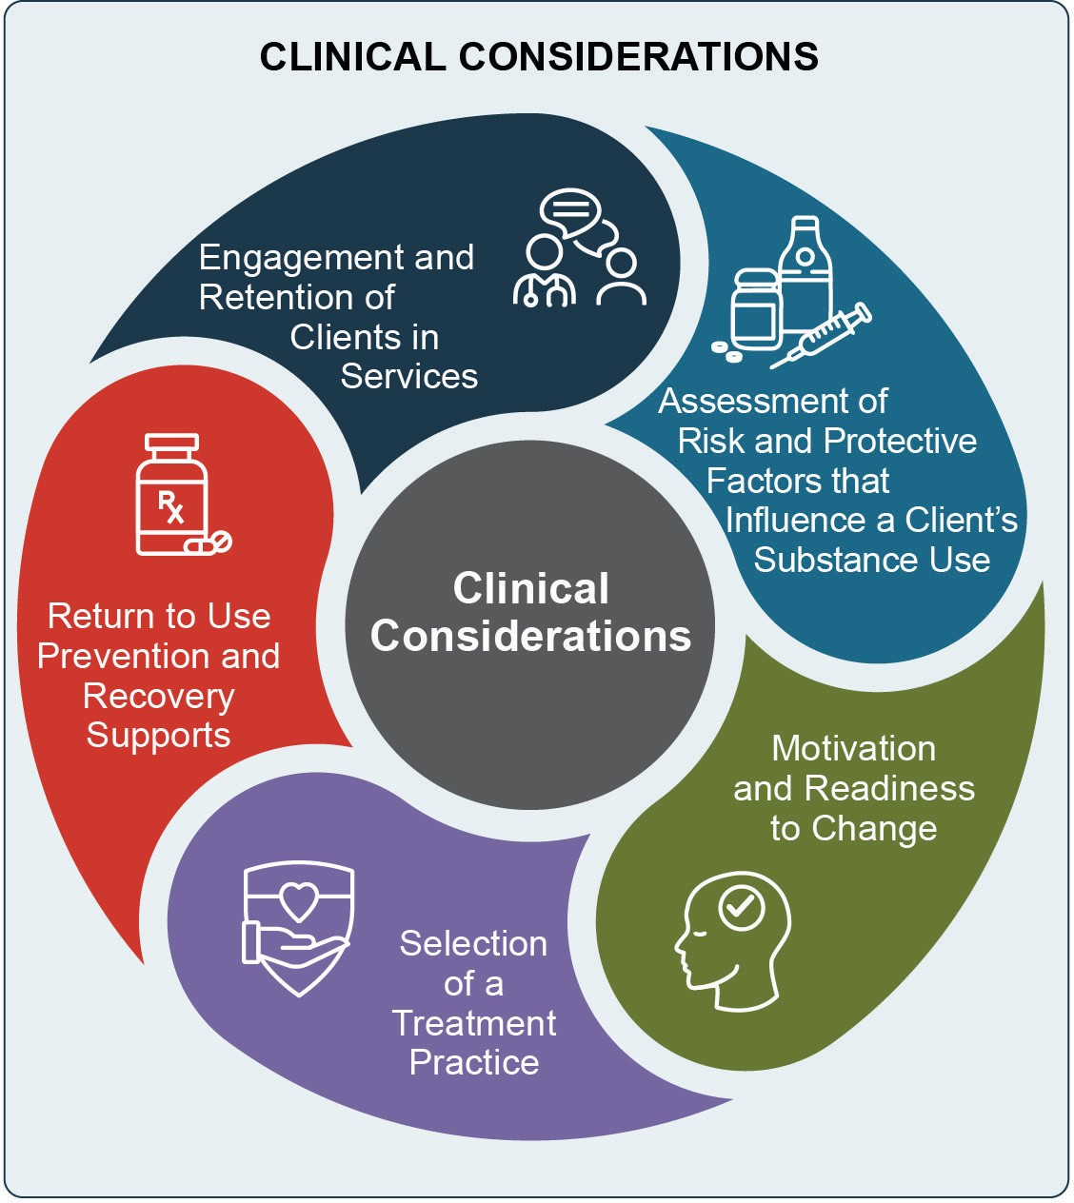

Engagement and Retention of Clients in Services
Consideration: Those with CSU and concurrent SUD often have low rates of treatment retention and completion, and it can be difficult to keep clients engaged in care.
Clients may have competing priorities or encounter a triggering situation that leads to a return to use.

Strategies:
- Strengthen relationships between the clinician and client. The therapeutic alliance—or the way in which the client and therapist connect, behave, and engage with each other—is a strong predictor of retention in treatment. Clients who feel a strong connection to their therapist and feel that their therapist cares about their success tend to attend more sessions and complete
treatment at higher rates.¹² Clinicians can build rapport with clients by providing them a safe and non-judgmental environment, showing empathy for their given situation both verbally and non-verbally, and making the client feel like an equal instead of being “talked-down” to. This process takes time, especially for clients who are distrusting of others or who have had negative experiences with clinicians in the past.
Clients may continue to use substances and miss sessions until they fully “buy-in” to the treatment process. Clinicians should practice patience and work to unpack and understand
their client’s hesitancy. It may also be that clients want to reduce use, not stop use altogether.
Clinicians should be open and respectful of the clients’ goals, connect them to services for safer drug use and assist them in reducing their use.
- Identify barriers to treatment and provide resources to complete treatment. Transportation to appointments, childcare, safe and stable housing, health insurance, and flexibility in scheduling appointments are all important factors for treatment completion. Clinicians should be aware of the barriers a client may face and refer them to a social worker, case manager, or other community provider to assist with resources, such as submitting paperwork to Medicaid or a housing authority. Some barriers like housing could take weeks or months to resolve. In these instances, clinicians should assess the client’s readiness to start treatment, as well as their severity of use and overdose risk. If there is a risk of overdose, treatment should not be delayed. For those experiencing housing instability, a referral may be warranted to a provider who specializes in medical care and/or mental health and SUD treatment for people experiencing homelessness, if such an organization exists in the client’s area.
- Use motivational interviewing (MI) to heighten motivation and increase self-efficacy. Struggling with substances for long periods can lead to a feeling of helplessness,¹³ for which MI can be particularly helpful.¹⁴ MI is a counseling technique and treatment approach that helps individuals overcome ambivalent feelings and resistance, while clinicians offer their empathy and support. In the process, individuals become motivated to

explore the reasons for their behavior with the goal of eliciting positive behavioral change. Clinicians can use MI to help engage clients in treatment at the outset. They can also use it in combination with other treatments, such as cognitive behavioral therapy, to enhance retention and adherence throughout the treatment process.¹³

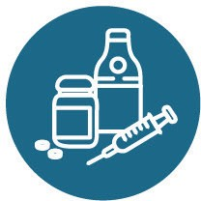
Assessment of Risk and Protective Factors that Influence a Client’s Substance Use
Consideration: Individuals with CSU and concurrent SUD often exhibit more severe risk factors than individuals with a single SUD.³ Addressing a client’s risk factors for CSU and concurrent SUD is essential to achieving positive treatment outcomes.

Strategies:
- Assess social determinants of health and integrate into treatment. Living environments, transportation to services, and educational and occupational attainment affect overall health and well-being. Clients with risk factors such as poverty, housing instability, educational challenges, legal issues, domestic violence, and a multitude of other challenges have increased risk of CSU and concurrent SUD. Chronic
stress, depression, and other mental health issues can further compound the risk.
However, these individuals may also have protective factors, such as strong family support systems, positive outlooks, or a desire to change. It is crucial to assess both risk and protective factors to understand how they impact substance use and can support treatment and recovery.
The Recovery Capital Scale is a helpful tool for assessing risk and protective factors and identifying ways to bolster protective factors.
- Help connect the client with resources to improve quality of life. Clinicians should connect their clients to services and resources that address social determinants of health. For example, organizational staff, such as care coordinators or case managers, may be able to assist clients residing in unsafe living conditions by sharing housing resources or providing a referral to a pro-bono lawyer. They may be able to assist someone with food insecurity by linking them to a food pantry, or they may connect
someone who is out of work with unemployment
benefits and a job training program.
Addressing issues related to social determinants of health will provide clients with resources needed to support their CSU or concurrent SUD treatment and recovery. This also encourages engagement in treatment, as clients often feel their clinician cares about them personally.
- Assess client’s partner or family influences and characteristics. Unhealthy relationships with partners or with others in the home can contribute to a client’s chronic stress and feeling that the home is not a safe space. Partners and family members can also be protective factors when they serve as positive influences and provide a support system for clients. Clinicians should attempt
to integrate these healthy relationships into treatment planning. For example, after a bad day, partners and family can talk through problems and triggering situations with clients.
- Assess the influence of trauma on substance use. Experiencing a traumatic event or living in traumatic circumstances is a risk factor for
CSU and concurrent SUD. Clinicians should use trauma-informed care, which considers a client’s past and current life situation in the delivery of care and builds on a client’s strengths to promote healing and recovery. Clinicians should screen individuals with CSU and concurrent SUD for symptoms of trauma and post-traumatic stress disorder (PTSD). If clinicians identify trauma, they should fully explore its relationship with the substance use. If they are amenable, the client and their clinician can identify working through this trauma in treatment goals.
If a client is presently enduring abuse or interpersonal violence (IPV), clinicians may be mandated to report it. Each state’s laws are different, and clinicians should understand the laws in their area.
Clients should be given contact information for resources, such as domestic violence shelters that specialize in providing support. Clinicians should have open lines of communication with the client, recognizing that current IPV can impact treatment in multiple ways (e.g., failure to keep appointments, diversion of medications, etc.).

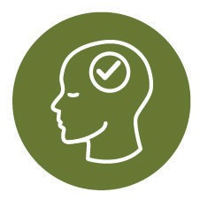
Motivation and Readiness to Change
Consideration: Those with CSU or concurrent SUD often have a long history of substance use and may have been in treatment before. It can be common to feel a sense of helplessness or unwillingness to discontinue substance use after previous unsuccessful treatment attempts.

Strategies:
- Utilize harm reduction strategies. Harm reduction is a set of practical strategies and ideas aimed at reducing negative consequences associated with drug use.⁴ Harm reduction is built on a belief in, and respect for, the rights of
people who use drugs. If the individual is not yet ready to engage in services, their decision should be respected, and there may still be opportunities to help them minimize the risk of harm from substance use:
  - Clinicians can point clients to nearby syringe service programs (SSPs), which provide safe and sterile drug use supplies and education. There are over 400 SSPs in the United States. Clinicians should stay up to date on the SSPs in their area.
  - Clinicians can also provide access to fentan- yl test strips and naloxone or point the indi- vidual to a program that does. If there are no naloxone providers in the area, individuals may be able to obtain free naloxone via mail or through community resources.
  - Clinicians can point individuals to super- vised consumption services (designated sites where people can use pre-obtained drugs under the safety and support of trained per- sonnel), if available in their area.
- Consider prior treatment history and outcomes and engage the client in treatment planning. When engaging someone with CSU or concurrent SUD in services, it is important to understand their treatment history: what they feel has worked well, what hasn’t worked well, and the extent to which earlier treatment was completed successfully. If treatment yielded some success, clinicians should ask what led the client to start using again. If prior treatment was unsuccessful, clinicians should
ask what factors they felt contributed to the lack of success; this may include location of the services, transportation and childcare concerns, or lack of individual-specific services (i.e., sex, sexual identity, gender, age, race, ethnicity).
Understanding these factors will influence the individual’s future treatment and enable the clinician to build off aspects that worked well and address aspects that did not.
Discussions with the client also give the client an active role in treatment planning, which can increase engagement and retention in treatment. Goal setting and treatment planning should be a collaborative process tied to the individual’s own objectives and aspirations. Clinicians should support building small goals into the treatment plan that are realistic and attainable.⁵ Setting
and continually reviewing progress on goals and the treatment plan can enhance motivation while allowing the clinician to assess client engagement throughout the treatment process.⁶⁻⁷

Selection of a Treatment Practice
Consideration: Clients engage in CSU and concurrent SUD for different reasons, including to escape from reality and the unavailability of the primary drug of choice. Clients also use multiple substances to:
- Enhance the physical or psychological effects of
each substance
- Counteract the effects of one or more substances
- Counter the effects of withdrawal from a different substance
- Prolong a substance’s effects
- Experience a new effect

Strategies:
- Understand the client’s pharmacological, psychosocial, and behavioral reasons for combining certain substances when developing treatment plans. Each client’s situation is unique and there are several strategies that clinicians can implement when determining the most appropriate treatment. Selecting an appropriate treatment
in collaboration with the client will increase the likelihood of positive treatment outcomes.

- Determine the severity of a client’s CSU or concurrent SUD and the appropriate level and setting of care. In initial visits with clients,
clinicians must evaluate for each substance used. It is important to be thorough and continue the assessment after a substance is identified, to avoid assuming the client continues to use just one substance. Clinicians must then implement treatment practices that address each substance.
This assessment will also help clinicians determine the appropriate level of care (i.e., the setting and intensity of services). Individuals with less severe symptoms may benefit most from outpatient care and receipt of counseling, peer support, employee assistance programs, and member assistance programs. Individuals with more severe symptoms and disorders may require inpatient or other intensive treatment modes.
Individuals can receive services and supports
in-person or through telehealth communications. Receiving services through telehealth communications can be particularly helpful
for individuals who live in areas with limited access. SAMHSA’s Telehealth for the Treatment of Serious Mental Illness and Substance Use Disorders Guide reviews literature and research findings related to this issue, examines emerging and best practices, and identifies challenges and strategies for implementation.
Additionally, age-, gender-, and sex-specific services may be optimal for individual clients. Clinicians need to consider the needs and goals for each individual prior to identifying the level and setting of care.
- Consider combining therapy with other forms of treatment and social supports. This can take different forms depending on the client’s wants and needs. For example, clinicians can combine pharmacotherapy with individual counseling for people using certain substances; they can add group therapy to individual counseling for those seeking connections and moral support; or connect individuals to case management for housing support and medical care.
- Adapt treatment practices to the client’s culture, values, and preferences. Treatment practices have often been designed for and evaluated
with predominantly White individuals,⁸ and adaptation may be needed when used with individuals from other groups, such as racial and ethnic minorities, individuals in the lesbian, gay, bisexual, transgender, and queer or questioning population; older adults; homeless populations; and persons with physical or cognitive disabilities. Fortunately, treatment practices are adaptable for multiple communities. For example, contingency management (CM) can be adapted for use with American Indian and Alaskan Native communities, so long as reinforcers are aligned with cultural and community practices and facilitate cultural and family engagement.⁹
If a clinician is not knowledgeable about a client’s culture, it is okay to recognize that, while being open and interested to learn more. Showing humility and honesty with the client is vital to developing rapport and establishing trust.
The Substance Abuse and Mental Health Services Administration’s (SAMHSA’s) Treatment Improvement Protocol (TIP) on Improving Cultural Competence may assist clinicians in expanding knowledge and adapting practices.

Consider the client’s physical health when incorporating pharmacotherapy.
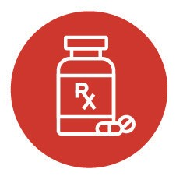
Pharmacotherapy is appropriate for both men and women; however, additional considerations apply to pregnant and postpartum women and those with impaired liver function. For treating opioid use disorder (OUD) during pregnancy, methadone or buprenorphine is recommended.¹⁰ Acamprosate, disulfiram, and naloxone for alcohol use disorder have not yet been studied for pregnant and breastfeeding women.¹¹

Return to Use Prevention and Recovery Supports
Consideration: Returning to substance use is a common occurrence among those with CSU or concurrent SUD, likely due to underlying causes not being addressed or not having adequate tools and supports to continue in their recovery.

Strategy:
- Ensure the client has the tools, resources, and recovery supports they need during and post-treatment. While the client is in treatment

clinicians should work with them to mitigate underlying causes of substance use, develop tools needed to identify and respond to situations that trigger them to use substances, and connect them with resources and support systems, to deal with those triggers when cravings become too intense.
Clinicians should educate clients about recovery and potential periods of intense cravings after significant sobriety. Normalizing this as a process of healing and strategizing with clients on how to surround themselves with individuals who are also in recovery can aid them in successful recovery and prevent relapse.
Creating a comprehensive plan with the client prior to treatment completion and incorporating their strengths and risks into the plan will ensure the client understands what to expect post- treatment. The Recovery Capital Scale identifies tools, resources, and recovery supports to create this plan.

Implementation Considerations and Strategies for Organizations
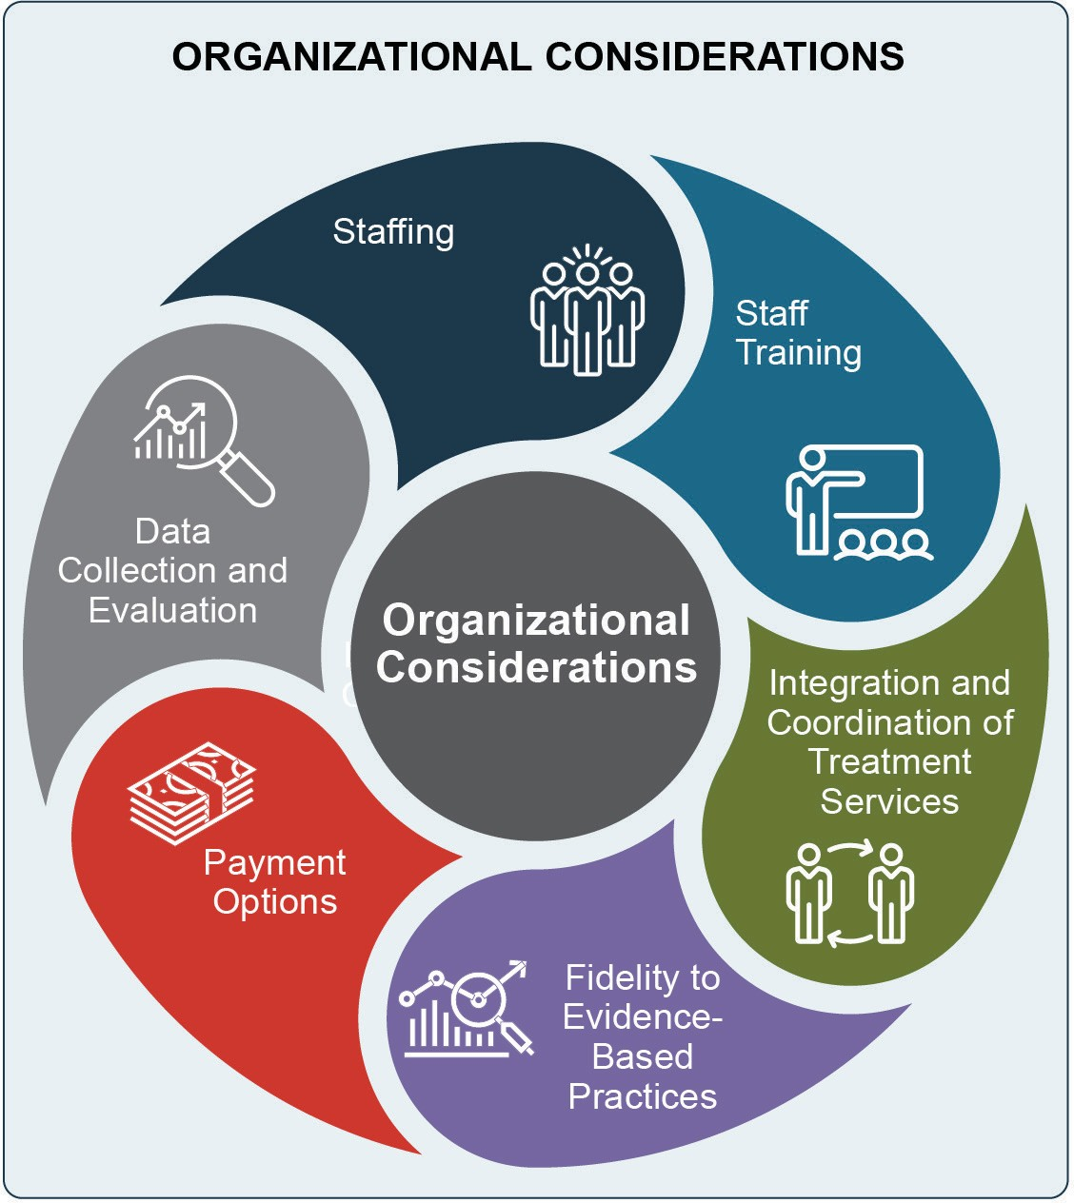

Staffing
Consideration: Individuals with CSU and concurrent
SUD often have complex needs, and clinicians play a critical role in the effectiveness of treatment and treatment outcomes. Having the right staff to work is integral to treatment success.¹²

Strategy:
- Hire a well-trained, diverse workforce. Ensuring staff consists of properly credentialed professionals is essential for providing high quality care to clients. A diverse workforce reflecting the racial and ethnic compositions, gender and gender identity, languages, and lived experiences of the organization’s clients will also improve treatment initiation, delivery of culturally appropriate treatment practices, treatment retention and adherence, and health outcomes.

Staff
Training
Consideration: Unfortunately, a training program specific to CSU or concurrent SUD is not available at the time of this guide’s release, and few clinicians specialize in this area. Program administrators and clinicians may need to develop their own staff training on this topic.

Strategy:
- Conduct staff training on identification of CSU and concurrent SUD and its risk factors. It is important for all staff to recognize that substance use may not be limited to a single substance. Staff should understand the prevalence of CSU and concurrent SUD, be able to recognize when it is present, and identify potentially dangerous interactions of various substance combinations. In addition, organizations and clinicians should be trauma-informed, and training should cover the clinical skills needed to effectively screen
for and identify trauma, including PTSD, and respond to clients with trauma histories. SAMHSA has published a TIP on Trauma-
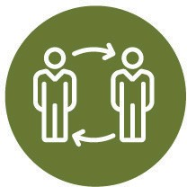
Informed Care in Behavioral Health Services.

Integration and Coordination of Treatment Services
Consideration: Those with CSU or concurrent SUD may have treatment and service plans with several providers for different medical and mental health goals. These plans may affect their treatment.

Strategies:
- Ensure communication and collaboration among a client’s providers. The optimal setting for clients with complex needs is one that integrates physical health, mental health, and substance use treatment services in one location, with multi-disciplinary treatment teams working together toward shared patient goals. However, many organizations do not have integrated services and in these cases, clinicians should work to understand their client’s other health and health-related social and economic needs, if those needs are being met, and how those needs
impact their substance use treatment. If the client has needs that are not being met, connection to
a care coordinator or identifying and directly
referring them to the needed service should be the goal. Substance use treatment clinicians can build relationships and lines of communication with these providers through formal agreements or releases of information, to discuss pertinent details related to the client’s treatment progress.

Seek collaborative partnerships with medical
staff. Implementing pharmacotherapy or identifying a practice that provides
pharmacotherapy can be a daunting undertaking, but for clients who use substances for which there are FDA-approved medications,
those treatments should be made available, either in-house or through partnerships with another community provider.
Treatment programs with medical staff are more likely to have the capacity to implement pharmacotherapy than smaller programs with few or no medical doctors on staff.¹⁵ Programs without these services may consider partnering (for example, through an official subcontract or referral/outreach contract) with primary care or psychiatric practices, to make these services available to their clients. Pharmacotherapy should be supplemented by other therapies
and supports, and treatment clinicians must coordinate with prescribers and those monitoring medications, to ensure coordination and delivery of high-quality care.
- Implement harm reduction approaches. Providing access to naloxone, SSPs, fentanyl test strips, and supervised consumption services, among other resources, helps to keep clients safe and meet them where they are in their recovery. Organizations serving those with
CSU and concurrent SUD should work to either provide these resources, or partner with other organizations that do.

Fidelity to Evidence-Based Practices
Consideration: Since treatment practices have not been designed for those with CSU and concurrent SUD, some adaptation may be needed to fit the treatment to a client’s unique needs. At the same time, it is important to maintain a balance between fidelity and adaptation to avoid compromising expected treatment outcomes.

Strategy:
- Carefully balance adaptation with fidelity of practice. Fidelity, also referred to as adherence, is defined as the extent to which the clinician delivering an intervention adheres to the core components of the protocol or practice model. Fidelity is critical to obtaining intended program outcomes.¹⁶
While certain treatment practices may not yet be proven to address CSU, concurrent SUD, a
particular substance, or for specific communities, clinicians can adapt practices while still ensuring fidelity to core principles and treatment practice components. In general, subtracting program components can be detrimental to fidelity.
However, other adaptations may enhance program or treatment practice outcomes. Some examples include when:¹⁷⁻¹⁸
- A treatment practice is tailored to local beliefs, languages, or culture to enhance its relevance
- A program component is added.
Clinicians should measure fidelity by tracking
and evaluating program outcomes.

Payment Options
Consideration: Payment for specific treatment services depends on public and private insurance requirements around the particular practice and what insurers deem to be the merits of the treatment that was provided and the “usual and customary” payment for the service.

Strategy:
- Obtain funding to implement treatment practices and other services for CSU and concurrent SUD. Many states have included services for individuals with SUD in their Medicaid plans and Medicaid managed care waivers. For states that have expanded Medicaid and for those with private insurance, SUD treatment services are required to be covered. Further, Medicare also covers inpatient and outpatient SUD treatment services.
While SUD treatment is generally covered by insurance and treatments are available, there are fewer options with an evidence base showing effectiveness for those with concurrent SUD.
One such option is CM. Despite evidence that CM is cost-effective¹⁹⁻²⁰ and there is an economic and therapeutic benefit to using it, many state Medicaid, Medicare, and private insurance entities may not reimburse for the
CM reinforcers (payment), due to federal anti- kickback rules.²¹⁻²²
Case-by-case exemptions may be granted by the federal government for individual programs (including, but not limited to, those sponsored and overseen by other government agencies like the National Institutes of Health).²³ Clinicians wishing to implement CM may identify funding for reinforcers, including federal, state, and private grants, as well as contributions from or opportunities to share costs with community partners. Medicaid, Medicare, and private insurers may reimburse for CM as a service,
but cannot directly reimburse for reinforcers. Therefore, CM implementation requires careful coordination with HHS, the state Medicaid agency, and other insurance providers.
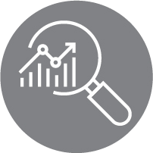
If implementation of CM in-house is not feasible, another option could be partnering with outside CM services. For example, treatment programs can provide CM through a phone application that clients use to share saliva test results with clinicians. The reinforcers are then deposited to a debit card, which blocks cash withdrawals and purchases at certain types of establishments, such as liquor stores and bars.

Data Collection and Evaluation
Consideration: The evidence base on treatment outcomes for those with CSU and concurrent SUD is limited. Therefore, it is essential to collect and assess outcomes data when implementing a program or practice for this client population. Clinicians should regularly review and discuss these data to ensure that the practice is having the intended effects.

Strategy:
- Evaluate effectiveness and disseminate findings. While data collection and evaluation can be difficult and time consuming, evaluating effectiveness and sharing these outcomes internally and with the field will

add to the evidence base and help the program administrators, clinicians, and others understand what works and what does not. Chapter 5 provides information on how organizations and clinicians can incorporate evaluation into their treatment program activities.

Treatment Practice Resources
In addition to the overarching implementation guidance provided above, there are several manuals and resources developed specifically to help stakeholders implement the treatment practices described in Chapter 2. Please note that this guide is not intended to be a training manual. Additional resources are available to support implementation of these treatment practices.

Contingency Management Resources
The Northwest Addiction Technology Transfer Center (Northwest ATTC) developed an online course on contingency management. The training features separate modules for decision-makers, clinical supervisors, and direct care staff. Organizations can use the training as a bridge to more intensive technical assistance.
Texas Christian University’s Institute of Behavioral Research developed a counseling manual for CM. The manual provides “focused, time-limited CM strategies for engaging clients in discussions and activities on important recovery topics.”
Rash and DePhilippis published an article in the journal, Perspectives on Behavior Science, on considerations for implementing CM in substance use treatment clinics. In addition to providing an overview of CM and reviewing the research base, the article also describes CM protocols and specific design considerations important to CM’s efficacy.²⁴

Pharmacotherapy Resources
The American Society of Addiction Medicine (ASAM) developed the National Practice Guideline for the Use of Medications in the Treatment of Addiction Involving Opioid Use to provide information on evidence-based treatment for OUD.
The Department of Veterans Affairs published findings from a qualitative study on pre-implementation barriers and implementation outcomes associated with pharmacotherapy for alcohol use disorder in primary care settings.²⁵
The American Psychiatric Association developed practice guidelines for the pharmacological treatment of clients with alcohol use disorder, with the goal of improving quality of care and treatment outcomes.²⁶
SAMHSA’s Medication for the Treatment of Alcohol Use Disorder: A Brief Guide provides an overview of using FDA-approved medications to manage alcohol dependence or prevent relapse to alcohol use. Three medications are discussed: acamprosate, disulfiram, and naltrexone (both oral and injectable). Further detail on incorporating each of these medications into treatment is described in SAMHSA’s TIP 49: Incorporating Alcohol Pharmacotherapies Into Medical Practice and their advisory document, Prescribing Pharmacotherapies for Patients With Alcohol Use Disorder.
SAMHSA’s TIP 63: Medications for Opioid Use Disorder describes three FDA-approved medications that can help individuals with OUD achieve remission and maintain recovery: buprenorphine, methadone, and naltrexone.

Twelve-Step Facilitation (TSF) Therapy Resources
Hazelden produced a detailed guidebook on TSF therapy and TSF therapy for co-occurring disorders. The adaptations for co-occurring disorders could be applicable for those with concurrent SUD.
Campbell and colleagues published a study providing insights into TSF therapist selection, training, and supervision characteristics associated with improved outcomes for clients.²⁷

Reference List

¹ Wise, R. A. (2008). Dopamine and reward: The anhedonia hypothesis 30 years on. Neurotoxicity Research, 14(2-3), 169-183. https://dx.doi. org/10.1007%2FBF03033808
² Rawson, R. A., Gonzales, R., & Brethen, P. (2002). Treatment of methamphetamine use disorders: An update. Journal of Substance Abuse Treatment, 23(2), 145-150. https://doi.org/10.1016/s0740-
5472(02)00256-8
³ Bhalla, I. P., Stefanovics, E. A., & Rosenheck, R.
A. (2017). Clinical epidemiology of single versus multiple substance use disorders: Polysubstance use disorder. Medical Care, 55, S24-S32. https://doi. org/10.1097/mlr.0000000000000731
⁴ National Harm Reduction Coalition. (2021). Principles of harm reduction. https://harmreduction. org/about-us/principles-of-harm-reduction/
⁵ McPherson, S. M., Burduli, E., Smith, C. L., Herron, J., Oluwoye, O., Hirchak, K., Orr, M. F., McDonell, M. G., & Roll, J. M. (2018). A review of contingency management for the treatment of
substance-use disorders: Adaptation for underserved populations, use of experimental technologies, and personalized optimization strategies. Substance Abuse and Rehabilitation, 9, 43-57. https://dx.doi. org/10.2147%2FSAR.S138439
⁶ Adams, N., & Grieder, D. M. (2004). Treatment planning for person-centered care: The road to mental health and addiction recovery. Academic Press (Elsevier).
⁷ Johnson, L. R., & Sandhu, D. S. (2010). Treatment planning in a multicultural context: Some suggestions for counselors and psychotherapists. In M. M. Leach & J. D. Aten (Eds.), Culture and the therapeutic process: A guide for mental health professionals (pp. 117-156). Routledge.
⁸ Sue, D. W., & Torino, G. C. (2005). Racial-cultural competence: Awareness, knowledge, and skills. In
R. T. Carter (Ed.), Racial-cultural psychology and counseling (pp. 3-18). John Wiley & Sons, Inc.
⁹ Hirchak, K. A., Leickly, E., Herron, J., Shaw, J.,
Skalisky, J., Dirks, L. G., Avey, J. P., McPherson, S., Nepom, J., Donovan, D., Buchwald, D., McDonell,
M. G., & HONOR Study Team. (2018). Focus groups to increase the cultural acceptability of a contingency management intervention for American Indian and Alaska Native Communities. Journal of Substance Abuse Treatment, 90, 57-63. https://doi. org/10.1016/j.jsat.2018.04.014
¹⁰ Substance Abuse and Mental Health Services Administration. (2020). Medications for opioid use disorder. Treatment Improvement Protocol (TIP) Series, No. 63. https://store.samhsa.gov/product/ TIP-63-Medications-for-Opioid-Use-Disorder-Full- Document/PEP20-02-01-006
¹¹ Substance Abuse and Mental Health Services Administration. (2018). Clinical Guidance for Treating Pregnant and Parenting Women With Opioid Use Disorder and Their Infants. HHS Publication No. (SMA) 18-5054. https://store. samhsa.gov/sites/default/files/d7/priv/sma18-5054. pdf
¹² Catty, J. (2004). ‘The vehicle of success’: Theoretical and empirical perspectives on the therapeutic alliance in psychotherapy and psychiatry. Psychology and Psychotherapy, 77(Pt 2), 255-272. https://doi. org/10.1348/147608304323112528
- Ingersoll, K. (2013). Motivational interviewing for substance use disorders. Diagnostic and Statistical Manual of Mental Disorders, 5th Edition [DSM-V]. American Psychiatric Association. https://doi. org/10.1176/appi.books.9780890425596
¹⁴ Rollnick, S., Butler, C. C., Kinnersley, P., Gregory, J., & Mash, B. (2010). Motivational interviewing. BMJ, 340, c1900. https://doi.org/10.1136/bmj.c1900
¹⁵ Abraham, A. J., Knudsen, H. K., & Roman, P.
M. (2011). A longitudinal examination of alcohol pharmacotherapy adoption in substance use disorder treatment programs: Patterns of sustainability and discontinuation. Journal of Studies on Alcohol
and Drugs, 72(4), 669-677. https://dx.doi. org/10.15288%2Fjsad.2011.72.669
¹⁶ James Bell Associates. (2009). Evaluation brief: Measuring implementation fidelity. https:// www.jbassoc.com/wp-content/uploads/2018/03/ Measuring-Implementation-Fidelity.pdf

¹⁷ Backer, T. E. (2002). Finding the balance: Program fidelity and adaptation in substance abuse prevention. A state-of-the-art review. Center for Substance Abuse Prevention, Substance Abuse and Mental Health Services Administration. https://ntrl.
ntis.gov/NTRL/dashboard/searchResults/titleDetail/ PB2004101354.xhtml
¹⁸ McHugh, R. K., Murray, H. W., & Barlow, D. H. (2009). Balancing fidelity and adaptation in the dissemination of empirically-supported treatments: The promise of transdiagnostic interventions. Behaviour Research and Therapy, 47(11), 946-953. https://doi. org/10.1016/j.brat.2009.07.005
¹⁹ Murphy, S. M., McDonell, M. G., McPherson, S., Srebnik, D., Angelo, F., Roll, J. M., & Ries, R. K. (2015). An economic evaluation of a contingency- management intervention for stimulant use among community mental health patients with serious mental illness. Drug and Alcohol Dependence, 153, 293-299. https://dx.doi.org/10.1016%2Fj. drugalcdep.2015.05.004
²⁰ Olmstead, T. A., Sindelar, J. L., & Petry, N. M. (2007). Cost-effectiveness of prize-based incentives for stimulant abusers in outpatient psychosocial treatment programs. Drug and Alcohol Dependence, 87(2-3), 175-182. https://dx.doi.org/10.1016%2Fj. drugalcdep.2006.08.012
²¹ Petry, N. M. (2010). Contingency management treatments: Controversies and challenges. Addiction, 105(9), 1507-1509. https://doi.org/10.1111/j.1360-
0443.2009.02879.x
²² Roll, J. M., Madden, G. J., Rawson, R., & Petry, N.
M. (2009). Facilitating the adoption of contingency management for the treatment of substance use disorders. Behavior Analysis in Practice, 2(1), 4-13. https://doi.org/10.1007/BF03391732
²³ U.S. Department of Health and Human Services. (2020). Medicare and State Health Care Programs: Fraud and Abuse; Revisions to Safe Harbors Under the Anti-Kickback Statute, and Civil Monetary Penalty Rules Regarding Beneficiary Inducements, 0936-AA10 C.F.R. https://www.federalregister. gov/documents/2020/12/02/2020-26072/medicare- and-state-health-care-programs-fraud-and-abuse- revisions-to-safe-harbors-under-the
²⁴ Rash, C. J., & DePhilippis, D. (2019). Considerations for implementing contingency management in substance abuse treatment clinics: The Veterans Affairs Initiative as a model. Perspectives on Behavior Science, 42(3), 479-499. https://dx.doi.org/10.1007%2Fs40614-019-00204-3
²⁵ Hagedorn, H. J., Wisdom, J. P., Gerould, H., Pinsker, E., Brown, R., Dawes, M., Dieperink, E., Myrick,
D. H., Oliva, E. M., Wagner, T. H., & Harris, A.
H. S. (2019). Implementing alcohol use disorder pharmacotherapy in primary care settings: A qualitative analysis of provider-identified barriers and impact on implementation outcomes. Addiction Science & Clinical Practice, 14(1), 24. https://doi. org/10.1186/s13722-019-0151-7
²⁶ Reus, V. I., Fochtmann, L. J., Bukstein, O., Eyler,
A. E., Hilty, D. M., Horvitz-Lennon, M., Mahoney, J., Pasic, J., Weaver, M., Wills, C. D., McIntyre, J., Kidd, J., Yager, J., & Hong, S. (2018). The American Psychiatric Association practice guideline for the pharmacological treatment of patients with alcohol use disorder. American Journal of Psychiatry, 175(1), 86-90. https://doi.org/10.1176/appi. ajp.2017.1750101
²⁷ Campbell, B. K., Buti, A., Fussell, H. E., Srikanth, P., McCarty, D., & Guydish, J. R. (2013). Therapist predictors of treatment delivery fidelity in a community-based trial of 12-step facilitation. American Journal of Drug and Alcohol Abuse,
39(5), 304-311. https://doi.org/10.3109/00952990.20
13.799175

4CHAPTER

Examples of Treatment Programs

This chapter highlights three community examples of programs providing treatment services to people with concurrent substance use (CSU) or concurrent substance use disorders (SUD).
The chapter documents how each program has implemented one or more of the treatment practices described in Chapter 2:
- FDA-approved pharmacotherapy together with counseling
- Contingency management together with FDA- approved pharmacotherapy and counseling
- Twelve-step facilitation (TSF) therapy together with FDA-approved pharmacotherapy and counseling
This chapter describes how each program has implemented these practices as part of a comprehensive strategy to address the needs of their populations.
The programs in this chapter were identified through reviewing the literature, scanning community programs, and consulting with experts.
The programs highlighted in this chapter are implementing treatment practices with documented evidence of success and serving adults with CSU or concurrent SUD from geographically, racially, and ethnically diverse populations. The programs have not been subject to rigorous evaluation of effectiveness and are offered here only as implementation examples.
To be included in this chapter, a program had to:
- Implement one or more of the treatment
practices identified in Chapter 2
- Be replicable (i.e., well-defined with guidance
materials or a manual)
- Provide appropriate and effective interventions for its particular geographic area, treatment practice setting, and population
Whenever possible, programs were chosen that have findings to support their impact on CSU or concurrent SUD.
The summaries include information gathered through interviews with each program staff and other program materials (print or online). Each summary concludes with lessons learned that program staff shared during interviews.
Programs should implement treatment practices with fidelity to evaluated models. Fidelity is the degree to which a program delivers a treatment practice as intended and must be maintained for desired outcomes. However, many programs
adapt chosen treatment practices to better serve their clients. As clinicians modify these treatment practices to address the needs and constraints of their population, budget, setting, and other local factors, fidelity to the treatment practice’s foundational principles and core components is essential.

Outpatient Center

Enterhealth (Dallas, TX)

Enterhealth, founded in 2008, provides a continuum of SUD treatment services across various settings, from medical detox and residential care to outpatient and family therapy. Enterhealth’s Outpatient Center of
Excellence serves adults with a range of SUD, including those with CSU and concurrent SUD. Clients often enter the outpatient program from Enterhealth’s inpatient facility or from other residential programs in the Dallas area.
A majority of clients present with alcohol use disorder (AUD); clients also seek treatment for opioids, marijuana, cocaine, methamphetamines, benzodiazepines, and nicotine. Many also have co- occurring mental health concerns, such as depression, anxiety, trauma, and personality disorder. Enterhealth provides treatment to adults (aged 18 and older).
Enterhealth does not publish client demographics on race or ethnicity.
Enterhealth typically serves between 350 and 400 clients at a time across its continuum of outpatient programs: intensive outpatient program (IOP), supportive outpatient program (SOP), and maintenance outpatient program (MOP). Clients receive direct services each week, based on the client’s level of care:
- IOP: 120 minutes of care, 3 days per week
- SOP: 90 minutes of care, 2 days per week
- MOP: 90 minutes of care, 1 day a week
Individuals receive services in accordance with their treatment plan. Services include evidence-based medication management and individual, group, and family therapy. Naltrexone, acamprosate, disulfiram, or buprenorphine may be used in addition to individual and group therapy. Physicians refer out for methadone induction, if needed. As appropriate, clients may also receive medications to treat mental disorders, such as depression and anxiety.

Program’s Treatment Practice
FDA-approved pharmacotherapy together with counseling; TSF therapy together with FDA- approved pharmacotherapy and counseling
Setting
Continuum of outpatient programs (ranging from intensive outpatient to maintenance)
Population of Focus
Adults
Program Duration
Aim to keep clients involved for one year, including approximately 2 months in intensive outpatient, 3-5 months in supportive outpatient, and 3-5 months in maintenance
Related Resources
Program website: https://enterhealth.com/ outpatient-ocoe/
Key Implementation Considerations
- Engagement and retention of clients in treatment
- Assessment of risk and protective factors that
influence client’s substance use
- Motivation and readiness to change
- Integration and coordination of treatment services

Model Features and Elements
- Medication combined with group, individual, and family therapy using manualized treatments, including cognitive behavioral therapy (CBT), dialectic behavioral therapy, and motivational interviewing (MI)

- Individualized treatment plans reflecting substance use history, substance of choice, family and lifestyle considerations, severity of dependence, and overall health and wellness
- Integrated team focused on client engagement, including an addiction psychiatrist, neuropsychologist, therapist, and nurse
- Treatment effectiveness assessments to track individual progress, including quality of life and substance use, completed at admission,
discharge, and 60 days, 90 days, 6 months, and 1 year after the end of treatment
- Substance use monitoring, including urine toxicology screens and self-report
- Full continuum of care available in-house, facilitating step-up or step-down care, as needed
- Adherence to evidence-based treatment maintained through weekly refresher trainings and supervision, as well as in-house trainings and outside resources provided, as needed

Findings and Outcomes
From treatment initiation to 90 days after treatment, 84 percent of clients show:
- Reduced substance use
- Improved self-reported quality of life

Lessons Learned
- Involve clients in developing their care plan and ensure they understand the science behind the program
- Build relationships between clients and staff at all levels, including administrative staff, so clients know they are cared for
- Include family members and/or significant
others, when appropriate

Outpatient Alcohol and Drug Rehab

Hazelden Betty Ford Foundation (St. Paul, MN)

Hazelden Betty Ford opened in 1949 in Center City, Minnesota, as an organization serving men with AUD using a new approach at the time: a 12-step orientation. Within the first decade, the organization expanded services to women and people with other SUD. The organization continued to evolve and expand its services based on changes in client needs and available evidence. Now, there are 17 sites throughout the United States, each providing treatment programs and services tailored to specific population needs. All employ evidence-based practices for individuals with CSU and concurrent SUD, including pharmacotherapy together with counseling, TSF therapy, and MI.
Program’s Treatment Practice
FDA-approved pharmacotherapy together with counseling and TSF therapy together with FDA- approved pharmacotherapy and counseling
Setting
Continuum of outpatient programs (ranging from day treatment to high-intensity outpatient treatment)
Population of Focus
Adults
Program Duration
4 to 7 weeks in day treatment, 4 to 6 months or
more in IOP and outpatient
Related Resources
Program website: https://www.hazeldenbettyford. org/locations/st-paul
Klein, A. A. & Seppala, M. D. (2019). Study of COR-12: Medication-assisted treatment for opioid use disorder within a 12-step based treatment center: Feasibility and initial results. Journal of Substance Abuse Treatment, 104, 51-63.
Key Implementation Considerations
- Engagement and retention of clients in treatment
- Selection of a treatment practice
- Return to use prevention and recovery supports
- Staff training
- Fidelity to evidence-based practices
- Data collection and evaluation
As the prevalence of individuals with opioid use disorder (OUD) increased, the organization’s Chief Medical Officer assembled a team to examine how the organization should respond to this issue. This examination drove the development of a research-based program tailored to OUD: Comprehensive Opioid Response with the Twelve Steps (COR-12®). In COR-12®, clients receive medication (extended-release naltrexone or buprenorphine/naloxone), case management, specific education related to OUD,
and connection to 12-step and other mutual recovery groups. Program clients may be served in residential or outpatient levels of care, depending on their individual needs. Facilities throughout the Hazelden Betty
Ford organization implement COR-12®. Across the organization, 20 percent of clients have an OUD and are treated with COR-12®.
The COR-12® approach evolved over time as staff learned how to keep clients engaged in treatment and safe from returning to use and overdose. Clients required more case management than originally anticipated,
and group therapy topics were refined as certain topics were of greater interest than others. The approach to prescribing also changed as the evidence for this practice and the organization’s experience grew. There are no time limits on how long clients utilize medications.
Decisions about tapering off a medication are individualized based on the client’s progress, and clients and clinicians make this decision together.

The Outpatient Alcohol and Drug Rehab treatment center in St. Paul, Minnesota, serves about 500 people at a given time, including 50 to 60 people in its COR-12® program. Compared with those in standard substance use treatment at this facility, those in COR-12® tend to be younger—many are young adults aged 18 to 25—and the majority are non-Hispanic, White, middle class, and covered by commercial insurance (approximately 95 percent). Use of substances in addition to opioids (e.g., alcohol, cocaine, methamphetamines) is common in
this population, and over 90 percent have co-occurring mental illness. Program clients typically receive
day treatment for four-to-seven weeks depending
on insurance coverage, then IOP and low-intensity outpatient for four-to-six months or more, in some cases well over a year.
Staff receive training in COR-12® that focuses on engagement tactics, including the role of adverse childhood experiences, trauma-informed care, and person-centered care.

Model Features and Elements
- Medication combined with counseling, psychoeducation, and TSF therapy, in addition to connection to 12-step and other recovery support
- One counselor model for IOP (3 or 4 sessions per week) and outpatient (1 or 2 sessions per week), so clients keep the same counselor as they move between levels of care
- Three-hour sessions in IOP and outpatient that include psychoeducation and a process group led by a counselor
- Mental health services provided by master’s- level therapists, psychologists, and psychiatrists
- Response to treatment monitored using weekly self-assessments of drug craving, therapeutic alliance, self-efficacy, and depression and anxiety
- Integrated care teams, including counselors, mental health staff, medical providers, and nursing staff, depending on the particular level of care
- In-house residential unit offering a structured recovery setting if a more intensive level of care is needed

Findings and Outcomes
- When COR-12® was incorporated in residential treatment, 92 percent of clients completed residential treatment, which represented a considerable increase from previous completion rates
- After completing residential treatment, 73 percent of COR-12® clients attended at least one other Hazelden Betty Ford program, and 5
percent attended a program with another provider
- Data are not available for the Outpatient Alcohol and Drug Rehab treatment center in St. Paul, Minnesota

Lessons Learned
- Educate clinicians and partners that FDA- approved pharmacotherapy is compatible with the 12-steps
- Conduct outreach through phone conversations, in-person meetings, and onsite community meetings, so clinicians can meet, hear from, and learn about the evidence and efficacy of medication for OUD, discuss concerns, and brainstorm solutions to concerns
- Curate lists of 12-step groups that accept people
receiving medication for OUD
- Include messaging at the beginning, middle, and end of treatment around return to use, tolerance, and safety, particularly for clients with OUD
- Approach clients in a non-judgmental and low
conflict way to keep them engaged

Outpatient Drug Rehab Clinic in Beaverton, OR
Hazelden Betty Ford Foundation’s outpatient addiction treatment center in Beaverton, OR provides day treatment, IOP, and continuing care outpatient services to approximately 180 clients at a time.
Combining patient-centered treatment, FDA-approved pharmacotherapy, TSF, MI, and integrated SUD and mental health therapies, the Beaverton team helps individuals move from clinical management (high intensity clinical oversight and care coordination) to self-management. Measurement-based treatment is central to the clinical model. Using Feedback-Informed Treatment (FIT) assessments, the team collects baseline data on how an individual is doing with respect to cravings, commitment, anxiety and depression, and uses FIT assessments throughout treatment to measure progress and inform clinical interventions. These evidence-based treatment methods continue to enhance the therapeutic environment, improving client willingness, engagement, and overall satisfaction.
Originally meant to serve the Portland, OR area, the treatment center began serving clients across both Oregon and Washington by transitioning to virtual care. In 2020, the COVID-19 public health emergency shifted admissions and all programming to virtual; the Beaverton treatment center plans to continue offering virtual programming long-term. Preliminary data comparing outcomes among clients receiving in-person services
(pre-pandemic) to those receiving virtual services found no differences in abstinence rates between the groups at one month and three months post-treatment. Part of the success of virtual services may be the continuation of drug testing. Clinicians use test results to discuss client progress or challenges constructively; positive test results do not result in punishment. Partnering with a company that conducts at-home testing ensured that there was no reduction in the frequency of testing even when all other services were virtual. Routine testing and a non-punitive approach help to maintain treatment quality and client safety when clients are remote.

Outpatient Clinic

Steppingstone Incorporated (Fall River, MA and New Bedford, MA)

Steppingstone Incorporated, an alcohol and drug treatment program with sites in Fall River and New Bedford, Massachusetts, has provided residential SUD treatment since the early 1970s. In 1997, Steppingstone established its flagship Outpatient Clinic (the Clinic) in Fall River, as part of a concerted effort to expand access to community-based SUD treatment and has since scaled up its capacity and services in recognition of residential clients’ ongoing care needs. The Clinic further expanded to include a second location in New Bedford in 2019.
The Clinic serves adults (18 years of age or older) with a range of SUD, including CSU and concurrent SUD. Clients enroll in the Outpatient Clinic program through Steppingstone’s residential programs and through both clinicians and self referrals.
The Clinic sites serve approximately 500 to 600 clients annually, with a caseload of about 150 clients at any given time. Clients receive direct services on a weekly basis, though greater frequency and intensity of service is available if clinically needed. The duration and content of treatment plans are individualized. Treatment plans are reviewed and updated on a quarterly basis. The Clinic currently has the capacity to provide services in English, Spanish, and Portuguese.
Both clinic locations currently provide an array of outpatient SUD treatment services, including FDA- approved pharmacotherapy (in the form of methadone, buprenorphine, naloxone, and naltrexone) with counseling, and individual, group, and family therapy using CBT and MI. The Clinic also offers mental health treatment (including psychiatric services), gambling treatment services, and wraparound services (including case management, housing support, and peer recovery coaching), as needed. Clinic staff include master’s-
and doctoral-level trained therapists (i.e., counselors, social workers, and psychologists), nurse practitioners, physician assistants, and administrative staff.

Program’s Treatment Practice
FDA-approved pharmacotherapy together with counseling
Setting
Outpatient behavioral health clinic
Population of Focus
Adults
Program Duration
Variable
Related Resources
Program website: http://www.steppingstoneinc.org/outpatient-clinic/
Key Implementation Considerations
- Engagement and retention of clients in treatment
- Motivation and readiness to change
- Selection of a treatment practice
- Integration and coordination of treatment services
- Staffing

Opioids (in the form of heroin, prescription opioids, and fentanyl) are the most commonly reported substance used by clients, though alcohol and cocaine are used or co-used often. A substantial number of clients have co- occurring mental health needs and/or trauma histories. The majority of clients have low income, and many speak Portuguese as their primary language (though they also speak and receive services in English).

Model Features and Elements
- Structured clinical assessments, including Beck’s Inventory, Brief Psychiatric Rating Scale (BPRS), Trauma Symptom Checklist, CAGE and CAGE-AID, and University of Rhode Island Change Assessment (URICA), completed at intake and again on a monthly basis
- Individualized treatment planning, updated quarterly, with wraparound services and supports (including coordinated mental health services, case management, housing and peer recovery coaching)
- FDA-approved pharmacotherapy combined with group, individual, and family therapy using manualized treatments, including CBT and MI
- Substance use monitoring in the form of urine screening and breath analysis

Findings and Outcomes
The Clinic recently transitioned to an electronic health record system and has begun inputting and tracking longitudinal client clinical assessment data in that system. Steppingstone is required to enter quarterly
and annual reporting data into a state database for performance monitoring. Steppingstone is also required to provide data to SAMHSA using a variety of assessments, including Government Performance and Results Act performance measures, National Outcomes Measures, and the Recovery Capital Assessment. The Clinic tracks completion of treatment goals that are
created through collaborative efforts of the consumer and
the assigned counselor.

Lessons Learned
- Be flexible—clinicians must be prepared to “meet clients where they are” and develop and implement a treatment plan that works for that individual; assess treatment planning over time.
- Co-locating services (SUD, mental health, wraparound) in a single location, especially for clients who are anxious about getting into treatment, can be very beneficial.
- Coordinating with clinicians across the continuum of care (outreach, residential, outpatient, ongoing peer recovery supports) helps to keep clients engaged by ensuring warm handoffs between clinicians, and uninterrupted care.

Other Examples of Treatment Programs
Contingency management: An example of a program implementing contingency management can be found in SAMHSA’s Treatment of Stimulant Use Disorders Guide.
Comprehensive treatment: SAMHSA Certified Community Behavioral Health Clinic (CCBHC) Grants provide person- and family-centered integrated services. The purpose of SAMHSA’s CCBHC grant program is to increase access to and improve the quality of community mental health and SUD treatment services. CCBHCs provide comprehensive 24/7 access to community-based mental health and SUD services, including crisis services, treatment of concurrent SUD, treatment of co-occurring disorders, and coordination with medical care.

5CHAPTER

Resources for Evaluation and Quality Improvement

Evaluating an intervention can answer critical questions about how well clinicians have implemented a practice and determine what may or may not be working. Evaluation can also show how clients benefit from a practice. This information can be helpful in adjusting the practice, if necessary, and demonstrating the value of a practice or program to justify its continuation and secure additional funding. In addition, stakeholders can use information gathered through evaluation to encourage implementation of that practice in other settings or communities.
Ideally, evaluated practices would see a reduction in clients’ symptomatology because of the practice and a high level of retention, acceptability, and satisfaction with the treatment practice. Treatment clinicians and clients should be engaged in the generation of evaluation tools and plans to ensure they are appropriate for the evaluated communities and to secure buy-in from these stakeholders. Reporting findings back to clinicians and clients should be prioritized, to promote transparency and inform care choices.
This chapter provides an overview of approaches to evaluate implementation of and results from treatment practices and other services for clients with concurrent substance use (CSU) and concurrent substance use disorders (SUD). The chapter also includes information on implementing a continuous quality improvement (CQI) process and an outcome-focused evaluation.
Further, it provides specific evaluation resources,
including potential outcomes to track.

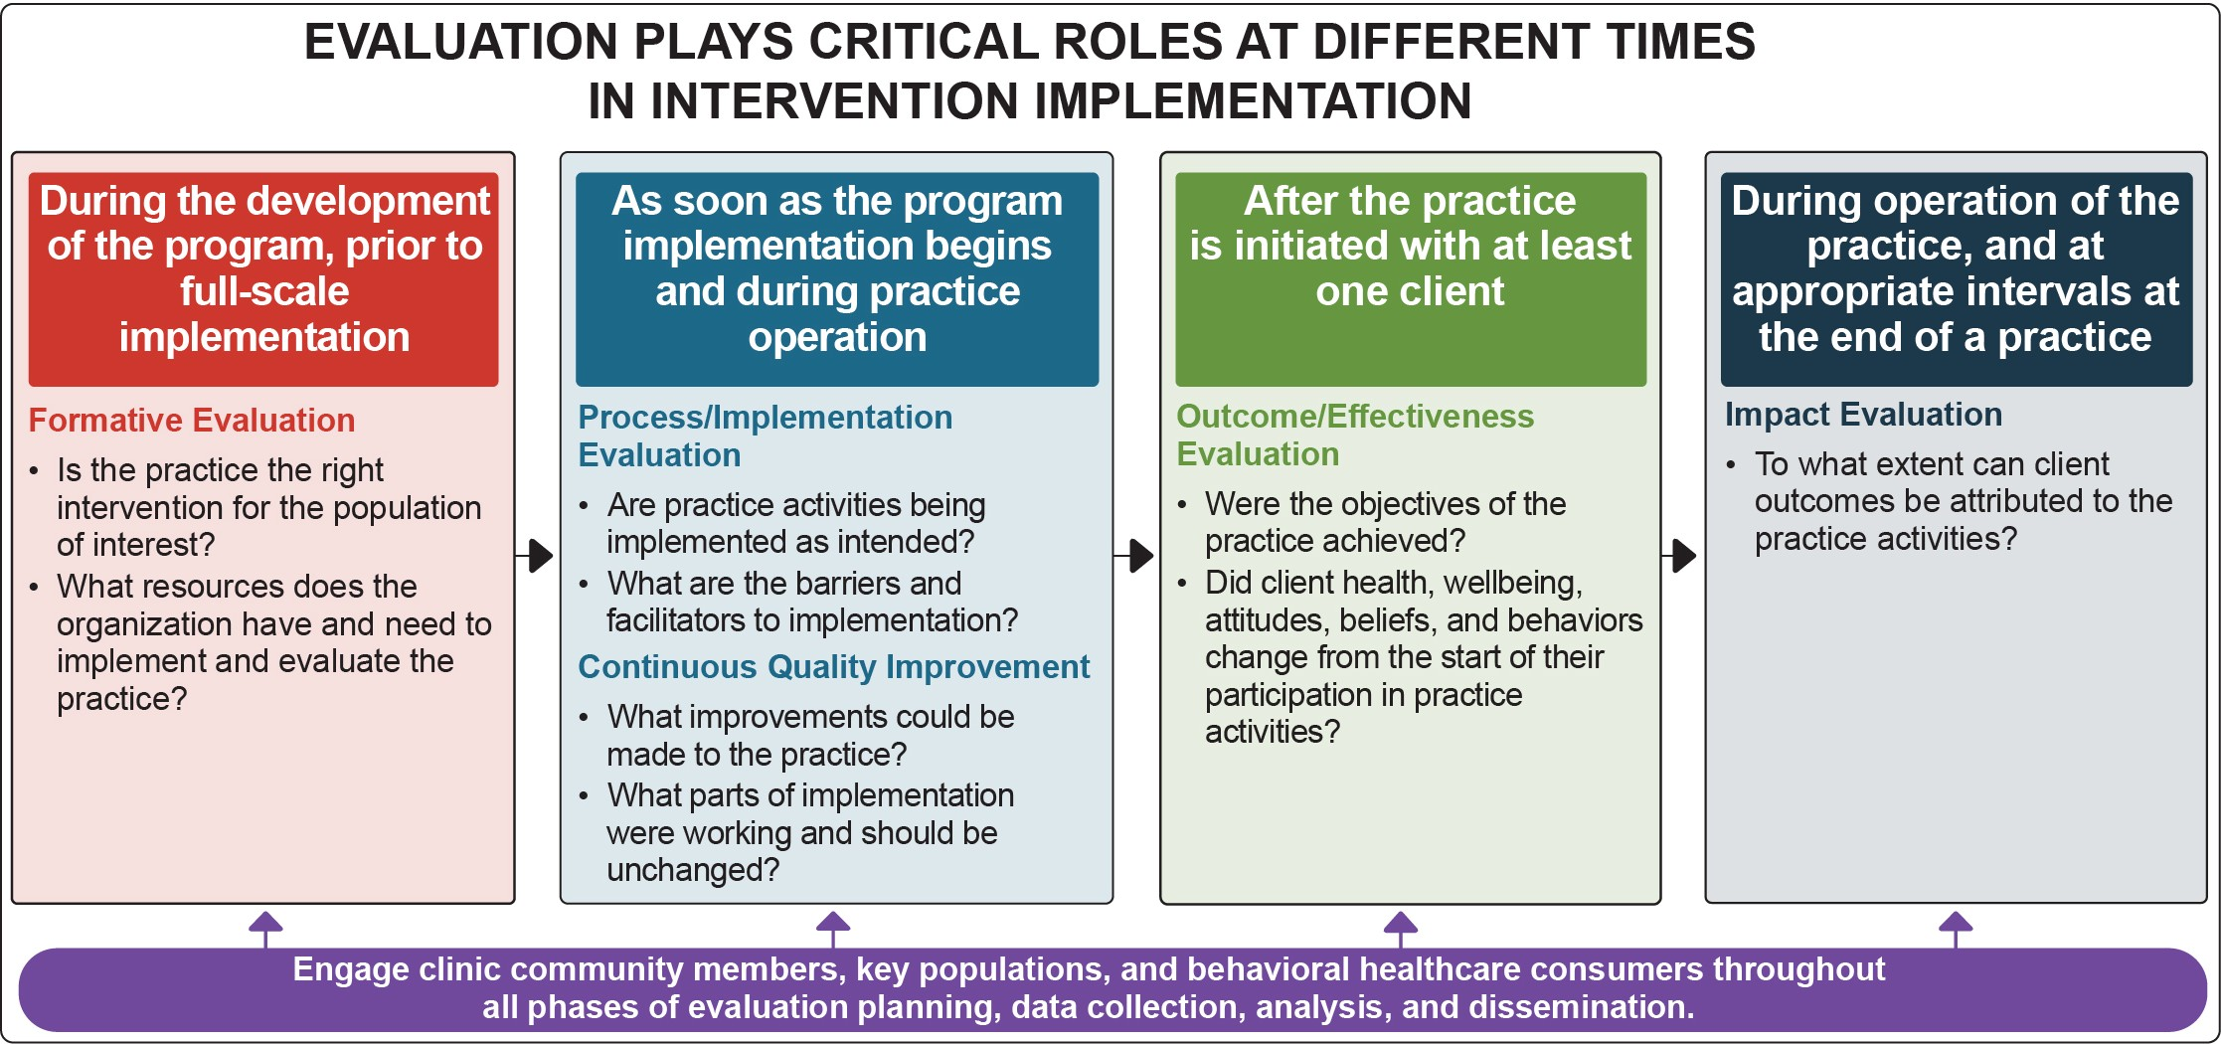

Types of Evaluations
Researchers conduct evaluation activities:
- Before a treatment practice is implemented to determine its feasibility (formative evaluation)
- During implementation (process evaluation and
CQI)
- After the treatment has been delivered to at least one client (outcome and impact evaluations)
All evaluation types are necessary to assess a practice’s
effectiveness.

Conducting Continuous Quality Improvement
Providing services to individuals with CSU and concurrent SUD may be new to an organization, or new treatment practices and other services may be
introduced and adapted to meet the needs of an evolving client population. CQI can be used to systematically identify, document, and analyze barriers and facilitators to implementation for the purposes of improving outcomes.

What is CQI?

CONTINUOUS QUALITY IMPROVEMENT (CQI)

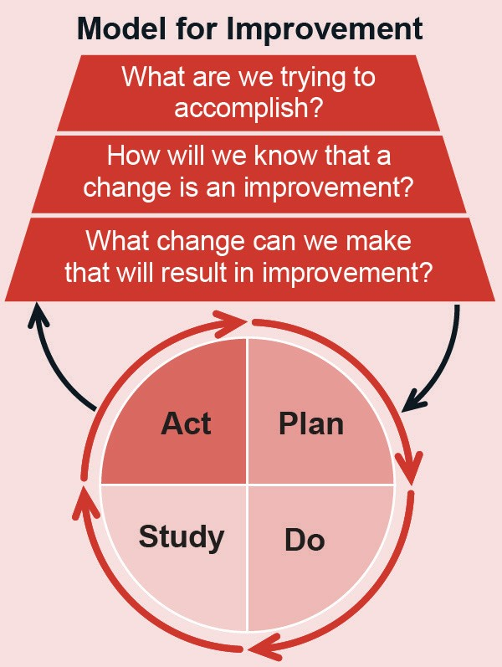CQI involves a systematic process of assessing program or practice implementation and short-term outcomes and then involving program staff in identifying and implementing improvements in service delivery and organizational systems to achieve better treatment outcomes. CQI helps assess practice fidelity, the degree to which a program delivers a practice as intended. There are many potential CQI models and approaches (e.g., https://www.healthit.gov/faq/what-are-leading-continuous-quality-improvement-strategies-health-care-settings).
CQI differs from process evaluation in that it involves quick assessments of program performance, timely identification of problems and potential solutions, and implementation of small improvements to enhance treatment quality. CQI is usually conducted by internal staff. Process evaluation involves longer-term assessments and is best conducted by an external evaluator.
NIATx, a project originally funded by SAMHSA’s Center for Substance Abuse Treatment, offers tools to conduct CQI and improve services in SUD treatment settings. NIATx is based on the principle of program improvement through a series of small changes, tested and implemented one at a time, that in the end have a cumulative effect.
The Institute for Healthcare Improvement’s PDSA Model for Improvement identifies a scientific method for testing small-scale changes in an action-oriented, cyclical manner. The stages include: planning it (Plan), trying it (Do), observing the results (Study), and acting on what is learned (Act).
Why use CQI?
CQI takes a broad look at the systems in which programs or practices operate. Because of the pivotal role it plays in performance management, organizations implementing services with people experiencing CSU and concurrent SUD are encouraged to implement CQI procedures.
What are the steps involved in CQI?
Although steps in the CQI process may vary based on objectives, typical CQI steps include:
  - Identify a program or practice issue needing improvement and a target improvement goal
  - Analyze the issue and its root causes
  - Develop an action plan to correct the root causes of the problem,
including specific actions to take
  - Implement the actions in the action plan
  - Review the results to confirm the issue and its root causes have been addressed and short-term and long-
term treatment outcomes have improved
  - Repeat these steps to identify and address other issues as they arise

Institute for Healthcare Improvement. (n.d.). Science of improvement: Testing changes. http://www.ihi.org/resources/Pages/HowtoImprove/ScienceofImprovementTestingChanges.aspx
New Jersey Department of Children and Families. (n.d.). Five Stages of Continuous Quality Improvement.
https://www.nj.gov/dcf/about/divisions/opma/CQI%20framework.pdf
University of Wisconsin-Madison, NIATx National Program Office. (n.d.). What is NIATx?
https://www.niatx.net/what-is-niatx/
U.S. Department of Health & Human Services Office of Adolescent Health. (n.d.). Continuous Quality Improvement, Part 1: Basics for Pregnancy Assistance Fund Programs. https://www.hhs.gov/ash/oah/sites/default/files/cqi-intro.pdf

Preparing to Collect Data
The following steps can help clinics and practitioners prepare to collect and analyze data:
- Determine if the purpose of the data collection is evaluation or research.
Qualitative and quantitative evaluation and research enable managers and clinicians to
learn from clients and obtain the perspective of those with lived experiences. Both
evaluation and research can also involve collecting data from staff who deliver the treatment to obtain their perspectives on
facilitators and challenges to implementation. Where program evaluation supports program improvement, research systematically follows
study protocols to develop generalizable
knowledge. Research requires protocol and procedure approval by an Institutional Review Board (IRB), to adhere to human
subject research protections. Most program evaluations and quality improvement projects do not require IRB approval, but researchers should consult with their institutions during evaluation design to ensure they are following appropriate data collection procedures.
- Determine outcomes of interest.
A challenging step in the process of implementing new practices is to determine whether they have yielded desired CSU and concurrent SUD outcomes. An outcome is the change a program plans to accomplish through the implementation of a practice. Evaluations exist across a continuum, from tracking staff activities, numbers, client no-shows, and payments to conducting client satisfaction surveys and comparing results between
clients receiving different treatment options. Organizations conducting evaluation or research should engage stakeholders (within the clinic and the community) to identify appropriate processes and outcomes and the metrics used to assess outcomes.

Qualitative and quantitative data are complementary. Each provides critical insight into if and how the intervention is operating and achieving the intended objectives.
Qualitative data include any non-numeric, text-based information, such as verbal, visual, or written data. Qualitative data collection
methods include interviews, focus groups, clinical observations, gathering data from documents and images, and open-ended survey questions and polling responses.
Quantitative data are any numeric data that can be processed by mathematical or statistical analysis. Quantitative data collection includes close-ended survey questions and polling responses, services and utilization data, and claims and encounter data.

- Identify team members to conduct evaluation activities and capacity to conduct evaluations. Regardless of the type of research or evaluation
conducted, collecting and analyzing data take
time. Programs need to identify team members who can conduct evaluation activities, as well as secure funding for evaluation trainings, data collection, and data analyses.

Process and Outcome Measures to Determine Impacts and Effects
The table below provides a list of potential measures, indicators, and data sources that program managers, clinicians, and others may use to evaluate practices identified in Chapter 2. CSU and concurrent SUD process and outcome measures may be tracked at baseline and throughout the program duration using standardized screening or through interviews with staff and clients.
Organizations can also leverage performance measures, quality metrics, and outcomes that are already reported to other entities, such as the state, SAMHSA, insurers, or other funders.

Evaluations Include a Variety of Process and Outcomes Measures

Illustrative Measure | Illustrative Indicators | Illustrative Data Sources
Process Measures
Treatment engagement | - Extent of client engagement in the treatment | - Client self-report  - Provider organization electronic data sources
Treatment retention | - Number of treatment sessions attended  - Number of 12-step meetings attended | - Attendance/administrative data  - Provider organization electronic data sources
Short-Term and Intermediate Outcome Measures
Reduced use of substances (short- and long- term) | - Amount of use for multiple substances  - Frequency of use for multiple substances  - Usage during reference periods (e.g.,  past 30 days, past year) | - Client self-report  - Lab data (e.g., urine screen)  Measurement tools  - Addiction Severity Index (ASI)  - Cocaine Selective Severity Assessment (CSSA)  - Maudsley Addiction Profile (MAP)  - Substance Abuse Calendar  - Substance Problem Scale (SPS)  - Timeline Follow-Back Method Assessment (TLFB)  - Treatment Effectiveness Score (TES)
Reduced craving | - Feeling of craving for either single or multiple substances | - Client self-report  Measurement tools  - Addiction Severity Index (ASI)  - Brief Substance Craving Scale (BSCS)
Improvements in behavioral,  psychiatric, health, and emotional functioning | - Attainment of client’s personal goals  - Decreases in legal involvement  - Improved daily functioning (e.g., hygiene, making meals)  - Increased enjoyment of and interest in activities  - Improved sleep  - Participation in rehabilitation program, school, or employment  - Participation in medical appointments and care  - Reduction of mental disorder symptoms  - Reduction or absence of suicidal ideation and self-harm  - Reduction in feelings of helplessness and hopelessness  - Stable relationships/social functioning | - Client self-report  - Employment administrative data  - Hospital and medical facility administrative data  - Justice system administrative data  - Parent/guardian/friend observation  - School administrative data  Measurement tools  - Beck Depression Inventory (BDI-II)  - Hamilton Rating Scale for Depression  (HAM-D-27)  - Maudsley Addiction Profile (MAP)  - Modified Global Assessment of Functioning  - Patient Health Questionnaire (PHQ-9)  - Quick Inventory of Depressive Symptomatology (QIDS)  - State Trait Anxiety Inventory (STAI)

Illustrative Measure | Illustrative Indicators | Illustrative Data Sources
Short-Term and Intermediate Outcome Measures
Improvements in educational or professional  achievement and attainment | - Attainment of client’s personal goals for education and professional development  - School achievement  - Vocational training | - Client self-report  - Degree/certificate attainment  - Employment status  - Grade promotion/retention  - Graduation or dropout status  - Overall grade point averages
Long-Term Outcome Measures
Reduced prevalence of substance use | - Prevalence of substance use for single or multiple substances  - Substance overdose | - Large-scale national surveys  - State or community surveys  - National databases
Reduction in mental health issues in individuals with CSU/concurrent SUD | Rate of hospitalizations related to:  - Attempted suicides  - Co-occurring mental and substance use disorders | - Client self-report  - Hospital and medical facility administrative data
Reduction in CSU/concurrent SUD-related crime | Rate of arrests related to:  - Impaired driving  - Possession of substance(s)  - Public impairment  - Underage smoking or drinking | - Client self-report  - Justice system administrative data
Improvements in educational or professional  achievement and attainment | - Attainment of client’s personal goals for education and professional development | - Client self-report  - Degree/certificate attainment  - Employment status  - Grade promotion/retention  - Graduation or dropout status

Evaluation Resources

Evaluating Programs
  - A Framework for Program Evaluation from the
Program Performance and Evaluation Office
at the Centers for Disease Control and Preven- tion summarizes essential elements of program evaluation.
  - The Community Toolbox from the Center for Community Health and Development at the University of Kansas includes a step- by-step guide to developing an evaluation
of a community program, specific tools, and
examples.

Evaluating Program Sustainability
  - Center for Public Health Systems Science at the Brown School at Washington University in St. Louis has developed a Program Sustainability Assessment Tool (PSAT) and a Clinical Sustainability Assessment Tool (CSAT) to measure progress towards sustaining new implementation efforts.

Quality Improvement and Continuous Performance Monitoring
  - The Institute for Healthcare Improvement’s Quality Improvement Essentials Toolkit includes the tools and templates to launch a quality improvement project and manage performance improvement.

Appendix 1: Acknowledgments

This publication was developed with significant contributions from Kyle Kampman, MD and Cori Sheedy, PhD. The guide is based on the thoughtful input of SAMHSA staff and the Expert Panel on Treating Concurrent Substance Use Among Adults from October 2020 through August 2021. A series of guide development meetings was held virtually over a period of several months. Three expert panel meetings were convened during this time.

SAMHSA Staff
Robert Baillieu, MD, MPH Center for Substance Abuse Treatment*
Christine Cichetti National Mental Health and Substance Use Policy Laboratory
Thomas Clarke, PhD National Mental Health and Substance Use Policy Laboratory
Amanda Doreson, MPA National Mental Health and Substance Use Policy Laboratory
Tanya Geiger, PhD, MPH National Mental Health and Substance Use Policy Laboratory*
Donelle Johnson, PhD, MHSA National Mental Health and Substance Use Policy Laboratory*
Krishnan Radhakrishnan, MD, PhD, MPH National Mental Health and Substance Use Policy Laboratory
Carter Roeber, PhD National Mental Health and Substance Use Policy Laboratory*
Onaje Salim, EdD Center for Substance Abuse Prevention*
Expert Panel
Diana Ball, MSW, LCSW Crosswinds Counseling
Frederic Blow, PhD University of Michigan, U-M Addiction Center
Emily Einstein, PhD National Institute on Drug Abuse
Thomas Freese, PhD University of California at Los Angeles Integrated Substance Abuse Program; Pacific Southwest Addiction Technology Transfer Center
Gerardo Gonzalez, MD University of Massachusetts Medical School
Kyle Kampman, MD Perelman School of Medicine, University of Pennsylvania*
Laura Kwako, PhD National Institute on Alcohol Abuse and Alcoholism
Sharon Reif, PhD Heller School for Social Policy & Management, Brandeis University
Les Sperling, BA LAC Recovery PRN LLC
Contract Staff
Cori Sheedy, PhD, MA Abt Associates*
Sarah Steverman, PhD, MSW Abt Associates* Margaret Gwaltney, MBA Abt Associates* Korrin Bishop Korrin Bishop Writing & Editing Meaghan Hunt Abt Associates
Dana Maglić, MS Abt Associates Daniel Jefferson Smith Abt Associates Bill Villalba, MA Abt Associates
Christopher Weiss, PhD Abt Associates
Micaiah Wheeler Abt Associates
*Members of Guide Planning Team

Appendix 2: Evidence Review Methodology

The authors followed a rigorous, systematic evidence review process in developing this guide. This appendix provides an overview of the evidence review methodology used to identify the ratings for the treatment practices included in the guide:
  - FDA-approved pharmacotherapy together with counseling
  - Contingency management together with FDA- approved pharmacotherapy and counseling
  - Twelve-step facilitation therapy together with FDA-approved pharmacotherapy and counseling
Reviewers, in coordination with SAMHSA and experts, conducted a four-step process to select treatments, identify related studies, review and rate studies, and identify treatment ratings.

Step 1: Treatment Selection
The authors identified these treatments after a review of the literature and in consultation with experts. Eligible treatments were required to meet the following criteria for evidence review:
  - Be clearly defined and replicable
  - Address the target outcome of improving substance use outcomes for individuals with concurrent substance use (CSU) or concurrent substance use disorders (SUD)
  - Be currently implemented in the field
  - Have studies of their effectiveness
  - Have accessible implementation and fidelity
supports
At the conclusion of this step, SAMHSA and the guide’s Expert Panel reviewed the proposed programs identified by the authors and agreed on three treatment practices for inclusion in the evidence review and rating processes.

Step 2: Study
Identification
Once the practices were selected, the reviewers conducted a comprehensive review of published research to identify studies of the selected practices. This review only included studies from eligible sources (i.e., peer- reviewed journals and government reports) that avoid clear conflicts of interest. The reviewers documented all potential studies identified through the literature search.
The studies identified in the literature search varied in type and rigor, so the reviewers assessed them further for inclusion in the evidence review. To be eligible for review and study rating, research studies had to:
  - Employ a randomized or quasi-experimental design, or
  - Be a single sample pre-post design or an epidemiological study with a strong
counterfactual—a study that analyzes what would have happened in the absence of the intervention.
Literature reviews, descriptive studies, implementation studies, and meta-analyses were not included in the review, but were documented to provide context and identify implementation supports for the practices.
Additionally, to be eligible for further review and rating, studies had to:
  - Be published or prepared in or after 2000
  - Be a publicly available peer-reviewed or research report
  - Be available in English
  - Include at least one eligible outcome related to the topic
  - Have a comparison/control group that is treatment as usual or no/minimal intervention if using a randomized experimental or quasi- experimental design

Step 3: Study Review and Rating
Next, trained reviewers assessed each study to ensure the methodology was rigorous, and, therefore, could demonstrate causality between the treatment practice and the identified outcomes. Reviewers analyzed and documented each study to ensure:
- Experimental and comparison groups were statistically equivalent, with the only difference being that participants in the experimental group received the intervention and those in the comparison group received treatment as usual or no/minimal intervention.
- For randomized experiments with high attrition and for quasi-experimental designs, baseline equivalence had been established between the treatment and comparison groups.
- For randomized experiments, randomization was not compromised. For example, ensuring reassignment of treatment status (usually made to balance the distribution of background variables between treatment and control groups) did not occur.
- Study did not have any confounding factors (i.e., those that affect the outcome but are not accounted for in the study).
- Missing data were addressed appropriately, including:
  - Imputation based on surrounding cases was considered valid.
  - Complete case analysis was considered valid and accounted for as attrition.
  - Using model with dummy for missing as a covariate was considered valid.
  - Assuming all missing data points are either positive or negative was not considered valid.
  - Regression-based imputation was considered valid and mean imputation was not considered valid.
- Outcome measures were reliable, valid, and
collected consistently from all participants.
- Valid statistical models were used to estimate impacts.
- Treatment demonstrated improved outcomes related to substance use, SUD, or treatment engagement.
Based on the study design and these study characteristics, reviewers gave each study a rating for causal impact. Reviewers used the following scoring metric for each study based on the eight factors above:
  - High support of causal evidence
  - Moderate support of causal evidence
  - Low support of causal evidence
Only randomized controlled trials, quasi-experimental designs, and epidemiological studies with a strong comparison group were eligible to receive a high or moderate study rating.

Step 4: Treatment Rating
After all studies for a treatment were assessed for the criteria discussed previously, the reviewers gave each treatment practice a rating based on the number of studies with strong, moderate, or emerging support of causal impact. Causal impact is evidence demonstrating that an intervention causes, or is responsible for, the outcome measured in the study’s sample population.
The treatment was classified into one of the following categories based on the level of causal evidence apparent from analyses of the treatment:
- Strong Evidence: Causal impact demonstrated by at least two randomized controlled trials, quasi-experimental designs, or epidemiological studies with a high or moderate rating.
- Moderate Evidence: Causal impact demonstrated by at least one randomized controlled trial, quasi- experimental design, or epidemiological study with a high or moderate rating.
- Emerging Evidence: No study received a high or a moderate rating. The treatment may have been evaluated with less rigorous studies (e.g., pre-post designs) that demonstrate an association between the treatment and positive outcomes, but additional studies are needed to establish causal impact.
The four-step process described above resulted in identification and rating of three practices. The rating given to each practice is intended to inform decision making about adoption of new practices or clinical or system enhancements that will improve outcomes for people with CSU and concurrent SUD.

Photos are for illustrative purposes only. Any person depicted in a photo is a model.

Publication No. PEP21-06-02-002

SAMHSA’s mission is to reduce the impact of substance abuse and mental illness on America’s communities.
1-877-SAMHSA -7 (1-877-726-4727) 1-800-487-4889 (TDD) www.samhsa.gov

