-

A TREATMENT IMPROVEMENT PROTOCOL
Trau a-In or ed Be aviora Hea t
- -
are 1• n erv1• ces

on

www.sam .gov• 1-877-SAMHSA-7 (1-877-726-4727)

A TREATMENT IMPROVEMENT PROTOCOL
Trauma-Info med Ca e in Beha ioral H alt S vices

Tl 7
U.S. DEPARTMENT OF HEALTH AND HUMAN SERVICES
Substance Abuse and Mental Health Services Administration Center for Substance Abuse Treatment
1 Choke Cherry Road Rockville, MD 20857

Trauma-Informed Care in Behavioral Health Services

Acknowledgments
This publication was produced under contract numbers 270-99-7072, 270-04-7049, and 270- 09-0307 by the Knowledge Application Program (KAP), a Joint Venture ofThe CDM Group, Inc., and JBS International, Inc., for the Substance Abuse and Mental Health Services Administration (SAMHSA), U.S. Department of Health and Human Services (HHS). Andrea Kopstein, Ph.D., M.P.H., Karl D. White, Ed.D., and Christina Currier served as the Contracting Officer's Representatives.

Disclaimer
The views, opinions, and content expressed herein are the views of the consensus panel members and do not necessarily reflect the official position of SAMHSA or HHS. No official support of or endorsement by SAMHSA or HHS for these opinions or for the instruments or resources described are intended or should be inferred. The guidelines presented should not be considered substitutes for individualized client care and treatment decisions.

Public Domain Notice
All materials appearing in this volume except those taken directly from copyrighted sources are in the public domain and may be reproduced or copied without permission from SAMHSA or the authors. Citation of the source is appreciated. However, this publication may not be reproduced or distributed for a fee without the specific, written authorization of the Office of Communications, SAMHSA, HHS.

Electronic Access and Copies of Publication
This publication may be ordered or downloaded from SAMHSA's Publications Ordering Web page at http://store.samhsa.gov. Or, please call SAMHSA at 1-877-SAMHSA-7 (1-877-726- 4727) (English and Espanol).

Recommended Citation
Substance Abuse and Mental Health Services Administration. Trauma-Informed Care in Behavioral Health Services. Treatment Improvement Protocol (TIP) Series 57. HHS Publication No. (SMA) 13-4801. Rockville, MD: Substance Abuse and Mental Health Services Administration, 2014.

Originating Office
Qyality Improvement and Workforce Development Branch, Division of Services Improvement, Center for Substance Abuse Treatment, Substance Abuse and Mental Health Services Administration, 1 Choke Cherry Road, Rockville, MD 20857.

HHS Publication No. (SMA) 14-4816 First Printed 2014

II

Please share your thoughts about this publication by completing a brief online survey at:

https://www.surveymonkey.com/r/KAPPFS

The survey takes about 7 minutes to complete and is anonymous.
Your feedback will help SAMHSA develop future products.

Contents

Consensus Panel. vii

KAP Expert Panel and Federal Government Participants ix

What Is aTIP? xi

Foreword xiii

HowThisTIP Is Organized xv
Terminology xvi

PART 1: A PRACTICAL GUIDE FOR THE PROVISION OF BEHAVIORAL HEALTH SERVICES 1

Chapter 1-Trauma-Informed Care: A Sociocultural Perspective 3
Scope of the TIP 4
Intended Audience 4
Before You Begin 4
Structure of the TIP 6
What Is Trauma? 7
Trauma Matters in Behavioral Health Services 7
Trauma-Informed Intervention and Treatment Principles 11
As You Proceed 32

Chapter 2-TraumaAwareness 33
Types ofTrauma 33
Characteristics of Trauma 46
Individual and Sociocultural Features 52

Chapter 3-Understandingthe Impact ofTrauma 59
Sequence of Trauma Reactions 60
Common Experiences and Responses to Trauma 61
Subthreshold Trauma-Related Symptoms 75
Specific Trauma-Related Psychological Disorders 77
Other Trauma- Related and Co-Occurring Disorders 85

Ill

Trauma-Informed Care in Behavioral Health Services

Chapter 4-Screening and Assessment 91
Screening and Assessment 92
Barriers and Challenges to Trauma-Informed Screening and Assessment 99
Cross-Cultural Screening and Assessment 103
Choosing Instruments 104
Trauma-Informed Screening and Assessment 106
Concluding Note 110
Chapter 5-Clinical Issues Across Services 111
Trauma-Informed Prevention and Treatment Objectives 111
Treatment Issues 127
Making Referrals to Trauma-Specific Services 135
Chapter 6-Trauma-Specific Services 137
Introduction 137
Trauma-Specific Treatment Models 139
Integrated Models for Trauma 147
Emerging Interventions 153
Concluding Note 155
PART 2: AN IMPLEMENTATION GUIDE FOR BEHAVIORAL HEALTH PROGRAM ADMINISTRATORS 157
Chapter 1-Trauma-lnformed Organizations 159
Strategy #1: Show Organizational and Administrative Commitment to TIC 161
Strategy #2: Use Trauma-Informed Principles in Strategic Planning 162
Strategy #3: Review and Update Vision, Mission, and Value Statements 162
Strategy #4: Assign a Key Staff Member To Facilitate Change 163
Strategy #5: Create a Trauma-Informed Oversight Committee 163
Strategy #6: Conduct an Organizational Self-Assessment ofTrauma-lnformed Services 164
Strategy #7: Develop an Implementation Plan 164
Strategy #8: Develop Policies and Procedures To Ensure Trauma-Informed Practices and
To Prevent Retraumatization 166
Strategy #9: Develop a Disaster Plan 166
Strategy #10: Incorporate Universal Routine Screenings 167
Strategy #11: Apply Culturally Responsive Principles 167
Strategy #12: Use Science-Based Knowledge 169
Strategy #13: Create a Peer-Support Environment 169
Strategy#14: Obtain Ongoing Feedback and Evaluations 170
Strategy #15: Change the Environment To Increase Safety 171
Strategy #16: Develop Trauma-Informed Collaborations 171
Chapter 2-Building aTrauma-Informed Workforce 173
Introduction 173
Workforce Recruitment, Hiring, and Retention 174
IV
Contents
Training in TIC 177
Trauma-Informed Counselor Competencies 181
Counselor Responsibilities and Ethics 182
Clinical Supervision and Consultation 191
Secondary Traumatization 193
Counselor Self-Care 205
APPENDICES 215
Appendix A-Bibliography 215
Appendix B-Trauma Resource List 247
Appendix C-HistoricalAccount ofTrauma 267
Appendix D-Screening and Assessment Instruments 271
Appendix £-Consumer Materials 285
Appendix F-Organizational Assessment for Trauma- Informed Care 287
Appendix G-Resource Panel 289
Appendix H-Field Reviewers 293
Appendix I-Cultural Competence and Diversity Network Participants 299
AppendixJ-Acknowledgments 300

EXHIBITS
Exhibit 1.1-1: TIC Framework in Behavioral Health Services-Sociocultural Perspective 6
Exhibit 1.1-2: A Social-Ecological Model for Understanding Trauma and Its Effects 15
Exhibit 1.1-3: Understanding the Levels Within the Social-Ecological Model of
Trauma and Its Effects 16
Exhibit 1.1-4: Cross-Cutting Factors of Culture 26
Exhibit 1.2-1: Trauma Examples 35
Exhibit 1.3-1: Immediate and Delayed Reactions to Trauma 62
Exhibit 1.3-2: Cognitive Triad of Traumatic Stress 67
Exhibit 1.3-3: DSM-5 Diagnostic Criteria for ASD 78
Exhibit 1.3-4: DSM-5 Diagnostic Criteria for PTSD 82
Exhibit 1.3-5: ICD-10 Diagnostic Criteria for PTSD 85
Exhibit 1.3-6: Important Treatment Facts About PTSD and Substance Use Disorders 89
Exhibit 1.4-1: Grounding Techniques 98
Exhibit 1.4-2: Key Areas ofTrauma Screening and Assessment 105
Exhibit 1.4-3: SLE Screening 107
Exhibit 1.4-4: STaT: Intimate Partner Violence Screening Tool 108
Exhibit 1.4-5: PC-PTSD Screen 108
Exhibit 1.4-6: The SPAN 108
Exhibit 1.4-7: The PTSD Checklist 109
Exhibit 1.4-8: Resilience Scales 110
Exhibit 1.5-1: OBSERVATIONS: A Coping Strategy 119
V

Trauma-Informed Care in Behavioral Health Services
Exhibit 2.1-1: TIC Planning Guidelines 165
Exhibit 2.2-1: Clinical Practice Issues Relevant to Counselor Training in Trauma-
Informed Treatment Settings 179
Exhibit 2.2-2: Guidelines for Training in Mental Health Interventions forTrauma-
Exposed Populations 180
Exhibit 2.2-3: Trauma-Informed Counselor Competencies Checklist 183
Exhibit 2.2-4: Sample Statement of the Client's Right to Confidentiality From a
Client Bill of Rights 185
Exhibit 2.2-5: Green Cross Academy ofTraumatology Ethical Guidelines for the
Treatment of Clients Who Have Been Traumatized 186
Exhibit 2.2-6: Boundaries in Therapeutic Relationships 189
Exhibit 2.2-7: Counselor Strategies To Prevent Secondary Traumatization 198
Exhibit 2.2-8: Secondary Traumatization Signs 199
Exhibit 2.2-9: ProQOL Scale 201
Exhibit 2.2-10: Your Scores on the ProQOL: Professional Qyality of Life Screening 202
Exhibit 2.2-11: What Is My Score and What Does It Mean? 203
Exhibit 2.2-12: Clinical Supervisor Guidelines for Addressing SecondaryTraumatization 205
Exhibit 2.2-13: Comprehensive Self-Care Plan Worksheet 208
Exhibit 2.2-14: Comprehensive Self-Care Plan Worksheet Instructions 209
Exhibit 2.2-15: The Ethics of Self-Care 210

VI

Consensus Panel

Note: Each panelist's information reflects his or her affiliation at the time of the Consensus Panel meeting and may not reflect that person's most current affiliation.

Chair

Lisa M. Najavits, Ph.D.
Research Psychologist
Veterans Affairs Boston Healthcare System Professor of Psychiatry
Boston University School of Medicine Boston, MA

Co-Chair
Linda B. Cottier, Ph.D., M.P.H. Professor of Epidemiology in Psychiatry Department of Psychiatry
Washington University-St. Louis St. Louis, MO

Workgroup Leaders

Stephanie S. Covington, Ph.D., LCSW, MFCC
Co- Director
Center for Gender and Justice Institute for Relational Development La Jolla, CA

Margaret Cramer, Ph.D.
Clinical Psychologist/Clinical Instructor Harvard Medical School
Boston,MA

Anne M. Herron, M.S.
Director
Treatment Programming
New York State Office of Alcoholism and Substance Abuse Services
Albany,NY

Denise Hien, Ph.D.
Research Scholar
Social Intervention Group School of Social Work Columbia University NewYork,NY

Dee S. Owens, M.P.A.
Director
Alcohol-Drug Information Indiana University Bloomington, IN

Panelists

Charlotte Chapman, M.S., LPC, CAC
Training Director
Division of Addiction Psychiatry
Mid-Atlantic Addiction Technology Transfer Center
Virginia Commonwealth University Richmond, VA

VII

Trauma-Informed Care in Behavioral Health Services

Scott F. Coffey, Ph.D.
Associate Professor
Department of Psychiatry and Human Behavior
University of Mississippi Medical Center Jackson,MS

ReneeM. Cunningham-Williams,M.S.W., M.P.E., Ph.D.
Research Assistant/Professor of Social Work Department of Psychiatry
Washington University St. Louis, MO

Chad D. Emrick, Ph.D.
Administrative Director
Substance Abuse Treatment Program Denver VA Medical Center (116Al) Denver,CO

Charles R. Figley, Ph.D.
Professor
Director of the Traumatology Institute Florida State University
Tallahassee, FL

Larry M. Gentilello, M.D., FACS
Professor and Chairman
Division of Burn, Trauma, and Critical Care University ofTexas Southwestern Medical
School Dallas,TX

Robert Grant, Ph.D. Trauma Consultant Oakland,CA

Anthony (Tony) Taiwai Ng, M.D.
Disaster Psychiatrist Washington, DC

Pallavi Nishith, Ph.D. Associate Research Professor Center for Trauma Department of Psychology
University of Missouri-St. Louis St. Louis, MO

Joseph B. Stone, Ph.D., CACIII, ICADC Program Manager and Clinical Supervisor Confederated Tribes of Grand Ronde
Behavioral Health Program Grand Ronde, OR

Michael Villanueva, Ph.D.
Research Professor
Center on Alcoholism, Substance Abuse, and Addiction
Albuquerque, NM

viii

KAP Expert Panel and Federal Government Participants

Barry S. Brown, Ph.D.
Adjunct Professor
University of North Carolina-Wilmington Carolina Beach, NC

Jacqueline Butler, M.S.W., LISW, LPCC, CCDC III, CJS
Professor of Clinical Psychiatry College of Medicine
University of Cincinnati Cincinnati, OH

DeionCash
Executive Director
Community Treatment and Correction Center, Inc.
Canton,OH

Debra A. Claymore, M.Ed.Adm. Owner/Chief Executive Officer WC Consulting, LLC
Loveland, CO

Carlo C. DiClemente, Ph.D.
Chair
Department of Psychology
University of Maryland-Baltimore County Baltimore, MD

Catherine E. Dube, Ed.D. Independent Consultant Brown University Providence, RI

Jerry P. Flanzer, D.S.W., LCSW, CAC
Chief, Services
Division of Clinical and Services Research National Institute on Drug Abuse Bethesda, MD

Michael Galer, D.B.A. Independent Consultant Westminster, MA

Renata}. Henry, M.Ed.
Director
Division of Alcoholism, Drug Abuse and Mental Health
Delaware Department of Health and Social Services
New Castle, DE

Joel Hochberg, M.A.
President
Asher & Partners Los Angeles, CA

IX

Trauma-Informed Care in Behavioral Health Services

Jack Hollis, Ph.D.
Associate Director, Center for Health Research
Kaiser Permanente Portland, OR

Mary BethJohnson, M.S.W.
Director
Addiction Technology Transfer Center University of Missouri-Kansas City Kansas City, MO

Eduardo Lopez Executive Producer EVS Communications Washington, DC

Holly A. Massett, Ph.D.
Academy for Educational Development Washington, DC

Diane Miller
Chief
Scientific Communications Branch National Institute on Alcohol Abuse and
Alcoholism Bethesda, MD

Harry B. Montoya, M.A. President/Chief Executive Officer Hands Across Cultures
Espanola, NM

Richard K. Ries, M.D.
Director/Professor
Outpatient Mental Health Services Dual Disorder Programs
Seattle, WA

Gloria M. Rodriguez, D.S.W.
Research Scientist
Division of Addiction Services
New Jersey Department of Health and Senior Services
Trenton,NJ

Everett Rogers, Ph.D.
Center for Communications Programs Johns Hopkins University
Baltimore, MD

Jean R. Slutsky, P.A., M.S.P.H.
Senior Health Policy Analyst
Agency for Healthcare Research & Qyality Rockville, MD

Nedra Klein Weinreich, M.S.
President
Weinreich Communications Canoga Park, CA

Clarissa Wittenberg
Director
Office of Communications and Public Liaison
National Institute of Mental Health Bethesda, MD

Consulting Members of the KAP Expert Panel
Paul Purnell, M.A Social Solutions, LLC Potomac,MD

Scott Ratzan, M.D., M.P.A., M.A. Academy for Educational Development Washington, DC

Thomas W. Valente, Ph.D.
Director
Master of Public Health Program Department of Preventive Medicine School of Medicine
University of Southern California Los Angeles, CA

Patricia A. Wright, Ed.D. Independent Consultant Baltimore, MD

X

What Is a TIP?

Treatment Improvement Protocols (TIPs) are developed by the Substance Abuse and Mental Health Services Administration (SAMHSA) within the U.S. Department of Health and Human Services (HHS). Each TIP involves the development of topic-specific best practice guidelines for the prevention and treatment of substance use and mental disorders. TIPs draw on the experience and knowledge of clinical, research, and administrative experts of various forms of treatment and prevention. TIPs are distributed to facilities and individuals across the country. Published TIPs can be accessed via the Internet at http://store.samhsa.gov.
Although each consensus-based TIP strives to include an evidence base for the practices it rec­ ommends, SAMHSA recognizes that behavioral health is continually evolving, and research fre­ quently lags behind the innovations pioneered in the field. A major goal of each TIP is to convey "front-line" information quickly but responsibly. If research supports a particular approach, cita­ tions are provided.

XI

Foreword

The Substance Abuse and Mental Health Services Administration (SAMHSA) is the agency within the U.S. Department of Health and Human Services that leads public health efforts to advance the behavioral health of the nation. SAMHSA's mission is to reduce the impact of sub­ stance abuse and mental illness on America's communities.
The Treatment Improvement Protocol (TIP) series fulfills SAMHSA's mission to improve pre­ vention and treatment of substance use and mental disorders by providing best practices guidance to clinicians, program administrators, and payers. TIPs are the result of careful consideration of all relevant clinical and health services research findings, demonstration experience, and imple­ mentation requirements. A panel of non-Federal clinical researchers, clinicians, program admin­ istrators, and patient advocates debates and discusses their particular area of expertise until they reach a consensus on best practices. This panel's work is then reviewed and critiqued by field reviewers.
The talent, dedication, and hard work that TIP panelists and reviewers bring to this highly par­ ticipatory process have helped bridge the gap between the promise of research and the needs of practicing clinicians and administrators to serve, in the most scientifically sound and effective ways, people in need of behavioral health services. We are grateful to all who have joined with us to contribute to advances in the behavioral health field.

Pamela S. Hyde,J.D.
Administrator
Substance Abuse and Mental Health Services Administration

H. Westley Clark, M.D.,J.D., M.P.H., CAS, FASAM
Director
Center for Substance Abuse Treatment
Substance Abuse and Mental Health Services Administration

Frances M. Harding
Director
Center for Substance Abuse Prevention
Substance Abuse and Mental Health Services Administration

Paolo del Vecchio, M.S.W.
Director
Center for Mental Health Services
Substance Abuse and Mental Health Services Administration

XIII

Screening and Assessment
4

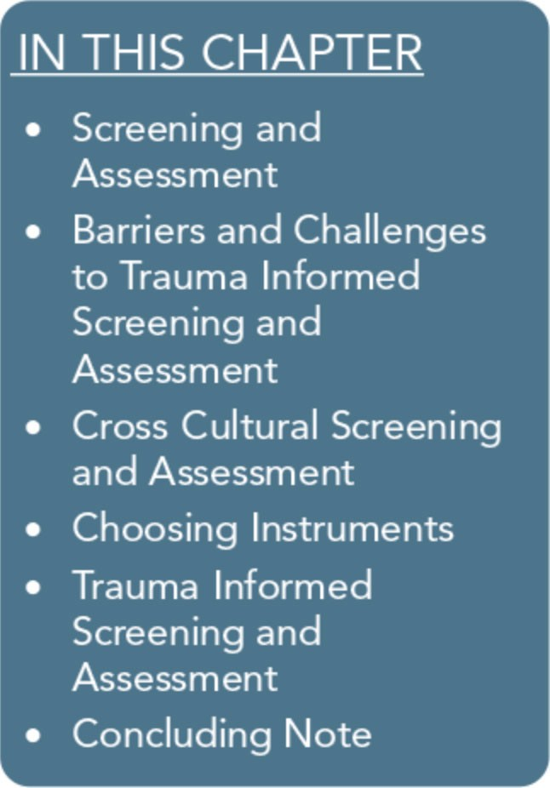
Why screen universally for trauma in behavioral health services? Ex­ posure to trauma is common; in many surveys, more than half of re­ spondents report a history of trauma, and the rates are even higher among clients with mental or substance use disorders. Furthermore, behavioral health problems, including substance use and mental dis­ orders, are more difficult to treat if trauma-related symptoms and disorders aren't detected early and treated effectively (Part 3, Section 1, of this Treatment Improvement Protocol [TIP], available online, summarizes research on the prevalence of trauma and its relation­ ship with other behavioral health problems).
Not addressing traumatic stress symptoms, trauma-specific disor­ ders, and other symptoms/disorders related to trauma can impede successful mental health and substance abuse treatment. Unrecog­ nized, unaddressed trauma symptoms can lead to poor engagement in treatment, premature termination, greater risk for relapse of psy­ chological symptoms or substance use, and worse outcomes.
Screening can also prevent misdiagnosis and inappropriate treat­ ment planning. People with histories of trauma often display symptoms that meet criteria for other disorders.
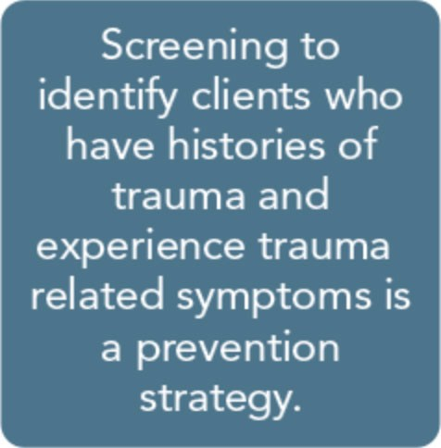
Without screening, clients' trauma histories and related symptoms often go undetected, leading providers to direct services toward symptoms and disorders that may only partially explain client presentations and distress. Universal
screening for trauma history and trauma- related symptoms can help behavioral health practitioners identify individuals at risk of developing more pervasive and se- vere symptoms of traumatic stress.
Screening, early identification, and inter- vention serves as a prevention strategy.

91

Trauma-Informed Care in Behavioral Health Services
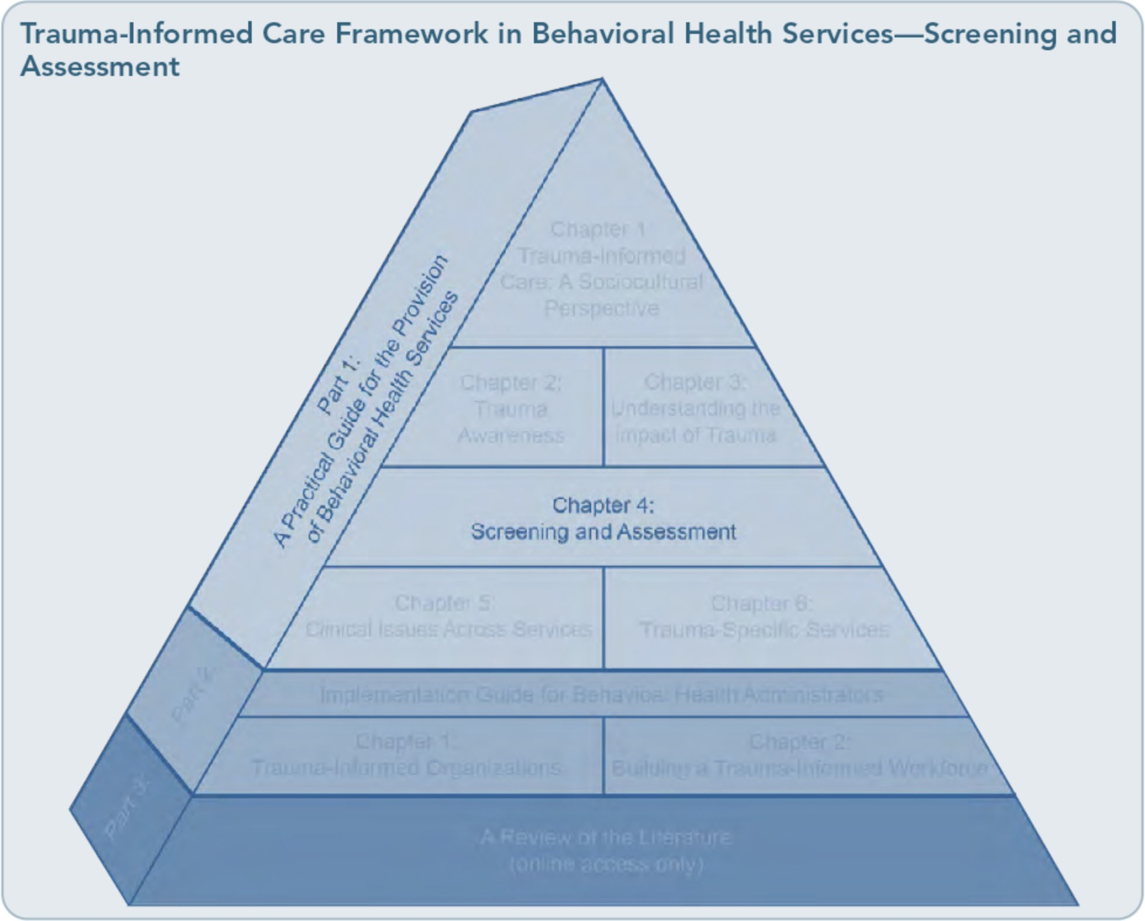

The chapter begins with a discussion of screening and assessment concepts, with a particular focus on trauma-informed screen­ ing. It then highlights specific factors that influence screening and assessment, including timing and environment. Barriers and chal­ lenges in providing trauma-informed screen­ ing are discussed, along with culturally specific screening and assessment considerations and guidelines. Instrument selection, trauma­ informed screening and assessment tools, and trauma-informed screening and assessment processes are reviewed as well. For a more research-oriented perspective on screening and assessment for traumatic stress disorders, please refer to the literature review provided in Part 3 of this TIP, which is available online.

Screening and Assessment

Screening
The first two steps in screening are to deter­ mine whether the person has a history of trauma and whether he or she has trauma­ related symptoms. Screening mainly obtains answers to "yes" or "no" questions: "Has this client experienced a trauma in the past?" and "Does this client at this time warrant further assessment regarding trauma-related symp­ toms?" If someone acknowledges a trauma history, then further screening is necessary to determine whether trauma-related symptoms are present. However, the presence of such symptoms does not necessarily say anything about their severity, nor does a positive screen indicate that a disorder actually exists. Positive

92

Part 1, Chapter 4-Screening and Assessment

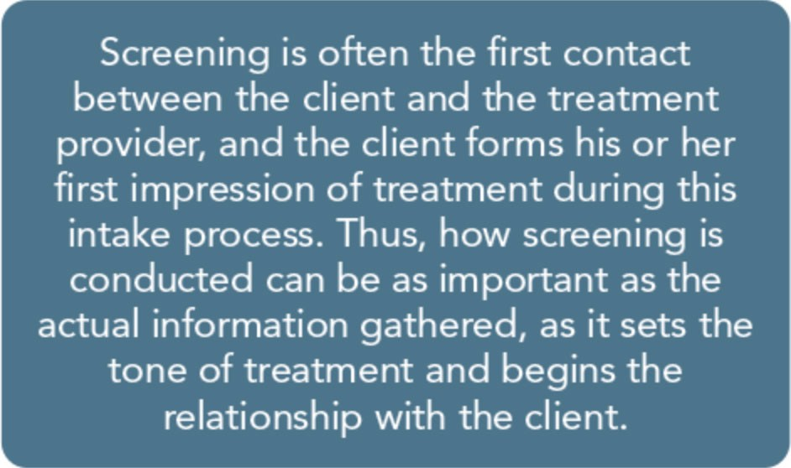
screens only indicate that assessment or fur­ ther evaluation is warranted, and negative screens do not necessarily mean that an indi­ vidual doesn't have symptoms that warrant intervention.
Screening procedures should always define the steps to take after a positive or negative screening. That is, the screening process es­ tablishes precisely how to score responses to screening tools or questions and clearly defines what constitutes a positive score (called a "cut­ off score") for a particular potential problem. The screening procedures detail the actions to take after a client scores in the positive range. Clinical supervision is helpful-and some­ times necessary-in judging how to proceed.
Trauma-informed screening is an essential part of the intake evaluation and the treatment planning process, but it is not an end in itself. Screening processes can be developed that allow staff without advanced degrees or gradu­ ate-level training to conduct them, whereas assessments for trauma-related disorders re­ quire a mental health professional trained in assessment and evaluation processes. The
most important domains to screen among individuals with trauma histories include:
- Trauma-related symptoms.
- Depressive or dissociative symptoms, sleep disturbances, and intrusive experiences.
- Past and present mental disorders, includ­ ing typically trauma-related disorders (e.g., mood disorders).

- Severity or characteristics of a specific trauma type (e.g., forms ofinterpersonal vi­ olence, adverse childhood events, combat experiences).
- Substance abuse.
- Social support and coping styles.
- Availability of resources.
- Risks for self-harm, suicide, and violence.
- Health screenings.
Assessment
When a client screens positive for substance abuse, trauma-related symptoms, or mental disorders, the agency or counselor should fol­ low up with an assessment. A positive screen­ ing calls for more action-an assessment that determines and defines presenting struggles to develop an appropriate treatment plan and to make an informed and collaborative decision about treatment placement. Assessment de­ termines the nature and extent of the client's problems; it might require the client to re­ spond to written questions, or it could involve a clinical interview by a mental health or sub­ stance abuse professional qualified to assess the client and arrive at a diagnosis. A clinical assessment delves into a client's past and cur­ rent experiences, psychosocial and cultural history, and assets and resources.
Assessment protocols can require more than a single session to complete and should also use multiple avenues to obtain the necessary clini­ cal information, including self-assessment tools, past and present clinical and medical records, structured clinical interviews, assess­ ment measures, and collateral information from significant others, other behavioral health professionals, and agencies. Qialifica­ tions for conducting assessments and clinical interviews are more rigorous than for screen­ ing. Advanced degrees, licensing or certifica­ tion, and special training in administration, scoring, and interpretation of specific assess­ ment instruments and interviews are often

93

Trauma-Informed Care in Behavioral Health Services

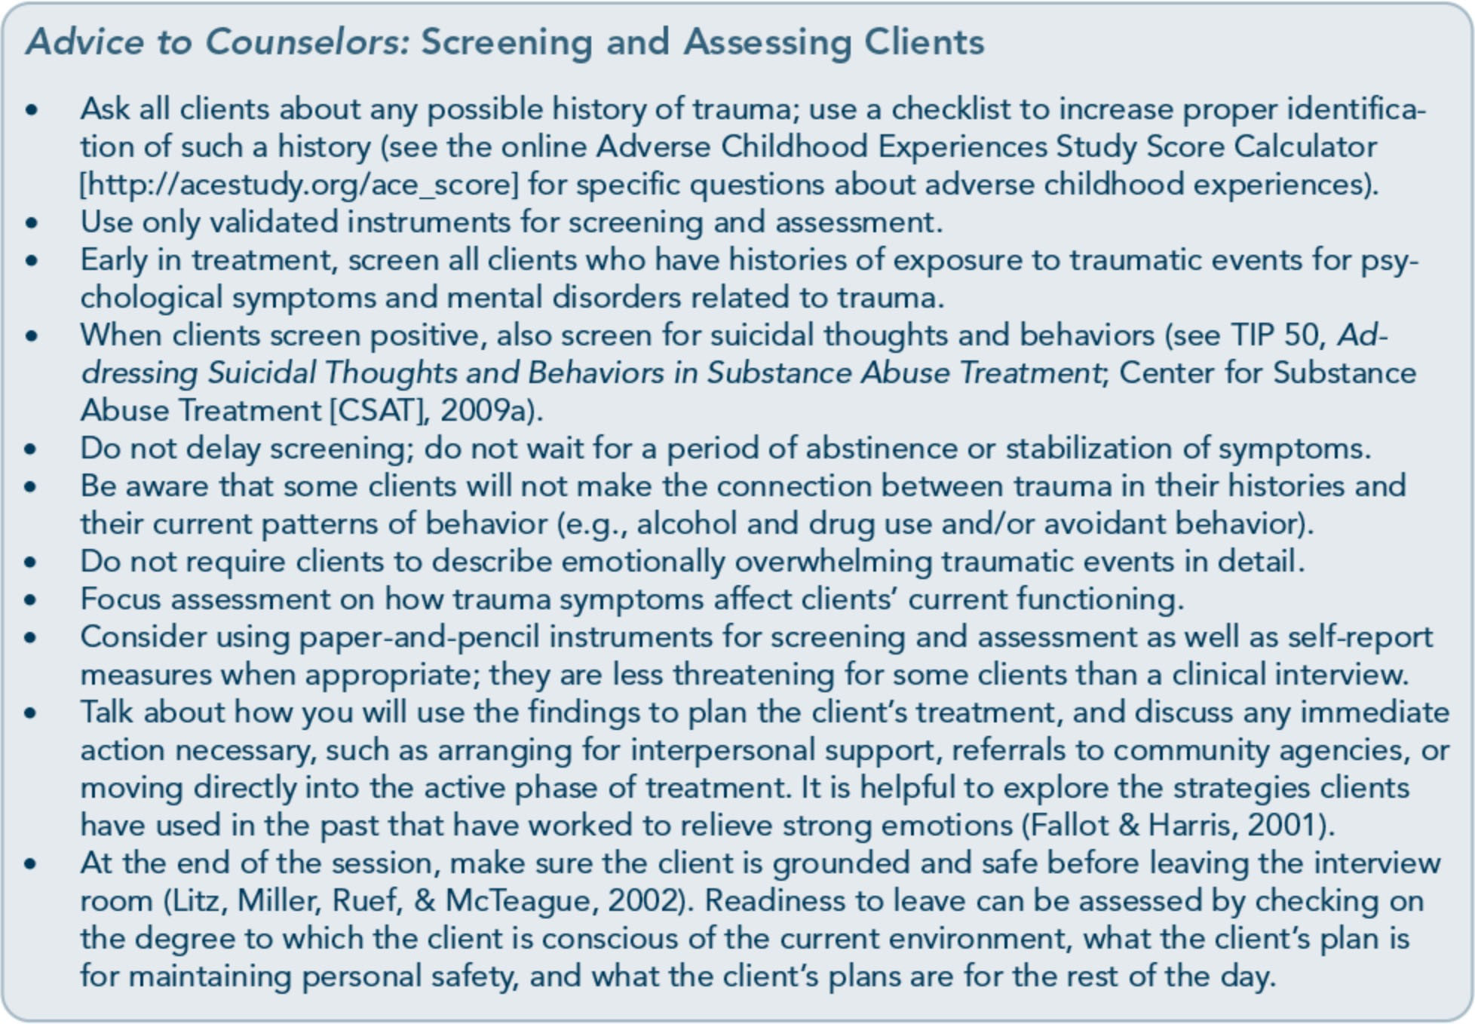

required. Counselors must be familiar with (and obtain) the level of training required for any instruments they consider using.
For people with histories of traumatic life events who screen positive for possible trauma­ related symptoms and disorders, thorough assessment gathers all relevant information necessary to understand the role of the trauma in their lives; appropriate treatment objectives, goals, planning, and placement; and any ongo­ ing diagnostic and treatment considerations, including reevaluation or follow-up.
Overall, assessment may indicate symptoms that meet diagnostic criteria for a substance use or mental disorder or a milder form of symptomatology that doesn't reach a diagnos­ tic level-or it may reveal that the positive screen was false and that there is no significant cause for concern. Information from an as­ sessment is used to plan the client's treatment.
The plan can include such domains as level of care, acute safety needs, diagnosis, disability, strengths and skills, support network, and cultural context. Assessments should reoccur throughout treatment. Ongoing assessment during treatment can provide valuable infor­ mation by revealing further details of trauma history as clients' trust in staff members grows and by gauging clients' progress.

Timing of Screening and Assessment
As a trauma-informed counselor, you need to offer psychoeducation and support from the outset of service provision; this begins with explaining screening and assessment and with proper pacing of the initial intake and evalua­ tion process. The client should understand the screening process, why the specific questions are important, and that he or she may choose to delay a response or to not answer a question

94

Part 1, Chapter 4-Screening and Assessment

at all. Discussing the occurrence or conse­ quences of traumatic events can feel as unsafe and dangerous to the client as if the event were reoccurring. It is important not to en­ courage avoidance of the topic or reinforce the belief that discussing trauma-related material is dangerous, but be sensitive when gathering information in the initial screening. Initial questions about trauma should be general and gradual. Taking the time to prepare and ex­ plain the screening and assessment process to the client gives him or her a greater sense of control and safety over the assessment process.
Clients with substance use disorders No screening or assessment of trauma should occur when the client is under the influence of alcohol or drugs. Clients under the influence are more likely to give inaccurate information. Although it's likely that clients in an active phase of use (albeit not at the assessment it­ self) or undergoing substance withdrawal can provide consistent information to obtain a valid screening and assessment, there is insuf­ ficient data to know for sure. Some theorists state that no final assessment of trauma or posttraumatic stress disorder (PTSD) should occur during these early phases (Read, Bollinger, & Sharkansky, 2003), asserting that
symptoms of withdrawal can mimic PTSD and thus result in overdiagnosis of PTSD and other trauma-related disorders. Alcohol or drugs can also cause memory impairment that clouds the client's history of trauma symp­ toms. However, Najavits (2004) and others note that underdiagnosis, not overdiagnosis, of trauma and PTSD has been a significant issue in the substance abuse field and thus claim that it is essential to obtain an initial assess­ ment early, which can later be modified if needed (e.g., if the client's symptom pattern changes). Indeed, clinical observations suggest that assessments for both trauma and PTSD­ even during active use or withdrawal-appear

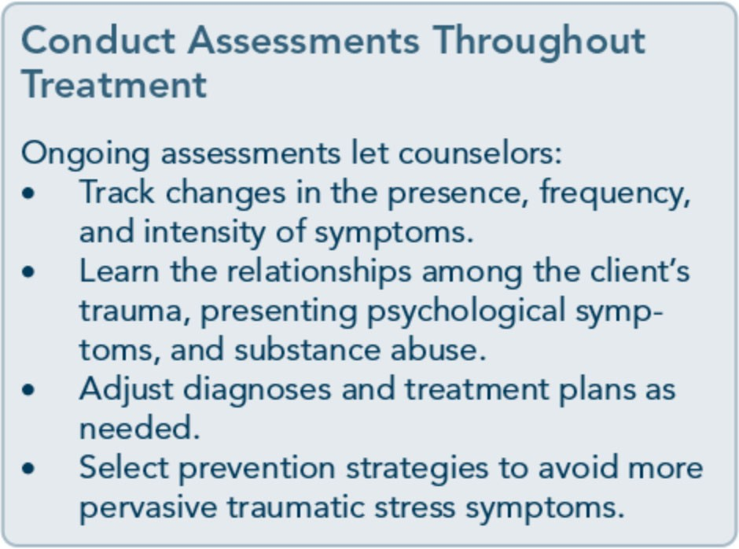
robust (Coffey, Schumacher, Brady, & Dansky, 2003). Although some PTSD symptoms and trauma memories can be dampened or in­ creased to a degree, their overall presence or absence, as assessed early in treatment, appears accurate (Najavits, 2004).

The Setting for Trauma Screening and Assessment
Advances in the development of simple, brief, and public-domain screening tools mean that at least a basic screening for trauma can be done in almost any setting. Not only can cli­ ents be screened and assessed in behavioral health treatment settings; they can also be evaluated in the criminal justice system, edu­ cational settings, occupational settings, physi­ cians' offices, hospital medical and trauma units, and emergency rooms. Wherever they occur, trauma-related screenings and subse­ quent assessments can reduce or eliminate wasted resources, relapses, and, ultimately, treatment failures among clients who have histories of trauma, mental illness, and/or sub­ stance use disorders.
Creating an effective screening and
assessment environment
You can greatly enhance the success of treat­ ment by paying careful attention to how you approach the screening and assessment pro­ cess. Take into account the following points:

95

Trauma-Informed Care in Behavioral Health Services

  - Clarify for the client what to expect in the screening and assessment process. For exam­ ple, tell the client that the screening and as­ sessment phase focuses on identifying issues that might benefit from treatment. Inform him or her that during the trauma screening and assessment process, uncom­ fortable thoughts and feelings can arise. Provide reassurance that, if they do, you'll assist in dealing with this distress-but also let them know that, even with your assis­ tance, some psychological and physical re­ actions to the interview may last for a few hours or perhaps as long as a few days after the interview, and be sure to highlight the fact that such reactions are normal (Read et al., 2003).
  - Approach the client in a matter-of-fad, yet supportive, manner. Such an approach helps create an atmosphere of trust, respect, acceptance, and thoughtfulness (Melnick & Bassuk, 2000). Doing so helps to normalize symptoms and experiences generated by the trauma; consider informing clients that such events are common but can cause con­ tinued emotional distress if they are not treated. Clients may also find it helpful for you to explain the purpose of certain diffi­ cult questions. For example, you could say, "Many people have experienced troubling events as children, so some of my questions are about whether you experienced any such events while growing up." Demon­ strate kindness and directness in equal measure when screening/assessing clients (Najavits, 2004).
  - Resped the client's personal space. Cultural
and ethnic factors vary greatly regarding the appropriate physical distance to maintain during the interview. You should respect the client's personal space, sitting neither too far from nor too close to the client; let your observations of the client's comfort level during the screening and assessment pro­ cess guide the amount of distance. Clients

with trauma may have particular sensitivity about their bodies, personal space, and boundaries.
- Atijust tone and volume of speech to suit the client's level of engagement and degree of comfort in the interview process. Strive to maintain a soothing, quiet demeanor. Be sensitive to how the client might hear what you have to say in response to personal dis­ closures. Clients who have been trauma­ tized may be more reactive even to benign or well-intended questions.
- Provide culturally appropriate symbols of safety in the physical environment. These include paintings, posters, pottery, and other room decorations that symbolize the safety of the surroundings to the cli­ ent population. Avoid culturally inappro­ priate or insensitive items in the physical environment.
- Be aware of one's own emotional responses to hearing clients' trauma histories. Hearing about clients' traumas may be very painful and can elicit strong emotions. The client may interpret your reaction to his or her revelations as disinterest, disgust for the cli­ ent's behavior, or some other inaccurate in­ terpretation. It is important for you to monitor your interactions and to check in with the client as necessary. You may also feel emotionally drained to the point that it interferes with your ability to accurately lis­ ten to or assess clients. This effect of expo­ sure to traumatic stories, known as secondary traumatization, can result in symptoms similar to those experienced by the client (e.g., nightmares, emotional numbing); if necessary, refer to a colleague for assessment (Valent, 2002). Secondary traumatization is addressed in greater detail in Part 2, Chapter 2, of this TIP.
- Overcome linguistic barriers via an inter­ preter. Deciding when to add an interpreter requires careful judgment. The interpreter should be knowledgeable of behavioral

96

Part 1, Chapter 4-Screening and Assessment

health terminology, be familiar with the concepts and purposes of the interview and treatment programming, be unknown to the client, and be part of the treatment team. Avoid asking family members or friends of the client to serve as interpreters.
  - Elicit only the information necessary for determining a history of trauma and the possible existence and extent of traumatic
stress symptoms and related disorders. There is no need to probe deeply into the details of a client's traumatic experiences at this stage in the treatment process. Given the lack of a therapeutic relationship in which to process the information safely, pursuing details of trauma can cause re­ traumatization or produce a level of re­ sponse that neither you nor your client is prepared to handle. Even if a client wants to tell his or her trauma story, it's your job to serve as "gatekeeper" and preserve the client's safety. Your tone of voice when sug­ gesting postponement of a discussion of trauma is very important. Avoid conveying the message, "I really don't want to hear about it." Examples of appropriate state­ ments are:
"Your life experiences are very im­ portant, but at this early point in our work together, we should start with what's going on in your life currently rather than discussing past experiences in detail. If you feel that certain past experiences are having a big effect on your life now, it would be helpful for us to discuss them as long as we focus on your safety and recovery right now." "Talking about your past at this point could arouse intense feelings-even more than you might be aware of right now. Later, if you choose to, you can talk with your counselor about how to work on exploring your past."
"Often, people who have a history of trauma want to move quickly into the

details of the trauma to gain relief. I understand this desire, but my concern for you at this moment is to help you establish a sense of safety and support before moving into the traumatic expe­ riences. We want to avoid retraumati­ zation-meaning,we want to establish resources that weren't available to you at the time of the trauma before delv­ ing into more content."
- Give the client as much personal control as
possible during the assessment by: Presenting a rationale for the interview and its stress-inducing potential, mak­ ing clear that the client has the right to refuse to answer any and all questions. Giving the client (where staffing per­ mits) the option of being interviewed
by someone of the gender with which he or she is most comfortable.
Postponing the interview if necessary (Fallot & Harris, 2001).
- Use self-administered, written checklists rather than interviews when possible to as­ sess trauma. Traumas can evoke shame, guilt, anger, or other intense feelings that can make it difficult for the client to report them aloud to an interviewer. Clients are more likely to report trauma when they use self-administered screening tools; however, these types of screening instruments only guide the next step. Interviews should coin­ cide with self-administered tools to create a sense of safety for the client (someone is present as he or she completes the screen­ ing) and to follow up with more indepth data gathering after a self-administered screening is complete. The Trauma History
Qyestionnaire (THQ2 is a self­ administered tool (Green, 1996). It has been used successfully with clinical and nonclinical populations, including medi­
cal patients, women who have experi­ enced domestic violence, and people with serious mental illness (Hooper, Stockton,

97

Trauma-Informed Care in Behavioral Health Services

Krupnick, & Green, 2011). Screening in­ struments (including the THQ2 are includ­ ed in Appendix D of this TIP.
  - Interview the client if he or she has trouble
reading or writing or is otherwise unable to complete a checklist. Clients who are likely to minimize their trauma when using a checklist (e.g., those who exhibit significant symptoms of dissociation or repression) benefit from a clinical interview. A trained interviewer can elicit information that a self-administered checklist does not cap­
ture. Overall, using both a self-administered

questionnaire and an interview can help achieve greater clarity and context.
- Allow time for the client to become calm and
oriented to the present if he or she has very intense emotional responses when recalling
or acknowledging a trauma. At such times, avoid responding with such exclamations as "I don't know how you survived that!" (Bernstein, 2000). If the client has difficul­ ty self-soothing, guide him or her through grounding techniques (Exhibit 1.4-1), which are particularly useful-perhaps even critical-to achieving a successful

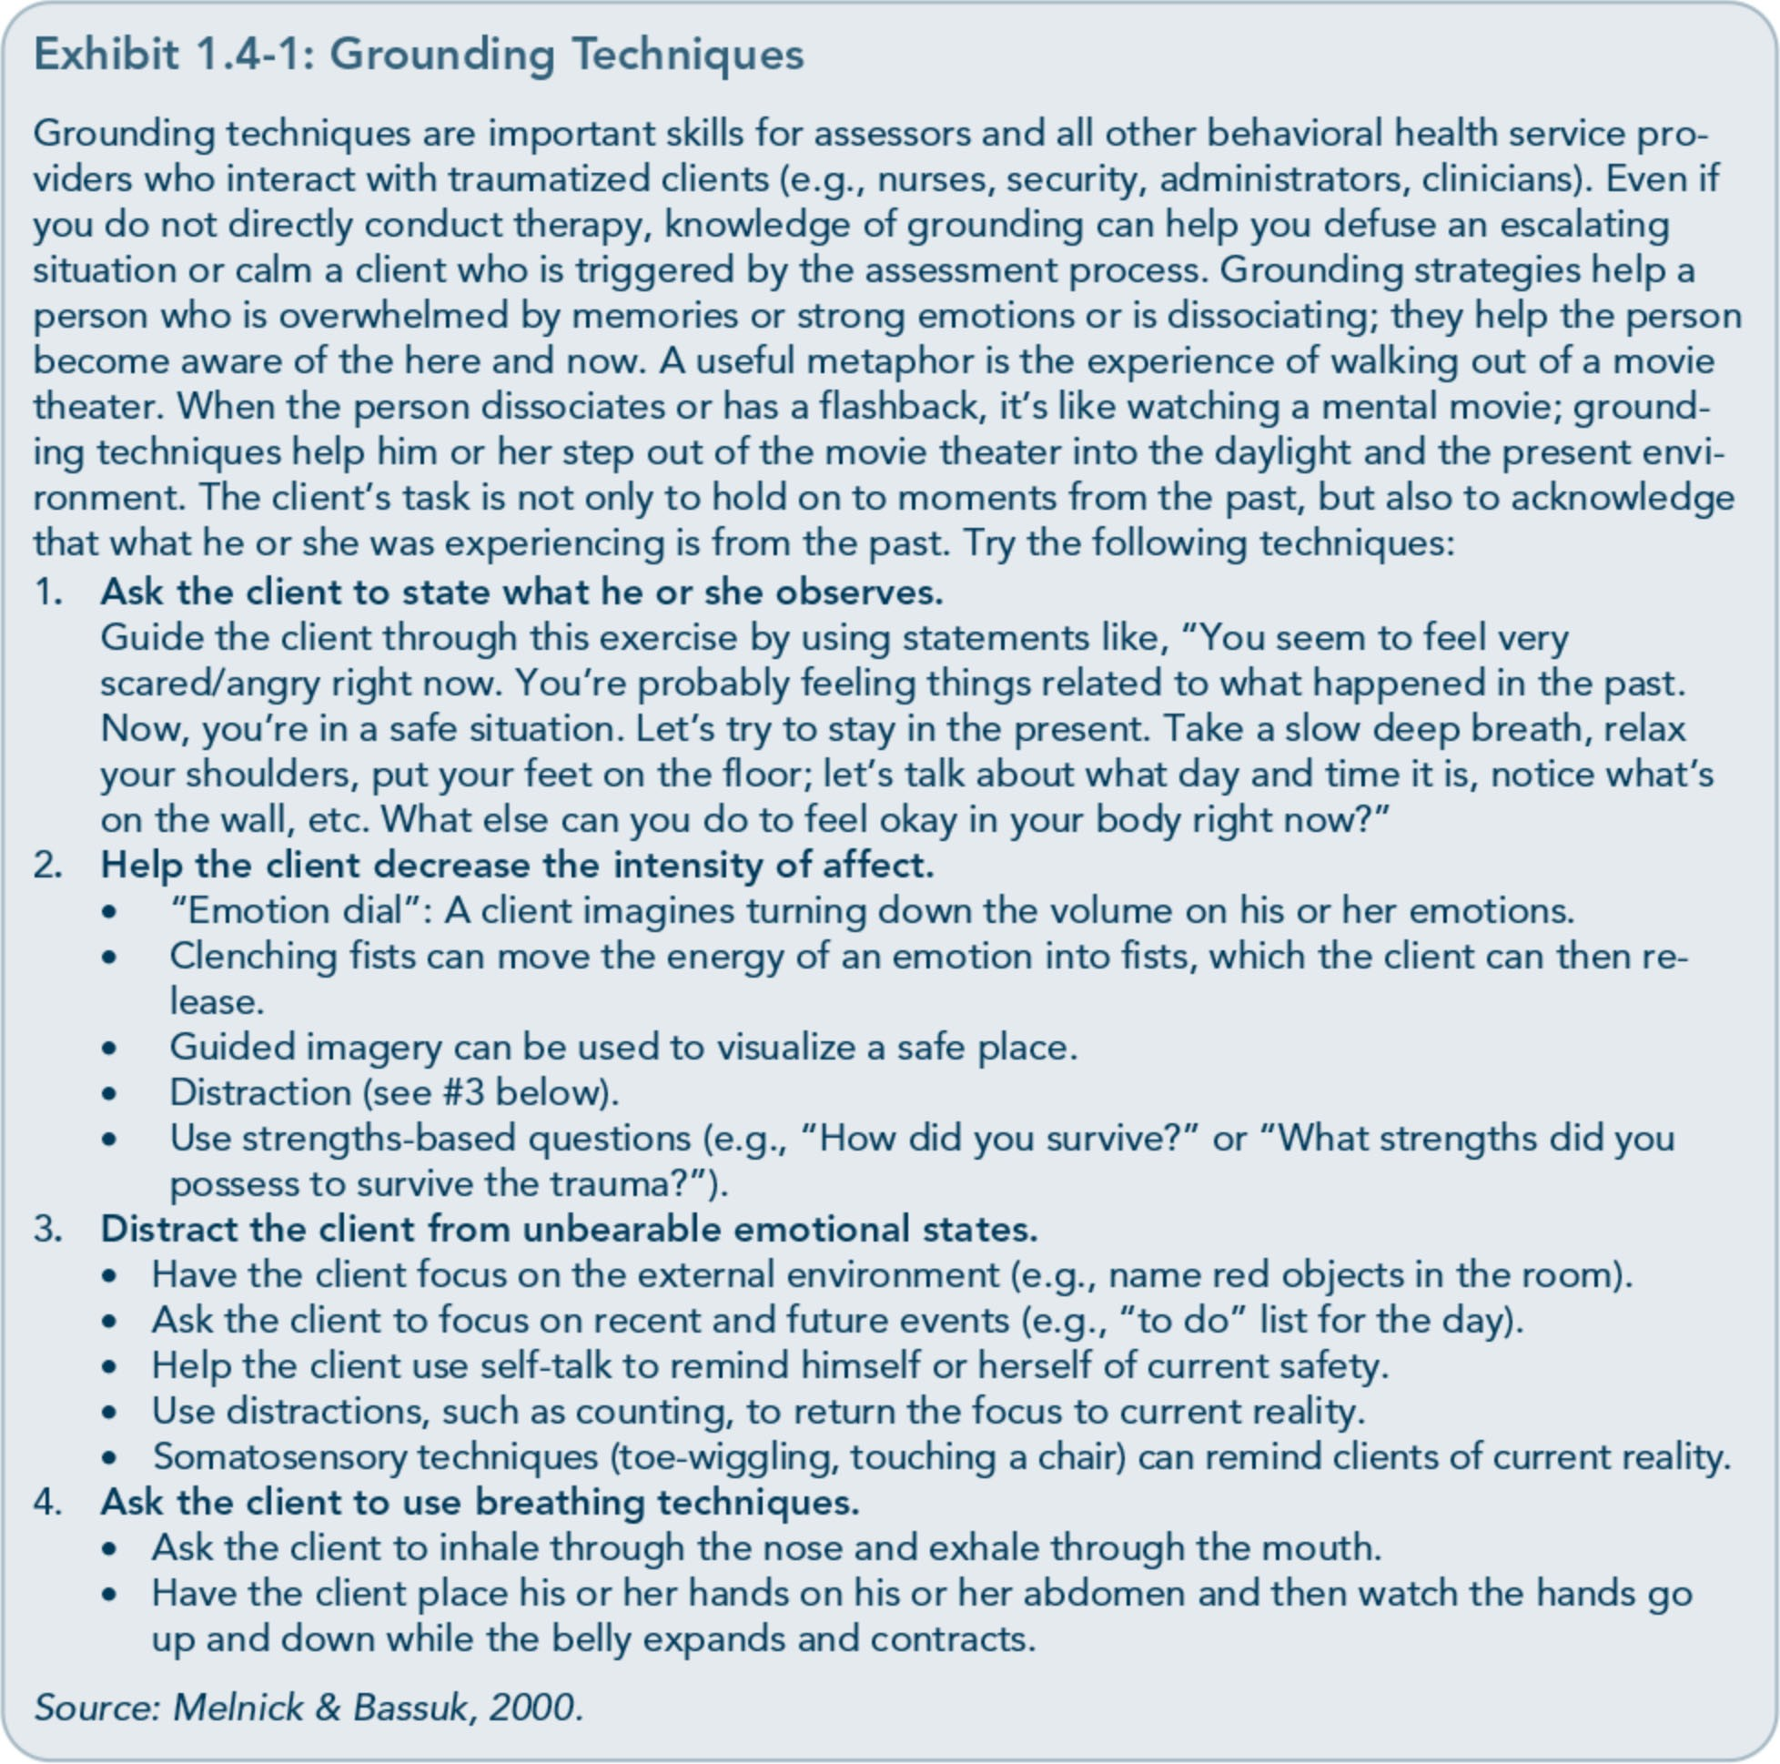

98

Part 1, Chapter 4-Screening and Assessment

interview when a client has dissociated or is experiencing intense feelings in response to screening and/or interview questions.
  - Avoid phrases that imply judgment about the trauma. For example, don't say to a cli­ ent who survived Hurricane Katrina and lost family members, "It was God's will," or "It was her time to pass," or "It was meant to be." Do not make assumptions about what a person has experienced. Ra­ ther, listen supportively without imposing personal views on the client's experience.
  - Provide feedback about the results of the
screening. Keep in mind the client's vulner­ ability, ability to access resources, strengths, and coping strategies. Present results in a synthesized manner, avoiding complicated, overly scientific jargon or explanations. Al­ low time to process client reactions during the feedback session. Answer client ques­ tions and concerns in a direct, honest, and compassionate manner. Failure to deliver feedback in this way can negatively affect clients' psychological status and severely weaken the potential for developing a ther­ apeutic alliance with the client.
  - Be aware of the possible legal implications of assessment. Information you gather dur­ ing the screening and assessment process can necessitate mandatory reporting to au­ thorities, even when the client does not
want such information disclosed (Najavits, 2004). For example, you can be required to report a client's experience of child abuse even if it happened many years ago or the client doesn't want the information report­ ed. Other legal issues can be quite com­ plex, such as confidentiality of records, pursuing a case against a trauma perpetra­ tor and divulging information to third par­ ties while still protecting the legal status of information used in prosecution, and child custody issues (Najavits, 2004). It's essen­ tial that you know the laws in your State,

have an expert legal consultant available, and access clinical supervision.

Barriers and Challenges to Trauma-Informed Screening and Assessment

Barriers
It is not necessarily easy or obvious to identify an individual who has survived trauma with­ out screening. Moreover, some clients may deny that they have encountered trauma and its effects even after being screened or asked direct questions aimed at identifying the oc­ currence of traumatic events. The two main barriers to the evaluation of trauma and its related disorders in behavioral health settings are clients not reporting trauma and providers overlooking trauma and its effects.
Concerning the first main barrier, some events will be experienced as traumatic by one person but considered nontraumatic by another. A history of trauma encompasses not only the experience of a potentially traumatic event, but also the person's responses to it and the mean­ ings he or she attaches to the event. Certain situations make it more likely that the client will not be forthcoming about traumatic events or his or her responses to those events. Some clients might not have ever thought of a particular event or their response to it as trau­ matic and thus might not report or even recall the event. Some clients might feel a reluctance to discuss something that they sense might bring up uncomfortable feelings (especially with a counselor whom they've only recently met). Clients may avoid openly discussing traumatic events or have difficulty recognizing or articulating their experience of trauma for other reasons, such as feelings of shame, guilt, or fear of retribution by others associated with the event (e.g., in cases ofinterpersonal or

99

Trauma-Informed Care in Behavioral Health Services

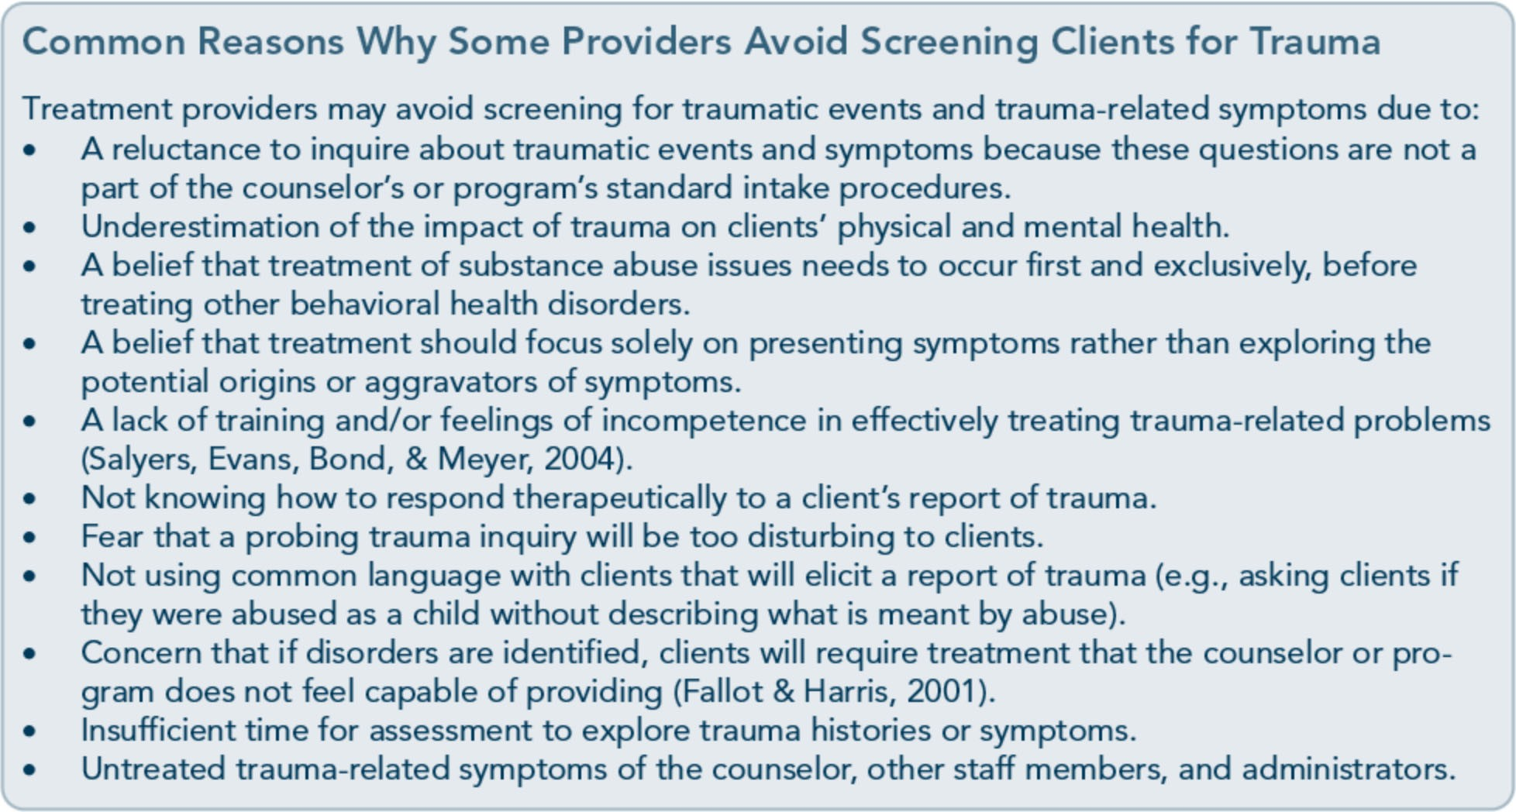

domestic violence). Still others may deny their history because they are tired of being inter­ viewed or asked to fill out forms and may be­ lieve it doesn't matter anyway.
A client may not report past trauma for many reasons, including:
  - Concern for safety (e.g., fearing more abuse by a perpetrator for revealing the trauma).
  - Fear of being judged by service providers.
  - Shame about victimization.
  - Reticence about talking with others in re­ sponse to trauma.
  - Not recalling past trauma through dissocia­ tion, denial, or repression (although genuine blockage of all trauma memory is rare among trauma survivors; McNally, 2003).
  - Lack of trust in others, including behavior- al health service providers.
  - Not seeing a significant event as traumatic.
Regarding the second major barrier, counselors and other behavioral health service providers may lack awareness that trauma can signifi­ cantly affect clients' presentations in treatment and functioning across major life areas, such as relationships and work. In addition, some counselors may believe that their role is to
treat only the presenting psychological and/or substance abuse symptoms, and thus they may not be as sensitive to histories and effects of trauma. Other providers may believe that a client should abstain from alcohol and drugs for an extended period before exploring trau­ ma symptoms. Perhaps you fear that address­ ing a clients' trauma history will only exacerbate symptoms and complicate treat­ ment. Behavioral health service providers who hold biases may assume that a client doesn't have a history of trauma and thus fail to ask the "right" questions, or they may be uncom­ fortable with emotions that arise from listen­ ing to client experiences and, as a result, redirect the screening or counseling focus.

Challenges
Awareness of acculturation and language
Acculturation levels can affect screening and assessment results. Therefore, indepth discus­ sions may be a more appropriate way to gain an understanding of trauma from the client's point of view. During the intake, prior to trauma screening, determine the client's history of

100

Part 1, Chapter 4-Screening and Assessment

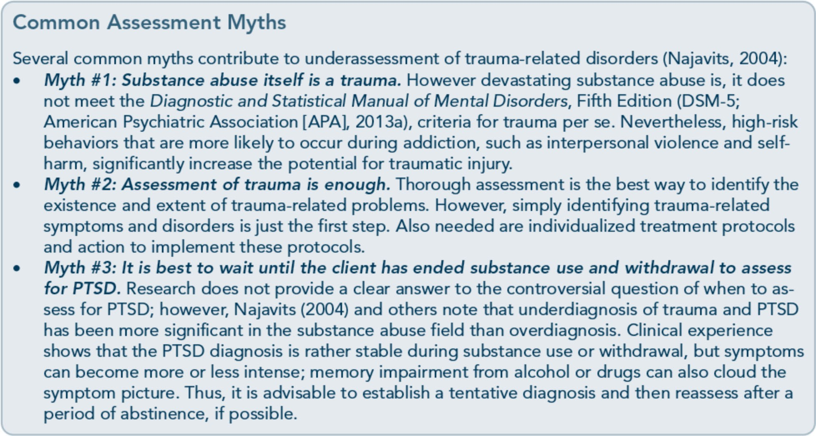

migration, if applicable, and primary language. Qyestions about the client's country of birth, length of time in this country, events or reasons for migration, and ethnic self-identification are also appropriate at intake. Also be aware that even individuals who speak English well might have trouble understanding the subtleties of questions on standard screening and assessment tools. It is not adequate to translate items simp­ ly from English into another language; words, idioms, and examples often don't translate di­ rectly into other languages and therefore need to be adapted. Screening and assessment should be conducted in the client's preferred language by trained staff members who speak the lan­
guage or by professional translators familiar with treatment jargon.
Awareness of co-occurring diagnoses A trauma-informed assessor looks for psycho­ logical symptoms that are associated with trauma or simply occur alongside it. Symptom screening involves questions about past or present mental disorder symptoms that may indicate the need for a full mental health as­
sessment. A variety of screening tools are available, including symptom checklists.
However, you should only use symptom checklists when you need information about how your client is currently feeling; don't use them to screen for specific disorders. Responses will likely change from one administration of the checklist to the next.
Basic mental health screening tools are availa­ ble. For example, the Mental Health Screening Form-III screens for present or past symptoms of most mental disorders (Carroll &McGinley, 2001); it is available at no charge from Project Return Foundation, Inc. and is also reproduced in TIP 42, Substance Abuse Treatment far Per­ sons With Co-Occurring Disorders (CSAT, 2005c). Other screening tools, such as the Beck Depression Inventory II and the Beck Anxiety Inventory (Beck, Wright, Newman, &Liese, 1993), also screen broadly for mental and sub­ stance use disorders, as well as for specific dis­ orders often associated with trauma. For further screening information and resources on depression and suicide, see TIP 48, Managing Depressive Symptoms in Substance Abuse Clients During Early Recovery (CSAT, 2008), and TIP 50, Addressing Suicidal Thoughts and Behaviors in Substance Abuse Treatment (CSAT, 2009a).

101

Trauma-Informed Care in Behavioral Health Services

For screening substance use disorders, see TIP 11, Simple Screening Instruments far Outreach far Alcohol and Other Drug Abuse and Infectious Diseases (CSAT, 1994); TIP 24,A Guide to Substance Abuse Services far Primary Care Cli­ nicians (CSAT, 1997a); TIP 31, Screening and Assessing Adolescents far Substance Use Disorders (CSAT, 1999c); TIP 42, Substance Abuse Treatment far Persons With Co-Occurring Dis­ orders (CSAT, 2005c); and TIP 51, Substance Abuse Treatment: Addressing the Specific Needs of Women (CSAT, 2009d).
A common dilemma in the assessment of trauma-related disorders is that certain trauma symptoms are also symptoms of other disor­ ders. Clients with histories of trauma typically present a variety of symptoms; thus, it is im­ portant to determine the full scope of symp­ toms and/or disorders present to help improve treatment planning. Clients with trauma­ related and substance use symptoms and dis­ orders are at increased risk for additional Axis I and/or Axis II mental disorders (Brady, Killeen, Saladin, Dansky, & Becker, 1994; Cottler, Nishith, & Compton, 2001). These symptoms need to be distinguished so that other presenting subclinical features or disor­ ders do not go unidentified and untreated. To accomplish this, a comprehensive assessment of the client's mental health is recommended.
Misdiagnosis and underdiagnosis Many trauma survivors are either misdiagnosed (i.e., given diagnoses that are not accurate) or underdiagnosed (i.e., have one or more diagno­ ses that have not been identified at all). Such diagnostic errors could result, in part, from the fact that many general instruments to evaluate mental disorders are not sufficiently sensitive to identify posttraumatic symptoms and can mis­ classify them as other disorders, including per­ sonality disorders or psychoses. Intrusive posttraumatic symptoms, for example, can show up on general measures as indicative of

hallucinations or obsessions. Dissociative symptoms can be interpreted as indicative of schiwphrenia. Trauma-based cognitive symp­ toms can be scored as evidence for paranoia or other delusional processes (Briere, 1997). Some of the most common misdiagnoses in clients with PTSD and substance abuse are:
- Mood and anxiety disorders. Overlapping symptoms with such disorders as major de­ pression, generalized anxiety disorder, and bipolar disorder can lead to misdiagnosis.
- Borderline personality disorder. Historically, this has been more frequently diagnosed than PTSD. Many of the symptoms, in­ cluding a pattern of intense interpersonal relationships, impulsivity, rapid and unpre­ dictable mood swings, power struggles in the treatment environment, underlying anxiety and depressive symptoms, and tran­ sient, stress-related paranoid ideation or se­ vere dissociative symptoms overlap. The effect of this misdiagnosis on treatment can be particularly negative; counselors often view clients with a borderline personality diagnosis as difficult to treat and unrespon­ sive to treatment.
- Antisocial personality disorder. For men and women who have been traumatized in childhood, "acting out" behaviors, a lack of empathy and conscience, impulsivity, and self-centeredness can be functions of trau­ ma and survival skills rather than true anti­ social characteristics.
- Attention deficit hyperactivity disorder
{ADHD). For children and adolescents, impulsive behaviors and concentration problems can be diagnosed as ADHD ra­ ther than PTSD.
It is possible, however, for clients to legiti­ mately have any of these disorders in addition to trauma-related disorders. Given the overlap of posttraumatic symptoms with those of oth­ er disorders, a wide variety of diagnoses often needs to be considered to avoid misidentifying

102

Part 1, Chapter 4-Screening and Assessment

other disorders as PTSD and vice versa. A trained and experienced mental health profes­ sional will be required to weigh differential diagnoses. TIP 42 (CSAT, 2005c) explores issues related to differential diagnosis.

Cross-Cultural Screening and Assessment
Many trauma-related symptoms and disorders are culture specific, and a client's cultural background must be considered in screening and assessment (for review of assessment and cultural considerations when working with trauma, see Wilson & Tang, 2007). Behavioral health service providers must approach screen­ ing and assessment processes with the influ­ ences of culture, ethnicity, and race firmly in mind. Cultural factors, such as norms for ex­ pressing psychological distress, defining trau-

ma, and seeking help in dealing with trauma, can affect:
- How traumas are experienced.
- The meaning assigned to the event(s).
- How trauma-related symptoms are ex­ pressed (e.g., as somatic expressions of dis­ tress, level of emotionality, types of avoidant behavior).
- Willingness to express distress or identify trauma with a behavioral health service provider and sense of safety in doing so.
- Whether a specific pattern of behavior, emotional expression, or cognitive process is considered abnormal.
- Willingness to seek treatment inside and outside of one's own culture.
- Response to treatment.
- Treatment outcome.
When selecting assessment instruments, coun­ selors and administrators need to choose,

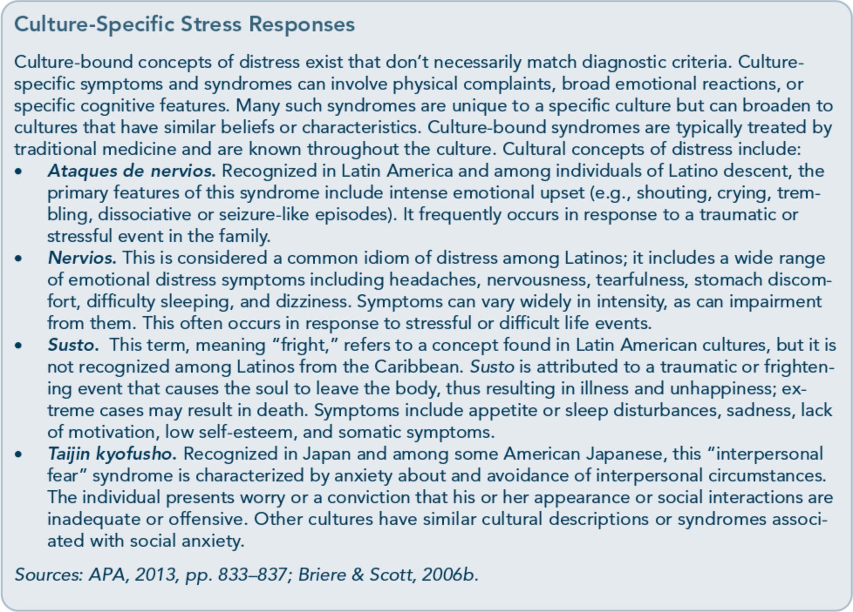

103

Trauma-Informed Care in Behavioral Health Services

whenever possible, instruments that are cul­ turally appropriate for the client. Instruments that have been normed for, adapted to, and tested on specific cultural and linguistic groups should be used. Instruments that are not normed for the population are likely to con­ tain cultural biases and produce misleading results. Subsequently, this can lead to misdiag­ nosis, overdiagnosis, inappropriate treatment plans, and ineffective interventions.Thus, it is important to interpret all test results cautious­ ly and to discuss the limitations of instruments with clients from diverse ethnic populations and cultures. For a review of cross-cultural screening and assessment considerations, refer to the planned TIP, Improving Cultural Com­ petence (Substance Abuse and Mental Health Services Administration, planned c).

Choosing Instruments
Numerous instruments screen for trauma his­ tory, indicate symptoms, assess trauma-related and other mental disorders, and identify relat­ ed clinical phenomena, such as dissociation.
One instrument is unlikely to meet all screen­ ing or assessment needs or to determine the existence and full extent of trauma symptoms and traumatic experiences. The following sec­ tions present general considerations in select­ ing standardized instruments.

Purpose
Define your assessment needs. Do you need a standardized screening or assessment instru­ ment for clinical purposes? Do you need in-

formation on a specific aspect of trauma, such as history, PTSD, or dissociation? Do you wish to make a formal diagnosis, such as PTSD? Do you need to determine quickly whether a client has experienced a trauma? Do you want an assessment that requires a clini­ cian to administer it, or can the client com­ plete the instrument himself or herself? Does the instrument match the current and specific diagnostic criteria established in the DSM-5?

Population
Consider the population to be assessed (e.g., women, children, adolescents, refugees, disaster survivors, survivors of physical or sexual vio­ lence, survivors of combat-related trauma, peo­ ple whose native language is not English); some tools are appropriate only for certain populations. Is the assessment process devel­ opmentally and culturally appropriate for your client? Exhibit 1.4-2 lists considerations in choosing a screening or assessment instrument for trauma and/or PTSD.

Instrument Quality
An instrument should be psychometrically adequate in terms of sensitivity and specificity or reliability and validity as measured in sever­ al ways under varying conditions. Published research offers information on an instrument's psychometric properties as well as its utility in both research and clinical settings. For further information on a number of widely used trauma evaluation tools, see Appendix D and Antony, Orsillo, and Roemer's paper (2001).

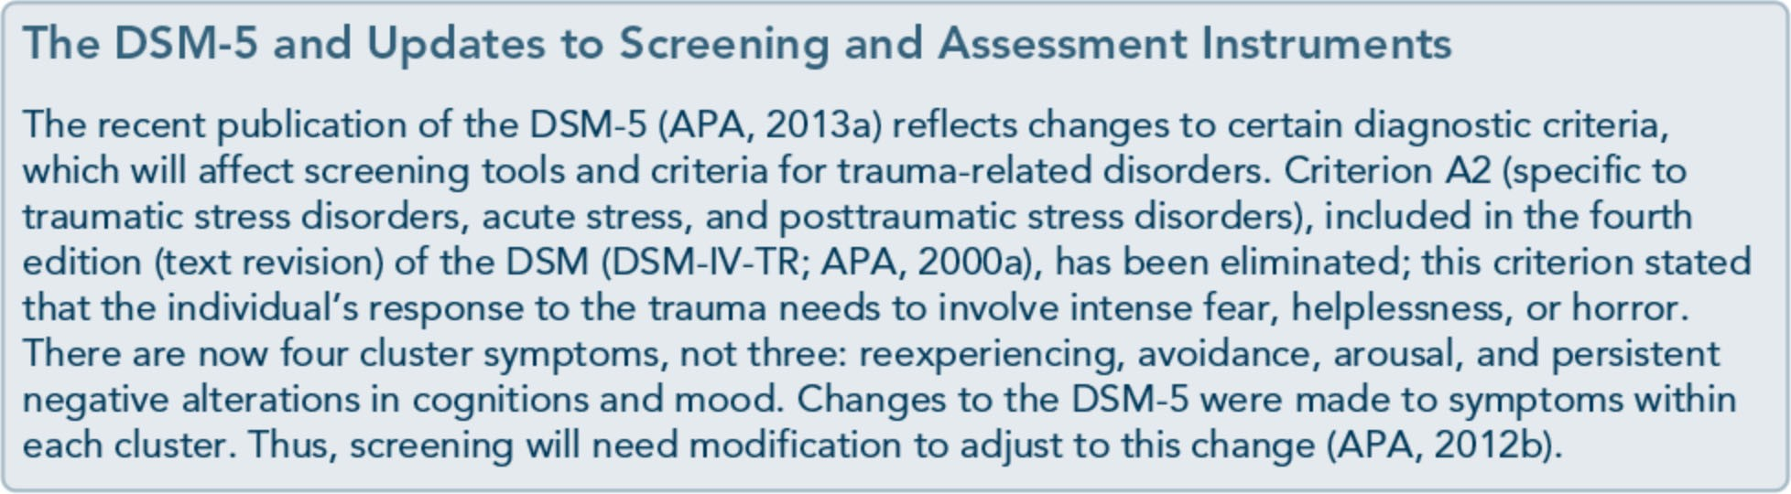

104

Part 1, Chapter 4-Screening and Assessment

Exhibit 1.4-2: Key Areas of Trauma Screening and Assessment
Trauma
Key question: Did the client experience a trauma?
Examples of measures: Life Stressor Checklist-Revised (Wolfe & Kimerling, 1997); Trauma History Questionnaire (Green, 1996); Traumatic Life Events Questionnaire (Kubany et al., 2000).
Note: A good trauma measure identifies events a person experienced (e.g., rape, assault, accident) and also evaluates other trauma-related symptoms (e.g., presence of fear, helplessness, or horror).
Acute Stress Disorder (ASD) and PTSD
Key question: Does the client meet criteria for ASD or PTSD?
Examples of measures: Clinician-Administered PTSD Scale (CAPS; Blake et al., 1990); Modified PTSD Symptom Scale (Falsetti, Resnick, Resnick, & Kilpatrick, 1993); PTSD Checklist (Weathers, Litz, Herman, Huska, & Keane, 1993); Stanford Acute Stress Reaction Questionnaire (Cardena, Koopman, Classen, Waelde, & Spiegel, 2000).
Note: A PTSD diagnosis requires the person to meet criteria for having experienced a trauma; some measures include this, but others do not and require use of a separate trauma measure. The CAPS is an interview; the others listed are self-report questionnaires and take less time.
Other Trauma-Related Symptoms
Key question: Does the client have other symptoms related to trauma? These include depressive symptoms, self-harm, dissociation, sexuality problems, and relationship issues, such as distrust.
Examples of measures: Beck Depression Inventory II (Beck, 1993; Beck et al., 1993); Dissociative Experiences Scale (Bernstein & Putnam, 1986; Carlson & Putnam, 1993); Impact of Event Scale (measures intrusion and avoidance due to exposure to traumatic events; Horowitz, Wilner, & Alvarez, 1979; Weiss & Marmar, 1997); Trauma Symptom Inventory (Briere, 1995); Trauma Symptom Checklist for Children (Briere, 19966); Modified PTSD Symptom Scale (Falsetti et al., 1993).
Note: These measures can be helpful for clinical purposes and for outcome assessment because they gauge levels of symptoms. Trauma-related symptoms are broader than diagnostic criteria and thus useful to measure, even if the patient doesn't meet criteria for any specific diagnoses.
Other Trauma-Related Diagnoses
Key question: Does the client have other disorders related to trauma? These include mood disor­ ders, anxiety disorders besides traumatic stress disorders, and dissociative disorders.
Examples of measures: Mental Health Screening Form Ill (Carroll & McGinley, 2001); The Mini­ International Neuropsychiatric Interview (M.I.N.I.) Structured Clinical Interview for DSM-IV-TR, Pa­ tient Edition (First, Spitzer, Gibbon, & Williams, revised 2011); Structured Clinical Interview for DSM­ IV-TR, Non-Patient Edition (First, Spitzer, Gibbon, & Williams, revised 2011a).
Note: For complex symptoms and diagnoses such as dissociation and dissociative disorders, inter­ views are recommended. Look for measures that incorporate DSM-5 criteria.
Sources: Antony et al., 2001; Najavits, 2004.

105

Trauma-Informed Care in Behavioral Health Services

Practical Issues
Is the instrument freely and readily available, or is there a fee? Is costly and extensive train­ ing required to administer it? Is the instru­ ment too lengthy to be used in the clinical setting? Is it easily administered and scored with accompanying manuals and/or other training materials? How will results be pre­ sented to or used with the client? Is technical support available for difficulties in administra­ tion, scoring, or interpretation of results? Is special equipment required such as a micro­ phone, a video camera, or a touch-screen com­ puter with audio?

Trauma-Informed Screening and Assessment
The following sections focus on initial screen­ ing. For more information on screening and assessment tools, including structured inter­ views, see Exhibit 1.4-2. Screening is only as good as the actions taken afterward to address a positive screen (when clients acknowledge that they experience symptoms or have en­ countered events highlighted within the screening). Once a screening is complete and a positive screen is acquired, the client then needs referral for a more indepth assessment
to ensure development of an appropriate treatment plan that matches his or her pre­ senting problems.

Establish a History of Trauma
A person cannot have ASD, PTSD, or any trauma-related symptoms without experienc­ ing trauma; therefore, it is necessary to inquire about painful, difficult, or overwhelming past experiences. Initial information should be gathered in a way that is minimally intrusive yet clear. Brief questionnaires can be less threatening to a client than face-to-face inter­ views, but interviews should be an integral part of any screening and assessment process.

If the client initially denies a history of trauma (or minimizes it), administer the questionnaire later or delay additional trauma-related ques­ tions until the client has perhaps developed more trust in the treatment setting and feels safer with the thoughts and emotions that might arise in discussing his or her trauma experiences.
The Stressful Life Experiences (SLE) screen (Exhibit 1.4-3) is a checklist of traumas that also considers the client's view of the impact of those events on life functioning. Using the SLE can foster the client-counselor relation­ ship. By going over the answers with the cli­ ent, you can gain a deep understanding of your client, and the client receives a demonstration of your sensitivity and concern for what the client has experienced. The National Center for PTSD Web site offers similar instruments (http://www. ptsd.va.gov/professional/ pages/as sessments/assessment.asp).
In addition to broad screening tools that cap­ ture various traumatic experiences and symp­ toms, other screening tools, such as the Combat Exposure Scale (Keane et al., 1989) and the Intimate Partner Violence Screening Tool (Exhibit 1.4-4), focus on acknowledging a specific type of traumatic event.

Screen for Trauma-Related Symptoms and Disorders in Clients With Histories of Trauma This step evaluates whether the client's trauma resulted in subclinical or diagnosable disor­ ders. The counselor can ask such questions as, "Have you received any counseling or therapy? Have you ever been diagnosed or treated for a psychological disorder in the past? Have you ever been prescribed medications for your emotions in the past?" Screening is typically conducted by a wide variety of behavioral health service providers with different levels
of training and education; however, all

106

Part 1, Chapter 4-Screening and Assessment

Exhibit 1.4-3: SLE Screening

Please fill in the number that best represents how much the following statements describe your experiences. You will need to use l\ o scales, one for how" ell the statement describes your experiences and one for how stressful you found this experience. The two scales are below.

Describes your Experience:
0 | I | 2 | 3 | 4 | 5 | 6 | 7 | 8 | 9 | 10
O1dno1  experience tlu, | a hllle hke my expencnccs |  |  |  | ',Ome\\ hat hke my experiences |  |  |  |  | exactly hke my expcnences
Stressfulness of Experience:
0 | I | 2 | 3 | 4 | 5 | 6 | 7 | 8 | 9 | 10
0101all u·e,;,ful | not very tre»ful |  |  |  | some\\ hat  ,1re, ful |  |  |  |  | extremely  ,tre..ful

Describe, your Experience | Life Experience  I have witnessed or experienced a natural disaster; like a hurricane or earthquake. | Strc,sfulncss  !hen |  | Strcssfulnc.s  0\\
 | I ha e witnessed or experienced a human made disaster like a plane crash or industrial disaster.
 | I have witnessed or experienced a serious accident or injury.
 | I have witnessed or experienced chemical or radiation exposure haooening to me, a close friend or a family member.
I ha e witnessed or experienced a life threatening illness
haooening to me, a close friend or a family member.
 | I have witnessed or experienced the death of my spouse or child.
I ha e witnessed or experienced the death of a close friend or
family member (other than my spouse or child).
 | I or a close friend or family member has been kidnapped or taken hostage.
I or a close friend or family member has been the ictim ofa
terrorist auack or torture.
 | I ha e been involved in combat or a war or Ii ed in a war alTccted area.
 | I have seen or handled dead bodies other than at a funeral.
 | I ha e felt responsible for the serious injury or death of another oerson.
I have witnessed or been attacked with a weapon other than in
combat or family setting
 | As a child/teen I was hit, spanked, choked or pushed hard enoue.h to cause injurv
 | As an adult, I was hit, choked or pushed hard enough to cause injury.
As an adult or child, I have witnessed someone else being
choked, hit, spanked, or pushed hard enough to cause injury.
 | As a child/teen I was forced to have unwanted sexual contact.
 | As an adult I was forced to have unwanted sexual contact.
 | As a child or adult I have witnessed someone else being forced to have unwanted sexual contact
 | I have witnessed or experienced an extremely stressful event not already mentioned. Please Explain:
Sources: Hudnall Stamm, 1996, 1997. Used with permission.

107

Trauma-Informed Care in Behavioral Health Services

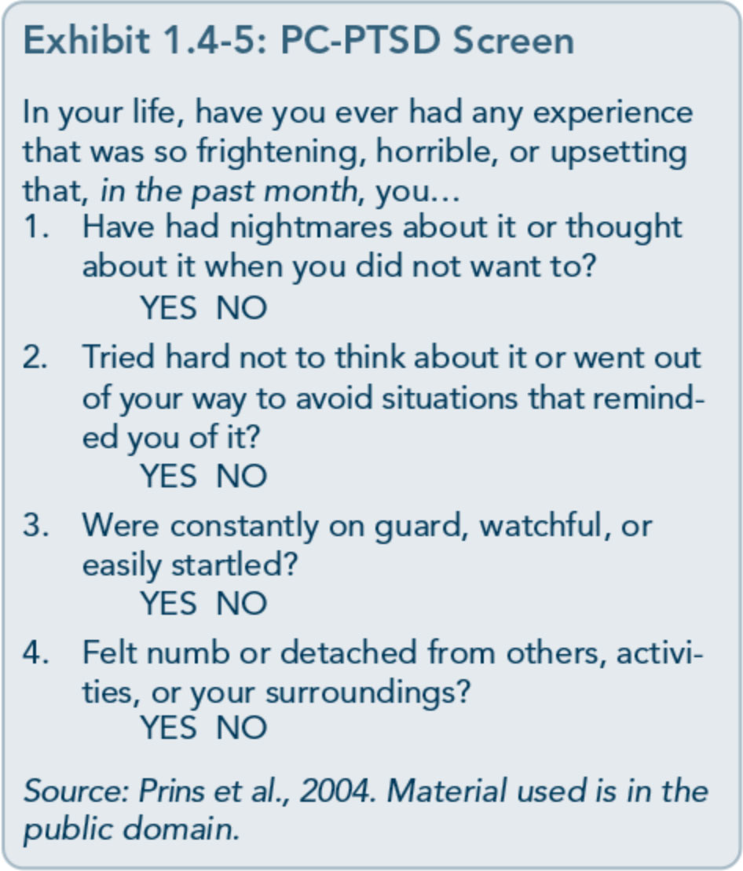
108

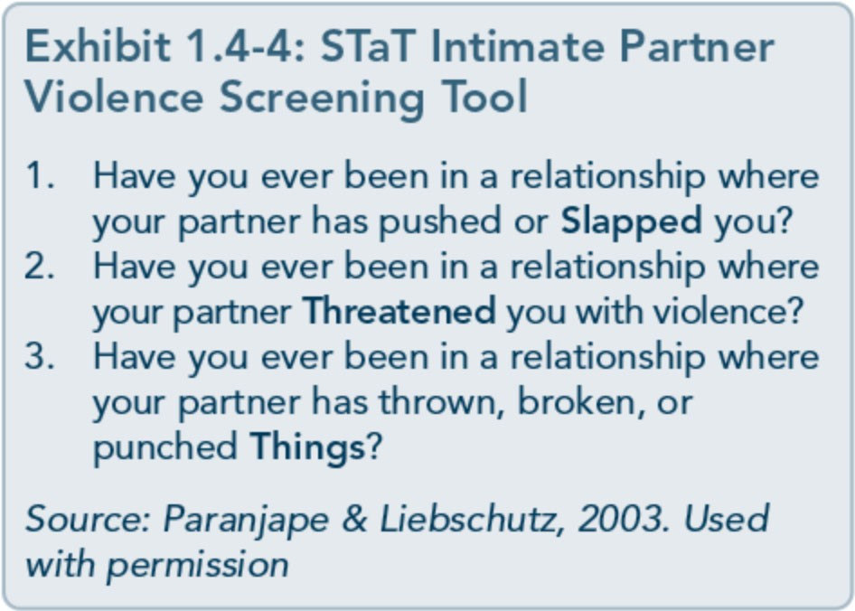
individuals who administer screenings, regard­ less of education level and experience, should be aware of trauma-related symptoms, grounding techniques, ways of creating safety for the client, proper methods for introducing screening tools, and the protocol to follow when a positive screen is obtained. (See Ap­ pendix D for information on specific instru­ ments.) Exhibit 1.4-5 is an example of a screening instrument for trauma symptoms, the Primary Care PTSD (PC-PTSD) Screen. Current research (Prins et al., 2004) suggests that the optimal cutoff score for the PC-PTSD is 3. If sensitivity is of greater concern than efficiency, a cutoff score of 2 is recommended.

Another instrument that can screen for trau­ matic stress symptoms is the four-item self­ report SPAN, summarized in Exhibit 1.4-6, which is derived from the 17-item Davidson Trauma Scale (DTS). SPAN is an acronym for the four items the screening addresses: startle, physiological arousal, anger, and numbness. It was developed using a small, diverse sample of adult patients (N=243; 72 percent women;
17.4 percent African American; average age = 37 years) participating in several clinical stud­ ies, including a family study of rape trauma, combat veterans, and Hurricane Andrew sur­ vivors, among others.
The SPAN has a high diagnostic accuracy of
0.80 to 0.88, with sensitivity (percentage of true positive instances) of 0.84 and specificity (percentage of true negative instances) of0.91 (Meltzer-Brody, Churchill, & Davidson, 1999). SPAN scores correlated highly with the full DTS (r = 0.96) and other measures, such as the Impact of Events Scale (r = 0.85) and the Sheehan Disability Scale (r = 0.87).
The PTSD Checklist (Exhibit 1.4-7), devel­ oped by the National Center for PTSD, is in the public domain. Originally developed for combat veterans of the Vietnam and Persian
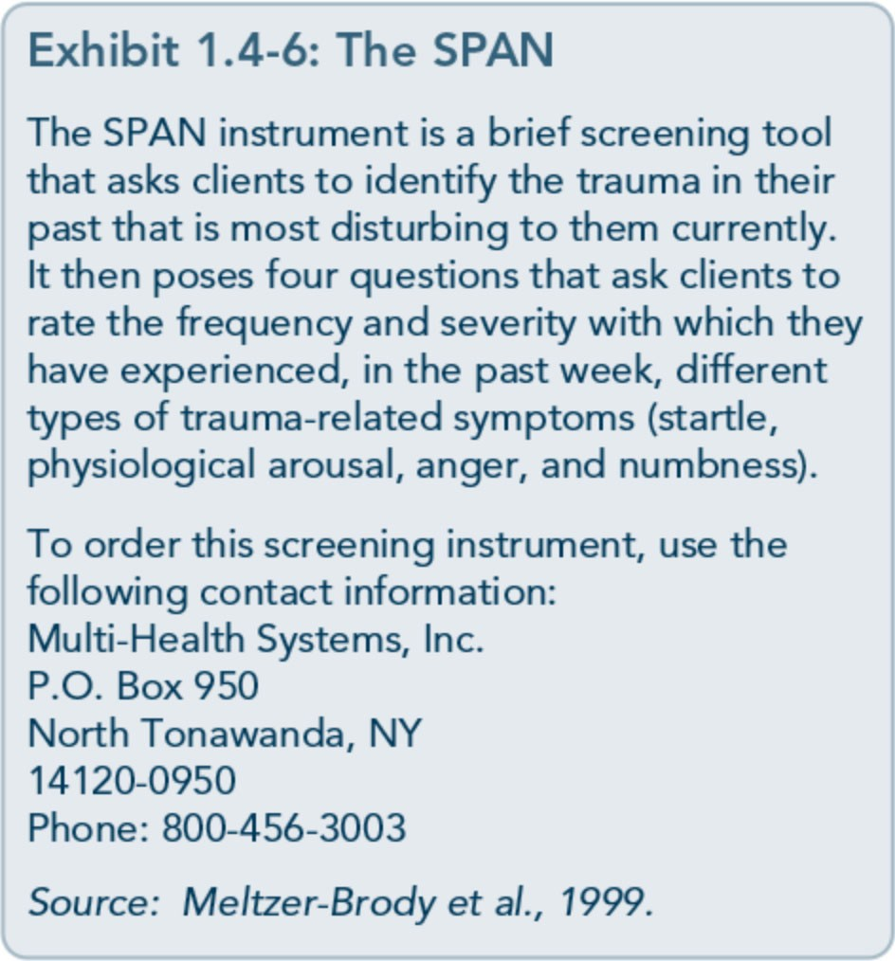

Part 1, Chapter 4-Screening and Assessment

Exhibit 1.4-7: The PTSD Checklist
Instructions to Client: Below is a list of problems and complaints that people sometimes have in response to stressful experiences. Please read each one carefully and circle the number that indi­ cates how much you have been bothered by that problem in the past month.
- Repeated, disturbing memories, thoughts, or images of a stressful experience?
  - Not at all 2. A little bit 3. Moderately 4. Quite a bit 5. Extremely
  - Repeated, disturbing dreams of a stressful experience?
    - Not at all 2. A little bit 3. Moderately 4. Quite a bit 5. Extremely
  - Suddenly acting or feeling as if a stressful experience were happening again (as if you were reliving it)?
    - Not at all 2. A little bit 3. Moderately 4. Quite a bit 5. Extremely
  - Feeling very upset when something reminded you of a stressful experience?
    - Not at all 2. A little bit 3. Moderately 4. Quite a bit 5. Extremely
  - Having physical reactions (e.g., heart pounding, trouble breathing, sweating) when some­ thing reminded you of a stressful experience?
    - Not at all 2. A little bit 3. Moderately 4. Quite a bit 5. Extremely
  - Avoiding thinking about or talking about a stressful experience or avoiding having feelings related to it?
    - Not at all 2. A little bit 3. Moderately 4. Quite a bit 5. Extremely
  - Avoiding activities or situations because they reminded you of a stressful experience?
    - Not at all 2. A little bit 3. Moderately 4. Quite a bit 5. Extremely
  - Trouble remembering important parts of a stressful experience?
    - Not at all 2. A little bit 3. Moderately 4. Quite a bit 5. Extremely
  - Loss of interest in activities that you used to enjoy?
    - Not at all 2. A little bit 3. Moderately 4. Quite a bit 5. Extremely
  - Feeling distant or cut off from other people?
    - Not at all 2. A little bit 3. Moderately 4. Quite a bit 5. Extremely
  - Feeling emotionally numb or being unable to have loving feelings for those close to you?
    - Not at all 2. A little bit 3. Moderately 4. Quite a bit 5. Extremely
  - Feeling as if your future will somehow be cut short?
    - Not at all 2. A little bit 3. Moderately 4. Quite a bit 5. Extremely
  - Trouble falling or staying asleep?

    - Not at all 2. A little bit 3. Moderately
  - Feeling irritable or having angry outbursts?
    - Not at all 2. A little bit 3. Moderately
  - Having difficulty concentrating?
    - Not at all 2. A little bit 3. Moderately
  - Being "super-alert" or watchful or on guard?
    - Not at all 2. A little bit 3. Moderately
  - Feeling jumpy or easily startled?
    - Not at all 2. A little bit 3. Moderately
4. Quite a bit 5. Extremely

4. Quite a bit 5. Extremely

4. Quite a bit 5. Extremely

4. Quite a bit 5. Extremely

4. Quite a bit 5. Extremely

Source: Weathers et al., 1993. Material used is in the public domain.

109

Trauma-Informed Care in Behavioral Health Services

GulfWars, it has since been validated on a variety of noncombat traumas (Keane, Brief, Pratt, &Miller, 2007). When using the checklist, identify a specific trauma first and then have the client answer questions in rela­ tion to that one specific trauma.

Other Screening and Resilience Measures
Along with identifying the presence of trauma-related symptoms that warrant as­ sessment to determine the severity of symp­ toms as well as whether or not the individual possesses subclinical symptoms or has met criteria for a trauma-related disorder, clients should receive other screenings for symptoms associated with trauma (e.g., depression, sui­ cidality). It is important that screenings ad­
dress both external and internal resources (e.g., support systems, strengths, coping styles).
Knowing the client's strengths can significant­ ly shape the treatment planning process by allowing you to use strategies that have already worked for the client and incorporating strat­ egies to build resilience (Exhibit 1.4-8).
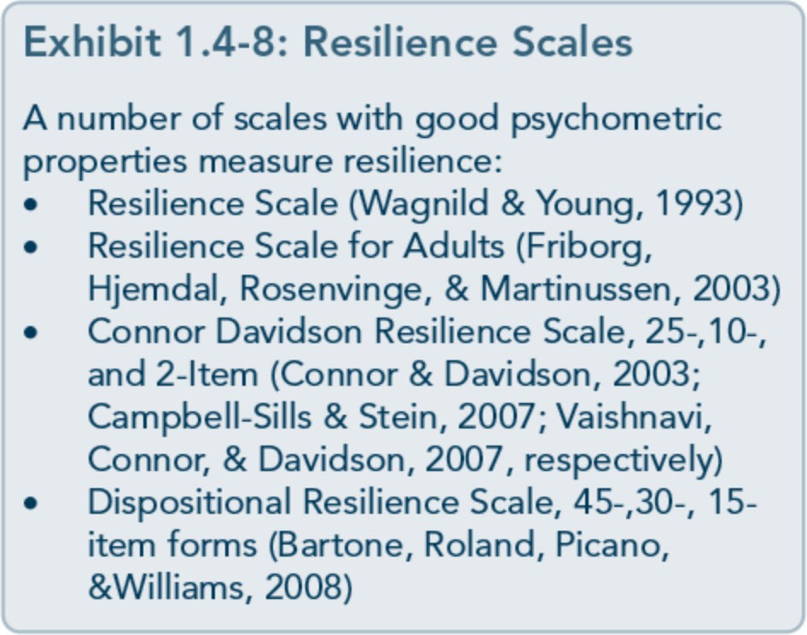

Preliminary research shows improvement of individual resilience through treatment inter­ ventions in other populations (Lavretsky, Siddarth, & Irwin, 2010).
Screen for suicidality
All clients-particularly those who have expe­ rienced trauma-should be screened for sui­ cidality by asking, "In the past, have you ever had suicidal thoughts, had intention to com­ mit suicide, or made a suicide attempt? Do you have any of those feelings now? Have you had any such feelings recently?" Behavioral
health service providers should receive training to screen for suicide. Additionally, clients with substance use disorders and a history of psy­ chological trauma are at heightened risk for suicidal thoughts and behaviors; thus, screen­ ing for suicidality is indicated. See TIP 50, Addressing Suicidal Thoughts and Behaviors in Substance Abuse Treatment (CSAT, 2009a). For additional descriptions of screening processes for suicidality, see TIP 42 (CSAT, 2005c).

Concluding Note
Screenings are only beneficial if there are follow-up procedures and resources for han­ dling positive screens, such as the ability to review results with and provide feedback to the individual after the screening, sufficient resources to complete a thorough assessment or to make an appropriate referral for an as­ sessment, treatment planning processes that can easily incorporate additional trauma­ informed care objectives and goals, and availa­ bility and access to trauma-specific services
that match the client's needs. Screening is only the first step!

110

Appendix A-Bibliography

Abrahams, I. A., Ali, 0., Davidson, L., Evans, A. C., King,]. K., Poplawski, P., et al. (2010).
Philadelphia behavioral health services traniformation: Practice guidelines for recovery and resilience oriented treatment. Philadelphia: Department of Behavioral Health and Intellectual Disability Services.
Adams, R. E., Figley, C.R., & Boscarino,]. A. (2008). The Compassion Fatigue Scale: Its use with social workers following urban disaster. Research on Social Work Practice, 18, 238-250.
Adler, A. B., Litz, B. T., Castro, C. A., Suvak, M., Thomas,]. L., Burrell, L., et al. (2008). A group randomized trial of critical incident stress debriefing provided to U.S. peacekeepers.journalof Traumatic Stress, 21, 253-263.
Administration on Children, Youth, and Families. (2002). Sexual abuse among homeless adolescents: Prevalence, correlates, and sequelae. Washington, DC: Administration on Children, Youth, and Families.
Advanced Trauma Solutions, Inc. (2012). Trauma affect regulation: Guide for education & therapy.
Farmington, CT: Advanced Trauma Solutions, Inc.
Allen,]. G. (2001). Traumatic relationships and serious mental disorders. New York: John Wiley &
Sons Ltd.
American Psychiatric Association. (1980). Diagnostic and statistical manual of mental disorders. (3rd ed.). Washington, DC: American Psychiatric Association.
American Psychiatric Association. (2000a). Diagnostic and statistical manual of mental disorders.
(4th ed., text rev.). Washington, DC: American Psychiatric Association.
American Psychiatric Association. (20006). Position statement on therapies focused on memories of
childhood physical and sexual abuse. Washington, DC: American Psychiatric Association.
American Psychiatric Association. (2012a). G 03 posttraumatic stress disorder. Washington, DC:
American Psychiatric Association.
American Psychiatric Association. (20126). Proposed draft revisions to DSM disorders and criteria.
Washington, DC: American Psychiatric Association.
American Psychiatric Association. (2013a). Diagnostic and statistical manual of mental disorders.
(5th ed.). Arlington, VA: American Psychiatric Association.

215

Trauma-Informed Care in Behavioral Health Services

American Psychiatric Association. (2013b). Highlights of changes from DSM-IV-TR to DSM-5.
Arlington, VA: American Psychiatric Association.
American Psychological Association & The Ad Hoc Committee on Legal and Ethical Issues in the Treatment oflnterpersonal Violence. (2003). Potential problems far psychologists working with the area of interpersonal violence. Washington, DC: American Psychiatric Association.
Anda, R. F., Felitti, V.J., Bremner,]. D., Walker,]. D., Whitfield, C., Perry, B. D., et al. (2006). The enduring effects of abuse and related adverse experiences in childhood. A convergence of evidence from neurobiology and epidemiology. European Archives of Psychiatry and Clinical Neuroscience, 256 (3), 174-86.
Anda, R. F., Felitti, V.J., Brown, D., Chapman, D., Dong, M., Dube, S. R., et al. (2006). Insights into intimate partner violence from the adverse childhood experiences (ACE) study. In The physician's guide to intimate partner violence and abuse (pp. 77-88). Volcano, CA: Volcano Press.
Andreasen, N. C. (2010). Posttraumatic stress disorder: A history and a critique.Annals of the New YorkAcademy of Sciences, 1208, 67-71.
Antony, M. M., Orsillo, S. M., & Roemer, L. (2001). Practitioner's guide to empirically based measures of anxiety. New York: Plenum Press.
Arkowitz, H., Miller, W.R., Westra, H. A., & Rollnick, S. (2008). Motivational interviewing in the treatment of psychological problems: Conclusions and future directions. In Motivational interviewing in the treatment of psychological problems (pp. 324-342). New York: Guilford Press.
Auerbach, S. (2003). Sleep disorders related to alcohol and other drug use. In A.W. Graham, T. K. Schultz, M. F. Mayo-Smith, R. K. Ries, & B. B. Wilford (Eds.), Principles of addiction medicine. (3rd ed.). (pp. 1179-1193). Chevy Chase, MD: American Society of Addiction Medicine.
Baer, R. A. (2003). Mindfulness training as a clinical intervention: A conceptual and empirical review. Clinical Psychology: Science and Practice, 10, 125-143.
Baker, K. G. & Gippenreiter,J. B. (1998). Stalin's purge and its impact on Russian families: A pilot study. In Y. Danieli (Ed.), International handbook of multigenerational legacies of trauma (pp.
403-434). New York: Plenum Press.
Bartone, P. T., Roland, R.R., Picano,J.J., & Williams, T. (2008). Psychological hardiness predicts success in US Army Special Forces candidates. International journal of Selection and Assessment, 16, 78-81.
Batten, S. V. & Hayes, S. C. (2005). Acceptance and commitment therapy in the treatment of comorbid substance abuse and post-traumatic stress disorder: A case study. Clinical Case Studies, 4, 246-262.
Beck, A. T. (1993). Beck anxiety inventory. San Antonio, TX: The Psychological Corporation. Beck, A. T., Rush, A.]., Shaw, B. F., & Emery, G. (1979). Cognitive therapy of depression. New York:
Guilford Press.
Beck, A. T., Steer, R. A., & Brown, G. K. (1996). Beck depression inventory -II manual. San Antonio, TX: The Psychological Corporation.

216

Appendix A-Bibliography

Beck, A. T., Wright, F. D., Newman, C. F., & Liese, B. F. (1993). Cognitive therapy of substance abuse. New York: Guilford Press.
Bell, C. C. (2011). Trauma, culture, and resiliency. In S. M. Southwick, B. T. Litz, D. Charney, &
M.J. Friedman (Eds.), Resilience and mental health: Challenges across the lifespan (pp. 176-187). New York: Cambridge University Press.
Benedek, D. M. & Ursano, R.J. (2009). Posttraumatic stress disorder: From phenomenology to clinical practice. FOCUS: The journal of Lifelong Learning in Psychiatry, 7, 160-175.
Bernard,]. M. & Goodyear, R. K. (2009). Fundamentals of clinical supervision. (4th ed.). Upper Saddle River, NJ: Merrill/Pearson.
Bernstein, D. P. (2000). Childhood trauma and drug addiction: Assessment, diagnosis, and
treatment.Alcoholism Treatment Quarterly, 18, 19-30.
Bernstein, E. M. & Putnam, F. W. (1986). Development, reliability, and validity of a dissociation
scale.journal of Nervous and Mental Disease, 174, 727-735.
Bills, L.J. (2003). Using trauma theory and S.A.G.E. in outpatient psychiatric practice. Psychiatric Quarterly, 74, 191-203.
Blackburn, C. (1995). Family and relapse. Counselor. Alexandria, VA: National Association of Alcoholism and Drug Abuse Counselors.
Blake, D., Weathers, F., Nagy, L., Koloupek, D., Klauminzer, G., Charney, D., et al. (1990). Clinician Administered PTSD Scale (CAPS). Boston: National Center for Post-Traumatic Stress Disorder.
Bleich, A., Gelkopf, M., & Solomon, Z. (2003). Exposure to terrorism, stress-related mental health symptoms, and coping behaviors among a nationally representative sample in Israel. journal of the American Medical Association, 290, 612-620.
Bloom, S. L. (1997). Creating sanctuary: Toward the evolution of sane societies. New York: Routledge. Bloom, S. L., Bennington-Davis, M., Farragher, B., McCorkle, D., Nice-Martini, K., & Wellbank,
K. (2003). Multiple opportunities for creating sanctuary. Psychiatric Quarterly, 74, 173-190.
Bloom, S. L., Foderaro,]. F., & Ryan, R. (2006). S.E.L.F: A trauma-informed psychoeducational group Curriculum. Retrieved on November 18, 2013, from: http://sanctuaryweb.com/PDFs_new/COMPLETE%20INTRODUCTO RY%20MATERI AL.pdf
Bober, T. & Regehr, C. (2006). Strategies for reducing secondary or vicarious trauma: Do they work? Brie/Treatment and Crisis Intervention, 6, 1-9.
Bonanno, G. A. (2004). Loss, trauma, and human resilience: Have we underestimated the human capacity to thrive after extremely aversive events? American Psychologist, 29, 20-28.
Bonanno, G. A. & Mancini, A. D. (2011). Toward a lifespan approach to resilience and potential trauma. In S. M. Southwick, B. T. Litz, D. Charney, &M.J. Friedman (Eds.), Resilience and mental health: Challenges across the lifespan (pp. 120-134). New York: Cambridge University Press.

217

Trauma-Informed Care in Behavioral Health Services

Bowman, C. G. &Mertz, E. (1996). A dangerous direction: Legal intervention in sexual abuse survivor therapy. Harvard Law Review, 109, 551-639.
Brady, K. T., Killeen, T., Saladin, M. E., Dansky, B., & Becker, S. (1994). Comorbid substance abuse and posttraumatic stress disorder: Characteristics of women in treatment. American journal on Addictions, 3, 160-164.
Breslau, N. (2002). Gender differences in trauma and posttraumatic stress disorder.journal of
Gender Specific Medicine, 5, 34-40.
Brewin, C.R. (2007). Remembering and forgetting. In M.J. Friedman, T. M. Keane, & P.A. Resick (Eds.), Handbook of PTSD: Science and practice (pp. 116-134). New York: Guilford Press.
Brewin, C.R., Andrews, B., & Valentine,]. D. (2000). Meta-analysis of risk factors for posttraumatic stress disorder in trauma-exposed adults.journal of Consulting and Clinical
Psychology, 68, 748-766.
Bride, B. E. (2007). Prevalence of secondary traumatic stress among social workers. Social Work, 52,
63-70.
Briere,]. (1995). Trauma symptom inventory professional manual. Odessa, FL: Psychological Assessment Resources.
Briere, J. (1996a). Therapy far adults molested as children: Beyond survival (2nd ed.). New York: Springer Pub.
Briere,]. (19966). Trauma symptom checklist far children professional manual. Odessa, FL: Psychological Assessment Resources.
Briere,]. (1997). Psychological assessment of adult posttraumatic states. (1st ed.). Washington, DC: American Psychological Association.
Briere, J. & Scott, C. (2006a). Central issues in trauma treatment. In Principles of trauma therapy: A guide to symptoms, evaluation, and treatment (pp. 67-85). Thousand Oaks, CA: Sage Publications.
Briere,]. & Scott, C. (20066). Principles of trauma therapy: A guide to symptoms, evaluation, and treatment. Thousand Oaks, CA: Sage Publications.
Briere,]., & Scott, C. (2012). Principles of trauma therapy: A guide to symptoms, evaluation, and treatment. (2nd ed.). Thousand Oaks, CA: Sage Publications.
Bronfenbrenner,U. (1979). The ecology of human development: Experiments by nature and design.
Cambridge, MA: Harvard University Press.
Bronfenbrenner,U. & Ceci, S.J. (1994). Nature-nurture reconceptualized in developmental perspective: A bioecological model. Psychological Review, 101, 568-586.
Brown, L. S. (2008). Feminist therapy. InJ. L. Lebow (Ed.), Twenty-first century psychotherapies: Contemporary approaches to theory and practice (pp. 277-306). Hoboken, NJ: John Wiley & Sons, Inc.

218

Appendix A-Bibliography

Brown, P. J., Read,]. P., & Kahler, C. W. (2003). Comorbid posttraumatic stress disorder and substance use disorders: Treatment outcomes and the role of coping. In P. Ouimette & P. J. Brown (Eds.), Trauma and substance abuse: Causes, consequences, and treatment of comorbid disorders (pp. 171-188). Washington, DC: American Psychological Association.
Bryant, R. A. & Harvey, A. G. (2000). Acute stress disorder: A handbook of theory, assessment, and treatment. (1st ed.). Washington, DC: American Psychological Association.
Bryant, R. A. & Harvey, A.G. (2003). Gender differences in the relationship between acute stress disorder and posttraumatic stress disorder following motor vehicle accidents.Australian and New Zealand journal of Psychiatry, 37, 226-229.
Burke, P.A., Carruth, B., & Prichard, D. (2006). Counselor self-care in work with traumatized addicted people. In B. Carruth (Ed.), Psychological trauma and addiction treatment (pp. 283- 302). New York: Haworth Press.
Cahill, S. P., Rothbaum, B. 0., Resick, P.A., & Follette, V. M. (2009). Cognitive-behavioral therapy for adults. In E. B. Foa, T. M. Keane, M.J. Friedman, &J. A. Cohen (Eds.), Effective treatments far PTSD: Practice guidelines from the International Society far Traumatic Stress Studies. (2nd ed.). (pp. 139-222). New York: Guilford Press.
Caldwell, B. A. & Redeker, N. (2005). Sleep and trauma: An overview. Issues in Mental Health Nursing, 26, 721-738.
Campbell-Sills, L. & Stein, M. B. (2007). Psychometric analysis and refinement of the Connor­ Davidson Resilience Scale (CD-RISC): Validation of a 10-item measure of resilience.journal of Traumatic Stress, 20, 1019-1028.
Capezza, N. M. & Najavits, L. M. (2012). Rates of trauma-informed counseling at substance abuse treatment facilities: Reports from over 10,000 programs. Psychiatric Services, 63, 390- 394.
Cardena, E., Koopman, C., Classen, C., Waelde, L. C., & Spiegel, D. (2000). Psychometric properties of the Stanford Acute Stress Reaction Qyestionnaire (SASRQ2: a valid and reliable measure of acute stress.journal ofTraumatic Stress, 13, 719-734.
Carlson, E. B. & Putnam, F. W. (1993). An update on the Dissociative Experiences Scale.
Dissociation, 6, 16-27.
Carroll,]. F. X. & McGinley,J.J. (2001). A screening form for identifying mental health problems in alcohol/other drug dependent persons. Alcoholism Treatment Quarterly, 19, 33-47.
Catalano, S. (2012). Intimate partner violence in the US. Washington, DC: Bureau ofJustice Statistics.
Catalano, S. M. (2004). Criminal victimization, 2003: National crime victimization survey.
Washington, DC: Bureau of Justice Statistics.
Centers for Disease Control and Prevention. (2009). The social-ecological model· A framework far prevention. Retrieved on November 20, 2013, from: http://www.cdc.gov/violenceprevention/overview/social-ecologicalmodel.html

219

Trauma-Informed Care in Behavioral Health Services

Centers for Disease Control and Prevention. (2012). Publications by health outcome: Adverse childhood experiences (ACE) study. Atlanta, GA: Centers for Disease Control and Prevention.
Centers for Disease Control and Prevention. (2013,January 18). Adverse Childhood Experiences (ACE) Study. Retrieved on August 14, 2013, from http://www.cdc.gov/ace/about.htm
Center for Mental Health Services. (1996). Responding to the needs of people with serious and persistent mental illness in times of major disaster (Rep. No. SMA 96-3077). Rockville, MD: Substance Abuse and Mental Health Services Administration.
Center for Mental Health Services, Division of Prevention, Traumatic Stress and Special Programs, Emergency Mental Health and Traumatic Stress Services Branch. (2003). Fact sheet (Rep. No. KEN 95-0011). Rockville, MD: Substance Abuse and Mental Health Services Administration.
Center for Mental Health Services, Substance Abuse and Mental Health Services Administration. (2005). Roadmap to seclusion and restraint free mental health services. Rockville, MD: Substance Abuse and Mental Health Services Administration.
Center for Substance Abuse Treatment. (1993a). Improving treatment far drug-exposed infants. Treatment Improvement Protocol (TIP) Series 5. HHS Publication No. (SMA) 95-3057. Rockville, MD: Substance Abuse and Mental Health Services Administration.
Center for Substance Abuse Treatment. (19936). Pregnant, substance-using women. Treatment Improvement Protocol (TIP) Series 2. HHS Publication No. (SMA) 93-1998. Rockville, MD: Substance Abuse and Mental Health Services Administration.
Center for Substance Abuse Treatment. (1993c). Screening/or infectious diseases among substance abusers. Treatment Improvement Protocol (TIP) Series 6. HHS Publication No. (SMA) 95- 3060. Rockville, MD: Substance Abuse and Mental Health Services Administration.
Center for Substance Abuse Treatment. (1994). Simple screening instruments far outreach far alcohol and other drug abuse and infectious diseases. Treatment Improvement Protocol (TIP) Series 11. HHS Publication No. (SMA) 94-2094. Rockville, MD: Substance Abuse and Mental Health Services Administration.
Center for Substance Abuse Treatment. (1995a). Alcohol and other drug screening of hospitalized trauma patients. Treatment Improvement Protocol (TIP) Series 16. HHS Publication No. (SMA) 95-3041. Rockville, MD: Substance Abuse and Mental Health Services Administration.
Center for Substance Abuse Treatment. (19956). Combining alcohol and other drug treatment with diversion far juveniles in the justice system. Treatment Improvement Protocol (TIP) Series 21. HHS Publication No. (SMA) 95-3051. Rockville, MD: Substance Abuse and Mental Health Services Administration.
Center for Substance Abuse Treatment. (1995c). Developing state outcomes monitoring systems far alcohol and other drug abuse treatment. Treatment Improvement Protocol (TIP) Series 14. HHS Publication No. (SMA) 95-3031. Rockville, MD: Substance Abuse and Mental Health Services Administration.

220

Appendix A-Bibliography

Center for Substance Abuse Treatment. (1995d). The role and current status of patient placement criteria in the treatment of substance use disorders. Treatment Improvement Protocol (TIP) Series
13. HHS Publication No. (SMA) 95-3021. Rockville, MD: Substance Abuse and Mental Health Services Administration.
Center for Substance Abuse Treatment. (1995e). The tuberculosis epidemic: Legal and ethical issues far alcohol and other drug abuse treatment providers. Treatment Improvement Protocol (TIP) Series 18. HHS Publication No. (SMA) 95-3047. Rockville, MD: Substance Abuse and Mental Health Services Administration.
Center for Substance Abuse Treatment. (1996). Treatment drug courts: Integrating substance abuse treatment with legal case processing. Treatment Improvement Protocol (TIP) Series 23. HHS Publication No. (SMA) 96-3113. Rockville, MD: Substance Abuse and Mental Health Services Administration.
Center for Substance Abuse Treatment. (1997a). A guide to substance abuse services far primary care clinicians. Treatment Improvement Protocol (TIP) Series 24. HHS Publication No. (SMA) 97-3139. Rockville, MD: Substance Abuse and Mental Health Services Administration.
Center for Substance Abuse Treatment. (1997b). Substance abuse treatment and domestic violence. Treatment Improvement Protocol (TIP) Series 25. HHS Publication No. (SMA) 97-3163. Rockville, MD: Substance Abuse and Mental Health Services Administration.
Center for Substance Abuse Treatment. (1998a). Comprehensive case management far substance abuse treatment. Treatment Improvement Protocol (TIP) Series 27. HHS Publication No. (SMA) 98-3222. Rockville, MD: Substance Abuse and Mental Health Services Administration.
Center for Substance Abuse Treatment. (1998b). Continuity of offender treatment far substance use disorders from institution to community. Treatment Improvement Protocol (TIP) Series 30.
HHS Publication No. (SMA) 98-3245. Rockville, MD: Substance Abuse and Mental Health Services Administration.
Center for Substance Abuse Treatment. (1998c). Naltrexone and alcoholism treatment. Treatment Improvement Protocol (TIP) Series 28. HHS Publication No. (SMA) 98-3206. Rockville, MD: Substance Abuse and Mental Health Services Administration.
Center for Substance Abuse Treatment. (1998d). Substance abuse among older adults. Treatment Improvement Protocol (TIP) Series 26. HHS Publication No. (SMA) 98-3179. Rockville, MD: Substance Abuse and Mental Health Services Administration.
Center for Substance Abuse Treatment. (1998e). Substance use disorder treatment far people with physical and cognitive disabilities. Treatment Improvement Protocol (TIP) Series 29. HHS Publication No. (SMA) 98-3249. Rockville, MD: Substance Abuse and Mental Health Services Administration.
Center for Substance Abuse Treatment. (1999a). Brief interventions and brief therapies far substance abuse. Treatment Improvement Protocol (TIP) Series 34. HHS Publication No. (SMA) 99- 3353. Rockville, MD: Substance Abuse and Mental Health Services Administration.

221

Trauma-Informed Care in Behavioral Health Services

Center for Substance Abuse Treatment. (1999b). Enhancing motivation far change in substance abuse treatment. Treatment Improvement Protocol (TIP) Series 35. HHS Publication No. (SMA) 99-3354. Rockville, MD: Substance Abuse and Mental Health Services Administration.
Center for Substance Abuse Treatment. (1999c). Screening and assessing adolescents far substance use disorders. Treatment Improvement Protocol (TIP) Series 31. HHS Publication No. (SMA) 99-3282. Rockville, MD: Substance Abuse and Mental Health Services Administration.
Center for Substance Abuse Treatment. (1999d). Treatment of adolescents with substance use disorders. Treatment Improvement Protocol (TIP) Series 32. HHS Publication No. (SMA) 99- 3283. Rockville, MD: Substance Abuse and Mental Health Services Administration.
Center for Substance Abuse Treatment. (1999e). Treatment far stimulant use disorders. Treatment Improvement Protocol (TIP) Series 33. HHS Publication No. (SMA) 99-3296. Rockville, MD: Substance Abuse and Mental Health Services Administration.
Center for Substance Abuse Treatment. (2000a). Integrating substance abuse treatment and vocational services. Treatment Improvement Protocol (TIP) Series 38. HHS Publication No. (SMA) 00-3470. Rockville, MD: Substance Abuse and Mental Health Services Administration.
Center for Substance Abuse Treatment. (2000b). Substance abuse treatment far persons with child abuse and neglect issues. Treatment Improvement Protocol (TIP) Series 36. HHS Publication No. (SMA) 00-3357. Rockville, MD: Substance Abuse and Mental Health Services Administration.
Center for Substance Abuse Treatment. (2000c). Substance abuse treatment far persons with HIV/AIDS. Treatment Improvement Protocol (TIP) Series 37. HHS Publication No. (SMA) 00-3459. Rockville, MD: Substance Abuse and Mental Health Services Administration.
Center for Substance Abuse Treatment. (2004a). Clinical guidelines far the use of buprenorphine in the treatment of opioid addiction. Treatment Improvement Protocol (TIP) Series 40. HHS Publication No. (SMA) 04-3939. Rockville, MD: Substance Abuse and Mental Health Services Administration.
Center for Substance Abuse Treatment. (2004b). Substance abuse treatment and family therapy. Treatment Improvement Protocol (TIP) Series 39. HHS Publication No. (SMA) 04-3957. Rockville, MD: Substance Abuse and Mental Health Services Administration.
Center for Substance Abuse Treatment. (2005a). Medication-assisted treatment far opioid addiction.
Treatment Improvement Protocol (TIP) Series 43. HHS Publication No. SMA 05-4048. Rockville, MD: Substance Abuse and Mental Health Services Administration.
Center for Substance Abuse Treatment. (2005b). Substance abuse treatment far adults in the criminal justice system. Treatment Improvement Protocol (TIP) Series 44. HHS Publication No. (SMA) 05-4056. Rockville, MD: Substance Abuse and Mental Health Services Administration.
Center for Substance Abuse Treatment. (2005c). Substance abuse treatment far persons with co­ occurring disorders. Treatment Improvement Protocol (TIP) Series 42. HHS Publication No. SMA 05-3992. Rockville, MD: Substance Abuse and Mental Health Services Administration.

222

Appendix A-Bibliography

Center for Substance Abuse Treatment. (2005d). Substance abuse treatment: Group therapy.
Treatment Improvement Protocol (TIP) Series 41. HHS Publication No. SMA 05-4056. Rockville, MD: Substance Abuse and Mental Health Services Administration.
Center for Substance Abuse Treatment. (2006a). Detoxification and substance abuse treatment. Treatment Improvement Protocol (TIP) Series 45. HHS Publication No. SMA 06-4131. Rockville, MD: Substance Abuse and Mental Health Services Administration.
Center for Substance Abuse Treatment. (2006b). Substance abuse:Administrative issues in intensive outpatient treatment. Treatment Improvement Protocol (TIP) Series 46. HHS Publication No. SMA 06-4151. Rockville, MD: Substance Abuse and Mental Health Services Administration.
Center for Substance Abuse Treatment. (2006c). Substance abuse: Clinical issues in intensive outpatient treatment. Treatment Improvement Protocol (TIP) Series 47. HHS Publication No. SMA 06-4182. Rockville, MD: Substance Abuse and Mental Health Services Administration.
Center for Substance Abuse Treatment. (2008). Managing depressive symptoms in substance abuse clients during early recovery. Treatment Improvement Protocol (TIP) Series 48. HHS Publication No. SMA 08-4353. Rockville, MD: Substance Abuse and Mental Health Services Administration.
Center for Substance Abuse Treatment. (2009a).Addressing suicidal thoughts and behaviors in substance abuse treatment. Treatment Improvement Protocol (TIP) Series 50. HHS Publication No. SMA 09-4381. Rockville, MD: Substance Abuse and Mental Health Services Administration.
Center for Substance Abuse Treatment. (2009b). Clinical supervision and the professional development of the substance abuse counselor. Treatment Improvement Protocol (TIP) Series 52. HHS Publication No. SMA 09-4435. Rockville, MD: Substance Abuse and Mental Health Services Administration.
Center for Substance Abuse Treatment. (2009c). Incorporating alcohol pharmacotherapies into medical practice. Treatment Improvement Protocol (TIP) Series 49. HHS Publication No. SMA 09-4380. Rockville, MD: Substance Abuse and Mental Health Services Administration.
Center for Substance Abuse Treatment. (2009d). Substance abuse treatment:Addressing the specific needs of women. Treatment Improvement Protocol (TIP) Series 51. HHS Publication No.
SMA 09-4426. Rockville, MD: Substance Abuse and Mental Health Services Administration.
Center for Substance Abuse Treatment. (2009e). What are peer recovery support services? HHS Publication No. SMA 09-4454. Rockville, MD: Substance Abuse and Mental Health Services Administration, U.S. Department of Health and Human Services.
Chambless, D. L. & Hollon, S. D. (1998). Defining empirically supported therapies.journal of
Consulting and Clinical Psychology, 66, 7-18.
Chilcoat, H. D. & Breslau, N. (1998). Posttraumatic stress disorder and drug disorders: Testing causal pathways.Archives of General Psychiatry, 55, 913-917.
Christensen, R. C., Hodgkins, C. C., Garces, L. K., Estlund, K. L., Miller, M. D., & Touchton, R. (2005). Homeless, mentally ill and addicted: The need for abuse and trauma services.journal of Health Care far the Poor and Underserved, 16, 615-621.

223

Trauma-Informed Care in Behavioral Health Services

Claes, L. & Vandereycken, W. (2007). Is there a link between traumatic experiences and self­ injurious behaviours in eating-disordered patients? Eating Disorders, 15, 305-315.
Claes, L., Vandereycken, W., & Vertommen, H. (2005). Self-care versus self-harm: Piercing, tattooing, and self-injuring in eating disorders. European Eating Disorders Review, 13, 11-18.
Clark, C. & Fearday, F. E. (2003). Triad women's project: Group facilitator's manual. Tampa, FL: Louis de la Parte Florida Mental Health Institute, University of South Florida.
Cloitre, M., Koenen, K. C., Cohen, L. R., & Han, H. (2002). Skills training in affective and interpersonal regulation followed by exposure: A phase-based treatment for PTSD related to childhood abuse.journal of Consulting and Clinical Psychology, 70, 1067-1074.
Coffey, S. F., Dansky, B. S., & Brady, K. T. (2003). Exposure-based, trauma focused therapy for comorbid posttraumatic stress disorder-substance use disorder. In P. Ouimette & P.J. Brown (Eds.), Trauma and substance abuse: Causes, consequences, and treatment of comorbid disorders. (pp.
127-146). Washington, DC: American Psychological Association.
Coffey, S. F., Schumacher,]. A., Brady, K. T., &Dansky, B. S. (2003). Reductions in trauma symptomalogy during acute and protracted alcohol and cocaine abstinence. Symposium conducted at the Annual Meeting of the International Society for Traumatic Stress Studies, Chicago, IL.
Coffey, S. F., Schumacher,]. A., Brimo, M. L., & Brady, K. T. (2005). Exposure therapy for substance abusers with PTSD: Translating research to practice. Behavior Modification, 29, 10- 38.
Connor, K. M. & Davidson,]. R. T. (2003). Development of a new resilience scale: The Connor­ Davidson Resilience Scale (CD-RISC). Depression and Anxiety, 18, 76-82.
Connors, G.J., Donovan, D. M., & DiClemente, C. C. (2001). Substance abuse treatment and the stages of change selecting and planning interventions. New York: Guilford Press.
Cottler, L.B., Nishith, P., & Compton, W. M. (2001). Gender differences in risk factors for trauma exposure and post-traumatic stress disorder among inner-city drug abusers in and out of treatment. Comprehensive Psychiatry, 42, 111-117.
Courtois, C. A. & Ford,]. D. (Eds.). (2009). Treating complex traumatic stress disorders:An evidence­ based guide. New York: Guilford Press.
Covington, S.S. (2003). Beyond trauma:A healingjourneyfar women: Facilitator's guide. Center City, MN: Hazelden.
Covington, S.S. (2008). Helping women recover: A program far treating addiction. (Revised loose leaf ed.). San Francisco:Jossey-Bass.
Cross, T. L., Bazron, B.J., Dennis, K. W., &Isaacs, M. R. (1989). Towards a culturally competent system of care: A monograph on effective services far minority children who are severely emotionally disturbed (Vol. 1). Washington, DC: Georgetown University Child Development Center.
Danieli, Y., Brom, D., & Sills,]. (2005). Sharing knowledge and shared care.journal ofAggression, Maltreatment &Trauma, 10, 775-790.

224

Appendix A-Bibliography

Daniels, A., Grant, E., Filson, B., Powell, I., Fricks, L., & Goodale, L. (2010). Pillars of peer support: Traniforming mental health systems of care through peer support services. Retrieved on November 21, 2013, from: http://www.pillarsofpeersupport.org/final%20%20PillarsofPeerSupportService%20Report.pdf
Daniels, A. S., Tunner, T. P., Ashenden, P., Bergeson, S., Fricks, L., & Powell, I. (2012). Pillars of peer support -III- Whole health peer support services. Retrieved on November 21, 2013, from: http://www.pillarsofpeersupport.org/P.O.PS2011.pdf
Dass-Brailsford, P. &Myrick, A. C. (2010). Psychological trauma and substance abuse: The need for an integrated approach. Trauma, Violence, & Abuse, 11, 202-213.
Daoust,]. P., Renaud, M., Bruyere, B., Lemieux, V., Fleury, G., & Najavits, L. M. (2012). Posttraumatic stress disorder and substance use disorder: Evaluation of the effectiveness of a specialized clinic far French-Canadians based in a teaching hospital Retrieved on November 21, 2013, from: http://www.seekingsafety.org/3-03-06/studies.html
Davidson,]. R., Book, S. W., Colket,J. T., Tupler, L.A., Roth, S., David, D., et al. (1997).
Assessment of a new self-rating scale for post-traumatic stress disorder. Psychological Medicine, 27, 153-160.
De Bellis, M. D. (2002). Developmental traumatology: A contributory mechanism for alcohol and substance use disorders. Psychoneuroendocrinology, 27, 155-170.
de Fabrique, N., Van Hasselt, V. B., Vecchi, G. M., & Romano, S.J. (2007). Common variables associated with the development of Stockholm syndrome: Some case examples. Victims & Offenders, 2, 91-98.
de Girolamo, G. (1993). lnternational perspectives on the treatment and prevention of posttraumatic stress disorder. In J.P. Wilson & Raphael Beverley (Eds.), International handbook of traumatic stress syndrome (pp. 935-946). New York: Plenum Press.
dePanfilis, D. (2006). Child neglect: A guide far prevention, assessment, and intervention. Washington, DC: U.S. Department of Health and Human Services, Administration for Children and Families, Administration on Children, Youth and Families Children's Bureau, Office on Child Abuse and Neglect.
DeWolfe, D.J. (2000). Training manual· For mental health and human service workers in major disasters (Rep. No. ADM 90-538). Rockville, MD: Substance Abuse and Mental Health Services Administration.
Dillon,]. R. (2001). lnternalized homophobia, attributions of blame, and psychological distress among lesbian, gay, and bisexual trauma victims. Dissertation Abstracts International· Section B: The Sciences & Engineering, 62, 2054.
Dom, G., De, W. B., Hulstijn, W., & Sabbe, B. (2007). Traumatic experiences and posttraumatic stress disorders: differences between treatment-seeking early- and late-onset alcoholic patients. Comprehensive Psychiatry, 48, 178-185.
Driessen, M., Schulte, S., Luedecke, C., Schaefer, I., Sutmann, F., Ohlmeier, M., et al. (2008).
Trauma and PTSD in patients with alcohol, drug, or dual dependence: A multi-center study.
Alcoholism: Clinical & Experimental Research, 32, 481-488.

225

Trauma-Informed Care in Behavioral Health Services

Dube, S. R., Anda, R. F., Felitti, V.J., Edwards, V.J., & Croft,]. B. (2002). Adverse childhood experiences and personal alcohol abuse as an adult. Addictive Behaviors, 27, 713-725.
Duckworth, M. P. & Follette, V. M. (2011). Retraumatization: Assessment, treatment, and prevention. New York: Brunner-Routledge.
Ehlers, A. & Clark, D. (2003). Early psychological interventions for adult survivors of trauma: A review. Biological Psychiatry, 53, 817-826.
El-Gabalawy, R. (2012).Association between traumatic experiences and physical health conditions in a nationally representative sample. Retrieved on November 21, 2013, from: http://www.adaa.org/sites/default/files/El-Gabalawy0Ai20331.pdf
Ellis, A. & Harper, R. A. (1975). A new guide to rational living. Oxford, England: Prentice-Hall.
Elliott, D. E., Bjelajac, P., Fallot, R. D., Markoff, L. S., & Reed, B. G. (2005). Trauma-informed or trauma-denied: Principles and implementation of trauma-informed services for women.
journal of Community Psychology, 33, 461-477.
EMDR Network. (2012).A brief description of EMDR therapy. Retrieved on November 21, 2013, Retrieved on November 21from: http://www.emdrnetwork.org/description.html
Falck, R. S., Wang,]., Siegal, H. A., & Carlson, R. G. (2004). The prevalence of psychiatric disorder among a community sample of crack cocaine users: An exploratory study with practical implications.journal of Nervous and Mental Disease, 192, 503-507.
Falender, C. A. & Shafranske, E. P. (2004). Clinical supervision: A competency-based approach. (1st ed.). Washington, DC: American Psychological Association.
Fallot, R. D. & Harris, M. (2001). A trauma-informed approach to screening and assessment. In
M. Harris & R. D. Fallot (Eds.), Using trauma theory to design service systems (pp. 23-31). San Francisco: Jossey-Bass.
Fallot, R. D. & Harris, M. (2002). The trauma recovery and empowerment model (TREM): Conceptual and practical issues in a group intervention for women. Community Mental Health journal, 38, 475-485.
Fallot, R. D. & Harris, M. (2009). Creating cultures of trauma-informed care (CCTIC): A se!f­ assessment and planning protocol. Washington, DC: Community Connections.
Falsetti, S. A., Resnick, H. S., Resnick, P.A., & Kilpatrick, D. (1993). The Modified PTSD Symptom Scale: A brief self-report measure of posttraumatic stress disorder. Behavior Therapist, 16, 161-162.
Farley, M., Golding,]. M., Young, G., Mulligan, M., &Minkoff,]. R. (2004). Trauma history and relapse probability among patients seeking substance abuse treatment.journal of Substance Abuse Treatment, 27, 161-167.
Feder, A., Charney, D., & Collins, K. (2011). Neurobiology of resilience. In S. M. Southwick, B. T. Litz, D. Charney, &M.J. Friedman (Eds.), Resilience and mental health: Challenges across the lifespan (pp. 1-29). New York: Cambridge University Press.

226

Appendix A-Bibliography

Feldner, M. T., Monson, C. M., & Friedman, M.J. (2007). A critical analysis of approaches to targeted PTSD prevention: Current status and theoretically derived future directions. Behavior Modification, 31, 80-116.
Felitti, V.J., Anda, R. F., Nordenberg, D., Williamson, D. F., Spitz, A. M., Edwards, V., et al. (1998). Relationship of childhood abuse and household dysfunction to many of the leading causes of death in adults: The Adverse Childhood Experiences (ACE) study.American journal of Preventive Medicine, 14, 245-258.
Figley, C.R. (1995). Compassion fatigue: Toward a new understanding of the costs of caring. In B.
H. Stamm (Ed.), Secondary traumatic stress: Se!f-care issues far clinicians, researchers, and educators
(pp. 3-28). Lutherville, MD: Sidran Press.
Figley, C.R. (2002). Origins of traumatology and prospects for the future, part i.journal of Trauma Practice, 1, 17-32.
First, M. B., Spitzer, R. L., Gibbon, M., & Williams,]. B. W. (2011a). Structured clinical interview far DSM-IV-TR axis I disorders, research version, non-patient edition. New York: Biometrics Research, New York State Psychiatric Institute.
First, M. B., Spitzer, R. L., Gibbon, M., & Williams,]. B. W. (20116). Structured clinical interview far DSM-IV-TR axis I disorders, research version, patient edition. New York: Biometrics Research, New York State Psychiatric Institute.
Foa, E. B., Dancu, C. V., Hembree, E. A.,Jaycox, L. H., Meadows, E. A., & Street, G. P. (1999). A comparison of exposure therapy, stress inoculation training, and their combination for reducing posttraumatic stress disorder in female assault victims.journal of Consulting and Clinical Psychology, 67, 194-200.
Foa, E. B., Hembree, E. A., & Rothbaum, B. 0. (2007). Prolonged exposure therapy far PTSD: Emotional processing of traumatic experiences: Therapist guide. New York: Oxford University Press.
Foa, E. B., Keane, T. M., Friedman, M.J., & Cohen,]. A. (2009). Introduction. In E. B. Foa, T. M. Keane, M. J. Friedman, & J. A. Cohen (Eds.), Effective treatments far PTSD: Practice guidelines from the International Society far Traumatic Stress Studies. (2nd ed.). (pp.1-20). New York: Guilford Press.
Foa, E. B., Rothbaum, B. 0., Riggs, D.S., &Murdock, T. B. (1991). Treatment of posttraumatic stress disorder in rape victims: A comparison between cognitive-behavioral procedures and counseling.journal of Consulting & Clinical Psychology, 59, 715-723.
Foa, E. B., Stein, D.J., &McFarlane,A. C. (2006). Symptomatology and psychopathology of mental health problems after disaster.journal of Clinical Psychiatry, 67 Supplement 2, 15-25.
Ford,]. D. & Fournier, D. (2007). Psychological trauma and post-traumatic stress disorder among women in community mental health aftercare following psychiatric intensive care.journal of Psychiatric Intensive Care, 3, 27-34.
Ford,]. D. & Russo, E. (2006). Trauma-focused, present-centered, emotional self-regulation approach to integrated treatment for posttraumatic stress and addiction: Trauma adaptive recovery group education and therapy (TARGET).Americanjournal of Psychotherapy, 60, 335-355.

227

Trauma-Informed Care in Behavioral Health Services

Foy, D. W., Ruzek,J. I., Glynn, S. M., Riney, S.J., & Gusman, F. D. (2002). Trauma focus group therapy for combat-related PTSD: An update.journal of Clinical Psychology, 58, 907-918.
Frank, B., Dewart, T., Schmeidler,]., &Demirjian,A. (2006). The impact of9/11 on New York City's substance abuse treatment programs: A study of program administrators.journalof Addictive Diseases, 25, 5-14.
Frankl, V. E. (1992). Man's search far meaning: An introduction to logotherapy. (4th ed.). Boston: Beacon Press.
Friborg, 0., Hjemdal, 0., Rosenvinge,J. H., &Martinussen, M. (2003). A new rating scale for adult resilience: What are the central protective resources behind healthy adjustment?
International journal of Methods in Psychiatric Research, 12, 65-76.
Friedman, M.J. (2006). Posttraumatic stress disorder among military returnees from Afghanistan and Iraq.American]ournal of Psychiatry, 163, 586-593.
Frisman, L., Ford,]., Lin, H.J., Mallon, S., & Chang, R. (2008). Outcomes of trauma treatment using the TARGET model.Journal of Groups in Addiction and Recovery, 3, 285-303.
Frueh, B. C., Knapp, R. G., Cusack, K.J., Grubaugh, A. L., Sauvageot,J. A., Cousins, V. C., et al. (2005). Patients' reports of traumatic or harmful experiences within the psychiatric setting.
Psychiatric Services, 56, 1123-1133.
Galea, S., Ahern,]., Resnick, Kilpatrick, D., Bucuvalas, M., Gold,]., et al. (2002). Psychological sequelae of the September 11 terrorist attacks in New York City. New England journal of Medicine, 346, 982-987.
Gentilello, L. M., Ebel, B. E., Wickizer, T. M., Salkever, D. S., & Rivara, F. P. (2005). Alcohol interventions for trauma patients treated in emergency departments and hospitals: A cost benefit analysis.Annals of Surgery, 241, 541-550.
Gentilello, L. M., Villaveces, A., Ries, R.R., Nason, K. S., Daranciang, E., Donovan, D. M., et al. (1999). Detection of acute alcohol intoxication and chronic alcohol dependence by trauma
center staff Journal of Trauma, 47, 1131-1135.
Gill, D. A. & Picou,}. S. (1997). The day the water died: Cultural impacts of the Exxon Valdez oil spill. InJ. S. Picou (Ed.), The Exxon Valdez disaster: Readings on a modern social problem (pp.167-187). Dubuque, IA: Indo American Books.
Gone,J. P. (2009). A community-based treatment for Native American historical trauma: Prospects for evidence-based practice.journal of Consulting and Clinical Psychology, 77, 751-762.
Goodell,]. (2003). Who's a hero now? Retrieved on November 21, 2013 from: http://www.nytimes.com/2003/07/27/magazine/who-s-a-hero-now.html
Grant, B. F., Stinson, F. S., Dawson, D. A., Chou, S. P., Dufour, M. C., Compton, W., et al. (2004).
Prevalence and co-occurrence of substance use disorders and independent mood and anxiety disorders: Results from the National Epidemiologic Survey on Alcohol and Related Conditions.Archives of General Psychiatry, 61, 807-816.
Green, B. L. (1996). Trauma History Qyestionnaire. In B. H. Stamm (Ed.), Measurement of stress, trauma, and adaptation (pp. 366-369). Lutherville, MD: Sidran Press.

228

Appendix A-Bibliography

Green Cross Academy ofTraumatology. (2007). Standards of traumatology practice revised. Retrieved on November 18, 2013, from: http://www.greencross.org/index.php?option=com_content&view=article&id=183&Itemid=123
Green Cross Academy ofTraumatology. (2010). Standards ofse!f care. Retrieved on November 21, 2013,from: http://www.greencross.org/index.php?option=com_content&view=article&id=184&Itemid=124
Green,]. G., McLaughlin, K. A., Berglund, P.A., Gruber, M.J., Sampson, N. A., Zaslavsky, A. M., et al. (2010). Childhood adversities and adult psychiatric disorders in the National Comorbidity Survey Replication I: Associations with first onset of DSM-IV disorders.
Archives of General Psychiatry, 6 7, 113-123.
Greene, L. R., Meisler, A. W., Pilkey, D., Alexander, G., Cardella, L.A., Sirois, B. C., et al. (2004). Psychological work with groups in the Veterans Administration. In]. L.DeLucia-Waack, D.
A. Gerrity, C.R. Kalodner, & M. T. Riva (Eds.), Handbook of group counseling and psychotherapy
(pp. 322-337). Thousand Oaks, CA: Sage Publications.
Grossman, D. (1995). On killing: The psychological cost of learning to kill in war and society. (1st ed.).
Boston: Little Brown.
Guarino, K., Soares, P., Konnath, K., Clervil, R., and Bassuk, E. (2009). Trauma-informed organizational toolkit. Rockville, MD: Center for Mental Health Services, Substance Abuse and Mental Health Services Administration, and the Daniels Fund, the National Child Traumatic Stress Network, and the W. K. Kellogg Foundation.
Gutheil, T. G. & Brodsky, A. (2008). Preventing boundary violations in clinical practice. New York: Guilford Press.
Habukawa, M., Maeda, M., & Uchimura, N. (2010). Sleep disturbances in posttraumatic stress disorder. In L. Sher & A. Vilens (Eds.), Neurobiology of post-traumatic stress disorder (pp. 119- 135). Hauppage, NY: Nova Science Publishers, Inc.
Hamblen,]. (2001). PTSD in children and adolescents, a National Center far PTSD fact sheet.
Washington, DC: National Center for PTSD.
Harned, M. S., Najavits, L. M., & Weiss, R. D. (2006). Self-harm and suicidal behavior in women with comorbid PTSD and substance dependence.American journal of Addiction, 15, 392-395.
Harris, M. & Fallot, R. D. (2001a). Envisioning a trauma-informed service system: A vital paradigm shift. In M. Harris & R. D. Fallot (Eds.), Using trauma theory to design service systems (pp. 3-22). San Francisco:Jossey-Bass.
Harris, M. & Fallot, R. D. (20016). Trauma-informed inpatient services. In M. Harris & R. D. Fallot (Eds.), Using trauma theory to design service systems (pp. 33-46). San Francisco: Jossey­ Bass.
Harris, M. & Fallot, R. D. (2001c). Using trauma theory to design service systems: New directions far mental health services. San Francisco: Jossey-Bass.
Harris, M. & The Community Connections Trauma Work Group. (1998). Trauma recovery and empowerment: A clinician's guide far working with women in groups. New York: Simon & Schuster.

229

Trauma-Informed Care in Behavioral Health Services

Hayes, S. C. (2004). Acceptance and commitment therapy and the new behavior therapies: Mindfulness, acceptance, and relationship. In S. C. Hayes, V. M. Follette, & M. M. Linehan (Eds.), Mincifulness and acceptance: Expanding the cognitive-behavioral tradition (pp. 1-29). New York: Guilford Press.
Heim, C., Mletzko, T., Purselle, D., Musselman, D. L., & Nemeroff, C. B. (2008). The dexamethasone/corticotropin-releasing factor test in men with major depression: Role of childhood trauma. Biological Psychiatry, 63, 398-405.
Heim, C., Newport, D.J., Mletzko, T., Miller, A.H., & Nemeroff, C. B. (2008). The link between childhood trauma and depression: Insights from HPA axis studies in humans.
Psychoneuroendocrinology, 33, 693-710.
Herman,]. L. (1992). Trauma and recovery. New York: Basic Books. Herman,]. L. (1997). Trauma and recovery. (Rev. ed.). New York: Basic Books.
Hoge,M.A.,Morris,J. A., Daniels,A. S., Stuart, G. W., Huey, L. Y., &Adams, N. (2007).An action plan far behavioral health workforce development: A framework far discussion. Rockville, MD: Substance Abuse and Mental Health Services Administration.
Hooper, L. M., Stockton, P., Krupnick,J. L., & Green, B. L. (2011). Development, use, and psycho­ metric properties of the Trauma History Qyestionnaire.journalof Loss and Trauma, 16, 258-283.
Hopper, E. K., Bassuk, E. L., & Olivet,]. (2010). Shelter from the storm: Trauma-informed care in homelessness services settings. The Open Health Services and Policy journal, 3, 80-100.
Horowitz, M., Wilner, N., &Alvarez, W. (1979). Impact of Event Scale: A measure of subjective stress. Psychosomatic Medicine, 41, 209-218.
Huckshorn, K. (2009). Traniforming cultures ofcare toward recovery oriented services: Guidelines toward creating a trauma informed system ofcare: Trauma informed care (TIC) planning guidelines far use in developing an organizationalaction plan. Austin, TX:Texas Network of Youth Services.
Hui, C.H. &Triandis, H. C. (1986). Individualism-collectivism: A study of cross-cultural
researchers.journal of Cross-Cultural Psychology, 17, 225-248.
Huriwai, T. (2002). Re-enculturation: Culturally congruent interventions for Maori with alcohol­ and drug-use-associated problems in New Zealand. Substance Use and Misuse, 37, 1259-1268.
Hutton, D. (2000). Patterns of psychosocial coping and adaptation among riverbank erosion­ induced displacees in Bangladesh: Implications for development programming. Prehospital and Disaster Medicine, 15, S99.
Institute of Medicine. (2008). Treatment of posttraumatic stress disorder: An assessment of the evidence. Washington, DC: The National Academies Press.
Institute of Medicine & National Research Council. (2007). PTSD compensation and military service. Washington, DC: The National Academies.

230

Appendix A-Bibliography

Institute of Medicine, Committee on Prevention of Mental Disorders and Substance Abuse Among Children, O'Connell, M. E., Boat, T. F., Warner, K. E., National Research Council (U.S.), et al. (2009). Preventing mental, emotional, and behavioral disorders among young people: Progress and possibilities.Washington, DC: National Academies Press.
Jackson, C., Nissenson, K., & Cloitre, M. (2009). Cognitive-behavioral therapy. In C. A. Courtois (Ed.), Treating complex traumatic stress disorders: An evidence-based guide (pp. 243-263). New York: Guilford Press.
Jainchill, N., Hawke,]., & Yagelka,J. (2000). Gender, psychopathology, and patterns of homelessness among clients in shelter-based TCs. American journal of Drug and Alcohol Abuse, 26, 553-567.
Janoff-Bulman, R. (1992). Shattered assumptions: Towards a new psychology of trauma. New York: Free Press.
Jennings, A. (2004). Models far developing trauma-informed behavioral health systems and trauma­ specific services. Retrieved on November 21, 2013, from: http://www.theannainstitute.org/MDT.pdf
Jennings, A. (2007a). Blueprint far action: Building trauma-informed mental health service systems: State accomplishments, activities and resources. Retrieved on November 21, 2013, from: http://www.theannainstitute.org/2007%202008%20Blueprint%20BfA>20Criteria%202%2015
%2008.pdf
Jennings, A. (20076). Criteria far building a trauma-informed mental health service system. Adapted from "Developing Trauma-Informed Behavioral Health Systems."
Retrieved on November 21, 2013, from: http://www.theannainstitute.org/CBTIMHSS.pdf
Jennings, A. (2009). Models far developing trauma-informed behavioral health systems and trauma­ specific services: 2008 update. Retrieved on November 21, 2013, from: http://www.theannainstitute.org/Models%20for%20Developing%20Traums-Report%201-09- 09%20_FINAL_.pdf
Kabat-Zinn,]. (1994). Wherever you go, there you are: Mincifulness meditation in everyday life. (1st ed.). New York: Hyperion.
Kabat-Zinn,]., University of Massachusetts Medical Center/Worcester, & Stress, R. C. (1990). Full catastrophe living: Using the wisdom of your body and mind to face stress, pain, and illness. New York: Delacorte Press.
Karlin, B. E., Ruzek,J. I., Chard, K. M., Eftekhari, A., Monson, C. M., Hembree, E. A., et al. (2010). Dissemination of evidence-based psychological treatments for posttraumatic stress disorder in the Veterans Health Administration.journalofTraumatic Stress, 23, 663-673.
Karon, B. P. & Widener, A.J. (1997). Repressed memories and World War II: Lest we forget!
Professional Psychology: Research and Practice, 28, 338-340.
Keane, T. M., Brief, D.J., Pratt, E. M., &Miller, M. W. (2007). Assessment of PTSD and its comorbidities in adults. In M.J. Friedman, T. M. Keane, & P.A. Resick (Eds.), Handbook of PTSD: Science and practice (pp. 279-305). New York: Guilford Press.

231

Trauma-Informed Care in Behavioral Health Services

Keane, T. M., Fairbank,]. A., Caddell,]. M., Zimering, R. T., Taylor, K. L., &Mora, C. A. (1989). Clinical evaluation of a measure to assess combat exposure. Psychological Assessment, 1, 53-55.
Keane, T. M. & Piwowarczyk, L.A. (2006). Trauma, terror, and fear: Mental health professionals respond to the impact of9/11-an overview. In L.A. Schein, H. I. Spitz, G. M. Burlingame, &
P.R. Muskin (Eds.), Psychological effects of catastrophic disasters: Group approaches to treatment
(pp. 3-16). New York: Haworth Press.
Kelly, D. C., Howe-Barksdale, S., & Gitelson, D. (2011). Treating young veterans: Promoting resilience through practice and advocacy. New York: Springer Publishing.
Kessler, R. C., Chiu, W. T., Demler, 0., Merikangas, K. R., & Walters, E. E. (2005). Prevalence, severity, and comorbidity of 12-month DSM-IV disorders in the National Comorbidity Survey replication.Archives of General Psychiatry, 62, 617-627.
Kessler, R. C., Sonnega, A., Bromet, E., Hughes, M., & Nelson, C. B. (1995). Posttraumatic stress disorder in the National Comorbidity Survey.Archives of General Psychiatry, 52, 1048-1060.
Kessler, R. C., Sonnega, A., Bromet, E., Hughes, M., Nelson, C. B., & Breslau, N. N. (1999).
Epidemiological risk factors for trauma and PTSD. In R. Yehuda (Ed.), Risk factors far PTSD.
(pp. 23-59). Washington, DC: American Psychiatric Press.
Khantzian, E.J. (1985). The self-medication hypothesis of addictive disorders: focus on heroin and cocaine dependence. American journal of Psychiatry, 142, 1259-1264.
Kilpatrick, D. G., Veronen, L.J., & Resick, P.A. (1982). Psychological sequelae to rape: Assessment and treatment strategies. In D. M. Doleys, R. L. Meredith, & A. R. Ciminero (Eds.), Behavioral medicine: assessment and treatment strategies (pp. 473-497). New York: Plenum.
Kimerling, R., Ouimette, P., & Weitlauf,J. C. (2007). Gender issues in PTSD. In M.J. Friedman,
T. M. Keane, & P.A. Resick (Eds.), Handbook of PTSD: Science and practice (pp. 207-228). New York: Guilford Press.
Kirmayer, L.J. (1996). Confusion of the senses: Implications of ethnocultural variations in somatoform and dissociative disorders for PTSD. In A.J. Marsella &M.J. Friedman (Eds.), Ethnocultural aspects of posttraumatic stress disorder: Issues, research, and clinical applications (pp. 131-163). Washington, DC: American Psychological Association.
Klinic Community Health Centre. (2008). Trauma-informed· The trauma toolkit. Winnipeg, Manitoba: Klinic Community Health Centre.
Koenen, K. C., Stellman, S. D., Sommer,]. F.,Jr., & Stellman,]. M. (2008). Persisting posttraumatic stress disorder symptoms and their relationship to functioning in Vietnam veterans: A 14-year follow-up.journal ofTraumatic Stress, 21, 49-57.
Koenen, K. C., Stellman,]. M., Stellman, S. D., & Sommer,]. F.,Jr. (2003). Risk factors for course of posttraumatic stress disorder among Vietnam veterans: A 14-year follow-up of American Legionnaires.journal of Consulting & Clinical Psychology, 71, 980-986.
Kozaric-Kovacic, D., Ljubin, T., & Grappe, M. (2000). Comorbidity of posttraumatic stress disorder and alcohol dependence in displaced persons. Croatian Medical journal, 41, 173-178.

232

Appendix A-Bibliography

Kramer, T. L. & Green, B. L. (1997). Post-traumatic stress disorder: A historical context and evolution. In D. F. Halpern (Ed.), States of mind: American and post-Soviet perspectives on contemporary issues in psychology (pp. 215-237). New York: Oxford University Press.
Kress, V. E. & Hoffman, R. M. (2008). Non-suicidal self-injury and motivational interviewing: Enhancing readiness for change.journal of Mental Health Counseling, 30, 311-329.
Kubany, E. S., Haynes, S. N., Leisen, M. B., Owens,]. A., Kaplan, A. S., Watson, S. B., et al. (2000). Development and preliminary validation of a brief broad-spectrum measure of trauma exposure: The Traumatic Life Events Qyestionnaire. Psychological Assessment, 12, 210-224.
Kuhn,J. H. & Nakashima,]. (2011). Community homelessness assessment, local education and networking croup (CHA.LENG) far veterans: The seventeenth annual progress report. Retrieved on November 21, 2013, from: http://www.va.gov/HOMELESS/docs/chaleng/CHALENG_Report_Seventeenth_Annual.pdf
Lasiuk, G. C. & Hegadoren, K. M. (2006). Posttraumatic stress disorder part I: Historical development of the concept. Perspectives in Psychiatric Care, 42, 13-20.
Lavretsky, H., Siddarth, P., & Irwin, M. R. (2010). Improving depression and enhancing resilience in family dementia caregivers: A pilot randomized placebo-controlled trial of escitalopram.
The American journal of Geriatric Psychiatry, 18, 154-162.
Lester, K. M., Milby,]. B., Schumacher,]. E., Vuchinich, R., Person, S., & Clay, O.J. (2007).
Impact of behavioral contingency management intervention on coping behaviors and PTSD symptom reduction in cocaine-addicted homeless.journal ofTraumatic Stress, 20, 565-575.
Linehan, M. M. (1993). Dialectical behavior therapy for treatment of borderline personality disorder: Implications for the treatment of substance abuse. In L. S. Onken,]. D. Blaine, &J.J. Boren (Eds.), Behavioral treatments far drug abuse and dependence (pp. 201-216). Rockville, MD: National Institute on Drug Abuse.
Litz, B. T. & Gray, M.J. (2002). Early intervention for mass violence: What is the evidence? What should be done? Cognitive and Behavioral Practice, 9, 266-272.
Litz, B. T., Miller, M., Ruef, A., & McTeague, L. (2002). Exposure to trauma in adults. In M. Antony & D. Barlow (Eds.), Handbook of assessment and treatment planningfar psychological disorders. New York: Guilford Press.
Liu, D., Diorio,]., Day,J. C., Francis, D. D., & Meaney, M.J. (2000). Maternal care, hippocampal synaptogenesis and cognitive development in rats. Nature Neuroscience, 3, 799-806.
Mahalik,J. R. (2001). Cognitive therapy for men. In G. R. Brooks & G. E. Good (Eds.), The new handbook of psychotherapy and counseling with men: A comprehensive guide to settings, problems, and treatment approaches (pp. 544-564). San Francisco: Jossey-Bass.
Malta, L. S., Levitt,]. T., Martin, A., Davis, L., & Cloitre, M. (2009). Correlates of functional impairment in treatment-seeking survivors of mass terrorism. Behavior Therapy, 40, 39-49.
Marlatt, G. A. & Donovan, D. M. (Eds.) (2005). Relapse prevention: Maintenance strategies in the treatment of addictive behaviors. (2nd ed.). New York: Guilford Press.

233

Trauma-Informed Care in Behavioral Health Services

Martino, S., Canning-Ball, M., Carroll, K. M., & Rounsaville, B.J. (2011). A criterion-based stepwise approach for training counselors in motivational interviewing.journalof Substance Abuse Treatment, 40, 357-365.
Maschi, T. & Brown, D. (2010). Professional self-care and prevention of secondary trauma. In Helping bereaved children: A handbook far practitioners. (3rd ed.). (pp. 345-373). New York: Guilford Press.
McCaig, L. F. & Burt, C. W. (2005). National Hospital Ambulatory Medical Care Survey: 2003 emergency department summary. Hyattsville, MD: National Center for Health Statistics.
Mc Cann, L. & Pearlman, L. A. (1990). Vicarious traumatization: A framework for understanding the psychological effects of working with victims.journal of Traumatic Stress, 3, 1.
McGarrigle, T. & Walsh, C. A. (2011). Mindfulness, self-care, and wellness in social work: Effects of contemplative training.journal of Religion & Spirituality in Social Work: Social Thought, 30, 212-233.
McGovern, M. P., Lambert-Harris, C., Alterman, A. I., Xie, H., &Meier, A. (2011). A randomized controlled trial comparing integrated cognitive behavioral therapy versus individual addiction counseling for co-occurring substance use and posttraumatic stress disorders.journal of Dual Diagnosis, 7, 207-227.
McLeod,]. (1997). Narrative and psychotherapy. London: Sage Publications.
McNally, R.J. (2003). Remembering trauma. Cambridge, MA: Belknap Press of Harvard University Press.
McNally, R.J. (2005). Debunking myths about trauma and memory. The Canadian journal of
Psychiatry/La Revue Canadienne de Psychiatrie, 50, 817-822.
McNally, R.J., Bryant, R. A., & Ehlers, A. (2003). Does early psychological intervention promote recovery from posttraumatic stress? Psychological Science in the Public Interest, 4, 45-79.
McNamara, C., Schumacher,]. E., Milby,]. B., Wallace, D., & Usdan, S. (2001). Prevalence of nonpsychotic mental disorders does not affect treatment outcome in a homeless cocaine­ dependent sample. American journal of Drug and Alcohol Abuse, 2 7, 91-106.
Mead, S. (2008). Intentional peer support: An alternative approach. Plainfield, NH: Shery Mead Consulting.
Meaney, M.J., Brake, W., & Gratton, A. (2002). Environmental regulation of the development of mesolimbic dopamine systems: A neurobiological mechanism for vulnerability to drug abuse? Psychoneuroendocrinology, 27, 127-138.
Meichenbaum, D. (1994).A clinical handbook/practical therapist manual far assessing and treating adults with post-traumatic stress disorder (PTSD). Waterloo, Ontario: Institute Press.
Meichenbaum, D. (1996). Stress inoculation training for coping with stressors. The Clinical Psychologist, 49, 4-7.
Meichenbaum, D. (2007). Stress inoculation training: A preventative and treatment approach. In
Principles and practice of stress management. (3rd ed.). (pp. 497-516). New York: Guilford Press.

234

Appendix A-Bibliography

Meichenbaum, D. H. & Deffenbacher,J. L. (1988). Stress inoculation training. Counseling Psychologist, 16, 69-90.
Melnick, S. M. & Bassuk, E. L. (2000). Identifying and responding to violence among poor and homeless women. Nashville, TN: National Healthcare for the Homeless Council.
Meltzer-Brody, S., Churchill, E., & Davidson,}. R. T. (1999). Derivation of the SPAN, a brief diagnostic screening test for post-traumatic stress disorder. Psychiatry Research, 88, 63-70.
Mental Health America Centers for Technical Assistance. (2012). Trauma recovery and empowerment model (TREM). Alexandria, VA: Mental Health America Centers for Technical Assistance.
Miller, D. & Guidry, L. (2001). Addictions and trauma recovery: Healing the body, mind, and spirit. New York: W.W. Norton and Co.
Miller, K. E., Weine, S. M., Ramie, A., Brkic, N., Bjedic, Z. D., Smajkic, A., et al. (2002). The relative contribution of war experiences and exile-related stressors to levels of psychological distress among Bosnian refugees.journal ofTraumatic Stress, 15, 377-387.
Miller, N. A. & Najavits, L. M. (2012). Creating trauma-informed correctional care: A balance of goals and environment. European journal of Psychotraumatology, 3, 17246.
Miller, W.R. & Rollnick, S. (2002). Motivational interviewing: Preparing people far change. (2nd ed.). New York: Guilford Press.
Mills, K. L., Teesson, M., Back, S. E., Brady, K.T., Baker, A. L., Hopwood, S., et al. (2012). Integrated exposure-based therapy for co-occurring posttraumatic stress disorder and substance dependence: A randomized controlled trial.JAMA., 308, 690-699.
Mills, K. L., Teesson, M., Ross,]., & Peters, L. (2006). Trauma, PTSD, and substance use disorders: Findings from the Australian National Survey of Mental Health and Well-Being. American]ournal of Psychiatry, 163, 652-658.
Mitchell,]. T. & Everly, G. S.Jr. (2001). Critical Incident Stress Debriefing:An operations manual far CISD, defusing and other group crisis intervention services. (3rd ed.). Ellicott City, MD: Chevron Publishing Corporation.
Mollick, L. & Spett, M. (2002). Cloitre: Why exposure fails with most PTSD patients. Retrieved on November 21, 2013, from: http://www.nj-act.org/cloitre.html
Monson, C. M., Schnurr, P. P., Resick, P.A., Friedman, M.J., Young-Xu, Y., & Stevens, S. P. (2006). Cognitive processing therapy for veterans with military-related posttraumatic stress disorder.journal of Consulting and Clinical Psychology, 74, 898-907.
Moore, B. A. & Kennedy, C.H. (2011). Wheels down: Acijusting to life after deployment. (1st ed.).
Washington, DC: American Psychological Association.
Morrissey,]. P.,Jackson, E.W., Ellis, A. R., Amaro, H., Brown, V. B., & Najavits, L. M. (2005). Twelve-month outcomes of trauma-informed interventions for women with co-occurring disorders. Psychiatric Services, 56, 1213-1222.
Moul, D. E., Hall, M., Pilkonis, P.A., & Buysse, D.J. (2004). Self-report measures of insomnia in adults: Rationales, choices, and needs. Sleep Medicine Review, 8, 177-198.

235

Trauma-Informed Care in Behavioral Health Services

Mueser, K. T., Salyers, M. P., Rosenberg, S. D., Goodman, L.A., Essock, S. M., Osher, F. C., et al. (2004). Interpersonal trauma and posttraumatic stress disorder in patients with severe mental illness: Demographic, clinical, and health correlates. Schizophrenia Bulletin, 30, 45-57.
Myers, D. G. & Wee, D. F. (2002). Strategies for managing disaster mental health worker stress. In C.
R. Figley (Ed.), Treating compassion fatigue (pp. 181-211). New York: Brunner-Routledge.
Najavits, L. M. (2002a). Seeking safety: A treatment manual far PTSD and substance abuse. New York: Guilford Press.
Najavits, L. M. (20026). Seeking safety: Psychotherapy far PTSD and substance abuse. Retrieved on November 21, 2013, from: http://www.seekingsafety.org/
Najavits, L. M. (2004). Assessment of trauma, PTSD, and substance use disorder: A practical guide. In]. P. Wilson & T. Keane (Eds.),Assessingpsychological trauma and PTSD (pp. 466- 491). New York: Guilford Press.
Najavits, L. M. (2007a). Psychosocial treatments for posttraumatic stress disorder. In P. E. Nathan & E. M. Gorman (Eds.),A guide to treatments that work. (3d ed.). (pp. 513-530). New York: Oxford Press.
Najavits, L. M. (20076). Seeking safety: An evidence-based model for substance abuse and trauma/PTSD. In Therapist's guide to evidence-based relapse prevention (pp. 141-167). San Diego, CA: Elsevier Academic Press.
Najavits, L. M., Griffin, M. L., Luborsky, L., Frank, A., Weiss, R. D., Liese, B. S., et al. (1995).
Therapists' emotional reactions to substance abusers: A new questionnaire and initial findings.
Psychotherapy: Theory, Research, Practice, Training, 32, 669-677.
Najavits, L. M., Harned, M. S., Gallop, R.J., Butler, S. F., Barber,]. P., Thase, M. E., et al. (2007). Six-month treatment outcomes of cocaine-dependent patients with and without PTSD in a multisite national trial.journal of Studies on Alcohol and Drugs, 68, 353-361.
Najavits, L. M., Norman, S. B., Kivlahan, D., & Kosten, T. R. (2010). Improving PTSD/substance abuse treatment in the VA: A survey of providers. The American journal on Addictions, 19, 257-263
Najavits, L. M., Ryngala, D., Back, S. E., Bolton, E., Mueser, K.T., & Brady, K. T. (2009).
Treatment of PTSD and comorbid disorders. In E. B. Foa, T. M. Keane, M.J. Friedman, &J.
A. Cohen (Eds.), Effective treatments far PTSD: Practice guidelines from the International Society far Traumatic Stress Studies. (2nd ed.). (pp. 508-535). New York: Guilford Press.
Najavits, L. M., Sonn,J., Walsh, M., & Weiss, R. D. (2004). Domestic violence in women with PTSD and substance abuse.Addictive Behaviors, 29, 707-715.
Najavits, L. M., Weiss, R. D., Reif, S., Gastfriend, D.R., Siqueland, L., Barber,]. P., et al. (1998). The Addiction Severity Index as a screen for trauma and posttraumatic stress disorder.journal of Studies on Alcohol, 59, 56-62.
Najavits, L. M., Weiss, R. D., & Shaw, S. R. (1997). The link between substance abuse and post­ traumatic stress disorder in women: A research review.American journal on Addictions, 6, 273-283.

236

Appendix A-Bibliography

National Association of State Mental Health Program Directors. (2005). Trauma Informed Care (TIC) planning guidelines far use in developing an organizationalaction plan: Traniforming cultures ofcare toward recovery oriented services: Guidelines toward creating a trauma informed system ofcare.
Alexandria, VA: National Association of State Mental Health Program Directors.
National Center for Post-Traumatic Stress Disorder. (2002). Working with trauma survivors: A National Center far PTSD fact sheet. Washington, DC: National Center for PTSD.
National Child Traumatic Stress Network (2013). Types of traumatic stress. Retrieved on December 16, 2013, from: http://www.nctsn.org/trauma-types
National Child Traumatic Stress Network, Child Sexual Abuse Task Force and Research & Practice Core. (2004). How to implement trauma-focused cognitive behavioral therapy (TF-CBT). Los Angeles: National Child Traumatic Stress Network.
National Child Traumatic Stress Network & National Center for PTSD. (2012). Psychological first aid. Retrieved on November 21, 2013, from: http://www.nctsn.org/print/795
National Coalition for the Homeless. (2002). Why are people homeless?Washington,DC: National Coalition for the Homeless.
National Institute of Mental Health. (2002). Mental health and mass violence: Evidence-based early psychological intervention far victims/survivors of mass violence, a workshop to reach consensus on best practices. Washington, DC: U. S. Government Printing Office.
Neuner, F., Schauer, M., Klaschik, C., Karunakara, U., & Elbert, T. (2004). A comparison of narrative exposure therapy, supportive counseling, and psychoeducation for treating posttraumatic stress disorder in an African refugee settlement.journal of Consulting and Clinical Psychology, 72, 579-587.
Neuner, F., Schauer, M., Roth, W.T., & Elbert, T. (2002). A narrative exposure treatment as interven­ tion in a refugee camp: A case report. Behavioural and Cognitive Psychotherapy, 30, 205-210.
New Logic Organizational Learning. (2011). Creating a culture of care: A toolkit far creating a trauma-informed environment. Retrieved on November 21, 2013, from: http://www.dshs.state.tx.us/cultureofcare/toolkit.doc
New South Wales Institute of Psychiatry and Centre for Mental Health. (2000). Disaster mental health response handbook: An educational resource far mental health professionals involved in disaster manage­ ment. Sydney,Australia: New South Wales Institute of Psychiatry and Center for Mental Health.
Newell,]. M. & MacNeil, G. A. (2010). Professional burnout, vicarious trauma, secondary
traumatic stress, and compassion fatigue: A review of theoretical terms, risk factors, and preventive methods for clinicians and researchers. Best Practices in Mental Health: An International]ournal, 6, 57-68.
Nishith, P., Mechanic, M. B., & Resick, P.A. (2000). Prior interpersonal trauma: The contribution to current PTSD symptoms in female rape victims.journal ofAbnormal Psychology, 109,20-25.
Nishith, P., Resick, P.A., & Griffin, M. G. (2002). Pattern of change in prolonged exposure and cognitive-processing therapy for female rape victims with posttraumatic stress disorder.journal
of Consulting and Clinical Psychology, 70, 880-886.

237

Trauma-Informed Care in Behavioral Health Services

Nixon, R. D. V. & Nearmy, D. M. (2011). Treatment of comorbid posttraumatic stress disorder and major depressive disorder: A pilot study.journal ofTraumatic Stress, 24, 451-455.
Noll,]. G., Horowitz, L.A., Bonanno, G. A., Trickett, P. K., & Putnam, F. W. (2003).
Revictimization and self-harm in females who experienced childhood sexual abuse: Results from a prospective study.journal of Interpersonal Violence, 18, 1452-1471.
North, C. S., Eyrich, K. M., Pollio, D. E., & Spitznagel, E. L. (2004). Are rates of psychiatric disorders in the homeless population changing? American journal of Public Health, 94,103-108.
O'Donnell, C. & Cook,J. M. (2006). Cognitive-behavioral therapies for psychological trauma and comorbid substance use disorders. In B. Carruth (Ed.), Psychological trauma and addiction treatment. New York: Haworth Press.
Office of Applied Studies. (2002). Results from the 2001 National Household Survey on Drug Abuse: Voll., Summary of national findings HHS Publication No. SMA 02-3758. Rockville,MD: Substance Abuse and Mental Health Services Administration.
Ohio Legal Rights Service. (2007). Trauma informed treatment in behavioral health settings.
Columbus, OH: Ohio Legal Rights Service.
Olff, M., Langeland, W., Draijer, N., & Gersons, B. P.R. (2007). Gender differences in posttraumatic stress disorder. Psychological Bulletin, 133, 183-204.
Ompad, D. C., Ikeda, R. M., Shah, N., Fuller, C. M., Bailey, S., Morse, E., et al. (2005). Childhood sexual abuse and age at initiation of injection drug use.American journal of Public Health, 95, 703-709.
Osterman,]. E. & de Jong,]. T. V. M. (2007). Cultural issues and trauma. In M.J. Friedman, T. M. Keane, & P.A. Resick (Eds.), Handbook of PTSD: Science and practice (pp. 425-446). Guilford Press: New York.
Ouimette, P., Ahrens, C., Moos, R.H., & Finney,]. W. (1998). During treatment changes in substance abuse patients with posttraumatic stress disorder: The influence of specific interventions and program environments.journal of Substance Abuse Treatment, 15, 555-564.
Ouimette, P. & Brown, P. J. (2003). Trauma and substance abuse: Causes, consequences, and treatment of comorbid disorders. Washington, DC: American Psychological Association.
Paranjape, A. & Liebschutz,J. (2003). STaT: A three-question screen for intimate partner
violence.journal of Women's Health (Larchment), 12, 233-239.
Paulson, D.S. & Krippner, S. (2007). Haunted by combat: Understanding PTSD in war veterans including women, reservists, and those coming back from Iraq. Westport, CT: Praeger Security International.
Pearlman, L.A. & Saakvitne, K. W. (1995). Trauma and the therapist: Countertraniference and vicarious traumatization in psychotherapy with incest survivors. New York: W.W. Norton and Co.
Pennebaker,]. W., Kiecolt-Glaser,J. K., & Glaser, R. (1988). Disclosure of traumas and immune function: Health implications for psychotherapy.journal of Consulting and Clinical Psychology, 56, 239-245.

238

Appendix A-Bibliography

Pietrzak, R.H., Goldstein, R. B., Southwick, S. M., & Grant, B. F. (2011). Personality disorders associated with full and partial posttraumatic stress disorder in the U.S. population: Results from Wave 2 of the National Epidemiologic Survey on Alcohol and Related Conditions. journal of Psychiatric Research, 45, 678-686.
Pope, K. S. & Brown, L. S. (1996). Recovered memories of abuse: Assessment, therapy, forensics.
Washington, D.C: American Psychological Association.
Prescott, L., Soares, P., Konnath, K., & Bassuk, E. (2008). A long journey home: A guide far creating trauma-informed services far mothers and children experiencing homelessness. Retrieved on November 21, 2013, from: http://www.familyhomelessness.org/media/89.pdf
Prins, A., Ouimette, P., Kimerling, R., Cameron, R. P., Hugelshofer, D.S., Shaw-Hegwer,]., et al. (2004). The Primary Care PTSD Screen (PC-PTSD): Development and operating characteristics. Primary Care Psychiatry, 9, 9-14.
Read,]. P., Bollinger, A. R., & Sharkansky, E. (2003). Assessment of comorbid substance use disorder and posttraumatic stress disorder. In P. Ouimette & P.J. Brown (Eds.), Trauma and substance abuse: Causes, consequences, and treatment of comorbid disorders (pp. 111-125).
Washington, DC: American Psychological Association.
Reivich, K.J., Seligman, M.E., & McBride, S. (2011). Master resilience training in the U.S. Army.
American Psychologist, 66, 25-34.
Resick, P.A. (2001). Cognitive therapy for posttraumatic stress disorder.journal of Cognitive Psychotherapy:An International Quarterly, 15, 321-329.
Resick, P.A., Nishith, P., & Griffin, M. G. (2003). How well does cognitive-behavioral therapy treat symptoms of complex PTSD? An examination of child sexual abuse survivors within a clinical trial. CNS Spectrums, 8, 340-355.
Resick, P.A., Nishith, P., Weaver, T. L., Astin, M. C., & Feuer, C. A. (2002). A comparison of cognitive-processing therapy with prolonged exposure and a waiting condition for the treatment of chronic posttraumatic stress disorder in female rape victims.journal of Consulting & Clinical Psychology, 70, 867-879.
Resick, P.A. & Schnicke, M. K. (1992). Cognitive processing therapy for sexual assault victims.
journal of Consulting and Clinical Psychology, 60, 748-756.
Resick, P.A. & Schnicke, M. K. (1993). Cognitive processing therapy far rape victims: A treatment manual. Newbury Park, CA: Sage Publications.
Resick, P.A. & Schnicke, M. K. (1996). Cognitive processing therapy far rape victims: A treatment manual Newbury Park, CA: Sage Publications, Inc.
Resnick, H. S., Acierno, R., Kilpatrick, D. G., Holmes, M. (2005). Description of an early intervention to prevent substance abuse and psychopathology in recent rape victims. Behavior Modification, 29, 156-188.
Reynolds, M., Mezey, G., Chapman, M., Wheeler, M., Drummond, C., & Baldacchino, A. (2005).
Co-morbid post-traumatic stress disorder in a substance misusing clinical population. Drug and Alcohol Dependence, 77, 251-258.

239

Trauma-Informed Care in Behavioral Health Services

Riggs, D.S., Monson, C. M., Glynn, S. M., & Canterino,J. (2009). Couple and family therapy for adults. In E. B. Foa, T. M. Keane, M.J. Friedman, &J. A. Cohen (Eds.),Effective treatments far PTSD: Practice guidelines from the International Society far Traumatic Stress Studies. (2nd ed.). (pp. 458-478). New York: Guilford Press.
Rothbaum, B. 0., Meadows, E. A., Resick, P., & Foy, D. W. (2000). Cognitive-behavioral therapy.
In E. B. Foa & T. M. Keane (Eds.), Effective treatments far PTSD: Practice guidelines from the International Society far Traumatic Stress Studies (pp. 60-83). New York: Guilford Press.
Roy-Byrne, P. P., Russo,]., Michelson, E., Zatzick, D., Pitman, R. K., & Berliner, L. (2004). Risk factors and outcome in ambulatory assault victims presenting to the acute emergency department setting: implications for secondary prevention studies in PTSD. Depression and Anxiety, 19, 77-84.
Saakvitne, K. W., Pearlman, L.A., & Traumatic Stress Institute/Center for Adult & Adolescent Psychotherapy. (1996). Traniforming the pain:Aworkbook on vicarious traumatization. (1st ed.). New York: W.W. Norton and Co.
Salasin, S. (2011). Sine qua non for public health. National Council Magazine, 18.
Salyers, M. P., Evans, L.J., Bond, G. R., &Meyer, P. S. (2004). Barriers to assessment and treatment of posttraumatic stress disorder and other trauma-related problems in people with severe mental illness: Clinician perspectives. Community Mental Health journal, 40, 17-31.
San Diego Trauma Informed Guide Team. (2012).Are you asking the right questions? A client centered approach. Retrieved on November 21, 2013, from: http://www.elcajoncollaborative.org/uploads/1/4/1/5/1415935/sd_tigt_brochure2_f.pdf
Santa Mina, E. E. & Gallop, R. M. (1998). Childhood sexual and physical abuse and adult self­ harm and suicidal behaviour: A literature review. Canadian journal of Psychiatry, 43, 793-800.
Saxon, A.]., Davis, T. M., Sloan, K. L., McKnight, K. M.,Jeammet, P., & Kivlahan, D.R. (2001).
Trauma, symptoms of posttraumatic stress disorder, and associated problems among incarcerated veterans. Psychiatric Services, 52, 959-964.
Schein, L.A., Spitz, H. I., Burlingame, G. M., & Muskin, P.R. (2006). Psychological effects of catastrophic disasters: Group approaches to treatment. New York: Haworth Press.
Schulz, P. M., Marovic-Johnson, D., & Huber, L. C. (2006). Cognitive-behavioral treatment of rape- and war-related posttraumatic stress disorder with a female, Bosnian refugee. Clinical Case Studies, 5, 191-208.
Schwartzbard, R. (1997). On the scene report of the Missouri floods. Retrieved on November 21, 2013, from: http://www.aaets.org/arts/art23.htm
Segal, Z. V., Williams,]. M. G., & Teasdale,]. D. (2002). Mincifulness-based cognitive therapy far depression: A new approach to preventing relapse. New York: Guilford Press.
Seidler, G. H. & Wagner, F. E. (2006). Comparing the efficacy ofEMDR and trauma-focused cognitive-behavioral therapy in the treatment of PTSD: A meta-analytic study. Psychological Medicine, 36, 1515-1522.

240

Appendix A-Bibliography

Shapiro, F. (2001). Eye movement desensitization and reprocessing (EMDR): Basic principles, protocols, and procedures. (2nd ed.). New York: Guilford Press.
Sholomskas, D. E. & Carroll, K. M. (2006). One small step for manuals: Computer-assisted training in twelve-step facilitation.journal of Studies on Alcohol, 67, 939-945.
Shoptaw, S., Stein,}. A., & Rawson, R. A. (2000). Burnout in substance abuse counselors: Impact of environment, attitudes, and clients with HIV.journal of Substance Abuse Treatment, 19, 117-126.
Silver, R. C.,Poulin,M., Holman, E.A.,Mclntosh,D. N., Gil-Rivas, V., &Pizarro,]. (2004).
Exploring the myths of coping with a national trauma: A longitudinal study of responses to the September 11th terrorist attacks.Journal ofAggression, Maltreatment & Trauma, 9, 129-141.
Slattery, S. M. & Goodman, L.A. (2009). Secondary traumatic stress among domestic violence advocates: Workplace risk and protective factors. Violence Against Women, 15, 1358-1379.
Smith, B. W., Ortiz,]. A., Steffen, L. E., Tooley, E. M., Wiggins, K.T., Yeater, E. A., et al. (2011).
Mindfulness is associated with fewer PTSD symptoms, depressive symptoms, physical symptoms, and alcohol problems in urban firefighters.journal of Consulting and Clinical
Psychology, 79, 613-617.
Smith, D. W., Christiansen, E. H., Vincent, R. D., & Hann, N. E. (1999). Population effects of the bombing of Oklahoma City.journal of the Oklahoma State Medical Association, 92, 193-198.
Smyth,]. M., Hockemeyer,J. R., & Tulloch, H. (2008). Expressive writing and post-traumatic stress disorder: Effects on trauma symptoms, mood states, and cortisol reactivity. British
journal of Health Psychology, 13, 85-93.
Spitzer, C., Vogel, M., Barnow, S., Freyberger, H.J., & Grabe, H.J. (2007). Psychopathology and alexithymia in severe mental illness: the impact of trauma and posttraumatic stress symptoms.
European Archives of Psychiatry and Neurological Sciences, 257, 191-196.
Sprang, G., Clark,J.J., & Whitt-Woosley, A. (2007). Compassion fatigue, compassion satisfaction, and burnout: Factors impacting a professional's quality oflife.journal of Loss and Trauma, 12, 259-280.
Stamm, B. H. (1997). Work related secondary traumatic stress. PTSD Research Quarterly, 8, 1-3.
Stamm, B. H. (2012). Professional Quality of Life: Compassion satiifa,ction and fatigue version 5
(ProQOL). Retrieved on November 21, 2013, from: http://proqol.org/uploads/ProQOL_5_English.pd[
Stamm, B. H. & Figley, C.R. (1996). Compassion satiifaction and fatigue test. Pocatello, ID: Idaho State University.
Stamm, B. H. & Friedman, M. (2000). Cultural diversity in the appraisal and expression of trauma. In A. Y. Shalev, R. Yehuda, &A. C. McFarlane (Eds.),International handbook of human response to trauma (pp. 69-85). New York: Kluwer Academic/Plenum Publishers.
Starr, A.J., Smith, W.R., Frawley, W. H., Borer, D.S., Morgan, S.J., Reinert, C. M., et al. (2004). Symptoms of posttraumatic stress disorder after orthopaedic trauma.journal of Bone andjoint Surgery, 86-A, 1115-1121.

241

Trauma-Informed Care in Behavioral Health Services

Steel, Z., Chey, T., Silove, D., Marnane, C., Bryant, R. A., & Van, 0. M. (2009). Association of torture and other potentially traumatic events with mental health outcomes among populations exposed to mass conflict and displacement: A systematic review and meta­ analysis.]AMA, 302, 537-549.
Stewart, S. H. & Conrod, P.J. (2003). Psychosocial models of functional associations between posttraumatic stress disorder and substance use disorder. In P. Ouimette & P.J. Brown (Eds.), Trauma and substance abuse: Causes, consequences, and treatment of comorbid disorders (pp. 29-55). Washington, DC: American Psychological Association.
Stewart, S. H., Ouimette, P. C., & Brown, P.J. (2002). Gender and the comorbidity of PTSD with substance use disorders. In R. Kimerling, P. C. Ouimette, &J. Wolfe (Eds.), Gender and PTSD (pp. 233-270). New York: Guilford Press.
Stokols, D. (1996). Translating social ecological theory into guidelines for community health
promotion.American journal of Health Promotion, 10, 282-298.
Substance Abuse and Mental Health Services Administration. (2007). The Women, Co-Occurring Disorders and Violence Study and Children's Subset Study: Program summary. Rockville, MD: Substance Abuse and Mental Health Services Administration.
Substance Abuse and Mental Health Services Administration. (2011a). Addressing viral hepatitis in people with substance use disorders. Treatment Improvement Protocol (TIP) Series 53. HHS Publication No. SMA 11-4656). Rockville, MD: Substance Abuse and Mental Health Services Administration.
Substance Abuse and Mental Health Services Administration. (20116). Managing chronic pain in adults with or in recovery from substance use disorders. Treatment Improvement Protocol (TIP) Series 54. HHS Publication No. SMA 11-4661. Rockville, MD: Substance Abuse and Mental Health Services Administration.
Substance Abuse and Mental Health Services Administration. (2012). SAMHSA's working definition of trauma and principles and guidance far a trauma-informed approach [Draft]. Rockville, MD: Substance Abuse and Mental Health Services Administration.
Substance Abuse and Mental Health Services Administration. (2013a).Addressing the specific behavioral health needs of men.Treatment Improvement Protocol (TIP) Series 56. HHS Publication No. SMA 13-4736. Rockville, MD: Substance Abuse and Mental Health Services Administration.
Substance Abuse and Mental Health Services Administration. (20136). Behavioral health services far people who are homeless. Treatment Improvement Protocol (TIP) Series 55-R. HHS Publication No. SMA 13-4734. Rockville, MD: Substance Abuse and Mental Health Services Administration.
Substance Abuse and Mental Health Services Administration. (planned a). Behavioral health services: Building health, wellness, and quality of life far sustained recovery. Treatment Improvement Protocol (TIP) Series. Rockville, MD: Substance Abuse and Mental Health Services Administration.

242

Appendix A-Bibliography

Substance Abuse and Mental Health Services Administration. (planned b). Behavioral health services far American Indians and Alaska Natives. Treatment Improvement Protocol (TIP) Series. Rockville, MD: Substance Abuse and Mental Health Services Administration.
Substance Abuse and Mental Health Services Administration. (planned c). Improving cultural competence. Treatment Improvement Protocol (TIP) Series. Rockville, MD: Substance Abuse and Mental Health Services Administration.
Substance Abuse and Mental Health Services Administration. (planned d). Managing anxiety symptoms in behavioral health services. Treatment Improvement Protocol (TIP) Series.
Rockville, MD: Substance Abuse and Mental Health Services Administration.
Substance Abuse and Mental Health Services Administration. (planned e). Relapse prevention and recovery promotion in behavioral health services. Treatment Improvement Protocol (TIP) Series. Rockville, MD: Substance Abuse and Mental Health Services Administration.
Substance Abuse and Mental Health Services Administration. (planned f). Reintegration-related behavioral health issues in veterans and military families. Treatment Improvement Protocol (TIP) Series. Rockville, MD: Substance Abuse and Mental Health Services Administration.
Substance Abuse and Mental Health Services Administration. (planned g). Using technology-based therapeutic tools in behavioral health services. Treatment Improvement Protocol (TIP) Series.
Rockville, MD: Substance Abuse and Mental Health Services Administration.
Substance Abuse and Mental Health Services Administration & Office of Applied Studies. (2008). Impact of hurricanes Katrina and Rita on substance use and mental health. (Rep. No. January 31). Rockville, MD: Substance Abuse and Mental Health Services Administration & Office of Applied Studies.
Suvak, M., Maguen, S., Litz, B. T., Silver, R. C., & Holman, E. A. (2008). lndirect exposure to the September 11 terrorist attacks: Does symptom structure resemble PTSD? journal of Traumatic Stress, 21, 30-39.
Tanielian, T. &Jaycox, L. H. (2008). Invisible wounds of war: Psychological and cognitive injuries, their consequences, and services to assist recovery. Washington, DC: RAND Centre for Military Health Policy Research.
Teicher, M. H. (2002). Scars that won't heal: The neurobiology of child abuse. Scientific American,
286, 68-75.
Tolin, D. F. & Foa, E. B. (2006). Sex differences in trauma and posttraumatic stress disorder: A quantitative review of 25 years of research. Psychological Bulletin, 132, 959-992.
Toussaint, D. W., VanDeMark, N. R., Bornemann, A., & Graeber, C.J. (2007). Modifications to the trauma recovery and empowerment model (TREM) for substance-abusing women with histories of violence: Outcomes and lessons learned at a Colorado substance abuse treatment
center.journal of Community Psychology, 35, 879-894.
Tri-County Mental Health Services. (2008). You and Tri-county: Consumer rights and concerns.
Retrieved on November 21, 2013, from: http://tcmhs.org/pdfs/31288-Rightsbooklet.pdf

243

Trauma-Informed Care in Behavioral Health Services

Triffleman, E. (2000). Gender differences in a controlled pilot study of psychosocial treatment in substance dependent patients with post-traumatic stress disorder: Design considerations and outcomes. Alcoholism Treatment Quarterly, 18, 113-126.
Trippany, R. L., Kress, V. E.W., & Wilcoxon, S. A. (2004). Preventing vicarious trauma: What counselors should know when working with trauma survivors.journal of Counseling & Development, 82, 31-37.
Turnbull, G.J. (1998). A review of post-traumatic stress disorder; part I: Historical development and classification. Injury, 29, 87-91.
U.S. Committee for Refugees and Immigrants. (2006). World Refugee Survey 2006: Risks and rights.
Arlington, VA: U.S. Committee for Refugees and Immigrants.
U.S. Department of Health and Human Services, Health Resources and Services Administration. (2006). Model trauma system: Planning and evaluation. Rockville, MD: U.S. Department of Health and Human Services, Health Resources and Services Administration.
U.S. Department of Health and Human Services. (2003). Developing cultural competence in disaster mental health programs: Guiding principles and recommendations. (Rep. No. HHS Pub. No. SMA 03-3828). Rockville, MD: Center for Mental Health Services, Substance Abuse and Mental Health Services Administration.
U.S. Department of Housing and Urban Development & Office of Community Planning and Development. (2007). The annual homeless assessment report to Congress. Retrieved November 21, 2013, from: http://www.huduser.org/Publications/pdf/ahar.pdf
U.S. Department of Veterans Affairs & U.S. Department of Defense. (2010). "01/DoD clinical practice guideline far management of post-traumatic stress. Washington, DC: Department of Veterans Affairs, Department of Defense.
U.S. Fire Administration. (2007). I-JSW bridge collapse and response: Technical report series USFA­ TR-166 August. Emmittsburg, MD: U.S. Fire Administration.
University of South Florida, College of Behavioral and Community Sciences. (2012). Creating trauma-informed care environments:An organizational self-assessment. Retrieved on November 21, 2013, from: http://www.cfbhn.org/assets/TIC/youthresidentialself assess Fillable FORM%20%282%29.pdf
Vaishnavi, S., Connor, K., & Davidson,]. R. T. (2007). An abbreviated version of the Connor­ Davidson Resilience Scale (CD-RISC), the CD-RISC2: Psychometric properties and applications in psychopharmacological trials. Psychiatry Research, 152, 293-297.
Valent, P. (2002). Diagnosis and treatment of helper stresses, traumas, and illnesses. In C.R. Figley (Ed.), Treating compassion fatigue (pp. 17-38). New York: Brunner-Routledge.
Valentine, P. V. & Smith, T. E. (2001). Evaluating traumatic incident reduction therapy with female inmates: A randomized controlled clinical trial. Research on Social Work Practice, 11, 40-52.

244

Appendix A-Bibliography

van der Kolk, B. A., McFarlane, A. C., & Van der Hart, 0. (1996). A general approach to treatment of posttraumatic stress disorder. In B. A. van der Kolk, A. C. McFarlane, & L. Weisaeth (Eds.), Traumatic stress: The effects of overwhelming experience on mind, body, and society (pp. 417-440). New York: Guilford Press.
van der Kolk, B. A., McFarlane, A. C., & Weisaeth, L. (1996). Traumatic stress: the effects of overwhelming experience on mind, body, and society. New York: Guilford Press.
van der Kolk, B., Roth, S., Pelcovitz, D., &Mandel, F. (1993). Complex PTSD: Results of the PTSD field trials far DSM-IV. Washington, DC: American Psychiatric Association.
Van Emmerik, A. A. P., Kamphuis,J. H., Hulsbosch, A. M., & Emmelkamp, P. M. G. (2002).
Single session debriefing after psychological trauma: A meta-analysis. Lancet, 360, 766-771.
Varra, A. A. & Follette, V. M. (2005). ACT with posttraumatic stress disorder. In S. C. Hayes (Ed.),A practical guide to acceptance and commitment therapy (pp. 133-152). New York: Springer Science & Business Media.
Vlahov, D., Galea, S., Ahern,]., Resnick, H., & Kilpatrick, D. (2004). Sustained increased consumption of cigarettes, alcohol, and marijuana among Manhattan residents after September 11, 2001.Americanjournal of Public Health, 94, 253-254.
Vo, N.M. (2006). The Vietnamese boat people, 1954and 1975-1992.Jefferson, NC: McFarland &Co.
Vogt, D., Bruce, T. A., Street, A. E., & Stafford,]. (2007). Attitudes toward women and tolerance for sexual harassment among reservists. Violence Against Women, 13, 879-900.
Von Rueden, K. T., Hinderer, K. A., McQyillan, K. A., Murray, M., Logan, T., Kramer, B., et al. (2010). Secondary traumatic stress in trauma nurses: Prevalence and exposure, coping, and personal/environmental characteristics.journal ofTrauma Nursing, 17, 191-200.
Wagnild, G. M. & Young, H. M. (1993). Development and psychometric evaluation of the Resilience Scale.journal of Nursing Measurement, 1, 165-178.
Waldrop, A. E., Back, S. E., Verduin, M. L., & Brady, K.T. (2007). Triggers for cocaine and alcohol use in the presence and absence of posttraumatic stress disorder.Addictive Behaviors, 32, 634-639.
Walser, R. D. (2004). Disaster response: Professional and personal journeys at the Pentagon. The Behavior Therapist, 25, 27-30
Way, I., VanDeusen, K. M., Martin, G., Applegate, B., &Jandle, D. (2004). Vicarious trauma: A comparison of clinicians who treat survivors of sexual abuse and sexual offenders.journalof Interpersonal Violence, 19, 49-71.
Weathers, F. W., Litz, B. T., Herman, D.S., Huska,]. A., & Keane, T. M. (1993). The PTSD checklist: Reliability, validity, and diagnostic utility. Paper presented at the Annual Meeting of the International Society for Traumatic Stress Studies, San Antonio, TX.
Weine, S., Danieli, Y., Silove, D., Ommeren, M. V., Fairbank,]. A., & Saul,]. (2002). Guidelines for international training in mental health and psychosocial interventions for trauma exposed populations in clinical and community settings. Psychiatry, 65, 156-164.

245

Trauma-Informed Care in Behavioral Health Services

Weiss, D. &Marmar, C. (1997). The Impact of Event Scale-revised. In]. Wilson & T. Keane
(Eds.),Assessingpsychological trauma and PTSD. (pp. 399-411). New York: Guildford Press.
Weiss, L., Fabri, A., McCoy, K., Coffin, P., Netherland,]., & Finkelstein, R. (2002). A vulnerable population in a time of crisis: Drug users and the attacks on the World Trade Center.journal
of Urban Health: Bulletin of the New York Academy of Medicine, 79, 392-403.
Wessely, S., Bryant, R. A., Greenberg, N., Earnshaw, M., Sharpley,]., & Hughes,]. H. (2008).
Does psychoeducation help prevent posttraumatic psychological distress? Psychiatry: Interpersonal and Biological Processes, 71, 287-302.
Westermeyer,J. (2004). Cross-cultural aspects of substance abuse. In M. Galanter & H. D. Kleber (Eds.), The American Psychiatric Publishing textbook of substance abuse treatment. (3rd ed.). (pp. 89-98). Washington, DC: American Psychiatric Publishing.
Whitbeck, L.B., Chen, X., Hoyt, D.R., &Adams, G. W. (2004). Discrimination, historical loss and enculturation: culturally specific risk and resiliency factors for alcohol abuse among American Indians.journal of Studies on Alcohol, 65, 409-418.
White, M. (2004). Narrative therapy. Retrieved on November 21, 2013, from: http://www.massey.ac.nz/~alock/virtual/white.htm
Wilson,]. P. & Tang, C. S. (2007). Cross-cultural assessment of psychological trauma and PTSD. New York: Springer Publishing.
Wolfe,]. & Kimerling, R. (1997). Gender issues in the assessment of posttraumatic stress disorder. InJ. P. Wilson & T. M. Keane (Eds.),Assessingpsychological trauma and PTSD (pp. 192-238). New York: Guilford Press.
Wolpe,]. (1958). Psychotherapy by reciprocal inhibition. Stanford, CA: Stanford University Press.
Wolpe,]. &Abrams,]. (1991). Post-traumatic stress disorder overcome by eye-movement desensitization: A case report.journalof Behavior Therapy and Experimental Psychiatry, 22, 39-43.
Wong, P. T. P. & Wong, L. C.J. (2006). Handbook of multicultural perspectives on stress and coping.
Dallas, TX: Spring Publications.
World Health Organization. (1992). International statistical classification of diseases and related health problems. (10th revision ed.). Geneva, Switzerland: World Health Organization.
Young, M.A. (2001). The community crisis response team training manual Washington, DC: U.S. Department of Justice, Office of Justice Programs.
Zatzick, D. F.,Jurkovich, G.J., Gentilello, L.,Wisner, D., & Rivara, F. P. (2002). Posttraumatic stress, problem drinking, and functional outcomes after injury.Archives of Surgery, 137, 200-205.
Zatzick, D., Roy-Byrne, P., Russo,]., Rivara, F., Droesch, R., Wagner, A., et al. (2004). A randomized effectiveness trial of stepped collaborative care for acutely injured trauma survivors. Archives of General Psychiatry, 61, 498-506.
Zinzow, H. M., Resnick, H. S., Amstadter, A. B., McCauley,]. L., Ruggiero, K.J., & Kilpatrick, D. G. (2010). Drug- or alcohol-facilitated, incapacitated, and forcible rape in relationship to mental health among a national sample of women.journal of Interpersonal Violence, 25, 2217-2236.

246

