-

A TREATMENT IMPROVEMENT PROTOCOL
Trau a-In or ed Be aviora Hea t
- -
are 1• n erv1• ces

on

www.sam .gov• 1-877-SAMHSA-7 (1-877-726-4727)

A TREATMENT IMPROVEMENT PROTOCOL
Trauma-Info med Ca e in Beha ioral H alt S vices

Tl 7
U.S. DEPARTMENT OF HEALTH AND HUMAN SERVICES
Substance Abuse and Mental Health Services Administration Center for Substance Abuse Treatment
1 Choke Cherry Road Rockville, MD 20857

Trauma-Informed Care in Behavioral Health Services

Acknowledgments
This publication was produced under contract numbers 270-99-7072, 270-04-7049, and 270- 09-0307 by the Knowledge Application Program (KAP), a Joint Venture ofThe CDM Group, Inc., and JBS International, Inc., for the Substance Abuse and Mental Health Services Administration (SAMHSA), U.S. Department of Health and Human Services (HHS). Andrea Kopstein, Ph.D., M.P.H., Karl D. White, Ed.D., and Christina Currier served as the Contracting Officer's Representatives.

Disclaimer
The views, opinions, and content expressed herein are the views of the consensus panel members and do not necessarily reflect the official position of SAMHSA or HHS. No official support of or endorsement by SAMHSA or HHS for these opinions or for the instruments or resources described are intended or should be inferred. The guidelines presented should not be considered substitutes for individualized client care and treatment decisions.

Public Domain Notice
All materials appearing in this volume except those taken directly from copyrighted sources are in the public domain and may be reproduced or copied without permission from SAMHSA or the authors. Citation of the source is appreciated. However, this publication may not be reproduced or distributed for a fee without the specific, written authorization of the Office of Communications, SAMHSA, HHS.

Electronic Access and Copies of Publication
This publication may be ordered or downloaded from SAMHSA's Publications Ordering Web page at http://store.samhsa.gov. Or, please call SAMHSA at 1-877-SAMHSA-7 (1-877-726- 4727) (English and Espanol).

Recommended Citation
Substance Abuse and Mental Health Services Administration. Trauma-Informed Care in Behavioral Health Services. Treatment Improvement Protocol (TIP) Series 57. HHS Publication No. (SMA) 13-4801. Rockville, MD: Substance Abuse and Mental Health Services Administration, 2014.

Originating Office
Qyality Improvement and Workforce Development Branch, Division of Services Improvement, Center for Substance Abuse Treatment, Substance Abuse and Mental Health Services Administration, 1 Choke Cherry Road, Rockville, MD 20857.

HHS Publication No. (SMA) 14-4816 First Printed 2014

II

Please share your thoughts about this publication by completing a brief online survey at:

https://www.surveymonkey.com/r/KAPPFS

The survey takes about 7 minutes to complete and is anonymous.
Your feedback will help SAMHSA develop future products.

Contents

Consensus Panel. vii
KAP Expert Panel and Federal Government Participants ix
What Is aTIP? xi
Foreword xiii
HowThisTIP Is Organized xv
Terminology xvi
PART 1: A PRACTICAL GUIDE FOR THE PROVISION OF BEHAVIORAL HEALTH SERVICES 1
Chapter 1-Trauma-Informed Care: A Sociocultural Perspective 3
Scope of the TIP 4
Intended Audience 4
Before You Begin 4
Structure of the TIP 6
What Is Trauma? 7
Trauma Matters in Behavioral Health Services 7
Trauma-Informed Intervention and Treatment Principles 11
As You Proceed 32
Chapter 2-TraumaAwareness 33
Types ofTrauma 33
Characteristics of Trauma 46
Individual and Sociocultural Features 52
Chapter 3-Understandingthe Impact ofTrauma 59
Sequence of Trauma Reactions 60
Common Experiences and Responses to Trauma 61
Subthreshold Trauma-Related Symptoms 75
Specific Trauma-Related Psychological Disorders 77
Other Trauma- Related and Co-Occurring Disorders 85

Ill

Trauma-Informed Care in Behavioral Health Services
Chapter 4-Screening and Assessment 91
Screening and Assessment 92
Barriers and Challenges to Trauma-Informed Screening and Assessment 99
Cross-Cultural Screening and Assessment 103
Choosing Instruments 104
Trauma-Informed Screening and Assessment 106
Concluding Note 110
Chapter 5-Clinical Issues Across Services 111
Trauma-Informed Prevention and Treatment Objectives 111
Treatment Issues 127
Making Referrals to Trauma-Specific Services 135
Chapter 6-Trauma-Specific Services 137
Introduction 137
Trauma-Specific Treatment Models 139
Integrated Models for Trauma 147
Emerging Interventions 153
Concluding Note 155
PART 2: AN IMPLEMENTATION GUIDE FOR BEHAVIORAL HEALTH PROGRAM ADMINISTRATORS 157
Chapter 1-Trauma-lnformed Organizations 159
Strategy #1: Show Organizational and Administrative Commitment to TIC 161
Strategy #2: Use Trauma-Informed Principles in Strategic Planning 162
Strategy #3: Review and Update Vision, Mission, and Value Statements 162
Strategy #4: Assign a Key Staff Member To Facilitate Change 163
Strategy #5: Create a Trauma-Informed Oversight Committee 163
Strategy #6: Conduct an Organizational Self-Assessment ofTrauma-lnformed Services 164
Strategy #7: Develop an Implementation Plan 164
Strategy #8: Develop Policies and Procedures To Ensure Trauma-Informed Practices and
To Prevent Retraumatization 166
Strategy #9: Develop a Disaster Plan 166
Strategy #10: Incorporate Universal Routine Screenings 167
Strategy #11: Apply Culturally Responsive Principles 167
Strategy #12: Use Science-Based Knowledge 169
Strategy #13: Create a Peer-Support Environment 169
Strategy#14: Obtain Ongoing Feedback and Evaluations 170
Strategy #15: Change the Environment To Increase Safety 171
Strategy #16: Develop Trauma-Informed Collaborations 171
Chapter 2-Building aTrauma-Informed Workforce 173
Introduction 173
Workforce Recruitment, Hiring, and Retention 174
IV

Contents
Training in TIC 177
Trauma-Informed Counselor Competencies 181
Counselor Responsibilities and Ethics 182
Clinical Supervision and Consultation 191
Secondary Traumatization 193
Counselor Self-Care 205
APPENDICES 215
Appendix A-Bibliography 215
Appendix B-Trauma Resource List 247
Appendix C-HistoricalAccount ofTrauma 267
Appendix D-Screening and Assessment Instruments 271
Appendix £-Consumer Materials 285
Appendix F-Organizational Assessment for Trauma- Informed Care 287
Appendix G-Resource Panel 289
Appendix H-Field Reviewers 293
Appendix I-Cultural Competence and Diversity Network Participants 299
AppendixJ-Acknowledgments 300
EXHIBITS
Exhibit 1.1-1: TIC Framework in Behavioral Health Services-Sociocultural Perspective 6
Exhibit 1.1-2: A Social-Ecological Model for Understanding Trauma and Its Effects 15
Exhibit 1.1-3: Understanding the Levels Within the Social-Ecological Model of
Trauma and Its Effects 16
Exhibit 1.1-4: Cross-Cutting Factors of Culture 26
Exhibit 1.2-1: Trauma Examples 35
Exhibit 1.3-1: Immediate and Delayed Reactions to Trauma 62
Exhibit 1.3-2: Cognitive Triad of Traumatic Stress 67
Exhibit 1.3-3: DSM-5 Diagnostic Criteria for ASD 78
Exhibit 1.3-4: DSM-5 Diagnostic Criteria for PTSD 82
Exhibit 1.3-5: ICD-10 Diagnostic Criteria for PTSD 85
Exhibit 1.3-6: Important Treatment Facts About PTSD and Substance Use Disorders 89
Exhibit 1.4-1: Grounding Techniques 98
Exhibit 1.4-2: Key Areas ofTrauma Screening and Assessment 105
Exhibit 1.4-3: SLE Screening 107
Exhibit 1.4-4: STaT: Intimate Partner Violence Screening Tool 108
Exhibit 1.4-5: PC-PTSD Screen 108
Exhibit 1.4-6: The SPAN 108
Exhibit 1.4-7: The PTSD Checklist 109
Exhibit 1.4-8: Resilience Scales 110
Exhibit 1.5-1: OBSERVATIONS: A Coping Strategy 119
V

Trauma-Informed Care in Behavioral Health Services
Exhibit 2.1-1: TIC Planning Guidelines 165
Exhibit 2.2-1: Clinical Practice Issues Relevant to Counselor Training in Trauma-
Informed Treatment Settings 179
Exhibit 2.2-2: Guidelines for Training in Mental Health Interventions forTrauma-
Exposed Populations 180
Exhibit 2.2-3: Trauma-Informed Counselor Competencies Checklist 183
Exhibit 2.2-4: Sample Statement of the Client's Right to Confidentiality From a
Client Bill of Rights 185
Exhibit 2.2-5: Green Cross Academy ofTraumatology Ethical Guidelines for the
Treatment of Clients Who Have Been Traumatized 186
Exhibit 2.2-6: Boundaries in Therapeutic Relationships 189
Exhibit 2.2-7: Counselor Strategies To Prevent Secondary Traumatization 198
Exhibit 2.2-8: Secondary Traumatization Signs 199
Exhibit 2.2-9: ProQOL Scale 201
Exhibit 2.2-10: Your Scores on the ProQOL: Professional Qyality of Life Screening 202
Exhibit 2.2-11: What Is My Score and What Does It Mean? 203
Exhibit 2.2-12: Clinical Supervisor Guidelines for Addressing SecondaryTraumatization 205
Exhibit 2.2-13: Comprehensive Self-Care Plan Worksheet 208
Exhibit 2.2-14: Comprehensive Self-Care Plan Worksheet Instructions 209
Exhibit 2.2-15: The Ethics of Self-Care 210

VI

Consensus Panel

Note: Each panelist's information reflects his or her affiliation at the time of the Consensus Panel meeting and may not reflect that person's most current affiliation.

Chair

Lisa M. Najavits, Ph.D.
Research Psychologist
Veterans Affairs Boston Healthcare System Professor of Psychiatry
Boston University School of Medicine Boston, MA

Co-Chair
Linda B. Cottier, Ph.D., M.P.H. Professor of Epidemiology in Psychiatry Department of Psychiatry
Washington University-St. Louis St. Louis, MO

Workgroup Leaders

Stephanie S. Covington, Ph.D., LCSW, MFCC
Co- Director
Center for Gender and Justice Institute for Relational Development La Jolla, CA

Margaret Cramer, Ph.D.
Clinical Psychologist/Clinical Instructor Harvard Medical School
Boston,MA

Anne M. Herron, M.S.
Director
Treatment Programming
New York State Office of Alcoholism and Substance Abuse Services
Albany,NY

Denise Hien, Ph.D.
Research Scholar
Social Intervention Group School of Social Work Columbia University NewYork,NY

Dee S. Owens, M.P.A.
Director
Alcohol-Drug Information Indiana University Bloomington, IN

Panelists

Charlotte Chapman, M.S., LPC, CAC
Training Director
Division of Addiction Psychiatry
Mid-Atlantic Addiction Technology Transfer Center
Virginia Commonwealth University Richmond, VA

VII

Trauma-Informed Care in Behavioral Health Services

Scott F. Coffey, Ph.D.
Associate Professor
Department of Psychiatry and Human Behavior
University of Mississippi Medical Center Jackson,MS

ReneeM. Cunningham-Williams,M.S.W., M.P.E., Ph.D.
Research Assistant/Professor of Social Work Department of Psychiatry
Washington University St. Louis, MO

Chad D. Emrick, Ph.D.
Administrative Director
Substance Abuse Treatment Program Denver VA Medical Center (116Al) Denver,CO

Charles R. Figley, Ph.D.
Professor
Director of the Traumatology Institute Florida State University
Tallahassee, FL

Larry M. Gentilello, M.D., FACS
Professor and Chairman
Division of Burn, Trauma, and Critical Care University ofTexas Southwestern Medical
School Dallas,TX

Robert Grant, Ph.D. Trauma Consultant Oakland,CA

Anthony (Tony) Taiwai Ng, M.D.
Disaster Psychiatrist Washington, DC

Pallavi Nishith, Ph.D. Associate Research Professor Center for Trauma Department of Psychology
University of Missouri-St. Louis St. Louis, MO

Joseph B. Stone, Ph.D., CACIII, ICADC Program Manager and Clinical Supervisor Confederated Tribes of Grand Ronde
Behavioral Health Program Grand Ronde, OR

Michael Villanueva, Ph.D.
Research Professor
Center on Alcoholism, Substance Abuse, and Addiction
Albuquerque, NM

viii

KAP Expert Panel and Federal Government Participants

Barry S. Brown, Ph.D.
Adjunct Professor
University of North Carolina-Wilmington Carolina Beach, NC

Jacqueline Butler, M.S.W., LISW, LPCC, CCDC III, CJS
Professor of Clinical Psychiatry College of Medicine
University of Cincinnati Cincinnati, OH

DeionCash
Executive Director
Community Treatment and Correction Center, Inc.
Canton,OH

Debra A. Claymore, M.Ed.Adm. Owner/Chief Executive Officer WC Consulting, LLC
Loveland, CO

Carlo C. DiClemente, Ph.D.
Chair
Department of Psychology
University of Maryland-Baltimore County Baltimore, MD

Catherine E. Dube, Ed.D. Independent Consultant Brown University Providence, RI

Jerry P. Flanzer, D.S.W., LCSW, CAC
Chief, Services
Division of Clinical and Services Research National Institute on Drug Abuse Bethesda, MD

Michael Galer, D.B.A. Independent Consultant Westminster, MA

Renata}. Henry, M.Ed.
Director
Division of Alcoholism, Drug Abuse and Mental Health
Delaware Department of Health and Social Services
New Castle, DE

Joel Hochberg, M.A.
President
Asher & Partners Los Angeles, CA

IX

Trauma-Informed Care in Behavioral Health Services

Jack Hollis, Ph.D.
Associate Director, Center for Health Research
Kaiser Permanente Portland, OR

Mary BethJohnson, M.S.W.
Director
Addiction Technology Transfer Center University of Missouri-Kansas City Kansas City, MO

Eduardo Lopez Executive Producer EVS Communications Washington, DC

Holly A. Massett, Ph.D.
Academy for Educational Development Washington, DC

Diane Miller
Chief
Scientific Communications Branch National Institute on Alcohol Abuse and
Alcoholism Bethesda, MD

Harry B. Montoya, M.A. President/Chief Executive Officer Hands Across Cultures
Espanola, NM

Richard K. Ries, M.D.
Director/Professor
Outpatient Mental Health Services Dual Disorder Programs
Seattle, WA

Gloria M. Rodriguez, D.S.W.
Research Scientist
Division of Addiction Services
New Jersey Department of Health and Senior Services
Trenton,NJ

Everett Rogers, Ph.D.
Center for Communications Programs Johns Hopkins University
Baltimore, MD

Jean R. Slutsky, P.A., M.S.P.H.
Senior Health Policy Analyst
Agency for Healthcare Research & Qyality Rockville, MD

Nedra Klein Weinreich, M.S.
President
Weinreich Communications Canoga Park, CA

Clarissa Wittenberg
Director
Office of Communications and Public Liaison
National Institute of Mental Health Bethesda, MD

Consulting Members of the KAP Expert Panel
Paul Purnell, M.A Social Solutions, LLC Potomac,MD

Scott Ratzan, M.D., M.P.A., M.A. Academy for Educational Development Washington, DC

Thomas W. Valente, Ph.D.
Director
Master of Public Health Program Department of Preventive Medicine School of Medicine
University of Southern California Los Angeles, CA

Patricia A. Wright, Ed.D. Independent Consultant Baltimore, MD

X

What Is a TIP?

Treatment Improvement Protocols (TIPs) are developed by the Substance Abuse and Mental Health Services Administration (SAMHSA) within the U.S. Department of Health and Human Services (HHS). Each TIP involves the development of topic-specific best practice guidelines for the prevention and treatment of substance use and mental disorders. TIPs draw on the experience and knowledge of clinical, research, and administrative experts of various forms of treatment and prevention. TIPs are distributed to facilities and individuals across the country. Published TIPs can be accessed via the Internet at http://store.samhsa.gov.
Although each consensus-based TIP strives to include an evidence base for the practices it rec­ ommends, SAMHSA recognizes that behavioral health is continually evolving, and research fre­ quently lags behind the innovations pioneered in the field. A major goal of each TIP is to convey "front-line" information quickly but responsibly. If research supports a particular approach, cita­ tions are provided.

XI

Foreword

The Substance Abuse and Mental Health Services Administration (SAMHSA) is the agency within the U.S. Department of Health and Human Services that leads public health efforts to advance the behavioral health of the nation. SAMHSA's mission is to reduce the impact of sub­ stance abuse and mental illness on America's communities.
The Treatment Improvement Protocol (TIP) series fulfills SAMHSA's mission to improve pre­ vention and treatment of substance use and mental disorders by providing best practices guidance to clinicians, program administrators, and payers. TIPs are the result of careful consideration of all relevant clinical and health services research findings, demonstration experience, and imple­ mentation requirements. A panel of non-Federal clinical researchers, clinicians, program admin­ istrators, and patient advocates debates and discusses their particular area of expertise until they reach a consensus on best practices. This panel's work is then reviewed and critiqued by field reviewers.
The talent, dedication, and hard work that TIP panelists and reviewers bring to this highly par­ ticipatory process have helped bridge the gap between the promise of research and the needs of practicing clinicians and administrators to serve, in the most scientifically sound and effective ways, people in need of behavioral health services. We are grateful to all who have joined with us to contribute to advances in the behavioral health field.

Pamela S. Hyde,J.D.
Administrator
Substance Abuse and Mental Health Services Administration

H. Westley Clark, M.D.,J.D., M.P.H., CAS, FASAM
Director
Center for Substance Abuse Treatment
Substance Abuse and Mental Health Services Administration

Frances M. Harding
Director
Center for Substance Abuse Prevention
Substance Abuse and Mental Health Services Administration

Paolo del Vecchio, M.S.W.
Director
Center for Mental Health Services
Substance Abuse and Mental Health Services Administration

XIII

How This TIP Is Organized

This Treatment Improvement Protocol (TIP) is divided into three parts:
- Part 1: A Practical Guide far the Provision of Behavioral Health Services
- Part 2: An Implementation Guide far Behavioral Health Program Administrators
- Part 3: A Review of the Literature
Part 1 is for behavioral health service providers and consists of six chapters. Recurring themes include the variety of ways that substance abuse, mental health, and trauma interact; the im­ portance of context and culture in a person's response to trauma; trauma-informed screening and assessment tools, techniques, strategies, and approaches that help behavioral health professionals assist clients in recovery from mental and substance use disorders who have also been affected by acute or chronic traumas; and the significance of adhering to a strengths-based perspective that acknowledges the resilience within individual clients, providers, and communities.
Chapter 1 lays the groundwork and rationale for the implementation and provision of trauma­ informed services. It provides an overview of specific trauma-informed intervention and treat­ ment principles that guide clinicians, other behavioral health workers, and administrators in becoming trauma informed and in creating a trauma-informed organization and workforce.
Chapter 2 provides an overview of traumatic experiences. It covers types of trauma; distinguishes among traumas that affect individuals, groups, and communities; describes trauma characteristics; and addresses the socioecological and cultural factors that influence the impact of trauma. Chap­ ter 3 broadly focuses on understanding the impact of trauma, trauma-related stress reactions and associated symptoms, and common mental health and substance use disorders associated with trauma. Chapter 4 provides an introduction to screening and assessment as they relate to trauma
and is devoted to screening and assessment processes and tools that are useful in evaluating trauma exposure, its effects, and client intervention and treatment needs. Chapter 5 covers clini­ cal issues that counselors and other behavioral health professionals may need to know and ad­ dress when treating clients who have histories of trauma. Chapter 6 presents information on specific treatment models for trauma, distinguishing integrated models (which address substance
use disorders, mental disorders, and trauma simultaneously) from those that treat trauma alone.
Advice to Counselors and/or Administrators boxes in Part 1 provide practical information for providers. Case illustrations, exhibits, and text boxes further illustrate information in the text by offering practical examples.
Part 2 provides an overview of programmatic and administrative practices that will help behav­ ioral health program administrators increase the capacity of their organizations to deliver

xv

Trauma-Informed Care in Behavioral Health Services

trauma-informed services. Chapter 1 examines the essential ingredients, challenges, and processes in creating and implementing trauma-informed services within an organization. Chapter 2 focuses on key development activities that support staff members, including trauma-informed training and supervision, ethics, and boundaries pertinent to responding to traumatic stress, secondary trauma, and counselor self-care.
Advice to Administrators and/or Supervisors boxes in Part 2 highlight more detailed information that supports the organizational implementation of trauma-informed care (TIC). In addition, case illustrations, organizational activities, and text boxes reinforce the material presented within this section.
Part 3 is a literature review on TIC and behavioral health services and is intended for use by clin­ ical supervisors, interested providers, and administrators. Part 3 has three sections: an analysis of the literature, links to select abstracts of the references most central to the topic, and a general bibliography of the available literature. To facilitate ongoing updates (performed periodically for up to 3 years from first publication), the literature review is only available online at the Substance Abuse and Mental Health Services Administration (SAMHSA) Publications Ordering Web page (http://store.samhsa.gov).

Terminology
Behavioral health: Throughout the TIP, the term "behavioral health" is used. Behavioral health refers to a state of mental/emotional being and/or choices and actions that affect wellness. Be­ havioral health problems include substance abuse or misuse, alcohol and drug addiction, serious psychological distress, suicide, and mental and substance use disorders. This includes a range of problems from unhealthy stress to diagnosable and treatable diseases like serious mental illness and substance use disorders, which are often chronic in nature but from which people can and do recover. The term is also used in this TIP to describe the service systems encompassing the pro­ motion of emotional health, the prevention of mental and substance use disorders, substance use and related problems, treatments and services for mental and substance use disorders, and recov­ ery support. Because behavioral health conditions, taken together, are the leading causes of disa­ bility burden in North America, efforts to improve their prevention and treatment will benefit society as a whole. Efforts to reduce the impact of mental and substance use disorders on Ameri­ ca's communities, such as those described in this TIP, will help achieve nationwide improvements in health.
Client/consumer: In this TIP, the term "client" means anyone who seeks or receives mental health or substance abuse services. The term "consumer" stands in place of "client" in content areas that address consumer participation and determination. It is not the intent of this docu­ ment to ignore the relevance and historical origin of the term "consumer" among individuals who have received, been subject to, or are seeking mental health services. Instead, we choose the word "client," given that this terminology is also commonly used in substance abuse treatment services. Note: This TIP also uses the term "participant(s)" instead of"client(s)" for individuals, families, or communities seeking or receiving prevention services.
Complex trauma: This manual adopts the National Child Traumatic Stress Network (NCTSN) definition of complex trauma. The term refers to the pervasive impact, including developmental

XVI

How This TIP Is Organized

consequences, of exposure to multiple or prolonged traumatic events. According to the NCTSN Web site (http://www.nctsn.org/trauma-types), complex trauma typically involves exposure to sequential or simultaneous occurrences of maltreatment, "including psychological maltreatment, neglect, physical and sexual abuse, and domestic violence.... Exposure to these initial traumatic experiences-and the resulting emotional dysregulation and the loss of safety, direction, and the ability to detect or respond to danger cues-often sets off a chain of events leading to subsequent or repeated trauma exposure in adolescence and adulthood" (NCTSN, 2013).
Co-occurring disorders: When an individual has one or more mental disorders as well as one or more substance use disorders (including substance abuse), the term "co-occurring" applies.
Although people may have a number of health conditions that co-occur, including physical prob­ lems, the term "co-occurring disorders," in this TIP, refers to substance use and mental disorders.
Cultural responsiveness and cultural competence: This TIP uses these terms interchangeably, with "responsiveness" applied to services and systems and "competence" applied to people, to refer to "a set of behaviors, attitudes, and policies that... enable a system, agency, or group of profes­ sionals to work effectively in cross-cultural situations" (Cross, Bazron, Dennis, & Isaacs, 1989, p. 13). Culturally responsive behavioral health services and culturally competent providers "honor and respect the beliefs, languages, interpersonal styles, and behaviors of individuals and families receiving services [C]ultural competence is a dynamic, ongoing developmental process that
requires a long-term commitment and is achieved over time" (U.S. Department of Health and Human Services, 2003, p. 12).
Evidence-based practices: There are many different uses of the term "evidence-based practices." One of the most widely accepted is that of Chambless and Hollon (1998), who say that for a treatment to be considered evidence based, it must show evidence of positive outcomes based on peer-reviewed randomized controlled trials or other equivalent strong methodology. A treatment is labeled "strong" if criteria are met for what Chambless and Hollon term "well-established" treatments. To attain this level, rigorous treatment outcome studies conducted by independent investigators (not just the treatment developer) are necessary. Research support is labeled "mod­ est" when treatments attain criteria for what Chambless and Hollon call "probably efficacious treatments."To meet this standard, one well-designed study or two or more adequately designed studies must support a treatment's efficacy. In addition, it is possible to meet the "strong" and "modest" thresholds through a series of carefully controlled single-case studies. An evidence­ based practice derived from sound, science-based theories incorporates detailed and empirically supported procedures and implementation guidelines, including parameters of applications (such as for populations), inclusionary and exclusionary criteria for participation, and target interventions.
Promising practices: Even though current clinical wisdom, theories, and professional and expert consensus may support certain practices, these practices may lack support from studies that are scientifically rigorous in research design and statistical analysis; available studies may be limited in number or sample size, or they may not be applicable to the current setting or population. This TIP refers to such practices as "promising."

XVII

Trauma-Informed Care in Behavioral Health Services

Recovery: This term denotes a process of change through which individuals improve their health and wellness, live a self-directed life, and strive to reach their full potential. Major dimen­ sions that support a life in recovery, as defined by SAMHSA, include:
- Health: overcoming or managing one's disease(s) as well as living in a physically and emo­ tionally healthy way.
- Home: a stable and safe place to live.
- Purpose: meaningful daily activities, such as a job, school, volunteerism, family caretaking, or creative endeavors, and the independence, income, and resources to participate in society.
- Community: relationships and social networks that provide support, friendship, love, and hope.
Resilience: This term refers to the ability to bounce back or rise above adversity as an individual, family, community, or provider. Well beyond individual characteristics of hardiness, resilience includes the process of using available resources to negotiate hardship and/or the consequences of adverse events. This TIP applies the term "resilience" and its processes to individuals across the life span.
Retraumatization: In its more literal translation, "retraumatization'' means the occurrence of traumatic stress reactions and symptoms after exposure to multiple events (Duckworth & Follette, 2011). This is a significant issue for trauma survivors, both because they are at increased risk for higher rates of retraumatization, and because people who are traumatized multiple times often have more serious and chronic trauma-related symptoms than those with single traumas. In this manual, the term not only refers to the effect of being exposed to multiple events, but also implies the process of reexperiencing traumatic stress as a result of a current situation that mir­ rors or replicates in some way the prior traumatic experiences (e.g., specific smells or other senso­ ry input; interactions with others; responses to one's surroundings or interpersonal context, such as feeling emotionally or physically trapped).
Secondary trauma: Literature often uses the terms "secondary trauma,""compassion fatigue," and "vicarious traumatization'' interchangeably. Although compassion fatigue and secondary trauma refer to similar physical, psychological, and cognitive changes and symptoms that behav­ ioral health workers may encounter when they work specifically with clients who have histories of trauma, vicarious trauma usually refers more explicitly to specific cognitive changes, such as in worldview and sense of self (Newell & MacNeil, 2010). This publication uses "secondary trauma" to describe trauma-related stress reactions and symptoms resulting from exposure to another individual's traumatic experiences, rather than from exposure directly to a traumatic event. Sec­ ondary trauma can occur among behavioral health service providers across all behavioral health settings and among all professionals who provide services to those who have experienced trauma (e.g., healthcare providers, peer counselors, first responders, clergy, intake workers).
Substance abuse: Throughout the TIP, the term "substance abuse" has been used to refer to both substance abuse and substance dependence. This term was chosen partly because behavioral health professionals commonly use the term substance abuse to describe any excessive use of ad­ dictive substances. In this TIP, the term refers to the use of alcohol as well as other substances of abuse. Readers should attend to the context in which the term occurs to determine what possible range of meanings it covers; in most cases, it will refer to all varieties of substance-related

XVIII

How This TIP Is Organized

disorders as found in Diagnostic and Statistical Manual of Mental Disorders, Fifth Edition (American Psychiatric Association, 2013a).
Trauma: In this text, the term "trauma" refers to experiences that cause intense physical and psy­ chological stress reactions. It can refer to "a single event, multiple events, or a set of circumstances that is experienced by an individual as physically and emotionally harmful or threatening and that has lasting adverse effects on the individual's physical, social, emotional, or spiritual well­ being" (SAMHSA, 2012, p. 2). Although many individuals report a single specific traumatic event, others, especially those seeking mental health or substance abuse services, have been ex­ posed to multiple or chronic traumatic events. See the "What Is Trauma" section in Part 1, Chap­ ter 1, for a more indepth definition and discussion of trauma.
Trauma-informed: A trauma-informed approach to the delivery of behavioral health services includes an understanding of trauma and an awareness of the impact it can have across settings, services, and populations. It involves viewing trauma through an ecological and cultural lens and recognizing that context plays a significant role in how individuals perceive and process traumatic events, whether acute or chronic. In May 2012, SAMHSA convened a group of national experts who identified three key elements of a trauma-informed approach: "(1) realizing the prevalence of trauma; (2) recognizing how trauma affects all individuals involved with the program, organi­ zation, or system, including its own workforce; and (3) responding by putting this knowledge into practice" (SAMHSA, 2012, p 4).
Trauma-informed care: TIC is a strengths-based service delivery approach "that is grounded in an understanding of and responsiveness to the impact of trauma, that emphasizes physical, psy­ chological, and emotional safety for both providers and survivors, and that creates opportunities for survivors to rebuild a sense of control and empowerment" (Hopper, Bassuk, & Olivet, 2010, p. 82). It also involves vigilance in anticipating and avoiding institutional processes and individual practices that are likely to retraumatize individuals who already have histories of trauma, and it upholds the importance of consumer participation in the development, delivery, and evaluation of services.
Trauma-specific treatment services: These services are evidence-based and promising practices that facilitate recovery from trauma. The term "trauma-specific services" refers to prevention, intervention, or treatment services that address traumatic stress as well as any co-occurring disor­ ders (including substance use and mental disorders) that developed during or after trauma.
Trauma survivor: This phrase can refer to anyone who has experienced trauma or has had a traumatic stress reaction. Knowing that the use of language and words can set the tone for recov­ ery or contribute to further retraumatization, it is the intent of this manual to put forth a message of hope by avoiding the term "victim" and instead using the term "survivor" when appropriate.

XIX

Part 1: A Practical Guide for the Provision of Behavioral Health Services

Trauma-Informed Care: A Sociocultural Perspective

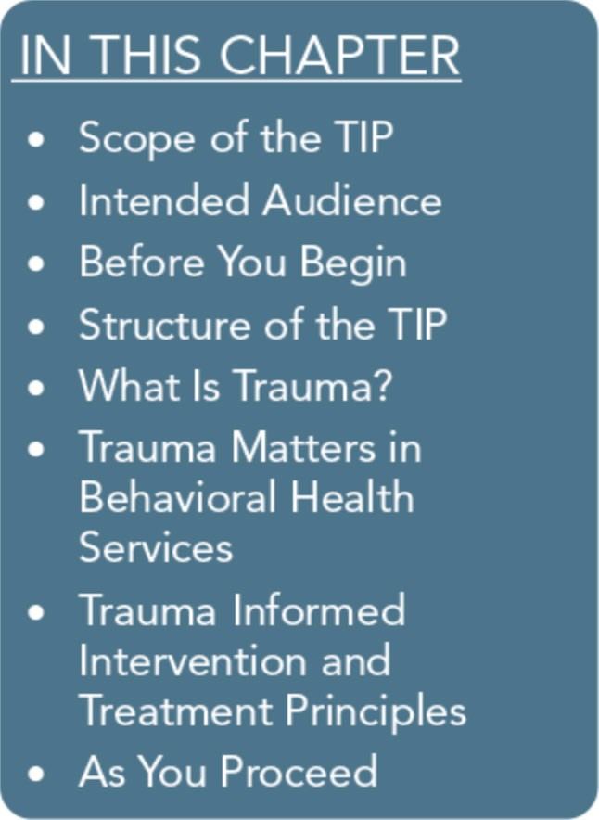
Many individuals who seek treatment in behavioral health settings have histories of trauma, but they often don't recognize the signifi­ cant effects of trauma in their lives; either they don't draw connec­ tions between their trauma histories and their presenting problems, or they avoid the topic altogether. Likewise, treatment providers may not ask questions that elicit a client's history of trauma, may feel unprepared to address trauma-related issues proactively, or may struggle to address traumatic stress effectively within the con­ straints of their treatment program, the program's clinical orienta­ tion, or their agency's directives.
By recognizing that traumatic experiences and their sequelae tie closely into behavioral health problems, front-line professionals and community-based programs can begin to build a trauma­ informed environment across the continuum of care. Key steps include meeting client needs in a safe, collaborative, and compas­ sionate manner; preventing treatment practices that retraumatize people with histories of trauma who are seeking help or receiving services; building on the strengths and resilience of clients in the context of their environments and communities; and endorsing trauma-informed principles in agencies through support, consulta­ tion, and supervision of staff.
This Treatment Improvement Protocol (TIP) begins by introducing the scope, purpose, and organization of the topic and describing its intended audience. Along with defining trauma and trauma­ informed care (TIC), the first chapter discusses the rationale for addressing trauma in behavioral health services and reviews trauma­ informed intervention and treatment principles. These principles serve as the TIP's conceptual framework.

3

Trauma-Informed Care in Behavioral Health Services

Scope of the TIP
Many individuals experience trauma during their lifetimes. Although many people exposed to trauma demonstrate few or no lingering symptoms, those individuals who have experi­ enced repeated, chronic, or multiple traumas are more likely to exhibit pronounced symp­ toms and consequences, including substance abuse, mental illness, and health problems.
Subsequently, trauma can significantly affect how an individual engages in major life areas as well as treatment.
This TIP provides evidence-based and best practice information for behavioral health service providers and administrators who want to work more effectively with people who have been exposed to acute and chronic traumas and/or are at risk of developing traumatic stress reactions. Using key trauma-informed principles, this TIP addresses trauma-related prevention, intervention, and treatment issues and strategies in behavioral health services.
The content is adaptable across behavioral health settings that service individuals, fami­ lies, and communities-placing emphasis on the importance of coordinating as well as inte­ grating services.

Intended Audience
This TIP is for behavioral health service pro­ viders, prevention specialists, and program administrators-the professionals directly re­ sponsible for providing care to trauma survi­ vors across behavioral health settings, including substance abuse and mental health services. This TIP also targets primary care professionals, including physicians; teams working with clients and communities who have experienced trauma; service providers in the criminal justice system; and researchers with an interest in this topic.

Before You Begin
This TIP endorses a trauma-informed model of care; this model emphasizes the need for behavioral health practitioners and organiza­ tions to recognize the prevalence and pervasive impact of trauma on the lives of the people they serve and develop trauma-sensitive or trauma-responsive services. This TIP provides key information to help behavioral health practitioners and program administrators be­ come trauma aware and informed, improve screening and assessment processes, and im­ plement science-informed intervention strate­ gies across settings and modalities in behavioral health services. Whether provided by an agency or an individual provider, trauma­ informed services may or may not include trauma-specific services or trauma specialists (individuals who have advanced training and education to provide specific treatment inter­ ventions to address traumatic stress reactions). Nonetheless, TIC anticipates the role that trauma can play across the continuum of care­ establishing integrated and/or collaborative processes to address the needs of traumatized individuals and communities proactively.
Individuals who have experienced trauma are at an elevated risk for substance use disorders, including abuse and dependence; mental health problems (e.g., depression and anxiety symptoms or disorders, impairment in rela­ tional/social and other major life areas, other distressing symptoms); and physical disorders and conditions, such as sleep disorders. This TIP focuses on specific types of prevention (Institute of Medicine et al., 2009): selective prevention, which targets people who are at risk for developing social, psychological, or other conditions as a result of trauma or who are at greater risk for experiencing trauma due to behavioral health disorders or conditions; and indicated prevention, which targets people who display early signs of trauma-related

4

Part 1, Chapter 1-T rauma-lnformed Care: A Sociocultural Perspective

symptoms. This TIP identifies interventions, including trauma-informed and trauma­ specific strategies, and perceives treatment as a means of prevention-building on resilience, developing safety and skills to negotiate the impact of trauma, and addressing mental and substance use disorders to enhance recovery.
This TIP's target population is adults. Beyond the context of family, this publication does not examine or address youth and adolescent responses to trauma, youth-tailored trauma­ informed strategies, or trauma-specific inter­ ventions for youth or adolescents, because the developmental and contextual issues of these populations require specialized interventions. Providers who work with young clients who have experienced trauma should refer to the resource list in Appendix B. This TIP covers TIC, trauma characteristics, the impact of traumatic experiences, assessment, and inter­ ventions for persons who have had traumatic experiences. Considering the vast knowledge base and specificity of individual, repeated, and chronic forms of trauma, this TIP does not provide a comprehensive overview of the unique characteristics of each type of trauma (e.g., sexual abuse, torture, war-related trauma, murder). Instead, this TIP provides an over­ view supported by examples. For more infor­ mation on several specific types of trauma, please refer to TIP 36, Substance Abuse Treatment for Persons With Child Abuse and Neglect Issues (Center for Substance Abuse Treatment [CSATJ, 20006), TIP 25,
Substance Abuse Treatment and Domestic
Violence (CSAT, 19976), TIP 51, Substance Abuse Treatment: Addressing the Specific Needs of Women (CSAT, 2009d), and the planned TIP, Reintegration-Related Behavioral Health Issues in Veterans and Military Families (Substance Abuse and Mental Health Services Administration [SAMHSAJ, planned f).

This TIP, Trauma-Informed Care in Behavioral Health Services, is guided by SAMHSA's Stra­ tegic Initiatives described in Leading Change: A Plan for SAMHSA's Roles and Actions 2011- 2014 (SAMHSA, 20116). Specific to Strate­ gic Initiative #2, Trauma and Justice, this TIP addresses several goals, objectives, and actions outlined in this initiative by providing behav­ ioral health practitioners, supervisors, and ad­ ministrators with an introduction to culturally responsive TIC.
Specifically, the TIP presents fundamental concepts that behavioral health service provid­ ers can use to:
- Become trauma aware and knowledgeable about the impact and consequences of traumatic experiences for individuals, fami­ lies, and communities.
- Evaluate and initiate use of appropriate trauma-related screening and assessment tools.
- Implement interventions from a collabora­ tive, strengths-based approach, appreciating the resilience of trauma survivors.
- Learn the core principles and practices that reflect TIC.
- Anticipate the need for specific trauma­ informed treatment planning strategies that support the individual's recovery.
- Decrease the inadvertent retraumatization that can occur from implementing standard organizational policies, procedures, and in­ terventions with individuals, including cli­ ents and staff, who have experienced trauma or are exposed to secondary trauma.
- Evaluate and build a trauma-informed or- ganization and workforce.
The consensus panelists, as well as other con­ tributors to this TIP, have all had experience as substance abuse and mental health counselors, prevention and peer specialists, supervisors, clinical directors, researchers, or administrators working with individuals, families, and

5

Trauma-Informed Care in Behavioral Health Services

communities who have experienced trauma. The material presented in this TIP uses the wealth of their experience in addition to the available published resources and research relevant to this topic. Throughout the consen­ sus process, the panel members were mindful of the strengths and resilience inherent in in­ dividuals, families, and communities affected by trauma and the challenges providers face in addressing trauma and implementing TIC.

Structure of the TlP
Using a TIC framework (Exhibit 1.1-1), this TIP provides information on key aspects of trauma, including what it is; its consequences; screening and assessment; effective

prevention, intervention, and treatment ap­ proaches; trauma recovery; the impact of trauma on service providers; programmatic and administrative practices; and trauma re­ sources.
Note: To produce a user-friendly but in­ formed document, the first two parts of the TIP include minimal citations. If you are in­ terested in the citations associated with topics covered in Parts 1 and 2, please consult the review of the literature provided in Part 3 (available online at http://store.samhsa.gov). Parts 1 and 2 are easily read and digested on their own, but it is highly recommended that you read the literature review as well.

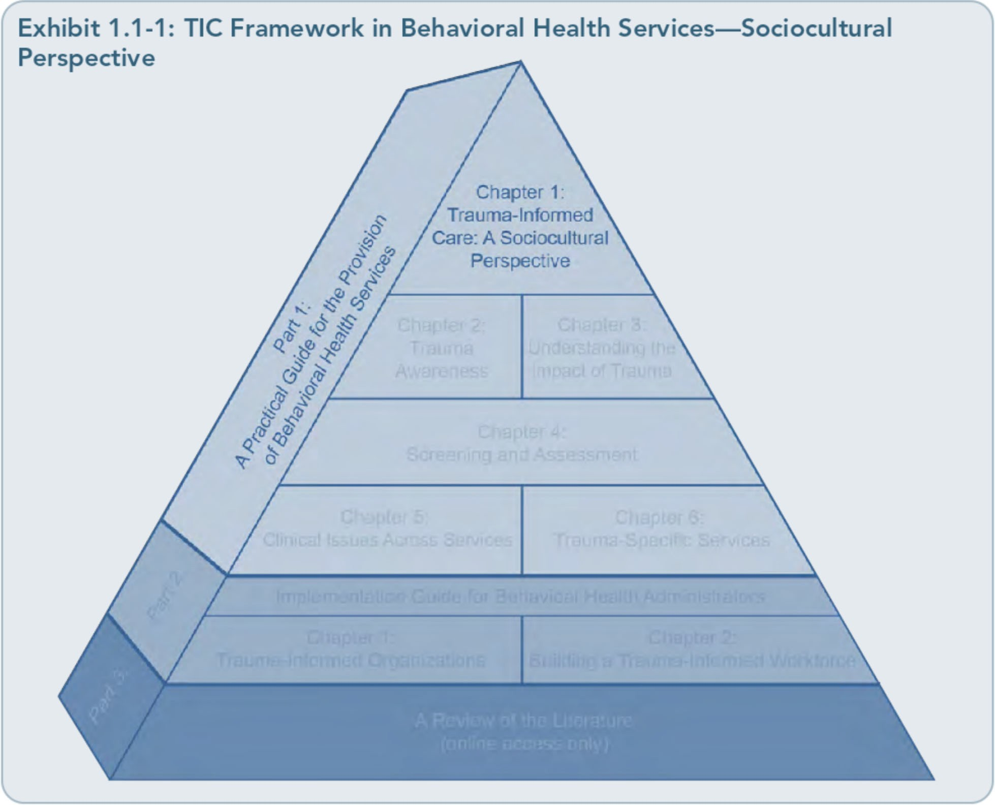

6

Part 1, Chapter 1-Trauma-lnformed Care: A Sociocultural Perspective

What Is Trauma?
According to SAMHSA's Trauma and Justice Strategic Initiative, "trauma results from an event, series of events, or set of circumstances that is experienced by an individual as physi­ cally or emotionally harmful or threatening and that has lasting adverse effects on the in­ dividual's functioning and physical, social, emotional, or spiritual well-being" (SAMHSA, 2012, p. 2). Trauma can affect people of every race, ethnicity, age, sexual ori­ entation, gender, psychosocial background, and geographic region. A traumatic experience can be a single event, a series of events, and/or a chronic condition (e.g., childhood neglect, domestic violence). Traumas can affect indi­ viduals, families, groups, communities, specific cultures, and generations. It generally over­ whelms an individual's or community's re­ sources to cope, and it often ignites the "fight, flight, or freeze" reaction at the time of the event(s).It frequently produces a sense of fear, vulnerability, and helplessness.
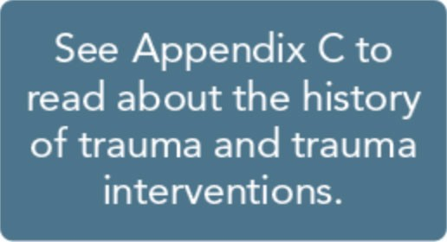
Often, traumatic events are unex­ pected. Individuals may experience the traumatic
event directly, witness an event, feel threat­ ened, or hear about an event that affects someone they know. Events may be human­ made, such as a mechanical error that causes a disaster, war, terrorism, sexual abuse, or vio­ lence, or they can be the products of nature (e.g., flooding, hurricanes, tornadoes). Trauma can occur at any age or developmental stage, and often, events that occur outside expected life stages are perceived as traumatic (e.g., a child dying before a parent, cancer as a teen, personal illness,job loss before retirement).
It is not just the event itself that determines whether something is traumatic, but also the

individual's experience of the event. Two peo­ ple may be exposed to the same event or series of events but experience and interpret these events in vastly different ways. Various biopsychosocial and cultural factors influence an individual's immediate response and long­ term reactions to trauma. For most, regardless of the severity of the trauma, the immediate or enduring effects of trauma are met with resili­ ence-the ability to rise above the circum­ stances or to meet the challenges with fortitude.
For some people, reactions to a traumatic event are temporary, whereas others have pro­ longed reactions that move from acute symp­ toms to more severe, prolonged, or enduring mental health consequences (e.g., posttrau­ matic stress and other anxiety disorders, sub­ stance use and mood disorders) and medical problems (e.g., arthritis, headaches, chronic pain). Others do not meet established criteria for posttraumatic stress or other mental disor­ ders but encounter significant trauma-related symptoms or culturally expressed symptoms of trauma (e.g., somatization, in which psycho­ logical stress is expressed through physical concerns). For that reason, even if an individu­ al does not meet diagnostic criteria for
trauma-related disorders, it is important to recognize that trauma may still affect his or her life in significant ways. For more infor­ mation on traumatic events, trauma character­ istics, traumatic stress reactions, and factors that heighten or decrease the impact of trau­ ma, see Part 1, Chapter 2, "Trauma Aware­ ness," and Part 1, Chapter 3, "Understanding the Impact ofTrauma."

Trauma Matters in Behavioral Health Services
The past decade has seen an increased focus on the ways in which trauma, psychological distress, quality oflife, health, mental illness,

7

Trauma-Informed Care in Behavioral Health Services

and substance abuse are linked. With the at­ tacks of September 11, 2001, and other acts of terror, the wars in Iraq and Afghanistan, disas­ trous hurricanes on the Gulf Coast, and sexual abuse scandals, trauma has moved to the fore­ front of national consciousness.
Trauma was once considered an abnormal experience. However, the first National Comorbidity Study established how prevalent traumas were in the lives of the general popu­ lation of the United States. In the study, 61 percent of men and 51 percent of women re­ ported experiencing at least one trauma in their lifetime, with witnessing a trauma, being involved in a natural disaster, and/or experi­ encing a life-threatening accident ranking as the most common events (Kessler et al., 1999). In Wave 2 of the National Epidemiologic Survey on Alcohol and Related Conditions,
71.6 percent of the sample reported witnessing trauma, 30.7 percent experienced a trauma that resulted in injury, and 17.3 percent expe­ rienced psychological trauma (El-Gabalawy, 2012). For a thorough review of the impact of trauma on quality of life and health and among individuals with mental and substance use disorders, refer to Part 3 of this TIP, the online literature review.

Rationale for TIC
Integrating TIC into behavioral health ser­ vices provides many benefits not only for cli­ ents, but also for their families and communities, for behavioral health service

organizations, and for staf£ Trauma-informed services bring to the forefront the belief that trauma can pervasively affect an individual's well-being, including physical and mental health. For behavioral health service providers, trauma-informed practice offers many oppor­ tunities. It reinforces the importance of ac­ quiring trauma-specific knowledge and skills to meet the specific needs of clients; of recog­ nizing that individuals may be affected by trauma regardless of its acknowledgment; of understanding that trauma likely affects many clients who are seeking behavioral health ser­ vices; and of acknowledging that organizations and providers can retraumatize clients through standard or unexamined policies and practices. TIC stresses the importance of addressing the client individually rather than applying gen­ eral treatment approaches.
TIC provides clients more opportunities to engage in services that reflect a compassionate perspective of their presenting problems. TIC can potentially provide a greater sense of safe­ ty for clients who have histories of trauma and a platform for preventing more serious conse­ quences of traumatic stress (Fallot & Harris, 2001). Although many individuals may not identify the need to connect with their histo­ ries, trauma-informed services offer clients a chance to explore the impact of trauma, their strengths and creative adaptations in manag­ ing traumatic histories, their resilience, and the relationships among trauma, substance use, and psychological symptoms.

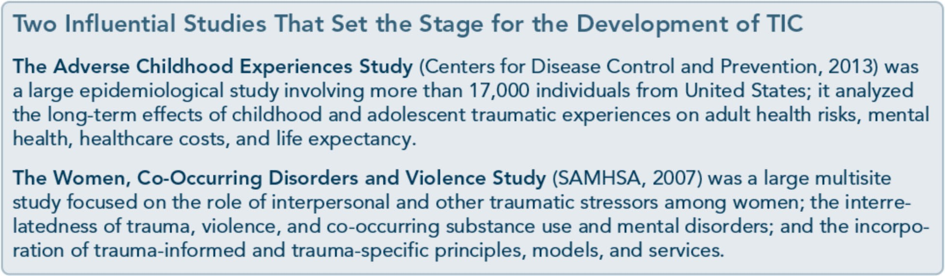

8

Part 1, Chapter 1-T rauma-lnformed Care: A Sociocultural Perspective

Implementing trauma-informed services can improve screening and assessment processes, treatment planning, and placement while also decreasing the risk for retraumatization. The implementation may enhance communication between the client and treatment provider, thus decreasing risks associated with misun­ derstanding the client's reactions and present­ ing problems or underestimating the need for appropriate referrals for evaluation or trauma­ specific treatment. Organizational investment in developing or improving trauma-informed services may also translate to cost effective­ ness, in that services are more appropriately matched to clients from the outset. TIC is an essential ingredient in organizational risk management; it ensures the implementation of decisions that will optimize therapeutic out­ comes and minimize adverse effects on the client and, ultimately, the organization. A key principle is the engagement of community, clients, and staff. Clients and staff are more
apt to be empowered, invested, and satisfied if they are involved in the ongoing development and delivery of trauma-informed services.

An organization also benefits from work de­ velopment practices through planning for, attracting, and retaining a diverse workforce of individuals who are knowledgeable about trauma and its impact. Developing a trauma­ informed organization involves hiring and promotional practices that attract and retain individuals who are educated and trained in trauma-informed practices on all levels of the organization, including board as well as peer support appointments. Trauma-informed or­ ganizations are invested in their staff and adopt similar trauma-informed principles, including establishing and providing ongoing support to promote TIC in practice and in addressing secondary trauma and implement­ ing processes that reinforce the safety of the staf£ Even though investing in a trauma­ informed workforce does not necessarily guar­ antee trauma-informed practices, it is more likely that services will evolve more profi­ ciently to meet client, staff, and community needs.

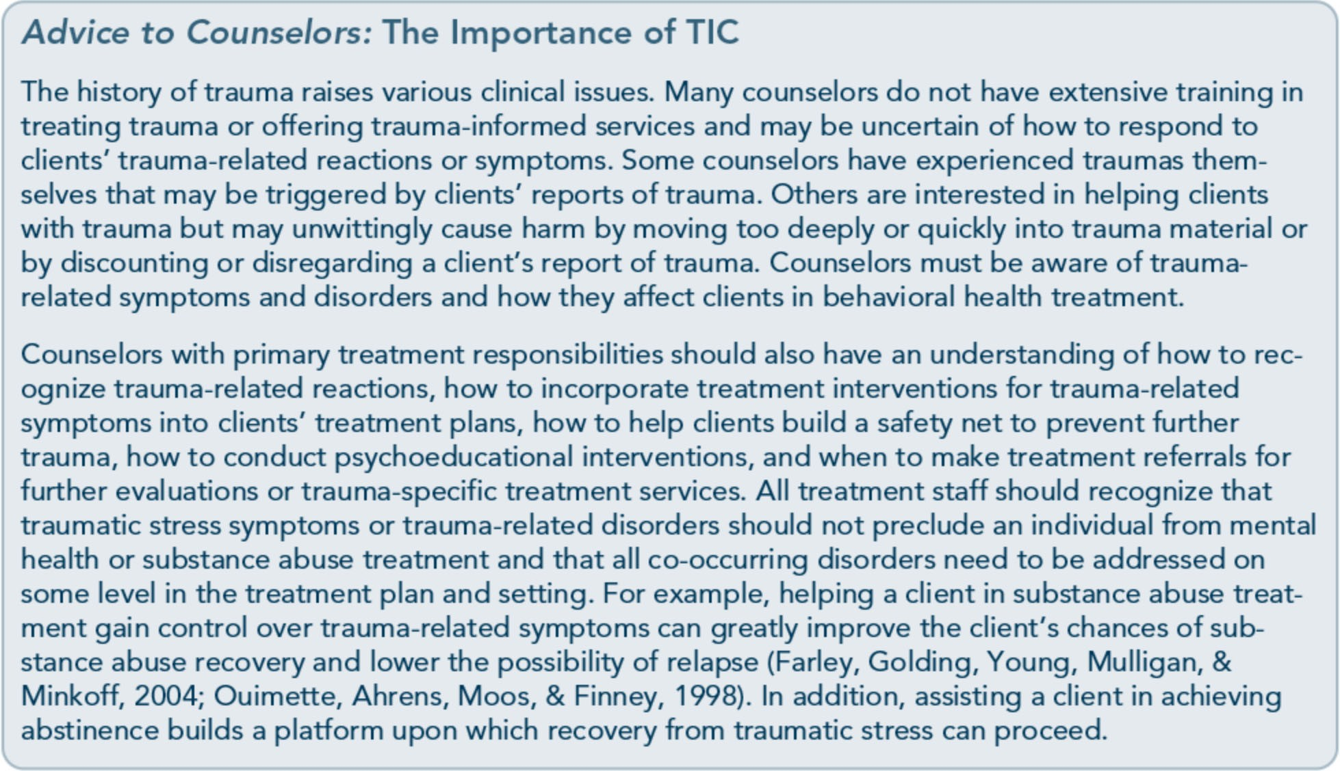

9

Trauma-Informed Care in Behavioral Health Services

Trauma and Substance Use Disorders
Many people who have substance use disor­ ders have experienced trauma as children or adults (Koenen, Stellman, Sommer, & Stellman, 2008; Ompad et al., 2005). Sub­ stance abuse is known to predispose people to higher rates of traumas, such as dangerous situations and accidents, while under the in­ fluence (Stewart & Conrod, 2003; Zinzow, Resnick, Amstadter, McCauley, Ruggiero, & Kilpatrick, 2010) and as a result of the lifestyle associated with substance abuse (Reynolds et al., 2005). In addition, people who abuse sub­ stances and have experienced trauma have worse treatment outcomes than those without histories of trauma (Driessen et al., 2008; Najavits et al., 2007). Thus, the process of re­ covery is more difficult, and the counselor's role is more challenging, when clients have histories of trauma. A person presenting with both trauma and substance abuse issues can have a variety of other difficult life problems that commonly accompany these disorders, such as other psychological symptoms or men­ tal disorders, poverty, homelessness, increased risk of HIV and other infections, and lack of social support (Mills, Teesson, Ross, & Peters, 2006; Najavits, Weiss, & Shaw, 1997). Many individuals who seek treatment for substance use disorders have histories of one or more traumas. More than half of women seeking substance abuse treatment report one or more lifetime traumas (Farley, Golding, Young, Mulligan, & Minkoff, 2004; Najavits et al., 1997), and a significant number of clients in inpatient treatment also have subclinical traumatic stress symptoms or posttraumatic stress disorder (PTSD; Falck, Wang, Siegal, &

Carlson, 2004; Grant et al., 2004; Reynolds et al., 2005).

Trauma and Mental Disorders People who are receiving treatment for severe mental disorders are more likely to have histo­ ries of trauma, including childhood physical and sexual abuse, serious accidents, homeless­ ness, involuntary psychiatric hospitalizations, drug overdoses, interpersonal violence, and other forms of violence. Many clients with severe mental disorders meet criteria for PTSD; others with serious mental illness who have histories of trauma present with psycho­ logical symptoms or mental disorders that are commonly associated with a history of trauma, including anxiety symptoms and disorders, mood disorders (e.g., major depression, dys­ thymia, bipolar disorder; Mueser et al., 2004), impulse control disorders, and substance use disorders (Kessler, Chiu, Demler, & Walters, 2005).
Traumatic stress increases the risk for mental illness, and findings suggest that traumatic stress increases the symptom severity of men­ tal illness (Spitzer, Vogel, Barnow, Freyberger & Grabe, 2007). These findings propose that traumatic stress plays a significant role in per­ petuating and exacerbating mental illness and suggest that trauma often precedes the devel­ opment of mental disorders. As with trauma and substance use disorders, there is a bidirec­ tional relationship; mental illness increases the risk of experiencing trauma, and trauma in­ creases the risk of developing psychological symptoms and mental disorders. For a more comprehensive review of the interactions among traumatic stress, mental illness, and substance use disorders, refer to Part 3 of this TIP, the online literature review.

10

Part 1, Chapter 1-T rauma-lnformed Care: A Sociocultural Perspective

Trauma-Informed Intervention and Treatment Principles
TIC is an intervention and organizational approach that focuses on how trauma may affect an individual's life and his or her re­ sponse to behavioral health services from pre­ vention through treatment. There are many definitions ofTIC and various models for incorporating it across organizations, but a "trauma-informed approach incorporates three key elements: (1) realizing the prevalence of trauma; (2) recognizing how trauma affects all individuals involved with the program, organi­ zation, or system, including its own workforce; and (3) responding by putting this knowledge into practice" (SAMHSA, 2012, p. 4).
TIC begins with the first contact a person has with an agency; it requires all staff members (e.g., receptionists, intake personnel, direct care staff, supervisors, administrators, peer supports, board members) to recognize that the individual's experience of trauma can greatly influence his or her receptivity to and engagement with services, interactions with staff and clients, and responsiveness to pro­ gram guidelines, practices, and interventions. TIC includes program policies, procedures, and practices to protect the vulnerabilities of those who have experienced trauma and those who provide trauma-related services. TIC is created through a supportive environment and by redesigning organizational practices, with

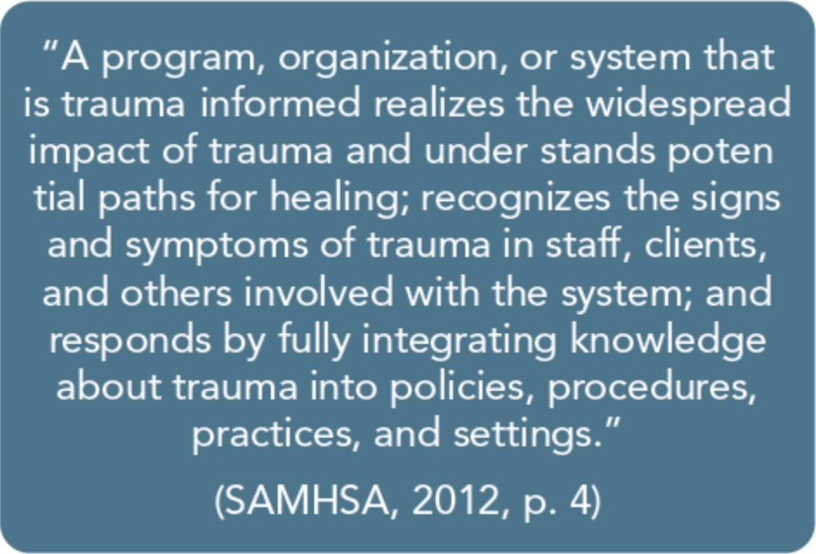
consumer participation, to prevent practices that could be retraumatizing (Harris & Fallot, 2001c; Hopper et al., 2010). The ethical prin­ ciple, "first, do no harm," resonates strongly in the application ofTIC.
TIC involves a commitment to building com­ petence among staff and establishing pro­ grammatic standards and clinical guidelines that support the delivery of trauma-sensitive services. It encompasses recruiting, hiring, and retaining competent staff; involving consum­ ers, trauma survivors, and peer support special­ ists in the planning, implementation, and evaluation of trauma-informed services; devel­ oping collaborations across service systems to streamline referral processes, thereby securing trauma-specific services when appropriate; and building a continuity ofTIC as consumers move from one system or service to the next. TIC involves reevaluating each service deliv­ ery component through a trauma-aware lens.
The principles described in the following sub­ sections serve as the TIP's conceptual

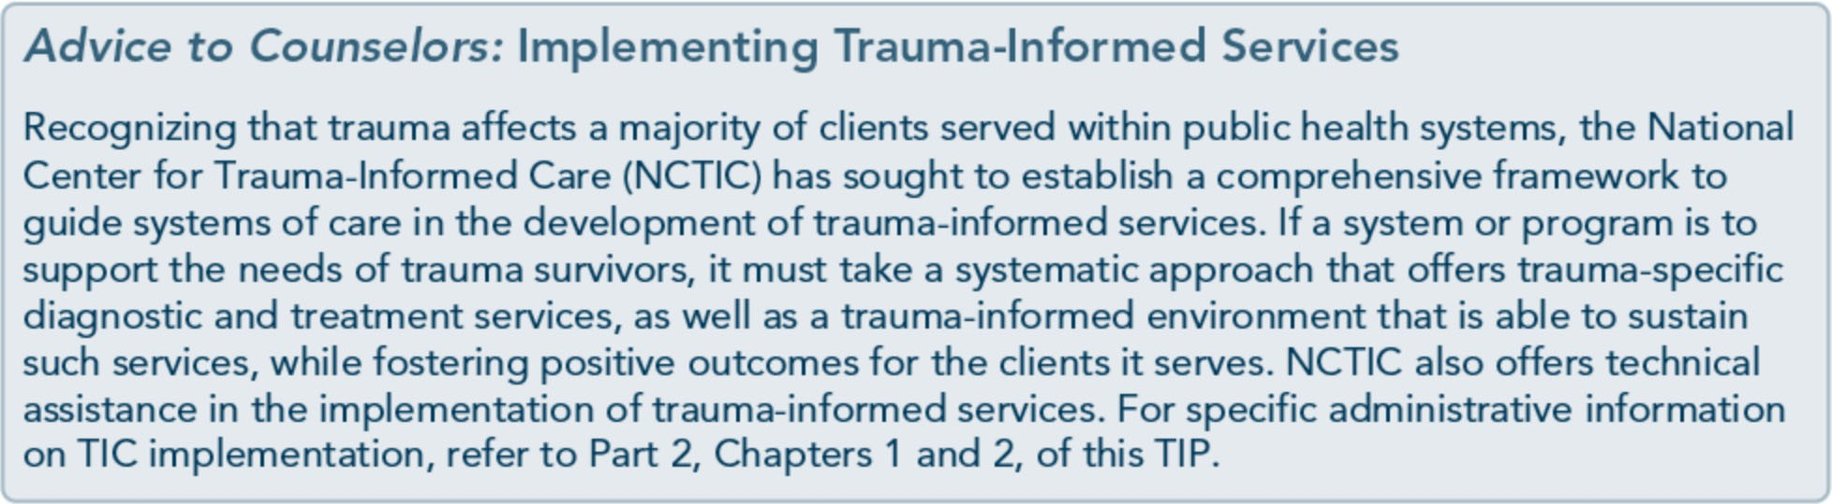

11

Trauma-Informed Care in Behavioral Health Services

framework. These principles comprise a com­ pilation of resources, including research, theo­ retical papers, commentaries, and lessons learned from treatment facilities. Key elements are outlined for each principle in providing services to clients affected by trauma and to populations most likely to incur trauma.
Although these principles are useful across all prevention and intervention services, settings, and populations, they are of the utmost im­ portance in working with people who have had traumatic experiences.

Promote Trauma Awareness and Understanding
Foremost, a behavioral health service provider must recognize the prevalence of trauma and its possible role in an individual's emotional, behavioral, cognitive, spiritual, and/or physical development, presentation, and well-being.
Being vigilant about the prevalence and po­ tential consequences of traumatic events among clients allows counselors to tailor their presentation styles, theoretical approaches, and intervention strategies from the outset to plan for and be responsive to clients' specific needs. Although not every client has a history of trauma, those who have substance use and mental disorders are more likely to have expe­ rienced trauma. Being trauma aware does not mean that you must assume everyone has a history of trauma, but rather that you antici­ pate the possibility from your initial contact and interactions, intake processes, and screen­ ing and assessment procedures.
Even the most standard behavioral health practices can retraumatize an individual ex-
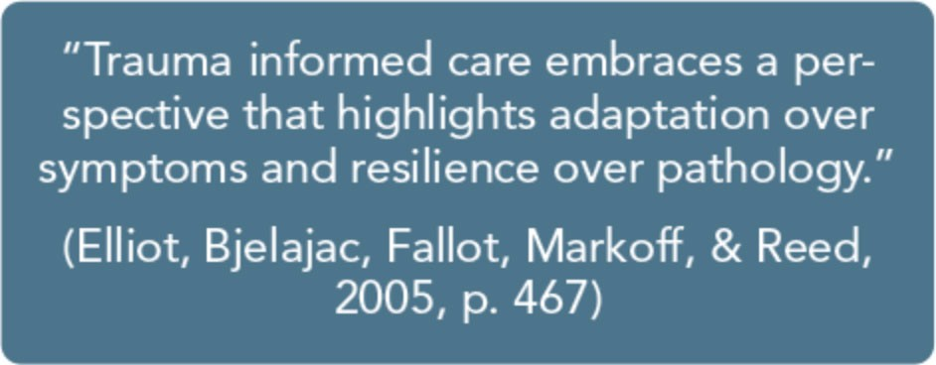

12

posed to prior traumatic experiences if the provider implements them without recogniz­ ing or considering that they may do harm. For example, a counselor might develop a treat­ ment plan recommending that a female cli­ ent-who has been court mandated to substance abuse treatment and was raped as an adult-attend group therapy, but without con­ sidering the implications, for her, of the fact that the only available group at the facility is all male and has had a low historical rate of female participation.Trauma awareness is an essential strategy for preventing this type of retraumatization; it reinforces the need for providers to reevaluate their usual practices.
Becoming trauma aware does not stop with the recognition that trauma can affect clients; instead, it encompasses a broader awareness that traumatic experiences as well as the im­ pact of an individual's trauma can extend to significant others, family members, first re­ sponders and other medical professionals, be­ havioral health workers, broader social networks, and even entire communities. Fami­ ly members frequently experience the trau­ matic stress reactions of the individual family member who was traumatized (e.g., angry outbursts, nightmares, avoidant behavior, other symptoms of anxiety, overreactions or underre­ actions to stressful events). These repetitive experiences can increase the risk of secondary trauma and symptoms of mental illness among the family, heighten the risk for externalizing and internalizing behavior among children (e.g., bullying others, problems in social rela­ tionships, health-damaging behaviors), in­ crease children's risk for developing posttraumatic stress later in life, and lead to a greater propensity for traumatic stress reac­ tions across generations of the family. Hence, prevention and intervention services can pro­ vide education and age-appropriate program­ ming tailored to develop coping skills and support systems.

Part 1, Chapter 1-T rauma-lnformed Care: A Sociocultural Perspective

So too, behavioral health service providers can be influenced by exposure to trauma-related affect and content when working with clients. A trauma-aware workplace supports supervi­ sion and program practices that educate all direct service staff members on secondary trauma, encourages the processing of trauma­ related content through participation in peer­ supported activities and clinical supervision, and provides them with professional develop­ ment opportunities to learn about and engage in effective coping strategies that help prevent secondary trauma or trauma-related symp­ toms. It is important to generate trauma awareness in agencies through education across services and among all staff members who have any direct or indirect contact with clients (including receptionists or intake and admission personnel who engage clients for the first time within the agency). Agencies can maintain a trauma-aware environment through ongoing staff training, continued su­ pervisory and administrative support, collabo­ rative (i.e., involving consumer participation) trauma-responsive program design and im­ plementation, and organizational policies and practices that reflect accommodation and flex­ ibility in attending to the needs of clients af­ fected by trauma.

Recognize That Trauma-Related Symptoms and Behaviors Originate From Adapting to Traumatic Experiences
A trauma-informed perspective views trauma­ related symptoms and behaviors as an individ­ ual's best and most resilient attempt to man­ age, cope with, and rise above his or her experience of trauma. Some individuals' means of adapting and coping have produced little difficulty; the coping and adaptive strategies of others have worked in the past but are not working as well now. Some people have diffi-

culties in one area oflife but have effectively negotiated and functioned in other areas.
Individuals who have survived trauma vary widely in how they experience and express traumatic stress reactions. Traumatic stress reactions vary in severity; they are often meas­ ured by the level of impairment or distress that clients report and are determined by the mul­ tiple factors that characterize the trauma itself individual history and characteristics, devel- opmental factors, sociocultural attributes, and available resources. The characteristics of the trauma and the subsequent traumatic stress reactions can dramatically influence how indi­ viduals respond to the environment, relation­ ships, interventions, and treatment services
'
'
and those same characteristics can also shape the assumptions that clients/consumers make about their world (e.g., their view of others, sense of safety), their future (e.g., hopefulness, fear of a foreshortened future), and themselves (e.g., feeling resilient, feeling incompetent in regulating emotions). The breadth of these effects may be observable or subtle.
Once you become aware of the significance of traumatic experiences in clients' lives and begin to view their presentation as adaptive, your identification and classification of their presenting symptoms and behaviors can shift from a "pathology" mindset (i.e., defining cli­ ents strictly from a diagnostic label, implying that something is wrong with them) to one of resilience-a mindset that views clients' pre­ senting difficulties, behaviors, and emotions as responses to surviving trauma. In essence, you will come to view traumatic stress reactions as normal reactions to abnormal situations. In embracing the belief that trauma-related reac­ tions are adaptive, you can begin relationships with clients from a hopeful, strengths-based stance that builds upon the belief that their responses to traumatic experiences reflect
creativity, self-preservation, and determination.

13

Trauma-Informed Care in Behavioral Health Services

This will help build mutual and collaborative therapeutic relationships, help clients identify what has worked and has not worked in their attempts to deal with the aftermath of trauma from a nonjudgmental stance, and develop intervention and coping strategies that are more likely to fit their strengths and resources. This view of trauma prevents further retrau­ matization by not defining traumatic stress reactions as pathological or as symptoms of pathology.

View Trauma in the Context of Individuals' Environments
Many factors contribute to a person's response to trauma, whether it is an individual, group, or community-based trauma. Individual at­ tributes, developmental factors (including pro­ tective and risk factors), life history, type of trauma, specific characteristics of the trauma, amount and length of trauma exposure, cultur­ al meaning of traumatic events, number of losses associated with the trauma, available resources (internal and external, such as coping skills and family support), and community reactions are a few of the determinants that influence a person's responses to trauma across time. Refer to the "View Trauma Through a Sociocultural Lens" section later in this chap­ ter for more specific information highlighting the importance of culture in understanding and treating the effects of trauma.
Trauma cannot be viewed narrowly; instead, it needs to be seen through a broader lens-a contextual lens integrating biopsychosocial, interpersonal, community, and societal (the degree of individualistic or collective cultural values) characteristics that are evident preced­ ing and during the trauma, in the immediate and sustained response to the event(s), and in the short- and long-term effects of the trau­ matic event(s), which may include housing availability, community response, adherence to

or maintenance of family routines and struc­ ture, and level of family support.
To more adequately understand trauma, you must also consider the contexts in which it occurred. Understanding trauma from this angle helps expand the focus beyond individu­ al characteristics and effects to a broader sys­ temic perspective that acknowledges the influences of social interactions, communities, governments, cultures, and so forth, while also examining the possible interactions among those various influences. Bronfenbrenner's (1979) and Bronfenbrenner and Ceci's (1994) work on ecological models sparked the devel­ opment of other contextual models. In recent years, the social-ecological framework has been adopted in understanding trauma, in implementing health promotion and other prevention strategies, and in developing treat­ ment interventions (Centers for Disease Con­ trol and Prevention, 2009). Here are the three main beliefs of a social-ecological approach (Stokols, 1996):
- Environmental factors greatly influence emotional, physical, and social well-being.
- A fundamental determinant of health ver­ sus illness is the degree of fit between indi­ viduals' biological, behavioral, and sociocultural needs and the resources avail­ able to them.
- Prevention, intervention, and treatment approaches integrate a combination of strategies targeting individual, interperson­ al, and community systems.
This TIP uses a social-ecological model to explore trauma and its effects (Exhibit 1.1-2). The focus of this model is not only on nega­ tive attributes (risk factors) across each level, but also on positive ingredients (protective factors) that protect against or lessen the im­ pact of trauma. This model also guides the inclusion of certain targeted interventions in this text, including selective and indicated

14

Part 1, Chapter 1-T rauma-lnformed Care: A Sociocultural Perspective
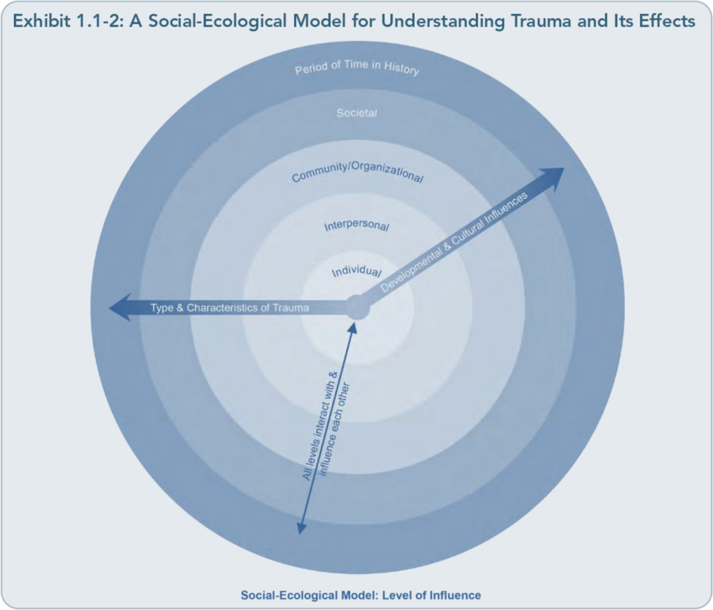

prevention activities. In addition, culture, de­ velopmental processes (including the devel­ opmental stage or characteristics of the individual and/or community), and the specific era when the trauma(s) occurred can signifi­ cantly influence how a trauma is perceived and processed, how an individual or community engages in help-seeking, and the degree of accessibility, acceptability, and availability of individual and community resources.
Depending on the developmental stage and/or processes in play, children, adolescents, and adults will perceive, interpret, and cope with traumatic experiences differently. For example, a child may view a news story depicting a traumatic event on television and believe that
the trauma is recurring every time they see the scene replayed. Similarly, the era in which one lives and the timing of the trauma can greatly influence an individual or community re­ sponse. Take, for example, a pregnant woman who is abusing drugs and is wary of receiving medical treatment after being beaten in a do­ mestic dispute. She may fear losing her chil­ dren or being arrested for child neglect. Even though a number of States have adopted poli­ cies focused on the importance of treatment for pregnant women who are abusing drugs and of the accessibility of prenatal care, other States have approached this issue from a crim­ inality standpoint (e.g., with child welfare and criminal laws) in the past few decades. Thus, the traumatic event's timing is a significant

15

Trauma-Informed Care in Behavioral Health Services

component in understanding the context of trauma and trauma-related responses.
The social-ecological model depicted in Ex­ hibit 1.1-2 provides a systemic framework for looking at individuals, families, and communi­ ties affected by trauma in general; it highlights the bidirectional influence that multiple con­ texts can have on the provision of behavioral health services to people who have experi­ enced trauma (see thin arrow). Each ring rep­ resents a different system (refer to Exhibit
1.1-3 for examples of specific factors within each system). The innermost ring represents the individual and his or her biopsychosocial characteristics. The "Interpersonal" circle em­ bodies all immediate relationships including family, friends, peers, and others. The "Com­ munity/Organizational"band represents social support networks, workplaces, neighborhoods, and institutions that directly influence the individual and his/her relationships.The "So­ cietal" circle signifies the largest system-State

and Federal policies and laws, such as eco­ nomic and healthcare policies, social norms, governmental systems, and political ideologies. The outermost ring, "Period of Time in His­ tory," reflects the significance of the period of time during which the event occurred; it influ­ ences each other level represented in the circle. For example, making a comparison of society's attitudes and responses to veterans' homecom­ ings across different wars and conflicts
through time shows that homecoming envi­ ronments can have either a protective or a negative effect on healing from the psycholog­ ical and physical wounds of war, depending on the era in question. The thicker arrows in the figure represent the key influences of culture, developmental characteristics, and the type and characteristics of the trauma. All told, the context of traumatic events can significantly influence both initial and sustained responses to trauma; treatment needs; selection of pre­ vention, intervention, and other treatment

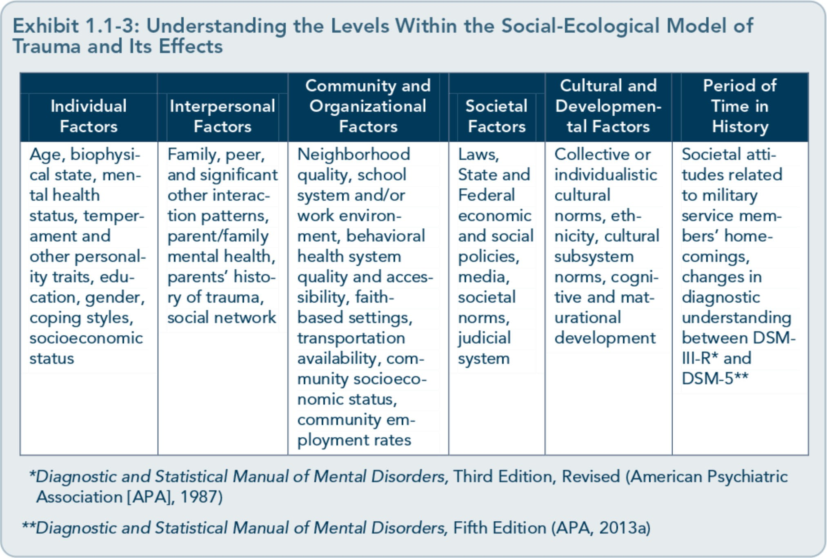

16

Part 1, Chapter 1-T rauma-lnformed Care: A Sociocultural Perspective

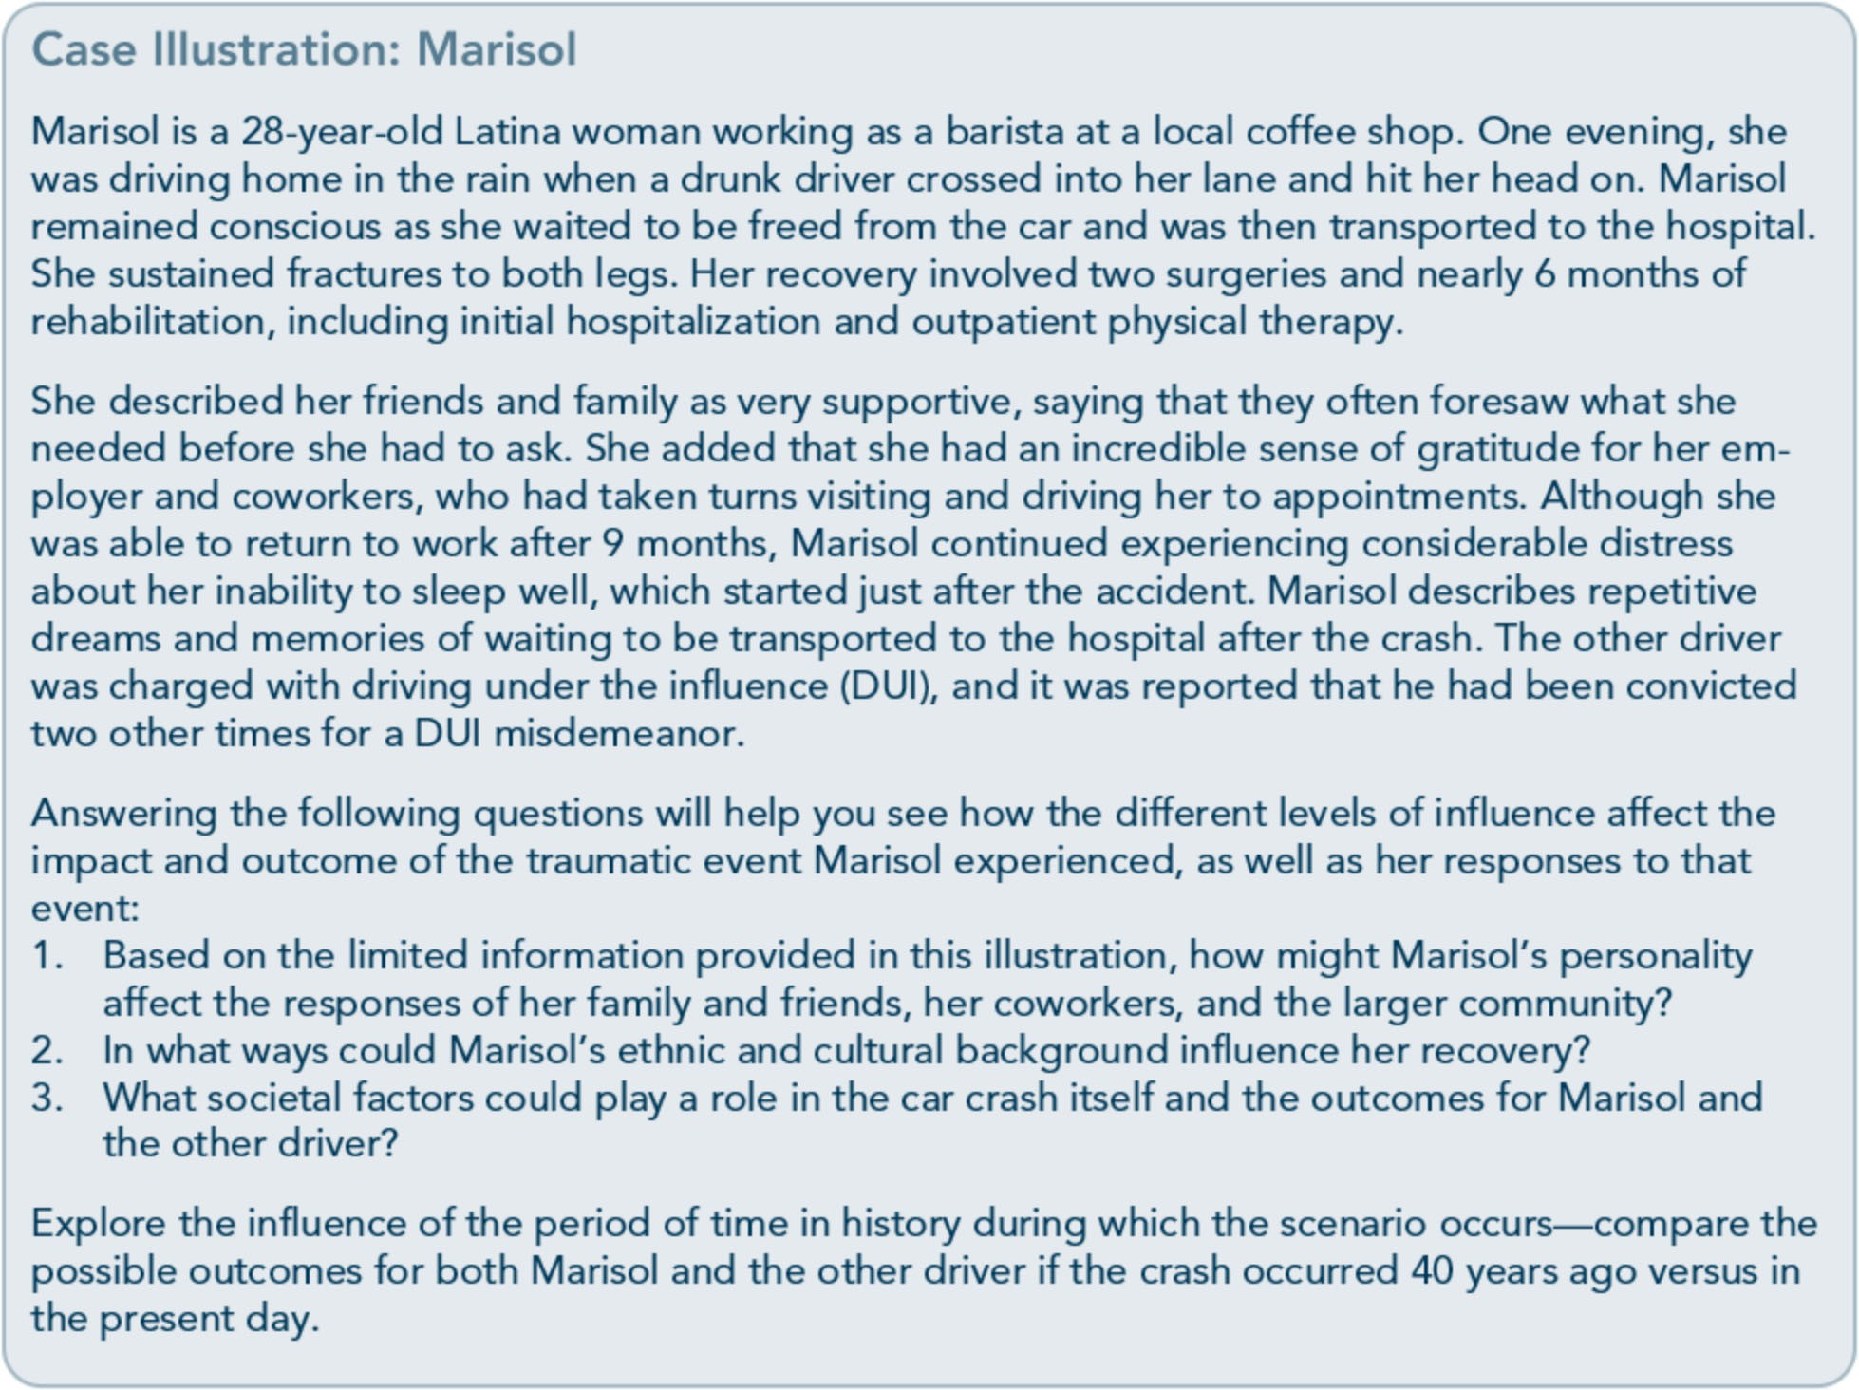

strategies; and ways of providing hope and promoting recovery.

Minimize the Risk of Retraumatization or Replicating Prior Trauma Dynamics
Trauma-informed treatment providers acknowledge that clients who have histories of trauma may be more likely to experience par­ ticular treatment procedures and practices as negative, reminiscent of specific characteristics of past trauma or abuse, or retraumatizing­ feeling as if the past trauma is reoccurring or as if the treatment experience is as dangerous and unsafe as past traumas. For instance, cli­ ents may express feelings of powerlessness or being trapped if they are not actively involved in treatment decisions; if treatment processes or providers mirror specific behavior from the
clients' past experiences with trauma, they may voice distress or respond in the same way as they did to the original trauma. Among the potentially retraumatizing elements of treat­ ment are seclusion or "time-out" practices that isolate individuals, mislabeling client symp­ toms as personality or other mental disorders rather than as traumatic stress reactions, in­ teractions that command authority, treatment assignments that could humiliate clients (such as asking a client to wear a sign in group that reflects one of their treatment issues, even if the assignment centers on positive attributes of the client), confronting clients as resistant, or presenting treatment as conditional upon conformity to the provider's beliefs and defini­ tions of issues.
Clients' experiences are unique to the specific traumas they have faced and the surrounding

17

Trauma-Informed Care in Behavioral Health Services

circumstances before, during, and after that trauma, so remember that even seemingly safe and standard treatment policies and proce­ dures, including physical plant operations (e.g., maintenance, grounds, fire and safety proce­ dures), may feel quite the contrary for a client if one or more of those elements is reminiscent of his or her experience of trauma in some way. Examples include having limited privacy or personal space, being interviewed in a room that feels too isolating or confining, undergo­ ing physical examination by a medical profes­ sional of the same sex as the client's previous perpetrator of abuse, attending a group session in which another client expresses anger appro­ priately in a role play, or being directed not to talk about distressing experiences as a means of deescalating traumatic stress reactions.
Although some treatment policies or proce­ dures are more obviously likely to solicit dis-

tress than others, all standard practices should be evaluated for their potential to retraumatize a client; this cannot be done without knowing the specific features of the individual's history of trauma. Consider, for instance, a treatment program that serves meals including entrees that combine more than one food group. Your client enters this program and refuses to eat most of the time; he expresses anger toward dietary staff and claims that food choices are limited. You may initially perceive your cli­ ent's refusal to eat or to avoid certain foods as an eating disorder or a behavioral problem.
However, a trauma-aware perspective might change your assumptions; consider that this client experienced neglect and abuse sur­ rounding food throughout childhood (his mother forced him to eat meals prepared by combining anything in the refrigerator and cooking them together).

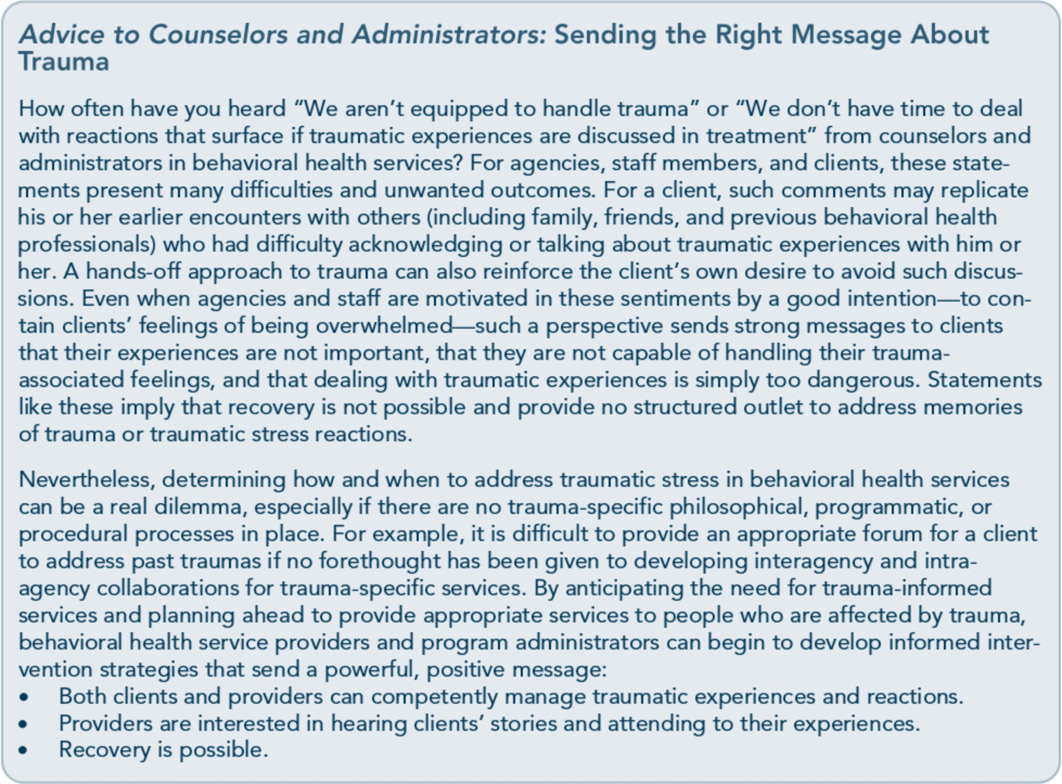

18

Part 1, Chapter 1-T rauma-lnformed Care: A Sociocultural Perspective

As a treatment provider, you cannot consist­ ently predict what may or may not be upset­ ting or retraumatizing to clients. Therefore, it is important to maintain vigilance and an atti­ tude of curiosity with clients, inquiring about the concerns that they express and/or present in treatment. Remember that certain behaviors or emotional expressions can reflect what has happened to them in the past.
Foremost, a trauma-informed approach begins with taking practical steps to reexamine treat­ ment strategies, program procedures, and or­ ganizational polices that could solicit distress or mirror common characteristics of traumatic experiences (loss of control, being trapped, or feeling disempowered).To better anticipate the interplay between various treatment ele­ ments and the more idiosyncratic aspects of a particular client's trauma history, you can:
  - Work with the client to learn the cues he or she associates with past trauma.
  - Obtain a good history.
  - Maintain a supportive, empathetic, and collaborative relationship.
  - Encourage ongoing dialog.
  - Provide a clear message of availability and accessibility throughout treatment.
In sum, trauma-informed providers anticipate and respond to potential practices that may be perceived or experienced as retraumatizing to clients; they are able to forge new ways to re­ spond to specific situations that trigger a trauma-related response, and they can provide clients with alternative ways of engaging in a particularly problematic element of treatment.

Create a Safe Environment
The need to create a safe environment is not new to providers; it involves an agency-wide effort supported by effective policies and pro­ cedures. However, creating safety within a trauma-informed framework far exceeds the standard expectations of physical plant safety (e.g., facility, environmental, and space-related concerns), security (of staff members, clients, and personal property), policies and proce­ dures (including those specific to seclusion and restraint), emergency management and disaster planning, and adherence to client rights. Providers must be responsive and adapt the environment to establish and support cli­ ents' sense of physical and emotional safety.
Beyond anticipating that various environ­ mental stimuli within a program may generate strong emotions and reactions in a trauma survivor (e.g., triggers such as lighting, access to exits, seating arrangements, emotionality within a group, or visual or auditory stimuli) and implementing strategies to help clients cope with triggers that evoke their experiences with trauma, other key elements in establish­ ing a safe environment include consistency in client interactions and treatment processes, following through with what has been re­ viewed or agreed upon in sessions or meetings, and dependability. Mike's case illustration de­ picts ways in which the absence of these key elements could erode a client's sense of safety during the treatment process.
Neither providers nor service processes are always perfect. Sometimes, providers

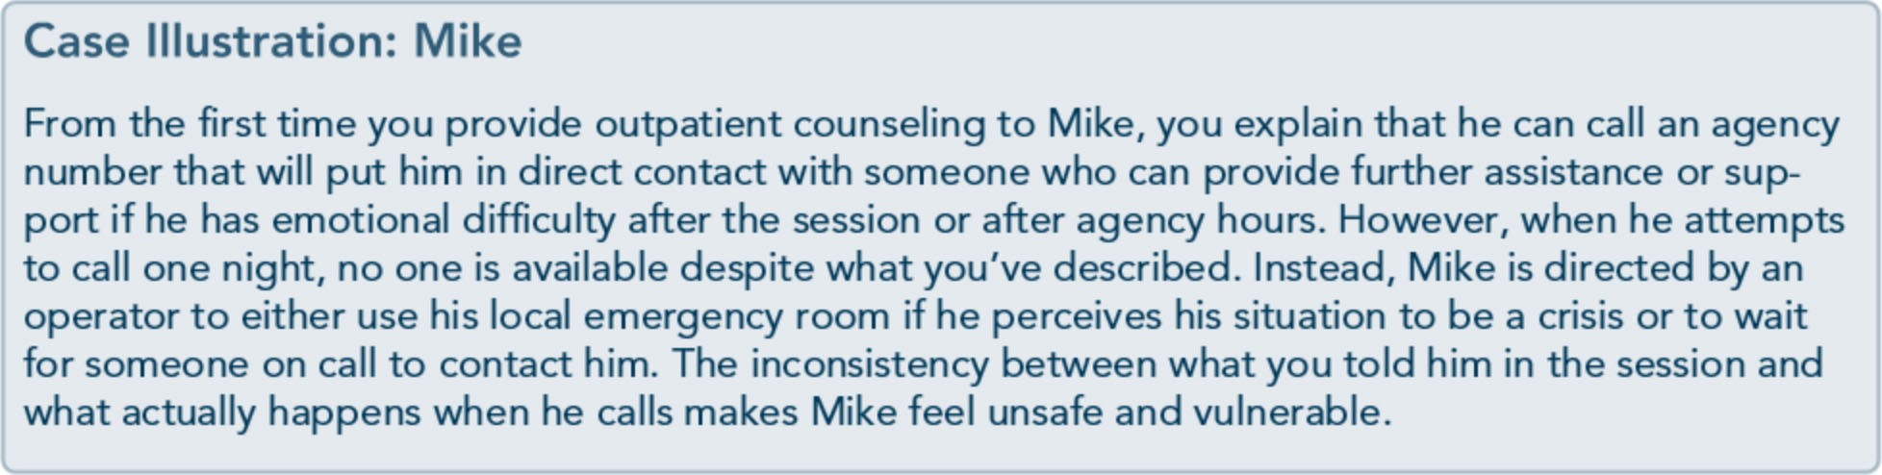

19

Trauma-Informed Care in Behavioral Health Services

unintentionally relay information inaccurately or inconsistently to clients or other staff mem­ bers; other times, clients mishear something, or extenuating circumstances prevent provid­ ers from responding as promised. Creating safety is not about getting it right all the time; it's about how consistently and forthrightly you handle situations with a client when cir­ cumstances provoke feelings of being vulnera­ ble or unsafe. Honest and compassionate communication that conveys a sense of han­ dling the situation together generates safety. It is equally important that safety extends be­ yond the client. Counselors and other behav­ ioral health staff members, including peer support specialists, need to be able to count on the agency to be responsive to and maintain their safety within the environment as well. By incorporating an organizational ethos that recognizes the importance of practices that promote physical safety and emotional well­ being, behavioral health staff members may be more likely to seek support and supervision when needed and to comply with clinical and programmatic practices that minimize risks
for themselves and their clients.
Beyond an attitudinal promotion of safety, organizational leaders need to consider and create avenues of professional development and assistance that will give their staff the means to seek support and process distressing circumstances or events that occur within the agency or among their clientele, such as case

consultation and supervision, formal or infor­ mal processes to debrief service providers about difficult clinical issues, and referral pro­ cesses for client psychological evaluations and employee assistance for staff. Organizational practices are only effective if supported by unswerving trauma awareness, training, and education among staff.Jane's case illustration shows the impact of a minor but necessary postponement in staff orientation for a new hire-not anunusual circumstance in behav­ ioral health programs that have heavy case­ loads and high staff turnover.

Identify Recovery From Trauma as a Primary Goal
Often, people who initiate or are receiving mental health or substance abuse services don't identify their experiences with trauma as a significant factor in their current challenges or problems. In part, this is because people who have been exposed to trauma, whether once or repeatedly, are generally reluctant to revisit it. They may already feel stuck in repetitive memories or experiences, which may add to their existing belief that any intervention will make matters worse or, at least, no better. For some clients, any introduction to their trauma­ related memories or minor cues reminiscent of the trauma will cause them to experience
strong, quick-to-surface emotions, supporting their belief that addressing trauma is danger­ ous and that they won't be able to handle the

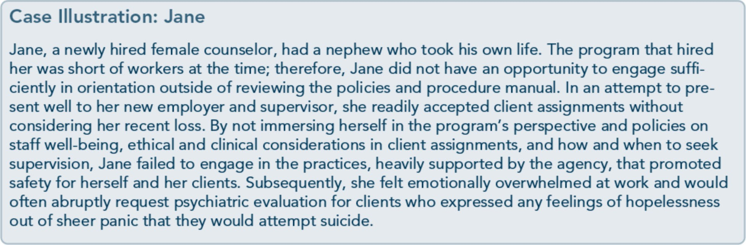

20

Part 1, Chapter 1-T rauma-lnformed Care: A Sociocultural Perspective

emotions or thoughts that result from at­ tempting to do so. Others readily view their experiences of trauma as being in the past; as a result, they engage in distraction, dissociation, and/or avoidance (as well as adaptation) due to a belief that trauma has little impact on their current lives and presenting problems. Even individuals who are quite aware of the impact that trauma has had on their lives may still struggle to translate or connect how these events continue to shape their choices, behav­ iors, and emotions. Many survivors draw no connection between trauma and their mental health or substance abuse problems, which makes it more difficult for them to see the value of trauma-informed or trauma-specific interventions, such as creating safety, engaging in psychoeducation, enhancing coping skills, and so forth.
As a trauma-informed provider, it is important that you help clients bridge the gap between their mental health and substance-related is­ sues and the traumatic experiences they may have had. All too often, trauma occurs before substance use and mental disorders develop; then, such disorders and their associated symptoms and consequences create opportuni­ ties for additional traumatic events to occur. If individuals engage in mental health and sub­ stance abuse treatment without addressing the role that trauma has played in their lives, they are less likely to experience recovery in the long run. For example, a person with a history of trauma is more likely to have anxiety and depressive symptoms, use substances to self­ medicate, and/or relapse after exposure to trauma-related cues. Thus, collaboration with­ in and between behavioral health agencies is necessary to make integrated, timely, trauma­ specific interventions available from the be­ ginning to clients/consumers who engage in substance abuse and mental health services.

Support Control, Choice, and Autonomy
Not every client who has experienced trauma and is engaged in behavioral health services wants, or sees the need for, trauma-informed or trauma-specific treatment. Clients may think that they've already dealt with their trauma adequately, or they may believe that the effects of past trauma cause minimal dis­ tress for them. Other clients may voice the same sentiments, but without conviction­ instead using avoidant behavior to deter dis­ tressing symptoms or reactions. Still others may struggle to see the role of trauma in their presenting challenges, not connecting their past traumatic experiences with other, more current difficulties (e.g., using substances to self-medicate strong emotions). Simply the idea of acknowledging trauma-related experi­ ences and/or stress reactions may be too frightening or overwhelming for some clients, and others may fear that their reactions will be dismissed. On the other hand, some individu­ als want so much to dispense with their trau­ matic experiences and reactions that they hurriedly and repeatedly disclose their experi­ ences before establishing a sufficiently safe environment or learning effective coping strat­ egies to offset distress and other effects of re­ traumatization.
As these examples show, not everyone affected by trauma will approach trauma-informed services or recognize the impact of trauma in their lives in the same manner. This can be challenging to behavioral health service pro­ viders who are knowledgeable about the im­ pact of trauma and who perceive the importance of addressing trauma and its ef­ fects with clients. As with knowing that dif­ ferent clients may be at different levels of awareness or stages of change in substance abuse treatment services, you should acknowledge that people affected by trauma

21

Trauma-Informed Care in Behavioral Health Services

present an array of reactions, various levels of trauma awareness, and different degrees of urgency in their need to address trauma.
Appreciating clients' perception of their pre­ senting problems and viewing their responses to the impact of trauma as adaptive-even when you believe their methods of dealing with trauma to be detrimental-are equally important elements of TIC. By taking the time to engage with clients and understand the ways they have perceived, adjusted to, and responded to traumatic experiences, providers are more likely to project the message that clients possess valuable personal expertise and knowledge about their own presenting prob­ lems. This shifts the viewpoint from "Provid­ ers know best" to the more collaborative "Together, we can find solutions."
How often have you heard from clients that they don't believe they can handle symptoms that emerge from reexperiencing traumatic cues or memories? Have you ever heard clients state that they can't trust themselves or their reactions, or that they never know when they are going to be triggered or how they are go­ ing to react? How confident would you feel about yourself if, at any time, a loud noise could initiate an immediate attempt to hide, duck, or dive behind something? Traumatic experiences have traditionally been described as exposure to events that cause intense fear, helplessness, horror, or feelings of loss of con­ trol. Participation in behavioral health services should not mirror these aspects of traumatic experience. Working collaboratively to facili­ tate clients' sense of control and to maximize clients' autonomy and choices throughout the treatment process, including treatment plan­ ning, is crucial in trauma-informed services.
For some individuals, gaining a sense of con­ trol and empowerment, along with under­ standing traumatic stress reactions, may be pivotal ingredients for recovery. By creating

opportunities for empowerment, counselors and other behavioral health service providers help reinforce, clients' sense of competence, which is often eroded by trauma and pro­ longed traumatic stress reactions. Keep in mind that treatment strategies and procedures that prioritize client choice and control need not focus solely on major life decisions or treatment planning; you can apply such ap­ proaches to common tasks and everyday inter­ actions between staff and consumers. Try asking your clients some of the following questions (which are only a sample of the types of questions that could be useful):
- What information would be helpful for us to know about what happened to you?
- Where/when would you like us to call you?
- How would you like to be addressed?
- Of the services I've described, which seem to match your present concerns and needs?
- From your experience, what responses from others appear to work best when you feel overwhelmed by your emotions?
Likewise, organizations need to reinforce the importance of staff autonomy, choice, and sense of control. What resources can staff members access, and what choices are availa­ ble to them, in processing emotionally charged content or events in treatment? How often do administrators and supervisors seek out feed­ back on how to handle problematic situations (e.g., staff rotations for vacations, case consul­ tations, changes in scheduling)? Think about the parallel between administration and staff members versus staff members and clients; often, the same philosophy, attitudes, and behaviors conveyed to staff members by ad­ ministrative practices are mirrored in staff­ client interactions. Simply stated, if staff members do not feel empowered, it will be a challenge for them to value the need for client empowerment. (For more information on administrative and workforce development issues, refer to Part 2, Chapters 1 and 2.)

22

Part 1, Chapter 1-T rauma-lnformed Care: A Sociocultural Perspective

Case Illustration: Mina
Mina initially sought counseling after her husband was admitted to an intensive outpatient drug and alcohol program. She was self-referred for low-grade depression, resentment toward her spouse, and codependency. When asked to define "codependency" and how the term applied to her, she responded that she always felt guilty and responsible for everyone in her family and for events that occurred even when she had little or no control over them.
After the intake and screening process, she expressed interest in attending group sessions that fo­ cused primarily on family issues and substance abuse, wherein her presenting concerns could be explored. In addition to describing dynamics and issues relating to substance abuse and its impact on her marriage, she referred to her low mood as frozen grief. During treatment, she reluctantly began to talk about an event that she described as life changing: the loss of her father. The story began to unfold in group; her father, who had been 62 years old, was driving her to visit a cousin. During the ride, he had a heart attack and drove off the road. As the car came to stop in a field, she remembered calling 911 and beginning cardiopulmonary resuscitation while waiting for the ambu­ lance. She rode with the paramedics to the hospital, watching them work to save her father's life; however, he was pronounced dead soon after arrival.
She always felt that she never really said goodbye to her father. In group, she was asked what she would need to do or say to feel as if she had revisited that opportunity. She responded in quite a unique way, saying, "I can't really answer this question; the lighting isn't right for me to talk about my dad." The counselor encouraged her to adjust the lighting so that it felt "right" to her. Being invited to do so turned out to be pivotal in her ability to address her loss and to say goodbye to her father on her terms. She spent nearly 10 minutes moving the dimmer switch for the lighting as oth­ ers in the group patiently waited for her to return to her chair. She then began to talk about what happened during the evening of her father's death, their relationship, the events leading up to that evening, what she had wanted to say to him at the hospital, and the things that she had been want­ ing to share with him since his death.
Weeks later, as the group was coming to a close, each member spoke about the most important experiences, tools, and insights that he or she had taken from participating. Mina disclosed that the group helped her establish boundaries and coping strategies within her marriage, but said that the event that made the most difference for her had been having the ability to adjust the lighting in the room. She explained that this had allowed her to control something over which she had been pow­ erless during her father's death. To her, the lighting had seemed to stand out more than other de­ tails at the scene of the accident, during the ambulance ride, and at the hospital. She felt that the personal experience of losing her father and needing to be with him in the emergency room was marred by the obtrusiveness of staff, procedures, machines, and especially, the harsh lighting. She reflected that she now saw the lighting as a representation of this tragic event and the lack of priva­ cy she had experienced when trying to say goodbye to her father. Mina stated that this moment in group had been the greatest gift: "...to be able to say my goodbyes the way I wanted ... I was given an opportunity to have some control over a tragic event where I couldn't control the outcome no ) matter how hard I tried."

Create Collaborative Relationships and Participation Opportunities
This trauma-informed principle encompasses three main tenets. First, ensure that the provider-client relationship is collaborative, regardless of setting or service. Agency staff
members cannot make decisions pertaining to interventions or involvement in community services autocratically; instead, they should develop trauma-informed, individualized care plans and/or treatment plans collaboratively with the client and, when appropriate, with family and caregivers. The nonauthoritarian approach that characterizes TIC views clients

23

Trauma-Informed Care in Behavioral Health Services

as the experts in their own lives and current struggles, thereby emphasizing that clients and providers can learn from each other.
The second tenet is to build collaboration beyond the provider-client relationship. Building ongoing relationships across the ser­ vice system, provider networks, and the local community enhances TIC continuity as cli­ ents move from one level of service to the next or when they are involved in multiple services at one time. It also allows you to learn about resources available to your clients in the ser­ vice system or community and to connect with providers who have more advanced training in trauma-specific interventions and services.
The third tenet emphasizes the need to en­ sure client/consumer representation and participation in behavioral health program development, planning, and evaluation as well as in the professional development of behavioral health workers. To achieve trau­ ma-informed competence in an organization or across systems, clients need to play an active role; this starts with providing program feed­ back. However, consumer involvement should not end there; rather, it should be encouraged throughout the implementation of trauma­ informed services. So too, clients, potential clients, their families, and the community should be invited to participate in forming any behavioral health organization's plans to im­ prove trauma-informed competence, provide TIC, and design relevant treatment services and organizational policies and procedures.
Trauma-informed principles and practices generated without the input of people affected by trauma are difficult to apply effectively.
Likewise, staff trainings and presentations should include individuals who have felt the impact of trauma. Their participation reaches past the purely cognitive aspects of such edu­ cation to offer a personal perspective on the strengths and resilience of people who have

experienced trauma. The involvement of trauma survivors in behavioral health educa­ tion lends a human face to subject matter that is all too easily made cerebral by some staff members in an attempt to avoid the emotion­ ality of the topic.
Consumer participation also means giving clients/consumers the chance to obtain State training and certification, as well as employ­ ment in behavioral health settings as peer spe­ cialists. Programs that incorporate peer support services reinforce a powerful mes­ sage-that provider-consumer partnership is important, and that consumers are valued.
Peer support specialists are self-identified in­ dividuals who have progressed in their own recovery from alcohol dependence, drug ad­ diction, and/or a mental disorder and work within behavioral health programs or at peer support centers to assist others with similar disorders and/or life experiences. Tasks and responsibilities may include leading a peer support group; modeling effective coping, help-seeking, and self-care strategies; helping clients practice new skills or monitor progress; promoting positive self-image to combat cli­ ents' potentially negative feelings about them­ selves and the discrimination they may perceive in the program or community; han­ dling case management tasks; advocating for program changes; and representing a voice of hope that views recovery as possible.

Familiarize the Client With Trauma-Informed Services Without thinking too much about it, you probably know the purpose of an intake pro­ cess, the correct way to complete a screening
device, the meaning of a lot of the jargon spe­ cific to behavioral health, and your program's expectations for client participation; in fact, maybe you're already involved in facilitating these processes in behavioral health services every day, and they've become almost

24

Part 1, Chapter 1-T rauma-lnformed Care: A Sociocultural Perspective

automatic for you. This can make it easy to forget that nearly everything clients and their families encounter in seeking behavioral health assistance is new to them. Thus, intro­ ducing clients to program services, activities, and interventions in a manner that expects them to be unfamiliar with these processes is essential, regardless of their clinical and treat­ ment history. Beyond addressing the unfamili­ arity of services, educating clients about each process-from first contact all the way through recovery services-gives them a chance to participate actively and make in­
formed decisions across the continuum of care.
Familiarizing clients with trauma-informed services extends beyond explaining program services or treatment processes; it involves explaining the value and type of trauma­ related questions that may be asked during an intake process, educating clients about trauma to help normalize traumatic stress reactions, and discussing trauma-specific interventions and other available services (including expla­ nations of treatment methodologies and of the rationale behind specific interventions). De­ velopmentally appropriate psychoeducation about trauma-informed services allows clients to be informed participants.

Incorporate Universal Routine Screenings for Trauma
Screening universally for client histories, expe­ riences, and symptoms of trauma at intake can benefit clients and providers. Most providers know that clients can be affected by trauma, but universal screening provides a steady re­ minder to be watchful for past traumatic expe­ riences and their potential influence upon a client's interactions and engagement with ser­ vices across the continuum of care. Screening should guide treatment planning; it alerts the staff to potential issues and serves as a valuable tool to increase clients' awareness of the possi-

ble impact of trauma and the importance of addressing related issues during treatment.
Nonetheless, screenings are only as useful as the guidelines and processes established to address positive screens (which occur when clients respond to screening questions in a way that signifies possible trauma-related symp­ toms or histories). Staff should be trained to use screening tools consistently so that all cli­ ents are screened in the same way. Staff mem­ bers also need to know how to score screenings and when specific variables (e.g., race/ethnicity, native language, gender, culture) may influence screening results. For example, a
woman who has been sexually assaulted by a
man may be wary of responding to questions if a male staff member or interpreter administers the screening or provides translation services. Likewise, a person in a current abusive or vio­ lent relationship may not acknowledge the interpersonal violence in fear of retaliation or as a result of disconnection or denial of his or her experience, and he or she may have diffi­ culty in processing and then living between two worlds-what is acknowledged in treat­ ment versus what is experienced at home.
In addition, staff training on using trauma­ related screening tools needs to center on how and when to gather relevant information after the screening is complete. Organizational pol­ icies and procedures should guide staff mem­ bers on how to respond to a positive screening, such as by making a referral for an indepth assessment of traumatic stress, providing the client with an introductory psychoeducational session on the typical biopsychosocial effects of trauma, and/or coordinating care so that the client gains access to trauma-specific services that meet his or her needs. Screening tool se­ lection is an important ingredient in incorpo­ rating routine, universal screening practices into behavioral health services. Many screen­ ing tools are available, yet they differ in format

25

Trauma-Informed Care in Behavioral Health Services

and in how they present questions. Select tools based not just on sound test properties, but also according to whether they encompass a broad range of experiences typically consid­ ered traumatic and are flexible enough to al­ low for an individual's own interpretation of traumatic events. For more information on screening and assessment of trauma and trau­ ma-related symptoms and effects, see Chapter 4, "Screening and Assessment," in this TIP.

View Trauma Through a Sociocultural Lens
To understand how trauma affects an individ­ ual, family, or community, you must first un­ derstand life experiences and cultural background as key contextual elements for

that trauma. As demonstrated in Exhibit 1.1- 2, many factors shape traumatic experiences and individual and community responses to it; one of the most significant factors is culture. It influences the interpretation and meaning of traumatic events, individual beliefs regarding personal responsibility for the trauma and subsequent responses, and the meaning and acceptability of symptoms, support, and help­ seeking behaviors. As this TIP proceeds to describe the differences among cultures per­ taining to trauma, remember that there are numerous cross-cutting factors that can direct­ ly or indirectly influence the attitudes, beliefs, behaviors, resources, and opportunities within a given culture, subculture, or racial and/or ethnic group (Exhibit 1.1-4). For an indepth

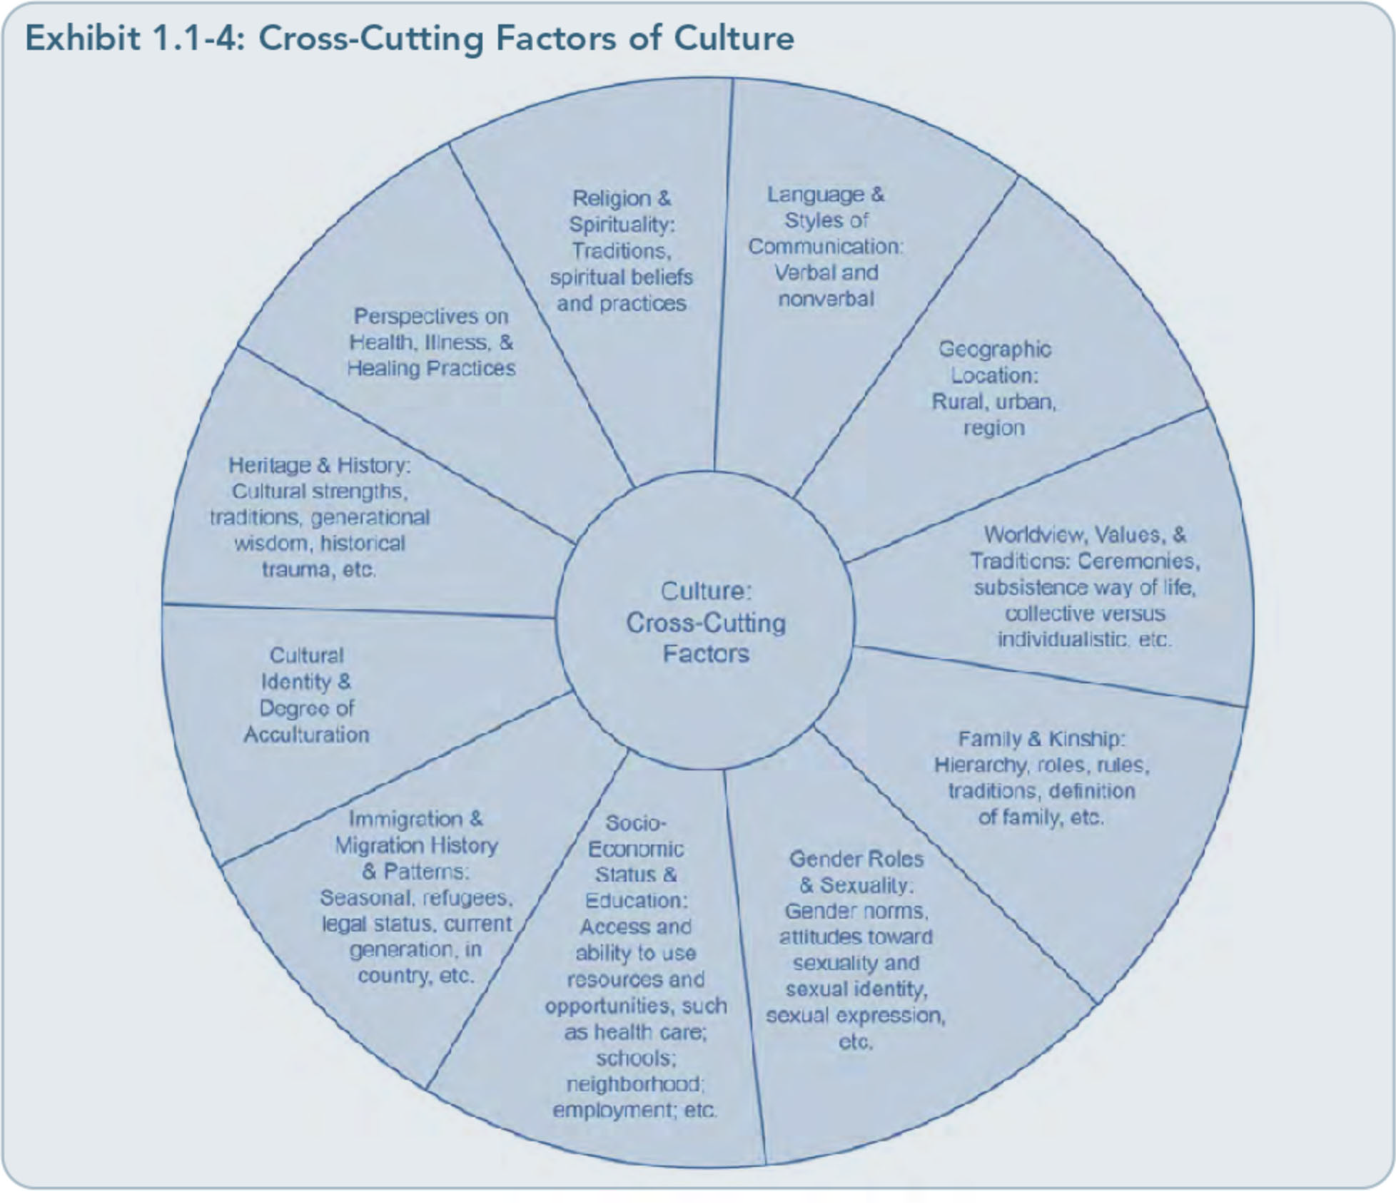

26

Part 1, Chapter 1-T rauma-lnformed Care: A Sociocultural Perspective

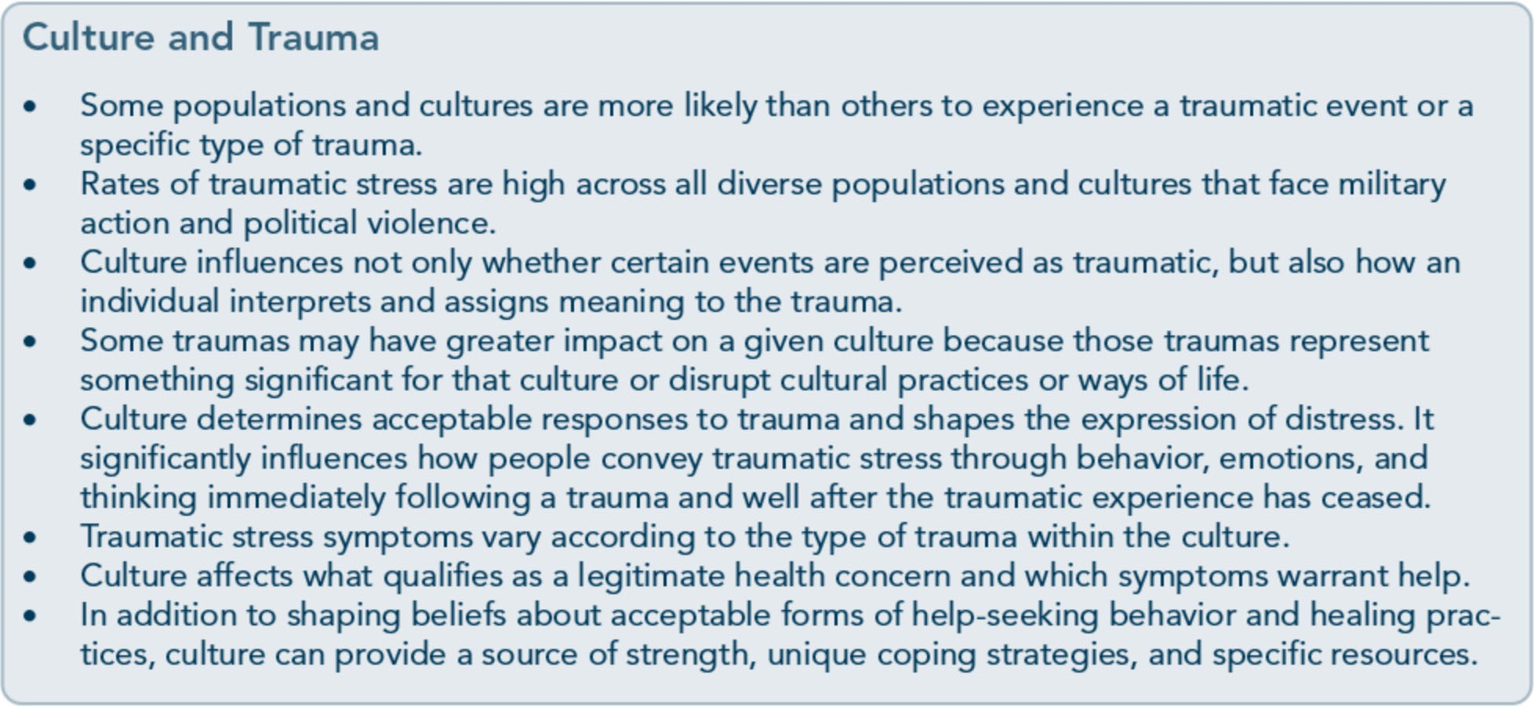

exploration of these cross-cutting cultural fac­ tors, refer to the planned TIP, Improving Cul­ tural Competence (SAMHSA, planned c).
When establishing TIC, it is vital that behav­ ioral health systems, service providers, licens­ ing agencies, and accrediting bodies build culturally responsive practices into their cur­ ricula, standards, policies and procedures, and credentialing processes. The implementation of culturally responsive practices will further guide the treatment planning process so that trauma-informed services are more appropri­ ate and likely to succeed.

Use a Strengths-Focused Perspective: Promote Resilience Fostering individual strengths is a key step in prevention when working with people who have been exposed to trauma. It is also an es­ sential intervention strategy-one that builds on the individual's existing resources and views him or her as a resourceful, resilient survivor.
Individuals who have experienced trauma de­ velop many strategies and/or behaviors to adapt to its emotional, cognitive, spiritual, and physical consequences. Some behaviors may be effective across time, whereas others may eventually produce difficulties and disrupt the
healing process. Traditionally, behavioral health services have tended to focus on pre­ senting problems, risk factors, and symptoms in an attempt to prevent negative outcomes, provide relief, increase clients' level of func­ tioning, and facilitate healing. However, focus­ ing too much on these areas can undermine clients' sense of competence and hope. Target­ ing only presenting problems and symptoms does not provide individuals with an oppor­ tunity to see their own resourcefulness in managing very stressful and difficult experi­ ences. It is important for providers to engage in interventions using a balanced approach that targets the strengths clients have
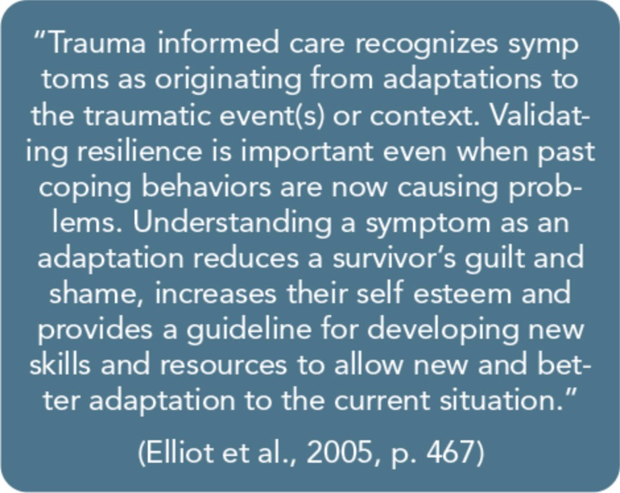

27

Trauma-Informed Care in Behavioral Health Services

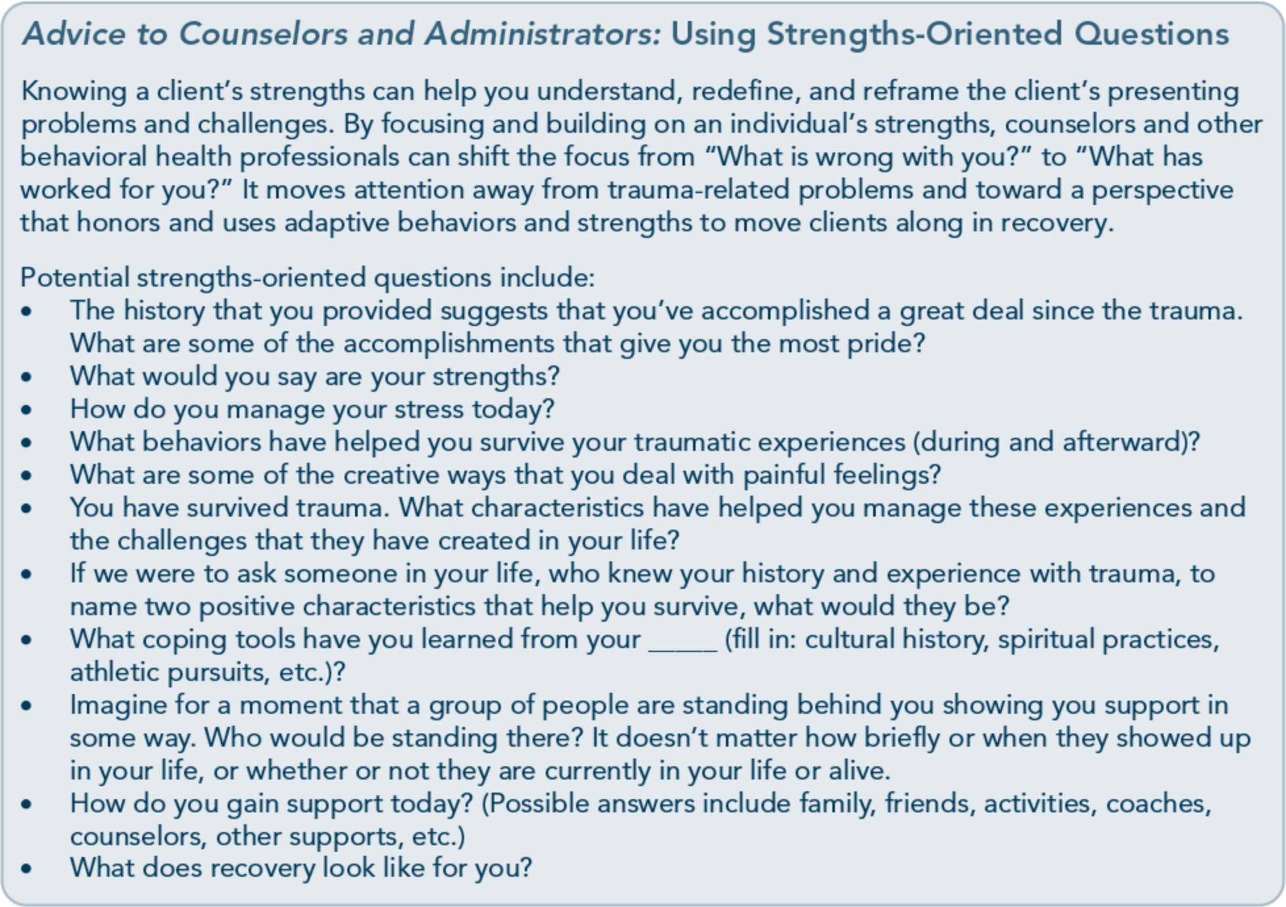

developed to survive their experiences and to thrive in recovery. A strengths-based, resilience-minded approach lets trauma survi­ vors begin to acknowledge and appreciate their fortitude and the behaviors that help them survive.

Foster Trauma-Resistant Skills Trauma-informed services build a foundation on which individuals can begin to explore the role of trauma in their lives; such services can also help determine how best to address and tailor interventions to meet their needs. Pre­ vention, mental health, and substance abuse treatment services should include teaching clients about how trauma can affect their lives; these services should also focus on developing self-care skills, coping strategies, supportive networks, and a sense of competence. Building trauma-resistant skills begins with normaliz­ ing the symptoms of traumatic stress and
helping clients who have experienced trauma connect the dots between current problems and past trauma when appropriate.
Nevertheless, TIC and trauma-specific inter­ ventions that focus on skill-building should not do so at the expense of acknowledging individual strengths, creativity in adapting to trauma, and inherent attributes and tools cli­ ents possesses to combat the effects of trauma. Some theoretical models that use skill­ building strategies base the value of this ap­ proach on a deficit perspective; they assume that some individuals lack the necessary tools to manage specific situations and, because of this deficiency, they encounter problems that others with effective skills would not experi­ ence. This type of perspective further assumes that, to recover, these individuals must learn new coping skills and behavior. TIC, on the other hand, makes the assumption that clients

28

Part 1, Chapter 1-T rauma-lnformed Care: A Sociocultural Perspective

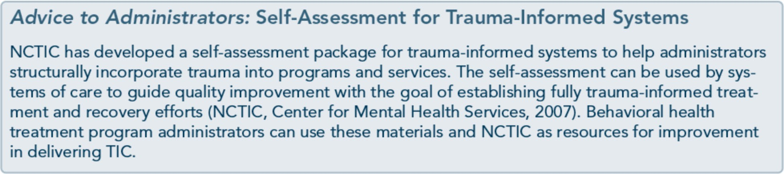

are the experts in their own lives and have learned to adapt and acquire skills to survive. The TIC approach honors each individual's adaptations and acquired skills, and it helps clients explore how these may not be working as well as they had in the past and how their current repertoire of responses may not be as effective as other strategies.

Demonstrate Organizational and Administrative Commitment to TIC
Becoming a trauma-informed organization requires administrative guidance and support across all levels of an agency. Behavioral health staff will not likely sustain TIC practices without the organization's ongoing commit­ ment to support professional development and to allocate resources that promote these prac­ tices. An agency that wishes to commit to TIC will benefit from an organizational assessment of how staff members identify and manage trauma and trauma-related reactions in their clients. Are they trauma aware-do they rec­ ognize that trauma can significantly affect a client's ability to function in one or more areas of his or her life? Do the staff members under­ stand that traumatic experiences and trauma­ related reactions can greatly influence clients' engagement, participation, and response to services?
Agencies need to embrace specific strategies across each level of the organization to create trauma-informed services; this begins with staff education on the impact of trauma among clients. Other agency strategies that
reflect a trauma-informed infrastructure in­ clude, but are not limited to:
- Universal screening and assessment proce-
dures for trauma.
- Interagency and intra-agency collaboration to secure trauma-specific services.
- Referral agreements and networks to match clients' needs.
- Mission and value statements endorsing the importance of trauma recognition.
- Consumer- and community-supported committees and trauma response teams.
- Workforce development strategies, includ­ ing hiring practices.
- Professional development plans, including staff training/supervision focused on TIC.
- Program policies and procedures that en- sure trauma recognition and secure trauma­
informed practices, trauma-specific services, and prevention of retraumatization.
TIC requires organizational commitment, and often, cultural change. For more information on implementing TIC in organizations, see Part 2, Chapter 1 of this TIP.

Develop Strategies To Address Secondary Trauma and Promote Self-Care
Secondary trauma is a normal occupational hazard for mental health and substance abuse professionals, particularly those who serve populations that are likely to include survivors of trauma (Figley, 199 5; Klinic Community Health Centre, 2008). Behavioral health staff members who experience secondary trauma present a range of traumatic stress reactions

29

Trauma-Informed Care in Behavioral Health Services

and effects from providing services focused on trauma or listening to clients recount traumatic experiences. So too, when a coun­ selor has a history of personal trauma, work­ ing with trauma survivors may evoke memories of the counselor's own trauma his­ tory, which may increase the potential for secondary traumatization.
The range of reactions that manifest with sec­ ondary trauma can be, but are not necessarily, similar to the reactions presented by clients who have experienced primary trauma. Symp­ toms of secondary trauma can produce varying levels of difficulty, impairment, or distress in daily functioning; these may or may not meet diagnostic thresholds for acute stress, post­ traumatic stress, or adjustment, anxiety, or mood disorders (Bober & Regehr, 2006).
Symptoms may include physical or psycholog­ ical reactions to traumatic memories clients have shared; avoidance behaviors during client interactions or when recalling emotional con­ tent in supervision; numbness, limited emo­ tional expression, or diminished affect; somatic complaints; heightened arousal, including in­ somnia; negative thinking or depressed mood; and detachment from family, friends, and oth­ er supports (Maschi & Brown, 2010).
Working daily with individuals who have been traumatized can be a burden for counselors and other behavioral health service providers, but all too often, they blame the symptoms resulting from that burden on other stressors at work or at home. Only in the past 2 decades have literature and trainings begun paying attention to secondary trauma or compassion fatigue; even so, agencies often do not trans­ late this knowledge into routine prevention practices. Counselors and other staff members may find it difficult to engage in activities that could ward off secondary trauma due to time constraints, workload, lack of agency re­ sources, and/or an organizational culture that

disapproves of help-seeking or provides inade­ quate staff support. The demands of providing care to trauma survivors cannot be ignored, lest the provider become increasingly impaired and less effective. Counselors with unacknowledged secondary trauma can cause harm to clients via poorly enforced bounda­ ries, missed appointments, or even abandon­ ment of clients and their needs (Pearlman & Saakvitne, 1995).
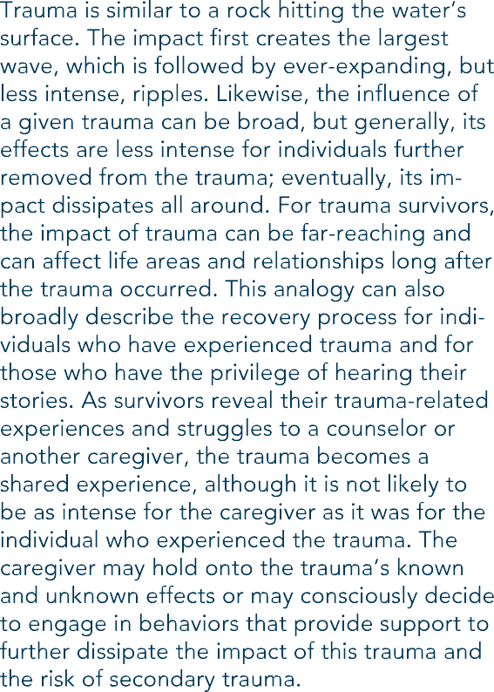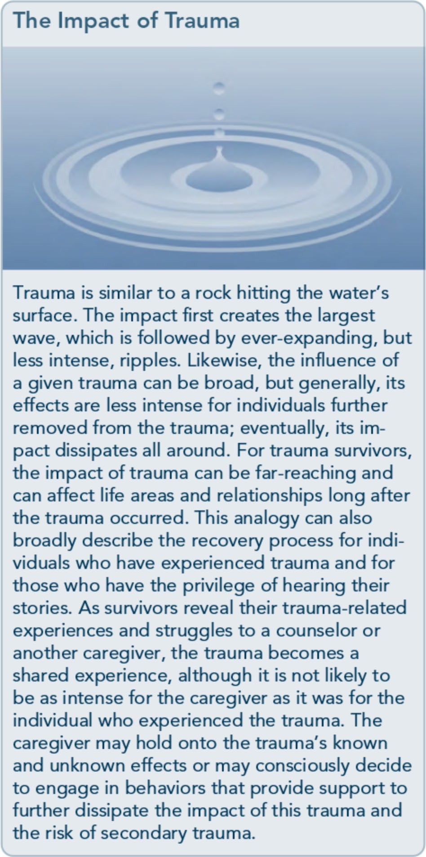Essential components of TIC include organi­ zational and personal strategies to address

30

Part 1, Chapter 1-T rauma-lnformed Care: A Sociocultural Perspective

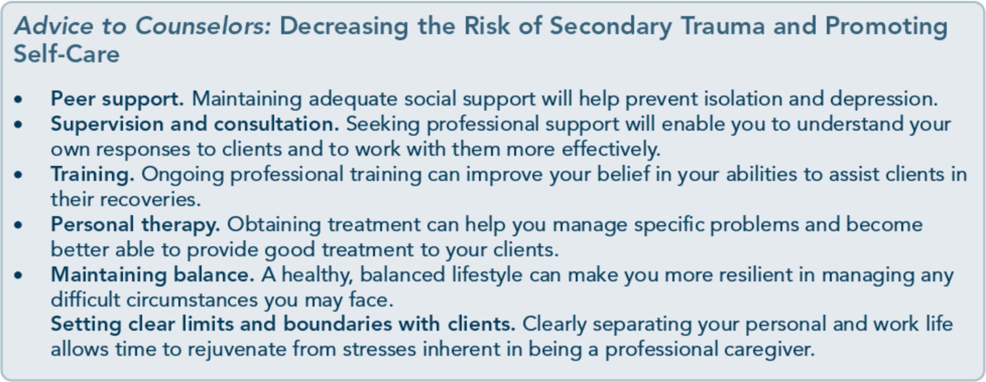

secondary trauma and its physical, cognitive, emotional, and spiritual consequences. In agencies and among individual providers, it is key for the culture to promote acceptability, accessibility, and accountability in seeking help, accessing support and supervision, and engaging in self-care behaviors in and outside of the agency or office. Agencies should in­ volve staff members who work with trauma in developing informal and formal agency prac­ tices and procedures to prevent or address sec­ ondary trauma. Even though a number of community-based agencies face fiscal con­ straints, prevention strategies for secondary
trauma can be intertwined with the current infrastructure (e.g., staff meetings, education, case consultations and group case discussions, group support, debriefing sessions as appropri­ ate, supervision). For more information on strategies to address and prevent secondary trauma, see Part 2, Chapter 2 of this TIP.

Provide Hope-Recovery Is Possible
What defines recovery from trauma-related symptoms and traumatic stress disorders? Is it the total absence of symptoms or conse­ quences? Does it mean that clients stop hav­ ing nightmares or being reminded, by cues, of past trauma? When clients who have experi­ enced trauma enter into a helping relationship
to address trauma specifically, they are often looking for a cure, a remission of symptoms, or relief from the pain as quickly as possible.
However, they often possess a history of un­ predictable symptoms and symptom intensity that reinforces an underlying belief that recov­ ery is not possible. On one hand, clients are looking for a message that they can be cured, while on the other hand, they have serious doubts about the likely success of any intervention.
Clients often express ambivalence about deal­ ing with trauma even if they are fully aware of trauma's effects on their lives. The idea ofliv­ ing with more discomfort as they address the past or as they experiment with alternative ways of dealing with trauma-related symptoms or consequences is not an appealing prospect, and it typically elicits fear. Clients may inter­ pret the uncomfortable feelings as dangerous or unsafe even in an environment and rela­ tionship that is safe and supportive.
How do you promote hope and relay a mes­ sage that recovery is possible? First, maintain consistency in delivering services, promoting and providing safety for clients, and showing respect and compassion within the client­ provider relationship. Along with clients' commitment to learning how to create safety for themselves, counselors and agencies need

31

Trauma-Informed Care in Behavioral Health Services

to be aware of, and circumvent, practices that could retraumatize clients. Projecting hope and reinforcing the belief that recovery is pos­ sible extends well beyond the practice of es­ tablishing safety; it also encompasses discussing what recovery means and how it looks to clients, as well as identifying how they will know that they've entered into recov­ ery in earnest.
Providing hope involves projecting an attitude that recovery is possible. This attitude also involves viewing clients as competent to make changes that will allow them to deal with trauma-related challenges, providing opportu­ nities for them to practice dealing with diffi­ cult situations, and normalizing discomfort or difficult emotions and framing these as man­ ageable rather than dangerous. If you convey this attitude consistently to your clients, they will begin to understand that discomfort is not a signal to avoid, but a sign to engage-and that behavioral, cognitive, and emotional re­ sponses to cues associated with previous trau­ mas are a normal part of the recovery process. It's not the absence of responses to such trig­ gers that mark recovery, but rather, how clients experience and manage those responses. Cli­ ents can also benefit from interacting with others who are further along in their recovery from trauma. Time spent with peer support staff or sharing stories with other trauma sur­ vivors who are well on their way to recovery is invaluable-it sends a powerful message that

recovery is achievable, that there is no shame in being a trauma survivor, and that there is a future beyond the trauma.

As You Proceed
This chapter has established the foundation and rationale of this TIP, reviewed trauma­ informed concepts and terminology, and pro­ vided an overview of TIC principles and a guiding framework for this text. As you pro­ ceed, be aware of the wide-ranging responses to trauma that occur not only across racially and ethnically diverse groups but also within specific communities, families, and individuals. Counselors, prevention specialists, other be­ havioral health workers, supervisors, and or­ ganizations all need to develop skills to create an environment that is responsive to the unique attributes and experiences of each cli­ ent. As you read this TIP, remember that many cross-cutting factors influence the expe­ riences, help-seeking behaviors, intervention responses, and outcomes of individuals, fami­ lies, and populations who have survived trau­ ma. Single, multiple, or chronic exposures to traumatic events, as well as the emotional, cognitive, behavioral, and spiritual responses to trauma, need to be understood within a social­ ecological framework that recognizes the many ingredients prior to, during, and after traumatic experiences that set the stage for recovery.

32

Appendix A-Bibliography

Abrahams, I. A., Ali, 0., Davidson, L., Evans, A. C., King,]. K., Poplawski, P., et al. (2010).
Philadelphia behavioral health services traniformation: Practice guidelines for recovery and resilience oriented treatment. Philadelphia: Department of Behavioral Health and Intellectual Disability Services.
Adams, R. E., Figley, C.R., & Boscarino,]. A. (2008). The Compassion Fatigue Scale: Its use with social workers following urban disaster. Research on Social Work Practice, 18, 238-250.
Adler, A. B., Litz, B. T., Castro, C. A., Suvak, M., Thomas,]. L., Burrell, L., et al. (2008). A group randomized trial of critical incident stress debriefing provided to U.S. peacekeepers.journalof Traumatic Stress, 21, 253-263.
Administration on Children, Youth, and Families. (2002). Sexual abuse among homeless adolescents: Prevalence, correlates, and sequelae. Washington, DC: Administration on Children, Youth, and Families.
Advanced Trauma Solutions, Inc. (2012). Trauma affect regulation: Guide for education & therapy.
Farmington, CT: Advanced Trauma Solutions, Inc.
Allen,]. G. (2001). Traumatic relationships and serious mental disorders. New York: John Wiley &
Sons Ltd.
American Psychiatric Association. (1980). Diagnostic and statistical manual of mental disorders. (3rd ed.). Washington, DC: American Psychiatric Association.
American Psychiatric Association. (2000a). Diagnostic and statistical manual of mental disorders.
(4th ed., text rev.). Washington, DC: American Psychiatric Association.
American Psychiatric Association. (20006). Position statement on therapies focused on memories of
childhood physical and sexual abuse. Washington, DC: American Psychiatric Association.
American Psychiatric Association. (2012a). G 03 posttraumatic stress disorder. Washington, DC:
American Psychiatric Association.
American Psychiatric Association. (20126). Proposed draft revisions to DSM disorders and criteria.
Washington, DC: American Psychiatric Association.
American Psychiatric Association. (2013a). Diagnostic and statistical manual of mental disorders.
(5th ed.). Arlington, VA: American Psychiatric Association.

215

Trauma-Informed Care in Behavioral Health Services

American Psychiatric Association. (2013b). Highlights of changes from DSM-IV-TR to DSM-5.
Arlington, VA: American Psychiatric Association.
American Psychological Association & The Ad Hoc Committee on Legal and Ethical Issues in the Treatment oflnterpersonal Violence. (2003). Potential problems far psychologists working with the area of interpersonal violence. Washington, DC: American Psychiatric Association.
Anda, R. F., Felitti, V.J., Bremner,]. D., Walker,]. D., Whitfield, C., Perry, B. D., et al. (2006). The enduring effects of abuse and related adverse experiences in childhood. A convergence of evidence from neurobiology and epidemiology. European Archives of Psychiatry and Clinical Neuroscience, 256 (3), 174-86.
Anda, R. F., Felitti, V.J., Brown, D., Chapman, D., Dong, M., Dube, S. R., et al. (2006). Insights into intimate partner violence from the adverse childhood experiences (ACE) study. In The physician's guide to intimate partner violence and abuse (pp. 77-88). Volcano, CA: Volcano Press.
Andreasen, N. C. (2010). Posttraumatic stress disorder: A history and a critique.Annals of the New YorkAcademy of Sciences, 1208, 67-71.
Antony, M. M., Orsillo, S. M., & Roemer, L. (2001). Practitioner's guide to empirically based measures of anxiety. New York: Plenum Press.
Arkowitz, H., Miller, W.R., Westra, H. A., & Rollnick, S. (2008). Motivational interviewing in the treatment of psychological problems: Conclusions and future directions. In Motivational interviewing in the treatment of psychological problems (pp. 324-342). New York: Guilford Press.
Auerbach, S. (2003). Sleep disorders related to alcohol and other drug use. In A.W. Graham, T. K. Schultz, M. F. Mayo-Smith, R. K. Ries, & B. B. Wilford (Eds.), Principles of addiction medicine. (3rd ed.). (pp. 1179-1193). Chevy Chase, MD: American Society of Addiction Medicine.
Baer, R. A. (2003). Mindfulness training as a clinical intervention: A conceptual and empirical review. Clinical Psychology: Science and Practice, 10, 125-143.
Baker, K. G. & Gippenreiter,J. B. (1998). Stalin's purge and its impact on Russian families: A pilot study. In Y. Danieli (Ed.), International handbook of multigenerational legacies of trauma (pp.
403-434). New York: Plenum Press.
Bartone, P. T., Roland, R.R., Picano,J.J., & Williams, T. (2008). Psychological hardiness predicts success in US Army Special Forces candidates. International journal of Selection and Assessment, 16, 78-81.
Batten, S. V. & Hayes, S. C. (2005). Acceptance and commitment therapy in the treatment of comorbid substance abuse and post-traumatic stress disorder: A case study. Clinical Case Studies, 4, 246-262.
Beck, A. T. (1993). Beck anxiety inventory. San Antonio, TX: The Psychological Corporation. Beck, A. T., Rush, A.]., Shaw, B. F., & Emery, G. (1979). Cognitive therapy of depression. New York:
Guilford Press.
Beck, A. T., Steer, R. A., & Brown, G. K. (1996). Beck depression inventory -II manual. San Antonio, TX: The Psychological Corporation.

216

Appendix A-Bibliography

Beck, A. T., Wright, F. D., Newman, C. F., & Liese, B. F. (1993). Cognitive therapy of substance abuse. New York: Guilford Press.
Bell, C. C. (2011). Trauma, culture, and resiliency. In S. M. Southwick, B. T. Litz, D. Charney, &
M.J. Friedman (Eds.), Resilience and mental health: Challenges across the lifespan (pp. 176-187). New York: Cambridge University Press.
Benedek, D. M. & Ursano, R.J. (2009). Posttraumatic stress disorder: From phenomenology to clinical practice. FOCUS: The journal of Lifelong Learning in Psychiatry, 7, 160-175.
Bernard,]. M. & Goodyear, R. K. (2009). Fundamentals of clinical supervision. (4th ed.). Upper Saddle River, NJ: Merrill/Pearson.
Bernstein, D. P. (2000). Childhood trauma and drug addiction: Assessment, diagnosis, and
treatment.Alcoholism Treatment Quarterly, 18, 19-30.
Bernstein, E. M. & Putnam, F. W. (1986). Development, reliability, and validity of a dissociation
scale.journal of Nervous and Mental Disease, 174, 727-735.
Bills, L.J. (2003). Using trauma theory and S.A.G.E. in outpatient psychiatric practice. Psychiatric Quarterly, 74, 191-203.
Blackburn, C. (1995). Family and relapse. Counselor. Alexandria, VA: National Association of Alcoholism and Drug Abuse Counselors.
Blake, D., Weathers, F., Nagy, L., Koloupek, D., Klauminzer, G., Charney, D., et al. (1990). Clinician Administered PTSD Scale (CAPS). Boston: National Center for Post-Traumatic Stress Disorder.
Bleich, A., Gelkopf, M., & Solomon, Z. (2003). Exposure to terrorism, stress-related mental health symptoms, and coping behaviors among a nationally representative sample in Israel. journal of the American Medical Association, 290, 612-620.
Bloom, S. L. (1997). Creating sanctuary: Toward the evolution of sane societies. New York: Routledge. Bloom, S. L., Bennington-Davis, M., Farragher, B., McCorkle, D., Nice-Martini, K., & Wellbank,
K. (2003). Multiple opportunities for creating sanctuary. Psychiatric Quarterly, 74, 173-190.
Bloom, S. L., Foderaro,]. F., & Ryan, R. (2006). S.E.L.F: A trauma-informed psychoeducational group Curriculum. Retrieved on November 18, 2013, from: http://sanctuaryweb.com/PDFs_new/COMPLETE%20INTRODUCTO RY%20MATERI AL.pdf
Bober, T. & Regehr, C. (2006). Strategies for reducing secondary or vicarious trauma: Do they work? Brie/Treatment and Crisis Intervention, 6, 1-9.
Bonanno, G. A. (2004). Loss, trauma, and human resilience: Have we underestimated the human capacity to thrive after extremely aversive events? American Psychologist, 29, 20-28.
Bonanno, G. A. & Mancini, A. D. (2011). Toward a lifespan approach to resilience and potential trauma. In S. M. Southwick, B. T. Litz, D. Charney, &M.J. Friedman (Eds.), Resilience and mental health: Challenges across the lifespan (pp. 120-134). New York: Cambridge University Press.

217

Trauma-Informed Care in Behavioral Health Services

Bowman, C. G. &Mertz, E. (1996). A dangerous direction: Legal intervention in sexual abuse survivor therapy. Harvard Law Review, 109, 551-639.
Brady, K. T., Killeen, T., Saladin, M. E., Dansky, B., & Becker, S. (1994). Comorbid substance abuse and posttraumatic stress disorder: Characteristics of women in treatment. American journal on Addictions, 3, 160-164.
Breslau, N. (2002). Gender differences in trauma and posttraumatic stress disorder.journal of
Gender Specific Medicine, 5, 34-40.
Brewin, C.R. (2007). Remembering and forgetting. In M.J. Friedman, T. M. Keane, & P.A. Resick (Eds.), Handbook of PTSD: Science and practice (pp. 116-134). New York: Guilford Press.
Brewin, C.R., Andrews, B., & Valentine,]. D. (2000). Meta-analysis of risk factors for posttraumatic stress disorder in trauma-exposed adults.journal of Consulting and Clinical
Psychology, 68, 748-766.
Bride, B. E. (2007). Prevalence of secondary traumatic stress among social workers. Social Work, 52,
63-70.
Briere,]. (1995). Trauma symptom inventory professional manual. Odessa, FL: Psychological Assessment Resources.
Briere, J. (1996a). Therapy far adults molested as children: Beyond survival (2nd ed.). New York: Springer Pub.
Briere,]. (19966). Trauma symptom checklist far children professional manual. Odessa, FL: Psychological Assessment Resources.
Briere,]. (1997). Psychological assessment of adult posttraumatic states. (1st ed.). Washington, DC: American Psychological Association.
Briere, J. & Scott, C. (2006a). Central issues in trauma treatment. In Principles of trauma therapy: A guide to symptoms, evaluation, and treatment (pp. 67-85). Thousand Oaks, CA: Sage Publications.
Briere,]. & Scott, C. (20066). Principles of trauma therapy: A guide to symptoms, evaluation, and treatment. Thousand Oaks, CA: Sage Publications.
Briere,]., & Scott, C. (2012). Principles of trauma therapy: A guide to symptoms, evaluation, and treatment. (2nd ed.). Thousand Oaks, CA: Sage Publications.
Bronfenbrenner,U. (1979). The ecology of human development: Experiments by nature and design.
Cambridge, MA: Harvard University Press.
Bronfenbrenner,U. & Ceci, S.J. (1994). Nature-nurture reconceptualized in developmental perspective: A bioecological model. Psychological Review, 101, 568-586.
Brown, L. S. (2008). Feminist therapy. InJ. L. Lebow (Ed.), Twenty-first century psychotherapies: Contemporary approaches to theory and practice (pp. 277-306). Hoboken, NJ: John Wiley & Sons, Inc.

218

Appendix A-Bibliography

Brown, P. J., Read,]. P., & Kahler, C. W. (2003). Comorbid posttraumatic stress disorder and substance use disorders: Treatment outcomes and the role of coping. In P. Ouimette & P. J. Brown (Eds.), Trauma and substance abuse: Causes, consequences, and treatment of comorbid disorders (pp. 171-188). Washington, DC: American Psychological Association.
Bryant, R. A. & Harvey, A. G. (2000). Acute stress disorder: A handbook of theory, assessment, and treatment. (1st ed.). Washington, DC: American Psychological Association.
Bryant, R. A. & Harvey, A.G. (2003). Gender differences in the relationship between acute stress disorder and posttraumatic stress disorder following motor vehicle accidents.Australian and New Zealand journal of Psychiatry, 37, 226-229.
Burke, P.A., Carruth, B., & Prichard, D. (2006). Counselor self-care in work with traumatized addicted people. In B. Carruth (Ed.), Psychological trauma and addiction treatment (pp. 283- 302). New York: Haworth Press.
Cahill, S. P., Rothbaum, B. 0., Resick, P.A., & Follette, V. M. (2009). Cognitive-behavioral therapy for adults. In E. B. Foa, T. M. Keane, M.J. Friedman, &J. A. Cohen (Eds.), Effective treatments far PTSD: Practice guidelines from the International Society far Traumatic Stress Studies. (2nd ed.). (pp. 139-222). New York: Guilford Press.
Caldwell, B. A. & Redeker, N. (2005). Sleep and trauma: An overview. Issues in Mental Health Nursing, 26, 721-738.
Campbell-Sills, L. & Stein, M. B. (2007). Psychometric analysis and refinement of the Connor­ Davidson Resilience Scale (CD-RISC): Validation of a 10-item measure of resilience.journal of Traumatic Stress, 20, 1019-1028.
Capezza, N. M. & Najavits, L. M. (2012). Rates of trauma-informed counseling at substance abuse treatment facilities: Reports from over 10,000 programs. Psychiatric Services, 63, 390- 394.
Cardena, E., Koopman, C., Classen, C., Waelde, L. C., & Spiegel, D. (2000). Psychometric properties of the Stanford Acute Stress Reaction Qyestionnaire (SASRQ2: a valid and reliable measure of acute stress.journal ofTraumatic Stress, 13, 719-734.
Carlson, E. B. & Putnam, F. W. (1993). An update on the Dissociative Experiences Scale.
Dissociation, 6, 16-27.
Carroll,]. F. X. & McGinley,J.J. (2001). A screening form for identifying mental health problems in alcohol/other drug dependent persons. Alcoholism Treatment Quarterly, 19, 33-47.
Catalano, S. (2012). Intimate partner violence in the US. Washington, DC: Bureau ofJustice Statistics.
Catalano, S. M. (2004). Criminal victimization, 2003: National crime victimization survey.
Washington, DC: Bureau of Justice Statistics.
Centers for Disease Control and Prevention. (2009). The social-ecological model· A framework far prevention. Retrieved on November 20, 2013, from: http://www.cdc.gov/violenceprevention/overview/social-ecologicalmodel.html

219

Trauma-Informed Care in Behavioral Health Services

Centers for Disease Control and Prevention. (2012). Publications by health outcome: Adverse childhood experiences (ACE) study. Atlanta, GA: Centers for Disease Control and Prevention.
Centers for Disease Control and Prevention. (2013,January 18). Adverse Childhood Experiences (ACE) Study. Retrieved on August 14, 2013, from http://www.cdc.gov/ace/about.htm
Center for Mental Health Services. (1996). Responding to the needs of people with serious and persistent mental illness in times of major disaster (Rep. No. SMA 96-3077). Rockville, MD: Substance Abuse and Mental Health Services Administration.
Center for Mental Health Services, Division of Prevention, Traumatic Stress and Special Programs, Emergency Mental Health and Traumatic Stress Services Branch. (2003). Fact sheet (Rep. No. KEN 95-0011). Rockville, MD: Substance Abuse and Mental Health Services Administration.
Center for Mental Health Services, Substance Abuse and Mental Health Services Administration. (2005). Roadmap to seclusion and restraint free mental health services. Rockville, MD: Substance Abuse and Mental Health Services Administration.
Center for Substance Abuse Treatment. (1993a). Improving treatment far drug-exposed infants. Treatment Improvement Protocol (TIP) Series 5. HHS Publication No. (SMA) 95-3057. Rockville, MD: Substance Abuse and Mental Health Services Administration.
Center for Substance Abuse Treatment. (19936). Pregnant, substance-using women. Treatment Improvement Protocol (TIP) Series 2. HHS Publication No. (SMA) 93-1998. Rockville, MD: Substance Abuse and Mental Health Services Administration.
Center for Substance Abuse Treatment. (1993c). Screening/or infectious diseases among substance abusers. Treatment Improvement Protocol (TIP) Series 6. HHS Publication No. (SMA) 95- 3060. Rockville, MD: Substance Abuse and Mental Health Services Administration.
Center for Substance Abuse Treatment. (1994). Simple screening instruments far outreach far alcohol and other drug abuse and infectious diseases. Treatment Improvement Protocol (TIP) Series 11. HHS Publication No. (SMA) 94-2094. Rockville, MD: Substance Abuse and Mental Health Services Administration.
Center for Substance Abuse Treatment. (1995a). Alcohol and other drug screening of hospitalized trauma patients. Treatment Improvement Protocol (TIP) Series 16. HHS Publication No. (SMA) 95-3041. Rockville, MD: Substance Abuse and Mental Health Services Administration.
Center for Substance Abuse Treatment. (19956). Combining alcohol and other drug treatment with diversion far juveniles in the justice system. Treatment Improvement Protocol (TIP) Series 21. HHS Publication No. (SMA) 95-3051. Rockville, MD: Substance Abuse and Mental Health Services Administration.
Center for Substance Abuse Treatment. (1995c). Developing state outcomes monitoring systems far alcohol and other drug abuse treatment. Treatment Improvement Protocol (TIP) Series 14. HHS Publication No. (SMA) 95-3031. Rockville, MD: Substance Abuse and Mental Health Services Administration.

220

Appendix A-Bibliography

Center for Substance Abuse Treatment. (1995d). The role and current status of patient placement criteria in the treatment of substance use disorders. Treatment Improvement Protocol (TIP) Series
13. HHS Publication No. (SMA) 95-3021. Rockville, MD: Substance Abuse and Mental Health Services Administration.
Center for Substance Abuse Treatment. (1995e). The tuberculosis epidemic: Legal and ethical issues far alcohol and other drug abuse treatment providers. Treatment Improvement Protocol (TIP) Series 18. HHS Publication No. (SMA) 95-3047. Rockville, MD: Substance Abuse and Mental Health Services Administration.
Center for Substance Abuse Treatment. (1996). Treatment drug courts: Integrating substance abuse treatment with legal case processing. Treatment Improvement Protocol (TIP) Series 23. HHS Publication No. (SMA) 96-3113. Rockville, MD: Substance Abuse and Mental Health Services Administration.
Center for Substance Abuse Treatment. (1997a). A guide to substance abuse services far primary care clinicians. Treatment Improvement Protocol (TIP) Series 24. HHS Publication No. (SMA) 97-3139. Rockville, MD: Substance Abuse and Mental Health Services Administration.
Center for Substance Abuse Treatment. (1997b). Substance abuse treatment and domestic violence. Treatment Improvement Protocol (TIP) Series 25. HHS Publication No. (SMA) 97-3163. Rockville, MD: Substance Abuse and Mental Health Services Administration.
Center for Substance Abuse Treatment. (1998a). Comprehensive case management far substance abuse treatment. Treatment Improvement Protocol (TIP) Series 27. HHS Publication No. (SMA) 98-3222. Rockville, MD: Substance Abuse and Mental Health Services Administration.
Center for Substance Abuse Treatment. (1998b). Continuity of offender treatment far substance use disorders from institution to community. Treatment Improvement Protocol (TIP) Series 30.
HHS Publication No. (SMA) 98-3245. Rockville, MD: Substance Abuse and Mental Health Services Administration.
Center for Substance Abuse Treatment. (1998c). Naltrexone and alcoholism treatment. Treatment Improvement Protocol (TIP) Series 28. HHS Publication No. (SMA) 98-3206. Rockville, MD: Substance Abuse and Mental Health Services Administration.
Center for Substance Abuse Treatment. (1998d). Substance abuse among older adults. Treatment Improvement Protocol (TIP) Series 26. HHS Publication No. (SMA) 98-3179. Rockville, MD: Substance Abuse and Mental Health Services Administration.
Center for Substance Abuse Treatment. (1998e). Substance use disorder treatment far people with physical and cognitive disabilities. Treatment Improvement Protocol (TIP) Series 29. HHS Publication No. (SMA) 98-3249. Rockville, MD: Substance Abuse and Mental Health Services Administration.
Center for Substance Abuse Treatment. (1999a). Brief interventions and brief therapies far substance abuse. Treatment Improvement Protocol (TIP) Series 34. HHS Publication No. (SMA) 99- 3353. Rockville, MD: Substance Abuse and Mental Health Services Administration.

221

Trauma-Informed Care in Behavioral Health Services

Center for Substance Abuse Treatment. (1999b). Enhancing motivation far change in substance abuse treatment. Treatment Improvement Protocol (TIP) Series 35. HHS Publication No. (SMA) 99-3354. Rockville, MD: Substance Abuse and Mental Health Services Administration.
Center for Substance Abuse Treatment. (1999c). Screening and assessing adolescents far substance use disorders. Treatment Improvement Protocol (TIP) Series 31. HHS Publication No. (SMA) 99-3282. Rockville, MD: Substance Abuse and Mental Health Services Administration.
Center for Substance Abuse Treatment. (1999d). Treatment of adolescents with substance use disorders. Treatment Improvement Protocol (TIP) Series 32. HHS Publication No. (SMA) 99- 3283. Rockville, MD: Substance Abuse and Mental Health Services Administration.
Center for Substance Abuse Treatment. (1999e). Treatment far stimulant use disorders. Treatment Improvement Protocol (TIP) Series 33. HHS Publication No. (SMA) 99-3296. Rockville, MD: Substance Abuse and Mental Health Services Administration.
Center for Substance Abuse Treatment. (2000a). Integrating substance abuse treatment and vocational services. Treatment Improvement Protocol (TIP) Series 38. HHS Publication No. (SMA) 00-3470. Rockville, MD: Substance Abuse and Mental Health Services Administration.
Center for Substance Abuse Treatment. (2000b). Substance abuse treatment far persons with child abuse and neglect issues. Treatment Improvement Protocol (TIP) Series 36. HHS Publication No. (SMA) 00-3357. Rockville, MD: Substance Abuse and Mental Health Services Administration.
Center for Substance Abuse Treatment. (2000c). Substance abuse treatment far persons with HIV/AIDS. Treatment Improvement Protocol (TIP) Series 37. HHS Publication No. (SMA) 00-3459. Rockville, MD: Substance Abuse and Mental Health Services Administration.
Center for Substance Abuse Treatment. (2004a). Clinical guidelines far the use of buprenorphine in the treatment of opioid addiction. Treatment Improvement Protocol (TIP) Series 40. HHS Publication No. (SMA) 04-3939. Rockville, MD: Substance Abuse and Mental Health Services Administration.
Center for Substance Abuse Treatment. (2004b). Substance abuse treatment and family therapy. Treatment Improvement Protocol (TIP) Series 39. HHS Publication No. (SMA) 04-3957. Rockville, MD: Substance Abuse and Mental Health Services Administration.
Center for Substance Abuse Treatment. (2005a). Medication-assisted treatment far opioid addiction.
Treatment Improvement Protocol (TIP) Series 43. HHS Publication No. SMA 05-4048. Rockville, MD: Substance Abuse and Mental Health Services Administration.
Center for Substance Abuse Treatment. (2005b). Substance abuse treatment far adults in the criminal justice system. Treatment Improvement Protocol (TIP) Series 44. HHS Publication No. (SMA) 05-4056. Rockville, MD: Substance Abuse and Mental Health Services Administration.
Center for Substance Abuse Treatment. (2005c). Substance abuse treatment far persons with co­ occurring disorders. Treatment Improvement Protocol (TIP) Series 42. HHS Publication No. SMA 05-3992. Rockville, MD: Substance Abuse and Mental Health Services Administration.

222

Appendix A-Bibliography

Center for Substance Abuse Treatment. (2005d). Substance abuse treatment: Group therapy.
Treatment Improvement Protocol (TIP) Series 41. HHS Publication No. SMA 05-4056. Rockville, MD: Substance Abuse and Mental Health Services Administration.
Center for Substance Abuse Treatment. (2006a). Detoxification and substance abuse treatment. Treatment Improvement Protocol (TIP) Series 45. HHS Publication No. SMA 06-4131. Rockville, MD: Substance Abuse and Mental Health Services Administration.
Center for Substance Abuse Treatment. (2006b). Substance abuse:Administrative issues in intensive outpatient treatment. Treatment Improvement Protocol (TIP) Series 46. HHS Publication No. SMA 06-4151. Rockville, MD: Substance Abuse and Mental Health Services Administration.
Center for Substance Abuse Treatment. (2006c). Substance abuse: Clinical issues in intensive outpatient treatment. Treatment Improvement Protocol (TIP) Series 47. HHS Publication No. SMA 06-4182. Rockville, MD: Substance Abuse and Mental Health Services Administration.
Center for Substance Abuse Treatment. (2008). Managing depressive symptoms in substance abuse clients during early recovery. Treatment Improvement Protocol (TIP) Series 48. HHS Publication No. SMA 08-4353. Rockville, MD: Substance Abuse and Mental Health Services Administration.
Center for Substance Abuse Treatment. (2009a).Addressing suicidal thoughts and behaviors in substance abuse treatment. Treatment Improvement Protocol (TIP) Series 50. HHS Publication No. SMA 09-4381. Rockville, MD: Substance Abuse and Mental Health Services Administration.
Center for Substance Abuse Treatment. (2009b). Clinical supervision and the professional development of the substance abuse counselor. Treatment Improvement Protocol (TIP) Series 52. HHS Publication No. SMA 09-4435. Rockville, MD: Substance Abuse and Mental Health Services Administration.
Center for Substance Abuse Treatment. (2009c). Incorporating alcohol pharmacotherapies into medical practice. Treatment Improvement Protocol (TIP) Series 49. HHS Publication No. SMA 09-4380. Rockville, MD: Substance Abuse and Mental Health Services Administration.
Center for Substance Abuse Treatment. (2009d). Substance abuse treatment:Addressing the specific needs of women. Treatment Improvement Protocol (TIP) Series 51. HHS Publication No.
SMA 09-4426. Rockville, MD: Substance Abuse and Mental Health Services Administration.
Center for Substance Abuse Treatment. (2009e). What are peer recovery support services? HHS Publication No. SMA 09-4454. Rockville, MD: Substance Abuse and Mental Health Services Administration, U.S. Department of Health and Human Services.
Chambless, D. L. & Hollon, S. D. (1998). Defining empirically supported therapies.journal of
Consulting and Clinical Psychology, 66, 7-18.
Chilcoat, H. D. & Breslau, N. (1998). Posttraumatic stress disorder and drug disorders: Testing causal pathways.Archives of General Psychiatry, 55, 913-917.
Christensen, R. C., Hodgkins, C. C., Garces, L. K., Estlund, K. L., Miller, M. D., & Touchton, R. (2005). Homeless, mentally ill and addicted: The need for abuse and trauma services.journal of Health Care far the Poor and Underserved, 16, 615-621.

223

Trauma-Informed Care in Behavioral Health Services

Claes, L. & Vandereycken, W. (2007). Is there a link between traumatic experiences and self­ injurious behaviours in eating-disordered patients? Eating Disorders, 15, 305-315.
Claes, L., Vandereycken, W., & Vertommen, H. (2005). Self-care versus self-harm: Piercing, tattooing, and self-injuring in eating disorders. European Eating Disorders Review, 13, 11-18.
Clark, C. & Fearday, F. E. (2003). Triad women's project: Group facilitator's manual. Tampa, FL: Louis de la Parte Florida Mental Health Institute, University of South Florida.
Cloitre, M., Koenen, K. C., Cohen, L. R., & Han, H. (2002). Skills training in affective and interpersonal regulation followed by exposure: A phase-based treatment for PTSD related to childhood abuse.journal of Consulting and Clinical Psychology, 70, 1067-1074.
Coffey, S. F., Dansky, B. S., & Brady, K. T. (2003). Exposure-based, trauma focused therapy for comorbid posttraumatic stress disorder-substance use disorder. In P. Ouimette & P.J. Brown (Eds.), Trauma and substance abuse: Causes, consequences, and treatment of comorbid disorders. (pp.
127-146). Washington, DC: American Psychological Association.
Coffey, S. F., Schumacher,]. A., Brady, K. T., &Dansky, B. S. (2003). Reductions in trauma symptomalogy during acute and protracted alcohol and cocaine abstinence. Symposium conducted at the Annual Meeting of the International Society for Traumatic Stress Studies, Chicago, IL.
Coffey, S. F., Schumacher,]. A., Brimo, M. L., & Brady, K. T. (2005). Exposure therapy for substance abusers with PTSD: Translating research to practice. Behavior Modification, 29, 10- 38.
Connor, K. M. & Davidson,]. R. T. (2003). Development of a new resilience scale: The Connor­ Davidson Resilience Scale (CD-RISC). Depression and Anxiety, 18, 76-82.
Connors, G.J., Donovan, D. M., & DiClemente, C. C. (2001). Substance abuse treatment and the stages of change selecting and planning interventions. New York: Guilford Press.
Cottler, L.B., Nishith, P., & Compton, W. M. (2001). Gender differences in risk factors for trauma exposure and post-traumatic stress disorder among inner-city drug abusers in and out of treatment. Comprehensive Psychiatry, 42, 111-117.
Courtois, C. A. & Ford,]. D. (Eds.). (2009). Treating complex traumatic stress disorders:An evidence­ based guide. New York: Guilford Press.
Covington, S.S. (2003). Beyond trauma:A healingjourneyfar women: Facilitator's guide. Center City, MN: Hazelden.
Covington, S.S. (2008). Helping women recover: A program far treating addiction. (Revised loose leaf ed.). San Francisco:Jossey-Bass.
Cross, T. L., Bazron, B.J., Dennis, K. W., &Isaacs, M. R. (1989). Towards a culturally competent system of care: A monograph on effective services far minority children who are severely emotionally disturbed (Vol. 1). Washington, DC: Georgetown University Child Development Center.
Danieli, Y., Brom, D., & Sills,]. (2005). Sharing knowledge and shared care.journal ofAggression, Maltreatment &Trauma, 10, 775-790.

224

Appendix A-Bibliography

Daniels, A., Grant, E., Filson, B., Powell, I., Fricks, L., & Goodale, L. (2010). Pillars of peer support: Traniforming mental health systems of care through peer support services. Retrieved on November 21, 2013, from: http://www.pillarsofpeersupport.org/final%20%20PillarsofPeerSupportService%20Report.pdf
Daniels, A. S., Tunner, T. P., Ashenden, P., Bergeson, S., Fricks, L., & Powell, I. (2012). Pillars of peer support -III- Whole health peer support services. Retrieved on November 21, 2013, from: http://www.pillarsofpeersupport.org/P.O.PS2011.pdf
Dass-Brailsford, P. &Myrick, A. C. (2010). Psychological trauma and substance abuse: The need for an integrated approach. Trauma, Violence, & Abuse, 11, 202-213.
Daoust,]. P., Renaud, M., Bruyere, B., Lemieux, V., Fleury, G., & Najavits, L. M. (2012). Posttraumatic stress disorder and substance use disorder: Evaluation of the effectiveness of a specialized clinic far French-Canadians based in a teaching hospital Retrieved on November 21, 2013, from: http://www.seekingsafety.org/3-03-06/studies.html
Davidson,]. R., Book, S. W., Colket,J. T., Tupler, L.A., Roth, S., David, D., et al. (1997).
Assessment of a new self-rating scale for post-traumatic stress disorder. Psychological Medicine, 27, 153-160.
De Bellis, M. D. (2002). Developmental traumatology: A contributory mechanism for alcohol and substance use disorders. Psychoneuroendocrinology, 27, 155-170.
de Fabrique, N., Van Hasselt, V. B., Vecchi, G. M., & Romano, S.J. (2007). Common variables associated with the development of Stockholm syndrome: Some case examples. Victims & Offenders, 2, 91-98.
de Girolamo, G. (1993). lnternational perspectives on the treatment and prevention of posttraumatic stress disorder. In J.P. Wilson & Raphael Beverley (Eds.), International handbook of traumatic stress syndrome (pp. 935-946). New York: Plenum Press.
dePanfilis, D. (2006). Child neglect: A guide far prevention, assessment, and intervention. Washington, DC: U.S. Department of Health and Human Services, Administration for Children and Families, Administration on Children, Youth and Families Children's Bureau, Office on Child Abuse and Neglect.
DeWolfe, D.J. (2000). Training manual· For mental health and human service workers in major disasters (Rep. No. ADM 90-538). Rockville, MD: Substance Abuse and Mental Health Services Administration.
Dillon,]. R. (2001). lnternalized homophobia, attributions of blame, and psychological distress among lesbian, gay, and bisexual trauma victims. Dissertation Abstracts International· Section B: The Sciences & Engineering, 62, 2054.
Dom, G., De, W. B., Hulstijn, W., & Sabbe, B. (2007). Traumatic experiences and posttraumatic stress disorders: differences between treatment-seeking early- and late-onset alcoholic patients. Comprehensive Psychiatry, 48, 178-185.
Driessen, M., Schulte, S., Luedecke, C., Schaefer, I., Sutmann, F., Ohlmeier, M., et al. (2008).
Trauma and PTSD in patients with alcohol, drug, or dual dependence: A multi-center study.
Alcoholism: Clinical & Experimental Research, 32, 481-488.

225

Trauma-Informed Care in Behavioral Health Services

Dube, S. R., Anda, R. F., Felitti, V.J., Edwards, V.J., & Croft,]. B. (2002). Adverse childhood experiences and personal alcohol abuse as an adult. Addictive Behaviors, 27, 713-725.
Duckworth, M. P. & Follette, V. M. (2011). Retraumatization: Assessment, treatment, and prevention. New York: Brunner-Routledge.
Ehlers, A. & Clark, D. (2003). Early psychological interventions for adult survivors of trauma: A review. Biological Psychiatry, 53, 817-826.
El-Gabalawy, R. (2012).Association between traumatic experiences and physical health conditions in a nationally representative sample. Retrieved on November 21, 2013, from: http://www.adaa.org/sites/default/files/El-Gabalawy0Ai20331.pdf
Ellis, A. & Harper, R. A. (1975). A new guide to rational living. Oxford, England: Prentice-Hall.
Elliott, D. E., Bjelajac, P., Fallot, R. D., Markoff, L. S., & Reed, B. G. (2005). Trauma-informed or trauma-denied: Principles and implementation of trauma-informed services for women.
journal of Community Psychology, 33, 461-477.
EMDR Network. (2012).A brief description of EMDR therapy. Retrieved on November 21, 2013, Retrieved on November 21from: http://www.emdrnetwork.org/description.html
Falck, R. S., Wang,]., Siegal, H. A., & Carlson, R. G. (2004). The prevalence of psychiatric disorder among a community sample of crack cocaine users: An exploratory study with practical implications.journal of Nervous and Mental Disease, 192, 503-507.
Falender, C. A. & Shafranske, E. P. (2004). Clinical supervision: A competency-based approach. (1st ed.). Washington, DC: American Psychological Association.
Fallot, R. D. & Harris, M. (2001). A trauma-informed approach to screening and assessment. In
M. Harris & R. D. Fallot (Eds.), Using trauma theory to design service systems (pp. 23-31). San Francisco: Jossey-Bass.
Fallot, R. D. & Harris, M. (2002). The trauma recovery and empowerment model (TREM): Conceptual and practical issues in a group intervention for women. Community Mental Health journal, 38, 475-485.
Fallot, R. D. & Harris, M. (2009). Creating cultures of trauma-informed care (CCTIC): A se!f­ assessment and planning protocol. Washington, DC: Community Connections.
Falsetti, S. A., Resnick, H. S., Resnick, P.A., & Kilpatrick, D. (1993). The Modified PTSD Symptom Scale: A brief self-report measure of posttraumatic stress disorder. Behavior Therapist, 16, 161-162.
Farley, M., Golding,]. M., Young, G., Mulligan, M., &Minkoff,]. R. (2004). Trauma history and relapse probability among patients seeking substance abuse treatment.journal of Substance Abuse Treatment, 27, 161-167.
Feder, A., Charney, D., & Collins, K. (2011). Neurobiology of resilience. In S. M. Southwick, B. T. Litz, D. Charney, &M.J. Friedman (Eds.), Resilience and mental health: Challenges across the lifespan (pp. 1-29). New York: Cambridge University Press.

226

Appendix A-Bibliography

Feldner, M. T., Monson, C. M., & Friedman, M.J. (2007). A critical analysis of approaches to targeted PTSD prevention: Current status and theoretically derived future directions. Behavior Modification, 31, 80-116.
Felitti, V.J., Anda, R. F., Nordenberg, D., Williamson, D. F., Spitz, A. M., Edwards, V., et al. (1998). Relationship of childhood abuse and household dysfunction to many of the leading causes of death in adults: The Adverse Childhood Experiences (ACE) study.American journal of Preventive Medicine, 14, 245-258.
Figley, C.R. (1995). Compassion fatigue: Toward a new understanding of the costs of caring. In B.
H. Stamm (Ed.), Secondary traumatic stress: Se!f-care issues far clinicians, researchers, and educators
(pp. 3-28). Lutherville, MD: Sidran Press.
Figley, C.R. (2002). Origins of traumatology and prospects for the future, part i.journal of Trauma Practice, 1, 17-32.
First, M. B., Spitzer, R. L., Gibbon, M., & Williams,]. B. W. (2011a). Structured clinical interview far DSM-IV-TR axis I disorders, research version, non-patient edition. New York: Biometrics Research, New York State Psychiatric Institute.
First, M. B., Spitzer, R. L., Gibbon, M., & Williams,]. B. W. (20116). Structured clinical interview far DSM-IV-TR axis I disorders, research version, patient edition. New York: Biometrics Research, New York State Psychiatric Institute.
Foa, E. B., Dancu, C. V., Hembree, E. A.,Jaycox, L. H., Meadows, E. A., & Street, G. P. (1999). A comparison of exposure therapy, stress inoculation training, and their combination for reducing posttraumatic stress disorder in female assault victims.journal of Consulting and Clinical Psychology, 67, 194-200.
Foa, E. B., Hembree, E. A., & Rothbaum, B. 0. (2007). Prolonged exposure therapy far PTSD: Emotional processing of traumatic experiences: Therapist guide. New York: Oxford University Press.
Foa, E. B., Keane, T. M., Friedman, M.J., & Cohen,]. A. (2009). Introduction. In E. B. Foa, T. M. Keane, M. J. Friedman, & J. A. Cohen (Eds.), Effective treatments far PTSD: Practice guidelines from the International Society far Traumatic Stress Studies. (2nd ed.). (pp.1-20). New York: Guilford Press.
Foa, E. B., Rothbaum, B. 0., Riggs, D.S., &Murdock, T. B. (1991). Treatment of posttraumatic stress disorder in rape victims: A comparison between cognitive-behavioral procedures and counseling.journal of Consulting & Clinical Psychology, 59, 715-723.
Foa, E. B., Stein, D.J., &McFarlane,A. C. (2006). Symptomatology and psychopathology of mental health problems after disaster.journal of Clinical Psychiatry, 67 Supplement 2, 15-25.
Ford,]. D. & Fournier, D. (2007). Psychological trauma and post-traumatic stress disorder among women in community mental health aftercare following psychiatric intensive care.journal of Psychiatric Intensive Care, 3, 27-34.
Ford,]. D. & Russo, E. (2006). Trauma-focused, present-centered, emotional self-regulation approach to integrated treatment for posttraumatic stress and addiction: Trauma adaptive recovery group education and therapy (TARGET).Americanjournal of Psychotherapy, 60, 335-355.

227

Trauma-Informed Care in Behavioral Health Services

Foy, D. W., Ruzek,J. I., Glynn, S. M., Riney, S.J., & Gusman, F. D. (2002). Trauma focus group therapy for combat-related PTSD: An update.journal of Clinical Psychology, 58, 907-918.
Frank, B., Dewart, T., Schmeidler,]., &Demirjian,A. (2006). The impact of9/11 on New York City's substance abuse treatment programs: A study of program administrators.journalof Addictive Diseases, 25, 5-14.
Frankl, V. E. (1992). Man's search far meaning: An introduction to logotherapy. (4th ed.). Boston: Beacon Press.
Friborg, 0., Hjemdal, 0., Rosenvinge,J. H., &Martinussen, M. (2003). A new rating scale for adult resilience: What are the central protective resources behind healthy adjustment?
International journal of Methods in Psychiatric Research, 12, 65-76.
Friedman, M.J. (2006). Posttraumatic stress disorder among military returnees from Afghanistan and Iraq.American]ournal of Psychiatry, 163, 586-593.
Frisman, L., Ford,]., Lin, H.J., Mallon, S., & Chang, R. (2008). Outcomes of trauma treatment using the TARGET model.Journal of Groups in Addiction and Recovery, 3, 285-303.
Frueh, B. C., Knapp, R. G., Cusack, K.J., Grubaugh, A. L., Sauvageot,J. A., Cousins, V. C., et al. (2005). Patients' reports of traumatic or harmful experiences within the psychiatric setting.
Psychiatric Services, 56, 1123-1133.
Galea, S., Ahern,]., Resnick, Kilpatrick, D., Bucuvalas, M., Gold,]., et al. (2002). Psychological sequelae of the September 11 terrorist attacks in New York City. New England journal of Medicine, 346, 982-987.
Gentilello, L. M., Ebel, B. E., Wickizer, T. M., Salkever, D. S., & Rivara, F. P. (2005). Alcohol interventions for trauma patients treated in emergency departments and hospitals: A cost benefit analysis.Annals of Surgery, 241, 541-550.
Gentilello, L. M., Villaveces, A., Ries, R.R., Nason, K. S., Daranciang, E., Donovan, D. M., et al. (1999). Detection of acute alcohol intoxication and chronic alcohol dependence by trauma
center staff Journal of Trauma, 47, 1131-1135.
Gill, D. A. & Picou,}. S. (1997). The day the water died: Cultural impacts of the Exxon Valdez oil spill. InJ. S. Picou (Ed.), The Exxon Valdez disaster: Readings on a modern social problem (pp.167-187). Dubuque, IA: Indo American Books.
Gone,J. P. (2009). A community-based treatment for Native American historical trauma: Prospects for evidence-based practice.journal of Consulting and Clinical Psychology, 77, 751-762.
Goodell,]. (2003). Who's a hero now? Retrieved on November 21, 2013 from: http://www.nytimes.com/2003/07/27/magazine/who-s-a-hero-now.html
Grant, B. F., Stinson, F. S., Dawson, D. A., Chou, S. P., Dufour, M. C., Compton, W., et al. (2004).
Prevalence and co-occurrence of substance use disorders and independent mood and anxiety disorders: Results from the National Epidemiologic Survey on Alcohol and Related Conditions.Archives of General Psychiatry, 61, 807-816.
Green, B. L. (1996). Trauma History Qyestionnaire. In B. H. Stamm (Ed.), Measurement of stress, trauma, and adaptation (pp. 366-369). Lutherville, MD: Sidran Press.

228

Appendix A-Bibliography

Green Cross Academy ofTraumatology. (2007). Standards of traumatology practice revised. Retrieved on November 18, 2013, from: http://www.greencross.org/index.php?option=com_content&view=article&id=183&Itemid=123
Green Cross Academy ofTraumatology. (2010). Standards ofse!f care. Retrieved on November 21, 2013,from: http://www.greencross.org/index.php?option=com_content&view=article&id=184&Itemid=124
Green,]. G., McLaughlin, K. A., Berglund, P.A., Gruber, M.J., Sampson, N. A., Zaslavsky, A. M., et al. (2010). Childhood adversities and adult psychiatric disorders in the National Comorbidity Survey Replication I: Associations with first onset of DSM-IV disorders.
Archives of General Psychiatry, 6 7, 113-123.
Greene, L. R., Meisler, A. W., Pilkey, D., Alexander, G., Cardella, L.A., Sirois, B. C., et al. (2004). Psychological work with groups in the Veterans Administration. In]. L.DeLucia-Waack, D.
A. Gerrity, C.R. Kalodner, & M. T. Riva (Eds.), Handbook of group counseling and psychotherapy
(pp. 322-337). Thousand Oaks, CA: Sage Publications.
Grossman, D. (1995). On killing: The psychological cost of learning to kill in war and society. (1st ed.).
Boston: Little Brown.
Guarino, K., Soares, P., Konnath, K., Clervil, R., and Bassuk, E. (2009). Trauma-informed organizational toolkit. Rockville, MD: Center for Mental Health Services, Substance Abuse and Mental Health Services Administration, and the Daniels Fund, the National Child Traumatic Stress Network, and the W. K. Kellogg Foundation.
Gutheil, T. G. & Brodsky, A. (2008). Preventing boundary violations in clinical practice. New York: Guilford Press.
Habukawa, M., Maeda, M., & Uchimura, N. (2010). Sleep disturbances in posttraumatic stress disorder. In L. Sher & A. Vilens (Eds.), Neurobiology of post-traumatic stress disorder (pp. 119- 135). Hauppage, NY: Nova Science Publishers, Inc.
Hamblen,]. (2001). PTSD in children and adolescents, a National Center far PTSD fact sheet.
Washington, DC: National Center for PTSD.
Harned, M. S., Najavits, L. M., & Weiss, R. D. (2006). Self-harm and suicidal behavior in women with comorbid PTSD and substance dependence.American journal of Addiction, 15, 392-395.
Harris, M. & Fallot, R. D. (2001a). Envisioning a trauma-informed service system: A vital paradigm shift. In M. Harris & R. D. Fallot (Eds.), Using trauma theory to design service systems (pp. 3-22). San Francisco:Jossey-Bass.
Harris, M. & Fallot, R. D. (20016). Trauma-informed inpatient services. In M. Harris & R. D. Fallot (Eds.), Using trauma theory to design service systems (pp. 33-46). San Francisco: Jossey­ Bass.
Harris, M. & Fallot, R. D. (2001c). Using trauma theory to design service systems: New directions far mental health services. San Francisco: Jossey-Bass.
Harris, M. & The Community Connections Trauma Work Group. (1998). Trauma recovery and empowerment: A clinician's guide far working with women in groups. New York: Simon & Schuster.

229

Trauma-Informed Care in Behavioral Health Services

Hayes, S. C. (2004). Acceptance and commitment therapy and the new behavior therapies: Mindfulness, acceptance, and relationship. In S. C. Hayes, V. M. Follette, & M. M. Linehan (Eds.), Mincifulness and acceptance: Expanding the cognitive-behavioral tradition (pp. 1-29). New York: Guilford Press.
Heim, C., Mletzko, T., Purselle, D., Musselman, D. L., & Nemeroff, C. B. (2008). The dexamethasone/corticotropin-releasing factor test in men with major depression: Role of childhood trauma. Biological Psychiatry, 63, 398-405.
Heim, C., Newport, D.J., Mletzko, T., Miller, A.H., & Nemeroff, C. B. (2008). The link between childhood trauma and depression: Insights from HPA axis studies in humans.
Psychoneuroendocrinology, 33, 693-710.
Herman,]. L. (1992). Trauma and recovery. New York: Basic Books. Herman,]. L. (1997). Trauma and recovery. (Rev. ed.). New York: Basic Books.
Hoge,M.A.,Morris,J. A., Daniels,A. S., Stuart, G. W., Huey, L. Y., &Adams, N. (2007).An action plan far behavioral health workforce development: A framework far discussion. Rockville, MD: Substance Abuse and Mental Health Services Administration.
Hooper, L. M., Stockton, P., Krupnick,J. L., & Green, B. L. (2011). Development, use, and psycho­ metric properties of the Trauma History Qyestionnaire.journalof Loss and Trauma, 16, 258-283.
Hopper, E. K., Bassuk, E. L., & Olivet,]. (2010). Shelter from the storm: Trauma-informed care in homelessness services settings. The Open Health Services and Policy journal, 3, 80-100.
Horowitz, M., Wilner, N., &Alvarez, W. (1979). Impact of Event Scale: A measure of subjective stress. Psychosomatic Medicine, 41, 209-218.
Huckshorn, K. (2009). Traniforming cultures ofcare toward recovery oriented services: Guidelines toward creating a trauma informed system ofcare: Trauma informed care (TIC) planning guidelines far use in developing an organizationalaction plan. Austin, TX:Texas Network of Youth Services.
Hui, C.H. &Triandis, H. C. (1986). Individualism-collectivism: A study of cross-cultural
researchers.journal of Cross-Cultural Psychology, 17, 225-248.
Huriwai, T. (2002). Re-enculturation: Culturally congruent interventions for Maori with alcohol­ and drug-use-associated problems in New Zealand. Substance Use and Misuse, 37, 1259-1268.
Hutton, D. (2000). Patterns of psychosocial coping and adaptation among riverbank erosion­ induced displacees in Bangladesh: Implications for development programming. Prehospital and Disaster Medicine, 15, S99.
Institute of Medicine. (2008). Treatment of posttraumatic stress disorder: An assessment of the evidence. Washington, DC: The National Academies Press.
Institute of Medicine & National Research Council. (2007). PTSD compensation and military service. Washington, DC: The National Academies.

230

Appendix A-Bibliography

Institute of Medicine, Committee on Prevention of Mental Disorders and Substance Abuse Among Children, O'Connell, M. E., Boat, T. F., Warner, K. E., National Research Council (U.S.), et al. (2009). Preventing mental, emotional, and behavioral disorders among young people: Progress and possibilities.Washington, DC: National Academies Press.
Jackson, C., Nissenson, K., & Cloitre, M. (2009). Cognitive-behavioral therapy. In C. A. Courtois (Ed.), Treating complex traumatic stress disorders: An evidence-based guide (pp. 243-263). New York: Guilford Press.
Jainchill, N., Hawke,]., & Yagelka,J. (2000). Gender, psychopathology, and patterns of homelessness among clients in shelter-based TCs. American journal of Drug and Alcohol Abuse, 26, 553-567.
Janoff-Bulman, R. (1992). Shattered assumptions: Towards a new psychology of trauma. New York: Free Press.
Jennings, A. (2004). Models far developing trauma-informed behavioral health systems and trauma­ specific services. Retrieved on November 21, 2013, from: http://www.theannainstitute.org/MDT.pdf
Jennings, A. (2007a). Blueprint far action: Building trauma-informed mental health service systems: State accomplishments, activities and resources. Retrieved on November 21, 2013, from: http://www.theannainstitute.org/2007%202008%20Blueprint%20BfA>20Criteria%202%2015
%2008.pdf
Jennings, A. (20076). Criteria far building a trauma-informed mental health service system. Adapted from "Developing Trauma-Informed Behavioral Health Systems."
Retrieved on November 21, 2013, from: http://www.theannainstitute.org/CBTIMHSS.pdf
Jennings, A. (2009). Models far developing trauma-informed behavioral health systems and trauma­ specific services: 2008 update. Retrieved on November 21, 2013, from: http://www.theannainstitute.org/Models%20for%20Developing%20Traums-Report%201-09- 09%20_FINAL_.pdf
Kabat-Zinn,]. (1994). Wherever you go, there you are: Mincifulness meditation in everyday life. (1st ed.). New York: Hyperion.
Kabat-Zinn,]., University of Massachusetts Medical Center/Worcester, & Stress, R. C. (1990). Full catastrophe living: Using the wisdom of your body and mind to face stress, pain, and illness. New York: Delacorte Press.
Karlin, B. E., Ruzek,J. I., Chard, K. M., Eftekhari, A., Monson, C. M., Hembree, E. A., et al. (2010). Dissemination of evidence-based psychological treatments for posttraumatic stress disorder in the Veterans Health Administration.journalofTraumatic Stress, 23, 663-673.
Karon, B. P. & Widener, A.J. (1997). Repressed memories and World War II: Lest we forget!
Professional Psychology: Research and Practice, 28, 338-340.
Keane, T. M., Brief, D.J., Pratt, E. M., &Miller, M. W. (2007). Assessment of PTSD and its comorbidities in adults. In M.J. Friedman, T. M. Keane, & P.A. Resick (Eds.), Handbook of PTSD: Science and practice (pp. 279-305). New York: Guilford Press.

231

Trauma-Informed Care in Behavioral Health Services

Keane, T. M., Fairbank,]. A., Caddell,]. M., Zimering, R. T., Taylor, K. L., &Mora, C. A. (1989). Clinical evaluation of a measure to assess combat exposure. Psychological Assessment, 1, 53-55.
Keane, T. M. & Piwowarczyk, L.A. (2006). Trauma, terror, and fear: Mental health professionals respond to the impact of9/11-an overview. In L.A. Schein, H. I. Spitz, G. M. Burlingame, &
P.R. Muskin (Eds.), Psychological effects of catastrophic disasters: Group approaches to treatment
(pp. 3-16). New York: Haworth Press.
Kelly, D. C., Howe-Barksdale, S., & Gitelson, D. (2011). Treating young veterans: Promoting resilience through practice and advocacy. New York: Springer Publishing.
Kessler, R. C., Chiu, W. T., Demler, 0., Merikangas, K. R., & Walters, E. E. (2005). Prevalence, severity, and comorbidity of 12-month DSM-IV disorders in the National Comorbidity Survey replication.Archives of General Psychiatry, 62, 617-627.
Kessler, R. C., Sonnega, A., Bromet, E., Hughes, M., & Nelson, C. B. (1995). Posttraumatic stress disorder in the National Comorbidity Survey.Archives of General Psychiatry, 52, 1048-1060.
Kessler, R. C., Sonnega, A., Bromet, E., Hughes, M., Nelson, C. B., & Breslau, N. N. (1999).
Epidemiological risk factors for trauma and PTSD. In R. Yehuda (Ed.), Risk factors far PTSD.
(pp. 23-59). Washington, DC: American Psychiatric Press.
Khantzian, E.J. (1985). The self-medication hypothesis of addictive disorders: focus on heroin and cocaine dependence. American journal of Psychiatry, 142, 1259-1264.
Kilpatrick, D. G., Veronen, L.J., & Resick, P.A. (1982). Psychological sequelae to rape: Assessment and treatment strategies. In D. M. Doleys, R. L. Meredith, & A. R. Ciminero (Eds.), Behavioral medicine: assessment and treatment strategies (pp. 473-497). New York: Plenum.
Kimerling, R., Ouimette, P., & Weitlauf,J. C. (2007). Gender issues in PTSD. In M.J. Friedman,
T. M. Keane, & P.A. Resick (Eds.), Handbook of PTSD: Science and practice (pp. 207-228). New York: Guilford Press.
Kirmayer, L.J. (1996). Confusion of the senses: Implications of ethnocultural variations in somatoform and dissociative disorders for PTSD. In A.J. Marsella &M.J. Friedman (Eds.), Ethnocultural aspects of posttraumatic stress disorder: Issues, research, and clinical applications (pp. 131-163). Washington, DC: American Psychological Association.
Klinic Community Health Centre. (2008). Trauma-informed· The trauma toolkit. Winnipeg, Manitoba: Klinic Community Health Centre.
Koenen, K. C., Stellman, S. D., Sommer,]. F.,Jr., & Stellman,]. M. (2008). Persisting posttraumatic stress disorder symptoms and their relationship to functioning in Vietnam veterans: A 14-year follow-up.journal ofTraumatic Stress, 21, 49-57.
Koenen, K. C., Stellman,]. M., Stellman, S. D., & Sommer,]. F.,Jr. (2003). Risk factors for course of posttraumatic stress disorder among Vietnam veterans: A 14-year follow-up of American Legionnaires.journal of Consulting & Clinical Psychology, 71, 980-986.
Kozaric-Kovacic, D., Ljubin, T., & Grappe, M. (2000). Comorbidity of posttraumatic stress disorder and alcohol dependence in displaced persons. Croatian Medical journal, 41, 173-178.

232

Appendix A-Bibliography

Kramer, T. L. & Green, B. L. (1997). Post-traumatic stress disorder: A historical context and evolution. In D. F. Halpern (Ed.), States of mind: American and post-Soviet perspectives on contemporary issues in psychology (pp. 215-237). New York: Oxford University Press.
Kress, V. E. & Hoffman, R. M. (2008). Non-suicidal self-injury and motivational interviewing: Enhancing readiness for change.journal of Mental Health Counseling, 30, 311-329.
Kubany, E. S., Haynes, S. N., Leisen, M. B., Owens,]. A., Kaplan, A. S., Watson, S. B., et al. (2000). Development and preliminary validation of a brief broad-spectrum measure of trauma exposure: The Traumatic Life Events Qyestionnaire. Psychological Assessment, 12, 210-224.
Kuhn,J. H. & Nakashima,]. (2011). Community homelessness assessment, local education and networking croup (CHA.LENG) far veterans: The seventeenth annual progress report. Retrieved on November 21, 2013, from: http://www.va.gov/HOMELESS/docs/chaleng/CHALENG_Report_Seventeenth_Annual.pdf
Lasiuk, G. C. & Hegadoren, K. M. (2006). Posttraumatic stress disorder part I: Historical development of the concept. Perspectives in Psychiatric Care, 42, 13-20.
Lavretsky, H., Siddarth, P., & Irwin, M. R. (2010). Improving depression and enhancing resilience in family dementia caregivers: A pilot randomized placebo-controlled trial of escitalopram.
The American journal of Geriatric Psychiatry, 18, 154-162.
Lester, K. M., Milby,]. B., Schumacher,]. E., Vuchinich, R., Person, S., & Clay, O.J. (2007).
Impact of behavioral contingency management intervention on coping behaviors and PTSD symptom reduction in cocaine-addicted homeless.journal ofTraumatic Stress, 20, 565-575.
Linehan, M. M. (1993). Dialectical behavior therapy for treatment of borderline personality disorder: Implications for the treatment of substance abuse. In L. S. Onken,]. D. Blaine, &J.J. Boren (Eds.), Behavioral treatments far drug abuse and dependence (pp. 201-216). Rockville, MD: National Institute on Drug Abuse.
Litz, B. T. & Gray, M.J. (2002). Early intervention for mass violence: What is the evidence? What should be done? Cognitive and Behavioral Practice, 9, 266-272.
Litz, B. T., Miller, M., Ruef, A., & McTeague, L. (2002). Exposure to trauma in adults. In M. Antony & D. Barlow (Eds.), Handbook of assessment and treatment planningfar psychological disorders. New York: Guilford Press.
Liu, D., Diorio,]., Day,J. C., Francis, D. D., & Meaney, M.J. (2000). Maternal care, hippocampal synaptogenesis and cognitive development in rats. Nature Neuroscience, 3, 799-806.
Mahalik,J. R. (2001). Cognitive therapy for men. In G. R. Brooks & G. E. Good (Eds.), The new handbook of psychotherapy and counseling with men: A comprehensive guide to settings, problems, and treatment approaches (pp. 544-564). San Francisco: Jossey-Bass.
Malta, L. S., Levitt,]. T., Martin, A., Davis, L., & Cloitre, M. (2009). Correlates of functional impairment in treatment-seeking survivors of mass terrorism. Behavior Therapy, 40, 39-49.
Marlatt, G. A. & Donovan, D. M. (Eds.) (2005). Relapse prevention: Maintenance strategies in the treatment of addictive behaviors. (2nd ed.). New York: Guilford Press.

233

Trauma-Informed Care in Behavioral Health Services

Martino, S., Canning-Ball, M., Carroll, K. M., & Rounsaville, B.J. (2011). A criterion-based stepwise approach for training counselors in motivational interviewing.journalof Substance Abuse Treatment, 40, 357-365.
Maschi, T. & Brown, D. (2010). Professional self-care and prevention of secondary trauma. In Helping bereaved children: A handbook far practitioners. (3rd ed.). (pp. 345-373). New York: Guilford Press.
McCaig, L. F. & Burt, C. W. (2005). National Hospital Ambulatory Medical Care Survey: 2003 emergency department summary. Hyattsville, MD: National Center for Health Statistics.
Mc Cann, L. & Pearlman, L. A. (1990). Vicarious traumatization: A framework for understanding the psychological effects of working with victims.journal of Traumatic Stress, 3, 1.
McGarrigle, T. & Walsh, C. A. (2011). Mindfulness, self-care, and wellness in social work: Effects of contemplative training.journal of Religion & Spirituality in Social Work: Social Thought, 30, 212-233.
McGovern, M. P., Lambert-Harris, C., Alterman, A. I., Xie, H., &Meier, A. (2011). A randomized controlled trial comparing integrated cognitive behavioral therapy versus individual addiction counseling for co-occurring substance use and posttraumatic stress disorders.journal of Dual Diagnosis, 7, 207-227.
McLeod,]. (1997). Narrative and psychotherapy. London: Sage Publications.
McNally, R.J. (2003). Remembering trauma. Cambridge, MA: Belknap Press of Harvard University Press.
McNally, R.J. (2005). Debunking myths about trauma and memory. The Canadian journal of
Psychiatry/La Revue Canadienne de Psychiatrie, 50, 817-822.
McNally, R.J., Bryant, R. A., & Ehlers, A. (2003). Does early psychological intervention promote recovery from posttraumatic stress? Psychological Science in the Public Interest, 4, 45-79.
McNamara, C., Schumacher,]. E., Milby,]. B., Wallace, D., & Usdan, S. (2001). Prevalence of nonpsychotic mental disorders does not affect treatment outcome in a homeless cocaine­ dependent sample. American journal of Drug and Alcohol Abuse, 2 7, 91-106.
Mead, S. (2008). Intentional peer support: An alternative approach. Plainfield, NH: Shery Mead Consulting.
Meaney, M.J., Brake, W., & Gratton, A. (2002). Environmental regulation of the development of mesolimbic dopamine systems: A neurobiological mechanism for vulnerability to drug abuse? Psychoneuroendocrinology, 27, 127-138.
Meichenbaum, D. (1994).A clinical handbook/practical therapist manual far assessing and treating adults with post-traumatic stress disorder (PTSD). Waterloo, Ontario: Institute Press.
Meichenbaum, D. (1996). Stress inoculation training for coping with stressors. The Clinical Psychologist, 49, 4-7.
Meichenbaum, D. (2007). Stress inoculation training: A preventative and treatment approach. In
Principles and practice of stress management. (3rd ed.). (pp. 497-516). New York: Guilford Press.

234

Appendix A-Bibliography

Meichenbaum, D. H. & Deffenbacher,J. L. (1988). Stress inoculation training. Counseling Psychologist, 16, 69-90.
Melnick, S. M. & Bassuk, E. L. (2000). Identifying and responding to violence among poor and homeless women. Nashville, TN: National Healthcare for the Homeless Council.
Meltzer-Brody, S., Churchill, E., & Davidson,}. R. T. (1999). Derivation of the SPAN, a brief diagnostic screening test for post-traumatic stress disorder. Psychiatry Research, 88, 63-70.
Mental Health America Centers for Technical Assistance. (2012). Trauma recovery and empowerment model (TREM). Alexandria, VA: Mental Health America Centers for Technical Assistance.
Miller, D. & Guidry, L. (2001). Addictions and trauma recovery: Healing the body, mind, and spirit. New York: W.W. Norton and Co.
Miller, K. E., Weine, S. M., Ramie, A., Brkic, N., Bjedic, Z. D., Smajkic, A., et al. (2002). The relative contribution of war experiences and exile-related stressors to levels of psychological distress among Bosnian refugees.journal ofTraumatic Stress, 15, 377-387.
Miller, N. A. & Najavits, L. M. (2012). Creating trauma-informed correctional care: A balance of goals and environment. European journal of Psychotraumatology, 3, 17246.
Miller, W.R. & Rollnick, S. (2002). Motivational interviewing: Preparing people far change. (2nd ed.). New York: Guilford Press.
Mills, K. L., Teesson, M., Back, S. E., Brady, K.T., Baker, A. L., Hopwood, S., et al. (2012). Integrated exposure-based therapy for co-occurring posttraumatic stress disorder and substance dependence: A randomized controlled trial.JAMA., 308, 690-699.
Mills, K. L., Teesson, M., Ross,]., & Peters, L. (2006). Trauma, PTSD, and substance use disorders: Findings from the Australian National Survey of Mental Health and Well-Being. American]ournal of Psychiatry, 163, 652-658.
Mitchell,]. T. & Everly, G. S.Jr. (2001). Critical Incident Stress Debriefing:An operations manual far CISD, defusing and other group crisis intervention services. (3rd ed.). Ellicott City, MD: Chevron Publishing Corporation.
Mollick, L. & Spett, M. (2002). Cloitre: Why exposure fails with most PTSD patients. Retrieved on November 21, 2013, from: http://www.nj-act.org/cloitre.html
Monson, C. M., Schnurr, P. P., Resick, P.A., Friedman, M.J., Young-Xu, Y., & Stevens, S. P. (2006). Cognitive processing therapy for veterans with military-related posttraumatic stress disorder.journal of Consulting and Clinical Psychology, 74, 898-907.
Moore, B. A. & Kennedy, C.H. (2011). Wheels down: Acijusting to life after deployment. (1st ed.).
Washington, DC: American Psychological Association.
Morrissey,]. P.,Jackson, E.W., Ellis, A. R., Amaro, H., Brown, V. B., & Najavits, L. M. (2005). Twelve-month outcomes of trauma-informed interventions for women with co-occurring disorders. Psychiatric Services, 56, 1213-1222.
Moul, D. E., Hall, M., Pilkonis, P.A., & Buysse, D.J. (2004). Self-report measures of insomnia in adults: Rationales, choices, and needs. Sleep Medicine Review, 8, 177-198.

235

Trauma-Informed Care in Behavioral Health Services

Mueser, K. T., Salyers, M. P., Rosenberg, S. D., Goodman, L.A., Essock, S. M., Osher, F. C., et al. (2004). Interpersonal trauma and posttraumatic stress disorder in patients with severe mental illness: Demographic, clinical, and health correlates. Schizophrenia Bulletin, 30, 45-57.
Myers, D. G. & Wee, D. F. (2002). Strategies for managing disaster mental health worker stress. In C.
R. Figley (Ed.), Treating compassion fatigue (pp. 181-211). New York: Brunner-Routledge.
Najavits, L. M. (2002a). Seeking safety: A treatment manual far PTSD and substance abuse. New York: Guilford Press.
Najavits, L. M. (20026). Seeking safety: Psychotherapy far PTSD and substance abuse. Retrieved on November 21, 2013, from: http://www.seekingsafety.org/
Najavits, L. M. (2004). Assessment of trauma, PTSD, and substance use disorder: A practical guide. In]. P. Wilson & T. Keane (Eds.),Assessingpsychological trauma and PTSD (pp. 466- 491). New York: Guilford Press.
Najavits, L. M. (2007a). Psychosocial treatments for posttraumatic stress disorder. In P. E. Nathan & E. M. Gorman (Eds.),A guide to treatments that work. (3d ed.). (pp. 513-530). New York: Oxford Press.
Najavits, L. M. (20076). Seeking safety: An evidence-based model for substance abuse and trauma/PTSD. In Therapist's guide to evidence-based relapse prevention (pp. 141-167). San Diego, CA: Elsevier Academic Press.
Najavits, L. M., Griffin, M. L., Luborsky, L., Frank, A., Weiss, R. D., Liese, B. S., et al. (1995).
Therapists' emotional reactions to substance abusers: A new questionnaire and initial findings.
Psychotherapy: Theory, Research, Practice, Training, 32, 669-677.
Najavits, L. M., Harned, M. S., Gallop, R.J., Butler, S. F., Barber,]. P., Thase, M. E., et al. (2007). Six-month treatment outcomes of cocaine-dependent patients with and without PTSD in a multisite national trial.journal of Studies on Alcohol and Drugs, 68, 353-361.
Najavits, L. M., Norman, S. B., Kivlahan, D., & Kosten, T. R. (2010). Improving PTSD/substance abuse treatment in the VA: A survey of providers. The American journal on Addictions, 19, 257-263
Najavits, L. M., Ryngala, D., Back, S. E., Bolton, E., Mueser, K.T., & Brady, K. T. (2009).
Treatment of PTSD and comorbid disorders. In E. B. Foa, T. M. Keane, M.J. Friedman, &J.
A. Cohen (Eds.), Effective treatments far PTSD: Practice guidelines from the International Society far Traumatic Stress Studies. (2nd ed.). (pp. 508-535). New York: Guilford Press.
Najavits, L. M., Sonn,J., Walsh, M., & Weiss, R. D. (2004). Domestic violence in women with PTSD and substance abuse.Addictive Behaviors, 29, 707-715.
Najavits, L. M., Weiss, R. D., Reif, S., Gastfriend, D.R., Siqueland, L., Barber,]. P., et al. (1998). The Addiction Severity Index as a screen for trauma and posttraumatic stress disorder.journal of Studies on Alcohol, 59, 56-62.
Najavits, L. M., Weiss, R. D., & Shaw, S. R. (1997). The link between substance abuse and post­ traumatic stress disorder in women: A research review.American journal on Addictions, 6, 273-283.

236

Appendix A-Bibliography

National Association of State Mental Health Program Directors. (2005). Trauma Informed Care (TIC) planning guidelines far use in developing an organizationalaction plan: Traniforming cultures ofcare toward recovery oriented services: Guidelines toward creating a trauma informed system ofcare.
Alexandria, VA: National Association of State Mental Health Program Directors.
National Center for Post-Traumatic Stress Disorder. (2002). Working with trauma survivors: A National Center far PTSD fact sheet. Washington, DC: National Center for PTSD.
National Child Traumatic Stress Network (2013). Types of traumatic stress. Retrieved on December 16, 2013, from: http://www.nctsn.org/trauma-types
National Child Traumatic Stress Network, Child Sexual Abuse Task Force and Research & Practice Core. (2004). How to implement trauma-focused cognitive behavioral therapy (TF-CBT). Los Angeles: National Child Traumatic Stress Network.
National Child Traumatic Stress Network & National Center for PTSD. (2012). Psychological first aid. Retrieved on November 21, 2013, from: http://www.nctsn.org/print/795
National Coalition for the Homeless. (2002). Why are people homeless?Washington,DC: National Coalition for the Homeless.
National Institute of Mental Health. (2002). Mental health and mass violence: Evidence-based early psychological intervention far victims/survivors of mass violence, a workshop to reach consensus on best practices. Washington, DC: U. S. Government Printing Office.
Neuner, F., Schauer, M., Klaschik, C., Karunakara, U., & Elbert, T. (2004). A comparison of narrative exposure therapy, supportive counseling, and psychoeducation for treating posttraumatic stress disorder in an African refugee settlement.journal of Consulting and Clinical Psychology, 72, 579-587.
Neuner, F., Schauer, M., Roth, W.T., & Elbert, T. (2002). A narrative exposure treatment as interven­ tion in a refugee camp: A case report. Behavioural and Cognitive Psychotherapy, 30, 205-210.
New Logic Organizational Learning. (2011). Creating a culture of care: A toolkit far creating a trauma-informed environment. Retrieved on November 21, 2013, from: http://www.dshs.state.tx.us/cultureofcare/toolkit.doc
New South Wales Institute of Psychiatry and Centre for Mental Health. (2000). Disaster mental health response handbook: An educational resource far mental health professionals involved in disaster manage­ ment. Sydney,Australia: New South Wales Institute of Psychiatry and Center for Mental Health.
Newell,]. M. & MacNeil, G. A. (2010). Professional burnout, vicarious trauma, secondary
traumatic stress, and compassion fatigue: A review of theoretical terms, risk factors, and preventive methods for clinicians and researchers. Best Practices in Mental Health: An International]ournal, 6, 57-68.
Nishith, P., Mechanic, M. B., & Resick, P.A. (2000). Prior interpersonal trauma: The contribution to current PTSD symptoms in female rape victims.journal ofAbnormal Psychology, 109,20-25.
Nishith, P., Resick, P.A., & Griffin, M. G. (2002). Pattern of change in prolonged exposure and cognitive-processing therapy for female rape victims with posttraumatic stress disorder.journal
of Consulting and Clinical Psychology, 70, 880-886.

237

Trauma-Informed Care in Behavioral Health Services

Nixon, R. D. V. & Nearmy, D. M. (2011). Treatment of comorbid posttraumatic stress disorder and major depressive disorder: A pilot study.journal ofTraumatic Stress, 24, 451-455.
Noll,]. G., Horowitz, L.A., Bonanno, G. A., Trickett, P. K., & Putnam, F. W. (2003).
Revictimization and self-harm in females who experienced childhood sexual abuse: Results from a prospective study.journal of Interpersonal Violence, 18, 1452-1471.
North, C. S., Eyrich, K. M., Pollio, D. E., & Spitznagel, E. L. (2004). Are rates of psychiatric disorders in the homeless population changing? American journal of Public Health, 94,103-108.
O'Donnell, C. & Cook,J. M. (2006). Cognitive-behavioral therapies for psychological trauma and comorbid substance use disorders. In B. Carruth (Ed.), Psychological trauma and addiction treatment. New York: Haworth Press.
Office of Applied Studies. (2002). Results from the 2001 National Household Survey on Drug Abuse: Voll., Summary of national findings HHS Publication No. SMA 02-3758. Rockville,MD: Substance Abuse and Mental Health Services Administration.
Ohio Legal Rights Service. (2007). Trauma informed treatment in behavioral health settings.
Columbus, OH: Ohio Legal Rights Service.
Olff, M., Langeland, W., Draijer, N., & Gersons, B. P.R. (2007). Gender differences in posttraumatic stress disorder. Psychological Bulletin, 133, 183-204.
Ompad, D. C., Ikeda, R. M., Shah, N., Fuller, C. M., Bailey, S., Morse, E., et al. (2005). Childhood sexual abuse and age at initiation of injection drug use.American journal of Public Health, 95, 703-709.
Osterman,]. E. & de Jong,]. T. V. M. (2007). Cultural issues and trauma. In M.J. Friedman, T. M. Keane, & P.A. Resick (Eds.), Handbook of PTSD: Science and practice (pp. 425-446). Guilford Press: New York.
Ouimette, P., Ahrens, C., Moos, R.H., & Finney,]. W. (1998). During treatment changes in substance abuse patients with posttraumatic stress disorder: The influence of specific interventions and program environments.journal of Substance Abuse Treatment, 15, 555-564.
Ouimette, P. & Brown, P. J. (2003). Trauma and substance abuse: Causes, consequences, and treatment of comorbid disorders. Washington, DC: American Psychological Association.
Paranjape, A. & Liebschutz,J. (2003). STaT: A three-question screen for intimate partner
violence.journal of Women's Health (Larchment), 12, 233-239.
Paulson, D.S. & Krippner, S. (2007). Haunted by combat: Understanding PTSD in war veterans including women, reservists, and those coming back from Iraq. Westport, CT: Praeger Security International.
Pearlman, L.A. & Saakvitne, K. W. (1995). Trauma and the therapist: Countertraniference and vicarious traumatization in psychotherapy with incest survivors. New York: W.W. Norton and Co.
Pennebaker,]. W., Kiecolt-Glaser,J. K., & Glaser, R. (1988). Disclosure of traumas and immune function: Health implications for psychotherapy.journal of Consulting and Clinical Psychology, 56, 239-245.

238

Appendix A-Bibliography

Pietrzak, R.H., Goldstein, R. B., Southwick, S. M., & Grant, B. F. (2011). Personality disorders associated with full and partial posttraumatic stress disorder in the U.S. population: Results from Wave 2 of the National Epidemiologic Survey on Alcohol and Related Conditions. journal of Psychiatric Research, 45, 678-686.
Pope, K. S. & Brown, L. S. (1996). Recovered memories of abuse: Assessment, therapy, forensics.
Washington, D.C: American Psychological Association.
Prescott, L., Soares, P., Konnath, K., & Bassuk, E. (2008). A long journey home: A guide far creating trauma-informed services far mothers and children experiencing homelessness. Retrieved on November 21, 2013, from: http://www.familyhomelessness.org/media/89.pdf
Prins, A., Ouimette, P., Kimerling, R., Cameron, R. P., Hugelshofer, D.S., Shaw-Hegwer,]., et al. (2004). The Primary Care PTSD Screen (PC-PTSD): Development and operating characteristics. Primary Care Psychiatry, 9, 9-14.
Read,]. P., Bollinger, A. R., & Sharkansky, E. (2003). Assessment of comorbid substance use disorder and posttraumatic stress disorder. In P. Ouimette & P.J. Brown (Eds.), Trauma and substance abuse: Causes, consequences, and treatment of comorbid disorders (pp. 111-125).
Washington, DC: American Psychological Association.
Reivich, K.J., Seligman, M.E., & McBride, S. (2011). Master resilience training in the U.S. Army.
American Psychologist, 66, 25-34.
Resick, P.A. (2001). Cognitive therapy for posttraumatic stress disorder.journal of Cognitive Psychotherapy:An International Quarterly, 15, 321-329.
Resick, P.A., Nishith, P., & Griffin, M. G. (2003). How well does cognitive-behavioral therapy treat symptoms of complex PTSD? An examination of child sexual abuse survivors within a clinical trial. CNS Spectrums, 8, 340-355.
Resick, P.A., Nishith, P., Weaver, T. L., Astin, M. C., & Feuer, C. A. (2002). A comparison of cognitive-processing therapy with prolonged exposure and a waiting condition for the treatment of chronic posttraumatic stress disorder in female rape victims.journal of Consulting & Clinical Psychology, 70, 867-879.
Resick, P.A. & Schnicke, M. K. (1992). Cognitive processing therapy for sexual assault victims.
journal of Consulting and Clinical Psychology, 60, 748-756.
Resick, P.A. & Schnicke, M. K. (1993). Cognitive processing therapy far rape victims: A treatment manual. Newbury Park, CA: Sage Publications.
Resick, P.A. & Schnicke, M. K. (1996). Cognitive processing therapy far rape victims: A treatment manual Newbury Park, CA: Sage Publications, Inc.
Resnick, H. S., Acierno, R., Kilpatrick, D. G., Holmes, M. (2005). Description of an early intervention to prevent substance abuse and psychopathology in recent rape victims. Behavior Modification, 29, 156-188.
Reynolds, M., Mezey, G., Chapman, M., Wheeler, M., Drummond, C., & Baldacchino, A. (2005).
Co-morbid post-traumatic stress disorder in a substance misusing clinical population. Drug and Alcohol Dependence, 77, 251-258.

239

Trauma-Informed Care in Behavioral Health Services

Riggs, D.S., Monson, C. M., Glynn, S. M., & Canterino,J. (2009). Couple and family therapy for adults. In E. B. Foa, T. M. Keane, M.J. Friedman, &J. A. Cohen (Eds.),Effective treatments far PTSD: Practice guidelines from the International Society far Traumatic Stress Studies. (2nd ed.). (pp. 458-478). New York: Guilford Press.
Rothbaum, B. 0., Meadows, E. A., Resick, P., & Foy, D. W. (2000). Cognitive-behavioral therapy.
In E. B. Foa & T. M. Keane (Eds.), Effective treatments far PTSD: Practice guidelines from the International Society far Traumatic Stress Studies (pp. 60-83). New York: Guilford Press.
Roy-Byrne, P. P., Russo,]., Michelson, E., Zatzick, D., Pitman, R. K., & Berliner, L. (2004). Risk factors and outcome in ambulatory assault victims presenting to the acute emergency department setting: implications for secondary prevention studies in PTSD. Depression and Anxiety, 19, 77-84.
Saakvitne, K. W., Pearlman, L.A., & Traumatic Stress Institute/Center for Adult & Adolescent Psychotherapy. (1996). Traniforming the pain:Aworkbook on vicarious traumatization. (1st ed.). New York: W.W. Norton and Co.
Salasin, S. (2011). Sine qua non for public health. National Council Magazine, 18.
Salyers, M. P., Evans, L.J., Bond, G. R., &Meyer, P. S. (2004). Barriers to assessment and treatment of posttraumatic stress disorder and other trauma-related problems in people with severe mental illness: Clinician perspectives. Community Mental Health journal, 40, 17-31.
San Diego Trauma Informed Guide Team. (2012).Are you asking the right questions? A client centered approach. Retrieved on November 21, 2013, from: http://www.elcajoncollaborative.org/uploads/1/4/1/5/1415935/sd_tigt_brochure2_f.pdf
Santa Mina, E. E. & Gallop, R. M. (1998). Childhood sexual and physical abuse and adult self­ harm and suicidal behaviour: A literature review. Canadian journal of Psychiatry, 43, 793-800.
Saxon, A.]., Davis, T. M., Sloan, K. L., McKnight, K. M.,Jeammet, P., & Kivlahan, D.R. (2001).
Trauma, symptoms of posttraumatic stress disorder, and associated problems among incarcerated veterans. Psychiatric Services, 52, 959-964.
Schein, L.A., Spitz, H. I., Burlingame, G. M., & Muskin, P.R. (2006). Psychological effects of catastrophic disasters: Group approaches to treatment. New York: Haworth Press.
Schulz, P. M., Marovic-Johnson, D., & Huber, L. C. (2006). Cognitive-behavioral treatment of rape- and war-related posttraumatic stress disorder with a female, Bosnian refugee. Clinical Case Studies, 5, 191-208.
Schwartzbard, R. (1997). On the scene report of the Missouri floods. Retrieved on November 21, 2013, from: http://www.aaets.org/arts/art23.htm
Segal, Z. V., Williams,]. M. G., & Teasdale,]. D. (2002). Mincifulness-based cognitive therapy far depression: A new approach to preventing relapse. New York: Guilford Press.
Seidler, G. H. & Wagner, F. E. (2006). Comparing the efficacy ofEMDR and trauma-focused cognitive-behavioral therapy in the treatment of PTSD: A meta-analytic study. Psychological Medicine, 36, 1515-1522.

240

Appendix A-Bibliography

Shapiro, F. (2001). Eye movement desensitization and reprocessing (EMDR): Basic principles, protocols, and procedures. (2nd ed.). New York: Guilford Press.
Sholomskas, D. E. & Carroll, K. M. (2006). One small step for manuals: Computer-assisted training in twelve-step facilitation.journal of Studies on Alcohol, 67, 939-945.
Shoptaw, S., Stein,}. A., & Rawson, R. A. (2000). Burnout in substance abuse counselors: Impact of environment, attitudes, and clients with HIV.journal of Substance Abuse Treatment, 19, 117-126.
Silver, R. C.,Poulin,M., Holman, E.A.,Mclntosh,D. N., Gil-Rivas, V., &Pizarro,]. (2004).
Exploring the myths of coping with a national trauma: A longitudinal study of responses to the September 11th terrorist attacks.Journal ofAggression, Maltreatment & Trauma, 9, 129-141.
Slattery, S. M. & Goodman, L.A. (2009). Secondary traumatic stress among domestic violence advocates: Workplace risk and protective factors. Violence Against Women, 15, 1358-1379.
Smith, B. W., Ortiz,]. A., Steffen, L. E., Tooley, E. M., Wiggins, K.T., Yeater, E. A., et al. (2011).
Mindfulness is associated with fewer PTSD symptoms, depressive symptoms, physical symptoms, and alcohol problems in urban firefighters.journal of Consulting and Clinical
Psychology, 79, 613-617.
Smith, D. W., Christiansen, E. H., Vincent, R. D., & Hann, N. E. (1999). Population effects of the bombing of Oklahoma City.journal of the Oklahoma State Medical Association, 92, 193-198.
Smyth,]. M., Hockemeyer,J. R., & Tulloch, H. (2008). Expressive writing and post-traumatic stress disorder: Effects on trauma symptoms, mood states, and cortisol reactivity. British
journal of Health Psychology, 13, 85-93.
Spitzer, C., Vogel, M., Barnow, S., Freyberger, H.J., & Grabe, H.J. (2007). Psychopathology and alexithymia in severe mental illness: the impact of trauma and posttraumatic stress symptoms.
European Archives of Psychiatry and Neurological Sciences, 257, 191-196.
Sprang, G., Clark,J.J., & Whitt-Woosley, A. (2007). Compassion fatigue, compassion satisfaction, and burnout: Factors impacting a professional's quality oflife.journal of Loss and Trauma, 12, 259-280.
Stamm, B. H. (1997). Work related secondary traumatic stress. PTSD Research Quarterly, 8, 1-3.
Stamm, B. H. (2012). Professional Quality of Life: Compassion satiifa,ction and fatigue version 5
(ProQOL). Retrieved on November 21, 2013, from: http://proqol.org/uploads/ProQOL_5_English.pd[
Stamm, B. H. & Figley, C.R. (1996). Compassion satiifaction and fatigue test. Pocatello, ID: Idaho State University.
Stamm, B. H. & Friedman, M. (2000). Cultural diversity in the appraisal and expression of trauma. In A. Y. Shalev, R. Yehuda, &A. C. McFarlane (Eds.),International handbook of human response to trauma (pp. 69-85). New York: Kluwer Academic/Plenum Publishers.
Starr, A.J., Smith, W.R., Frawley, W. H., Borer, D.S., Morgan, S.J., Reinert, C. M., et al. (2004). Symptoms of posttraumatic stress disorder after orthopaedic trauma.journal of Bone andjoint Surgery, 86-A, 1115-1121.

241

Trauma-Informed Care in Behavioral Health Services

Steel, Z., Chey, T., Silove, D., Marnane, C., Bryant, R. A., & Van, 0. M. (2009). Association of torture and other potentially traumatic events with mental health outcomes among populations exposed to mass conflict and displacement: A systematic review and meta­ analysis.]AMA, 302, 537-549.
Stewart, S. H. & Conrod, P.J. (2003). Psychosocial models of functional associations between posttraumatic stress disorder and substance use disorder. In P. Ouimette & P.J. Brown (Eds.), Trauma and substance abuse: Causes, consequences, and treatment of comorbid disorders (pp. 29-55). Washington, DC: American Psychological Association.
Stewart, S. H., Ouimette, P. C., & Brown, P.J. (2002). Gender and the comorbidity of PTSD with substance use disorders. In R. Kimerling, P. C. Ouimette, &J. Wolfe (Eds.), Gender and PTSD (pp. 233-270). New York: Guilford Press.
Stokols, D. (1996). Translating social ecological theory into guidelines for community health
promotion.American journal of Health Promotion, 10, 282-298.
Substance Abuse and Mental Health Services Administration. (2007). The Women, Co-Occurring Disorders and Violence Study and Children's Subset Study: Program summary. Rockville, MD: Substance Abuse and Mental Health Services Administration.
Substance Abuse and Mental Health Services Administration. (2011a). Addressing viral hepatitis in people with substance use disorders. Treatment Improvement Protocol (TIP) Series 53. HHS Publication No. SMA 11-4656). Rockville, MD: Substance Abuse and Mental Health Services Administration.
Substance Abuse and Mental Health Services Administration. (20116). Managing chronic pain in adults with or in recovery from substance use disorders. Treatment Improvement Protocol (TIP) Series 54. HHS Publication No. SMA 11-4661. Rockville, MD: Substance Abuse and Mental Health Services Administration.
Substance Abuse and Mental Health Services Administration. (2012). SAMHSA's working definition of trauma and principles and guidance far a trauma-informed approach [Draft]. Rockville, MD: Substance Abuse and Mental Health Services Administration.
Substance Abuse and Mental Health Services Administration. (2013a).Addressing the specific behavioral health needs of men.Treatment Improvement Protocol (TIP) Series 56. HHS Publication No. SMA 13-4736. Rockville, MD: Substance Abuse and Mental Health Services Administration.
Substance Abuse and Mental Health Services Administration. (20136). Behavioral health services far people who are homeless. Treatment Improvement Protocol (TIP) Series 55-R. HHS Publication No. SMA 13-4734. Rockville, MD: Substance Abuse and Mental Health Services Administration.
Substance Abuse and Mental Health Services Administration. (planned a). Behavioral health services: Building health, wellness, and quality of life far sustained recovery. Treatment Improvement Protocol (TIP) Series. Rockville, MD: Substance Abuse and Mental Health Services Administration.

242

Appendix A-Bibliography

Substance Abuse and Mental Health Services Administration. (planned b). Behavioral health services far American Indians and Alaska Natives. Treatment Improvement Protocol (TIP) Series. Rockville, MD: Substance Abuse and Mental Health Services Administration.
Substance Abuse and Mental Health Services Administration. (planned c). Improving cultural competence. Treatment Improvement Protocol (TIP) Series. Rockville, MD: Substance Abuse and Mental Health Services Administration.
Substance Abuse and Mental Health Services Administration. (planned d). Managing anxiety symptoms in behavioral health services. Treatment Improvement Protocol (TIP) Series.
Rockville, MD: Substance Abuse and Mental Health Services Administration.
Substance Abuse and Mental Health Services Administration. (planned e). Relapse prevention and recovery promotion in behavioral health services. Treatment Improvement Protocol (TIP) Series. Rockville, MD: Substance Abuse and Mental Health Services Administration.
Substance Abuse and Mental Health Services Administration. (planned f). Reintegration-related behavioral health issues in veterans and military families. Treatment Improvement Protocol (TIP) Series. Rockville, MD: Substance Abuse and Mental Health Services Administration.
Substance Abuse and Mental Health Services Administration. (planned g). Using technology-based therapeutic tools in behavioral health services. Treatment Improvement Protocol (TIP) Series.
Rockville, MD: Substance Abuse and Mental Health Services Administration.
Substance Abuse and Mental Health Services Administration & Office of Applied Studies. (2008). Impact of hurricanes Katrina and Rita on substance use and mental health. (Rep. No. January 31). Rockville, MD: Substance Abuse and Mental Health Services Administration & Office of Applied Studies.
Suvak, M., Maguen, S., Litz, B. T., Silver, R. C., & Holman, E. A. (2008). lndirect exposure to the September 11 terrorist attacks: Does symptom structure resemble PTSD? journal of Traumatic Stress, 21, 30-39.
Tanielian, T. &Jaycox, L. H. (2008). Invisible wounds of war: Psychological and cognitive injuries, their consequences, and services to assist recovery. Washington, DC: RAND Centre for Military Health Policy Research.
Teicher, M. H. (2002). Scars that won't heal: The neurobiology of child abuse. Scientific American,
286, 68-75.
Tolin, D. F. & Foa, E. B. (2006). Sex differences in trauma and posttraumatic stress disorder: A quantitative review of 25 years of research. Psychological Bulletin, 132, 959-992.
Toussaint, D. W., VanDeMark, N. R., Bornemann, A., & Graeber, C.J. (2007). Modifications to the trauma recovery and empowerment model (TREM) for substance-abusing women with histories of violence: Outcomes and lessons learned at a Colorado substance abuse treatment
center.journal of Community Psychology, 35, 879-894.
Tri-County Mental Health Services. (2008). You and Tri-county: Consumer rights and concerns.
Retrieved on November 21, 2013, from: http://tcmhs.org/pdfs/31288-Rightsbooklet.pdf

243

Trauma-Informed Care in Behavioral Health Services

Triffleman, E. (2000). Gender differences in a controlled pilot study of psychosocial treatment in substance dependent patients with post-traumatic stress disorder: Design considerations and outcomes. Alcoholism Treatment Quarterly, 18, 113-126.
Trippany, R. L., Kress, V. E.W., & Wilcoxon, S. A. (2004). Preventing vicarious trauma: What counselors should know when working with trauma survivors.journal of Counseling & Development, 82, 31-37.
Turnbull, G.J. (1998). A review of post-traumatic stress disorder; part I: Historical development and classification. Injury, 29, 87-91.
U.S. Committee for Refugees and Immigrants. (2006). World Refugee Survey 2006: Risks and rights.
Arlington, VA: U.S. Committee for Refugees and Immigrants.
U.S. Department of Health and Human Services, Health Resources and Services Administration. (2006). Model trauma system: Planning and evaluation. Rockville, MD: U.S. Department of Health and Human Services, Health Resources and Services Administration.
U.S. Department of Health and Human Services. (2003). Developing cultural competence in disaster mental health programs: Guiding principles and recommendations. (Rep. No. HHS Pub. No. SMA 03-3828). Rockville, MD: Center for Mental Health Services, Substance Abuse and Mental Health Services Administration.
U.S. Department of Housing and Urban Development & Office of Community Planning and Development. (2007). The annual homeless assessment report to Congress. Retrieved November 21, 2013, from: http://www.huduser.org/Publications/pdf/ahar.pdf
U.S. Department of Veterans Affairs & U.S. Department of Defense. (2010). "01/DoD clinical practice guideline far management of post-traumatic stress. Washington, DC: Department of Veterans Affairs, Department of Defense.
U.S. Fire Administration. (2007). I-JSW bridge collapse and response: Technical report series USFA­ TR-166 August. Emmittsburg, MD: U.S. Fire Administration.
University of South Florida, College of Behavioral and Community Sciences. (2012). Creating trauma-informed care environments:An organizational self-assessment. Retrieved on November 21, 2013, from: http://www.cfbhn.org/assets/TIC/youthresidentialself assess Fillable FORM%20%282%29.pdf
Vaishnavi, S., Connor, K., & Davidson,]. R. T. (2007). An abbreviated version of the Connor­ Davidson Resilience Scale (CD-RISC), the CD-RISC2: Psychometric properties and applications in psychopharmacological trials. Psychiatry Research, 152, 293-297.
Valent, P. (2002). Diagnosis and treatment of helper stresses, traumas, and illnesses. In C.R. Figley (Ed.), Treating compassion fatigue (pp. 17-38). New York: Brunner-Routledge.
Valentine, P. V. & Smith, T. E. (2001). Evaluating traumatic incident reduction therapy with female inmates: A randomized controlled clinical trial. Research on Social Work Practice, 11, 40-52.

244

Appendix A-Bibliography

van der Kolk, B. A., McFarlane, A. C., & Van der Hart, 0. (1996). A general approach to treatment of posttraumatic stress disorder. In B. A. van der Kolk, A. C. McFarlane, & L. Weisaeth (Eds.), Traumatic stress: The effects of overwhelming experience on mind, body, and society (pp. 417-440). New York: Guilford Press.
van der Kolk, B. A., McFarlane, A. C., & Weisaeth, L. (1996). Traumatic stress: the effects of overwhelming experience on mind, body, and society. New York: Guilford Press.
van der Kolk, B., Roth, S., Pelcovitz, D., &Mandel, F. (1993). Complex PTSD: Results of the PTSD field trials far DSM-IV. Washington, DC: American Psychiatric Association.
Van Emmerik, A. A. P., Kamphuis,J. H., Hulsbosch, A. M., & Emmelkamp, P. M. G. (2002).
Single session debriefing after psychological trauma: A meta-analysis. Lancet, 360, 766-771.
Varra, A. A. & Follette, V. M. (2005). ACT with posttraumatic stress disorder. In S. C. Hayes (Ed.),A practical guide to acceptance and commitment therapy (pp. 133-152). New York: Springer Science & Business Media.
Vlahov, D., Galea, S., Ahern,]., Resnick, H., & Kilpatrick, D. (2004). Sustained increased consumption of cigarettes, alcohol, and marijuana among Manhattan residents after September 11, 2001.Americanjournal of Public Health, 94, 253-254.
Vo, N.M. (2006). The Vietnamese boat people, 1954and 1975-1992.Jefferson, NC: McFarland &Co.
Vogt, D., Bruce, T. A., Street, A. E., & Stafford,]. (2007). Attitudes toward women and tolerance for sexual harassment among reservists. Violence Against Women, 13, 879-900.
Von Rueden, K. T., Hinderer, K. A., McQyillan, K. A., Murray, M., Logan, T., Kramer, B., et al. (2010). Secondary traumatic stress in trauma nurses: Prevalence and exposure, coping, and personal/environmental characteristics.journal ofTrauma Nursing, 17, 191-200.
Wagnild, G. M. & Young, H. M. (1993). Development and psychometric evaluation of the Resilience Scale.journal of Nursing Measurement, 1, 165-178.
Waldrop, A. E., Back, S. E., Verduin, M. L., & Brady, K.T. (2007). Triggers for cocaine and alcohol use in the presence and absence of posttraumatic stress disorder.Addictive Behaviors, 32, 634-639.
Walser, R. D. (2004). Disaster response: Professional and personal journeys at the Pentagon. The Behavior Therapist, 25, 27-30
Way, I., VanDeusen, K. M., Martin, G., Applegate, B., &Jandle, D. (2004). Vicarious trauma: A comparison of clinicians who treat survivors of sexual abuse and sexual offenders.journalof Interpersonal Violence, 19, 49-71.
Weathers, F. W., Litz, B. T., Herman, D.S., Huska,]. A., & Keane, T. M. (1993). The PTSD checklist: Reliability, validity, and diagnostic utility. Paper presented at the Annual Meeting of the International Society for Traumatic Stress Studies, San Antonio, TX.
Weine, S., Danieli, Y., Silove, D., Ommeren, M. V., Fairbank,]. A., & Saul,]. (2002). Guidelines for international training in mental health and psychosocial interventions for trauma exposed populations in clinical and community settings. Psychiatry, 65, 156-164.

245

Trauma-Informed Care in Behavioral Health Services

Weiss, D. &Marmar, C. (1997). The Impact of Event Scale-revised. In]. Wilson & T. Keane
(Eds.),Assessingpsychological trauma and PTSD. (pp. 399-411). New York: Guildford Press.
Weiss, L., Fabri, A., McCoy, K., Coffin, P., Netherland,]., & Finkelstein, R. (2002). A vulnerable population in a time of crisis: Drug users and the attacks on the World Trade Center.journal
of Urban Health: Bulletin of the New York Academy of Medicine, 79, 392-403.
Wessely, S., Bryant, R. A., Greenberg, N., Earnshaw, M., Sharpley,]., & Hughes,]. H. (2008).
Does psychoeducation help prevent posttraumatic psychological distress? Psychiatry: Interpersonal and Biological Processes, 71, 287-302.
Westermeyer,J. (2004). Cross-cultural aspects of substance abuse. In M. Galanter & H. D. Kleber (Eds.), The American Psychiatric Publishing textbook of substance abuse treatment. (3rd ed.). (pp. 89-98). Washington, DC: American Psychiatric Publishing.
Whitbeck, L.B., Chen, X., Hoyt, D.R., &Adams, G. W. (2004). Discrimination, historical loss and enculturation: culturally specific risk and resiliency factors for alcohol abuse among American Indians.journal of Studies on Alcohol, 65, 409-418.
White, M. (2004). Narrative therapy. Retrieved on November 21, 2013, from: http://www.massey.ac.nz/~alock/virtual/white.htm
Wilson,]. P. & Tang, C. S. (2007). Cross-cultural assessment of psychological trauma and PTSD. New York: Springer Publishing.
Wolfe,]. & Kimerling, R. (1997). Gender issues in the assessment of posttraumatic stress disorder. InJ. P. Wilson & T. M. Keane (Eds.),Assessingpsychological trauma and PTSD (pp. 192-238). New York: Guilford Press.
Wolpe,]. (1958). Psychotherapy by reciprocal inhibition. Stanford, CA: Stanford University Press.
Wolpe,]. &Abrams,]. (1991). Post-traumatic stress disorder overcome by eye-movement desensitization: A case report.journalof Behavior Therapy and Experimental Psychiatry, 22, 39-43.
Wong, P. T. P. & Wong, L. C.J. (2006). Handbook of multicultural perspectives on stress and coping.
Dallas, TX: Spring Publications.
World Health Organization. (1992). International statistical classification of diseases and related health problems. (10th revision ed.). Geneva, Switzerland: World Health Organization.
Young, M.A. (2001). The community crisis response team training manual Washington, DC: U.S. Department of Justice, Office of Justice Programs.
Zatzick, D. F.,Jurkovich, G.J., Gentilello, L.,Wisner, D., & Rivara, F. P. (2002). Posttraumatic stress, problem drinking, and functional outcomes after injury.Archives of Surgery, 137, 200-205.
Zatzick, D., Roy-Byrne, P., Russo,]., Rivara, F., Droesch, R., Wagner, A., et al. (2004). A randomized effectiveness trial of stepped collaborative care for acutely injured trauma survivors. Archives of General Psychiatry, 61, 498-506.
Zinzow, H. M., Resnick, H. S., Amstadter, A. B., McCauley,]. L., Ruggiero, K.J., & Kilpatrick, D. G. (2010). Drug- or alcohol-facilitated, incapacitated, and forcible rape in relationship to mental health among a national sample of women.journal of Interpersonal Violence, 25, 2217-2236.

246

