EVIDENCE-BASED RESOURCE GUIDE SERIES

Prevention and Treatment of HIV
Among People Living with Substance
Use and/or Mental Disorders

Prevention and Treatment of HIV Among People Living with Substance Use and/or Mental Disorders
Acknowledgments
This report was prepared for the Substance Abuse and Mental Health Services Administration (SAMHSA),
U.S. Department of Health and Human Services (HHS), under contract number HHSS283201700001/
75S20319F42002 with SAMHSA, HHS. Donelle Johnson served as contracting officer representative.
Disclaimer
The views, opinions, and content of this publication are those of the authors and do not necessarily reflect
the views, opinions, or policies of SAMHSA. Nothing in this document constitutes a direct or indirect endorsement by SAMHSA of any non-federal entity’s products, services, or policies, and any reference to non- federal entity’s products, services, or policies should not be construed as such.
Public Domain Notice
All material appearing in this publication is in the public domain and may be reproduced or copied without permission from SAMHSA. Citation of the source is appreciated. However, this publication may not be reproduced or distributed for a fee without the specific, written authorization of the Office of Communications, SAMHSA, HHS.
Electronic Access
This publication may be downloaded from http://store.samhsa.gov
Recommended Citation
Substance Abuse and Mental Health Services Administration (SAMHSA). Prevention and Treatment of HIV Among People Living with Substance Use and/or Mental Disorders. Publication No. PEP20-06-03-001 Rockville, MD: National Mental Health and Substance Use Policy Laboratory. Substance Abuse and Mental Health Services Administration, 2020.
Originating Office
National Mental Health and Substance Use Policy Laboratory, Substance Abuse and Mental Health Services Administration, 5600 Fishers Lane, Rockville, MD 20857, Publication No. PEP20-06-03-001. Released 2020.
Nondiscrimination Notice
SAMHSA complies with applicable federal civil rights laws and does not discriminate on the basis of race, color, national origin, age, disability, or sex.
SAMHSA cumple con las leyes federales de derechos civiles aplicables y no discrimina por motivos de raza,
color, nacionalidad, ni edad.
Publication No. PEP20-06-03-001 Released 2020

Prevention and Treatment of HIV Among People Living with Substance Use and/or Mental Disorders
Acknowledgments II

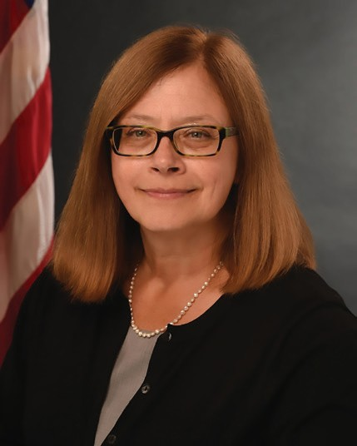
MESSAGE FROM THE ASSISTANT SECRETARY FOR MENTAL HEALTH AND SUBSTANCE USE,
U.S. DEPARTMENT OF HEALTH AND HUMAN SERVICES

As the first U.S. Department of Health and Human Services Assistant Secretary for Mental Health and Substance Use at the Substance Abuse and Mental Health Services Administration (SAMHSA), I am pleased to present this new resource: Prevention and Treatment of HIV Among People Living with Substance Use and/or Mental Disorders.
In response to the charge of the 21st Century Cures Act to disseminate information on evidence-based practices and service delivery models, the National Mental Health and Substance Use Policy Laboratory has developed the Evidence-Based Resource Guide Series focused on the prevention and treatment of substance use disorders (SUD) and mental illnesses. With this specific guide, SAMHSA’s goal is to inform health care practitioners
and administrators, policy makers, and community members about strategies to prevent and treat HIV among individuals who have mental illness and/or SUD.
Established in 2019, the federal initiative “Ending the HIV Epidemic: A Plan for America” aims to reduce new HIV infections in the United States by 90 percent by the year 2030. It encourages implementation of HIV prevention, diagnosis, treatment, and outbreak response through effective programs, practices, and resources.
Supporting the needs of people at risk for and with HIV who have co-occurring mental illness and/or SUD is key to meeting the initiative’s goals. People with mental illness and/or SUD are particularly vulnerable to HIV. SUD, in particular, can hasten the progress of HIV.¹ More specifically, injection drug use increases the risk of getting or transmitting the disease,² and the risk of getting HIV is 4 to 10 times greater for people with mental illness.³
This guide reviews effective programs and practices to prevent HIV and increase adherence to and retention in care. I encourage you to use this guide to become informed about the populations experiencing mental illness and/ or SUD with or at risk for HIV; to review the current evidence on the effectiveness of programs and practices to prevent HIV among this population; and to develop and implement appropriate and effective programming in your communities. Ultimately, your efforts will help meet the goals of ending the HIV epidemic over the next decade.

Elinore F. McCance-Katz, MD, PhD
Assistant Secretary for Mental Health and Substance Use
U.S. Department of Health and Human Services

- National Institute on Drug Abuse. (2020, April 10). Common comorbidities with substance use disorders research report. https:// www.drugabuse.gov/publications/research-reports/common-comorbidities-substance-use-disorders/part-3-connection-between- substance-use-disorders-hiv
- National Institute on Drug Abuse. (2020, April 10). ibid
- Remien, R. H., Stirratt, M. K., Nguyen, N., Robbins, R. N., Pala, A. N., & Mellins, C. A. (2019). Mental health and HIV/AIDS: The need for an integrated response. AIDS, 33(9), 1411-1420. doi: 10.1097/QAD.0000000000002227

Evidence-Based Resource Guide Series Overview

The Substance Abuse and Mental Health Services Administration (SAMHSA), and specifically, the National Mental Health and Substance Use Policy Laboratory (Policy Lab), is pleased to fulfill the charge of the 21st Century Cures Act to disseminate information on evidence-based practices and service delivery models to prevent substance misuse and help people with substance use disorders (SUD), serious mental illnesses (SMI), and serious emotional disturbances (SED) get the treatment and support they need.
Treatment and recovery for SUD, SMI, and SED can vary based on a number of geographic, socio-economic, cultural, gender, race, ethnicity, and age-related factors, which can complicate evaluating the effectiveness
of services, treatments, and supports. Despite these variations, however, there is substantial evidence to inform the types of resources that can help reduce substance use, lessen symptoms of mental illness, and improve quality of life.
This Evidence-Based Resource Guide Series contains a comprehensive set of modules with information
to improve health outcomes for people at risk for developing, living with, or recovering from mental illness and/or SUD. It is designed for practitioners, administrators, community leaders, and others considering an intervention for their organization or community.
A priority topic for SAMHSA is preventing human immunodeficiency virus (HIV) among people with mental illness and/or SUD and linking people with HIV and co-occurring mental illness and/or SUD to HIV care. This guide reviews research findings and literature related to this issue, examines emerging and
best practices, and identifies challenges and strategies for
implementation.

FOREWORD

SAMHSA’s Policy Lab developed this guide between 2019 and 2020, prior to and during the COVID-19 pandemic. The practices and programs included in Chapter 2 were studied prior to the onset of COVID-19 and may require adaptation to accommodate the unique challenges of delivering health care during the pandemic. Implementation strategies, outlined in Chapter 3, may also need to account for COVID-19 conditions in each community, county, and state. Finally, the practices and programs highlighted in Chapter 4 are examples of implementation prior to and at early phases of the pandemic. It is possible these organizations and programs have modified their service delivery to include telehealth and other ways of providing services due to the COVID-19 public health emergency.

Expert panels of federal, state, and non-governmental participants provided input for each guide in this series. The panels included accomplished scientists, researchers, service providers, community administrators, federal and state policy makers, and people with lived experience.
Members provided input based on their knowledge of healthcare systems, implementation strategies, evidence- based practices, provision of services, and policies that foster change.
Research shows that implementing evidence-based practices requires a comprehensive, multi-pronged approach. This guide is one piece of an overall approach to implement and sustain change. Readers are encouraged to visit the SAMHSA website for additional tools and technical assistance opportunities.

Content of the Guide
This guide contains a foreword and five chapters. The chapters stand alone and
can be read in any order. Each chapter is designed to be brief and accessible to healthcare practitioners, healthcare system administrators, community
members, policy makers, and others working to meet the needs of people at risk for developing, experiencing, or recovering from mental illness and/or SUD.
The goal of this guide is to review the literature on preventing and treating HIV for people with mental illness and/or SUD, distill the research into recommendations for practice, and provide examples of how practitioners use these practices in their programs.

FW Evidence-Based Resource Guide Series Overview
Introduction to the series.

- Issue Brief
Overview of current approaches and challenges to preventing and treating HIV for people with mental illness and/or SUD.

- What Research Tells Us
Current evidence on effectiveness of programs and strategies to prevent HIV among people with co-occurring mental illness and/ or SUD and link them to HIV care: Practices to increase uptake of and improve adherence to Pre-Exposure Prophylaxis (PrEP),
Syringe Services Programs, Contingency Management, Cognitive Behavioral Therapy, and Patient Navigation.

- Guidance for Selecting and Implementing Evidence-based Practices
Practical information to consider when selecting and implementing programs and practices to improve health outcomes for people with mental illness and/or SUD with or at risk for HIV.

- Examples of Effective Programs and Strategies
Descriptions of programs and practices to prevent HIV and link people with HIV and co-occurring mental illness and/or SUD to HIV care.

- Resources for Evaluation and Quality Improvement
Guidance and resources for implementing best practices, monitoring outcomes, and improving quality.

FOCUS OF THE GUIDE
People with mental illness and/or SUD are disproportionally affected by HIV. They may participate
in behaviors that increase risk for contracting and transmitting HIV, such as sharing injection drug equipment or engaging in sexual behaviors that increase HIV risk. This guide addresses the co-occurrence of HIV and mental illness and/or SUD. It reviews effective programs and practices to prevent HIV and, for
those with HIV, to increase linkage and retention in care in order to improve health outcomes.

A NOTE ON MEDICATIONS FOR OPIOID USE DISORDER
SAMHSA has an extensive online resource center with tools for use alongside this guide. For example, practitioners can use the current (2020) Treatment Improvement Protocol (TIP) 63: Medications for Opioid Use Disorder together with practices recommended in this guide to support improved health outcomes for people with or at risk for HIV who are experiencing opioid use disorder. To avoid duplication, this guide does not discuss medications for opioid use disorder.

The framework below provides an overview of this guide. The guide addresses the prevention and treatment of HIV among people with mental illness and/or SUD, and focuses on prevention and treatment practices that have been evaluated with adults. The review of these programs and practices in Chapter 2 of the guide includes specific outcomes, practitioner types, and delivery settings.
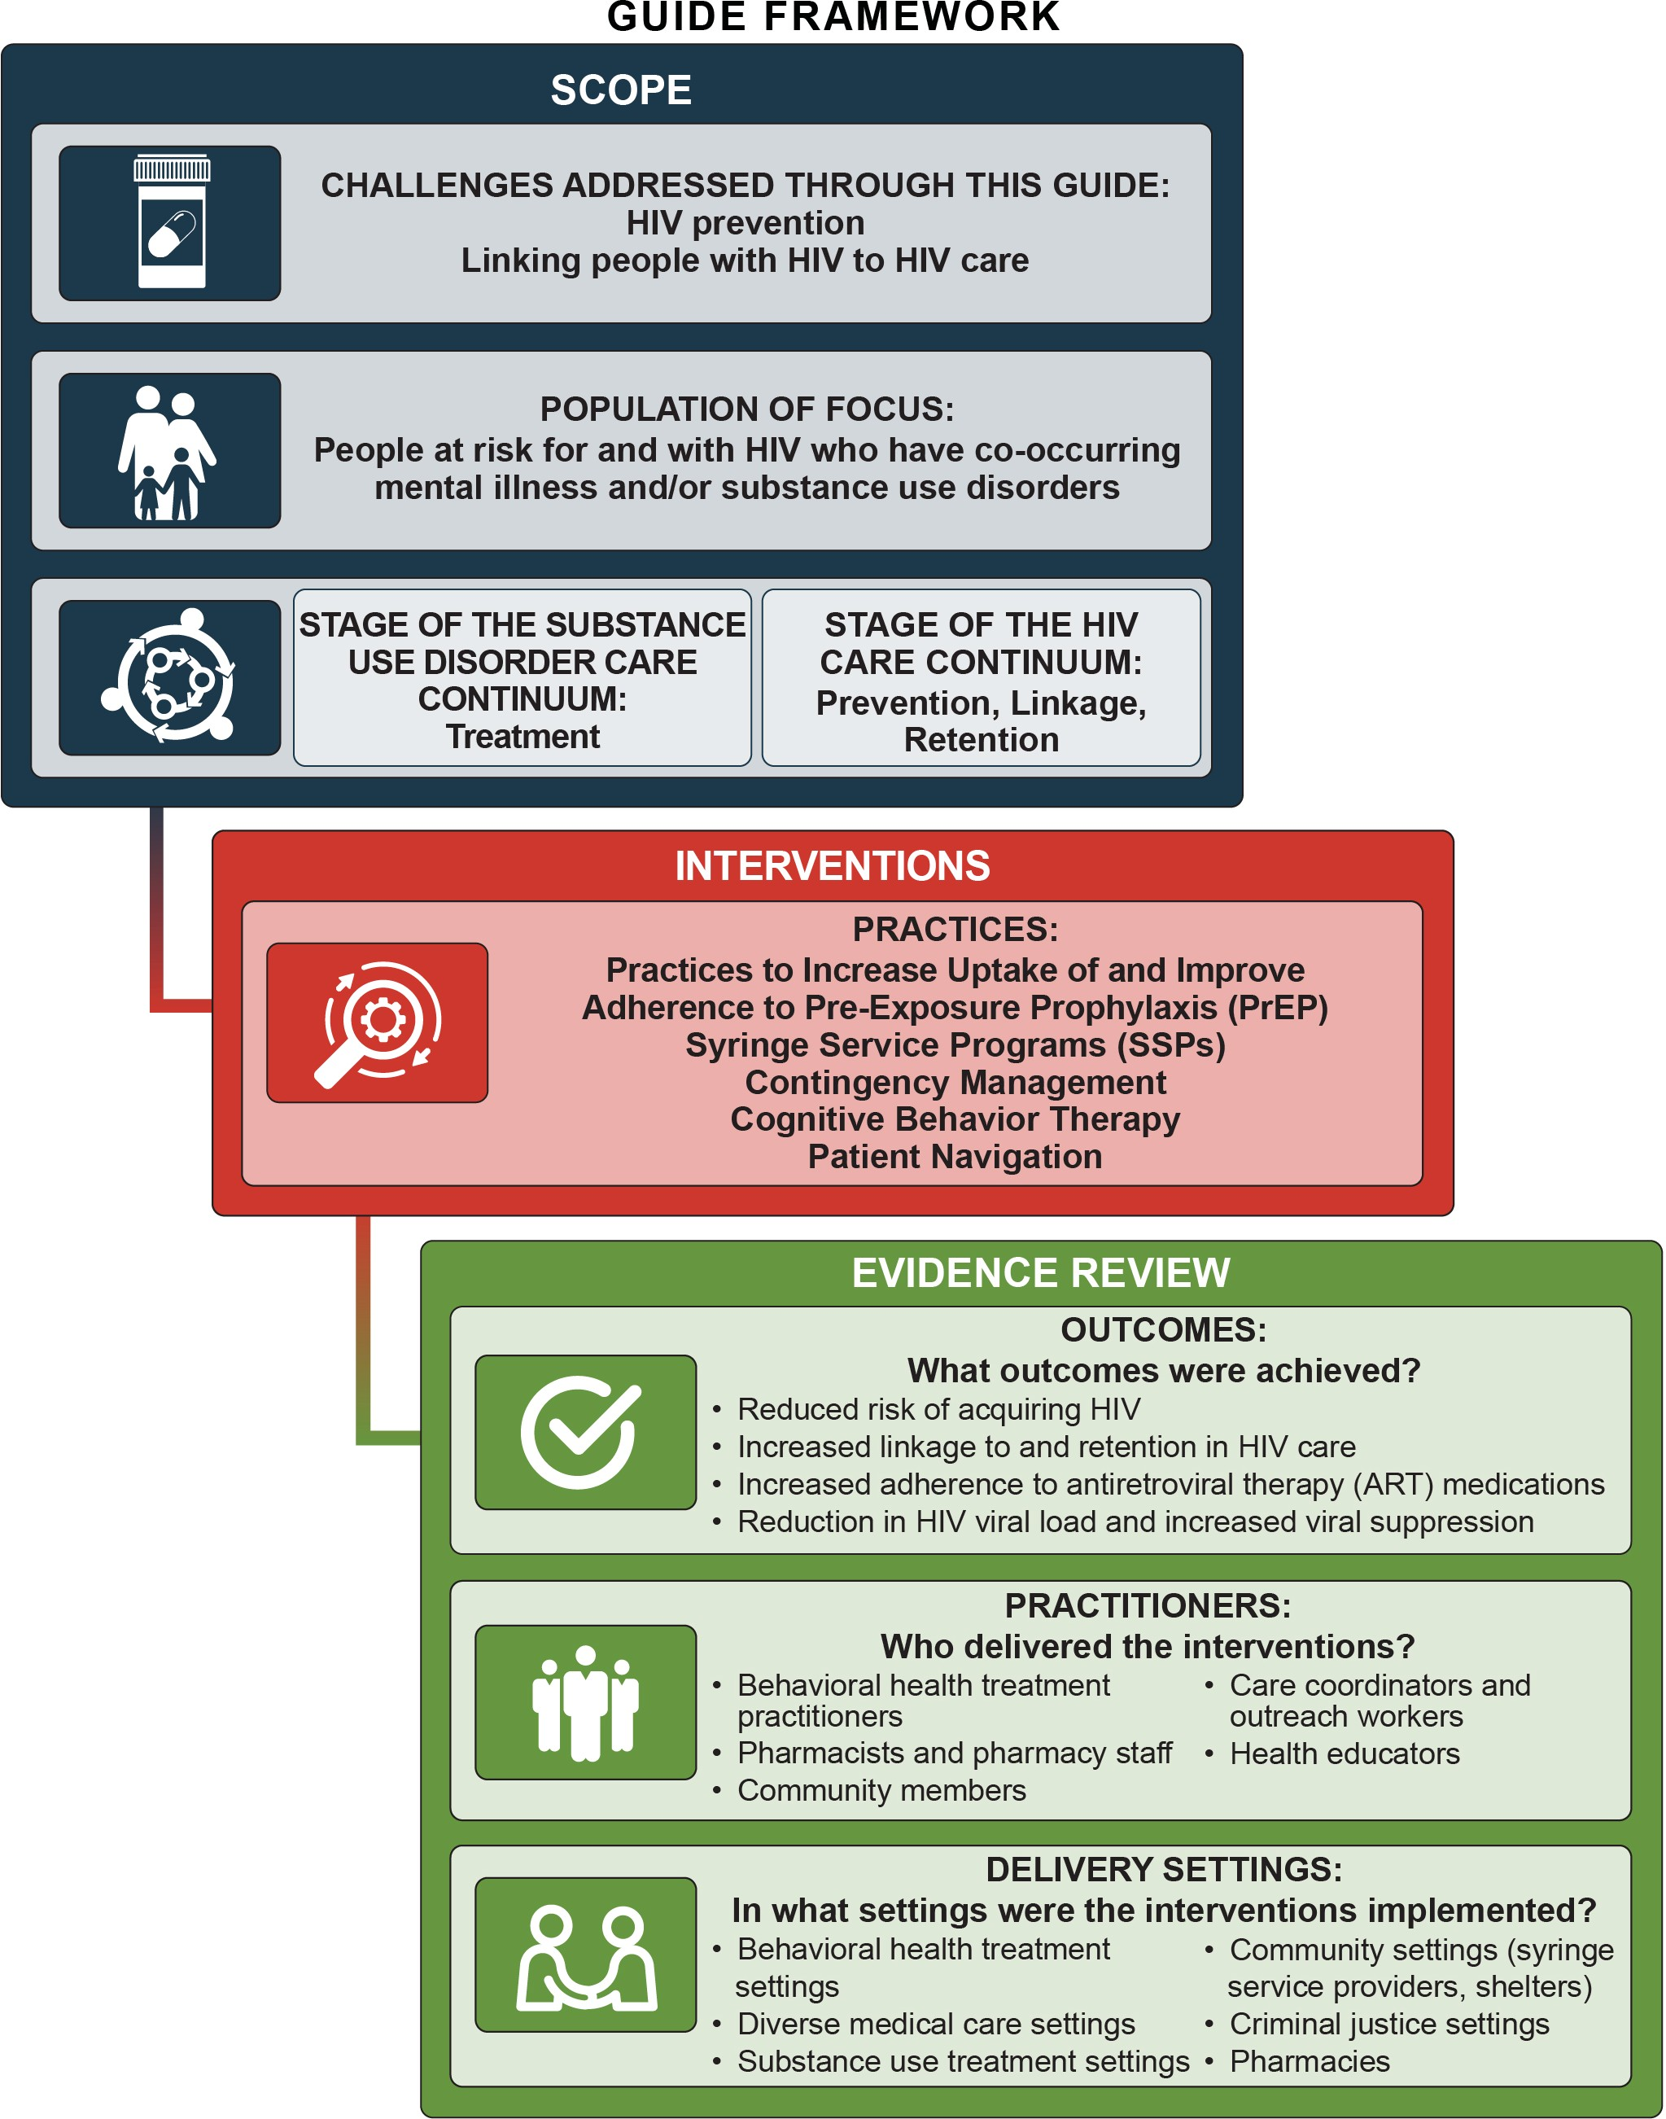

First detected in 1981,¹ human immunodeficiency virus (HIV) is a retrovirus that infects a type of white blood cells called CD4+ T-cells and puts people at increased risk for other infections. If left untreated, HIV can lead to acquired immunodeficiency syndrome (AIDS), which was once a fatal infection.
While there is no cure for HIV, it can be effectively managed as a chronic illness with antiretroviral therapy (ART), and prevented through harm reduction strategies (e.g., condoms and syringe services programs) and medical interventions (e.g., pre-exposure prophylaxis [PrEP] and post-exposure prophylaxis [PEP]).
Substantial progress has been made in preventing HIV and supporting people with HIV, however, there is still room for improvement in addressing linkage to treatment, ART initiation and adherence, and viral
suppression, as well as engagement and retention along the HIV care continuum.

Challenges with client engagement across the HIV care continuum hinder the effectiveness of prevention and treatment efforts. These challenges increase the likelihood of HIV transmission and negative health outcomes for people with HIV.
Established in 2019, the federal initiative “Ending the HIV Epidemic: A Plan for America” (EHE)⁴ capitalizes on scientific discoveries and increased public awareness to prevent and treat HIV. As of 2020, there are 1 million people with HIV in the United States, and an estimated 38,000 new infections occur each year.⁵ The goal of the EHE initiative is to reduce new infections by 75 percent by 2025 and by 90 percent by 2030.⁶
The success of the EHE initiative relies on identifying pathways to increase access to HIV prevention and treatment for those with complex needs.⁷⁻⁸

1CHAPTER
Issue Brief
Biomedical Interventions for HIV Prevention and Treatment
Pre-Exposure Prophylaxis (PrEP) and Post-Exposure Prophylaxis (PEP) are medications that can be taken to prevent HIV transmission. PrEP has been shown to reduce the risk of contracting HIV from sex by 99 percent, and contracting HIV from injection drug use by 74 percent.2 PEP, when taken within three days of possible exposure to the virus, has been shown to lower chances of HIV transmission by more than 80 percent.3
ART is a combination of medications used to treat HIV. ART blocks HIV replication, decreasing the amount of HIV in blood and bodily fluids. By reducing the HIV viral load (amount of virus) in the body, ART improves the health outcomes of people with HIV; decreases mortality; and, when treatment results in an undetectable viral load, reduces the chance of transmitting the disease to others to zero. The availability of and adherence to ART has changed HIV from a terminal diagnosis to a manageable chronic disease.

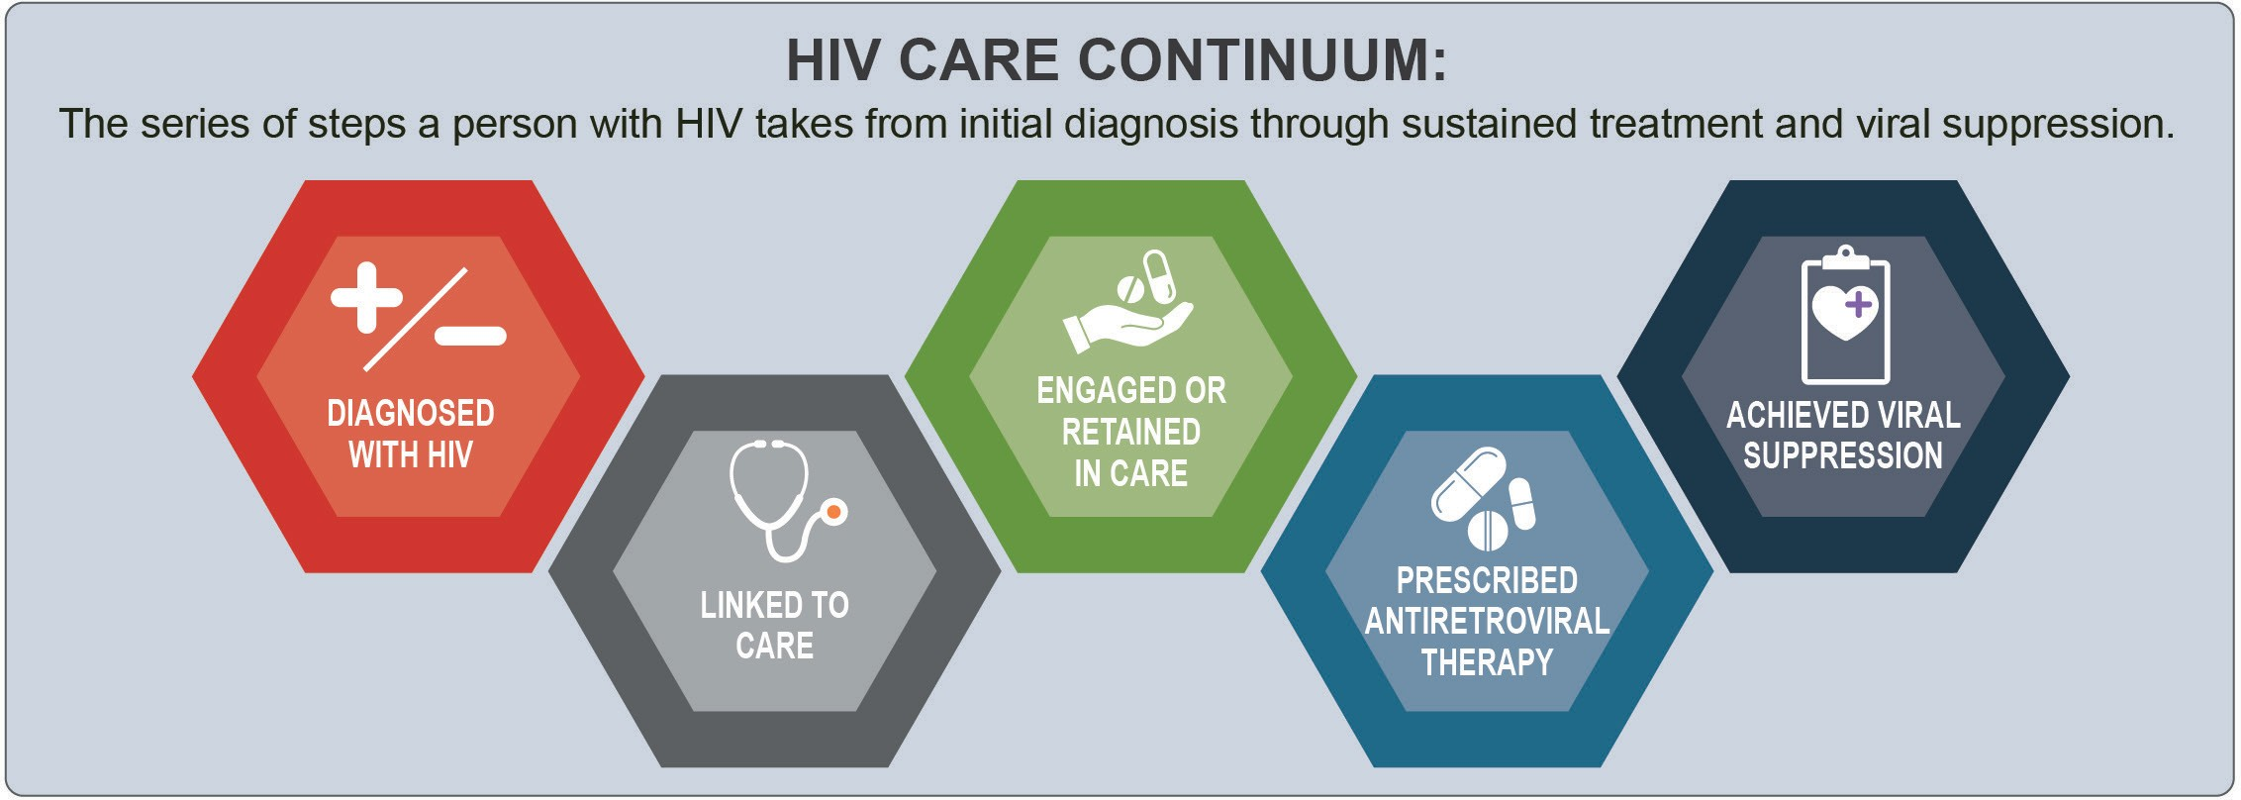

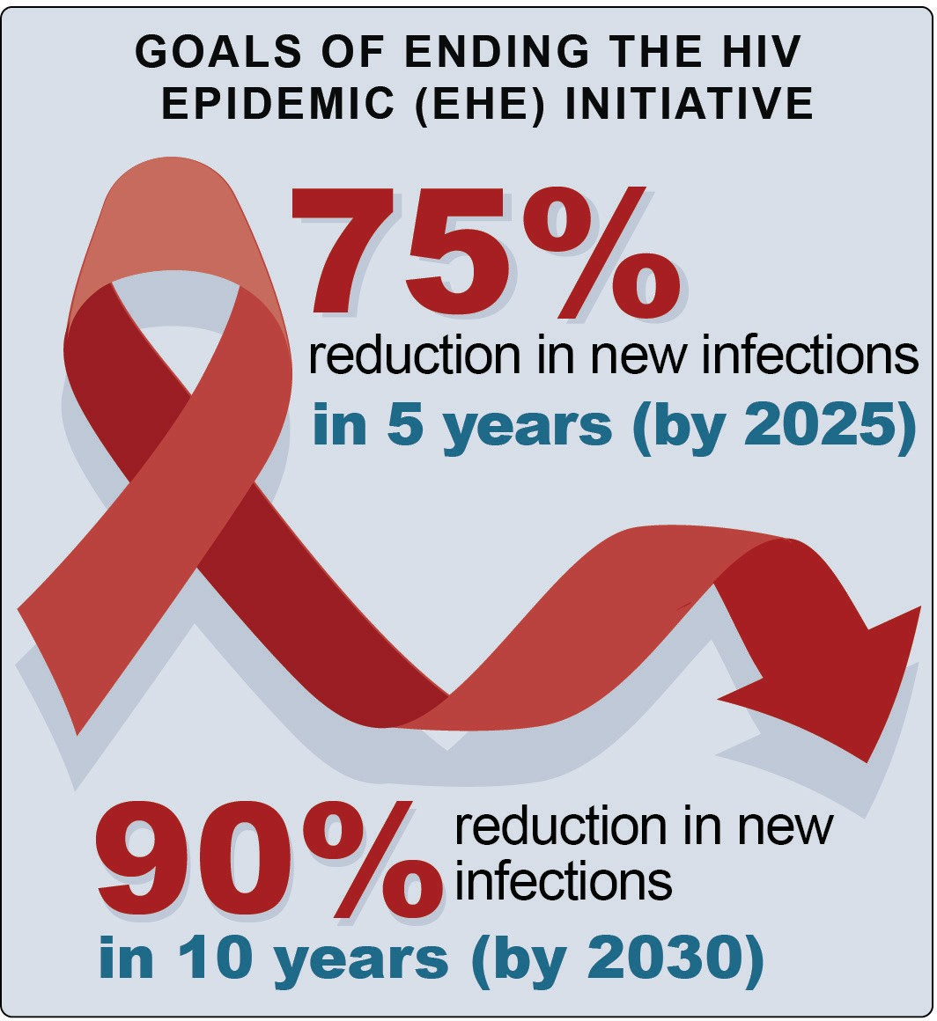

HIV Testing
In the United States, about 1 in 7 (14 percent) of the estimated 1 million people with HIV do not know they have the disease.⁹ Testing identifies a person’s HIV status and helps to link those who are newly diagnosed with HIV to care. Testing also helps to prevent HIV transmission and new infections.¹⁰ Individuals who are undiagnosed or unaware of their HIV infection account for an estimated 30 to 40 percent of ongoing HIV transmissions.¹¹⁻¹² The U.S. Preventive Services Task Force recommends that clinicians conduct screening for
HIV infection among individuals aged 15 to 65, younger adolescents and older adults at increased risk, and all pregnant women, giving the recommendation an “A” rating, requiring HIV testing be provided free by health insurance companies.¹³⁻¹⁵
The EHE initiative recommends the following steps to increase the number of undiagnosed people with HIV who receive an HIV test, are diagnosed, and receive treatment: 1) make HIV testing simple, accessible, and routine in healthcare and non-healthcare settings using innovative technology, systems, and programs; and 2) conduct focused work to increase annual testing among people who are at substantial risk for HIV. HIV testing can be conducted in a range of clinical settings or at home (through rapid or mail-in self-tests).¹⁶⁻¹⁷
Behavioral health providers play an essential role in providing integrated HIV, viral hepatitis, mental health, and substance use screenings within the clinic setting. In a 2019 “Dear Colleague Letter,” SAMHSA called on mental health and substance use providers to increase on-site, same-day oral fluid HIV testing efforts and include HIV testing as part of the standard of care.¹⁹ Oral fluid testing can be self-administered and provides results within 20 minutes.²⁰ Settings that provide screening for many common co-occurring illnesses often include testing for viral hepatitis to address both hepatitis prevention and potentially serious co-occurring HIV and viral hepatitis infections.²¹
People with any mental illness diagnoses or symptoms were more likely to report being tested for HIV than those without mental illness diagnoses or symptoms.²²

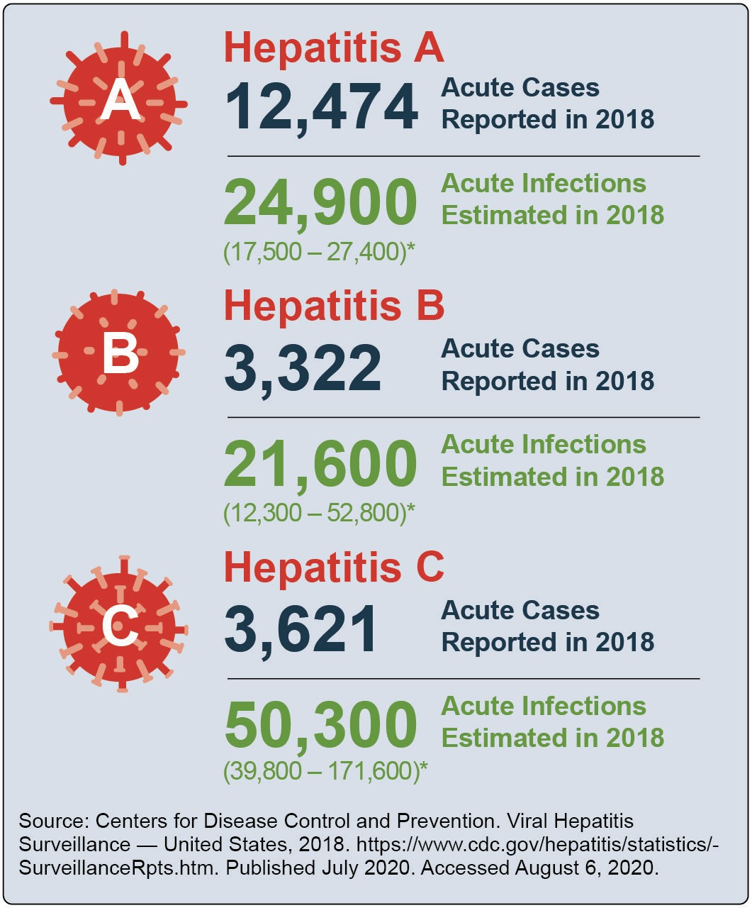
However, only 48.5 percent of people with a mental illness have had an HIV test.²³ Once diagnosed with HIV, persons with three or more psychosocial concerns were less likely to be adherent to HIV medications and persons with four or more problems were less likely to be virally suppressed.²⁴ People with mental illnesses were less likely to be prescribed ART and achieve viral suppression.²⁵
Aligning with the EHE key strategy of diagnosing all individuals with HIV, universal testing in behavioral health settings can support rapid linkage to preventive services and HIV care including supportive services to increase PrEP uptake and adherence, syringe services programs (SSPs), cognitive behavioral therapy (CBT), contingency management (CM), and patient navigation (further discussed in Chapter 2).²⁶ The flow diagram (on page 4) shows the role of mental health and substance use providers in caring for clients who are at risk for or have been diagnosed with HIV.

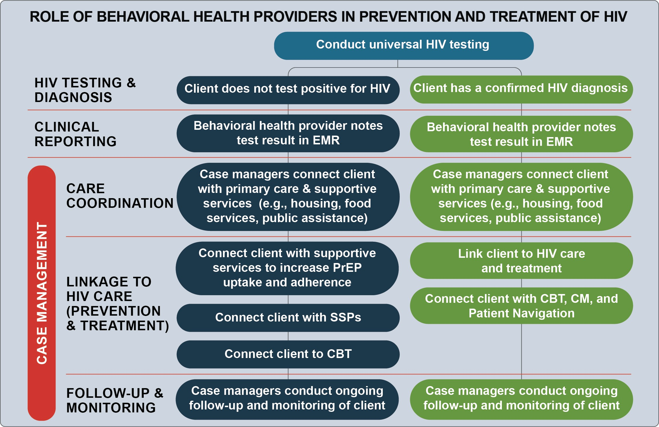

Substance Use and HIV
SUD can increase the risk of getting HIV and negatively impact HIV care, treatment, and related health outcomes. The prevalence of substance use among people with HIV is also higher than among the general population (as shown in the chart below). People who inject drugs (PWID) are at increased risk for blood borne pathogens, such as HIV and hepatitis B and C.²⁷ In 2017, 9 percent (or 3,641) of the 38,739 new HIV diagnoses in the United States and its territories were among PWID.^{6,}
²⁸ Of that population, 2,625 were male and 1,016 were female.²⁸ Six percent (or 2,389) of new HIV diagnoses in the United States were directly attributed to PWID.²⁹ New HIV diagnoses are most prevalent among Whites, Blacks/African Americans, and individuals between the ages of 25 and 44.²⁸
In addition, research suggests that substance use, including alcohol,³⁰⁻³² methamphetamine,³³⁻³⁴ cocaine,³⁵ opioids, and inhalants, increases sexual behaviors that are associated with increased likelihood of getting HIV (e.g., condomless sex).^{28,} ³⁶⁻³⁸

Mental Health and HIV
Mental illness can interfere with HIV prevention and adherence to treatment⁴⁸⁻⁴⁹ and is linked to behaviors that increase likelihood of getting HIV.

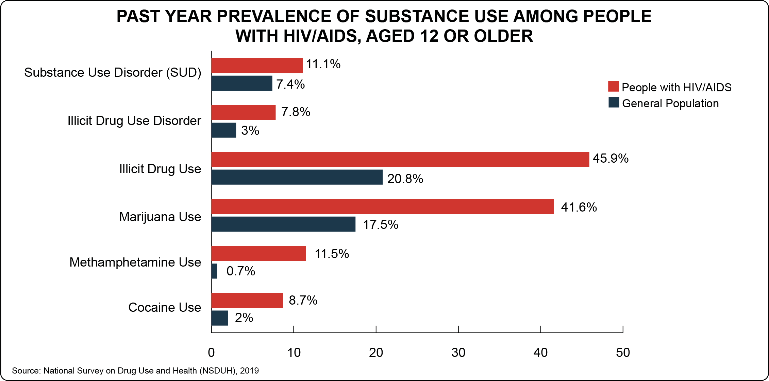

Substances and HIV-Related Outcomes
Alcohol | Heavy alcohol consumption is linked to sexual behaviors that increase likelihood of getting HIV and associated with delays in HIV diagnosis and lower rates of ART receipt and adherence.39-40
Opioids | Opioid use is associated with injection drug use equipment sharing and sexual behaviors that increase likelihood of getting HIV.41-42 Injection drug use presents increased likelihood for HIV transmission, because the virus can survive in a used syringe for up to 42 days. A person without HIV has a 1 in 160 chance of getting HIV when using a syringe previously used by someone who has HIV.38 Emerging evidence suggests that individuals who misuse prescription opioids are engaging in sexual behaviors that increase likelihood of getting HIV (e.g., condomless sex, sex with multiple partners).42-43
Methamphetamine | Methamphetamine use is associated with injection drug use equipment sharing and sexual behaviors that increase likelihood of getting HIV. People who actively use methamphetamines have lower rates of adherence to ART and medical follow- up (impacting both prevention and treatment).44-45
“Club drugs” [e.g., 3,4- methylenedioxymethamphetamine (MDMA, Ecstasy, Molly), Ketamine (Special K), Gamma Hydroxybutyric Acid (GHB, Liquid Ecstasy), alkyl nitrites (Poppers, TNT)]46 | “Club drugs” have been linked to sexual behaviors that increase likelihood of getting HIV. However, studies on these drugs are complicated, as it can be difficult to determine the timing of drug use and sexual behavior. Poly-drug use is also common among users of club drugs, complicating analyses.47

The prevalence of mental illness among people with HIV is also higher than among the general population (as shown in the chart below). People with HIV may experience
high rates of depression, mood disorders, and generalized anxiety disorder.⁵⁰⁻⁵⁵ An estimated 10 to 28 percent of people with HIV have co-occurring mental illness and/or SUD.⁵⁶ People with HIV who also experience depression report higher rates of other co-occurring mental health concerns such as anxiety disorders (78 percent) and
SUD (61 percent), as well as increased viral loads.^{54,} ⁵⁷⁻⁵⁸
Depression in people with HIV can also negatively affect
HIV treatment, as it is associated with discontinuation of and non-adherence to ART.⁵⁹⁻⁶⁰
In addition to depression and anxiety, trauma and post- traumatic stress disorder (PTSD) are strongly associated with HIV. Experiences of trauma among people with HIV can lead to behavior that increases likelihood of transmitting HIV, lower adherence to HIV care and ART, and higher likelihood of AIDS-related mortality.⁶¹
Among women in the United States with HIV, 30 percent
have PTSD (five times the national rate for women).⁶²

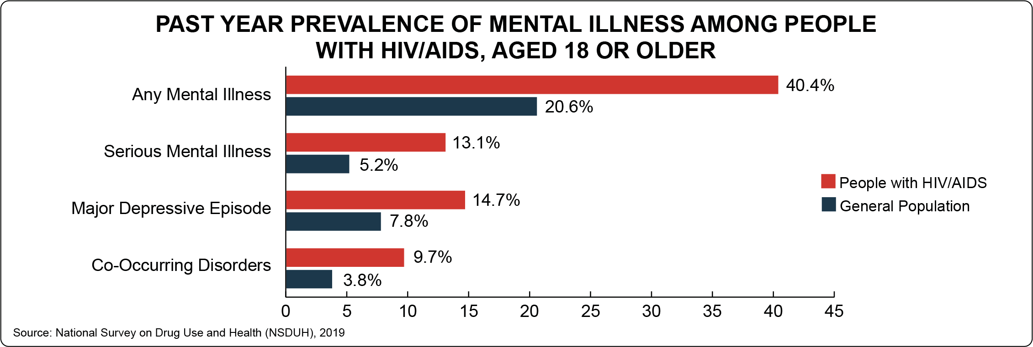

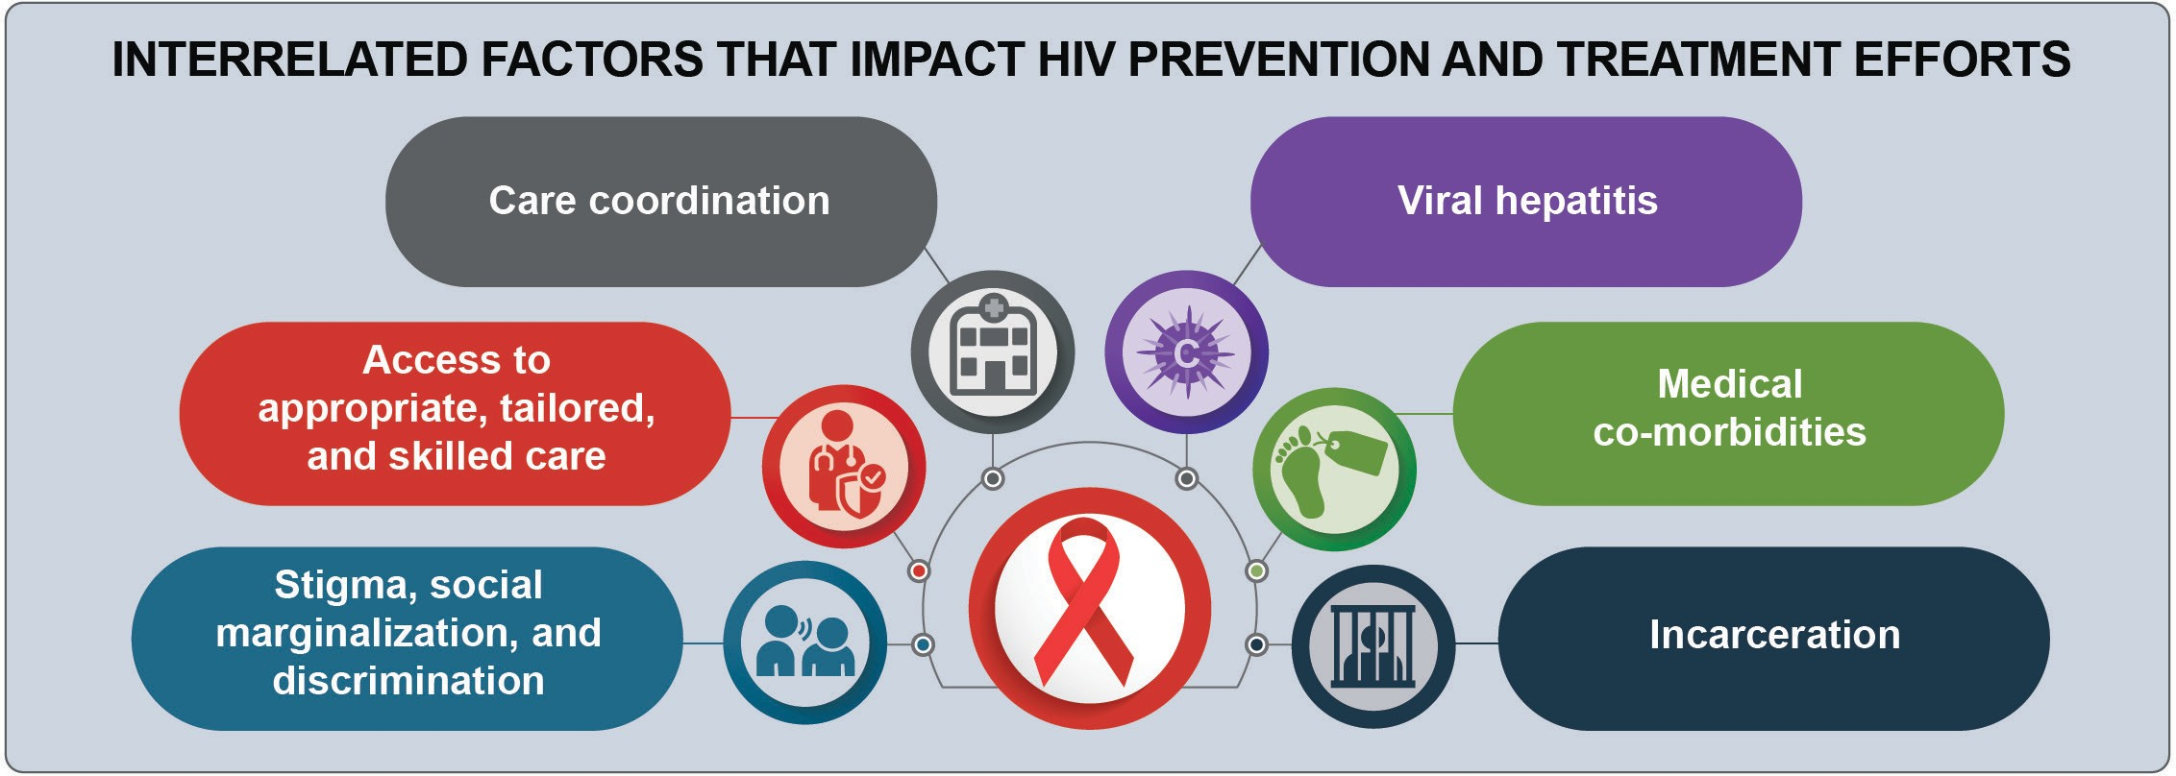

Furthermore, women from low-income, high-HIV prevalence communities experience stressors that lead to the development of PTSD, such as high rates of child
maltreatment and physical, emotional, and sexual abuse.⁶³

Interrelated Factors that Impact HIV Prevention and Treatment Efforts
Understanding the complex relationship between social determinants of health, unmet needs, and HIV-related risk factors is key to addressing HIV and mental illness and/ or SUD.⁶⁴ For example, it is difficult to engage people in HIV prevention or treatment programs when their basic ancillary needs (e.g., housing, child care, transportation, food, employment, health insurance) are not met.⁶⁵⁻⁶⁸ In urban, high-poverty areas, higher HIV prevalence tends to be associated with socioeconomic status, including educational attainment, household income, employment status, structural racism, and housing status.⁶⁹⁻⁷⁰ There are six key interrelated factors (identified below) that impact HIV prevention and treatment efforts addressed through the practices highlighted in this guide.

Stigma, social marginalization, and discrimination
Stigma is a “perennial problem,”⁷¹ contributing to poor ART adherence, higher rates of depression,⁷² and challenges related to HIV prevention (e.g., fear of disclosure impacting negotiation of condom use).⁷³
Stigmatizing beliefs (e.g., that HIV can be transmitted through coughing or sneezing) contribute to a culture of social discomfort, prejudice, violence, and discriminatory actions (e.g., avoiding interactions with a person they know has HIV).⁷³ Stigma and mistrust of medical systems may deter individuals from seeking care and from sharing
with their healthcare providers details about behaviors that increase risk of getting HIV (e.g., injection drug use, condomless sex) and existing medical conditions (e.g., mental illness, SUD, HIV status, testing, and medication adherence).

Access to appropriate, tailored, and skilled care
Mental illness and SUD are conditions that present barriers to accessing and linking to HIV care, as well as initiating and adhering to medication (ART, PrEP, and PEP).^{60,} ⁷⁴⁻⁸⁰ Access to treatment is key to reaching viral suppression.⁷⁹ Individuals may experience challenges in finding providers that have expertise in HIV, mental health, and SUD. Mental illness and SUD treatment
providers are well positioned to address some of the social determinants of health and unmet needs, but they may need additional training to address co-occurring HIV.⁸¹

Care coordination
Untreated or undertreated mental illness and/or SUD can create obstacles to initiating and continuing PrEP and ART, increasing the potential for HIV transmission.
Integrated testing (as previously described) and service delivery (e.g., multi-disciplinary teams and one-stop-shop models that provide co-located or coordinated substance use, mental health, medical, and social services, further discussed in Chapter 3) are successful strategies for engaging and retaining in care people with or at risk for HIV who may have multiple co-occurring health and ancillary service needs.⁸²⁻⁸⁵ Coordinated care, linkage to HIV care, and patient follow-up and monitoring within behavioral health settings (further discussed in Chapter 2) are also key to facilitating HIV prevention and treatment.

Medical co-morbidities
People with HIV have been shown to be at higher risk for cardiovascular disease, hepatic and renal disease, osteoporosis and fractures, metabolic disorders,
skin and soft-tissue disorders, pulmonary disorders, central nervous system disorders, and various forms of cancer.⁸⁶⁻⁸⁷ Cognitive difficulties can be caused by the impact of HIV on the brain (i.e., HIV-associated neurocognitive disorder).⁸⁸⁻⁸⁹ Possible side effects and interactions from pharmacological therapy, including
ART and medication for opioid use disorder, may further complicate health outcomes.^{86-87,} ⁹⁰

Viral hepatitis
People with HIV are disproportionately affected by viral hepatitis (hepatitis A virus [HAV], hepatitis B virus [HBV], and hepatitis C virus [HCV]). Of those with co- occurring HIV and viral hepatitis, about one third have both HBV and HCV. HBV and HCV are bloodborne pathogens, which can be spread through needle sharing associated with injection-drug use.²¹ Nearly 75 percent of people with HIV who inject drugs also are infected with HCV.⁹¹ Both HBV and HCV are also associated with sexual behaviors that increase risk of HIV (e.g., condomless sex). About half of people who have HCV do not display symptoms, so it is important that regular testing is done.⁹² Co-occurring HIV and viral hepatitis present challenges in managing and treating HIV infection.^{91,} ⁹⁴⁻⁹⁵ Hepatitis A, B, and C are all associated with liver inflammation and liver damage. When the liver is inflamed, it is less able to process medications including anti-retroviral medications, which can cause
worsened side effects of HIV medicine.⁹⁶ People with HIV who contract viral hepatitis are more likely to experience a faster progression of liver-related injury than people who do not have HIV.²¹ Medications to treat hepatitis are similar to HIV in that they are anti- retroviral. However, some medications that treat HIV and HCV are not safe to use together, so it is important that people with HIV and HCV regularly consult with a doctor.⁹⁴

Incarceration
While the extent of HIV transmission within jails and
prisons is not fully understood,⁹⁷⁻⁹⁹ the risk of HIV is heightened for incarcerated populations compared to non-incarcerated populations, namely due to high rates of HIV in prisons, inconsistent screening for
HIV upon entry and release, condomless sex, injection drug use equipment sharing, and the labeling of condoms as contraband within prisons.¹⁰⁰⁻¹⁰² Release from incarceration is widely considered an especially vulnerable period for both opioid overdose¹⁰¹⁻¹⁰³ and discontinuation of HIV care and ART treatment provided during incarceration. The interruption in care can lead to reductions in treatment adherence^{101,} ¹⁰⁴ and increases in viral loads.¹⁰¹⁻¹⁰²
¹ HIV.gov. (n.d.). A timeline of HIV and AIDS. https:// www.hiv.gov/hiv-basics/overview/history/hiv-and- aids-timeline
² Centers for Disease Control and Prevention. (2019, October 17). PrEP. https://www.cdc.gov/hiv/basics/ prep.html

Reference List

³ Centers for Disease Control and Prevention. (2019, August 6). PEP. https://www.cdc.gov/hiv/basics/pep. html
⁴ Fauci, A. S., Redfield, R. R., Sigounas, G., Weahkee,
M. D., & Giroir, B. P. (2019). Ending the HIV Epidemic: A plan for the United States. Journal of the American Medical Association (JAMA), 321(9), 844-845. https://doi.org/10.1001/jama.2019.1343
⁵ HIV.gov. (2020, January 16). HIV basics - overview: Data & trends: U.S. statistics. https://www.hiv.gov/ hiv-basics/overview/data-and-trends/statistics
⁶ HIV.gov. (2019, September 3). What is Ending the HIV Epidemic: A plan for America? https://www. hiv.gov/federal-response/ending-the-hiv-epidemic/ overview
⁷ Remien, R. H. (2019, January). The impact of mental health across the HIV care continuum: Mental health treatment gaps are drivers of increased HIV acquisition and poor health outcomes. American Psychological Association Psychology and AIDS Exchange Newsletter. https://www.apa. org/pi/aids/resources/exchange/2019/01/continuum
⁸ Bavinton, B. R., Pinto, A. N., Phanuphak, N., Grinsztejn, B., Prestage, G. P., Zablotska-Manos, I. B., Jin, F., Fairley, C. K., Moore, R., Roth, N., Bloch, M., Pell, C., McNulty, A. M., Baker, D., Hoy, J.,
Tee, B. K., Templeton, D. J., Cooper, D. A., Emery, S.,… Grulich, A. E. (2018). Viral suppression and HIV transmission in serodiscordant male couples: An international, prospective, observational, cohort study. The Lancet HIV, 5(8), e438-e447. https://doi. org/10.1016/s2352-3018(18)30132-2
⁹ Centers for Disease Control and Prevention. (2020, July 30). ‘Ending the HIV Epidemic’: CDC Role - Diagnose. https://www.cdc.gov/endhiv/diagnose.html
¹⁰ Mayo Clinic. (2020, January 10). HIV testing. https://www.mayoclinic.org/tests-procedures/hiv- testing/about/pac-20385018#:~:text=Why%20 it’s%20done,spreading%20the%20virus%20to%20 others.
¹¹ Centers for Disease Control and Prevention. (2020, January 21). HIV testing. https://www.cdc.gov/hiv/ guidelines/testing.html
¹² Skarbinski, J, Rosenberg, E, Paz-Bailey, G, et
al. Human immunodeficiency virus transmission at
each step of the care continuum in the United States.
JAMA Intern Med. 2015;175(4):588–596. https:// jamanetwork.com/journals/jamainternalmedicine/ fullarticle/2130723
¹³ Moyer, VA US Preventive Services Task Force
. Screening for HIV: U.S. Preventive Services Task Force recommendation statement. Ann Intern
Med. 2013;159:51–60. https://www.acpjournals.org/
doi/10.7326/0003-4819-159-1-201307020-00645
¹⁴ Background: The Affordable Care Act’s new rules on preventive care. CMS.gov website. Published July 14, 2010. Accessed October 1, 2019. https:// www.cms.gov/CCIIO/Resources/Fact-Sheets-and- FAQs/preventive-care-background.html
¹⁵ Owens, D. K., Davidson, K. W., Krist, A. H., Barry,
M. J., Cabana, M., Caughey, A. B., Curry, S. J., Doubeni, C. A., Epling, J. W., Kubik, M., Landefeld,
C. S., Mangione, C. M., Pbert, L., Silverstein, M., Simon, M. A., Tseng, C.-W., & Wong, J. B. (2019). Screening for HIV Infection. JAMA, 321(23), 2326. https://doi.org/10.1001/jama.2019.6587
¹⁶ Centers for Disease Control and Prevention. (2020, August 4). HIV Testing: Let’s Stop HIV Together. https://www.cdc.gov/stophivtogether/hiv-testing/ index.html
¹⁷ Centers for Disease Control and Prevention. GetTested: National HIV, STD, and hepatitis testing. https://gettested.cdc.gov/
¹⁸ Centers for Disease Control and Prevention. (2018). Quick reference guide: recommended laboratory HIV testing algorithm for serum or plasma speci- mens. https://stacks.cdc.gov/view/cdc/50872
¹⁹ Substance Abuse and Mental Health Services Administration, & McCance-Katz, Elinore. (2019, November 21). Dear colleauge letter from Dr. McCance-Katz on oral fluids HIV testing. https:// www.samhsa.gov/sites/default/files/oral-fluids-dear- colleague-letter.pdf
²⁰ Centers for Disease Control and Prevention. Types of HIV Tests. (2020, June 8). https://www.cdc.gov/hiv/ basics/hiv-testing/test-types.html
²¹ Centers for Disease Control and Prevention. (2020, May 21). Viral hepatitis: People with coinfected with HIV and viral hepatitis. https://www.cdc.gov/

hepatitis/populations/hiv.htm
²² Blank, M. B., Himelhoch, S. S., Balaji, A. B., Metzger, D. S., Dixon, L. B., Rose, C. E.,
Oraka, E., Davis-Vogel, A., Thompson, W. W., & Heffelfinger, J. D. (2014). A multisite study of the prevalence of HIV with rapid testing in
mental health settings. American Journal of Public Health, 104(12), 2377–2384. https://doi.org/10.2105/ AJPH.2013.301633
²³ Yehia, B. R., Cui, W., Thompson, W. W., Zack, M. M., McKnight-Eily, L., DiNenno, E., Rose, C. E., & Blank, M. B. (2014). HIV testing among adults with mental illness in the United States. AIDS
Patient Care and STDs, 28(12), 628–634. https://doi. org/10.1089/apc.2014.0196
²⁴ Mizuno, Y., Purcell, D. W., Knowlton, A. R., Wilkinson, J. D., Gourevitch, M. N., & Knight, K. R. (2015). Syndemic vulnerability, sexual and injection risk behaviors, and HIV continuum of care outcomes in HIV-positive injection drug users. AIDS and Behavior, 19(4), 684–693. https://doi.org/10.1007/ s10461-014-0890-0
²⁵ Yehia, B. R., Stephens-Shield, A. J., Momplaisir, F., Taylor, L., Gross, R., Dubé, B., Glanz, K., & Brady, K. A. (2015). Health outcomes of HIV- infected people with mental illness. AIDS and
Behavior, 19(8), 1491–1500. https://doi.org/10.1007/ s10461-015-1080-4
²⁶ HIV.gov. (2020, May 8). ‘Ending the HIV Epidemic’: Key strategies in the plan. https://www. hiv.gov/federal-response/ending-the-hiv-epidemic/ key-strategies
²⁷ Wejnert, C., Hess, K. L., Hall, H. I., Van Handel, M., Hayes, D., Fulton, P. J., An, Q., Koenig, L. J., Prejean, J., & Valleroy, L. A. (2016). Vital signs: Trends in HIV diagnoses, risk behaviors, and prevention among persons who inject drugs—United States. Morbidity and Mortality Weekly Report (MMWR), 65(47), 1336- 1342. https://doi.org/10.15585/mmwr.mm6547e1
²⁸ Centers for Disease Control and Prevention. (2019, August 21). HIV and people who inject drugs. https://www.cdc.gov/hiv/group/hiv-idu.html
²⁹ Centers for Disease Control and Prevention. (2019, August 6). Basic statistics. https://www.cdc.gov/hiv/ basics/statistics.html
³⁰ Bryant, K. J., Nelson, S., Braithwaite, R. S., & Roach,
D. (2010). Integrating HIV/AIDS and alcohol research. Alcohol Research & Health: The Journal of the National Institute on Alcohol Abuse and Alcoholism, 33(3), 167-178. https://www.ncbi.nlm.nih.gov/ pubmed/23584058
³¹ Woolf, S. E., & Maisto, S. A. (2009). Alcohol use and risk of HIV infection among men who have sex with men. AIDS and Behavior, 13(4), 757-782. https://doi. org/10.1007/s10461-007-9354-0
³² Kerr, D. C., Washburn, I. J., Morris, M. K., Lewis, K. A., & Tiberio, S. S. (2015). Event-level associations of marijuana and heavy alcohol use
with intercourse and condom use. Journal of Studies on Alcohol and Drugs, 76(5), 733-737. https://doi. org/10.15288/jsad.2015.76.733
³³ Hoenigl, M., Chaillon, A., Moore, D. J., Morris, S. R., Smith, D. M., & Little, S. J. (2016). Clear links between starting methamphetamine and increasing sexual risk behavior: A cohort study among men who have sex with men. Journal of Acquired Immune Deficiency Syndromes (JAIDS), 71(5), 551- 557. https://doi.org/10.1097/qai.0000000000000888
³⁴ Freeman, P., Walker, B. C., Harris, D. R., Garofalo, R., Willard, N., Ellen, J. M., & Adolescent Trials Network for HIV/AIDS Interventions 016b Team. (2011). Methamphetamine use and risk for HIV among young men who have sex with men in 8
US cities. Archives of Pediatrics & Adolescent Medicine, 165(8), 736-740. https://doi.org/10.1001/ archpediatrics.2011.118
³⁵ Khan, M. R., Berger, A., Hemberg, J., O’Neill, A., Dyer, T. P., & Smyrk, K. (2013). Non-injection and injection drug use and STI/HIV risk in the United States: The degree to which sexual risk behaviors versus sex with an STI-infected partner account for infection transmission among drug users. AIDS and Behavior, 17(3), 1185-1194. https://doi.org/10.1007/ s10461-012-0276-0
³⁶ Woolf-King, S. E., Rice, T. M., Truong, H. M., Woods, W. J., Jerome, R. C., & Carrico, A. W. (2013). Substance use and HIV risk behavior among men who have sex with men: The role of sexual compulsivity. Journal of Urban Health: Bulletin of the New York Academy of Medicine, 90(5), 948-952. https://doi.org/10.1007/s11524-013-9820-0
³⁷ Shoptaw, S., Montgomery, B., Williams, C. T., El- Bassel, N., Aramrattana, A., Metsch, L., Metzger, D. S., Kuo, I., Bastos, F. I., & Strathdee, S. A. (2013). Not just the needle: The state of HIV-prevention science among substance users and future directions. Journal of Acquired Immune Deficiency Syndromes (JAIDS), 63, S174-S178. https://doi.org/10.1097/ QAI.0b013e3182987028
³⁸ Centers for Disease Control and Prevention. (2019, September 18). Injection drug use and HIV risk. https://www.cdc.gov/hiv/risk/idu.html
³⁹ Vagenas, P., Azar, M. M., Copenhaver, M. M., Springer, S. A., Molina, P. E., & Altice, F. L. (2015). The impact of alcohol use and related disorders on

the HIV continuum of care: A systematic review. Current HIV/AIDS Reports, 12(4), 421-436. https:// doi.org/10.1007/s11904-015-0285-5
⁴⁰ Chichetto, N. E., Mannes, Z. L., Allen, M. K., Cook, R. L., & Ennis, N. (2019). HIV care provider perceptions and approaches to managing unhealthy
alcohol use in primary HIV care settings: A qualitative study. Addiction Science & Clinical Practice, 14(1), 21. https://doi.org/10.1186/s13722-019-0150-8
⁴¹ Lerner, A. M., & Fauci, A. S. (2019). Opioid injection in rural areas of the United States: A potential obstacle to ending the HIV epidemic. Journal of the American Medical Association (JAMA), 322(11), 1041-1042. https://doi. org/10.1001/jama.2019.10657
⁴² Buttram, M. E., & Kurtz, S. P. (2016). Alternate routes of administration among prescription opioid misusers and associations with sexual HIV
transmission risk behaviors. Journal of Psychoactive Drugs, 48(3), 187-194. https://doi.org/10.1080/0279
1072.2016.1187319
⁴³ Lemons, A., DeGroote, N., Perez, A., Craw, J., Nyaku, M., Broz, D., Mattson, C. L., & Beer, L. (2019). Opioid misuse among HIV-positive adults in medical care: Results from the medical monitoring project, 2009-2014. Journal of Acquired Immune Deficiency Syndromes (JAIDS), 80(2), 127-134. https://doi.org/10.1097/QAI.0000000000001889
⁴⁴ Yeon, P., & Albrecht, H.. (2007). Crystal meth and HIV/AIDS: The perfect storm. NEJM Journal Watch. https://www.jwatch.org/
ac200712030000001/2007/12/03/crystal-meth-and- hiv-aids-perfect-storm
⁴⁵ Health Resources and Services Administration. (2009, June). HRSA CARE Action: Methamphetamine and HIV. https://hab. hrsa.gov/sites/default/files/hab/Publications/ careactionnewsletter/june2009.pdf
⁴⁶ Drug Enforcement Agency Houston Division. (2017). DEA intelligence report: Drug slang code words. https://www.dea.gov/sites/default/files/2018-07/DIR- 020-17%20Drug%20Slang%20Code%20Words.pdf
⁴⁷ Grov, C., Kelly, B. C., & Parsons, J. T. (2009). Polydrug use among club-going young adults recruited through time-space sampling. Journal of Substance Use and Misuse, 44(6), 848-864. https:// doi.org/10.1080/10826080802484702
⁴⁸ Mehrotra, M. L., Glidden, D. V., McMahan, V., Amico, K. R., Hosek, S., Defechereux, P., Mayer,
K. H., Veloso, V. G., Bekker, L., Avelino-Silva, V. I., Schechter, M., & Grant, R. M. (2016). The effect of depressive symptoms on adherence to daily oral
PrEP in men who have sex with men and transgender
women: A marginal structural model analysis of the iPrEx OLE study. AIDS and Behavior, 20(7), 1527- 1534. https://doi.org/10.1007/s10461-016-1415-9
⁴⁹ Senn, T. E., & Carey, M. P. (2009). HIV testing among individuals with a severe mental illness: Review, suggestions for research, and clinical implications. Psychological Medicine, 39(3), 355- 363. https://doi.org/10.1017/S0033291708003930
⁵⁰ Yehia, B. R., Stewart, L., Momplaisir, F., Mody, A., Holtzman, C. W., Jacobs, L. M., Hines, J., Mounzer, K., Glanz, K., Metlay, J. P., & Shea, J. A. (2015). Barriers and facilitators to patient retention in HIV care. BMC Infectious Diseases, 15(1), 246. https://doi. org/10.1186/s12879-015-0990-0
⁵¹ Bing, E. G., Burnam, M. A., Longshore, D., Fleishman, J. A., Sherbourne, C. D., London, A. S., Turner, B. J., Eggan, F., Beckman, R., & Vitiello,
B. (2001). Psychiatric disorders and drug use among human immunodeficiency virus-infected adults in the United States. Archives of General Psychiatry, 58(8), 721-728. https://doi.org/10.1001/ archpsyc.58.8.721
⁵² Machtinger, E. L., Wilson, T. C., Haberer, J. E., & Weiss, D. S. (2012). Psychological trauma and PTSD in HIV-positive women: A meta-analysis. AIDS and Behavior, 16(8), 2091-2100. https://doi.org/10.1007/ s10461-011-0127-4
⁵³ Parhami, I., Fong, T. W., Siani, A., Carlotti, C., & Khanlou, H. (2013). Documentation of psychiatric disorders and related factors in a large sample population of HIV-positive patients in California. AIDS and Behavior, 17(8), 2792-2801. https://doi. org/10.1007/s10461-012-0386-8
⁵⁴ Gaynes, B. N., Pence, B. W., Eron Jr, J. J., & Miller,
W. C. (2008). Prevalence and comorbidity of psychiatric diagnoses based on reference standard in an HIV+ patient population. Psychosomatic Medicine, 70(4), 505-511. https://doi.org/10.1097/ psy.0b013e31816aa0cc
⁵⁵ Do, A. N., Rosenberg, E. S., Sullivan, P. S., Beer, L., Strine, T. W., Schulden, J. D., Fagan, J. L., Freedman, M. S., & Skarbinski, J. (2014). Excess burden of depression among HIV-infected persons receiving medical care in the United States: Data from the Medical Monitoring Project and the Behavioral Risk Factor Surveillance System. PloS One, 9(3), e92842. https://doi.org/10.1371/journal. pone.0092842
⁵⁶ Chander, G., Himelhoch, S., & Moore, R. D. (2006). Substance abuse and psychiatric disorders in HIV- positive patients. Drugs, 66(6), 769-789. https://doi. org/10.2165/00003495-200666060-00004
⁵⁷ Schumacher, J. E., McCullumsmith, C., Mugavero,

M. J., Ingle-Pang, P. E., Raper, J. L., Willig, J. H., You, Z., Batey, D. S., Crane, H., Lawrence, S. T., Wright, C., Treisman, G., & Saag, M. S. (2013). Routine depression screening in an HIV clinic cohort identifies patients with complex psychiatric co-morbidities who show significant response to treatment. AIDS and Behavior, 17(8), 2781-2791. https://doi.org/10.1007/s10461-012-0342-7
⁵⁸ Substance Abuse and Mental Health Services Administration, & Health Resources and Services Administration. (2016). The case for behavioral health screening in HIV care settings. U.S. Department of Health and Human Services. https:// store.samhsa.gov/product/The-Case-for-Behavioral- Health-Screening-in-HIV-Care-Settings/SMA16-4999
⁵⁹ Safren, S. A., O’Cleirigh, C., Tan, J. Y., Raminani, S. R., Reilly, L. C., Otto, M. W., & Mayer, K. H. (2009). A randomized controlled trial of cognitive behavioral therapy for adherence and depression (CBT-ad) in HIV-infected individuals. Health Psychology, 28(1), 1-10. https://doi.org/10.1037/a0012715
⁶⁰ Leserman, J. (2008). Role of depression, stress, and trauma in HIV disease progression. Psychosomatic Medicine, 70(5), 539-545. https://doi.org/10.1097/ psy.0b013e3181777a5f
⁶¹ Sales, J. M., Swartzendruber, A., & Phillips, A.
L. (2016). Trauma-informed HIV prevention and treatment. Current HIV/AIDS Reports, 13(6), 374- 382. https://doi.org/10.1007/s11904-016-0337-5
⁶² Machtinger, Wilson, T., E., Haberer, J., & Weiss, D. (2012). Psychological trauma and PTSD in HIV- positive women: A meta-analysis. AIDS and Behavior, 16, 2091-2100. https://doi.org/10.1007/s10461-011- 0127-4
⁶³ Golin, C. E., Haley, D. F., Wang, J., Hughes, J. P., Kuo, I., Justman, J., Adimora, A. A., Soto-Torres, L., O’Leary, A., & Hodder, S. (2016). Post-traumatic stress disorder symptoms and mental health over time among low-income women at increased risk
of HIV in the U.S. Journal of Health Care for the Poor and Underserved, 27(2), 891-910. https://doi. org/10.1353/hpu.2016.0093
⁶⁴ Singer, M. (1994). AIDS and the health crisis of the
U.S. urban poor; the perspective of critical medical anthropology. Social Science & Medicine, 39(7), 931- 948. https://doi.org/10.1016/0277-9536(94)90205-4
⁶⁵ Aidala, A. A., Wilson, M. G., Shubert, V.,
Gogolishvili, D., Globerman, J., Rueda, S., Bozack,
A. K., Caban, M., & Rourke, S. B. (2016). Housing status, medical care, and health outcomes among people living with HIV/AIDS: A systematic review.
American Journal of Public Health, 106(1), e1-e23.
https://doi.org/10.2105/ajph.2015.302905
⁶⁶ Feller, D. J., & Agins, B. D. (2017). Understanding determinants of racial and ethnic disparities in viral load suppression: A data mining approach. Journal of the International Association of Providers of AIDS Care (JIAPAC), 16(1), 23-29. https://doi. org/10.1177/2325957416667488
⁶⁷ Gupta, G. R., Parkhurst, J. O., Ogden, J. A., Aggleton, P., & Mahal, A. (2008). Structural approaches to HIV prevention. The Lancet, 372(9640), 764-775. https://doi.org/10.1016/s0140- 6736(08)60887-9
⁶⁸ Kamarulzaman, A., & Altice, F. L. (2015). Challenges in managing HIV in people who use drugs. Current Opinion in Infectious Disease, 28(1), 10-16. https:// doi.org/10.1097/QCO.0000000000000125
⁶⁹ Denning, P., & DiNenno, E. (2019, December 11). Communities in crisis: Is there a generalized HIV epidemic in impoverished urban areas of the United States? Centers for Disease Control and Prevention. https://www.cdc.gov/hiv/group/poverty.html
⁷⁰ Buot, M. G., Docena, J. P., Ratemo, B. K., Bittner,
M. J., Burlew, J. T., Nuritdinov, A. R., & Robbins, J.
R. (2014). Beyond race and place: Distal sociological determinants of HIV disparities. PloS One, 9(4). https://doi.org/10.1371/journal.pone.0091711
⁷¹ National Academies of Sciences, Engineering, and Medicine. (2020). Opportunities to improve opioid use disorder and infectious disease
services: Integrating responses to a dual epidemic. The National Academies Press. https://doi. org/10.17226/25626
⁷² Turan, B., Budhwani, H., Fazeli, P. L., Browning,
W. R., Raper, J. L., Mugavero, M. J., & Turan, J.
M. (2017). How does stigma affect people living with HIV? The mediating roles of internalized and anticipated HIV stigma in the effects of perceived community stigma on health and psychosocial outcomes. AIDS and Behavior, 21(1), 283-291. https://doi.org/10.1007/s10461-016-1451-5
⁷³ Vanable, P. A., Carey, M. P., Blair, D. C., & Littlewood, R. A. (2006). Impact of HIV-related stigma on health behaviors and psychological adjustment among HIV-positive men and women. AIDS and Behavior, 10(5), 473-482. https://doi. org/10.1007/s10461-006-9099-1
⁷⁴ Antelman, G., Kaaya, S., Wei, R., Mbwambo, J., Msamanga, G. I., Fawzi, W. W., & Fawzi, M. C. S. (2007). Depressive symptoms increase risk of HIV disease progression and mortality among women in Tanzania. Journal of Acquired Immune Deficiency

Syndromes (JAIDS), 44(4), 470-477. https://doi. org/10.1097/QAI.0b013e31802f1318
⁷⁵ Bemelmans, M., Baert, S., Negussie, E., Bygrave, H., Biot, M., Jamet, C., Ellman, T., Banda, A., van den Akker, T., & Ford, N. (2016). Sustaining the future of HIV counselling to reach 90-90-
90: A regional country analysis. Journal of the International AIDS Society, 19(1), 20751. http:// dx.doi.org/10.7448/IAS.19.1.20751
⁷⁶ Gonzalez, J. S., Batchelder, A. W., Psaros, C., & Safren, S. A. (2011). Depression and HIV/AIDS treatment nonadherence: A review and meta- analysis. Journal of Acquired Immune Deficiency Syndromes (JAIDS), 58(2), 181-187. https://doi. org/10.1097/QAI.0b013e31822d490a
⁷⁷ Krumme, A. A., Kaigamba, F., Binagwaho, A., Murray, M. B., Rich, M. L., & Franke, M. F. (2015). Depression, adherence and attrition from care in HIV-infected adults receiving antiretroviral therapy. Journal of Epidemiology & Community Health, 69(3), 284-289. https://doi.org/10.1136/jech-2014- 204494
⁷⁸ Uthman, O. A., Magidson, J. F., Safren, S. A., & Nachega, J. B. (2014). Depression and adherence to antiretroviral therapy in low-, middle-and high- income countries: A systematic review and meta-
analysis. Current HIV/AIDS Reports, 11(3), 291-307. https://doi.org/10.1007/s11904-014-0220-1
⁷⁹ Hartzler, B., Dombrowski, J. C., Crane, H. M., Eron, J. J., Geng, E. H., Mathews, W. C., Mayer, K. H., Moore, R. D., Mugavero, M. J., Napravnik, S.,
Rodriguez, B., & Donovan, D. M. (2017). Prevalence
and predictors of substance use disorders among HIV care enrollees in the United States. AIDS and Behavior, 21(4), 1138-1148. https://doi.org/10.1007/ s10461-016-1584-6
⁸⁰ Korthuis, P. T., Lum, P. J., Vergara-Rodriguez, P., Ahamad, K., Wood, E., Kunkel, L. E., Oden, N. L., Lindblad, R., Sorensen, J. L., Arenas, V., Ha, D., Mandler, R. N., & McCarty, D. (2017). Feasibility and safety of extended-release naltrexone treatment of opioid and alcohol use disorder in HIV clinics: A pilot/feasibility randomized trial. Addiction, 112(6), 1036-1044. https://doi.org/10.1111/add.13753
⁸¹ Seeman, M. V. (2015). The role of mental health services in addressing HIV infection among women with serious mental illness. Psychiatric Services, 66(9), 966-974. https://doi.org/10.1176/appi. ps.201400411
⁸² Substance Abuse and Mental Health Services Administration, & National Council for Behavioral Health. What is integrated care? Center of Excellence for Integrated Health Solutions. https:// www.thenationalcouncil.org/integration-primary-
care-behavioral-health/integrated-care/
⁸³ Backus, L., Czarnogorski, M., Yip, G., Thomas, B. P., Torres, M., Bell, T., & Ross, D. (2015). HIV care continuum applied to the US Department of Veterans Affairs: HIV virologic outcomes in an integrated health care system. Journal of Acquired Immune Deficiency Syndromes (JAIDS), 69(4), 474-480. https://doi.org/10.1097/qai.0000000000000615
⁸⁴ Health Resources and Services Administration. (2018, February). HRSA CARE Action: The role of behavioral health services in the Ryan White HIV/AIDS program. https://hab.hrsa.gov/sites/
default/files/hab/Publications/careactionnewsletter/
BehavioralHealth.pdf
⁸⁵ Ojikutu, B., Holman, J., Kunches, L., Landers, S.,
Perlmutter, D., Ward, M., Fant, G., & Hirschhorn,
L. (2014). Interdisciplinary HIV care in a changing healthcare environment in the USA. AIDS Care, 26(6), 731-735. https://doi.org/10.1080/09540121.20 13.855299
⁸⁶ Gallant, J., Hsue, P. Y., Shreay, S., & Meyer, N. (2017). Comorbidities among US patients with prevalent HIV infection—a trend analysis. Journal of Infectious Diseases, 216(12), 1525-1533. https:// doi.org/10.1093/infdis/jix518
⁸⁷ Altice, F. L., Kamarulzaman, A., Soriano, V.
V., Schechter, M., & Friedland, G. H. (2010). Treatment of medical, psychiatric, and substance-use comorbidities in people infected with HIV who use drugs. The Lancet, 376(9738), 367-387. https://doi. org/10.1016/s0140-6736(10)60829-x
⁸⁸ National Institute on Drug Abuse. (2020, April 10). Common comorbidities with substance use disorders research report. https://www.drugabuse. gov/publications/research-reports/common- comorbidities-substance-use-disorders/part-3- connection-between-substance-use-disorders-hiv
⁸⁹ Krel, R., & Thomas, F. P. (2018, April 12). How is HIV-associated neurocognitive disorder (HAND) diagnosed and treated? Medscape. https://www. medscape.com/answers/1167008-171239/how-
is-hiv-associated-neurocognitive-disorder-hand- diagnosed-and-treated
⁹⁰ Grov, C., Golub, S. A., Parsons, J. T., Brennan, M., & Karpiak, S. E. (2010). Loneliness and HIV-related stigma explain depression among older HIV-positive adults. AIDS Care, 22(5), 630-639. https://doi. org/10.1080/09540120903280901
⁹¹ Centers for Disease Control and Prevention. (2017, June). HIV and viral hepatitis. https://www.cdc.gov/ hepatitis/populations/hiv.htm
⁹² Mayo Clinic. (2020, March 20). Hepatitis C: Symptoms & causes. https://www.mayoclinic.org/

diseases-conditions/hepatitis-c/symptoms-causes/ syc-20354278
⁹³ Panel on Opportunistic Infections in Adults
and Adolescents with HIV. (2020, January 10). Guidelines for the prevention and treatment of opportunistic infections in adults and adolescents with HIV: Recommendations from the Centers for Disease Control and Prevention, the National Institutes of Health, and the HIV Medicine Association of the Infectious Diseases Society of America. U.S. Department of Health and Human Services. https://aidsetc.org/resource/guidelines-
prevention-and-treatment-opportunistic-infections- hiv-infected-adults-and
⁹⁴ National Library of Medicine. (2019, June 13). HIV and hepatitis C. U.S. Department of Health and Human Services, National Institutes of Health.
https://aidsinfo.nih.gov/understanding-hiv-aids/fact- sheets/26/88/hiv-and-hepatitis-c
⁹⁵ American Association for the Study of Liver Disease, & Infectious Diseases Society of America. HCV guidance: Recommendations for testing, managing, and treating hepatitis C. https://www. hcvguidelines.org/
⁹⁶ Jones, Amelia. (2019, May). Liver disease, hepatitis, and HIV. NAM. https://www.aidsmap.com/about- hiv/liver-disease-hepatitis-and-hiv
⁹⁷ Centers for Disease Control and Prevention. (2019, October 25). HIV by group. https://www.cdc.gov/ hiv/group/index.html
⁹⁸ Ojikutu, B. O., Srinivasan, S., Bogart, L. M., Subramanian, S., & Mayer, K. H. (2018). Mass incarceration and the impact of prison release on HIV diagnoses in the US south. PloS One, 13(6), e0198258-e0198258. https://doi.org/10.1371/journal. pone.0198258
⁹⁹ National Center for Innovation in HIV Care, The Fenway Institute, & Fenway Health. (2017). Models for improving linkage to care for people living with HIV released from jail or prison. U.S. Department of Health and Human Services. https://targethiv.org/
sites/default/files/file-upload/resources/HIV%20
and%20Incarceration%20Brief.pdf
¹⁰⁰ Avert. (2019, October 10). Prisoners, HIV and AIDS. https://www.avert.org/professionals/ hiv-social-issues/key-affected-populations/ prisoners#footnote1_pbx20my
¹⁰¹ Sawyer, W., & Widra, E. (2017). Unpacking the connections between race, incarceration, and women’s HIV rates. Prison Policy Initiative. https:// www.prisonpolicy.org/blog/2017/05/08/hiv/
¹⁰² Wohl, D. A. (2016). HIV and mass incarceration where infectious diseases and social justice meet. North Carolina Medical Journal, 77(5), 359-364. https://doi.org/10.18043/ncm.77.5.359
¹⁰³ Boston University Center for Innovation in Social Work & Health. (n.d.) Transitional care coordination: From jail intake to community HIV
primary care. TargetHIV. https://targethiv.org/deii/ deii-transitional-care
¹⁰⁴ Beckwith, C., Castonguay, B. U., Trezza, C., Bazerman, L., Patrick, R., Cates, A., Olsen, H., Kurth, A., Liu, T., Peterson, J., & Kuo, I. (2017). Gender differences in HIV care among
criminal justice-involved persons: Baseline data from the Care+ Corrections Study. PloS One, 12(1), e0169078. https://doi.org/10.1371/journal. pone.0169078

2CHAPTER

What Research Tells Us

This chapter presents five practices that healthcare practitioners can use to prevent and treat human immunodeficiency virus (HIV) among people living with mental illness and/or substance use disorders (SUD).
- Practices to increase uptake of and improve adherence to Pre-Exposure Prophylaxis (PrEP)
- Syringe Services Programs (SSPs)
- Contingency Management (CM)
- Cognitive Behavioral Therapy (CBT)
- Patient Navigation
Although selected practices are non-pharmacological, some are focused on improving uptake and adherence to medications. Each practice is described and given a rating to assist practitioners, clinic administrators,
and policy makers in identifying ones that might serve their population of focus. This chapter also provides an overview of each practice, including a discussion of the typical implementation settings, populations that benefit from the practices, intensity of services, and practice outcomes.

Practice Selection
To be considered for inclusion in this guide, eligible practices had to meet the following criteria:
- Must be clearly defined and replicable
- Impact HIV prevention and treatment–related health outcomes among people with mental illness and/or SUD
- Are currently in use

- Have accessible technical assistance and support for implementation

Evidence Review and Rating
Authors completed a comprehensive review of published research for each selected practice to determine its strength as an evidence–based practice. Eligible research studies had to be published after the year 2000 and:
- Employ a randomized or quasi-experimental
design, or
- Be a single sample pre-post design or an epidemiological study with a strong counterfactual (i.e., a study that analyzes what would have happened in the absence of the intervention).
Descriptive and implementation studies and meta-analyses were not included in the review, but were documented
to provide context and identify implementation supports for the practices. Authors included systematic reviews when assessing SSPs, as an evidence base for SSPs was established pre-2000.*
Each eligible study was reviewed for evidence of measurable change in HIV and mental illness and/ or SUD-related health outcomes. In addition, trained reviewers checked each study to ensure rigorous methodology, asking questions such as:
- Are experimental and comparison groups demographically equivalent, with the only difference being that participants in the experimental group received the intervention and those in the comparison group received treatment as usual or no/minimal intervention?
- Was baseline equivalence established between the treatment and comparison groups on outcome measures?
- Were missing data addressed appropriately?
- Were outcome measures reliable, valid, and collected consistently from all participants?
Using these criteria, each study’s causal impact was assessed and given a rating of low, moderate, or high. Only randomized controlled trials, quasi-experimental designs, and epidemiological studies with a strong comparison were
eligible to receive a high or moderate rating (see Appendix 2 for more information about the evidence review process).
Causal Impact: Evidence demonstrating that an intervention causes, or is responsible for, the outcome measured in the study’s sample population.

After all studies for a practice were assessed and rated, each practice was placed into one of three categories based on its causal evidence:
- SSPs, CM, CBT, and Patient Navigation have strong evidence.
- Practices to Increase Uptake and Improve
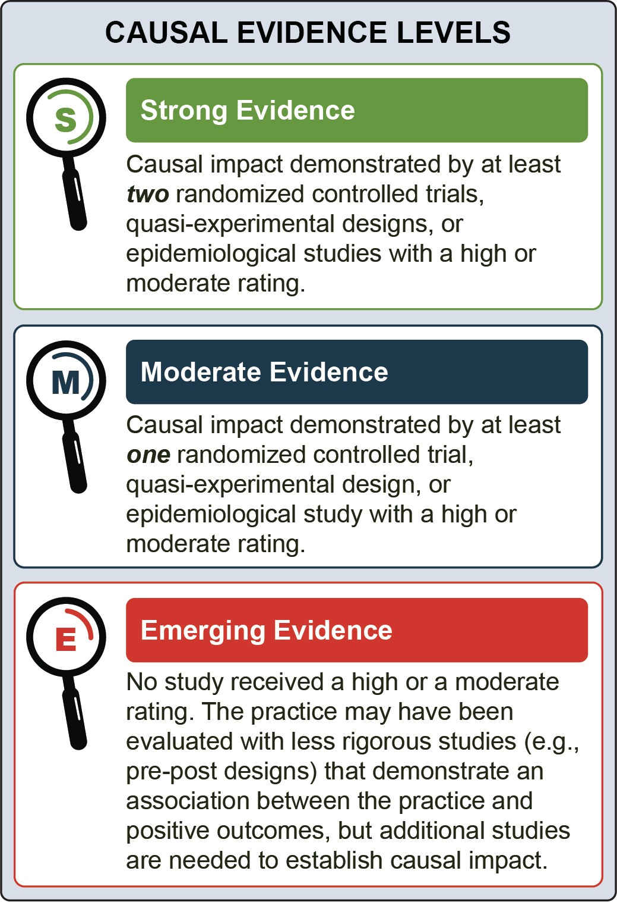
Adherence to PrEP have an emerging evidence base.

* Due to concerns raised in the mid-1990s about the ethics of experimental design in SSP research,¹⁻³ researchers have had to rely on longitudinal and epidemiological approaches to understand the impact of regular use of an SSP on injection drug use behaviors, substance use frequency, substance use treatment enrollment, and HIV incidence, among people who inject drugs. Systematic reviews support strong evidence of effectiveness.⁴⁻⁵

Identification of Practices Associated with HIV
Prevention and Treatment

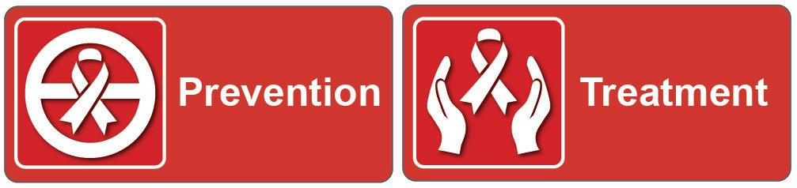
In the discussion of selected practices, the following icons will be used to indicate ways in which the practice has been implemented to improve HIV prevention and treatment outcomes:

Prevention
Treatment

Practices to Increase Uptake of and Improve Adherence to PrEP

Goal
PrEP is a biomedical intervention in which people at risk of getting HIV adhere to a regimen of daily oral antiretroviral medications. The Food and Drug Administration has approved two forms of PrEP
medication⁶ that prevent HIV from multiplying within the body. Long-acting injectable forms of PrEP are currently being tested.⁷

Efficacy of PrEP as a biomedical intervention is
established.
However, evidence for interventions that aim to increase PrEP uptake and adherence among people at risk of HIV who have mental illness and/ or SUD is emerging.
The U.S. Preventive Services Task Force gave PrEP a Grade A recommendation.⁸ It is an effective tool for reducing HIV transmission, including among populations behaviorally vulnerable to HIV, such as
people who inject drugs (PWID)⁹ and people who may be exposed to HIV through sexual contact.¹⁰ PrEP is approximately 99 percent effective at preventing HIV when taken consistently and adhering to prescription guidelines.⁹ PrEP is recommended for people who have had an increased risk of getting HIV in the past 6
months, and the risks/benefits of uptake and continuing should be an ongoing discussion between the client and provider.
While the efficacy of PrEP as a biomedical intervention is clear, people may face significant barriers to starting and adhering to PrEP, posing obstacles to reaching the goals of the Ending the HIV Epidemic (EHE) initiative. Barriers include, but are not limited to, the following:
- Stigma (both of HIV and of taking PrEP)
- Low awareness of the existence of PrEP among eligible PrEP users
- Low perception of risk of getting HIV
- Concern about possible side effects
- Lack of social support
- Perceived and actual cost
- Difficulty following the daily regimen¹⁰
- Health insurance coverage, or health insurance that does not cover laboratory and clinical visits¹¹⁻¹³
- Limited access to care (e.g., transportation,
hours of services)
Mental illness and/or SUD may compound these barriers.
Since the effectiveness of PrEP as a biomedical intervention has been established, this evidence review examines psychosocial supports to increase uptake and adherence to PrEP. These psychosocial interventions include the following:
- PrEP Mate: A bidirectional text-messaging program, grounded in the information, motivation, and behavioral (IMB) theory of behavior change, involving daily text reminders to take PrEP and weekly text check-ins.¹⁸
- Bio-Behavioral Community Health Recovery Program (CHRP-BB): A weekly group therapy and text-message reminder intervention encouraging PrEP adherence and teaching health management skills for people who are vulnerable to HIV (through injection drug use or condomless sex).¹⁹
- Pharmacy-led PrEP (P-PrEP): An integrated care intervention in which an in-clinic pharmacist consults with the client and prescribes PrEP the same day that the client tests negative for HIV.¹⁵

Outcomes Associated with Practices to Increase Uptake and Improve Adherence to PrEP
- Increased PrEP uptake, sustained for up to 9 months.15-17
- Increased PrEP adherence, sustained for up to 12 months.15-19
Typical Settings
Practitioners can implement practices designed to increase PrEP uptake and adherence in diverse mental illness, SUD, and HIV treatment settings, including the following:
- Safety net health clinics focused on HIV prevention and treatment¹⁸
- Mobile application that extends the reach of
PrEP support¹⁸
- Methadone maintenance clinics¹⁹
- Non-clinical testing centers; pharmacies; community health centers¹⁵⁻¹⁷
Safety-net clinics provide care to individuals who have limited or no access to health care (as a result of financial circumstances, insurance status, or health conditions).20

Demographic Groups
Several categories of people can benefit from practices
designed to increase PrEP uptake and adherence, including:
- Young men (mean age of 24) who have sex with men (MSM)¹⁹
- Individuals who reported recreational drug use¹⁹
- Individuals who reported binge drinking over the past 3 months¹⁹
- PWID¹⁹
- People who test negative for HIV¹⁷
PrEP should not be prescribed to people with HIV (as it is an inappropriate medical intervention for HIV) and/or people with severe renal insufficiency.¹⁰

Practitioner Types
A diverse range of behavioral health practitioners and clinical providers can implement practices to increase PrEP uptake and adherence, including:
- Clinic and research staff¹⁸
- Graduate-level trained facilitators¹⁹
- Pharmacists¹⁵⁻¹⁷

Intensity and Duration
While PrEP can be taken indefinitely, intensity and duration of individual practices to support PrEP uptake and adherence vary depending on the intervention.
- PrEPMate includes daily text reminders to take PrEP and weekly check-in texts about PrEP adherence, side effects, and attitudes around PrEP sent from clinicians¹⁸⁻¹⁹
- CHRP-BB includes four 50-minute weekly
group meetings that address behaviors related to increased risk of getting HIV and increased PrEP adherence and daily text reminders to take PrEP¹⁹
- P-PrEP includes same-day PrEP referral by a pharmacist and follow-up appointment with a clinician within 6 weeks¹⁷

Syringe Services Programs (SSPs)

Goal
SSPs reduce the risk of infectious disease associated with injection drug use through preventive services, including provision of sterile syringes, injection drug equipment, and harm reduction education, as well as linkage to HIV and mental illness and/or SUD treatment.²¹⁻²³
Decades of research demonstrate the efficacy and
importance of SSPs in reducing the transmission of
infectious diseases, including HIV and hepatitis C virus (HCV).²⁴ Due to concerns raised in the mid-1990s about the ethics of experimental design in SSP research,¹⁻³ researchers have had to rely on longitudinal and epidemiological approaches to understand the impact of regular use of an SSP on reductions in harm associated with injection drug use, substance use frequency and treatment enrollment, and HIV incidence among PWID.
SSPs have been shown to reduce HIV and HCV incidence by approximately 50 percent and are a key practice identified in the EHE initiative.²⁵⁻²⁶ Additionally, SSPs have been effective in engaging hard to reach populations, as SSPs reduce typical barriers to entry

(e.g., clients do not need insurance coverage, pre- scheduled appointments, referrals)⁷ and can adjust delivery venues to meet community needs (e.g., fixed- site or mobile exchange vans).²⁸ SSPs are also a prime setting for implementing combined interventions, including medication for opioid use disorder.²⁹

Outcomes Associated with SSPs

- Reduction in self-reported receptive syringe sharing (i.e., using a previously used syringe)30-33
- Increase in frequency of injecting with a sterile syringe, as opposed to a non- sterile syringe31, 34
- Reduction in self-reported sharing of injection equipment and/or paraphernalia31-33
- Reduction in HIV incidence30
- Reduction in self-reported substance use frequency35
Typical Settings
SSPs are community-based interventions that vary significantly based on implementation setting, geographic location, scope, and services to meet local community needs.^{26,} ³⁶ The eight studies in this evidence review showed that SSPs have been effective in both urban and rural settings and have operated successfully as both long-standing programs and temporary emergency public health responses to HIV outbreaks.
SSPs have also been effective in both fixed-site and
mobile settings.³⁰⁻³¹

Demographic Groups
PWID, regardless of gender, age, education, marital status, income, or housing status, can benefit from consistent availability of sterile syringes provided through SSPs.³⁴ Access to sterile injection drug equipment, harm reduction education, and linkage to treatment through SSPs²² can lead to reductions in
harm associated with injection drug use, substance use
frequency, and overall HIV incidence.³⁰⁻³⁵
Geographic proximity may also impact an individual’s ability to access an SSP, suggesting that populations living near SSPs benefit most from their services.³²
In this practice, individuals can acquire large numbers of syringes to distribute to their networks of others
who also inject. As a result, SSPs can facilitate a larger number of sterile syringes available within a community.^{33,} ³⁷

Practitioner Types
SSP activities can be conducted by:
- Pharmacists, pharmacy managers, clerks, and technicians dispensing over-the-counter syringes^{34,} ³⁸
- Care service coordinators³¹ and outreach
workers³⁹
- Professional staff and volunteers (including trained healthcare professionals)
These personnel are best equipped to take on these roles when provided with overdose prevention and response training and appropriate education about sterile syringe distribution and needle-stick injuries.⁴⁰⁻⁴¹

Intensity and Duration
SSPs are structural interventions designed to impact population health.³⁸ Implementing an SSP is less about a specific number of interactions with PWID, and more about providing consistent, stable access to sterile syringes to increase the volume of sterile syringes available in a given community (benefiting both direct participants of SSPs and their networks).
However, the higher the number of interactions with SSPs, the more opportunities a provider has to offer additional harm reduction education materials (e.g., naloxone kits, PrEP, PEP) and SUD treatment.
Studies in this evidence review identified the following
factors as affecting the success of service provision:
- Operating hours: Due to limited funding, SSPs may restrict their hours, potentially reducing interactions with clients and the number
of syringes provided (at the individual and community levels).³⁴
- Location of the SSP: The distance between
an individual’s home and the SSP has been
identified as a barrier to accessing SSPs.^{32,} ^{34,} ³⁹
- Number of syringes provided: SSPs can provide sterile syringes (not purchased using federal funding) in single or multiple day supplies, based on the number of syringes returned and reported injection frequency.³¹

Contingency Management (CM)
- Reduction in self-reported sexual behaviors that increase risk for HIV over the previous month (i.e., number of sexual partners, condomless sex, sex for money or nonmonetary items, and anal sex) sustained for up to 12 months.42, 44, 48
- Reduction in self-reported drug-use behaviors that increase likelihood for getting HIV over the previous month, (i.e., injection drug use, receptive syringe sharing, syringe lending, and using injection drug use equipment that has not been cleaned or sterilized) sustained for up to 12 months.42, 48-49
- Reduction in viral load, sustained for up to 6 months.44, 52
- Increase in adherence to antiretroviral therapy (ART), sustained for up to 4 months.53

Goal
CM is a behavioral therapy that uses motivational incentives and tangible reinforcers to increase desirable behavior.⁴²⁻⁴³ People in CM programs are given reinforcers—often vouchers that can be exchanged for money or goods, or chances to win prizes—when they consistently demonstrate positive behavior (e.g., negative urine drug screens, showing up for an appointment).⁴⁴
Many state Medicaid, Medicare, and private insurance entities may not reimburse for CM reinforcers. Additionally, the Department of Health and Human Services’ (HHS) Office of the Inspector General (OIG) has ruled that the Centers for Medicare and Medicaid Services (CMS) may not provide more than $75 annually (or $15 per individual appointment) in goods to beneficiaries, limiting CM enforcers to that amount.⁴⁵⁻⁴⁷ Medicaid, Medicare, and private insurance agencies may reimburse for CM as a service, but any value of payment for the reinforcers is prohibited. Therefore, CM implementation requires careful coordination with HHS, the state health department, and other insurance providers. Providers wishing to implement CM may identify other funding for reinforcers (up to $75 per beneficiary annually), including federal, state, and private grants, as well as contributions from or opportunities to share costs with community partners.
Practitioners can implement CM along with individual or group counseling or in conjunction with scheduled medical visits, including urine drug screens, daily methadone dosing, or HIV-related appointments.⁴⁸⁻⁴⁹

Outcomes Associated with CM
CM is an effective psychosocial intervention for reducing substance use and maintaining substance use abstinence for periods of up to 1 year.⁵⁰ In 2006, researchers began testing CM principles in the prevention and treatment of HIV.⁵¹ Behavior change takes time, and while CM has been shown to be effective for periods up to one year, it is important to note that these may be temporary changes for life-long disorders. HIV prevention and treatment outcomes attributed to CM are outlined below:

Typical Settings
Practitioners can use CM across a variety of outpatient and inpatient settings and across urban, suburban, and rural settings, including:
- Outpatient treatment clinics^{42,} ^{44,} ^{48-49,} ⁵²
- SUD treatment settings (e.g., methadone clinics)⁴⁹
- Counseling centers^{42,} ²⁵
- HIV-focused drop-in centers⁴⁴

Demographic Groups
- CM has been effective in preventing HIV among adults aged 18 to 65, living in urban and suburban areas, who
use cocaine and opioids and who are taking methadone. It has also been effective among adults who engage in sexual and drug use behaviors that increase likelihood of getting HIV.42, 44, 48-49
- CM is effective in increasing linkage to and retention in HIV care among
people with co-occurring HIV and SUD including adults aged 18 to 65, living in urban and suburban settings, with HIV, and who use cocaine and opioids It has also shown efficacy among PWID and adults who take methadone.42, 44,
48-49, 52

Practitioner Types
CM can be implemented by a variety of practitioners, including:
- Counselors^{42,} ⁵³
- Post-doctoral fellows in psychology (who are provided with supervision from licensed psychologists)⁴⁴
- Clinic staff with education levels ranging from
no bachelor’s degree to master’s degree in social work 48-49
Formal CM-specific training is not required, but training or coursework in behavioral analysis is available to support implementation of this practice.

Intensity and Duration
CM does not require a prescribed number of sessions
or specified length of individual sessions, and has
demonstrated efficacy when implemented in the
following settings for the following durations:
- An intensive outpatient setting with daily counseling over 6 weeks⁴⁸
- A methadone clinic with daily methadone dosing
and weekly individual and group counseling over 12 weeks^{42,} ⁴⁹
- A counseling center with individual counseling
over 16 weeks⁵²
- A counseling center with weekly group counseling sessions over 24 weeks⁴⁴
CM can also act as a “buy-in” for other behavioral interventions associated with longer-term benefits. For example, when combined with counseling, it may increase attendance at sessions, which in turn can have long-term therapeutic benefits.⁴⁸

Cognitive Behavioral Therapy (CBT)

Goal
Providers in mental health settings are uniquely positioned to prevent HIV and support linkage and retention in HIV care and ART adherence for people with HIV. Through individual and group counseling such as CBT, providers can build “reciprocal, robust, and trusting relationships” by having consistent and confidential interactions with clients over time.⁵⁴
CBT is a form of psychotherapy that seeks to modify problematic thinking, beliefs, or behavior through skill- building. CBT programs share three core principles. They are 1) goal-oriented; 2) time-limited; and 3) structured.⁵⁵ CBT helps individuals identify specific problems and gain the skills to manage and solve them.⁵⁶ All studies included in this evidence review employed the core components
of CBT (basing individual and group work on thoughts, feelings, emotions, and skill-building).
This evidence review includes specific applications of CBT for mental health clinicians to use with clients living with mental illness and/or SUD with and at risk for HIV, detailed below:

Cognitive Behavioral Skill Building Intervention (E-CB)
E-CB facilitates HIV prevention through structured sessions on the following topics:
- HIV education, including personalizing risk of getting HIV, condom use and negotiation skills and identifying situations with increased risk of getting HIV
- developing and practicing problem solving, assertiveness, and communication training approaches.57
Cognitive Behavioral Therapy for Trauma and Self Care (Project Thrive)
Project Thrive addresses posttraumatic stress responses in MSM with histories of childhood sexual abuse who are at increased risk for HIV. This individual therapy model integrates counseling for sexual health with cognitive and behavioral strategies as a feasible and acceptable treatment among MSM to effectively reduce sexual risk for HIV and decrease post-traumatic stress disorder (PTSD) symptom severity.58-59
Behavioral Activation for Methamphetamine Dependence (Project IMPACT)
Project IMPACT is an individual therapy intervention that aims to reduce crystal methamphetamine use and condomless sex among MSM. This integrated treatment consists of behavioral activation, an evidence- based approach for depression that involves identifying and participating in pleasurable, goal-directed activities, and CBT with HIV sexual risk counseling.60
Cognitive Behavioral Therapy for Social Anxiety and Sexual Health (Sexual Confidence)
Sexual Confidence adapts the CBT framework for social anxiety to include substance use management in interpersonal situations and reducing sexual behaviors that increase likelihood of getting HIV through sessions on the following:
- setting goals related to reducing risk of getting HIV and reducing social anxiety
- the role of social anxiety and substance use in increasing risk of getting HIV
- discussing and practicing coping skills for anxiety reduction⁶¹⁻⁶²
Cognitive Behavioral Therapy for HIV Medication Adherence and Depression (CBT-AD)
CBT-AD integrates continued adherence counseling with traditional CBT techniques for the treatment of depression. CBT-AD uses proactive problem solving, action planning, and motivational interviewing to:
- facilitate behavior change63
- address the cognitive and behavioral patterns commonly experienced by adults with co-occurring depression and HIV64
- improve ART adherence63

Outcomes Associated with CBT

- Reduced sexual behaviors that increase likelihood of getting HIV, including improved attitudes towards condom use and greater condom use skills, sustained for up to 6 months57,62, 65-66
- Reduced PTSD and depression symptom severity for up to 9 months58, 60
- Reduction in crystal methamphetamine use for up to 6 months66
- Increased perceived susceptibility to getting HIV, defined as perceptions of personal vulnerability to HIV
disease, sustained for up to 6 months57
- Reduction in viral load, sustained for up to 12 months67
- Increase in adherence to ART, sustained for up to 15 months63, 68-70

Typical Settings
Practitioners can incorporate CBT in mental illness and/or SUD and social service settings including:
- Academic medical centers⁶⁵
- Outpatient treatment centers⁵⁷
- Methadone clinics⁶³
- Homeless shelters⁷¹
- Community health clinics⁶⁹

Demographic Groups
CBT is a well-established, effective treatment for people with mental illness and/or SUD who have or at risk for HIV. It is appropriate for anyone who can relate to the CBT core components, problem-solving approach, and structure, including:

- Men who have sex with men (MSM) who are at risk for HIV61, 71
- People with severe mental illness at risk for HIV57
- People with at least one HIV-related risk behavior, including self-reported injection drug use, two or more sex partners in the past 90 days, or having a partner with HIV65
- People with a history of child sexual abuse and at risk for getting HIV58
- People with co-occurring HIV and depression68-69
- People with co-occurring HIV and depression who inject drugs63
Practitioner Types
CBT can be implemented effectively by a variety of professionals including:
- Clinical psychologists⁶³
- Master’s level psychologists,⁶⁸ social workers, and counselors
- Case managers⁷²
- Facilitators with an average of 10 years of experience leading group-based HIV prevention interventions with people who use drugs⁶⁵
Practitioners do not need to be certified to practice CBT, but certifications are available.⁷³
Intensity and Duration
CBT generally provides the tools for behavior change in 8 to 12 individual or group sessions, meeting once or twice weekly, with each session lasting between 60 and 90 minutes.⁷⁴ The length of treatment also varies depending on the individual’s symptoms, resources, and preference. As highlighted below, studies included in this evidence review varied by time and number of sessions.

The E-CB intervention consists of six
90-minute sessions over the course of 6 weeks. Weekly sessions gave participants time to practice lessons between sessions, reinforcing content discussed during the sessions.57
Project Thrive consists of approximately 10 individual therapy sessions on integrated cognitive therapy strategies, behavioral techniques, and sexual risk reduction counseling.58
Project IMPACT consists of 10 weekly,
50-minute, in-person sessions that include HIV risk reduction sessions, sessions of cognitive behavioral therapy for reducing substance use, behavioral activation sessions, and preventing re-starting substance use.60
Sexual Confidence consists of 10 weekly 1 hour sessions using an integrated CBT model focusing on conversations between the client and facilitator (instead of a didactic learning session).62
CBT-AD consists of between nine and 12 50- to 60-minute sessions, with three “open sessions” (which allow for the individual and therapist to revisit the modules that are most relevant to the client’s specific
needs).63, 64, 67, 69

Patient Navigation
PATIENT NAVIGATION:
Supporting transition between jail and community
While incarcerated, people with HIV often achieve viral suppression due to the highly structured environment and consistent access to care. Post- release delays in linkage to and retention in care can cause declines in viral suppression.74
Peer patient navigators with shared lived experiences can play a key part in facilitating linkage to care by acting as role models. In the study included in this review, peer patient navigators established relationships with
participants before they left jail, met them at the time of release, provided referrals for post-release housing and SUD treatment, and counseled them on retention and adherence behaviors in HIV care.

Goal
Patient navigation is a client-centered approach aimed at improving care engagement by addressing client and system barriers, and helps clients access medical and
support services in an often complex healthcare system.⁷⁵ Originally developed as a strategy to improve timely access to cancer screening, diagnosis, and treatment,⁷⁶ patient navigation has been used to improve the health outcomes of multiple medical conditions, including
HIV. During individual sessions, navigators work with participants to facilitate access to care, review health information, overcome personal or logistical challenges, and provide psychosocial support by promoting self- efficacy and problem-solving behaviors. In addition to the sessions, navigators accompany participants to HIV care and SUD treatment appointments.
In the context of the HIV-care continuum, patient navigation services typically focus on linkage to and retention in care, improving HIV treatment outcomes, client satisfaction, and client self-management.⁷⁷

Outcomes Associated with Patient Navigation

- Viral suppression, sustained up to 12 months78
- Linkage to HIV care, with the greatest probability of linkage occurring within 6 months53, 78
- Retention in HIV care, sustained up to
12 months78
- Adherence to ART medications, sustained up to 12 months53
Typical Settings
Practitioners can provide patient navigation services in a wide range of treatment settings including:
- Correctional and criminal justice settings⁷⁸
- Mental illness and/or SUD treatment programs⁷⁹
- Primary health and HIV-specific care clinics⁵³
- Hospitals⁵³

Demographic Groups
Patient navigation can be used with a variety of populations, but is often targeted for those at highest likelihood of not linking to or continuing in care⁸⁰ including:
- People with HIV, aged 18 or older, who report recent use of substances (i.e., opioids, stimulants, alcohol)⁵³
- People with HIV (specifically men and
transgender women) transitioning from jail to
the community⁷⁸

Practitioner Types
Patient navigation can be implemented effectively by a variety of professionals including:
- Medical professionals or clinical staff, community members, social workers, and other diverse professionals (e.g., case management, discharge planning, criminal justice system)⁷⁷
- Peer patient navigators⁷⁸

Patient navigators often share qualifications and skills with other support service providers in clinical settings, such as advocates, health educators, or case managers.⁷⁴ Matching peer patient navigators with individuals who have similar experiences is a successful approach for linking and retaining clients in HIV care⁸¹ and can play a key role in building social networks and establishing trust, especially among stigmatized populations.⁸²

Intensity and Duration
Patient navigation services are customized to the specific needs of clients, so there is no standard model for the intensity and duration of the program.⁸⁰ Typically, navigators meet regularly with clients for 11 to 12 individual sessions over 6 months, and their work continues through a predetermined endpoint (determined by the clinic model). In the case of HIV care, this endpoint is often linkage to care.⁷⁷

Summary of Evidence-based Review

Practice | Practices to Increase Uptake of and Improve Adherence to PrEP | Syringe Services Programs (SSPs) | Contingency Management (CM) | Cognitive Behavioral Therapy (CBT) | Patient Navigation
Review Rating | Emerging Evidence | Strong Evidence | Strong Evidence | Strong Evidence | Strong Evidence
Focus of the practice | Practices designed to overcome barriers to initiating and sustaining PrEP use. | A harm reduction method for reducing the likelihood of  HIV and HCV associated with injection drug use. | Focus on positively rewarding desired behaviors. | Focus on helping clients improve their quality of life not  by changing their circumstances, but by altering their perceptions of those circumstances. | A client-centered approach aimed at improving  engagement in HIV care by addressing client and system barriers.
Can be used in out-patient healthcare settings | ✓ | ✓ | ✓ | ✓ | ✓
Can be used in in-patient healthcare settings | ✓ | - | ✓ | ✓ | ✓
Specific training available | ✓ | ✓ | - | ✓ | ✓
Can be practiced by peers | - | ✓ | - | - | ✓
Special populations with whom the practice has been successfully implemented | Young MSM; PWID or recreationally use drugs | PWID | Individuals with co- occurring HIV and SUD; individuals who engage in sexual or drug use behaviors that increase likelihood of getting HIV | MSM; individuals with severe mental illness; individuals with co-occurring HIV, mental illness and/or SUD | Individuals with SUD; men and transgender women transitioning from jail to community
Intensity and duration | Indefinite | Indefinite | No prescribed intensity or duration; shown to be effective for between 6 to 24 weeks | Varies depending on specific CBT intervention implemented, ranges from 1 to 2 weekly sessions  over the course of 8 to 12 weeks | No prescribed intensity or duration; typical range of 11 to 12 sessions over 6 months

Reference List

¹ Leary, W. E. (1996, October 18). Questions on ethics lead to review of needle-exchange study. The New York Times. https://www.nytimes.com/1996/10/18/ us/questions-on-ethics-lead-to-review-of-needle- exchange-study.html
² Benowitz, S. (1997, February 2). Politics polarizing issues in needle-exchange study. The Scientist. https://www.the-scientist.com/news/politics- polarizing-issues-in-needle-exchange-study-57635
³ Fisher, D. G., Fenaughty, A. M., Cagle, H. H., & Wells, R. S. (2003). Needle exchange and
injection drug use frequency: A randomized clinical trial. Journal of Acquired Immune Deficiency Syndromes (JAIDS), 33(2), 199-205. https://doi. org/10.1097/00126334-200306010-00014
⁴ Abdul-Quader, A. S., Feelemyer, J., Modi, S., Stein, E. S., Briceno, A., Semaan, S., Horvath, T., Kennedy, G. E., & Des Jarlais, D. C. (2013).
Effectiveness of structural-level needle/syringe programs to reduce HCV and HIV infection among people who inject drugs: A systematic review. AIDS and Behavior Addiction, 17(9), 2878-2892. https:// doi.org/10.1007/s10461-013-0593-y
⁵ Aspinall, E. J., Nambiar, D., Goldberg, D. J., Hickman, M., Weir, A., Van Velzen, E., Palmateer, N., Doyle, J. S., Hellard, M. E., & Hutchinson,
S. J. (2014). Are needle and syringe programmes associated with a reduction in HIV transmission among people who inject drugs: A systematic review and meta-analysis. International Journal of Epidemiology, 43(1), 235-248. https://doi.org/ doi:10.1093/ije/dyt243
⁶ Centers for Disease Control and Prevention. (2020, May 18). Pre-exposure prophylaxis (PrEP). https:// www.cdc.gov/hiv/clinicians/prevention/prep.html
⁷ Cohen, J. (2020). Long-acting injectable drug prevents HIV infections. Science. https://doi. org/10.1126/science.abc8634
⁸ U.S. Preventive Services Task Force. (2019). Preexposure prophylaxis for the prevention of HIV infection: U.S. Preventive Services Task Force recommendation statement. Journal of the American Medical Association (JAMA), 321(22), 2203-2213. https://doi.org/10.1001/jama.2019.6390
⁹ Centers for Disease Control and Prevention. (2019, October 17). PrEP. https://www.cdc.gov/hiv/basics/ prep.html
¹⁰ Centers for Disease Control and Prevention. (2020, May 18). Pre-exposure prophylaxis (PrEP).https:// www.cdc.gov/hiv/clinicians/prevention/prep.html
¹¹ Sidebottom, D., Ekström, A. M., & Strömdahl, S. (2018). A systematic review of adherence to oral pre-exposure prophylaxis for HIV - How can we improve uptake and adherence? BMC Infectious Diseases, 18(1), 581-581. https://doi.org/10.1186/ s12879-018-3463-4
¹² Otto, M. A. (2019, April 4). PrEP adherence lowest among Medicaid patients, others. MDedge. https:// www.mdedge.com/infectiousdisease/article/198180/ hiv/prep-adherence-lowest-among-medicaid- patients-others
¹³ Huang, Y. A., Tao, G., Smith, D. K., & Hoover,
K. W. (2020). Persistence with HIV preexposure prophylaxis in the United States, 2012-2017. Clinical Infectious Diseases. Advance online publication. https://doi.org/10.1093/cid/ciaa037
¹⁴ Kay, E. S., & Pinto, R. M. (2020). Is insurance a barrier to HIV preexposure prophylaxis?
Clarifying the issue. American Journal of Public Health, 110(1), 61-64. https://doi.org/10.2105/ AJPH.2019.305389
¹⁵ Havens, J. P., Scarsi, K. K., Sayles, H., Klepser,
D. G., Swindells, S., & Bares, S. H. (2019). Acceptability and feasibility of a pharmacist-led human immunodeficiency virus pre-exposure prophylaxis program in the midwestern United States. Open Forum Infectious Diseases, 6(10), ofz365. https://doi.org/10.1093/ofid/ofz365
¹⁶ Khosropour, C. M., Backus, K. V., Means, A. R., Beauchamps, L., Johnson, K., Golden, M. R., & Mena, L. (2020). A pharmacist-led, same-day, HIV pre-exposure prophylaxis initiation program to increase PrEP uptake and decrease time to PrEP initiation. AIDS Patient Care & STDs, 34(1), 1-6. https://doi.org/10.1089/apc.2019.0235
¹⁷ Smith, B. L., Hester, A. M., Cantos, V. D., James, T. R., & Lora, M. H. (2019). 1280. A pharmacist-led PrEP program at the epicenter of the HIV epidemic in Atlanta; our experience. Open Forum Infectious Diseases, 6(Suppl 2), S461. https://doi.org/10.1093/ ofid/ofz360.1143

¹⁸ Liu, A. Y., Vittinghoff, E., von Felten, P., Amico, K. R., Anderson, P. L., Lester, R., Andrew, E., Estes, I., Serrano, P., Brothers, J., Buchbinder, S., Hosek, S., & Fuchs, J. D. (2019). Randomized controlled trial of a mobile health intervention to promote retention and adherence to preexposure prophylaxis among young people at risk for human immunodeficiency virus: The epic study. Clinical Infectious Diseases, 68(12), 2010-2017. https://doi.org/10.1093/cid/ ciy810
¹⁹ Shrestha, R., Altice, F. L., Karki, P., & Copenhaver,
M. M. (2018). Integrated bio-behavioral approach to improve adherence to pre-exposure prophylaxis and reduce HIV risk in people who use drugs: A pilot feasibility study. AIDS and Behavior, 22(8), 2640- 2649. https://doi.org/10.1007/s10461-018-2099-0
²⁰ National Association of Public Hospitals and Health Systems. (n.d.). What is a Safety Net Hospital? http://www.literacynet.org/hls/hls_conf_materials/ WhatIsASafetyNetHospital.pdf
²¹ Dawson, L., & Kates, J. (2018). HIV and the opioid epidemic: 5 key points. Kaiser Family Foundation. https://www.kff.org/hivaids/issue-brief/hiv-and-the- opioid-epidemic-5-key-points/
²² Centers for Disease Control and Prevention (2020, June 4). Summary of information on the safety and effectiveness of syringe services programs (SSPs). https://www.cdc.gov/ssp/syringe-services-programs- summary.html
²³ HIV.gov. (2020, January 31). Syringe services programs - Opioid crisis is raising risks of HIV & other infectious diseases. https://www.hiv.gov/ federal-response/policies-issues/syringe-services- programs
²⁴ HIV.gov. (2020, July 2). What is Ending the HIV Epidemic: A plan for America?. https://www.hiv. gov/federal-response/ending-the-hiv-epidemic/ overview
²⁵ Ojikutu, B., Holman, J., Kunches, L., Landers, S.,
Perlmutter, D., Ward, M., Fant, G., & Hirschhorn,
L. (2014). Interdisciplinary HIV care in a changing healthcare environment in the USA. AIDS Care, 26(6), 731-735. https://doi.org/10.1080/09540121.20 13.855299
²⁶ Centers for Disease Control and Prevention (2019, May 23). Syringe services programs (SSPs) fact sheet. https://www.cdc.gov/ssp/syringe-services- programs-factsheet.html
²⁷ Clarke, K., Harris, D., Zweifler, J. A., Lasher, M., Mortimer, R. B., & Hughes, S. (2016). The significance of harm reduction as a social and
health care intervention for injecting drug users: An exploratory study of a needle exchange program in Fresno, California. Social Work In Public Health, 31(5), 398-407. https://doi.org/10.1080/19371918.20
15.1137522
²⁸ Miller, C. L., Tyndall, M., Spittal, P., Li, K., Palepu, A., & Schechter, M. T. (2002). Risk-taking behaviors among injecting drug users who obtain syringes from pharmacies, fixed sites, and mobile van needle exchanges. Journal of Urban Health, 79(2), 257- 265. https://doi.org/10.1093/jurban/79.2.257
²⁹ Hood, J. E., Banta-Green, C. J., Duchin, J. S., Breuner, J., Dell, W., Finegood, B., Glick, S. N., Hamblin, M., Holcomb, S., Mosse, D., Oliphant- Wells, T., & Shim, M. M. (2019). Engaging an unstably housed population with low-barrier buprenorphine treatment at a syringe services program: Lessons learned from Seattle, Washington. Substance Abuse, 1-9. https://doi.org/10.1080/08897 077.2019.1635557
³⁰ Kerr, T., Small, W., Buchner, C., Zhang, R., Li, K., Montaner, J., & Wood, E. (2010). Syringe sharing and HIV incidence among injection drug users and increased access to sterile syringes. American
Journal of Public Health, 100(8), 1449-1453. https:// doi.org/10.2105/AJPH.2009.178467
³¹ Dasgupta, S., Broz, D., Tanner, M., Patel, M., Halleck, B., Peters, P. J., Weidle, P. J., O’Donnell, J., Amlung, J., McAlister, C., Chapman, E., Bailey, A., Burnett, J., & Duwve, J. (2019). Changes in reported injection behaviors following the public health response to an HIV outbreak among people
who inject drugs: Indiana, 2016. AIDS and Behavior, 23(12), 3257-3266. https://doi.org/10.1007/s10461-
019-02600-x
³² Williams, C. T., & Metzger, D. S. (2010). Race and distance effects on regular syringe exchange program use and injection risks: A geobehavioral analysis. American Journal of Public Health, 100(6), 1068-1074. https://doi.org/10.2105/ AJPH.2008.158337
³³ Behrends, C. N., Li, C., & Gibson, D. R. (2017). Decreased odds of injection risk behavior associated with direct versus indirect use of syringe exchange: Evidence from two California cities. Substance Use & Misuse, 52(9), 1151-1159. https://doi.org/10.1080/ 10826084.2017.1299182

³⁴ Rudolph, A. E., Crawford, N. D., Ompad, D. C., Benjamin, E. O., Stern, R. J., & Fuller, C.
M. (2010). Comparison of injection drug users accessing syringes from pharmacies, syringe exchange programs, and other syringe sources to inform targeted HIV prevention and intervention strategies. Journal of the American Pharmacists Association, 50(2), 140-147. https://doi.org/10.1331/ japha.2010.09193
³⁵ Huo, D., Bailey, S. L., & Ouellet, L. J. (2006). Cessation of injection drug use and change in injection frequency: The Chicago needle exchange evaluation study. Addiction, 101(11), 1606-1613. https://doi.org/10.1111/j.1360-0443.2006.01577.x
³⁶ North American Syringe Exchange Network. (n.d.). SEP locations. Retrieved July 17, 2020, from https:// nasen.org/map/
³⁷ Benyo, A. (2006). Promoting secondary exchange: Opportunities to advance public health. The Harm Reduction Coalition. http://
harmreduction.org/hrc/wp-content/uploads/2012/01/ promotingsecondaryexchange.pdf
³⁸ Cooper, H., Des Jarlais, D., Ross, Z., Tempalski, B., Bossak, B. H., & Friedman, S. R. (2012). Spatial access to sterile syringes and the odds of injecting with an unsterile syringe among injectors: A longitudinal multilevel study. Journal of Urban Health: Bulletin of the New York Academy of Medicine, 89(4), 678-696. https://doi.org/10.1007/ s11524-012-9673-y
³⁹ Welch-Lazoritz, M., Habecker, P., Dombrowski, K., Villegas, A. R., Davila, C. A., Colón, Y. R., & De León, S. M. (2017). Differential access to syringe exchange and other prevention activities
among people who inject drugs in rural and urban areas of Puerto Rico. International Journal of Drug Policy, 43, 16-22. https://doi.org/10.1016/j. drugpo.2016.12.011
⁴⁰ AIDS Projects Management Group. (2007) Guide to starting and managing needle and syringe programmes. World Health
Organization. https://apps.who.int/iris/bitstream/ handle/10665/43816/9789241596275_eng. pdf?sequence=1
⁴¹ New York State Department of Health AIDS Institute. (2009, January). Policies and procedures: Syringe exchange programs. Harm Reduction Coalition. https://harmreduction.org/hrc/wp-content/ uploads/2012/01/NYSDOHAI-pp.pdf
⁴² Ghitza, U. E., Epstein, D. H., & Preston, K. L. (2008). Contingency management reduces injection- related HIV risk behaviors in heroin and cocaine using outpatients. Addictive Behaviors, 33(4), 593- 604. https://doi.org/10.1016/j.addbeh.2007.11.009
⁴³ Shoptaw, S., Reback, C. J., Peck, J. A., Yang, X., Rotheram-Fuller, E., Larkins, S., Veniegas, R. C., Freese, T. E., & Hucks-Ortiz, C. (2005). Behavioral treatment approaches for methamphetamine dependence and HIV-related sexual risk behaviors among urban gay and bisexual men. Drug and Alcohol Dependence, 78(2), 125-134. https://doi. org/10.1016/j.drugalcdep.2004.10.004
⁴⁴ Petry, N. M., Weinstock, J., Alessi, S. M., Lewis,
M. W., & Dieckhaus, K. (2010). Group-based randomized trial of contingencies for health and abstinence in HIV patients. Journal of Consulting and Clinical Psychology, 78(1), 89-97. https://doi.org/10.1037/a0016778
⁴⁵ Special advisory bulletin: Offering gifts and other inducements to beneficiaries. (2002). Office of the Inspector General. https://oig.hhs.gov/fraud/docs/ alertsandbulletins/SABGiftsandInducements.pdf
⁴⁶ Health Care Programs: Fraud and abuse; Revised OIG civil money penalties resulting from public law 104–191. (2000). Office of the Inspector General. https://oig.hhs.gov/authorities/docs/cmpfinal.pdf
⁴⁷ Office of Inspector General policy statement regarding gifts of nominal value to medicare and medicaid beneficiaries. (2016). Office of the
Inspector General. https://oig.hhs.gov/fraud/docs/ alertsandbulletins/OIG-Policy-Statement-Gifts-of- Nominal-Value.pdf
⁴⁸ Petry, N. M., Weinstock, J., & Alessi, S. M. (2011). A randomized trial of contingency management delivered in the context of group counseling. Journal of Consulting and Clinical Psychology, 79(5), 686- 696. https://doi.org/10.1037/a0024813
⁴⁹ Hanson, T., Alessi, S. M., & Petry, N. M. (2008). Contingency management reduces drug-related human immunodeficiency virus risk behaviors in cocaine-abusing methadone patients. Addiction, 103(7), 1187-1197. https://doi.org/10.1111/j.1360- 0443.2008.02216.x
⁵⁰ Haug, N. A., & Sorensen, J. L. (2006). Contingency management interventions for HIV-related behaviors. Current HIV/AIDS Reports, 3(4), 154- 159. https://doi.org/10.1007/s11904-006-0010-5
⁵¹ Schroeder, J. R., Epstein, D. H., Umbricht, A., & Preston, K. L. (2006). Changes in HIV risk behaviors among patients receiving combined pharmacological and behavioral interventions for heroin and cocaine dependence. Addictive
Behaviors, 31(5), 868-879. https://doi.org/10.1016/j.
addbeh.2005.07.009

⁵² Rosen, M. I., Dieckhaus, K., McMahon, T. J., Valdes, B., Petry, N. M., Cramer, J., & Rounsaville,
B. (2007). Improved adherence with contingency management. AIDS Patient Care & STDs, 21(1), 30- 40. https://doi.org/10.1089/apc.2006.0028
⁵³ Metsch, L. R., Feaster, D. J., Gooden, L., Matheson, T., Stitzer, M., Das, M., Jain, M. K., Rodriguez, A. E., Armstrong, W. S., Lucas, G. M., Nijhawan, A. E., Drainoni, M., Herrera, P., Vergara-Rodriguez,
P., Jacobson, J. M., Mugavero, M. J., Sullivan, M.,
Daar, E. S., McMahon, D. K.,… Del Rio, C. (2016). Effect of patient navigation with or without financial incentives on viral suppression among hospitalized patients with HIV infection and substance use: A randomized clinical trial. Journal of the American Medical Association (JAMA), 316(2), 156-170. https://doi.org/10.1001/jama.2016.8914
⁵⁴ Seeman, M. V. (2015). The role of mental health services in addressing HIV infection among women with serious mental illness. Psychiatric
Services, 66(9), 966-974. https://ps.psychiatryonline. org/doi/10.1176/appi.ps.201400411
⁵⁵ Beck, J. S. (2011). Cognitive behavior therapy: Basics and beyond (2nd ed.). Guilford Press.
⁵⁶ Fenn, K., & Byrne, M. (2013). The key principles of cognitive behavioural therapy. InnovAiT, 6(9), 579- 585. https://doi.org/10.1177/1755738012471029
⁵⁷ Malow, R. M., McMahon, R. C., Dévieux, J., Rosenberg, R., Frankel, A., Bryant, V., Lerner, B., & Miguez, M. J. (2012). Cognitive behavioral HIV risk reduction in those receiving psychiatric treatment: A clinical trial. AIDS and Behavior, 16(5), 1192-1202. https://doi.org/10.1007/s10461-011-0104-y
⁵⁸ O’Cleirigh, C., Safren, S. A., Taylor, S. W., Goshe,
B. M., Bedoya, C. A., Marquez, S. M., Boroughs, M. S., & Shipherd, J. C. (2019). Cognitive behavioral therapy for trauma and self-care (CBT-tsc) in men who have sex with men with a history of childhood sexual abuse: A randomized controlled trial. AIDS and Behavior, 23(9), 2421-2431. https://doi. org/10.1007/s10461-019-02482-z
⁵⁹ Taylor, S. W., Goshe, B. M., Marquez, S. M., Safren, S. A., & O’Cleirigh, C. (2018). Evaluating a novel intervention to reduce trauma symptoms and sexual risk taking: Qualitative exit interviews with sexual minority men with childhood sexual abuse. Psychology, Health & Medicine, 23(4), 454-464. https://doi.org/10.1080/13548506.2017.1348609
⁶⁰ Mimiaga, M. J., Pantalone, D. W., Biello, K. B.,
Hughto, J. M. W., Frank, J., O’Cleirigh, C., Reisner,
S. L., Restar, A., Mayer, K. H., & Safren, S. A. (2019). An initial randomized controlled trial of behavioral activation for treatment of concurrent crystal methamphetamine dependence and sexual risk for HIV acquisition among men who have sex with men. AIDS Care, 31(9), 1083-1095. https://doi. org/10.1080/09540121.2019.1595518
⁶¹ Hart, T. A., Tulloch, T. G., & O’Cleirigh, C. (2014). Integrated cognitive behavioral therapy for social anxiety and HIV prevention for gay and bisexual men. Cognitive and Behavioral Practice, 21(2), 149- 160. https://doi.org/10.1016/j.cbpra.2013.07.001
⁶² Hart, T. A., Noor, S. W., Vernon, J. R., Antony, M. M., Gardner, S., & O’Cleirigh, C. (2020). Integrated cognitive-behavioral therapy for social anxiety and HIV/STI prevention for gay and bisexual men: A pilot intervention trial. Behavior Therapy, 51(3), 503-517. https://doi.org/10.1016/j.beth.2019.09.001
⁶³ Safren, S. A., O’Cleirigh, C. M., Bullis, J. R., Otto,
M. W., Stein, M. D., & Pollack, M. H. (2012). Cognitive behavioral therapy for adherence and depression (CBT-ad) in HIV-infected injection drug users: A randomized controlled trial. Journal of Consulting and Clinical Psychology, 80(3), 404-415. https://doi.org/10.1037/a0028208
⁶⁴ Newcomb, M. E., Bedoya, C. A., Blashill, A. J., Lerner, J. A., O’Cleirigh, C., Pinkston, M. M., & Safren, S. A. (2015). Description and demonstration of cognitive behavioral therapy to enhance antiretroviral therapy adherence and treat depression in HIV-infected adults. Cognitive and Behavioral Practice, 22(4), 430-438. https://doi.org/10.1016/j. cbpra.2014.02.001
⁶⁵ Tobin, K., Davey-Rothwell, M. A., Nonyane, B.
A. S., Knowlton, A., Wissow, L., & Latkin, C. A. (2017). RCT of an integrated CBT-HIV intervention on depressive symptoms and HIV risk. PloS One, 12(12), e0187180-e0187180. https://doi.org/10.1371/ journal.pone.0187180
⁶⁶ Mimiaga, M. J., Reisner, S. L., Pantalone, D.
W., O’Cleirigh, C., Mayer, K. H., & Safren, S.
A. (2012). A pilot trial of integrated behavioral activation and sexual risk reduction counseling for HIV-uninfected men who have sex with men abusing crystal methamphetamine. AIDS Patient Care and STDs, 26(11), 681-693. https://doi.org/https://dx.doi. org/10.1089%2Fapc.2012.0216

⁶⁷ Safren, S. A., O’Cleirigh, C., Tan, J. Y., Raminani,
S. R., Reilly, L. C., Otto, M. W., & Mayer, K. H. (2009). A randomized controlled trial of cognitive behavioral therapy for adherence and depression (CBT-ad) in HIV-infected individuals. Health Psychology, 28(1), 1-10. https://doi.org/10.1037/ a0012715
⁶⁸ Safren, S. A., Bedoya, C. A., O’Cleirigh, C., Biello,
K. B., Pinkston, M. M., Stein, M. D., Traeger, L.,
Kojic, E., Robbins, G. K., Lerner, J. A., Herman,
D. S., Mimiaga, M. J., & Mayer, K. H. (2016). Cognitive behavioural therapy for adherence and depression in patients with HIV: A three-
arm randomised controlled trial. The Lancet HIV, 3(11), e529-e538. https://doi.org/10.1016/S2352-
3018(16)30053-4
⁶⁹ Simoni, J. M., Wiebe, J. S., Sauceda, J. A., Huh, D., Sanchez, G., Longoria, V., Andres Bedoya, C., & Safren, S. A. (2013). A preliminary RCT of CBT-AD for adherence and depression among HIV-positive Latinos on the U.S.-Mexico border: The Nuevo Día study. AIDS and Behavior, 17(8), 2816-2829. https:// doi.org/10.1007/s10461-013-0538-5
⁷⁰ Johnson, M. O., Charlebois, E., Morin, S. F., Remien, R. H., Chesney, M. A., & National Institute of Mental Health Healthy Living Project Team. (2007). Effects of a behavioral intervention on antiretroviral medication adherence among people living with HIV: The healthy living project randomized controlled study. Journal of Acquired Immune Deficiency Syndromes (JAIDS), 46(5), 574- 580. https://doi.org/10.1097/qai.0b013e318158a474
⁷¹ Mayer, K. H., Safren, S. A., Elsesser, S. A., Psaros, C., Tinsley, J. P., Marzinke, M., Clarke, W., Hendrix, C., Taylor, S. W., Haberer, J., & Mimiaga, M. J. (2017). Optimizing pre-exposure antiretroviral prophylaxis adherence in men who have sex with men: Results of a pilot randomized controlled trial of “Life-Steps for PrEP”. AIDS and Behavior, 21(5), 1350-1360. https://doi.org/10.1007/s10461-016- 1606-4
⁷² Linn, J., Neff, J. A., Theriot, R., Harris, J., Interrante, J., & Graham, M. (2003). Reaching impaired populations with HIV prevention programs: A clinical trial for homeless mentally ill African- American men. Cellular and Molecular Biology (Noisy-le-Grand, France), 49(7), 1167-1175. https:// pubmed.ncbi.nlm.nih.gov/14682400/
⁷³ Beck Institute. (2019). Beck CBT certification.
https://beckinstitute.org/certification/
⁷⁴ Foa, E. B., Keane, T. M., Friedman, M. J., & Cohen, J. A. (2009). Effective treatments for PTSD:
Practice guidelines from the International Society for Traumatic Stress Studies (2nd ed.). Guilford Press.
75 Boston University Center for Innovation in Social Work & Health (2016). Enhanced patient navigation for HIV-positive women of color. TargetHIV. https:// targethiv.org/deii/deii-enhanced-patient-navigation
⁷⁶ Harold P. Freeman Patient Navigation Institute. (2020). Our model: The gold standard. http://www. hpfreemanpni.org/our-model/
⁷⁷ Farrisi, D., & Dietz, N. (2013). Patient navigation is a client-centered approach that helps to engage people in HIV care. HIV Clinician, 25(1), 1-3. https://pubmed.ncbi.nlm.nih.gov/23476957
⁷⁸ Cunningham, W. E., Weiss, R. E., Nakazono, T., Malek, M. A., Shoptaw, S. J., Ettner, S. L., & Harawa, N. T. (2018). Effectiveness of a peer
navigation intervention to sustain viral suppression among HIV-positive men and transgender women released from jail: The link la randomized clinical trial. JAMA Internal Medicine, 178(4), 542-553. https://doi.org/10.1001/jamainternmed.2018.0150
⁷⁹ Center for Health Policy and Inequalities Research. (n.d.). Including peers as part of a substance use treatment program for individuals living with HIV: The peer assisted treatment of HIV and substance (PATHS) model. http://chpir.org/wp-content/uploads/ paths_model.pdf
⁸⁰ Broeckaert, L., & Challacombe, L. (2014, August 11). Health navigation: A review of the evidence. Remedy Health Media. https://www.thebodypro. com/article/health-navigation-a-review-of-the- evidence
⁸¹ Cabral, H. J., Davis-Plourde, K., Sarango, M., Fox, J., Palmisano, J., & Rajabiun, S. (2018). Peer support and the HIV continuum of care: Results from a multi-site randomized clinical trial in
three urban clinics in the United States. AIDS and Behavior, 22(8), 2627-2639. https://doi.org/10.1007/ s10461-017-1999-8
⁸² AIDS United. (2015). Best practices for integrating peer navigators into HIV models of care. https:// www.aidsunited.org/data/files/Site_18/PeerNav_ v8.pdf

3CHAPTER

Guidance for Selecting and Implementing Evidence-based Practices

This chapter discusses key implementation considerations to address the challenges of implementing programs
for human immunodeficiency virus (HIV) prevention and treatment among people with mental illness and/ or substance use disorders (SUD). It covers steps from
practice selection and program funding through engaging and retaining people in care.
Prior to implementing practices identified in Chapter 2, each program or clinic should conduct a needs assessment to understand the following factors:
- Client population (e.g., the population of focus, their unique HIV-related risk factors,¹ cultures, challenges, and assets)
- Existing protocols and procedures that could
facilitate or become barriers to implementation (e.g., intake procedures)
- Local factors that could impact service delivery
(e.g., partnerships with community-based organizations and service providers, geography, transportation, and socio-political climate)²
- Program or organizational strengths, resources, and areas for development (e.g., organizational leaders and program champions, budget, available health insurance reimbursement
to support planned activities, staffing and infrastructure, and information management support)³
- Training opportunities (program-specific and
ongoing professional development)

Based on the needs assessment, practitioners can work with their clinical teams, administrators, leaders, and community members and partners to take the
following steps to identify practices that are appropriate and feasible given available resources and local characteristics:
- Identify prevention and treatment priorities
- Identify desired short- and long-term outcomes
- Map resources (e.g., housing, employment, transportation, legal services) available within the local area to effectively connect clients with needed services
- Develop a logic model (a graphic depiction of the relationship between a program’s activities and their intended outcomes)⁴

Implementation Challenges and Strategies
This chapter includes strategies to promote implementation and appropriate adaptation of practices to the population of focus, as well as specific implementation tools for the programs and practices described in Chapters 2 and 4. Key considerations described in this chapter include:
- Adapting and tailoring the practice to meet the needs of the client population
- Care coordination
- Workforce capacity and development
- Access to services
- Financing
ADAPTING AND TALORING THE PRACTICE

Challenge
Practices implemented without adaptation may not be relevant to or acceptable for the client population.⁵
Practices should be culturally relevant, available in the appropriate language, and produced at the appropriate reading level.⁶⁻⁷

Core components are defined by SAMHSA in the Strategic Prevention Framework as “those parts of a program or practice that are responsible
for producing positive outcomes, and thus most essential and indispensable.”8

Strategies
Program administrators and clinic leadership can:
- Identify and consistently implement key characteristics (or core components) of each practice to generate anticipated outcomes.^{1,} ⁹ Outside of the core components, organizations can use their needs assessment to identify
local-level adaptations that will improve service delivery to their client population.¹⁰
- When adapting a program, organizations should
strive to preserve the setting (e.g., outpatient clinic, mobile health unit), maintain the prescribed dosage, and, if necessary, add rather than remove content.¹¹
- Use a systematic process, such as the ADAPT- ITT model, to balance local program adaptation needs and adherence to the instructions provided in the original model.⁵
- Engage existing and potential clients in project planning, practice selection, and materials development. Members of the client community will have insight into ways to make programs culturally appropriate, reflecting a community’s preferred language, attitudes, beliefs, values, and experiences.
- Assess and address staff and client health literacy,¹²⁻¹³ and ensure materials meet federal plain
language and National Standards for Culturally and Linguistically Appropriate Services guidelines.¹⁴⁻¹⁵
- Adapt and tailor client care plans and
individualize case management approaches to meet the unique needs of the client. Effective case management is a client-driven process where the case manager and client collaborate on a care plan, including specific goals for prevention or treatment, and then continue to communicate to ensure the client is able to reach their goals.

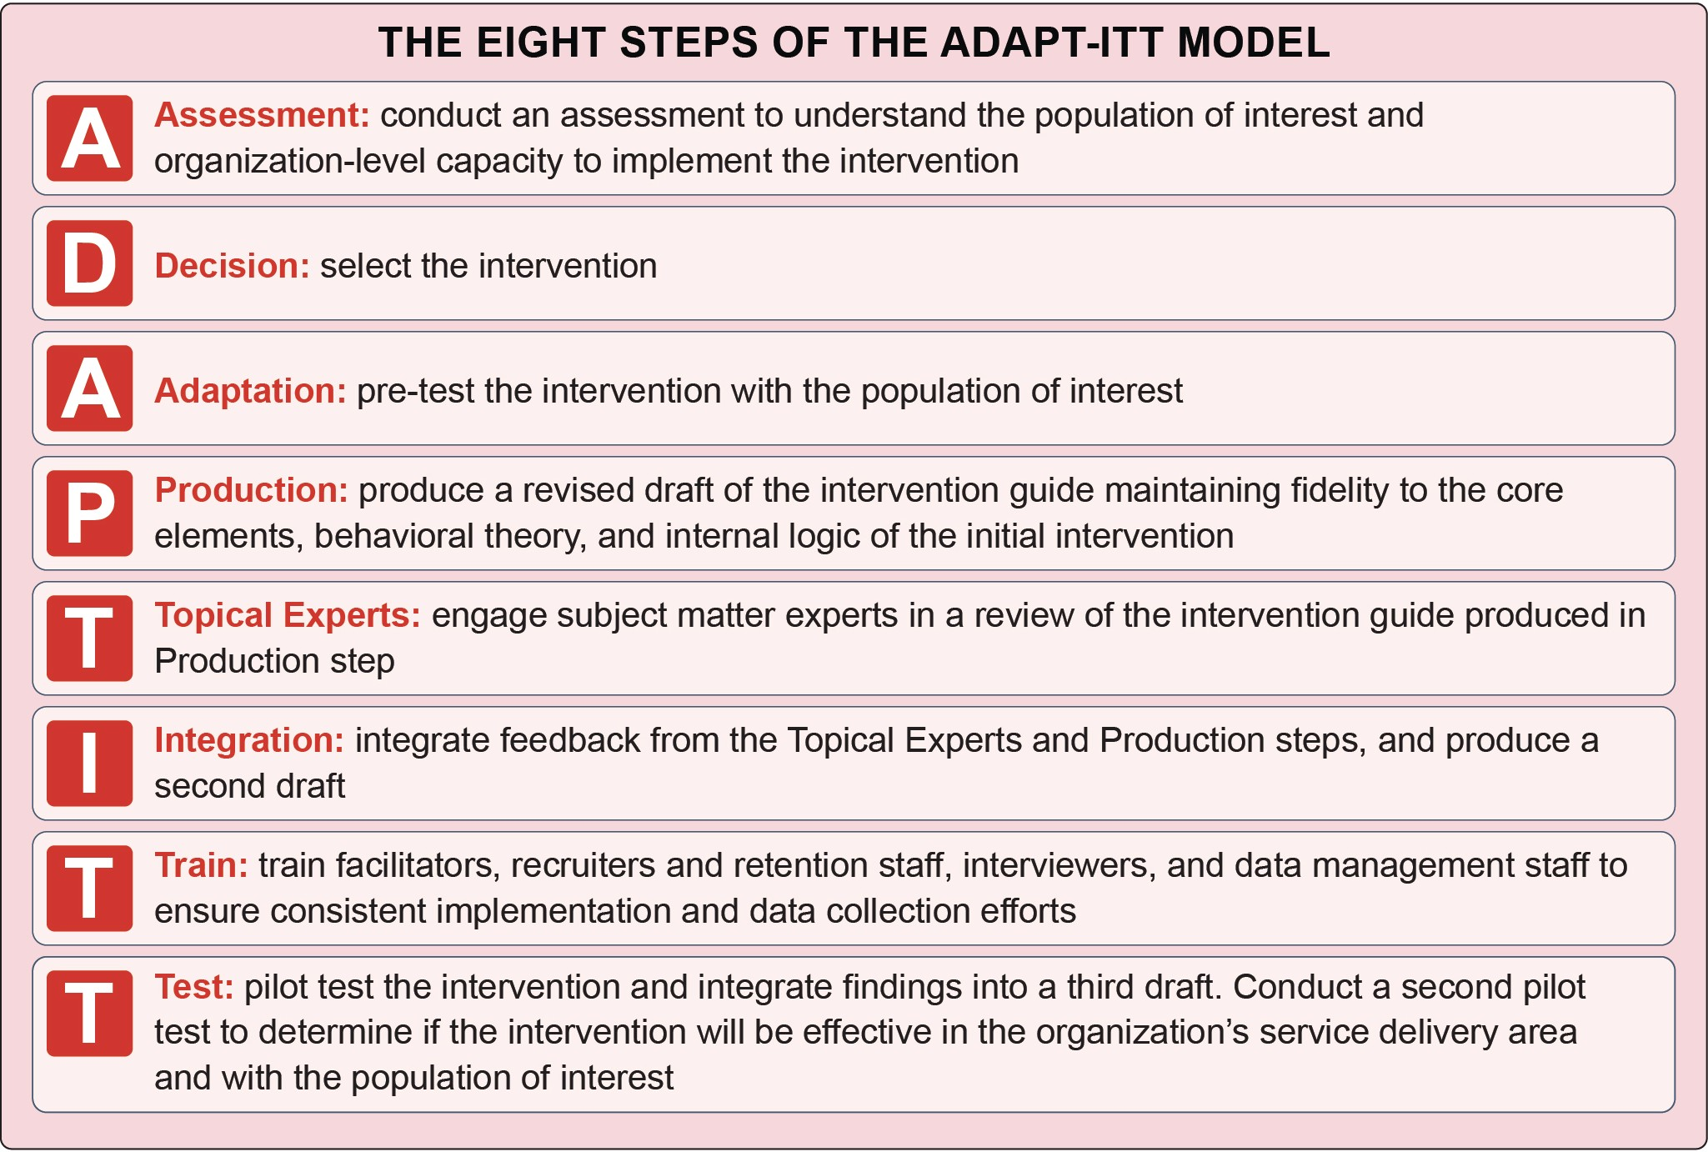

Challenge
COORDINATING CARE
People at risk for or with HIV who also have co-occurring mental illness and/or SUD experience complex medical comorbidities. Fragmented behavioral health and HIV primary care services make it difficult for practitioners to communicate with each other and their clients, potentially leading to poor HIV and mental illness and/or SUD outcomes.¹⁶
Moreover, fragmented care systems place a burden on the clients as they become the ones responsible for
communicating sometimes complex health information among practitioners. Ancillary needs (e.g., housing, childcare, transportation, food insecurity, employment), which are critical to clients seeking or engaging in care, may also be difficult to address in a fragmented system.¹⁷⁻²⁰

Strategies
Effectively addressing these interrelated conditions takes a coordinated approach²¹ between mental illness and/
or SUD and HIV care providers, and other agencies and stakeholders that are well-positioned to address the social determinants of health. Coordinated models may feature screening for mental illness and/or SUD using validated tools; team-based care, including both physician and
non-physician staff; shared IT and electronic medical record systems to facilitate communication within care teams; and systematic measurement and review of patient outcomes.
When HIV clinics screen for mental illness and SUD and are able to provide coordinated care to address mental illness, SUD, and HIV, clients are more likely to reach viral suppression than their counterparts visiting HIV primary care services without coordinated mental health and substance use services.³² Coordinated services help practitioners streamline service delivery to address unmet needs.

Collaborative Care involves increased collaboration between behavioral healthcare management, mental health, and primary care providers. This model includes taking a team-based, client-centered, collaborative approach to elements of client care, such as client registries, client education, screening or assessment tools, adherence monitoring, and evidence-based treatment guidelines.22-23
Integrated Care involves merging primary health care, mental illness and/or SUD screening and treatment, additional medical services (e.g., hepatology, dermatology), and social services (e.g., housing, employment) into one treatment plan. These linkages improve client outcomes by combining efforts such as referrals, case planning, and resources.23-26
The two terms are not interchangeable, and exist on a continuum.27 For example, a system can collaborate while having separate EHR, billing, and scheduling systems. A system can also have integrated care with co-located services where practitioners collaborate and case-conference to discuss client care.
Examples of coordinated care models include patient centered medical homes,28 primary care case management arrangements,29 co-located or limited capacity primary care in behavioral health organizations,29 SAMHSA’s Primary Care and Behavioral Health Integration model,30 and Certified Community Behavioral Health Clinic models.31

Practitioners can use the following strategies to determine the level of integration feasible and appropriate within their organization:
- Identify leaders within clinical networks and health systems who can champion integration and advocate for coordination, co-location, and integration over time.²¹ Integration
takes administrative, political, and financial investments, as well as cultural change and different ways of communicating among care teams and clinics.
- Modify funding structures, billing codes, and procedures to account for new coordinated models and consultation between practitioners.²¹
- Permit data sharing across AIDS-Service
Organizations, social and health service practitioners, behavioral health specialists, and the department of corrections to increase
service coordination.³³ When sharing data across organizations, review updated laws, policies, and regulations on confidentiality to maintain compliance and protect client information³⁴
and obtain consent from clients for data sharing during client assessment and intake.

Challenge
WORKFORCE CAPACITY AND DEVELOPMENT
Behavioral health treatment practitioners and their clinical teams (e.g., case managers, clinical coordinators) are well positioned to address unmet needs (e.g., transportation, housing, employment, childcare), but may need additional training to address co-occurring infectious diseases.³⁵
Practitioners who deliver services aimed at preventing and treating HIV among people experiencing co- occurring mental illness and/or SUD may need training and capacity building in the following areas:
- Practice-specific training to facilitate consistent
implementation
- Working with clients who have co-occurring HIV and mental illness and/or SUD
- Creating a culturally appropriate, non-
judgmental, and non-stigmatizing clinical environment supportive of both clients and staff36-39

Strategies
Provide intervention-specific training to implement the
practices.
- Receiving customized, site-specific training can be resource intensive, and the provision of program-specific training and technical
assistance may be dependent on grant awards. In recent years, federal funders have emphasized the need for replicable practice models that are easy to adapt, scale up, and implement in the absence of technical assistance, leading to an increase in robust training resources available online. These models include:
  - CDC’s Effective Behavioral Intervention (EBIs) models
  - HRSA’s Dissemination of Evidence In-
formed Interventions (DEII) model
  - HRSA’s Evidence-Informed Interventions (E2i) models
- Program managers and practitioners should
select implementation trainings that are not overly cumbersome or time consuming.⁴⁰
Provide cross-disciplinary training and institutional support to practitioners to facilitate better understanding of different disciplines and ways to promote coordinated client care.
- Promote cross-training provided by the AIDS Education and Training Centers (AETCs) on HIV-related programs, policies, and practices to both Ryan White HIV/AIDS Program (RWHAP) and behavioral health practitioners. Similarly, promote training offered by SAMHSA’s Prevention, Mental Health and Addiction Technology Transfer Centers for practitioners and volunteers providing care for persons with and at risk of HIV.
- Create mechanisms for staff to work and train across HIV and behavioral health service programs.⁴¹
- Identify in-house trainings (e.g., grand-rounds,
in-service trainings), local trainings, online webinars, opportunities to attend conferences, and continuing education unit training opportunities to support cross-disciplinary learning.⁹
- Prevent vicarious trauma (i.e., work-related trauma due to continuous exposure to victims of trauma and violence),⁴² burnout, and turnover by
supporting manageable caseloads for staff and providing consistent clinical supervision. For example, peers and patient navigators may not have the formal clinical training their licensed mental health, substance use, and social work colleagues do, and may benefit from ongoing, structured clinical supervision.⁴³
Provide ongoing trainings on ways to create welcoming, supportive environments for people with or at risk for HIV.
- Conduct and support staff training to enhance cultural competence and create a safe, supportive environment that improves client-staff relationships and reduces the risk of a client discontinuing treatment.³³
- Include sessions on non-stigmatizing language⁴⁴ and trauma-informed practices⁴⁵⁻⁴⁶ to improve client interactions with all staff (from the front desk, to their nurse, to the billing department).
ACCESS TO SERVICES

Challenge
Linkage to and retention in care requires connection between the client and the provider. However, transportation and geographic barriers can make in- person, face-to-face connections challenging.
- Transportation-related challenges can include having to travel long distances to clinics,³⁹ inability to afford gas or fares for public transportation, and unreliable or lack of access to a personal vehicle or public transportation for travel to appointments.³⁸
- People with HIV in rural areas are less likely to receive HIV care or be engaged in ART
as a result of limited availability of HIV- specific practitioners, provider discrimination, confidentiality concerns, and lack of financial resources.⁴⁷ Geographic barriers can be compounded by HIV-related stigma where individuals may be reluctant to seek HIV prevention or treatment services in a small town or community for fear they may be “outed.”⁴⁸

Strategies
Program administrators and practitioners can overcome these challenges by employing the following strategies:
- Telehealth - Telehealth can connect clients with specialty practitioners and provide access to services without having to travel.⁴⁹ Telephone- based Cognitive Behavioral Therapy (CBT),
as an example, has been shown to reduce depressive symptoms and improve ART adherence among people with HIV.⁵⁰
- Transportation assistance - Vouchers for gas or public transportation can help eliminate worry about missing appointments due to transportation cost-related barriers.⁵¹ In one model, peer navigators provided transportation to appointments for the first month to give clients sufficient time to establish a long-term
transportation plan.⁵² Ride share companies may also provide travel assistance. For example, Uber Health has partnered with an IT vendor,
Cerner, in six states to get clients to and from their medical appointments. Lyft is also designated as a covered option for providing rides for eligible Medicaid beneficiaries.⁵³
- Combined healthcare visits - Combining HIV care and other healthcare needs (e.g., routine check-up, behavioral health services) in one visit can limit the number of times a client needs to visit their healthcare provider, especially in settings where significant travel may be needed to attend appointments.⁵⁴ Practitioners should
clarify if adequate reimbursement for these visits is available by confirming whether third party payers have the capacity to reimburse for same- day services.
- Mobile health programs - Mobile health programs have been used successfully to increase HIV screening among high-incidence populations in underserved areas.⁵⁵ Many syringe services programs (SSPs) utilize mobile sites due to their flexibility to respond to changing client needs and ability to provide a more informal, easily accessible location for clients who are unable to travel to a fixed site.⁵⁶
- Outreach - Outreach activities, commonly used
to link and retain people with HIV in care, can reduce barriers to accessing care. Patient navigation models specifically emphasize
outreach, with navigation sessions often taking
place in community settings where clients may feel more comfortable than in a clinic environment.⁵⁷ SSPs also expand their reach through secondary or peer-delivery models. SSPs provide people who inject drugs (PWID) with sterile injection drug use equipment to distribute to their networks and to inform them of disposal options.⁵⁶
FINANCING

Challenge
Funding (including financing trainings, reimbursing staff, furnishing programs with needed materials) is essential to implementing and sustaining public health practices. Specific financing challenges for the recommended programs include:
- Insurance reimbursements for services
- Sustainable federal and state funding for service delivery not covered by insurance
- Restrictions on the use of federal funding for SSPs
- Lack of funding for reinforcers and vouchers necessary for Contingency Management (CM)
- Lack of funding for highly experienced clinicians
to implement and facilitate programming

Strategies
Clinic administrators and leadership need to consider strategies for how to:
- Fund a practice
- Diversify funding streams across federal, state, local, and private initiatives⁵⁸
- Counteract cost-prohibitive challenges to
program implementation
When doing so, they should pay particular attention to:
- The specific resources available and needed to implement HIV and mental illness and/ or SUD services, including number of staff,
additional costs related to program materials, and anticipated duration of funding.⁵⁸
- Potential collaborators that may have access to
alternative funding sources. Community-based organizations, correctional facilities, community health centers, or mental illness and/or SUD

treatment settings can act as partners when applying for grants that may only be accessible to specific types of organizations. Partnerships can also be a way to offset the cost of program- related materials.
  - CM costs pose a unique challenge, as many state Medicaid, Medicare, and private insurance entities may not reimburse the reinforcers that are used in this practice, and programs are prohibited from reimbursing for more than $75 annually or $15 per indi- vidual appointment, regardless of the source of the funds. Additional funding sources, such as federal, state, and private grants,
as well as contributions from or opportu- nities to share costs with partners, can help overcome barriers to funding CM reinforc- ers. SAMHSA suggests soliciting donations (which might prove particularly effective at providing CM reinforcers) and making use of volunteers or internships to cut costs.⁶⁰
RYAN WHITE HIV/AIDS PROGRAM (RWHAP)
- RWHAP, a federal initiative started in 1990, can act as the “payer of last resort” for people with HIV, and be used to complete care for uninsured and underinsured individuals (for out of pocket costs, including medication copays or co-insurance for office visits). RWHAP complements and supplements other health programs such as Medicaid and commercial health insurance.
- RWHAP plays a critical role in improving health outcomes for people with HIV across the care continuum.
- This funding is only available for people with HIV, leaving a gap in coverage for preventive services.
- Each year over half a million people receive at least one service under the program.
- RWHAP is the third largest source of federal funding for HIV care in the United States, following Medicare and Medicaid, and was funded at $2.3 billion in FY 2019.59
- How the practice aligns with federal-level priorities and funding opportunities.
- The “Ending the HIV Epidemic: A Plan for
America” initiative allocated $716 million in fiscal year (FY) 2021 to preventing, diagnosing, treating, and responding to HIV.⁶¹
- Potential insurance reimbursement strategies.
  - PrEP is included in Grade A preventive in- terventions by the U.S. Preventive Services Task Force. Therefore, most insurance plans are required to cover prescriptions for PrEP at no cost to the client. However, the task force recommendation does not extend to lab tests or other clinical services.⁶²
o The Centers for Medicare & Medicaid Services offer grant funding to reimburse patient navigators.⁶³
- Opportunities to expand the types of trained facilitators leading behavioral health interventions, such as CBT and CM. Tapping graduate students and psychology or social work interns to facilitate these programs under clinical supervision can offset program costs as these practitioners are generally not paid.⁶⁴⁻⁶⁵

Special Funding Considerations for SSPs
The Consolidated Appropriations Act of 2016 allows the U.S. Department of Health and Human Services to fund SSP education and program evaluation.66 Importantly, this legislation, as well as subsequent congressional appropriations acts, states that federal funds cannot be used to purchase needles or syringes.67-68

Practice Resources

Practices to Increase Uptake of and Improve Adherence to PrEP
- The AETC’s “Prescribing PrEP for HIV Prevention: A Guide for Medical Providers” is a “pocket-guide” for practitioners considering prescribing PrEP. It includes an ideal timeline for screenings and visits, billing codes, and information about potential side effects.⁶⁹
- The Harford County Health Department PrEP Resource Binder⁷⁰ and Michigan Department of Health & Human Services PrEP Provider Toolkit⁷¹ are resources for providers (e.g., CDC consultation, prescribing guidelines, and summaries of PrEP efficacy trials) and clients considering PrEP (e.g., FAQs).
- The Fenway Institute’s Implementing PrEP for HIV Prevention: State-wide Initiative and Provider Experiences presentation focuses
on state-wide implementations of PrEP, provider feedback and experiences, and health communication materials to promote PrEP uptake.⁷²

Syringe Services Programs (SSPs)
- The Harm Reduction Coalition Capacity Building Services provides free mentoring, training,
and technical assistance, including the HIV Harm Reduction Navigator Core Competency Training and Skills-Building Training, to health departments, community-based organizations, and other community stakeholders seeking to establish, expand, or improve the effectiveness of their SSPs.⁷³
- The CDC’s Capacity Building Assistance Provider Network provides free training and technical assistance, continuous quality
improvement, and marketing and administrative support for health departments, community- based organizations, and community partners looking to implement or improve HIV prevention programs and services.⁷⁴
- The Harm Reduction Coalition’s Guide to Developing and Managing Syringe Access Programs provides an overview of harm reduction principles and guidance on how to develop, implement, and manage a SSP.⁷⁵
- The National Alliance of State and Territorial AIDS Directors (NASTAD) and Urban Coalition for HIV/AIDS Prevention Services (UCHAPS)

Syringe Services Programs (SSP) Development and Implementation Guidelines for State and Local Health Departments provides guidance on several aspects of SSP implementation, including how to conduct a community needs assessment, select a service delivery model, monitor outcomes, and build capacity of program staff.⁵⁶
- Comer Family Foundation’s Guide to Establishing Syringe Services Programs in Rural, At-Risk Areas provides an overview of the importance
of SSPs in fighting the opioid epidemic. This resource offers guidance on considerations for SSP implementation and case studies of rural SSPs.⁷⁶
- Oregon Health Authority Harm Reduction and SSP Planning Manual and Resource Library offers a manual and several resources on SSP planning and implementation.⁷⁷

Contingency Management
- Contingency Management: Using Motivational Incentives to Improve Drug Abuse Treatment provides an overview of CM principles, a case study of a program using CM, and guidance regarding how to implement and supervise CM procedures.⁷⁸
- The UCLA Integrated Substance Abuse Program’s A Treatment Manual for Implementing Contingency Management: Using Incentives to Improve Parolee Enrollment and Attendance in Community Treatment is a guide for implementing CM for SUD treatment among parolees.⁷⁹
- The Behavioral Health Recovery Management project A Clinician’s Guide for Implementing Contingency Management Programs provides step-by-step guidance on CM implementation.⁸⁰

Cognitive Behavioral Therapy
- National Association of Cognitive Behavioral Therapists CBT Onsite Training provides multiple resources for both administrators and clients, training, and certification for CBT administrators (i.e., professionals, educators, graduate students).⁸¹
- Beck Academy CBT training and certification offers training and certification for CBT administrators (i.e., professionals, educators, graduate students), online and in-person training
courses, newsletters, assistance with program implementation, and information on utilizing supervisors and consultants.⁸²
- The Evidence-Based Practice
Institute’s Intersecting Epidemics: Evidenced Based Approaches for Treating Depression and HIV/AIDS is an on-demand course (paid access), including a video recording, slides, and handouts.⁸³
- Massachusetts General Hospital offers an online CBT program led by clinical experts (through paid access) for practitioners, including live chats with faculty and interactive discussion boards.⁸⁴

Patient Navigation
- Texas Institute for Excellence in Mental Health Peer Specialist Training and Certification Programs: A National Overview is a compilation of information on existing peer specialist training and certification programs in the United States.⁸⁵
- Best Practices for Integrating Peer Navigators into HIV Models of Care is an AIDS United publication that provides findings and lessons learned from diverse peer navigation models and grantee types.⁸⁶
- As part of the National Minority AIDS Council’s Organizational Effectiveness Series: Building Healthy Organizations, HIV Navigation Services: A Guide to Peer and Patient Navigation Programs provides information
and tools to use in planning and implementing patient navigation programs.⁸⁷
- The Peer Assisted Treatment of HIV and
Substance (PATHS) Model guide describes the development, implementation, and evaluation of a navigation program that incorporates peers into a substance use treatment program for people with HIV.⁸⁸
- Rural Health Information Hub’s Rural HIV/ AIDS Prevention and Treatment Toolkit contains resources and information focused on developing, implementing, evaluating, and
sustaining rural HIV/AIDS programs, including a patient navigation model.⁸⁹

Reference List

¹ Veniegas, R. C., Kao, U. H., & Rosales, R. (2009). Adapting HIV prevention evidence-based interventions in practice settings: An interview
study. Implementation Science, 4(1), 76. https://doi. org/10.1186/1748-5908-4-76
² Kegeles, S. M., Rebchook, G., Tebbetts, S., Arnold, E., & TRIP Team. (2015). Facilitators and barriers to effective scale-up of an evidence-based multilevel
HIV prevention intervention. Implementation Science, 10(1), 50. https://doi.org/10.1186/s13012-015-0216-2
³ Ramsey, A., Lord, S., Torrey, J., Marsch, L., & Lardiere, M. (2016). Paving the way to successful implementation: Identifying key barriers to use of technology-based therapeutic tools for behavioral health care. Journal of Behavioral Health Services Research, 43(1), 54-70. https://doi.org/10.1007/ s11414-014-9436-5
⁴ Centers for Disease Control and Prevention. (2018, December 18). Logic models. https://www.cdc.gov/ eval/logicmodels/index.htm
⁵ Wingood, G. M., & DiClemente, R. J. (2008). The ADAPT-ITT model: A novel method of adapting evidence-based HIV interventions.
Journal of Acquired Immune Deficiency Syndromes (JAIDS), 47, S40-S46. https://doi.org/10.1097/ QAI.0b013e3181605df1
⁶ Amodeo, M., Lundgren, L., Cohen, A., Rose, D., Chassler, D., Beltrame, C., & D’ippolito, M. (2011). Barriers to implementation of evidence- based practices in community-based addiction
treatment: Comparing staff reports on motivational interviewing, adolescent community reinforcement approach, assertive community treatment, and cognitive-behavioral therapy. Evaluation Program Planning, 34(4), 382-389. https://doi.org/10.1016/j. evalprogplan.2011.02.005
⁷ Cohen, A., Lundgren, L., Amodeo, M., Chassler, D., & Rose, D. (n.d.). Barriers to implementation of evidence-based practices in community-based addiction treatment: Comparing staff reports of barriers from a nationwide sample [PowerPoint Slides]. Centers for Addictions Research and Services, Boston University School of Social Work. https://apha.confex.com/apha/138am/ recordingredirect.cgi/id/39706
⁸ Substance Abuse and Mental Health Services Administration. (2019). A guide to SAMHSA’s strategic prevention framework. https://www. samhsa.gov/sites/default/files/20190620-samhsa- strategic-prevention-framework-guide.pdf
⁹ Collins Jr., C. B., & Sapiano, T. N. (2016). Lessons learned from dissemination of evidence-based interventions for HIV prevention. American Journal of Preventive Medicine, 51(4), S140-S147. https:// doi.org/10.1016/j.amepre.2016.05.017
¹⁰ Galbraith, J. S., Herbst, J. H., Whittier, D. K., Jones,
P. L., Smith, B. D., Uhl, G., & Fisher, H. H. (2011).
Taxonomy for strengthening the identification of core elements for evidence-based behavioral interventions for HIV/AIDS prevention. Health Education Research, 26(5), 872-885. https://doi.
org/10.1093/her/cyr030
¹¹ Substance Abuse and Mental Health Services Administration. (2018). Selecting best-fit programs and practices: Guidance for substance misuse prevention practitioners. https://www.samhsa. gov/sites/default/files/ebp_prevention_guidance_ document_241.pdf
¹² Network of the National Library of Medicine. (n.d.). Health literacy.National Institutes of Health. https:// nnlm.gov/initiatives/topics/health-literacy
¹³ Centers for Disease Control and Prevention. (2019, October 17). Assess health literacy in your organization. https://www.cdc.gov/healthliteracy/
researchevaluate/organization-assessment-tools.html
¹⁴ Agency for Healthcare Research and Quality. (2015, January). Guide to implementing the health literacy universal precautions toolkit. https://www.ahrq. gov/health-literacy/quality-resources/tools/literacy- toolkit/impguide/index.html
¹⁵ Office of Minority Health Resource Center. (2018, October 2). The National CLAS Standards. U.S. Department of Health and Human Services. https://minorityhealth.hhs.gov/omh/browse. aspx?lvl=2&lvlid=53

¹⁶ Substance Abuse and Mental Health Services Administration, Health Resources and Services Administration, & National Council for Behavioral Health. (2016, September 14). Strategies for success in integrating HIV care into behavioral health care. Center of Excellence for Integrated Health Solutions. https://www.thenationalcouncil.org/coe_resource/ strategies-for-success-in-integrating-hiv-care-
into-behavioral-health-care/strategies-for-success- in-integrating-hiv-care-into-behavioral-health- care-9-14-16/
¹⁷ Aidala, A. A., Wilson, M. G., Shubert, V.,
Gogolishvili, D., Globerman, J., Rueda, S., Bozack,
A. K., Caban, M., & Rourke, S. B. (2016). Housing status, medical care, and health outcomes among people living with HIV/AIDS: A systematic review. American Journal of Public Health, 106(1), e1-e23. https://doi.org/10.2105/ajph.2015.302905
¹⁸ Feller, D. J., & Agins, B. D. (2017). Understanding determinants of racial and ethnic disparities in viral load suppression: A data mining approach. Journal of the International Association of Providers of AIDS Care (JIAPAC), 16(1), 23-29. https://doi. org/10.1177/2325957416667488
¹⁹ Gupta, G. R., Parkhurst, J. O., Ogden, J. A., Aggleton, P., & Mahal, A. (2008). Structural approaches to HIV prevention. The Lancet, 372(9640), 764-775. https:// doi.org/10.1016/s0140-6736(08)60887-9
²⁰ Kamarulzaman, A., & Altice, F. L. (2015). Challenges in managing HIV in people who use drugs. Current Opinion in Infectious Disease, 28(1), 10-16. https://doi. org/10.1097/QCO.0000000000000125
²¹ Heath Jr., B., Reynolds, K., & Romero, P. W. (2013). A standard framework for levels of integrated healthcare. Substance Abuse and Mental Health Services Administration – Health Services and Resources Administration Center for Integrated Health Solutions https://www.pcpcc.org/resource/ standard-framework-levels-integrated-healthcare
²² Ivbijaro, G. O., Enum, Y., Khan, A. A., Lam, S. S., & Gabzdyl, A. (2014). Collaborative care: Models for treatment of patients with complex medical- psychiatric conditions. Current Psychiatry Reports, 16(11), 506. https://doi.org/10.1007/s11920-014- 0506-4
²³ National Institute of Mental Health. (2017, February). Integrated care. U.S. Department of Health and Human Services. https://www.nimh.nih. gov/health/topics/integrated-care/index.shtml
²⁴ Chuah, F. L. H., Haldane, V. E., Cervero-Liceras, F., Ong, S. E., Sigfrid, L. A., Murphy, G., Watt, N., Balabanova, D., Hogarth, S., Maimaris, W., Otero, L., Buse, K., McKee, M., Piot, P., Perel, P., & Legido-Quigley, H. (2017). Interventions and approaches to integrating HIV and mental health services: A systematic review. Health Policy and Planning, 32(Suppl. 4), iv27-iv47. https://doi. org/10.1093/heapol/czw169
²⁵ Kinman, C. R., Gilchrist, E. C., Payne-Murphy, J. C., & Miller, B. F. (2015). Provider- and practice- level competencies for integrated behavioral health in primary care: A literature review. Agency for Healthcare Research and Quality (AHRQ). https:// integrationacademy.ahrq.gov/sites/default/files/ AHRQ_AcadLitReview.pdf
²⁶ Hoge M.A., Morris J.A., Laraia M., Pomerantz A., & Farley, T. (2014). Core competencies for integrated behavioral health and primary care. Substance Abuse and Mental Health Services Administration – Health Services and Resources Administration Center for Integrated Health Solutions http://womenshealthcouncil.org/wp- content/uploads/2016/11/WF-Core-Competencies-
for-Integrated-Behavioral-Health-and-Primary-Care. pdf
²⁷ Substance Abuse and Mental Health Services Administration – Health Services and Resources Administration Center for Integrated Health Solutions. (2020, January). Standard framework for levels of integrated care. National Council for Behavioral Health. https://www.thenationalcouncil.
org/wp-content/uploads/2020/01/CIHS_Framework_ Final_charts.pdf?daf=375ateTbd56
²⁸ Keuroghlian, A. (2017). Expanding access to behavioral health care for people living with HIV/ AIDS. National Center for Innovation in HIV Care. https://targethiv.org/library/expanding-access- behavioral-health-care-people-living-hivaids
²⁹ Shah, V. (2018). Behavioral health integration within the HIV continuum of care. National Alliance of State and Territorial AIDS Directors. https://www. nastad.org/sites/default/files/resources/docs/issue_ brief_final.pdf
³⁰ Scharf, D. M., Eberhart, N. K., Hackbarth, N. S., Horvitz-Lennon, M., Beckman, R., Han, B., Lovejoy, S. L., Pincus, H. A., & Burnam, M. A.
(2014). Evaluation of the SAMHSA Primary and Behavioral Health Care Integration (PBHCI) grant program: Final report. Rand Health Quarterly, 4(3),
6. Retrieved July 17, 2020, from https://www.rand. org/pubs/periodicals/health-quarterly/issues/v4/ n3/06.html

³¹ Substance Abuse and Mental Health Services Administration. (2018, October 11). Section 223 demonstration program for certified community behavioral health clinics. https://www.samhsa.gov/ section-223
³² Hoang, T., Goetz, M. B., Yano, E. M., Rossman, B., Anaya, H. D., Knapp, H., Korthuis, P. T., Henry, R., Bowman, C., & Gifford, A. (2009). The impact of integrated HIV care on patient health
outcomes. Medical care, 47(5), 560-567. https://doi.
org/10.1097/MLR.0b013e31819432a0
³³ Grau, L. E., Griffiths-Kundishora, A., Heimer, R.,
Hutcheson, M., Nunn, A., Towey, C., & Stopka, T.
J. (2017). Barriers and facilitators of the HIV care continuum in southern new england for people with drug or alcohol use and living with HIV/AIDS: Perspectives of HIV surveillance experts and service providers. Addiction Science & Clinical Practice, 12(1), 24. https://doi.org/10.1186/s13722-017-0088-7
³⁴ Integrated Behavioral Health Partners. (n.d.). Confidentiality. Integrated Behavioral Health Partners. http://www.ibhpartners.org/get-started/ procedures/confidentiality/
³⁵ Seeman, M. V. (2015). The role of mental health services in addressing HIV infection among women with serious mental illness. Psychiatric Services, 66(9), 966-974. https://doi.org/10.1176/appi. ps.201400411
³⁶ Geter, A., Herron, A. R., & Sutton, M. Y. (2018). HIV-related stigma by healthcare providers in the United States: A systematic review. AIDS Patient Care and STDs, 32(10), 418-424. https://doi. org/10.1089/apc.2018.0114
³⁷ Stringer, K. L., Turan, B., McCormick, L., Durojaiye, M., Nyblade, L., Kempf, M., Lichtenstein, B., & Turan, J. M. (2016). HIV-related stigma among healthcare providers in the deep south. AIDS and Behavior, 20(1), 115-125. https:// doi.org/10.1007/s10461-015-1256-y
³⁸ Yehia, B. R., Stewart, L., Momplaisir, F., Mody, A.,
Holtzman, C. W., Jacobs, L. M., Hines, J., Mounzer,
K., Glanz, K., & Metlay, J. P. (2015). Barriers and facilitators to patient retention in HIV care. BMC Infectious Diseases, 15(1), 246. https://doi.
org/10.1186/s12879-015-0990-0
³⁹ Kempf, M., McLeod, J., Boehme, A. K., Walcott, M. W., Wright, L., Seal, P., Norton, W. E., Schumacher,
J. E., Mugavero, M., & Moneyham, L. (2010). A qualitative study of the barriers and facilitators to retention-in-care among HIV-positive women in the rural southeastern United States: Implications for targeted interventions. AIDS Patient Care and STDs, 24(8), 515-520. https://doi.org/10.1089/ apc.2010.0065
⁴⁰ D’Ippolito, M., Lundgren, L., Amodeo, M., Beltrame, C., Lim, L., & Chassler, D. (2015). Addiction treatment staff perceptions of training as a facilitator or barrier to implementing evidence-based practices: A national qualitative research study. Substance Abuse, 36(1), 42-50. https://doi.org/10.10 80/08897077.2013.849646
⁴¹ Hoge, M. A., Morris, J. A., Laraia, M., Pomerantz, A., & Farely, T. (2014). Core competencies for integrated behavioral health and primary care. Substance Abuse and Mental Health Services Administration, & Health Resources and Services Administration Center of Excellence for Integrated Health Solutions. https://www.hrsa.gov/behavioral- health/core-competencies-integrated-behavioral- health-and-primary-care
⁴² Office for Victims of Crime. The vicarious trauma toolkit. Office of Justice Programs, U.S. Department of Justice. https://ovc.ojp.gov/program/vtt/ introduction
⁴³ Georgia Mental Health Consumer Network, Tucker, S., Tiegreen, W., Toole, J., Banathy, J., Mulloy,
D., & Swarbrick, M. (2013). Supervisor guide: Peer support whole health and wellness. Health
Resources and Services Administration. https://bhta. hrsa.gov/resources/supervisor-guide-peer-support- whole-health-and-wellness
⁴⁴ Recovery Research Institute. Addictionary®. Massachusetts General Hospital, Harvard Medical School. https://www.recoveryanswers.org/ addiction-ary/
⁴⁵ Substance Abuse and Mental Health Services Administration, & Health Resources and Services Administration Center for Integrated Health Solutions. (2015). Improving health through trauma- informed care. https://bhta.hrsa.gov/resources/ improving-health-through-trauma-informed-care
⁴⁶ Substance Abuse and Mental Health Services Administration. (2014). Trauma-informed care in behavioral health services. Treatment Improvement Protocol (TIP) series 57.U.S. Department of Health and Human Services. https://store.samhsa. gov/product/TIP-57-Trauma-Informed-Care-in- Behavioral-Health-Services/SMA14-4816
⁴⁷ Pellowski, J. A. (2013). Barriers to care for rural people living with HIV: A review of domestic research and health care models. Journal of the Association of Nurses in AIDS Care, 24(5), 422-437. https://doi.org/10.1016/j.jana.2012.08.007

⁴⁹ Dandachi, D., Lee, C., Morgan, R. O., Tavakoli- Tabasi, S., Giordano, T. P., & Rodriguez-Barradas,
M. C. (2019). Integration of telehealth services in the healthcare system: With emphasis on the experience of patients living with HIV. Journal of Investigative Medicine, 67(5), 815-820. https://doi.org/10.1136/ jim-2018-000872
⁵⁰ Himelhoch, S., Medoff, D., Maxfield, J., Dihmes, S., Dixon, L., Robinson, C., Potts, W., & Mohr, D. C. (2013). Telephone based cognitive behavioral therapy targeting major depression among urban dwelling, low income people living with HIV/AIDS: Results
of a randomized controlled trial. AIDS and Behavior, 17(8), 2756-2764. https://doi.org/10.1007/s10461-
013-0465-5
⁵¹ Yehia, B. R., Stewart, L., Momplaisir, F., Mody, A., Holtzman, C. W., Jacobs, L. M., Hines, J., Mounzer, K., Glanz, K., Metlay, J. P., & Shea, J. A. (2015). Barriers and facilitators to patient retention in HIV care. BMC Infectious Diseases, 15(1), 246. https://doi. org/10.1186/s12879-015-0990-0
⁵² Center for Health Policy and Inequalities Research. Including peers as part of a substance use treatment program for individuals living with HIV: The peer assisted treatment of HIV and substance (PATHS) model. http://chpir.org/wp-content/uploads/paths_ model.pdf
⁵³ Cohen, J. K. (2019, October 28). Lyft, uber expand reach into healthcare. Modern Healthcare. https:// www.modernhealthcare.com/patients/lyft-uber- expand-reach-healthcare
⁵⁴ Kempf, M. C., McLeod, J., Boehme, A. K., Walcott, M. W., Wright, L., Seal, P., Norton, W. E., Schumacher, J. E., Mugavero, M., & Moneyham,
L. (2010). A qualitative study of the barriers and facilitators to retention-in-care among HIV-positive women in the rural southeastern United States: Implications for targeted interventions. AIDS Patient Care and STDs, 24(8), 515-520. https://doi. org/10.1089/apc.2010.0065
⁵⁵ Yu, S. W. Y., Hill, C., Ricks, M. L., Bennet, J., & Oriol, N. E. (2017). The scope and impact of mobile health clinics in the United States: A literature review. International Journal for Equity in Health, 16(1), 178. https://doi.org/10.1186/s12939-017-0671-2
⁵⁶ National Alliance of State & Territorial Aids Directors, & Urban Coalition for HIV/AIDS Prevention Services. (2012). Syringe services program (SSP) development and implementation guidelines for state and local health departments. https://www.nastad.org/sites/default/files/resources/ docs/055419_NASTAD-SSP-Guidelines-
August-2012.pdf
⁵⁷ AIDS United. (2015). Best practices for integrating peer navigators into HIV models of care. https:// www.aidsunited.org/data/files/Site_18/PeerNav_ v8.pdf
⁵⁸ Center for Substance Abuse Treatment. (2000). Chapter 10—Funding and policy considerations. In Substance abuse treatment for persons with HIV/ AIDS. Treatment Improvement Protocol (TIP) series, no. 37. Substance Abuse and Mental Health Services Administration. https://www.ncbi.nlm.nih.gov/ books/NBK64925/
⁵⁹ Kaiser Family Foundation. (2019, February 4). The Ryan White HIV/AIDS program: The basics. https:// www.kff.org/hivaids/fact-sheet/the-ryan-white- hivaids-program-the-basics/
⁶⁰ Center for Substance Abuse Treatment. (2009). Implementing change in substance abuse treatment programs. Technical Assistance Publication Series
31. HHS Publication No. (SMA) 09-4377. Substance Abuse and Mental Health Services Administration. https://www.ctcertboard.org/files/pdfs/TAP31.pdf
⁶¹ HIV.gov. (2019, September 3). What is ‘Ending the HIV Epidemic: A plan for America’? https://www. hiv.gov/federal-response/ending-the-hiv-epidemic/ overview
⁶² Andrews, M. (2019, July 15). Even when HIV prevention drug is covered, other costs block treatment. Kaiser Health News. https://khn.org/ news/even-when-hiv-prevention-drug-is-covered- other-costs-block-treatment/
⁶³ Keith, K. (2019, September 1). Centers for Medicare and Medicaid Services (CMS) announces new navigator grantees for 2020, 2021. Health Affairs. https://www.healthaffairs.org/do/10.1377/ hblog20190831.204373/full/#:~:text=For%20 2020%20and%202021%2C%20CMS,based%20 marketplace%20using%20HealthCare.gov
⁶⁴ Safren, S. A., O’Cleirigh, C. M., Bullis, J. R., Otto,
M. W., Stein, M. D., & Pollack, M. H. (2012). Cognitive behavioral therapy for adherence and depression (CBT-ad) in HIV-infected injection drug users: A randomized controlled trial. Journal of Consulting and Clinical Psychology, 80(3), 404-415. https://doi.org/10.1037/a0028208
⁶⁵ Petry, N. M., Weinstock, J., & Alessi, S. M. (2011). A randomized trial of contingency management delivered in the context of group counseling. Journal of Consulting and Clinical Psychology, 79(5), 686- 696. http://dx.doi.org/10.1037/a0024813

⁶⁶ HIV.gov. (2020, January 31). Syringe services programs - Opioid crisis is raising risks of HIV & other infectious diseases. https://www.hiv.gov/ federal-response/policies-issues/syringe-services- programs
⁶⁷ Centers for Disease Control and Prevention (2019, May 23). Federal funding for syringe services programs. https://www.cdc.gov/ssp/ssp-funding.html
⁶⁸ National Academies of Sciences, Engineering, and Medicine. (2020). Opportunities to improve opioid use disorder and infectious disease
services: Integrating responses to a dual epidemic. The National Academies Press. https://doi. org/10.17226/25626
⁶⁹ AETC National Coordinating Resource Center, & Oregon AETC. (2019, February 25). Prescribing PrEP for HIV prevention: A guide for medical providers. https://aidsetc.org/resource/prescribing- prep-hiv-prevention-guide-medical-providers
⁷⁰ Kosinski, Z., & Harford County Health Department PrEP Program. (2018). PrEP program resource binder. https://harfordcountyhealth.com/wp-content/ uploads/2018/10/PrEP-Provider-Toolkit_optimized. pdf
⁷¹ Michigan Department of Health & Human Services. (2019). PrEP provider toolkit. https://www. michigan.gov/documents/mdhhs/PrEP_Provider_ Toolkit_MDHHS_547647_7.pdf
⁷² Calabrese, S. K., St. George, D., Callis, B., & Buchelli, M. (2015, June 4). Implementing PrEP for HIV prevention: State-wide initiatives and provider experiences [PowerPoint slides]. National LGBT Health Education Center, Fenway Institute. https:// www.lgbthealtheducation.org/wp-content/uploads/ Implementing-PrEP-for-HIV-Prevention_Final.pdf
⁷³ Harm Reduction Coalition. (n.d.). Syringe access implementation. https://harmreduction.org/our-work/ syringe-access-implementation/
⁷⁴ Centers for Disease Control and Prevention. (2020, March 19). Capacity building assistance. U.S. Department of Health and Human Services. https:// www.cdc.gov/hiv/capacity-building-assistance/ index.html
⁷⁵ Winkelstein, E. (2010). Guide to developing and managing syringe access programs. Harm Reduction Coalition. https://harmreduction.org/issues/syringe- access/guide-to-managing-programs/
⁷⁶ La Belle, R. (2017). A guide to establishing syringe services programs in rural, at-risk areas. Comer Family Foundation. https://www. comerfamilyfoundation.org/img/A-Guide-to-
Establishing-Syringe-Services-Programs-in-Rural-At- Risk-Areas.pdf
⁷⁷ Oregon Public Health Division.(2019) Harm reduction and SSP planning and resource manual. Oregon Health Authority. https://www.oregon.gov/oha/PH/ PREVENTIONWELLNESS/SUBSTANCEUSE/ Pages/harm-reduction-library.aspx
⁷⁸ Petry, N.M. & Stitzer, M.L. (2002). Contingency
Management: Using Motivational Incentives to Improve Drug Abuse Treatment. Yale University Psychotherapy Development Center. https://medicine.yale.edu/psychiatry/ research/programs/clinical_people/pdc/
ContingencyManagement_176454_284_46619_ v1.pdf
⁷⁹ Prendergast, M., Hall, E., & Rokke, A. (2011). A treatment manual for implementing contingency management. UCLA Integrated Substance Abuse Programs. http://www.uclaisap.org/assets/
documents/Manual%20for%20Implementing%20 Contingency%20Management_11-8-2011%20clean. pdf
⁸⁰ Petry, N. (2001). A clinician’s guide for implementing contingency management programs. Department
of Psychiatry, University of Connecticut School of Medicine. https://www.drugsandalcohol.ie/13618/1/ NTA_Contingency_management_Petry.pdf
⁸¹ National Association of Cognitive-Behavioral Therapists. (n.d.). CBT: Cognitive-behavioral therapy onsite training. https://www.nacbt.org/cbt- cognitive-behavioral-therapy-onsite-training/
⁸² Beck Institute. (2019). Beck cognitive behavior therapy: Get training. https://beckinstitute.org/get- training/
⁸³ Safren, S. (2020). Intersecting epidemics: Evidenced based approaches for treating depression and HIV/ AIDS. PracticeGround. https://www.practiceground. org/abct-2018-safren
⁸⁴ Massachusetts General Hospital Psychiatry Academy. (2020). Cognitive behavioral therapy. Massachusetts General Hospital. https://www. massgeneral.org/psychiatry/treatments-and-services/ cognitive-behavioral-therapy-program
⁸⁵ Kaufman, L., Kuhn, W., Stevens Manser, S., & Texas Institute for Excellence in Mental Health. (2016). Peer specialist training and certification programs: A national overview. Health Resources and Services Administration. https://bhta.hrsa.gov/ resources/peer-specialist-training-and-certification- programs-national-overview
⁸⁶ AIDS United. (2015). Best practices for integrating peer navigators into HIV models of care. https:// www.aidsunited.org/data/files/Site_18/PeerNav_ v8.pdf

⁸⁷ National Minority AIDS Council, & Linking and Integrating Networks for Collaboration. (2015). HIV navigation services: A guide to peer & patient navigation programs. Organizational Effectiveness Series: Building Healthy Organizations. http:// nmac.org/wp-content/uploads/2012/08/OES-HNS_ FINAL_9-3-2015.pdf
⁸⁸ Centers for Health Policy & Inequalities Research. (n.d.). Including peers as part of a substance use treatment program for individuals living with HIV: The peer assisted treatment of HIV and substance (PATHS) model. Duke University. http://chpir.org/ wp-content/uploads/paths_model.pdf
⁸⁹ Rural Health Information Hub, Health Resources and Services Administration, & U.S. Department of Health and Human Services. (2020). Rural HIV/
AIDS prevention and treatment toolkit. https://www. ruralhealthinfo.org/toolkits/hiv-aids

4CHAPTER

Examples of Effective Programs and Strategies

The chapter describes how practitioners have implemented three prevention and treatment programs as part of a comprehensive strategy to prevent and treat HIV among people living with mental illness and/or substance use disorders (SUD):
- Faster Paths to Treatment: a SUD bridge clinic program implementing practices to Increase Uptake and Improve Adherence to Pre-Exposure Prophylaxis (PrEP)
- Louisville Metro Syringe Exchange Program (LMSEP): a Syringe Services Program (SSP)
- The Alexis Project: a HIV linkage and retention
program implementing both Contingency Management (CM) and Patient Navigation
The three examples highlighted in this chapter were identified through an environmental scan and in consultation with experts. While there are additional programs that could have been featured in this chapter, those highlighted below were included to provide diverse examples of settings in which HIV and mental illness and/ or SUD can be addressed.
To be included, the interventions had to:
- Include one or more of the practices identified in
Chapter 2
- Be replicable (well-defined with guidance
materials or a manual)
- Have research to support their impact on HIV and mental illness and/or SUD, or be identified as a promising practice

- Provide appropriate and effective interventions for varied geographic areas, practice settings, and diverse populations
Programs should implement practices with fidelity to evaluated models. Fidelity is the degree to which a program delivers a practice as intended and must be maintained for desired therapy outcomes. However, many programs adapt chosen practices to better serve their clients. As practitioners modify practices to address the needs and constraints of their population, budget, setting, and other local factors, they should strive to adhere to the practice’s foundational principles.

Faster Paths to Treatment
Boston Medical Center (Boston, MA)

Faster Paths to Treatment is a low-barrier SUD bridge clinic that opened in 2016 to address the opioid use disorder (OUD) epidemic and overdose crisis. It is part of a network of SUD treatment programs at Boston Medical Center, and it uses a flexible, client-centered, harm-reduction model to provide rapid access to medications for OUD, outpatient medically-managed withdrawal, overdose and HIV prevention services, sexually transmitted infection testing and treatment, and linkage to long-term SUD treatment and primary/ psychiatric care after stabilization. Faster Paths serves a population with high rates of prior drug overdose,
polysubstance use, and homelessness. It is funded by the Massachusetts Department of Public Health Bureau of Substance Addiction Services.

Model Features and Elements
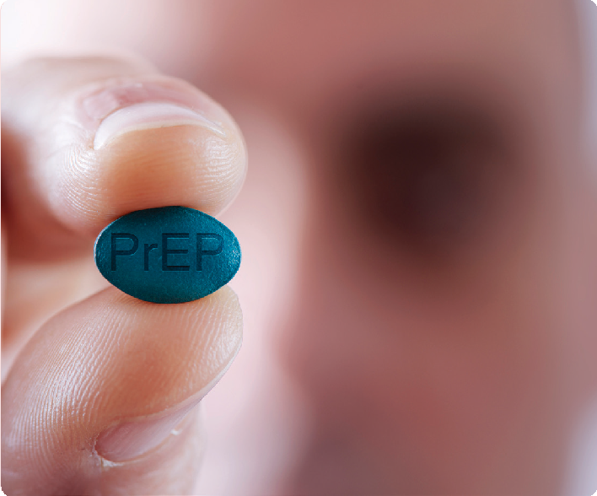
Recognizing the need for on-demand services, Faster Paths offers both scheduled and walk-in appointments and aims to provide same day access to buprenorphine (a form of medication for opioid use disorder) and HIV prevention services including testing, PrEP, and post- exposure prophylaxis (PEP). Same day services mitigate the chance of loss to follow-up and support client engagement.

Evidence-Based Practice Implemented by the Program
Practices to increase uptake of and improve adherence to PrEP
Population of Focus
People who use substances; 66 percent of clinic clients report injection drug behavior. Many clients have co-occurring psychiatric disorders and face significant psychosocial barriers to care, including housing instability.
Approximate Time Period (Duration)
Clients are typically followed in Faster Paths for weeks to months
Related Resources
Program Website

Taylor, J. L., Walley, A. Y., & Bazzi, A. R. (2019). Stuck in the window with you: HIV exposure prophylaxis in the highest risk people who inject drugs. Substance Abuse, 40(4), 441-443. https:// pubmed.ncbi.nlm.nih.gov/31644387/
eReview of PrEP in PWID

Findings and Outcomes
- Because Faster Paths clients often report recent potential HIV exposures, “PEP-to-PrEP” (starting on PEP and transitioning to PrEP) has been the safest, most efficient, and effective way to start PrEP for this population.¹ If a client reports being exposed to HIV within the last 72 hours, Faster Paths emphasizes PEP as a bridge to PrEP, which can be started immediately at the end of a 28-day PEP course in clients who remain HIV negative. In April 2020, 22 percent of provider visit notes (including initial visits and follow up visits) addressed PEP or PrEP.

- To support practitioners in consistently evaluating HIV prevention needs, Faster Paths has a standardized intake laboratory panel and electronic medical record note templates to assess risk of getting HIV and PrEP eligibility.

Lessons Learned
- Many clients seen in Faster Paths have limited awareness about PrEP and its potential benefits as a result of not having had the opportunity
to discuss PrEP with a provider in the past, limited information about PrEP within their social network, and marketing that has not been inclusive of people who inject drugs (PWID).
- The way a provider discusses PrEP can be crucial for uptake. For example, it can be important to emphasize that PrEP is
recommended for preventing HIV for a wide range of populations (e.g., PWID, men who have sex with men, and heterosexual people) to reduce stigma related to PrEP.
- Faster Paths aims to educate clients about PrEP in a manner that is not overwhelming (e.g., at initial or follow-up visits, depending on client preference), highlighting the ways PrEP can benefit both the client and their networks (i.e., sexual and injection drug use equipment–sharing partners), and emphasizing that PrEP will not necessarily be a life-long medication.
- Faster Paths clients have an increased likelihood of acute HIV disease due to a current outbreak among PWID in Boston, MA. In April, 2020, 13 percent of HIV screening tests in Faster Paths resulted in a new diagnosis of HIV transmission associated with injection drug use. Providers have expressed concern about starting same- day PrEP while awaiting HIV test results due
to potential barriers to reaching the client to stop PrEP if the test returns positive. However, providers realized when they asked the client to return to the clinic to begin PrEP at a later date, opportunities were missed due to loss to follow-
up. Therefore, if a client has a reliable method of contact, providers consider starting PrEP while HIV test results are pending.
- Many SUD providers were not educated about PEP/PrEP during their clinical training, and the PEP/PrEP cases seen in Faster Paths are complex. To increase provider confidence prescribing PEP/PrEP in PWID, Faster Paths conducts didactic sessions with faculty, nurses, fellows, licensed drug and alcohol counselors, and administrative staff and provides real-time
clinical support when PEP/PrEP questions arise.

Louisville Metro Syringe Exchange Program (LMSEP)
Louisville Metro Department of Public Health and Wellness (Louisville, KY)

The Louisville Metro Syringe Exchange Program (LMSEP) is a SSP that started in 2015. Established through the Louisville Department of Public Health and Wellness, LMSEP has two main goals:
  - Prevent the spread of blood-borne infectious diseases transmitted through syringe sharing
  - Link PWID to treatment
As a harm reduction program, LMSEP works with numerous community organizations and stakeholders to provide the following to PWID in the Louisville Metro area:
  - Access to free and sterile syringes
  - Safe syringe disposal (on site and at two mailbox disposals in the community)
  - Fentanyl test strips
  - Safe injection supplies
  - HIV and hepatitis C virus (HCV) testing and referrals
  - Referrals for mental illness and/or SUD
treatment
  - Counseling
  - Harm reduction education on HCV, HIV, sexually transmitted infections, wound care, and overdose prevention (including providing naloxone)
LMSEP offers syringe exchange services at their main site inside the Louisville Metro Department of Public Health and Wellness. In addition, they offer mobile van exchange services at seven satellite locations during the week.

Model Features and Elements
  - The primary pillar of LMSEP is trust. Through its outreach work, LMSEP emphasizes accepting participants where they are and not judging them or stigmatizing them further. Staff and volunteers also tell participants that pursuing SUD treatment is voluntary and not a requirement of the program.
  - Underscoring the importance of mutual respect between participants and staff, LMSEP created

Evidence-based Practice Implemented by the Program
Syringe Services Program (SSP)
LMSEP is an outpatient SSP organized by the Louisville Department of Public Health and Wellness. LMSEP offers social and health services to PWID through fixed-site and mobile van settings.
Population of Focus
PWID, specifically adults aged 18 to 25.
Approximate Time Period (Duration)
Indefinite
Related Resources
- Program Website
- LMSEP Overview (slides)
- LMSEP Brochure of Services
- LMSEP Guidelines
- LMSEP Research Brief

a Participant Bill of Rights and Responsibilities to ensure the rights and expectations of participants, staff, and volunteers are clear to all individuals involved with the program.
- During their first visit, participants are asked to complete a voluntary intake form. Using the Program Staff Check List and this intake form,
staff discuss LMSEP’s numerous harm reduction and treatment services with participants.
- Within LMSEP’s harm reduction model,
certified alcohol and SUD counselors and HIV prevention specialists provide onsite support, testing, and linkage. LMSEP staff link participants who test positive for HIV to a Kentucky Care Coordination program case manager at the University of Louisville to facilitate HIV-specific care and treatment.

Findings and Outcomes
  - Since its establishment in 2015, LMSEP has served more than 20,000 unique participants, has had about 115,000 visits, and has distributed more than five million sterile syringes. LMSEP has also:
    - Tested more than 35,000 people for HIV and referred 29 for treatment
    - Tested more than 4,800 people for HCV and
referred approximately 700 for treatment
    - Referred 719 people for SUD treatment
    - Connected more than 300 people to other community services
  - Since LMSEP staff began distributing naloxone, 890 participants have reported almost 2,000 overdose reversals.
  - Louisville has prevented a substantial rise
in new HIV diagnoses, reporting a stable transmission rate while neighboring states have experienced increases. Before LMSEP opened, the rate of new HIV diagnoses in the Louisville metropolitan region was 15.3 per 100,000 in 2014. In 2017, the rate of new HIV diagnoses was 13.9 per 100,000.²

Lessons Learned
- Less restrictive dispensation policies (e.g., providing the number of supplies a client reports needing instead of offering one set of sterile supplies for every one set of used supplies) reduce syringe re-use and may benefit people who use injection drugs and may not directly attend a SSP.
- Build community collaboration and support to counter the stigma attached to the SSP practice. Engage partners from the start of program development throughout implementation. When assessing community readiness to start an SSP, LMSEP worked to build support with various partners and stakeholders, including political and social leaders, healthcare and social services providers, law enforcement, neighborhood associations, business owners, fire and rescue departments, the local media, and district and county attorneys.
- Building trust with program participants is often difficult but especially important. In LMSEP, this trust facilitated an increase of immunizations and treatment during a hepatitis
A outbreak and the ability to educate participants
on COVID-19 health and safety issues.

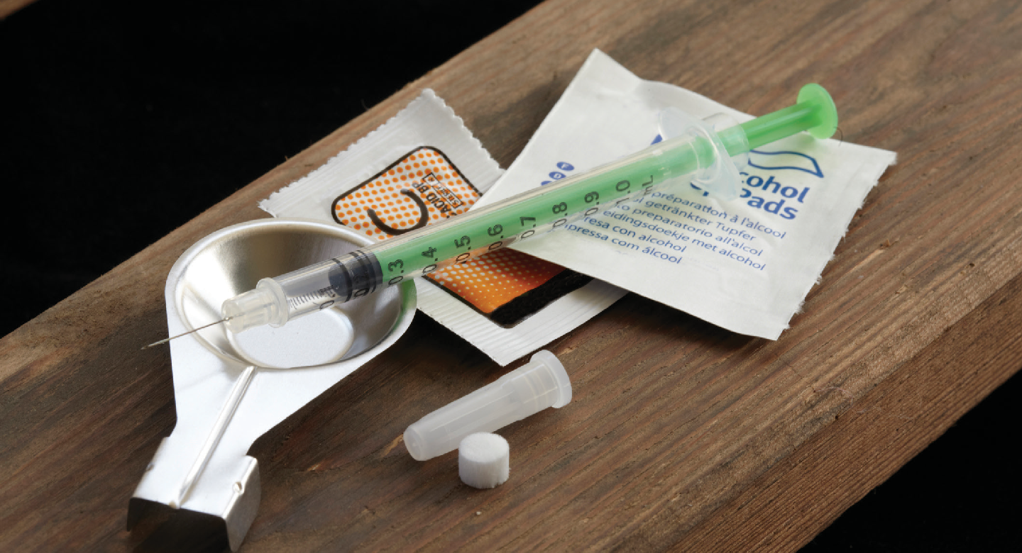

The Alexis Project
Friends Community Center, a Division of Friends Research Institute (Los Angeles County, CA)

The Alexis Project was developed under the Enhancing Engagement and Retention in Quality HIV Care for Transgender Women of Color Initiative funded by the Health Resources and Services Administration’s (HRSA) Special Programs of National Significance (SPNS).
The project utilizes a multi-tiered approach to identify, engage, and retain in care transgender women of color with HIV.
The Alexis Project is named after Alexis Rivera
who died on March 28, 2012, at the age of 34, from complications related to HIV. She was a proud Latina transgender woman, community activist, and peer advocate.

Model Features and Elements
The Alexis Project incorporates social network recruitment and engagement, peer health navigation, and contingency management to promote achievement of health outcomes along the HIV care continuum. Through social network recruitment, the Alexis Project recruits transgender women of color, who know they have
HIV but are not in care, to the combined peer health navigation and contingency management intervention.
Peer Health Navigation (PHN):
  - Peer health navigators work with participants to develop a client-centered treatment plan and link them to HIV care and/or other needed services (e.g., hormone therapy, mental health counseling, substance use treatment, legal services, transportation assistance).
  - Participants receive unlimited PHN sessions and can contact peer health navigators any time.
  - Participants complete a needs and barriers
assessment at each session.
  - The goals of sessions are to:
    - Identify barriers to care,
    - Identify and link participants to needed services, and
    - Increase participants’ self-efficacy in work-
ing with HIV care providers and other treat- ment facilities.

Evidence-based Practice Implemented by the Program
Contingency Management (CM), Peer Health Navigation (PHN)
Friends Community Center is a non-clinical community research center that collaborates with two medical clinics that provide HIV primary care.
Population of Focus
Transgender women of color with HIV Approximate Time Period (Duration) 18 months
Resources on the Program
- Program Website
- Alexis Project Implementation Manual
- SPNS Initiative: Enhancing Engagement and Retention in Quality HIV Care for Transgender Women of Color, 2012-2017 background
- Reback, C.J., Kisler, K.A., & Fletcher, J.B. (2019). A novel adaptation of peer health navigation and contingency management for advancement along the HIV care continuum among transgender women of color. AIDS and Behavior. https://doi.org/10.1007/s10461-019- 02554-0
- Participants receive increasingly valuable reinforcers in the form of CM reward points, which are redeemable for goods or services that promote a healthy, prosocial lifestyle (e.g., gift cards, bus tickets, payment of a utility bill, clothing).
- Increasingly valuable reinforcers serve as motivators for HIV care-seeking behavior and are specifically awarded to participants for attending HIV care visits and reaching and maintaining HIV milestones.

Findings and Outcomes
  - Combined PHN and CM intervention was found to be effective in linking and retaining transgender women of color in HIV care.
  - Average time from enrollment to linkage with
HIV care was 67 days.
  - 88 percent of participants attended at least two PHN sessions.
  - 85 percent of participants attended a first HIV
care visit, and 57 percent returned for a second HIV care visit.
  - 14 percent of participants escalated through
the entire CM schedule to achieve undetectable status.
  - At intervention completion, 85 percent of
participants were linked to care, and 44 percent had achieved and/or maintained viral load suppression.
  - Increased attendance at PHN sessions was associated with increased probability of achieving behavioral and biomedical CM targets.

Lessons Learned
  - Program administrators should support patient health navigators in setting boundaries to prevent burnout and vicarious trauma. Patient health navigators should receive ongoing training and support.
  - Implementation teams will need to train HIV clinics on providing culturally competent health care to transgender women of color.
  - Programs can promote retention in HIV care
by providing unlimited PHN sessions, linking participants to other needed services, and providing an increasingly valuable reward schedule based on advancement through the HIV care continuum.
  - PHN can be time consuming; for some participants, it may take multiple PHN sessions to feel ready to make a behavioral change. PHN should adopt a client-centered approach and build relationships first to develop a trusting partnership that facilitates lasting change for the client.

Coordination of Mental Health and HIV Care in a Mental Health Setting
Each of the case examples in this chapter illustrates how organizations have implemented one or more evidence-based practices in a clinical or community setting. While none of these examples highlights a program that is primarily focused on mental health, it is critical that programs primarily serving people with mental illness assess their clients for HIV risk, conduct HIV testing, and provide appropriate and integrated HIV prevention and treatment services and mental health treatment to address their client’s complex needs.3
When first working with a potential client, mental health providers can conduct an intake and/or mental health assessment using screening tools such as the brief measure for assessing generalized anxiety disorder (GAD- 7)4 or the major depressive disorder module of the Patient Health Questionnaire (PHQ-9).5 During this intake and screening, a mental health provider has an opportunity to discuss a client’s overall health and wellbeing, including co-occurring medical conditions such as HIV.
- If a client has not had a recent HIV test, mental health providers can supply a self-administered oral fluids
test which can provide results within 20 minutes.
  - If a client does not have HIV, a mental health provider can provide PrEP education, and support PrEP uptake and adherence (as described in Chapter 2); PrEP is highly effective in preventing HIV transmission from condomless sex and injection drug use.
  - If a client has HIV, a mental health provider can link a client to HIV primary care treatment, and provide the counseling necessary to support client mental health and ART uptake and adherence (including Cognitive Behavioral Therapy, as described in Chapter 2).
- For clients at risk for or with HIV, mental health providers can also connect the client to case management to address a client’s unmet ancillary needs (e.g., housing, employment, transportation), which will help reduce barriers to PrEP and ART adherence.
Integrated behavioral health and infectious disease care can facilitate rapid screening, testing, and treatment, and improve health outcomes for people experiencing mental disorders and HIV. One example of effective mental health and HIV service integration is an infectious disease psychiatric consultation service embedded within the infectious disease outpatient department in a Boston hospital. Participants were offered a comprehensive approach to depression care that included pharmacologic and ancillary psychological therapies. When psychiatric consultation services were offered and linked to primary care, participants experienced benefits to both their mental health and HIV-related health outcomes. Participants had a statistically significant reduction in depression and viral load, and statistically significant increase in CD4 count. Additionally, a greater number of participants were prescribed anti-depressants and stimulants to treat their depression.6

Reference List

¹ Taylor, J. L., Walley, A. Y., & Bazzi, A. R. (2019). Stuck in the window with you: HIV exposure prophylaxis in the highest risk people who inject drugs. Substance Abuse, 40(4), 441-443. https://doi. org/10.1080/08897077.2019.1675118
² Moyer, S. (2019, December 12). Louisville’s syringe exchange - preventing HIV transmission while pointing to recovery. Kentuckiana Health Collaborative. https://www.khcollaborative. org/2019/12/louisvilles-syringe-exchange-2/
³ Chuah, F., Haldane, V. E., Cervero-Liceras, F., Ong, S. E., Sigfrid, L. A., Murphy, G., Watt, N., Balabanova, D., Hogarth, S., Maimaris, W., Otero, L., Buse, K., McKee, M., Piot, P., Perel, P., & Legido-Quigley, H. (2017). Interventions and approaches to integrating HIV and mental health services: a systematic review. Health policy and planning, 32(suppl_4), iv27–iv47. https://doi. org/10.1093/heapol/czw169
⁴ Spitzer, R. L., Kroenke, K., Williams, J. B. W., & Löwe, B. (2006). The brief measure for assessing generalized anxiety disorder: The GAD-7. Archives of Internal Medicine, 166(10), 1092-1097. https:// doi.org/10.1001/archinte.166.10.1092
⁵ Patient Health Questionnaire (PHQ-9). https://www. med.umich.edu/1info/FHP/practiceguides/depress/ phq-9.pdf
⁶ Coleman, S. M., Blashill, A. J., Gandhi, R.
T., Safren, S. A., & Freudenreich, O. (2012). Impact of integrated and measurement-based depression care: clinical experience in an HIV clinic. Psychosomatics, 53(1), 51–57. https://doi. org/10.1016/j.psym.2011.07.004

5CHAPTER

Evaluating a practice or program answers critical questions about how well a practice has been implemented, and what is and is not working. Evaluation can also show how clients benefit from a program.
This information can be helpful in making program adjustments, if necessary, and demonstrating the value of a program or practice to justify its continuation and secure additional funding. In addition, stakeholders can use information gathered through evaluation to encourage implementation of that practice in other programs or communities.
This chapter provides an overview of approaches to evaluate implementation of and results from practices to prevent and treat human immunodeficiency virus (HIV) among people with mental illness and/or substance use disorders (SUD).
This chapter also includes information on implementing a continuous quality improvement (CQI) process.
Finally, the chapter concludes with specific evaluation
resources, including potential outcomes to track.

Resources for Evaluation and Quality Improvement
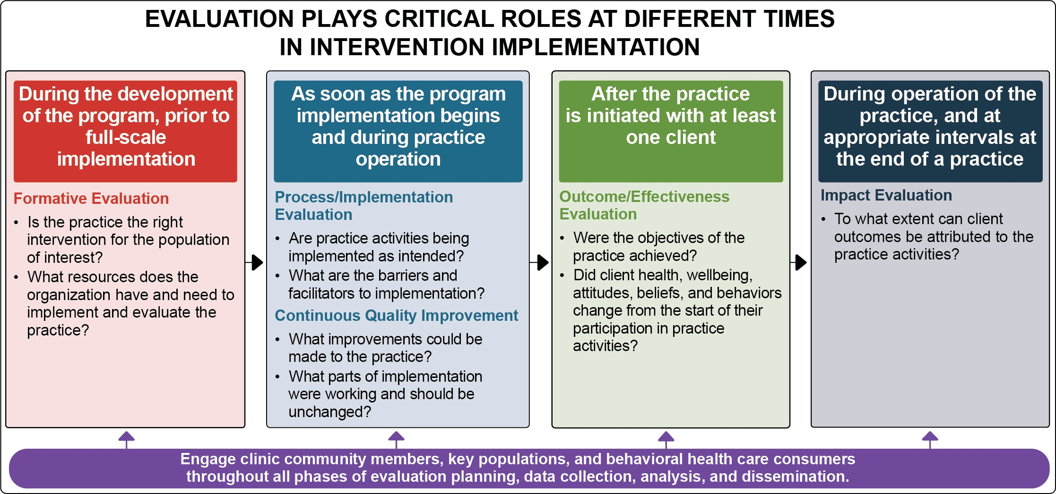

Types of Evaluations
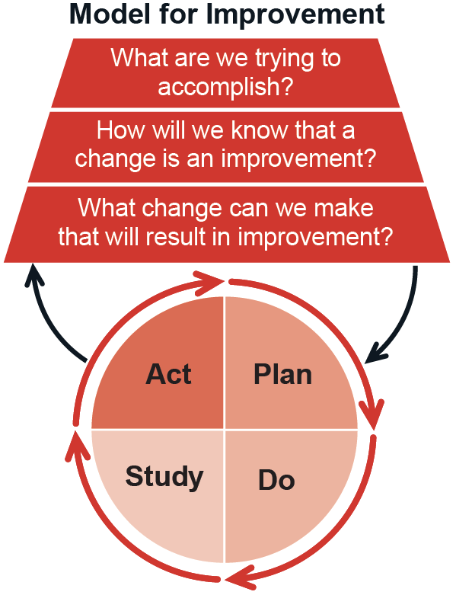Evaluation is typically conducted before a practice is implemented to determine its feasibility (formative evaluation), during implementation (process evaluation and CQI), and after the intervention has been delivered to at least one client (outcome and impact evaluations). Each type of evaluation is necessary to assess an intervention’s effectiveness. The graphic below illustrates these evaluation types in greater detail.

What is CQI?

CONTINUOUS QUALITY IMPROVEMENT (CQI)

CQI involves a systematic process of assessing program or practice implementation and short-term outcomes and then involving program staff in identifying and implementing improvements in service delivery and organizational systems to achieve better treatment outcomes. CQI helps assess practice fidelity, the degree to which a program delivers a practice as intended. There are many potential CQI models and approaches (see e.g., https://www. healthit.gov/faq/what-are-leading-continuous-quality-improvement-strategies-health-care-settings).
CQI differs from process evaluation in that it involves quick assessments of program performance, timely identification of problems and potential solutions, and implementation of small improvements to enhance treatment quality. CQI is usually conducted by internal staff. Process evaluation involves longer-term assessments and is best conducted by an external evaluator.
The Network for Improvement of Addiction Treatment (NIATx), a project originally funded by SAMHSA’s Center for Substance Abuse Treatment, offers tools to conduct CQI and improve services in substance use disorder treatment settings. NIATx is based on the principle of program improvement through a series of small changes, tested and implemented one at a time, that in the end have a cumulative effect.
The Institute for Healthcare Improvement’s PDSA Model for Improvement identifies a scientific method for testing small-scale changes in an action-oriented, cyclical manner. The stages are: planning it (Plan), trying it (Do), observing the results (Study), and acting on what is learned (Act).
Why use CQI?
CQI takes a broader look at the systems in which programs or practices operate. Because of the pivotal role it plays in performance management, organizations preventing and treating HIV among people with mental illness and/or substance use disorders are encouraged to implement CQI procedures.
What are the steps involved in CQI?
Although steps in the CQI process may vary based on objectives, typical CQI steps are:
- Identify a program or practice issue needing improvement and a target improvement goal
- Analyze the issue and its root causes
- Develop an action plan to correct the root causes of the problem, including
specific actions to be taken
- Implement the actions in the action plan
- Review the results to confirm that the issue and its root causes have been
addressed and short-term and long-term treatment outcomes have improved
- Repeat these steps to identify and address other issues as they arise
Institute for Healthcare Improvement. (n.d.). Science of improvement: Testing changes. http://www.ihi.org/resources/Pages/HowtoImprove/ScienceofImprovementTestingChanges.aspx New Jersey Department of Children and Families. (n.d.). Five Stages of Continuous Quality Improvement. https://www.nj.gov/dcf/about/divisions/opma/CQI%20framework.pdf University of Wisconsin-Madison, NIATx National Program Office. (n.d.). What is NIATx? https://www.niatx.net/what-is-niatx/
U.S. Department of Health & Human Services Office of Adolescent Health. (n.d.). Continuous Quality Improvement, Part 1: Basics for Pregnancy Assistance Fund Programs.
https://www.hhs.gov/ash/oah/sites/default/files/cqi-intro.pdf

Preparing to Collect Data
The following steps can help clinics and practitioners
prepare to collect and analyze data:

Determine if the purpose of the data collection is evaluation or research.
Qualitative and quantitative evaluation and research enables managers and clinicians to learn from clients and obtain the perspective of those with lived experiences. Both evaluation and research can also involve collecting data from staff who deliver the new treatment to obtain their perspectives on facilitators and challenges to practice implementation.
Program evaluation supports program improvement. Research contributes to generalizable knowledge by implementing study protocols and procedures approved by Institutional Review Boards (IRB) that adhere to human subject research protections. When designing program evaluations, researchers should consult with their institutions to ensure they are following appropriate data collection procedures.

Identify team members to conduct evaluation activities.
Regardless of the type of evaluation conducted,
collecting and analyzing data takes time. Programs need to identify team members who can conduct evaluation activities and secure funding to protect their time for evaluation trainings, data collection, and data analysis.

Determine outcomes of interest.
A challenging step in the process of implementing new practices is to determine whether the practice

Qualitative and quantitative data are complementary. Each provides critical insight into if and how the intervention is operating and achieving the intended objectives.
Qualitative data include any non-numeric, text-based information, such as verbal, visual, or written data. Qualitative data collection
methods include interviews, focus groups, clinical observations, gathering data from documents and images, and open-ended survey questions and polling responses.
Quantitative data are any numeric data that can be processed by mathematical or statistical analysis. Quantitative data collection includes close-ended survey questions and polling responses, services and utilization data, and claims and encounter data.

has yielded desired outcomes. An outcome is the change a program hopes to accomplish through the implementation of a practice.

Outcomes
The table below provides a list of potential outcomes, example outcome indicators, and qualitative and quantitative data sources that program managers, clinicians, and others may use to evaluate practices identified in Chapter 2. Some of the short- and intermediate-term outcomes may be tracked at baseline and throughout the practice or program duration through an electronic health record, or through interviews with staff and clients. Longer-term outcomes may be obtained from administrative and survey data.

Outcome | Practice | Illustrative Indicators | Illustrative Data Sources
Short-term and intermediate outcomes
Engagement in services | SSPs | - Access to SSP (number of sites, hours open)  - Clients accessing SSP (visit numbers and dates)  - Syringes distributed and returned for disposal | - Qualitative interviews (staff and clients)  - Administrative data  - Intake/enrollment data
 | PrEP | - Sessions and contacts scheduled and  completed | - Administrative data
 | CBT
 | CM
 | PN
HIV education | CBT | - Change in knowledge, motivation, and skills to engage in HIV preventive acts (e.g., condom attitudes and use),  - Perceptions of personal vulnerability  to HIV | - Qualitative interviews (staff and clients)  - Structured scales and assessments (e.g., Sexual Risk Behavior Assessment Schedule)
 | CM
 | PN
Knowledge of HIV and SUD harm reduction strategies | SSPs | - Knowledge of safe injection practices  - Knowledge about HIV transmission  - Knowledge of overdose prevention strategies (e.g., naloxone access and trainings) | - Qualitative interviews (staff and clients)  - Structured scales and assessments  - Attendance/administrative data  - Number of naloxone trainings and naloxone kits distributed
 | CBT
PrEP uptake | PrEP | - Number of PrEP prescriptions  provided and filled | - Medical records  - Pharmacy records
Linkage or re- linkage to HIV care | SSPs | - Number of HIV linkage-to-care visits scheduled and completed | - Administrative records  - Medical records
 | CM
 | PN
Injection drug use behaviors | SSPs | - Injecting with a sterile syringe  - Sharing injection equipment | - Qualitative interviews (clients)  - Staff logbooks  - National Institute on Drug Abuse (NIDA) Risk Behavior Assessment
 | CBT
 | CM
Ancillary service delivery | SSPs | - Referrals made and visits completed for specialty care and ancillary services (e.g., HIV/HCV/STI testing, medication-assisted treatment) | - Qualitative interviews (staff and client)  - Administrative data  - Medical records
 | PN
Retention in HIV care | CM | - Number of medical visits that were at least 90 days apart (in the past year) | - Qualitative interviews (clients)  - Medical records
 | PN
Medication Adherence | PrEP | - Ongoing PrEP prescriptions provided  and filled | - Medical records  - Pharmacy records
 | CBT | - ART prescriptions provided and filled | - Qualitative interviews (client)  - Medical records  - Medication Event Monitoring Systems (MEMS)
 | CM
 | PN

Outcome | Practice | Illustrative Indicators | Illustrative Data Sources
Short-term and intermediate outcomes
Substance Use | PN | - SUD  - Days of substance use in the prior 30 days | - Qualitative interviews (client)  - Urine drug screen  - Alcohol, Smoking, and Substance Involvement Screening Test (ASSIST)  - Alcohol Use Disorders Identification Test  (AUDIT)  - Drug Abuse Screening Test (DAST-10)
Individual-level mental health | CBT | - Mental health score | - Structured scales and assessments (e.g., PHQ-9 for depression, Beck Depression Inventory, Hamilton Depression Scale, Montgomery-Asberg Depression Rating Scale, Generalized Anxiety Disorder (GAD-7) Scale)
 | PN |  | - 12-item short form health survey (SF-12)
Changes in HIV risk associated with SUD | SSPs | - Frequency of substance use  - Cessation of injection drug use | - Qualitative interviews (staff and clients)  - NIDA Risk Behavior Assessment
Long-term and population-level outcomes and impacts
Individual-level HIV outcomes | CBT | - CD4 cell count  - Viral load | - Medical records  - Lab test/blood sample
 | CM
 | PN
Population-level HIV outcomes | SSPs | - Rate of new HIV diagnoses  - Prevalence of HIV | - Administrative data  - Medical records
 | PrEP
 | CBT
 | CM
 | PN
SSPs PrEP CBT CM PN

Evaluation Resources

Evaluating Program Implementation
  - A Framework for Program Evaluation, from the Program Performance and Evaluation Office at the Centers for Disease Control and Prevention, summarizes essential elements of program evaluation.
  - The Community Toolbox, from the Center for Community Health and Development at the University of Kansas, includes a step-by-step guide to developing an evaluation of a community program, specific tools, and examples.

Quality Improvement and Continuous Performance Monitoring
  - Institute for Healthcare Improvement’s Quality Improvement Essentials Toolkit includes the tools and templates to launch a quality improvement project and manage performance improvement.

Evaluating Practices Specifically Addressing
HIV and Mental Illness and/or SUD
  - The Center for Innovation in Social Work and Health Community Health Worker toolkit includes best practices for evaluating peer programs.
  - Rural Health Information Hub (RHIhub)
has created HIV, Mental Health, SUD, and Telehealth specific Evidence-Based Toolkits for Rural Community Health (that can be broadly applied to both rural and urban health).
  - The National Minority AIDS Council created a guide to program evaluation as part of their Organizational Effectiveness Series, defining types of evaluation, ways to assemble an evaluation team and design an evaluation plan, and steps to conducting an evaluation.

Appendix 1: Acknowledgments

This publication was developed with a significant contribution from Alexis Marbach, MPH, SAMHSA staff, a technical expert panel, and Abt Associates staff. The guidance is based on the thoughtful input of SAMHSA staff and the Expert Panel on the prevention and treatment of HIV among individuals experiencing co-occurring mental illness and/or substance use disorders (SUD) from October 2019 through August 2020. A series of guide development meetings was held virtually over a period of several months. Three expert panel meetings were convened during this time.

SAMHSA Staff
Fred Bamfo, DNP, MPH Center for Substance Abuse Treatment*
Christine Cichetti, National Mental Health and Substance Use Policy Laboratory
Thomas Clarke, PhD National Mental Health and Substance Use Policy Laboratory
Amanda Doreson, MPA National Mental Health and Substance Use Policy Laboratory
Daniel Gallardo, MPH National Mental Health and Substance Use Policy Laboratory
Neeraj Gandotra, MD Chief Medical Officer*
Tanya Geiger, PhD, MPH National Mental Health and Substance Use Policy Laboratory*
Kirk James, MD Center for Substance Abuse Treatment
Donelle Johnson, PhD, MHSA National Mental Health and Substance Use Policy Laboratory*

Expert Panel
Michael B. Blank, PhD University of Pennsylvania Perelman School of Medicine
Katie Biello, PhD, MPH Brown University School of Public Health, The Fenway Institute
Deb Bourne, MD, MSW San Francisco Health Network, San Francisco Department of Public Health
Redonna Chandler, PhD National Institute on Drug Abuse (NIDA)
Francine Cournous, MD Columbia University Mailman School of Public Health, Northeast/Caribbean AIDS Education and Training Center
Carlos Del Rio, MD Emory University School of Medicine, Rollins School of Public Health. Principal Investigator, and Center for AIDS Research
Antigone Dempsey, M.Ed Division of Policy and Data, HIV/AIDS Bureau, Health Resources and Services Administration (HRSA)
Traci Green, PhD, MSc, Opioid Policy Research
Collaborative, Brandeis University
Douglas Krakower, MD Beth Israel Deaconess Medical Center, The Fenway Institute, and Harvard Medical School
Conall O’Cleirigh, PhD Harvard Medical School, Massachusetts General Hospital
Melinda Tinsley, MA Division of Policy and Data, HIV/AIDS Bureau, Health Resources and Services Administration (HRSA)
Glenn Treisman, MD, PhD Johns Hopkins University School of Medicine

Contract Staff
Olivia Bacon, Abt Associates
Korrin Bishop, Korrin Bishop Writing & Editing
Yvonne Cristy, Abt Associates
Margaret Gwaltney, MBA Abt Associates* Alexis V. Marbach, MPH, Abt Associates* Nikitha Reddy, Abt Associates
Cayla D. Roby, MA, MPH, Abt Associates
Daniel Jefferson Smith, Abt Associates
Sarah Steverman, PhD, MSW Abt Associates*
Christopher Weiss, PhD Abt Associates
Elyse Yarmosky, LISCW, Abt Associates
*Members of Guide Planning Team

The authors followed a rigorous, systematic evidence review process in the development of this guide. This appendix provides an overview of the evidence review methodology used to identify the ratings for the practices included in the guide: practices to increase uptake of and improve adherence to PrEP, syringe services programs, cognitive behavioral therapy, contingency management, and patient navigation. Reviewers, in coordination with SAMHSA and experts, conducted a four-step process to select practices, identify related studies, review and rate studies, and identify practice ratings.

Step 1: Practice Selection
The authors identified these five practices after a review of the literature and in consultation with experts. In an effort to include interventions that would be most useful to those seeking to prevent and treat HIV among people with mental illness and/or substance use disorders (SUD), eligible practices were required to meet the following criteria for evidence review:
  - Be clearly defined and replicable
  - Address the target outcome of preventing and treating HIV among people who use substances and/or have mental health concerns
  - Be currently in use
  - Have studies of their effectiveness
  - Have accessible implementation and fidelity
supports
At the conclusion of this step, SAMHSA and the guide’s Expert Panel reviewed the proposed practices identified by the authors and agreed on five for inclusion in the evidence review and rating process.

Step 2: Study
Identification
Once the practices were selected, the reviewers conducted a comprehensive review of published research on these practices to identify studies of the selected practices. This review only included studies from eligible sources (i.e., peer reviewed journals and government reports) that avoid clear conflicts of interest. The reviewers documented all potential studies identified through the literature search.
The studies identified in the literature search varied in type and rigor, so the reviewers assessed them further for inclusion in the evidence review. To be eligible for review and study rating, research studies had to:
  - Employ a randomized or quasi-experimental
design, or
  - Be a single sample pre-post design or an epidemiological study with a strong
counterfactual—a study that analyzes what would have happened in the absence of the intervention.
Literature reviews, descriptive studies, implementation studies, and meta-analyses were not included in the review, but were documented to provide context and identify implementation supports for the practices.
Additionally, to be eligible for further review and rating, studies had to:
  - Be published or prepared in or after 2000
  - Be a publicly available peer-reviewed paper or research report
  - Be available in English
  - Include at least one eligible outcome related to HIV prevention and/or treatment
  - Have a comparison/control group that is
treatment as usual or no/minimal intervention if using a randomized experimental or quasi- experimental design

Step 3: Study Review and Rating
Next, trained reviewers assessed each study to ensure the methodology was rigorous and therefore could demonstrate causation between the practice and the
identified outcomes. Reviewers reviewed and documented
each study to ensure that:
  - Experimental and comparison groups were statistically equivalent, with the only difference being that participants in the experimental group received the intervention and those in the comparison group received treatment as usual or no/minimal intervention

  - For randomized experiments with high attrition and for quasi-experimental designs, baseline equivalence was established between the treatment and comparison groups
  - For randomized experiments, randomization was not compromised. For example, ensuring that reassignment of treatment status, usually made to balance the distribution of background variables between treatment and control groups, did not occur.
  - Study did not have any confounding factors (factors that affect the outcome but are not accounted for by the study)
  - Missing data were addressed appropriately
    - Imputation based on surrounding cases was considered valid
    - Complete case analysis was considered valid
and accounted for as attrition
    - Using model with dummy for missing as a covariate was considered valid
    - Assuming all missing data points are either
positive or negative was not considered valid
    - Regression-based imputation was consid-
ered valid; mean imputation was not consid- ered valid.
  - Outcome measures were reliable, valid, and
collected consistently from all participants
  - Valid statistical models were used to estimate impacts
  - Practice demonstrated improved outcomes
related to HIV prevention and treatment
Based on the study design and these study characteristics, reviewers gave each study a rating for causal impact.
Reviewers used the following scoring metric for each study based on the eight factors above to determine if a study is rated:
  - High support of causal evidence
  - Moderate support of causal evidence
  - Low support of causal evidence
Only randomized controlled trials, quasi-experimental designs, and epidemiological studies with a strong comparison were eligible to receive a high or moderate study rating.

Step 4: Practice Rating
After all studies for a practice were assessed for these criteria, the reviewers gave each practice a rating based on the number of studies with strong, moderate, or emerging support of causal impact. Causal impact is evidence demonstrating that an intervention causes, or is responsible for, the outcome measured in the study’s sample population. The practice was placed into one of the following categories based on the level of causal evidence of its studies:
  - Strong Evidence: Causal impact demonstrated by at least two randomized controlled trials, quasi-experimental designs, or epidemiological studies with a high or moderate rating.
  - Moderate Evidence: Causal impact demonstrated by at least one randomized controlled trial, quasi-experimental design, or epidemiological study with a high or moderate rating.
  - Emerging Evidence: No study received a high or a moderate rating. The practice may have been evaluated with less rigorous studies (e.g., pre-post designs) that demonstrate an association between the practice and positive outcomes, but additional studies are needed to establish causal impact.
The four-step process described above resulted in identification and rating of the five practices. The rating given to each practice is intended to inform decision making about adoption of new practices or clinical or system enhancements that will improve health outcomes for people with or at risk for HIV with co-occurring mental illness and/or SUD.

Photos are for illustrative purposes only. Any person depicted in a photo is a model.

Publication No. PEP20-06-03-001 First released 2020

SAMHSA’s mission is to reduce the impact of substance abuse and mental illness on America’s communities.
1-877-SAMHSA -7 (1-877-726-4727) 1-800-487-4889 (TDD) www.samhsa.gov

