-

A TREATMENT IMPROVEMENT PROTOCOL
Trau a-In or ed Be aviora Hea t
- -
are 1• n erv1• ces

on

www.sam .gov• 1-877-SAMHSA-7 (1-877-726-4727)

A TREATMENT IMPROVEMENT PROTOCOL
Trauma-Info med Ca e in Beha ioral H alt S vices

Tl 7
U.S. DEPARTMENT OF HEALTH AND HUMAN SERVICES
Substance Abuse and Mental Health Services Administration Center for Substance Abuse Treatment
1 Choke Cherry Road Rockville, MD 20857

Trauma-Informed Care in Behavioral Health Services

Acknowledgments
This publication was produced under contract numbers 270-99-7072, 270-04-7049, and 270- 09-0307 by the Knowledge Application Program (KAP), a Joint Venture ofThe CDM Group, Inc., and JBS International, Inc., for the Substance Abuse and Mental Health Services Administration (SAMHSA), U.S. Department of Health and Human Services (HHS). Andrea Kopstein, Ph.D., M.P.H., Karl D. White, Ed.D., and Christina Currier served as the Contracting Officer's Representatives.

Disclaimer
The views, opinions, and content expressed herein are the views of the consensus panel members and do not necessarily reflect the official position of SAMHSA or HHS. No official support of or endorsement by SAMHSA or HHS for these opinions or for the instruments or resources described are intended or should be inferred. The guidelines presented should not be considered substitutes for individualized client care and treatment decisions.

Public Domain Notice
All materials appearing in this volume except those taken directly from copyrighted sources are in the public domain and may be reproduced or copied without permission from SAMHSA or the authors. Citation of the source is appreciated. However, this publication may not be reproduced or distributed for a fee without the specific, written authorization of the Office of Communications, SAMHSA, HHS.

Electronic Access and Copies of Publication
This publication may be ordered or downloaded from SAMHSA's Publications Ordering Web page at http://store.samhsa.gov. Or, please call SAMHSA at 1-877-SAMHSA-7 (1-877-726- 4727) (English and Espanol).

Recommended Citation
Substance Abuse and Mental Health Services Administration. Trauma-Informed Care in Behavioral Health Services. Treatment Improvement Protocol (TIP) Series 57. HHS Publication No. (SMA) 13-4801. Rockville, MD: Substance Abuse and Mental Health Services Administration, 2014.

Originating Office

Qyality Improvement and Workforce Development Branch, Division of Services Improvement, Center for Substance Abuse Treatment, Substance Abuse and Mental Health Services Administration, 1 Choke Cherry Road, Rockville, MD 20857.

HHS Publication No. (SMA) 14-4816 First Printed 2014

II

Please share your thoughts about this publication by completing a brief online survey at:

https://www.surveymonkey.com/r/KAPPFS

The survey takes about 7 minutes to complete and is anonymous.
Your feedback will help SAMHSA develop future products.

Contents

Consensus Panel. vii
KAP Expert Panel and Federal Government Participants ix
What Is aTIP? xi
Foreword xiii
HowThisTIP Is Organized xv
Terminology xvi
PART 1: A PRACTICAL GUIDE FOR THE PROVISION OF BEHAVIORAL HEALTH SERVICES 1
Chapter 1-Trauma-Informed Care: A Sociocultural Perspective 3
Scope of the TIP 4
Intended Audience 4
Before You Begin 4
Structure of the TIP 6
What Is Trauma? 7
Trauma Matters in Behavioral Health Services 7
Trauma-Informed Intervention and Treatment Principles 11
As You Proceed 32
Chapter 2-TraumaAwareness 33
Types ofTrauma 33
Characteristics of Trauma 46
Individual and Sociocultural Features 52
Chapter 3-Understandingthe Impact ofTrauma 59
Sequence of Trauma Reactions 60
Common Experiences and Responses to Trauma 61
Subthreshold Trauma-Related Symptoms 75
Specific Trauma-Related Psychological Disorders 77
Other Trauma- Related and Co-Occurring Disorders 85

Ill

Trauma-Informed Care in Behavioral Health Services
Chapter 4-Screening and Assessment 91

Screening and Assessment 92

Barriers and Challenges to Trauma-Informed Screening and Assessment 99

Cross-Cultural Screening and Assessment 103

Choosing Instruments 104

Trauma-Informed Screening and Assessment 106

Concluding Note 110
Chapter 5-Clinical Issues Across Services 111

Trauma-Informed Prevention and Treatment Objectives 111

Treatment Issues 127

Making Referrals to Trauma-Specific Services 135
Chapter 6-Trauma-Specific Services 137

Introduction 137

Trauma-Specific Treatment Models 139

Integrated Models for Trauma 147

Emerging Interventions 153

Concluding Note 155
PART 2: AN IMPLEMENTATION GUIDE FOR BEHAVIORAL HEALTH PROGRAM ADMINISTRATORS 157
Chapter 1-Trauma-lnformed Organizations 159

Strategy #1: Show Organizational and Administrative Commitment to TIC 161

Strategy #2: Use Trauma-Informed Principles in Strategic Planning 162

Strategy #3: Review and Update Vision, Mission, and Value Statements 162

Strategy #4: Assign a Key Staff Member To Facilitate Change 163

Strategy #5: Create a Trauma-Informed Oversight Committee 163

Strategy #6: Conduct an Organizational Self-Assessment ofTrauma-lnformed Services 164

Strategy #7: Develop an Implementation Plan 164

Strategy #8: Develop Policies and Procedures To Ensure Trauma-Informed Practices and

To Prevent Retraumatization 166

Strategy #9: Develop a Disaster Plan 166

Strategy #10: Incorporate Universal Routine Screenings 167

Strategy #11: Apply Culturally Responsive Principles 167

Strategy #12: Use Science-Based Knowledge 169

Strategy #13: Create a Peer-Support Environment 169

Strategy#14: Obtain Ongoing Feedback and Evaluations 170

Strategy #15: Change the Environment To Increase Safety 171

Strategy #16: Develop Trauma-Informed Collaborations 171
Chapter 2-Building aTrauma-Informed Workforce 173

Introduction 173

Workforce Recruitment, Hiring, and Retention 174
IV

Contents

Training in TIC 177

Trauma-Informed Counselor Competencies 181

Counselor Responsibilities and Ethics 182

Clinical Supervision and Consultation 191

Secondary Traumatization 193

Counselor Self-Care 205
APPENDICES 215
Appendix A-Bibliography 215
Appendix B-Trauma Resource List 247
Appendix C-HistoricalAccount ofTrauma 267
Appendix D-Screening and Assessment Instruments 271
Appendix £-Consumer Materials 285
Appendix F-Organizational Assessment for Trauma- Informed Care 287
Appendix G-Resource Panel 289
Appendix H-Field Reviewers 293
Appendix I-Cultural Competence and Diversity Network Participants 299
AppendixJ-Acknowledgments 300
EXHIBITS
Exhibit 1.1-1: TIC Framework in Behavioral Health Services-Sociocultural Perspective 6
Exhibit 1.1-2: A Social-Ecological Model for Understanding Trauma and Its Effects 15
Exhibit 1.1-3: Understanding the Levels Within the Social-Ecological Model of

Trauma and Its Effects 16

Exhibit 1.1-4: Cross-Cutting Factors of Culture 26

Exhibit 1.2-1: Trauma Examples 35

Exhibit 1.3-1: Immediate and Delayed Reactions to Trauma 62

Exhibit 1.3-2: Cognitive Triad of Traumatic Stress 67

Exhibit 1.3-3: DSM-5 Diagnostic Criteria for ASD 78

Exhibit 1.3-4: DSM-5 Diagnostic Criteria for PTSD 82

Exhibit 1.3-5: ICD-10 Diagnostic Criteria for PTSD 85

Exhibit 1.3-6: Important Treatment Facts About PTSD and Substance Use Disorders 89

Exhibit 1.4-1: Grounding Techniques 98

Exhibit 1.4-2: Key Areas ofTrauma Screening and Assessment 105

Exhibit 1.4-3: SLE Screening 107

Exhibit 1.4-4: STaT: Intimate Partner Violence Screening Tool 108

Exhibit 1.4-5: PC-PTSD Screen 108

Exhibit 1.4-6: The SPAN 108

Exhibit 1.4-7: The PTSD Checklist 109

Exhibit 1.4-8: Resilience Scales 110

Exhibit 1.5-1: OBSERVATIONS: A Coping Strategy 119
V

Trauma-Informed Care in Behavioral Health Services

Exhibit 2.1-1: TIC Planning Guidelines 165

Exhibit 2.2-1: Clinical Practice Issues Relevant to Counselor Training in Trauma-

Informed Treatment Settings 179

Exhibit 2.2-2: Guidelines for Training in Mental Health Interventions forTrauma-

Exposed Populations 180

Exhibit 2.2-3: Trauma-Informed Counselor Competencies Checklist 183

Exhibit 2.2-4: Sample Statement of the Client's Right to Confidentiality From a

Client Bill of Rights 185

Exhibit 2.2-5: Green Cross Academy ofTraumatology Ethical Guidelines for the

Treatment of Clients Who Have Been Traumatized 186

Exhibit 2.2-6: Boundaries in Therapeutic Relationships 189

Exhibit 2.2-7: Counselor Strategies To Prevent Secondary Traumatization 198

Exhibit 2.2-8: Secondary Traumatization Signs 199

Exhibit 2.2-9: ProQOL Scale 201

Exhibit 2.2-10: Your Scores on the ProQOL: Professional Qyality of Life Screening 202

Exhibit 2.2-11: What Is My Score and What Does It Mean? 203

Exhibit 2.2-12: Clinical Supervisor Guidelines for Addressing SecondaryTraumatization 205

Exhibit 2.2-13: Comprehensive Self-Care Plan Worksheet 208

Exhibit 2.2-14: Comprehensive Self-Care Plan Worksheet Instructions 209

Exhibit 2.2-15: The Ethics of Self-Care 210

VI

Consensus Panel

Note: Each panelist's information reflects his or her affiliation at the time of the Consensus Panel meeting and may not reflect that person's most current affiliation.

Chair

Lisa M. Najavits, Ph.D.
Research Psychologist
Veterans Affairs Boston Healthcare System Professor of Psychiatry
Boston University School of Medicine Boston, MA

Co-Chair
Linda B. Cottier, Ph.D., M.P.H. Professor of Epidemiology in Psychiatry Department of Psychiatry
Washington University-St. Louis St. Louis, MO

Workgroup Leaders

Stephanie S. Covington, Ph.D., LCSW, MFCC
Co- Director
Center for Gender and Justice Institute for Relational Development La Jolla, CA

Margaret Cramer, Ph.D.
Clinical Psychologist/Clinical Instructor Harvard Medical School
Boston,MA

Anne M. Herron, M.S.
Director
Treatment Programming
New York State Office of Alcoholism and Substance Abuse Services
Albany,NY

Denise Hien, Ph.D.
Research Scholar
Social Intervention Group School of Social Work Columbia University NewYork,NY

Dee S. Owens, M.P.A.
Director
Alcohol-Drug Information Indiana University Bloomington, IN

Panelists

Charlotte Chapman, M.S., LPC, CAC
Training Director
Division of Addiction Psychiatry
Mid-Atlantic Addiction Technology Transfer Center
Virginia Commonwealth University Richmond, VA

VII

Trauma-Informed Care in Behavioral Health Services

Scott F. Coffey, Ph.D.
Associate Professor
Department of Psychiatry and Human Behavior
University of Mississippi Medical Center Jackson,MS

ReneeM. Cunningham-Williams,M.S.W., M.P.E., Ph.D.
Research Assistant/Professor of Social Work Department of Psychiatry
Washington University St. Louis, MO

Chad D. Emrick, Ph.D.
Administrative Director
Substance Abuse Treatment Program Denver VA Medical Center (116Al) Denver,CO

Charles R. Figley, Ph.D.
Professor
Director of the Traumatology Institute Florida State University
Tallahassee, FL

Larry M. Gentilello, M.D., FACS
Professor and Chairman
Division of Burn, Trauma, and Critical Care University ofTexas Southwestern Medical
School Dallas,TX

Robert Grant, Ph.D. Trauma Consultant Oakland,CA

Anthony (Tony) Taiwai Ng, M.D.
Disaster Psychiatrist Washington, DC

Pallavi Nishith, Ph.D. Associate Research Professor Center for Trauma Department of Psychology
University of Missouri-St. Louis St. Louis, MO

Joseph B. Stone, Ph.D., CACIII, ICADC Program Manager and Clinical Supervisor Confederated Tribes of Grand Ronde
Behavioral Health Program Grand Ronde, OR

Michael Villanueva, Ph.D.
Research Professor
Center on Alcoholism, Substance Abuse, and Addiction
Albuquerque, NM

viii

KAP Expert Panel and Federal Government Participants

Barry S. Brown, Ph.D.
Adjunct Professor
University of North Carolina-Wilmington Carolina Beach, NC

Jacqueline Butler, M.S.W., LISW, LPCC, CCDC III, CJS
Professor of Clinical Psychiatry College of Medicine
University of Cincinnati Cincinnati, OH

DeionCash
Executive Director
Community Treatment and Correction Center, Inc.
Canton,OH

Debra A. Claymore, M.Ed.Adm. Owner/Chief Executive Officer WC Consulting, LLC
Loveland, CO

Carlo C. DiClemente, Ph.D.
Chair
Department of Psychology
University of Maryland-Baltimore County Baltimore, MD

Catherine E. Dube, Ed.D. Independent Consultant Brown University Providence, RI

Jerry P. Flanzer, D.S.W., LCSW, CAC
Chief, Services
Division of Clinical and Services Research National Institute on Drug Abuse Bethesda, MD

Michael Galer, D.B.A. Independent Consultant Westminster, MA

Renata}. Henry, M.Ed.
Director
Division of Alcoholism, Drug Abuse and Mental Health
Delaware Department of Health and Social Services
New Castle, DE

Joel Hochberg, M.A.
President
Asher & Partners Los Angeles, CA

IX

Trauma-Informed Care in Behavioral Health Services

Jack Hollis, Ph.D.
Associate Director, Center for Health Research
Kaiser Permanente Portland, OR

Mary BethJohnson, M.S.W.
Director
Addiction Technology Transfer Center University of Missouri-Kansas City Kansas City, MO

Eduardo Lopez Executive Producer EVS Communications Washington, DC

Holly A. Massett, Ph.D.
Academy for Educational Development Washington, DC

Diane Miller
Chief
Scientific Communications Branch National Institute on Alcohol Abuse and
Alcoholism Bethesda, MD

Harry B. Montoya, M.A. President/Chief Executive Officer Hands Across Cultures
Espanola, NM

Richard K. Ries, M.D.
Director/Professor
Outpatient Mental Health Services Dual Disorder Programs
Seattle, WA

Gloria M. Rodriguez, D.S.W.
Research Scientist
Division of Addiction Services
New Jersey Department of Health and Senior Services
Trenton,NJ

Everett Rogers, Ph.D.
Center for Communications Programs Johns Hopkins University
Baltimore, MD

Jean R. Slutsky, P.A., M.S.P.H.
Senior Health Policy Analyst
Agency for Healthcare Research & Qyality Rockville, MD

Nedra Klein Weinreich, M.S.
President
Weinreich Communications Canoga Park, CA

Clarissa Wittenberg
Director
Office of Communications and Public Liaison
National Institute of Mental Health Bethesda, MD

Consulting Members of the KAP Expert Panel
Paul Purnell, M.A Social Solutions, LLC Potomac,MD

Scott Ratzan, M.D., M.P.A., M.A. Academy for Educational Development Washington, DC

Thomas W. Valente, Ph.D.
Director
Master of Public Health Program Department of Preventive Medicine School of Medicine
University of Southern California Los Angeles, CA

Patricia A. Wright, Ed.D. Independent Consultant Baltimore, MD

X

What Is a TIP?

Treatment Improvement Protocols (TIPs) are developed by the Substance Abuse and Mental Health Services Administration (SAMHSA) within the U.S. Department of Health and Human Services (HHS). Each TIP involves the development of topic-specific best practice guidelines for the prevention and treatment of substance use and mental disorders. TIPs draw on the experience and knowledge of clinical, research, and administrative experts of various forms of treatment and prevention. TIPs are distributed to facilities and individuals across the country. Published TIPs can be accessed via the Internet at http://store.samhsa.gov.
Although each consensus-based TIP strives to include an evidence base for the practices it rec­ ommends, SAMHSA recognizes that behavioral health is continually evolving, and research fre­ quently lags behind the innovations pioneered in the field. A major goal of each TIP is to convey "front-line" information quickly but responsibly. If research supports a particular approach, cita­ tions are provided.

XI

Foreword

The Substance Abuse and Mental Health Services Administration (SAMHSA) is the agency within the U.S. Department of Health and Human Services that leads public health efforts to advance the behavioral health of the nation. SAMHSA's mission is to reduce the impact of sub­ stance abuse and mental illness on America's communities.
The Treatment Improvement Protocol (TIP) series fulfills SAMHSA's mission to improve pre­ vention and treatment of substance use and mental disorders by providing best practices guidance to clinicians, program administrators, and payers. TIPs are the result of careful consideration of all relevant clinical and health services research findings, demonstration experience, and imple­ mentation requirements. A panel of non-Federal clinical researchers, clinicians, program admin­ istrators, and patient advocates debates and discusses their particular area of expertise until they reach a consensus on best practices. This panel's work is then reviewed and critiqued by field reviewers.
The talent, dedication, and hard work that TIP panelists and reviewers bring to this highly par­ ticipatory process have helped bridge the gap between the promise of research and the needs of practicing clinicians and administrators to serve, in the most scientifically sound and effective ways, people in need of behavioral health services. We are grateful to all who have joined with us to contribute to advances in the behavioral health field.

Pamela S. Hyde,J.D.
Administrator
Substance Abuse and Mental Health Services Administration

H. Westley Clark, M.D.,J.D., M.P.H., CAS, FASAM
Director
Center for Substance Abuse Treatment
Substance Abuse and Mental Health Services Administration

Frances M. Harding
Director
Center for Substance Abuse Prevention
Substance Abuse and Mental Health Services Administration

Paolo del Vecchio, M.S.W.
Director
Center for Mental Health Services
Substance Abuse and Mental Health Services Administration

XIII

Clinical Issues Across Services

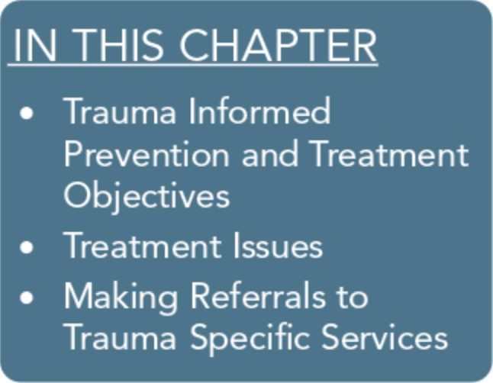
Many clients in behavioral health treatment may have histories of trauma, so counselors should be prepared to help them address is­ sues that arise from those histories. This chapter begins with a thorough discussion of trauma-informed prevention and treatment objectives along with practical counselor strategies. Specific treat­ ment issues related to working with trauma survivors in a clinical setting are discussed as well, including client engagement, pacing and timing, traumatic memories, and culturally appropriate and gender-responsive services. The chapter ends with guidelines for making referrals to trauma-specific services.

Trauma-Informed Prevention and Treatment Objectives
Trauma-informed care (TIC) not only focuses on identifying indi­ viduals who have histories of trauma and traumatic stress symp­ toms; it also places considerable effort in creating an environment that helps them recognize the impact of trauma and determine the next course of action in a safe place. For some individuals, psy­ choeducation and development or reinforcement of coping strate­ gies will be the most suitable and effective strategy, whereas others may request or warrant a referral for more trauma-specific inter­ ventions (see Part 1, Chapter 6, of this Treatment Improvement Protocol [TIP]). Although research is limited in the area of build­ ing resilience to prevent exacerbation of trauma symptoms and traumatic stress disorders, TIC also focuses on prevention strate­ gies to avoid retraumatization in treatment, to promote resilience, and to prevent the development of trauma-related disorders. The following sections highlight key trauma-informed prevention and treatment objectives.

111

Trauma-Informed Care in Behavioral Health Services

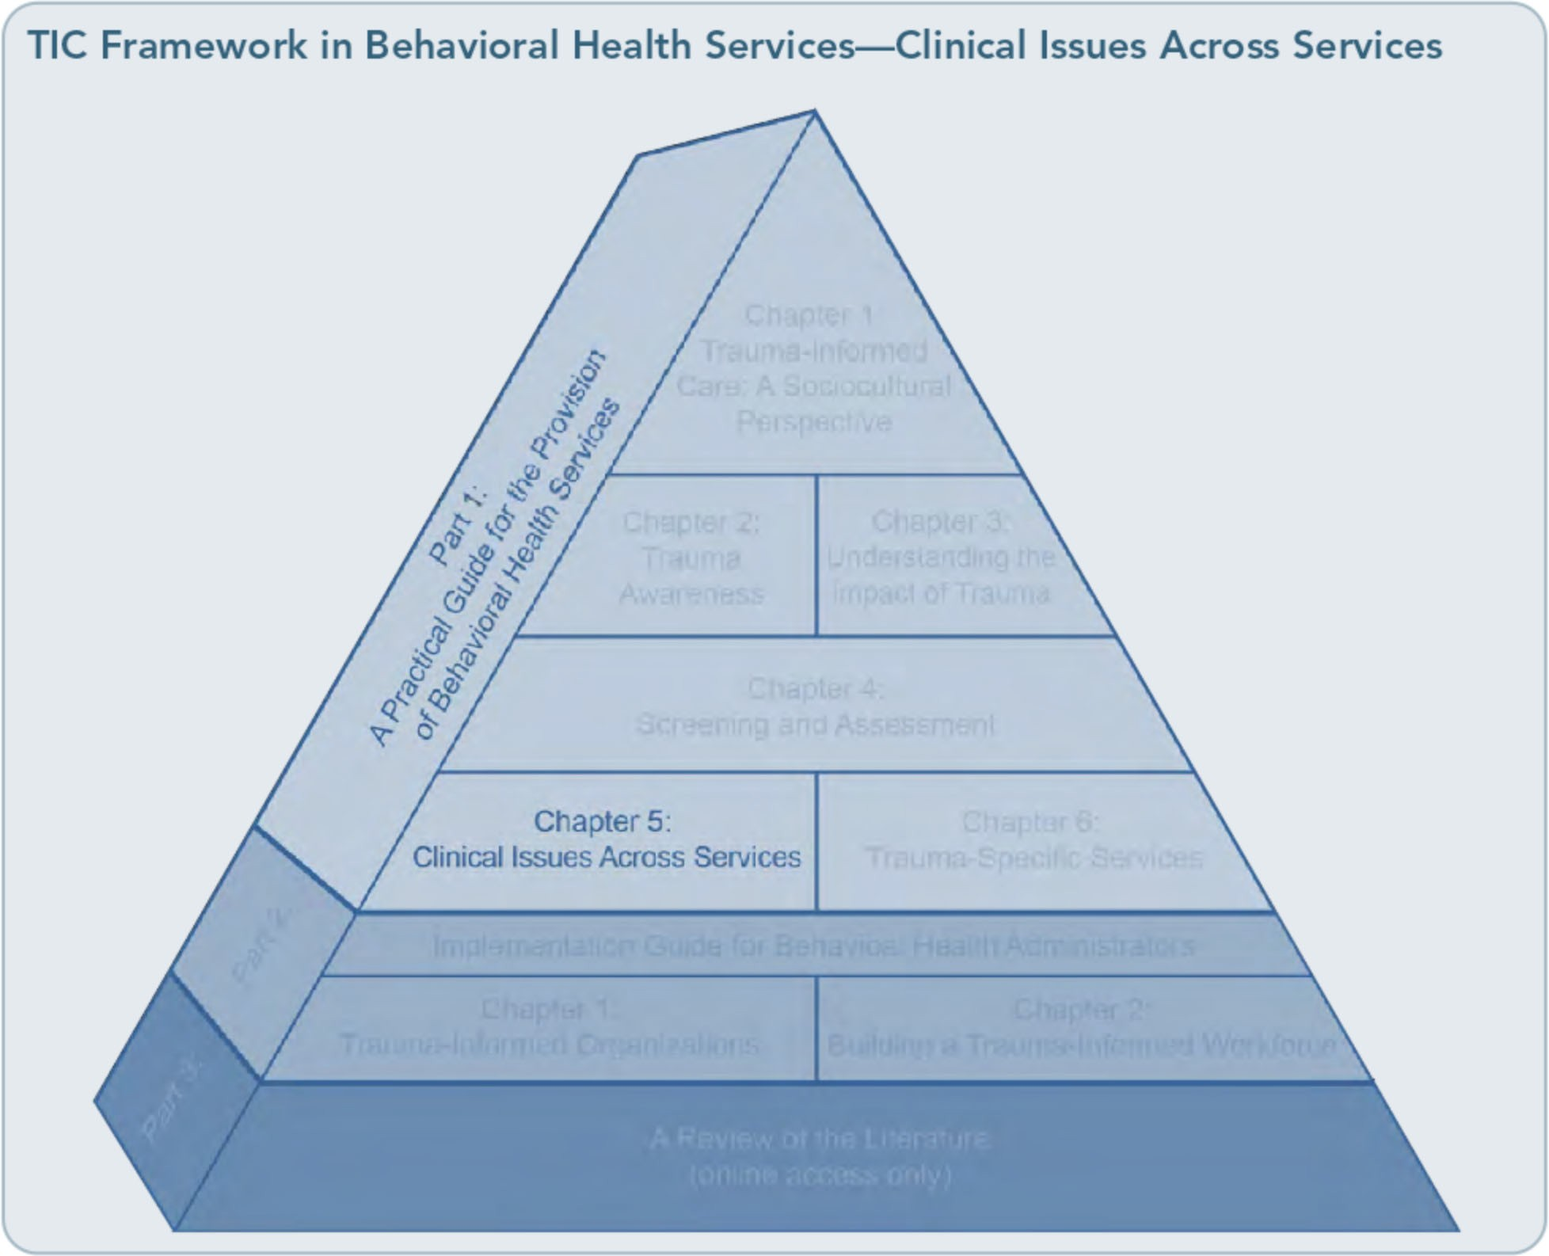

Establish Safety
Beyond identifying trauma and trauma-related symptoms, the initial objective of TIC is es­ tablishing safety. Borrowing from Herman's (1992) conceptualization of trauma recovery, safety is the first goal of treatment. Establish­ ing safety is especially crucial at the outset of trauma-informed treatment and often be­ comes a recurrent need when events or thera­ peutic changes raise safety issues, such as a change in treatment staffing due to vacations.
In the context of TIC, safety has a variety of meanings. Perhaps most importantly, the cli­ ent has to have some degree of safety from trauma symptoms. Recurring intrusive night­ mares; painful memories that burst forth
seemingly without provocation; feelings of sadness, anger, shame, or being overwhelmed; or not having control over sudden disconnec­ tions from others make moment-to-moment living feel unsafe. Clients might express feel­ ing unsafe through statements such as, "I can't control my feelings," or, "I just space out and disconnect from the world for no reason," or, "I'm afraid to go to sleep because of the nightmares." The intense feelings that accom­ pany trauma can also make clients feel unsafe. They may wake up in the morning feeling fine but become immobilized by depression as the day progresses. Clients with histories of trau­ ma may experience panicky feelings of being trapped or abandoned. An early effort in trauma treatment is thus helping the client

112

Part 1, Chapter 5-Clinical Issues Across Services

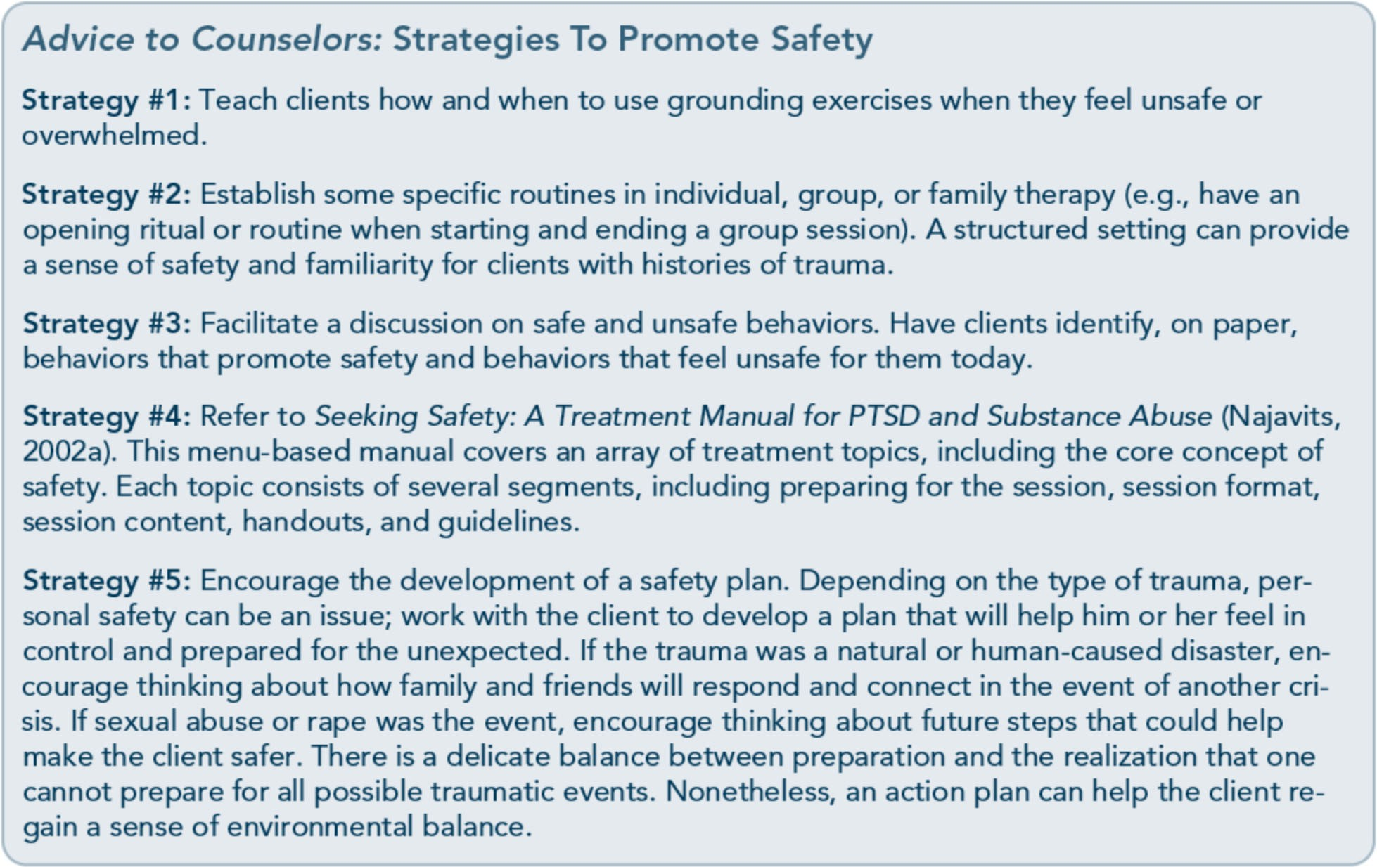

gain more control over trauma symptoms (and be able to label them as such) by learning more about the client and helping him or her develop new coping skills to handle symptoms when they arise and stay more grounded when flooded with feelings or memories.
A second aspect is safety in the environment. Trauma reactions can be triggered by sudden loud sounds (e.g., television at high volume, raised voices), tension between people, certain smells, or casual touches that are perceived as invasions of physical boundaries. The vulnera­ bility of exposing one's history in the treat­ ment setting can manifest in the client as feeling physically vulnerable and unsafe in the treatment environment. Sudden or inade­ quately explained treatment transitions, such as moving from one level of treatment to an­ other or changing counselors, can also evoke feelings of danger, abandonment, or instabil­ ity. Early in treatment, trauma survivors gen­ erally value routine and predictability. The counselor should recognize these needs and
respond appropriately by offering information in advance, providing nonshaming responses to a client's reactions to stimuli in his or her environment, and helping the client build a daily structure that feels safe.
A third aspect of safety is preventing a recur­ rence of trauma. People with histories of trauma and substance abuse are more likely to engage in high-risk behaviors and to experi­ ence subsequent traumas. Early treatment should focus on helping clients stop using
unsafe coping mechanisms, such as substance abuse, self-harm, and other self-destructive behaviors, and replacing them with safe and healthy coping strategies. Helping clients learn to protect themselves in reasonable ways is a positive goal of treatment.

Prevent Retraumatization
A key objective in TIC is to prevent retrauma­ tization generated by intervention and treat­ ment practices and policies. Unfortunately, treatment settings and clinicians can

113

Trauma-Informed Care in Behavioral Health Services

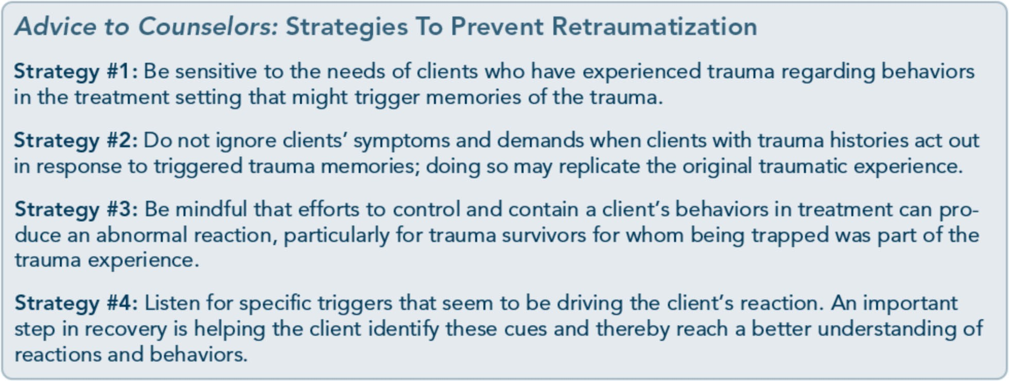

unintentionally create retraumatizing experi­ ences (for a review of traumas that can occur when treating serious mental illness, see Frueh et al., 2005). For instance, compassionate in­ quiry into a client's history can seem similar to the interest shown by a perpetrator many years before. Direct confrontation by counselors about behaviors related to substance abuse can be seen, by someone who has been repeatedly physically assaulted, as provocation building up to assault. Counselor and program efforts to help clients constrain destructive behaviors can be interpreted as efforts to control and dominate the individual. Intrusive shaming or insensitive behavior demonstrated by another client in the program can threaten a trauma survivor whose boundaries have been disre­ garded in the past-thus making the experi­ ence of treatment feel dangerous rather than safe. Some staff and agency issues that can result in retraumatization include:
- Disrespectfully challenging reports of abuse or other traumatic events.
- Discounting a client's report of a traumatic event.
- Using isolation.
- Using physical restraints.
- Allowing the abusive behavior of one client toward another to continue without intervention.
- Labeling intense rage and other feelings as pathological.
- Minimizing, discrediting, or ignoring client responses.
- Disrupting counselor-client relationships by changing counselors' schedules and as­ signments.
- Obtaining urine specimens in a nonprivate and/or disrespectful manner.
- Having clients undress in the presence of others.
- Being insensitive to a client's physical or emotional boundaries.
- Inconsistently enforcing rules and allowing chaos in the treatment environment.
- Applying rigid agency policies or rules without an opportunity for clients to ques­ tion them.
- Accepting agency dysfunction, including a lack of consistent, competent leadership.

Provide Psychoeducation
Trauma-informed education informs clients about traumatic stress and trauma-related symptoms and disorders as well as the related consequences of trauma exposure. It focuses on giving information to clients to help nor­
malize presenting symptoms, to highlight po­ tential short-term and long-term consequences of trauma and various paths to recovery, and to underscore the message that recovery is possible. Education frequently takes place prior to or immediately following an initial screening as a way to prepare clients

114

Part 1, Chapter 5-Clinical Issues Across Services

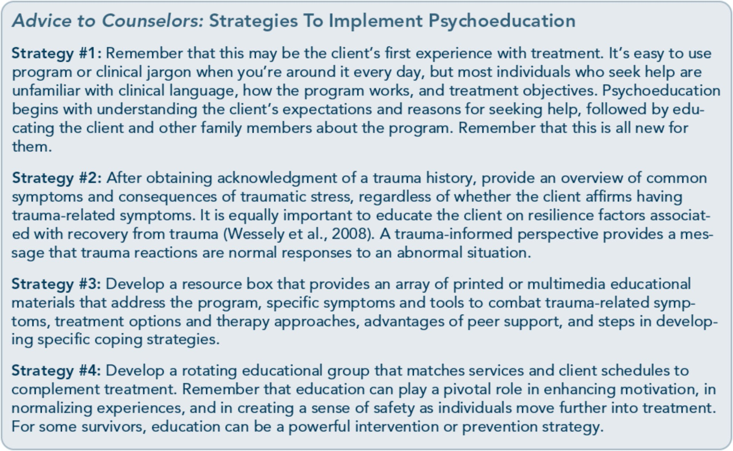

for hearing results or to place the screening and subsequent assessment findings in proper context. Education in and of itself, however, does not necessarily constitute a stand-alone treatment; rather, it can be conceptualized as a first step and/or component of more compre­ hensive treatment. Nonetheless, education may be a prevention and intervention strategy for individuals who have histories of trauma without current consequences or symptoms and/or those who have reported a resolution of past trauma(s). For example, some clients may have significantly delayed onset of trau­ matic stress symptoms. In this scenario, earlier education can enhance recognition of symp­ toms and ease the path of seeking treatment.
Some clients do not recognize the link be­ tween their current difficulties and their trau­ ma histories; education can help them understand the possible origin of their diffi­ culties. Psychoeducation presents trauma­ related symptoms that follow a trauma as normal reactions. By identifying the source of
clients' current difficulties and framing them as normal thoughts, emotions, and behaviors in response to trauma, many trauma survivors report a reduction in the intensity of the diffi­ culties or symptoms. Often, a client will ex­ press relief that his or her reactions are normal.You may find the U.S. Department of Veterans Affairs (VA) National Center on PTSD's educational handouts on traumatic stress reactions useful.
Psychoeducation goes beyond the identifica­ tion of traumatic stress symptoms and/or learning about the psychological, cognitive, and physical impacts of trauma. Numerous curricula are available that use psychoeduca­ tion as a first-line or complementary approach to trauma-specific therapies to enhance coping strategies in key areas, including safety, emo­ tional regulation, help-seeking, avoidant be­ havior, and so forth. An example is S.E.L.F.,
a trauma-informed psychoeducational group curriculum with educational components re­ lated to trauma recovery in the following

115

Trauma-Informed Care in Behavioral Health Services

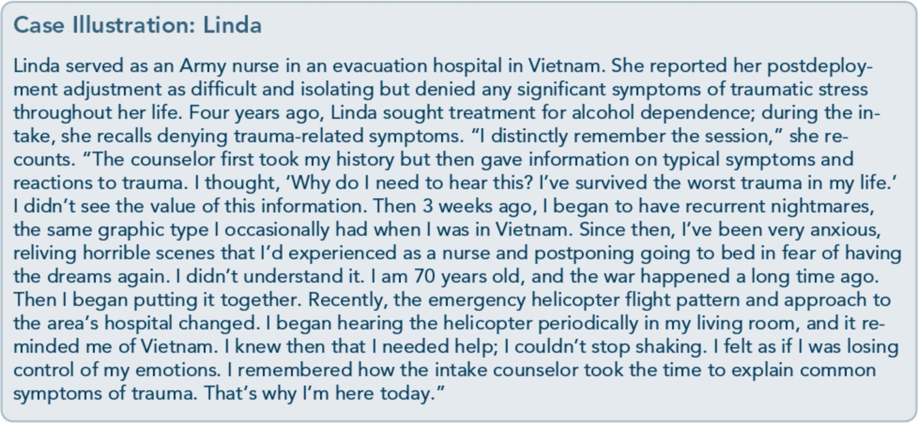
areas: creating Safety, regulating Emotions, addressing Loss, and redefining the Future (Bloom, Foderaro, & Ryan, 2006).

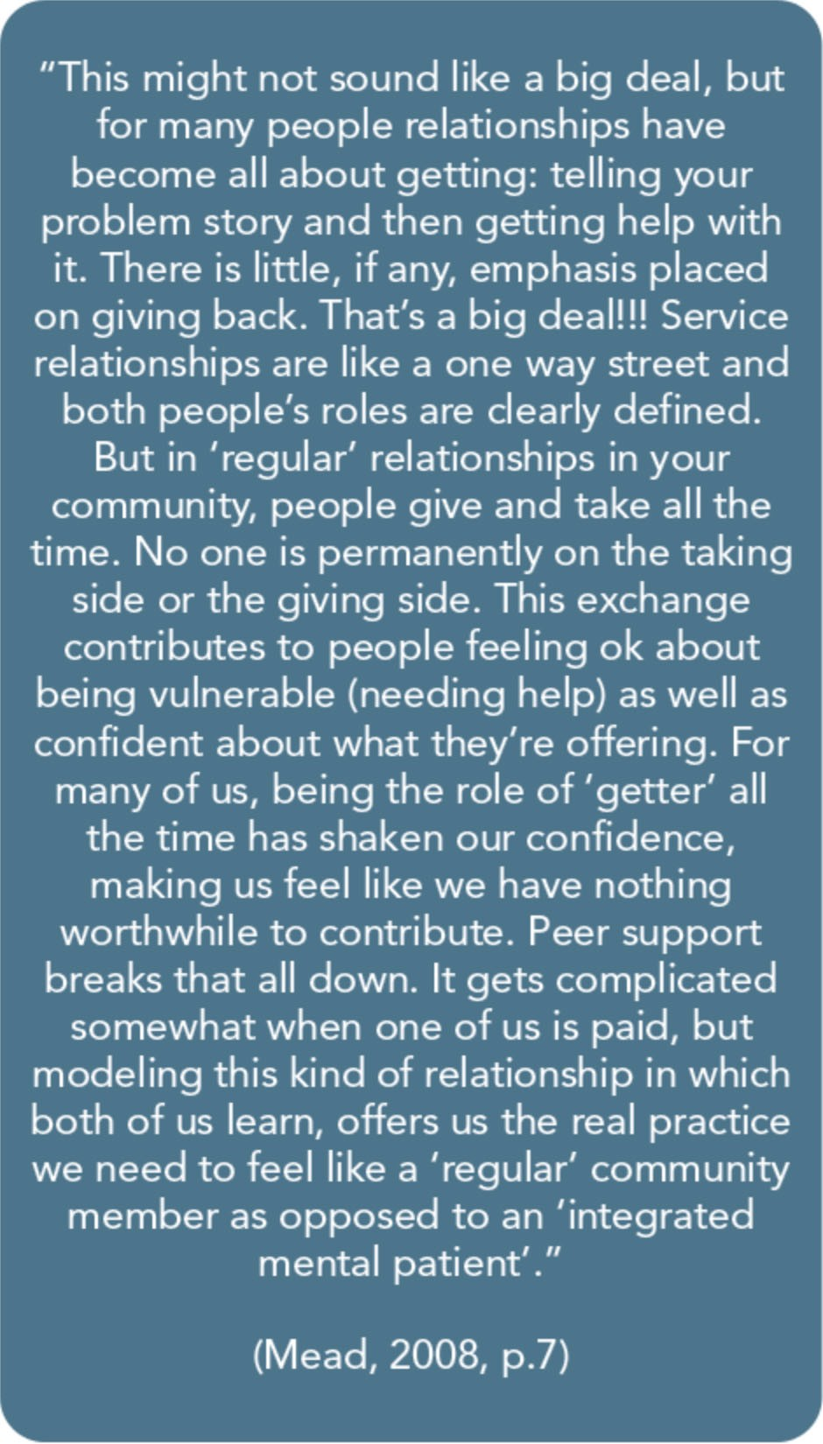
Offer Trauma-Informed Peer Support

Living with a history of trauma can be isolat­ ing and consuming. The experience of trauma can reinforce beliefs about being different, alone, and marred by the experience. At times, behavioral health treatment for trauma-related effects can inadvertently reinforce these be­ liefs. Simply engaging in treatment or receiv­ ing specialized services (although warranted) can further strengthen clients' beliefs that there is something wrong with them. Formal­ ized peer support can enhance the treatment experience. Treatment plus peer support can break the cycle of beliefs that reinforce trau­ matic stress (e.g., believing that one is perma­ nently damaged; that nobody could understand; that no one should or could toler­ ate one's story). Peer support provides oppor­ tunities to form mutual relationships; to learn how one's history shapes perspectives of self, others, and the future; to move beyond trau­ ma; and to mirror and learn alternate coping strategies. Peer support defines recovery as an

116

Part 1, Chapter 5-Clinical Issues Across Services

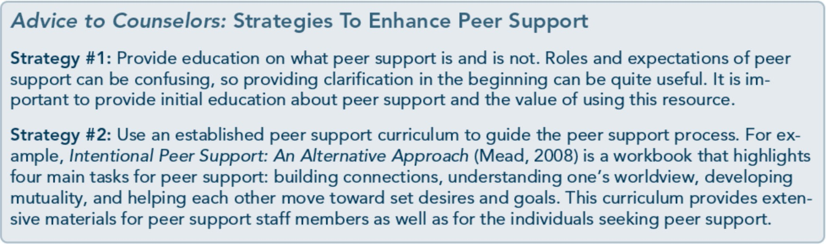

interactive process, not as a definitive moment wherein someone fixes the "problem."

Normalize Symptoms
Symptoms of trauma can become serious bar­ riers to recovery from substance use and men­ tal disorders, including trauma-related ones. Counselors should be aware of how trauma
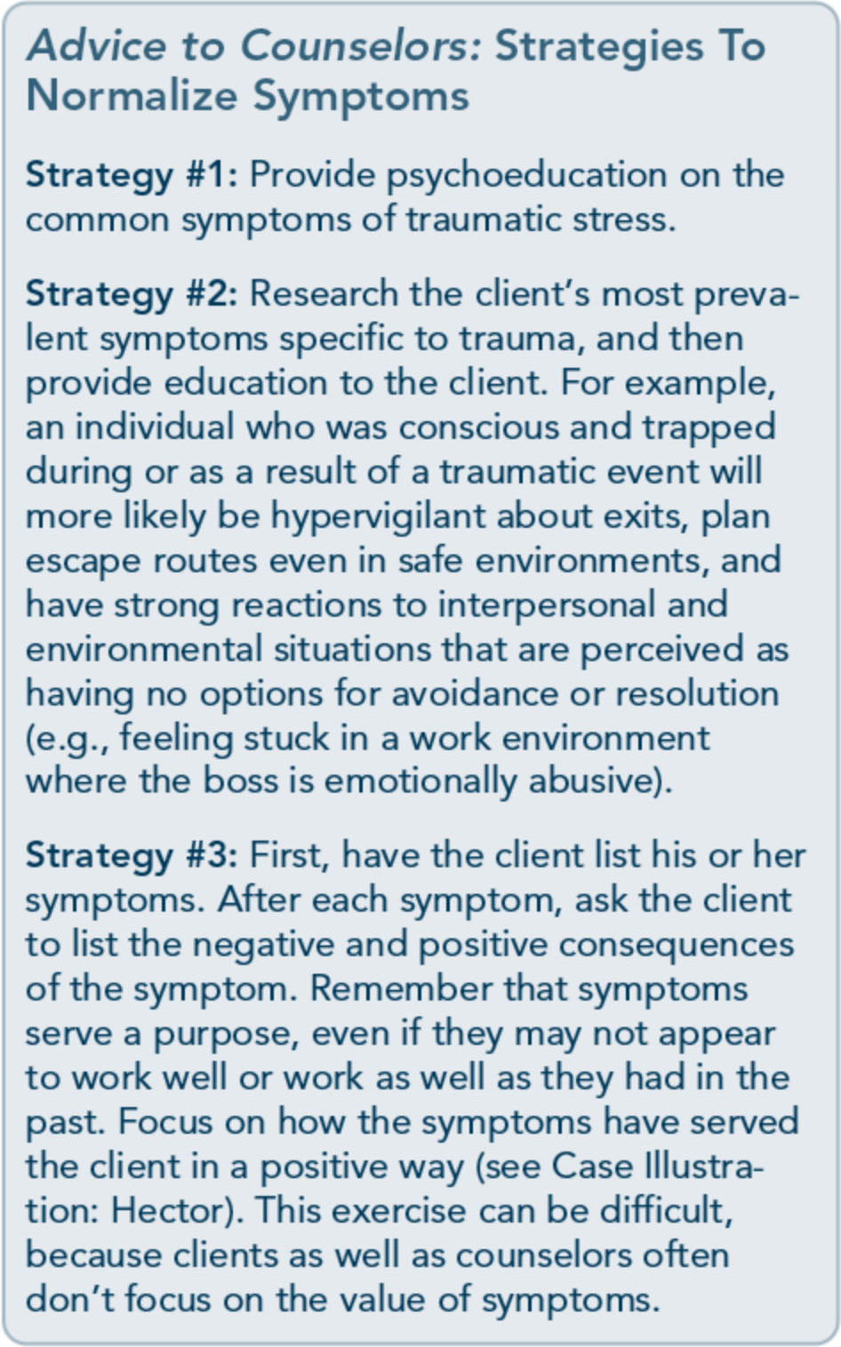
symptoms can present and how to respond to them when they do appear. A significant step in addressing symptoms is normalizing them. People with traumatic stress symptoms need to know that their symptoms are not unique and that their reactions are common to their experience(s). Often, normalizing symptoms gives considerable relief to clients who may have thought that their symptoms signified some pervasive, untreatable mental disorder.

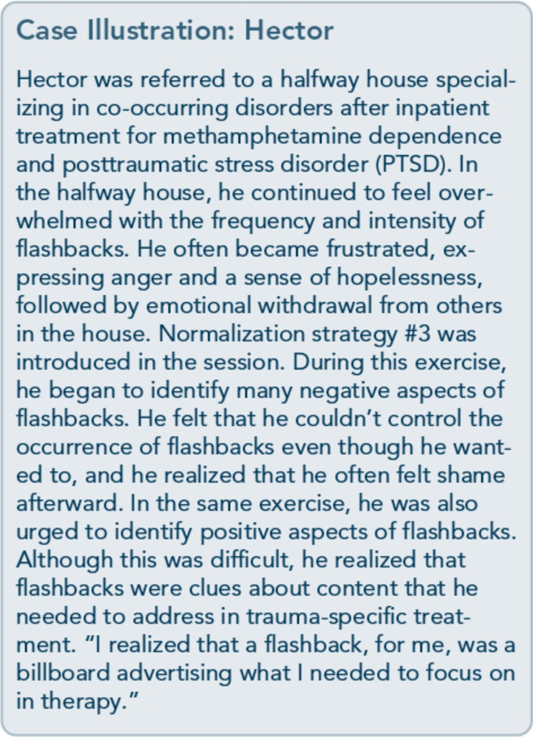

117

Trauma-Informed Care in Behavioral Health Services

Identify and Manage Trauma­ Related Triggers
Many clients who have traumatic stress are aught off guard with intrusive thoughts, feel­ ings, sensations, or environmental cues of the trauma. This experience can be quite discon­ certing, but often, the individual does not draw an immediate connection between the internal or external trigger and his or her reac­ tions. At other times, the trigger is so potent that the individual is unable to discern the present trigger from the past trauma and be­ gins to respond as if the trauma is reoccurring.

Key steps in identifying triggers are to reflect back on the situation, surroundings, or sensa­ tions prior to the strong reaction. By doing so, you and your client may be able to determine the connections among these cues, the past trauma(s), and the client's reaction. Once the cue is identified, discuss the ways in which it is connected to past trauma. For some cues, there will be an obvious and immediate con­ ecti n e.g., having someone say "I love you" m a s1gmficant relationship as an adult and connecting this to an abuser who said the same thing prior to a sexual assault). Other

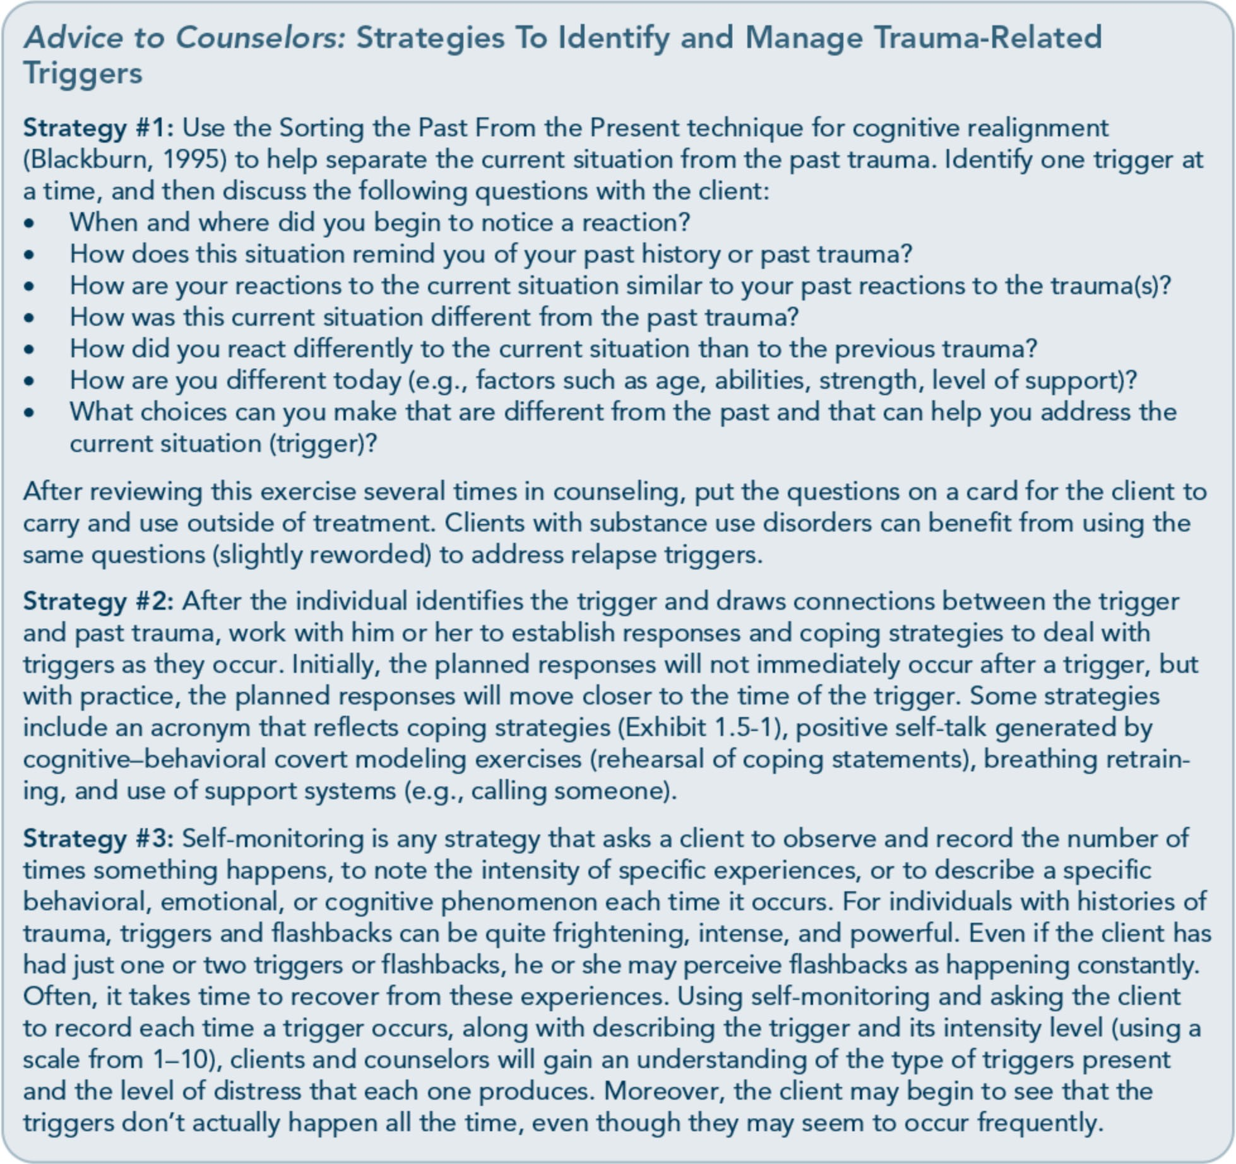

118

Part 1, Chapter 5-Clinical Issues Across Services

Exhibit 1.5-1: The OBSERVATIONS
Coping Strategy
  - Take a moment to just Observe what is happening. Pay attention to your body, your senses, and your environment.
  - Focus on your Breathing. Allow your feel­ ings and sensations to wash over you. Breathe.
  - Name the Situation that initiated your response. In what way is this situation fa­ miliar to your past? How is it different?
  - Remember that Emotions come and go. They may be intense now, but later they will be less so. Name your feelings.
  - Recognize that this situation does not de­ fine you or your future. It does not dictate how things will be, nor is it a sign of things to come. Even if it is familiar, it is only one event.
  - Validate your experience. State, at least internally, what you are feeling, thinking, and experiencing.
  - Ask for help. You don't have to do this alone. Seek support. Other people care for you. Let them!
  - This too shall pass. Remember: There are times that are good and times that are not so good. This hard time will pass.
- I can handle this. Name your strengths. Your strengths have helped you survive.
- Keep an Open mind. Look for and try out new solutions.
- Name strategies that have worked before. Choose one and apply it to this situation.
- Remember you have survived. You are a
Survivor!

cues will not be as obvious. With practice, the client can begin to track back through what occurred immediately before an emotional, physical, or behavioral reaction and then ex­ amine how that experience reminds him or her of the past.

Draw Connections
Mental health and substance abuse treatment providers have historically underestimated the effects of trauma on their clients for many reasons. Some held a belief that substance
Advice to Counselors: Strategies To Help Clients Draw Connections
Strategy #1: Writing about trauma can help clients gain awareness of their thoughts, feel­ ings, and current experiences and can even improve physical health outcomes (Pennebaker, Kiecolt-Glaser, & Glaser, 1988; Smyth, Hockemeyer, & Tulloch, 2008). Although this tool may help some people draw connections between current experiences and past traumas, it should be used with caution; others may find that it brings up too much intense trauma mate­ rial (especially among vulnerable trauma survi­ vors with co-occuring substance abuse, psychosis, and current domestic violence). Jour­ nal writing is safest when you ask clients to write about present-day specific targets, such as log­ ging their use of coping strategies or identifying strengths with examples. Writing about trauma can also be done via key questions or a work­ book that provides questions centered upon trauma experiences and recovery.
Strategy #2: Encourage clients to explore the links among traumatic experiences and mental and substance use disorders. Recognition that a mental disorder or symptom developed after the trauma occurred can provide relief and hope that the symptoms may abate if the trauma is addressed. Ways to help clients con­ nect substance use with trauma histories in­ clude (Najavits, 20026; Najavits, Weiss, & Shaw, 1997):
- Identifying how substances have helped "solve" trauma or PTSD symptoms in the short term (e.g., drinking to get to sleep).
- Teaching clients how trauma, mental, and substance use disorders commonly co­ occur so that they will not feel so alone and ashamed about these issues.
- Discussing how substance abuse has im­ peded healing from trauma (e.g., by block­ ing feelings and memories).
- Helping clients recognize trauma symp­ toms as triggers for relapse to substance use and mental distress.
- Working on new coping skills to recover from trauma and substance abuse at the same time.
- Recognizing how both trauma and sub­ stance abuse often occur in families through multiple generations.

119

Trauma-Informed Care in Behavioral Health Services

abuse should be addressed before attending to any co-occurring conditions. Others did not have the knowledge and training to evaluate trauma issues or were uncomfortable or reluc­ tant to discuss these sensitive issues with cli­ ents (Ouimette & Brown, 2003). Similarly, in other behavioral health settings, clinicians sometimes address trauma-related symptoms but do not have experience or training in the treatment of substance abuse.
So too, people who have histories of trauma will often be unaware of the connection be­ tween the traumas they've experienced and their traumatic stress reactions. They may no­ tice depression, anger, or anxiety, or they may describe themselves as "going crazy" without being able to pinpoint a specific experience that produced the trauma symptoms. Even if clients recognize the events that precipitated their trauma symptoms, they may not understand how others with similar experiences can have different reactions. Thus, a treatment goal for trauma survivors is helping them gain aware­ ness of the connections between their histories of trauma and subsequent consequences. Seeing the connections can improve clients' ability to work on recovery in an integrated fashion.

Teach Balance
You and your clients need to walk a thin line when addressing trauma. Too much work focused on highly distressing content can turn a desensitization process into a session where­ by the client dissociates, shuts down, or be­ comes emotionally overwhelmed. On the other hand, too little focus by the client or

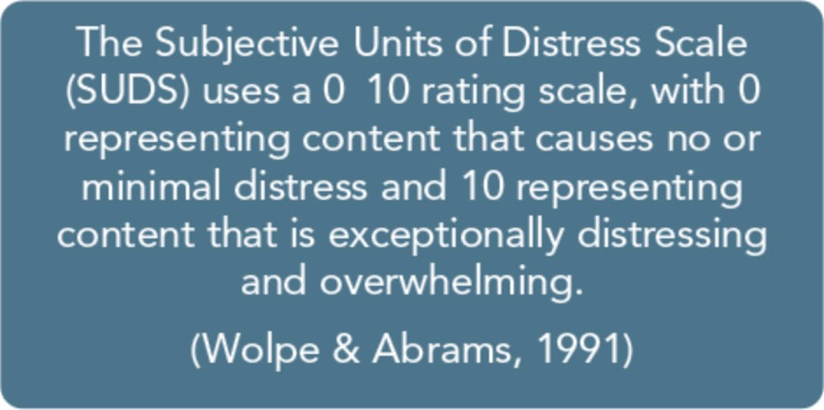
counselor can easily reinforce avoidance and confirm the client's internal belief that it is too dangerous to deal with the aftermath of the trauma. Several trauma-specific theories offer guidelines on acceptable levels of distress asso­ ciated with the traumatic content that the therapy addresses. For example, some tradi­ tional desensitization processes start at a very low level of subjective distress, gradually work­ ing up through a hierarchy of trauma memo­ ries and experiences until those experiences produce minimal reactions when paired with some coping strategy, such as relaxation train­ ing. Other desensitization processes start at a higher level of intensity to provide more rapid extinction of traumatic associations and to decrease the risk of avoidance-a behavior that reinforces traumatic stress.
Working with trauma is a delicate balancing act between the development and/or use of coping strategies and the need to process the traumatic experiences. Individuals will choose different paths to recovery; it's a myth that every traumatic experience needs to be ex­ pressed and every story told. For some indi­ viduals, the use of coping skills, support, and spirituality are enough to recover. Regardless of theoretical beliefs, counselors must teach

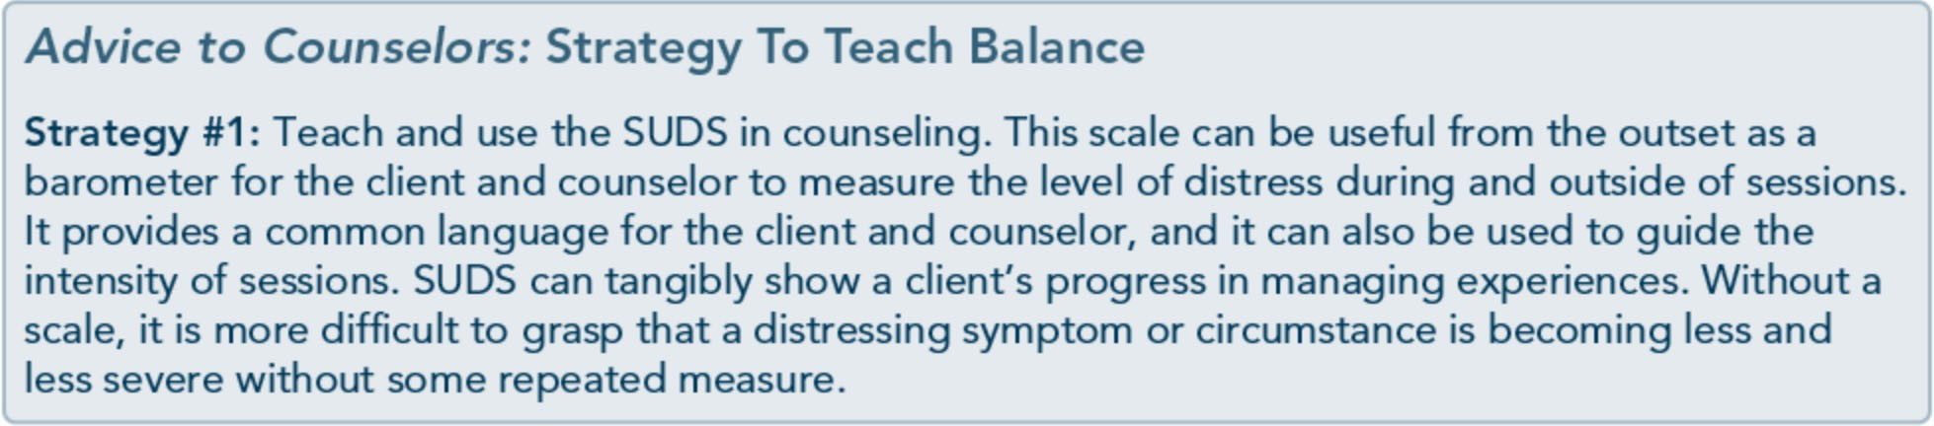

120

Part 1, Chapter 5-Clinical Issues Across Services

coping strategies as soon as possible. Retrau­ matization is a risk whenever clients are ex­ posed to their traumatic histories without sufficient tools, supports, and safety to manage emotional, behavioral, and physical reactions.

Build Resilience
Survivors are resilient! Often, counselors and clients who are trauma survivors focus on the negative consequences of trauma while failing to recognize the perseverance and attributes that have helped them survive. It is natural to focus on what's not working rather than what has worked. To promote growth after trauma and establish a strengths-based approach, fo­ cus on building on clients' resilience. Current resilience theories claim that building or rein­ forcing resilience prevents further development of trauma-related symptoms and disorders. The following Advice to Counselors box is adapted from the American Psychological Association's 2003 statement on resilience.

Address Sleep Disturbances
Sleep disturbances are one of the most endur­ ing symptoms of traumatic stress and are a particularly common outcome of severe and prolonged trauma. Sleep disturbances increase one's risk of developing traumatic stress; they significantly alter physical and psychological processes, thus causing problems in daytime functioning (e.g., fatigue, cognitive difficulty, excessive daytime sleepiness). People with sleep disturbances have worse general health and quality oflife. The cardiovascular and immune systems, among others, may be affect­ ed as well. Sleep disturbances can worsen traumatic stress symptoms and interfere with healing by impeding the brain's ability to pro­ cess and consolidate traumatic memories (Caldwell & Redeker, 2005).
Sleep disturbances vary among trauma survi­ vors and can include decreased ability to stay asleep, frequent awakenings, early morning

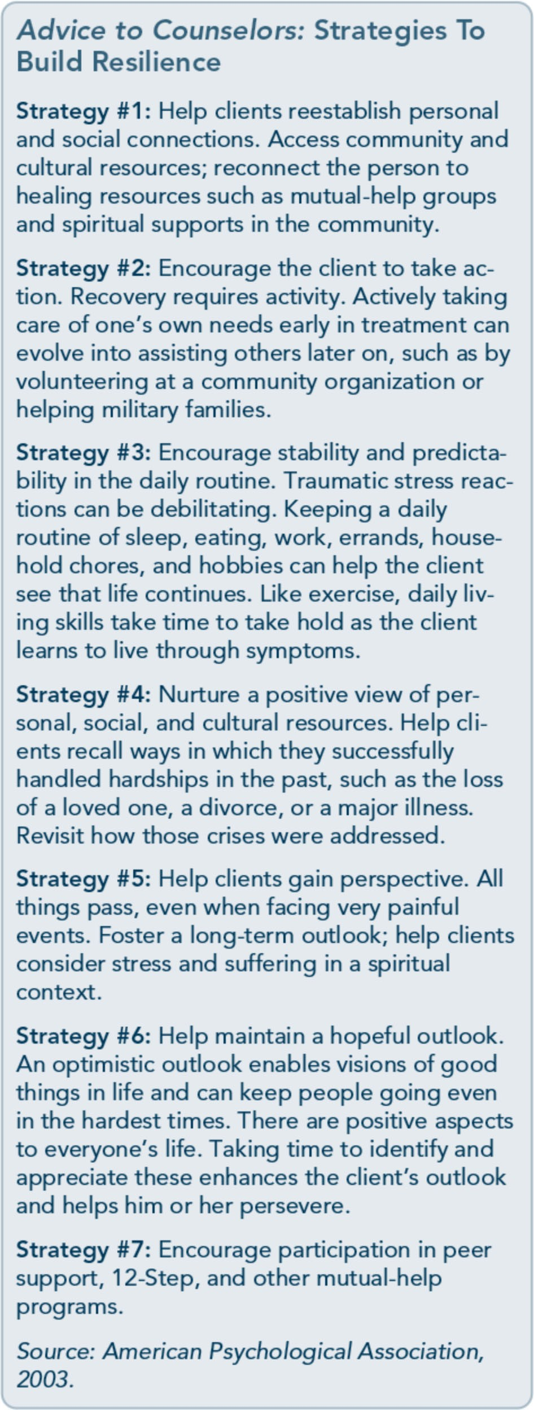
unintentional awakening, trouble falling asleep, poor quality of sleep, and disordered

121

Trauma-Informed Care in Behavioral Health Services
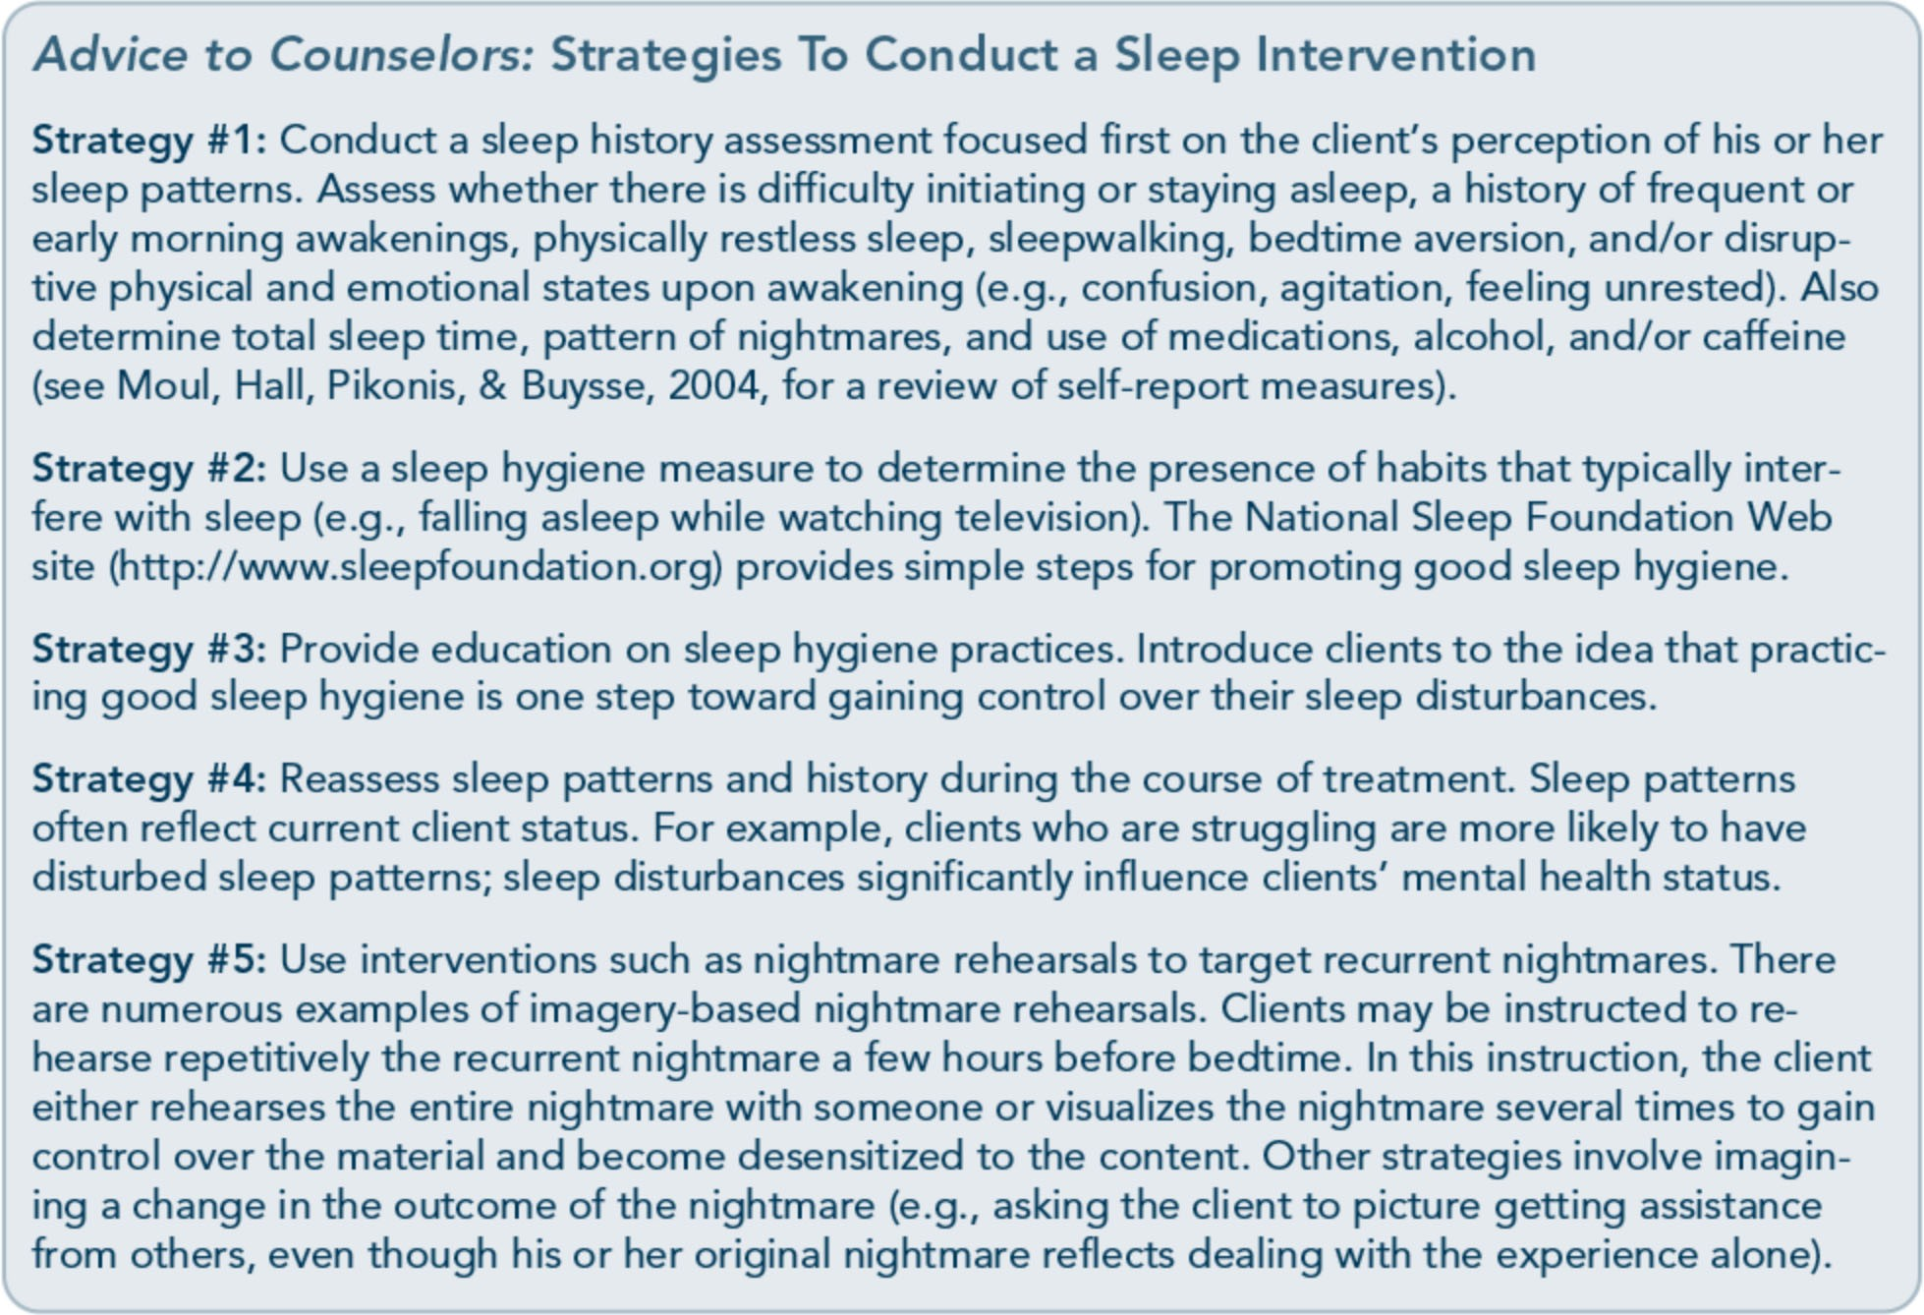

breathing during sleep (Caldwell & Redeker, 2005). Most traumatic stress literature focuses on nightmares, insomnia, and frequent awak­ enings. These disturbances are connected to two main symptoms of traumatic stress: hy­ perarousal (which causes difficulty in falling and remaining asleep) and reexperiencing the trauma (e.g., through recurrent nightmares).
Other sleep disturbances trauma survivors report include sleep avoidance or resistance to sleep (see Case Illustration: Selena), panic awakenings, and restless or unwanted body movements (e.g., hitting your spouse uninten­ tionally in bed while asleep; Habukawa, Maeda, & Uchimura, 2010).

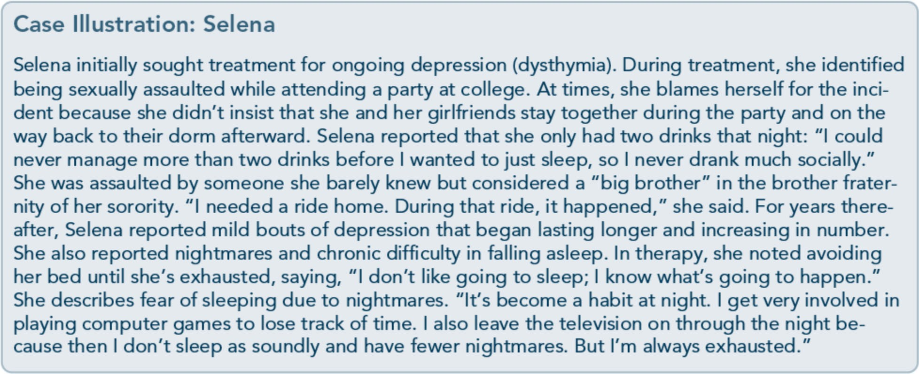

122

Part 1, Chapter 5-Clinical Issues Across Services

Build Trust
Some traumatic experiences result from trust­ ing others (e.g., interpersonal trauma). In oth­ er cases, trust was violated during or after the traumatic experience, as in cases when help was late to arrive on the scene of a natural disaster. This lack of trust can leave individuals alienated, socially isolated, and terrified of developing relationships. Some feel that the trauma makes them different from others who haven't had similar experiences. Sometimes, a client's trust issues arise from a lack of trust in self-for instance, a lack of trust in one's per­ ceptions, judgment, or memories. People who have also experienced severe mental or sub­ stance use disorders may have difficulty trust­ ing others because, during the course of their illness, they felt alienated or discriminated against for behaviors and emotions generated by or associated with the disorders.
Some client groups (e.g., gay, lesbian, and bi­ sexual clients; people from diverse cultures; those with serious mental illness) evidence

significant mistrust because their trust has been repeatedly violated in the past. Traumatic experiences then compound this mistrust.
Mistrust can come from various sources, is usually unstated, and, ifleft unaddressed, can impede treatment. For example, some clients leave treatment early or do not engage in po­ tentially beneficial treatments. Others avoid issues of trust and commitment by leaving treatment when those issues begin to arise.
Establishing a safe, trusting relationship is paramount to healing-yet this takes time in the counseling process. Counselors and other behavioral health professionals need to be consistent throughout the course of treatment; this includes maintaining consistency in the parameters set for availability, attendance, and level of empathy. Trust is built on behavior shown inside and outside of treatment; you should immediately address any behavior that may even slightly injure the relationship (e.g., being 5 minutes late for an appointment, not responding to a phone message in a timely manner, being distracted in a session).

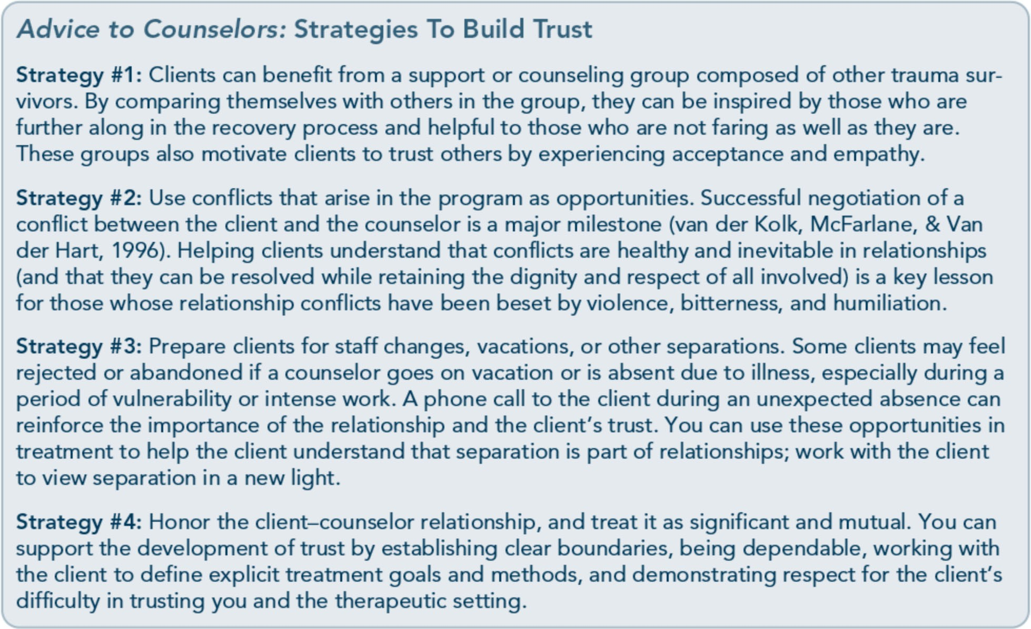

123

Trauma-Informed Care in Behavioral Health Services

Support Empowerment
Strong feelings of powerlessness can arise in trauma survivors seeking to regain some con­ trol of their lives. Whether a person has sur­ vived a single trauma or chronic trauma, the survivor can feel crushed by the weight of powerlessness. Mental illness and substance abuse, too, can be disempowering; clients may feel that they've lost control over their daily lives, over a behavior such as drug use, or over

powerful emotions such as fear, sadness, or anger. Empowerment means helping clients feel greater power and control over their lives, as long as such control is within safe and healthy bounds. A key facet of empowerment is to help clients build on their strengths. Em­ powerment is more than helping clients dis­ cover what they "should" do; it is also helping them take the steps they feel ready to take.

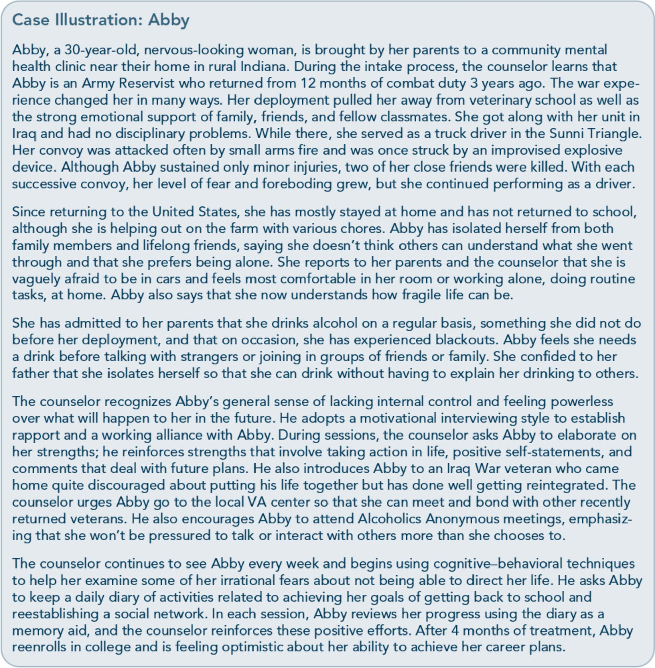

124

Part 1, Chapter 5-Clinical Issues Across Services

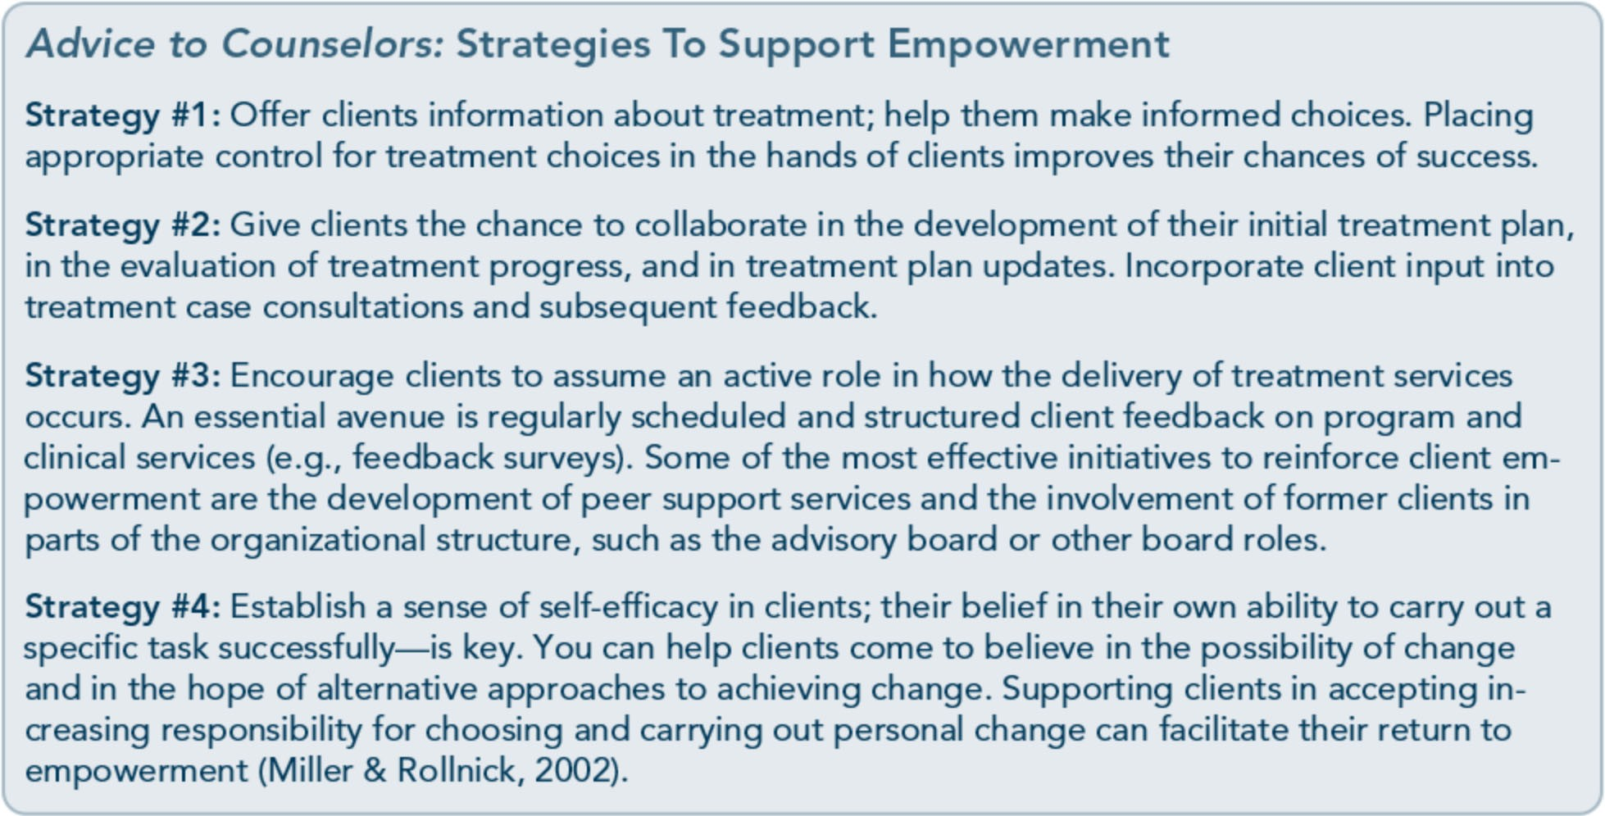

Acknowledge Grief and Bereavement
The experience ofloss is common after trau­ mas, whether the loss is psychological (e.g., no longer feeling safe) or physical (e.g., death of a loved one, destruction of community, physical impairment). Loss can cause public displays of grief, but it is more often a private experience. Grieving processes can be emotionally over­ whelming and can lead to increased substance use and other impulsive behaviors as a way to manage grief and other feelings associated with the loss. Even for people who experi­ enced trauma years prior to treatment, grief is still a common psychological issue. Delayed or absent reactions of acute grief can cause ex­ haustion, lack of strength, gastrointestinal symptoms, and avoidance of emotions.
Risk factors of chronic bereavement (grief lasting more than 6 months) can include:
  - Perceived lack of social support.
  - Concurrent crises or stressors (including reactivation of PTSD symptoms).
  - High levels of ambivalence about the loss.
  - An extremely dependent relationship prior to the loss.
- Loved one's death resulting from disaster: unexpected, untimely, sudden, and shock­ ing (New South Wales Institute of Psychi­ atry & Centre for Mental Health, 2000).
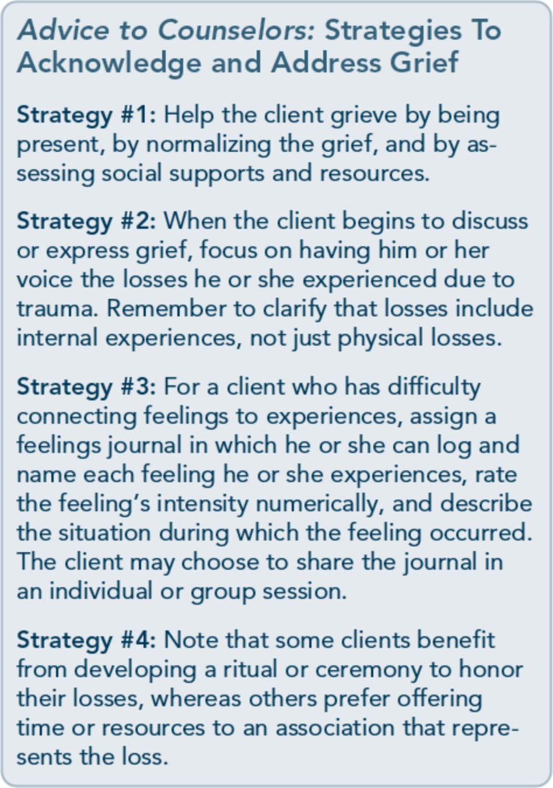

125

Trauma-Informed Care in Behavioral Health Services

126
Monitor and Facilitate Stability Stability refers to an ongoing psychological and physical state whereby one is not over­ whelmed by disruptive internal or external stimuli (Briere & Scott, 20066). It's common for individuals to have an increase in symp­ toms, distress, or impairment when dealing with the impact of their trauma or talking about specific aspects of their trauma. There is a thin line that the client and counselor need to negotiate and then walk when addressing

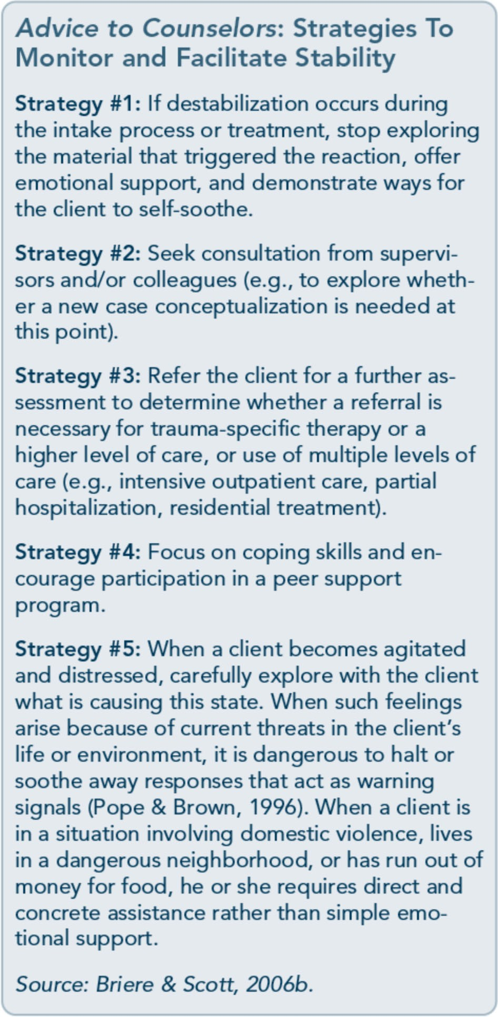

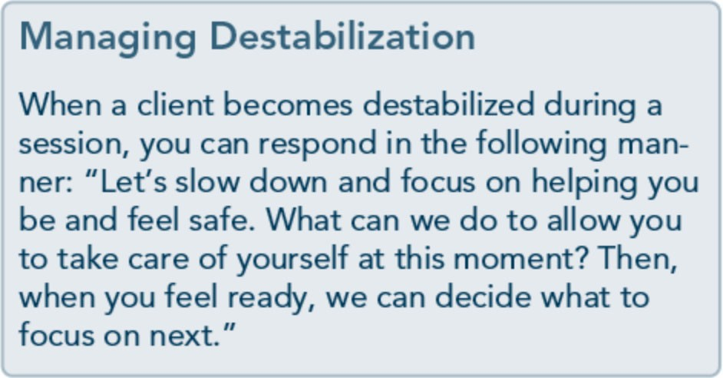
trauma. Too much work focused on highly distressing content can turn a desensitization process into a session that causes the client to dissociate, shut down, or become emotionally overwhelmed. On the other hand, too little focus by the client or counselor can easily rein­ force avoidance and confirm the client's inter­ nal belief that it is too dangerous to deal with the aftermath of the trauma.
Clients should have some psychological stabil­ ity to engage in trauma-related work. An im­ portant distinction can be made between a normative increase in symptoms (e.g., the typ­ ical up-and-down course of traumatic stress reactions or substance abuse) and destabiliza­ tion (dangerous, significant decrease in func­ tioning). Signs of destabilization include (Green Cross Academy ofTraumatology, 2007; Najavits, 20026):
- Increased substance use or other unsafe behavior (e.g., self-harm).
- Increased psychiatric symptoms (e.g., de­ pression, agitation, anxiety, withdrawal, anger).
- Increased symptoms of trauma (e.g., severe dissociation).
- Helplessness or hopelessness expressed verbally or behaviorally.
- Difficulty following through on commit­ ments (e.g., commitment to attend treat­ ment sessions).
- Isolation.
- Notable decline in daily activities (e.g., self-care, hygiene, care of children or pets, going to work).

Part 1, Chapter 5-Clinical Issues Across Services

Treatment Issues
The treatment environment itself can signifi­ cantly affect how clients experience traumatic stress and how the client responds to treat­ ment. Some specific issues related to working with trauma survivors in a clinical setting are discussed in the following sections.

Client Engagement
A lack of engagement in treatment is the cli­ ent's inability to make progress toward treat­ ment goals, deal with important topics in treatment, or complete treatment. Clients who have histories of trauma will express ambiva­ lence about treatment similarly to others, ex­ cept that clients who have traumatic stress can feel more "stuck'' and perceive themselves as having fewer options. In addition, clients may be avoiding engagement in treatment because it is one step closer to addressing their trauma. You should attend to the client's motivation to change, implement strategies that address am­ bivalence toward treatment, and use approach­ es that help clients overcome avoidant behavior.

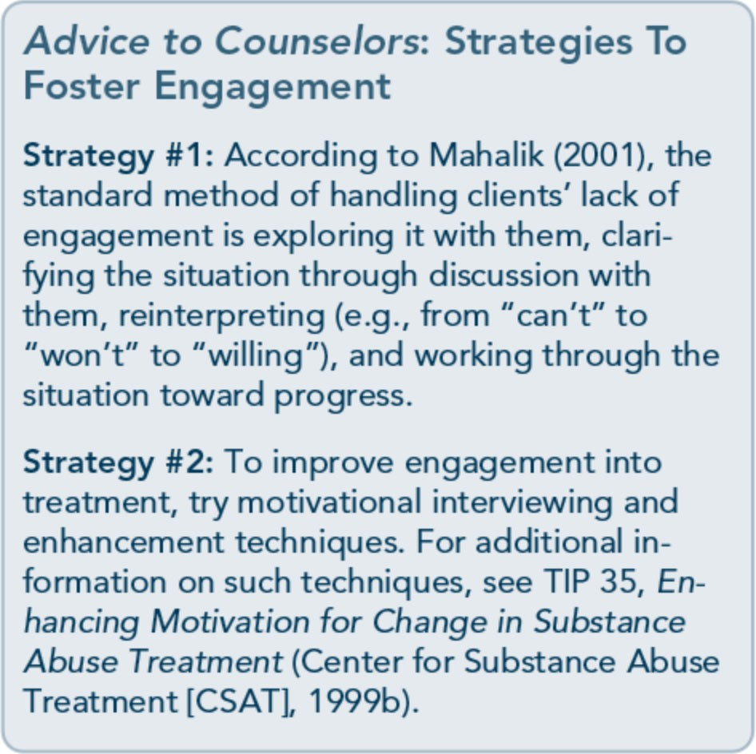

Pacing and Timing
Although your training or role as a counselor may prohibit you from providing trauma­ specific services, you must still be prepared for the fact that clients are not as focused on when or where it is most appropriate to ad­ dress trauma-they want relief, and most lay and professional people have been taught that the only path to recovery is disclosure. Some clients are reluctant to talk about anything associated with their histories of trauma. Oth­ er clients immediately want to delve into the memories of their trauma without developing
a safe environment. The need to gain any relief for the traumatic stress pushes some individu­ als to disclose too quickly, without having the necessary support and coping skills to manage the intensity of their memories. Clients who enter treatment and immediately disclose past trauma often don't return because the initial encounter was so intense or because they ex­ perienced considerable emotional distress for several days afterward and/or in anticipation of the next session.
Proper pacing of sessions, disclosure, and in­ tensity is paramount. Clients who immediate­ ly disclose without proper safety nets are actually retraumatizing themselves by reliving the experience without adequate support­ often placing themselves in the same circum­ stances that occurred during the actual trau­ mas they experienced. Although you should not adamantly direct clients not to talk about what happened, it is important to discuss with the clients, even if you have to interrupt them empathically and respectfully, the potential consequences of disclosing too soon and too fast. Ask whether they have done this before, and then inquire about the outcome. Rein­ force with clients that trauma heals when there are support, trust, and skills in place to manage the memories of the traumatic experi­ ences. Ideally, disclosure begins after these elements are secured, but realistically, it is a

127

Trauma-Informed Care in Behavioral Health Services

Advice to Counselors: Strategies To Establish Appropriate Pacing and Timing
Strategy #1: Frequently discuss and request feedback from clients about pacing and timing. Moving too quickly into discussion of the trauma can increase the risk of dissociation, overactivation of memories, and feeling overwhelmed.
Strategy #2: Use the SUDS as a barometer of intensity to determine the level of work.
Strategy #3: Slowly increase the speed of interventions and continually adjust the intensity of inter­ ventions; move in and out of very intense work, or use strategies that decrease the intensity when necessary. One approach that typically decreases the intensity of traumatic memories is to ask the individual to imagine that he or she is seeing the scene through a window or on a television screen. This helps decrease intensity and the risk of dissociation. It provides an opportunity for the client to view the trauma from a different perspective and a strategy to use outside of treatment to shift from reliving the trauma to observing it from a neutral position.
Strategy #4: Monitor clients to ensure that treatment does not overwhelm their internal capacities, retraumatize them, or result in excessive avoidance; make sure therapy occurs in the "therapeutic window" (Briere & Scott, 20066).
Strategy #5: Be alert to signs that discussions of trauma, including screening, assessment, and in­ take processes, are going too fast. Mild to moderate signs are:
  - Missing counseling appointments after discussions of important material.
  - Periods of silence.
  - Dissociation.
  - Misunderstanding what are usually understandable concepts.
  - Redirecting the focus of the discussion when certain issues arise.
Strategy #6: Observe the client's emotional state. Slow down; seek consultation if the client exhibits:
  - Persistent resistance to addressing trauma symptoms.
  - Repetitive flashbacks.
  - Increase in dissociation.
  - Regression.
  - Difficulty in daily functioning (e.g., trouble maintaining everyday self-care tasks).
  - Substance use relapses.
  - Self-harm or suicidal thoughts/behaviors (e.g., talking about suicide).
Strategy #7: Use caution and avoid (Briere, 19966, p. 115):
  - Encouraging clients to describe traumatic material in detail before they can deal with the conse­ quences of disclosure.
  - Using overly stressful interventions (e.g., intensive role-plays, group confrontation, guided imagery).
  - Confrontations or interpretations that are too challenging given the client's current functioning.
  - Demanding that the client work harder and stop resisting.
Source: Strategies 1--6: Green Cross Academy of Traumatology, 2001. Adapted with permission.

balancing act for both the counselor and client as to when and how much should be ad­ dressed in any given session. Remember not to inadvertently give a message that it is too dan­ gerous to talk about trauma; instead, reinforce the importance of addressing trauma without further retraumatization.

Length of Treatment

Many factors influence decisions regarding the length of treatment for a given client. Severity of addiction, type of substance abused, type of trauma, age at which the trauma occurred, level of social support, and the existence of

128

Part 1, Chapter 5-Clinical Issues Across Services

mental disorders all influence length of treat­ ment. External factors, such as transportation and childcare, caps on insurance coverage, and limitations in professional resources, can also affect length of treatment. In general, longer treatment experiences should be expected for clients who have histories of multiple or early traumas, meet diagnostic criteria for multiple Axis I or Axis II diagnoses, and/or require intensive case management. Most of the em­ pirically studied and/or manual-based models described in the next chapter are short-term models (e.g., lasting several months); however, ongoing care is indicated for clients with more complex co-occurring trauma disorders.

Traumatic Memories
One of the most controversial issues in the trauma field is the phenomenon of "recovered memories" or "traumatic amnesia" (Brewin, 2007). Practitioners working with traumatized individuals are particularly concerned about the possibility of new memories of the trau­ matic event emerging during the course of therapy and the possibility of these memories being induced by the clinician. Scientific re­ views indicate that people can experience am­ nesia and delayed recall for some memories of a wide variety of traumas, including military combat and prisoner of war experiences, natural disasters and accidents, childhood sexual abuse, and political torture (Bowman & Mertz, 1996; Brewin, 2007; Karon & Widener, 1997; McNally, 2005). In some cases, the survivor will not remember some of what happened, and the counselor may need to help the client face the prospect of never knowing all there is to know about the past and accept moving on with what is known.

Legal Issues
Legal issues can emerge during treatment. A client, for instance, could seek to prosecute a perpetrator of trauma (e.g., for domestic vio-

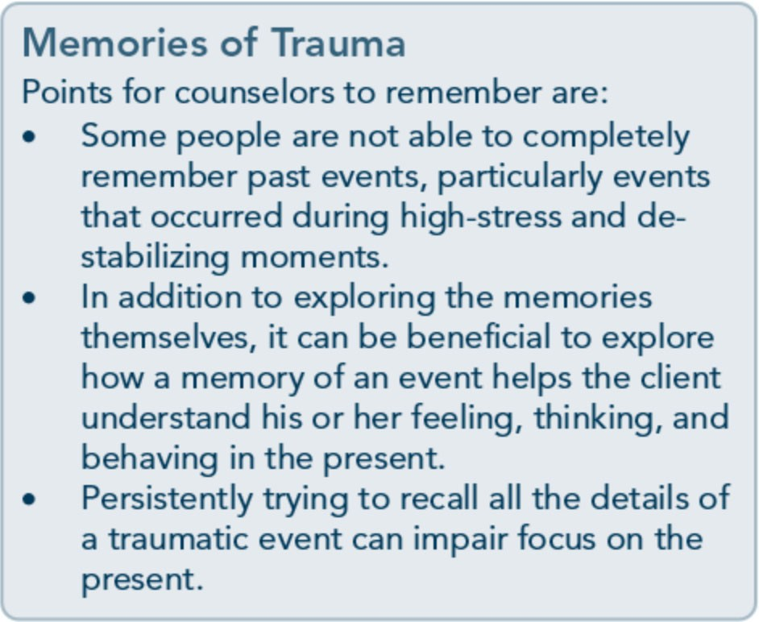
lence) or to sue for damages sustained in an accident or natural disaster. The counselor's role is not to provide legal advice, but rather, to offer support during the process and, if needed, refer the client to appropriate legal help (see Advice to Counselors box on p. 131). A legal matter can dominate the treatment atmosphere for its duration. Some clients have difficulty making progress in treatment until most or all legal matters are resolved and no longer act as ongoing stressors.

Forgiveness
Clients may have all sorts of reactions to what has happened to them. They may feel grateful for the help they received, joy at having sur­ vived, and dedication to their recovery. At the other extreme, they may have fantasies of re­ venge, a loss of belief that the world is a good place, and feelings of rage at what has hap­ pened. They may hold a wide variety of beliefs associated with these feelings.
One issue that comes up frequently among counselors is whether to encourage clients to forgive. The issue of forgiveness is a very deli­ cate one. It is key to allow survivors their feel­ ings, even if they conflict with the counselor's own responses. Some may choose to forgive the perpetrator, whereas others may remain angry or seek justice through the courts and other legal means. Early in recovery from

129

Trauma-Informed Care in Behavioral Health Services

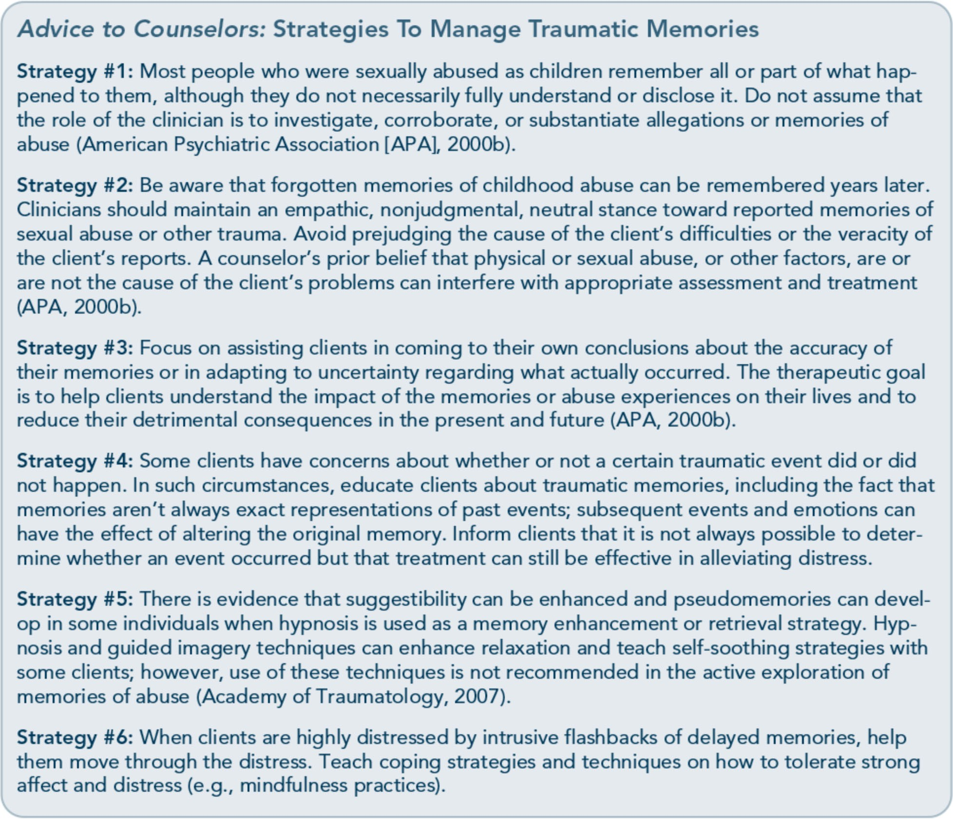

trauma, it is best to direct clients toward fo­ cusing on stabilization and a return to normal functioning; suggest that, if possible, they de­ lay major decisions about forgiveness until they have a clearer mind for making decisions (Herman, 1997). Even in later stages of recov­ ery, it's not essential for the client to forgive in order to recover. Forgiveness is a personal choice independent of recovery. Respect cli­ ents' personal beliefs and meanings; don't push clients to forgive or impose your own beliefs about forgiveness onto clients.
In the long-term healing process, typically months or years after the trauma(s), for­ giveness may become part of the discussion for
some people and some communities. For ex­ ample, in South Africa, years after the bitter and bloody apartheid conflicts, a Truth and Reconciliation Commission was established by the Government. Public hearings created dia­ log and aired what had been experienced as a means, ultimately, to promote forgiveness and community healing. By addressing very diffi­ cult topics in public, all could potentially benefit from the discourse. Similarly, a paren­ tal survivor of the Oklahoma City bombing was, at first, bitter about his daughter's early, unfair, and untimely death. Today, he gives talks around the world about the abolition of the death penalty. He sat with convicted

130

Part 1, Chapter 5-Clinical Issues Across Services

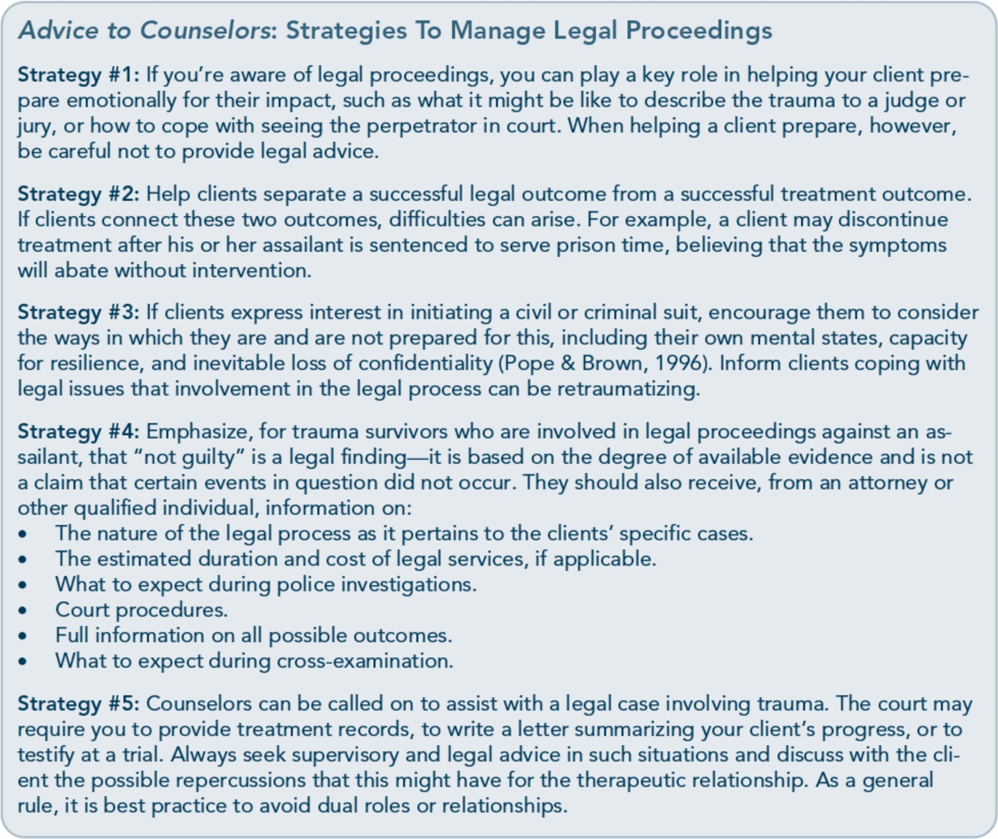

bomber Timothy McVeigh's father while the man's son was executed in Indiana at a Federal prison several years after the bombing. For this man, forgiveness and acceptance helped him attain personal peace. Other trauma survivors may choose never to forgive what happened, and this, too, is a legitimate response.

Culturally and Gender Responsive Services
Culture is the lens through which reality is interpreted. Without an understanding of cul­ ture, it is difficult to gauge how individuals organize, interpret, and resolve their traumas. The challenge is to define how culture affects individuals who have been traumatized.
Increased knowledge of PTSD (Wilson & Tang, 2007), mental illness, and substance use disorders and recovery (Westermeyer, 2004) requires behavioral health practitioners to con­ sider the complicated interactions between culture, personality, mental illness, and sub­ stance abuse in adapting treatment protocols. This section offers some general guidelines for working with members of cultures other than one's own. Treatment for traumatic stress, mental illness, substance use disorders, and co­ occurring trauma-related symptoms is more effective if it is culturally responsive.

131

Trauma-Informed Care in Behavioral Health Services

132

The U.S. Department of Health and Human Services (2003) has defined the term "cultural competence" as follows:
Cultural competence is a set of values, behav­ iors, attitudes, and practices within a system, organization, program, or among individuals that enables people to work effectively across cultures. It refers to the ability to honor and respect the beliefs, language, interpersonal styles, and behaviors of individuals and fami­ lies receiving services, as well as staff who are providing such services. Cultural competence
is a dynamic, ongoing, developmental process that requires a long-term commitment and is achieved over time (p. 12).

Cultural competence is a process that begins with an awareness of one's own culture and beliefs and includes an understanding of how those beliefs affect one's attitudes toward peo­ ple of other cultures. It is rooted in respect, validation, and openness toward someone whose social and cultural background is differ­ ent from one's own. For a thorough review of cultural competence, see the planned TIP, Im­ proving Cultural Competence (Substance Abuse and Mental Health Services Administration [SAMHSA], planned c).

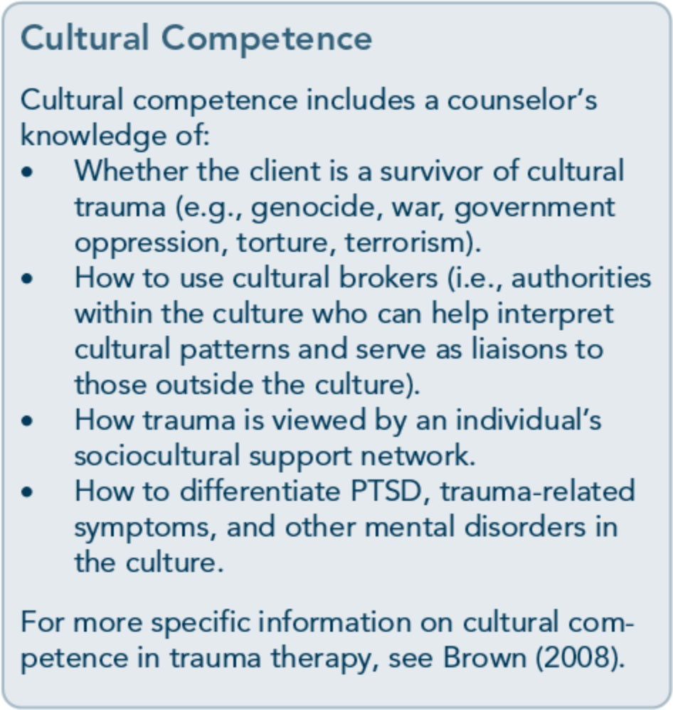

In some cultures, an individual's needs take precedence over group needs (Hui & Triandis, 1986), and problems are seen as deriving from the self. In other cultures, however, complex family, kin, and community systems take prec­ edence over individual needs. Considerable heterogeneity exists within and across most ethnic subcultures and across lines of gender, class, age, and political groups (CSAT, 19996). Subcultures abound in every culture, such as gangs; populations that are homeless or use substances; orphaned or disenfranchised peo­ ple; religious, ethnic, and sexual minorities; indigenous people; and refugee and immigrant populations. Some subcultures have more in common with similar subcultures in other countries than with their own cultures (e.g., nonheterosexual populations).
Trauma and substance abuse can themselves be a basis for affiliation with a subculture. De Girolamo (1993) reports that "disaster subcul­ tures" exist within many cultures. These cul­ tures of victimization, like all subcultures, have unique worldviews, codes of conduct, and per­ ceptions of the larger society. In a disaster sub­ culture, people are, to some extent, inured to disaster and heedless of warnings of impend­ ing disaster. For example, riverbank erosion in Bangladesh displaces thousands of people each year, yet few believe that it is a serious problem or that the displacement will be permanent (Hutton, 2000). Israelis who have lived with unpredictable violence for many years behave differently in public areas and have adapted to different norms than people who don't com­ monly experience violence (Young, 2001).
Many people identify with more than one subculture. Some identify with a particular culture or subculture, but not with all of its values. Individual identities are typically a mo­ saic of factors, including developmental achievements, life experiences, behavioral health histories, traumatic experiences, and

Part 1, Chapter 5-Clinical Issues Across Services

alcohol and illicit drug use; levels of accultura­ tion and/or assimilation vary from one indi­ vidual to the next as well.
Importance of the trauma aftermath Counselors working in the immediate after­ math of trauma-whether individual, group, or community in nature-face many challenges. For example, survivors may be forced to adjust without access to other health services, em­ ployment, support, or insurance. In these in­
stances, counselors must often work with individuals and communities coping with the trauma while struggling daily to meet basic needs. Research suggests that reestablishing ties to family, community, culture, and spiritual systems can not only be vital to the individual, but can also influence the impact of the trau­ ma upon future generations. For example, Baker and Gippenreiter (1998) studied the descendants of people victimized by Joseph Stalin's purge. They found that families who were able to maintain a sense of connection and continuity with grandparents affected by the purge experienced fewer negative effects than did those who were emotionally or physi­ cally severed from their grandparents. The researchers also found that whether the grandparents survived was less important than the connection the grandchildren managed to keep to their past. Ties to family and commu­ nity can also have an adverse effect, especially if the family or community downplays the trauma or blames the victim. Counselors need to have a full understanding of available sup­ port before advocating a particular approach.

Treatment strategies
Many traditional healing ways have been damaged, forgotten, or lost-yet much wis­ dom remains. Drawing on the best traditional and contemporary approaches to human dis­ tress and defining culturally competent curric­ ula regarding identity and healing (Huriwai, 2002; Wilson & Tang, 2007) both require

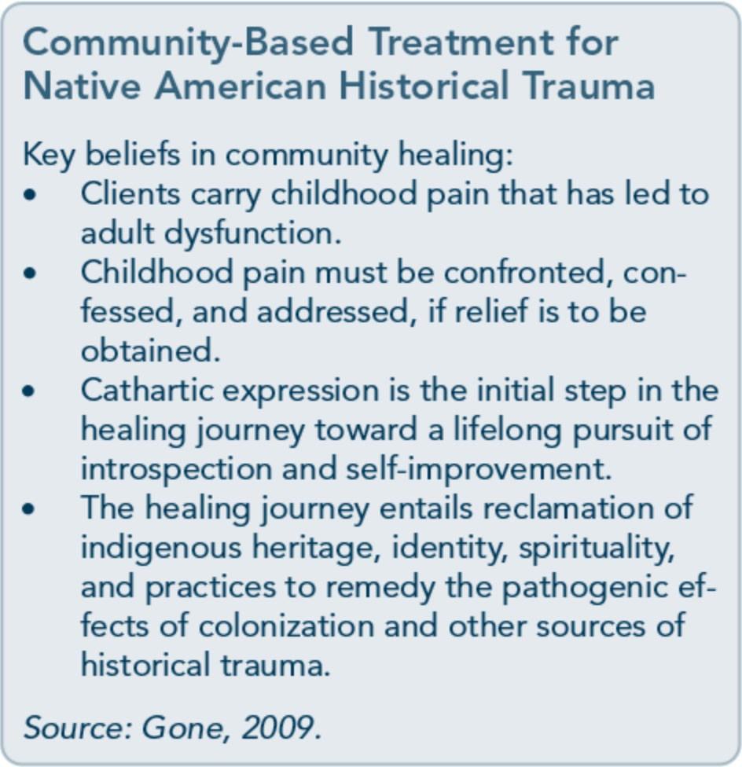
respect and appreciation for the many ways in which various people characterize and resolve trauma and how they use addictive substances to bear the burdens of human distress.
It is not yet known how well existing PTSD treatments work for individuals who identify primarily with cultures other than mainstream American culture. It is possible that such treatments do work for clients of other cul­ tures, though some cultural adaptation and translation may be required. For example, some PTSD treatments that have been used with subculture groups without adaptation other than language translation and that ap­ pear to be effective across cultures include eye movement desensitization and reprocessing (Bleich, Gelkopf, & Solomon, 2003) and Seeking Safety (Daouest et al., 2012).

Gender
Gender differences exist in traumatic stress, mental disorders, and substance use disorders. For example, women have higher rates of PTSD, whereas men have higher rates of sub­ stance abuse (Kessler, Chiu, Demler, Merikangas, & Walters, 2005; Stewart, Ouimette, & Brown, 2002; Tolin & Foa, 2006).

133

Trauma-Informed Care in Behavioral Health Services
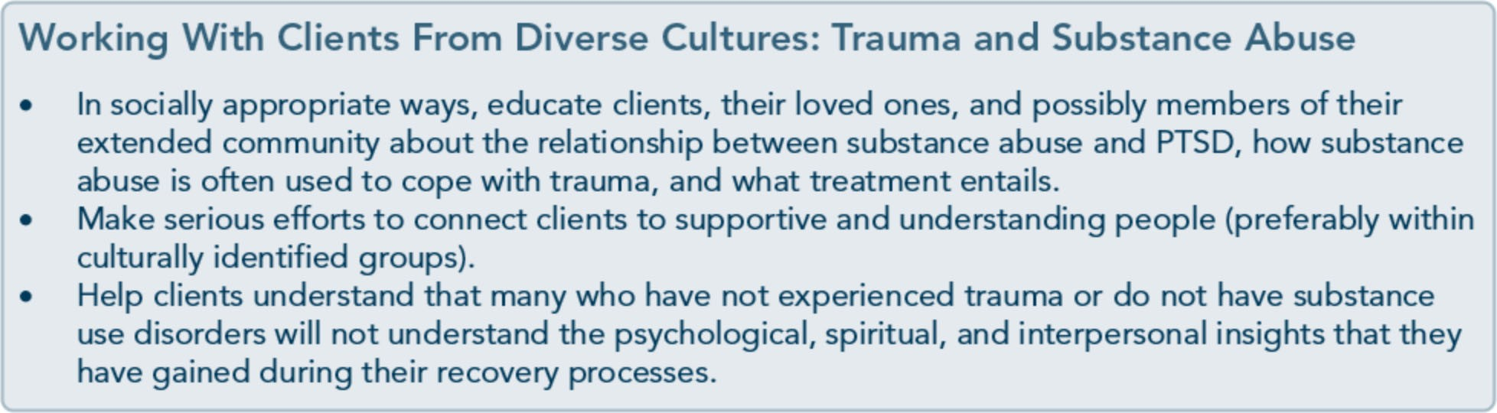

The types of interpersonal trauma experienced by men and by women are often different. A number of studies (K.imerling, Ouimette, & Weitlauf, 2007) indicate that men experience more combat and crime victimization and women experience more physical and/or sexu­ al assault-implying that men's traumas often occur in public, whereas the traumatization of women is more likely to take place in a private setting, such as a home. Men's abusers are more often strangers. Those who abuse wom­ en, on the other hand, are more often in a rela­ tionship with them. Women (and girls) often are told, "I love you," during the same time period when the abuse occurs. However, wom­ en now serve in the military and thus are in­ creasingly subject to some of the same traumas as men and also to military sexual trauma, which is much more common for women to experience. Similarly, men can be subject to domestic violence or sexual abuse.
In treatment, gender considerations are rele­ vant in a variety of ways, including, but not limited to, the role and impact of societal gen­ der stereotypes upon assessment processes, treatment initiation, and engagement of ser­ vices (e.g., peer support systems); the selection and implementation of gender-specific and gender-responsive approaches for both men and women at each level of intervention; and the best selection of trauma-related interven­ tions that account for gender-specific differ­ ences related to traumatic stress. For an extensive review and discussion of gender­ specific and gender-responsive care for trau-
matic stress and substance use, see the TIP 51, Substance Abuse Treatment: Addressing the Specific Needs of Women (CSAT, 2009d), and TIP 56,Addressing the Specific Behavioral Health Needs of Men (SAMHSA, 2013a).
Beyond the complexities of gender considera­ tions, one must also consider whether clients should be given the choice of working with a male or a female counselor. Some clients who have been traumatized have no preference, particularly if their trauma wasn't associated with gender (e.g., a natural disaster, act ofter­ rorism, fire, serious accident). If gender did play a role in trauma (e.g., childhood sexual abuse), clients can have strong fears of work­ ing with a counselor who is the same gender as the perpetrator. Many women who experi­ enced sexual abuse (whose perpetrators are typically men) feel uncomfortable being treat­ ed by men because of the intense emotions that can be evoked (e.g., anger, fear). Men who experienced sexual abuse (whose perpetrators are also typically men) can feel uncomfortable for the same reasons, or they may feel shame when talking to men due to feelings evoked about masculinity, homosexuality, and so forth. However, not all clients with trauma histories prefer female therapists.
Discuss with clients the possible risks (e.g., initial emotional discomfort) and benefits of being treated by a woman or man (e.g., devel­ oping a therapeutic relationship with a man might challenge a client's belief that all men are dangerous), and, if possible, let them then choose the gender of their counselor. Tell

134

Part 1, Chapter 5-Clinical Issues Across Services

them that if they experience initial emotional discomfort, and the discomfort does not de­ crease, they can switch to a counselor of the opposite gender. For group therapy that focuses on trauma, similar considerations apply. Gener­ ally, gender-specific groups are recommended when possible, but mixed-gender groups also work. Gender also comes into play in substance abuse treatment. Research and clinical observa­ tion indicate that significant gender differences occur in many facets of substance abuse and its treatment. For example, men and women expe­ rience different physical repercussions of sub­ stance use (e.g., women have more health problems), different trajectories (e.g., women become addicted more quickly), and different treatment considerations (e.g., traditional sub­ stance abuse treatment was designed for men).
Sexual orientation
Lesbian, gay, bisexual, and transgender (LGBT) clients face specific issues in behav­ ioral health treatment settings, including his­ tories of abuse and discrimination relating to sexual orientation, homophobia in treatment on the part of counselors or other clients, po­ tential difficulty addressing traumatic experi­ ences related to their sexuality or sexual orientation, and often, a significant lack of trust toward others. LGBT people sometimes think that others can't understand them and their specific needs and thus are reluctant to engage in treatment programs in which the clientele is predominantly heterosexual. Some clients react with judgment, anger, or embar­ rassment when an LGBT client attempts to describe sexual trauma relating to homosexual behavior, making it even harder for LGBT clients to describe their experiences.
Often, individual counseling can address issues the LGBT client isn't comfortable discussing in group treatment. "Providing one-on-one services may decrease the difficulty of mixing heterosexual and LGBT clients in treatment

groups and decrease the likelihood that hetero­ sexism or homophobia will become an issue" (CSAT, 2001, p. 56). For more on treating LGBT individuals, see A Provider's Introduc­ tion to Substance Abuse Treatment far Lesbian, Gay, Bisexual, and Transgender Individuals (CSAT, 2001).

Making Referrals to Trauma-Specific Services
Many people who experience trauma do not exhibit persistent traumatic stress symptoms. In fact, people do recover on their own. So how do you determine who is at higher risk for developing more persistent symptoms of traumatic stress, trauma-related disorders, and traumatic stress disorders? One main factor is the severity of symptoms at the time of screening and assessment. Other factors, be­ yond trauma characteristics and pretrauma individual characteristics, to consider in mak­ ing referrals include (Ehlers & Clark, 2003):
- Cognitive appraisals that are excessively negative regarding trauma sequelae, includ­ ing consequences, changes after the event(s), responses of other people to the trauma, and symptoms.
- Acknowledgment of intrusive memories.
- Engagement in behaviors that reinforce or prevent resolution of trauma, including avoidance, dissociation, and substance use.
- History of physical consequences of trauma (e.g., chronic pain, disfigurement, health problems).
- Experiences of more traumas or stressful life events after the prior trauma.
- Identification of co-occurring mood disor- ders or serious mental illness.
The next chapter provides an overview of trauma-specific services to complement this chapter and to provide trauma-informed counselors with a general knowledge of trauma-specific treatment approaches.

135

Appendix A-Bibliography

Abrahams, I. A., Ali, 0., Davidson, L., Evans, A. C., King,]. K., Poplawski, P., et al. (2010).
Philadelphia behavioral health services traniformation: Practice guidelines for recovery and resilience oriented treatment. Philadelphia: Department of Behavioral Health and Intellectual Disability Services.
Adams, R. E., Figley, C.R., & Boscarino,]. A. (2008). The Compassion Fatigue Scale: Its use with social workers following urban disaster. Research on Social Work Practice, 18, 238-250.

Adler, A. B., Litz, B. T., Castro, C. A., Suvak, M., Thomas,]. L., Burrell, L., et al. (2008). A group randomized trial of critical incident stress debriefing provided to U.S. peacekeepers.journalof Traumatic Stress, 21, 253-263.
Administration on Children, Youth, and Families. (2002). Sexual abuse among homeless adolescents: Prevalence, correlates, and sequelae. Washington, DC: Administration on Children, Youth, and Families.
Advanced Trauma Solutions, Inc. (2012). Trauma affect regulation: Guide for education & therapy.

Farmington, CT: Advanced Trauma Solutions, Inc.
Allen,]. G. (2001). Traumatic relationships and serious mental disorders. New York: John Wiley &

Sons Ltd.
American Psychiatric Association. (1980). Diagnostic and statistical manual of mental disorders. (3rd ed.). Washington, DC: American Psychiatric Association.
American Psychiatric Association. (2000a). Diagnostic and statistical manual of mental disorders.

(4th ed., text rev.). Washington, DC: American Psychiatric Association.
American Psychiatric Association. (20006). Position statement on therapies focused on memories of
childhood physical and sexual abuse. Washington, DC: American Psychiatric Association.
American Psychiatric Association. (2012a). G 03 posttraumatic stress disorder. Washington, DC:

American Psychiatric Association.
American Psychiatric Association. (20126). Proposed draft revisions to DSM disorders and criteria.

Washington, DC: American Psychiatric Association.
American Psychiatric Association. (2013a). Diagnostic and statistical manual of mental disorders.

(5th ed.). Arlington, VA: American Psychiatric Association.

215

Trauma-Informed Care in Behavioral Health Services

American Psychiatric Association. (2013b). Highlights of changes from DSM-IV-TR to DSM-5.

Arlington, VA: American Psychiatric Association.
American Psychological Association & The Ad Hoc Committee on Legal and Ethical Issues in the Treatment oflnterpersonal Violence. (2003). Potential problems far psychologists working with the area of interpersonal violence. Washington, DC: American Psychiatric Association.
Anda, R. F., Felitti, V.J., Bremner,]. D., Walker,]. D., Whitfield, C., Perry, B. D., et al. (2006). The enduring effects of abuse and related adverse experiences in childhood. A convergence of evidence from neurobiology and epidemiology. European Archives of Psychiatry and Clinical Neuroscience, 256 (3), 174-86.
Anda, R. F., Felitti, V.J., Brown, D., Chapman, D., Dong, M., Dube, S. R., et al. (2006). Insights into intimate partner violence from the adverse childhood experiences (ACE) study. In The physician's guide to intimate partner violence and abuse (pp. 77-88). Volcano, CA: Volcano Press.
Andreasen, N. C. (2010). Posttraumatic stress disorder: A history and a critique.Annals of the New YorkAcademy of Sciences, 1208, 67-71.
Antony, M. M., Orsillo, S. M., & Roemer, L. (2001). Practitioner's guide to empirically based measures of anxiety. New York: Plenum Press.
Arkowitz, H., Miller, W.R., Westra, H. A., & Rollnick, S. (2008). Motivational interviewing in the treatment of psychological problems: Conclusions and future directions. In Motivational interviewing in the treatment of psychological problems (pp. 324-342). New York: Guilford Press.

Auerbach, S. (2003). Sleep disorders related to alcohol and other drug use. In A.W. Graham, T. K. Schultz, M. F. Mayo-Smith, R. K. Ries, & B. B. Wilford (Eds.), Principles of addiction medicine. (3rd ed.). (pp. 1179-1193). Chevy Chase, MD: American Society of Addiction Medicine.
Baer, R. A. (2003). Mindfulness training as a clinical intervention: A conceptual and empirical review. Clinical Psychology: Science and Practice, 10, 125-143.
Baker, K. G. & Gippenreiter,J. B. (1998). Stalin's purge and its impact on Russian families: A pilot study. In Y. Danieli (Ed.), International handbook of multigenerational legacies of trauma (pp.

403-434). New York: Plenum Press.
Bartone, P. T., Roland, R.R., Picano,J.J., & Williams, T. (2008). Psychological hardiness predicts success in US Army Special Forces candidates. International journal of Selection and Assessment, 16, 78-81.

Batten, S. V. & Hayes, S. C. (2005). Acceptance and commitment therapy in the treatment of comorbid substance abuse and post-traumatic stress disorder: A case study. Clinical Case Studies, 4, 246-262.
Beck, A. T. (1993). Beck anxiety inventory. San Antonio, TX: The Psychological Corporation. Beck, A. T., Rush, A.]., Shaw, B. F., & Emery, G. (1979). Cognitive therapy of depression. New York:

Guilford Press.
Beck, A. T., Steer, R. A., & Brown, G. K. (1996). Beck depression inventory -II manual. San Antonio, TX: The Psychological Corporation.

216

Appendix A-Bibliography

Beck, A. T., Wright, F. D., Newman, C. F., & Liese, B. F. (1993). Cognitive therapy of substance abuse. New York: Guilford Press.

Bell, C. C. (2011). Trauma, culture, and resiliency. In S. M. Southwick, B. T. Litz, D. Charney, &
M.J. Friedman (Eds.), Resilience and mental health: Challenges across the lifespan (pp. 176-187). New York: Cambridge University Press.
Benedek, D. M. & Ursano, R.J. (2009). Posttraumatic stress disorder: From phenomenology to clinical practice. FOCUS: The journal of Lifelong Learning in Psychiatry, 7, 160-175.
Bernard,]. M. & Goodyear, R. K. (2009). Fundamentals of clinical supervision. (4th ed.). Upper Saddle River, NJ: Merrill/Pearson.

Bernstein, D. P. (2000). Childhood trauma and drug addiction: Assessment, diagnosis, and
treatment.Alcoholism Treatment Quarterly, 18, 19-30.

Bernstein, E. M. & Putnam, F. W. (1986). Development, reliability, and validity of a dissociation
scale.journal of Nervous and Mental Disease, 174, 727-735.
Bills, L.J. (2003). Using trauma theory and S.A.G.E. in outpatient psychiatric practice. Psychiatric Quarterly, 74, 191-203.

Blackburn, C. (1995). Family and relapse. Counselor. Alexandria, VA: National Association of Alcoholism and Drug Abuse Counselors.
Blake, D., Weathers, F., Nagy, L., Koloupek, D., Klauminzer, G., Charney, D., et al. (1990). Clinician Administered PTSD Scale (CAPS). Boston: National Center for Post-Traumatic Stress Disorder.
Bleich, A., Gelkopf, M., & Solomon, Z. (2003). Exposure to terrorism, stress-related mental health symptoms, and coping behaviors among a nationally representative sample in Israel. journal of the American Medical Association, 290, 612-620.
Bloom, S. L. (1997). Creating sanctuary: Toward the evolution of sane societies. New York: Routledge. Bloom, S. L., Bennington-Davis, M., Farragher, B., McCorkle, D., Nice-Martini, K., & Wellbank,
K. (2003). Multiple opportunities for creating sanctuary. Psychiatric Quarterly, 74, 173-190.
Bloom, S. L., Foderaro,]. F., & Ryan, R. (2006). S.E.L.F: A trauma-informed psychoeducational group Curriculum. Retrieved on November 18, 2013, from: http://sanctuaryweb.com/PDFs_new/COMPLETE%20INTRODUCTO RY%20MATERI AL.pdf
Bober, T. & Regehr, C. (2006). Strategies for reducing secondary or vicarious trauma: Do they work? Brie/Treatment and Crisis Intervention, 6, 1-9.

Bonanno, G. A. (2004). Loss, trauma, and human resilience: Have we underestimated the human capacity to thrive after extremely aversive events? American Psychologist, 29, 20-28.
Bonanno, G. A. & Mancini, A. D. (2011). Toward a lifespan approach to resilience and potential trauma. In S. M. Southwick, B. T. Litz, D. Charney, &M.J. Friedman (Eds.), Resilience and mental health: Challenges across the lifespan (pp. 120-134). New York: Cambridge University Press.

217

Trauma-Informed Care in Behavioral Health Services

Bowman, C. G. &Mertz, E. (1996). A dangerous direction: Legal intervention in sexual abuse survivor therapy. Harvard Law Review, 109, 551-639.
Brady, K. T., Killeen, T., Saladin, M. E., Dansky, B., & Becker, S. (1994). Comorbid substance abuse and posttraumatic stress disorder: Characteristics of women in treatment. American journal on Addictions, 3, 160-164.
Breslau, N. (2002). Gender differences in trauma and posttraumatic stress disorder.journal of
Gender Specific Medicine, 5, 34-40.
Brewin, C.R. (2007). Remembering and forgetting. In M.J. Friedman, T. M. Keane, & P.A. Resick (Eds.), Handbook of PTSD: Science and practice (pp. 116-134). New York: Guilford Press.
Brewin, C.R., Andrews, B., & Valentine,]. D. (2000). Meta-analysis of risk factors for posttraumatic stress disorder in trauma-exposed adults.journal of Consulting and Clinical
Psychology, 68, 748-766.

Bride, B. E. (2007). Prevalence of secondary traumatic stress among social workers. Social Work, 52,
63-70.
Briere,]. (1995). Trauma symptom inventory professional manual. Odessa, FL: Psychological Assessment Resources.
Briere, J. (1996a). Therapy far adults molested as children: Beyond survival (2nd ed.). New York: Springer Pub.
Briere,]. (19966). Trauma symptom checklist far children professional manual. Odessa, FL: Psychological Assessment Resources.
Briere,]. (1997). Psychological assessment of adult posttraumatic states. (1st ed.). Washington, DC: American Psychological Association.
Briere, J. & Scott, C. (2006a). Central issues in trauma treatment. In Principles of trauma therapy: A guide to symptoms, evaluation, and treatment (pp. 67-85). Thousand Oaks, CA: Sage Publications.
Briere,]. & Scott, C. (20066). Principles of trauma therapy: A guide to symptoms, evaluation, and treatment. Thousand Oaks, CA: Sage Publications.
Briere,]., & Scott, C. (2012). Principles of trauma therapy: A guide to symptoms, evaluation, and treatment. (2nd ed.). Thousand Oaks, CA: Sage Publications.
Bronfenbrenner,U. (1979). The ecology of human development: Experiments by nature and design.

Cambridge, MA: Harvard University Press.
Bronfenbrenner,U. & Ceci, S.J. (1994). Nature-nurture reconceptualized in developmental perspective: A bioecological model. Psychological Review, 101, 568-586.
Brown, L. S. (2008). Feminist therapy. InJ. L. Lebow (Ed.), Twenty-first century psychotherapies: Contemporary approaches to theory and practice (pp. 277-306). Hoboken, NJ: John Wiley & Sons, Inc.

218

Appendix A-Bibliography

Brown, P. J., Read,]. P., & Kahler, C. W. (2003). Comorbid posttraumatic stress disorder and substance use disorders: Treatment outcomes and the role of coping. In P. Ouimette & P. J. Brown (Eds.), Trauma and substance abuse: Causes, consequences, and treatment of comorbid disorders (pp. 171-188). Washington, DC: American Psychological Association.
Bryant, R. A. & Harvey, A. G. (2000). Acute stress disorder: A handbook of theory, assessment, and treatment. (1st ed.). Washington, DC: American Psychological Association.
Bryant, R. A. & Harvey, A.G. (2003). Gender differences in the relationship between acute stress disorder and posttraumatic stress disorder following motor vehicle accidents.Australian and New Zealand journal of Psychiatry, 37, 226-229.
Burke, P.A., Carruth, B., & Prichard, D. (2006). Counselor self-care in work with traumatized addicted people. In B. Carruth (Ed.), Psychological trauma and addiction treatment (pp. 283- 302). New York: Haworth Press.
Cahill, S. P., Rothbaum, B. 0., Resick, P.A., & Follette, V. M. (2009). Cognitive-behavioral therapy for adults. In E. B. Foa, T. M. Keane, M.J. Friedman, &J. A. Cohen (Eds.), Effective treatments far PTSD: Practice guidelines from the International Society far Traumatic Stress Studies. (2nd ed.). (pp. 139-222). New York: Guilford Press.
Caldwell, B. A. & Redeker, N. (2005). Sleep and trauma: An overview. Issues in Mental Health Nursing, 26, 721-738.
Campbell-Sills, L. & Stein, M. B. (2007). Psychometric analysis and refinement of the Connor­ Davidson Resilience Scale (CD-RISC): Validation of a 10-item measure of resilience.journal of Traumatic Stress, 20, 1019-1028.
Capezza, N. M. & Najavits, L. M. (2012). Rates of trauma-informed counseling at substance abuse treatment facilities: Reports from over 10,000 programs. Psychiatric Services, 63, 390- 394.
Cardena, E., Koopman, C., Classen, C., Waelde, L. C., & Spiegel, D. (2000). Psychometric properties of the Stanford Acute Stress Reaction Qyestionnaire (SASRQ2: a valid and reliable measure of acute stress.journal ofTraumatic Stress, 13, 719-734.
Carlson, E. B. & Putnam, F. W. (1993). An update on the Dissociative Experiences Scale.
Dissociation, 6, 16-27.
Carroll,]. F. X. & McGinley,J.J. (2001). A screening form for identifying mental health problems in alcohol/other drug dependent persons. Alcoholism Treatment Quarterly, 19, 33-47.
Catalano, S. (2012). Intimate partner violence in the US. Washington, DC: Bureau ofJustice Statistics.
Catalano, S. M. (2004). Criminal victimization, 2003: National crime victimization survey.

Washington, DC: Bureau of Justice Statistics.
Centers for Disease Control and Prevention. (2009). The social-ecological model· A framework far prevention. Retrieved on November 20, 2013, from: http://www.cdc.gov/violenceprevention/overview/social-ecologicalmodel.html

219

Trauma-Informed Care in Behavioral Health Services

Centers for Disease Control and Prevention. (2012). Publications by health outcome: Adverse childhood experiences (ACE) study. Atlanta, GA: Centers for Disease Control and Prevention.
Centers for Disease Control and Prevention. (2013,January 18). Adverse Childhood Experiences (ACE) Study. Retrieved on August 14, 2013, from http://www.cdc.gov/ace/about.htm
Center for Mental Health Services. (1996). Responding to the needs of people with serious and persistent mental illness in times of major disaster (Rep. No. SMA 96-3077). Rockville, MD: Substance Abuse and Mental Health Services Administration.

Center for Mental Health Services, Division of Prevention, Traumatic Stress and Special Programs, Emergency Mental Health and Traumatic Stress Services Branch. (2003). Fact sheet (Rep. No. KEN 95-0011). Rockville, MD: Substance Abuse and Mental Health Services Administration.
Center for Mental Health Services, Substance Abuse and Mental Health Services Administration. (2005). Roadmap to seclusion and restraint free mental health services. Rockville, MD: Substance Abuse and Mental Health Services Administration.

Center for Substance Abuse Treatment. (1993a). Improving treatment far drug-exposed infants. Treatment Improvement Protocol (TIP) Series 5. HHS Publication No. (SMA) 95-3057. Rockville, MD: Substance Abuse and Mental Health Services Administration.
Center for Substance Abuse Treatment. (19936). Pregnant, substance-using women. Treatment Improvement Protocol (TIP) Series 2. HHS Publication No. (SMA) 93-1998. Rockville, MD: Substance Abuse and Mental Health Services Administration.
Center for Substance Abuse Treatment. (1993c). Screening/or infectious diseases among substance abusers. Treatment Improvement Protocol (TIP) Series 6. HHS Publication No. (SMA) 95- 3060. Rockville, MD: Substance Abuse and Mental Health Services Administration.
Center for Substance Abuse Treatment. (1994). Simple screening instruments far outreach far alcohol and other drug abuse and infectious diseases. Treatment Improvement Protocol (TIP) Series 11. HHS Publication No. (SMA) 94-2094. Rockville, MD: Substance Abuse and Mental Health Services Administration.
Center for Substance Abuse Treatment. (1995a). Alcohol and other drug screening of hospitalized trauma patients. Treatment Improvement Protocol (TIP) Series 16. HHS Publication No. (SMA) 95-3041. Rockville, MD: Substance Abuse and Mental Health Services Administration.
Center for Substance Abuse Treatment. (19956). Combining alcohol and other drug treatment with diversion far juveniles in the justice system. Treatment Improvement Protocol (TIP) Series 21. HHS Publication No. (SMA) 95-3051. Rockville, MD: Substance Abuse and Mental Health Services Administration.
Center for Substance Abuse Treatment. (1995c). Developing state outcomes monitoring systems far alcohol and other drug abuse treatment. Treatment Improvement Protocol (TIP) Series 14. HHS Publication No. (SMA) 95-3031. Rockville, MD: Substance Abuse and Mental Health Services Administration.

220

Appendix A-Bibliography

Center for Substance Abuse Treatment. (1995d). The role and current status of patient placement criteria in the treatment of substance use disorders. Treatment Improvement Protocol (TIP) Series

13. HHS Publication No. (SMA) 95-3021. Rockville, MD: Substance Abuse and Mental Health Services Administration.
Center for Substance Abuse Treatment. (1995e). The tuberculosis epidemic: Legal and ethical issues far alcohol and other drug abuse treatment providers. Treatment Improvement Protocol (TIP) Series 18. HHS Publication No. (SMA) 95-3047. Rockville, MD: Substance Abuse and Mental Health Services Administration.
Center for Substance Abuse Treatment. (1996). Treatment drug courts: Integrating substance abuse treatment with legal case processing. Treatment Improvement Protocol (TIP) Series 23. HHS Publication No. (SMA) 96-3113. Rockville, MD: Substance Abuse and Mental Health Services Administration.
Center for Substance Abuse Treatment. (1997a). A guide to substance abuse services far primary care clinicians. Treatment Improvement Protocol (TIP) Series 24. HHS Publication No. (SMA) 97-3139. Rockville, MD: Substance Abuse and Mental Health Services Administration.

Center for Substance Abuse Treatment. (1997b). Substance abuse treatment and domestic violence. Treatment Improvement Protocol (TIP) Series 25. HHS Publication No. (SMA) 97-3163. Rockville, MD: Substance Abuse and Mental Health Services Administration.
Center for Substance Abuse Treatment. (1998a). Comprehensive case management far substance abuse treatment. Treatment Improvement Protocol (TIP) Series 27. HHS Publication No. (SMA) 98-3222. Rockville, MD: Substance Abuse and Mental Health Services Administration.
Center for Substance Abuse Treatment. (1998b). Continuity of offender treatment far substance use disorders from institution to community. Treatment Improvement Protocol (TIP) Series 30.
HHS Publication No. (SMA) 98-3245. Rockville, MD: Substance Abuse and Mental Health Services Administration.
Center for Substance Abuse Treatment. (1998c). Naltrexone and alcoholism treatment. Treatment Improvement Protocol (TIP) Series 28. HHS Publication No. (SMA) 98-3206. Rockville, MD: Substance Abuse and Mental Health Services Administration.
Center for Substance Abuse Treatment. (1998d). Substance abuse among older adults. Treatment Improvement Protocol (TIP) Series 26. HHS Publication No. (SMA) 98-3179. Rockville, MD: Substance Abuse and Mental Health Services Administration.
Center for Substance Abuse Treatment. (1998e). Substance use disorder treatment far people with physical and cognitive disabilities. Treatment Improvement Protocol (TIP) Series 29. HHS Publication No. (SMA) 98-3249. Rockville, MD: Substance Abuse and Mental Health Services Administration.
Center for Substance Abuse Treatment. (1999a). Brief interventions and brief therapies far substance abuse. Treatment Improvement Protocol (TIP) Series 34. HHS Publication No. (SMA) 99- 3353. Rockville, MD: Substance Abuse and Mental Health Services Administration.

221

Trauma-Informed Care in Behavioral Health Services

Center for Substance Abuse Treatment. (1999b). Enhancing motivation far change in substance abuse treatment. Treatment Improvement Protocol (TIP) Series 35. HHS Publication No. (SMA) 99-3354. Rockville, MD: Substance Abuse and Mental Health Services Administration.
Center for Substance Abuse Treatment. (1999c). Screening and assessing adolescents far substance use disorders. Treatment Improvement Protocol (TIP) Series 31. HHS Publication No. (SMA) 99-3282. Rockville, MD: Substance Abuse and Mental Health Services Administration.
Center for Substance Abuse Treatment. (1999d). Treatment of adolescents with substance use disorders. Treatment Improvement Protocol (TIP) Series 32. HHS Publication No. (SMA) 99- 3283. Rockville, MD: Substance Abuse and Mental Health Services Administration.

Center for Substance Abuse Treatment. (1999e). Treatment far stimulant use disorders. Treatment Improvement Protocol (TIP) Series 33. HHS Publication No. (SMA) 99-3296. Rockville, MD: Substance Abuse and Mental Health Services Administration.
Center for Substance Abuse Treatment. (2000a). Integrating substance abuse treatment and vocational services. Treatment Improvement Protocol (TIP) Series 38. HHS Publication No. (SMA) 00-3470. Rockville, MD: Substance Abuse and Mental Health Services Administration.
Center for Substance Abuse Treatment. (2000b). Substance abuse treatment far persons with child abuse and neglect issues. Treatment Improvement Protocol (TIP) Series 36. HHS Publication No. (SMA) 00-3357. Rockville, MD: Substance Abuse and Mental Health Services Administration.
Center for Substance Abuse Treatment. (2000c). Substance abuse treatment far persons with HIV/AIDS. Treatment Improvement Protocol (TIP) Series 37. HHS Publication No. (SMA) 00-3459. Rockville, MD: Substance Abuse and Mental Health Services Administration.
Center for Substance Abuse Treatment. (2004a). Clinical guidelines far the use of buprenorphine in the treatment of opioid addiction. Treatment Improvement Protocol (TIP) Series 40. HHS Publication No. (SMA) 04-3939. Rockville, MD: Substance Abuse and Mental Health Services Administration.

Center for Substance Abuse Treatment. (2004b). Substance abuse treatment and family therapy. Treatment Improvement Protocol (TIP) Series 39. HHS Publication No. (SMA) 04-3957. Rockville, MD: Substance Abuse and Mental Health Services Administration.
Center for Substance Abuse Treatment. (2005a). Medication-assisted treatment far opioid addiction.

Treatment Improvement Protocol (TIP) Series 43. HHS Publication No. SMA 05-4048. Rockville, MD: Substance Abuse and Mental Health Services Administration.
Center for Substance Abuse Treatment. (2005b). Substance abuse treatment far adults in the criminal justice system. Treatment Improvement Protocol (TIP) Series 44. HHS Publication No. (SMA) 05-4056. Rockville, MD: Substance Abuse and Mental Health Services Administration.
Center for Substance Abuse Treatment. (2005c). Substance abuse treatment far persons with co­ occurring disorders. Treatment Improvement Protocol (TIP) Series 42. HHS Publication No. SMA 05-3992. Rockville, MD: Substance Abuse and Mental Health Services Administration.

222

Appendix A-Bibliography

Center for Substance Abuse Treatment. (2005d). Substance abuse treatment: Group therapy.

Treatment Improvement Protocol (TIP) Series 41. HHS Publication No. SMA 05-4056. Rockville, MD: Substance Abuse and Mental Health Services Administration.
Center for Substance Abuse Treatment. (2006a). Detoxification and substance abuse treatment. Treatment Improvement Protocol (TIP) Series 45. HHS Publication No. SMA 06-4131. Rockville, MD: Substance Abuse and Mental Health Services Administration.
Center for Substance Abuse Treatment. (2006b). Substance abuse:Administrative issues in intensive outpatient treatment. Treatment Improvement Protocol (TIP) Series 46. HHS Publication No. SMA 06-4151. Rockville, MD: Substance Abuse and Mental Health Services Administration.
Center for Substance Abuse Treatment. (2006c). Substance abuse: Clinical issues in intensive outpatient treatment. Treatment Improvement Protocol (TIP) Series 47. HHS Publication No. SMA 06-4182. Rockville, MD: Substance Abuse and Mental Health Services Administration.
Center for Substance Abuse Treatment. (2008). Managing depressive symptoms in substance abuse clients during early recovery. Treatment Improvement Protocol (TIP) Series 48. HHS Publication No. SMA 08-4353. Rockville, MD: Substance Abuse and Mental Health Services Administration.
Center for Substance Abuse Treatment. (2009a).Addressing suicidal thoughts and behaviors in substance abuse treatment. Treatment Improvement Protocol (TIP) Series 50. HHS Publication No. SMA 09-4381. Rockville, MD: Substance Abuse and Mental Health Services Administration.
Center for Substance Abuse Treatment. (2009b). Clinical supervision and the professional development of the substance abuse counselor. Treatment Improvement Protocol (TIP) Series 52. HHS Publication No. SMA 09-4435. Rockville, MD: Substance Abuse and Mental Health Services Administration.
Center for Substance Abuse Treatment. (2009c). Incorporating alcohol pharmacotherapies into medical practice. Treatment Improvement Protocol (TIP) Series 49. HHS Publication No. SMA 09-4380. Rockville, MD: Substance Abuse and Mental Health Services Administration.
Center for Substance Abuse Treatment. (2009d). Substance abuse treatment:Addressing the specific needs of women. Treatment Improvement Protocol (TIP) Series 51. HHS Publication No.

SMA 09-4426. Rockville, MD: Substance Abuse and Mental Health Services Administration.
Center for Substance Abuse Treatment. (2009e). What are peer recovery support services? HHS Publication No. SMA 09-4454. Rockville, MD: Substance Abuse and Mental Health Services Administration, U.S. Department of Health and Human Services.
Chambless, D. L. & Hollon, S. D. (1998). Defining empirically supported therapies.journal of
Consulting and Clinical Psychology, 66, 7-18.
Chilcoat, H. D. & Breslau, N. (1998). Posttraumatic stress disorder and drug disorders: Testing causal pathways.Archives of General Psychiatry, 55, 913-917.
Christensen, R. C., Hodgkins, C. C., Garces, L. K., Estlund, K. L., Miller, M. D., & Touchton, R. (2005). Homeless, mentally ill and addicted: The need for abuse and trauma services.journal of Health Care far the Poor and Underserved, 16, 615-621.

223

Trauma-Informed Care in Behavioral Health Services

Claes, L. & Vandereycken, W. (2007). Is there a link between traumatic experiences and self­ injurious behaviours in eating-disordered patients? Eating Disorders, 15, 305-315.
Claes, L., Vandereycken, W., & Vertommen, H. (2005). Self-care versus self-harm: Piercing, tattooing, and self-injuring in eating disorders. European Eating Disorders Review, 13, 11-18.
Clark, C. & Fearday, F. E. (2003). Triad women's project: Group facilitator's manual. Tampa, FL: Louis de la Parte Florida Mental Health Institute, University of South Florida.
Cloitre, M., Koenen, K. C., Cohen, L. R., & Han, H. (2002). Skills training in affective and interpersonal regulation followed by exposure: A phase-based treatment for PTSD related to childhood abuse.journal of Consulting and Clinical Psychology, 70, 1067-1074.
Coffey, S. F., Dansky, B. S., & Brady, K. T. (2003). Exposure-based, trauma focused therapy for comorbid posttraumatic stress disorder-substance use disorder. In P. Ouimette & P.J. Brown (Eds.), Trauma and substance abuse: Causes, consequences, and treatment of comorbid disorders. (pp.

127-146). Washington, DC: American Psychological Association.
Coffey, S. F., Schumacher,]. A., Brady, K. T., &Dansky, B. S. (2003). Reductions in trauma symptomalogy during acute and protracted alcohol and cocaine abstinence. Symposium conducted at the Annual Meeting of the International Society for Traumatic Stress Studies, Chicago, IL.

Coffey, S. F., Schumacher,]. A., Brimo, M. L., & Brady, K. T. (2005). Exposure therapy for substance abusers with PTSD: Translating research to practice. Behavior Modification, 29, 10- 38.
Connor, K. M. & Davidson,]. R. T. (2003). Development of a new resilience scale: The Connor­ Davidson Resilience Scale (CD-RISC). Depression and Anxiety, 18, 76-82.
Connors, G.J., Donovan, D. M., & DiClemente, C. C. (2001). Substance abuse treatment and the stages of change selecting and planning interventions. New York: Guilford Press.

Cottler, L.B., Nishith, P., & Compton, W. M. (2001). Gender differences in risk factors for trauma exposure and post-traumatic stress disorder among inner-city drug abusers in and out of treatment. Comprehensive Psychiatry, 42, 111-117.
Courtois, C. A. & Ford,]. D. (Eds.). (2009). Treating complex traumatic stress disorders:An evidence­ based guide. New York: Guilford Press.
Covington, S.S. (2003). Beyond trauma:A healingjourneyfar women: Facilitator's guide. Center City, MN: Hazelden.
Covington, S.S. (2008). Helping women recover: A program far treating addiction. (Revised loose leaf ed.). San Francisco:Jossey-Bass.
Cross, T. L., Bazron, B.J., Dennis, K. W., &Isaacs, M. R. (1989). Towards a culturally competent system of care: A monograph on effective services far minority children who are severely emotionally disturbed (Vol. 1). Washington, DC: Georgetown University Child Development Center.
Danieli, Y., Brom, D., & Sills,]. (2005). Sharing knowledge and shared care.journal ofAggression, Maltreatment &Trauma, 10, 775-790.

224

Appendix A-Bibliography

Daniels, A., Grant, E., Filson, B., Powell, I., Fricks, L., & Goodale, L. (2010). Pillars of peer support: Traniforming mental health systems of care through peer support services. Retrieved on November 21, 2013, from: http://www.pillarsofpeersupport.org/final%20%20PillarsofPeerSupportService%20Report.pdf
Daniels, A. S., Tunner, T. P., Ashenden, P., Bergeson, S., Fricks, L., & Powell, I. (2012). Pillars of peer support -III- Whole health peer support services. Retrieved on November 21, 2013, from: http://www.pillarsofpeersupport.org/P.O.PS2011.pdf

Dass-Brailsford, P. &Myrick, A. C. (2010). Psychological trauma and substance abuse: The need for an integrated approach. Trauma, Violence, & Abuse, 11, 202-213.
Daoust,]. P., Renaud, M., Bruyere, B., Lemieux, V., Fleury, G., & Najavits, L. M. (2012). Posttraumatic stress disorder and substance use disorder: Evaluation of the effectiveness of a specialized clinic far French-Canadians based in a teaching hospital Retrieved on November 21, 2013, from: http://www.seekingsafety.org/3-03-06/studies.html

Davidson,]. R., Book, S. W., Colket,J. T., Tupler, L.A., Roth, S., David, D., et al. (1997).
Assessment of a new self-rating scale for post-traumatic stress disorder. Psychological Medicine, 27, 153-160.

De Bellis, M. D. (2002). Developmental traumatology: A contributory mechanism for alcohol and substance use disorders. Psychoneuroendocrinology, 27, 155-170.
de Fabrique, N., Van Hasselt, V. B., Vecchi, G. M., & Romano, S.J. (2007). Common variables associated with the development of Stockholm syndrome: Some case examples. Victims & Offenders, 2, 91-98.
de Girolamo, G. (1993). lnternational perspectives on the treatment and prevention of posttraumatic stress disorder. In J.P. Wilson & Raphael Beverley (Eds.), International handbook of traumatic stress syndrome (pp. 935-946). New York: Plenum Press.
dePanfilis, D. (2006). Child neglect: A guide far prevention, assessment, and intervention. Washington, DC: U.S. Department of Health and Human Services, Administration for Children and Families, Administration on Children, Youth and Families Children's Bureau, Office on Child Abuse and Neglect.
DeWolfe, D.J. (2000). Training manual· For mental health and human service workers in major disasters (Rep. No. ADM 90-538). Rockville, MD: Substance Abuse and Mental Health Services Administration.
Dillon,]. R. (2001). lnternalized homophobia, attributions of blame, and psychological distress among lesbian, gay, and bisexual trauma victims. Dissertation Abstracts International· Section B: The Sciences & Engineering, 62, 2054.
Dom, G., De, W. B., Hulstijn, W., & Sabbe, B. (2007). Traumatic experiences and posttraumatic stress disorders: differences between treatment-seeking early- and late-onset alcoholic patients. Comprehensive Psychiatry, 48, 178-185.
Driessen, M., Schulte, S., Luedecke, C., Schaefer, I., Sutmann, F., Ohlmeier, M., et al. (2008).
Trauma and PTSD in patients with alcohol, drug, or dual dependence: A multi-center study.
Alcoholism: Clinical & Experimental Research, 32, 481-488.

225

Trauma-Informed Care in Behavioral Health Services

Dube, S. R., Anda, R. F., Felitti, V.J., Edwards, V.J., & Croft,]. B. (2002). Adverse childhood experiences and personal alcohol abuse as an adult. Addictive Behaviors, 27, 713-725.
Duckworth, M. P. & Follette, V. M. (2011). Retraumatization: Assessment, treatment, and prevention. New York: Brunner-Routledge.

Ehlers, A. & Clark, D. (2003). Early psychological interventions for adult survivors of trauma: A review. Biological Psychiatry, 53, 817-826.
El-Gabalawy, R. (2012).Association between traumatic experiences and physical health conditions in a nationally representative sample. Retrieved on November 21, 2013, from: http://www.adaa.org/sites/default/files/El-Gabalawy0Ai20331.pdf
Ellis, A. & Harper, R. A. (1975). A new guide to rational living. Oxford, England: Prentice-Hall.

Elliott, D. E., Bjelajac, P., Fallot, R. D., Markoff, L. S., & Reed, B. G. (2005). Trauma-informed or trauma-denied: Principles and implementation of trauma-informed services for women.
journal of Community Psychology, 33, 461-477.
EMDR Network. (2012).A brief description of EMDR therapy. Retrieved on November 21, 2013, Retrieved on November 21from: http://www.emdrnetwork.org/description.html
Falck, R. S., Wang,]., Siegal, H. A., & Carlson, R. G. (2004). The prevalence of psychiatric disorder among a community sample of crack cocaine users: An exploratory study with practical implications.journal of Nervous and Mental Disease, 192, 503-507.
Falender, C. A. & Shafranske, E. P. (2004). Clinical supervision: A competency-based approach. (1st ed.). Washington, DC: American Psychological Association.

Fallot, R. D. & Harris, M. (2001). A trauma-informed approach to screening and assessment. In
M. Harris & R. D. Fallot (Eds.), Using trauma theory to design service systems (pp. 23-31). San Francisco: Jossey-Bass.
Fallot, R. D. & Harris, M. (2002). The trauma recovery and empowerment model (TREM): Conceptual and practical issues in a group intervention for women. Community Mental Health journal, 38, 475-485.
Fallot, R. D. & Harris, M. (2009). Creating cultures of trauma-informed care (CCTIC): A se!f­ assessment and planning protocol. Washington, DC: Community Connections.

Falsetti, S. A., Resnick, H. S., Resnick, P.A., & Kilpatrick, D. (1993). The Modified PTSD Symptom Scale: A brief self-report measure of posttraumatic stress disorder. Behavior Therapist, 16, 161-162.
Farley, M., Golding,]. M., Young, G., Mulligan, M., &Minkoff,]. R. (2004). Trauma history and relapse probability among patients seeking substance abuse treatment.journal of Substance Abuse Treatment, 27, 161-167.
Feder, A., Charney, D., & Collins, K. (2011). Neurobiology of resilience. In S. M. Southwick, B. T. Litz, D. Charney, &M.J. Friedman (Eds.), Resilience and mental health: Challenges across the lifespan (pp. 1-29). New York: Cambridge University Press.

226

Appendix A-Bibliography

Feldner, M. T., Monson, C. M., & Friedman, M.J. (2007). A critical analysis of approaches to targeted PTSD prevention: Current status and theoretically derived future directions. Behavior Modification, 31, 80-116.
Felitti, V.J., Anda, R. F., Nordenberg, D., Williamson, D. F., Spitz, A. M., Edwards, V., et al. (1998). Relationship of childhood abuse and household dysfunction to many of the leading causes of death in adults: The Adverse Childhood Experiences (ACE) study.American journal of Preventive Medicine, 14, 245-258.
Figley, C.R. (1995). Compassion fatigue: Toward a new understanding of the costs of caring. In B.
H. Stamm (Ed.), Secondary traumatic stress: Se!f-care issues far clinicians, researchers, and educators

(pp. 3-28). Lutherville, MD: Sidran Press.
Figley, C.R. (2002). Origins of traumatology and prospects for the future, part i.journal of Trauma Practice, 1, 17-32.
First, M. B., Spitzer, R. L., Gibbon, M., & Williams,]. B. W. (2011a). Structured clinical interview far DSM-IV-TR axis I disorders, research version, non-patient edition. New York: Biometrics Research, New York State Psychiatric Institute.
First, M. B., Spitzer, R. L., Gibbon, M., & Williams,]. B. W. (20116). Structured clinical interview far DSM-IV-TR axis I disorders, research version, patient edition. New York: Biometrics Research, New York State Psychiatric Institute.
Foa, E. B., Dancu, C. V., Hembree, E. A.,Jaycox, L. H., Meadows, E. A., & Street, G. P. (1999). A comparison of exposure therapy, stress inoculation training, and their combination for reducing posttraumatic stress disorder in female assault victims.journal of Consulting and Clinical Psychology, 67, 194-200.
Foa, E. B., Hembree, E. A., & Rothbaum, B. 0. (2007). Prolonged exposure therapy far PTSD: Emotional processing of traumatic experiences: Therapist guide. New York: Oxford University Press.
Foa, E. B., Keane, T. M., Friedman, M.J., & Cohen,]. A. (2009). Introduction. In E. B. Foa, T. M. Keane, M. J. Friedman, & J. A. Cohen (Eds.), Effective treatments far PTSD: Practice guidelines from the International Society far Traumatic Stress Studies. (2nd ed.). (pp.1-20). New York: Guilford Press.
Foa, E. B., Rothbaum, B. 0., Riggs, D.S., &Murdock, T. B. (1991). Treatment of posttraumatic stress disorder in rape victims: A comparison between cognitive-behavioral procedures and counseling.journal of Consulting & Clinical Psychology, 59, 715-723.
Foa, E. B., Stein, D.J., &McFarlane,A. C. (2006). Symptomatology and psychopathology of mental health problems after disaster.journal of Clinical Psychiatry, 67 Supplement 2, 15-25.
Ford,]. D. & Fournier, D. (2007). Psychological trauma and post-traumatic stress disorder among women in community mental health aftercare following psychiatric intensive care.journal of Psychiatric Intensive Care, 3, 27-34.

Ford,]. D. & Russo, E. (2006). Trauma-focused, present-centered, emotional self-regulation approach to integrated treatment for posttraumatic stress and addiction: Trauma adaptive recovery group education and therapy (TARGET).Americanjournal of Psychotherapy, 60, 335-355.

227

Trauma-Informed Care in Behavioral Health Services

Foy, D. W., Ruzek,J. I., Glynn, S. M., Riney, S.J., & Gusman, F. D. (2002). Trauma focus group therapy for combat-related PTSD: An update.journal of Clinical Psychology, 58, 907-918.

Frank, B., Dewart, T., Schmeidler,]., &Demirjian,A. (2006). The impact of9/11 on New York City's substance abuse treatment programs: A study of program administrators.journalof Addictive Diseases, 25, 5-14.
Frankl, V. E. (1992). Man's search far meaning: An introduction to logotherapy. (4th ed.). Boston: Beacon Press.

Friborg, 0., Hjemdal, 0., Rosenvinge,J. H., &Martinussen, M. (2003). A new rating scale for adult resilience: What are the central protective resources behind healthy adjustment?
International journal of Methods in Psychiatric Research, 12, 65-76.
Friedman, M.J. (2006). Posttraumatic stress disorder among military returnees from Afghanistan and Iraq.American]ournal of Psychiatry, 163, 586-593.
Frisman, L., Ford,]., Lin, H.J., Mallon, S., & Chang, R. (2008). Outcomes of trauma treatment using the TARGET model.Journal of Groups in Addiction and Recovery, 3, 285-303.

Frueh, B. C., Knapp, R. G., Cusack, K.J., Grubaugh, A. L., Sauvageot,J. A., Cousins, V. C., et al. (2005). Patients' reports of traumatic or harmful experiences within the psychiatric setting.
Psychiatric Services, 56, 1123-1133.
Galea, S., Ahern,]., Resnick, Kilpatrick, D., Bucuvalas, M., Gold,]., et al. (2002). Psychological sequelae of the September 11 terrorist attacks in New York City. New England journal of Medicine, 346, 982-987.
Gentilello, L. M., Ebel, B. E., Wickizer, T. M., Salkever, D. S., & Rivara, F. P. (2005). Alcohol interventions for trauma patients treated in emergency departments and hospitals: A cost benefit analysis.Annals of Surgery, 241, 541-550.
Gentilello, L. M., Villaveces, A., Ries, R.R., Nason, K. S., Daranciang, E., Donovan, D. M., et al. (1999). Detection of acute alcohol intoxication and chronic alcohol dependence by trauma
center staff Journal of Trauma, 47, 1131-1135.
Gill, D. A. & Picou,}. S. (1997). The day the water died: Cultural impacts of the Exxon Valdez oil spill. InJ. S. Picou (Ed.), The Exxon Valdez disaster: Readings on a modern social problem (pp.167-187). Dubuque, IA: Indo American Books.
Gone,J. P. (2009). A community-based treatment for Native American historical trauma: Prospects for evidence-based practice.journal of Consulting and Clinical Psychology, 77, 751-762.
Goodell,]. (2003). Who's a hero now? Retrieved on November 21, 2013 from: http://www.nytimes.com/2003/07/27/magazine/who-s-a-hero-now.html

Grant, B. F., Stinson, F. S., Dawson, D. A., Chou, S. P., Dufour, M. C., Compton, W., et al. (2004).
Prevalence and co-occurrence of substance use disorders and independent mood and anxiety disorders: Results from the National Epidemiologic Survey on Alcohol and Related Conditions.Archives of General Psychiatry, 61, 807-816.
Green, B. L. (1996). Trauma History Qyestionnaire. In B. H. Stamm (Ed.), Measurement of stress, trauma, and adaptation (pp. 366-369). Lutherville, MD: Sidran Press.

228

Appendix A-Bibliography

Green Cross Academy ofTraumatology. (2007). Standards of traumatology practice revised. Retrieved on November 18, 2013, from: http://www.greencross.org/index.php?option=com_content&view=article&id=183&Itemid=123
Green Cross Academy ofTraumatology. (2010). Standards ofse!f care. Retrieved on November 21, 2013,from: http://www.greencross.org/index.php?option=com_content&view=article&id=184&Itemid=124

Green,]. G., McLaughlin, K. A., Berglund, P.A., Gruber, M.J., Sampson, N. A., Zaslavsky, A. M., et al. (2010). Childhood adversities and adult psychiatric disorders in the National Comorbidity Survey Replication I: Associations with first onset of DSM-IV disorders.
Archives of General Psychiatry, 6 7, 113-123.

Greene, L. R., Meisler, A. W., Pilkey, D., Alexander, G., Cardella, L.A., Sirois, B. C., et al. (2004). Psychological work with groups in the Veterans Administration. In]. L.DeLucia-Waack, D.
A. Gerrity, C.R. Kalodner, & M. T. Riva (Eds.), Handbook of group counseling and psychotherapy

(pp. 322-337). Thousand Oaks, CA: Sage Publications.
Grossman, D. (1995). On killing: The psychological cost of learning to kill in war and society. (1st ed.).

Boston: Little Brown.
Guarino, K., Soares, P., Konnath, K., Clervil, R., and Bassuk, E. (2009). Trauma-informed organizational toolkit. Rockville, MD: Center for Mental Health Services, Substance Abuse and Mental Health Services Administration, and the Daniels Fund, the National Child Traumatic Stress Network, and the W. K. Kellogg Foundation.
Gutheil, T. G. & Brodsky, A. (2008). Preventing boundary violations in clinical practice. New York: Guilford Press.

Habukawa, M., Maeda, M., & Uchimura, N. (2010). Sleep disturbances in posttraumatic stress disorder. In L. Sher & A. Vilens (Eds.), Neurobiology of post-traumatic stress disorder (pp. 119- 135). Hauppage, NY: Nova Science Publishers, Inc.
Hamblen,]. (2001). PTSD in children and adolescents, a National Center far PTSD fact sheet.

Washington, DC: National Center for PTSD.
Harned, M. S., Najavits, L. M., & Weiss, R. D. (2006). Self-harm and suicidal behavior in women with comorbid PTSD and substance dependence.American journal of Addiction, 15, 392-395.
Harris, M. & Fallot, R. D. (2001a). Envisioning a trauma-informed service system: A vital paradigm shift. In M. Harris & R. D. Fallot (Eds.), Using trauma theory to design service systems (pp. 3-22). San Francisco:Jossey-Bass.
Harris, M. & Fallot, R. D. (20016). Trauma-informed inpatient services. In M. Harris & R. D. Fallot (Eds.), Using trauma theory to design service systems (pp. 33-46). San Francisco: Jossey­ Bass.
Harris, M. & Fallot, R. D. (2001c). Using trauma theory to design service systems: New directions far mental health services. San Francisco: Jossey-Bass.
Harris, M. & The Community Connections Trauma Work Group. (1998). Trauma recovery and empowerment: A clinician's guide far working with women in groups. New York: Simon & Schuster.

229

Trauma-Informed Care in Behavioral Health Services

Hayes, S. C. (2004). Acceptance and commitment therapy and the new behavior therapies: Mindfulness, acceptance, and relationship. In S. C. Hayes, V. M. Follette, & M. M. Linehan (Eds.), Mincifulness and acceptance: Expanding the cognitive-behavioral tradition (pp. 1-29). New York: Guilford Press.

Heim, C., Mletzko, T., Purselle, D., Musselman, D. L., & Nemeroff, C. B. (2008). The dexamethasone/corticotropin-releasing factor test in men with major depression: Role of childhood trauma. Biological Psychiatry, 63, 398-405.
Heim, C., Newport, D.J., Mletzko, T., Miller, A.H., & Nemeroff, C. B. (2008). The link between childhood trauma and depression: Insights from HPA axis studies in humans.
Psychoneuroendocrinology, 33, 693-710.
Herman,]. L. (1992). Trauma and recovery. New York: Basic Books. Herman,]. L. (1997). Trauma and recovery. (Rev. ed.). New York: Basic Books.
Hoge,M.A.,Morris,J. A., Daniels,A. S., Stuart, G. W., Huey, L. Y., &Adams, N. (2007).An action plan far behavioral health workforce development: A framework far discussion. Rockville, MD: Substance Abuse and Mental Health Services Administration.

Hooper, L. M., Stockton, P., Krupnick,J. L., & Green, B. L. (2011). Development, use, and psycho­ metric properties of the Trauma History Qyestionnaire.journalof Loss and Trauma, 16, 258-283.
Hopper, E. K., Bassuk, E. L., & Olivet,]. (2010). Shelter from the storm: Trauma-informed care in homelessness services settings. The Open Health Services and Policy journal, 3, 80-100.
Horowitz, M., Wilner, N., &Alvarez, W. (1979). Impact of Event Scale: A measure of subjective stress. Psychosomatic Medicine, 41, 209-218.
Huckshorn, K. (2009). Traniforming cultures ofcare toward recovery oriented services: Guidelines toward creating a trauma informed system ofcare: Trauma informed care (TIC) planning guidelines far use in developing an organizationalaction plan. Austin, TX:Texas Network of Youth Services.

Hui, C.H. &Triandis, H. C. (1986). Individualism-collectivism: A study of cross-cultural
researchers.journal of Cross-Cultural Psychology, 17, 225-248.

Huriwai, T. (2002). Re-enculturation: Culturally congruent interventions for Maori with alcohol­ and drug-use-associated problems in New Zealand. Substance Use and Misuse, 37, 1259-1268.
Hutton, D. (2000). Patterns of psychosocial coping and adaptation among riverbank erosion­ induced displacees in Bangladesh: Implications for development programming. Prehospital and Disaster Medicine, 15, S99.
Institute of Medicine. (2008). Treatment of posttraumatic stress disorder: An assessment of the evidence. Washington, DC: The National Academies Press.
Institute of Medicine & National Research Council. (2007). PTSD compensation and military service. Washington, DC: The National Academies.

230

Appendix A-Bibliography

Institute of Medicine, Committee on Prevention of Mental Disorders and Substance Abuse Among Children, O'Connell, M. E., Boat, T. F., Warner, K. E., National Research Council (U.S.), et al. (2009). Preventing mental, emotional, and behavioral disorders among young people: Progress and possibilities.Washington, DC: National Academies Press.
Jackson, C., Nissenson, K., & Cloitre, M. (2009). Cognitive-behavioral therapy. In C. A. Courtois (Ed.), Treating complex traumatic stress disorders: An evidence-based guide (pp. 243-263). New York: Guilford Press.
Jainchill, N., Hawke,]., & Yagelka,J. (2000). Gender, psychopathology, and patterns of homelessness among clients in shelter-based TCs. American journal of Drug and Alcohol Abuse, 26, 553-567.
Janoff-Bulman, R. (1992). Shattered assumptions: Towards a new psychology of trauma. New York: Free Press.
Jennings, A. (2004). Models far developing trauma-informed behavioral health systems and trauma­ specific services. Retrieved on November 21, 2013, from: http://www.theannainstitute.org/MDT.pdf
Jennings, A. (2007a). Blueprint far action: Building trauma-informed mental health service systems: State accomplishments, activities and resources. Retrieved on November 21, 2013, from: http://www.theannainstitute.org/2007%202008%20Blueprint%20BfA>20Criteria%202%2015

%2008.pdf
Jennings, A. (20076). Criteria far building a trauma-informed mental health service system. Adapted from "Developing Trauma-Informed Behavioral Health Systems."
Retrieved on November 21, 2013, from: http://www.theannainstitute.org/CBTIMHSS.pdf
Jennings, A. (2009). Models far developing trauma-informed behavioral health systems and trauma­ specific services: 2008 update. Retrieved on November 21, 2013, from: http://www.theannainstitute.org/Models%20for%20Developing%20Traums-Report%201-09- 09%20_FINAL_.pdf
Kabat-Zinn,]. (1994). Wherever you go, there you are: Mincifulness meditation in everyday life. (1st ed.). New York: Hyperion.
Kabat-Zinn,]., University of Massachusetts Medical Center/Worcester, & Stress, R. C. (1990). Full catastrophe living: Using the wisdom of your body and mind to face stress, pain, and illness. New York: Delacorte Press.

Karlin, B. E., Ruzek,J. I., Chard, K. M., Eftekhari, A., Monson, C. M., Hembree, E. A., et al. (2010). Dissemination of evidence-based psychological treatments for posttraumatic stress disorder in the Veterans Health Administration.journalofTraumatic Stress, 23, 663-673.
Karon, B. P. & Widener, A.J. (1997). Repressed memories and World War II: Lest we forget!
Professional Psychology: Research and Practice, 28, 338-340.

Keane, T. M., Brief, D.J., Pratt, E. M., &Miller, M. W. (2007). Assessment of PTSD and its comorbidities in adults. In M.J. Friedman, T. M. Keane, & P.A. Resick (Eds.), Handbook of PTSD: Science and practice (pp. 279-305). New York: Guilford Press.

231

Trauma-Informed Care in Behavioral Health Services

Keane, T. M., Fairbank,]. A., Caddell,]. M., Zimering, R. T., Taylor, K. L., &Mora, C. A. (1989). Clinical evaluation of a measure to assess combat exposure. Psychological Assessment, 1, 53-55.

Keane, T. M. & Piwowarczyk, L.A. (2006). Trauma, terror, and fear: Mental health professionals respond to the impact of9/11-an overview. In L.A. Schein, H. I. Spitz, G. M. Burlingame, &
P.R. Muskin (Eds.), Psychological effects of catastrophic disasters: Group approaches to treatment

(pp. 3-16). New York: Haworth Press.
Kelly, D. C., Howe-Barksdale, S., & Gitelson, D. (2011). Treating young veterans: Promoting resilience through practice and advocacy. New York: Springer Publishing.
Kessler, R. C., Chiu, W. T., Demler, 0., Merikangas, K. R., & Walters, E. E. (2005). Prevalence, severity, and comorbidity of 12-month DSM-IV disorders in the National Comorbidity Survey replication.Archives of General Psychiatry, 62, 617-627.
Kessler, R. C., Sonnega, A., Bromet, E., Hughes, M., & Nelson, C. B. (1995). Posttraumatic stress disorder in the National Comorbidity Survey.Archives of General Psychiatry, 52, 1048-1060.

Kessler, R. C., Sonnega, A., Bromet, E., Hughes, M., Nelson, C. B., & Breslau, N. N. (1999).
Epidemiological risk factors for trauma and PTSD. In R. Yehuda (Ed.), Risk factors far PTSD.

(pp. 23-59). Washington, DC: American Psychiatric Press.
Khantzian, E.J. (1985). The self-medication hypothesis of addictive disorders: focus on heroin and cocaine dependence. American journal of Psychiatry, 142, 1259-1264.
Kilpatrick, D. G., Veronen, L.J., & Resick, P.A. (1982). Psychological sequelae to rape: Assessment and treatment strategies. In D. M. Doleys, R. L. Meredith, & A. R. Ciminero (Eds.), Behavioral medicine: assessment and treatment strategies (pp. 473-497). New York: Plenum.

Kimerling, R., Ouimette, P., & Weitlauf,J. C. (2007). Gender issues in PTSD. In M.J. Friedman,
T. M. Keane, & P.A. Resick (Eds.), Handbook of PTSD: Science and practice (pp. 207-228). New York: Guilford Press.
Kirmayer, L.J. (1996). Confusion of the senses: Implications of ethnocultural variations in somatoform and dissociative disorders for PTSD. In A.J. Marsella &M.J. Friedman (Eds.), Ethnocultural aspects of posttraumatic stress disorder: Issues, research, and clinical applications (pp. 131-163). Washington, DC: American Psychological Association.
Klinic Community Health Centre. (2008). Trauma-informed· The trauma toolkit. Winnipeg, Manitoba: Klinic Community Health Centre.

Koenen, K. C., Stellman, S. D., Sommer,]. F.,Jr., & Stellman,]. M. (2008). Persisting posttraumatic stress disorder symptoms and their relationship to functioning in Vietnam veterans: A 14-year follow-up.journal ofTraumatic Stress, 21, 49-57.
Koenen, K. C., Stellman,]. M., Stellman, S. D., & Sommer,]. F.,Jr. (2003). Risk factors for course of posttraumatic stress disorder among Vietnam veterans: A 14-year follow-up of American Legionnaires.journal of Consulting & Clinical Psychology, 71, 980-986.

Kozaric-Kovacic, D., Ljubin, T., & Grappe, M. (2000). Comorbidity of posttraumatic stress disorder and alcohol dependence in displaced persons. Croatian Medical journal, 41, 173-178.

232

Appendix A-Bibliography

Kramer, T. L. & Green, B. L. (1997). Post-traumatic stress disorder: A historical context and evolution. In D. F. Halpern (Ed.), States of mind: American and post-Soviet perspectives on contemporary issues in psychology (pp. 215-237). New York: Oxford University Press.
Kress, V. E. & Hoffman, R. M. (2008). Non-suicidal self-injury and motivational interviewing: Enhancing readiness for change.journal of Mental Health Counseling, 30, 311-329.

Kubany, E. S., Haynes, S. N., Leisen, M. B., Owens,]. A., Kaplan, A. S., Watson, S. B., et al. (2000). Development and preliminary validation of a brief broad-spectrum measure of trauma exposure: The Traumatic Life Events Qyestionnaire. Psychological Assessment, 12, 210-224.
Kuhn,J. H. & Nakashima,]. (2011). Community homelessness assessment, local education and networking croup (CHA.LENG) far veterans: The seventeenth annual progress report. Retrieved on November 21, 2013, from: http://www.va.gov/HOMELESS/docs/chaleng/CHALENG_Report_Seventeenth_Annual.pdf
Lasiuk, G. C. & Hegadoren, K. M. (2006). Posttraumatic stress disorder part I: Historical development of the concept. Perspectives in Psychiatric Care, 42, 13-20.

Lavretsky, H., Siddarth, P., & Irwin, M. R. (2010). Improving depression and enhancing resilience in family dementia caregivers: A pilot randomized placebo-controlled trial of escitalopram.
The American journal of Geriatric Psychiatry, 18, 154-162.

Lester, K. M., Milby,]. B., Schumacher,]. E., Vuchinich, R., Person, S., & Clay, O.J. (2007).
Impact of behavioral contingency management intervention on coping behaviors and PTSD symptom reduction in cocaine-addicted homeless.journal ofTraumatic Stress, 20, 565-575.

Linehan, M. M. (1993). Dialectical behavior therapy for treatment of borderline personality disorder: Implications for the treatment of substance abuse. In L. S. Onken,]. D. Blaine, &J.J. Boren (Eds.), Behavioral treatments far drug abuse and dependence (pp. 201-216). Rockville, MD: National Institute on Drug Abuse.
Litz, B. T. & Gray, M.J. (2002). Early intervention for mass violence: What is the evidence? What should be done? Cognitive and Behavioral Practice, 9, 266-272.
Litz, B. T., Miller, M., Ruef, A., & McTeague, L. (2002). Exposure to trauma in adults. In M. Antony & D. Barlow (Eds.), Handbook of assessment and treatment planningfar psychological disorders. New York: Guilford Press.

Liu, D., Diorio,]., Day,J. C., Francis, D. D., & Meaney, M.J. (2000). Maternal care, hippocampal synaptogenesis and cognitive development in rats. Nature Neuroscience, 3, 799-806.
Mahalik,J. R. (2001). Cognitive therapy for men. In G. R. Brooks & G. E. Good (Eds.), The new handbook of psychotherapy and counseling with men: A comprehensive guide to settings, problems, and treatment approaches (pp. 544-564). San Francisco: Jossey-Bass.

Malta, L. S., Levitt,]. T., Martin, A., Davis, L., & Cloitre, M. (2009). Correlates of functional impairment in treatment-seeking survivors of mass terrorism. Behavior Therapy, 40, 39-49.
Marlatt, G. A. & Donovan, D. M. (Eds.) (2005). Relapse prevention: Maintenance strategies in the treatment of addictive behaviors. (2nd ed.). New York: Guilford Press.

233

Trauma-Informed Care in Behavioral Health Services

Martino, S., Canning-Ball, M., Carroll, K. M., & Rounsaville, B.J. (2011). A criterion-based stepwise approach for training counselors in motivational interviewing.journalof Substance Abuse Treatment, 40, 357-365.
Maschi, T. & Brown, D. (2010). Professional self-care and prevention of secondary trauma. In Helping bereaved children: A handbook far practitioners. (3rd ed.). (pp. 345-373). New York: Guilford Press.
McCaig, L. F. & Burt, C. W. (2005). National Hospital Ambulatory Medical Care Survey: 2003 emergency department summary. Hyattsville, MD: National Center for Health Statistics.
Mc Cann, L. & Pearlman, L. A. (1990). Vicarious traumatization: A framework for understanding the psychological effects of working with victims.journal of Traumatic Stress, 3, 1.
McGarrigle, T. & Walsh, C. A. (2011). Mindfulness, self-care, and wellness in social work: Effects of contemplative training.journal of Religion & Spirituality in Social Work: Social Thought, 30, 212-233.

McGovern, M. P., Lambert-Harris, C., Alterman, A. I., Xie, H., &Meier, A. (2011). A randomized controlled trial comparing integrated cognitive behavioral therapy versus individual addiction counseling for co-occurring substance use and posttraumatic stress disorders.journal of Dual Diagnosis, 7, 207-227.
McLeod,]. (1997). Narrative and psychotherapy. London: Sage Publications.
McNally, R.J. (2003). Remembering trauma. Cambridge, MA: Belknap Press of Harvard University Press.
McNally, R.J. (2005). Debunking myths about trauma and memory. The Canadian journal of
Psychiatry/La Revue Canadienne de Psychiatrie, 50, 817-822.
McNally, R.J., Bryant, R. A., & Ehlers, A. (2003). Does early psychological intervention promote recovery from posttraumatic stress? Psychological Science in the Public Interest, 4, 45-79.

McNamara, C., Schumacher,]. E., Milby,]. B., Wallace, D., & Usdan, S. (2001). Prevalence of nonpsychotic mental disorders does not affect treatment outcome in a homeless cocaine­ dependent sample. American journal of Drug and Alcohol Abuse, 2 7, 91-106.
Mead, S. (2008). Intentional peer support: An alternative approach. Plainfield, NH: Shery Mead Consulting.

Meaney, M.J., Brake, W., & Gratton, A. (2002). Environmental regulation of the development of mesolimbic dopamine systems: A neurobiological mechanism for vulnerability to drug abuse? Psychoneuroendocrinology, 27, 127-138.
Meichenbaum, D. (1994).A clinical handbook/practical therapist manual far assessing and treating adults with post-traumatic stress disorder (PTSD). Waterloo, Ontario: Institute Press.
Meichenbaum, D. (1996). Stress inoculation training for coping with stressors. The Clinical Psychologist, 49, 4-7.

Meichenbaum, D. (2007). Stress inoculation training: A preventative and treatment approach. In
Principles and practice of stress management. (3rd ed.). (pp. 497-516). New York: Guilford Press.

234

Appendix A-Bibliography

Meichenbaum, D. H. & Deffenbacher,J. L. (1988). Stress inoculation training. Counseling Psychologist, 16, 69-90.
Melnick, S. M. & Bassuk, E. L. (2000). Identifying and responding to violence among poor and homeless women. Nashville, TN: National Healthcare for the Homeless Council.

Meltzer-Brody, S., Churchill, E., & Davidson,}. R. T. (1999). Derivation of the SPAN, a brief diagnostic screening test for post-traumatic stress disorder. Psychiatry Research, 88, 63-70.
Mental Health America Centers for Technical Assistance. (2012). Trauma recovery and empowerment model (TREM). Alexandria, VA: Mental Health America Centers for Technical Assistance.

Miller, D. & Guidry, L. (2001). Addictions and trauma recovery: Healing the body, mind, and spirit. New York: W.W. Norton and Co.
Miller, K. E., Weine, S. M., Ramie, A., Brkic, N., Bjedic, Z. D., Smajkic, A., et al. (2002). The relative contribution of war experiences and exile-related stressors to levels of psychological distress among Bosnian refugees.journal ofTraumatic Stress, 15, 377-387.
Miller, N. A. & Najavits, L. M. (2012). Creating trauma-informed correctional care: A balance of goals and environment. European journal of Psychotraumatology, 3, 17246.
Miller, W.R. & Rollnick, S. (2002). Motivational interviewing: Preparing people far change. (2nd ed.). New York: Guilford Press.

Mills, K. L., Teesson, M., Back, S. E., Brady, K.T., Baker, A. L., Hopwood, S., et al. (2012). Integrated exposure-based therapy for co-occurring posttraumatic stress disorder and substance dependence: A randomized controlled trial.JAMA., 308, 690-699.
Mills, K. L., Teesson, M., Ross,]., & Peters, L. (2006). Trauma, PTSD, and substance use disorders: Findings from the Australian National Survey of Mental Health and Well-Being. American]ournal of Psychiatry, 163, 652-658.
Mitchell,]. T. & Everly, G. S.Jr. (2001). Critical Incident Stress Debriefing:An operations manual far CISD, defusing and other group crisis intervention services. (3rd ed.). Ellicott City, MD: Chevron Publishing Corporation.
Mollick, L. & Spett, M. (2002). Cloitre: Why exposure fails with most PTSD patients. Retrieved on November 21, 2013, from: http://www.nj-act.org/cloitre.html
Monson, C. M., Schnurr, P. P., Resick, P.A., Friedman, M.J., Young-Xu, Y., & Stevens, S. P. (2006). Cognitive processing therapy for veterans with military-related posttraumatic stress disorder.journal of Consulting and Clinical Psychology, 74, 898-907.
Moore, B. A. & Kennedy, C.H. (2011). Wheels down: Acijusting to life after deployment. (1st ed.).
Washington, DC: American Psychological Association.
Morrissey,]. P.,Jackson, E.W., Ellis, A. R., Amaro, H., Brown, V. B., & Najavits, L. M. (2005). Twelve-month outcomes of trauma-informed interventions for women with co-occurring disorders. Psychiatric Services, 56, 1213-1222.
Moul, D. E., Hall, M., Pilkonis, P.A., & Buysse, D.J. (2004). Self-report measures of insomnia in adults: Rationales, choices, and needs. Sleep Medicine Review, 8, 177-198.

235

Trauma-Informed Care in Behavioral Health Services

Mueser, K. T., Salyers, M. P., Rosenberg, S. D., Goodman, L.A., Essock, S. M., Osher, F. C., et al. (2004). Interpersonal trauma and posttraumatic stress disorder in patients with severe mental illness: Demographic, clinical, and health correlates. Schizophrenia Bulletin, 30, 45-57.
Myers, D. G. & Wee, D. F. (2002). Strategies for managing disaster mental health worker stress. In C.
R. Figley (Ed.), Treating compassion fatigue (pp. 181-211). New York: Brunner-Routledge.
Najavits, L. M. (2002a). Seeking safety: A treatment manual far PTSD and substance abuse. New York: Guilford Press.
Najavits, L. M. (20026). Seeking safety: Psychotherapy far PTSD and substance abuse. Retrieved on November 21, 2013, from: http://www.seekingsafety.org/
Najavits, L. M. (2004). Assessment of trauma, PTSD, and substance use disorder: A practical guide. In]. P. Wilson & T. Keane (Eds.),Assessingpsychological trauma and PTSD (pp. 466- 491). New York: Guilford Press.

Najavits, L. M. (2007a). Psychosocial treatments for posttraumatic stress disorder. In P. E. Nathan & E. M. Gorman (Eds.),A guide to treatments that work. (3d ed.). (pp. 513-530). New York: Oxford Press.
Najavits, L. M. (20076). Seeking safety: An evidence-based model for substance abuse and trauma/PTSD. In Therapist's guide to evidence-based relapse prevention (pp. 141-167). San Diego, CA: Elsevier Academic Press.

Najavits, L. M., Griffin, M. L., Luborsky, L., Frank, A., Weiss, R. D., Liese, B. S., et al. (1995).
Therapists' emotional reactions to substance abusers: A new questionnaire and initial findings.
Psychotherapy: Theory, Research, Practice, Training, 32, 669-677.
Najavits, L. M., Harned, M. S., Gallop, R.J., Butler, S. F., Barber,]. P., Thase, M. E., et al. (2007). Six-month treatment outcomes of cocaine-dependent patients with and without PTSD in a multisite national trial.journal of Studies on Alcohol and Drugs, 68, 353-361.
Najavits, L. M., Norman, S. B., Kivlahan, D., & Kosten, T. R. (2010). Improving PTSD/substance abuse treatment in the VA: A survey of providers. The American journal on Addictions, 19, 257-263

Najavits, L. M., Ryngala, D., Back, S. E., Bolton, E., Mueser, K.T., & Brady, K. T. (2009).
Treatment of PTSD and comorbid disorders. In E. B. Foa, T. M. Keane, M.J. Friedman, &J.
A. Cohen (Eds.), Effective treatments far PTSD: Practice guidelines from the International Society far Traumatic Stress Studies. (2nd ed.). (pp. 508-535). New York: Guilford Press.
Najavits, L. M., Sonn,J., Walsh, M., & Weiss, R. D. (2004). Domestic violence in women with PTSD and substance abuse.Addictive Behaviors, 29, 707-715.

Najavits, L. M., Weiss, R. D., Reif, S., Gastfriend, D.R., Siqueland, L., Barber,]. P., et al. (1998). The Addiction Severity Index as a screen for trauma and posttraumatic stress disorder.journal of Studies on Alcohol, 59, 56-62.
Najavits, L. M., Weiss, R. D., & Shaw, S. R. (1997). The link between substance abuse and post­ traumatic stress disorder in women: A research review.American journal on Addictions, 6, 273-283.

236

Appendix A-Bibliography

National Association of State Mental Health Program Directors. (2005). Trauma Informed Care (TIC) planning guidelines far use in developing an organizationalaction plan: Traniforming cultures ofcare toward recovery oriented services: Guidelines toward creating a trauma informed system ofcare.

Alexandria, VA: National Association of State Mental Health Program Directors.
National Center for Post-Traumatic Stress Disorder. (2002). Working with trauma survivors: A National Center far PTSD fact sheet. Washington, DC: National Center for PTSD.
National Child Traumatic Stress Network (2013). Types of traumatic stress. Retrieved on December 16, 2013, from: http://www.nctsn.org/trauma-types
National Child Traumatic Stress Network, Child Sexual Abuse Task Force and Research & Practice Core. (2004). How to implement trauma-focused cognitive behavioral therapy (TF-CBT). Los Angeles: National Child Traumatic Stress Network.
National Child Traumatic Stress Network & National Center for PTSD. (2012). Psychological first aid. Retrieved on November 21, 2013, from: http://www.nctsn.org/print/795
National Coalition for the Homeless. (2002). Why are people homeless?Washington,DC: National Coalition for the Homeless.
National Institute of Mental Health. (2002). Mental health and mass violence: Evidence-based early psychological intervention far victims/survivors of mass violence, a workshop to reach consensus on best practices. Washington, DC: U. S. Government Printing Office.
Neuner, F., Schauer, M., Klaschik, C., Karunakara, U., & Elbert, T. (2004). A comparison of narrative exposure therapy, supportive counseling, and psychoeducation for treating posttraumatic stress disorder in an African refugee settlement.journal of Consulting and Clinical Psychology, 72, 579-587.
Neuner, F., Schauer, M., Roth, W.T., & Elbert, T. (2002). A narrative exposure treatment as interven­ tion in a refugee camp: A case report. Behavioural and Cognitive Psychotherapy, 30, 205-210.
New Logic Organizational Learning. (2011). Creating a culture of care: A toolkit far creating a trauma-informed environment. Retrieved on November 21, 2013, from: http://www.dshs.state.tx.us/cultureofcare/toolkit.doc
New South Wales Institute of Psychiatry and Centre for Mental Health. (2000). Disaster mental health response handbook: An educational resource far mental health professionals involved in disaster manage­ ment. Sydney,Australia: New South Wales Institute of Psychiatry and Center for Mental Health.

Newell,]. M. & MacNeil, G. A. (2010). Professional burnout, vicarious trauma, secondary
traumatic stress, and compassion fatigue: A review of theoretical terms, risk factors, and preventive methods for clinicians and researchers. Best Practices in Mental Health: An International]ournal, 6, 57-68.
Nishith, P., Mechanic, M. B., & Resick, P.A. (2000). Prior interpersonal trauma: The contribution to current PTSD symptoms in female rape victims.journal ofAbnormal Psychology, 109,20-25.

Nishith, P., Resick, P.A., & Griffin, M. G. (2002). Pattern of change in prolonged exposure and cognitive-processing therapy for female rape victims with posttraumatic stress disorder.journal
of Consulting and Clinical Psychology, 70, 880-886.

237

Trauma-Informed Care in Behavioral Health Services

Nixon, R. D. V. & Nearmy, D. M. (2011). Treatment of comorbid posttraumatic stress disorder and major depressive disorder: A pilot study.journal ofTraumatic Stress, 24, 451-455.

Noll,]. G., Horowitz, L.A., Bonanno, G. A., Trickett, P. K., & Putnam, F. W. (2003).
Revictimization and self-harm in females who experienced childhood sexual abuse: Results from a prospective study.journal of Interpersonal Violence, 18, 1452-1471.
North, C. S., Eyrich, K. M., Pollio, D. E., & Spitznagel, E. L. (2004). Are rates of psychiatric disorders in the homeless population changing? American journal of Public Health, 94,103-108.
O'Donnell, C. & Cook,J. M. (2006). Cognitive-behavioral therapies for psychological trauma and comorbid substance use disorders. In B. Carruth (Ed.), Psychological trauma and addiction treatment. New York: Haworth Press.
Office of Applied Studies. (2002). Results from the 2001 National Household Survey on Drug Abuse: Voll., Summary of national findings HHS Publication No. SMA 02-3758. Rockville,MD: Substance Abuse and Mental Health Services Administration.
Ohio Legal Rights Service. (2007). Trauma informed treatment in behavioral health settings.

Columbus, OH: Ohio Legal Rights Service.
Olff, M., Langeland, W., Draijer, N., & Gersons, B. P.R. (2007). Gender differences in posttraumatic stress disorder. Psychological Bulletin, 133, 183-204.
Ompad, D. C., Ikeda, R. M., Shah, N., Fuller, C. M., Bailey, S., Morse, E., et al. (2005). Childhood sexual abuse and age at initiation of injection drug use.American journal of Public Health, 95, 703-709.
Osterman,]. E. & de Jong,]. T. V. M. (2007). Cultural issues and trauma. In M.J. Friedman, T. M. Keane, & P.A. Resick (Eds.), Handbook of PTSD: Science and practice (pp. 425-446). Guilford Press: New York.
Ouimette, P., Ahrens, C., Moos, R.H., & Finney,]. W. (1998). During treatment changes in substance abuse patients with posttraumatic stress disorder: The influence of specific interventions and program environments.journal of Substance Abuse Treatment, 15, 555-564.
Ouimette, P. & Brown, P. J. (2003). Trauma and substance abuse: Causes, consequences, and treatment of comorbid disorders. Washington, DC: American Psychological Association.

Paranjape, A. & Liebschutz,J. (2003). STaT: A three-question screen for intimate partner
violence.journal of Women's Health (Larchment), 12, 233-239.
Paulson, D.S. & Krippner, S. (2007). Haunted by combat: Understanding PTSD in war veterans including women, reservists, and those coming back from Iraq. Westport, CT: Praeger Security International.
Pearlman, L.A. & Saakvitne, K. W. (1995). Trauma and the therapist: Countertraniference and vicarious traumatization in psychotherapy with incest survivors. New York: W.W. Norton and Co.
Pennebaker,]. W., Kiecolt-Glaser,J. K., & Glaser, R. (1988). Disclosure of traumas and immune function: Health implications for psychotherapy.journal of Consulting and Clinical Psychology, 56, 239-245.

238

Appendix A-Bibliography

Pietrzak, R.H., Goldstein, R. B., Southwick, S. M., & Grant, B. F. (2011). Personality disorders associated with full and partial posttraumatic stress disorder in the U.S. population: Results from Wave 2 of the National Epidemiologic Survey on Alcohol and Related Conditions. journal of Psychiatric Research, 45, 678-686.
Pope, K. S. & Brown, L. S. (1996). Recovered memories of abuse: Assessment, therapy, forensics.

Washington, D.C: American Psychological Association.
Prescott, L., Soares, P., Konnath, K., & Bassuk, E. (2008). A long journey home: A guide far creating trauma-informed services far mothers and children experiencing homelessness. Retrieved on November 21, 2013, from: http://www.familyhomelessness.org/media/89.pdf

Prins, A., Ouimette, P., Kimerling, R., Cameron, R. P., Hugelshofer, D.S., Shaw-Hegwer,]., et al. (2004). The Primary Care PTSD Screen (PC-PTSD): Development and operating characteristics. Primary Care Psychiatry, 9, 9-14.
Read,]. P., Bollinger, A. R., & Sharkansky, E. (2003). Assessment of comorbid substance use disorder and posttraumatic stress disorder. In P. Ouimette & P.J. Brown (Eds.), Trauma and substance abuse: Causes, consequences, and treatment of comorbid disorders (pp. 111-125).

Washington, DC: American Psychological Association.
Reivich, K.J., Seligman, M.E., & McBride, S. (2011). Master resilience training in the U.S. Army.
American Psychologist, 66, 25-34.
Resick, P.A. (2001). Cognitive therapy for posttraumatic stress disorder.journal of Cognitive Psychotherapy:An International Quarterly, 15, 321-329.

Resick, P.A., Nishith, P., & Griffin, M. G. (2003). How well does cognitive-behavioral therapy treat symptoms of complex PTSD? An examination of child sexual abuse survivors within a clinical trial. CNS Spectrums, 8, 340-355.
Resick, P.A., Nishith, P., Weaver, T. L., Astin, M. C., & Feuer, C. A. (2002). A comparison of cognitive-processing therapy with prolonged exposure and a waiting condition for the treatment of chronic posttraumatic stress disorder in female rape victims.journal of Consulting & Clinical Psychology, 70, 867-879.

Resick, P.A. & Schnicke, M. K. (1992). Cognitive processing therapy for sexual assault victims.
journal of Consulting and Clinical Psychology, 60, 748-756.
Resick, P.A. & Schnicke, M. K. (1993). Cognitive processing therapy far rape victims: A treatment manual. Newbury Park, CA: Sage Publications.
Resick, P.A. & Schnicke, M. K. (1996). Cognitive processing therapy far rape victims: A treatment manual Newbury Park, CA: Sage Publications, Inc.

Resnick, H. S., Acierno, R., Kilpatrick, D. G., Holmes, M. (2005). Description of an early intervention to prevent substance abuse and psychopathology in recent rape victims. Behavior Modification, 29, 156-188.
Reynolds, M., Mezey, G., Chapman, M., Wheeler, M., Drummond, C., & Baldacchino, A. (2005).
Co-morbid post-traumatic stress disorder in a substance misusing clinical population. Drug and Alcohol Dependence, 77, 251-258.

239

Trauma-Informed Care in Behavioral Health Services

Riggs, D.S., Monson, C. M., Glynn, S. M., & Canterino,J. (2009). Couple and family therapy for adults. In E. B. Foa, T. M. Keane, M.J. Friedman, &J. A. Cohen (Eds.),Effective treatments far PTSD: Practice guidelines from the International Society far Traumatic Stress Studies. (2nd ed.). (pp. 458-478). New York: Guilford Press.

Rothbaum, B. 0., Meadows, E. A., Resick, P., & Foy, D. W. (2000). Cognitive-behavioral therapy.
In E. B. Foa & T. M. Keane (Eds.), Effective treatments far PTSD: Practice guidelines from the International Society far Traumatic Stress Studies (pp. 60-83). New York: Guilford Press.

Roy-Byrne, P. P., Russo,]., Michelson, E., Zatzick, D., Pitman, R. K., & Berliner, L. (2004). Risk factors and outcome in ambulatory assault victims presenting to the acute emergency department setting: implications for secondary prevention studies in PTSD. Depression and Anxiety, 19, 77-84.
Saakvitne, K. W., Pearlman, L.A., & Traumatic Stress Institute/Center for Adult & Adolescent Psychotherapy. (1996). Traniforming the pain:Aworkbook on vicarious traumatization. (1st ed.). New York: W.W. Norton and Co.
Salasin, S. (2011). Sine qua non for public health. National Council Magazine, 18.

Salyers, M. P., Evans, L.J., Bond, G. R., &Meyer, P. S. (2004). Barriers to assessment and treatment of posttraumatic stress disorder and other trauma-related problems in people with severe mental illness: Clinician perspectives. Community Mental Health journal, 40, 17-31.
San Diego Trauma Informed Guide Team. (2012).Are you asking the right questions? A client centered approach. Retrieved on November 21, 2013, from: http://www.elcajoncollaborative.org/uploads/1/4/1/5/1415935/sd_tigt_brochure2_f.pdf
Santa Mina, E. E. & Gallop, R. M. (1998). Childhood sexual and physical abuse and adult self­ harm and suicidal behaviour: A literature review. Canadian journal of Psychiatry, 43, 793-800.
Saxon, A.]., Davis, T. M., Sloan, K. L., McKnight, K. M.,Jeammet, P., & Kivlahan, D.R. (2001).
Trauma, symptoms of posttraumatic stress disorder, and associated problems among incarcerated veterans. Psychiatric Services, 52, 959-964.
Schein, L.A., Spitz, H. I., Burlingame, G. M., & Muskin, P.R. (2006). Psychological effects of catastrophic disasters: Group approaches to treatment. New York: Haworth Press.
Schulz, P. M., Marovic-Johnson, D., & Huber, L. C. (2006). Cognitive-behavioral treatment of rape- and war-related posttraumatic stress disorder with a female, Bosnian refugee. Clinical Case Studies, 5, 191-208.
Schwartzbard, R. (1997). On the scene report of the Missouri floods. Retrieved on November 21, 2013, from: http://www.aaets.org/arts/art23.htm
Segal, Z. V., Williams,]. M. G., & Teasdale,]. D. (2002). Mincifulness-based cognitive therapy far depression: A new approach to preventing relapse. New York: Guilford Press.

Seidler, G. H. & Wagner, F. E. (2006). Comparing the efficacy ofEMDR and trauma-focused cognitive-behavioral therapy in the treatment of PTSD: A meta-analytic study. Psychological Medicine, 36, 1515-1522.

240

Appendix A-Bibliography

Shapiro, F. (2001). Eye movement desensitization and reprocessing (EMDR): Basic principles, protocols, and procedures. (2nd ed.). New York: Guilford Press.
Sholomskas, D. E. & Carroll, K. M. (2006). One small step for manuals: Computer-assisted training in twelve-step facilitation.journal of Studies on Alcohol, 67, 939-945.
Shoptaw, S., Stein,}. A., & Rawson, R. A. (2000). Burnout in substance abuse counselors: Impact of environment, attitudes, and clients with HIV.journal of Substance Abuse Treatment, 19, 117-126.

Silver, R. C.,Poulin,M., Holman, E.A.,Mclntosh,D. N., Gil-Rivas, V., &Pizarro,]. (2004).
Exploring the myths of coping with a national trauma: A longitudinal study of responses to the September 11th terrorist attacks.Journal ofAggression, Maltreatment & Trauma, 9, 129-141.

Slattery, S. M. & Goodman, L.A. (2009). Secondary traumatic stress among domestic violence advocates: Workplace risk and protective factors. Violence Against Women, 15, 1358-1379.
Smith, B. W., Ortiz,]. A., Steffen, L. E., Tooley, E. M., Wiggins, K.T., Yeater, E. A., et al. (2011).
Mindfulness is associated with fewer PTSD symptoms, depressive symptoms, physical symptoms, and alcohol problems in urban firefighters.journal of Consulting and Clinical
Psychology, 79, 613-617.
Smith, D. W., Christiansen, E. H., Vincent, R. D., & Hann, N. E. (1999). Population effects of the bombing of Oklahoma City.journal of the Oklahoma State Medical Association, 92, 193-198.

Smyth,]. M., Hockemeyer,J. R., & Tulloch, H. (2008). Expressive writing and post-traumatic stress disorder: Effects on trauma symptoms, mood states, and cortisol reactivity. British
journal of Health Psychology, 13, 85-93.

Spitzer, C., Vogel, M., Barnow, S., Freyberger, H.J., & Grabe, H.J. (2007). Psychopathology and alexithymia in severe mental illness: the impact of trauma and posttraumatic stress symptoms.
European Archives of Psychiatry and Neurological Sciences, 257, 191-196.

Sprang, G., Clark,J.J., & Whitt-Woosley, A. (2007). Compassion fatigue, compassion satisfaction, and burnout: Factors impacting a professional's quality oflife.journal of Loss and Trauma, 12, 259-280.
Stamm, B. H. (1997). Work related secondary traumatic stress. PTSD Research Quarterly, 8, 1-3.
Stamm, B. H. (2012). Professional Quality of Life: Compassion satiifa,ction and fatigue version 5
(ProQOL). Retrieved on November 21, 2013, from: http://proqol.org/uploads/ProQOL_5_English.pd[
Stamm, B. H. & Figley, C.R. (1996). Compassion satiifaction and fatigue test. Pocatello, ID: Idaho State University.
Stamm, B. H. & Friedman, M. (2000). Cultural diversity in the appraisal and expression of trauma. In A. Y. Shalev, R. Yehuda, &A. C. McFarlane (Eds.),International handbook of human response to trauma (pp. 69-85). New York: Kluwer Academic/Plenum Publishers.
Starr, A.J., Smith, W.R., Frawley, W. H., Borer, D.S., Morgan, S.J., Reinert, C. M., et al. (2004). Symptoms of posttraumatic stress disorder after orthopaedic trauma.journal of Bone andjoint Surgery, 86-A, 1115-1121.

241

Trauma-Informed Care in Behavioral Health Services

Steel, Z., Chey, T., Silove, D., Marnane, C., Bryant, R. A., & Van, 0. M. (2009). Association of torture and other potentially traumatic events with mental health outcomes among populations exposed to mass conflict and displacement: A systematic review and meta­ analysis.]AMA, 302, 537-549.
Stewart, S. H. & Conrod, P.J. (2003). Psychosocial models of functional associations between posttraumatic stress disorder and substance use disorder. In P. Ouimette & P.J. Brown (Eds.), Trauma and substance abuse: Causes, consequences, and treatment of comorbid disorders (pp. 29-55). Washington, DC: American Psychological Association.

Stewart, S. H., Ouimette, P. C., & Brown, P.J. (2002). Gender and the comorbidity of PTSD with substance use disorders. In R. Kimerling, P. C. Ouimette, &J. Wolfe (Eds.), Gender and PTSD (pp. 233-270). New York: Guilford Press.
Stokols, D. (1996). Translating social ecological theory into guidelines for community health
promotion.American journal of Health Promotion, 10, 282-298.
Substance Abuse and Mental Health Services Administration. (2007). The Women, Co-Occurring Disorders and Violence Study and Children's Subset Study: Program summary. Rockville, MD: Substance Abuse and Mental Health Services Administration.
Substance Abuse and Mental Health Services Administration. (2011a). Addressing viral hepatitis in people with substance use disorders. Treatment Improvement Protocol (TIP) Series 53. HHS Publication No. SMA 11-4656). Rockville, MD: Substance Abuse and Mental Health Services Administration.
Substance Abuse and Mental Health Services Administration. (20116). Managing chronic pain in adults with or in recovery from substance use disorders. Treatment Improvement Protocol (TIP) Series 54. HHS Publication No. SMA 11-4661. Rockville, MD: Substance Abuse and Mental Health Services Administration.
Substance Abuse and Mental Health Services Administration. (2012). SAMHSA's working definition of trauma and principles and guidance far a trauma-informed approach [Draft]. Rockville, MD: Substance Abuse and Mental Health Services Administration.
Substance Abuse and Mental Health Services Administration. (2013a).Addressing the specific behavioral health needs of men.Treatment Improvement Protocol (TIP) Series 56. HHS Publication No. SMA 13-4736. Rockville, MD: Substance Abuse and Mental Health Services Administration.

Substance Abuse and Mental Health Services Administration. (20136). Behavioral health services far people who are homeless. Treatment Improvement Protocol (TIP) Series 55-R. HHS Publication No. SMA 13-4734. Rockville, MD: Substance Abuse and Mental Health Services Administration.
Substance Abuse and Mental Health Services Administration. (planned a). Behavioral health services: Building health, wellness, and quality of life far sustained recovery. Treatment Improvement Protocol (TIP) Series. Rockville, MD: Substance Abuse and Mental Health Services Administration.

242

Appendix A-Bibliography

Substance Abuse and Mental Health Services Administration. (planned b). Behavioral health services far American Indians and Alaska Natives. Treatment Improvement Protocol (TIP) Series. Rockville, MD: Substance Abuse and Mental Health Services Administration.

Substance Abuse and Mental Health Services Administration. (planned c). Improving cultural competence. Treatment Improvement Protocol (TIP) Series. Rockville, MD: Substance Abuse and Mental Health Services Administration.
Substance Abuse and Mental Health Services Administration. (planned d). Managing anxiety symptoms in behavioral health services. Treatment Improvement Protocol (TIP) Series.

Rockville, MD: Substance Abuse and Mental Health Services Administration.
Substance Abuse and Mental Health Services Administration. (planned e). Relapse prevention and recovery promotion in behavioral health services. Treatment Improvement Protocol (TIP) Series. Rockville, MD: Substance Abuse and Mental Health Services Administration.
Substance Abuse and Mental Health Services Administration. (planned f). Reintegration-related behavioral health issues in veterans and military families. Treatment Improvement Protocol (TIP) Series. Rockville, MD: Substance Abuse and Mental Health Services Administration.
Substance Abuse and Mental Health Services Administration. (planned g). Using technology-based therapeutic tools in behavioral health services. Treatment Improvement Protocol (TIP) Series.

Rockville, MD: Substance Abuse and Mental Health Services Administration.
Substance Abuse and Mental Health Services Administration & Office of Applied Studies. (2008). Impact of hurricanes Katrina and Rita on substance use and mental health. (Rep. No. January 31). Rockville, MD: Substance Abuse and Mental Health Services Administration & Office of Applied Studies.

Suvak, M., Maguen, S., Litz, B. T., Silver, R. C., & Holman, E. A. (2008). lndirect exposure to the September 11 terrorist attacks: Does symptom structure resemble PTSD? journal of Traumatic Stress, 21, 30-39.
Tanielian, T. &Jaycox, L. H. (2008). Invisible wounds of war: Psychological and cognitive injuries, their consequences, and services to assist recovery. Washington, DC: RAND Centre for Military Health Policy Research.
Teicher, M. H. (2002). Scars that won't heal: The neurobiology of child abuse. Scientific American,
286, 68-75.

Tolin, D. F. & Foa, E. B. (2006). Sex differences in trauma and posttraumatic stress disorder: A quantitative review of 25 years of research. Psychological Bulletin, 132, 959-992.
Toussaint, D. W., VanDeMark, N. R., Bornemann, A., & Graeber, C.J. (2007). Modifications to the trauma recovery and empowerment model (TREM) for substance-abusing women with histories of violence: Outcomes and lessons learned at a Colorado substance abuse treatment
center.journal of Community Psychology, 35, 879-894.
Tri-County Mental Health Services. (2008). You and Tri-county: Consumer rights and concerns.
Retrieved on November 21, 2013, from: http://tcmhs.org/pdfs/31288-Rightsbooklet.pdf

243

Trauma-Informed Care in Behavioral Health Services

Triffleman, E. (2000). Gender differences in a controlled pilot study of psychosocial treatment in substance dependent patients with post-traumatic stress disorder: Design considerations and outcomes. Alcoholism Treatment Quarterly, 18, 113-126.
Trippany, R. L., Kress, V. E.W., & Wilcoxon, S. A. (2004). Preventing vicarious trauma: What counselors should know when working with trauma survivors.journal of Counseling & Development, 82, 31-37.

Turnbull, G.J. (1998). A review of post-traumatic stress disorder; part I: Historical development and classification. Injury, 29, 87-91.
U.S. Committee for Refugees and Immigrants. (2006). World Refugee Survey 2006: Risks and rights.

Arlington, VA: U.S. Committee for Refugees and Immigrants.
U.S. Department of Health and Human Services, Health Resources and Services Administration. (2006). Model trauma system: Planning and evaluation. Rockville, MD: U.S. Department of Health and Human Services, Health Resources and Services Administration.
U.S. Department of Health and Human Services. (2003). Developing cultural competence in disaster mental health programs: Guiding principles and recommendations. (Rep. No. HHS Pub. No. SMA 03-3828). Rockville, MD: Center for Mental Health Services, Substance Abuse and Mental Health Services Administration.
U.S. Department of Housing and Urban Development & Office of Community Planning and Development. (2007). The annual homeless assessment report to Congress. Retrieved November 21, 2013, from: http://www.huduser.org/Publications/pdf/ahar.pdf
U.S. Department of Veterans Affairs & U.S. Department of Defense. (2010). "01/DoD clinical practice guideline far management of post-traumatic stress. Washington, DC: Department of Veterans Affairs, Department of Defense.
U.S. Fire Administration. (2007). I-JSW bridge collapse and response: Technical report series USFA­ TR-166 August. Emmittsburg, MD: U.S. Fire Administration.
University of South Florida, College of Behavioral and Community Sciences. (2012). Creating trauma-informed care environments:An organizational self-assessment. Retrieved on November 21, 2013, from: http://www.cfbhn.org/assets/TIC/youthresidentialself assess Fillable FORM%20%282%29.pdf

Vaishnavi, S., Connor, K., & Davidson,]. R. T. (2007). An abbreviated version of the Connor­ Davidson Resilience Scale (CD-RISC), the CD-RISC2: Psychometric properties and applications in psychopharmacological trials. Psychiatry Research, 152, 293-297.
Valent, P. (2002). Diagnosis and treatment of helper stresses, traumas, and illnesses. In C.R. Figley (Ed.), Treating compassion fatigue (pp. 17-38). New York: Brunner-Routledge.
Valentine, P. V. & Smith, T. E. (2001). Evaluating traumatic incident reduction therapy with female inmates: A randomized controlled clinical trial. Research on Social Work Practice, 11, 40-52.

244

Appendix A-Bibliography

van der Kolk, B. A., McFarlane, A. C., & Van der Hart, 0. (1996). A general approach to treatment of posttraumatic stress disorder. In B. A. van der Kolk, A. C. McFarlane, & L. Weisaeth (Eds.), Traumatic stress: The effects of overwhelming experience on mind, body, and society (pp. 417-440). New York: Guilford Press.
van der Kolk, B. A., McFarlane, A. C., & Weisaeth, L. (1996). Traumatic stress: the effects of overwhelming experience on mind, body, and society. New York: Guilford Press.
van der Kolk, B., Roth, S., Pelcovitz, D., &Mandel, F. (1993). Complex PTSD: Results of the PTSD field trials far DSM-IV. Washington, DC: American Psychiatric Association.

Van Emmerik, A. A. P., Kamphuis,J. H., Hulsbosch, A. M., & Emmelkamp, P. M. G. (2002).
Single session debriefing after psychological trauma: A meta-analysis. Lancet, 360, 766-771.
Varra, A. A. & Follette, V. M. (2005). ACT with posttraumatic stress disorder. In S. C. Hayes (Ed.),A practical guide to acceptance and commitment therapy (pp. 133-152). New York: Springer Science & Business Media.
Vlahov, D., Galea, S., Ahern,]., Resnick, H., & Kilpatrick, D. (2004). Sustained increased consumption of cigarettes, alcohol, and marijuana among Manhattan residents after September 11, 2001.Americanjournal of Public Health, 94, 253-254.
Vo, N.M. (2006). The Vietnamese boat people, 1954and 1975-1992.Jefferson, NC: McFarland &Co.
Vogt, D., Bruce, T. A., Street, A. E., & Stafford,]. (2007). Attitudes toward women and tolerance for sexual harassment among reservists. Violence Against Women, 13, 879-900.

Von Rueden, K. T., Hinderer, K. A., McQyillan, K. A., Murray, M., Logan, T., Kramer, B., et al. (2010). Secondary traumatic stress in trauma nurses: Prevalence and exposure, coping, and personal/environmental characteristics.journal ofTrauma Nursing, 17, 191-200.
Wagnild, G. M. & Young, H. M. (1993). Development and psychometric evaluation of the Resilience Scale.journal of Nursing Measurement, 1, 165-178.
Waldrop, A. E., Back, S. E., Verduin, M. L., & Brady, K.T. (2007). Triggers for cocaine and alcohol use in the presence and absence of posttraumatic stress disorder.Addictive Behaviors, 32, 634-639.
Walser, R. D. (2004). Disaster response: Professional and personal journeys at the Pentagon. The Behavior Therapist, 25, 27-30
Way, I., VanDeusen, K. M., Martin, G., Applegate, B., &Jandle, D. (2004). Vicarious trauma: A comparison of clinicians who treat survivors of sexual abuse and sexual offenders.journalof Interpersonal Violence, 19, 49-71.
Weathers, F. W., Litz, B. T., Herman, D.S., Huska,]. A., & Keane, T. M. (1993). The PTSD checklist: Reliability, validity, and diagnostic utility. Paper presented at the Annual Meeting of the International Society for Traumatic Stress Studies, San Antonio, TX.

Weine, S., Danieli, Y., Silove, D., Ommeren, M. V., Fairbank,]. A., & Saul,]. (2002). Guidelines for international training in mental health and psychosocial interventions for trauma exposed populations in clinical and community settings. Psychiatry, 65, 156-164.

245

Trauma-Informed Care in Behavioral Health Services

Weiss, D. &Marmar, C. (1997). The Impact of Event Scale-revised. In]. Wilson & T. Keane
(Eds.),Assessingpsychological trauma and PTSD. (pp. 399-411). New York: Guildford Press.

Weiss, L., Fabri, A., McCoy, K., Coffin, P., Netherland,]., & Finkelstein, R. (2002). A vulnerable population in a time of crisis: Drug users and the attacks on the World Trade Center.journal
of Urban Health: Bulletin of the New York Academy of Medicine, 79, 392-403.

Wessely, S., Bryant, R. A., Greenberg, N., Earnshaw, M., Sharpley,]., & Hughes,]. H. (2008).
Does psychoeducation help prevent posttraumatic psychological distress? Psychiatry: Interpersonal and Biological Processes, 71, 287-302.
Westermeyer,J. (2004). Cross-cultural aspects of substance abuse. In M. Galanter & H. D. Kleber (Eds.), The American Psychiatric Publishing textbook of substance abuse treatment. (3rd ed.). (pp. 89-98). Washington, DC: American Psychiatric Publishing.
Whitbeck, L.B., Chen, X., Hoyt, D.R., &Adams, G. W. (2004). Discrimination, historical loss and enculturation: culturally specific risk and resiliency factors for alcohol abuse among American Indians.journal of Studies on Alcohol, 65, 409-418.
White, M. (2004). Narrative therapy. Retrieved on November 21, 2013, from: http://www.massey.ac.nz/~alock/virtual/white.htm
Wilson,]. P. & Tang, C. S. (2007). Cross-cultural assessment of psychological trauma and PTSD. New York: Springer Publishing.
Wolfe,]. & Kimerling, R. (1997). Gender issues in the assessment of posttraumatic stress disorder. InJ. P. Wilson & T. M. Keane (Eds.),Assessingpsychological trauma and PTSD (pp. 192-238). New York: Guilford Press.
Wolpe,]. (1958). Psychotherapy by reciprocal inhibition. Stanford, CA: Stanford University Press.
Wolpe,]. &Abrams,]. (1991). Post-traumatic stress disorder overcome by eye-movement desensitization: A case report.journalof Behavior Therapy and Experimental Psychiatry, 22, 39-43.
Wong, P. T. P. & Wong, L. C.J. (2006). Handbook of multicultural perspectives on stress and coping.

Dallas, TX: Spring Publications.
World Health Organization. (1992). International statistical classification of diseases and related health problems. (10th revision ed.). Geneva, Switzerland: World Health Organization.
Young, M.A. (2001). The community crisis response team training manual Washington, DC: U.S. Department of Justice, Office of Justice Programs.
Zatzick, D. F.,Jurkovich, G.J., Gentilello, L.,Wisner, D., & Rivara, F. P. (2002). Posttraumatic stress, problem drinking, and functional outcomes after injury.Archives of Surgery, 137, 200-205.
Zatzick, D., Roy-Byrne, P., Russo,]., Rivara, F., Droesch, R., Wagner, A., et al. (2004). A randomized effectiveness trial of stepped collaborative care for acutely injured trauma survivors. Archives of General Psychiatry, 61, 498-506.
Zinzow, H. M., Resnick, H. S., Amstadter, A. B., McCauley,]. L., Ruggiero, K.J., & Kilpatrick, D. G. (2010). Drug- or alcohol-facilitated, incapacitated, and forcible rape in relationship to mental health among a national sample of women.journal of Interpersonal Violence, 25, 2217-2236.

246

