-

A TREATMENT IMPROVEMENT PROTOCOL
Trau a-In or ed Be aviora Hea t
- -
are 1• n erv1• ces

on

www.sam .gov• 1-877-SAMHSA-7 (1-877-726-4727)

A TREATMENT IMPROVEMENT PROTOCOL
Trauma-Info med Ca e in Beha ioral H alt S vices

Tl 7
U.S. DEPARTMENT OF HEALTH AND HUMAN SERVICES
Substance Abuse and Mental Health Services Administration Center for Substance Abuse Treatment
1 Choke Cherry Road Rockville, MD 20857

Trauma-Informed Care in Behavioral Health Services

Acknowledgments
This publication was produced under contract numbers 270-99-7072, 270-04-7049, and 270- 09-0307 by the Knowledge Application Program (KAP), a Joint Venture ofThe CDM Group, Inc., and JBS International, Inc., for the Substance Abuse and Mental Health Services Administration (SAMHSA), U.S. Department of Health and Human Services (HHS). Andrea Kopstein, Ph.D., M.P.H., Karl D. White, Ed.D., and Christina Currier served as the Contracting Officer's Representatives.

Disclaimer
The views, opinions, and content expressed herein are the views of the consensus panel members and do not necessarily reflect the official position of SAMHSA or HHS. No official support of or endorsement by SAMHSA or HHS for these opinions or for the instruments or resources described are intended or should be inferred. The guidelines presented should not be considered substitutes for individualized client care and treatment decisions.

Public Domain Notice
All materials appearing in this volume except those taken directly from copyrighted sources are in the public domain and may be reproduced or copied without permission from SAMHSA or the authors. Citation of the source is appreciated. However, this publication may not be reproduced or distributed for a fee without the specific, written authorization of the Office of Communications, SAMHSA, HHS.

Electronic Access and Copies of Publication
This publication may be ordered or downloaded from SAMHSA's Publications Ordering Web page at http://store.samhsa.gov. Or, please call SAMHSA at 1-877-SAMHSA-7 (1-877-726- 4727) (English and Espanol).

Recommended Citation
Substance Abuse and Mental Health Services Administration. Trauma-Informed Care in Behavioral Health Services. Treatment Improvement Protocol (TIP) Series 57. HHS Publication No. (SMA) 13-4801. Rockville, MD: Substance Abuse and Mental Health Services Administration, 2014.

Originating Office
Qyality Improvement and Workforce Development Branch, Division of Services Improvement, Center for Substance Abuse Treatment, Substance Abuse and Mental Health Services Administration, 1 Choke Cherry Road, Rockville, MD 20857.

HHS Publication No. (SMA) 14-4816 First Printed 2014

II

Please share your thoughts about this publication by completing a brief online survey at:

https://www.surveymonkey.com/r/KAPPFS

The survey takes about 7 minutes to complete and is anonymous.
Your feedback will help SAMHSA develop future products.

Contents

Consensus Panel. vii
KAP Expert Panel and Federal Government Participants ix
What Is aTIP? xi
Foreword xiii
HowThisTIP Is Organized xv
Terminology xvi
PART 1: A PRACTICAL GUIDE FOR THE PROVISION OF BEHAVIORAL HEALTH SERVICES 1
Chapter 1-Trauma-Informed Care: A Sociocultural Perspective 3
Scope of the TIP 4
Intended Audience 4
Before You Begin 4
Structure of the TIP 6
What Is Trauma? 7
Trauma Matters in Behavioral Health Services 7
Trauma-Informed Intervention and Treatment Principles 11
As You Proceed 32
Chapter 2-TraumaAwareness 33
Types ofTrauma 33
Characteristics of Trauma 46
Individual and Sociocultural Features 52
Chapter 3-Understandingthe Impact ofTrauma 59
Sequence of Trauma Reactions 60
Common Experiences and Responses to Trauma 61
Subthreshold Trauma-Related Symptoms 75
Specific Trauma-Related Psychological Disorders 77
Other Trauma- Related and Co-Occurring Disorders 85

Ill

Trauma-Informed Care in Behavioral Health Services
Chapter 4-Screening and Assessment 91
Screening and Assessment 92
Barriers and Challenges to Trauma-Informed Screening and Assessment 99
Cross-Cultural Screening and Assessment 103
Choosing Instruments 104
Trauma-Informed Screening and Assessment 106
Concluding Note 110
Chapter 5-Clinical Issues Across Services 111
Trauma-Informed Prevention and Treatment Objectives 111
Treatment Issues 127
Making Referrals to Trauma-Specific Services 135
Chapter 6-Trauma-Specific Services 137
Introduction 137
Trauma-Specific Treatment Models 139
Integrated Models for Trauma 147
Emerging Interventions 153
Concluding Note 155
PART 2: AN IMPLEMENTATION GUIDE FOR BEHAVIORAL HEALTH PROGRAM ADMINISTRATORS 157
Chapter 1-Trauma-lnformed Organizations 159
Strategy #1: Show Organizational and Administrative Commitment to TIC 161
Strategy #2: Use Trauma-Informed Principles in Strategic Planning 162
Strategy #3: Review and Update Vision, Mission, and Value Statements 162
Strategy #4: Assign a Key Staff Member To Facilitate Change 163
Strategy #5: Create a Trauma-Informed Oversight Committee 163
Strategy #6: Conduct an Organizational Self-Assessment ofTrauma-lnformed Services 164
Strategy #7: Develop an Implementation Plan 164
Strategy #8: Develop Policies and Procedures To Ensure Trauma-Informed Practices and
To Prevent Retraumatization 166
Strategy #9: Develop a Disaster Plan 166
Strategy #10: Incorporate Universal Routine Screenings 167
Strategy #11: Apply Culturally Responsive Principles 167
Strategy #12: Use Science-Based Knowledge 169
Strategy #13: Create a Peer-Support Environment 169
Strategy#14: Obtain Ongoing Feedback and Evaluations 170
Strategy #15: Change the Environment To Increase Safety 171
Strategy #16: Develop Trauma-Informed Collaborations 171
Chapter 2-Building aTrauma-Informed Workforce 173
Introduction 173
Workforce Recruitment, Hiring, and Retention 174
IV

Contents
Training in TIC 177
Trauma-Informed Counselor Competencies 181
Counselor Responsibilities and Ethics 182
Clinical Supervision and Consultation 191
Secondary Traumatization 193
Counselor Self-Care 205
APPENDICES 215
Appendix A-Bibliography 215
Appendix B-Trauma Resource List 247
Appendix C-HistoricalAccount ofTrauma 267
Appendix D-Screening and Assessment Instruments 271
Appendix £-Consumer Materials 285
Appendix F-Organizational Assessment for Trauma- Informed Care 287
Appendix G-Resource Panel 289
Appendix H-Field Reviewers 293
Appendix I-Cultural Competence and Diversity Network Participants 299
AppendixJ-Acknowledgments 300
EXHIBITS
Exhibit 1.1-1: TIC Framework in Behavioral Health Services-Sociocultural Perspective 6
Exhibit 1.1-2: A Social-Ecological Model for Understanding Trauma and Its Effects 15
Exhibit 1.1-3: Understanding the Levels Within the Social-Ecological Model of
Trauma and Its Effects 16
Exhibit 1.1-4: Cross-Cutting Factors of Culture 26
Exhibit 1.2-1: Trauma Examples 35
Exhibit 1.3-1: Immediate and Delayed Reactions to Trauma 62
Exhibit 1.3-2: Cognitive Triad of Traumatic Stress 67
Exhibit 1.3-3: DSM-5 Diagnostic Criteria for ASD 78
Exhibit 1.3-4: DSM-5 Diagnostic Criteria for PTSD 82
Exhibit 1.3-5: ICD-10 Diagnostic Criteria for PTSD 85
Exhibit 1.3-6: Important Treatment Facts About PTSD and Substance Use Disorders 89
Exhibit 1.4-1: Grounding Techniques 98
Exhibit 1.4-2: Key Areas ofTrauma Screening and Assessment 105
Exhibit 1.4-3: SLE Screening 107
Exhibit 1.4-4: STaT: Intimate Partner Violence Screening Tool 108
Exhibit 1.4-5: PC-PTSD Screen 108
Exhibit 1.4-6: The SPAN 108
Exhibit 1.4-7: The PTSD Checklist 109
Exhibit 1.4-8: Resilience Scales 110
Exhibit 1.5-1: OBSERVATIONS: A Coping Strategy 119
V

Trauma-Informed Care in Behavioral Health Services
Exhibit 2.1-1: TIC Planning Guidelines 165
Exhibit 2.2-1: Clinical Practice Issues Relevant to Counselor Training in Trauma-
Informed Treatment Settings 179
Exhibit 2.2-2: Guidelines for Training in Mental Health Interventions forTrauma-
Exposed Populations 180
Exhibit 2.2-3: Trauma-Informed Counselor Competencies Checklist 183
Exhibit 2.2-4: Sample Statement of the Client's Right to Confidentiality From a
Client Bill of Rights 185
Exhibit 2.2-5: Green Cross Academy ofTraumatology Ethical Guidelines for the
Treatment of Clients Who Have Been Traumatized 186
Exhibit 2.2-6: Boundaries in Therapeutic Relationships 189
Exhibit 2.2-7: Counselor Strategies To Prevent Secondary Traumatization 198
Exhibit 2.2-8: Secondary Traumatization Signs 199
Exhibit 2.2-9: ProQOL Scale 201
Exhibit 2.2-10: Your Scores on the ProQOL: Professional Qyality of Life Screening 202
Exhibit 2.2-11: What Is My Score and What Does It Mean? 203
Exhibit 2.2-12: Clinical Supervisor Guidelines for Addressing SecondaryTraumatization 205
Exhibit 2.2-13: Comprehensive Self-Care Plan Worksheet 208
Exhibit 2.2-14: Comprehensive Self-Care Plan Worksheet Instructions 209
Exhibit 2.2-15: The Ethics of Self-Care 210

VI

Consensus Panel

Note: Each panelist's information reflects his or her affiliation at the time of the Consensus Panel meeting and may not reflect that person's most current affiliation.

Chair

Lisa M. Najavits, Ph.D.
Research Psychologist
Veterans Affairs Boston Healthcare System Professor of Psychiatry
Boston University School of Medicine Boston, MA

Co-Chair
Linda B. Cottier, Ph.D., M.P.H. Professor of Epidemiology in Psychiatry Department of Psychiatry
Washington University-St. Louis St. Louis, MO

Workgroup Leaders

Stephanie S. Covington, Ph.D., LCSW, MFCC
Co- Director
Center for Gender and Justice Institute for Relational Development La Jolla, CA

Margaret Cramer, Ph.D.
Clinical Psychologist/Clinical Instructor Harvard Medical School
Boston,MA

Anne M. Herron, M.S.
Director
Treatment Programming
New York State Office of Alcoholism and Substance Abuse Services
Albany,NY

Denise Hien, Ph.D.
Research Scholar
Social Intervention Group School of Social Work Columbia University NewYork,NY

Dee S. Owens, M.P.A.
Director
Alcohol-Drug Information Indiana University Bloomington, IN

Panelists

Charlotte Chapman, M.S., LPC, CAC
Training Director
Division of Addiction Psychiatry
Mid-Atlantic Addiction Technology Transfer Center
Virginia Commonwealth University Richmond, VA

VII

Trauma-Informed Care in Behavioral Health Services

Scott F. Coffey, Ph.D.
Associate Professor
Department of Psychiatry and Human Behavior
University of Mississippi Medical Center Jackson,MS

ReneeM. Cunningham-Williams,M.S.W., M.P.E., Ph.D.
Research Assistant/Professor of Social Work Department of Psychiatry
Washington University St. Louis, MO

Chad D. Emrick, Ph.D.
Administrative Director
Substance Abuse Treatment Program Denver VA Medical Center (116Al) Denver,CO

Charles R. Figley, Ph.D.
Professor
Director of the Traumatology Institute Florida State University
Tallahassee, FL

Larry M. Gentilello, M.D., FACS
Professor and Chairman
Division of Burn, Trauma, and Critical Care University ofTexas Southwestern Medical
School Dallas,TX

Robert Grant, Ph.D. Trauma Consultant Oakland,CA

Anthony (Tony) Taiwai Ng, M.D.
Disaster Psychiatrist Washington, DC

Pallavi Nishith, Ph.D. Associate Research Professor Center for Trauma Department of Psychology
University of Missouri-St. Louis St. Louis, MO

Joseph B. Stone, Ph.D., CACIII, ICADC Program Manager and Clinical Supervisor Confederated Tribes of Grand Ronde
Behavioral Health Program Grand Ronde, OR

Michael Villanueva, Ph.D.
Research Professor
Center on Alcoholism, Substance Abuse, and Addiction
Albuquerque, NM

viii

KAP Expert Panel and Federal Government Participants

Barry S. Brown, Ph.D.
Adjunct Professor
University of North Carolina-Wilmington Carolina Beach, NC

Jacqueline Butler, M.S.W., LISW, LPCC, CCDC III, CJS
Professor of Clinical Psychiatry College of Medicine
University of Cincinnati Cincinnati, OH

DeionCash
Executive Director
Community Treatment and Correction Center, Inc.
Canton,OH

Debra A. Claymore, M.Ed.Adm. Owner/Chief Executive Officer WC Consulting, LLC
Loveland, CO

Carlo C. DiClemente, Ph.D.
Chair
Department of Psychology
University of Maryland-Baltimore County Baltimore, MD

Catherine E. Dube, Ed.D. Independent Consultant Brown University Providence, RI

Jerry P. Flanzer, D.S.W., LCSW, CAC
Chief, Services
Division of Clinical and Services Research National Institute on Drug Abuse Bethesda, MD

Michael Galer, D.B.A. Independent Consultant Westminster, MA

Renata}. Henry, M.Ed.
Director
Division of Alcoholism, Drug Abuse and Mental Health
Delaware Department of Health and Social Services
New Castle, DE

Joel Hochberg, M.A.
President
Asher & Partners Los Angeles, CA

IX

Trauma-Informed Care in Behavioral Health Services

Jack Hollis, Ph.D.
Associate Director, Center for Health Research
Kaiser Permanente Portland, OR

Mary BethJohnson, M.S.W.
Director
Addiction Technology Transfer Center University of Missouri-Kansas City Kansas City, MO

Eduardo Lopez Executive Producer EVS Communications Washington, DC

Holly A. Massett, Ph.D.
Academy for Educational Development Washington, DC

Diane Miller
Chief
Scientific Communications Branch National Institute on Alcohol Abuse and
Alcoholism Bethesda, MD

Harry B. Montoya, M.A. President/Chief Executive Officer Hands Across Cultures
Espanola, NM

Richard K. Ries, M.D.
Director/Professor
Outpatient Mental Health Services Dual Disorder Programs
Seattle, WA

Gloria M. Rodriguez, D.S.W.
Research Scientist
Division of Addiction Services
New Jersey Department of Health and Senior Services
Trenton,NJ

Everett Rogers, Ph.D.
Center for Communications Programs Johns Hopkins University
Baltimore, MD

Jean R. Slutsky, P.A., M.S.P.H.
Senior Health Policy Analyst
Agency for Healthcare Research & Qyality Rockville, MD

Nedra Klein Weinreich, M.S.
President
Weinreich Communications Canoga Park, CA

Clarissa Wittenberg
Director
Office of Communications and Public Liaison
National Institute of Mental Health Bethesda, MD

Consulting Members of the KAP Expert Panel
Paul Purnell, M.A Social Solutions, LLC Potomac,MD

Scott Ratzan, M.D., M.P.A., M.A. Academy for Educational Development Washington, DC

Thomas W. Valente, Ph.D.
Director
Master of Public Health Program Department of Preventive Medicine School of Medicine
University of Southern California Los Angeles, CA

Patricia A. Wright, Ed.D. Independent Consultant Baltimore, MD

X

What Is a TIP?

Treatment Improvement Protocols (TIPs) are developed by the Substance Abuse and Mental Health Services Administration (SAMHSA) within the U.S. Department of Health and Human Services (HHS). Each TIP involves the development of topic-specific best practice guidelines for the prevention and treatment of substance use and mental disorders. TIPs draw on the experience and knowledge of clinical, research, and administrative experts of various forms of treatment and prevention. TIPs are distributed to facilities and individuals across the country. Published TIPs can be accessed via the Internet at http://store.samhsa.gov.
Although each consensus-based TIP strives to include an evidence base for the practices it rec­ ommends, SAMHSA recognizes that behavioral health is continually evolving, and research fre­ quently lags behind the innovations pioneered in the field. A major goal of each TIP is to convey "front-line" information quickly but responsibly. If research supports a particular approach, cita­ tions are provided.

XI

Foreword

The Substance Abuse and Mental Health Services Administration (SAMHSA) is the agency within the U.S. Department of Health and Human Services that leads public health efforts to advance the behavioral health of the nation. SAMHSA's mission is to reduce the impact of sub­ stance abuse and mental illness on America's communities.
The Treatment Improvement Protocol (TIP) series fulfills SAMHSA's mission to improve pre­ vention and treatment of substance use and mental disorders by providing best practices guidance to clinicians, program administrators, and payers. TIPs are the result of careful consideration of all relevant clinical and health services research findings, demonstration experience, and imple­ mentation requirements. A panel of non-Federal clinical researchers, clinicians, program admin­ istrators, and patient advocates debates and discusses their particular area of expertise until they reach a consensus on best practices. This panel's work is then reviewed and critiqued by field reviewers.
The talent, dedication, and hard work that TIP panelists and reviewers bring to this highly par­ ticipatory process have helped bridge the gap between the promise of research and the needs of practicing clinicians and administrators to serve, in the most scientifically sound and effective ways, people in need of behavioral health services. We are grateful to all who have joined with us to contribute to advances in the behavioral health field.

Pamela S. Hyde,J.D.
Administrator
Substance Abuse and Mental Health Services Administration

H. Westley Clark, M.D.,J.D., M.P.H., CAS, FASAM
Director
Center for Substance Abuse Treatment
Substance Abuse and Mental Health Services Administration

Frances M. Harding
Director
Center for Substance Abuse Prevention
Substance Abuse and Mental Health Services Administration

Paolo del Vecchio, M.S.W.
Director
Center for Mental Health Services
Substance Abuse and Mental Health Services Administration

XIII

Trauma Awareness

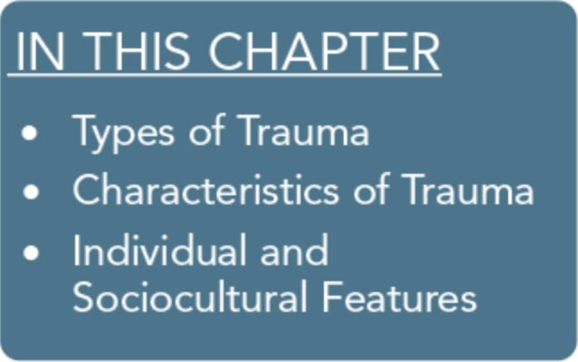
Traumatic experiences typically do not result in long-term im­ pairment for most individuals. It is normal to experience such events across the lifespan; often, individuals, families, and com­ munities respond to them with resilience. This chapter explores several main elements that influence why people respond differ­ ently to trauma. Using the social-ecological model outlined in Part 1, Chapter 1, this chapter explores some of the contextual and systemic dynamics that influence individual and community perceptions of trauma and its impact. The three main foci are: types of trauma, objective and subjective characteristics of trauma, and individual and sociocultural features that serve as risk or pro­ tective factors.
This chapter's main objective is to highlight the key characteris­ tics of traumatic experiences. Trauma-informed behavioral health service providers understand that many influences shape the ef­ fects of trauma among individuals and communities-it is not just the event that determines the outcome, but also the event's context and the resultant interactions across systems.

Types of Trauma
The following section reviews various forms and types of trauma. It does not cover every conceivable trauma that an individual, group, or community may encounter. Specific traumas are re­ viewed only once, even when they could fit in multiple categories of trauma. Additionally, the order of appearance does not denote a specific trauma's importance or prevalence, and there is no lack of relevance implied if a given trauma is not specifically addressed in this Treatment Improvement Protocol (TIP). The intent is to give a broad perspective of the various categories and types of trauma to behavioral health workers who wish to be trauma in­ formed.

33

Trauma-Informed Care in Behavioral Health Services

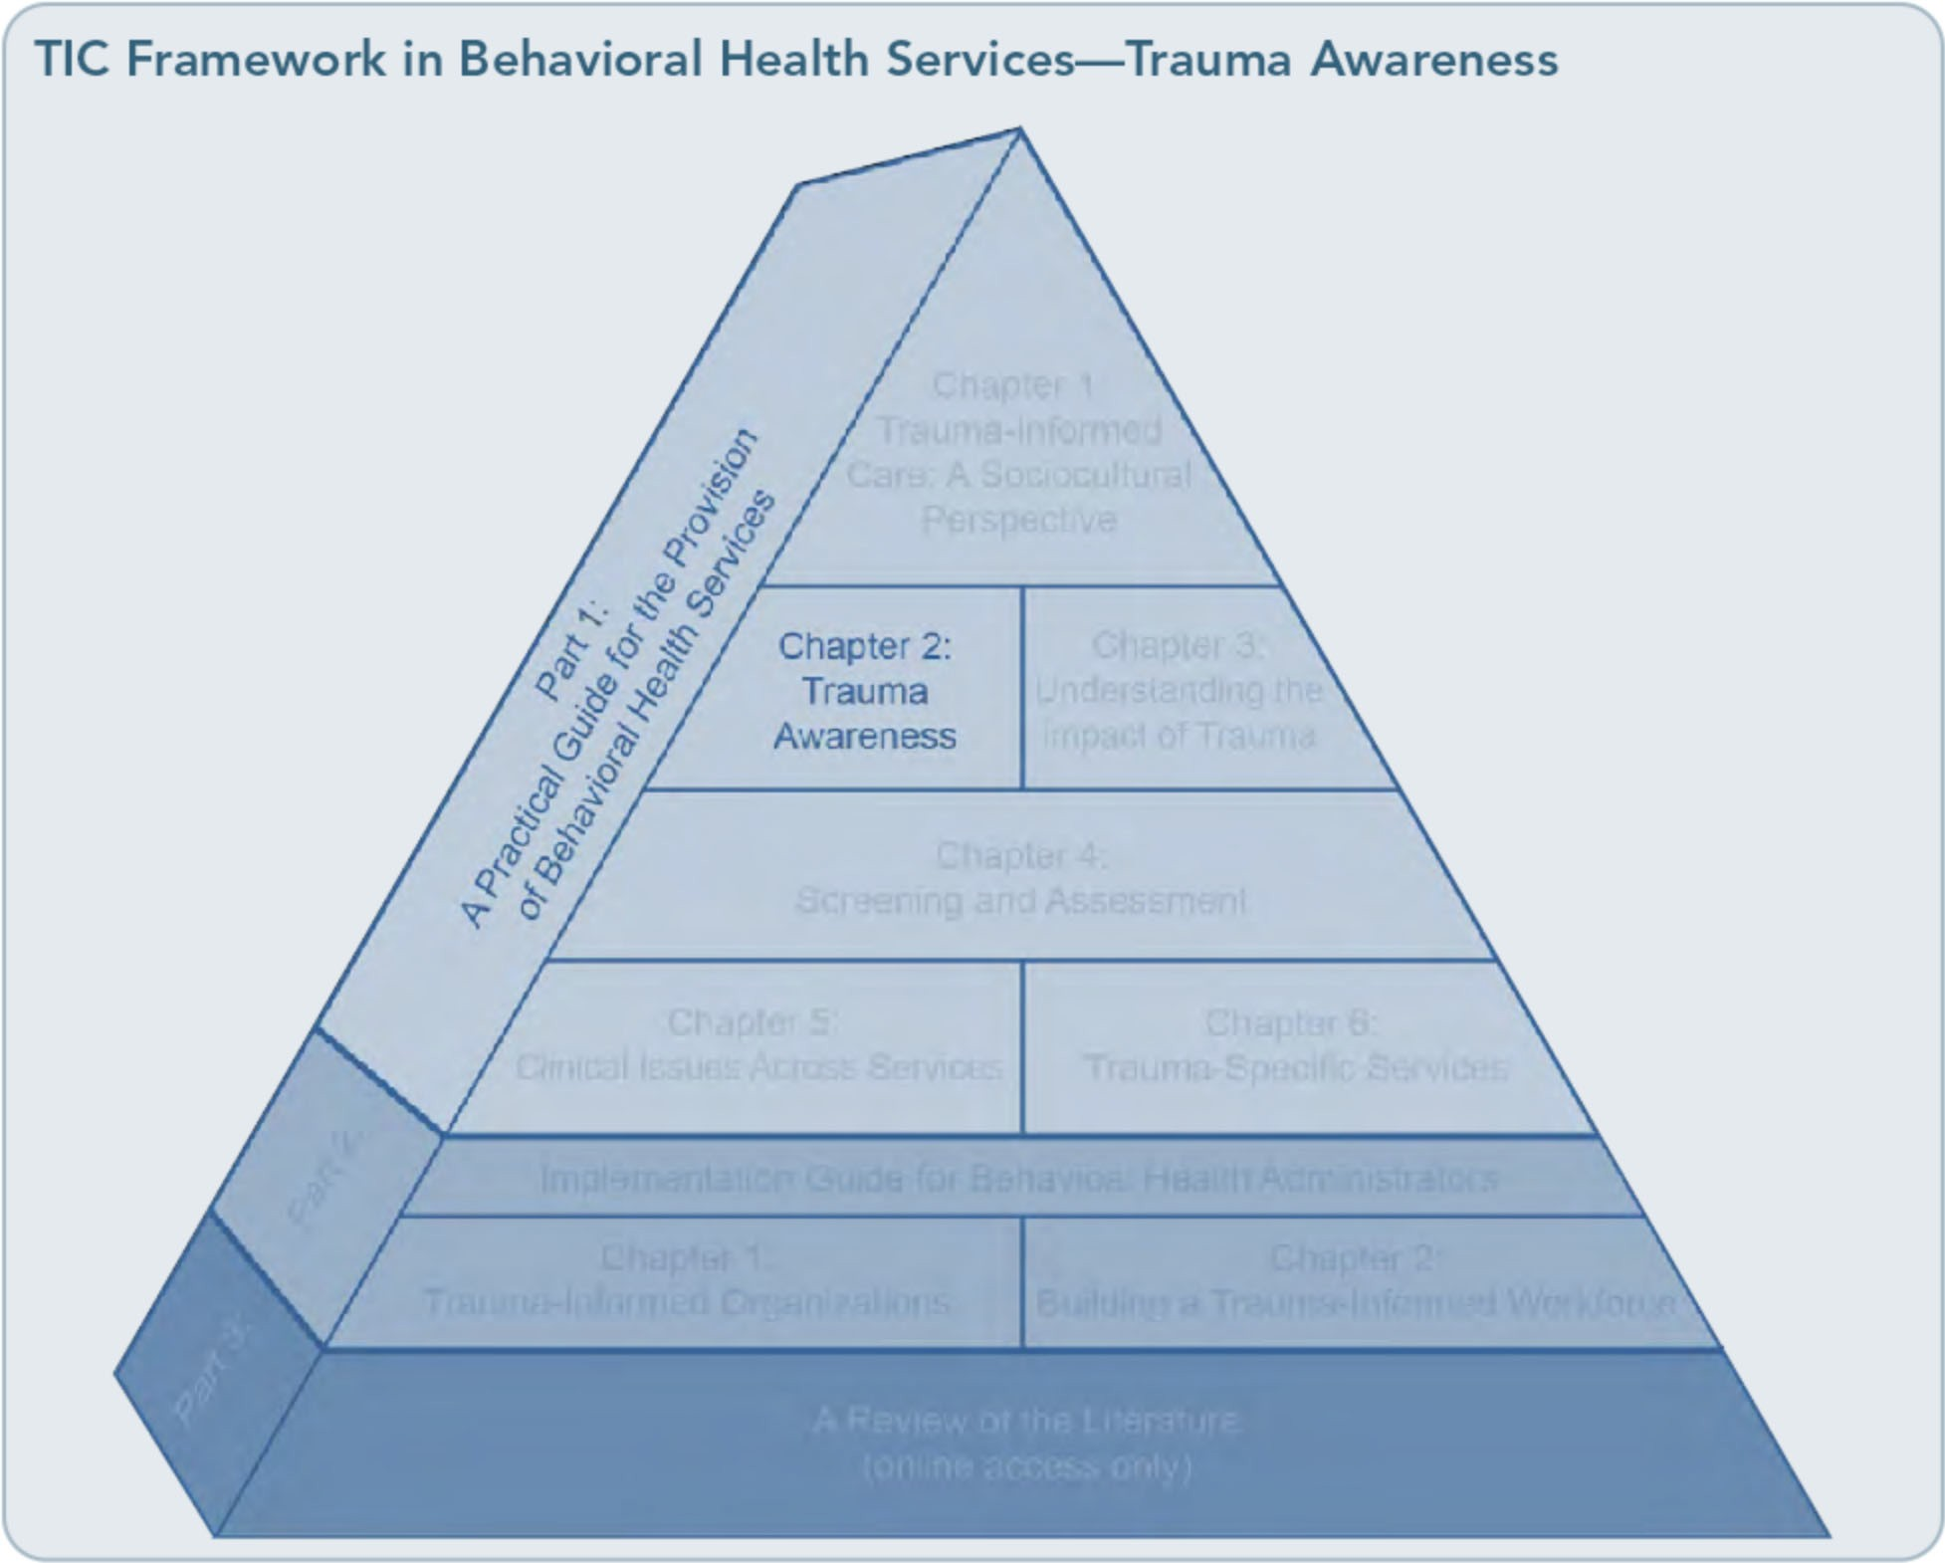

Natural or Human-Caused Traumas
The classification of a trauma as natural or caused by humans can have a significant im­ pact on the ways people react to it and on the types of assistance mobilized in its aftermath (see Exhibit 1.2-1 for trauma examples). Nat­ ural traumatic experiences can directly affect a small number of people, such as a tree falling on a car during a rainstorm, or many people and communities, as with a hurricane. Natural events, often referred to as "acts of God," are typically unavoidable. Human-caused traumas are caused by human failure (e.g., technologi­ cal catastrophes, accidents, malevolence) or by human design (e.g., war). Although multiple factors contribute to the severity of a natural
or human-caused trauma, traumas perceived as intentionally harmful often make the event more traumatic for people and communities.

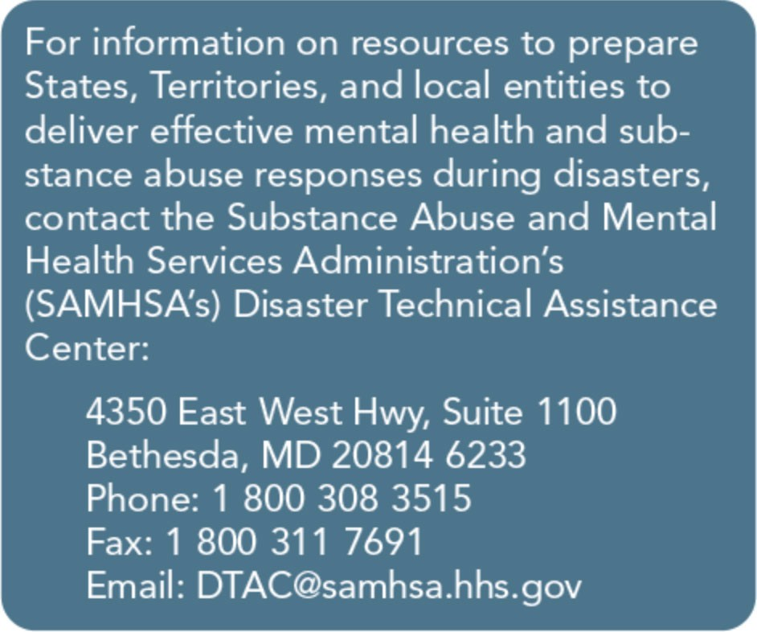

34

Part 1, Chapter 2-T rauma Awareness

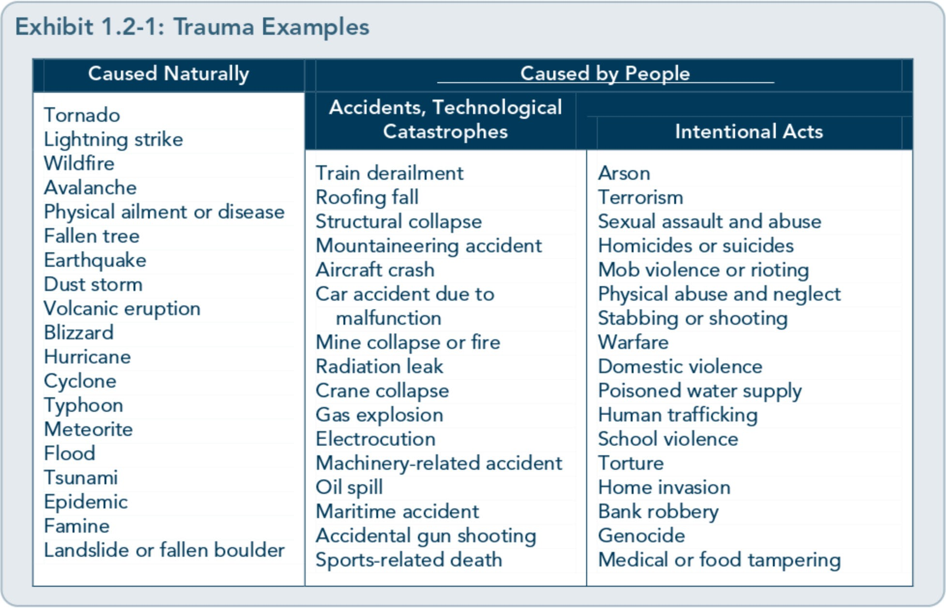

How survivors of natural trauma respond to the experience often depends on the degree of devastation, the extent of individual and community losses, and the amount of time it takes to reestablish daily routines, activities, and services (e.g., returning to school or work, being able to do laundry, having products to buy in a local store). The amount, accessibil­ ity, and duration of relief services can signifi­ cantly influence the duration of traumatic stress reactions as well as the recovery process.
Alongside the disruption of daily routines, the presence of community members or outsiders in affected areas may add significant stress or create traumatic experiences in and of them­ selves. Examples include the threat of others stealing what remains of personal property, restrictions on travel or access to property or living quarters, disruption of privacy within shelters, media attention, and subsequent ex­ posure to repetitive images reflecting the dev­ astation. Therefore, it isn't just the natural disaster or event that can challenge an indi-
vidual or community; often, the consequences of the event and behavioral responses from others within and outside the community play a role in pushing survivors away from effective coping or toward resilience and recovery.
Human-caused traumas are fundamentally different from natural disasters. They are ei­ ther intentional, such as a convenience store robbery at gunpoint, or unintentional, such as the technological accident of a bridge collapse (as occurred in Minneapolis, Minnesota, in 2007; U.S. Fire Administration, 2007). The subsequent reactions to these traumas often depend on their intentionality. However, a person or group of people is typically the tar­ get of the survivors' anger and blame. Survi­ vors of an unintentionally human-caused traumatic event may feel angry and frustrated because of the lack of protection or care of­ fered by the responsible party or government, particularly if there has been a perceived act of omission. After intentional human-caused acts, survivors often struggle to understand the

35

Trauma-Informed Care in Behavioral Health Services

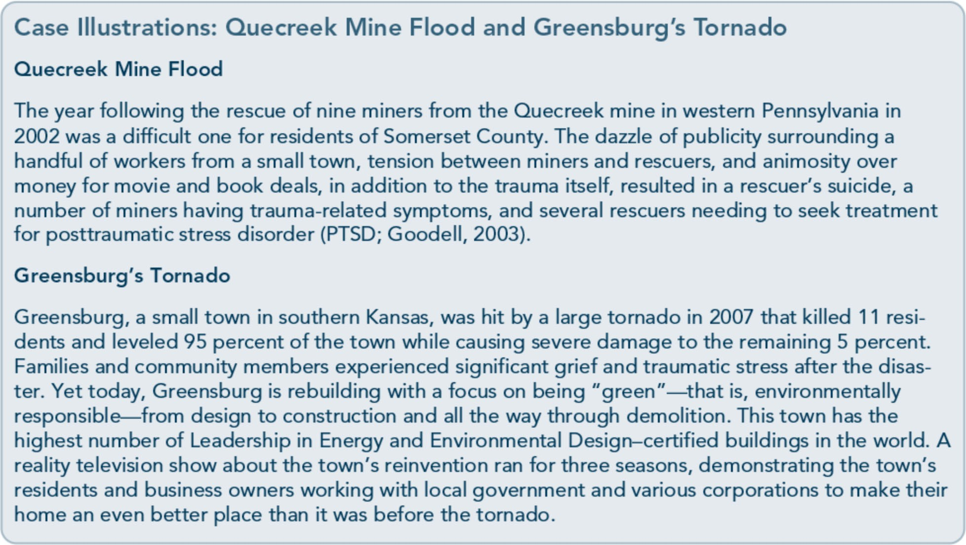

motives for performing the act, the calculated or random nature of the act, and the psycho­ logical makeup of the perpetrator(s).

Individual, Group, Community, and Mass Traumas
In recognizing the role of trauma and under­
standing responses to it, consider whether the trauma primarily affected an individual and perhaps his or her family (e.g., automobile accident, sexual or physical assault, severe ill­ ness); occurred within the context of a group (e.g., trauma experienced by first responders or those who have seen military combat) or community (e.g., gang-related shootings); transpired within a certain culture; or was a large-scale disaster (e.g., hurricane, terrorist attack). This context can have significant im­ plications for whether (and how) people expe­ rience shame as a result of the trauma, the kinds of support and compassion they receive, whether their experiences are normalized or diminished by others, and even the kinds of services they are offered to help them recover and cope.
Individual trauma
An individual trauma refers to an event that only occurs to one person. It can be a single event (e.g., mugging, rape, physical attack, work-related physical injury) or multiple or prolonged events (e.g., a life-threatening ill­ ness, multiple sexual assaults). Although the trauma directly affects just one individual, others who know the person and/or are aware of the trauma will likely experience emotional repercussions from the event(s) as well, such as recounting what they said to the person before the event, reacting in disbelief, or thinking that it could just as easily have hap­ pened to them, too.
Survivors of individual trauma may not receive the environmental support and concern that members of collectively traumatized groups and communities receive. They are less likely to reveal their traumas or to receive validation of their experiences. Often, shame distorts their perception of responsibility for the trau­ ma. Some survivors of individual traumas, especially those who have kept the trauma secret, may not receive needed comfort and

36

Part 1, Chapter 2-T rauma Awareness

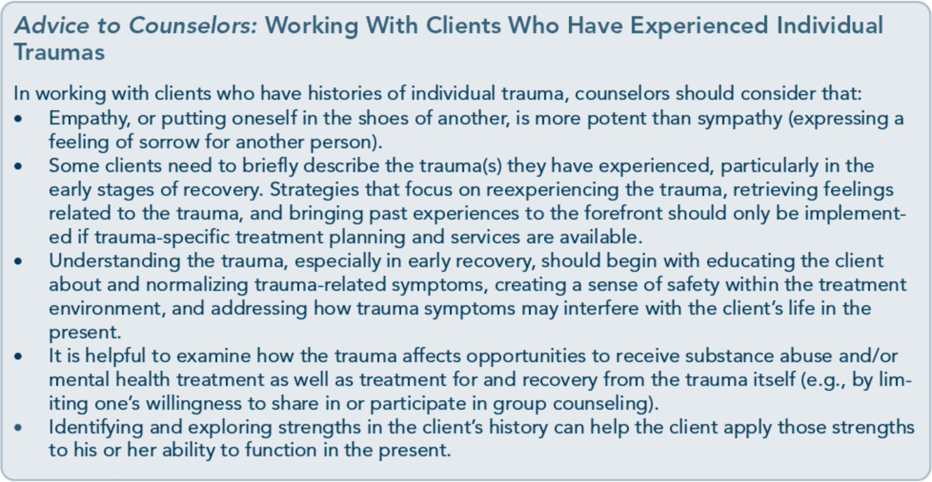

acceptance from others; they are also are more likely to struggle with issues of causation (e.g., a young woman may feel unduly responsible for a sexual assault), to feel isolated by the trauma, and to experience repeated trauma that makes them feel victimized.
Physical injuries
Physical injuries are among the most prevalent individual traumas. Millions of emergency room (ER) visits each year relate directly to physical injuries. Most trauma patients are relatively young; about 70 percent of injury­ related ER cases are people younger than 45 years old (McCaig & Burt, 2005). Dedicated ER hospital units, known as "trauma centers," specialize in physical traumas such as gunshot wounds, stabbings, and other immediate phys­ ical injuries. The term "trauma" in relation to ERs does not refer to psychological trauma, which is the focus of this TIP, yet physical injuries can be associated with psychological trauma. Sudden, unexpected, adverse health­ related events can lead to extensive psycholog­ ical trauma for patients and their families.
Excessive alcohol use is the leading risk factor for physical injuries; it's also the most promis-
ing target for injury prevention. Studies con­ sistently connect injuries and substance use (Gentilello, Ebel, Wickizer, Salkever, & Rivara, 2005); nearly 50 percent of patients admitted to trauma centers have injuries at­ tributable to alcohol abuse and dependence (Gentilello et al., 1999). One study found that two thirds of ambulatory assault victims pre­
senting to an ER had positive substance use urinalysis results; more than half of all victims had PTSD 3 months later (Roy-Byrne et al.,

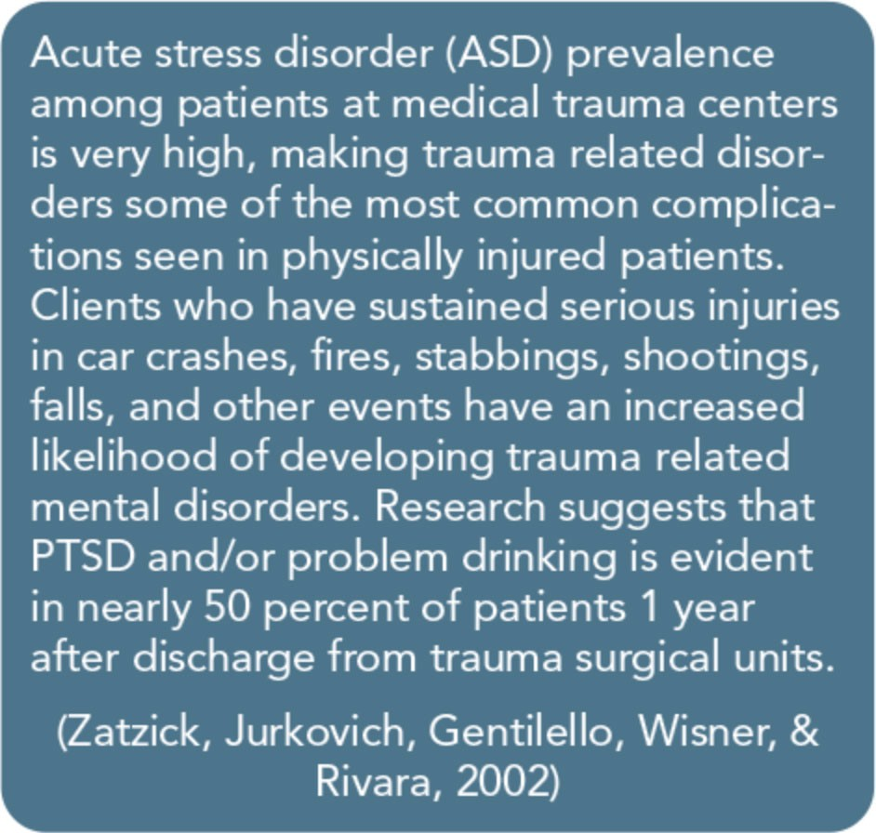

37

Trauma-Informed Care in Behavioral Health Services

2004). Nearly 28 percent of patients whose drinking was identified as problematic during an ER visit for a physical injury will have a new injury within 1 year (Gentilello et al., 2005). For further information, see TIP 16, Alcohol and Other Drug Screening of Hospital­ ized Trauma Patients (Center for Substance Abuse Treatment [CSAT], 1995a).

Group trauma
The term "group trauma" refers to traumatic experiences that affect a particular group of people. This TIP intentionally distinguishes group trauma from mass trauma to highlight the unique experiences and characteristics of trauma-related reactions among small groups. These groups often share a common identity and history, as well as similar activities and concerns. They include vocational groups who specialize in managing traumas or who rou­ tinely place themselves in harm's way-for example, first responders, a group including police and emergency medical personnel.
Some examples of group trauma include crews and their families who lose members from a commercial fishing accident, a gang whose members experience multiple deaths and inju­ ries, teams of firefighters who lose members in a roof collapse, responders who attempt to save flood victims, and military service mem­ bers in a specific theater of operation.
Survivors of group trauma can have different experiences and responses than survivors of individual or mass traumas. Survivors of group trauma, such as military service members and first responders, are likely to experience re­ peated trauma. They tend to keep the trauma experiences within the group, feeling that oth­ ers outside the group will not understand; group outsiders are generally viewed as intrud­ ers. Members may encourage others in the group to shut down emotionally and repress their traumatic experiences-and there are some occupational roles that necessitate the

repression of reactions to complete a mission or to be attentive to the needs at hand. Group members may not want to seek help and may discourage others from doing so out of fear that it may shame the entire group. In this environment, members may see it as a viola­ tion of group confidentiality when a member seeks assistance outside the group, such as by going to a counselor.
Group members who have had traumatic experiences in the past may not actively sup­ port traumatized colleagues for fear that ac­ knowledging the trauma will increase the risk of repressed trauma-related emotions surfac­ ing. However, groups with adequate resources for helping group members can develop a stronger and more supportive environment for handling subsequent traumas. These main group features influence the course of short­ and long-term adjustments, including the development of traumatic stress symptoms associated with mental and substance use disorders.
Certain occupational groups are at greater risk of experiencing trauma-particularly multiple traumas. This TIP briefly reviews two main groups as examples in the following sections: first responders and military service members. For more detailed information on the impact of trauma and deployment, refer to the planned TIP, Reintegration-Related Behavioral Health Issues in Veterans and Military Families (SAMHSA, planned f).

First responders
First responders are usually emergency medi­ cal technicians, disaster management person­ nel, police officers, rescue workers, medical
and behavioral health professionals,journalists, and volunteers from various backgrounds.
They also include lifeguards, military person­ nel, and clergy. Stressors associated with the kinds of traumatic events and/or disasters first responders are likely to experience include

38

Part 1, Chapter 2-T rauma Awareness

exposure to toxic agents, feeling responsible for the lives of others, witnessing catastrophic devastation, potential exposure to gruesome images, observing human and animal suffering and/or death, working beyond physical ex­ haustion, and the external and internal pres­ sure of working against the clock.

Military service members
Military personnel are likely to experience numerous stressors associated with trauma. Service members who have repeatedly de­ ployed to a war zone are at a greater risk for traumatic stress reactions (also known as com­ bat stress reaction or traumatic stress injury), other military personnel who provide support services are also at risk for traumatic stress and secondary trauma (refer to the glossary portion of the "How This TIP Is Organized" section that precedes Part 1, Chapter 1, of this TIP). So too, service members who anticipate de­ ployment or redeployment may exhibit psy­ chological symptoms associated with
trau atic stress. Some stressors that military service members may encounter include work­ ing while physically exhausted, exposure to gunfire, seeing or knowing someone who has been injured or killed, traveling in areas known for roadside bombs and rockets, ex­ ten_ded h ervigilance, fear of being struck by an 1mprov1sed explosive device, and so forth.

Trauma affecting communities and cultures
Trauma that affects communities and cultures covers a broad range of violence and atrocities that erode the sense of safety within a given community, including neighborhoods, schools, towns, and reservations. It may in­ volve violence in the form of physical or sexual assaults, hate crimes, robberies, workplace or gang-related violence, threats, shootings, or stabbings-for example, the school shooting at Virginia Polytechnic Institute and State University in 2007. It also includes actions that attempt to dismantle systemic cultural practices, resources, and identities, such as making boarding school attendance mandato­ ry for Native American children or placing them in non-Native foster homes. Cultural and/or community-based trauma can also oc­ cur via indifference or limited responsiveness to specific communities or cultures that are facing a potential catastrophe. Cultural trau­ mas are events that, whether intentionally or not, erode the heritage of a culture-as with prejudice, disenfranchisement, and health inequities (e.g., late prenatal care, inability to afford medications, limited access to culturally appropriate health education, vicinity and quality of affordable medical services), among other examples.

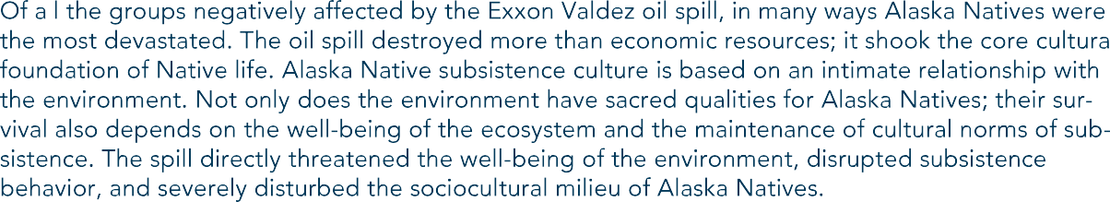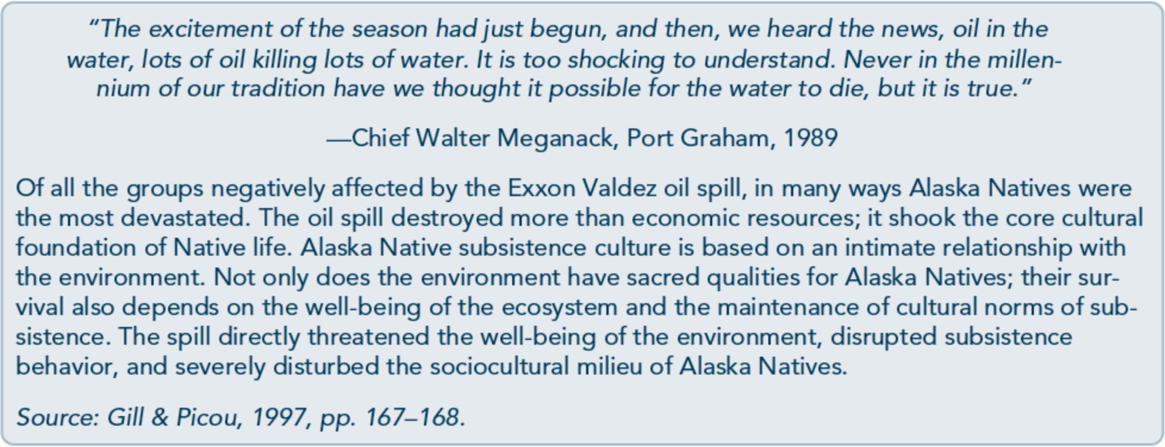

39

Trauma-Informed Care in Behavioral Health Services

Historical trauma
Historical trauma, known also as generational trauma, refers to events that are so widespread as to affect an entire culture; such events also have effects intense enough to influence gen­ erations of the culture beyond those who ex­ perienced them directly. The enslavement, torture, and lynching of African Americans; the forced assimilation and relocation of American Indians onto reservations; the ex­ termination of millions ofJews and others in Europe during World War II; and the geno­ cidal policies of the Hutus in Rwanda and the Khmer Rouge in Cambodia are examples of historical trauma.
In the past 50 years, research has explored the generational effects of the Holocaust upon survivors and their families. More recent liter­ ature has extended the concept of historical or generational trauma to the traumatic experi­ ences of Native Americans. Reduced popula­ tion, forced relocation, and acculturation are some examples of traumatic experiences that Native people have endured across centuries, beginning with the first European presence in the Americas. These tragic experiences have led to significant loss of cultural identity across generations and have had a significant impact on the well-being of Native communities (Whitbeck, Chen, Hoyt, &Adams, 2004).
Data are limited on the association of mental and substance use disorders with historical trauma among Native people, but literature suggests that historical trauma has repercus­ sions across generations, such as depression, grief, traumatic stress, domestic violence, and substance abuse, as well as significant loss of cultural knowledge, language, and identity (Gone, 2009). Historical trauma can increase the vulnerability of multiple generations to the effects of traumas that occur in their own lifetimes.

Mass trauma
Mass traumas or disasters affect large numbers of people either directly or indirectly. It is be­ yond the scope of this TIP to cover any specif­ ic disaster in detail; note, however, that mass traumas include large-scale natural and
human-caused disasters (including intentional acts and accidents alike). Mass traumas may involve significant loss of property and lives as well as the widespread disruption of normal routines and services. Responding to such traumas often requires immediate and exten­ sive resources that typically exceed the capaci­ ty of the affected communities, States, or countries in which they occur. Recent exam­ ples of such large-scale catastrophes include:
- In January 2010, a massive earthquake hit Haiti, killing hundreds of thousands of people and leaving over a million homeless.
- A nuclear reactor meltdown in the Ukraine in 1986 resulted in a technological and en­ vironmental disaster that affected tens of millions of people.
- The tsunami in the Indian Ocean in 2005 left hundreds of thousands dead in nine countries.
One factor that influences an individual's response to trauma is his or her ability to process one trauma before another trauma occurs. In mass traumas, the initial event causes considerable destruction, the conse­ quences of which may spawn additional traumas and other stressful events that lead to more difficulties and greater need for adjust­ ments among survivors, first responders, and disaster relief agencies. Often, a chain reac­ tion occurs. Take, for example, Hurricane Katrina and its impact on the people of Louisiana and other coastal States. After the initial flooding, people struggled to obtain basic needs, including food, drinking water, safe shelter, clothing, medicines, personal hygiene items, and so forth, all as concern mounted about the safety of children and

40

Part 1, Chapter 2-T rauma Awareness

other relatives, friends, and neighbors. In this and similar cases, the destruction from the initial flooding led to mass displacement of families and communities; many people had to relocate far from New Orleans and other badly affected areas, while also needing to gain fi­ nancial assistance, reinitiate work to generate income, and obtain stable housing. People could not assimilate one stressor before anoth­ er appeared.
Nevertheless, mass traumas can create an im­ mediate sense of commonality-many people are "in the same boat," thus removing much of the isolation that can occur with other types of trauma. People can acknowledge their diffi­ culties and receive support, even from strangers. It is easier to ask for help because blame is often externalized; large-scale disas­ ters are often referred to as "acts of God" or, in cases of terrorism and other intentional events, as acts of "evil." Even so, survivors of mass trauma often encounter an initial rally of support followed by quickly diminishing ser­ vices and dwindling care. When the disaster fades from the headlines, public attention and concern are likely to decrease, leaving survi­ vors struggling to reestablish or reinvent their lives without much outside acknowledgment.
The experience of mass trauma can lead to the development of psychological symptoms and substance use at either a subclinical or a diag­ nostic level (refer to Part 3 of this TIP, availa­ ble online, for more information highlighting the relationship between trauma and behav­ ioral health problems). Likewise, one of the greatest risks for traumatic stress reactions after a mass tragedy is the presence of preex­ isting mental and co-occurring disorders, and individuals who are in early recovery from substance use disorders are at greater risk for such reactions as well. Nonetheless, people are amazingly resilient, and most will not develop long-term mental or substance use disorders

after an event; in fact, most trauma-related symptoms will resolve in a matter of months (Keane & Piwowarczyk, 2006).

Interpersonal Traumas Interpersonal traumas are events that occur (and typically continue to reoccur) between people who often know each other, such as
spouses or parents and their children. Exam­ ples include physical and sexual abuse, sexual assault, domestic violence, and elder abuse.
Intimate partner violence
Intimate partner violence (IPV), often re­ ferred to as domestic violence, is a pattern of actual or threatened physical, sexual, and/or emotional abuse. It differs from simple assault in that multiple episodes often occur and the perpetrator is an intimate partner of the vic­ tim. Trauma associated with IPV is normally ongoing. Incidents of this form of violence are rarely isolated, and the client may still be in contact with and encountering abuse from the perpetrator while engaged in treatment.
Intimate partners include current and former spouses, boyfriends, and girlfriends. The ma­ jority of all nonfatal acts of violence and inti­ mate partner homicides are committed against women; IPV accounts for over 20 percent of nonfatal violence against women but only 3.6 percent of that committed against men (Catalano, 2012). Children are the hidden casualties ofIPV. They often witness the as­ saults or threats directly, within earshot, or by being exposed to the aftermath of the violence (e.g., seeing bruises and destruction of proper­ ty, hearing the pleas for it to stop or the prom­ ises that it will never happen again).
Substance abuse, particularly involving alco­ hol, is frequently associated with IPV. It is the presence of alcohol-related problems in either partner, rather than the level of alcohol con­ sumption itself, that is the important factor.

41

Trauma-Informed Care in Behavioral Health Services

Drinking may or may not be the cause of the violence; that said, couples with alcohol­ related disorders could have more tension and disagreement within the relationship in gen­ eral, which leads to aggression and violence. The consumption of alcohol during a dispute is likely to decrease inhibitions and increase impulsivity, thus creating an opportunity for an argument to escalate into a physical alterca­ tion. More information on domestic violence and its effects on partners and families, as well as its connection with substance use and trauma-related disorders, is available in TIP 25, Substance Abuse Treatment and Domestic Violence (CSAT, 19976), and from the Na­ tional Online Resource Center on Violence Against Women (http://www.vawnet.org/).

Developmental Traumas Developmental traumas include specific events or experiences that occur within a given devel­ opmental stage and influence later develop­ ment, adjustment, and physical and mental health. Often, these traumas are related to adverse childhood experiences (ACEs), but they can also result from tragedies that occur outside an expected developmental or life stage (e.g., a child dying before a parent, being diagnosed with a life-threatening illness as a young adult) or from events at any point in the life cycle that create significant loss and

have life-altering consequences (e.g., the death of a significant other in the later years that leads to displacement of the surviving partner).
Adverse childhood experiences Some people experience trauma at a young age through sexual, physical, or emotional abuse and neglect. The Adverse Childhood Experi­ ences Study (Felitti et al., 1998) examined the effects of several categories of ACEs on adult
health, including physical and emotional abuse; sexual abuse; a substance-dependent parent; an incarcerated, mentally ill, or suicidal household member; spousal abuse between parents; and divorce or separation that meant one parent was absent during childhood. The National Comorbidity Studies examined the prevalence of trauma and defined childhood adversities as parental death, parental divorce/separation,
life-threatening illness, or extreme economic hardship in addition to the childhood experi­ ences included in the Adverse Childhood Experiences Study (Green et al., 2010).
ACEs can negatively affect a person's well­ being into adulthood. Whether or not these experiences occur simultaneously, are time­ limited, or recur, they set the stage for in­ creased vulnerability to physical, mental, and substance use disorders and enhance the risk

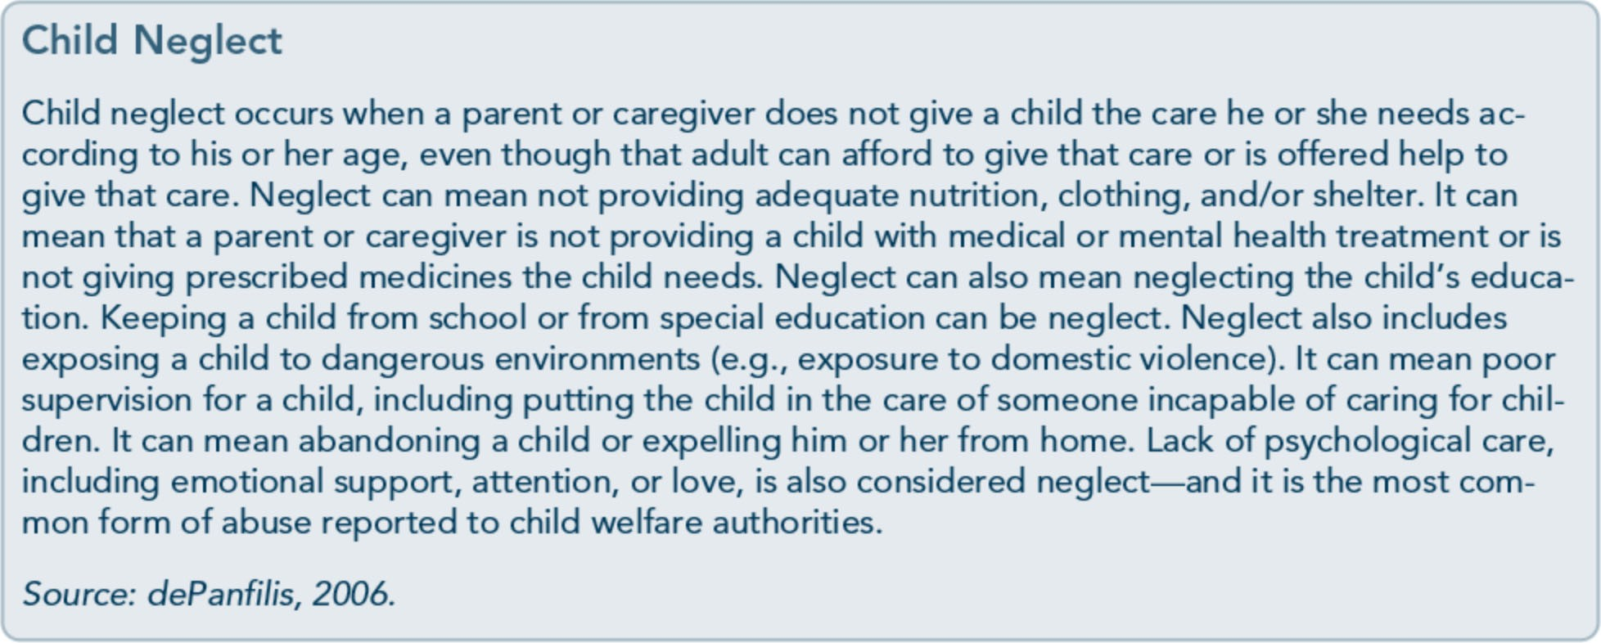

42

Part 1, Chapter 2-T rauma Awareness

for repeated trauma exposure across the life span. Childhood abuse is highly associated with major depression, suicidal thoughts, PTSD, and dissociative symptoms. So too, ACEs are associated with a greater risk of adult alcohol use. When a person experiences several adverse events in childhood, the risk of his or her heavy drinking, self-reported alco­ hol dependence, and marrying a person who is alcohol dependent is two to four times greater than that of a person with no AC Es (Dube, Anda, Felitti, Edwards, & Croft, 2002).
A detailed examination of the issues involved in providing substance abuse treatment to survivors of child abuse and neglect is the sub­ ject of TIP 36, Substance Abuse Treatment for Persons With Child Abuse and Neglect Issues (CSAT, 2000b).

Political Terror and War
Political terror and war are likely to have last­ ing consequences for survivors. In essence, anything that threatens the existence, beliefs, well-being, or livelihood of a community is likely to be experienced as traumatic by com­ munity members. Whether counselors are working with an immigrant or refugee enclave in the United States or in another country, they should be aware of local events, local his­ tory, and the possibility that clients have en­ dured trauma. (For international information about the clinical, historical, and theoretical

aspects of trauma and terrorism, see Danieli, Brom, & Sills, 2005.) Terrorism is a unique subtype of human-caused disasters. The over­ all goal of terrorist attacks is to maximize the uncertainty, anxiety, and fear of a large com­ munity, so the responses are often epidemic and affect large numbers of people who have had direct or indirect exposure to an event (Silver et al., 2004; Suvak, Maguen, Litz, Silver, & Holman, 2008). Terrorism has a vari­ ety of results not common to other disasters, such as reminders of the unpredictability of terrorist acts; increases in security measures for the general population; intensified suspicion about a particular population, ethnicity, or cul­ ture; and heightened awareness and/or arousal.

Refugees
According to the World Refugee Survey, there are an estimated 12 million refugees and asylum seekers, 21 million internally displaced people, and nearly 35 million uprooted people (U.S. Committee for Refugees and Immi­ grants, 2006). Many of these people have sur­ vived horrendous ordeals with profound and lasting effects for individuals and whole popu­ lations. In addition to witnessing deaths by execution, starvation, or beatings, many survi­ vors have experienced horrific torture.
Refugees are people who flee their homes be­ cause they have experienced or have a reason­ able fear of experiencing persecution. They

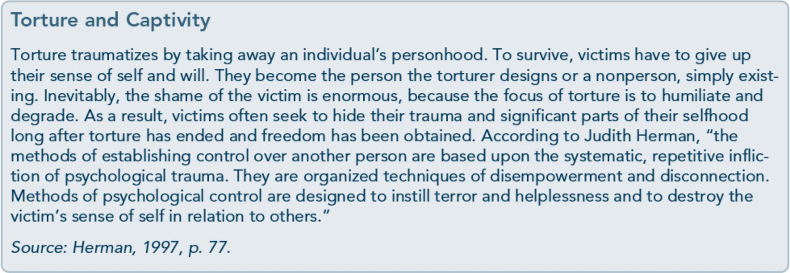

43

Trauma-Informed Care in Behavioral Health Services

differ from immigrants who willingly leave their homes or homeland to seek better op­ portunities. Although immigrants may experi­ ence trauma before migrating to or after reaching their new destination, refugees will often have greater exposure to trauma before migration. Refugees typically come from war­ torn countries and may have been persecuted or tortured. Consequently, greater exposure to trauma, such as torture, before migrating often leads to more adjustment-related difficulties and psychological symptoms after relocation (Steel et al., 2009).
Refugees typically face substantial difficulties in assimilating into new countries and cul­ tures. Moreover, the environment can create a new set of challenges that may include addi­ tional exposure to trauma and social isolation (Miller et al., 2002). These as well as addition­ al factors influence adjustment, the develop­ ment of mental illness (including PTSD), and

the occurrence of substance use disorders. Ad­ ditional factors that influence outcomes after relocation include receptivity of the local community, along with opportunities for so­ cial support and culturally responsive services.
Among refugee populations in the United States, little research is available on rates of mental illness and co-occurring substance use disorders and traumatic stress among refugee populations. Substance use patterns vary based on cultural factors as well as assimilation, yet research suggests that trauma increases the risk for substance use among refugees after war-related experiences (Kozaric- Kovacic, Ljubin, & Grappe, 2000). Therefore, providers should expect to see trauma-related disorders among refugees who are seeking treatment for a substance use disorder and greater preva­ lence of substance use disorders among refu­ gees who seek behavioral health services.

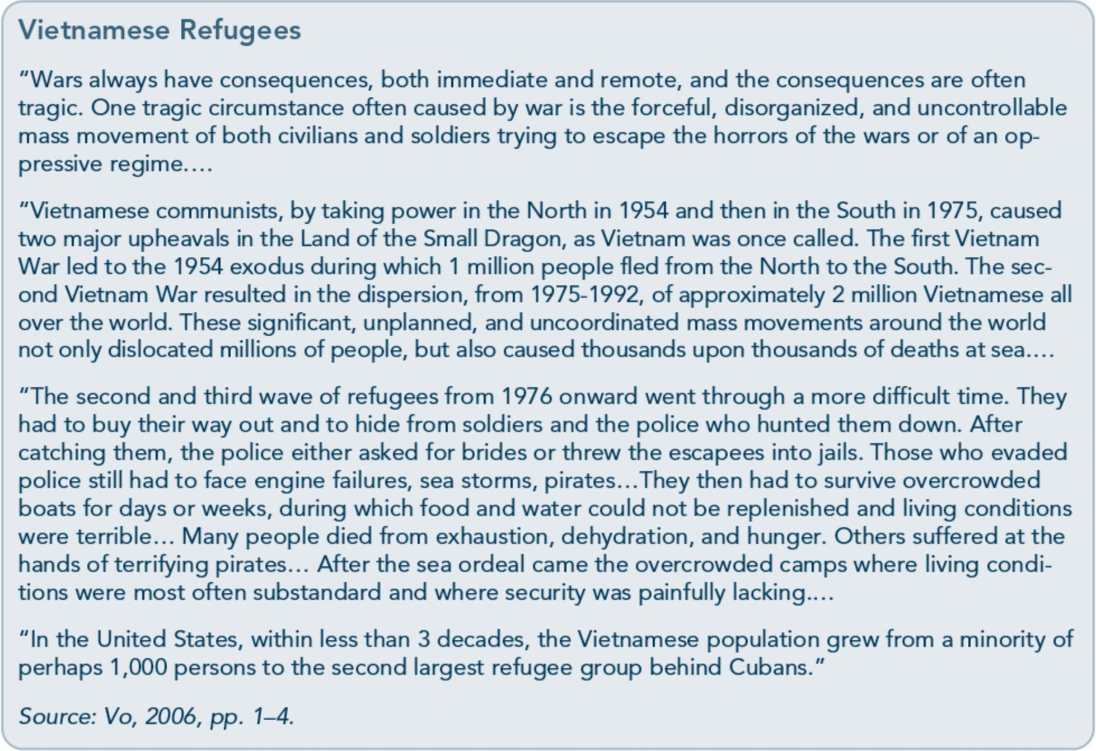

44

Part 1, Chapter 2-T rauma Awareness

System-Oriented Traumas: Retraumatization
Retraumatization occurs when clients experi­ ence something that makes them feel as though they are undergoing another trauma. Unfortunately, treatment settings and clini­ cians can create retraumatizing experiences, often without being aware of it, and some­ times clients themselves are not consciously aware that a clinical situation has actually trig­ gered a traumatic stress reaction. Agencies that anticipate the risk for retraumatization and actively work on adjusting program policies and procedures to remain sensitive to the his­ tories and needs of individuals who have un­ dergone past trauma are likely to have more success in providing care, retaining clients, and achieving positive outcomes.
Staff and agency issues that can cause retrau­ matization include:
  - Being unaware that the client's traumatic history significantly affects his or her life.

- Failing to screen for trauma history prior to treatment planning.
- Challenging or discounting reports of abuse or other traumatic events.
- Using isolation or physical restraints.
- Using experiential exercises that humiliate the individual.
- Endorsing a confrontational approach in counseling.
- Allowing the abusive behavior of one client toward another to continue without intervention.
- Labeling behavior/feelings as pathological.
- Failing to provide adequate security and safety within the program.
- Limiting participation of the client in treatment decisions and planning processes.
- Minimizing, discrediting, or ignoring client responses.
- Disrupting counselor-client relationships by changing counselors' schedules and assignments.
- Obtaining urine specimens in a nonprivate setting.

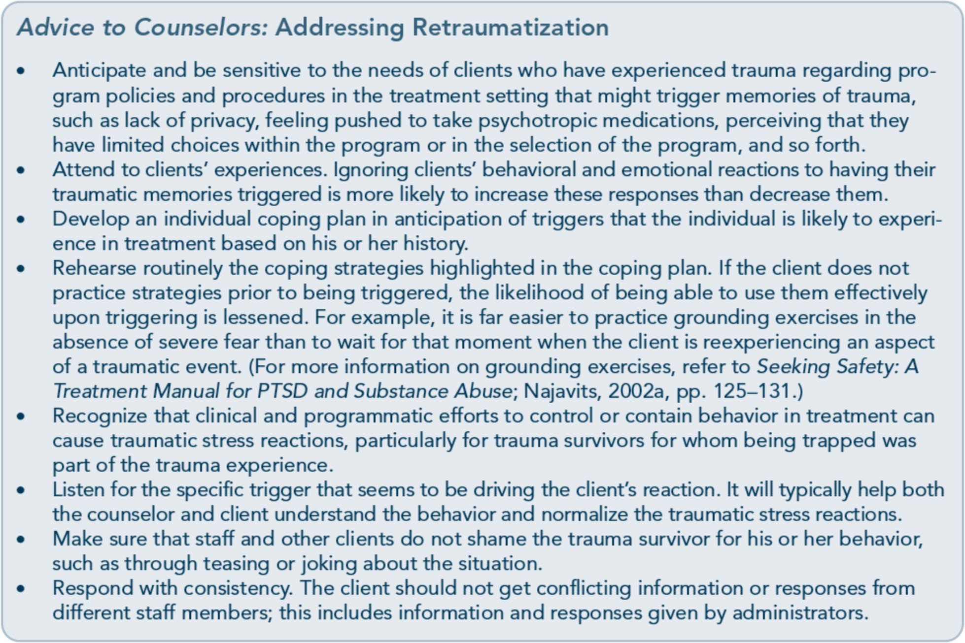
45

Trauma-Informed Care in Behavioral Health Services

  - Having clients undress in the presence of others.
  - Inconsistently enforcing rules and allowing chaos in the treatment environment.
  - Imposing agency policies or rules without exceptions or an opportunity for clients to question them.
  - Enforcing new restrictions within the pro­ gram without staff-client communication.
  - Limiting access to services for ethnically diverse populations.
  - Accepting agency dysfunction, including lack of consistent, competent leadership.

Characteristics of Trauma
The following section highlights several se­ lected characteristics of traumatic experiences that influence the effects of traumatic stress. Objective characteristics are those elements of a traumatic event that are tangible or factual; subjective characteristics include internal pro­ cesses, such as perceptions of traumatic experi­ ences and meanings assigned to them.

Objective Characteristics

Was it a single, repeated, or
sustained trauma?
Trauma can involve a single event, numerous or repeated events, or sustained/chronic expe­ riences. A single trauma is limited to a single point in time. A rape, an automobile accident, the sudden death of a loved one-all are ex­ amples of a single trauma. Some people who experience a single trauma recover without any specific intervention. But for others­ especially those with histories of previous trauma or mental or substance use disorders, or those for whom the trauma experience is particularly horrific or overwhelming-a sin­ gle trauma can result in traumatic stress symp­ toms and trauma- and stress-related disorders. Single traumas do not necessarily have a lesser
psychological impact than repeated traumas.

After the terrorist attacks on September 11, 2001-a significant single trauma-many Manhattan residents experienced intrusive memories and sleep disruption whether they were at the site of the attacks or watched tele­ vision coverage of it (Ford & Fournier, 2007; Galea et al., 2002).
A series of traumas happening to the same person over time is known as repeated trauma. This can include repeated sexual or physical assaults, exposure to frequent injuries of oth­ ers, or seemingly unrelated traumas. Military personnel, journalists covering stories of mass tragedies or prolonged conflicts, and first re­ sponders who handle hundreds of cases each year typify repeated trauma survivors. Repeti­ tive exposure to traumas can have a cumulative effect over one's lifetime. A person who was assaulted during adolescence, diagnosed with a life-threatening illness in his or her thirties, and involved in a serious car accident later in life has experienced repeated trauma.
Some repeated traumas are sustained or chronic. Sustained trauma experiences tend to wear down resilience and the ability to adapt. Some examples include children who endure ongoing sexual abuse, physical neglect, or emotional abuse; people who are in violent relationships; and people who live in chronic poverty. Individuals in chronically stressful, traumatizing environments are particularly susceptible to traumatic stress reactions, sub­ stance use, and mental disorders.
Bidirectional relationships exist between trauma and substance use as well as trauma and mental illness. For example, abuse of al­ cohol and drugs increases the risk of a trau­ matic experience and creates greater vulnerability to the effects of trauma; sub­ stance abuse reduces a person's ability to take corrective and remedial actions that might reduce the impact of the trauma. Likewise, traumatic stress leads to a greater likelihood of

46

Part 1, Chapter 2-T rauma Awareness

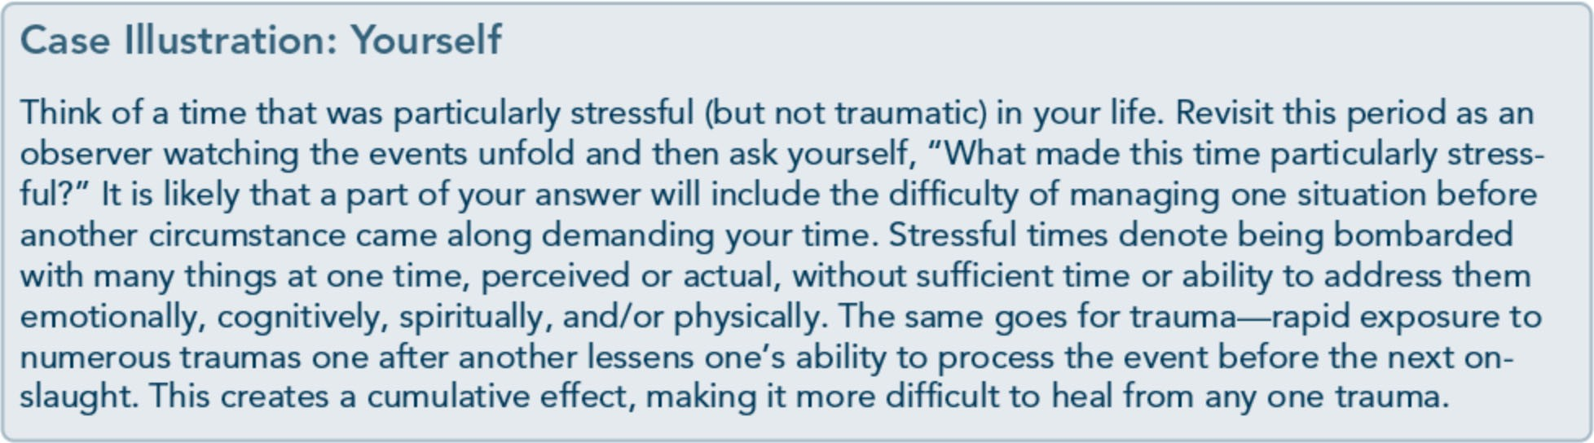

substance abuse that, in turn, increases the risk for additional exposure to trauma. Paralleling this bidirectional relationship, mental illness increases vulnerability to the effects of trauma and raises the risk for substance use disorders and for encountering additional traumatic events. So too, early exposure to ACEs is as­ sociated with traumatic stress reactions and subsequent exposure to trauma in adult years.
People who have encountered multiple and longer doses of trauma are at the greatest risk for developing traumatic stress. For example, military reservists and other military service members who have had multiple long tours of duty are at greater risk for traumatic stress reactions (see the planned TIP, Reintegration­ Related Behavioral Health Issues in Veterans and Military Families; SAMHSA, planned f). In addition, people are more likely to encounter greater impairment and distress from trauma if that trauma occurs with significant intensity and continues sporadically or unceasingly for extended periods.

Was there enough time to process the experience?
A particularly severe pattern of ongoing trau­ ma, sometimes referred to as "cascading trau­ ma," occurs when multiple traumas happen in a pattern that does not allow an individual to heal from one traumatic event before another occurs. Take, for example, California resi­ dents-they repeatedly face consecutive and/or simultaneous natural disasters includ-
ing fires, landslides, floods, droughts, and earthquakes. In other cases, there is ample time to process an event, but processing is limited because people don't have supportive relationships or environments that model pre­ ventive practices. This can lead to greater vul­ nerability to traumas that occur later in life.

How many losses has the trauma caused?
Trauma itself can create significant distress, but often, the losses associated with a trauma have more far-reaching effects. For instance, a child may be forced to assume adult responsi­ bilities, such as serving as a confidant for a parent who is sexually abusing him or her, and lose the opportunity of a childhood free from adult worries. In another scenario, a couple may initially feel grateful to have escaped a house fire, but they may nevertheless face sig­ nificant community and financial losses months afterward. In evaluating the impact of trauma, it is helpful to access and discuss the losses associated with the initial trauma. The number of losses greatly influences an individ­ ual's ability to bounce back from the tragedy.
In the case illustration on the next page, Rasheed's losses cause him to disconnect from his wife, who loves and supports him. Success­ ful confrontation of losses can be difficult if the losses compound each other, as with Rasheed's loss of his friend, his disability, his employment struggles, and the threats to his marriage and liberty. People can cite a specific

47

Trauma-Informed Care in Behavioral Health Services

Case Illustration: Rasheed
Rasheed was referred to an employee assistance program by his employer. He considered quitting his job, but his wife insisted he talk to a counselor. He is a 41-year-old auto mechanic who, 4 years ago, caused a head-on collision while attempting to pass another vehicle. A close friend, riding in the passenger's seat, was killed, and two young people in the other vehicle were seriously injured and permanently disabled. Rasheed survived with a significant back injury and has only been able to work sporadically. He was convicted of negligent homicide and placed on probation because of his physical disability. He is on probation for another 4 years, and if he is convicted of another felony during that time, he will have to serve prison time for his prior offense.
While still in the hospital, Rasheed complained of feeling unreal, numb, and disinterested in the care he received. He did not remember the crash but remembers waking up in the hospital 2 days later. He had difficulty sleeping in the hospital and was aware of feelings of impending doom, although he was unaware of the legal charges he would later face. He was diagnosed with ASD.
He was discharged from the hospital with a variety of medications, including pain pills and a sleep aid. He rapidly became dependent on these medications, feeling he could not face the day without the pain medication and being unable to sleep without sleep medicine in larger doses than had been prescribed. Within 3 months of the accident, he was "doctor shopping" for pain pills and even had a friend obtain a prescription for the sleeping medication from that friend's doctor. In the 4 intervening years, Rasheed's drug use escalated, and his blunted emotions and detachment from friends became more profound. He became adept at obtaining pain pills from a variety of sources, most of them illegal. He fears that if he seeks treatment for the drug problem, he will have to admit to felony offenses and will probably be imprisoned. He also does not believe he can manage his life without the pain pills.
In the past 2 years, he has had recurring dreams of driving a car on the wrong side of the road and into the headlights of an oncoming vehicle. In the dream, he cannot control the car and wakes up just before the vehicles crash. At unusual times-for instance, when he is just awakening in the morning, taking a shower, or walking alone-he will feel profound guilt over the death of his friend in the accident. He becomes very anxious when driving in traffic or when he feels he is driving faster than he should. His marriage of 18 years has been marked by increasing emotional distance, and his wife has talked about separating if he does not do something about his problem. He has been unable to work consistently because of back pain and depression. He was laid off from one job be­ cause he could not concentrate and was making too many mistakes.
The counselor in the employee assistance program elicited information on Rasheed's drug use, although she suspected Rasheed was minimizing its extent and effects. Knowledgeable about psy­ chological trauma, the counselor helped Rasheed feel safe enough to talk about the accident and how it had affected his life. She was struck by how little Rasheed connected his present difficulties to the accident and its aftermath. The counselor later commented that Rasheed talked about the acci­ dent as if it had happened to someone else. Rasheed agreed to continue seeing the counselor for five additional visits, during which time a plan would be made for Rasheed to begin treatment for drug dependence and PTSD.

event as precipitating their trauma, or, in oth­ er cases, the specific trauma can symbolize a series of disabling events in which the person felt his or her life was threatened or in which he or she felt emotionally overwhelmed, psy­ chologically disorganized, or significantly dis­ connected from his or her surroundings. It
will be important for Rasheed to understand how his losses played a part in his abuse of prescription medications to cope with symp­ toms associated with traumatic stress and loss, (e.g., guilt, depression, fear). If not addressed, his trauma could increase his risk for relapse.

48

Part 1, Chapter 2-T rauma Awareness

Was the trauma expected or unexpected?
When talking about a trauma, people some­ times say they didn't see it coming. Being un­ prepared, unaware, and vulnerable often increases the risk of psychological injury, but these are common components of most trau­ mas, given that most traumatic events do oc­ cur without warning (e.g., car crashes, terrorist attacks, sexual assaults). People with substance use disorders, mental illness, and/or cognitive disabilities may be especially vulnerable in that they may attend less or have competing con­ cerns that diminish attention to what is going on around them, even in high-risk environ­ ments. However, most individuals attempt to gain some control over the tragedy by replay­ ing the moments leading up to the event and processing how they could have anticipated it. Some people perseverate on these thoughts for months or years after the event.
Sometimes, a trauma is anticipated but has unexpected or unanticipated consequences, as in the case of Hurricane Katrina. Learning about what is likely to happen can reduce traumatization. For instance, training military personnel in advance of going to combat over­ seas prepares them to handle traumas and can reduce the impact of trauma.

Were the trauma's effects on the person's life isolated or pervasive?
When a trauma is isolated from the larger context of life, a person's response to it is more likely to be contained and limited. For in­ stance, military personnel in combat situations can be significantly traumatized by what they experience. On return to civilian life or non­ combat service, some are able to isolate the traumatic experience so that it does not invade ordinary, day-to-day living. This does not mean that the combat experience was not dis­ turbing or that it will not resurface if the indi­ vidual encounters an experience that triggers

memories of the trauma; it just means that the person can more easily leave the trauma in the past and attend to the present.
Conversely, people who remain in the vicinity of the trauma may encounter greater chal­ lenges in recovery. The traumatic event inter­ twines with various aspects of the person's daily activities and interactions, thus increas­ ing the possibility of being triggered by sur­ rounding cues and experiencing subsequent psychological distress. However, another way to view this potential dilemma for the client is to reframe it as an opportunity-the repetitive exposure to trauma-related cues may provide vital guidance as to when and which treatment and coping techniques to use in the delivery of trauma-informed and trauma-specific behav­ ioral health services.

Who was responsible for the trauma and was the act intentional?
If the severity of a trauma is judged solely by whether the act was intentional or not, events that reflect an intention to harm would be a primary indicator in predicting subsequent difficulties among individuals exposed to this form of trauma. For most survivors, there is an initial disbelief that someone would conceiva­ bly intend to harm others, followed by consid­ erable emotional and, at times, behavioral investment in somehow making things right again or in making sense of a senseless, mali­ cious act. For instance, in the wake of the World Trade Center attacks in New York City, people responded via renewed patriot­ ism, impromptu candlelight vigils, attacks on people of Arab and Muslim descent, and un­ precedented donations and willingness to wait in long lines to donate blood to the Red Cross. Each example is a response that in some way attempts to right the perceived wrong or attach new meaning to the event and subsequent consequences.

49

Trauma-Informed Care in Behavioral Health Services

When terrible things happen, it is human na­ ture to assign blame. Trauma survivors can become heavily invested in assigning blame or finding out who was at fault, regardless of the type of trauma. Often, this occurs as an at­ tempt to make sense of, give meaning to, and reestablish a sense of predictability, control, and safety after an irrational or random act. It is far easier to accept that someone, including oneself, is at fault or could have done some­ thing different than it is to accept the fact that one was simply in the wrong place at the wrong time.
For some trauma survivors, needing to find out why a trauma occurred or who is at fault can become a significant block to growth when the individual would be better served by asking, 'What do I need to do to heal?" Be­ havioral health professionals can help clients translate what they have learned about respon­ sibility in recovery to other aspects of their lives. For instance, someone in treatment for co-occurring disorders who has internalized that becoming depressed or addicted was not his or her fault, but that recovery is a personal responsibility, can then apply the same princi­ ple to the experience of childhood abuse and thereby overcome negative judgments of self (e.g., thinking oneself to be a bad person who deserves abuse). The individual can then begin to reassign responsibility by attaching the

blame to the perpetrator(s) while at the same time assuming responsibility for recovery.

Was the trauma experienced directly
or indirectly?
Trauma that happens to someone directly seems to be more damaging than witnessing trauma that befalls others. For example, it is usually more traumatic to be robbed at gun­ point than to witness someone else being robbed or hearing someone tell a story about being robbed. Yet, sometimes, experiencing another's pain can be equally traumatic. For instance, parents often internalize the pain and suffering of their children when the chil­ dren are undergoing traumatic circumstances (e.g., treatments for childhood cancer).
There are two ways to experience the trauma of others. An individual may witness the event, such as seeing someone killed or seriously in­ jured in a car accident, or may learn of an event that happened to someone, such as a violent personal assault, suicide, serious acci­ dent, injury, or sudden or unexpected death.
For many people, the impact of the trauma will depend on a host of variables, including their proximity to the event as eyewitnesses, the witnesses' response in the situation, their relationship to the victims, the degree of help­ lessness surrounding the experience, their ex­ posure to subsequent consequences, and so on.

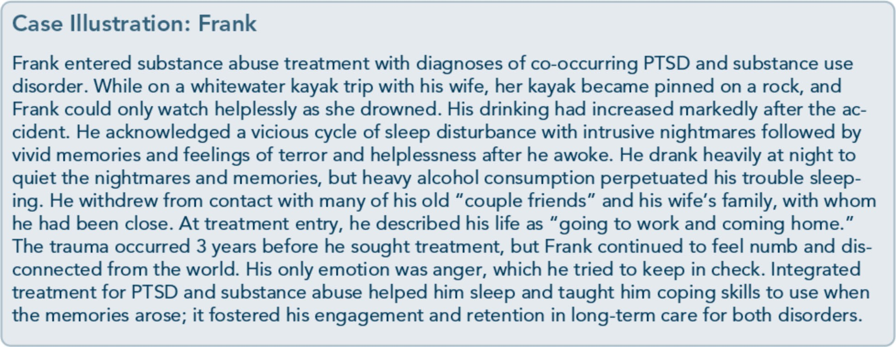

so

Part 1, Chapter 2-T rauma Awareness

The effects of traumas such as genocide and internment in concentration camps can be felt across generations-stories, coping behaviors, and stress reactions can be passed across gen­ erational lines far removed from the actual events or firsthand accounts. Known as histor­ ical trauma, this type of trauma can affect the functioning of families, communities, and cultures for multiple generations.
What happened since the trauma? In reviewing traumatic events, it is important to assess the degree of disruption after the initial trauma has passed, such as the loss of
employment, assets, community events, behav­ ioral health services, local stores, and recrea­ tional areas. There is typically an initial rally of services and support following a trauma, par­ ticularly if it is on a mass scale. However, the reality of the trauma's effects and their disrup­ tiveness may have a more lasting impact. The deterioration of normalcy, including the dis­ ruption of day-to-day activities and the dam­ age of structures that house these routines, will likely erode the common threads that provide a sense of safety in individual lives and com­ munities. Hence, the degree of disruption in resuming normal daily activities is a significant risk factor for substance use disorders, subclin­ ical psychological symptoms, and mental dis­ orders. For example, adults displaced from their homes because of Hurricanes Katrina or Rita had significantly higher rates of past­ month cigarette use, illicit drug use, and binge drinking than those who were not displaced (Office of Applied Studies, 2008).

Subjective Characteristics
Psychological meaning of trauma An important clinical issue in understanding the impact of trauma is the meaning that the
survivor has attached to the traumatic experi­ ence. Survivors' unique cognitive interpreta­ tions of an event-that is, their beliefs and

assumptions­ contribute to how they process, react to, cope with, and recov­ er from the trauma. Does the event repre­ sent retribution for past deeds committed
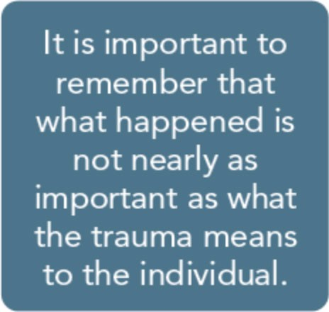
by the individual or his or her family? How does the individual attach meaning to his or her survival? Does he or she believe that it is a sign of a greater purpose not yet revealed?
People who attempt to share their interpreta­ tion and meaning of the event can feel misun­ derstood and sometimes alienated (Paulson & Krippner, 2007; Schein, Spitz, Burlingame, & Muskin, 2006).
People interpret traumatic events in vastly different ways, and many variables shape how an individual assigns meaning to the experi­ ence (framing the meaning through culture, family beliefs, prior life experiences and learn­ ing, personality and other psychological fea­ tures, etc.). Even in an event that happens in a household, each family member may interpret the experience differently. Likewise, the same type of event can occur at two different times in a person's life, but his or her interpretation of the events may differ considerably because of developmental differences acquired between events, current cognitive and emotional pro­ cessing skills, availability of and access to envi­ ronmental resources, and so forth.

Disruption of core assumptions and beliefs
Trauma often engenders a crisis of faith (Frankl, 1992) that leads clients to question basic assumptions about life. Were the indi­ vidual's core or life-organizing assumptions (e.g., about safety, perception of others, fair­ ness, purpose oflife, future dreams) chal­ lenged or disrupted during or after the traumatic event? (See the seminal work,

51

Trauma-Informed Care in Behavioral Health Services

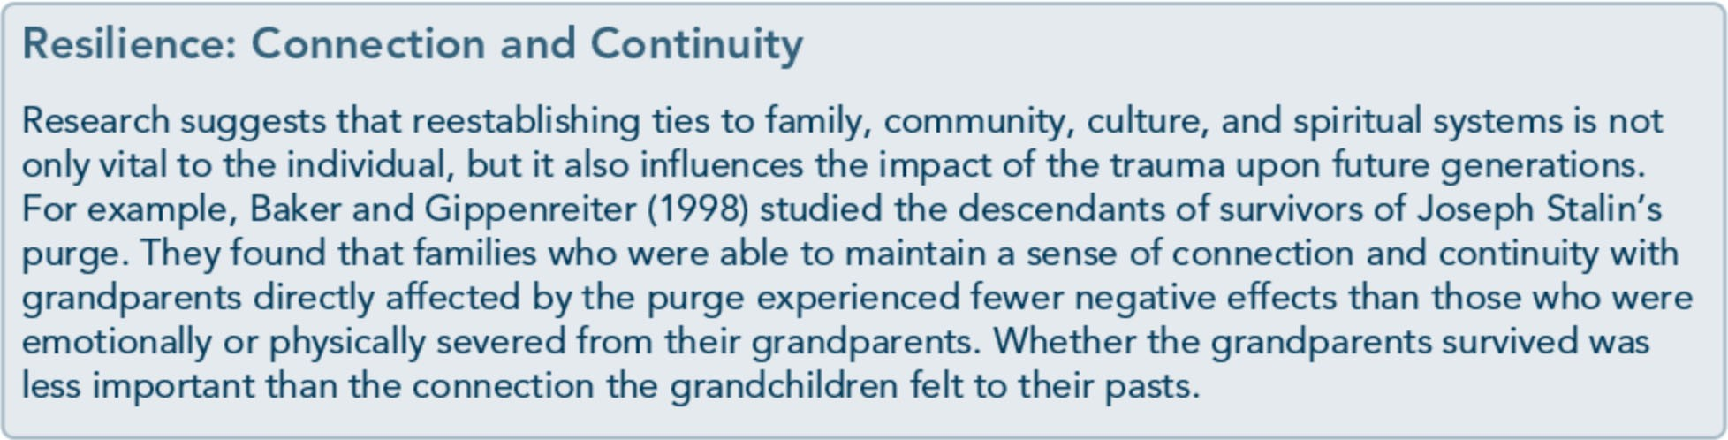

Shattered Assumptions, by Janoff-Bulman, 1992.) For example, some trauma survivors see themselves as irreparably wounded or beyond the possibility of healing. The following case illustration (Sonja) explores not only the im­ portance of meaning, but also the role that trauma plays in altering an individual's core assumptions-the very assumptions that pro­ vide meaning and a means to organize our lives and our interactions with the world and others.
Cultural meaning of trauma
Counselors should strive to appreciate the cultural meaning of a trauma. How do cultural interpretations, cultural support, and cultural responses affect the experience of trauma? It is critical that counselors do not presume to un­ derstand the meaning of a traumatic experi­ ence without considering the client's cultural context. Culture strongly influences the per­ ceptions of trauma. For instance, a trauma involving shame can be more profound for a person from an Asian culture than for some­ one from a European culture. Likewise, an Alaska Native individual or community, de­ pending upon their Tribal ancestry, may be­ lieve that the traumatic experience serves as a form of retribution. Similarly, the sudden death of a family member or loved one can be less traumatic in a culture that has a strong belief in a positive afterlife. It is important for counselors to recognize that their perceptions of a specific trauma could be very different from their clients' perceptions. Be careful not to judge a client's beliefs in light of your own value system. For more information on culture
and how to achieve cultural competence in providing behavioral health services, see SAMHSA's planned TIP, Improving Cultural Competence (SAMHSA, planned c).

Individual and Sociocultural Features
A wide variety of social, demographic, envi­ ronmental, and psychological factors influence a person's experience of trauma, the severity of traumatic stress reactions following the event, and his or her resilience in dealing with the short- and long-term environmental, physical, sociocultural, and emotional consequences.
This section addresses a few known factors that influence the risk of trauma along with the development of subclinical and diagnostic traumatic stress symptoms, such as mood and anxiety symptoms and disorders. It is not meant to be an exhaustive exploration of these factors, but rather, a brief presentation to make counselors and other behavioral health profes­ sionals aware that various factors influence risk for and protection against traumatic stress and subsequent reactions. (For a broader perspective on such factors, refer to Part 1, Chapter 1.)

Individual Factors
Several factors influence one's ability to deal with trauma effectively and increase one's risk for traumatic stress reactions. Individual fac­ tors pertain to the individual's genetic, biologi­ cal, and psychological makeup and history as they influence the person's experience and

52

Part 1, Chapter 2-T rauma Awareness

/
Case Illustration: Sonja
Sonja began to talk about how her life was different after being physically assaulted and robbed in a parking lot at a local strip mall a year ago. She recounts that even though there were people in the parking lot, no one came to her aid until the assailant ran off with her purse. She sustained a cheek­ bone fracture and developed visual difficulties due to the inflammation from the fracture. She re­ cently sought treatment for depressive symptoms and reported that she had lost interest in activities that typically gave her joy. She reported isolating herself from others and said that her perception of others had changed dramatically since the attack.
Sonja had received a diagnosis of major depression with psychotic features 10 years earlier and re­ ceived group therapy at a local community mental health center for 3 years until her depression went into remission. She recently became afraid that her depression was becoming more pro­ nounced, and she wanted to prevent another severe depressive episode as well as the use of psy­ chotropic medications, which she felt made her lethargic. Thus, she sought out behavioral health counseling.
As the sessions progressed, and after a psychological evaluation, it was clear that Sonja had some depressive symptoms, but they were subclinical. She denied suicidal thoughts or intent, and her thought process was organized with no evidence of hallucinations or delusions. She described her isolation as a reluctance to shop at area stores. On one hand, Sonja was self-compassionate about her reasons for avoidance, but on the other hand, she was concerned that the traumatic event had altered how she saw life and others. "I don't see people as very caring or kind, like I used to prior to the event. I don't trust them, and I feel people are too self-absorbed. I don't feel safe, and this bothers me. I worry that I'm becoming paranoid again. I guess I know better, but I just want to have the freedom to do what I want and go where I want."
Two months after Sonja initiated counseling, she came to the office exclaiming that things can in­ deed change. "You won't believe it. I had to go to the grocery store, so I forced myself to go the shopping center that had a grocery store attached to a strip mall. I was walking by a coffee shop, quickly browsing the items in the front window, when a man comes out of the shop talking at me. He says, 'You look like you need a cup of coffee.' What he said didn't register immediately. I looked at him blankly, and he said it again. 'You look like you need a cup of coffee. I'm the owner of the shop, and I noticed you looking in the window, and we have plenty of brewed coffee left before we close the shop. Come on in, it's on the house.' So I did! From that moment on, I began to see peo­ ple differently. He set it right for me-I feel as if I have myself back again, as if the assault was a sign that I shouldn't trust people, and now I see that there is some goodness in the world. As small as this kindness was, it gave me the hope that I had lost."
For Sonja, the assault changed her assumptions about safety and her view of others. She also at­ tached meaning to the event. She believed that the event was a sign that she shouldn't trust people and that people are uncaring. Yet these beliefs bothered her and contradicted how she saw herself in the world, and she was afraid that her depressive symptoms were returning.
For an inexperienced professional, her presentation may have ignited suspicions that she was be­ ginning to present with psychotic features. However, it is common for trauma survivors to experi­ ence changes in core assumptions immediately after the event and to attach meaning to the trauma. Often, a key ingredient in the recovery process is first identifying the meaning of the event and the beliefs that changed following the traumatic experience. So when you hear a client say "I will never see life the same," this expression should trigger further exploration into how life is different, what meaning has been assigned to the trauma, and how the individual has changed his or her perception of self, others, and the future.

\ (c_o_nt_i_n_ue_d_o_n_t_h_e_n_e_x_t_p_a_g_e_.)

53

Trauma-Informed Care in Behavioral Health Services

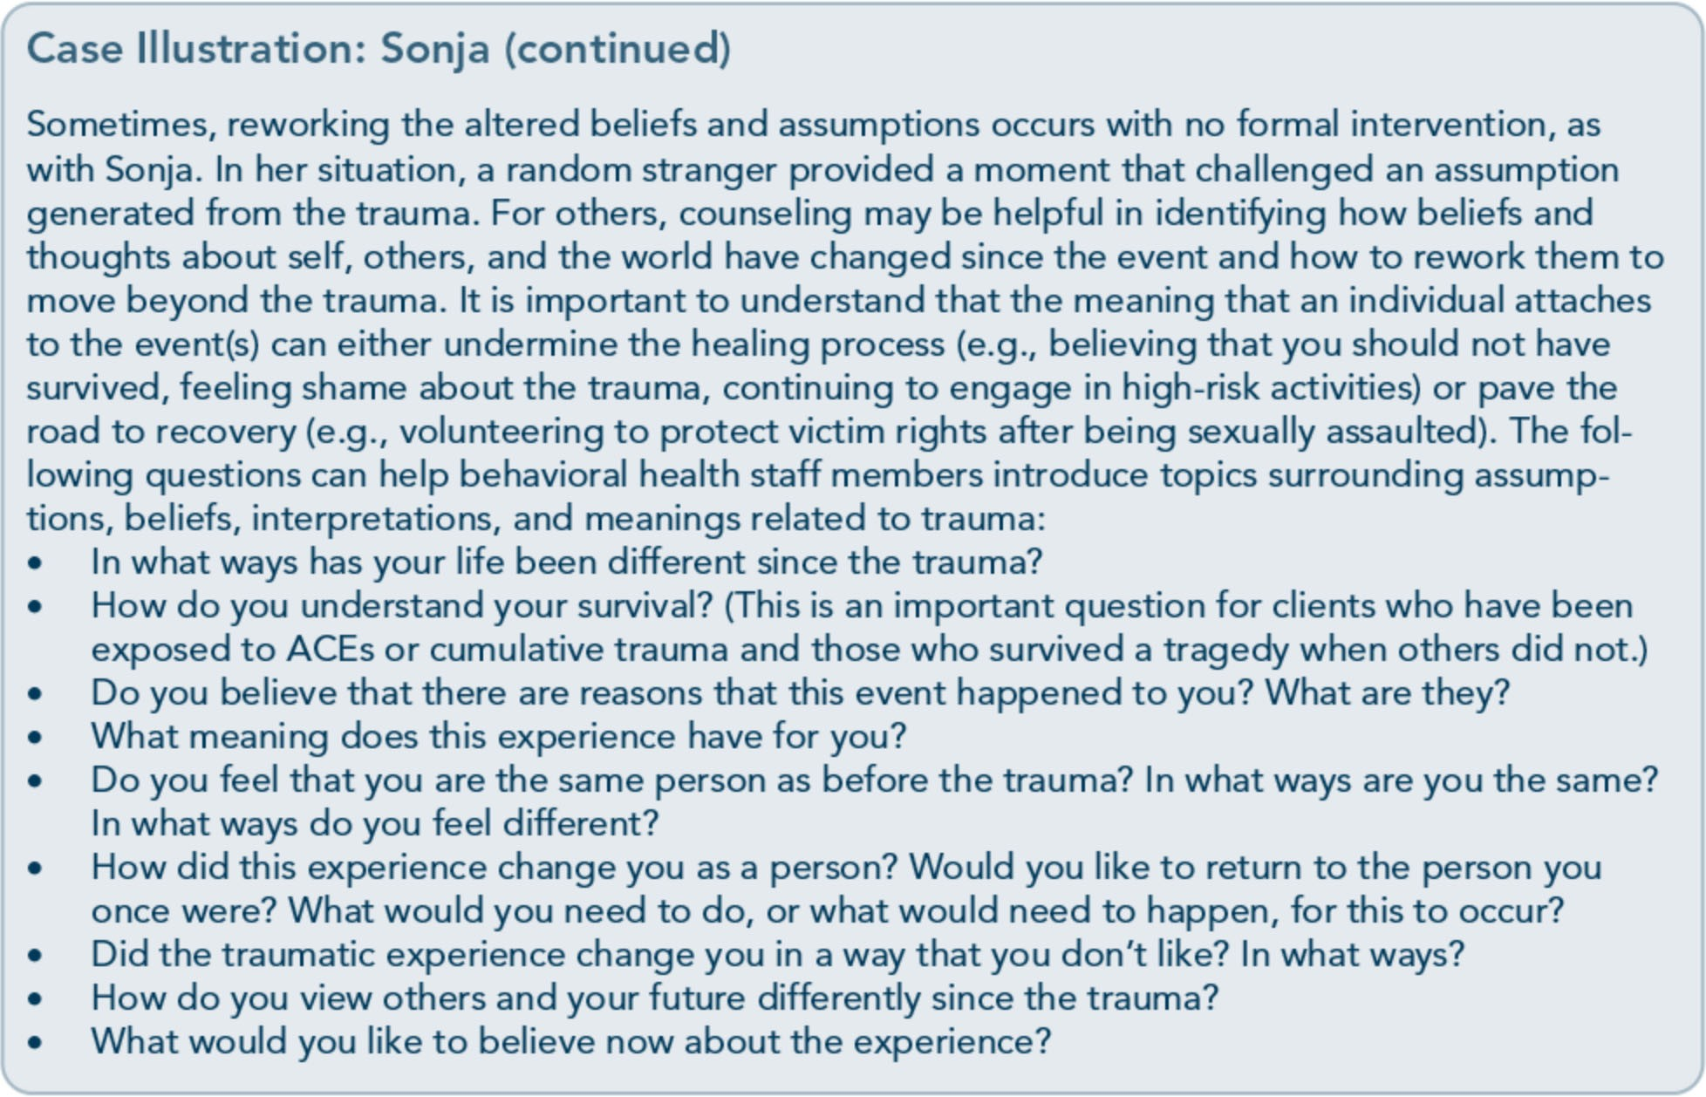

interpretation of, as well as his or her reactions to, trauma. However, many factors influence individual responses to trauma; it is not just individual characteristics. Failing to recognize that multiple factors aside from individual attributes and history influence experiences during and after trauma can lead to blaming the victim for having traumatic stress.

History of prior psychological trauma
People with histories of prior psychological trauma appear to be the most susceptible to severe traumatic responses (Nishith, Mechanic, & Resick, 2000; Vogt, Bruce, Street, & Stafford, 2007), particularly if they have avoided addressing past traumas. Because minimization, dissociation, and avoidance are common defenses for many trauma survivors, prior traumas are not always consciously avail­ able, and when they are, memories can be distorted to avoid painful affects. Some survi­ vors who have repressed their experiences de-
ny a history of trauma or are unable to explain their strong reactions to present situations.
Remember that the effects of trauma are cu­ mulative; therefore, a later trauma that out­ wardly appears less severe may have more impact upon an individual than a trauma that occurred years earlier. Conversely, individuals who have experienced earlier traumas may have developed effective coping strategies or report positive outcomes as they have learned to adjust to the consequences of the trauma(s). This outcome is often referred to as posttrau­ matic growth or psychological growth.
Clients in behavioral health treatment who have histories of trauma can respond negative­ ly to or seem disinterested in treatment efforts. They may become uncomfortable in groups that emphasize personal sharing; likewise, an individual who experiences brief bouts of dis­ sociation (a reaction of some trauma survivors) may be misunderstood by others in treatment and seen as uninterested. Providers need to

54

Part 1, Chapter 2-T rauma Awareness

attend to histories, adjust treatment to avoid retraumatization, and steer clear of labeling clients' behavior as pathological.
History of resilience
Resilience-the ability to thrive despite nega­ tive life experiences and heal from traumatic events-is related to the internal strengths and environmental supports of an individual. Most individuals are resilient despite experiencing traumatic stress. The ability to thrive beyond the trauma is associated with individual factors as well as situational and contextual factors.
There are not only one or two primary factors that make an individual resilient; many factors contribute to the development of resilience.
There is little research to indicate that there are specific traits predictive of resilience; instead, it appears that more general characteristics influ­ ence resilience, including neurobiology (Feder, Charney, & Collins, 2011), flexibility in adapt­ ing to change, beliefs prior to trauma, sense of self-efficacy, and ability to experience positive emotions (Bonanno &Mancini, 2011).
History of mental disorders
The correlations among traumatic stress, sub­ stance use disorders, and co-occurring mental disorders are well known. According to the Diagnostic and Statistical Manual of Mental Dis­ orders, Fifth Edition (American Psychiatric Association, 2013a), traumatic stress reactions are linked to higher rates of mood, substance­ related, anxiety, trauma, stress-related, and other mental disorders, each of which can pre­ cede, follow, or emerge concurrently with trauma itself. A co-occurring mental disorder is a significant determinant of whether an individual can successfully address and resolve trauma as it emerges from the past or occurs in the present. Koenen, Stellman, Stellman, and Sommer (2003) found that the risk of
developing PTSD following combat trauma was higher for individuals with preexisting conduct disorder, panic disorder, generalized

anxiety disorder, and/or major depression than for those without preexisting mental disorders. For additional information on comorbidity of trauma and other mental disorders, see TIP
42, Substance Abuse Treatment far Persons With Co-Occurring Disorders (CSAT, 2005c).

Sociodemographic Factors Demographic variables are not good predic­ tors of who will experience trauma and subse­ quent traumatic stress reactions. Gender, age, race and ethnicity, sexual orientation, marital status, occupation, income, and education can all have some influence, but not enough to determine who should or should not receive screening for trauma and traumatic stress symptoms. The following sections cover a few selected variables. (For more information, please refer to Part 3 of this TIP, the online literature review.)

Gender
In the United States, men are at greater risk than women for being exposed to stressful events. Despite the higher prevalence among men, lifetime PTSD occurs at about twice the rate among women as it does in men. Less is known about gender differences with subclini­ cal traumatic stress reactions. There are also other gender differences, such as the types of trauma experienced by men and women.
Women are more likely to experience physical and sexual assault, whereas men are most like­ ly to experience combat and crime victimiza­ tion and to witness killings and serious injuries (Breslau, 2002; Kimerling, Ouimette, & Weitlauf, 2007; Tolin & Foa, 2006). Women in military service are subject to the same risks as men and are also at a greater risk for mili­ tary sexual trauma. Men's traumas often occur in public; women's are more likely to take place in private settings. Perpetrators of trau­ mas against men are often strangers, but wom­ en are more likely to know the perpetrator.

55

Trauma-Informed Care in Behavioral Health Services

Age
In general, the older one becomes, the higher the risk of trauma-but the increase is not dramatic. Age is not particularly important in predicting exposure to trauma, yet at no age is one immune to the risk. However, trauma that occurs in the earlier and midlife years appears to have greater impact on people for different reasons. For younger individuals, the trauma can affect developmental processes, attach­ ment, emotional regulation, life assumptions, cognitive interpretations of later experiences, and so forth (for additional resources, visit the National Child Traumatic Stress Network; http://www.nctsn.org/). For adults in midlife, trauma may have a greater impact due to the enhanced stress or burden of care that often characterizes this stage of life-caring for their children and their parents at the same time. Older adults are as likely as younger adults to recover quickly from trauma, yet they may have greater vulnerabilities, including their ability to survive without injury and their ability to address the current trauma without psychological interference from earlier stress­ ful or traumatic events. Older people are natu­ rally more likely to have had a history of trauma because they have lived longer, thus creating greater vulnerability to the effects of cumulative trauma.

Race, ethnicity, and culture
The potential for trauma exists in all major racial and ethnic groups in American society, yet few studies analyze the relationship of race and ethnicity to trauma exposure and/or trau­ matic stress reactions. Some studies show that certain racial and ethnic groups are at greater risk for specific traumas. For example, African Americans experienced higher rates of overall violence, aggravated assault, and robbery than Whites but were as likely to be victims of rape or sexual assault (Catalano, 2004). Literature reflects that diverse ethnic, racial, and cultural groups are more likely to experience adverse effects from various traumas and to meet crite­ ria for posttraumatic stress (Bell, 2011).
Sexual orientation and gender identity Lesbian, gay, bisexual, and transgender indi­ viduals are likely to experience various forms of trauma associated with their sexual orienta­ tion, including harsh consequences from fami­ lies and faith traditions, higher risk of assault from casual sexual partners, hate crimes, lack oflegal protection, and laws of exclusion (Brown, 2008). Gay and bisexual men as well as transgender people are more likely to expe­ rience victimization than lesbians and bisexual women. Dillon (2001) reported a trauma ex­ posure rate of 94 percent among lesbian, gay,

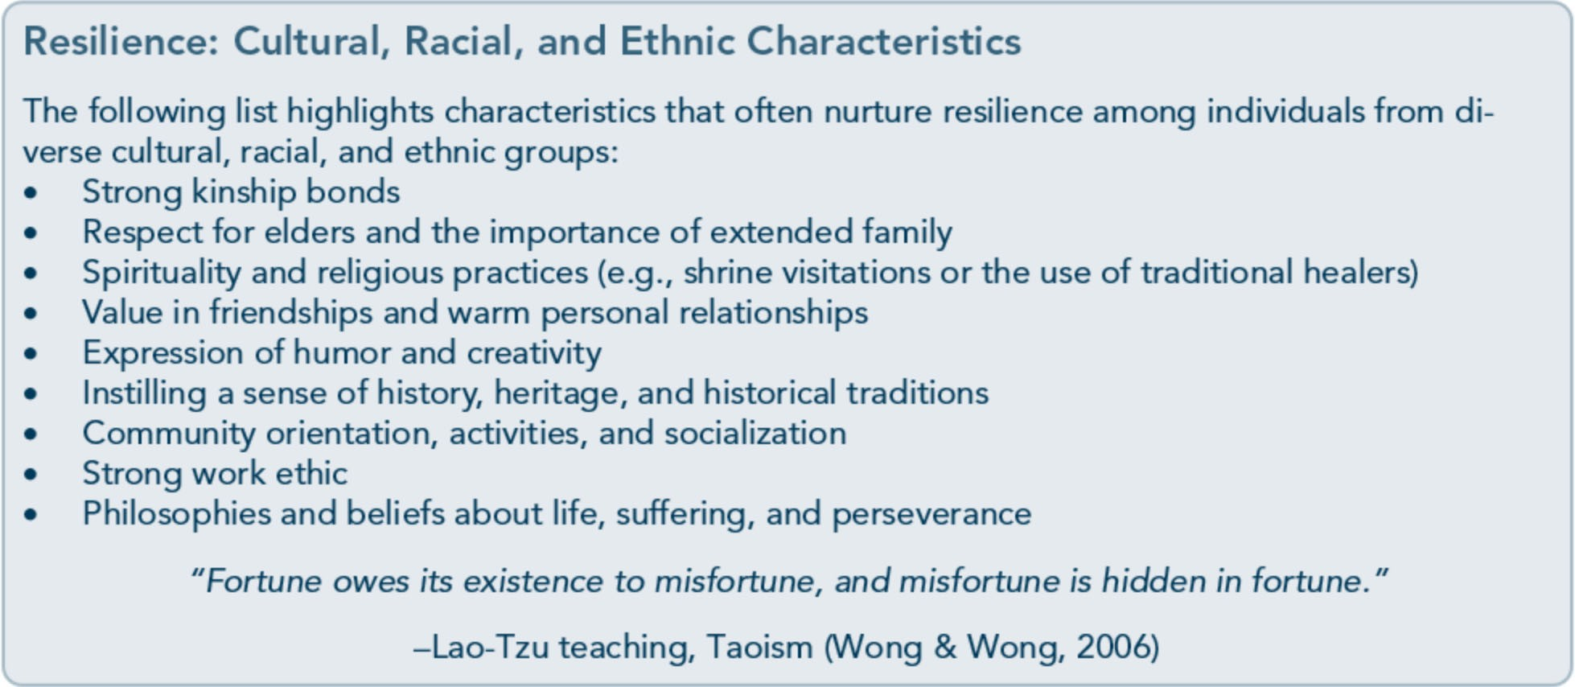

56

Part 1, Chapter 2-T rauma Awareness

and bisexual individuals; more than 40 percent of respondents experienced harassment due to their sexual orientation. Heterosexual orienta­ tion is also a risk for women, as women in relationships with men are at a greater risk of being physically and sexually abused.
People who are homeless Homelessness is typically defined as the lack of an adequate or regular dwelling, or having a nighttime dwelling that is a publicly or pri­ vately supervised institution or a place not intended for use as a dwelling (e.g., a bus sta­ tion). The U.S. Department of Housing and Urban Development (HUD) estimates that between 660,000 and 730,000 individuals were homeless on any given night in 2005 (HUD, 2007). Two thirds were unaccompa­ nied persons; the other third were people in families. Adults who are homeless and unmar­ ried are more likely to be male than female.
About 40 percent of men who are homeless
are veterans (National Coalition for the Homeless, 2002); this percentage has grown, including the number of veterans with de­ pendent children (Kuhn & Nakashima, 2011).
Rates of trauma symptoms are high among people who are homeless (76 to 100 percent of women and 67 percent of men; Christensen et al., 2005;Jainchill, Hawke, & Yagelka, 2000), and the diagnosis of PTSD is among the most prevalent non-substance use Axis I disorders (Lester et al., 2007; McNamara, Schumacher, Milby, Wallace, & Usdan, 2001). People who are homeless report high levels of trauma (es­ pecially physical and sexual abuse in childhood or as adults) preceding their homeless status; assault, rape, and other traumas frequently

happen while they are homeless. Research suggests that many women are homeless be­ cause they are fleeing domestic violence (National Coalition for the Homeless, 2002). Other studies suggest that women who are homeless are more likely to have histories of childhood physical and sexual abuse and to have experienced sexual assault as adults. A history of physical and/or sexual abuse is even more common among women who are home­ less and have a serious mental illness.
Youth who are homeless, especially those who live without a parent, are likely to have experi­ enced physical and/or sexual abuse. Between 21 and 42 percent of youth runaways report having been sexually abused before leaving their homes; for young women, rates range from 32 to 63 percent (Administration on Children, Youth and Families, 2002). Addi­ tionally, data reflect elevated rates of substance abuse for youth who are homeless and have histories of abuse.
More than half of people who are homeless have a lifetime prevalence of mental illness and substance use disorders. Those who are homeless have higher rates of substance abuse (84 percent of men and 58 percent of women), and substance use disorders, including alcohol and drug abuse/dependence, increase with longer lengths of homelessness (North, Eyrich, Pollio, & Spitznagel, 2004).
For more information on providing trauma­ informed behavioral health services to clients who are homeless, and for further discussion of the incidence of trauma in this population, see TIP 55- R, Behavioral Health Services far People Who Are Homeless (SAMHSA, 2013b).

57

Appendix A-Bibliography

Abrahams, I. A., Ali, 0., Davidson, L., Evans, A. C., King,]. K., Poplawski, P., et al. (2010).
Philadelphia behavioral health services traniformation: Practice guidelines for recovery and resilience oriented treatment. Philadelphia: Department of Behavioral Health and Intellectual Disability Services.
Adams, R. E., Figley, C.R., & Boscarino,]. A. (2008). The Compassion Fatigue Scale: Its use with social workers following urban disaster. Research on Social Work Practice, 18, 238-250.
Adler, A. B., Litz, B. T., Castro, C. A., Suvak, M., Thomas,]. L., Burrell, L., et al. (2008). A group randomized trial of critical incident stress debriefing provided to U.S. peacekeepers.journalof Traumatic Stress, 21, 253-263.
Administration on Children, Youth, and Families. (2002). Sexual abuse among homeless adolescents: Prevalence, correlates, and sequelae. Washington, DC: Administration on Children, Youth, and Families.
Advanced Trauma Solutions, Inc. (2012). Trauma affect regulation: Guide for education & therapy.
Farmington, CT: Advanced Trauma Solutions, Inc.
Allen,]. G. (2001). Traumatic relationships and serious mental disorders. New York: John Wiley &
Sons Ltd.
American Psychiatric Association. (1980). Diagnostic and statistical manual of mental disorders. (3rd ed.). Washington, DC: American Psychiatric Association.
American Psychiatric Association. (2000a). Diagnostic and statistical manual of mental disorders.
(4th ed., text rev.). Washington, DC: American Psychiatric Association.
American Psychiatric Association. (20006). Position statement on therapies focused on memories of
childhood physical and sexual abuse. Washington, DC: American Psychiatric Association.
American Psychiatric Association. (2012a). G 03 posttraumatic stress disorder. Washington, DC:
American Psychiatric Association.
American Psychiatric Association. (20126). Proposed draft revisions to DSM disorders and criteria.
Washington, DC: American Psychiatric Association.
American Psychiatric Association. (2013a). Diagnostic and statistical manual of mental disorders.
(5th ed.). Arlington, VA: American Psychiatric Association.

215

Trauma-Informed Care in Behavioral Health Services

American Psychiatric Association. (2013b). Highlights of changes from DSM-IV-TR to DSM-5.
Arlington, VA: American Psychiatric Association.
American Psychological Association & The Ad Hoc Committee on Legal and Ethical Issues in the Treatment oflnterpersonal Violence. (2003). Potential problems far psychologists working with the area of interpersonal violence. Washington, DC: American Psychiatric Association.
Anda, R. F., Felitti, V.J., Bremner,]. D., Walker,]. D., Whitfield, C., Perry, B. D., et al. (2006). The enduring effects of abuse and related adverse experiences in childhood. A convergence of evidence from neurobiology and epidemiology. European Archives of Psychiatry and Clinical Neuroscience, 256 (3), 174-86.
Anda, R. F., Felitti, V.J., Brown, D., Chapman, D., Dong, M., Dube, S. R., et al. (2006). Insights into intimate partner violence from the adverse childhood experiences (ACE) study. In The physician's guide to intimate partner violence and abuse (pp. 77-88). Volcano, CA: Volcano Press.
Andreasen, N. C. (2010). Posttraumatic stress disorder: A history and a critique.Annals of the New YorkAcademy of Sciences, 1208, 67-71.
Antony, M. M., Orsillo, S. M., & Roemer, L. (2001). Practitioner's guide to empirically based measures of anxiety. New York: Plenum Press.
Arkowitz, H., Miller, W.R., Westra, H. A., & Rollnick, S. (2008). Motivational interviewing in the treatment of psychological problems: Conclusions and future directions. In Motivational interviewing in the treatment of psychological problems (pp. 324-342). New York: Guilford Press.
Auerbach, S. (2003). Sleep disorders related to alcohol and other drug use. In A.W. Graham, T. K. Schultz, M. F. Mayo-Smith, R. K. Ries, & B. B. Wilford (Eds.), Principles of addiction medicine. (3rd ed.). (pp. 1179-1193). Chevy Chase, MD: American Society of Addiction Medicine.
Baer, R. A. (2003). Mindfulness training as a clinical intervention: A conceptual and empirical review. Clinical Psychology: Science and Practice, 10, 125-143.
Baker, K. G. & Gippenreiter,J. B. (1998). Stalin's purge and its impact on Russian families: A pilot study. In Y. Danieli (Ed.), International handbook of multigenerational legacies of trauma (pp.
403-434). New York: Plenum Press.
Bartone, P. T., Roland, R.R., Picano,J.J., & Williams, T. (2008). Psychological hardiness predicts success in US Army Special Forces candidates. International journal of Selection and Assessment, 16, 78-81.
Batten, S. V. & Hayes, S. C. (2005). Acceptance and commitment therapy in the treatment of comorbid substance abuse and post-traumatic stress disorder: A case study. Clinical Case Studies, 4, 246-262.
Beck, A. T. (1993). Beck anxiety inventory. San Antonio, TX: The Psychological Corporation. Beck, A. T., Rush, A.]., Shaw, B. F., & Emery, G. (1979). Cognitive therapy of depression. New York:
Guilford Press.
Beck, A. T., Steer, R. A., & Brown, G. K. (1996). Beck depression inventory -II manual. San Antonio, TX: The Psychological Corporation.

216

Appendix A-Bibliography

Beck, A. T., Wright, F. D., Newman, C. F., & Liese, B. F. (1993). Cognitive therapy of substance abuse. New York: Guilford Press.
Bell, C. C. (2011). Trauma, culture, and resiliency. In S. M. Southwick, B. T. Litz, D. Charney, &
M.J. Friedman (Eds.), Resilience and mental health: Challenges across the lifespan (pp. 176-187). New York: Cambridge University Press.
Benedek, D. M. & Ursano, R.J. (2009). Posttraumatic stress disorder: From phenomenology to clinical practice. FOCUS: The journal of Lifelong Learning in Psychiatry, 7, 160-175.
Bernard,]. M. & Goodyear, R. K. (2009). Fundamentals of clinical supervision. (4th ed.). Upper Saddle River, NJ: Merrill/Pearson.
Bernstein, D. P. (2000). Childhood trauma and drug addiction: Assessment, diagnosis, and
treatment.Alcoholism Treatment Quarterly, 18, 19-30.
Bernstein, E. M. & Putnam, F. W. (1986). Development, reliability, and validity of a dissociation
scale.journal of Nervous and Mental Disease, 174, 727-735.
Bills, L.J. (2003). Using trauma theory and S.A.G.E. in outpatient psychiatric practice. Psychiatric Quarterly, 74, 191-203.
Blackburn, C. (1995). Family and relapse. Counselor. Alexandria, VA: National Association of Alcoholism and Drug Abuse Counselors.
Blake, D., Weathers, F., Nagy, L., Koloupek, D., Klauminzer, G., Charney, D., et al. (1990). Clinician Administered PTSD Scale (CAPS). Boston: National Center for Post-Traumatic Stress Disorder.
Bleich, A., Gelkopf, M., & Solomon, Z. (2003). Exposure to terrorism, stress-related mental health symptoms, and coping behaviors among a nationally representative sample in Israel. journal of the American Medical Association, 290, 612-620.
Bloom, S. L. (1997). Creating sanctuary: Toward the evolution of sane societies. New York: Routledge. Bloom, S. L., Bennington-Davis, M., Farragher, B., McCorkle, D., Nice-Martini, K., & Wellbank,
K. (2003). Multiple opportunities for creating sanctuary. Psychiatric Quarterly, 74, 173-190.
Bloom, S. L., Foderaro,]. F., & Ryan, R. (2006). S.E.L.F: A trauma-informed psychoeducational group Curriculum. Retrieved on November 18, 2013, from: http://sanctuaryweb.com/PDFs_new/COMPLETE%20INTRODUCTO RY%20MATERI AL.pdf
Bober, T. & Regehr, C. (2006). Strategies for reducing secondary or vicarious trauma: Do they work? Brie/Treatment and Crisis Intervention, 6, 1-9.
Bonanno, G. A. (2004). Loss, trauma, and human resilience: Have we underestimated the human capacity to thrive after extremely aversive events? American Psychologist, 29, 20-28.
Bonanno, G. A. & Mancini, A. D. (2011). Toward a lifespan approach to resilience and potential trauma. In S. M. Southwick, B. T. Litz, D. Charney, &M.J. Friedman (Eds.), Resilience and mental health: Challenges across the lifespan (pp. 120-134). New York: Cambridge University Press.

217

Trauma-Informed Care in Behavioral Health Services

Bowman, C. G. &Mertz, E. (1996). A dangerous direction: Legal intervention in sexual abuse survivor therapy. Harvard Law Review, 109, 551-639.
Brady, K. T., Killeen, T., Saladin, M. E., Dansky, B., & Becker, S. (1994). Comorbid substance abuse and posttraumatic stress disorder: Characteristics of women in treatment. American journal on Addictions, 3, 160-164.
Breslau, N. (2002). Gender differences in trauma and posttraumatic stress disorder.journal of
Gender Specific Medicine, 5, 34-40.
Brewin, C.R. (2007). Remembering and forgetting. In M.J. Friedman, T. M. Keane, & P.A. Resick (Eds.), Handbook of PTSD: Science and practice (pp. 116-134). New York: Guilford Press.
Brewin, C.R., Andrews, B., & Valentine,]. D. (2000). Meta-analysis of risk factors for posttraumatic stress disorder in trauma-exposed adults.journal of Consulting and Clinical
Psychology, 68, 748-766.
Bride, B. E. (2007). Prevalence of secondary traumatic stress among social workers. Social Work, 52,
63-70.
Briere,]. (1995). Trauma symptom inventory professional manual. Odessa, FL: Psychological Assessment Resources.
Briere, J. (1996a). Therapy far adults molested as children: Beyond survival (2nd ed.). New York: Springer Pub.
Briere,]. (19966). Trauma symptom checklist far children professional manual. Odessa, FL: Psychological Assessment Resources.
Briere,]. (1997). Psychological assessment of adult posttraumatic states. (1st ed.). Washington, DC: American Psychological Association.
Briere, J. & Scott, C. (2006a). Central issues in trauma treatment. In Principles of trauma therapy: A guide to symptoms, evaluation, and treatment (pp. 67-85). Thousand Oaks, CA: Sage Publications.
Briere,]. & Scott, C. (20066). Principles of trauma therapy: A guide to symptoms, evaluation, and treatment. Thousand Oaks, CA: Sage Publications.
Briere,]., & Scott, C. (2012). Principles of trauma therapy: A guide to symptoms, evaluation, and treatment. (2nd ed.). Thousand Oaks, CA: Sage Publications.
Bronfenbrenner,U. (1979). The ecology of human development: Experiments by nature and design.
Cambridge, MA: Harvard University Press.
Bronfenbrenner,U. & Ceci, S.J. (1994). Nature-nurture reconceptualized in developmental perspective: A bioecological model. Psychological Review, 101, 568-586.
Brown, L. S. (2008). Feminist therapy. InJ. L. Lebow (Ed.), Twenty-first century psychotherapies: Contemporary approaches to theory and practice (pp. 277-306). Hoboken, NJ: John Wiley & Sons, Inc.

218

Appendix A-Bibliography

Brown, P. J., Read,]. P., & Kahler, C. W. (2003). Comorbid posttraumatic stress disorder and substance use disorders: Treatment outcomes and the role of coping. In P. Ouimette & P. J. Brown (Eds.), Trauma and substance abuse: Causes, consequences, and treatment of comorbid disorders (pp. 171-188). Washington, DC: American Psychological Association.
Bryant, R. A. & Harvey, A. G. (2000). Acute stress disorder: A handbook of theory, assessment, and treatment. (1st ed.). Washington, DC: American Psychological Association.
Bryant, R. A. & Harvey, A.G. (2003). Gender differences in the relationship between acute stress disorder and posttraumatic stress disorder following motor vehicle accidents.Australian and New Zealand journal of Psychiatry, 37, 226-229.
Burke, P.A., Carruth, B., & Prichard, D. (2006). Counselor self-care in work with traumatized addicted people. In B. Carruth (Ed.), Psychological trauma and addiction treatment (pp. 283- 302). New York: Haworth Press.
Cahill, S. P., Rothbaum, B. 0., Resick, P.A., & Follette, V. M. (2009). Cognitive-behavioral therapy for adults. In E. B. Foa, T. M. Keane, M.J. Friedman, &J. A. Cohen (Eds.), Effective treatments far PTSD: Practice guidelines from the International Society far Traumatic Stress Studies. (2nd ed.). (pp. 139-222). New York: Guilford Press.
Caldwell, B. A. & Redeker, N. (2005). Sleep and trauma: An overview. Issues in Mental Health Nursing, 26, 721-738.
Campbell-Sills, L. & Stein, M. B. (2007). Psychometric analysis and refinement of the Connor­ Davidson Resilience Scale (CD-RISC): Validation of a 10-item measure of resilience.journal of Traumatic Stress, 20, 1019-1028.
Capezza, N. M. & Najavits, L. M. (2012). Rates of trauma-informed counseling at substance abuse treatment facilities: Reports from over 10,000 programs. Psychiatric Services, 63, 390- 394.
Cardena, E., Koopman, C., Classen, C., Waelde, L. C., & Spiegel, D. (2000). Psychometric properties of the Stanford Acute Stress Reaction Qyestionnaire (SASRQ2: a valid and reliable measure of acute stress.journal ofTraumatic Stress, 13, 719-734.
Carlson, E. B. & Putnam, F. W. (1993). An update on the Dissociative Experiences Scale.
Dissociation, 6, 16-27.
Carroll,]. F. X. & McGinley,J.J. (2001). A screening form for identifying mental health problems in alcohol/other drug dependent persons. Alcoholism Treatment Quarterly, 19, 33-47.
Catalano, S. (2012). Intimate partner violence in the US. Washington, DC: Bureau ofJustice Statistics.
Catalano, S. M. (2004). Criminal victimization, 2003: National crime victimization survey.
Washington, DC: Bureau of Justice Statistics.
Centers for Disease Control and Prevention. (2009). The social-ecological model· A framework far prevention. Retrieved on November 20, 2013, from: http://www.cdc.gov/violenceprevention/overview/social-ecologicalmodel.html

219

Trauma-Informed Care in Behavioral Health Services

Centers for Disease Control and Prevention. (2012). Publications by health outcome: Adverse childhood experiences (ACE) study. Atlanta, GA: Centers for Disease Control and Prevention.
Centers for Disease Control and Prevention. (2013,January 18). Adverse Childhood Experiences (ACE) Study. Retrieved on August 14, 2013, from http://www.cdc.gov/ace/about.htm
Center for Mental Health Services. (1996). Responding to the needs of people with serious and persistent mental illness in times of major disaster (Rep. No. SMA 96-3077). Rockville, MD: Substance Abuse and Mental Health Services Administration.
Center for Mental Health Services, Division of Prevention, Traumatic Stress and Special Programs, Emergency Mental Health and Traumatic Stress Services Branch. (2003). Fact sheet (Rep. No. KEN 95-0011). Rockville, MD: Substance Abuse and Mental Health Services Administration.
Center for Mental Health Services, Substance Abuse and Mental Health Services Administration. (2005). Roadmap to seclusion and restraint free mental health services. Rockville, MD: Substance Abuse and Mental Health Services Administration.
Center for Substance Abuse Treatment. (1993a). Improving treatment far drug-exposed infants. Treatment Improvement Protocol (TIP) Series 5. HHS Publication No. (SMA) 95-3057. Rockville, MD: Substance Abuse and Mental Health Services Administration.
Center for Substance Abuse Treatment. (19936). Pregnant, substance-using women. Treatment Improvement Protocol (TIP) Series 2. HHS Publication No. (SMA) 93-1998. Rockville, MD: Substance Abuse and Mental Health Services Administration.
Center for Substance Abuse Treatment. (1993c). Screening/or infectious diseases among substance abusers. Treatment Improvement Protocol (TIP) Series 6. HHS Publication No. (SMA) 95- 3060. Rockville, MD: Substance Abuse and Mental Health Services Administration.
Center for Substance Abuse Treatment. (1994). Simple screening instruments far outreach far alcohol and other drug abuse and infectious diseases. Treatment Improvement Protocol (TIP) Series 11. HHS Publication No. (SMA) 94-2094. Rockville, MD: Substance Abuse and Mental Health Services Administration.
Center for Substance Abuse Treatment. (1995a). Alcohol and other drug screening of hospitalized trauma patients. Treatment Improvement Protocol (TIP) Series 16. HHS Publication No. (SMA) 95-3041. Rockville, MD: Substance Abuse and Mental Health Services Administration.
Center for Substance Abuse Treatment. (19956). Combining alcohol and other drug treatment with diversion far juveniles in the justice system. Treatment Improvement Protocol (TIP) Series 21. HHS Publication No. (SMA) 95-3051. Rockville, MD: Substance Abuse and Mental Health Services Administration.
Center for Substance Abuse Treatment. (1995c). Developing state outcomes monitoring systems far alcohol and other drug abuse treatment. Treatment Improvement Protocol (TIP) Series 14. HHS Publication No. (SMA) 95-3031. Rockville, MD: Substance Abuse and Mental Health Services Administration.

220

Appendix A-Bibliography

Center for Substance Abuse Treatment. (1995d). The role and current status of patient placement criteria in the treatment of substance use disorders. Treatment Improvement Protocol (TIP) Series
13. HHS Publication No. (SMA) 95-3021. Rockville, MD: Substance Abuse and Mental Health Services Administration.
Center for Substance Abuse Treatment. (1995e). The tuberculosis epidemic: Legal and ethical issues far alcohol and other drug abuse treatment providers. Treatment Improvement Protocol (TIP) Series 18. HHS Publication No. (SMA) 95-3047. Rockville, MD: Substance Abuse and Mental Health Services Administration.
Center for Substance Abuse Treatment. (1996). Treatment drug courts: Integrating substance abuse treatment with legal case processing. Treatment Improvement Protocol (TIP) Series 23. HHS Publication No. (SMA) 96-3113. Rockville, MD: Substance Abuse and Mental Health Services Administration.
Center for Substance Abuse Treatment. (1997a). A guide to substance abuse services far primary care clinicians. Treatment Improvement Protocol (TIP) Series 24. HHS Publication No. (SMA) 97-3139. Rockville, MD: Substance Abuse and Mental Health Services Administration.
Center for Substance Abuse Treatment. (1997b). Substance abuse treatment and domestic violence. Treatment Improvement Protocol (TIP) Series 25. HHS Publication No. (SMA) 97-3163. Rockville, MD: Substance Abuse and Mental Health Services Administration.
Center for Substance Abuse Treatment. (1998a). Comprehensive case management far substance abuse treatment. Treatment Improvement Protocol (TIP) Series 27. HHS Publication No. (SMA) 98-3222. Rockville, MD: Substance Abuse and Mental Health Services Administration.
Center for Substance Abuse Treatment. (1998b). Continuity of offender treatment far substance use disorders from institution to community. Treatment Improvement Protocol (TIP) Series 30.
HHS Publication No. (SMA) 98-3245. Rockville, MD: Substance Abuse and Mental Health Services Administration.
Center for Substance Abuse Treatment. (1998c). Naltrexone and alcoholism treatment. Treatment Improvement Protocol (TIP) Series 28. HHS Publication No. (SMA) 98-3206. Rockville, MD: Substance Abuse and Mental Health Services Administration.
Center for Substance Abuse Treatment. (1998d). Substance abuse among older adults. Treatment Improvement Protocol (TIP) Series 26. HHS Publication No. (SMA) 98-3179. Rockville, MD: Substance Abuse and Mental Health Services Administration.
Center for Substance Abuse Treatment. (1998e). Substance use disorder treatment far people with physical and cognitive disabilities. Treatment Improvement Protocol (TIP) Series 29. HHS Publication No. (SMA) 98-3249. Rockville, MD: Substance Abuse and Mental Health Services Administration.
Center for Substance Abuse Treatment. (1999a). Brief interventions and brief therapies far substance abuse. Treatment Improvement Protocol (TIP) Series 34. HHS Publication No. (SMA) 99- 3353. Rockville, MD: Substance Abuse and Mental Health Services Administration.

221

Trauma-Informed Care in Behavioral Health Services

Center for Substance Abuse Treatment. (1999b). Enhancing motivation far change in substance abuse treatment. Treatment Improvement Protocol (TIP) Series 35. HHS Publication No. (SMA) 99-3354. Rockville, MD: Substance Abuse and Mental Health Services Administration.
Center for Substance Abuse Treatment. (1999c). Screening and assessing adolescents far substance use disorders. Treatment Improvement Protocol (TIP) Series 31. HHS Publication No. (SMA) 99-3282. Rockville, MD: Substance Abuse and Mental Health Services Administration.
Center for Substance Abuse Treatment. (1999d). Treatment of adolescents with substance use disorders. Treatment Improvement Protocol (TIP) Series 32. HHS Publication No. (SMA) 99- 3283. Rockville, MD: Substance Abuse and Mental Health Services Administration.
Center for Substance Abuse Treatment. (1999e). Treatment far stimulant use disorders. Treatment Improvement Protocol (TIP) Series 33. HHS Publication No. (SMA) 99-3296. Rockville, MD: Substance Abuse and Mental Health Services Administration.
Center for Substance Abuse Treatment. (2000a). Integrating substance abuse treatment and vocational services. Treatment Improvement Protocol (TIP) Series 38. HHS Publication No. (SMA) 00-3470. Rockville, MD: Substance Abuse and Mental Health Services Administration.
Center for Substance Abuse Treatment. (2000b). Substance abuse treatment far persons with child abuse and neglect issues. Treatment Improvement Protocol (TIP) Series 36. HHS Publication No. (SMA) 00-3357. Rockville, MD: Substance Abuse and Mental Health Services Administration.
Center for Substance Abuse Treatment. (2000c). Substance abuse treatment far persons with HIV/AIDS. Treatment Improvement Protocol (TIP) Series 37. HHS Publication No. (SMA) 00-3459. Rockville, MD: Substance Abuse and Mental Health Services Administration.
Center for Substance Abuse Treatment. (2004a). Clinical guidelines far the use of buprenorphine in the treatment of opioid addiction. Treatment Improvement Protocol (TIP) Series 40. HHS Publication No. (SMA) 04-3939. Rockville, MD: Substance Abuse and Mental Health Services Administration.
Center for Substance Abuse Treatment. (2004b). Substance abuse treatment and family therapy. Treatment Improvement Protocol (TIP) Series 39. HHS Publication No. (SMA) 04-3957. Rockville, MD: Substance Abuse and Mental Health Services Administration.
Center for Substance Abuse Treatment. (2005a). Medication-assisted treatment far opioid addiction.
Treatment Improvement Protocol (TIP) Series 43. HHS Publication No. SMA 05-4048. Rockville, MD: Substance Abuse and Mental Health Services Administration.
Center for Substance Abuse Treatment. (2005b). Substance abuse treatment far adults in the criminal justice system. Treatment Improvement Protocol (TIP) Series 44. HHS Publication No. (SMA) 05-4056. Rockville, MD: Substance Abuse and Mental Health Services Administration.
Center for Substance Abuse Treatment. (2005c). Substance abuse treatment far persons with co­ occurring disorders. Treatment Improvement Protocol (TIP) Series 42. HHS Publication No. SMA 05-3992. Rockville, MD: Substance Abuse and Mental Health Services Administration.

222

Appendix A-Bibliography

Center for Substance Abuse Treatment. (2005d). Substance abuse treatment: Group therapy.
Treatment Improvement Protocol (TIP) Series 41. HHS Publication No. SMA 05-4056. Rockville, MD: Substance Abuse and Mental Health Services Administration.
Center for Substance Abuse Treatment. (2006a). Detoxification and substance abuse treatment. Treatment Improvement Protocol (TIP) Series 45. HHS Publication No. SMA 06-4131. Rockville, MD: Substance Abuse and Mental Health Services Administration.
Center for Substance Abuse Treatment. (2006b). Substance abuse:Administrative issues in intensive outpatient treatment. Treatment Improvement Protocol (TIP) Series 46. HHS Publication No. SMA 06-4151. Rockville, MD: Substance Abuse and Mental Health Services Administration.
Center for Substance Abuse Treatment. (2006c). Substance abuse: Clinical issues in intensive outpatient treatment. Treatment Improvement Protocol (TIP) Series 47. HHS Publication No. SMA 06-4182. Rockville, MD: Substance Abuse and Mental Health Services Administration.
Center for Substance Abuse Treatment. (2008). Managing depressive symptoms in substance abuse clients during early recovery. Treatment Improvement Protocol (TIP) Series 48. HHS Publication No. SMA 08-4353. Rockville, MD: Substance Abuse and Mental Health Services Administration.
Center for Substance Abuse Treatment. (2009a).Addressing suicidal thoughts and behaviors in substance abuse treatment. Treatment Improvement Protocol (TIP) Series 50. HHS Publication No. SMA 09-4381. Rockville, MD: Substance Abuse and Mental Health Services Administration.
Center for Substance Abuse Treatment. (2009b). Clinical supervision and the professional development of the substance abuse counselor. Treatment Improvement Protocol (TIP) Series 52. HHS Publication No. SMA 09-4435. Rockville, MD: Substance Abuse and Mental Health Services Administration.
Center for Substance Abuse Treatment. (2009c). Incorporating alcohol pharmacotherapies into medical practice. Treatment Improvement Protocol (TIP) Series 49. HHS Publication No. SMA 09-4380. Rockville, MD: Substance Abuse and Mental Health Services Administration.
Center for Substance Abuse Treatment. (2009d). Substance abuse treatment:Addressing the specific needs of women. Treatment Improvement Protocol (TIP) Series 51. HHS Publication No.
SMA 09-4426. Rockville, MD: Substance Abuse and Mental Health Services Administration.
Center for Substance Abuse Treatment. (2009e). What are peer recovery support services? HHS Publication No. SMA 09-4454. Rockville, MD: Substance Abuse and Mental Health Services Administration, U.S. Department of Health and Human Services.
Chambless, D. L. & Hollon, S. D. (1998). Defining empirically supported therapies.journal of
Consulting and Clinical Psychology, 66, 7-18.
Chilcoat, H. D. & Breslau, N. (1998). Posttraumatic stress disorder and drug disorders: Testing causal pathways.Archives of General Psychiatry, 55, 913-917.
Christensen, R. C., Hodgkins, C. C., Garces, L. K., Estlund, K. L., Miller, M. D., & Touchton, R. (2005). Homeless, mentally ill and addicted: The need for abuse and trauma services.journal of Health Care far the Poor and Underserved, 16, 615-621.

223

Trauma-Informed Care in Behavioral Health Services

Claes, L. & Vandereycken, W. (2007). Is there a link between traumatic experiences and self­ injurious behaviours in eating-disordered patients? Eating Disorders, 15, 305-315.
Claes, L., Vandereycken, W., & Vertommen, H. (2005). Self-care versus self-harm: Piercing, tattooing, and self-injuring in eating disorders. European Eating Disorders Review, 13, 11-18.
Clark, C. & Fearday, F. E. (2003). Triad women's project: Group facilitator's manual. Tampa, FL: Louis de la Parte Florida Mental Health Institute, University of South Florida.
Cloitre, M., Koenen, K. C., Cohen, L. R., & Han, H. (2002). Skills training in affective and interpersonal regulation followed by exposure: A phase-based treatment for PTSD related to childhood abuse.journal of Consulting and Clinical Psychology, 70, 1067-1074.
Coffey, S. F., Dansky, B. S., & Brady, K. T. (2003). Exposure-based, trauma focused therapy for comorbid posttraumatic stress disorder-substance use disorder. In P. Ouimette & P.J. Brown (Eds.), Trauma and substance abuse: Causes, consequences, and treatment of comorbid disorders. (pp.
127-146). Washington, DC: American Psychological Association.
Coffey, S. F., Schumacher,]. A., Brady, K. T., &Dansky, B. S. (2003). Reductions in trauma symptomalogy during acute and protracted alcohol and cocaine abstinence. Symposium conducted at the Annual Meeting of the International Society for Traumatic Stress Studies, Chicago, IL.
Coffey, S. F., Schumacher,]. A., Brimo, M. L., & Brady, K. T. (2005). Exposure therapy for substance abusers with PTSD: Translating research to practice. Behavior Modification, 29, 10- 38.
Connor, K. M. & Davidson,]. R. T. (2003). Development of a new resilience scale: The Connor­ Davidson Resilience Scale (CD-RISC). Depression and Anxiety, 18, 76-82.
Connors, G.J., Donovan, D. M., & DiClemente, C. C. (2001). Substance abuse treatment and the stages of change selecting and planning interventions. New York: Guilford Press.
Cottler, L.B., Nishith, P., & Compton, W. M. (2001). Gender differences in risk factors for trauma exposure and post-traumatic stress disorder among inner-city drug abusers in and out of treatment. Comprehensive Psychiatry, 42, 111-117.
Courtois, C. A. & Ford,]. D. (Eds.). (2009). Treating complex traumatic stress disorders:An evidence­ based guide. New York: Guilford Press.
Covington, S.S. (2003). Beyond trauma:A healingjourneyfar women: Facilitator's guide. Center City, MN: Hazelden.
Covington, S.S. (2008). Helping women recover: A program far treating addiction. (Revised loose leaf ed.). San Francisco:Jossey-Bass.
Cross, T. L., Bazron, B.J., Dennis, K. W., &Isaacs, M. R. (1989). Towards a culturally competent system of care: A monograph on effective services far minority children who are severely emotionally disturbed (Vol. 1). Washington, DC: Georgetown University Child Development Center.
Danieli, Y., Brom, D., & Sills,]. (2005). Sharing knowledge and shared care.journal ofAggression, Maltreatment &Trauma, 10, 775-790.

224

Appendix A-Bibliography

Daniels, A., Grant, E., Filson, B., Powell, I., Fricks, L., & Goodale, L. (2010). Pillars of peer support: Traniforming mental health systems of care through peer support services. Retrieved on November 21, 2013, from: http://www.pillarsofpeersupport.org/final%20%20PillarsofPeerSupportService%20Report.pdf
Daniels, A. S., Tunner, T. P., Ashenden, P., Bergeson, S., Fricks, L., & Powell, I. (2012). Pillars of peer support -III- Whole health peer support services. Retrieved on November 21, 2013, from: http://www.pillarsofpeersupport.org/P.O.PS2011.pdf
Dass-Brailsford, P. &Myrick, A. C. (2010). Psychological trauma and substance abuse: The need for an integrated approach. Trauma, Violence, & Abuse, 11, 202-213.
Daoust,]. P., Renaud, M., Bruyere, B., Lemieux, V., Fleury, G., & Najavits, L. M. (2012). Posttraumatic stress disorder and substance use disorder: Evaluation of the effectiveness of a specialized clinic far French-Canadians based in a teaching hospital Retrieved on November 21, 2013, from: http://www.seekingsafety.org/3-03-06/studies.html
Davidson,]. R., Book, S. W., Colket,J. T., Tupler, L.A., Roth, S., David, D., et al. (1997).
Assessment of a new self-rating scale for post-traumatic stress disorder. Psychological Medicine, 27, 153-160.
De Bellis, M. D. (2002). Developmental traumatology: A contributory mechanism for alcohol and substance use disorders. Psychoneuroendocrinology, 27, 155-170.
de Fabrique, N., Van Hasselt, V. B., Vecchi, G. M., & Romano, S.J. (2007). Common variables associated with the development of Stockholm syndrome: Some case examples. Victims & Offenders, 2, 91-98.
de Girolamo, G. (1993). lnternational perspectives on the treatment and prevention of posttraumatic stress disorder. In J.P. Wilson & Raphael Beverley (Eds.), International handbook of traumatic stress syndrome (pp. 935-946). New York: Plenum Press.
dePanfilis, D. (2006). Child neglect: A guide far prevention, assessment, and intervention. Washington, DC: U.S. Department of Health and Human Services, Administration for Children and Families, Administration on Children, Youth and Families Children's Bureau, Office on Child Abuse and Neglect.
DeWolfe, D.J. (2000). Training manual· For mental health and human service workers in major disasters (Rep. No. ADM 90-538). Rockville, MD: Substance Abuse and Mental Health Services Administration.
Dillon,]. R. (2001). lnternalized homophobia, attributions of blame, and psychological distress among lesbian, gay, and bisexual trauma victims. Dissertation Abstracts International· Section B: The Sciences & Engineering, 62, 2054.
Dom, G., De, W. B., Hulstijn, W., & Sabbe, B. (2007). Traumatic experiences and posttraumatic stress disorders: differences between treatment-seeking early- and late-onset alcoholic patients. Comprehensive Psychiatry, 48, 178-185.
Driessen, M., Schulte, S., Luedecke, C., Schaefer, I., Sutmann, F., Ohlmeier, M., et al. (2008).
Trauma and PTSD in patients with alcohol, drug, or dual dependence: A multi-center study.
Alcoholism: Clinical & Experimental Research, 32, 481-488.

225

Trauma-Informed Care in Behavioral Health Services

Dube, S. R., Anda, R. F., Felitti, V.J., Edwards, V.J., & Croft,]. B. (2002). Adverse childhood experiences and personal alcohol abuse as an adult. Addictive Behaviors, 27, 713-725.
Duckworth, M. P. & Follette, V. M. (2011). Retraumatization: Assessment, treatment, and prevention. New York: Brunner-Routledge.
Ehlers, A. & Clark, D. (2003). Early psychological interventions for adult survivors of trauma: A review. Biological Psychiatry, 53, 817-826.
El-Gabalawy, R. (2012).Association between traumatic experiences and physical health conditions in a nationally representative sample. Retrieved on November 21, 2013, from: http://www.adaa.org/sites/default/files/El-Gabalawy0Ai20331.pdf
Ellis, A. & Harper, R. A. (1975). A new guide to rational living. Oxford, England: Prentice-Hall.
Elliott, D. E., Bjelajac, P., Fallot, R. D., Markoff, L. S., & Reed, B. G. (2005). Trauma-informed or trauma-denied: Principles and implementation of trauma-informed services for women.
journal of Community Psychology, 33, 461-477.
EMDR Network. (2012).A brief description of EMDR therapy. Retrieved on November 21, 2013, Retrieved on November 21from: http://www.emdrnetwork.org/description.html
Falck, R. S., Wang,]., Siegal, H. A., & Carlson, R. G. (2004). The prevalence of psychiatric disorder among a community sample of crack cocaine users: An exploratory study with practical implications.journal of Nervous and Mental Disease, 192, 503-507.
Falender, C. A. & Shafranske, E. P. (2004). Clinical supervision: A competency-based approach. (1st ed.). Washington, DC: American Psychological Association.
Fallot, R. D. & Harris, M. (2001). A trauma-informed approach to screening and assessment. In
M. Harris & R. D. Fallot (Eds.), Using trauma theory to design service systems (pp. 23-31). San Francisco: Jossey-Bass.
Fallot, R. D. & Harris, M. (2002). The trauma recovery and empowerment model (TREM): Conceptual and practical issues in a group intervention for women. Community Mental Health journal, 38, 475-485.
Fallot, R. D. & Harris, M. (2009). Creating cultures of trauma-informed care (CCTIC): A se!f­ assessment and planning protocol. Washington, DC: Community Connections.
Falsetti, S. A., Resnick, H. S., Resnick, P.A., & Kilpatrick, D. (1993). The Modified PTSD Symptom Scale: A brief self-report measure of posttraumatic stress disorder. Behavior Therapist, 16, 161-162.
Farley, M., Golding,]. M., Young, G., Mulligan, M., &Minkoff,]. R. (2004). Trauma history and relapse probability among patients seeking substance abuse treatment.journal of Substance Abuse Treatment, 27, 161-167.
Feder, A., Charney, D., & Collins, K. (2011). Neurobiology of resilience. In S. M. Southwick, B. T. Litz, D. Charney, &M.J. Friedman (Eds.), Resilience and mental health: Challenges across the lifespan (pp. 1-29). New York: Cambridge University Press.

226

Appendix A-Bibliography

Feldner, M. T., Monson, C. M., & Friedman, M.J. (2007). A critical analysis of approaches to targeted PTSD prevention: Current status and theoretically derived future directions. Behavior Modification, 31, 80-116.
Felitti, V.J., Anda, R. F., Nordenberg, D., Williamson, D. F., Spitz, A. M., Edwards, V., et al. (1998). Relationship of childhood abuse and household dysfunction to many of the leading causes of death in adults: The Adverse Childhood Experiences (ACE) study.American journal of Preventive Medicine, 14, 245-258.
Figley, C.R. (1995). Compassion fatigue: Toward a new understanding of the costs of caring. In B.
H. Stamm (Ed.), Secondary traumatic stress: Se!f-care issues far clinicians, researchers, and educators
(pp. 3-28). Lutherville, MD: Sidran Press.
Figley, C.R. (2002). Origins of traumatology and prospects for the future, part i.journal of Trauma Practice, 1, 17-32.
First, M. B., Spitzer, R. L., Gibbon, M., & Williams,]. B. W. (2011a). Structured clinical interview far DSM-IV-TR axis I disorders, research version, non-patient edition. New York: Biometrics Research, New York State Psychiatric Institute.
First, M. B., Spitzer, R. L., Gibbon, M., & Williams,]. B. W. (20116). Structured clinical interview far DSM-IV-TR axis I disorders, research version, patient edition. New York: Biometrics Research, New York State Psychiatric Institute.
Foa, E. B., Dancu, C. V., Hembree, E. A.,Jaycox, L. H., Meadows, E. A., & Street, G. P. (1999). A comparison of exposure therapy, stress inoculation training, and their combination for reducing posttraumatic stress disorder in female assault victims.journal of Consulting and Clinical Psychology, 67, 194-200.
Foa, E. B., Hembree, E. A., & Rothbaum, B. 0. (2007). Prolonged exposure therapy far PTSD: Emotional processing of traumatic experiences: Therapist guide. New York: Oxford University Press.
Foa, E. B., Keane, T. M., Friedman, M.J., & Cohen,]. A. (2009). Introduction. In E. B. Foa, T. M. Keane, M. J. Friedman, & J. A. Cohen (Eds.), Effective treatments far PTSD: Practice guidelines from the International Society far Traumatic Stress Studies. (2nd ed.). (pp.1-20). New York: Guilford Press.
Foa, E. B., Rothbaum, B. 0., Riggs, D.S., &Murdock, T. B. (1991). Treatment of posttraumatic stress disorder in rape victims: A comparison between cognitive-behavioral procedures and counseling.journal of Consulting & Clinical Psychology, 59, 715-723.
Foa, E. B., Stein, D.J., &McFarlane,A. C. (2006). Symptomatology and psychopathology of mental health problems after disaster.journal of Clinical Psychiatry, 67 Supplement 2, 15-25.
Ford,]. D. & Fournier, D. (2007). Psychological trauma and post-traumatic stress disorder among women in community mental health aftercare following psychiatric intensive care.journal of Psychiatric Intensive Care, 3, 27-34.
Ford,]. D. & Russo, E. (2006). Trauma-focused, present-centered, emotional self-regulation approach to integrated treatment for posttraumatic stress and addiction: Trauma adaptive recovery group education and therapy (TARGET).Americanjournal of Psychotherapy, 60, 335-355.

227

Trauma-Informed Care in Behavioral Health Services

Foy, D. W., Ruzek,J. I., Glynn, S. M., Riney, S.J., & Gusman, F. D. (2002). Trauma focus group therapy for combat-related PTSD: An update.journal of Clinical Psychology, 58, 907-918.
Frank, B., Dewart, T., Schmeidler,]., &Demirjian,A. (2006). The impact of9/11 on New York City's substance abuse treatment programs: A study of program administrators.journalof Addictive Diseases, 25, 5-14.
Frankl, V. E. (1992). Man's search far meaning: An introduction to logotherapy. (4th ed.). Boston: Beacon Press.
Friborg, 0., Hjemdal, 0., Rosenvinge,J. H., &Martinussen, M. (2003). A new rating scale for adult resilience: What are the central protective resources behind healthy adjustment?
International journal of Methods in Psychiatric Research, 12, 65-76.
Friedman, M.J. (2006). Posttraumatic stress disorder among military returnees from Afghanistan and Iraq.American]ournal of Psychiatry, 163, 586-593.
Frisman, L., Ford,]., Lin, H.J., Mallon, S., & Chang, R. (2008). Outcomes of trauma treatment using the TARGET model.Journal of Groups in Addiction and Recovery, 3, 285-303.
Frueh, B. C., Knapp, R. G., Cusack, K.J., Grubaugh, A. L., Sauvageot,J. A., Cousins, V. C., et al. (2005). Patients' reports of traumatic or harmful experiences within the psychiatric setting.
Psychiatric Services, 56, 1123-1133.
Galea, S., Ahern,]., Resnick, Kilpatrick, D., Bucuvalas, M., Gold,]., et al. (2002). Psychological sequelae of the September 11 terrorist attacks in New York City. New England journal of Medicine, 346, 982-987.
Gentilello, L. M., Ebel, B. E., Wickizer, T. M., Salkever, D. S., & Rivara, F. P. (2005). Alcohol interventions for trauma patients treated in emergency departments and hospitals: A cost benefit analysis.Annals of Surgery, 241, 541-550.
Gentilello, L. M., Villaveces, A., Ries, R.R., Nason, K. S., Daranciang, E., Donovan, D. M., et al. (1999). Detection of acute alcohol intoxication and chronic alcohol dependence by trauma
center staff Journal of Trauma, 47, 1131-1135.
Gill, D. A. & Picou,}. S. (1997). The day the water died: Cultural impacts of the Exxon Valdez oil spill. InJ. S. Picou (Ed.), The Exxon Valdez disaster: Readings on a modern social problem (pp.167-187). Dubuque, IA: Indo American Books.
Gone,J. P. (2009). A community-based treatment for Native American historical trauma: Prospects for evidence-based practice.journal of Consulting and Clinical Psychology, 77, 751-762.
Goodell,]. (2003). Who's a hero now? Retrieved on November 21, 2013 from: http://www.nytimes.com/2003/07/27/magazine/who-s-a-hero-now.html
Grant, B. F., Stinson, F. S., Dawson, D. A., Chou, S. P., Dufour, M. C., Compton, W., et al. (2004).
Prevalence and co-occurrence of substance use disorders and independent mood and anxiety disorders: Results from the National Epidemiologic Survey on Alcohol and Related Conditions.Archives of General Psychiatry, 61, 807-816.
Green, B. L. (1996). Trauma History Qyestionnaire. In B. H. Stamm (Ed.), Measurement of stress, trauma, and adaptation (pp. 366-369). Lutherville, MD: Sidran Press.

228

Appendix A-Bibliography

Green Cross Academy ofTraumatology. (2007). Standards of traumatology practice revised. Retrieved on November 18, 2013, from: http://www.greencross.org/index.php?option=com_content&view=article&id=183&Itemid=123
Green Cross Academy ofTraumatology. (2010). Standards ofse!f care. Retrieved on November 21, 2013,from: http://www.greencross.org/index.php?option=com_content&view=article&id=184&Itemid=124
Green,]. G., McLaughlin, K. A., Berglund, P.A., Gruber, M.J., Sampson, N. A., Zaslavsky, A. M., et al. (2010). Childhood adversities and adult psychiatric disorders in the National Comorbidity Survey Replication I: Associations with first onset of DSM-IV disorders.
Archives of General Psychiatry, 6 7, 113-123.
Greene, L. R., Meisler, A. W., Pilkey, D., Alexander, G., Cardella, L.A., Sirois, B. C., et al. (2004). Psychological work with groups in the Veterans Administration. In]. L.DeLucia-Waack, D.
A. Gerrity, C.R. Kalodner, & M. T. Riva (Eds.), Handbook of group counseling and psychotherapy
(pp. 322-337). Thousand Oaks, CA: Sage Publications.
Grossman, D. (1995). On killing: The psychological cost of learning to kill in war and society. (1st ed.).
Boston: Little Brown.
Guarino, K., Soares, P., Konnath, K., Clervil, R., and Bassuk, E. (2009). Trauma-informed organizational toolkit. Rockville, MD: Center for Mental Health Services, Substance Abuse and Mental Health Services Administration, and the Daniels Fund, the National Child Traumatic Stress Network, and the W. K. Kellogg Foundation.
Gutheil, T. G. & Brodsky, A. (2008). Preventing boundary violations in clinical practice. New York: Guilford Press.
Habukawa, M., Maeda, M., & Uchimura, N. (2010). Sleep disturbances in posttraumatic stress disorder. In L. Sher & A. Vilens (Eds.), Neurobiology of post-traumatic stress disorder (pp. 119- 135). Hauppage, NY: Nova Science Publishers, Inc.
Hamblen,]. (2001). PTSD in children and adolescents, a National Center far PTSD fact sheet.
Washington, DC: National Center for PTSD.
Harned, M. S., Najavits, L. M., & Weiss, R. D. (2006). Self-harm and suicidal behavior in women with comorbid PTSD and substance dependence.American journal of Addiction, 15, 392-395.
Harris, M. & Fallot, R. D. (2001a). Envisioning a trauma-informed service system: A vital paradigm shift. In M. Harris & R. D. Fallot (Eds.), Using trauma theory to design service systems (pp. 3-22). San Francisco:Jossey-Bass.
Harris, M. & Fallot, R. D. (20016). Trauma-informed inpatient services. In M. Harris & R. D. Fallot (Eds.), Using trauma theory to design service systems (pp. 33-46). San Francisco: Jossey­ Bass.
Harris, M. & Fallot, R. D. (2001c). Using trauma theory to design service systems: New directions far mental health services. San Francisco: Jossey-Bass.
Harris, M. & The Community Connections Trauma Work Group. (1998). Trauma recovery and empowerment: A clinician's guide far working with women in groups. New York: Simon & Schuster.

229

Trauma-Informed Care in Behavioral Health Services

Hayes, S. C. (2004). Acceptance and commitment therapy and the new behavior therapies: Mindfulness, acceptance, and relationship. In S. C. Hayes, V. M. Follette, & M. M. Linehan (Eds.), Mincifulness and acceptance: Expanding the cognitive-behavioral tradition (pp. 1-29). New York: Guilford Press.
Heim, C., Mletzko, T., Purselle, D., Musselman, D. L., & Nemeroff, C. B. (2008). The dexamethasone/corticotropin-releasing factor test in men with major depression: Role of childhood trauma. Biological Psychiatry, 63, 398-405.
Heim, C., Newport, D.J., Mletzko, T., Miller, A.H., & Nemeroff, C. B. (2008). The link between childhood trauma and depression: Insights from HPA axis studies in humans.
Psychoneuroendocrinology, 33, 693-710.
Herman,]. L. (1992). Trauma and recovery. New York: Basic Books. Herman,]. L. (1997). Trauma and recovery. (Rev. ed.). New York: Basic Books.
Hoge,M.A.,Morris,J. A., Daniels,A. S., Stuart, G. W., Huey, L. Y., &Adams, N. (2007).An action plan far behavioral health workforce development: A framework far discussion. Rockville, MD: Substance Abuse and Mental Health Services Administration.
Hooper, L. M., Stockton, P., Krupnick,J. L., & Green, B. L. (2011). Development, use, and psycho­ metric properties of the Trauma History Qyestionnaire.journalof Loss and Trauma, 16, 258-283.
Hopper, E. K., Bassuk, E. L., & Olivet,]. (2010). Shelter from the storm: Trauma-informed care in homelessness services settings. The Open Health Services and Policy journal, 3, 80-100.
Horowitz, M., Wilner, N., &Alvarez, W. (1979). Impact of Event Scale: A measure of subjective stress. Psychosomatic Medicine, 41, 209-218.
Huckshorn, K. (2009). Traniforming cultures ofcare toward recovery oriented services: Guidelines toward creating a trauma informed system ofcare: Trauma informed care (TIC) planning guidelines far use in developing an organizationalaction plan. Austin, TX:Texas Network of Youth Services.
Hui, C.H. &Triandis, H. C. (1986). Individualism-collectivism: A study of cross-cultural
researchers.journal of Cross-Cultural Psychology, 17, 225-248.
Huriwai, T. (2002). Re-enculturation: Culturally congruent interventions for Maori with alcohol­ and drug-use-associated problems in New Zealand. Substance Use and Misuse, 37, 1259-1268.
Hutton, D. (2000). Patterns of psychosocial coping and adaptation among riverbank erosion­ induced displacees in Bangladesh: Implications for development programming. Prehospital and Disaster Medicine, 15, S99.
Institute of Medicine. (2008). Treatment of posttraumatic stress disorder: An assessment of the evidence. Washington, DC: The National Academies Press.
Institute of Medicine & National Research Council. (2007). PTSD compensation and military service. Washington, DC: The National Academies.

230

Appendix A-Bibliography

Institute of Medicine, Committee on Prevention of Mental Disorders and Substance Abuse Among Children, O'Connell, M. E., Boat, T. F., Warner, K. E., National Research Council (U.S.), et al. (2009). Preventing mental, emotional, and behavioral disorders among young people: Progress and possibilities.Washington, DC: National Academies Press.
Jackson, C., Nissenson, K., & Cloitre, M. (2009). Cognitive-behavioral therapy. In C. A. Courtois (Ed.), Treating complex traumatic stress disorders: An evidence-based guide (pp. 243-263). New York: Guilford Press.
Jainchill, N., Hawke,]., & Yagelka,J. (2000). Gender, psychopathology, and patterns of homelessness among clients in shelter-based TCs. American journal of Drug and Alcohol Abuse, 26, 553-567.
Janoff-Bulman, R. (1992). Shattered assumptions: Towards a new psychology of trauma. New York: Free Press.
Jennings, A. (2004). Models far developing trauma-informed behavioral health systems and trauma­ specific services. Retrieved on November 21, 2013, from: http://www.theannainstitute.org/MDT.pdf
Jennings, A. (2007a). Blueprint far action: Building trauma-informed mental health service systems: State accomplishments, activities and resources. Retrieved on November 21, 2013, from: http://www.theannainstitute.org/2007%202008%20Blueprint%20BfA>20Criteria%202%2015
%2008.pdf
Jennings, A. (20076). Criteria far building a trauma-informed mental health service system. Adapted from "Developing Trauma-Informed Behavioral Health Systems."
Retrieved on November 21, 2013, from: http://www.theannainstitute.org/CBTIMHSS.pdf
Jennings, A. (2009). Models far developing trauma-informed behavioral health systems and trauma­ specific services: 2008 update. Retrieved on November 21, 2013, from: http://www.theannainstitute.org/Models%20for%20Developing%20Traums-Report%201-09- 09%20_FINAL_.pdf
Kabat-Zinn,]. (1994). Wherever you go, there you are: Mincifulness meditation in everyday life. (1st ed.). New York: Hyperion.
Kabat-Zinn,]., University of Massachusetts Medical Center/Worcester, & Stress, R. C. (1990). Full catastrophe living: Using the wisdom of your body and mind to face stress, pain, and illness. New York: Delacorte Press.
Karlin, B. E., Ruzek,J. I., Chard, K. M., Eftekhari, A., Monson, C. M., Hembree, E. A., et al. (2010). Dissemination of evidence-based psychological treatments for posttraumatic stress disorder in the Veterans Health Administration.journalofTraumatic Stress, 23, 663-673.
Karon, B. P. & Widener, A.J. (1997). Repressed memories and World War II: Lest we forget!
Professional Psychology: Research and Practice, 28, 338-340.
Keane, T. M., Brief, D.J., Pratt, E. M., &Miller, M. W. (2007). Assessment of PTSD and its comorbidities in adults. In M.J. Friedman, T. M. Keane, & P.A. Resick (Eds.), Handbook of PTSD: Science and practice (pp. 279-305). New York: Guilford Press.

231

Trauma-Informed Care in Behavioral Health Services

Keane, T. M., Fairbank,]. A., Caddell,]. M., Zimering, R. T., Taylor, K. L., &Mora, C. A. (1989). Clinical evaluation of a measure to assess combat exposure. Psychological Assessment, 1, 53-55.
Keane, T. M. & Piwowarczyk, L.A. (2006). Trauma, terror, and fear: Mental health professionals respond to the impact of9/11-an overview. In L.A. Schein, H. I. Spitz, G. M. Burlingame, &
P.R. Muskin (Eds.), Psychological effects of catastrophic disasters: Group approaches to treatment
(pp. 3-16). New York: Haworth Press.
Kelly, D. C., Howe-Barksdale, S., & Gitelson, D. (2011). Treating young veterans: Promoting resilience through practice and advocacy. New York: Springer Publishing.
Kessler, R. C., Chiu, W. T., Demler, 0., Merikangas, K. R., & Walters, E. E. (2005). Prevalence, severity, and comorbidity of 12-month DSM-IV disorders in the National Comorbidity Survey replication.Archives of General Psychiatry, 62, 617-627.
Kessler, R. C., Sonnega, A., Bromet, E., Hughes, M., & Nelson, C. B. (1995). Posttraumatic stress disorder in the National Comorbidity Survey.Archives of General Psychiatry, 52, 1048-1060.
Kessler, R. C., Sonnega, A., Bromet, E., Hughes, M., Nelson, C. B., & Breslau, N. N. (1999).
Epidemiological risk factors for trauma and PTSD. In R. Yehuda (Ed.), Risk factors far PTSD.
(pp. 23-59). Washington, DC: American Psychiatric Press.
Khantzian, E.J. (1985). The self-medication hypothesis of addictive disorders: focus on heroin and cocaine dependence. American journal of Psychiatry, 142, 1259-1264.
Kilpatrick, D. G., Veronen, L.J., & Resick, P.A. (1982). Psychological sequelae to rape: Assessment and treatment strategies. In D. M. Doleys, R. L. Meredith, & A. R. Ciminero (Eds.), Behavioral medicine: assessment and treatment strategies (pp. 473-497). New York: Plenum.
Kimerling, R., Ouimette, P., & Weitlauf,J. C. (2007). Gender issues in PTSD. In M.J. Friedman,
T. M. Keane, & P.A. Resick (Eds.), Handbook of PTSD: Science and practice (pp. 207-228). New York: Guilford Press.
Kirmayer, L.J. (1996). Confusion of the senses: Implications of ethnocultural variations in somatoform and dissociative disorders for PTSD. In A.J. Marsella &M.J. Friedman (Eds.), Ethnocultural aspects of posttraumatic stress disorder: Issues, research, and clinical applications (pp. 131-163). Washington, DC: American Psychological Association.
Klinic Community Health Centre. (2008). Trauma-informed· The trauma toolkit. Winnipeg, Manitoba: Klinic Community Health Centre.
Koenen, K. C., Stellman, S. D., Sommer,]. F.,Jr., & Stellman,]. M. (2008). Persisting posttraumatic stress disorder symptoms and their relationship to functioning in Vietnam veterans: A 14-year follow-up.journal ofTraumatic Stress, 21, 49-57.
Koenen, K. C., Stellman,]. M., Stellman, S. D., & Sommer,]. F.,Jr. (2003). Risk factors for course of posttraumatic stress disorder among Vietnam veterans: A 14-year follow-up of American Legionnaires.journal of Consulting & Clinical Psychology, 71, 980-986.
Kozaric-Kovacic, D., Ljubin, T., & Grappe, M. (2000). Comorbidity of posttraumatic stress disorder and alcohol dependence in displaced persons. Croatian Medical journal, 41, 173-178.

232

Appendix A-Bibliography

Kramer, T. L. & Green, B. L. (1997). Post-traumatic stress disorder: A historical context and evolution. In D. F. Halpern (Ed.), States of mind: American and post-Soviet perspectives on contemporary issues in psychology (pp. 215-237). New York: Oxford University Press.
Kress, V. E. & Hoffman, R. M. (2008). Non-suicidal self-injury and motivational interviewing: Enhancing readiness for change.journal of Mental Health Counseling, 30, 311-329.
Kubany, E. S., Haynes, S. N., Leisen, M. B., Owens,]. A., Kaplan, A. S., Watson, S. B., et al. (2000). Development and preliminary validation of a brief broad-spectrum measure of trauma exposure: The Traumatic Life Events Qyestionnaire. Psychological Assessment, 12, 210-224.
Kuhn,J. H. & Nakashima,]. (2011). Community homelessness assessment, local education and networking croup (CHA.LENG) far veterans: The seventeenth annual progress report. Retrieved on November 21, 2013, from: http://www.va.gov/HOMELESS/docs/chaleng/CHALENG_Report_Seventeenth_Annual.pdf
Lasiuk, G. C. & Hegadoren, K. M. (2006). Posttraumatic stress disorder part I: Historical development of the concept. Perspectives in Psychiatric Care, 42, 13-20.
Lavretsky, H., Siddarth, P., & Irwin, M. R. (2010). Improving depression and enhancing resilience in family dementia caregivers: A pilot randomized placebo-controlled trial of escitalopram.
The American journal of Geriatric Psychiatry, 18, 154-162.
Lester, K. M., Milby,]. B., Schumacher,]. E., Vuchinich, R., Person, S., & Clay, O.J. (2007).
Impact of behavioral contingency management intervention on coping behaviors and PTSD symptom reduction in cocaine-addicted homeless.journal ofTraumatic Stress, 20, 565-575.
Linehan, M. M. (1993). Dialectical behavior therapy for treatment of borderline personality disorder: Implications for the treatment of substance abuse. In L. S. Onken,]. D. Blaine, &J.J. Boren (Eds.), Behavioral treatments far drug abuse and dependence (pp. 201-216). Rockville, MD: National Institute on Drug Abuse.
Litz, B. T. & Gray, M.J. (2002). Early intervention for mass violence: What is the evidence? What should be done? Cognitive and Behavioral Practice, 9, 266-272.
Litz, B. T., Miller, M., Ruef, A., & McTeague, L. (2002). Exposure to trauma in adults. In M. Antony & D. Barlow (Eds.), Handbook of assessment and treatment planningfar psychological disorders. New York: Guilford Press.
Liu, D., Diorio,]., Day,J. C., Francis, D. D., & Meaney, M.J. (2000). Maternal care, hippocampal synaptogenesis and cognitive development in rats. Nature Neuroscience, 3, 799-806.
Mahalik,J. R. (2001). Cognitive therapy for men. In G. R. Brooks & G. E. Good (Eds.), The new handbook of psychotherapy and counseling with men: A comprehensive guide to settings, problems, and treatment approaches (pp. 544-564). San Francisco: Jossey-Bass.
Malta, L. S., Levitt,]. T., Martin, A., Davis, L., & Cloitre, M. (2009). Correlates of functional impairment in treatment-seeking survivors of mass terrorism. Behavior Therapy, 40, 39-49.
Marlatt, G. A. & Donovan, D. M. (Eds.) (2005). Relapse prevention: Maintenance strategies in the treatment of addictive behaviors. (2nd ed.). New York: Guilford Press.

233

Trauma-Informed Care in Behavioral Health Services

Martino, S., Canning-Ball, M., Carroll, K. M., & Rounsaville, B.J. (2011). A criterion-based stepwise approach for training counselors in motivational interviewing.journalof Substance Abuse Treatment, 40, 357-365.
Maschi, T. & Brown, D. (2010). Professional self-care and prevention of secondary trauma. In Helping bereaved children: A handbook far practitioners. (3rd ed.). (pp. 345-373). New York: Guilford Press.
McCaig, L. F. & Burt, C. W. (2005). National Hospital Ambulatory Medical Care Survey: 2003 emergency department summary. Hyattsville, MD: National Center for Health Statistics.
Mc Cann, L. & Pearlman, L. A. (1990). Vicarious traumatization: A framework for understanding the psychological effects of working with victims.journal of Traumatic Stress, 3, 1.
McGarrigle, T. & Walsh, C. A. (2011). Mindfulness, self-care, and wellness in social work: Effects of contemplative training.journal of Religion & Spirituality in Social Work: Social Thought, 30, 212-233.
McGovern, M. P., Lambert-Harris, C., Alterman, A. I., Xie, H., &Meier, A. (2011). A randomized controlled trial comparing integrated cognitive behavioral therapy versus individual addiction counseling for co-occurring substance use and posttraumatic stress disorders.journal of Dual Diagnosis, 7, 207-227.
McLeod,]. (1997). Narrative and psychotherapy. London: Sage Publications.
McNally, R.J. (2003). Remembering trauma. Cambridge, MA: Belknap Press of Harvard University Press.
McNally, R.J. (2005). Debunking myths about trauma and memory. The Canadian journal of
Psychiatry/La Revue Canadienne de Psychiatrie, 50, 817-822.
McNally, R.J., Bryant, R. A., & Ehlers, A. (2003). Does early psychological intervention promote recovery from posttraumatic stress? Psychological Science in the Public Interest, 4, 45-79.
McNamara, C., Schumacher,]. E., Milby,]. B., Wallace, D., & Usdan, S. (2001). Prevalence of nonpsychotic mental disorders does not affect treatment outcome in a homeless cocaine­ dependent sample. American journal of Drug and Alcohol Abuse, 2 7, 91-106.
Mead, S. (2008). Intentional peer support: An alternative approach. Plainfield, NH: Shery Mead Consulting.
Meaney, M.J., Brake, W., & Gratton, A. (2002). Environmental regulation of the development of mesolimbic dopamine systems: A neurobiological mechanism for vulnerability to drug abuse? Psychoneuroendocrinology, 27, 127-138.
Meichenbaum, D. (1994).A clinical handbook/practical therapist manual far assessing and treating adults with post-traumatic stress disorder (PTSD). Waterloo, Ontario: Institute Press.
Meichenbaum, D. (1996). Stress inoculation training for coping with stressors. The Clinical Psychologist, 49, 4-7.
Meichenbaum, D. (2007). Stress inoculation training: A preventative and treatment approach. In
Principles and practice of stress management. (3rd ed.). (pp. 497-516). New York: Guilford Press.

234

Appendix A-Bibliography

Meichenbaum, D. H. & Deffenbacher,J. L. (1988). Stress inoculation training. Counseling Psychologist, 16, 69-90.
Melnick, S. M. & Bassuk, E. L. (2000). Identifying and responding to violence among poor and homeless women. Nashville, TN: National Healthcare for the Homeless Council.
Meltzer-Brody, S., Churchill, E., & Davidson,}. R. T. (1999). Derivation of the SPAN, a brief diagnostic screening test for post-traumatic stress disorder. Psychiatry Research, 88, 63-70.
Mental Health America Centers for Technical Assistance. (2012). Trauma recovery and empowerment model (TREM). Alexandria, VA: Mental Health America Centers for Technical Assistance.
Miller, D. & Guidry, L. (2001). Addictions and trauma recovery: Healing the body, mind, and spirit. New York: W.W. Norton and Co.
Miller, K. E., Weine, S. M., Ramie, A., Brkic, N., Bjedic, Z. D., Smajkic, A., et al. (2002). The relative contribution of war experiences and exile-related stressors to levels of psychological distress among Bosnian refugees.journal ofTraumatic Stress, 15, 377-387.
Miller, N. A. & Najavits, L. M. (2012). Creating trauma-informed correctional care: A balance of goals and environment. European journal of Psychotraumatology, 3, 17246.
Miller, W.R. & Rollnick, S. (2002). Motivational interviewing: Preparing people far change. (2nd ed.). New York: Guilford Press.
Mills, K. L., Teesson, M., Back, S. E., Brady, K.T., Baker, A. L., Hopwood, S., et al. (2012). Integrated exposure-based therapy for co-occurring posttraumatic stress disorder and substance dependence: A randomized controlled trial.JAMA., 308, 690-699.
Mills, K. L., Teesson, M., Ross,]., & Peters, L. (2006). Trauma, PTSD, and substance use disorders: Findings from the Australian National Survey of Mental Health and Well-Being. American]ournal of Psychiatry, 163, 652-658.
Mitchell,]. T. & Everly, G. S.Jr. (2001). Critical Incident Stress Debriefing:An operations manual far CISD, defusing and other group crisis intervention services. (3rd ed.). Ellicott City, MD: Chevron Publishing Corporation.
Mollick, L. & Spett, M. (2002). Cloitre: Why exposure fails with most PTSD patients. Retrieved on November 21, 2013, from: http://www.nj-act.org/cloitre.html
Monson, C. M., Schnurr, P. P., Resick, P.A., Friedman, M.J., Young-Xu, Y., & Stevens, S. P. (2006). Cognitive processing therapy for veterans with military-related posttraumatic stress disorder.journal of Consulting and Clinical Psychology, 74, 898-907.
Moore, B. A. & Kennedy, C.H. (2011). Wheels down: Acijusting to life after deployment. (1st ed.).
Washington, DC: American Psychological Association.
Morrissey,]. P.,Jackson, E.W., Ellis, A. R., Amaro, H., Brown, V. B., & Najavits, L. M. (2005). Twelve-month outcomes of trauma-informed interventions for women with co-occurring disorders. Psychiatric Services, 56, 1213-1222.
Moul, D. E., Hall, M., Pilkonis, P.A., & Buysse, D.J. (2004). Self-report measures of insomnia in adults: Rationales, choices, and needs. Sleep Medicine Review, 8, 177-198.

235

Trauma-Informed Care in Behavioral Health Services

Mueser, K. T., Salyers, M. P., Rosenberg, S. D., Goodman, L.A., Essock, S. M., Osher, F. C., et al. (2004). Interpersonal trauma and posttraumatic stress disorder in patients with severe mental illness: Demographic, clinical, and health correlates. Schizophrenia Bulletin, 30, 45-57.
Myers, D. G. & Wee, D. F. (2002). Strategies for managing disaster mental health worker stress. In C.
R. Figley (Ed.), Treating compassion fatigue (pp. 181-211). New York: Brunner-Routledge.
Najavits, L. M. (2002a). Seeking safety: A treatment manual far PTSD and substance abuse. New York: Guilford Press.
Najavits, L. M. (20026). Seeking safety: Psychotherapy far PTSD and substance abuse. Retrieved on November 21, 2013, from: http://www.seekingsafety.org/
Najavits, L. M. (2004). Assessment of trauma, PTSD, and substance use disorder: A practical guide. In]. P. Wilson & T. Keane (Eds.),Assessingpsychological trauma and PTSD (pp. 466- 491). New York: Guilford Press.
Najavits, L. M. (2007a). Psychosocial treatments for posttraumatic stress disorder. In P. E. Nathan & E. M. Gorman (Eds.),A guide to treatments that work. (3d ed.). (pp. 513-530). New York: Oxford Press.
Najavits, L. M. (20076). Seeking safety: An evidence-based model for substance abuse and trauma/PTSD. In Therapist's guide to evidence-based relapse prevention (pp. 141-167). San Diego, CA: Elsevier Academic Press.
Najavits, L. M., Griffin, M. L., Luborsky, L., Frank, A., Weiss, R. D., Liese, B. S., et al. (1995).
Therapists' emotional reactions to substance abusers: A new questionnaire and initial findings.
Psychotherapy: Theory, Research, Practice, Training, 32, 669-677.
Najavits, L. M., Harned, M. S., Gallop, R.J., Butler, S. F., Barber,]. P., Thase, M. E., et al. (2007). Six-month treatment outcomes of cocaine-dependent patients with and without PTSD in a multisite national trial.journal of Studies on Alcohol and Drugs, 68, 353-361.
Najavits, L. M., Norman, S. B., Kivlahan, D., & Kosten, T. R. (2010). Improving PTSD/substance abuse treatment in the VA: A survey of providers. The American journal on Addictions, 19, 257-263
Najavits, L. M., Ryngala, D., Back, S. E., Bolton, E., Mueser, K.T., & Brady, K. T. (2009).
Treatment of PTSD and comorbid disorders. In E. B. Foa, T. M. Keane, M.J. Friedman, &J.
A. Cohen (Eds.), Effective treatments far PTSD: Practice guidelines from the International Society far Traumatic Stress Studies. (2nd ed.). (pp. 508-535). New York: Guilford Press.
Najavits, L. M., Sonn,J., Walsh, M., & Weiss, R. D. (2004). Domestic violence in women with PTSD and substance abuse.Addictive Behaviors, 29, 707-715.
Najavits, L. M., Weiss, R. D., Reif, S., Gastfriend, D.R., Siqueland, L., Barber,]. P., et al. (1998). The Addiction Severity Index as a screen for trauma and posttraumatic stress disorder.journal of Studies on Alcohol, 59, 56-62.
Najavits, L. M., Weiss, R. D., & Shaw, S. R. (1997). The link between substance abuse and post­ traumatic stress disorder in women: A research review.American journal on Addictions, 6, 273-283.

236

Appendix A-Bibliography

National Association of State Mental Health Program Directors. (2005). Trauma Informed Care (TIC) planning guidelines far use in developing an organizationalaction plan: Traniforming cultures ofcare toward recovery oriented services: Guidelines toward creating a trauma informed system ofcare.
Alexandria, VA: National Association of State Mental Health Program Directors.
National Center for Post-Traumatic Stress Disorder. (2002). Working with trauma survivors: A National Center far PTSD fact sheet. Washington, DC: National Center for PTSD.
National Child Traumatic Stress Network (2013). Types of traumatic stress. Retrieved on December 16, 2013, from: http://www.nctsn.org/trauma-types
National Child Traumatic Stress Network, Child Sexual Abuse Task Force and Research & Practice Core. (2004). How to implement trauma-focused cognitive behavioral therapy (TF-CBT). Los Angeles: National Child Traumatic Stress Network.
National Child Traumatic Stress Network & National Center for PTSD. (2012). Psychological first aid. Retrieved on November 21, 2013, from: http://www.nctsn.org/print/795
National Coalition for the Homeless. (2002). Why are people homeless?Washington,DC: National Coalition for the Homeless.
National Institute of Mental Health. (2002). Mental health and mass violence: Evidence-based early psychological intervention far victims/survivors of mass violence, a workshop to reach consensus on best practices. Washington, DC: U. S. Government Printing Office.
Neuner, F., Schauer, M., Klaschik, C., Karunakara, U., & Elbert, T. (2004). A comparison of narrative exposure therapy, supportive counseling, and psychoeducation for treating posttraumatic stress disorder in an African refugee settlement.journal of Consulting and Clinical Psychology, 72, 579-587.
Neuner, F., Schauer, M., Roth, W.T., & Elbert, T. (2002). A narrative exposure treatment as interven­ tion in a refugee camp: A case report. Behavioural and Cognitive Psychotherapy, 30, 205-210.
New Logic Organizational Learning. (2011). Creating a culture of care: A toolkit far creating a trauma-informed environment. Retrieved on November 21, 2013, from: http://www.dshs.state.tx.us/cultureofcare/toolkit.doc
New South Wales Institute of Psychiatry and Centre for Mental Health. (2000). Disaster mental health response handbook: An educational resource far mental health professionals involved in disaster manage­ ment. Sydney,Australia: New South Wales Institute of Psychiatry and Center for Mental Health.
Newell,]. M. & MacNeil, G. A. (2010). Professional burnout, vicarious trauma, secondary
traumatic stress, and compassion fatigue: A review of theoretical terms, risk factors, and preventive methods for clinicians and researchers. Best Practices in Mental Health: An International]ournal, 6, 57-68.
Nishith, P., Mechanic, M. B., & Resick, P.A. (2000). Prior interpersonal trauma: The contribution to current PTSD symptoms in female rape victims.journal ofAbnormal Psychology, 109,20-25.
Nishith, P., Resick, P.A., & Griffin, M. G. (2002). Pattern of change in prolonged exposure and cognitive-processing therapy for female rape victims with posttraumatic stress disorder.journal
of Consulting and Clinical Psychology, 70, 880-886.

237

Trauma-Informed Care in Behavioral Health Services

Nixon, R. D. V. & Nearmy, D. M. (2011). Treatment of comorbid posttraumatic stress disorder and major depressive disorder: A pilot study.journal ofTraumatic Stress, 24, 451-455.
Noll,]. G., Horowitz, L.A., Bonanno, G. A., Trickett, P. K., & Putnam, F. W. (2003).
Revictimization and self-harm in females who experienced childhood sexual abuse: Results from a prospective study.journal of Interpersonal Violence, 18, 1452-1471.
North, C. S., Eyrich, K. M., Pollio, D. E., & Spitznagel, E. L. (2004). Are rates of psychiatric disorders in the homeless population changing? American journal of Public Health, 94,103-108.
O'Donnell, C. & Cook,J. M. (2006). Cognitive-behavioral therapies for psychological trauma and comorbid substance use disorders. In B. Carruth (Ed.), Psychological trauma and addiction treatment. New York: Haworth Press.
Office of Applied Studies. (2002). Results from the 2001 National Household Survey on Drug Abuse: Voll., Summary of national findings HHS Publication No. SMA 02-3758. Rockville,MD: Substance Abuse and Mental Health Services Administration.
Ohio Legal Rights Service. (2007). Trauma informed treatment in behavioral health settings.
Columbus, OH: Ohio Legal Rights Service.
Olff, M., Langeland, W., Draijer, N., & Gersons, B. P.R. (2007). Gender differences in posttraumatic stress disorder. Psychological Bulletin, 133, 183-204.
Ompad, D. C., Ikeda, R. M., Shah, N., Fuller, C. M., Bailey, S., Morse, E., et al. (2005). Childhood sexual abuse and age at initiation of injection drug use.American journal of Public Health, 95, 703-709.
Osterman,]. E. & de Jong,]. T. V. M. (2007). Cultural issues and trauma. In M.J. Friedman, T. M. Keane, & P.A. Resick (Eds.), Handbook of PTSD: Science and practice (pp. 425-446). Guilford Press: New York.
Ouimette, P., Ahrens, C., Moos, R.H., & Finney,]. W. (1998). During treatment changes in substance abuse patients with posttraumatic stress disorder: The influence of specific interventions and program environments.journal of Substance Abuse Treatment, 15, 555-564.
Ouimette, P. & Brown, P. J. (2003). Trauma and substance abuse: Causes, consequences, and treatment of comorbid disorders. Washington, DC: American Psychological Association.
Paranjape, A. & Liebschutz,J. (2003). STaT: A three-question screen for intimate partner
violence.journal of Women's Health (Larchment), 12, 233-239.
Paulson, D.S. & Krippner, S. (2007). Haunted by combat: Understanding PTSD in war veterans including women, reservists, and those coming back from Iraq. Westport, CT: Praeger Security International.
Pearlman, L.A. & Saakvitne, K. W. (1995). Trauma and the therapist: Countertraniference and vicarious traumatization in psychotherapy with incest survivors. New York: W.W. Norton and Co.
Pennebaker,]. W., Kiecolt-Glaser,J. K., & Glaser, R. (1988). Disclosure of traumas and immune function: Health implications for psychotherapy.journal of Consulting and Clinical Psychology, 56, 239-245.

238

Appendix A-Bibliography

Pietrzak, R.H., Goldstein, R. B., Southwick, S. M., & Grant, B. F. (2011). Personality disorders associated with full and partial posttraumatic stress disorder in the U.S. population: Results from Wave 2 of the National Epidemiologic Survey on Alcohol and Related Conditions. journal of Psychiatric Research, 45, 678-686.
Pope, K. S. & Brown, L. S. (1996). Recovered memories of abuse: Assessment, therapy, forensics.
Washington, D.C: American Psychological Association.
Prescott, L., Soares, P., Konnath, K., & Bassuk, E. (2008). A long journey home: A guide far creating trauma-informed services far mothers and children experiencing homelessness. Retrieved on November 21, 2013, from: http://www.familyhomelessness.org/media/89.pdf
Prins, A., Ouimette, P., Kimerling, R., Cameron, R. P., Hugelshofer, D.S., Shaw-Hegwer,]., et al. (2004). The Primary Care PTSD Screen (PC-PTSD): Development and operating characteristics. Primary Care Psychiatry, 9, 9-14.
Read,]. P., Bollinger, A. R., & Sharkansky, E. (2003). Assessment of comorbid substance use disorder and posttraumatic stress disorder. In P. Ouimette & P.J. Brown (Eds.), Trauma and substance abuse: Causes, consequences, and treatment of comorbid disorders (pp. 111-125).
Washington, DC: American Psychological Association.
Reivich, K.J., Seligman, M.E., & McBride, S. (2011). Master resilience training in the U.S. Army.
American Psychologist, 66, 25-34.
Resick, P.A. (2001). Cognitive therapy for posttraumatic stress disorder.journal of Cognitive Psychotherapy:An International Quarterly, 15, 321-329.
Resick, P.A., Nishith, P., & Griffin, M. G. (2003). How well does cognitive-behavioral therapy treat symptoms of complex PTSD? An examination of child sexual abuse survivors within a clinical trial. CNS Spectrums, 8, 340-355.
Resick, P.A., Nishith, P., Weaver, T. L., Astin, M. C., & Feuer, C. A. (2002). A comparison of cognitive-processing therapy with prolonged exposure and a waiting condition for the treatment of chronic posttraumatic stress disorder in female rape victims.journal of Consulting & Clinical Psychology, 70, 867-879.
Resick, P.A. & Schnicke, M. K. (1992). Cognitive processing therapy for sexual assault victims.
journal of Consulting and Clinical Psychology, 60, 748-756.
Resick, P.A. & Schnicke, M. K. (1993). Cognitive processing therapy far rape victims: A treatment manual. Newbury Park, CA: Sage Publications.
Resick, P.A. & Schnicke, M. K. (1996). Cognitive processing therapy far rape victims: A treatment manual Newbury Park, CA: Sage Publications, Inc.
Resnick, H. S., Acierno, R., Kilpatrick, D. G., Holmes, M. (2005). Description of an early intervention to prevent substance abuse and psychopathology in recent rape victims. Behavior Modification, 29, 156-188.
Reynolds, M., Mezey, G., Chapman, M., Wheeler, M., Drummond, C., & Baldacchino, A. (2005).
Co-morbid post-traumatic stress disorder in a substance misusing clinical population. Drug and Alcohol Dependence, 77, 251-258.

239

Trauma-Informed Care in Behavioral Health Services

Riggs, D.S., Monson, C. M., Glynn, S. M., & Canterino,J. (2009). Couple and family therapy for adults. In E. B. Foa, T. M. Keane, M.J. Friedman, &J. A. Cohen (Eds.),Effective treatments far PTSD: Practice guidelines from the International Society far Traumatic Stress Studies. (2nd ed.). (pp. 458-478). New York: Guilford Press.
Rothbaum, B. 0., Meadows, E. A., Resick, P., & Foy, D. W. (2000). Cognitive-behavioral therapy.
In E. B. Foa & T. M. Keane (Eds.), Effective treatments far PTSD: Practice guidelines from the International Society far Traumatic Stress Studies (pp. 60-83). New York: Guilford Press.
Roy-Byrne, P. P., Russo,]., Michelson, E., Zatzick, D., Pitman, R. K., & Berliner, L. (2004). Risk factors and outcome in ambulatory assault victims presenting to the acute emergency department setting: implications for secondary prevention studies in PTSD. Depression and Anxiety, 19, 77-84.
Saakvitne, K. W., Pearlman, L.A., & Traumatic Stress Institute/Center for Adult & Adolescent Psychotherapy. (1996). Traniforming the pain:Aworkbook on vicarious traumatization. (1st ed.). New York: W.W. Norton and Co.
Salasin, S. (2011). Sine qua non for public health. National Council Magazine, 18.
Salyers, M. P., Evans, L.J., Bond, G. R., &Meyer, P. S. (2004). Barriers to assessment and treatment of posttraumatic stress disorder and other trauma-related problems in people with severe mental illness: Clinician perspectives. Community Mental Health journal, 40, 17-31.
San Diego Trauma Informed Guide Team. (2012).Are you asking the right questions? A client centered approach. Retrieved on November 21, 2013, from: http://www.elcajoncollaborative.org/uploads/1/4/1/5/1415935/sd_tigt_brochure2_f.pdf
Santa Mina, E. E. & Gallop, R. M. (1998). Childhood sexual and physical abuse and adult self­ harm and suicidal behaviour: A literature review. Canadian journal of Psychiatry, 43, 793-800.
Saxon, A.]., Davis, T. M., Sloan, K. L., McKnight, K. M.,Jeammet, P., & Kivlahan, D.R. (2001).
Trauma, symptoms of posttraumatic stress disorder, and associated problems among incarcerated veterans. Psychiatric Services, 52, 959-964.
Schein, L.A., Spitz, H. I., Burlingame, G. M., & Muskin, P.R. (2006). Psychological effects of catastrophic disasters: Group approaches to treatment. New York: Haworth Press.
Schulz, P. M., Marovic-Johnson, D., & Huber, L. C. (2006). Cognitive-behavioral treatment of rape- and war-related posttraumatic stress disorder with a female, Bosnian refugee. Clinical Case Studies, 5, 191-208.
Schwartzbard, R. (1997). On the scene report of the Missouri floods. Retrieved on November 21, 2013, from: http://www.aaets.org/arts/art23.htm
Segal, Z. V., Williams,]. M. G., & Teasdale,]. D. (2002). Mincifulness-based cognitive therapy far depression: A new approach to preventing relapse. New York: Guilford Press.
Seidler, G. H. & Wagner, F. E. (2006). Comparing the efficacy ofEMDR and trauma-focused cognitive-behavioral therapy in the treatment of PTSD: A meta-analytic study. Psychological Medicine, 36, 1515-1522.

240

Appendix A-Bibliography

Shapiro, F. (2001). Eye movement desensitization and reprocessing (EMDR): Basic principles, protocols, and procedures. (2nd ed.). New York: Guilford Press.
Sholomskas, D. E. & Carroll, K. M. (2006). One small step for manuals: Computer-assisted training in twelve-step facilitation.journal of Studies on Alcohol, 67, 939-945.
Shoptaw, S., Stein,}. A., & Rawson, R. A. (2000). Burnout in substance abuse counselors: Impact of environment, attitudes, and clients with HIV.journal of Substance Abuse Treatment, 19, 117-126.
Silver, R. C.,Poulin,M., Holman, E.A.,Mclntosh,D. N., Gil-Rivas, V., &Pizarro,]. (2004).
Exploring the myths of coping with a national trauma: A longitudinal study of responses to the September 11th terrorist attacks.Journal ofAggression, Maltreatment & Trauma, 9, 129-141.
Slattery, S. M. & Goodman, L.A. (2009). Secondary traumatic stress among domestic violence advocates: Workplace risk and protective factors. Violence Against Women, 15, 1358-1379.
Smith, B. W., Ortiz,]. A., Steffen, L. E., Tooley, E. M., Wiggins, K.T., Yeater, E. A., et al. (2011).
Mindfulness is associated with fewer PTSD symptoms, depressive symptoms, physical symptoms, and alcohol problems in urban firefighters.journal of Consulting and Clinical
Psychology, 79, 613-617.
Smith, D. W., Christiansen, E. H., Vincent, R. D., & Hann, N. E. (1999). Population effects of the bombing of Oklahoma City.journal of the Oklahoma State Medical Association, 92, 193-198.
Smyth,]. M., Hockemeyer,J. R., & Tulloch, H. (2008). Expressive writing and post-traumatic stress disorder: Effects on trauma symptoms, mood states, and cortisol reactivity. British
journal of Health Psychology, 13, 85-93.
Spitzer, C., Vogel, M., Barnow, S., Freyberger, H.J., & Grabe, H.J. (2007). Psychopathology and alexithymia in severe mental illness: the impact of trauma and posttraumatic stress symptoms.
European Archives of Psychiatry and Neurological Sciences, 257, 191-196.
Sprang, G., Clark,J.J., & Whitt-Woosley, A. (2007). Compassion fatigue, compassion satisfaction, and burnout: Factors impacting a professional's quality oflife.journal of Loss and Trauma, 12, 259-280.
Stamm, B. H. (1997). Work related secondary traumatic stress. PTSD Research Quarterly, 8, 1-3.
Stamm, B. H. (2012). Professional Quality of Life: Compassion satiifa,ction and fatigue version 5
(ProQOL). Retrieved on November 21, 2013, from: http://proqol.org/uploads/ProQOL_5_English.pd[
Stamm, B. H. & Figley, C.R. (1996). Compassion satiifaction and fatigue test. Pocatello, ID: Idaho State University.
Stamm, B. H. & Friedman, M. (2000). Cultural diversity in the appraisal and expression of trauma. In A. Y. Shalev, R. Yehuda, &A. C. McFarlane (Eds.),International handbook of human response to trauma (pp. 69-85). New York: Kluwer Academic/Plenum Publishers.
Starr, A.J., Smith, W.R., Frawley, W. H., Borer, D.S., Morgan, S.J., Reinert, C. M., et al. (2004). Symptoms of posttraumatic stress disorder after orthopaedic trauma.journal of Bone andjoint Surgery, 86-A, 1115-1121.

241

Trauma-Informed Care in Behavioral Health Services

Steel, Z., Chey, T., Silove, D., Marnane, C., Bryant, R. A., & Van, 0. M. (2009). Association of torture and other potentially traumatic events with mental health outcomes among populations exposed to mass conflict and displacement: A systematic review and meta­ analysis.]AMA, 302, 537-549.
Stewart, S. H. & Conrod, P.J. (2003). Psychosocial models of functional associations between posttraumatic stress disorder and substance use disorder. In P. Ouimette & P.J. Brown (Eds.), Trauma and substance abuse: Causes, consequences, and treatment of comorbid disorders (pp. 29-55). Washington, DC: American Psychological Association.
Stewart, S. H., Ouimette, P. C., & Brown, P.J. (2002). Gender and the comorbidity of PTSD with substance use disorders. In R. Kimerling, P. C. Ouimette, &J. Wolfe (Eds.), Gender and PTSD (pp. 233-270). New York: Guilford Press.
Stokols, D. (1996). Translating social ecological theory into guidelines for community health
promotion.American journal of Health Promotion, 10, 282-298.
Substance Abuse and Mental Health Services Administration. (2007). The Women, Co-Occurring Disorders and Violence Study and Children's Subset Study: Program summary. Rockville, MD: Substance Abuse and Mental Health Services Administration.
Substance Abuse and Mental Health Services Administration. (2011a). Addressing viral hepatitis in people with substance use disorders. Treatment Improvement Protocol (TIP) Series 53. HHS Publication No. SMA 11-4656). Rockville, MD: Substance Abuse and Mental Health Services Administration.
Substance Abuse and Mental Health Services Administration. (20116). Managing chronic pain in adults with or in recovery from substance use disorders. Treatment Improvement Protocol (TIP) Series 54. HHS Publication No. SMA 11-4661. Rockville, MD: Substance Abuse and Mental Health Services Administration.
Substance Abuse and Mental Health Services Administration. (2012). SAMHSA's working definition of trauma and principles and guidance far a trauma-informed approach [Draft]. Rockville, MD: Substance Abuse and Mental Health Services Administration.
Substance Abuse and Mental Health Services Administration. (2013a).Addressing the specific behavioral health needs of men.Treatment Improvement Protocol (TIP) Series 56. HHS Publication No. SMA 13-4736. Rockville, MD: Substance Abuse and Mental Health Services Administration.
Substance Abuse and Mental Health Services Administration. (20136). Behavioral health services far people who are homeless. Treatment Improvement Protocol (TIP) Series 55-R. HHS Publication No. SMA 13-4734. Rockville, MD: Substance Abuse and Mental Health Services Administration.
Substance Abuse and Mental Health Services Administration. (planned a). Behavioral health services: Building health, wellness, and quality of life far sustained recovery. Treatment Improvement Protocol (TIP) Series. Rockville, MD: Substance Abuse and Mental Health Services Administration.

242

Appendix A-Bibliography

Substance Abuse and Mental Health Services Administration. (planned b). Behavioral health services far American Indians and Alaska Natives. Treatment Improvement Protocol (TIP) Series. Rockville, MD: Substance Abuse and Mental Health Services Administration.
Substance Abuse and Mental Health Services Administration. (planned c). Improving cultural competence. Treatment Improvement Protocol (TIP) Series. Rockville, MD: Substance Abuse and Mental Health Services Administration.
Substance Abuse and Mental Health Services Administration. (planned d). Managing anxiety symptoms in behavioral health services. Treatment Improvement Protocol (TIP) Series.
Rockville, MD: Substance Abuse and Mental Health Services Administration.
Substance Abuse and Mental Health Services Administration. (planned e). Relapse prevention and recovery promotion in behavioral health services. Treatment Improvement Protocol (TIP) Series. Rockville, MD: Substance Abuse and Mental Health Services Administration.
Substance Abuse and Mental Health Services Administration. (planned f). Reintegration-related behavioral health issues in veterans and military families. Treatment Improvement Protocol (TIP) Series. Rockville, MD: Substance Abuse and Mental Health Services Administration.
Substance Abuse and Mental Health Services Administration. (planned g). Using technology-based therapeutic tools in behavioral health services. Treatment Improvement Protocol (TIP) Series.
Rockville, MD: Substance Abuse and Mental Health Services Administration.
Substance Abuse and Mental Health Services Administration & Office of Applied Studies. (2008). Impact of hurricanes Katrina and Rita on substance use and mental health. (Rep. No. January 31). Rockville, MD: Substance Abuse and Mental Health Services Administration & Office of Applied Studies.
Suvak, M., Maguen, S., Litz, B. T., Silver, R. C., & Holman, E. A. (2008). lndirect exposure to the September 11 terrorist attacks: Does symptom structure resemble PTSD? journal of Traumatic Stress, 21, 30-39.
Tanielian, T. &Jaycox, L. H. (2008). Invisible wounds of war: Psychological and cognitive injuries, their consequences, and services to assist recovery. Washington, DC: RAND Centre for Military Health Policy Research.
Teicher, M. H. (2002). Scars that won't heal: The neurobiology of child abuse. Scientific American,
286, 68-75.
Tolin, D. F. & Foa, E. B. (2006). Sex differences in trauma and posttraumatic stress disorder: A quantitative review of 25 years of research. Psychological Bulletin, 132, 959-992.
Toussaint, D. W., VanDeMark, N. R., Bornemann, A., & Graeber, C.J. (2007). Modifications to the trauma recovery and empowerment model (TREM) for substance-abusing women with histories of violence: Outcomes and lessons learned at a Colorado substance abuse treatment
center.journal of Community Psychology, 35, 879-894.
Tri-County Mental Health Services. (2008). You and Tri-county: Consumer rights and concerns.
Retrieved on November 21, 2013, from: http://tcmhs.org/pdfs/31288-Rightsbooklet.pdf

243

Trauma-Informed Care in Behavioral Health Services

Triffleman, E. (2000). Gender differences in a controlled pilot study of psychosocial treatment in substance dependent patients with post-traumatic stress disorder: Design considerations and outcomes. Alcoholism Treatment Quarterly, 18, 113-126.
Trippany, R. L., Kress, V. E.W., & Wilcoxon, S. A. (2004). Preventing vicarious trauma: What counselors should know when working with trauma survivors.journal of Counseling & Development, 82, 31-37.
Turnbull, G.J. (1998). A review of post-traumatic stress disorder; part I: Historical development and classification. Injury, 29, 87-91.
U.S. Committee for Refugees and Immigrants. (2006). World Refugee Survey 2006: Risks and rights.
Arlington, VA: U.S. Committee for Refugees and Immigrants.
U.S. Department of Health and Human Services, Health Resources and Services Administration. (2006). Model trauma system: Planning and evaluation. Rockville, MD: U.S. Department of Health and Human Services, Health Resources and Services Administration.
U.S. Department of Health and Human Services. (2003). Developing cultural competence in disaster mental health programs: Guiding principles and recommendations. (Rep. No. HHS Pub. No. SMA 03-3828). Rockville, MD: Center for Mental Health Services, Substance Abuse and Mental Health Services Administration.
U.S. Department of Housing and Urban Development & Office of Community Planning and Development. (2007). The annual homeless assessment report to Congress. Retrieved November 21, 2013, from: http://www.huduser.org/Publications/pdf/ahar.pdf
U.S. Department of Veterans Affairs & U.S. Department of Defense. (2010). "01/DoD clinical practice guideline far management of post-traumatic stress. Washington, DC: Department of Veterans Affairs, Department of Defense.
U.S. Fire Administration. (2007). I-JSW bridge collapse and response: Technical report series USFA­ TR-166 August. Emmittsburg, MD: U.S. Fire Administration.
University of South Florida, College of Behavioral and Community Sciences. (2012). Creating trauma-informed care environments:An organizational self-assessment. Retrieved on November 21, 2013, from: http://www.cfbhn.org/assets/TIC/youthresidentialself assess Fillable FORM%20%282%29.pdf
Vaishnavi, S., Connor, K., & Davidson,]. R. T. (2007). An abbreviated version of the Connor­ Davidson Resilience Scale (CD-RISC), the CD-RISC2: Psychometric properties and applications in psychopharmacological trials. Psychiatry Research, 152, 293-297.
Valent, P. (2002). Diagnosis and treatment of helper stresses, traumas, and illnesses. In C.R. Figley (Ed.), Treating compassion fatigue (pp. 17-38). New York: Brunner-Routledge.
Valentine, P. V. & Smith, T. E. (2001). Evaluating traumatic incident reduction therapy with female inmates: A randomized controlled clinical trial. Research on Social Work Practice, 11, 40-52.

244

Appendix A-Bibliography

van der Kolk, B. A., McFarlane, A. C., & Van der Hart, 0. (1996). A general approach to treatment of posttraumatic stress disorder. In B. A. van der Kolk, A. C. McFarlane, & L. Weisaeth (Eds.), Traumatic stress: The effects of overwhelming experience on mind, body, and society (pp. 417-440). New York: Guilford Press.
van der Kolk, B. A., McFarlane, A. C., & Weisaeth, L. (1996). Traumatic stress: the effects of overwhelming experience on mind, body, and society. New York: Guilford Press.
van der Kolk, B., Roth, S., Pelcovitz, D., &Mandel, F. (1993). Complex PTSD: Results of the PTSD field trials far DSM-IV. Washington, DC: American Psychiatric Association.
Van Emmerik, A. A. P., Kamphuis,J. H., Hulsbosch, A. M., & Emmelkamp, P. M. G. (2002).
Single session debriefing after psychological trauma: A meta-analysis. Lancet, 360, 766-771.
Varra, A. A. & Follette, V. M. (2005). ACT with posttraumatic stress disorder. In S. C. Hayes (Ed.),A practical guide to acceptance and commitment therapy (pp. 133-152). New York: Springer Science & Business Media.
Vlahov, D., Galea, S., Ahern,]., Resnick, H., & Kilpatrick, D. (2004). Sustained increased consumption of cigarettes, alcohol, and marijuana among Manhattan residents after September 11, 2001.Americanjournal of Public Health, 94, 253-254.
Vo, N.M. (2006). The Vietnamese boat people, 1954and 1975-1992.Jefferson, NC: McFarland &Co.
Vogt, D., Bruce, T. A., Street, A. E., & Stafford,]. (2007). Attitudes toward women and tolerance for sexual harassment among reservists. Violence Against Women, 13, 879-900.
Von Rueden, K. T., Hinderer, K. A., McQyillan, K. A., Murray, M., Logan, T., Kramer, B., et al. (2010). Secondary traumatic stress in trauma nurses: Prevalence and exposure, coping, and personal/environmental characteristics.journal ofTrauma Nursing, 17, 191-200.
Wagnild, G. M. & Young, H. M. (1993). Development and psychometric evaluation of the Resilience Scale.journal of Nursing Measurement, 1, 165-178.
Waldrop, A. E., Back, S. E., Verduin, M. L., & Brady, K.T. (2007). Triggers for cocaine and alcohol use in the presence and absence of posttraumatic stress disorder.Addictive Behaviors, 32, 634-639.
Walser, R. D. (2004). Disaster response: Professional and personal journeys at the Pentagon. The Behavior Therapist, 25, 27-30
Way, I., VanDeusen, K. M., Martin, G., Applegate, B., &Jandle, D. (2004). Vicarious trauma: A comparison of clinicians who treat survivors of sexual abuse and sexual offenders.journalof Interpersonal Violence, 19, 49-71.
Weathers, F. W., Litz, B. T., Herman, D.S., Huska,]. A., & Keane, T. M. (1993). The PTSD checklist: Reliability, validity, and diagnostic utility. Paper presented at the Annual Meeting of the International Society for Traumatic Stress Studies, San Antonio, TX.
Weine, S., Danieli, Y., Silove, D., Ommeren, M. V., Fairbank,]. A., & Saul,]. (2002). Guidelines for international training in mental health and psychosocial interventions for trauma exposed populations in clinical and community settings. Psychiatry, 65, 156-164.

245

Trauma-Informed Care in Behavioral Health Services

Weiss, D. &Marmar, C. (1997). The Impact of Event Scale-revised. In]. Wilson & T. Keane
(Eds.),Assessingpsychological trauma and PTSD. (pp. 399-411). New York: Guildford Press.
Weiss, L., Fabri, A., McCoy, K., Coffin, P., Netherland,]., & Finkelstein, R. (2002). A vulnerable population in a time of crisis: Drug users and the attacks on the World Trade Center.journal
of Urban Health: Bulletin of the New York Academy of Medicine, 79, 392-403.
Wessely, S., Bryant, R. A., Greenberg, N., Earnshaw, M., Sharpley,]., & Hughes,]. H. (2008).
Does psychoeducation help prevent posttraumatic psychological distress? Psychiatry: Interpersonal and Biological Processes, 71, 287-302.
Westermeyer,J. (2004). Cross-cultural aspects of substance abuse. In M. Galanter & H. D. Kleber (Eds.), The American Psychiatric Publishing textbook of substance abuse treatment. (3rd ed.). (pp. 89-98). Washington, DC: American Psychiatric Publishing.
Whitbeck, L.B., Chen, X., Hoyt, D.R., &Adams, G. W. (2004). Discrimination, historical loss and enculturation: culturally specific risk and resiliency factors for alcohol abuse among American Indians.journal of Studies on Alcohol, 65, 409-418.
White, M. (2004). Narrative therapy. Retrieved on November 21, 2013, from: http://www.massey.ac.nz/~alock/virtual/white.htm
Wilson,]. P. & Tang, C. S. (2007). Cross-cultural assessment of psychological trauma and PTSD. New York: Springer Publishing.
Wolfe,]. & Kimerling, R. (1997). Gender issues in the assessment of posttraumatic stress disorder. InJ. P. Wilson & T. M. Keane (Eds.),Assessingpsychological trauma and PTSD (pp. 192-238). New York: Guilford Press.
Wolpe,]. (1958). Psychotherapy by reciprocal inhibition. Stanford, CA: Stanford University Press.
Wolpe,]. &Abrams,]. (1991). Post-traumatic stress disorder overcome by eye-movement desensitization: A case report.journalof Behavior Therapy and Experimental Psychiatry, 22, 39-43.
Wong, P. T. P. & Wong, L. C.J. (2006). Handbook of multicultural perspectives on stress and coping.
Dallas, TX: Spring Publications.
World Health Organization. (1992). International statistical classification of diseases and related health problems. (10th revision ed.). Geneva, Switzerland: World Health Organization.
Young, M.A. (2001). The community crisis response team training manual Washington, DC: U.S. Department of Justice, Office of Justice Programs.
Zatzick, D. F.,Jurkovich, G.J., Gentilello, L.,Wisner, D., & Rivara, F. P. (2002). Posttraumatic stress, problem drinking, and functional outcomes after injury.Archives of Surgery, 137, 200-205.
Zatzick, D., Roy-Byrne, P., Russo,]., Rivara, F., Droesch, R., Wagner, A., et al. (2004). A randomized effectiveness trial of stepped collaborative care for acutely injured trauma survivors. Archives of General Psychiatry, 61, 498-506.
Zinzow, H. M., Resnick, H. S., Amstadter, A. B., McCauley,]. L., Ruggiero, K.J., & Kilpatrick, D. G. (2010). Drug- or alcohol-facilitated, incapacitated, and forcible rape in relationship to mental health among a national sample of women.journal of Interpersonal Violence, 25, 2217-2236.

246

