Therapist Directory

https://directory.klosetraining.com/
Within
10 Miles
of
SearchReset
Find Therapists Near Me
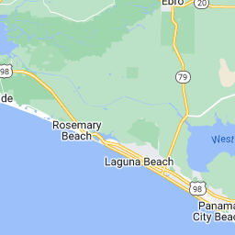
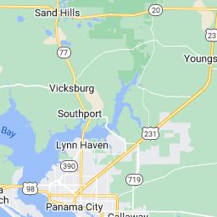
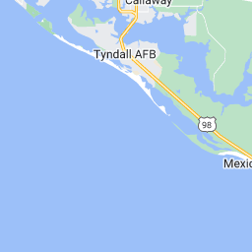

Showing 1 - 1 of 1
Kimberly Morris
LMT, CLT
Kimberly Marie, LMT #64056
12118 Panama City Blvd, Suite 17
Panama City Beach, FL 32407
850-712-527964

