Bollé Develops First High-Contrast Lens Using Artificial Intelligence
The Volt + enhances all colors, setting a new standard for the most complete high contrast lens that users can try-out via the Rediscover Earth AR campaign

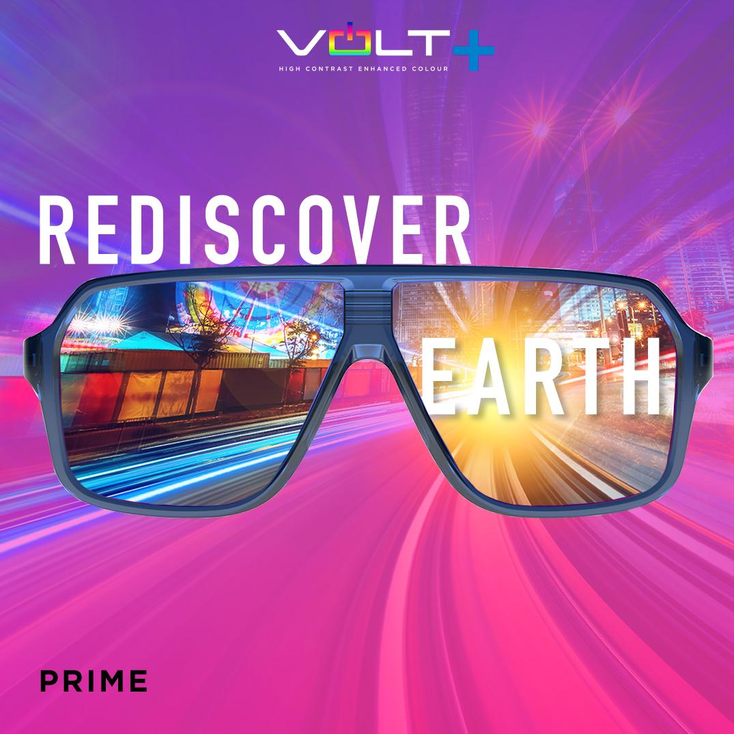
LYON, FRANCE (May 25, 2021) - Bollé is launching the most technologically advanced high contrast lens in the marketplace with the introduction of Volt +, Bollé’s first lens ever developed using Artificial Intelligence (AI). The Volt + lens is the latest innovation to come out of EPIC, Bollé’s new state-of-the-art design and technology innovation lab based in Lyon, France. The lens technology will be included throughout Bollé’s line of sport and lifestyle sunglasses for the current Spring/Summer 2021 season.

“We’ve set high standards to be the innovation and technology leader in the development and creation of sports performance eyewear and helmets,” said Tove Fritzell, Bollé Director of Product & Innovation. “Our EPIC design center located at the foot of the Alps continues to deliver amazing results to harness the most advanced technology with the collaboration of our athletes who have an opportunity to sample and provide feedback at the foot of the world’s biggest playground.”
Bollé worked with HUE.AI to evaluate 20 million different lens formula combinations to settle on an incomparable color experience that sets a new standard against which all other lenses will be measured. The goal was to create a lens that was high contrast, enhanced all colors, and improved depth perception without compromising white balance. In the past, high contrast lenses have only enhanced one color while diminishing others but the Volt + enhances all colors, offering a complete high contrast lens that dramatically improves depth perception.
To support the Volt + launch, Bollé is introducing a new global digital advertising campaign, called Rediscover Earth that lets users rediscover the earth as they’ve never seen it before. The campaign highlights the new high contrast Volt + technology, which allows consumers to see their world differently. “That sense of discovery will inspire a wide variety of colorful experiences,” said Chris Abbruzzese, vice president, trade marketing for Bollé Brands North America.
Partnering with M7 Innovations and QReal for the third time, Bollé is further supporting the launch with multiple Augmented Reality (AR) ‘try-on’ and ‘try out’ campaigns, which allows users to experience the Volt + lens’ vibrant new colors across 15 different Bollé styles. The marquee AR experience via Instagram lets users witness a ‘Big Bang’ of color that leads them to an exclusive try-out experience using Volt + lens technology so they can fully Experience the Power of Color.
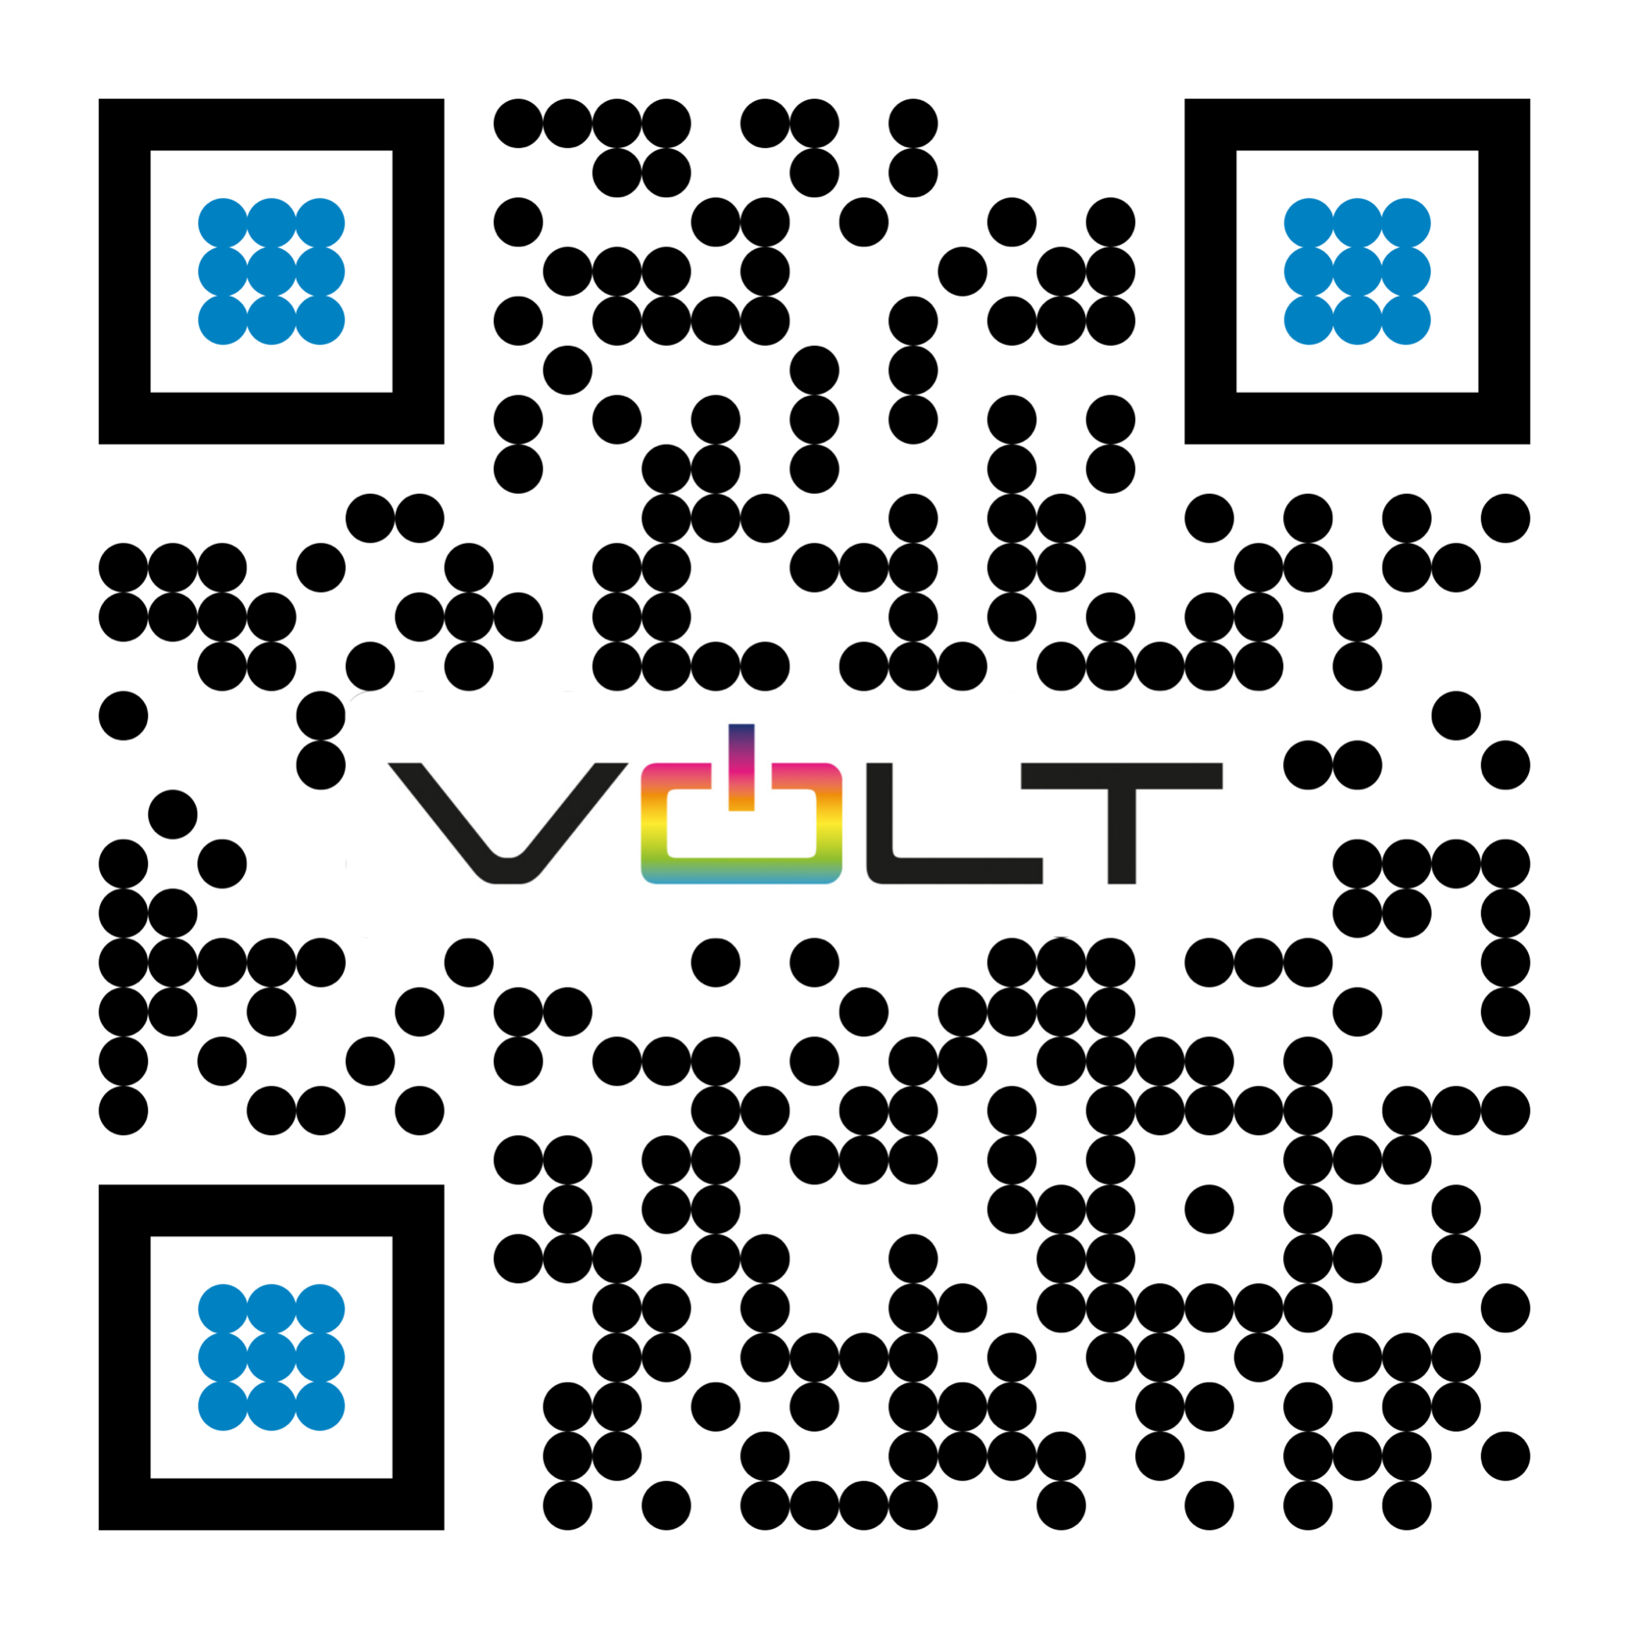
“Bollé has truly established itself as an innovative, dynamic brand by using advanced tech like AI and AR,” said Matt Maher, Founder of M7 Innovations. “While many brands took an unfortunate hit due to the pandemic, Bollé saw an opportunity to pivot and stay connected through fun, engaging AR campaigns that saw almost an 18 second dwell time, which is impressive. And now with AI, they have created a superior lens technology that users can experience through the company’s third AR campaign, demonstrating the value, success, and power of using these innovative technologies.”
About Bollé
Bollé is a leader in sport and lifestyle sunglasses, cycling helmets, ski goggles, and ski helmets. For more information, visit www.Bollé.com. Bollé is part of Bollé Brands™ which encompasses the brands Bollé, Bollé Safety, Cébé, Serengeti, Spy and H2Optics. Thanks to the complementary know-hows and innovative technologies developed by the six brands in their respective fields of activities, Bollé Brands’ expertise covers a large spectrum of products that meet the highest requirements in terms of protection, performance, innovation and style.
About M7 Innovations
M7 Innovations is an NYC-based creative firm that works with brands and executive teams to conceptualize, create, and execute on solutions that leverage Artificial Intelligence (AI), Voice Technology, Augmented Reality (AR), and Virtual Reality (VR). Founded in 2019 by Matt Maher, M7 partners with other tech visionaries and leaders in this space to create unique customer experiences that drive meaningful engagement – from retail and transportation, to lifestyle and fashion.
About QReal
QReal, a subsidiary of The Glimpse Group, creates world-class 3D and Augmented Reality content. The new frontier of eCommerce and social media requires hyper-realistic product showcasing and virtual storytelling. QReal provides end to end services to bring their clients sales lifts, brand recognition, and viral content. And they make them beautiful.
US Media Contact: Mark Tedeschi, True North Brand Group, Inc., 781-740-4050, mark@truenorthpr.com
Canadian PR Contact: Rene Gerber, Bolle Brands, 416-839-0023, rene.gerber@bollebrands.com
###

