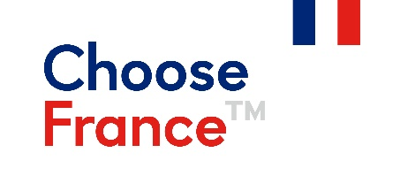
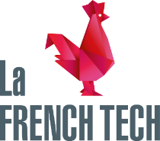

PRESS RELEASE

France returns to the Mobile World Congress with 56 exhibitors
28 February to 3 March 2022

The Mobile World Congress will be held in Barcelona from 28 February to 3 March 2022. More than 70 French companies will take part as exhibitors, including 56 at the French Tech pavilion. Highly innovative in the fields of 5G, AI, Cloud, Fintech and the Internet of Things, the French companies present are keen to return to face-to-face meetings with prospects, investors and partners on the lookout for the latest trends in the telecoms and Internet markets.

“Once again, this year, France has a major presence and is asserting its position as one of the largest national pavilions operating in the sectors of telecoms infrastructure and IoT, mobile applications and services, artificial intelligence, hardware and software. 2022 marks the grand return of the French Tech pavilion, which will this year celebrate 13 years at the Mobile World Congress. With the rise of 5G, the MWC is becoming even more of an unavoidable event in so far as concerns connectivity. It is as a result of the support of the Guadeloupe Chamber of Commerce, the SCS competitiveness cluster and the South region, as well as of Bretagne Commerce International, that Business France will be attending this major Telecoms sector event,” said Etienne Savin, Business France’s MWC event leader.

Tailor-made support for French businesses

Organised by Business France, the La French Tech pavilion will occupy an area of 344 m² in Hall 5 on stands 5B41 & 5B61. This support is part of France's export development strategy aimed at increasing the visibility of French products and services with international decision-makers. New products and services will be demonstrated to visitors during the 4 days of the event. The Business France teams based in countries in Europe, Africa and the Middle East have organised a number of meetings at the show designed to take full advantage of discussions between French exhibitors and foreign professionals. The collaboration between national pavilions such as Belgium, the Netherlands and Switzerland will also enable specially arranged meetings between French and international businesses.
A programme of visits by French officials to the French Tech pavilion is also planned with the arrival of Christophe Lecourtier, Managing Director of Business France, on 28 February and that of Laure de la Raudière, President of ARCEP, on 2 March.

Major Innovative Startups

Among the French delegation, we note the presence of major innovative start-ups. IPM FRANCE will present its interactive terminals designed to digitise self-service 24/7 Telecoms agencies. PONANT TECHNOLOGIE will present a user-friendly robotic solution, eTASQ Motion, which guarantees the quality of products by testing them under real-life conditions.

The full catalogue of all 70 exhibitors is available here: https://bit.ly/Catalogue-MWC22
To see all the news from the France Pavilion at the Mobile World Congress, follow https://twitter.com/Bonjour_MWC on Twitter.

Contact:
Etienne Savin
etienne.savin@businessfrance.fr
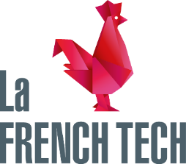
The “French Tech” is a federating community of the tech ecosystem that brings together all the actors and stakeholder this industry such as, entrepreneurs, investors, engineers, designers, public organizations, etc. All involved in this initiative remain committed to the growth of French start-ups and development of a creative ecosystem conducive to their international expansion.
Established in 2013 under the patronage of the French Ministry of the Economy and Finance, the French Tech endeavours to encourage and promote the growth of technological initiatives in France. The French Tech mission aims to do so through a series of dedicated programs, funding solutions, research, public services pro-startups and an impressive network of French Tech communities spread all over France and throughout the world.
#FrenchTech https://lafrenchtech.com/en @lafrenchtechEN https://twitter.com/LaFrenchTechEN
Choose France is a registered trademark of the French government that promotes France’s economic attractiveness internationally.
#ChooseFrance
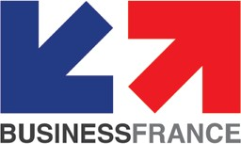

Business France is the national agency supporting the international development of the French economy, responsible for fostering export growth by French businesses, as well as promoting and facilitating international investment in France. It promotes France’s companies, business image and nationwide attractiveness as an investment location, and also runs the VIE international internship program.
Business France has 1,500 personnel, both in France and in 55 countries throughout the world, who work with a network of partners.Since January 2019, as part of the reform of the state support system for exports, Business France has given private partners responsibility for supporting French SMEs and mid-size companies in the following markets: Belgium, Hungary, Morocco, Norway, the Philippines and Singapore.

For further information, please visit: www.businessfrance.fr @businessfrance #BusinessFrance

Business France
77, boulevard Saint-Jacques
75680 Paris Cedex 14
Tél. : +33 1 40 73 30 00

