29th March 2016
Squash Australia Ltd
Office 9, Sports House
150 Caxton St
Milton, QLD, 4064

Tel: (07) 3367 3200
Fax: (07) 3367 3320
squashoz@squash.org.au www.squash.org.au

ABN: 73 072 625 935

Affiliations
World Squash Federation Australian Commonwealth Games Association
Oceania Squash Federation Confederation of Australian Sport Australian Olympic Committee

Squash Australia preferred Squash Court Builder Supplier

Squash Australia welcomes the tender submission from an interested squash court builder supplier, to become the official builder supplier for the World Junior Championships in 2020.
The dates for court construction are as per below:
- To be built by 5pm on the 26th of June 2020
- Commence bump out by 9am on the 31st of July 2020

Squash Australia is the governing body for the sport of Squash and Racquetball in Australia. With over 200,000 people playing the sport and decades of medal success on the world stage. Squash Australia is looking for an official court builder supplier for the World Junior Championships, to advise on and cover the following areas:

- Bump in and bump out of the court
- Complete full erection of the court in-line with international squash event standards
- Be available in advance for monthly project meetings via phone
- Advise on the size of the build team
  - Allow Squash Australia to use locally skilled labour to aid in the build
- Advise what equipment they require onsite
- Outline the full cost for the entirety of the build, inclusive of all points above

The court being provided is the ASB Glass Court used during the Gold Coast Commonwealth Games in 2018 (refer appendix 1.1).

All tenders are requested by 7th October in writing to Squash Australia CEO, Richard Vaughan ceo@squash.org.au.

Yours Sincerely,

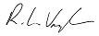

Richard Vaughan

Chief Executive Officer Squash Australia

Appendix 1.1

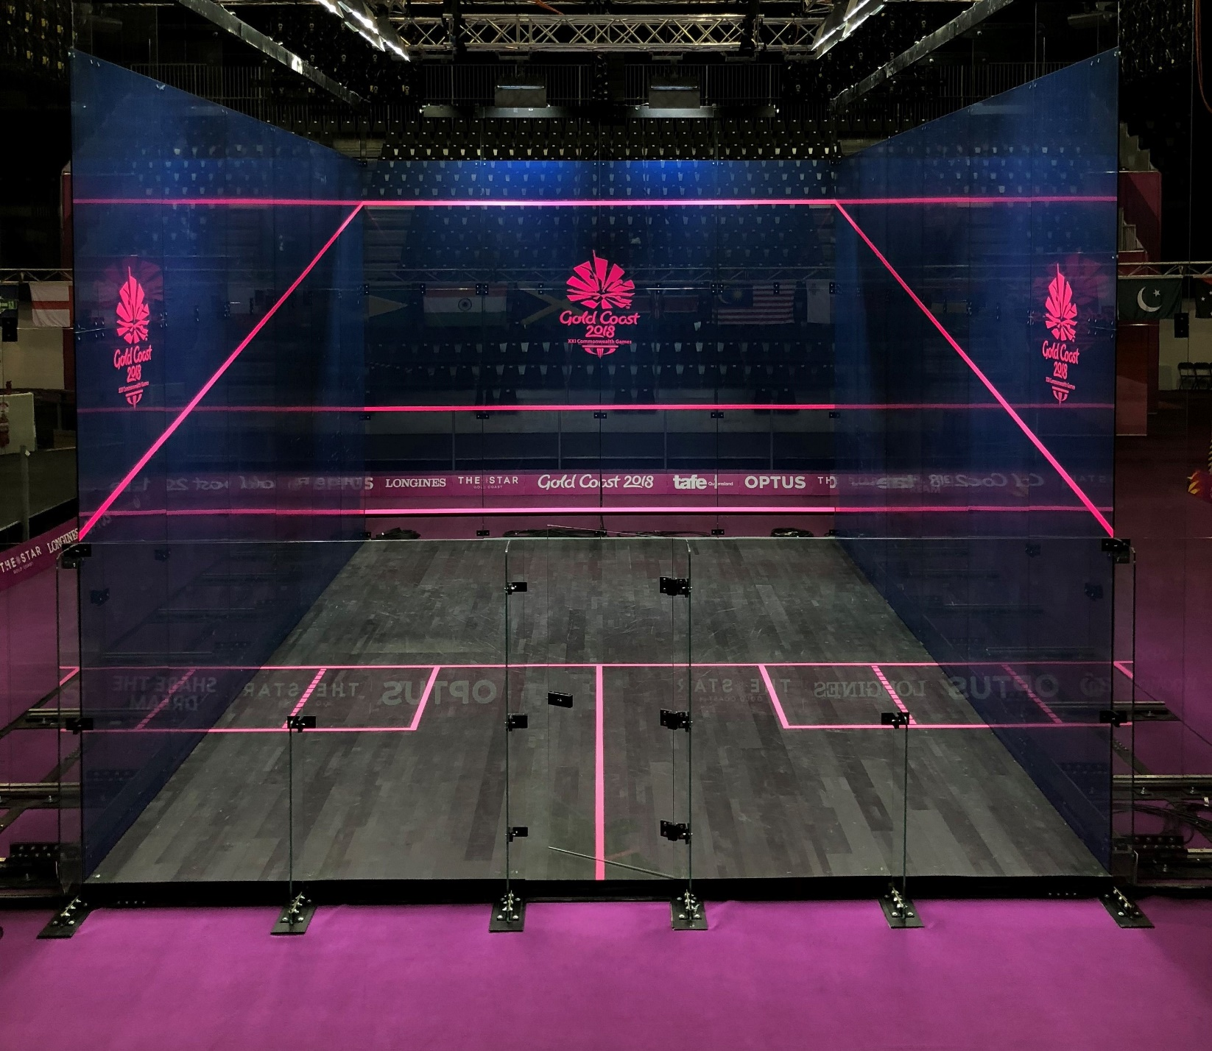

Principal Partner Official Ball

