Spree 2023 Ticket Booking Instructions for Group Members:

These are the steps that you will need to take:

- Go to : https://events.solidrock.io/spree-sw/spree-sw-2023
You will be taken to a page that looks like this: (If you have ever used Solid Rock booking system before you can log in to your account, if not, select the ‘Register now’ option at the bottom of the page – follow the steps as instructed including verifying your email address).
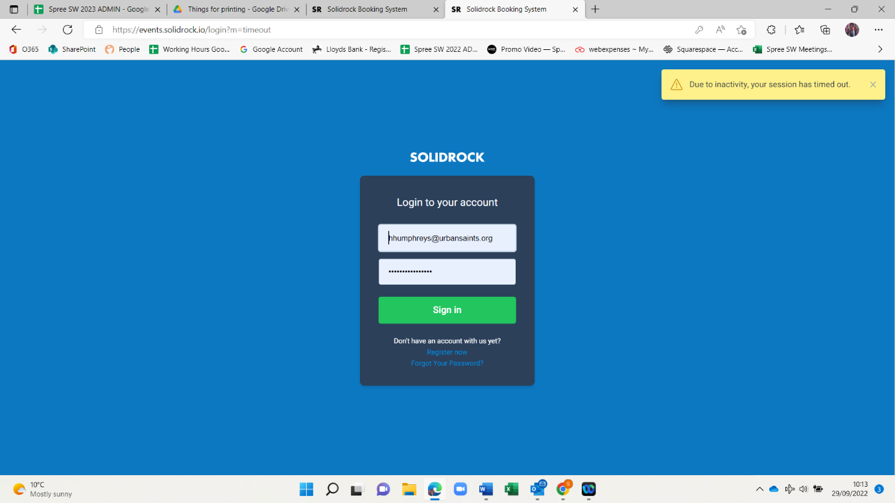

- Now you are registered, you should see a page that looks like this (if not copy and paste the link in step one into your web browser again).
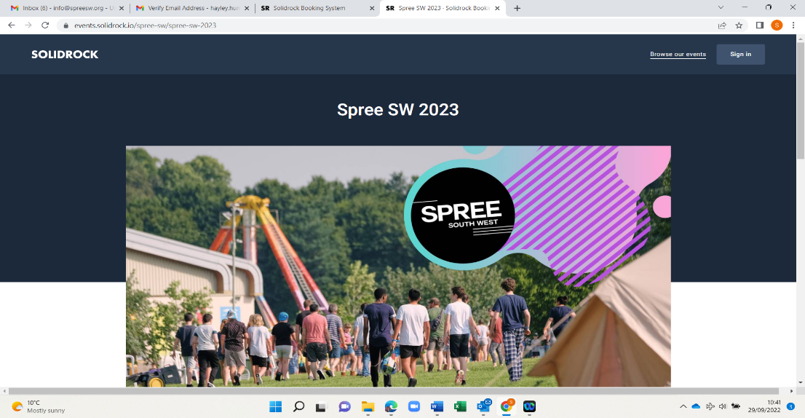
- Scroll down to the blue start booking button. Click on this button.
- You will now need to sign into your Solid Rock account, that you have just created.
- Book your tickets. Halfway through the form you will be asked to input your group code – it is 7 N F E E 9 Y H M L
- If you encounter any difficulties with the booking process, please don’t panic – we are here to help. Please contact info@spreesw.org, where one of the friendly team will be able to assist.

You should now be all set up and ready to go!

Please note:
Payment Plan Option.
This is visible on the checkout page where any booker can choose to pay in full or using the 25% deposit and 3 instalments payment plan.

