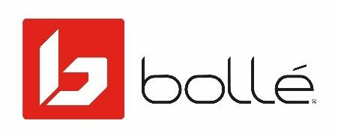

**BOLLÉ COMMITS TO PROTECTION WITH A 100% MIPS® HELMET RANGE**

*From now on, the 132-year-old brand will feature the MIPS® brain protection system in every new snow and cycling helmet.*

Lyon – January 2020 - Protection and performance are at the heart of Bollé’s product development strategy, and this is illustrated by the continuous in-house innovations and the collaboration with the best technologies available on the market. Climbing another step in its commitment to become THE reference for protection, Bollé announces a reinforced partnership with MIPS® and will, from now on, feature MIPS® Brain Protection System on every new ski and cycling Bollé helmet, becoming the first brand with such an offer.

A LONG-TIME PARTNERSHIP WITH THE SAME LONG-TERM VISION

Established in the world of science with over 20 years of research, MIPS® has been collaborating successfully with Bollé for years. Just like Bollé, the mission of MIPS® is to offer the best-in-class protection based on innovation and research. Committed to offer only the best possible solutions to create safer and most performant helmets, both brands work hand in hand and challenge themselves to achieve this vision. To achieve this goal, they approached the protection issues from an original angle, resulting in the most innovative brain protection system currently available on the market. 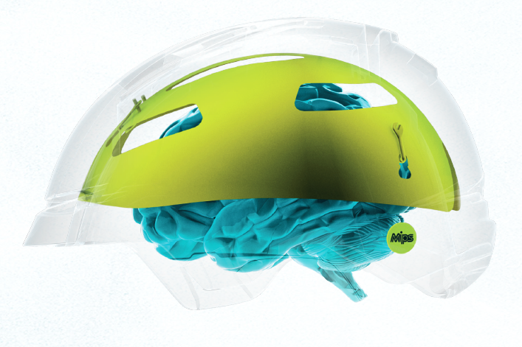

HOW DOES THE MIPS® TECHNOLOGY WORKS?

Injury statistics show that when someone falls, in most cases the impacts occur at an angle. Despite the fact that the human brain handles pretty well impacts that are perpendicular to the ground, it doesn’t cope well with angled impacts, which can result in severe brain trauma.

MIPS® Brain Protection System is a revolutionary technology that allows the head to move inside the helmet which can reduce the harmful rotational motion which may otherwise be transferred to the brain, and thus, reduce the risk for brain trauma.

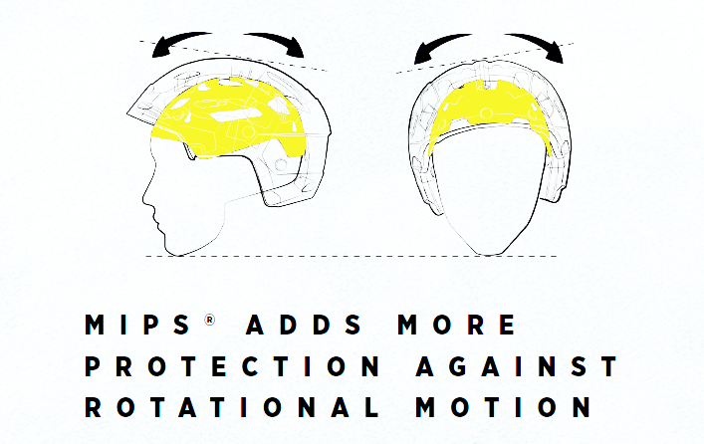 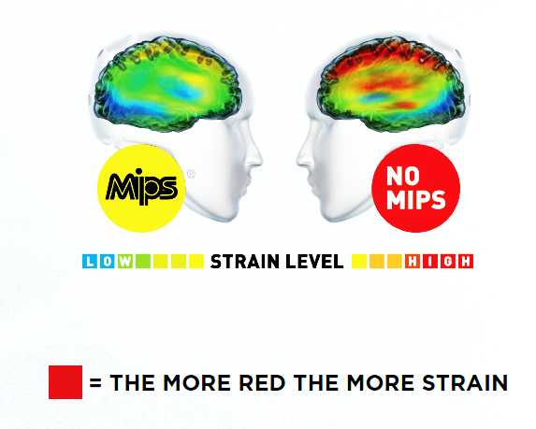

A LARGE CHOICE OF HELMETS EQUIPPED WITH THE MIPS® TECHNOLOGY ALREADY IN COLLECTION

Bollé will feature the MIPS® technology in all new helmets development, but the brand already has a large offer among its current products, including its latest high-end snow helmet RYFT, the choice of Bollé athletes Team MEDALIST CARBON PRO MIPS®, or the pinnacle of the brand’s cycling helmets FURO MIPS®.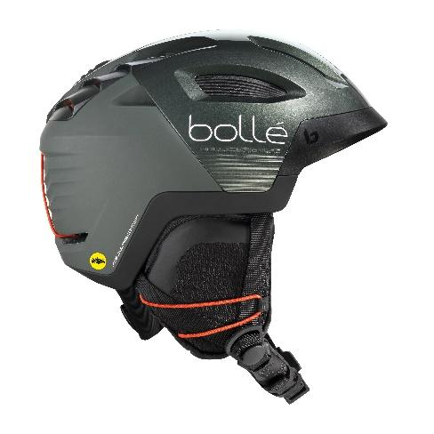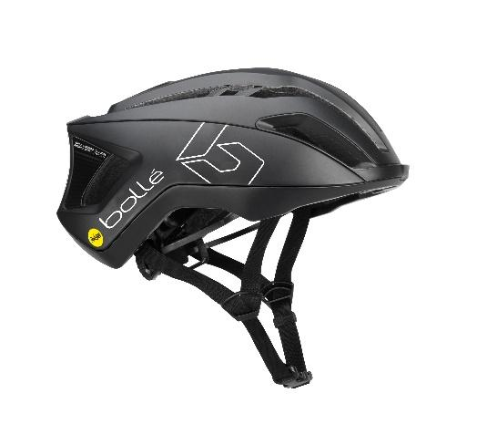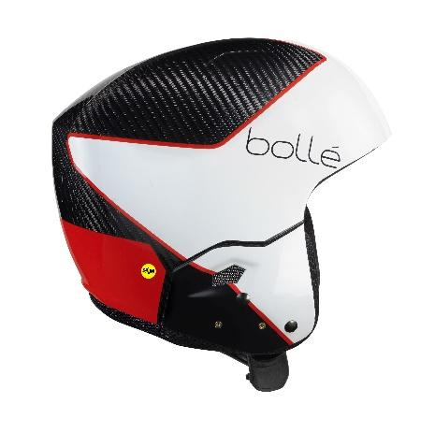



**Press contact: Mark Tedeschi -** Elevator North  **–** [**mtedeschi@elevatornorth.com**](mailto:mtedeschi@elevatornorth.com)

Bollé is a leader in sport and lifestyle sunglasses, cycling helmets, ski goggles, and ski helmets. For more information, visit [www.bolle.com](http://www.bolle.com). Bollé is part of Bollé Brands™ which encompasses the brands Bollé, Bollé Safety, Cébé, Serengeti, Spy and H2Optics. Thanks to the complementary know-hows and innovative technologies developed by the six brands in their respective fields of activities, Bollé Brands’ expertise covers a large spectrum of products that meet the highest requirements in terms of protection, performance, innovation and style.