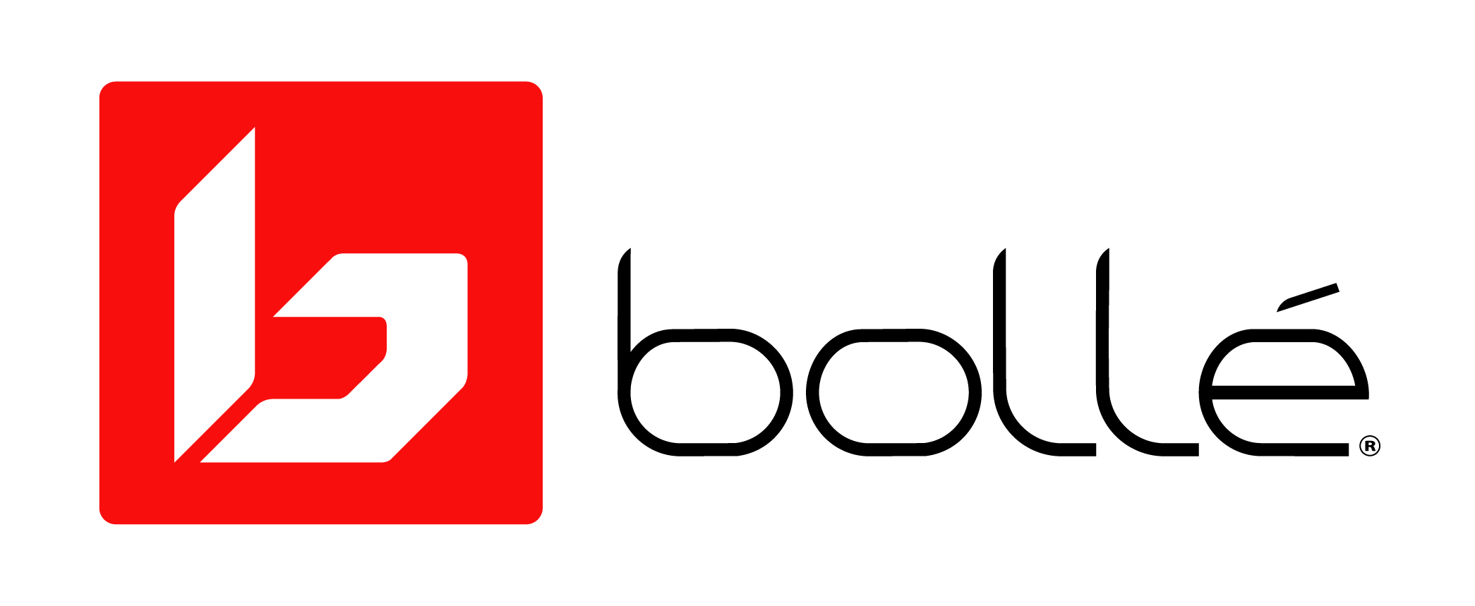

UNDER EMBARGO UNTIL JUNE 23, 2020

BOLLÉ LAUNCHES FIRST EVER AUGMENTED REALITY SUNGLASS EXPERIENCE FOR SMARTPHONES
Company partners with tech visionaries, QReal and M7 Innovations,
to provide hyper-realistic try-out experience of their best lens, Phantom

Lyon, France, (JUNE 23, 2020) - Bollé, maker of the most innovative lenses in the world is forever changing the way people try and buy sunglasses. With the introduction of an exclusive Augmented Reality Sunglass experience, shoppers can now try-out Bollé’s flagship lens technology Phantom without ever having to physically touch the glasses.

Partnering with QReal and M7 Innovations, Bollé’s AR experience is a first for the sunglass industry. Within Instagram, the demonstration invites users to try out Bollé’s Phantom lens through one of the brand’s iconic models – the Chronoshield. After seeing the glasses on their face, users simply flip their camera from selfie-view to front-facing and Phantom lenses are superimposed on their actual view. Users then introduce sunglass effects like high contrast, anti-fog, and photochromatic into their real surroundings to see Phantom lenses in action. Once users select a lens that suits their style and needs, they can search for a retailer that carries Bollé.
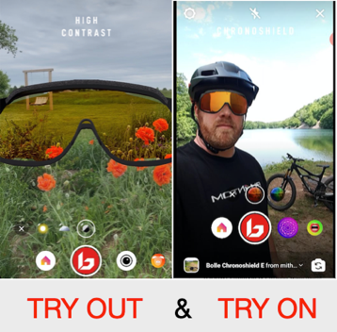
“AR is routinely used for try-on and certainly enhances the buying experience. But AR for try-out, this is a first,” said Louis Cisti, Vice President of Global Marketing for Bollé Brands. “In the new normal of retail, Bollé recognizes that safety is now the most important thing. Consumers demand shopping encounters that minimize physical interaction. However, when it comes to buying premium sunglasses, they still have high expectations and expect to see tangible benefits. Bollé’s AR try-out does all that heavy lifting. Shoppers get to see perceivable performance benefits before making a purchase.” Cisti continued.

Using AR, users will experience several unique Bollé lens features that demonstrate Phantom’s superiority for spring skiing, cycling, running and more:

● Light Adaptive Technology: the user is presented with a slider that allows them to change their exposure, making the scene brighter or darker. They watch Phantom’s molecular photochromic filter adapt to changes in ambient light.

● Platinum Anti-Fog Treatment: The user’s view begins to fog up, simulating the fogging that occurs from sweat while riding, hiking, or spring skiing. Fog condenses outside the glasses, but the view through the sunglasses remains crystal clear, mimicking the real-world performance Phantom Lenses in a perspiring situation.

● High Contrast: The scene outside the glasses remains natural, but the user is able to experience improved color and depth perception as they look through the Phantom lenses.

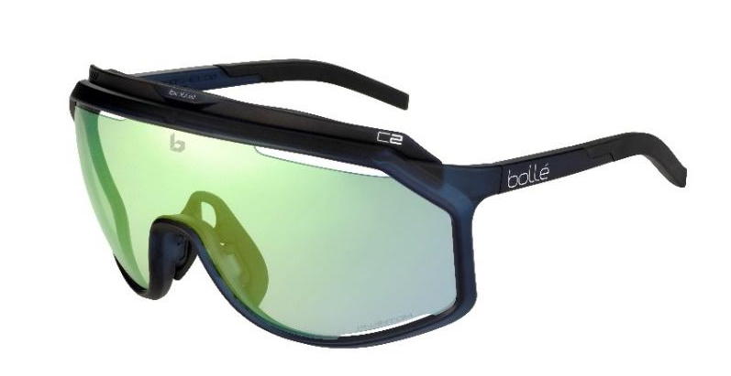
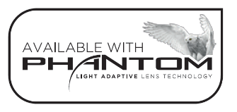
For the Try On part of the experience users will be able to see how they look in the Bollé Chronoshield, a new take on an original style from the 1980s. The Chronoshield offers an extra wide field of view, ideal for visual comfort and protection against wind or debris. Venting ensures the lenses never fog up and the adjustable Thermogrip nose-pads and temple tips gives a custom fit while making sure they stay in place.

To try-out Phantom Lenses using this augmented reality experience, users can either click on a QR code that will be included in Bollé marketing materials or may visit this link using their: Merged Single Lens Experience

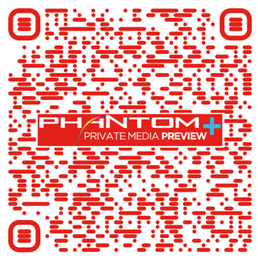

About Bollé
Bollé is a leader in sport and lifestyle sunglasses, cycling helmets, ski goggles, and ski helmets. For more information, visit www.Bollé.com. Bollé is part of Bollé Brands™ which encompasses the brands Bollé, Bollé Safety, Cébé, Serengeti, Spy and H2Optics. Thanks to the complementary know-hows and innovative technologies developed by the six brands in their respective fields of activities, Bollé Brands’ expertise covers a large spectrum of products that meet the highest requirements in terms of protection, performance, innovation and style.

About QReal
QReal, a subsidiary of The Glimpse Group, lifts brands into the real world. QReal, formerly Kabaq.io – established its beachhead within the AR industry by creating the most lifelike models of cuisine. For years QReal perfected their modeling process to present digital dishes that look completely real, are platform agnostic, and optimized for AR. The team knew the same process would work for a whole myriad of brands and items – and thus QReal was born. Now QReal works in many different verticals, including fashion, luxury, automotive, and more.

About M7 Innovations
M7 Innovations is an NYC-based creative firm that works with brands and executive teams to conceptualize, create, and execute on solutions that leverage Artificial Intelligence (AI), Voice Technology, Augmented Reality (AR), and Virtual Reality (VR). Founded in 2019 by Matt Maher, M7 partners with other tech visionaries and leaders in this space to create unique customer experiences that drive meaningful engagement – from retail and transportation, to lifestyle and fashion.

###

