**MSC** **Equilibrium Review 1**  Name_____________________________

1. How do the forward and reverse reaction rates compare at equilibrium?_____________________________
2. What is the only way to change the value of the Kc?
3. As a rule, which phases are **not** included in the equilibrium constant expression?
4. Consider the following equilibrium:

a) Cu2+(aq) + 2Ag(s) ⇄ Cu(s) + 2Ag+ (aq) Kc = 1 x 10-15

b) Pb2+ (aq) + 2 Cl- (aq) ⇄ PbCl2(s) Kc = 6.3 x 104

i) Which equilibrium favors products to the greatest extent? ______

ii) Which equilibrium favors reactants to the greatest extent? ______

1. Write the equilibrium expression for: **2A(aq) + B(l) 2C(g) +3D(s)**
2. Determine the Kc for the previous problem If [A] = 0.40, [B] = 0.30, [C] = 0.80 and [D] = 1.5
3. Predict whether reactants or products are favored in the following equilibrium systems

a) CH3COOH(aq) ⇄ H+(aq) + CH3COO-(aq) Kc = 1.8 x 10-5 _________________

b) H2O2(aq) ⇄ H+(aq) + HO2(aq) Kc = 2.6 x 10-12 _________________

c) CuSO4(aq) (+ Zn(s) ⇄ Cu(s) + ZnSO4(aq) Kc = 1037 _________________

1. Shown below is a concentration vs. time plot for the reaction A ⇌ 2B. For this reaction is the value of the equilibrium constant greater, than less than or equal to 1?

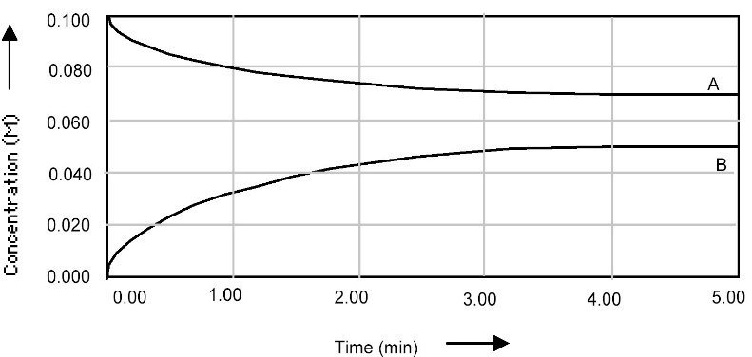

1. Calculate the Kc if the following amounts were found at equilibrium in a 2.00L volume.

CrO4-2 = 0.0300 mol, H+ = 0.0200 mol, Cr2O7-2 = 0.320 mol, H2O = 110 mol

**2 CrO4-2 (aq) + 2H+ (aq)  ⇄ Cr2O7-2 (aq) + H2O (l)**

10. For the following reaction the Kc=120. If [H2]=0.33 and [Br2]=0.50, what is [HBr]?

H2(g) + Br2(g)  2HBr(g)

11. If at a certain time [CO] = 0.80 M, [H2O] = 0.050 M, [CO2] = 0.50 M and [H2] = 0.40 M, is the reaction at equilibrium? If not, how will it shift in order to get to equilibrium

CO(g) + H2O(g) ⇄ CO2(g) + H2(g) Kc= 10.0

1. An equilibrium mixture of contains 0.0010 M CO2 and 0.0015 M O2. What is the equilibrium concentration of CO?

2 CO(*g*) + O2(*g*) ⇌ 2 CO2(*g*) *Kc* = 1.4 × 102

1. For the following reaction, what is the equilibrium concentration of **ICl** if 0.75 mol of I2 and 0.75 mol of Cl2 are initially mixed in a **2.00L** flask?

2 ICl(*g*) ⇌ I2(*g*) + Cl2(*g*) *Kc* = 0.11

1. What is the pH of 0.30M acetic acid?

HC2H3O2 (aq) + H2O (l) ⇌ H3O+ (aq) + C2H3O2-1(aq) Ka = 1.8 x 10-5

1. The balanced equation for the solubility equilibrium of Fe(OH)2 is shown below. What is the equilibrium constant expression for Fe(OH)2?



1. What is the silver ion concentration for a saturated solution of Ag2CO3?

The *K*sp for Ag2CO3 is 

1. Predict which way the following equilibrium systems will shift when the **total pressure** is **increased**.

a). ***N2(g) + O2(g)***  ***2NO(g)***......................... Answer__________________

b). ***2SO2(g) + O2(g)***  ***2SO3(g)*** ...................... Answer__________________

c). ***4NH3(g) + 5O2(g)***  ***4NO(g) + 6H2O(g)***....... Answer__________________

18. Hydrogen peroxide is decomposed as follows:

***H2O2(l)***  ***H2(g) + O2(g) H = +187 kJ***

Predict the ***direction of equilibrium shift*** by each of the following imposed changes:

a) ***Increase*** the [H2] ........................................ Answer _________________________

b) ***Decrease*** the [O2] ....................................... Answer _________________________

c) ***Decrease*** the ***total pressure*** ........................ Answer _________________________

d) ***Increase*** the ***temperature***............................ Answer _________________________

e) Add MnO2 as a ***catalyst***.............................. Answer _________________________

19. Using the following equilibrium, state what would happen to the equilibrium **amount of CH3OH gas** when each of the following changes are made:

***CO(g) + 2H2(g)***  ***CH3OH(g) H = -75.2 kJ***

a) CO gas is added to the container ............................ Answer __________________

b) The *temperature* is increased .................................. Answer __________________

c) The *total pressure* of the system is increased.......... Answer __________________

d) H2 gas is removed from the system......................... Answer ___________________

e) A *catalyst* is added.................................................. Answer ___________________

f) The *total volume* of the container is increased......... Answer ___________________