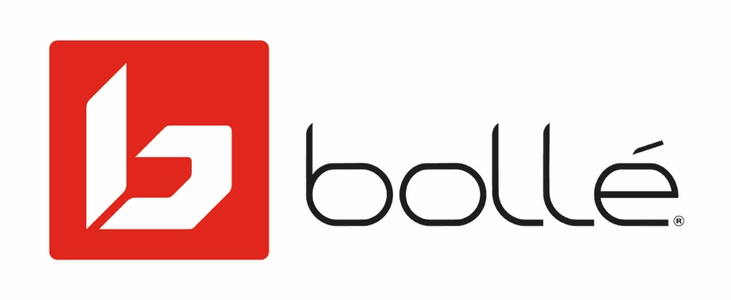
FOR IMMEDIATE RELEASE

Media Contact
Mark Tedeschi
True North Brand Group, Inc.
781-740-4050
mark@truenorthpr.com

Bollé Turns to Artificial Intelligence to Develop the Most Advanced High Contrast Lens Ever Introduced
The New Volt + is the Result of Evaluating More Than 20 Million Combinations

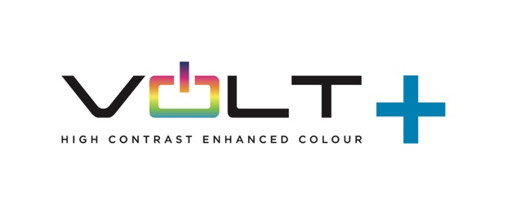
LYON, FRANCE (April 12, 2021) – Bollé is launching the most technologically advanced high contrast lens in the marketplace with the introduction of Volt +, the industry’s first lens ever developed using Artificial Intelligence.

The goal in developing the Volt + was to create a lens that provided high contrast and enhanced all colors to improve depth perception without compromising white balance. In the past, high contrast lenses enhanced one color while diminishing other colors. The Volt + enhances all colors, offering the most complete high contrast lens that improves depth perception.

Using AI, Bollé was able to evaluate 20 million different lens formula combinations to settle on an incomparable color experience that sets a new standard against which all other lenses will be measured.

The Volt + lens is the latest innovation to come out EPIC, Bollé’s new state-of-the-art design and technology innovation lab based in Lyon, France. The lens technology will be included throughout Bolle’s line of sport specific sunglasses for the Spring 2021 season.

“We’ve set high standards to be the innovation and technology leader in the development and creation of sports performance eyewear and helmets,” said Tove Fritzell, Bollé Director of Product & Innovation “Our EPIC design center located at the foot of the Alps continues to deliver amazing results to harness the most advanced technology with the needs of athletes who have an opportunity to sample and provide feedback at the foot of the world’s biggest playground.”

In developing Volt +, Bollé used AI to find out which wavelengths to enhance or dampen, to design and develop the chemical compound (pigments) that will absorb the right wavelengths and to then put together the perfect blend of pigments for the transition curve.
relationships

About Bollé
Bollé is a leader in sport and lifestyle sunglasses, cycling helmets, ski goggles, and ski helmets. For more information, visit www.Bollé.com. Bollé is part of Bollé Brands™ which encompasses the brands Bollé, Bollé Safety, Cébé, Serengeti, Spy and H2Optics. Thanks to the complementary know-hows and innovative technologies developed by the six brands in their respective fields of activities, Bollé Brands’ expertise covers a large spectrum of products that meet the highest requirements in terms of protection, performance, innovation and style.

###

