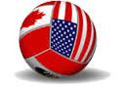
NAGVA
North American Gay Volleyball Association
Annual Meeting Agenda

- Welcome & Introductions Lew Smith, President

-Welcome Statement and Thank You

-NAGVA Board Present
- Lew Smith – President
- Jason Fallon – Vice President
- Andrew Crawford – Secretary
- Rich Sucre – Treasurer
- Scott Kilburg – Registrar
- Jen Callen – Regions
- Josh Christensen – Eligibility
- Steven Acosta – Tournaments
- Jason Pelletier – Canadian Rep
- Rick Talley – Past President
- Eric Reyes – Historian
- Jimmy Schultz – Member at Large
- Dianna Fernandez – Member at Large
- Josh Baxter – Member at Large
- Ray Robles – Member at Large

-NAGVA Board Absent
- Donald Leckey – Officials

-Discussion on NAGVA COVID Response:
- The NAGVA Board is currently sanctioning tournaments based on local and state guidelines with the caveat that if local, state, or federal guidelines restrict the ability to have a tournament.
- The VP of Tournaments and the Tournament Directors will be working closely leading up to each tournament.
- The NAGVA Board is creating guidelines for tournaments and their COVID response plans for the upcoming season.
- The NAGVA Board is also creating suggestions for those players that are wanting to attend NAGVA sanctioned tournaments.
- It is important that if any member is feeling ill that they DO NOT participate in a NAGVA sanctioned-tournament.
- It is the members responsibility to understand that before committing time and money for a tournament the possibility that it could lose sanctioning is very real during this time of COVID-19, and reimbursement of funds for the tournament/lodging/travel may not be viable.
- It is the members responsibility to understand the risks posed in participating in a tournament could pose to the health of themselves and those they are in close contact with.
- With the day-to-day evolving COVID-19 reports it is the goal of the NAGVA Board to look out for the safety, well-being, and desire of the members to play volleyball.

- State of the Organization

- Financial Report Rich Sucre, Treasurer

2019-2020 NAGVA Estimated Final Budget
Submitted by: Rich Sucré, Treasurer

REVENUE
Individual Online Registration | $143,929.82
Individual Onsite Registration | $3,960.00
Team Registration | $18,360.00
Tournament Sanctioning Fees | $21,475.00
2019 Championships Sponsorship | $16,764.10
Bank Account Interest | $152.91
Private Donation | $125.00
2019 Refund, Championships Security | $1,319.00
TOTAL REVENUES | $206,085.83

EXPENSES
Insurance | $13,405.53
PayPal Fees | $8,820.25
Web Site | $6,249.13
RC Reimbursements | $71,744.36
Mid-Year Board Meeting | $22,552.88
Planning Trips & Meetings | $15,839.03
Bank Service Charge | $1,395.00
Professional Fees | $769.53
COVID-19 Grants | $19,557.15
Charity Donation | $200.00
Championships
*Hotel | $5,000.00
**2019 Officials | $465.00
**TOTAL EXPENSES | $165,997.86
* Deposit of $5,000 for Championships Hotel; Prior Deposit of $5,000 for Championships Hotel occurred in 2018-2019 Fiscal Year

**Additional Payment towards Officials for 2019 Championships

- Department Reports (Please see the State of NAGVA for complete Report)
  - Secretary – Drew Crawford
  - Registrar – Scott Kilburg
  - Eligibility – Josh Christensen
  - Regions – Jen Callen
  - Tournaments – Steven Acosta
  - Officials – Donald Leckey (Absent)
  - Communications – Tyler Anderson
  - Canadian Representative – Jason Pelletier
  - Past President Representative – Rick Talley
  - Historian – Eric Reyes

- Member at Large Reports (Please see the State of NAGVA for complete Report)
  - Jimmy Schultz
  - Josh Baxter
  - Dianna Fernandez
  - Ray Robles (Absent)

- Executive Board Elections (LOIs: Attachment B) Jason Fallon, Vice President

-Request was made for members to ask any questions to the nominees.
-No questions were fielded
-Jason Fallon moved to approve all nominees by consensus as each position runs unopposed.
-Seconded by Rick Talley
-None Opposed

-Motion was Adopted.

-2020-2022 Executive Board will be:
  - President- Lew Smith
  - Vice President - Josh Baxter
  - Treasurer - Rich Sucre
  - Secretary - Drew Crawford

- Member Appeal: Edgar Lopez-Gonzalez Josh Christensen, Eligibility

-Explanation of proceedings, VP of Tournaments Steven Acosta supported translation for Edgar.
-Original Grievance:
“During pool play, Dallas Mustafa and Dallas Spartacus were scheduled to play against each other. I was informed by several people, including the Tournament Registrar and Mr. Kuhnagel, that there was some bad blood. Many allegations were discussed, including a post-registration party physical altercation during Austin 2019 that NAGVA personnel were not made aware of until the registration party in Dallas. Knowing of the previous incident, I stood less than 10 feet away from the court during the match. Mr. Vazquez was in the substitution zone to come into the match. Mr. Kuhnagel was holding onto the ball at the net on his side of the net (so both players were within 10 feet of each other). Mr. Kuhnagel, according to the referee, Shelly, said in Mr. Vazquez's direction, "Can you please speak in English?" Mr. Kuhnagel turned away from the net, ball in hand, walking to the center of his court. Mr. Vazquez came charging under the net and struck Mr. Kuhnagel in the face from behind with an overhand swing and closed fist. Mr. Vazquez was restrained as he attempted to later make a second charge. Mr. Vazquez and I, along with an interpreter, went into the hallway where I immediately ejected him from the rest of the tournament and forbade him from entering any tournament gym the rest of the weekend. Mr. Kuhnagel called the police, and a a witness, I gave a statement of what I observed.
Earlier in the day, Mr. Kuhnagel approached me and accused Mr. Vazquez, and others, from laughing loudly and talking about him during a pool play match a few feet off the court. I talked with Mr. Vazquez and the others to state that while I didn't know what was going on, for optics-sake, it may be best if they stepped away from the court. Mr. Vazquez later showed me pictures on his phone to indicate that Mr. Kuhnagel may be paying with people that were not at the BB level. I mention this as the tensions between the two had been building since earlier in the day. There were also allegations that Mr. Kuhnagel verbally antagonized Mr. Vazquez earlier, something Mr. Vazquez told me in the hallway ("He (Kuhnagel) kept saying he was going to call ICE on me."

-Director of Eligibility determined that a 2-year suspension was warranted for physical violence.

-Edgar Lopez Appeal:

Original Text
Buenos Dias tengan todos ustedes, quiero hacer una apelación, sobre mi suspencion debido aque no estan tomando en cuenta mis ataques que el jugador hiso contra mi, nunca habia tenido un problema desde que empece a jugar en esta liga, yo puse una queja en Austin el año pasado donde el jugador Nelson me agredio el y su esposo, yo no cai en su juego simplemente me retire de la registracion, les comente a los encargados de ese torneo y no hicieron nada, pero hece dia puse un reporte de policia, por la agrecion que tuve por parte de Nelson y su esposo Omar, en Dallas fue lo mismo les dije al Director Bryan Brosky que lo calmara por que nos estaba agrediendo y nos gritaba indocumentados ya que mi equipo y yo venimos desde mexico a jugar esta liga, con tal de divertirnos, y por el nivel que hay aqui, Nelson ya habia estado suspendido por intento de arma blanca en pleno juego, ese mismo dia quiso hacer lo mismo conmigo pero llame ala policia y lo lleve a tribunales, el esta en orden de restriccion no puede estar cercas de mi, por que el tiene antecedentes penales. En estos años que tengo jugando nunca e tenido problemas por eso pido mi apelaciom para cencelar mi suspencion por que no es justo que solo por venir de fuera a jugar en USA nos llamen inmigrantes o mojados, ustedes hablan de cero tolerencia pero lo que hace el es injusto, esto es discriminacion o racismo por venir a jugar a este pais. De ante mano muchas gracias espero y puedan ayudarme prometo tener mi buena conducta y solo les pido que cuando pongan una queja sobre alguien. No la dejen pasar, y llamen la atencion antes de que llege a mayores. Muchas gracias NAGVA.

Translation (Completed by VP of Tournaments)
Good Morning to you all. I want to make an appeal on my suspension, due to the fact the attacks of the player against me have not been considered. I have never had a problem since I started to play in this league, I put a complaint in Austin last year where the player Nelson and his husband were aggressive towards me. I did not fall for their game and I removed myself from registration. I discussed these attacks with those running the tournament and they didn’t do anything, but that day I filed a police report against Nelson and his husband Omar for the aggression I had experienced. In Dallas the same thing happened, I told the director Bryan Brodsky to calm him (Nelson) down because again he was attacking us and yelling that “my team was undocumented” since my team and I came from Mexico to play in this league, because it was fun and for the level of play. Nelson had already been suspended for attempting to stab someone in plain sight, that same day he wanted to do the same to me but I called the cops, and took him to court. A restraining order is placed and he cannot be close to me, because he has a criminal background. In these years that I have been playing I have never had problems, so I ask to have my suspension cancelled because it is not fair that just because someone comes from outside of the USA to play they call us “immigrants” or “wet backs”. You mention zero-tolerance policy but what he does is not right, this is discrimination or racism for coming to play here in this country. Beforehand many thanks and hope you can help me. I promise to have good behavior and all I ask is that when someone brings a complaint about someone, you don’t let it pass and that you call attention before it gets worse. Thank you very much NAGVA.

-Floor was open to questions:

-Question from NAGVA Member Austin Erke on if Nelson was also sanctioned?
-Director of Eligibility Responded “Yes”

-Director of Eligibility motioned to uphold the 2-year sanctioning.
-Seconded by Mark Davis

Vote was held
-For: 20
-Against: 4
-Abstain: 3

-Sanction was upheld and effective Nov 3, 2019 and will conclude Nov 3, 2021.

- Amendment Proposals Drew Crawford, Secretary

- Drew Crawford made a motion to cap discussion on each submission to 10 mins unless extended by simple majority vote by consensus.
-Seconded by Rick Talley.
-None Opposed.

Rules and Regulations Amendments

Submission #1
-Floor opened for discussion
-No discussion occurred.

-Josh Christensen motioned to adopt Submission #1 by consensus
-Second by Mark Davis
-None opposed

-Amendment Adopted

- What By-law article or Rules & Regulations section are you proposing to amend?
Section 1.02 and section 1.06 (Rules & Regulations)

- What is the original text of the article/section?
1.02 ‐ Requirements to Join
    - For a Team or League to be accepted as a Full Voting Member in the Association, annual dues in the amount as determined during the previous Annual Meeting must be paid before a competition which has been designated as a NAGVA‐sanctioned event. Teams that fail to register on‐line and provide proper documentation prior to the start of the NAGVA‐sanctioned event must register on‐site and pay $10.00 US more than the on‐line rate. The Team must have actually competed in that tournament or in another designated NAGVA Sanctioned Tournament during the current Championship’s Season (end of previous Championships to start of current season’s Championships) to validate the Full Voting Member Team’s right to vote. Leagues need to maintain current individual records and NAGVA registrations on all league participants
1.06 ‐ Annual Registration Fee
Each individual player, coach, or official participating in a NAGVA‐sanctioned qualifying tournament must pay an annual registration fee as determined during the previous Annual Meeting, due for (at) the first competition of the player’s respective fee, for purpose of general liability insurance coverage and administrative, operational, and organizational costs. Players that fail to register on‐line and provide proper documentation prior to the start of the NAGVA-sanctioned event must register on-site and pay $10.00 US more than the on-line rate.
- What is the proposed amended text of the article/section?
1.02 ‐ Requirements to Join

- For a Team or League to be accepted as a Full Voting Member in the Association, annual dues in the amount as determined during the previous Annual Meeting must be paid (in currency of citizenship/permanent residence, limited to USD & CDN currencies) before a competition which has been designated as a NAGVA‐sanctioned event. Teams that fail to register on‐line and provide proper documentation prior to the start of the NAGVA‐sanctioned event must register on‐site and pay the USD on‐line rate in addition to $10.00 USD more, regardless of citizenship/permanent residence. The Team must have actually competed in that tournament or in another designated NAGVA Sanctioned Tournament during the current Championship’s Season (end of previous Championships to start of current season’s Championships) to validate the Full Voting Member Team’s right to vote. Leagues need to maintain current individual records and NAGVA registrations on all league participants, coaches, and officials to validate the Full Voting Member League’s right to vote.
1.06 ‐ Annual Registration Fee
Each individual player, coach, or official participating in a NAGVA‐sanctioned qualifying tournament must pay an annual registration fee as determined during the previous Annual Meeting (in currency of citizenship/permanent residence, limited to USD & CDN currencies), due for (at) the first competition of the player’s respective fee, for purpose of general liability insurance coverage and administrative, operational, and organizational costs. Players that fail to register on‐line and provide proper documentation prior to the start of the NAGVA-sanctioned event must register on-site and pay $10.00 US more, regardless of citizenship/permanent residence, than the on-line rate.

- What is your rationale for this amendment?
Make NAGVA more affordable & accessible for Canadian players. This would only apply to individual registration fee and team fee.

- name
Jason Pelletier

- nagvaid
173047

- email
jezebel.bardot@gmail.com

Submission #2
-Floor opened for discussion
-No discussion occurred.

-Josh Christensen motioned to adopt Submission #2 by consensus
-Second by Mark Davis
-None opposed

-Amendment Adopted
- What By-law article or Rules & Regulations section are you proposing to amend?
Rules and Regulations 5.05
- What is the original text of the article/section?
Seeding for the pool play in the Championships will be based on the current year’s tournament results and the previous year’s Championships standings.
- What is the proposed amended text of the article/section?
Delete
- What is your rationale for this amendment?
No need for complex ranking system and most teams change on a tournament to tournament basis, teams play different numbers of tournaments, teams play in different regions, etc.

- name
Jimmy Schultz

- nagvaid
176916

- email
jschultz2@carthage.edu

Submission #3
-Floor opened for discussion
-Discussion held on possible effects of adoption

-Jason Fallon was recognized and believes that this may hinder the ability of players to join Championships.
-Mark Davis requests stats on population of membership effected.
-Josh Christensen clarifies amendment.
-Brian VanderWaal was recognized. Discussed possibility of people unable to afford multiple tournaments a year.
-Tyler Anderson is recognized. Discussed the possible issues of effecting membership.
-Lew Smith is recognized. Clarifies verbiage to the membership.
-Drew Crawford motioned for a vote on Submission #3
-Second by Mark Davis

Vote Held
-For: 10
-Against: 13
-Abstain: 3

-Amendment NOT adopted
- What By-law article or Rules & Regulations section are you proposing to amend?
2.07 Championship Eligibility

- What is the original text of the article/section?
2.07 Championships Eligibility
A. Player Eligibility
To be eligible to compete in the Men's Championships, each individual player in the Men's Divisions must meet the following requirements:
1. The player must have played in a NAGVA‐sanctioned tournament during
the current or previous season to be eligible to play in Championships (Rule
1.01). (Amended 6/2009)
2. The player must not have any outstanding financial or other sanctions
unless accepted by the Championships Committee.

- What is the proposed amended text of the article/section?
3. Any player receiving an initial rating (as defined in Rule 2.04), or that has been down rated in their most recent tournament, must play in an additional tournament in the division of their most recent effective rating and maintain that rating in order to be eligible to participate in that division at Championships. If a player is rated to a higher division during one of these tournaments, they are not required to play in a tournament at that higher division. A player may always play in a division higher than which they are rated.

- What is your rationale for this amendment?
To establish a more even skill level in each division. Having a player evaluated at two tournaments allows for better skill evaluation versus just one tournament.

- name
Joshua Baxter

- nagvaid
167146

- email
baxter280@yahoo.com

Bylaw Amendments

Submission #1

-Floor opened for discussion
-No discussion occurred.

-Drew Crawford motioned to adopt Submission #1 by consensus
-Second by Rick Talley
-None opposed

-Amendment Adopted
- What By-law article or Rules & Regulations section are you proposing to amend?
Bylaw 3.05 C
- What is the original text of the article/section?
N/A
- What is the proposed amended text of the article/section?
6. Shall maintain an archive of yearly Rules & Regulations and Bylaw document
- What is your rationale for this amendment?
To ensure we have all iterations of our past documents for data collection and history.
- name
Jimmy Schultz

- nagvaid
176916

- email
jschultz2@carthage.edu

Submission #2

-Floor opened for discussion
-No discussion occurred

- Josh Christensen motioned to adopt Submission #2 by consensus
-Second by Scott Kilburg
-None opposed

-Amendment Adopted
- What By-law article or Rules & Regulations section are you proposing to amend?
Bylaw 7.02 F

- What is the original text of the article/section?
1. Shall maintain a records keeping system, which records and ranks Teams for seeding purposes at tournaments.

- What is the proposed amended text of the article/section?
1. Shall maintain a records keeping system, which records team results.

- What is your rationale for this amendment?
No need for complex ranking system and most teams change on a tournament to tournament basis, teams play different numbers of tournaments, teams play in different regions, etc.

- name
Jimmy Schultz

- nagvaid
176916

- email
jschultz2@carthage.edu

- Membership Fees Discussion/Vote Rich Sucre, Treasurer

-Discussion on fees

-Floor recognizes JC to request last time the fees were raised.
-Answer from the floor is that before 2004.

-Rich Sucre motioned to keep the NAGVA dues $35 for individual members and $40 for team fees for the 2020-2021 season by consensus
-Drew Crawford seconded motion.
-None opposed

- Motion is adopted by consensus. NAGVA dues will stay $35 for individual membership and $40 for team fees for the 2020-2021 season.

- New Business Drew Crawford, Secretary

-No new business brought to the floor.

10. Adjournment

-Meeting adjourned at 8:30 PM PST.

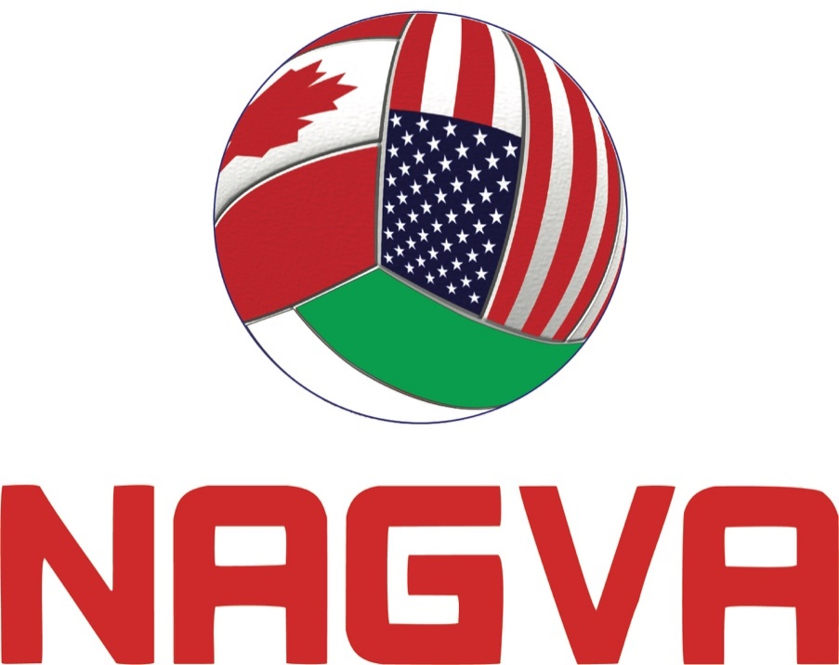

Attachment A

NAGVA
North American Gay Volleyball Association
NAGVA President – Letter of Intent

NAGVA Secretary; NAGVA Board of Directors
RE: Letter of Intent – President

NAGVA Secretary, NAGVA Board of Directors:

In adherence with NAGVA By‐Laws Article III, Section 3.03(B), I hereby submit my letter of intent to run
for the position of President for the 2020‐2022 term.

I have been a member of NAGVA since 2004, served on the NAGVA Board of Directors since 2008 in various
appointed roles, served as Treasurer from 2014‐2019 and as your President since 2019. I am proud of leading a
board over the past year that has seen an addition of seven new members and three existing members that
have taken on new and different leadership roles. It has been a great privilege to add these new experiences,
viewpoints, leadership styles, and ways of thinking to the board for the benefit of the organization and its
Membership. I would love the opportunity to be able to continue to mentor and train the board on the history
of NAGVA operations, our current policies and procedures, and allow them to continue developing the future
of NAGVA to better the Membership experience.

This past year I was happy to reinstate the ability for mass communication allowing for direct email
engagement with the entire Membership. I would like to continue with this open and honest communication
so everyone can keep apprised of news and developments within NAGVA and broaden our level of
transparency. While we have always operated with an open book, I think there is a disconnect when people
don’t have something to refer to that is not laid out in the By‐laws and Rules and Regulations. To that end, I
would like to start the process of developing a series of FAQs available on the website on topics that we always
receive questions about. I would also like to begin a monthly “Ask Me Anything” series where Members can
ask anything they wish of the President and have other board members available to ask specifics on their
department or on projects they are working on.

I would also like to continue developing the relationships I have made with various cities and
convention/sports bureaus to bring new destinations to NAGVA – not just for Championships but also for local
tournaments. Similarly, we have made strides in establishing relationships with other LGBTQ+ sports groups. It
has been a great experience to learn from them, their operations, their successes and struggles, and pick up
ideas that can benefit NAGVA as well as to hopefully avoid some of their missteps.

I have read the By‐Laws with regards to the duties and responsibilities of the position of NAGVA President,
along with the various tasks required under the Rules and Regulations and current Board policy, and I feel
strongly that I have and would continue to handle the requirements of the position. My institutional
knowledge of NAGVA, along with my work ethic, desire to better the organization, and openness to new
the ideas of the Membership I think best qualify me as the next President of the wonderful volleyball
community that is NAGVA.
Warmly,

Lew Smith
Member #151303
NAGVA
North American Gay Volleyball Association
Vice President – Letters of Intent
Dear Mr. Secretary and NAGVA Board of Directors,
In accordance with the Bylaws of the North American Gay Volleyball Association, Article III, Section 3.03 (B), I submit my Letter of Intent for Vice President for the 2020-2022 term.
I have been a member of NAGVA for 7 years. I was welcomed into a community that supports and empowers the LGBTQIA+ community. I will forever be grateful for the friends and memories I have made in this organization. These experiences spurred a drive within me to volunteer my time to benefit the organization. This started when I became the tournament director of the Nashville Music City Challenge in 2018. My goal as a tournament director has always been to stage a tournament that was worthwhile and rewarding to the players who attend.
I took that mentality when I decided to run for the Member at Large position for the 2019-2021 term. I feel that as an organization we should have a player-centered focus. We should be fair, transparent, and strive to constantly grow the organization. I have been able to you use my platform to interact with players of every division, receive feedback both positive and negative, and submit rule changes based off player feedback.
I have reviewed the requirements of the role of vice president as laid out by the organization’s bylaws and I believe I can represent the organization in a impactful manner. I view the role as the vice president, as multi-faceted. The vice president is responsible for supporting the president and the executive board in the vision that is laid out for the organization. The vice president also works closely with the Members at Large to facilitate the exchange of information from the members of the organization. I would also like to continue to focus on the core values that I ran on as a Member at Large candidate.
I am acutely aware of the need for strong leadership for our organization. I also know that being a strong leader means you are open to new ideas and criticism. We have a unique opportunity to grow as an organization and expand our presence in the lives of our members. My candidacy is about how WE can work together to improve the organization that we enjoy and that has introduced us to so many amazing individuals. I am so proud to be a member of NAGVA and I know our future is limitless!
I look forward to having a robust conversation about my candidacy as we continually strive to improve our organization.
Respectfully,
Joshua Baxter

NAGVA
North American Gay Volleyball Association
Treasurer – Letters of Intent

NAGVA Secretary and the NAGVA Board of Directors:

In adherence with NAGVA By-Laws Article III, Section 3.03(B), I hereby submit this email as my letter of intent to run for the position of Treasurer for the 2020‐2022 term.

I have been a member of NAGVA since 2011 and have served on the NAGVA Board of Directors for the past three years as a Member-At-Large (2016-2019), as Vice-President of Tournaments (2019), and Treasurer (2019 to Present). Since 2012, I have served as part of the leadership committee for the Balls of Furry Volleyball Group in San Francisco. In this capacity, we have helped to welcome new individuals to volleyball and also establish a local volleyball league in San Francisco/Bay Area.

I’ve been fortunate to contribute to the organization as a Regional Commissioner and as a Tournament Director/Co-Tournament Director for San Francisco (Red, White & Blue Ball since 2014), Hawaii (since 2017), and San Jose/Bay Area (since 2017). Overall, I care deeply about the member experience and ensuring that our tournaments are of the highest quality from coast to coast. In addition to managing and balancing the finances and budgets for tournaments and my local volleyball group, my professional background includes management of large-scale projects with substantial budgets. This skill set has translated nicely into the role of Treasurer, where I have helped maintain the Board’s fiscal responsibility, particularly in light of recent difficult events.
I have read the By‐Laws with regards to the duties and responsibilities of the position of NAGVA Treasurer, along with the various tasks required under the Rules and Regulations and current Board policy. Over the past year, I feel strongly that I've handled the requirements of this position in a manner that benefits the organization. I believe my knowledge and experience within NAGVA, and outside of NAGVA, is beneficial to the position of Treasurer and the Board of Directors.
I welcome the opportunity to answer questions and expand upon my views of the organization and how we can all, Board and Membership alike, work best together to continue to grow the association.
Sincerely,
Rich Sucre
richard.sucre@gmail.com

NAGVA
North American Gay Volleyball Association
Secretary – Letters of Intent

NAGVA Secretary and NAGVA Board of Directors:

In accordance with the Bylaws of the North American Gay Volleyball Association, Article III, Section 3.03 (B), I submit my Letter of Intent for the Secretary position for the 2020-2022 term.

I have had the pleasure of being a Member of NAGVA for the last 10 seasons, the honor of serving as the Vice President of Communications for the 2017 term, and am currently serving as your Secretary for the 2018-2020 term. My goal for joining the Board from the beginning was to bring transparency/open communication to the Membership and continue growing and sustaining an inclusive LGBTQIA+ volleyball organization, and I believe I have made strides towards both. An example of bringing open communication and transparency to Membership would be the strides I made as VP of Communications to advocate for Members to post open and respectful comments on all Facebook posts to allow for constructive conversation. In terms of growing and sustaining an inclusive LGBTQIA+ volleyball organization I look to the connections made as Secretary with smaller city/county Sports Alliances (SAs) at future opportunities to have tournaments in underserved locations.

Currently as Secretary I am working with the other Execs to network the organization with different Convention and Visitor Bureaus (CVBs) and Sports Alliances (SAs) to open up opportunities for future NAGVA tournaments and also Championship destinations. I would like to continue creating a Policy and Procedures (P&P) Manual for the Board to help with future onboarding and transitions of new Execs and illuminate how to execute each position in one document for the Board to utilize. Finally I would like to continue liasoning with the Membership and Executive Board to bring the best NAGVA product possible to our Members.

I am aware and excited to continue fulfilling the responsibilities of Secretary, should I be re-elected by the Membership. I understand the role of the Board of Directors and the commitment I undertake as a representative of NAGVA. If elected I will continue working for the Membership, and hope to find ways to continue bettering our NAGVA Community. I’ve enjoyed my time within the Board and hope to continue working with such a great group of friends.

If there are any other further questions you know I am always open to conversation. Thank you for the consideration and possible opportunity to step-up to the plate for this great organization.

Very Respectfully,
Andrew (Drewbear) Crawford
crawford.and@gmail.com

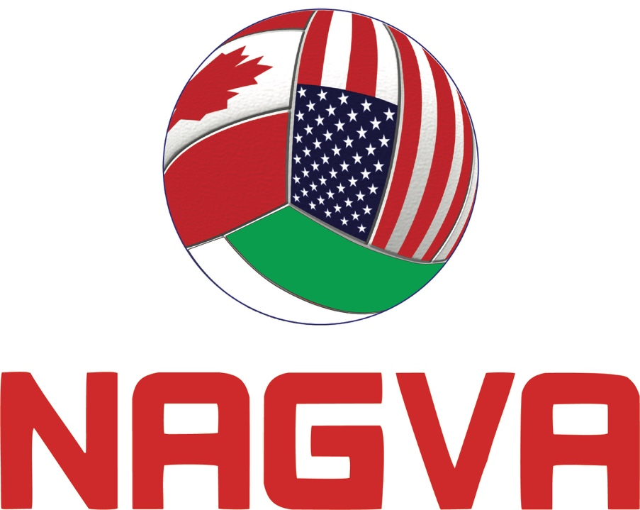

Attachment B

Robert’s Rules of Order – the Basics

Parliamentary procedure is a set of rules for conducting orderly meetings that accomplish goals fairly. Benefits of parliamentary procedure include the following:

• Justice and courtesy for all
• Maintenance of order
• Consideration of one item at a time
• All sides get heard
• Ability for each member to provide input
• Majority rule
• Protection of the rights of all members including the minority

Basic Principles

• All members have equal rights, privileges and obligations
• No person can speak until recognized by the chair
• Personal remarks during debate are out of order
• Only one question at a time may be considered, and only one person may have the floor at any one time
• Members have a right to know what the immediately pending question is and to have it restated before a vote is taken
• Full and free discussion of every main motion is a basic right
• A quorum must be present for business to be conducted
• A majority decides a question except when basic rights of members are involved or a rule provides otherwise.
• A 2/3 vote is required for any motion that deprives a member of right in any way (e.g., cutting off debate)
• Silence gives consent. Those who do not vote allow the decision to be made by those who do vote.
• The Chair should always remain impartial

Basic Definitions

Motion – A formal proposal made to bring a subject before an assembly for its consideration and action. Begins with “I move that...”

Second – A statement by a member who agrees that the motion made by another member be considered. Stated as “Second,” or “I second the motion.”

Amendment – Before the vote is taken on a motion, it may be amended by:
• Striking out words
• Inserting or adding words
• Striking out words and inserting others in their place
• Substituting one (1) paragraph or resolution for another

Presiding officer/Chair – The individual who facilitates the meeting, usually the President.

General rules of Debate:

• No member may speak until recognized by the chair
• All discussion must be relevant to the immediately pending question
• No member can speak more than twice to each debatable motion. The second time takes place after everyone wishing to debate the motion has had an opportunity to speak once
• No member can speak more than three minutes or as decided by members.
• All remarks must be addressed to the chair – no cross debate is permitted
• It is not permissible to speak against one’s own motion (but one can vote against one’s own motion)
• Debate must address issues not personalities – no one is permitted to make personal attacks or question the motives of other speakers
• The presiding officer must relinquish the chair in order to participate in debate and cannot reassume the chair until the pending main question is disposed of
• When possible, the chair should let the floor alternate between those speaking in support and those speaking in opposition to the motion
• Members may not disrupt the assembly
• Rules of debate can be changed by a 2/3 vote or general consent without objection

Helpful terminology:
• Recommendations, bylaws, rules, resolutions, budgets, and audits are adopted.
• Reports are filed.
• Resignations are accepted.
• Bills and minutes are approved.
• If corrections were made to the minutes, the minutes are then approved as corrected.
• Treasurer’s statement is neither approved nor adopted; but after questions are answered regarding any item as reported, it is placed on file for audit as stipulated in the bylaws.
• Motions are recorded as “adopted” or “lost.”

