Requiem For The Dead - Book Review – authorreading.com

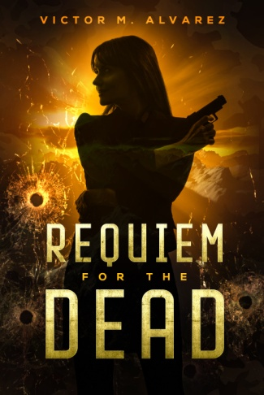
A criminal investigation or a terrorist plot? Requiem for the Dead by Victor M. Alvarez is a military cloak and dagger thriller written by an authority on military protocol with years of personal experience. The suspense novel is well researched and relatable, set in and around military installations in Stuttgart, Germany. The story is propelled forward quickly by well-developed characters against a realistic backdrop. The engaging plot follows two storylines, both involving military mayhem, murder, and the seemingly unrelated mysteries of kidnapped children.

The author enables the reader to visualize the protagonist, CID Special Agent Jacqueline Sinclair, as a sophisticated, tough, hard-core soldier wearing Class A Army jacket, a skirt that topped her knees, nylons, and plain black lace-up military issue shoes. However, she is highly attractive and sexy with runner’s legs and a tight-fitting blouse. Her assigned partner, DIA Agent Tom Price, is lean and well-muscled, “suggested by the bulging outline of his suit jacket.” He has a stocky chest, long blond hair, and appears to be “a man that attracts women rather effortlessly” although, to Sinclair, he also seems to be unsophisticated. Agent Sinclair said on meeting, “We’re going to get along famously I see.” Could there be a hint of romance? The many minor characters are equally fleshed out as identifiable individuals.
Agent Sinclair and her partner, Agent Tom Price, are investigating the sudden disappearance of four dependent children of high ranking generals. The children have become hostages of rogue ex-US military personnel who are using them as leverage in an attempt to coerce the military to exact revenge on Pyongyang for the capture, torture, and killing of another US Army General's son suspected by North Korea as being a CIA spy. The agents discover that the kidnappers are a surprisingly large unit of highly-trained mercenaries who are blindly following their leader as he advances his plot of revenge on Pyongyang, and the United States government for its foreign policies. Can the agents unravel the plots' twists in time to prevent the hijacking of nuclear bombs and prevent the possibility of WWIII? How are the president of the United States and the leader of North Korea in Pyongyang involved?
The engaging and detailed plot is enhanced by the author’s authenticity and insight into the inner workings of the military. He uses military jargon with clarification. The author’s use of current military terminology enhances the contemporary plot and may be compared to novels by Tom Clancy.
The vortex of violence is resolved in a climactic conclusion as the Agents Sinclair and Price lead military and civilian Special Forces into battle with the terrorists. The reader is left with the question of the possibility of such actions taking place in today’s society. Requiem for the Dead is an engaging, fast-paced novel with a satisfying plot complete with all the technical jargon that provides the authenticity one expects in a military-focused book. It is a frighteningly genuine tour de force with a gripping narrative that will resonate for military buffs. Alvarez’s work of fiction will definitely delight readers of action, adventure, thriller, suspense, and military genre books.
Reviewed by: Carole W.

About Victor Alvarez
Victor M. Alvarez was born in Puerto Rico, and at nine his family moved to New York City and later drafted into the US Army. He received airborne training, ranger, military police school and later jungle warfare training. His military awards range from Jump Wings, Vietnam Cross of Gallantry, awards of the Purple Heart, Air Medal, and Army Commendation Medal, among other many awards. He makes his home in New Smyrna Beach, Florida.

AuthorsReading.com is a participant in the Amazon Services LLC Associates Program, an affiliate advertising program designed to provide a means for sites to earn advertising fees by advertising and linking to Amazon.com. As an affiliate, this website earns from qualifying purchases.

