**PRESS RELEASE**

MARKER RELEASES ALL NEW ROYAL FAMILY OF BINDINGS

**For over 12 years, Marker’s Royal Family has provided innovations that maximize performance for pro athletes and everyday skiers alike. The German binding maker is set to start the new decade with a brand new collection, with more innovations that promise to continue the legend.**

The Jester, Jester Pro and Griffon models have become the preferred freeride bindings for skiers wanting to conquer any setting, from the park to the big mountain. In 2020/21, Marker introduces 3 brand new Royal Family models, with new technology that improves both function and performance.

**New Triple Pivot 3 Toe**

Starting up front, the new Triple Pivot Elite 3 toe piece with integrated Anti-Ice Rail gives the binding a new look and a great way to remove snow and ice from your boot soles without damaging the binding housing. Of course, with SOLE.ID technology, the new toe ensures 100% compatibility with any boot fitting the ISO 5355 (Alpine) and ISO 9532 (Alpine Touring) norms.

**New Inter Pivot 3 Heel**

The Inter Pivot 3 heel maintains its signature power transmission, with a re-design that makes it easier to step into, especially with many of today’s rubber boot soles. With a new housing and improved cosmetics, it’s offered in 90, 100, 110, and 120mm brake widths, so all ski shapes are covered.

**A Complete Family**

With 3 new high performance models, the Royal Family has something for any skier looking to make their new skis perform at their best. Set to be unveiled at the upcoming X Games, the Jester 18 Pro ID is offered in 90 and 120mm brake width. It leads the charge for the top skiers looking for the ultimate retention and power transmission. The Jester 16 ID is next in line, with a 6-16 DIN range and brake options of 90, 100, 110, and 120mm. Both Jester Pro and Jester benefit from magnesium sole holders and heel brackets, adding durability and power transmission for the ultimate performance in a freeskiing binding. Also coming in 90, 100, 110 and 120mm brake widths, skiing’s most popular binding, the Griffon 13 ID is also totally re-designed for 2020/21 with the same toe and heel innovations. To maximize the exposure for this important binding, it’s offered in 4 distinct color ways for the coming season.

**Griffon 13 ID**

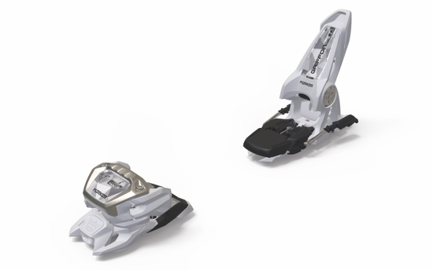

Press contact

Mark Tedeschi

Elevator North

781-740-4050

[mtedeschi@elevatornorth.com](mailto:mtedeschi@elevatornorth.com)

About Marker

Marker has been synonymous with innovation and protection in skiing for over six decades. In 1952, Hannes Marker patented the world's first ski binding with safety release. In the 1970's, the M-series with automatic heel release revolutionized the binding market. With the Duke and the continuous expansion of the Royal Family, the company has been setting new standards in the freeride and freestyle segment from its location in the Bavarian town of Penzberg since 2007. Working with some of the world's largest ski brands, allows Marker not only to develop their own pioneering products, but also to develop system bindings that form a perfect unit with the ski. In addition, Marker successfully expanded its product portfolio in 2013 to include helmets, goggles and protectors.