Action plan:
To set up a yearlong water quality monitoring of our Rivers Ward & Broadmeadow, collecting samples in various locations once a month.
Timeline:
We will start our project as soon as we receive the testing kits. Our first in person meeting will be held to select and physically visit the locations we are planning to test. We are normally meeting at least once a week as Swords Tidy Towns volunteers, but additional meetings (either in person or online) will be held as necessary.
Budget:
The additional funding will be most likely used for buying telescopic handle water samplers and getting extra testing kits.
Impact:
Swords Tidy Towns volunteers have participated in WaterBlitz evens for the last couple of years so there is quite a bit of data available now, however that data only represents a one particular point in time. A yearlong water testing & monitoring will give us a more complete view of the water quality of our rivers and might even help us to identify the contributing factors. We are hoping that by sharing the results we will get local community more interested and aware of the health of our rivers.
The below screenshots shows nitrates & phosphates levels from the samples collected during the WaterBlitz events.
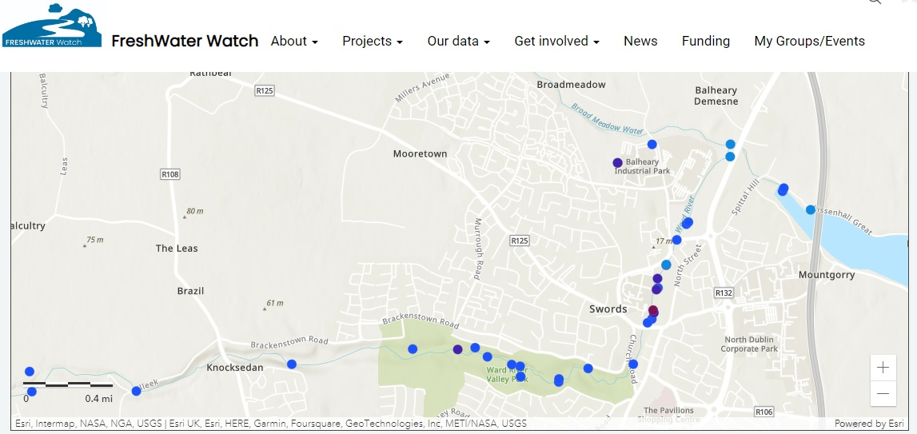

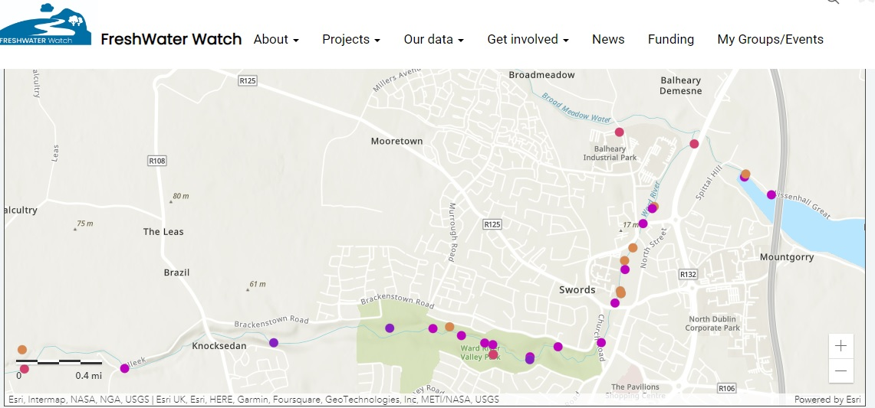
Location:
We will be testing our two rivers – Ward and Broadmeadow, the specific spots will be selected in due course.

