Lesson | Main Themes & learning | Actions
1 | How to become a Plastic Free Ambassador  What is an ambassador?  How can I be one?  Plastic in our lives  Is all plastic bad? | Upcycle Challenge: Find a creative reuse for a plastic bottle  Engagement Challenge: Engage your family through a shared plastic audit
2 | The History of Plastic  What is plastic made from?  When did we start using it?  What are the advantages & disadvantages of plastic? | Upcycle Challenge: Find a creative reuse for takeaway cups and plastic straws  Engagement Challenge: Engage your friends through poster, animation, phone call, email etc.
3 | The Plastic in our Oceans  How did so much plastic get into our oceans?  How does it affect sea life?  What can we do? | Upcycle Challenge: Find a creative reuse for plastic cutlery  Engagement Challenge: Engage your local community, poster, flyer, organize or join a local clean up
4 | The SDGs & Waste  What are the SDGs?  What is waste?  Understanding waste systems  How to change a habit | Upcycle Challenge: Find a creative reuse for plastic bags  Engagement Challenge: Engage your school community, ask them to get involved to take on some plastic free challenges as a whole school
5 | Reduce, Reuse, Recycle  What is recycling?  How to recycle properly in Ireland | Upcycle Challenge: Find a creative reuse for plastic toothbrushes  Engagement Challenge: Engage local businesses, thank them for their sustainable choices or request changes  Bonus: Song writing challenge
6 | Plastic in our local & global communities  How to do a litter pick  How do we make decisions for our country and planet?  The EU plastic ban  How to compost | Upcycle Challenge: Find a creative reuse for plastic soap bottles  Engagement Challenge: Engage decision makers & politicians – let them know your priority is looking after planet earth
7 | Plastic and our food  Plastic food packaging  How to pack a litterless lunch | Upcycle Challenge: Upcycle plastic food packaging  Engagement Challenge: Engage globally by contacting a global organisation or business.  Bonus: Food packaging Design Challenge
8 | Being a Plastic Free Ambassador  Start your own campaign  Being a Plastic Free Ambassador | Upcycle Challenge: Create your own  Engagement Challenge: Start your own campaign, follow your passion
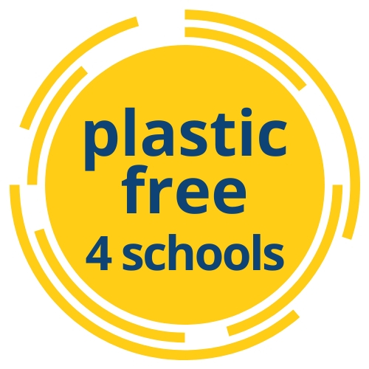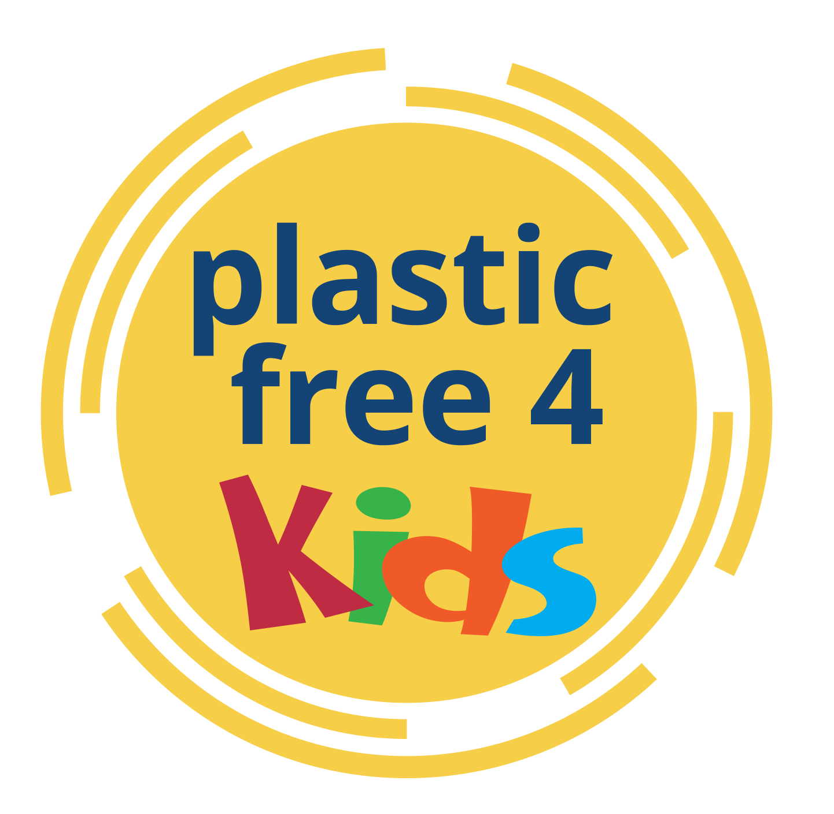
Plastic Free 4 Kids
Become a Plastic Free Ambassador

Online Lessons - Designed for Distance Learning
plasticfree4schools@gmail.com
@PlasticFree4Schools
#pf4kids #plasticfreeambassador

