**REVIEW OF 2018 BALLARAT OPEN RACQUETBALL CHAMPIONSHIPS**

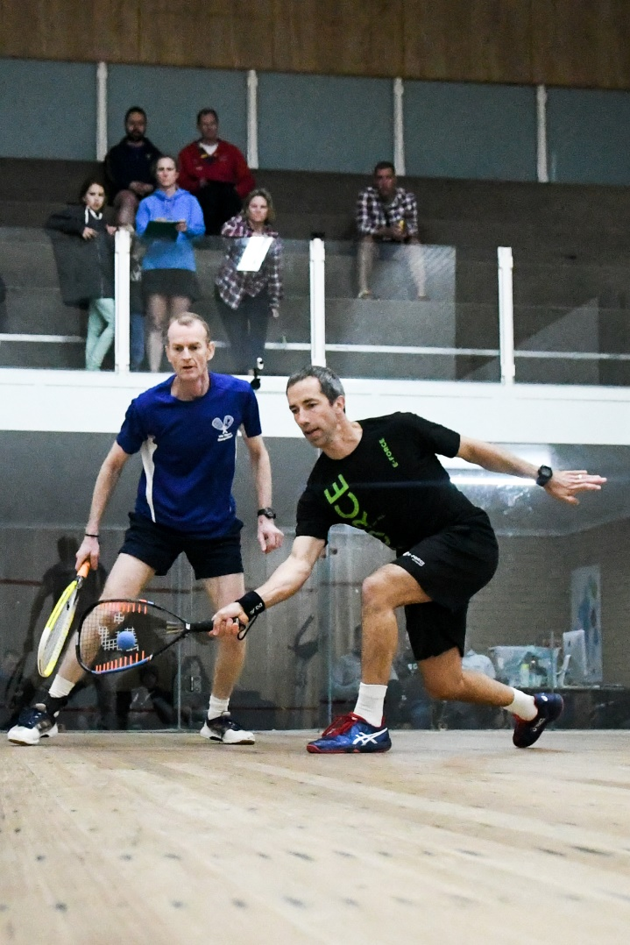The King of Racquetball Cam White lived up to his imposing record by claiming the Ballarat Men’s OpenChampionship and further extending his seventeen-year unbeaten period in tournament play, when he overpowered Garry Pedersen who is currently in second position on the National, and now in top place on the Victorian Grand Prix Circuit rankings, in a high-class finale to the event, 21/7, 21/16**.**

In the Women’s Open event, Bairnsdale’s seven times Australian Open Champion Judy Wright, survived a nail-biting encounter in the final over 2017 Australian Open semi-finalist Sally White, 22/20, 21/17, and deny a fairy tale ending for the White couple.

*Cam & Garry in the final.* *Photo courtesy of Mark Squire*

Overall, the event attracted one hundred and forty-one entries, of which twenty-three were playing in their first Grand Prix Racquetball event, and the host club enjoyed a most successful weekend on court, claiming four out of the ten singles titles, plus capturing one doubles title outright and shared in two others, out of the six events. Also, the Brigden family’s car was loaded up on the trip back to Albury after they claimed two singles titles courtesy of father Michael and youngest daughter Amelia, plus all five featured in the finals of three doubles events.

**SINGLES RESULTS**

**MEN’S OPEN**

Since 2012 this event has been owned by Cam White (2011/14/15/17), and Garry Pedersen (2012/13), with the only exception being in 2016 when Dromana’s Steve Andrewartha prevailed, and both were seeded to meet in the 2018 event’s climax.

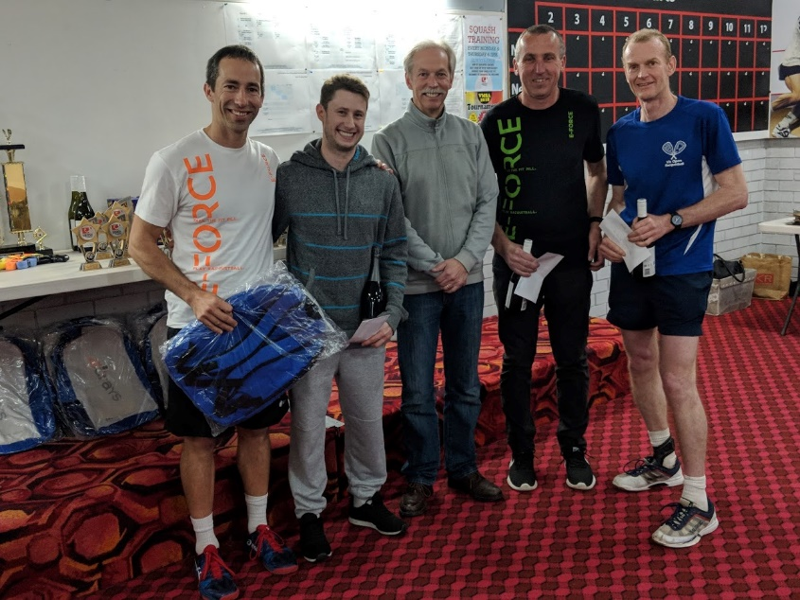Due to a heavy MFB work schedule this was White’s first event since the Lakes Classic last November, so it was a great chance to gauge where Pedersen stood with White in comparison to his straight games semi final loss to him in this event last year, if they both met up in the final chapter, which is what eventually happened.

In their respective semi finals, White overcame the tenacious 4th seeded Ryan McCarter, 21/10, 21/17, with Pedersen accounting for his Geelong stable mate Peter French, 21/16, 21/12.

When playing White you have a total understanding that you will be regularly extended to the four corners of the court with his pin point accuracy in both his short and long games, plus trying to counter his impeccable width which has his opponents doing far more stretching than against any other player in the sport.

*L-R: Cam White, Ryan McCarter, David Rowe, Peter French, Garry Pedersen*

The match commenced at a hectic pace with both players unrelenting in their pursuit of claiming every point available, but it was the virtually error free White who took control early, never relinquishing his lead and claiming the first game 21/7.

The second game also opened at a frenetic pace, but this time Pedersen stuck with White and it became a most enthralling game until White lifted a gear towards the end which led to him seizing control and claiming his fifth Ballarat Open title over a gallant Pedersen, 21/7, 21/16.

**Women’s Open**

Although current Australian Open winner Sarah Fitz-Gerald was missing, great anticipation still surrounded this year’s event with the top seed being National Grand Prix Circuit Rankings leader Sue Dunlop, who had so far this year captured the Tasmanian, Darwin and Wangaratta Opens; but over the past three years it has taken someone very special to deny second seeded Judy Wright the winners crown in Women’s Open events, happening only three times, once by top Australian squash player Christine Nunn and twice by Fitz-Gerald.

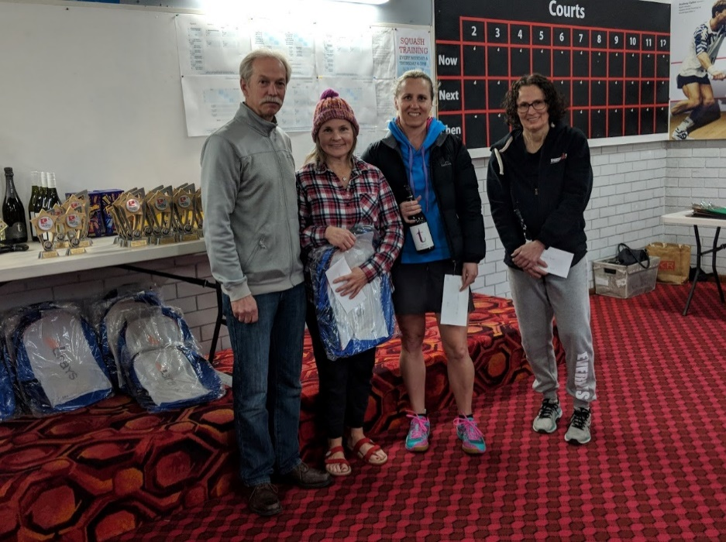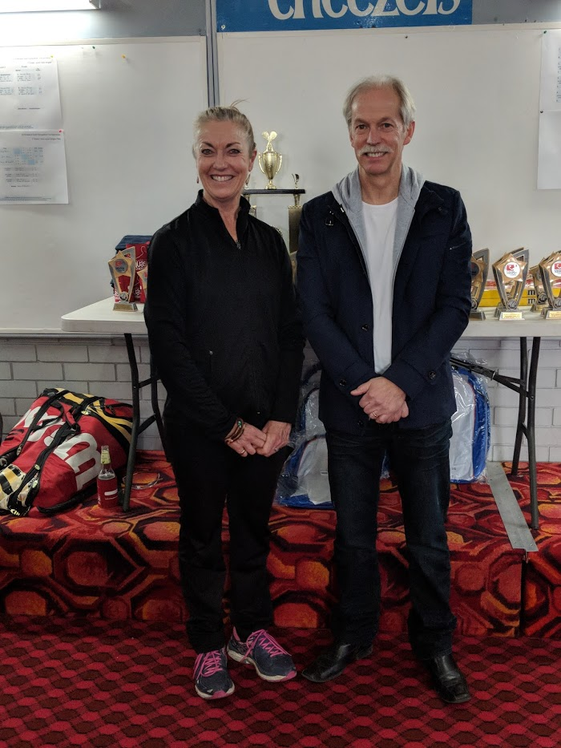

*L-R: David Rowe, Judy Wright, Sally White, Sue Dunlop Mandy Simpson, David Rowe*

When the final stanza was reached it was a face- off between Wright, the seven times Australian Open champion, who had accounted for Ballarat’s Mandy Simpson at the semi -final stage, 21/6, 21/6, and 2017 Australian Open semi-finalist Sally White, who had taken out a tough semi-final encounter over Dunlop, 21/19, 21/18.

The final was a titanic struggle with Wright eventually surviving a nail-biting encounter over the “never say die” White, 22/20, 21/17, and escalating Wright to the top of the Victorian Grand Prix rankings.

In the play-off for 3rd & 4th, Dunlop overcame Simpson, 21/13, 21/17.

**A GRADE:**

With the dominant A Grade player for the year Matt Bayley taking on the Men’s Open crew, this event on paper looked wide open, particularly as the field also contained four well performed locals who were returning to the Grand Prix circuit, with two of them eventually reaching the final stanza.

The two losing semi-finalists from this event in 2017 fought out the first semi-final, with Ballarat’s Troy Anwyl ousting Mt. District’s top seeded Rob Hay, 21/19, 21/11, whilst Ballarat’s second seeded Seth Adams won the 110th and final point in a marathon second semi-final to overcome another local Anthony Bossner, 21/14, 20/22, 21/12, to reach the event’s climax.

The first game of the final went point for point until Adams broke clear right at the end, then established an early lead in the second which he steadily increased to secure the match, 21/19, 21/13.

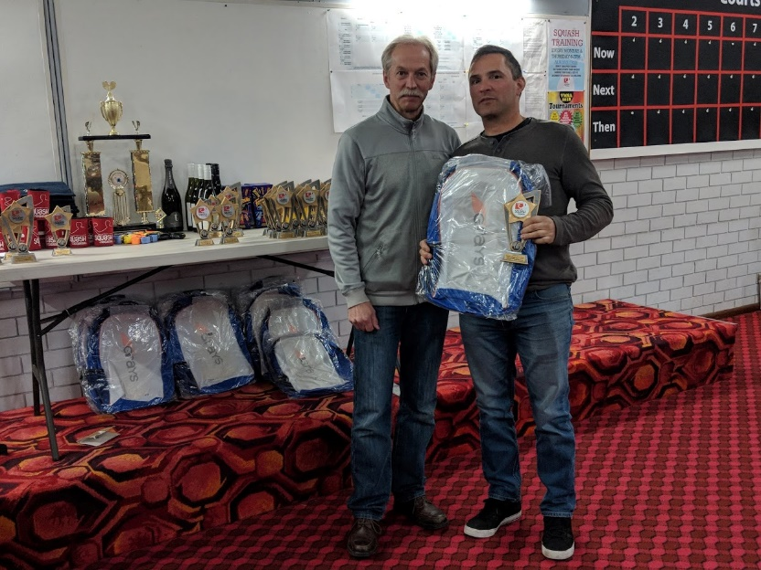 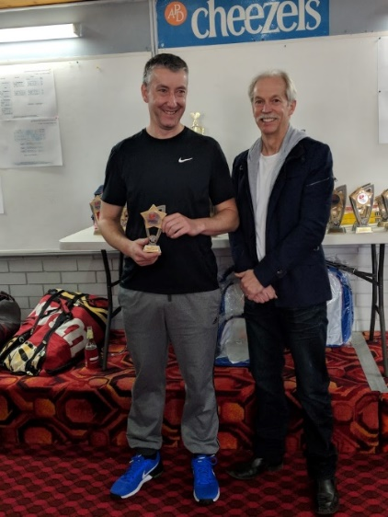 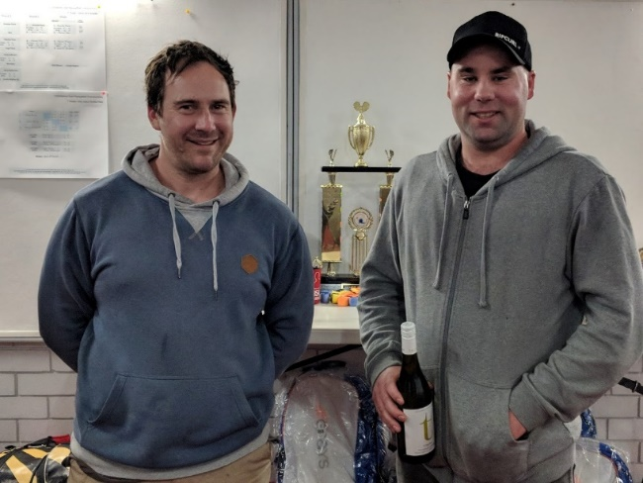

*L-R: David Rowe, Seth Adams Troy Anwyl, David Rowe Russell McLean, Tim Milne (Plate Winner)*

**B GRADE:**

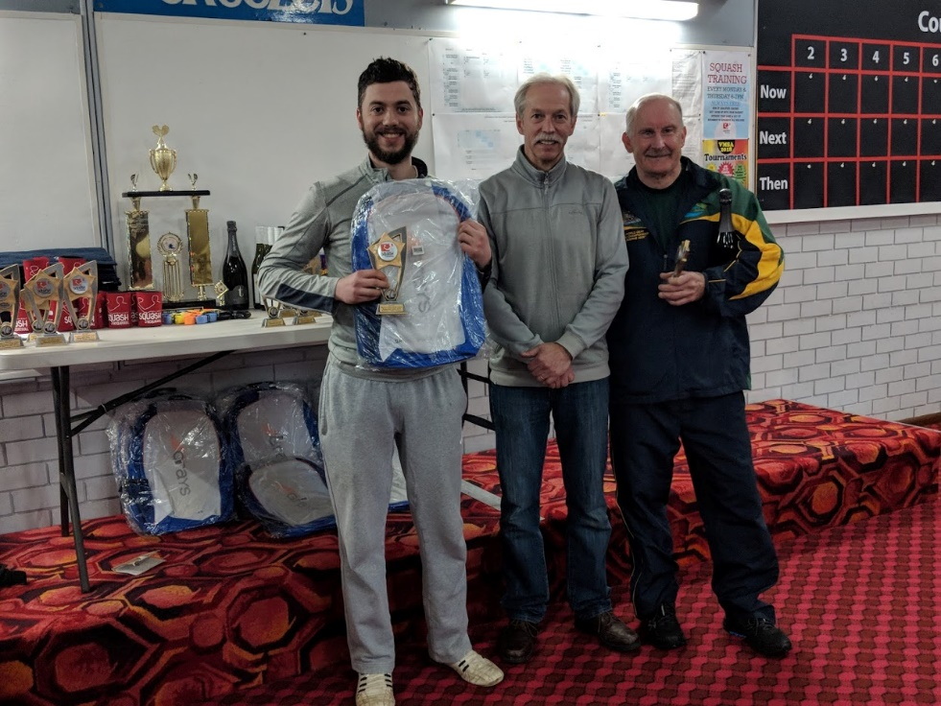 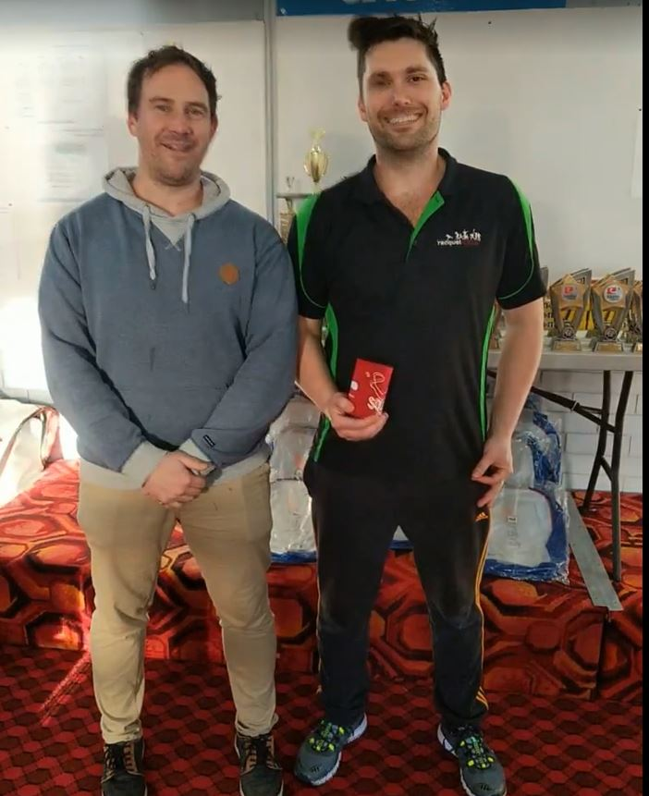

*L-R: Blake Caspersz, David Rowe, Peter Walters Russell McLean, Campbell Shobbrook (Plate Winner)*

Ballarat’s 2017 C Grade National and Victorian GP Circuit Champion Blake Caspersz, was out to make it three consecutive titles at his home event, having won the 2016 and 2017 Ballarat C Grade events, and hoping as well to capture his first B Grade GP title.

When the judge called a halt to proceedings for this event, the top seeded Caspersz had completed his “hat trick” of titles, but not before having to come back from a game down in a marathon final against former world deaf squash champion Peter Walters, to win 15/21, 21/10, 21/19.

In their respective semi finals, Caspersz defeated Wangaratta’s fourth seeded Paul Trinick, 21/16, 21/18, whilst Walter’s opponent Mitchell Harrison unfortunately sustained a calf injury during the first game and was forced to retire from the match.

**C GRADE:**

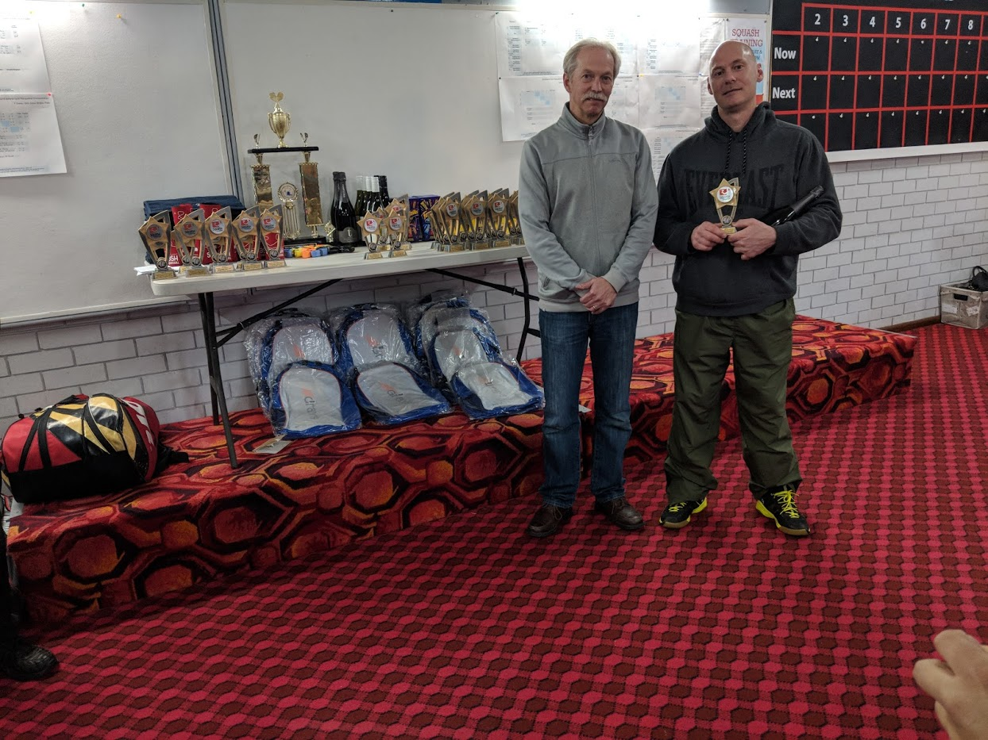 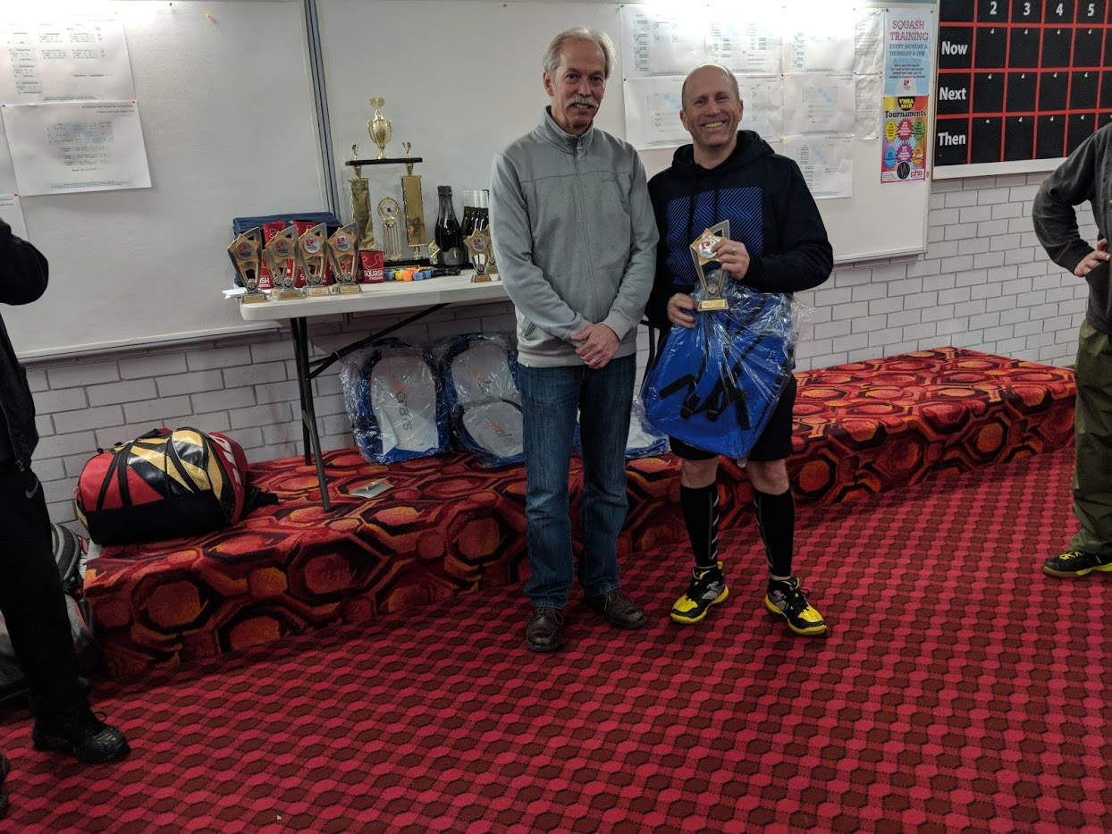 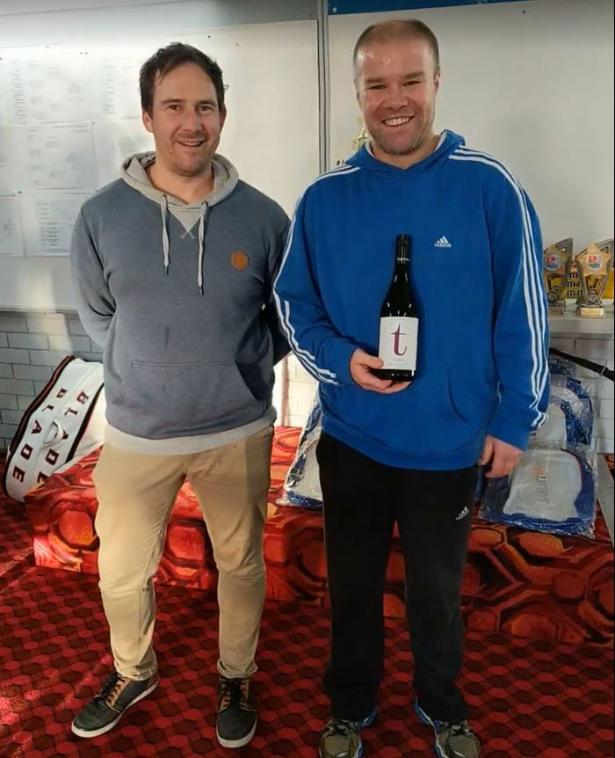

*L-R: David Rowe, Anthony Dzioba David Rowe, Michael Brigden Russell McLean, Drew Crittenden (Plate Winner)*

The C Grade event provided the biggest field of the tournament with eighteen starters, which meant the winner had to survive at least four competitive matches over the course of the day.

In the end it was the two top seeds, Bendigo’s Anthony Dzioba and Commercial Club’s Michael Brigden, who confronted each other in the final stanza, and it was literally a “last man standing affair”.

After sixty five minutes of unbelievable rallies, comebacks and counter punching, Brigden was able to claim the eightieth point and the title, 21/19, 21/19, and turn the tables on the top seeded Dzioba who had defeated Brigden in the final of the recent Victorian Open C Grade title.

In their penultimate match to reach the final, Dzioba won a stirring encounter over Commercial Club’s fourth seeded Ross Falconer, 21/12, 21/22, 21/12, whilst Brigden overcame 2018 Wangaratta Open C Grade winner John Broz, 21/18, 21/17.

**D GRADE:**

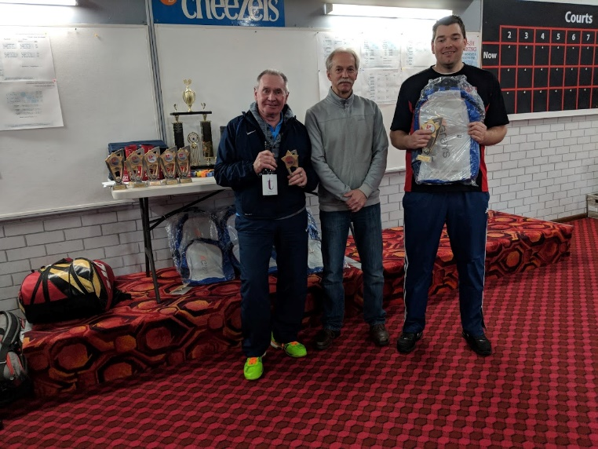 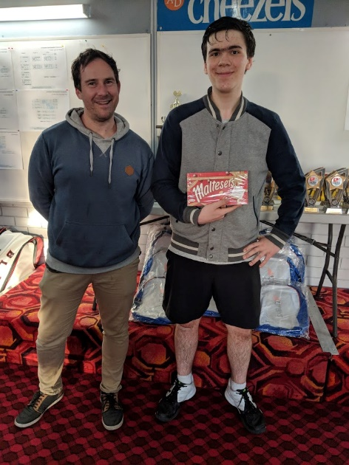

*L-R: Brian Richards, David Rowe, Andrew Curwood Russell McLean, Ilija Pantelich (Plate Winner)*

Ballarat’s Andrew Curwood was playing in only his second GP Circuit event, his first was in this tournament in 2017, where he won the Plate event, whereas top seeded South Australian stalwart Brian Richards had appeared in five events this year, winning the Darwin and Tasmanian Open D Grade titles, being runner up in two others, plus filled third placing in the Sth. Australian Open.

In the end, after putting three opponents to the sword, it was Curwood who took the honours over Richards in the finale, 21/19, 21/8, and register Ballarat’s third singles title for the tournament.

In their respective semi finals, Curwood accounted for one of our most promising junior players Commercial Club’s Xavier Brigden, 21/11, 21/11, whilst Richards came from a game down as well as saving a match point in the second game, to hold out Bendigo’s fourth seeded David Drew, 20/22, 22/21, 21/17.

**E Grade***:*

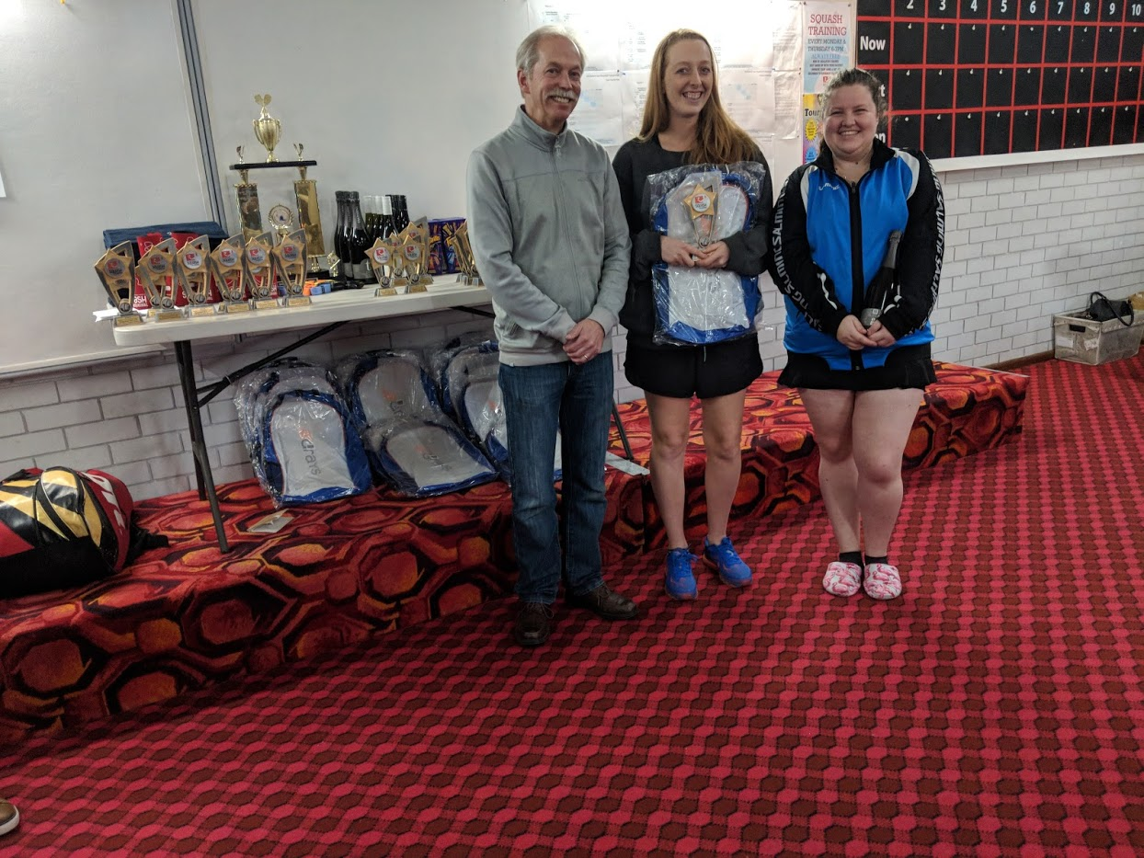 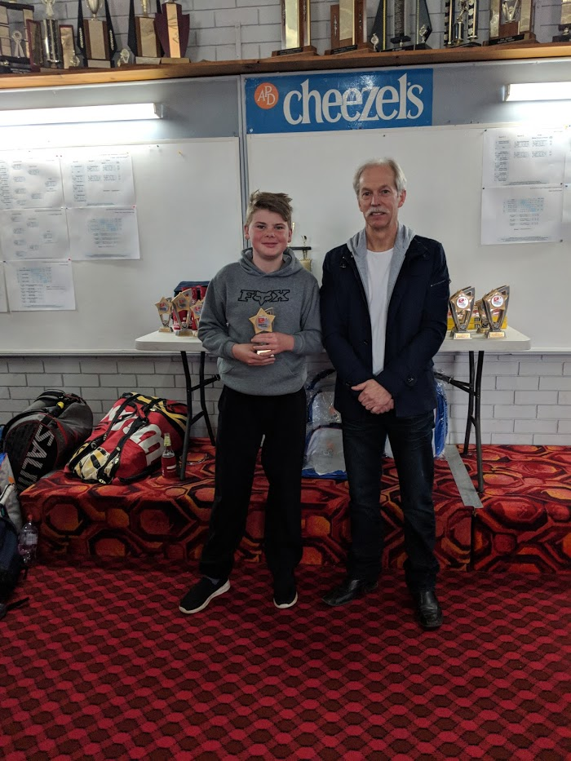

*L-R: David Rowe, Leah Horrobin, Jamie Disson (Plate Winner) Jackson Lander-Mitchell, David Rowe*

This event was a war of attrition with each player having to survive three matches, with eventually two Geelong players sharing the major booty, GP debutant Leah Horrobin and the youngest player in the field, Corio’s thirteen-year-old Jackson Lander-Mitchell, with Horrobin claiming the title, winning 21/14, 21/11.

In their respective semi finals, Horrobin overcame another GP debutant Ballarat’s Chloe Canfield, 21/3, 21/9, and Lander-Mitchell survived a marathon encounter over another debutant, Shepparton’s Jamie Disson, 21/7, 21/22, 21/18.

**F Grade**

Mulgrave’s top seeded Amanda Pavia was seeking her third consecutive F Grade title following her wins at the Geelong and Victorian Opens, which she succeeded in accomplishing, defeating Bendigo’s second seeded Thomas Chen in the final, 21/18, 21/17.

In their respective semi-finals, Pavia defeated Commercial Club’s eleven years old Amelia Brigden, 21/16, 21/7, with Chen overcoming Corio’s Danica Morgan, 21/19, 13/21, 21/13.

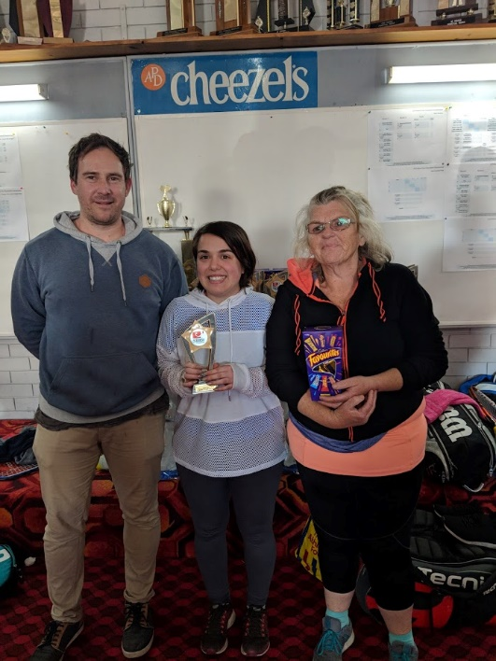 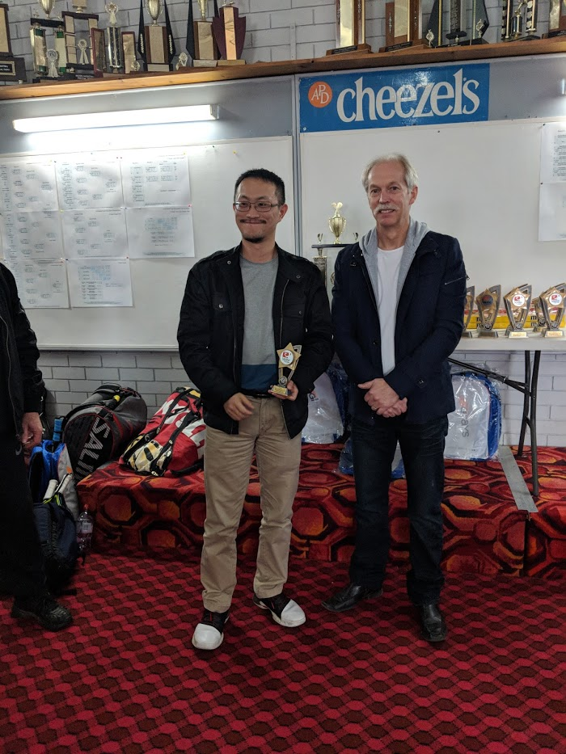

*L-R: Russell McLean, Amanda Pavia, Helen McDonald (Plate Winner) Thomas Chen, David Rowe*

**Junior Girls/Boys Under 13’s**

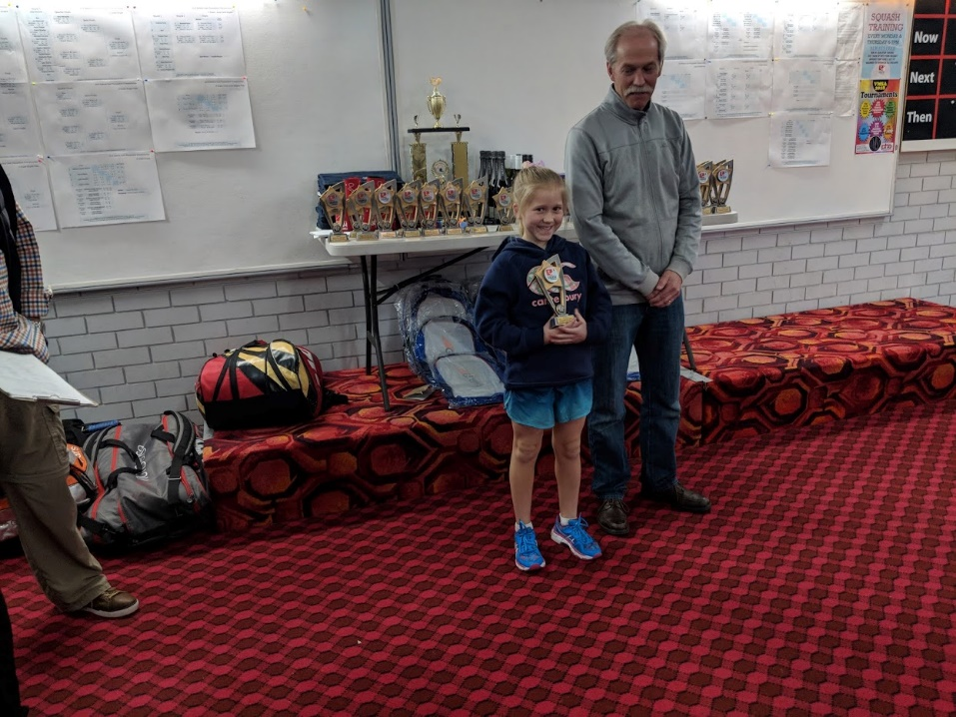Amelia Brigden took out the Junior Girl’s event, with Ballarat’s Will Parry defeating his younger brother Hugo, 21/11, 21/12, to claim the Junior Boy’s title and household bragging rights for a few months.

*L-R: Amelia Brigden, David Rowe,*

|  |  |  |
| --- | --- | --- |
| SINGLES | | |
| Grade | **Winner** | **Runner-Up** |
| Men’s Open | Cam White | Garry Pedersen |
| Women’s Open | Judy Wright | Sally White |
| A | Seth Adams | Troy Anwyl |
| B | Blake Caspersz | Peter Walters |
| C | Michael Brigden | Anthony Dzioba |
| D | Andrew Curwood | Brian Richards |
| E | Leah Horrobin | Jackson Lander-Mitchell |
| F | Amanda Pavia | Thomas Chen |
| Junior Girl’s | Amelia Brigden |  |
| Junior Boy’s | Will Parry | Hugo Parry |

|  |
| --- |
| DOUBLES |
| Grade Winner s Runners-Up |
| Open Stevenson/O’Donnell Morris/Patterson |
| A Bossner/Chaffey Seth & Sam Adams |
| B Horvat/Mihan Tiet/Tench |
| C Andrew & Gary Clancy Michael & Alex Brigden |
| D Lane/Drew Brigden/Adams |
| E Amelia & Xavier Brigden Chen/Bouhajid |

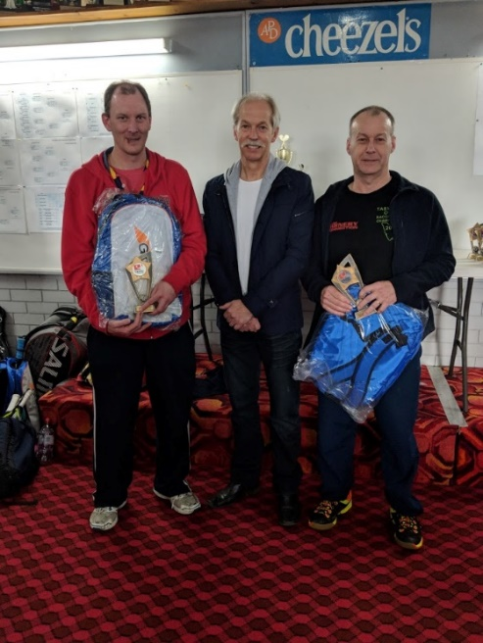 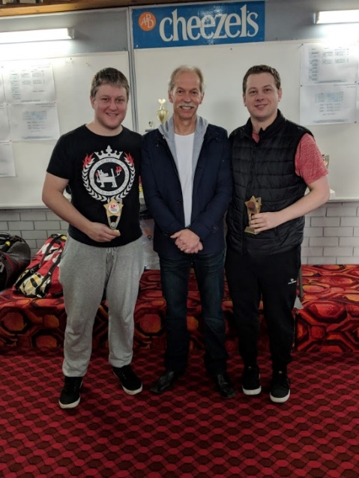

*Open: L-R: Darren O’Donnell, David Rowe, Charlie Stevenson Cam Morris, David Rowe, Nathan Patterson*

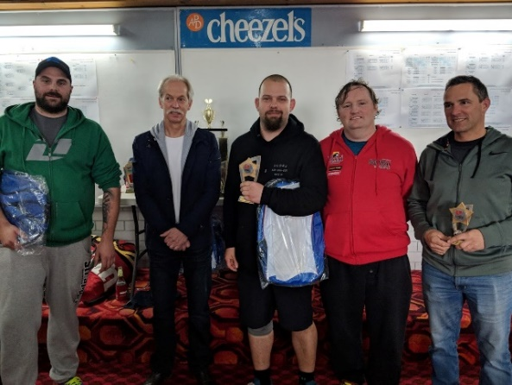

*A* *Grade: L-R:* *Anthony Bossner, David Rowe, Josh Chaffey, Sam & Seth Adams*

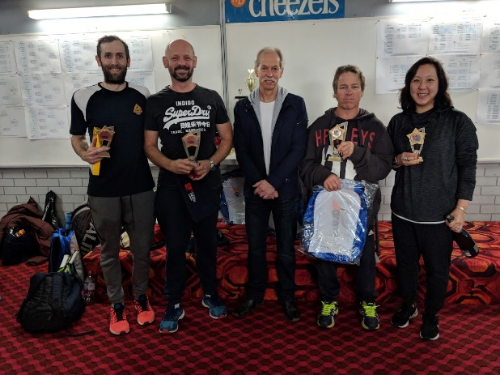

*B Grade: L-R:* *Matt Tench,* *Marcus Horvat, David Rowe, Chris Mihan, Sylvia Tiet*

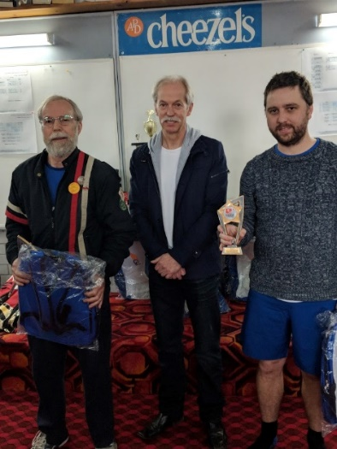 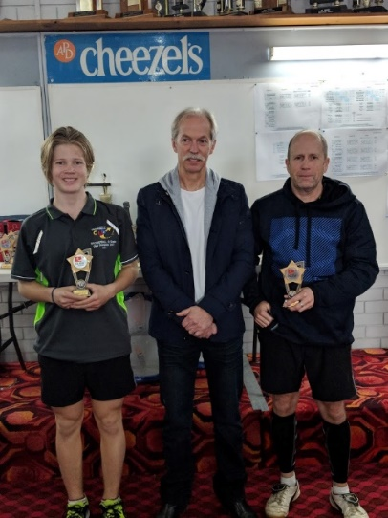

*C Grade: L-R: Gary Clancy, David Rowe, Andrew Clancy Alex Brigden, David Rowe, Michael Brigden*

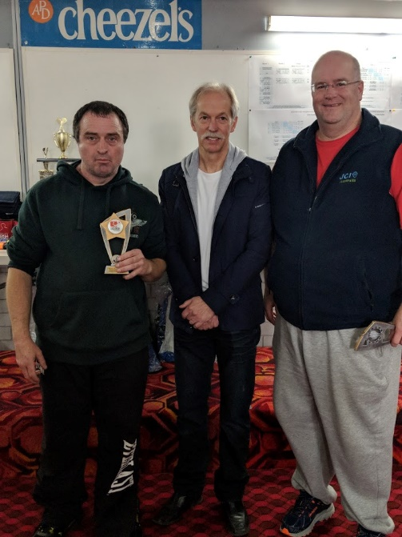 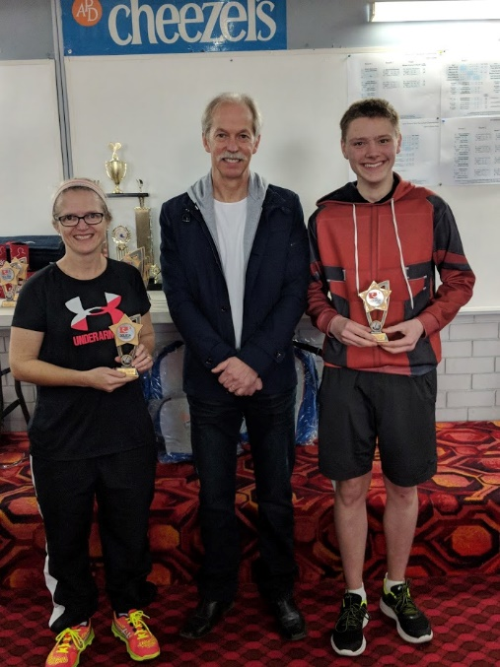

*D Grade: L-R: David Drew, David Rowe, Mark Lane Cheryl Brigden, David Rowe, Tyler Adams*

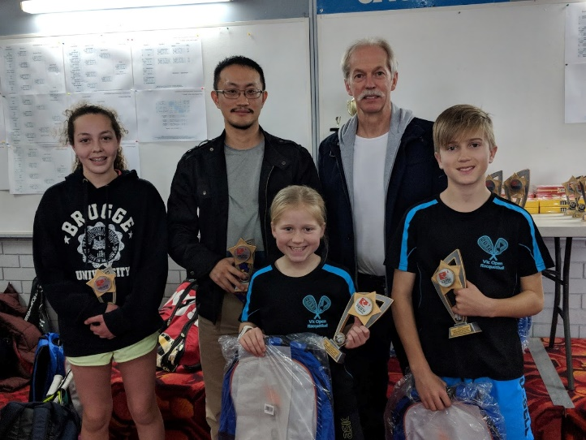

*E Grade: L-R: Back Row: Eboni Bouhajid, Thomas Chen, David Rowe: Front Row: Amelia & Xavier Brigden*

Words: Paul Vear

Special Presenters: David Rowe & Russell McLean

Photos Courtesy of: Russell McLean, Leon Faustini & Shane Skidmore