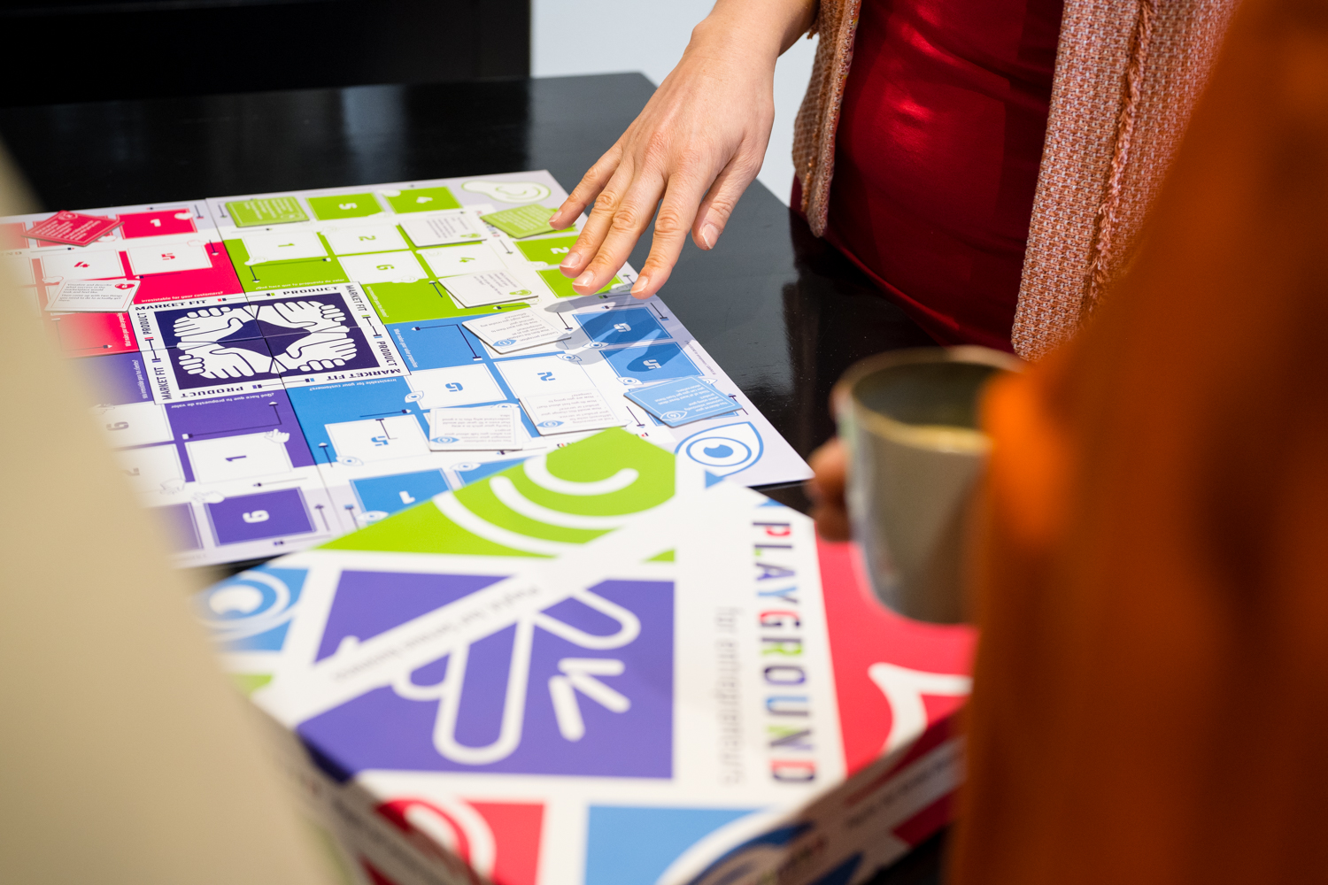

Implementation Playbook ChangeX Playground for Entrepreneurs

Your community

Your name

Date

Use this template to set up your implementation plan for the Playground for Entrepreneurs. It’s a meant to be a practical, short and concrete document stating your plans with this tool. Complete the template before application; during the training you’ll get the chance to adjust and refine. You can take out the yellow text and put in your own.

Introduction
Introduction to your community, context, background, previous entrepreneurship initiatives in your area, why it is important to start this project, etc.

Team
Introduce your team and their profiles. Take into account that your team needs to consist of at least 5 people, of which 2 facilitators. The other 3 team members can take on any role they want and that makes sense in your context. Example roles the team members may take on include:
Facilitator: Facilitator of the game and of other activities involved. These might include workshops, the program, etc. As a facilitator you take care of the content of these activities, the dynamics, preparing the space, etc.
Community promotor: As a community promotor you promote the program or activities to potential participants, like aspiring entrepreneurs or small business owners. You motivate people to start attending activities, as well as inform people about practical information like times and dates. You regularly meet up with the facilitators and may participate in activities.
(Potential) partners: You have close connections and contact with possible partners, like communities, schools or NGOs. You work with these partners to open up opportunities to expand upon the activities of the program, integrate them with existing initiatives or create new opportunities together.
Apprentice: You support facilitators in their activities, in preparation and during the activity as well as in between sessions to support the entrepreneurs taking the steps they need to.
Advisor: As an advisor, you offer specific professional services to the program or supporting participating entrepreneurs. For example, design or programming.

Creating your community of entrepreneurs
Community outreach is essential for the activities of your program. You need to be able to reach the right people in your community, your participating aspiring entrepreneurs and small business owners who want to get ahead with their business.
In this section, describe how you are going to do this. Point out a couple of alternatives to reach the right people, and what effort would be needed from your team.

Create partnerships
This is where you describe what partnerships would be relevant to your particular context, how you think you will develop them, at what term, and how they are going to impact your work with the Playground and entrepreneurship in general in your community.
Think about collaborating or partnering with schools, municipalities, NGOs. You might look for organizations that promote economic development, work with youth development, employability, etc.

Playing sessions with the Playground for Entrepreneurs
Describe your plan to organize playing sessions here: describe timing, frequency, participants, promotion, support, venue etc.

Workshops with the Playground for Entrepreneurs
Describe your plan to organize workshops that include the Playground for Entrepreneurs here: describe timing, frequency, participants, promotion, support, venue etc. Also think about the other elements of the workshop that you’ll present, entrepreneurship methods or frameworks (you will learn about some of these in the training, as well). Make sure this aligns with the audience you’re expecting for this workshop.

Entrepreneurship program for aspiring entrepreneurs or small business owners
In an entrepreneurship program, you support entrepreneurs during a fixed period of time. In this context, make sure you plan (and write down here):
- Who are your participants (or audience) and what is their expected starting point
- How long, with what frequency, are you supporting them.
- What elements are part of the program (coaching, workshops, advisors, events, one-on-one, etc.)
- What is their final goal, what point are you going to take them to at the end of the program?

Final event
Take one of two approaches:
- Showcase your successes over the duration of the program. Give the entrepreneurs the opportunity to speak for themselves, show off their products and results, and boost their visibility with this event. Make sure the event and the audience is as relevant as possible for them; invite possible partners, customers, etc.
- Promote the program with the entrepreneurs in it as a work-in-process. Invite the community to come and take a look, to get involved.

Timeline
Any additional comments on the timeline of the activities and events.

Set up your budget
Cost category | Number of times | Unit cost | Total | Comments
Venue for session | 8 | 50 | 400 | meeting room 4-8 people
Venue for workshop | 3 | 120 | 360 | venue with the capacity of 20-30 people.
Catering | 25x3 | 2 | 150 | catering for the workshops, or else if desirable. Average 25 participants per workshop, 2 euro per person
Closing event | 1 | 600 | 600 | venue, catering (snacks+drinks), rent microphone/sound, stands or decoration, promotional flyers.
Total budget |  |  | 1510

Revenue model after completing the process
Present the way you’re going to keep your activities running after finishing the 3 months program. This may involve partnerships, community organizations, etc.
Take into account that within the boundaries of this program, you’re not allowed to charge entrepreneurs for participating in your activities, however, you may charge through partnering or operating programs with partners. For example, let’s say that your local municipality wants to enhance economic development through entrepreneurship and self-employment. In order to do that, they may send out a call for partners who can operate their entrepreneurship program, and you can apply to it through a program that is supported by the Playground for Entrepreneurs method.

