BOLLÉ AND TEAM AG2R LA MONDIALE –

THE COLLABORATION

Media Contact
Mark Tedeschi
Elevator North
mtedeschi@elevatornorth.com
781-740-4050

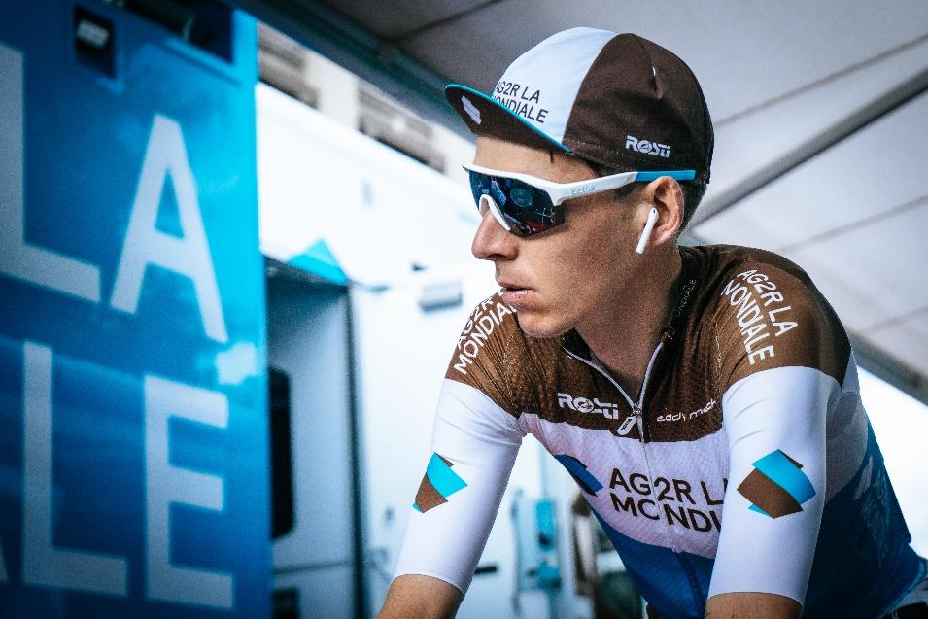
Lyon (FRA), October 2019 - Bollé has a long history of involvement with the highest levels of cycling and this is perfectly demonstrated by the collaboration with the UCI Professional Team AG2R LA MONDIALE who are among the top ranked teams in the world. Paying tribute to 5 years of collaboration with Bollé, the team have been the first to wear Bollé's latest cycling dedicated sunglasses LIGHTSHIFTER and wore them during this year’s Tour de France.

Romain Bardet – Photo Credit Kevin Bottin

We recently met Vincent Lavenu, General Manager of AG2R LA MONDIALE Pro Cycling Team and team rider Romain Bardet and took the opportunity to ask them some questions about the collaboration and their new sunglasses.
Vincent Lavenu - General Manager AG2R LA MONDIALE Pro Cycling Team
How would you describe the collaboration with Bollé, which started in 2014?
The first thing is the fidelity that is established between us. This fidelity is a guarantee of successful work, and an efficient collaboration. We find in Bollé a partner that is open to our suggestions, a partner who is proactive in the research of the best products, and in the service to our riders. Our riders are totally satisfied with the products and the collaboration. This is how collaborations should be – long lasting and satisfying. Both sides are winning, we are very happy in terms of products and Bollé is very happy in terms of our image. This guarantees that we work together in a positive way.
About product development, how does it work with your partners and specifically with Bollé?
In pro cycling, as in many other pro sports, performance is essential. Sunglasses are very important for vision and protection and our goal is to wear the best. Cycling is an endurance sport, for example the Tour de France stages can last from 5 to 6 or 7 hours at a time. The products must perform and must also be comfortable. The development is done thanks to collecting information and feedback from our riders and then discussing it with the team at Bollé. It’s a process done step by step over time. Today we have a product that is ‘perfection’, this makes our partnership completely trustworthy. The same process happens with our other partners. Cycling is a technical sport where developing, fine tuning and solving problems, in order to improve products is part of the process.
Romain Bardet – Team Rider
What are the most important points that you look for when choosing cycling sunglasses?
The fit needs to be perfect, especially at every contact point with the face. They need to be really comfortable, in some ways as though you forget that you are wearing them because they become a part of you. We wear them for many hours at a time, 5 to 6 to 7 hours so we cannot afford any discomfort or distraction. The lens has to perform and they must be really stable in all riding positions. Plus of course, they must look good !
You mention the lens, please tell us more about its importance.
It’s essential to have the highest performing lens, especially when we are cycling for so many hours and this is why it’s a great advantage for us to have the Bollé Phantom light adaptive lens. The weather and the light conditions can be very unpredictable and we find this lens performs brilliantly in terms of vision. It gives us confidence to know that we will always be wearing the ‘right’ lens so we can remain focused.
You are wearing the new launch Lightshifter – what is your opinion about it?
It’s the best model we have worn by Bollé. It gives us really clear unobscured vision and is so comfortable. The fit is excellent and of course it looks really really good ! Some of our riders need prescription sunglasses and it’s perfect that they can have their prescription in the Lightshifter.

LIGHTSHIFTER
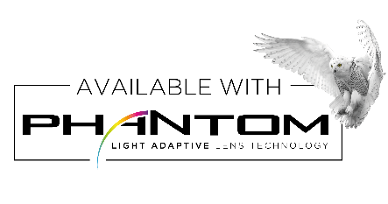
Bollé's Performance model LIGHTSHIFTER benefits from the combination of the best of Bollé’s technologies and meets all the needs of the performance cyclist.

Thermogrip®
for perfect stability

Adjustable nose piece
for comfort and stability
Semi-rimless design
for stability and lightness

ULTIMATE LENS TECHNOLOGY WITH PHANTOM PHOTOCHROMIC LENS
LIGHTSHIFTER is available with Phantom photochromic lenses, Bollé’s latest and most advanced lens technology. Made of NXT® offering a mix of exceptional optical clarity and impact resistance, Phantom lenses lighten and darken quickly, adapting automatically to the light conditions and providing the best vision at all times. In addition, the lens features a hydrophobic treatment (so that water droplets roll off) and an oleophobic treatment (to repel dirt), keeping the cyclist’s vision clear. Lastly, a frontal air vent ensures optimal air flow and prevents fog, and stylish lasered details on the lens offer a premium and assertive look.
PERFORMANCE AVAILABLE WITH OR WITHOUT PRESCRIPTION
Another advantage: LIGHTSHIFTER is available with prescription lenses that are inserted directly into the shield, ensuring all the frames properties and lens performance remain. This aspect convinced AG2R LA MONDIALE riders wearing prescription eyewear that it was the right model for them - and will be a real plus for all cycling enthusiasts alike. To meet all demands, Bollé offers a wide range of prescriptions (+6 to -8 / cyl-4) and a large choice of tints to cater for any type of weather and light conditions.
A FRAME DESIGNED FOR ACTION
In addition to the lens technology, the frame’s conception proves to have also been designed for action and performance. LIGHTSHIFTER’s modern and sharp semi-rimless design combines extreme lightness and perfect stability, with the top of the frame staying in contact with the face while the rimless part allows a wider field of vision. The curve of the temples improves comfort and stability by allowing more of Bollé’s Thermogrip® hydrophilic rubber to be in contact with the skin. Also placed on the adjustable nose piece, Thermogrip® ensures a perfect grip during the most intense action.

Designed for slim faces, LIGHTSHIFTER will be available in November in a wide range of colours, including two Phantom lens options.

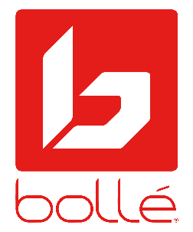
Bollé is a leader in sport and lifestyle sunglasses, cycling helmets, ski goggles, and ski helmets. For more information, visit www.bolle.com. Bollé is part of Bollé Brands™ which encompasses the brands Bollé, Bollé Safety, Cébé, Serengeti, Spy Optic and H2Optix. Thanks to the complementary know-hows and innovative technologies developed by the four brands in their respective fields of activities, Bollé Brands’ expertise covers a large spectrum of products that meet the highest requirements in terms of protection, performance, and innovation.

