Sound Healing Practitioner Certification Level 1 & 2

This certifies that

CARRIE R. RODMAN
Has successfully completed the required course of study, practicum walk-through, and testing to achieve certification as a
Sound Healing Practitioner Level 1 & 2

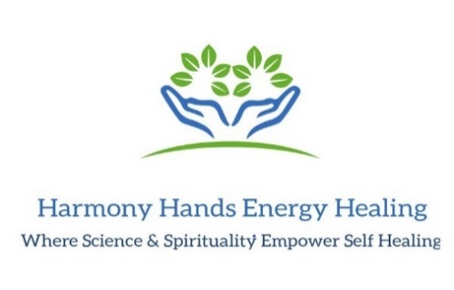
 | 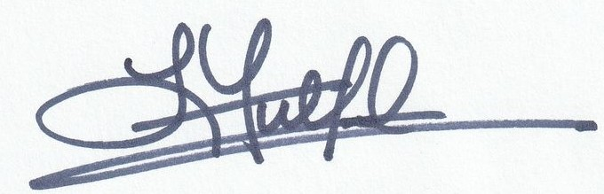 |  | __7/30/2024__
 | Laurie Fulford, PMP  Sound Healing Master/Teacher  Harmony Hands Energy Healing |  | Date Achieved

