**PRESS RELEASE**

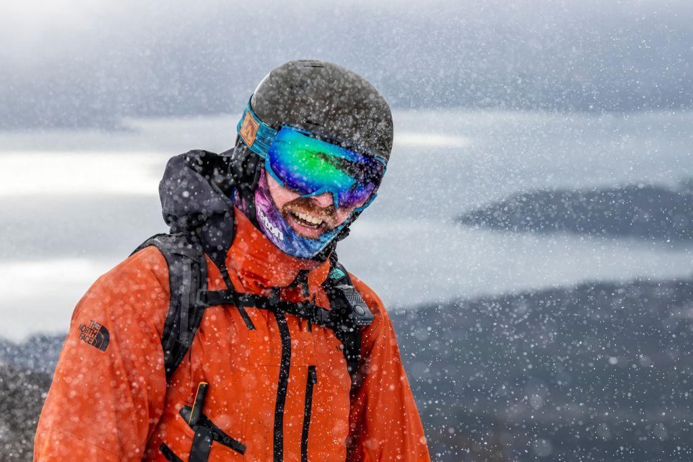

**THE RIGHT FIT FOR EVERYONE: MARKER EXPANDS HELMET & SKI GOGGLES COLLECTION**

**Marker always develops products with an eye to being able to offer each individual customer a suitable product. True to this vision, Marker, the traditional company from Upper Bavaria, is introducing two new highlight products, the Bino helmet and the Trivium goggles, to expand and complement the Protective Snow Equipment collection for the 20/21 season. The children's helmet impresses with its optimal fit and light weight, while the ski goggle model scores with its 80’s retro-style. But what makes both products absolute highlights is the extended size range.**

Protection plays a major role on the mountain today: winter sports athletes are paying more and more attention to good equipment while skiing. And in doing so there is no distinction between discipline, gender, age or skiing ability - the topic of safety is equally relevant to everyone. Marker Protective Snow Equipment is synonymous with innovation and protection in skiing and has been for many years. Their top priority is thereby to develop products that offer winter athletes both protection and comfort. In order to live up to this claim, the experts from the Bavarian town of Penzberg consistently develop their products further in terms of their anatomical, biomechanical and safety-related functionality and design. Marker is introducing the Bino helmet and Trivium goggles for the 20/21 season, two products that not only meet the highest safety standards and are visually absolutely appealing, but also cover an unprecedented range of sizes.

**The Bino keeps even the youngest skiers safer on the slopes**

The circumference of a child's head varies greatly in their first five years, a fact proven by the data-based survey of the head circumference of 10,000 children on the basis of which Marker have developed their products. Parents especially can testify to the times when their child's ski helmet does not fit well and there is too much or too little space between the helmet and their head. With two additional sizes, Marker is taking decisive steps to address this phenomenon and now also offers the new Bino children's helmet in sizes XXS and XS. Thus every child between the ages of three and nine can now find a helmet that fits - and reduce the risk of injury in the event of falls and accidents.

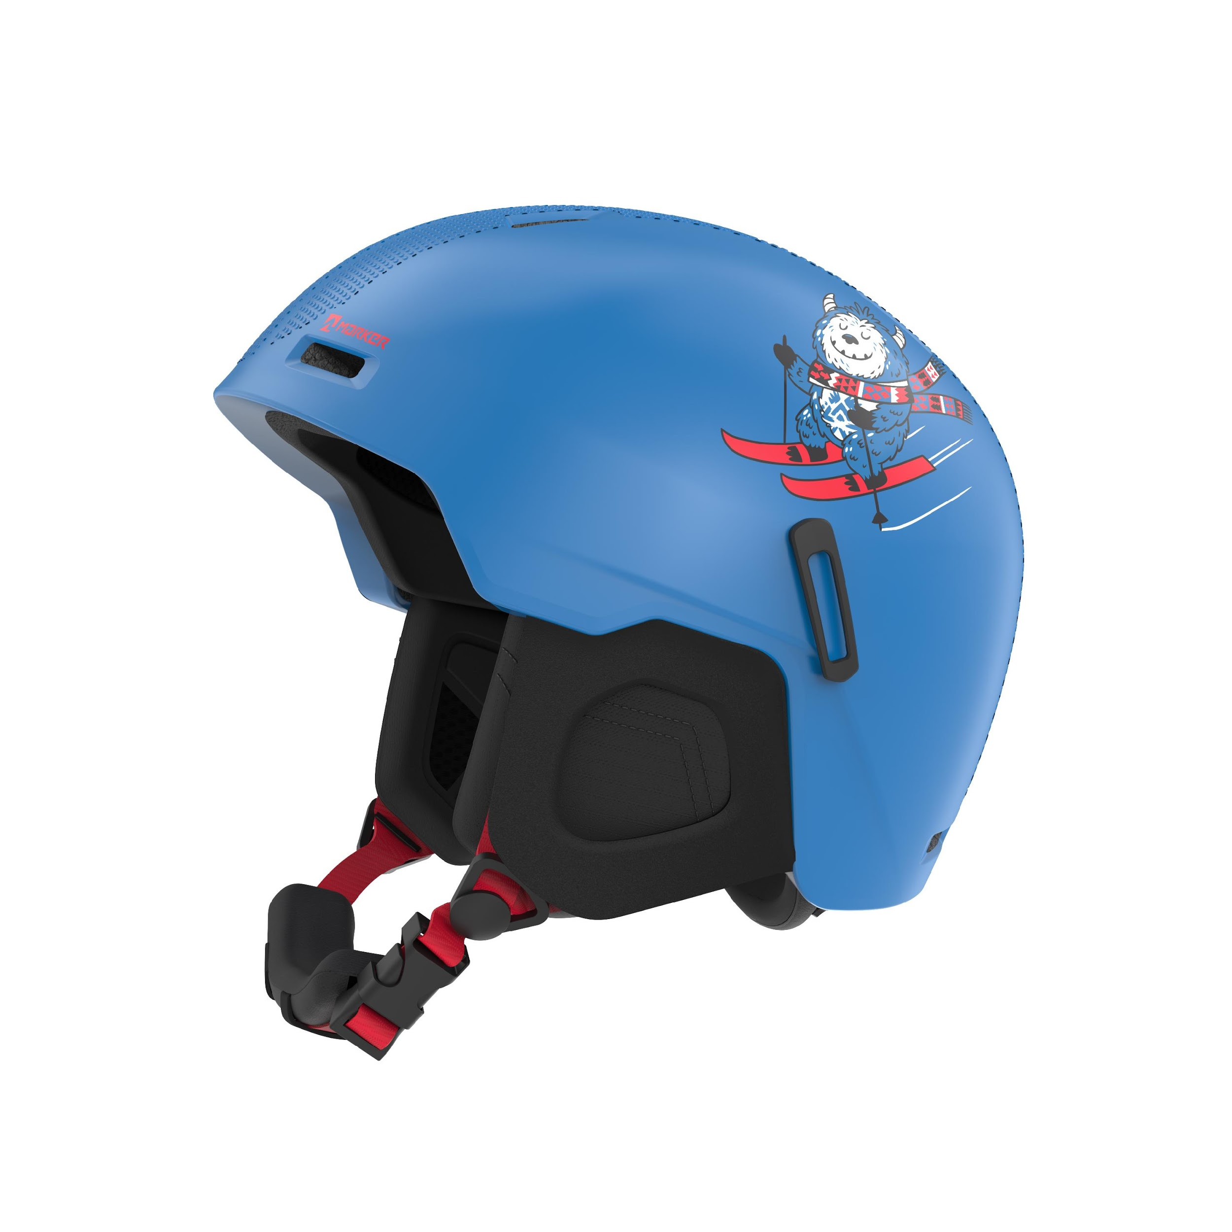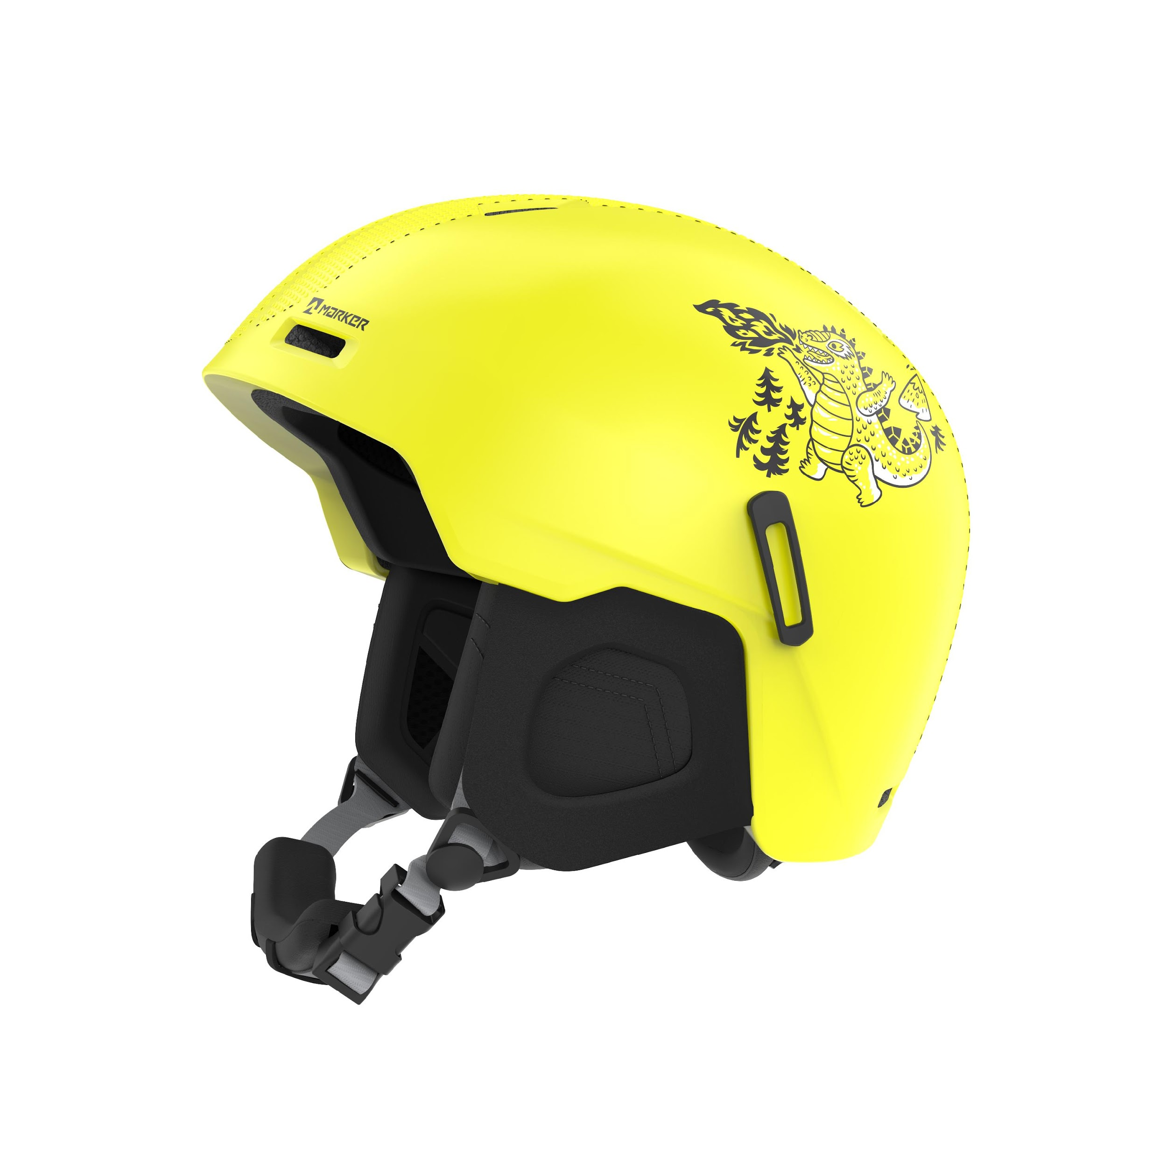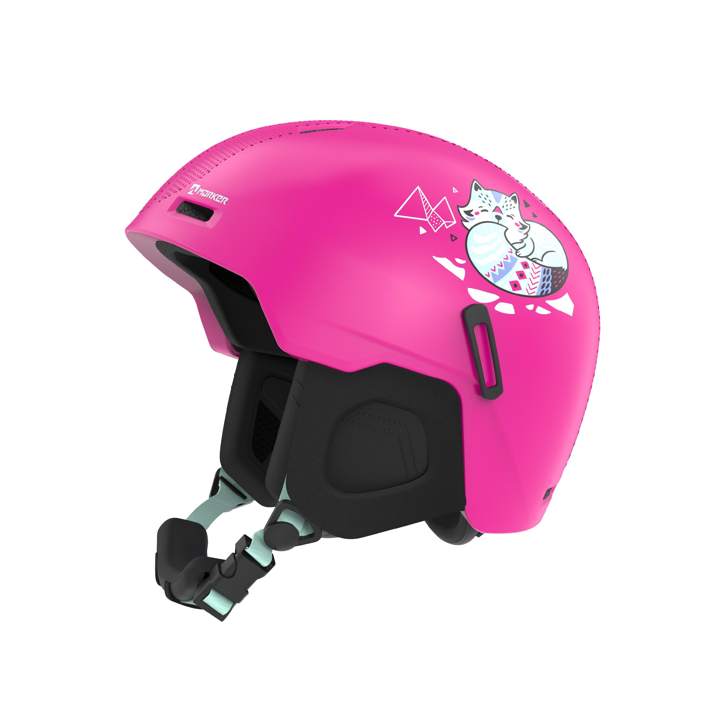

Another impressive feature of the new helmet model, in addition to the expanded range of sizes, is its lightness, thanks to its **superlight in-mould construction**. The Bino weighs just 345 grams making it one of the lightest models in the range of children's helmets on the market. This is very practical, because, after all, children prefer wearing a helmet and goggles that they hardly notice. Marker has achieved this with the new Bino. Despite its minimal weight, the helmet has many features that are highly functional and contribute to increased safety. The **PC shell protection** is among these with its 3D texture on the surface of the helmet, which provides increased scratch resistance. Its new shape and fit is not only very comfortable, but also envelops the head perfectly, providing protection in critical areas such as the temples. New, side mounted clips keep goggles in place for an entire day of skiing and prevent them from constantly slipping. Thus parents no longer have to worry about lost or forgotten ski goggles. Three of the eight Bino versions are also being released in bright colours with appealing graphics.

**Top scores in fit and design: Trivium goggles for adults**

Ski goggles too big? This is a problem that people with a narrow face or a small head are especially well-acquainted with. Finding a pair of goggles that fits and still looks good may seem impossible. Marker's Trivium goggles help to alleviate this problem, because during the development and design phase, product managers focused primarily on female facial features. Trivium, a new unisex pair of goggles covering the smallest adult sizes, is therefore coming on the market now. Marker has shown how in touch they are with the market by introducing the new sizes, aimed at a new target group. Problems finding a pair of ski goggles that fit are now a thing of the past.

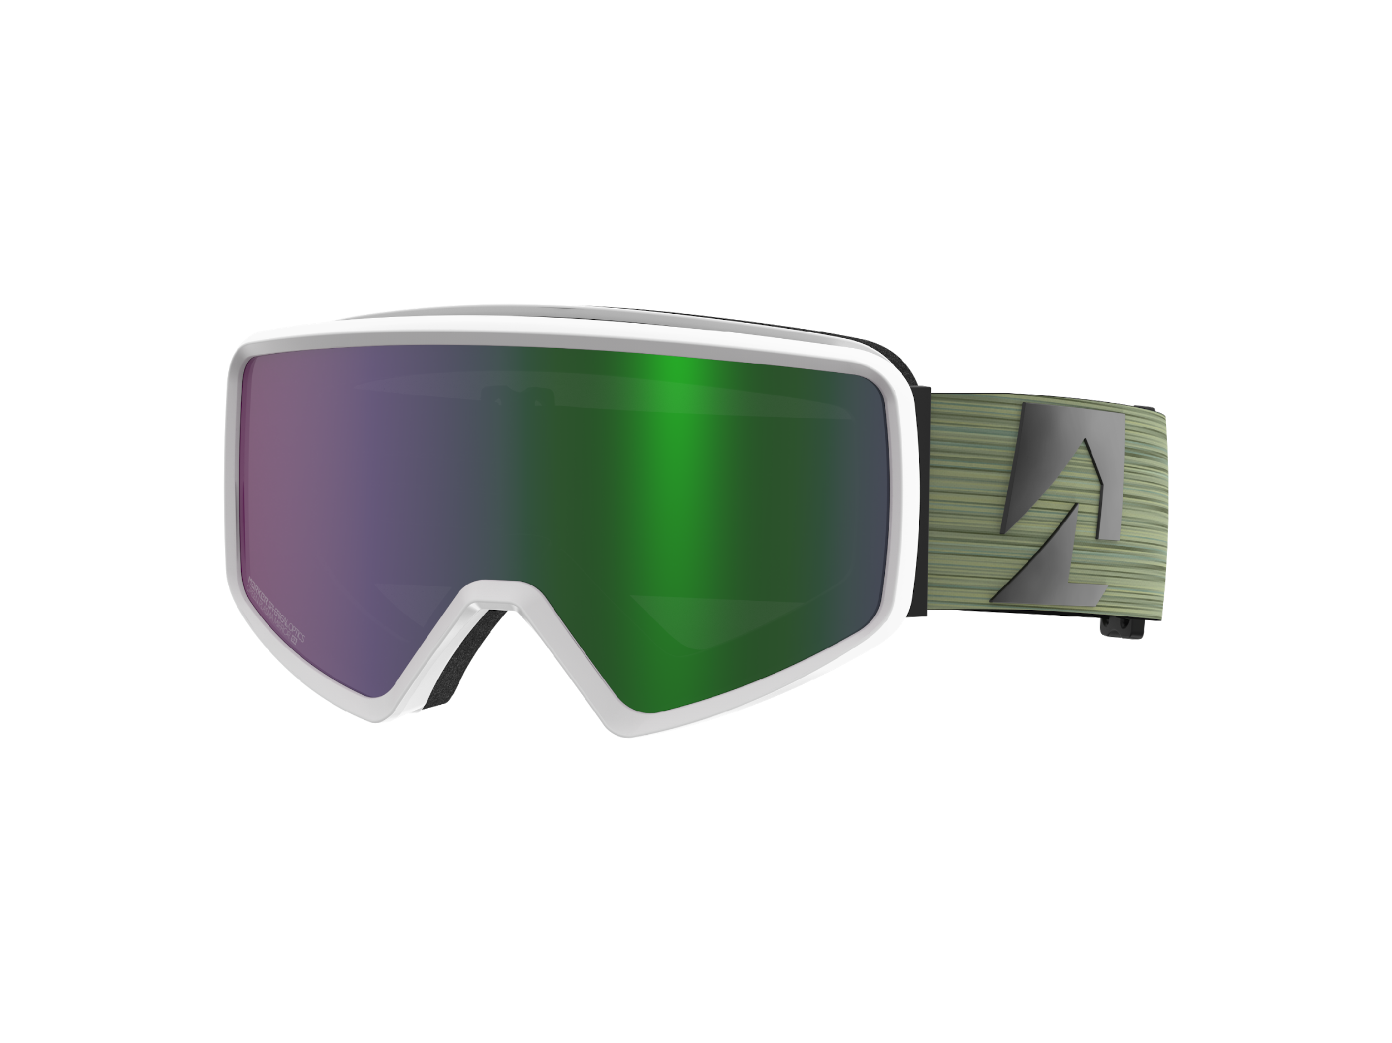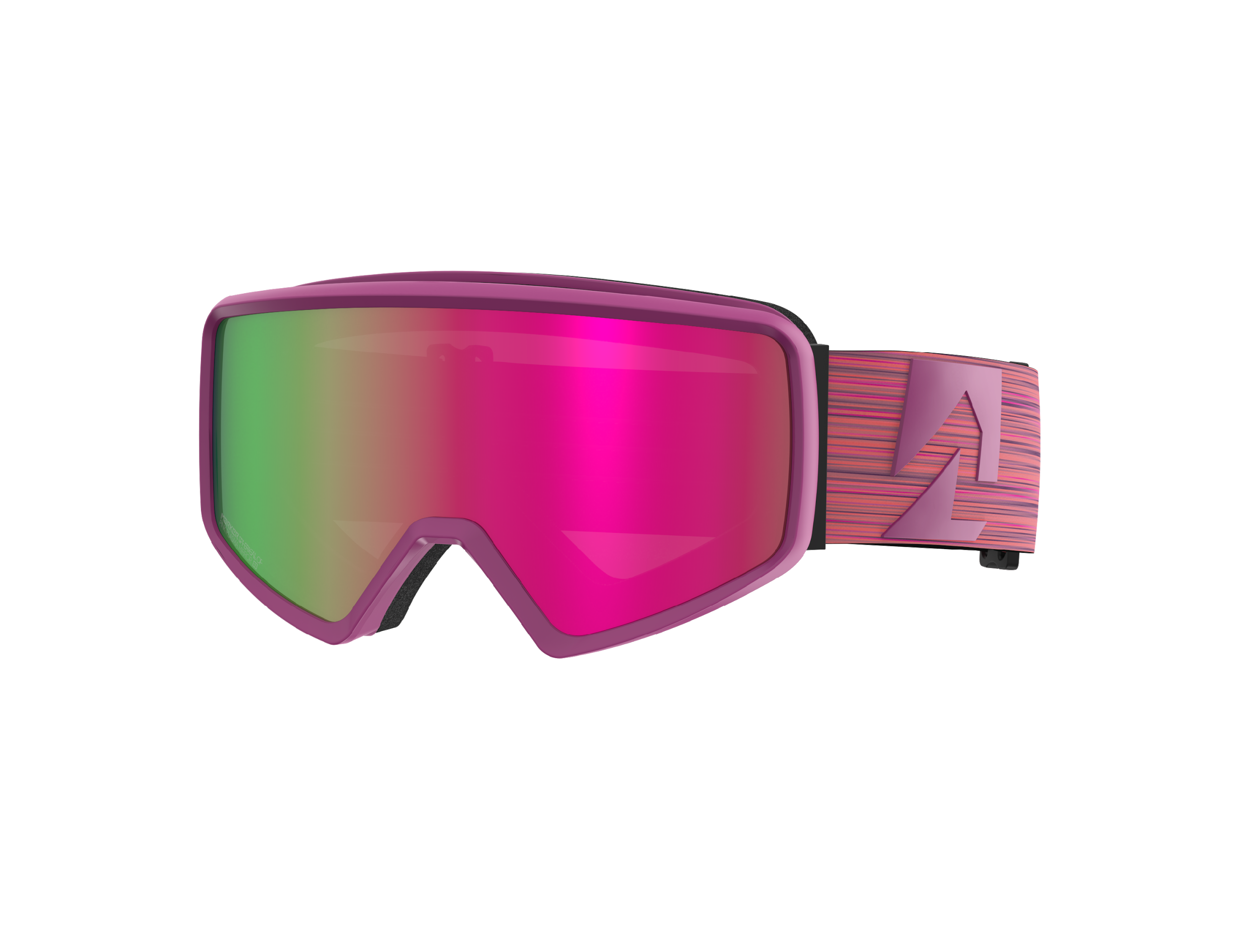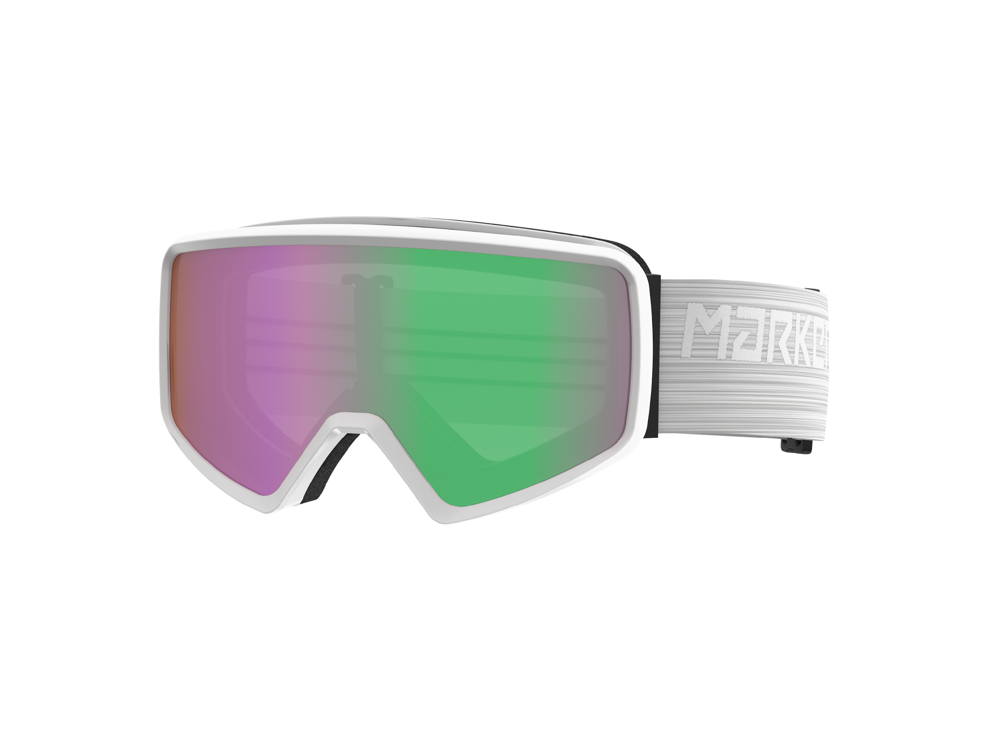

Besides the improved fit, Trivium is also a real eye-catcher: the new model with its cylindrical lenses that give the goggles a modern look, also has an edgy 80’s retro-style, which serves current market trends in terms of design.

**Press contact**

Mark Tedeschi

Elevator North

[mtedeschi@elevatornorth.com](mailto:mtedeschi@elevatornorth.com)

781-740-4050

**About Marker**

Marker has been synonymous with innovation and protection in skiing for over six decades. In 1952, Hannes Marker patented the world's first ski binding with safety release. In the 1970's, the M-series with automatic heel release revolutionised the bindings market. With the Duke and the continuous expansion of the Royal Family, the company has been setting new standards in the freeride and freestyle segment from its location in the Bavarian town of Penzberg since 2007. Working with some of the world's largest ski brands, allows Marker not only to develop their own pioneering products, but also to develop system bindings that form a perfect unit with the ski. In addition, Marker successfully expanded its product portfolio in 2013 to include helmets, goggles and protectors.