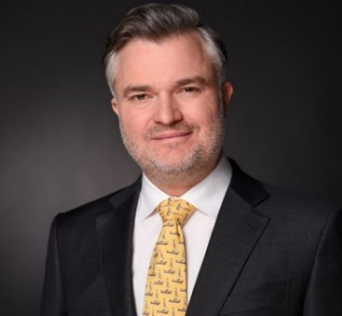
James Hills

Versatile and solution-orientated finance leader

Leadership – Business Partnering – Strategy – Business Planning
Mergers & Acquisitions – Business Process Outsourcing
Accounting – Controlling – Financial Reporting & Analysis

mobile: +49 179 109 4379
jamesdhills@outlook.com

PROFESSIONAL EXPERIENCE

Head of SSO FPRA
2017 – 2019, Nokia (Munich)
- Built and led shared service delivery of financial planning. reporting & analysis services
- Integrated disparate business process outsourcing following significant group acquisition
- Slashed operational cost by more than 30% through consolidation and automation
- Orchestrated site evolution in Colombia, Hungary, India and Romania leading 100 strong team

Director, CFO Strategic Projects & M&A Support
2012 – 2016, Nokia Networks (Munich)
- Instrumental to drive business cases for divestments, new technology and sourcing strategy
- Advocated for CFO / COO as challenger to deal, sales and technical teams
- Drove value creation through financial adjustment mechanisms and post-closing management
- Scope: 5,000 employees and 1b EUR recurrent revenue

Program Manager, Finance Integration
2010 – 2011, Nokia Siemens Networks (Helsinki)
- Integrated Motorola to Nokia financial systems and negotiated transitional service agreement
- Scope: 1.2b USD acquisition, 50 countries, 10,000 people, 850m EUR assets

Head of Finance & Control Japan
2006 – 2009, Nokia Siemens Networks (Tokyo)
- Ensured compliance of Japan and Korea subsidiaries with IFRS and local regulations
- 2-time global deal of the month wins for NTT entry and Softbank three-year renewal respectively
- Led due diligence and negotiation of financing arrangement leading to 1b EUR contracted revenue
- Secured credit lines of 100m EUR to factor accounts receivables during financial crisis

Vodafone Customer Account Team Controller
2004 – 2006, Nokia (Auckland)
- Rolled-out New Zealand’s first 3G network

EDUCATION & PROFESSIONAL QUALIFICATION

Master of Arts (Philosophy)
2003, The University of Auckland

Chartered Accountant
2002, Institute of Chartered Accountants of New Zealand
- Public accounting practice for 3 years at BDO

