VITALIY PODOLSKIY, CDir
43 Berkeley Square, London, W1J 5AP, UK I Mob. +44 7872 289 123 I vp@chesterfieldfund.com
LinkedIn: www.linkedin.com/in/vpodolskiy
- Executive chairman and NED of leading international public and private companies with 20+ years’ experience in executive and corporate governance leadership in the US, UK, Germany, France and Russia/CIS
- IoD Chartered Director, Institute of Directors, UK; Best Independent Director-2019 Award and laureate, VII-XIV Russia’s National Director of the Year, Top-50 Independent Directors (2012 - 2019)
- Partner, Chesterfield Fund, leading global technology fund
- Visiting professor, Finance & Strategy Program, Doctor of Business Administration (DBA) Program IBS RANEPA, Russia’s leading business school

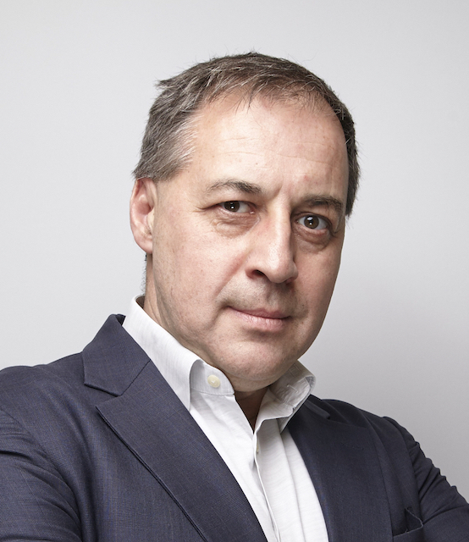

CORPORATE GOVERNANCE
2016 – now | Chairman, NED, Personnel & Remuneration Committee; member of Audit Committee, ESG and Strategy board committees | GROUP LSR (Russia), LSE-listed leading integrated construction materials and real estate development holding
2012 - 2017 | Chairman, NED, Audit Committee and Personnel & Remuneration Committee; member of Strategy and Investment committees | GROUP CHERKOZIVO (Russia), LSE-listed Russia’s largest agricultural and food holding
2008 - 2017 | Chairman, NED, SCM & Procurement Committee, member of Audit, Finance & Investments committee | ROSINTER RESTASURANTS (Russia), MOEX-RTS-listed largest casual-dining restaurant group
2014 - 2016 | Executive Chairman, Audit & Finance Committee, board director (acting CFO) | KAZAKHSTAN KAGAZY PLC, LSE-listed Central Asia’s largest paper, cardboard and packaging manufacturer
2013 - 2018 | Chairman, NED, Audit & Finance Committee | KITCHEN MARYA (Russia), PE-backed leading multi-brand and PL kitchens and bath furniture producer and retailer chain
2011 - 2013 | Chairman, NED, Board of Directors | GROUP FORMULA KINO / KRONVERK (Russia), PE-backed leading cinema chain
2011 - 2012 | Chairman, NED, Audit, Finance & Investments Committee of the Board | RG BRANDS (Kazakhstan), Central Asian largest snack & beverages producer and distributor
2009 - 2010 | Deputy Chairman, Board of Directors and Chief Executive Officer (CEO) | GROUP MOSMART (Russia), Sberbank-controlled leading food hypermarket chain
2003 - 2008 | - Member, Strategy and Audit committees, Board of Directors  - Member, Management Board  - Chairman, boards of directors for JSC X5 Development, X5 Express Retail and SPAR Middle Volga | X5 RETAIL GROUP N.V. (Russia), LSE-listed Eastern Europe largest food retailer
NON-PROFIT
2019 – now | President, Supervisory Board | IDA Directors’ Sailing Cup, annual regatta;
2017 – now | Advisory Board member | Retail Academy, RANERA (Russia)
2017 – now | Advisory Board member | IBS-Moscow (Institute of Business Studies), RANEPA (Russia)
2013 - 2015 | Audit Committee member, Board of Trustees | SkolTech (Skolkovo Institute of Science and Technology) (Russia)
2009 - 2010 | Advisory Board member | ACORT (Retail Companies Association) (Russia)
EXECUTIVE CAREER
2018 – now | Partner, Finance and Strategy | CHESTERFIELD FUND (London, UK)
2008 - 2018 | Executive board member Advisor for shareholders, PE Funds and founders on strategy, crises management, restructuring, finance and M&A | SBARRO USA, MAF CARREFOUR, «KRASNUY YAR», «YUTERRA», CYSLINK, CESAR SATELLITE, HEDIARD (world-wide)
2008 - 2009 | Chief Executive Officer (CEO) and Deputy Chairman of the Board | GROUP MOSMART (Moscow, Russia)
2008 - 2009 | Deputy Chief Executive Officer on Finance and Administration | GROUP EUROSET (Moscow, Russia)
2003 - 2008 | Group Chief Financial Officer (CFO) | X5 Retail Group N.V. (Moscow, Russia)
1998 - 2003 | Manager, Mergers & Acquisitions, European Business Development  European Controller, Material Planning & Logistics | Ford Motor Company Inc., (Brentwood, UK)  (Cologne, Germany)
1997 - 1998 | Senior Investment Banking Associate | Bankers Trust Plc. (London, UK)
1995 - 1997 | Consulting Management Associate | A.T. Kearney Inc. (New York, USA)
Russian Management Association’s Award “Best Retail CFO in Russia” (2004 - 2008) Russia’s “Aristos” Business Award nominee in the category “The CFO of Year” (2006 – 2008) Asia Retail Congress’s “Retail Leadership Award” (2010)
EDUCATION
2020 | IoD Diploma in Company Direction, Level 11 (SCQF), Chartered Director Programme | Institute of Directors (London, UK)
2018 | Diploma in Corporate Governance | MGIMO MID (Moscow, Russia)
1995 | MBA in International Business & Finance | University of Chicago Booth School of Business (Chicago, USA)
1991 | MA in Mass Media & Journalism | Moscow State University (Moscow, Russia)
Visiting lecturer at the Russian Economic School (RES) and Kingston University, speaker at key international and Russian business forums, including Gaidar Forum, Russian CFO Summit, Russian Retail Summit, «Russia», MarcusEvans, European CFO Summit, Asia Retail Congress, RBK; multiple TV and magazine publications on HR, Strategy and Finance
PERSONAL
Languages | English, Russian & Ukrainian (fluent/native)
Citizenship | British & Russian
Hobbies | Sailing - winner of the Atlantic Rally for Cruisers; Cape Horn, Chile sailing expedition led by Fedor Konuhov  Epee – honor degree of Master of Sports of the USSR in Fencing (1987), winner of national tournaments

