National Guild of Hypnotists

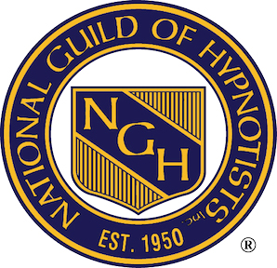

NGH

PO Box 308

Merrimack,NH

03054

June 11th 2024

NGH ID# 39430 Cheryl DeDecker

This is a letter confirming that Chery DeDecker has been a Member in Good Standing as a Consulting Hypnotist w/ the National Guild of Hypnotists since November 19thth 2011, and her membership is up to date through 6/01/25. She has maintained 25+ CEU’s hours every year since becoming a member, and also obtained her Board Certification in 2014.

Thank-you,

NGH Membership Dept.