FOR IMMEDIATE RELEASE

Media Contact
Matt Fitzgerald
True North Brand Group, Inc.
781-974-6657
matt@truenorthpr.com

Lions Not Sheep Partners with Navy SEAL Veteran and American Hero, Robert J. O'Neill

Salt Lake City – (September 8, 2022) – Lions Not Sheep, one of the fastest growing lifestyle apparel brands, has joined forces with Robert J. O'Neill, former United States Navy SEAL, to offer a range of limited edition products in observance of the 21-year anniversary of September 11th.

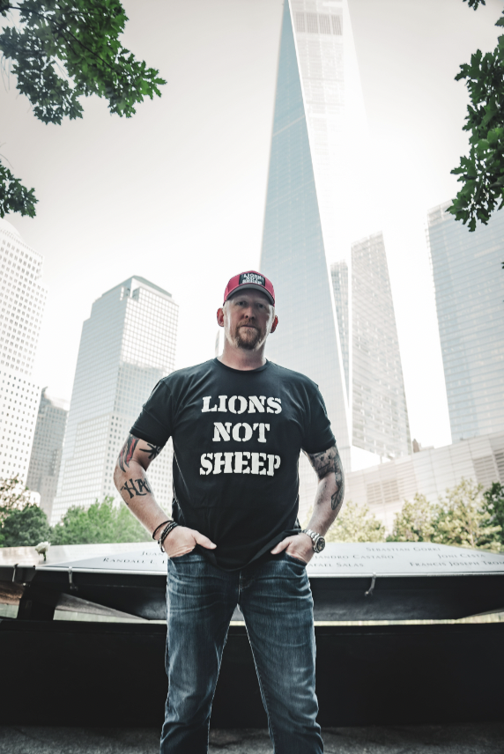
O'Neill, famously known for his heroic participation in May 2011's Operation Neptune Spear with SEAL Team Six, was part of the team of individuals to remove Osama bin Laden.

“What Lions Not Sheep means to me is being the person who goes out and gets it,” said O'Neill.

This month, Lions Not Sheep will be launching a line of products in collaboration with O'Neill to honor the American soldiers that protect the United States from foreign threats like 9/11. To show thanks for these heroes, Lions Not Sheep will donate a portion of its proceeds to the Special Operations Transition Foundation, a charity designed to provide Special Operations Forces veterans with the successful transition from service into their next great career in corporate America. Products will include hats, and trading cards, some of which will be signed by O'Neill himself.

“Robert’s service and his takedown of Bin Laden, moves me not only as an American, but on a personal level as one who lost my cousin, a firefighter, to the 9/11 terrorist attacks, and I am proud to have him join Lions Not Sheep,” said Whalen.

The Lions Not Sheep Podcast has released an interview with O'Neill, where they sat down to speak about what it takes to be a lion, which is available here.

-more-
Lions Not Sheep generates awareness through a range of grass root efforts. Lions Not Sheep has its own race car, which Whalen himself drives in the GT America Series, and the company is set to launch its own podcast in the coming month to give it yet another outlet to spread its message. The company also offers a monthly Black Box Subscription Service, giving select fans first looks at new styles and product partnerships highlighting Lions Donald “Cowboy” Cerrone of the UFC, and Supercross Champion Davi Milsaps. To sign up for a subscription box click here.

About Lions Not Sheep
Lions Not Sheep was Founded by Sean Whalen in 2014 it slowly amassed a following until it became a movement. A movement of individuals who have chosen not to be mediocre, not to be ordinary, and to never quit. Made of people who are willing to risk it all by bravely forging their own path where there was none. At Lions Not Sheep you have two choices. To LEAD or to be LED. We are a generation of LEADERS. We are a generation of LIONS. To Learn More Please Visit: https://www.lionsnotsheep.com/

###

