CURRICULUM VITAE

Name: Simon Cattlin
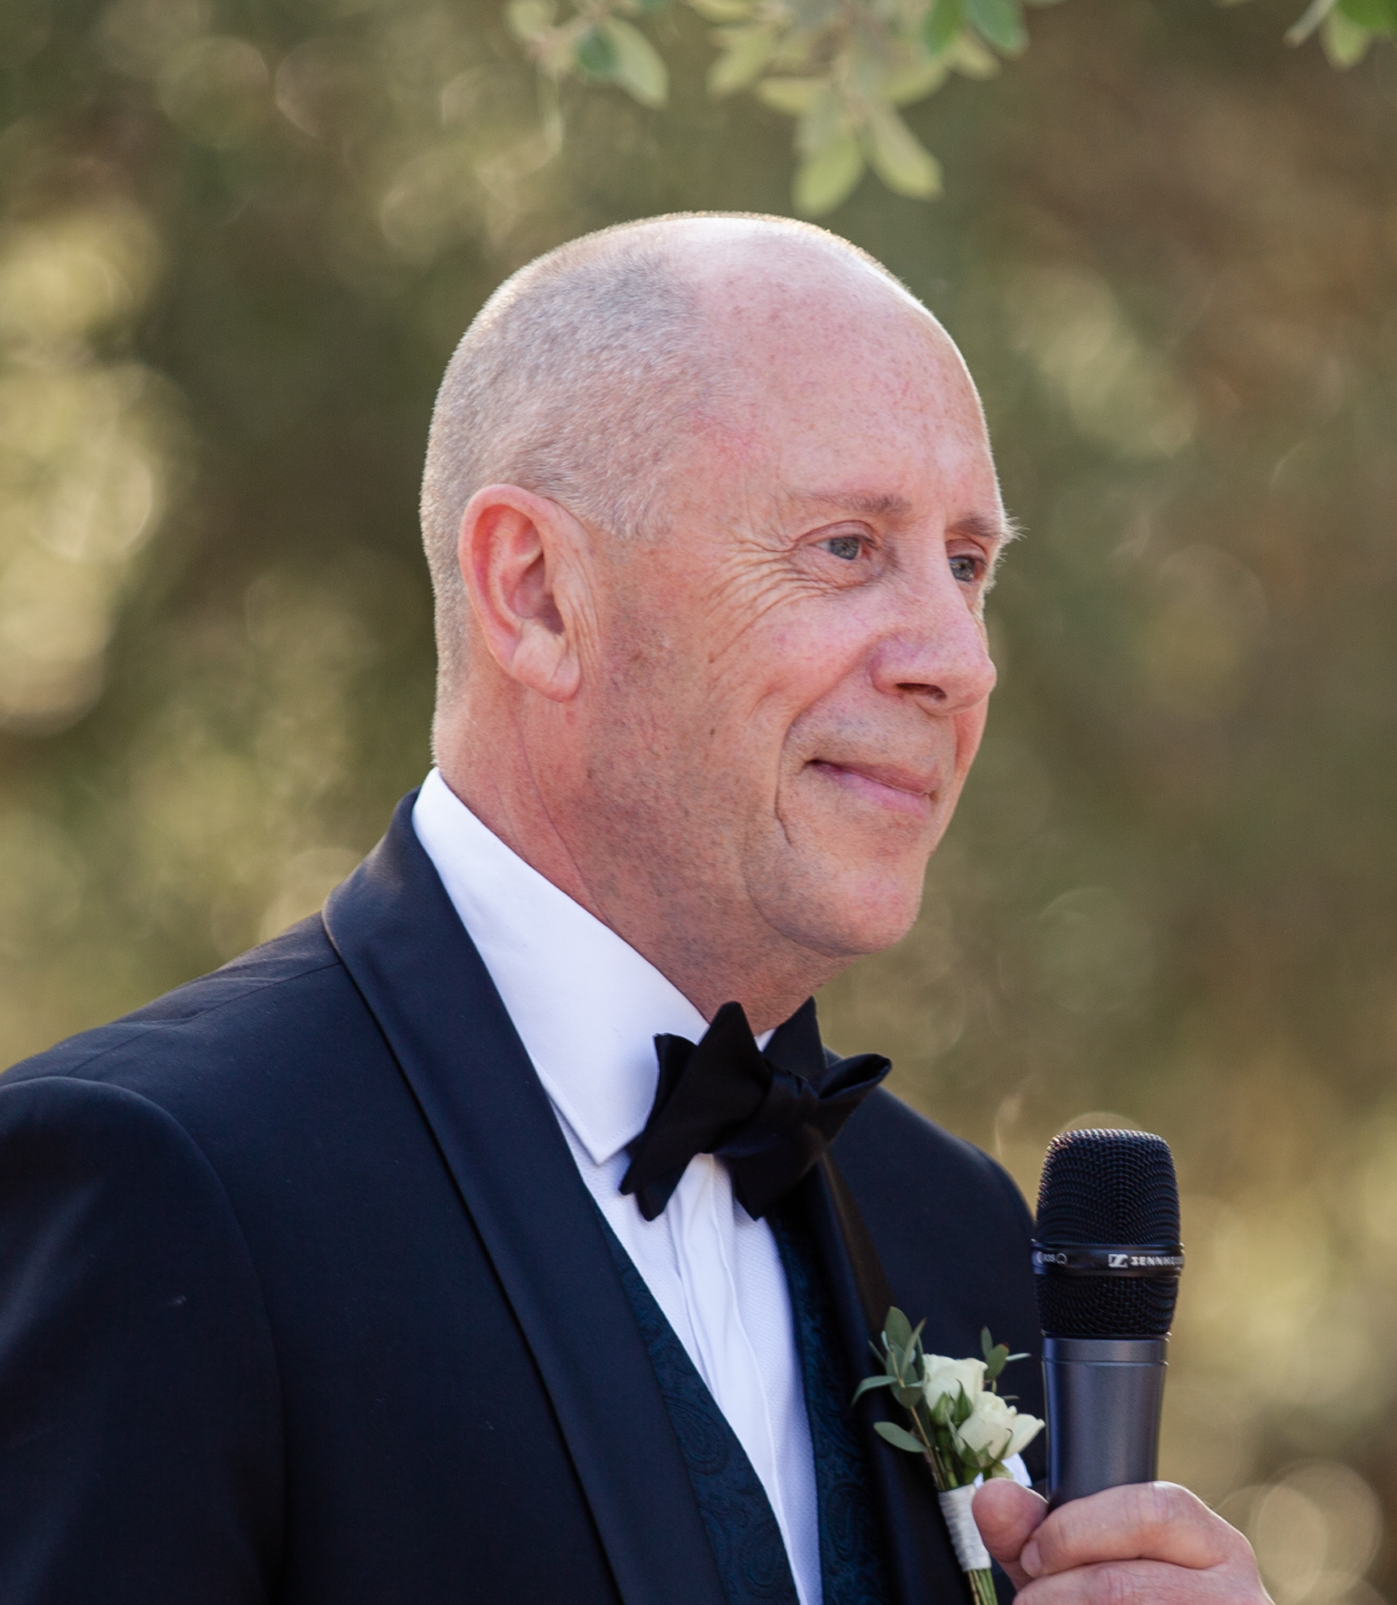

Nationality: British

Mobile: +44(0)7730 506129

Email: simon@simoncattlin.com

SUMMARY
I’ve enjoyed a wealth of experience in the Information Technology market as an Area/Regional Manager, Sales Director, Country Manager, EMEA Marketing Director, Regional VP, SVP, COO and CEO.
I’ve also held numerous non-executive directorships and industry advisory roles alongside active directorships in early stage technology businesses.

I have managed groups from 10 to 450 strong with direct annual revenue responsibilities in excess of $300m, $600m total including Support & Services. I’ve been engaged with all current licensing and commercial models with operational responsibilities for 100+ countries.

My recent commercial focus has been on big data solutions covering:
- Enterprise analytics solutions.
- B2B & B2C straight through processing (STP) and e-sign transacting.
- Adoption of secure public and private cloud data services.
- Reputation analysis systems for Global 2000 enterprises.
- Next generation social media for voice/touch platforms.
- Advanced e-communication & data security.

My experience covers both Direct and Partner Channels focussed on high value Infrastructure, application solutions & services into the global 2000 and SME markets. Many of my Director/VP roles have been focussed on either managing rapid revenue growth or deep turnaround / restructuring to optimise international field performance by up to 40% as part of key corporate development strategy.
I have achieved notable success in designing and implementing effective engagement strategies that reflect the rapidly changing nature of enterprise and SME sales. I’ve developed a field telemetry methodology that has been successfully adopted numerous times as the basis for accurately monitoring significant organisational change and cross-team productivity improvements.

I have worked extremely hard to build a strong reputation as a very capable hands-on commercial leader who can manage and motivate small and large teams alike whilst fully delivering on the revenue and cost requirements of a global brand. My non-executive roles have focussed on applying my experience to optimise field productivity, establish coherent and accurate revenue forecasting, assist with structured fundraising and fully support the CEO and wider executive team.

EMPLOYMENT SUMMARY

January 2017-Present
Whilst retaining one active directorship in an analytics start-up, and providing some NED services, most of my time has been spent building out my fine art portfolio in three focus areas. I’m a member of two fine art associations and sell internationally via two global curated online galleries as well as my own website. This is a good time to reset my professional balance and seek some new roles within the tech sector.

OpenText
Senior International Sales Director – Analytics

SCCV Ltd
Advisor, NED and Director level engagements
Silanis (www.silanis.com) + (www.iocs-systems.com)
Alva (www.alva-group.com)
e-radar (www.eradar.eu)
UK Ministry of Justice (CESL project )
SSLPost (www.sslpost.com)
CafeLabs / Echo (www.cafelabs.cc )
SearchYourCloud (www.searchyourcloud.com)

Ingres Corporation
Senior Vice President, Northern Europe, Middle East & Africa

BEA Systems
Regional Vice President

Sybase
Regional Vice President

BlueSpace Group Ltd
Executive Director Sales, Services & Marketing / COO / CEO

ComputerWire Group
Chief Executive Officer

Remedy Corporation
Vice President of Sales EMEA

EMC
Area Manager / Sales Director / Regional Director / MD EMEA Marketing

I was trained as a professional quantity surveyor (IQS) and managed a wide remit of construction contracts and revenues.

PERSONAL INTERESTS
I am a published artist and have been selling in small volumes for over 35 yrs. Most of my work is sold privately via www.simoncattlin.com or online galleries including Saatchi and Artfinder. I’m an associate member of the Guild of Aviation Artists and an artist member of the International Association of Astronomical Artists.

I ‘m a keen aerobatic pilot with 900+ hrs logged, I’ve competed up to advanced level in UK aerobatic competitions as a member of the British Aerobatic Association and do a limited number of displays alongside some film-work. I also enjoy regular fitness training, cycling and skiing.

