Why would The White Pocketbook make the “best new films” list?
As we approach seventy-five years after the liberation of Europe from the most devastating war in history, few survivors remain to tell their story. Consequently, there are no more voices coming from the shadows like that of Anne Frank’s. That is why America is ready for an amazing, new heroine to step out of the silence and into their lives. Andree Florin’s story is that rare voice!
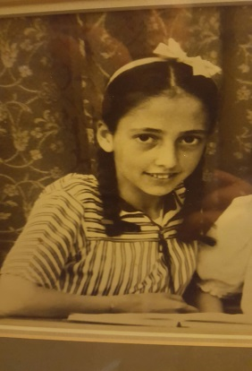
The White Pocketbook has all the critical components needed to make a great movie. Readers laugh, cry, gasp, ponder a while, see her love story, and then smile at the conclusion. Her life in Nazi occupied Belgium as a little girl is revealed after many years of quelling the truth. Recent tragic circumstances brought her to a point where she finally opened the vault of her experiences.
This story gives us a glimpse into the mind and heart of a struggle that lasted a lifetime. In the end, she emerged the victor.
This story could have been called, The Three Men I Hate, or, Hitler, Degrelle, and Joe McCarthy, or even Seventy Years of Silence, but after finding her stashed away pocketbook, The White Pocketbook was the perfect fit.
