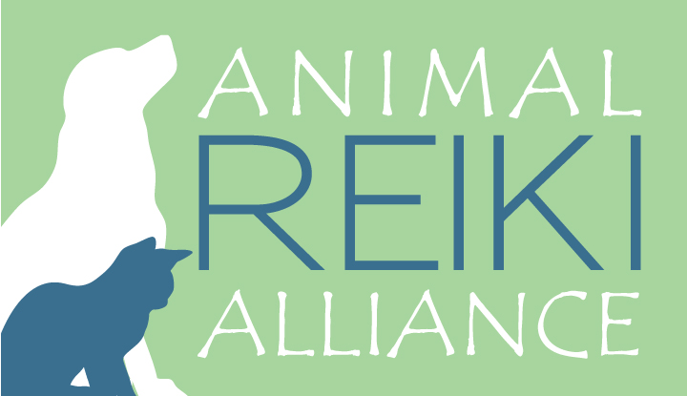
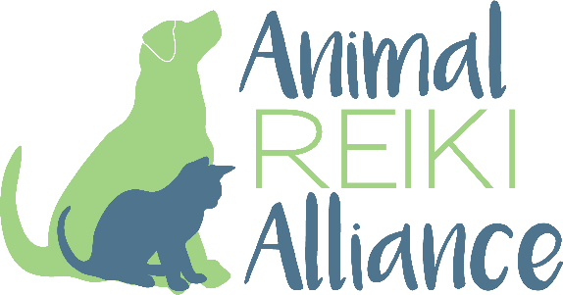

This Certifies that
Valerie Morini
has successfully completed
Okuden: Animal Reiki Level II
Training (7 Hours)

______________________________________ June 18, 2022_________
Kathleen Lester, Animal Reiki Teacher Date

