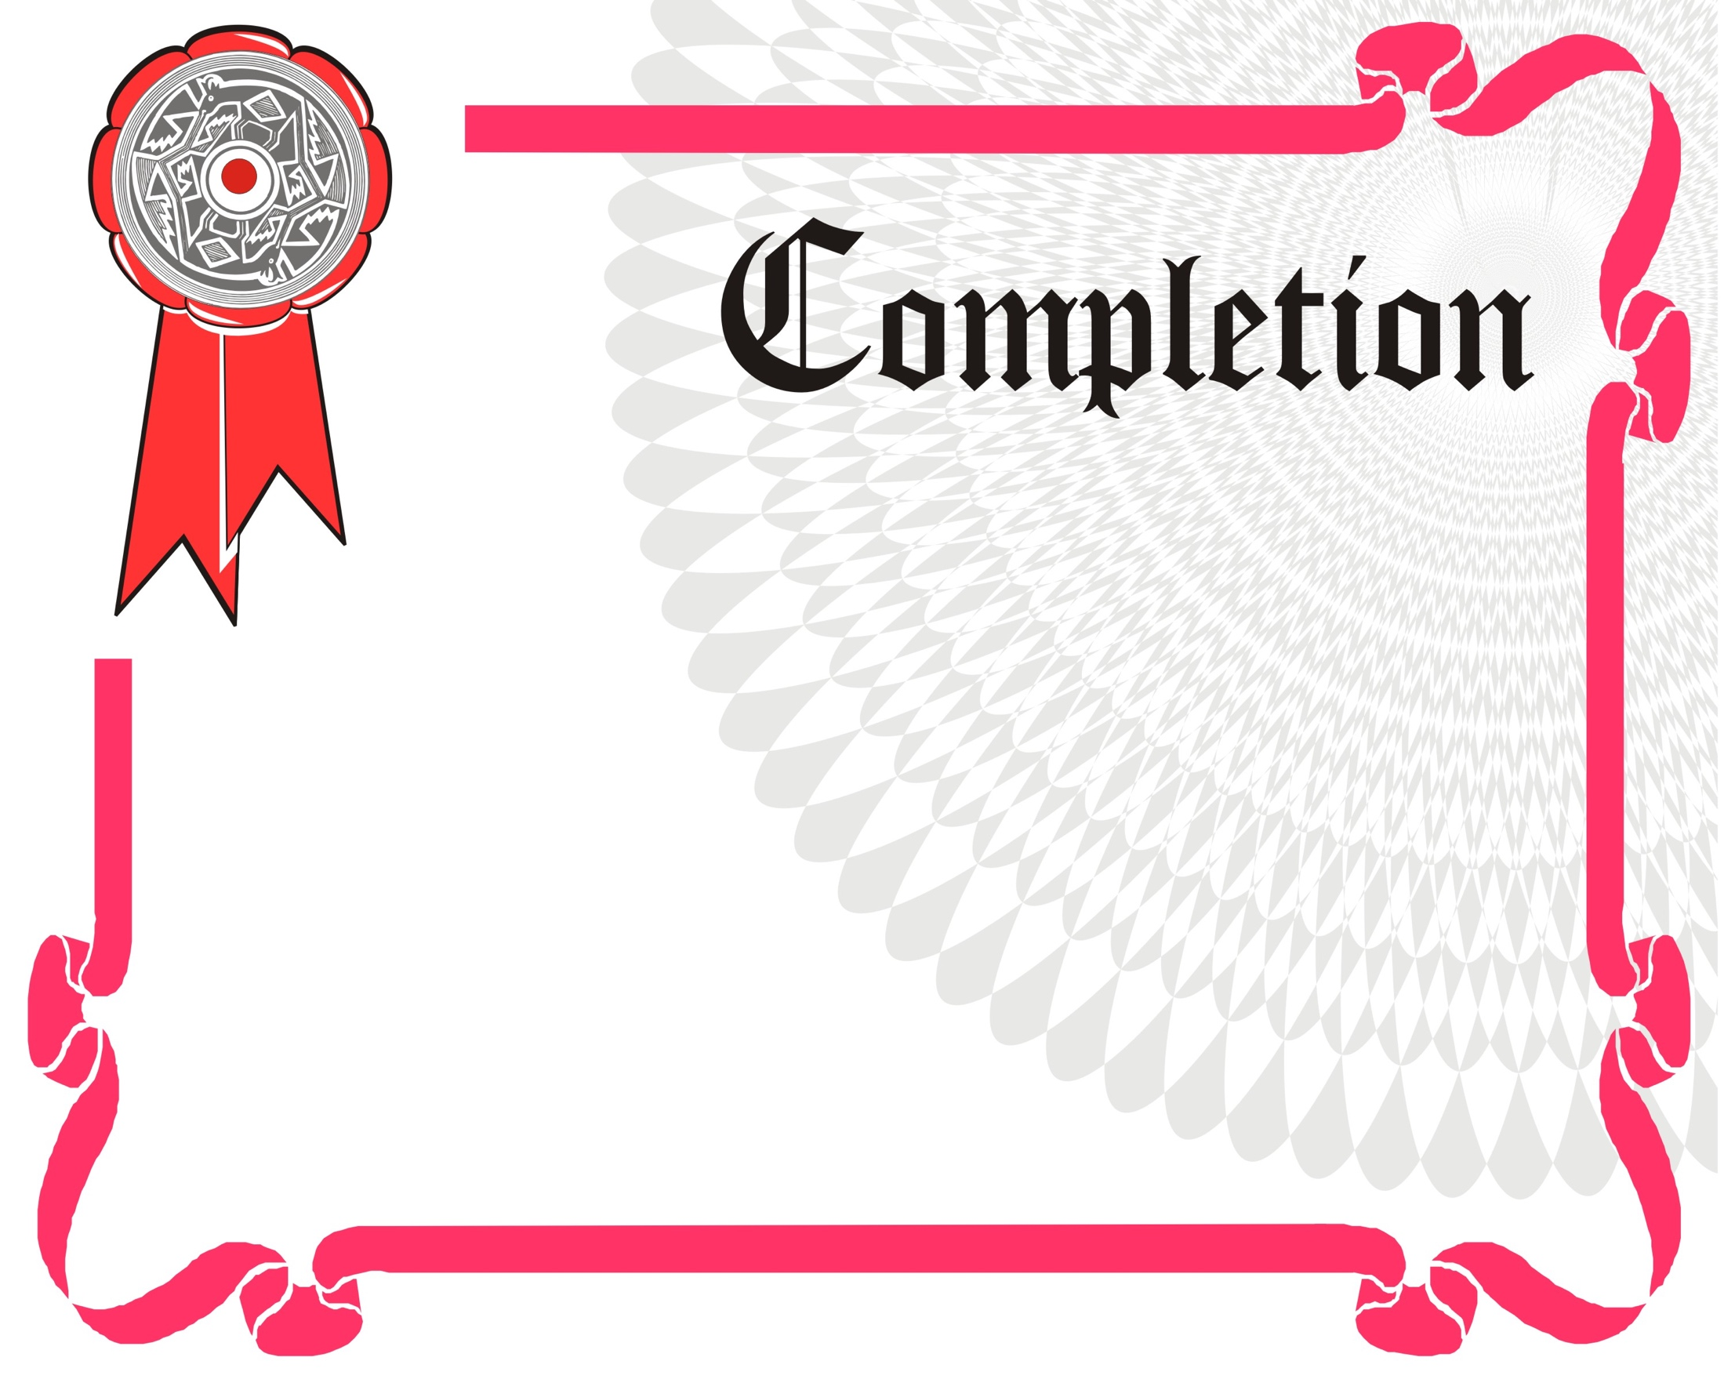

March 2 -3, 2019

**11 NBCC Clock Hours**

**NBCC Approval Number: SP-3068**

**NCSAPPB Approval 18-247-G**

**Up to 11 hours GSB**

We gladly present this certificate to

[**drshannonsouth@yahoo.com**](mailto:drshannonsouth@yahoo.com)

**138 Charlotte St.**

**Asheville, NC 28801**

## Kirsten Cantley

**Dr. Shannon South**

[**www.drshannonsouth.com**](http://www.drshannonsouth.com)

**How to Integrate Spirit and Soul into your Practice**

In recognition of completion of the training