**PRESS RELEASE**

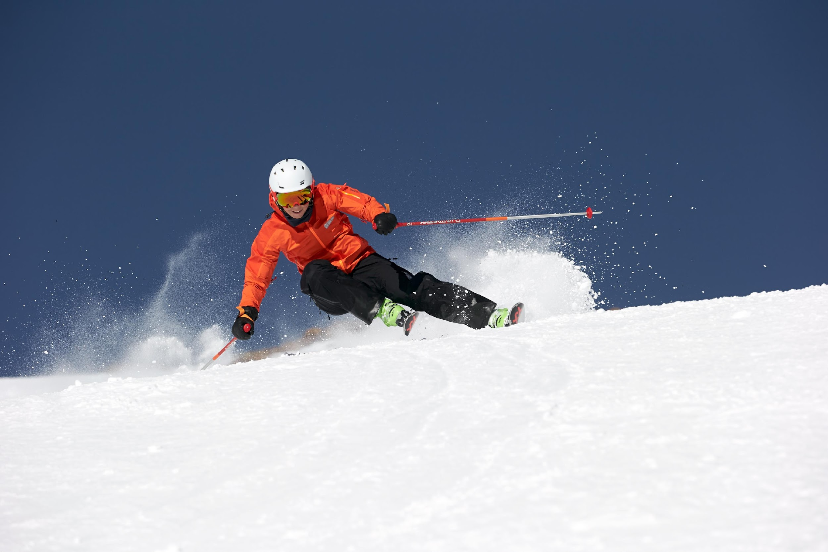

**DEACON V.WERKS: VÖLKL'S NEW PREMIUM ALL MOUNTAIN MODEL**

**For the 20/21 season, Völkl extends its Deacon series to include a new premium model, the Deacon V.Werks. With its advanced features, it appeals to skiers who value innovative constructions that take a no-holds-barred, technically superior approach to making a ski easier to control while simultaneously improving the level of excitement that it can deliver.**

Agile, lively, and easy to change the turn shape – those are the key characteristics the new Deacon V.Werks, flagship of Völkl's Deacon series, stands for. This premium product, with its huge performance envelope that can be felt and enjoyed without having to push the ski hard, is aimed at athletic, discerning All Mountain skiers. In order to unite sometimes difficult to combine performance characteristics, product developers and engineers in Straubing, Bavaria have gone one step further and set new standards to achieve the holy grail of coordinating torsional and longitudinal flex.

Völkl introduces a new manufacturing process for the Deacon V.Werks, called **Functional** **Carbon Fiber Placement**, which makes precise power transmission as well as liveliness and energy accessible with minimal effort. In the process, the carbon fibers are no longer incorporated as a uniform fleece, but integrated through a stitching process in such a way that their orientation and strength meet the functional requirements of each part of the ski. Since the performance of a ski is largely determined by the behavior in the tip and tail areas, the carbon fibers are concentrated in the front and back third of the ski, where they provide direct benefits. With reliable power transmission, the ski can be controlled precisely and directly, allowing the skier to access previously unknown levels of performance. The technology, which is making its debut in ski construction with the Deacon V.Werks, is not only noticeable to the skier while skiing, but visible by simply looking at the ski.

**Deacon V.Werks**

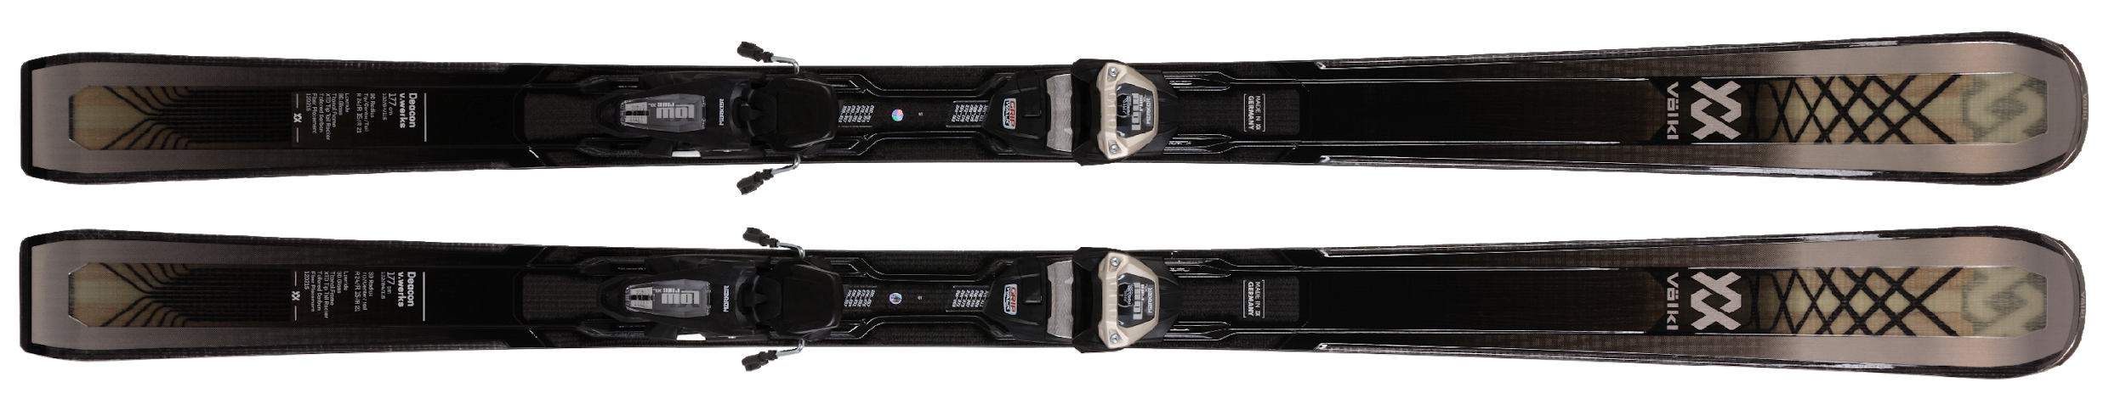

|  |  |  |  |  |  |
| --- | --- | --- | --- | --- | --- |
| **SIDECUT** | **LENGTH (RADIUS)** | **TECHNOLOGY** | **CORE** |  | **WEIGHT** |
| 132_84_115 | 162 [R1(17), R2(12), R3(20)]*1  167 [R1(18), R2(13), R3(21)]*1  172 [R1(19), R2(14), R3(23)]*1  177 [R1(21), R2(15), R3(24)]*1  182 [R1(22), R2(16), R3(26)]*1  *1 3D Radius Sidecut: R1=Tail Radius / R2=Center-Main Radius / R3=Tip Radius | Carbon Fibre Placement  Full Sidewall  3D.Ridge  3D Radius Sidecut  P-Tex 4504  3D Hybrid Sensor  Woodcore | 3D Hybrid Multilayer Woodcore |  | 1830 g* @ 177 without binding |

Like the Deacon 80 and Deacon 84 models released in 2019, the Deacon V.Werks also makes use of the innovative **3D Radius Sidecut technology**, which is tailored to the function of a Tip & Tail Rocker. Völkl has set an absolute benchmark in terms of the variability of turn radii and the combination of easy handling and stability. A tight radius in the cambered area of mid-body provides marked support for both relaxed skiing and liveliness in short turns. At the same time, the very large radius maintained in the tip and tail rocker areas makes the skis much more stable than would be possible with a short-turn sidecut over the entire length of the ski. Like no other ski, the Deacon V.Werks offers the greatest versatility and variability to allow the skier to switch between turn shapes.

The **Titanal Frame** of the Deacon V.Werks ensures maximum power transmission and shock absorption. A 0.7 mm thick Titanal frame surrounds critical tip and tail areas, giving the ski stability and cushioning impacts. This technically complex construction allows skiers to enjoy a combination of liveliness and high-speed stability that have never before been seen in a ski with metal – with a weight of just 1830 grams per ski without binding.

The integration of the **IPT Lowride binding system** sets new standards in terms of power transmission. In this high-tech setup, critical functions of the binding interface are performed by the ski body, lowering the system weight by 400g and the stand height by 1cm. With minimal effort, the binding allows quick, effortless edge changes and provides an unprecedented degree of agility.

**Press contact**

Mark Tedeschi

Elevator North, LLC

781-740-4050

[mtedeschi@elevatornorth.com](mailto:mtedeschi@elevatornorth.com)

**About Völkl**

Völkl have dedicated themselves to ski construction for more than 90 years. The passionate ski manufacturer is the only winter sports brand still developing and manufacturing in Germany. The Völkl parent plant located in Straubing, is one of the most modern ski manufacturers in the world and stands for technology and quality "Made in Germany". The team of development engineers, ski builders, product managers and athletes has made Völkl one of the world's leading ski manufacturers. In cooperation with its partners Marker and Dalbello, Völkl is striving to create the optimum equipment for skiers the world over. Marker designs and produces ski bindings, helmets, ski goggles and protectors, while Dalbello focuses entirely on the development and manufacture of ski boots.