NAGVA Board Call
Meeting Minutes: 06/12/2018

- Roll Call – Crumby, Ebel, Crawford, Smith, Kilburg, Davis, Bardot, Sucre, Schultz,
  - Absentees – Callen, DeLawder, Starks, Brink, Ware, Dubree
- Officer/Department Reports
  - President – Crumby*
    - As Board Members with the updated Bylaws we must be in Good Standing and have our dues paid at the beginning of every season.
    - Follow up to the Annual Meeting. Eric Nelson has reached out as the 17-18 VP of Eligibility to notify member (Jaime Estrella) of his year suspension that passed unanimously during the Annual Meeting at Championships XXXVI.
    - Board reminder to please review the website for updates.
    - Hall of Fame and Spirit award tab to be added.
    - Forms page that needs to be updated from 17-18/18-19.
    - Marshall added the FR rating option to Rating Form.
    - NAGVA Champs FB page has been updated; Denver Champs Team has a live page of their own.
    - Midyear date options going to go out soon.
    - Send Execs any projects that the Board may deem necessary; will be brought to midyear for work.
The following three (3) positions were brought to the attention of the Board by the President (Crumby) for consideration, no discussion was requested, and a vote by affirmation was held. All candidates were approved by unanimous consent.
    - Communications – Steven Acosta
    - Past President – Rick Talley
    - Historian – Eric Nelson
  - Vice President – Ebel*
    - Rules and Regulations have been updated, Highlights from Annual meeting updated.
    - Core 4 verbiage also updated with the Rules and Regulations
    - Reminder for the Board to log-in to Intercom.
  - Secretary – Crawford*
    - No new business
  - Treasurer – Lew*
    - All bills for Championships have been paid. Except for hotel.
    - Sponsorship from Minneapolis of $10k was granted.
    - Need to send Avenues for the Homeless donation.
    - Reimbursements being done this week for Championships.
    - Lew presented the Financial Report as of May 31, 2018. (see below)
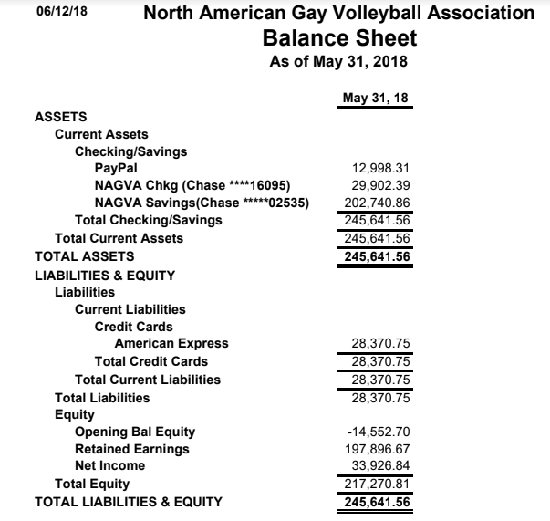

  - Registrar – Kilburg*
    - Updated member profiles.
    - Added a notes page for grievances or suspensions.
  - Tournaments – Davis*
    - Noted that there has been an attendance impact to Tournaments East of Mississippi due to Gay Games.
    - Confirmation that San Juan will have another tourney in Feb time frame.
    - Fall tourneys falling in line.
  - Canadian Representative – Jez*
    - No new business
    - Toronto tourney push. Requested timely notification of Midwest tourneys so he can push for participation, which would bolster participation of a Toronto tourney if more Canadians would already be registered with NAGVA for the 18-19 season.
- MAL Reports
  - Rich*
    - No news
  - Jimmy*
    - No new. Has a new dog Toby. Likes butt scratches.
- New Business
  - Information concerning a Board Member was brought to light. Board was given time to digest this information to be discussed at an upcoming meeting.
- Meeting Adjourned

