ADDITIONAL INFORMATION
& TEMPLATES

INSURANCE

Our streets are our public space, by running your playful street you’ll be inspiring & encouraging everyone to respect our streets like we would our homes and ensure everyone feels welcome. Try to generate a sense of shared responsibility for making sure the sessions are safe. The best way to prevent being held liable for anything that goes wrong is to make sure you do everything in a responsible way, preparation is key!

Most streets don’t get insurance, however we would advise you to do whatever you feel is necessary to feel covered. Here are some tips;

- Ask your insurance provider if you can extend your current home insurance to an event – this is generally only a little bit extra.

- Get in touch with your local resident association or with like-minded community groups. They usually have insurance and, if you link in with them and see if they can get involved, they are often happy to include your event, under their policy.

RAIN

Sure we all know there’s no such thing as bad weather in Ireland, all you need is the right gear. Children LOVE the rain, the mud and puddles. Bring the rubber duckies out for a swim in a puddle, make boats with sticks. Wellies and raincoats = hours of fun!

EVENT MANAGEMENT PLAN (EMP)

An EMP isn’t always required, but here are some of the details to include in your EMP on the off chance that you need to have one.

- Introduction (include the activities and a bit about Playful Streets)
- Event Breakdown
- Event Schedule (set up time and take down time)
- Event Management Team e.g organiser and stewards.
- Location of event (include map)
- Traffic Management (see our info sheet for stewards for this)
- Pre-event meeting
- Key contact list
  - Event Controller
  - Health and Safety Manager
  - Stewards
- Risk Management
- First Aid
- Structures & Facilities
- Emergency Plan
- Medical facilities
- Noise levels
- End of event procedure
- Waste and rubbish plan
- Insurance
- Promotion
- Resident notification
- Contact sheet
- Lost and Found children procedure

MAKING YOUR OWN FLIERS/POSTER

We’ve added some templates for fliers and posters in the templates section. If you’d like to make your own, we’d highly recommend canva.com for free templates and ideas.

RISK & SAFETY ASSESSMENT

We would advise you to do this, to help keep everybody safe while playing in the street.

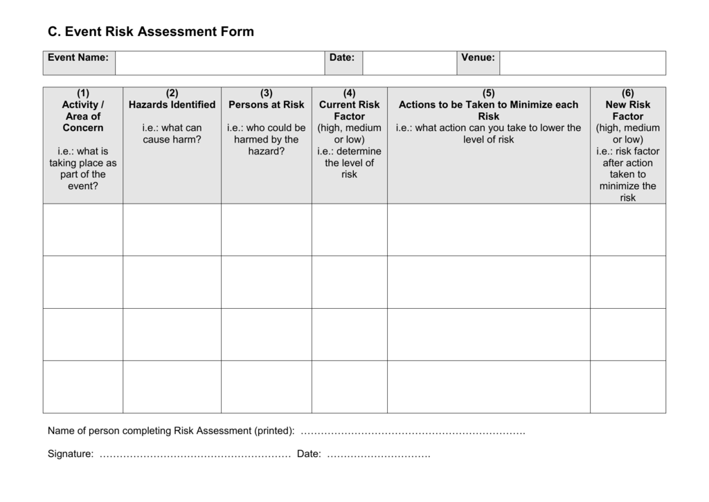
A Risk and Safety Assessment just involves listing any potential risks (e.g. cars moving on the street, parked cars, disgruntled drivers, children wandering off) and deciding what you can do to reduce that risk (e.g. brief stewards fully, talk to your neighbours about the plan, ensure parents know they are responsible for their own children, make sure all access/exit points are properly supervised). Once you have done this, bearing in mind there is no such thing as a ‘risk-free’ environment, it is a good idea to weigh up the overall risk against the potential benefits of going ahead. We have a template you can use, below, but every street is different so you still need to adapt it or do your own.

LETTER TO YOUR NEIGHBOURS

It’s important to pop a letter over to your neighbours just to let them know about the Playful Street once you’ve set a date and, importantly, inviting them to be involved in the planning with you.

Hello neighbour!

We just want to let you know that we’ll be popping by on* insert day * between *insert times * pm - pm to chat about the upcoming PLAYFUL STREET on *insert street/road* and how you might like to help make it happen.

Playful Street allows kids to play out on the street for a couple of hours & brings the whole community out to show the kids the street games we used to play…

Time & date of Playful Street:
*insert time and date*

OUR STREET is a PLAYFUL STREET :)

If you’d like to get involved;

*insert contact details if appropriate*

or *insert a time and date and location to meet*

or just show up! We’ll be setting up from *insert time*, come along and help make it happen :)

www.aplayfulcity.com

Dear Neighbour,

As we hope you know there is a Playful Street happening this *insert day, date and road*.

We would really appreciate if you could try to find a different spot for your car during this time to give children and the community the space to enjoy the event.

This notice is kindly supported by *Residents Association/ An Garda Siochana/ County Council*.

Hope to see you on *insert day*!

*Your Name*

www.aplayfulcity.com

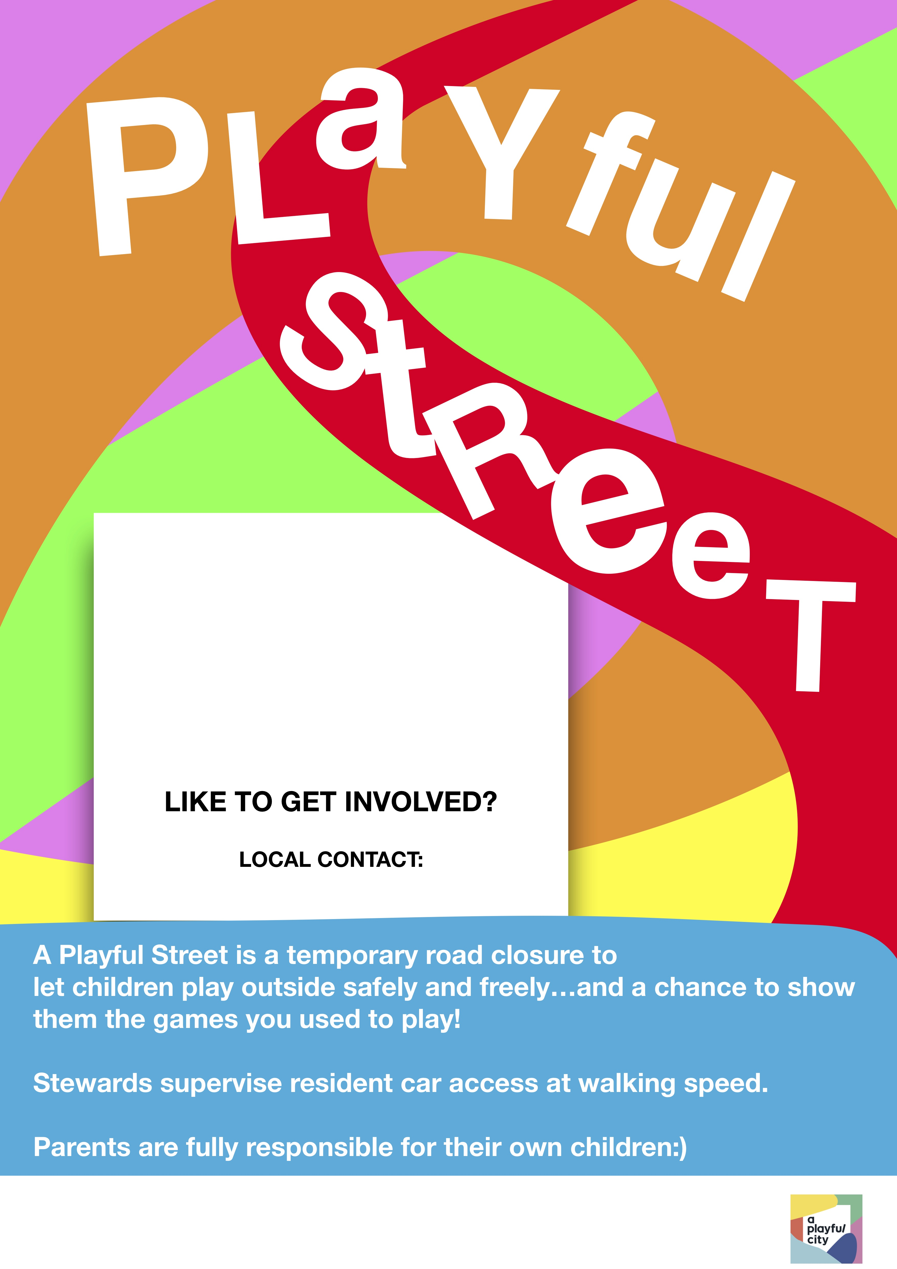

INFORMATION FOR STEWARDS

Playful Streets work best with the support of volunteers. While parents remain responsible for their children and should be reminded of that, cars moving on the street are the biggest concern for safe street play.

You will need at least two stewards for each vehicle access point throughout the session (one to stay put and one to walk in front of cars). We have found it’s best to ask people directly, rather than just sending out a general request. You might want to print out the steward sign-up sheet on our website and get people to commit in writing.

Two stewards should be positioned at points of access to cars (one to walk in front of cars and one to stay where they are). The job of the steward is key for safe and enjoyable Playful Streets so be sure to talk to people directly about signing up and be satisfied that they are dependable & confident to deal with vehicles and their drivers coming onto the street.

The stewards primary role at Playful Streets is to supervise any entry/exit points onto the street to ensure that if cars enter or exit the street, the instructions below are followed. Be sure to encourage all stewards to attend a post event meeting (this can be informal - on the street) to discuss the event with the organiser so you can make your Playful Street even better/ easier to run next time !

If cars come onto the street;

- Signalling the car to stop and explaining to the driver that there is a
Playful Street taking place. Let the driver know that a steward will walk in
front of the car so that the car is moving at walking speed in order to
ensure the safety of the children on the street. (Ideally only residents will
be allowed to drive onto the street, non -residents should be asked to use
an alternative route or park elsewhere).
- Before allowing cars to exit or enter, stewards will notify children (e.g by
using whistles) to move onto the footpath as there is a car coming.
- Walking in front of the car until it is safely off the street.
- Resume play!

And remember… Make sure the street is left as you found it!

www.aplayfulcity.com

PLAYFUL STREETS STEWARD SIGN UP SHEET

Name | Mobile Number | Email | Received Steward Info.

