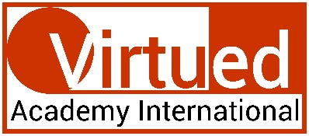
This certificate is granted to

Danielle Jackson
in recognition of completing the Virtued Academy International’s

Certification in Chakra Healing
 | 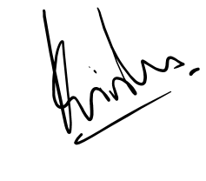  PROF KRISHNA N SHARMA  Course Coordinator |  | DATE September 4,2023
 | Note: This certificate is valid only with Udemy's certificate of completion. In absence of Udemy's certificate, this certification shall be considered null and void.

