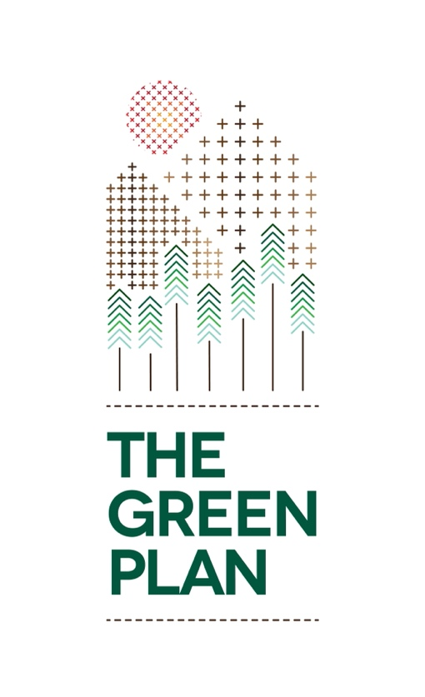

Bronze Activity Score Sheet

Theme | Activity |  | Target | Points
Energy | 1 | Home Energy Monitor | 25 kWhrs per home | 10
 | 2 | Battery Recycling | 150 AA Batteries | 10
Water | 3 | Water Hippo | 1 per home | 10
Waste | 4 | Beach / Road Clean | 5 Kgs collected | 10
Biodiversity | 5 | Meadow planting | Sow 25m | 10
 | 6 | Bug Hotel | 1 Bug Hotel | 10
Transport | 7 | Non Car Day | 100 kms | 10
Society | 8 | Clothes recycling | 21 Garments recycled | 10
 | 9 | Homemade Cleaning Spray | 1 per person | 10
Procurement | 10 | Non-perishable foods | 70 cans of food saved | 10
Bronze Certificate | Total points required |  |  | 100

ACTIVITY 1 |  | Start Date: | Finish Date:
Theme | Activity | Team Members Name | Energy saved kWhr
Energy | Home Energy Monitor
Notes:
Total

ACTIVITY 2 |  | Start Date: | Finish Date:
Theme | Activity | Team Members Name | Batteries Recycled
Energy | Battery Recycling
Notes:
Total

ACTIVITY 3 |  | Start Date: | Finish Date:
Theme | Activity | Team Members Name | Hippo Installed
Water | Water Hippo
Notes:
Total

ACTIVITY 4 |  | Start Date: | Finish Date:
Theme | Activity | Team Members Name | Weight collected
Waste | Beach / Roadside Clean
Notes:
Total

ACTIVITY 5 |  | Start Date: | Finish Date:
Theme | Activity | Team Members Name | Patch size
Biodiversity | Meadow Planting
Notes:
Total
ACTIVITY 6 |  | Start Date: | Finish Date:
Theme | Activity | Team Members Name | All build a Bug Hotel
Biodiversity | Bug Hotel
Notes:
Total

ACTIVITY 7 |  | Start Date: | Finish Date:
Theme | Activity | Team Members Name | 14 km trip reduction
Transport | No car day
Notes:
Total

ACTIVITY 8 |  | Start Date: | Finish Date:
Theme | Activity | Team Members Name | 21 units collected
Society | Clothes recycling / charity
Notes:
Total

ACTIVITY 9 |  | Start Date: | Finish Date:
Theme | Activity | Team Members Name | 1 per household
Procurement | Household Cleaner
Notes:
Total

ACTIVITY 10 |  | Start Date: | Finish Date:
Theme | Activity | Team Members Name | 70 cans of food saved
Procurement | Non-perishable foods
Notes:
Total

