**PRESS RELEASE**

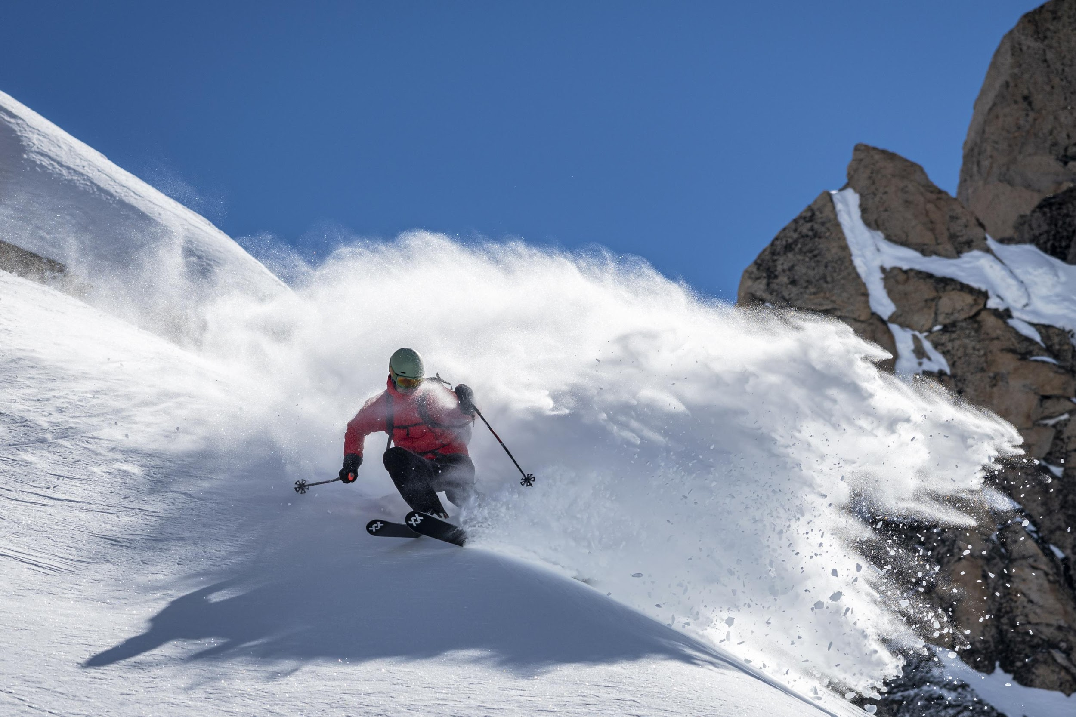

**ENJOYMENT FOR ALL LEVELS: VÖLKL'S NEW ALL MOUNTAIN FREERIDE MODELS**

**The product family that has grown to surround the legendary Mantra, with its high-tech Titanal Frame and 3D Radius sidecut designs, has become a benchmark in the All Mountain Freeride category. For the 2020/21 season, Völkl introduces four new models in this important segment: two new unisex models, the Katana 108 and Kanjo 84, along with two new women's skis, the Yumi 84 and Yumi 80.**

Völkl has always strived to develop products that are ideally suited to the widest range of skiers and their needs. Living up to this claim are four new technologically advanced skis: Katana 108, Kanjo 84, Yumi 84 and Yumi 80. They complete the broad ranging All Mountain Freeride series, which offers skiers of all ability ranges the best experience in any terrain or conditions.

The key technology uniting all these new models is the innovative **3D Radius Sidecut**. The sidecut geometry is synchronized with the Tip & Tail rocker by allowing three different radii to merge into one another over the length of the ski. In the tip and tail sections, longer radii ensure high speed stability and smoothness for long turns and challenging snow conditions. The tight radius in the mid-body of the ski, on the other hand, allows effortless turns at low speeds, and affords maximum maneuverability and liveliness, especially in trees or tight spots that demand quicker turns. With this technology, the skis are perfectly equipped for a wide variety of conditions and turn shapes, at any speed.

**Katana 108**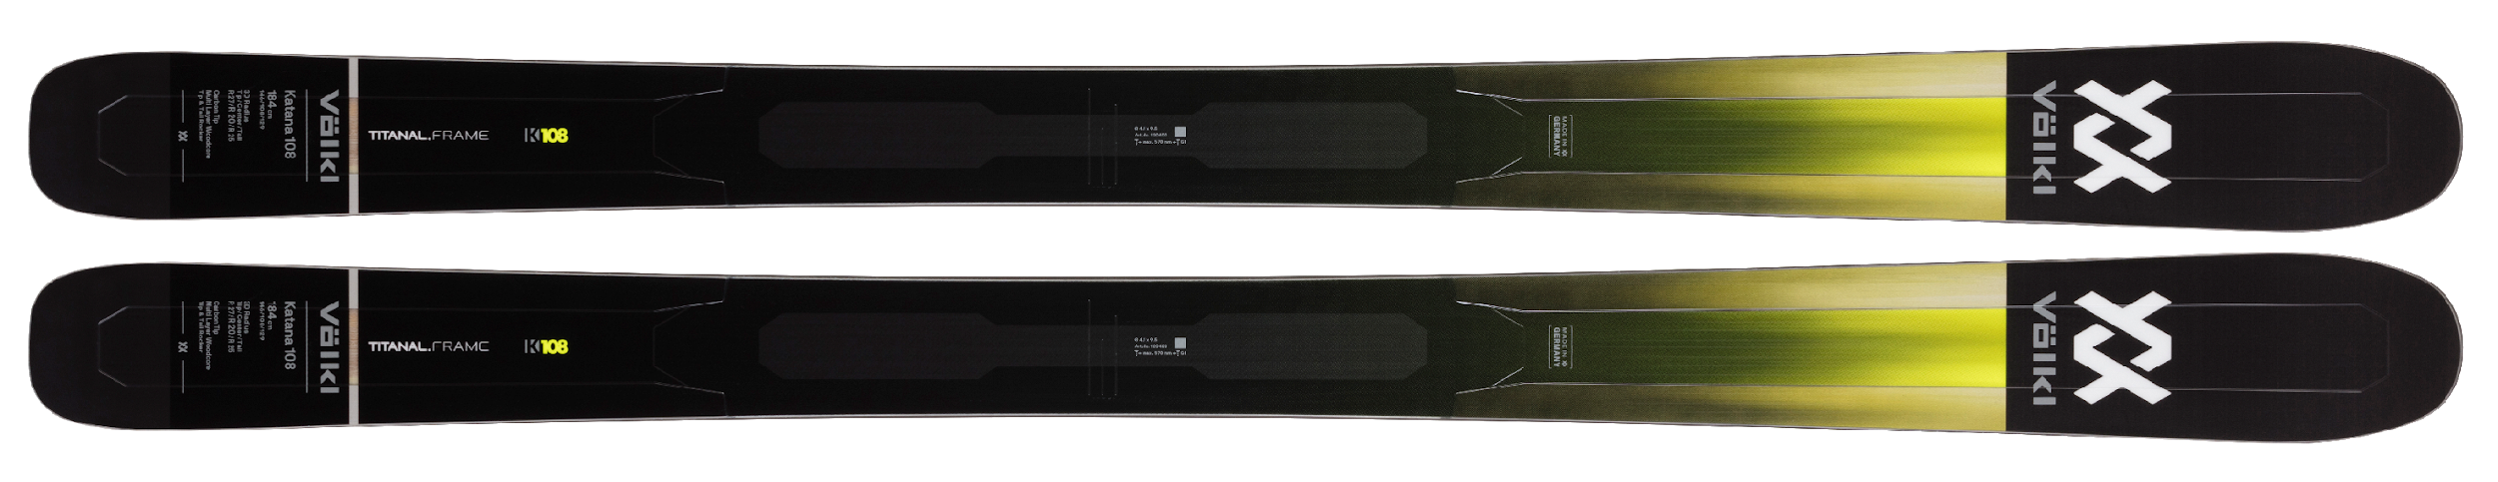

|  |  |  |  |
| --- | --- | --- | --- |
| **SIDECUT** | **LENGTH (RADIUS)** | **TECHNOLOGY** | **CORE** |
| 146_108_129 | 170 [R1(30), R2(16), R3(32)]*1  177 [R1(32), R2(18), R3(36)]*1  184 [R1(34), R2(19), R3(39)]*1  191 [R1(36), R2(21), R3(43)]*1  *1 3D Radius Sidecut: R1=Tail Radius / R2=Center-Main Radius / R3=Tip Radius | Titanal Frame  3D Radius Sidecut  Carbon Tips  Full Sidewall  Base: P-Tex 2100 | Multi Layer Woodcore |

With the Katana 108, Völkl expands the series, bringing in a new the flagship and addressing the big mountain charger category with an incredibly nimble ski for its width. The Katana 108 has a **Titanal Frame** that that provides the critical tip and tail areas with a 0.7 mm thick support area around their perimeter, giving the skis abundant stability and shock absorption. In the binding area, another 0.3 mm thick Titanal sheet provides less rigidity yet plenty of binding retention. The new shape gives the ski plenty of float for off-piste performance, and thanks to its 3D Radius Sidecut, skiers benefit from a combination of precise power transmission, uncompromising liveliness, smoothness and turn shape variability – something unheard of in past freeride ski designs.

**Yumi 84**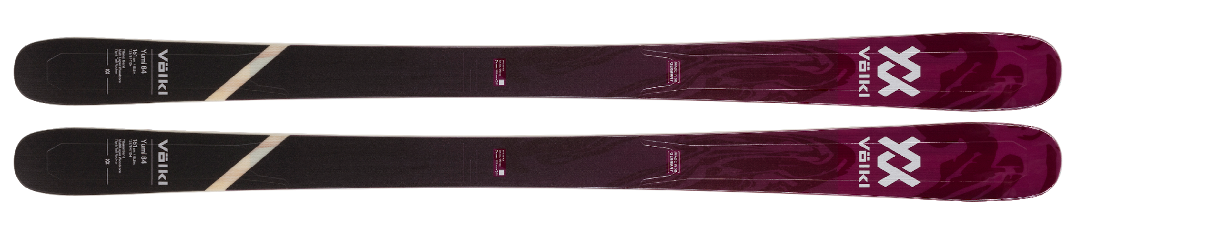

|  |  |  |  |
| --- | --- | --- | --- |
| **SIDECUT** | **LENGTH (RADIUS)** | **TECHNOLOGY** | **CORE** |
| 125_84_107 | 147 [R1(15), R2(11), R3(14)]*1  154 [R1(18), R2(13), R3(16)]*1  161 [R1(19), R2(14), R3(17)]*1  168 [R1(21), R2(15), R3(19)]*1  *1 3D Radius Sidecut: R1=Tail Radius / R2=Center-Main Radius / R3=Tip Radius | 3D Radius Sidecut  Glass Frame  Titanal Binding Platform  Full Sidewall  Base: P-Tex 2100 | Multi Layer Woodcore |

**Kanjo 84**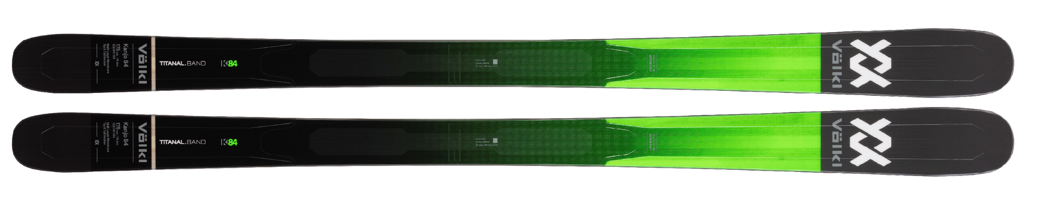

|  |  |  |  |
| --- | --- | --- | --- |
| **SIDECUT** | **LENGTH (RADIUS)** | **TECHNOLOGY** | **CORE** |
| 125_84_107 | 161 [R1(19), R2(14), R3(17)]*1  168 [R1(21), R2(15), R3(19)]*1  175 [R1(25), R2(17), R3(20)]*1  182 [R1(25), R2(19), R3(24)]*1  *1 3D Radius Sidecut: R1=Tail Radius / R2=Center-Main Radius / R3=Tip Radius | 3D Radius Sidecut  Glass Frame  Titanal Binding Platform  Full Sidewall  Base: P-Tex 2100 | Multi Layer Woodcore |

The new Yumi 84 and Kanjo 84 replace their predecessor models with huge technical enhancements. These skis offer easy handling, maximum agility and maneuverability to a wide range of skiing abilities. For the first time, Völkl combines **Glass Frame** construction with the innovative **Titanal Binding Plate** in these models. The Glass Frame construction mimics the Titanal Frame in Völkl’s higher-end freeride skis with a lighter, easier-handling setup that concentrates glass layers around the ski’s perimeter. The metal sheet under the binding simultaneously provides added rigidity in the binding area and optimizes power transmission under the foot for quick, direct grip when going from edge to edge.

**Yumi 80**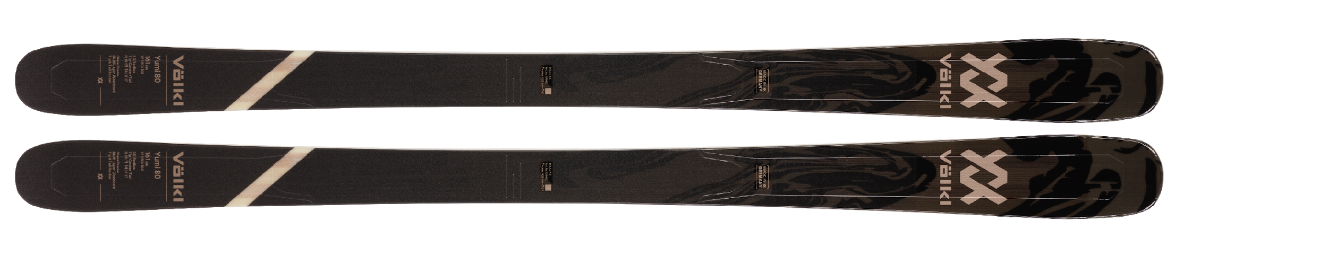

|  |  |  |  |
| --- | --- | --- | --- |
| **SIDECUT** | **LENGTH (RADIUS)** | **TECHNOLOGY** | **CORE** |
| 121_80_103 | 147 [R1(15), R2(11), R3(14)]*1  154 [R1(18), R2(13.1), R3(16)]*1  161 [R1(19), R2(14), R3(17)]*1  168 [R1(21), R2(15), R3(19)]*1  *1 3D Radius Sidecut: R1=Tail Radius / R2=Center-Main Radius / R3=Tip Radius | 3D Radius Sidecut  Glass Frame  Full Sidewall  Base: P-Tex 2100 | Multi Layer Woodcore |

With the Yumi 80, Völkl extends the All Mountain Freeride series to include a model for intermediate to advanced skiers who value easy handling and a lively ride quality. The Glass Frame makes the ski more forgiving and easier to control than a Titanal ski, and when coupled with 3D Radius Sidecut technology, gives a wide range of skiers easy access to great performance, light weight, and secure edge grip in all conditions.

**Press contact**

Mark Tedeschi

Elevator North, LLC

781-740-4050

[mtedeschi@elevatornorth.com](mailto:mtedeschi@elevatornorth.com)

**About Völkl**

Völkl have dedicated themselves to ski construction for more than 90 years. The passionate ski manufacturer is the only winter sports brand still developing and manufacturing in Germany. The Völkl parent plant located in Straubing, is one of the most modern ski manufacturers in the world and stands for technology and quality "Made in Germany". The team of development engineers, ski builders, product managers and athletes has made Völkl one of the world's leading ski manufacturers. In cooperation with its partners Marker and Dalbello, Völkl is striving to create the optimum equipment for skiers the world over. Marker designs and produces ski bindings, helmets, ski goggles and protectors, while Dalbello focuses entirely on the development and manufacture of ski boots.