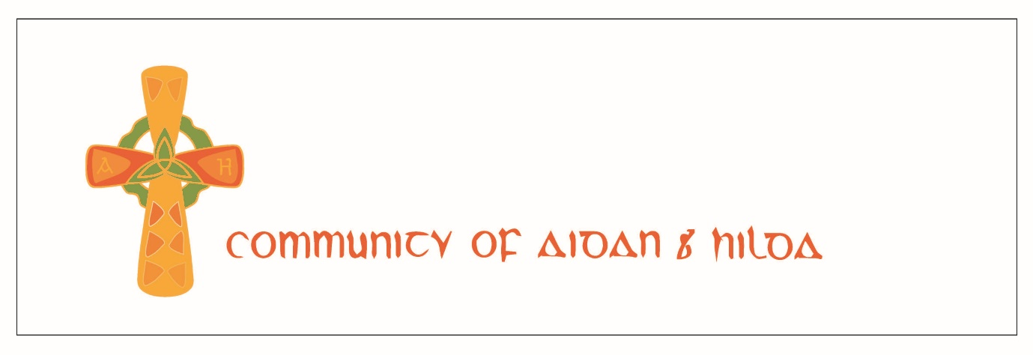
Retreat List 2022

Connections - a retreat for women only

Dates: Friday 6th to Monday 9th May

Retreat Leaders: Shona Stirling and Faith Brennan

Costs (including lunches and dinners):
Bedroom with ensuite shower room at High Rigg: £295
Bedroom with shared shower room at Shalom: £245
One bedroom flat: £345
(where two people share a room, the price for the second person is 50%)

This retreat is about pressing the pause button on your life and taking time to reconnect with God, yourself and others. The journey towards God includes increasing self-awareness and soul wholeness. For that to happen we need safe spaces to stop and ask, “What now God?”. This retreat offers you that space.

To book, please email faith.brennan@gmail.com

Cave, Table, Road
Dates: Friday 13th to Tuesday 17th May

Retreat Leader: Scott Brennan

Costs (including lunches and dinners):
Bedroom with ensuite shower room at High Rigg: £325
Bedroom with shared shower room at Shalom: £275
One bedroom flat: £345
Meals and retreat only: £125
(where two people share a room, the price for the second person is 50%)

This retreat looks at how to live with a holistic approach to life. It is inspired by the story of Elijah, who found that, despite his "success", he entered a period of opposition and questioning. He needed an encounter with God to get back on track. This experience released him to discover his true self and pass on his wisdom.
The retreat has lots of free space to rest, enjoy the beauty of Holy Island, go deep, enjoy food together and take part in rhythms of prayer in community.

To book, please email faith.brennan@gmail.com

Living from the True Self

Dates: Monday 23rd to Friday 27th May

Retreat Leader: Brother Cassian

About the retreat: some of the Christian Mystics talk about the difference between the True Self and the False Self, as does Carl Jung in Jungian psychology.
The False self is the created persona we project into the world, which is ego driven, but the True self is the Divine image in which we are created, the very essence of our inner selves, who we truly are.
To transition from the False self to the True self is a journey of transformation through life.
Come and learn more about this and how one can step onto the transformative path from the False self to the True self, discovering the Divine image within and the true essence of our being.

For costs and to book, please contact WaymarkMinistries@live.co.uk

Retreats for Ministry Leaders and their Spouses

Dates: four weekend options in 2022

Retreat Leaders: Scott and Faith Brennan
Contact Scott at scott.brennan12@gmail.com for more information

Costs (including lunches and dinners):
Bedroom with ensuite shower room at High Rigg: £155
Bedroom with shared shower room at Shalom: £135
One bedroom flat: £175
(where two people share a room the price for the second person is 50%)
(there is an option to stay an extra night)

About the retreats: Leadership is currently in the crucible of transition and transformation. This liminal space requires new practices and time priorities, which is a serious challenge because many leaders are living with demands that are unsustainable. We want to live a life worth imitating that includes a healthy, balanced Way of Life, but find our current culture of haste works against this. We can feel trapped on the hamster wheel of ministry.

These retreats offer a balance of prayer, time for personal reflection and rest, thought provoking input and time with others.

To book, please email faith.brennan@gmail.com

The Art of Peace

Dates: Monday 19th to Friday 23rd September

Retreat Leader: Brother Cassian (David Cole)

Teaching and practice based on the book ‘The Art of Peace’ by David Cole

For costs and to book, please contact WaymarkMinistries@live.co.uk

Igniting the Flame

A retreat for this year’s participants on the Igniting the Flame course

Dates: Monday 3rd to Friday 7th October
More details will be sent out to ITF students and tutors soon.

Working Weeks

In January 2023 we will be having two work weeks on the island (dates TBC). These weeks will combine prayer rhythms and work on the CAH properties, with space to retreat and rest. Accommodation will be provided free of charge.
The work will include decorating, DIY, cleaning and gardening.

To register your interest, please email faith.brennan@gmail.com

DIY Retreats

Our retreat houses are available to book all year round. Great for families, groups and individuals. We hold open prayer times at midday and 9pm Monday to Friday. There is access to the Celtic Studies Library and Meeting Place (a space for prayer, reading and meeting others) 9:30 – 6pm in Starbank Cottage very near all our retreat houses. It is also possible to book sessions with people on the island or online to help guide your retreat. There are books and information in the retreat houses to help support retreats and introduce you to Holy Island.

For full information, including costs, and to book, please email holyislandretreats@gmail.com

