

*for the*

True Purpose® Coach Certification

*June 18, 2021*

*is hereby awarded to*

Hank Childs

# certificate of completion

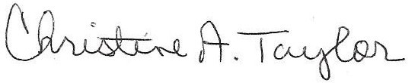

Christine A Taylor

Instructor

June 18, 2021