CERTIFICATE OF ACHIEVEMENT

COLLABORATIVE GROWTH LLC
CERTIFIES THAT

Carol Sachowski
SUCCESSFULLY COMPLETED RIGOROUS TRAINING IN

THE TESI
TEAM EMOTIONAL AND SOCIAL INTELLIGENCE SURVEY

August 15, 2013

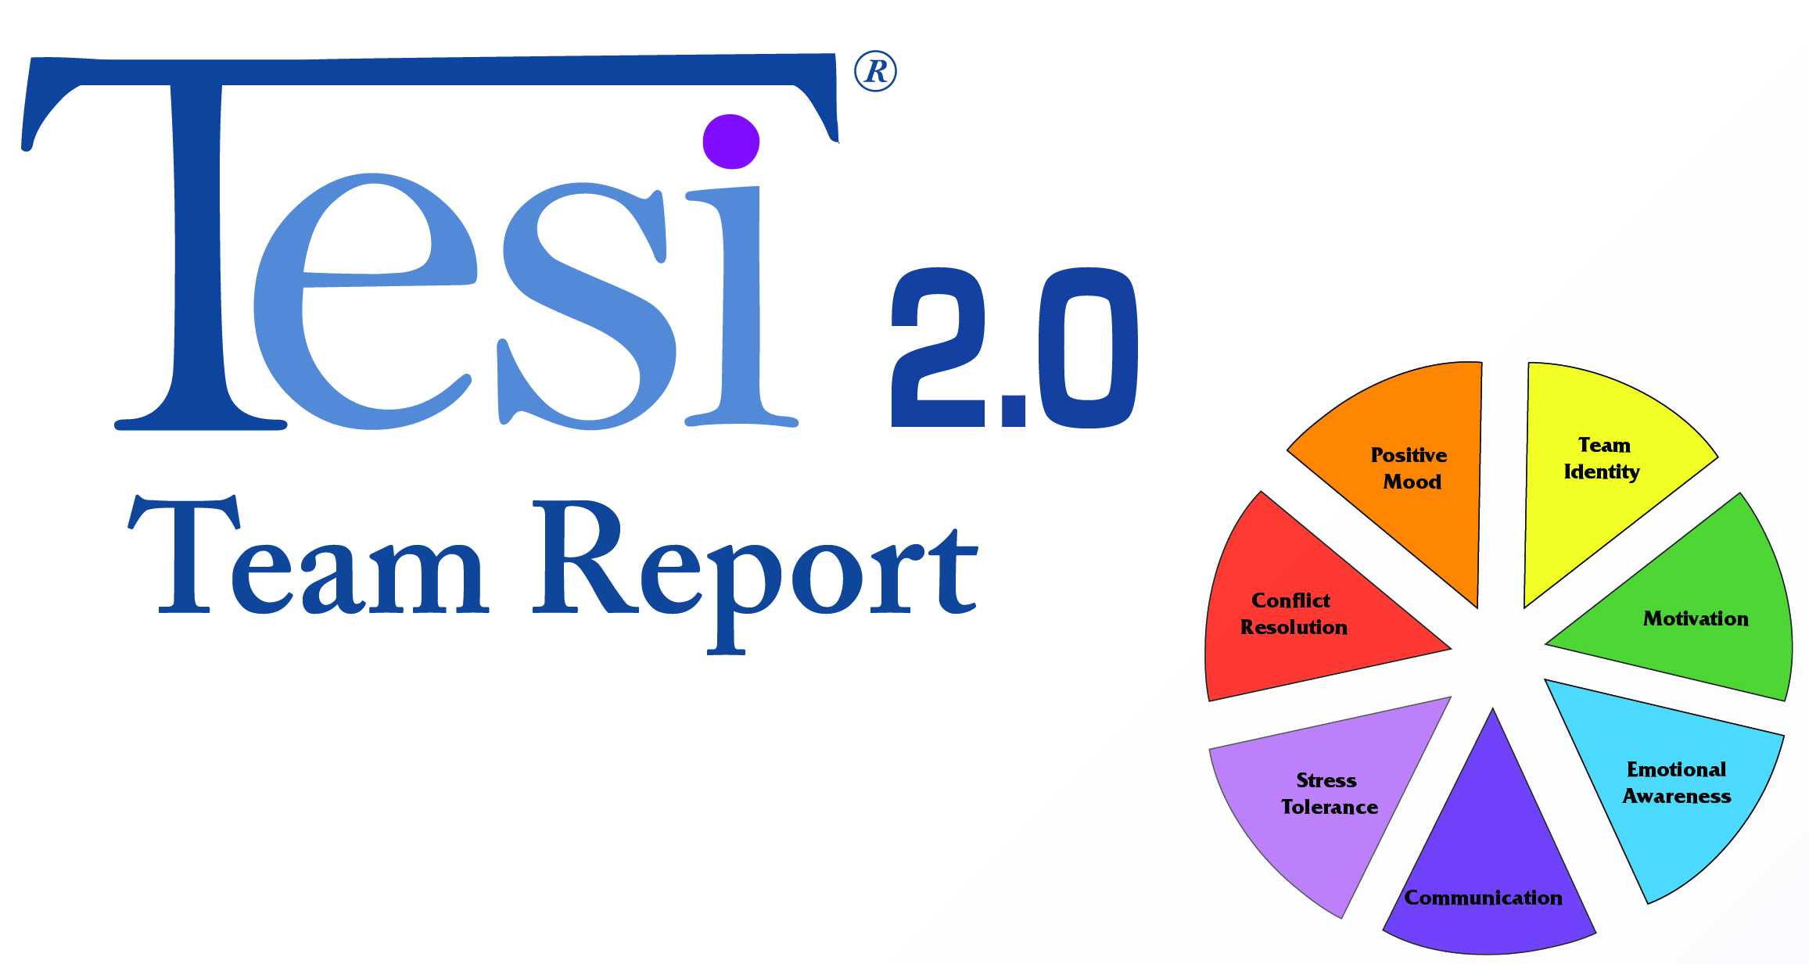

Marcia Hughes JD, M.A. James Terrell
President Vice President

