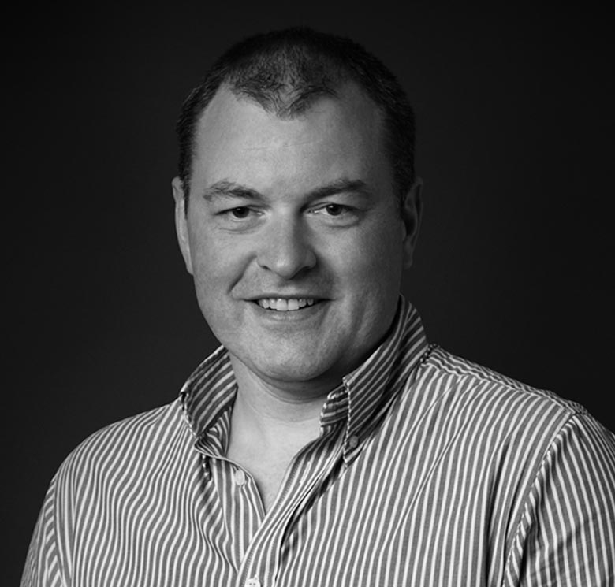

Matt Lovell

cEO & NED
Matt is a hands on CEO and NED with over 30 years experience in Technology and Startups. Matt is currently co-founder and CEO of a leading cyber security startup, CloudGuard. He is also a NED for BCN Group in Manchester since 2018 having recently completed a secondary round of investment with ECI. Previously, Matt recovered an SAP specialist company, Centiq, from administration in 2017 to a leading Microsoft global expert partner and a successful strategic exit to SoftwareONE in 2021. He is co-founder of a renewable energy business started in 2009 now operating cross 3 UK sites. He has successfully delivered 5 buy and build strategies, involving 28 acquisitions since 2003 with exits between 3 and 5x investment for shareholders. These businesses ranged from £2M to £25M EBITDA. For the last 5 years he has also been a small business coach in Manchester every other Sunday morning helping a range of over 30 businesses develop and grow.
Matt is a former international rowing champion and also enjoys Rugby and motorsports. He has built his own Cobra kit car and is an active member with his electrical skills in kit car electrification! He has a BSc(Hons) in Industrial Management, ACCA, Diploma in Marketing and has a Doctorate in IT investment measurements. Matt is married, has 2 daughters and lives in Cheshire with his dog.

Matt really really struggled at School and so did his teachers! Largely due to a lack of effort and application on his part which has held him back ever since. Targeting the bare minimum, Matt maintains a low profile and really doesn’t like challenges or hard work. He has fluffed and bluffed his way through a large number of roles and jobs by bamboolazing people with Technical jargon and general innovative guff which they think is great but will never help them. He is highly influential within the UK fashion scene where he is often revered and referred to and seen as a thought leading ambassador. Matt is an avid avoider of Lycra for Men but maintains his deep connections to religious belief and discovery. His early years involved a real split personally and career choice of becoming a priest or bus driver. He ultimately choose neither but would honestly say he would have failed at both.
Matt likes to over think most things but prides himself on remaining largely content free. He aspires to running male only businesses having been inspired by early Donald Trump leadership tips. He is an active member of the virtual Ferrari owner’s club and the Masons. Don’t try to shake his hand though or remove his sunglasses. Matt is officially known as a charity and basket case but struggles to deal with the depression this thought causes. He aspires to owning a Night club on a Monday and Tuesday night but by Friday of each week can be found at evening prayers at his local church where he likes to think of himself as in people’s thoughts – not always for the right reasons though. Gotta let go of the Hatred! Matt would like to be remembered – for anything – but fears it is now to late even for that. Boom !

