Certified GAPS™ Practitioner Training

Pilar Shilad, BSN, RN, CGP

Is hereby entitled to the distinction of Certified GAPS™ Practitioner (CGP)

For the successful completion of all required GAPS™ Practitioner Training hours (90 CEU’s), the above recipient is now authorized by Dr. Natasha Campbell-McBride and GAPS™ Training, LLC to use the designation of Certified GAPS™ Practitioner (CGP).

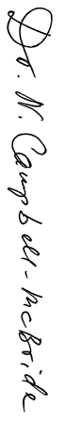

December 15th, 2020
__________________________________________ ___________________________________

Dr. Natasha Campbell-McBride, GAPS Training, LLC Founder Date of Issue

