**PRESS RELEASE**

**KEEP ON RACING: VÖLKL'S RACETIGER CONNECTS GENERATIONS**

**From "Renntiger" to "Racetiger", from one generation to the next: since 1970, the Völkl Racetiger has stood for Image, Innovation & Tradition - a revolutionary ski design with its legendary zebra pattern and a success story that still resonates today, recognized by racers of all ages. In 2020, this iconic design tells a brand-new story. A story in which the ski legend meets athletic legends and tomorrow's up-and-coming stars.**

The Bavarian company from Straubing, Germany has always been actively involved in working with young talents and places great emphasis on fostering them. Even when it comes to the development of new products for junior racing, the younger generation plays a decisive, leading role. It is Völkl's aim to involve these young talents in the development process and work with them to create skis that perform on the race course. The development of a ski is a lengthy process that goes through many stages. Each person involved brings different ideas and expectations into the process that need to be taken into account. "Racetiger - The Next Generation" sums up how the ski manufacturer has taken a unique turn in the development of the new Racetiger SL R Junior. By bringing former Völkl World Cup athletes, their children who are themselves racers, Völkl's engineers, and the product management team together, the first part of an amazing story came about - a story that is far from over. 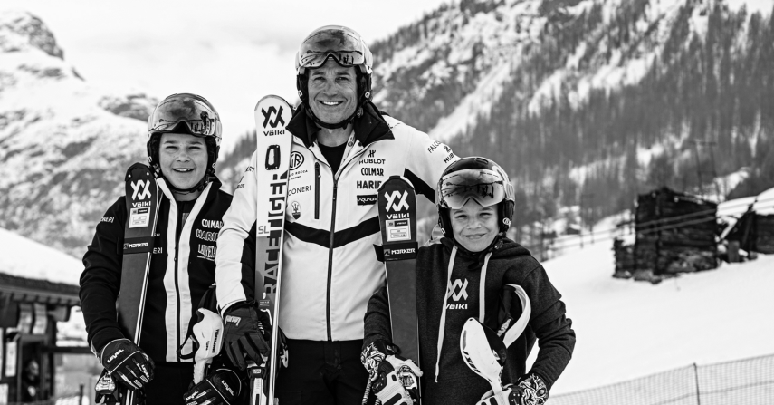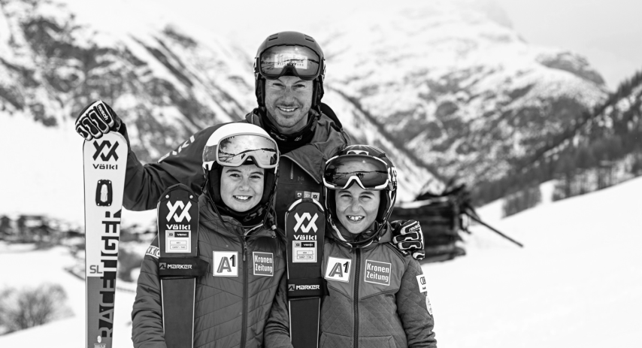

Enter former Italian World Cup ski racer, Giorgio Rocca, World Cup bronze medal winner in slalom, and skiing legend Manfred Pranger, slalom world champion from 2009, and their children Francesco and Giaccomo Rocca along with Mario and Laura Pranger, who were all involved in the process of developing the new Racetiger SL R Junior. They tested one of the final stages of development of the new junior ski together under real training conditions in Livigno, Italy. Their feedback and the experience and observations of their legendary parents were given directly to the Völkl engineers on location, and flowed straight into the final product. This put the "icing on the cake" in terms of finishing touches.

"We see it in the World Cup, the product has a big impact on performance on the slopes. Especially with children it is very apparent that it is counterproductive if the ski boots are too stiff or the ski too aggressive. So, it is ideal for us to work with Völkl to combine our experience as former racers with the demands that the new generation has on a ski in order to create the perfectly adapted racing ski," says Manfred Pranger. "When it comes to the construction of the ski, the children's age actually does not play a role. What matters is size and above all, weight. This means that the length of the ski in particular and also the flex need to be adapted exactly to the anatomy of the child. We have made this possible together with Völkl in the form of the new Junior Racetiger," explains Giorgio Rocca.

A completely new ski body was developed for the new Racetiger Junior. New sidecuts provide more support for turn initiation. Each length was also individually tailored to the different levels of development in terms of the children's weight and skiing skills. In each case two children of different sizes and with very good or average skiing skills tested the individual lengths. This allowed each ski to be individually designed in terms of construction, so that it works for both strong and not-so-strong skiers. Although the same materials were used for all constructions, each length differs in terms of the thickness, quantity and proportion of material used. In addition, the new setup combines three key technologies: Torsionally Soft Tip Technology, Marker’s new X-Comp 12 Binding, and a new race plate. The first of these provides direct, accurate and reliable ski tip response for easy turn initiation and greater agility. The modified hole pattern in the toe piece of the X-Comp binding (reduced from four to three screws) makes the ski more forgiving and allows for more forgiving, gradual turn entry. In addition, the Race Interface Plate provides an even flex and harmonious grip while providing direct edge response and power transmission.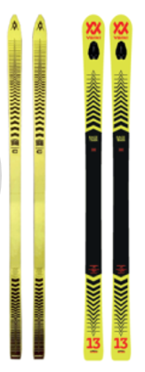

"When the ski stars of the past, junior athletes and Völkl developers team up with their experience and expertise, a ski is created that offers everything an athlete could wish for. Since the launch of the first Racetiger model, it has been our priority to build skis for racers that are optimized to meet their needs. Thanks to the collaboration with Manfred Pranger and Giorgio Rocca, we are proud to have gone a step further here, so the legend of the Racetiger lives on, also in product development", says Udo Stenzel, Völkl Managing Director of Sales, Germany commenting on the cooperation.

Constantly pushing the development of an optimal set-up is Völkl's top priority. But the company is also constantly setting new standards in terms of creativity. Special attention was also paid to graphics during the development of the new ski. The design of the Racetiger portfolio for the 20/21 season is based on the revolutionary, unique look of the first Racetiger, and reflects the tradition of this legendary ski.

For the coming winter, exciting new projects are also planned with other ski legends and junior athletes, who will intensively test new technologies with the Völkl development team and contribute to the further development of future Racetiger models.

**Press contact**

Mark Tedeschi

Elevator North, LLC

781-740-4050

[mtedeschi@elevatornorth.com](mailto:mtedeschi@elevatornorth.com)

**About Völkl**

Völkl have dedicated themselves to ski construction for more than 90 years. The passionate ski manufacturer is the only winter sports brand still developing and manufacturing in Germany. The Völkl parent plant located in Straubing, is one of the most modern ski manufacturers in the world and stands for technology and quality "Made in Germany". The team of development engineers, ski builders, product managers and athletes has made Völkl one of the world's leading ski manufacturers. In cooperation with its partners Marker and Dalbello, Völkl is striving to create the optimum equipment for skiers the world over. Marker designs and produces ski bindings, helmets, ski goggles and protectors, while Dalbello focuses entirely on the development and manufacture of ski boots.