Capital Finder Overview
The Capital Finder is a customizable database that contains over 7000 alternative funders across the developing world (excluding China). The funders are ranked by relevance to specific geographies, sectors, Sustainable Development Goals (SDGs), NGOs, or projects. The Capital Finder can be branded to your website’s ‘look and feel,’ and is a way to help your audience get a better understanding of the alternative finance landscape in relevant geographies and sectors.
It also allows NGOs to find funders they are aligned with across the SDGs — a unique opportunity to help promote finance for development and the SDG framework.
The Capital Finder shows all the innovative sources of capital available to NGOs in a country, including: foundations, impact investors, crowdfunding platforms, development banks, nonprofits, private investors, and others.
Sources of funding can be categorized by custom sectors (which you can define to fit your organization’s specific focus) or the SDGs. The Capital Finder also contains additional data points about the firms / organizations offering the funding, like description, capital type, office location, year founded, and social media presence.
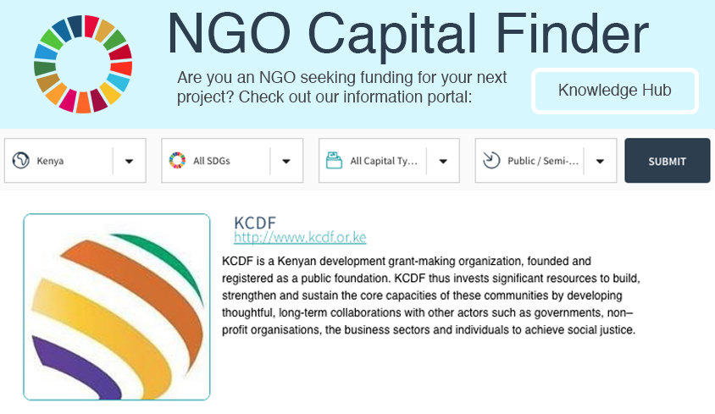
Capital Finder sample layout
In order to make the results more actionable, we developed the Knowledge Hub, an information portal and toolkit for entrepreneurs and NGOs. The Hub teaches NGOs how to write a business plan, model financial projections, and craft an actionable pitch — all skills they might not have formal training in. The Hub can be customized to fit your specific sectors and geographies, including by translating into the appropriate languages, referencing relevant regulations, etc. The Capital Finder shows businesses who to approach for funding, and the Hub explains how to do it.

Relevancy Score
To make the results highly targeted, the Capital Finder makes use of the Relevancy Score, an algorithm to improve the search results by filtering the most relevant data to the top. The Relevancy Score examines social media follower location, team size, office location, and other data points to attempt to improve the precision and accuracy of the search results. Crucially, the algorithm conducts keyword analysis of the funders’ websites to determine which ones are relevant for specific sectors or SDGs and countries. For example, if a foundation has many social followers in Kenya, has an office in the country, and mentions Kenya and Nairobi frequently on its site, it would show up higher in the ranking than a foundation that donates more broadly across the continent. The Relevancy Score solves the biggest problem NGOs face when fundraising: identifying specific funders with a high probability to back a project.

Data Points
The Capital Finder database results currently contain the following data points:
Company Name | URL | Provider Type
Year Founded | Logo | Description
Contact Details | Sectors / SDGs | Countries
Capital Types | Social Networks | Office Locations
The data points below, as well as others, can be integrated into the custom Capital Finder at an additional cost:
Average Donation Size | Funding Duration | News Feeds
Funding History | Funding Application Process | Total Assets
List of Employees | Web Traffic | Domain Registration Address

Expected Deliverables
The deliverable for this proposal is a custom-branded Capital Finder website, as well as access to the underlying data. The Capital Finder will allow you to search funders by country, sector or SDG, provider type, capital type, year founded, specific keywords, and more; the results will be sorted by relevancy to the search. Custom sectors can be created in order to make the results as relevant as possible to your organizations. If desired, additional data points can be added to the search results (see above).
The Capital Finder will allow you to help NGOs find funding; get data on which countries are leading in alternative finance; analyze impact investment trends; identify potential partners to fund SDGs; and much more.

