NAGVA Board Call
Meeting Minutes: 06/5/2019

- Roll Call – Smith, Crawford, Fallon, Dianna, Baxter
- Absentees – Jimmy, Ray
- Officer/Department Reports
  - President – Smith
    - The following seven (7) positions were brought to the attention of the Board by the President (Smith) for consideration, no discussion was requested, and a vote by affirmation was held. All candidates were approved by unanimous consent.
      - Registrar – Killburg
      - Eligibility – Josh Christensen
      - Regions – Callen
      - Tournaments - Sucre
      - Officials – Donald Leckey
      - Communications – Steven Acosta
      - Canada Rep – Jez
    - The following four (4) NAGVA members were brought to the attention of the Board by the President (Smith) for consideration as Regional Commisioners (RCs), no discussion was requested, and a vote by affirmation was held. All candidates were approved by unanimous consent.
      - Bronson
      - Nelson
      - Ethan
      - Flemimg
  - Vice President – Fallon
    - No new business
  - Secretary – Crawford*
    - No new business
  - Treasurer – Vacant
- Members at Large
  - Jimmy
    - No new business
  - Baxter
    - No new business
  - Dianna
    - No new business
  - Ray
    - No new business
- Motion to close the Call was seconded at 9:42 pm EST
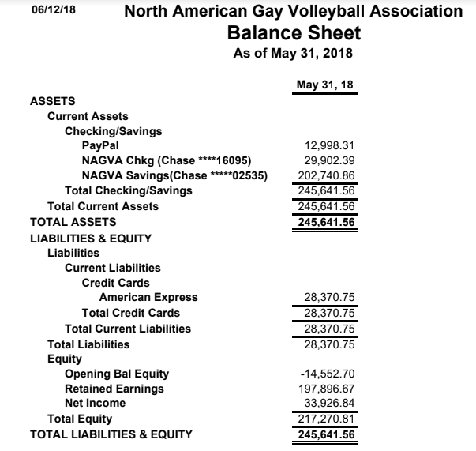

  - Registrar – Kilburg*
    - Updated member profiles.
    - Added a notes page for grievances or suspensions.
  - Tournaments – Davis*
    - Noted that there has been an attendance impact to Tournaments East of Mississippi due to Gay Games.
    - Confirmation that San Juan will have another tourney in Feb time frame.
    - Fall tourneys falling in line.
  - Canadian Representative – Jez*
    - No new business
    - Toronto tourney push. Requested timely notification of Midwest tourneys so he can push for participation, which would bolster participation of a Toronto tourney if more Canadians would already be registered with NAGVA for the 18-19 season.
- MAL Reports
  - Rich*
    - No news
  - Jimmy*
    - No new. Has a new dog Toby. Likes butt scratches.
- New Business
  - Information concerning a Board Member was brought to light. Board was given time to digest this information to be discussed at an upcoming meeting.
- Meeting Adjourned

