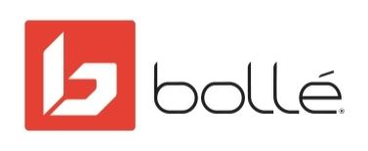

FOR IMMEDIATE RELEASE

Media Contact:
Mark Tedeschi
True North Brand Group, Inc.
mark@truenorthpr.com
781-740-4050

BOLLÉ LAUNCHES A NEW AUGMENTED REALITY EXPERIENCE FOR ITS WINTER PRODUCTS & BEST LENS PHANTOM
Allows Consumers to Experience Bollé Helmets and Goggles with a Virtual ‘Try On’ and ‘Try Out’ Feature

Lyon, France (OCTOBER 28, 2020) – In an increasingly digitized world, the Bollé brand stands out for its product innovations (offering ever more advanced and market-leading technology, such as its Phantom lens) as well as its digital initiatives. The most recent example was its revolutionary app, launched this summer, which allows you to try out the Phantom lens directly from a smartphone (a first in the sports market).

Committed to keep on addressing current sanitary challenges with innovative solutions, Bollé announces the launch of a new augmented reality filter allowing consumers to not only look out and experience Bollé’s exclusive Phantom lens in the sought-after Nevada goggle, but also safely see what they look like with Bollé helmets and goggles on without ever having to physically touch the products.
Partnering with QReal and M7 Innovations, Bollé’s AR experience is a first for the helmet and goggle industry. Within Instagram, the demonstration invites users to ‘try-on’ and ‘try-out’ Bollé’s most technical lens: the Phantom, along with the RYFT helmet, which is new for the 2020/21 season.

The unique customer experience also goes beyond Instagram with interactive 3D models on the Bollé website, offering informational bullet points that can be moused over for detailed information.

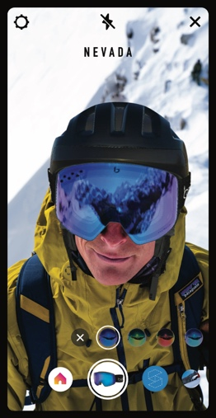
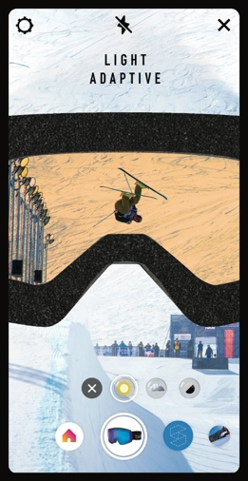
“For this winter version of our Phantom augmented reality experience, we have gone further in the realistic feel of the filter and in our communication,” said Louis Cisti, vice president of Global Marketing for Bollé. “Bollé has one of the strongest winter sports athletes’ team in the world. This experience pairs the greatest champions with the best photochromic lens technology on the market. It is a strong statement. Our products are worn by the best, and with the filter, anybody can see like a champion”, he concludes.

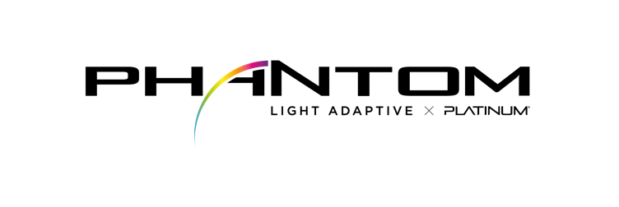
After seeing the helmet and goggle on their head, users can simply flip their camera from selfie-view to front-facing and Phantom lenses are superimposed on their actual view. Users then introduce goggle effects like high contrast, anti-fog, and photochromic into their real surroundings to see Phantom lenses in action. Once users select a lens that suits their style and needs, they can search for a participating dealer and purchase directly from that retailer.

“Augmented reality had a breakout moment this year as innovative brands continue to find fun, new ways to stay connected to consumers while they’re home shopping on their phone or computer and scrolling through social media,” said Matt Maher, Founder of M7 Innovations.

Using AR, users will experience first-hand what makes Bollé’s Phantom the leading lens in winter sports.

- Light Adaptive Technology: the user is presented with a slider that allows them to change their exposure, making the scene brighter or darker. They watch Phantom’s molecular photochromic filter adapt to changes in ambient light.
- Anti-Fog Treatment: The user’s view begins to fog up, simulating the fogging that occurs from sweat while skiing. Fog condenses outside the glasses, but the view through the goggles remains crystal clear, mimicking the real-world performance of Phantom Lenses in real world situations.
- Low Temperature Sensitivity: The Phantom lens with exclusive LTS Technology (Low Temperature Sensitivity), delivers improved activation, darkening or lightening whether the temperature is -13°F or 41°F.
Bolle’s full line-up of Phantom lenses will be available in the AR demo so consumers can select the lens that best works for them. The range includes:
- Phantom + which in addition to all the Phantom technology also includes a semi-polarized film that reduces distracting glare and enhances contrast to distinguish ice from snow.
- Phantom Green Emerald lens is ideal for bright light conditions.
- Phantom Fire Red lens amplifies color contrast is ideal sunny days.
- Phantom Vermillion Blue is a versatile lens offering color definition and depth perception.

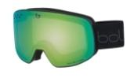
For the Try On part of the experience users will be able to see how they look in the Bollé RYFT helmet and Nevada Goggle.
The Nevada is the perfect combination of technology and style. Its cylindrical shape provides a wide field of view. A venting system designed within the frame promotes directional airflow across the inside surface of the lens, reducing the potential for moisture build-up while optimizing visual acuity. An embedded premium anti-fog layer in the inner lens disperses water molecules across the surface of the lens restricting build up. The lenses are sheathed in a protective armor to prevent scratches. The Nevada also features Double Layer Face Foam for increased comfort and fit and includes Bollé’s signature UV protection lenses that block harmful UVA/UVB rays up to 400 nanometers.

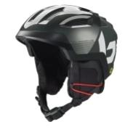
RYFT, the latest high-end helmet from Bollé, breaks all rules thanks to its revolutionary ventilation system. With bigger and wider vents than traditional helmets, the RYFT defies the market’s standards. An innovative Active Panel Ventilation system allows an airflow never achieved before in a snow helmet, while still meeting the highest impact protection norms. This exceptional ventilation performance is completed by Bollé’s Flow Tech Brim Venting system allowing the hot air contained in the goggles to be evacuated through the helmet’s ventings, and by rear vents guaranteeing the efficient extraction of the air transiting inside the helmet. Being in line with Bollé's 100% MIPS® commitment, the helmet features MIPS® brain protection system, combined with a hybrid shell and the brand’s proprietary AVID progressive EPS for perfect protection.

To try-on or try-out Nevada goggles with Phantom lenses and RYFT helmets users can scan a QR code that will take them to Instagram for the ultimate AR shopping experience.
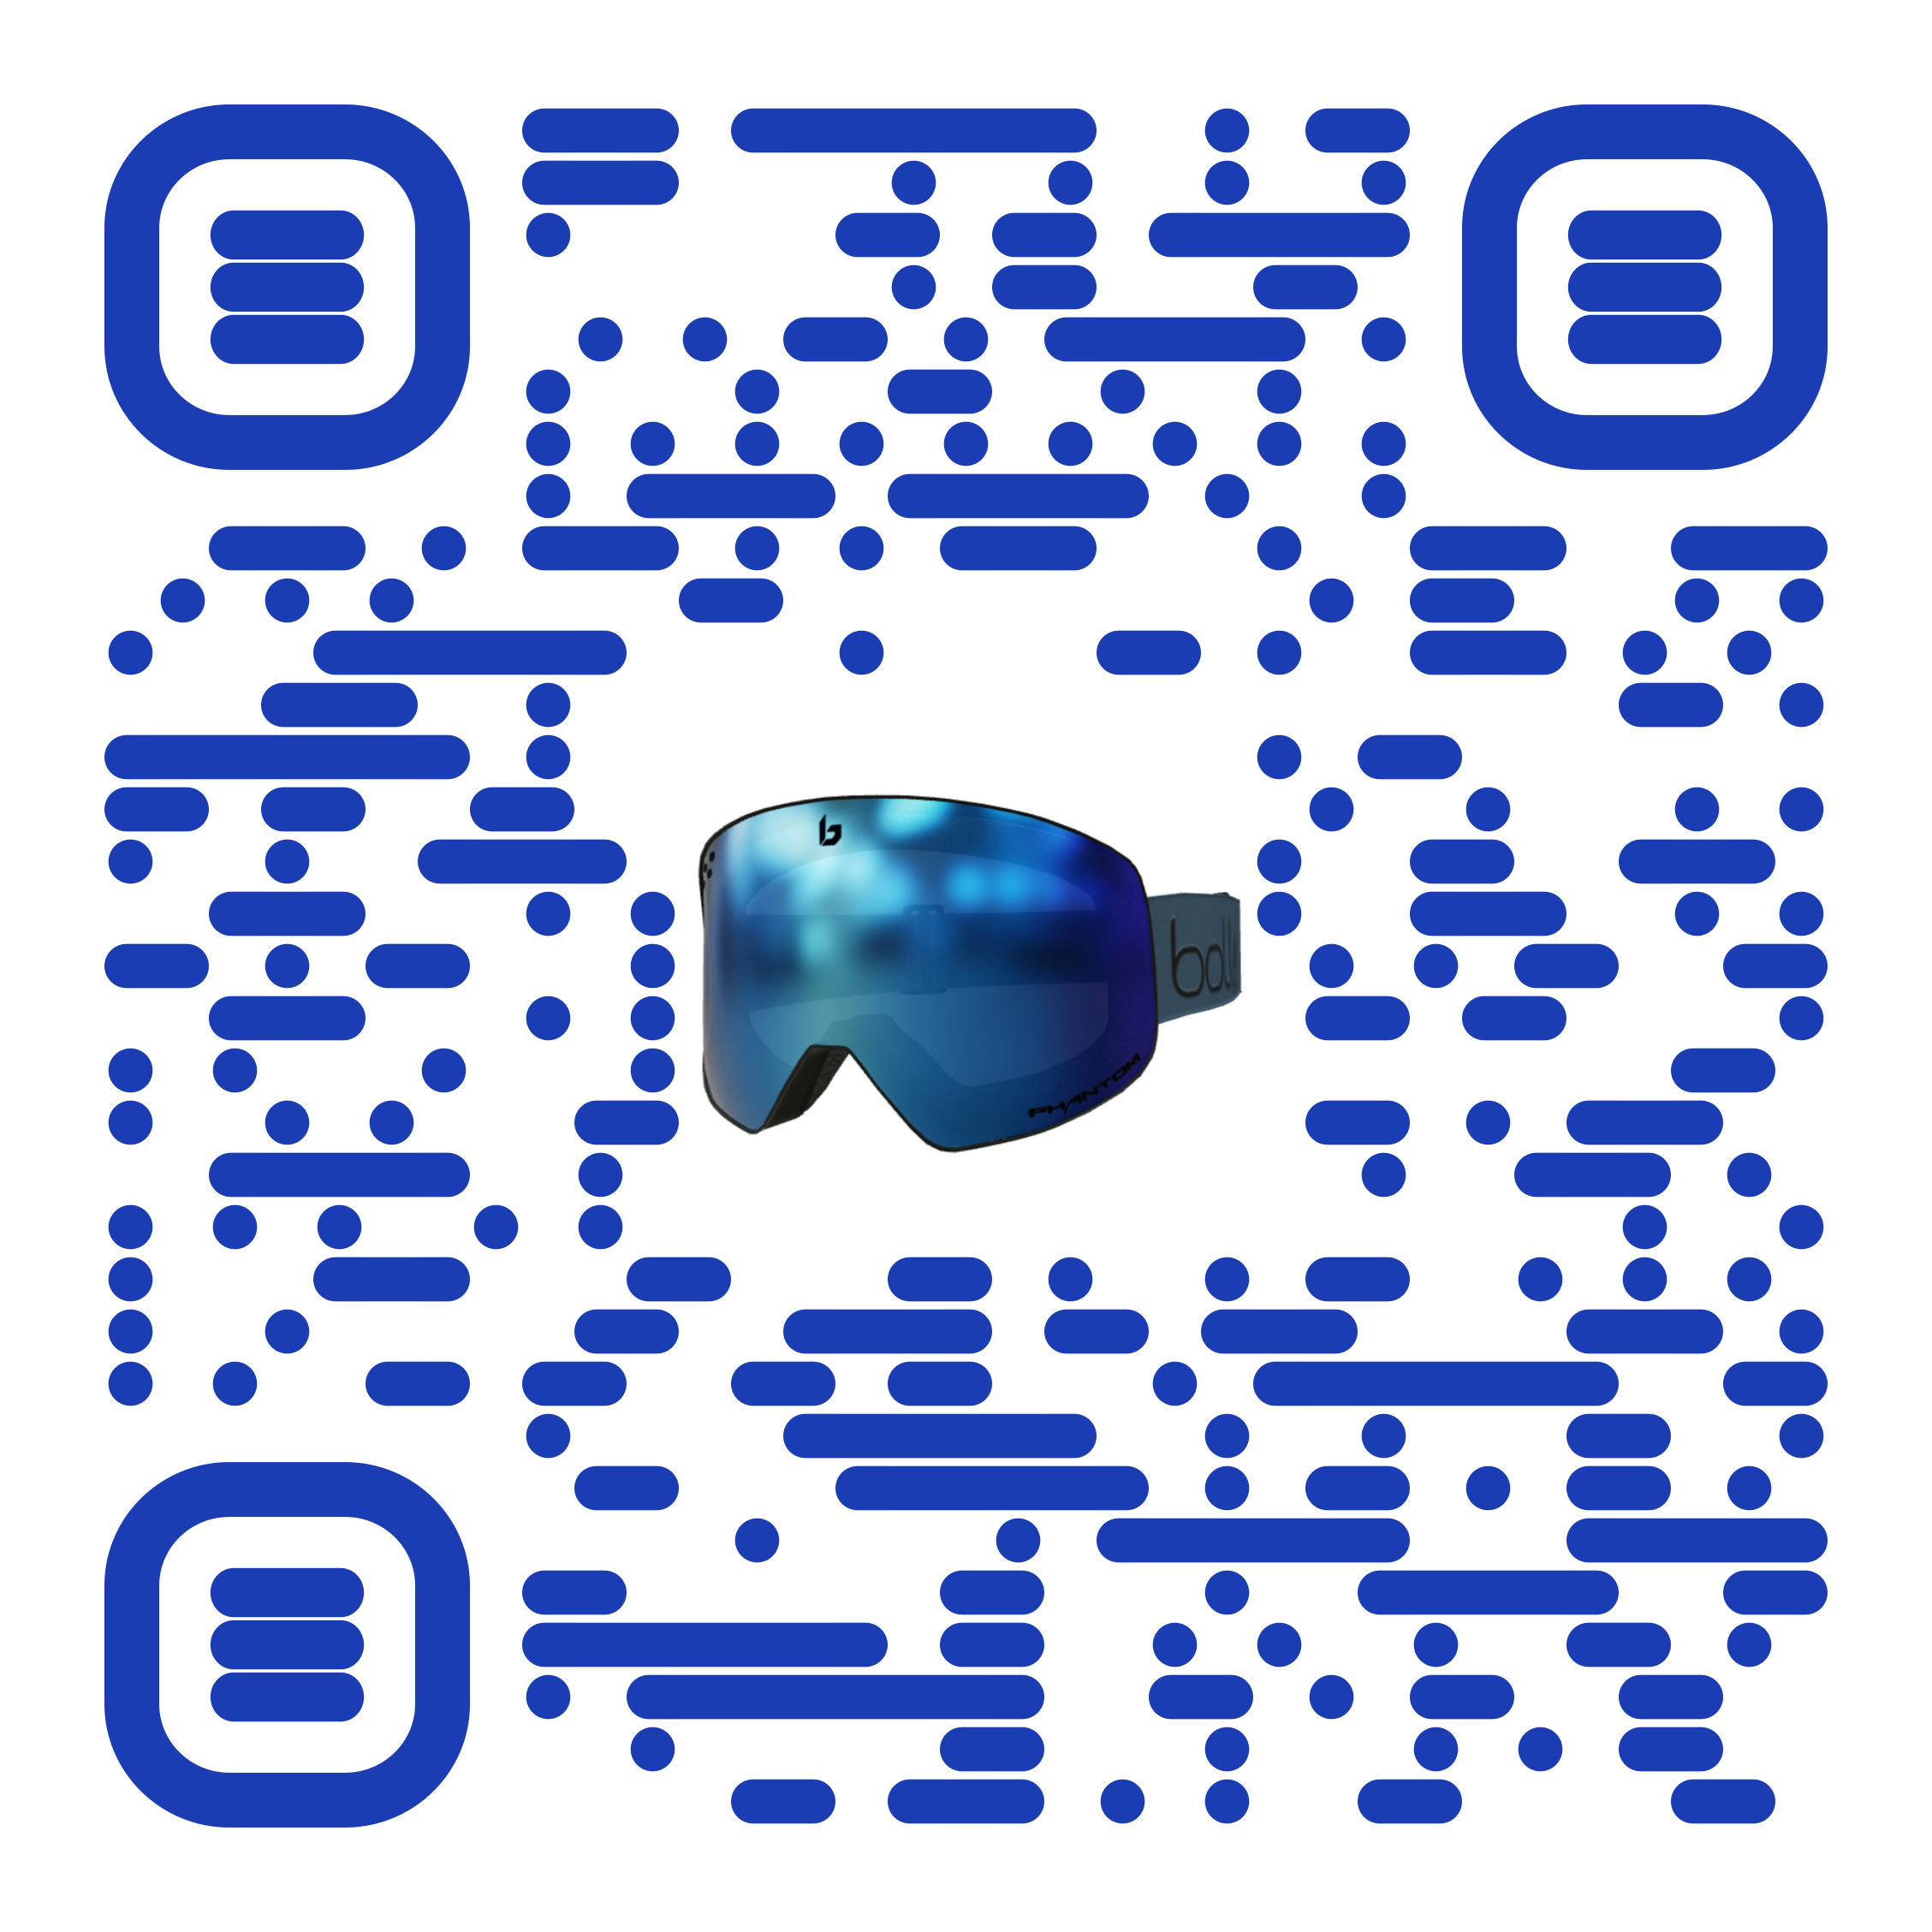
About Bollé
Bollé is a leader in sport and lifestyle sunglasses, cycling helmets, ski goggles, and ski helmets. For more information, visit www.Bollé.com. Bollé is part of Bollé Brands™ which encompasses the brands Bollé, Bollé Safety, Cébé, Serengeti, Spy and H2Optics. Thanks to the complementary know-hows and innovative technologies developed by the six brands in their respective fields of activities, Bollé Brands’ expertise covers a large spectrum of products that meet the highest requirements in terms of protection, performance, innovation and style.

About QReal
QReal, a subsidiary of The Glimpse Group, creates world-class 3D and Augmented Reality content. The new frontier of eCommerce and social media requires hyper-realistic product showcasing and virtual storytelling. QReal provides end to end services to bring their clients sales lifts, brand recognition, and viral content. And they make them beautiful.

About M7 Innovations
M7 Innovations is an NYC-based creative firm that works with brands and executive teams to conceptualize, create, and execute on solutions that leverage Artificial Intelligence (AI), Voice Technology, Augmented Reality (AR), and Virtual Reality (VR). Founded in 2019 by Matt Maher, M7 partners with other tech visionaries and leaders in this space to create unique customer experiences that drive meaningful engagement – from retail and transportation, to lifestyle and fashion.
###

