December 15, 2023

To Whom It May Concern:

I, Jeanelle Spencer, certify that: (1) the financial statements of Zehbras LLC included in this Form are true and complete in all material respects; and(2) since this is a startup business, no taxes have been filed for the fiscal year ended 2021 and 2022 and there is no tax return information for Zehbras LLC included in this Form.

Sincerely,

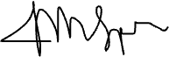

Jeanelle M. Spencer

Owner

Zehbras, LLC